Grade 8 Coding / Digital Technology

Grade : 8
Subject : Coding / Digital Technology
Topic : Algorithms and Flowcharts
Duration : 30 minutes
MEMORANDUM

Total: 20 marks

Activity 1 (5 marks)
1.1. An algorithm is an ordered set of steps used to solve a problem. (1)
1.2. An oval represents Start or End. (1)
1.3. A rectangle represents a process or action. (1)
1.4. A diamond represents a decision or Yes/No question. (1)
1.5. Planning helps identify missing steps and prevent logical errors. (1)

Activity 2: Complete the Flowchart (5 marks)
2.1. Oval. (1)
2.2. Rectangle. (1)
2.3. Diamond. (1)
2.4. Move and turn, then return to the decision to check again. (1)
2.5. Arrows show the direction and order of steps. (1)

Activity 3: Find and Correct the Error (5 marks)
3.1. The turning angle is incorrect. (1)
3.2. 90 degrees. (1)
3.3. Four times. (1)
3.4. A repeat loop repeats instructions without writing them separately each time. (1)
3.5. Check the repeat count, turning angle, pen setting and order of instructions. (1)

Activity 4: Exit Ticket (5 marks)
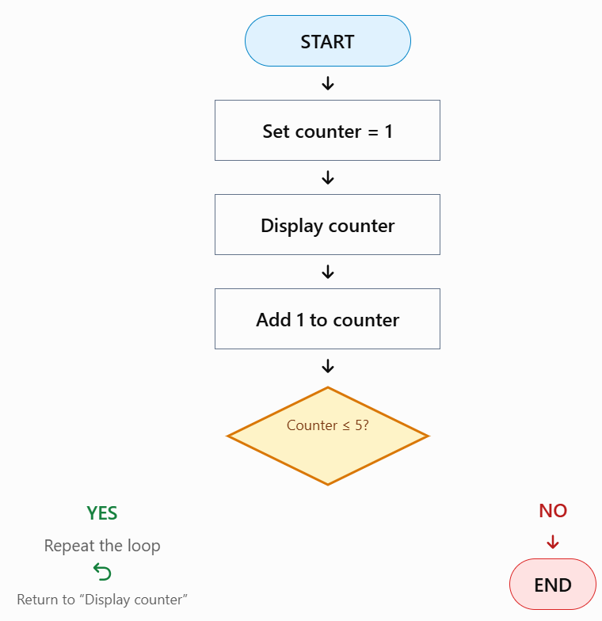

Mark the learner's flowchart as follows:
Criterion | Marks
Correct Start symbol | 1
Correct Process symbol | 1
Correct End symbol | 1
Logical order and arrows | 1
Complete and understandable | 1
Total | 5

