Grade 8 Coding / Digital Technology

Grade : 8
Subject : Coding / Digital Technology
Topic : Algorithms and Flowcharts
Duration : 1 hour
MEMORANDUM

Total: 50 marks
Section A: Knowledge and Understanding (10 marks)
1. An algorithm is an ordered set of steps used to solve a problem. (2)
2. The three basic flowchart symbols are shown below. Award 2 marks for each correct symbol and purpose. (6)
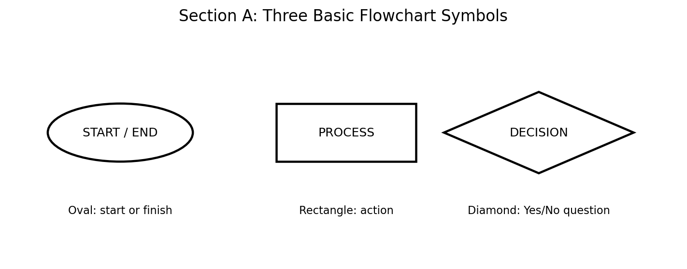
3. Any two: planning identifies missing steps, improves logical order, prevents errors, and makes coding easier. (1 mark each)
Section B: Algorithm and Flowchart Design (15 marks)
1. Suggested algorithm (5 marks):
- Start.
- Put the pen down.
- Repeat four times.
- Move 100 steps and turn 90 degrees.
- Stop and end.
2. Suggested flowchart (7 marks). This version uses a side counter to make the Decision and loop clear. Accept an equivalent correct flowchart.
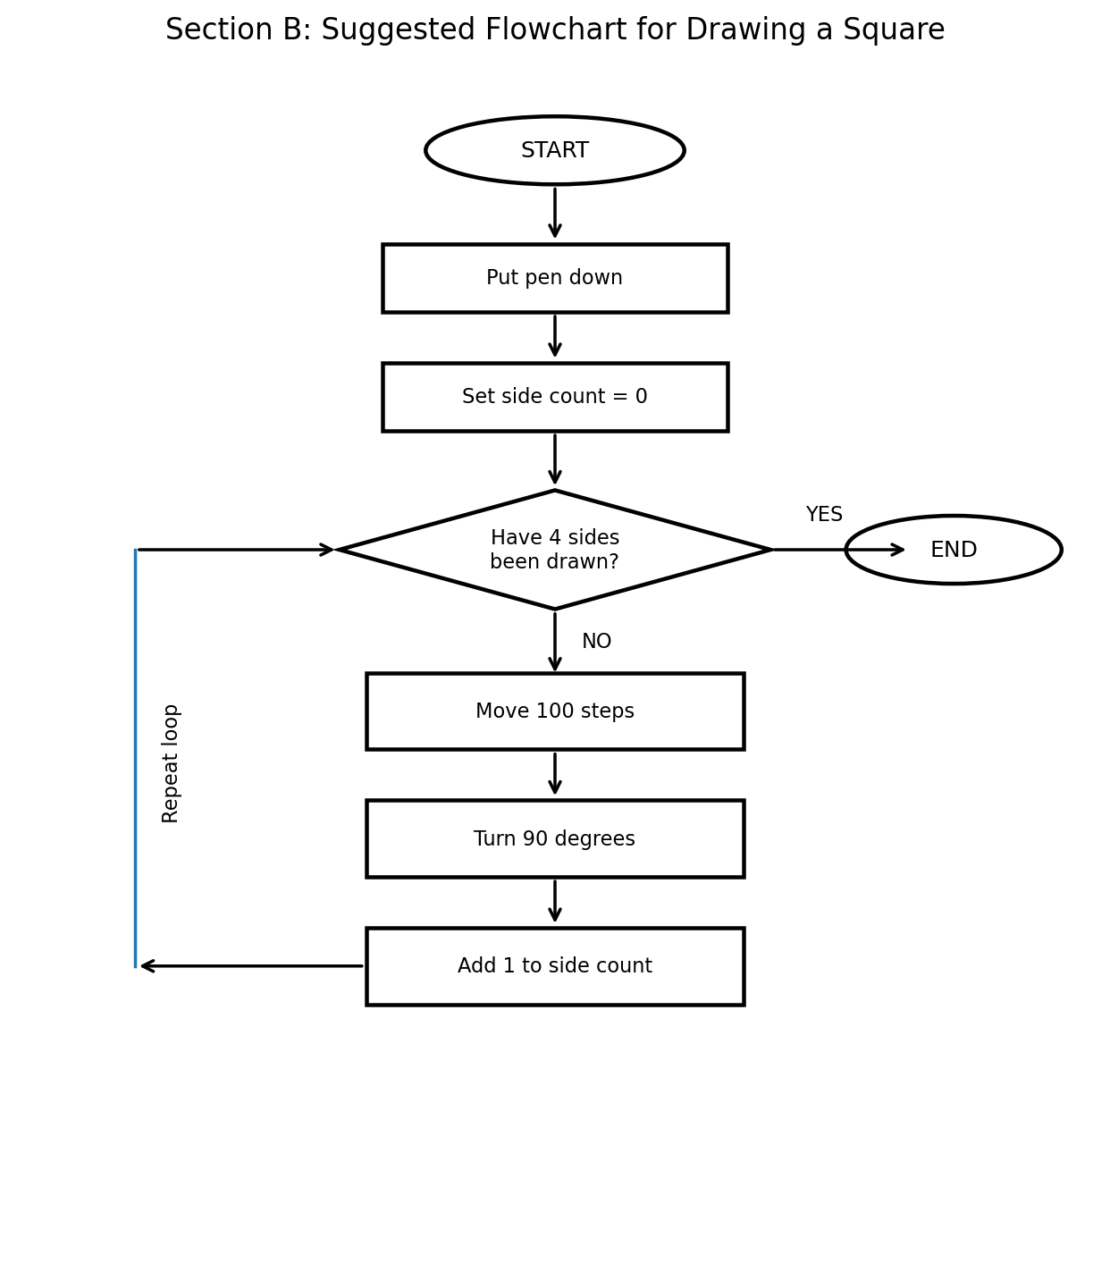
3. The Decision checks whether four sides have been drawn. If No, the instructions repeat; if Yes, the program ends. (3)
Section C: Practical Coding Task (15 marks)
Suggested Scratch block logic:
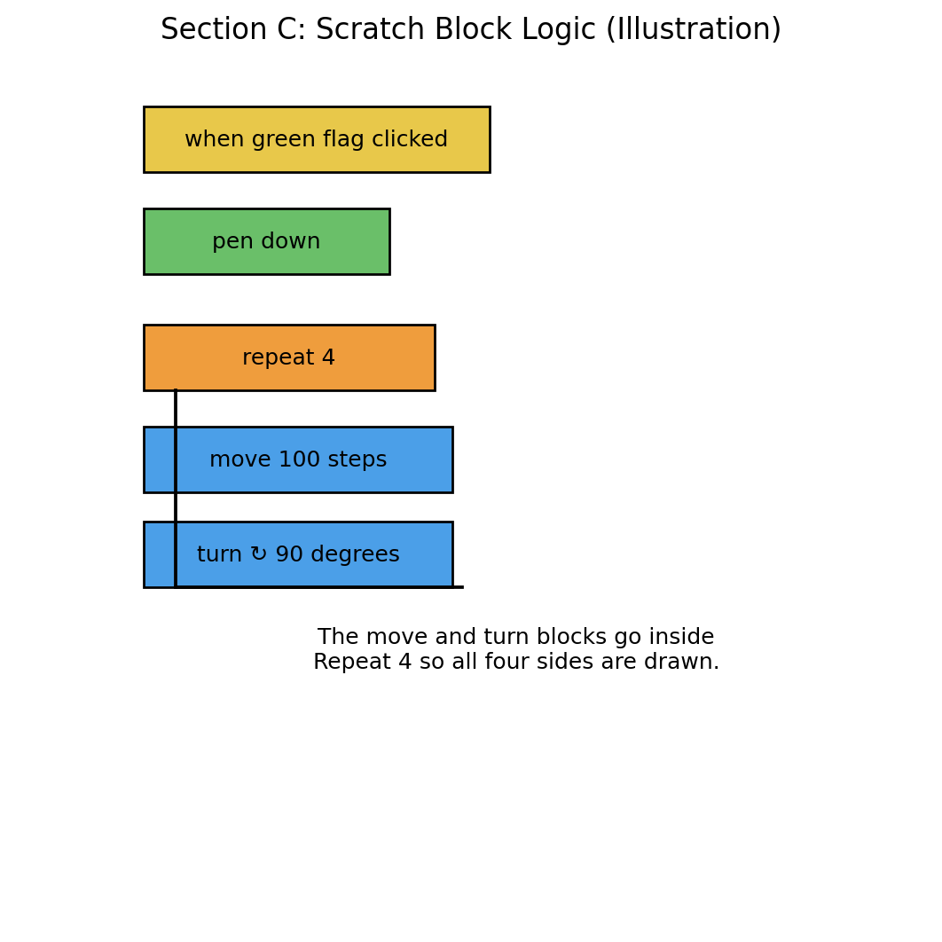
1. Appropriate event/start block used, such as when green flag clicked. (2)
2. Pen-down instruction included before drawing. (2)
3. Repeat loop uses four repetitions. (3)
4. Move 100 steps and turn 90 degrees are inside the loop. (3)
5. Program produces a closed square. (3)
6. Learner tests the program and corrects errors. (2)

Section D: Debugging and Reflection (10 marks)
Incorrect program: Repeat 4 times → Move 100 steps → Turn 60 degrees.
1. The turning angle is incorrect. (2)
2. The correct turning angle is 90 degrees. (1)
3. A 60-degree turn does not give the square its required four right-angle turns. (2)
4. Any two: run the program; observe the result; check the blocks and values; correct the error and run it again. (2)
5. The algorithm and flowchart describe the logic the code must follow. Matching them makes the program easier to understand, test and debug. (3)

Marking rubric: Sections B and C
Use the mark bands to award partial marks. Where a learner’s answer sits between two levels, award the lower band unless the evidence clearly supports the higher one.
Section B: Algorithm and flowchart design (15)
Criterion (marks) | Achieved | Partly | Not yet
Algorithm (5) | 5: at least 5 steps, in order, clear and unambiguous, including pen down and the repeat | 3–4: 4–5 steps, with minor gaps in order or clarity | 0–2: fewer than 4 steps, out of order, or missing
Symbols (3) | 3: oval Start/End, rectangle Process and diamond Decision all correct | 2: one symbol wrong or missing | 0–1: most symbols wrong
Decision (2) | 2: Decision has labelled Yes and No exits | 1: only one exit labelled, or labels unclear | 0: no Decision
Loop (2) | 2: arrow loops back correctly to the Decision | 1: loop partly correct | 0: no loop
Explanation (3) | 3: Decision checks if four sides are drawn; No repeats, Yes ends | 1–2: partly correct or vague | 0: no relevant answer
Section B total: 5 + 3 + 2 + 2 + 3 = 15
Section C: Practical coding task (15)
Criterion (marks) | Achieved | Partly | Not yet
Start event (2) | 2: when green flag clicked, or another suitable event | 1: event used but misplaced | 0: no event
Pen down (2) | 2: before drawing | 1: present but after drawing starts | 0: missing
Repeat loop (3) | 3: repeat 4 | 1–2: loop used with a wrong count | 0: no loop, blocks copied by hand
Move and turn (3) | 3: move 100 and turn 90, both inside the loop | 1–2: right values but outside the loop, or one wrong value | 0: missing
Closed square (3) | 3: closes with four equal sides | 1–2: shape drawn but not closed or not equal | 0: no shape
Testing (2) | 2: tested and corrected an error, with evidence | 1: tested but no correction shown | 0: no testing
Section C total: 2 + 2 + 3 + 3 + 3 + 2 = 15
GRAND TOTAL: 50

CAPS and cognitive-level alignment
Source: CAPS Technical Occupational, Digital Technology, Grades 8 and 9. Computational Thinking, Grade 8 Term 3 (p. 26); Coding, Grade 8 Term 3 (pp. 28–29); cognitive demand (pp. 47–48).
Question | Marks | CAPS topic (Grade 8, Term 3) | Cognitive level
A1 Define algorithm | 2 | Computational Thinking: understand what an algorithm is | L1 Knowledge
A2 Symbols and purposes | 6 | Computational Thinking: read and explain an algorithm (flowchart symbols) | L1 Knowledge
A3 Why plan | 2 | Computational Thinking: algorithms | L2 Understand/Apply
B1 Write algorithm | 5 | Computational Thinking: algorithms, detail and sequence | L2 Understand/Apply
B2 Draw flowchart | 7 | Computational Thinking: representing an algorithm as a diagram | L2 Understand/Apply
B3 Decision and repeat | 3 | Computational Thinking: explain an algorithm | L3 Analyse/Create
C1 to C5 Build program | 13 | Coding: create shapes with pen/turtle; single REPEAT loop; events | L2 Understand/Apply
C6 Test and correct | 2 | Computational Thinking: test steps in an algorithm | L3 Analyse/Create
D1, D3, D4 Debug | 6 | Computational Thinking: test steps; locate errors | L3 Analyse/Create
D2 Correct angle | 1 | Coding: create shapes (angles) | L2 Understand/Apply
D5 Why they must match | 3 | Computational Thinking: algorithms | L3 Analyse/Create

Mark distribution by cognitive level
Level | Marks | Test | CAPS guide | Comparison
L1 Knowledge | 8 | 16% | 40% | Below guide
L2 Understanding and Applying | 28 | 56% | 45% | Above guide
L3 Analysing, Evaluating, Creating | 14 | 28% | 15% | Above guide
Total | 50 | 100% | 100%
Notes
1. The test sits above the CAPS guide for L2 and L3 and below it for L1, because it assesses a planning-and-coding task and includes a debugging section. Teachers who need an exact 40/45/15 split can add recall questions to Section A and reduce Section D.
2. Flowcharts are not named in the Grade 8 CAPS content. They appear in Grade 9 (Term 2 and Term 3 Computational Thinking and Coding). Here they scaffold the Grade 8 algorithm outcomes, and CAPS p. 48 lists converting a flow chart representation to a program as an L2 example.
3. Cognitive levels are the author’s judgement, using the CAPS descriptors on p. 48.
4. This task combines a theory test and a practical, so it is longer than the CAPS minimums for a single Grade 8 test (theory: 30 marks and 40 minutes; practical: 25 marks and 30 minutes).

