QSolver Quickstart Guide

# Introduction

The QSolver tools are a set of scripts for Maya, written in python, that allow for the reading, editing and writing of QTM solver XML files. The XML reader constructs a Maya scene from a solver definition file. You can then edit the scene elements to adjust the skeleton to be solved. The exporter writes out a solver XML file that you load into QTM for solving with your data. This guide provides multiple examples of variations on this process to get you familiar with the procedures for editing solver definitions. But first, some terms, definitions and requirements:

* **QTM** – The Qualisys Track Manager. The main editing and analysis software at Qualisys. It also runs solver.
* **Solver** – The globally optimized solver tool for calculating skeleton motion from marker data. It is built in to QTM.
* **Maya** – Autodesk’s Maya 2020 is the version used for the initial development of these scripts.
  + It is assumed in this guide that you have some familiarity with using Maya.
  + Installation of the scripts is easy:
    - Copy the scripts to the Maya scripts folder
    - Make shortcut icons on a shelf in Maya for the QImportSolver and QExportSolver scripts.
* **Namespace** – A **namespace** is a simple grouping of objects under a given **name**. **Namespaces** are primarily used to resolve name-clash issues in **Maya**, where a new object has the same name as an existing object (from importing a file, for example). Using **namespaces**, you can have two objects with the same name, as long as they are contained in different **namespaces**. The name policy for markersets in QTM is that the namespace in Maya (and Motionbuiilder) is the same as the markerset name.
* **Markers** – These are locators in Maya whose positions come from a frame of marker data in QTM. These can come from the XML file or they can be created via other methods, such as importing an FBX file.
* **Skeleton** – The hierarchy of joints in Maya that define the skeleton portion of the model pose.
* **Character/Avatar** – These terms are used interchangeably. They refer to a user defined character/avatar rig that is independent of any description of the performer. They will almost always consist of a skeleton and a skin that is bound to the skeleton. Optionally they might have a reference node that is used to place/orient the character in the scene. This reference node is not driven by mocap data.
* **Poses**
  + **T-Pose** – A standard pose for many calculations. All retargeting tools (HIK, MotionBuilder) require a T-Pose for characterization as a way of relating different characters to each other. Some motion capture tools require this pose, QTM needs a T-Pose for calculating the animation (and sports) skeleton.
  + **A-Pose** – A common alternative to the T-Pose for binding the skeleton to a skin. The shoulders are easier to skin in a relaxed position compared to the T-Pose.
  + **Zero Pose** – The pose of the skeleton when all joint rotation values are set to zero. Often this is equal to the T-Pose, but it doesn’t have to be.
  + **Bind Pose** – The Maya pose for binding a skeleton to a skin. Most often this is the T-Pose, but many users prefer an A-Pose here.
  + **Model Pose** – The combination of markers and skeleton that define the offsets from the skeleton segments to the markers. This is usually a T-Pose, but it doesn’t have to be.

# QuickStart Samples

A series of examples for helping the user understand the solver model pose setup process.

## Adjusting the Animation Skeleton

This is an example which shows how to load an animation XML file, make a simple change to the model pose in Maya, then export back to QTM for solving. This assumes you have downloaded the sample dataset *Skeleton Solver Demo – Animation Marker Set.* Be sure to have a version of QTM that supports roll bones I n the animation markerset (2020.2 or later) and a dataset version that matches (a QAvatar with roll bones in the forearms).

The summary of the steps are here, images for the steps are shown below.

1. Load the file “EliROM.qtm” in to QTM
   1. Start QTM
   2. Select “Load Project” and choose the folder with the animation data
   3. Select EliROM.qtm
2. Export the Eli XML file to “Eli.xml”
   1. Open the Project Settings Dialog
   2. Select “Skeleton Solver”
   3. From the Name list select Eli
   4. Select Save
   5. Choose the file “Eli.xml” to save, for convenience put it in the “Data” folder
3. Using the “QImportSolver.py” script in Maya, load the file “Eli.xml”
   1. Start Maya
   2. Set the current project folder to the “Data” folder of the sample dataset. Make default project settings for Maya.
   3. Select the icon for QImportSolver. If you don’t have this, you can either just source the python script file or you can load the file and execute it from the script editor.
   4. Choose the file “Eli.xml”
   5. Note that QTM works in Z up world axis, Maya is typically Y -up, but for this you should change your preference in Maya to Z up.
4. Make a change to the skeleton
   1. Select the RightShoulder joint and rotate it a small amount backwards so the RightArm joint is closer to the RShoulderBack marker instead of being directly under the RShoulderTop marker.
   2. Counter rotate the UpperArm joint to put the RightHand joint back between the hand markers.
5. Load the change back into QTM
   1. Use the script QExportSolver to save out a new XML file.
      1. Select the root joint “Hips”
      2. Select QExportSolver
      3. Specify the file name to save, perhaps “Eli_modified.xml”
   2. In QTM select “Reprocess”
      1. Turn off all options except for “Solve Skeletons”
      2. Select “Skeleton Solver”
      3. Select “Load”
      4. Choose “Eli_modified.xml” (note that it comes back in as “Eli” in the list because that is the name saved in the XML file (which matches the namespace in Maya)
      5. Select “OK” and the skeleton will be recalculated.
6. Note that the solver results have been modified.

Some images:

|  |
| --- |
|  |
|  |

Above: Where to find the sample data. Go to the Qualisys website and look for the “Demo Files” link in the upper left. Locate and download the ***Skeleton Solver Demo – Animation Marker Set***sample data.

|  |  |
| --- | --- |
|  |  |
|  |  |
|  |  |

Above: images for Step 1. Load the original EliROM.qtm file. Note the position of the clavicle bones relative to the shoulder markers

|  |  |
| --- | --- |
|  |  |
|  |  |

Above: Images for Step 2. Export the Eli skeleton solver to an XML file.

|  |
| --- |
|  |

Above: Image for step 3. The QImportSolver icon is on the QTM_Connect shelf. Yours will be where ever you put it. Note the namespaces for the “Markers” and “Hips”

|  |  |
| --- | --- |
|  |  |
|  |  |

Above: Images for step4. Top image is the skeleton right after importing the XML. The bottom image is after rotational adjustments have been made.

|  |
| --- |
|  |
|  |
|  |

Above: Images for step 5. Note the change in the position of the clavicles.

## Streaming to the QAvatar

This shows how to take the above process and stream it onto the QAvatar with roll bones.

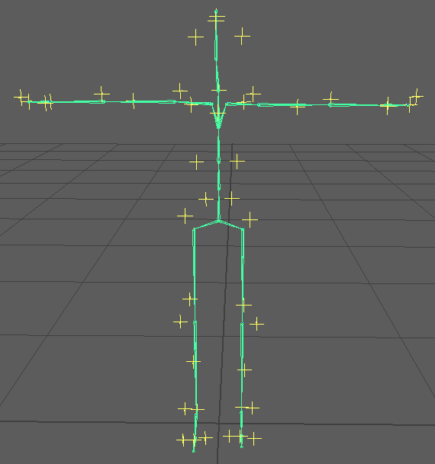

Above image, start with the modified skeleton from the first quickstart outline.

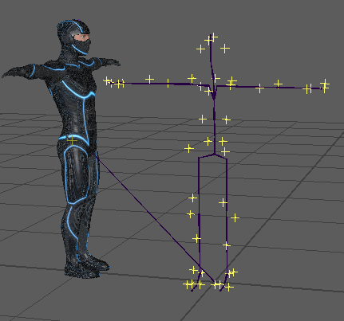

Import the QAvatar Maya file. Depending on your import settings you will get a modification to the names in the QAvatar file. Below is shown when the file is imported with namespaces.

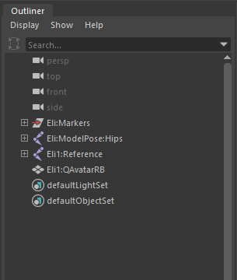

However the names were imported, the goal is to get the avatar into the “Eli” namespace without any prefixes. Use the Maya Namespace Editor to delete any invalid namespaces (such as “Eli1” in the above image) and put the QAvatar into the “Eli” namespace.

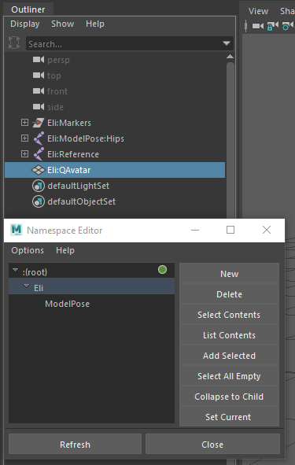

What your scene’s hierarchy should look like. The original Eli setup and the new Reference and QAvatar nodes from the QAvatar file. Note that there are two identical copies of the skeleton in the scene- the one in the “Eli” namespace and one under the “ModelPose” sub-namespace. This is how the name clashes are avoided.

Set QTM to “Play with Realtime Output”. This starts steaming data from QTM. In Maya, locate the QTM_Connect shelf. Select the “Connect to QTM” icon to bring up the connection dialog.

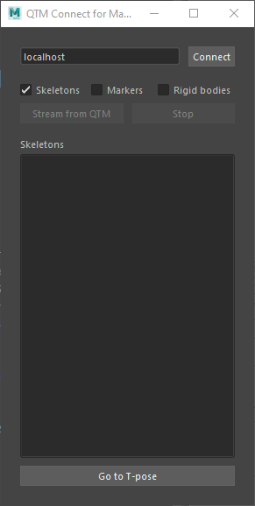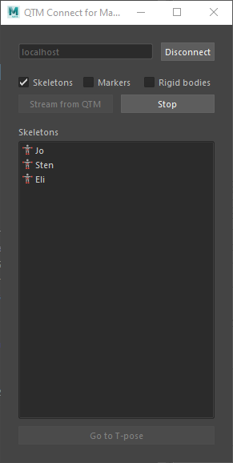

The QTM_Connect dialog before and after selecting “Connect” and “Stream from QTM”

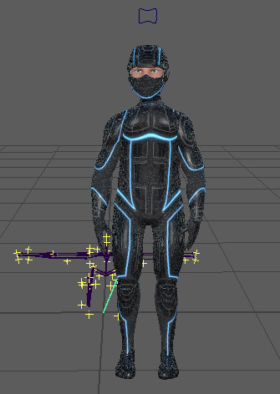

The result of streaming the modified skeleton from the first quickstart outlne. This is the animation skeleton with modifications.

Now on to creating a model pose directly from the QAvatar model.

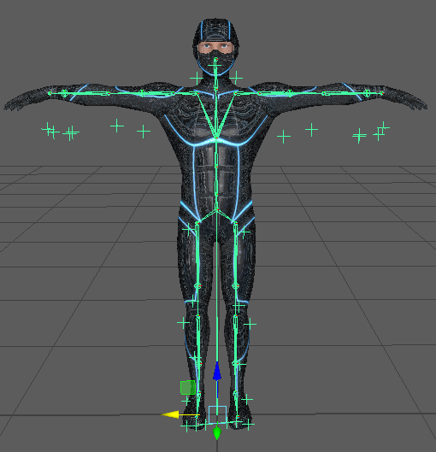

To get started, recreate the scene as depicted in the above image. Do this with the following steps:

* Start with a new scene
* Do QImportSolver on the Eli.xml file to create the model pose.
* Import QAvatar to merge it with the model pose
* Remove any namespace or prefix from the imported QAvatar, do not put the “Eli” prefix on it.
* Rearrange the hierarchy of the scene to replace the old skeleton with the new one
  + Delete the old model pose skeleton
  + Position the QAvatar in its place by only modifying the Hips node. Do not modify the “Reference” node.
  + Place the QAvatar joint hierarchy under the “Eli” root node (make “Reference” a child of “Eli”)

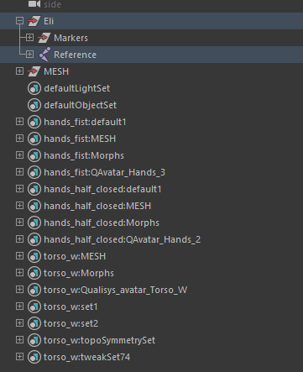

After rearranging the scene to be as above. You need to add DOF attribute information to all the joints. This uses a python helper script called “AddDOFAttributes.py”.

* Select the node “Hips” in the joint hierarchy.
* Use the Maya menu item “Select->Hierarchy” to select all the joints in the hierarchy.
* Invoke AddDOFAttributes.py

Select any joint to see the attributes that have been added. Here the Hips joint is shown:

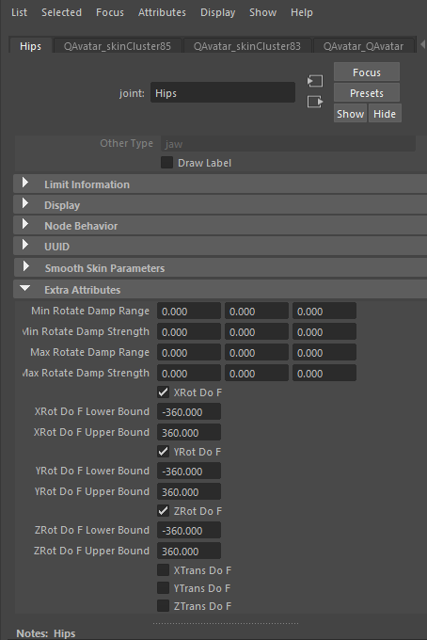

Now you must adjust the settings for a number of different joints.

* Turn on the translation dofs for the root.
* Turn off all dofs for the roll bones.
* Turn off “Segment Scale Compensate” for all the joints so the whole skeleton can be scaled from the hips joint.
* Scale the Hips joint by 0.86 in all axes. That is what works for this combination of character and performer. Other combinations will be different. But be sure to make all adjustments from the Hips node and not the parent “Reference” node.
* Add end effector joints for the hands, head and toes.
  + Select the end joint.
  + Duplicate it
  + Parent the new joint to the original
  + Rename the new joint the same as the original with “_end” added.
  + This creates a “EndPoint” tag for end effectors to make the segment draw correctly in QTM

|  |
| --- |
|  |
|  |

Above: what the model pose setup should look like, top and front views.

Select the Hips joint and use QExportSolver to create the XML for QTM. Load it into QTM and solve it on the EliROM capture. To view the streaming result, import the QAvatar again and rename the prefixes to “Eli_” for the streaming skeleton. You will now have two copies of the QAvatar in your Maya scene, one is for the model pose definition, the other is for viewing the streaming result.

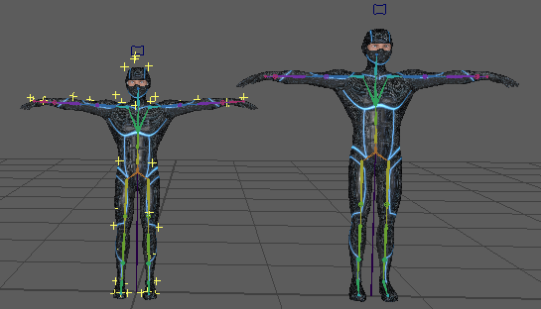

This is what it will look like after importing the new QAvatar and rotating it into place with a translation to separate them. Don’t worry about the scale difference, the new QAvatar will be scaled down by the data once it starts streaming. Now start streaming the data from QTM:

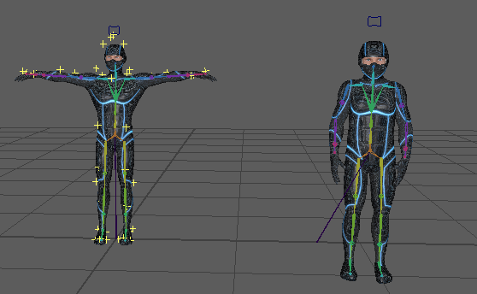

Another rotation adjustment of the reference node will be necessary to get the avatar upright. Note that the scales of the characters now match.

If you need for the QAvatar character to maintain its original scale, then enter a scale value of 1.163 (this inverse of 0.86) into the scale values of the Reference joint and turn off the “Segment Scale Compensate” flag for all the joints.

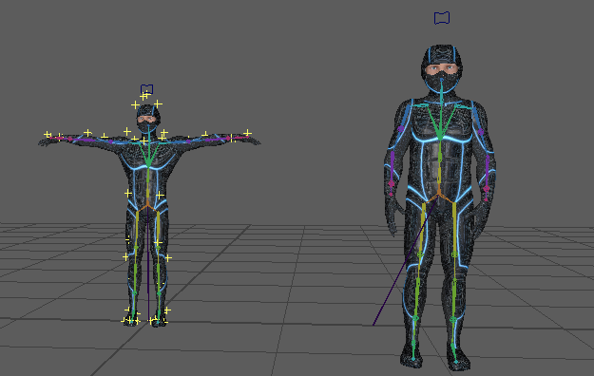

The final result on the QAvatar. The QAvatar is back at its original scale with its original skeleton structure. The data from the smaller performer is applied to it.

|  |  |
| --- | --- |
|  |  |

A comparison of the difference between using the built-in animation model pose (left) versus rebuilding the solver model pose from the original QAvatar (right). The difference in the shoulder construction is apparent, the structure differences of the hips and leg can also be seen.

## Solving to a Rigid Body Prop

Will show how to use the solver for solving a simple prop.

Using the sample data “DomiTake1” from the SIGGRAPH2019 dataset. In this capture there is a “stick” prop object as part of the capture. This quickstart outline will show how to turn the processing of the stick into a single segment solver definition.

1. Change the names of the markers for use with Maya and a markerset. Rename the stick markers “STICK_S1”, “STICK_S2”, etc….
2. Delete all the other marker names
3. Generate a new AIM definition. Call it “STICK”.
4. Remove the 6DOF definition of the stick.
5. Reprocess the move with the new STICK AIM model.
6. Export the data to an FBX file, be sure to export only marker data.
7. Load the FBX into Maya. You will see the marker data from the Stick as well as from the performer and another prop.
8. The first two markers of the stick aren’t actually used for the stick. So we’ll only work with the last 5 markers. Find a frame that makes it easy to see how the stick is to be held, I choose frame 123.
9. Select the 5 markers and use the python script “WashLocators” to make duplicates of those 5 markers at that frame. The new locators will be larger and brighter so they’re easy to see.
10. Create a joint that extends from the middle of the newly created markers down to where the hand of the performer is (this will be two Maya joints).
    1. Name them “TorchHandle” and “TorchHandle_end”
    2. Make sure the Joint Orient values are zero for both. You will have to rotate the TorchHandle joint back to the correct position after
    3. Make sure the translation offset for Torch Handle_end is only on the X axis. I chose an offset of 50.
    4. You will have to rotate the TorchHandle joint back to the correct position after these changes.
11. Once the TorchHandle joint has been positioned correctly, delete all the old locators (select the “Opticals” node and delete it).
12. Select the new locators and group them under a “Markers” group node
13. Select the Markers group node and the TorchHandle joint, group them under a node called “STICK”.
14. Change the names of the locators to remove the “New_STICK_” prefix.
15. Add marker attachments by:
    1. Select the TorchHandle joint
    2. Add the individual locators to the selection.
    3. Invoke the AddAttachments script to ad the attributes to the TorchHandle joint.
16. Add the DOFs to the TorchHandle:
    1. Select the TorchHandle joint and invoke the script AddDOFAttributes.
    2. Turn on the translation DOFs for the TorchHandle joint.
17. Save your Maya scene.
18. Export the XML
    1. Select the TorchHandle joint
    2. Invoke ExportSolver.py
19. Load the XML into QTM and re-solve
    1. Open the Reprocess interface
    2. Choose to “Apply the current AIM models”
    3. Make sure the STICK AIM model is loaded
    4. Choose “Solve Skeleton”
    5. In the Skeleton Solver options
       1. Remove the “m” skeleton solver
       2. Load the “STICK” skeleton solver
    6. Optionally, remove the STICK 6DOF rigid body

|  |  |
| --- | --- |
|  |  |

Before the label change (left) and after (right).

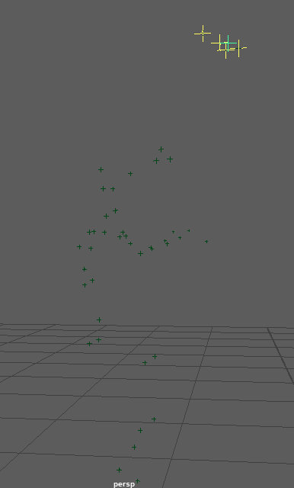

Above, after making the new locators by “Washing” the old ones.

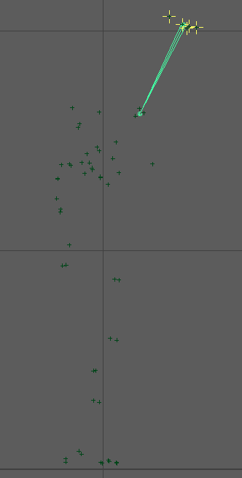

Using the Front Y orthographic view in Maya, draw the joints as in this image.

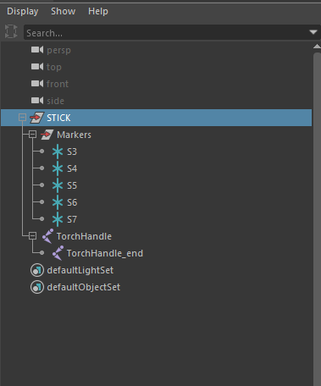

The scene hierarchy after deleting old locators, grouping the new ones and grouping the markers with the joints.

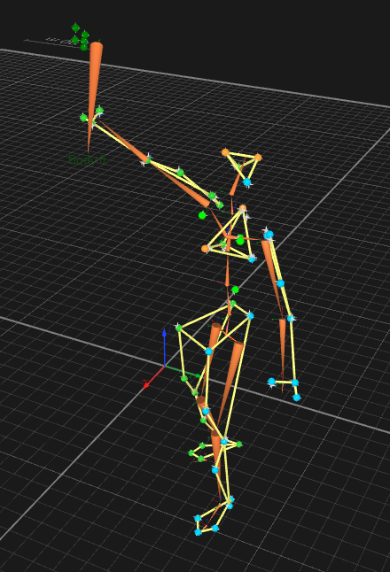

After retracking and re-solving with the STICK (torch) solver model.

## Solving to a Complex Prop with Multiple Segments

In this case a bow shooting an arrow.

## Solving to a User Defined Avatar

Show how to make a model pose from scratch using an avatar created outside of Qualisys. As always, be sure to save your Maya file periodically while going through the guide.

Using the QFL *Skeleton Solver Demo – Animation Marker Set.*  For obvious reasons the first step, Prepare the Model, must come first. But the next three 3 steps (Position the Avatar, Set the DOFS and Set the Marker Attachments) can go in any order and can be revisited as often as necessary to modify the settings.

1. Prepare the Model
   * Load the EliROM measurement
   * Export the Eli.XML file by using the “Save” option from the Reprocess->Skeleton Solver dialog:  
     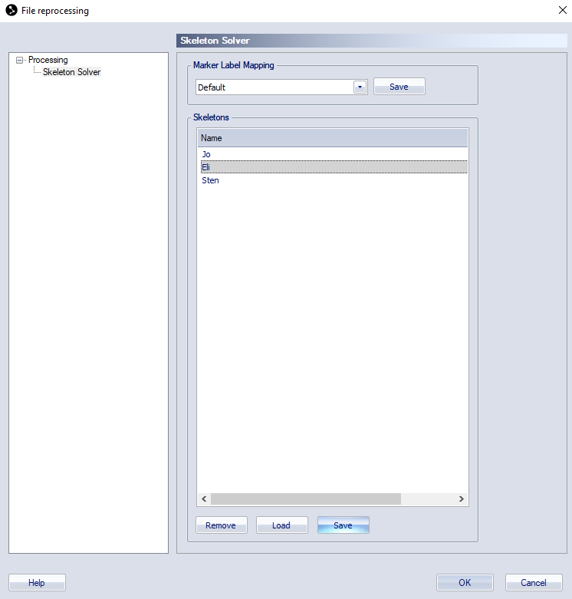
   * Load the XML file into Maya
   * Delete the skeleton by selecting “Hips” and hitting the delete button.
   * Import the Maya file of the Microsoft avatar “MaleAdult11.mb”  
     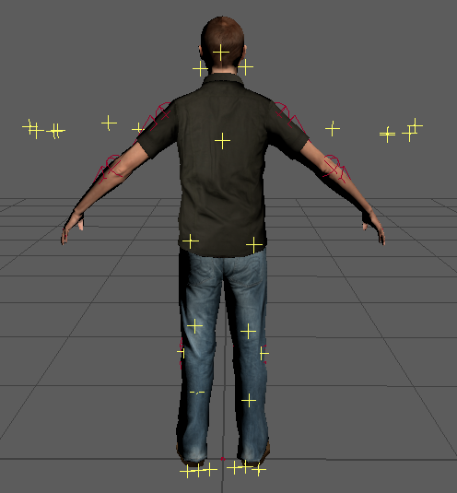
   * Rename the elements to remove any namespace or prefix that has been added to the imported nodes:  
     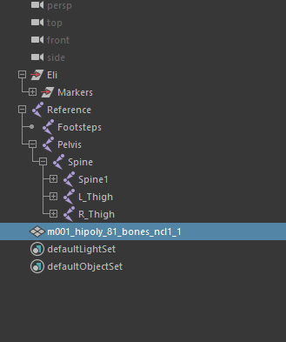
   * Remove any keys from the reference node and set all its values to zero so it is at the origin with no rotation.
   * Select the Pelvis and rotate, translate and scale the avatar to fit the markers. Here are the values for this character:  
     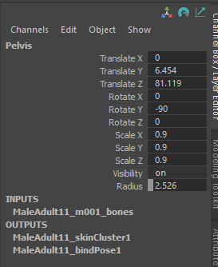
   * Parent the joint hierarch to the “Eli” group node
     + Select the “Reference” node.
     + Control select the “Eli” node
     + Hit “P” (or use the menu command) to make the Reference node a child of Eli.  
       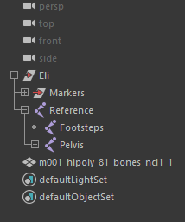
2. Position the Model
   * Now rotate the joints into place so that the avatar matches the position of the markers:  
     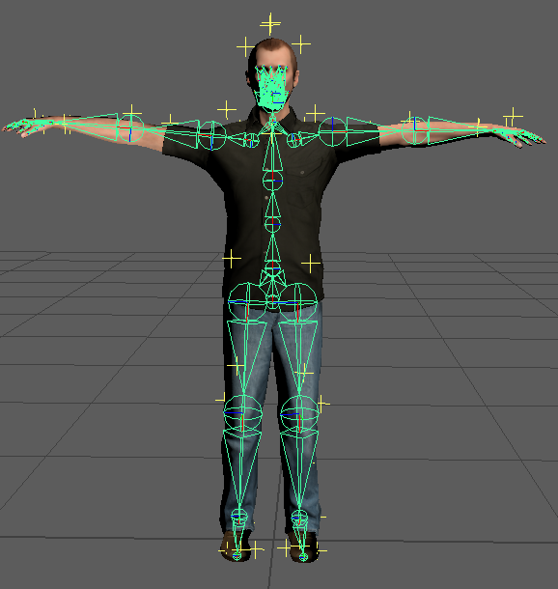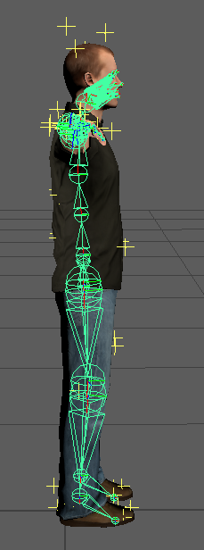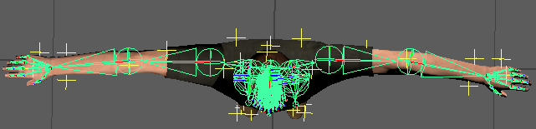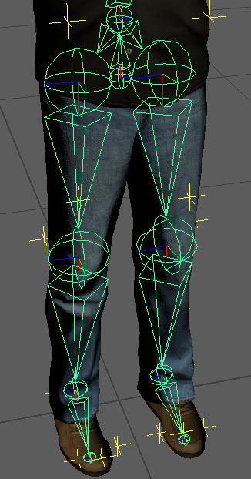
   * Select the Pelvis node and use Maya->Select->Select Hierarchy to select all of the joints.
   * Invoke the python scrip “AddDOFAttributes.py”
   * Edit the DOF attribute flags for all the joints:
     + Add all three translations DOFs to the Pelvis.
     + Turn off all DOFS for the fingers
   * Add an extra node to the toes (to give them length when viewed in QTM). The head and hands have many child nodes so there is no need to add an extra node, but if your avatar has no fingers then also had a child node).
     + Select the toe
     + Duplicate it
     + Make the new node a child of the toe
     + Rename the child node something like “Toe_end”, the name doesn’t matter.
       - After reparenting it’s possible that a transform node was added. This is fine, just delete the new node and rename the transform node.
       - Offset the new node to give the parent some length. It’s best to zero out rotations and joint orient values.  
         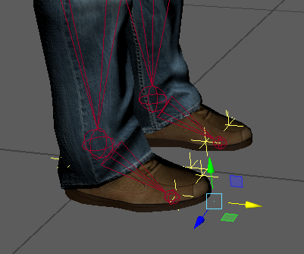 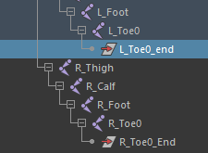
3. Set the Marker Attachments
   * For each segment with a DOF
     + Select the segment
     + Shift select in the 3D window (or control select in the outliner) the markers to be attached to the segment
     + Invoke the “AddAttachment.py” script to add the selected markers to the segment.
     + It’s good to practice doing this for the character so you know which attachments are going to which segments.
   * As an alternative to the above step, a MEL script called “AttachAnimToMSAvatar.mel” is provided to apply all the marker attachments. This can be used only with this combination of markers (the animation markerset) and skeleton (the MS Avatar). If you have a different set of markers or skeleton you will have to do the attachments manually the first time. It’s worth the time to copy the MEL commands for this into a script for the next time you set up a character with this skeleton/marker combination.
4. The model definition is complete. Export and solve the new definition.
   * Select the Pelvis node
   * Invoke the “QExportSolver.py” script. Select a file to export to.
   * Load the file in QTM
     + Select Reprocess
     + Turn off everything except “Solve Skeletons”
     + Select “Skeleton Solver” in the outliner
     + Select “Load”
     + Load the XML file
     + When you select “OK” the skeleton will be re-solved.  
       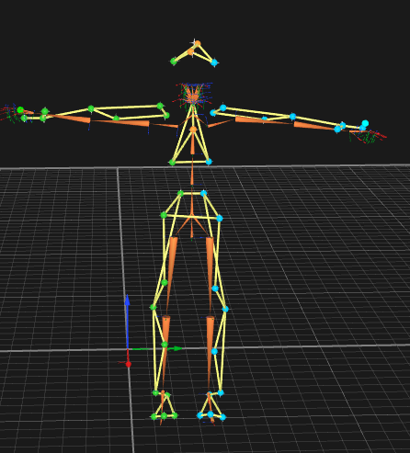
5. Making Adjustments. The solve will be pretty good, but there are some trouble spots. The neck moves too much and the clavicles might not be right. Here are some adjustments to make in Maya to address these issues:
   * On the Neck joint, set the two head marker weights to a small value: 0.1.
   * On the Clavicles
     + turn off the X rotation DOF.
     + Set the marker weights to 5 each.
   * On the hands
     + Turn off the X rotation DOF.
   * On the Toes
     + Turn off the X and Y rotation DOFS (leaving only Z)
     + Set the weight of the toe marker to 5

## Solving to a User Defined Avatar with Fingers

Same as above, but with fingers.

# Notes

## Maya Scene Construction

The Maya python scripts support a very specific Maya scene construction, other elements can be present, but with restrictions. The export script has been updated to allow for the presence of other scene elements, but there must be a model pose construction that obeys the following:

* Root node must be a group node whose name is the same as the markerset prefix in QTM. For example, “AH” would match the markers. Sometimes called the “Name Node”.
* A child of the root node must be a group node called “Markers”. This node contains all the markers as locators.
* All the locators are globally located. They’re still children of the Markers node, which in turn is a child of the root node, but those nodes have no transforms. The global position is stored in each locator.
* The root of the skeleton is a child of the name node. The name can be anything. Or it can be a grandchild of the root, just as long as there are nodes of “joint” type above it until it gets up to the root (or “Name”) node of the hierarchy.
* Some characters have a reference node, some do not. The reference node is not driven by mocap data. It must not be used to scale/position the character for the model pose. All such adjustments must be made on the root of the character, usually the Hips or Pelvis joint. This is the joint that must be selected when exporting the solver information.
* There MUST be NO name clashes. No marker can have the same name as any joint.
* Information for the model pose is stored in the joint nodes in Maya:
  + Each marker attachment is defined as a floating point user attribute. The value is the marker weight. The existence of the attribute indicates an attachment.
  + Every joint is assumed to have all the DOF flags. These are Booleans that indicate the use of each DoF.
  + The Rotational DoFs have lower and upper bound attributes. These are floats expressed as degrees in Maya but get turned into radians for the XML file.
  + The Maya “Preferred Angle” attribute is used for the “Default Transform” in the XML file. In Maya the Preferred Angle is used by the IK system, but otherwise has no effect on the joint.
* Except for the root, the “Joint Orient” value MUST be set to zeros.
* Careful attention should be made to the orientation of joints.
* Careful attention should be made to the offsets of children, this is what determines the “length” or “direction” of segments.
* At leaf nodes an “_end” joint must be added. This is required to specify the length of the segment (mostly for display purposes in QTM).