09/07/2007
1 | UNIQUE_KEY | Unique Identifier created as combination of INVENTORY_KEY & SIZE_INDEX
2 | PRODUCT_TITLE | Includes Manufacturer’s name
3 | PRODUCT_DESCRIPTION | Description of product features
4 | STYLE# | Mill style # same as style number used in catalogs
5 | AVAILABLE_SIZES | Sizes available
6 | BRAND_LOGO_IMAGE | File name of Brand image such as Port Authority or Ping
7 | THUMBNAIL_IMAGE | File name of Small image for Lifestyle-Model picture
8 | COLOR_SWATCH_IMAGE | File name of Colors available image for colors available in a style.
9 | PRODUCT_IMAGE | File name of Lifestyle-Model picture jpg for web sites
10 | SPEC_SHEET PDF | PDF or Word document listing specifications.
11 | PRICE_TEXT | How price applies such as Price applies to…..
12 | SUGGESTED_PRICE | Recommended retail
13 | CATEGORY_NAME | Major categories such as Tee Shirts, Knit Shirts, Woven’s
14 | SUBCATEGORY_NAME | Such as 100% Cotton Tee or Crewneck Sweatshirts or Camp Shirts
15 | COLOR_NAME | Name of color
16 | COLOR_SQUARE_IMAGE | File name of Image which creates the square in a color swatch.
17 | COLOR_PRODUCT_IMAGE | File name of Regular (usually folded) image
18 | COLOR_PRODUCT_IMAGE_THUMBNAIL | File name of Small picture of (usually folded) items
19 | SIZE | Size of item
20 | QTY | Quantity available as of this download – all warehouses combined
21 | PIECE_WEIGHT | Approximate Weight Per Piece – lbs./piece – Final weight determined at shipping.
22 | PIECE_PRICE | Price Per Piece based upon a purchase of 05 pieces or less of a single style & Color
23 | DOZENS_PRICE | Price Per Piece based upon a purchase of 6 pieces or more of a single style & color
24 | CASE_PRICE | Price per piece based upon Case Purchase by Size / Color / Style
25 | PRICE_GROUP | Pricing Group for white pricing group, lights pricing group, darks pricing group, etc.
26 | CASE_SIZE | Total # of pieces of a single style /color/ size per case
27 | INVENTORY_KEY | SanMar Proprietary Inventory Key
27 | SIZE_INDEX | 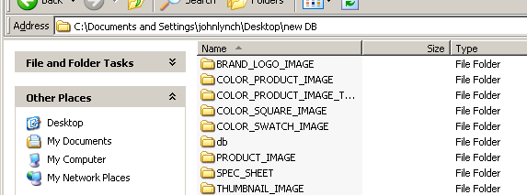  Size category number for each size grouping
28 | SANMAR_MAINFRAME_COLOR | Color name as it exists in SanMar Mainframe – may be different from catalog color. Order submission with colors must use this color
Folder Names for images
Fields 6, 8, 9, 16, 17, 18

Field 10 has its own folder

Data (CSV files) is in the DB folder.

