PrecisionPOP
Product Walkthrough

UX Evaluation Guide for v2 Redesign Planning

Test Account: Good 2 Go Store #119
Idaho Falls, ID

December 2024

1. Introduction
This document provides a guided walkthrough of the PrecisionPOP platform from the perspective of a store manager at Good 2 Go Store #119 in Idaho Falls, Idaho. The walkthrough is designed to evaluate the current user experience and identify opportunities for improvement in the v2 redesign.
Each section explores a different area of the platform, with evaluation questions highlighted in red italics to guide the UX assessment process.

Test Account Details
Store: Good 2 Go #119
Location: 250 S 45th East, Idaho Falls, ID 83401
Phone: (208)-535-5931

2. First Impressions: The Store Dashboard
Upon logging in, users land on the Store Profile page with the Exterior tab active. This page establishes the store's identity within the system and provides access to key information panels.
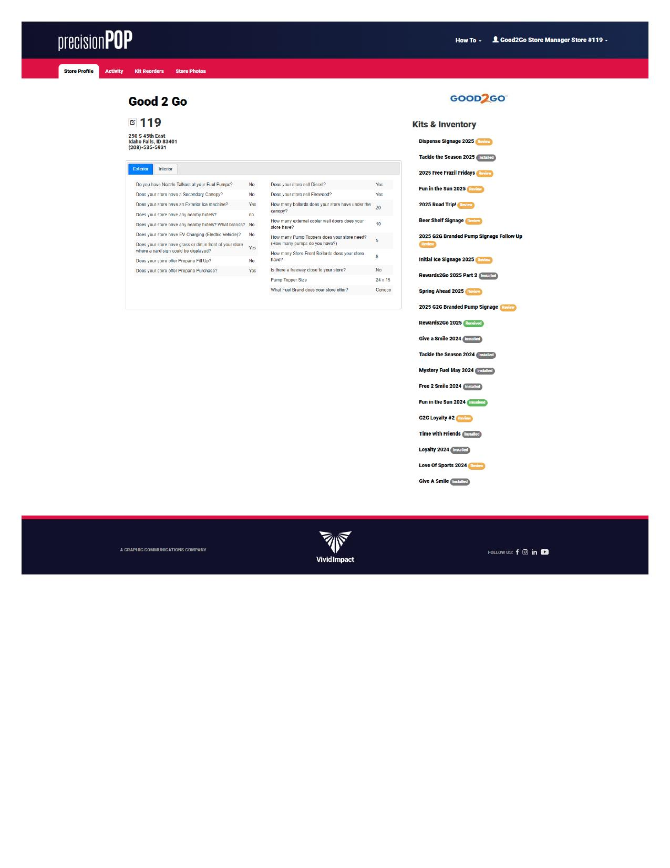
Dashboard - Exterior Tab showing store attributes and Kits panel

What We See
The dashboard displays the store name, number (#119), address, and phone number. A Good 2 Go logo appears in the right panel. The Kits & Inventory sidebar shows 25 promotional kits with color-coded status badges.

Evaluation Questions
• Does the layout effectively communicate the store's identity?
• Is the Kits & Inventory sidebar discoverable and scannable?
• What actions might a store manager want to take from this view?

3. Understanding Your Store: The Interior Tab
Clicking the Interior tab reveals the store survey system—over 50 questions capturing physical store attributes that drive promotional planning decisions.
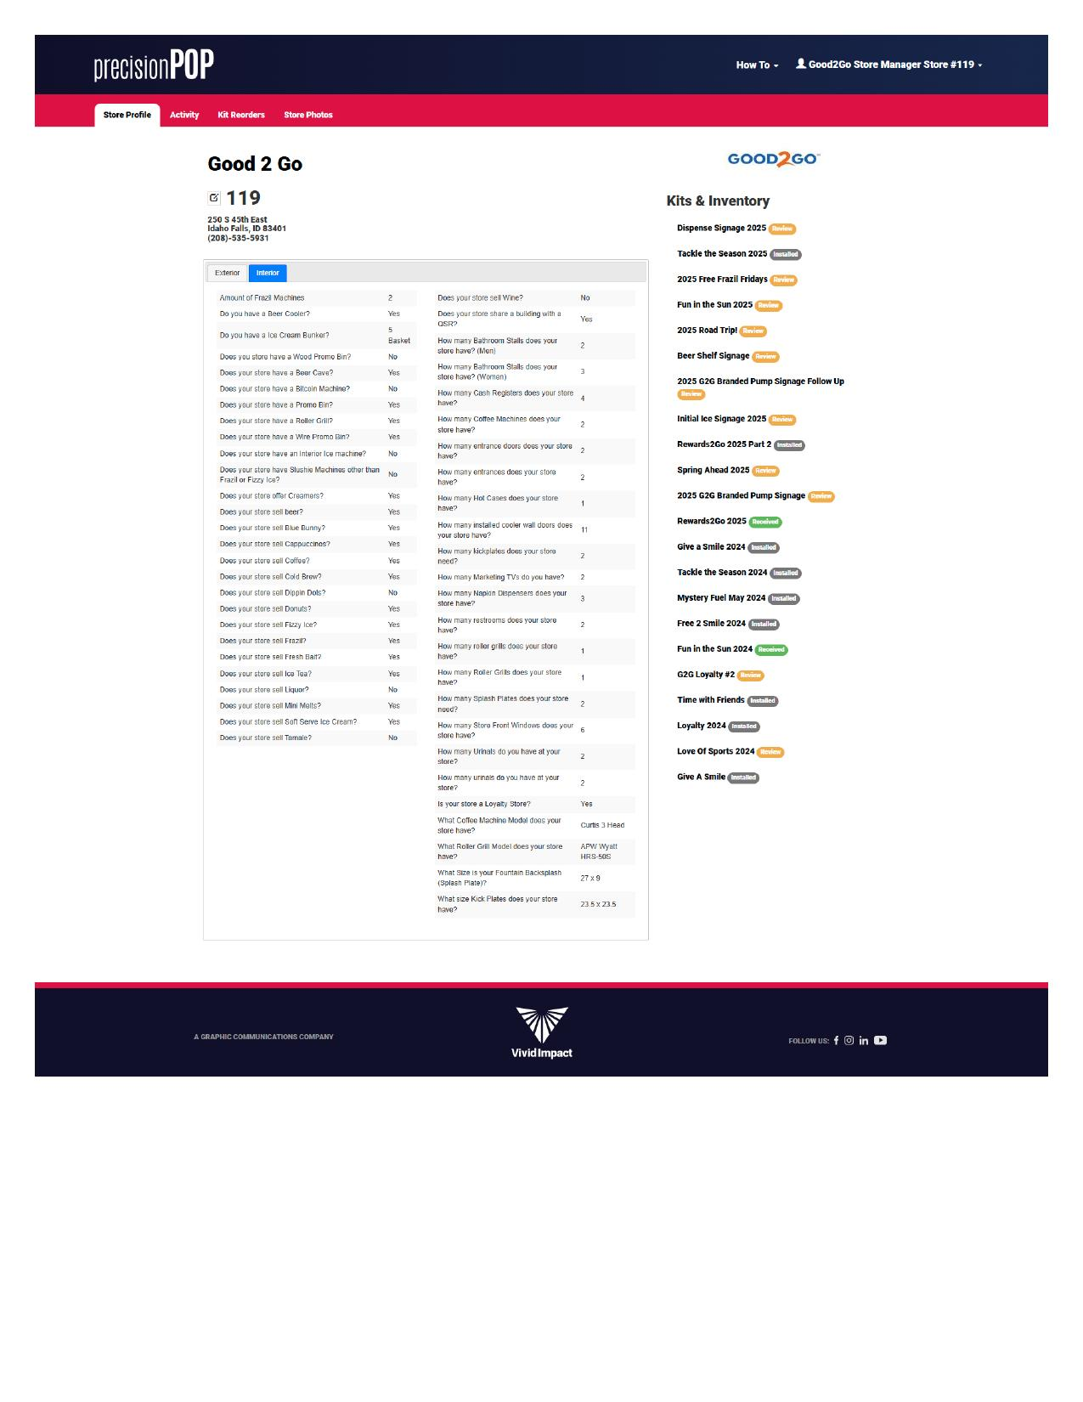
Dashboard - Interior Tab showing 50+ survey questions

Survey Categories
Questions cover: Store type and environment, Equipment presence (coolers, dispensers, ATMs), Service offerings (car wash, food service), Display capabilities and traffic patterns.

Evaluation Questions
• Is the survey format approachable or overwhelming?
• How might users understand the purpose of each question?
• What feedback mechanisms exist for incorrect or outdated data?

4. Tracking Changes: The Activity Log
The Activity tab provides a chronological record of all changes made to the store profile and kit statuses.
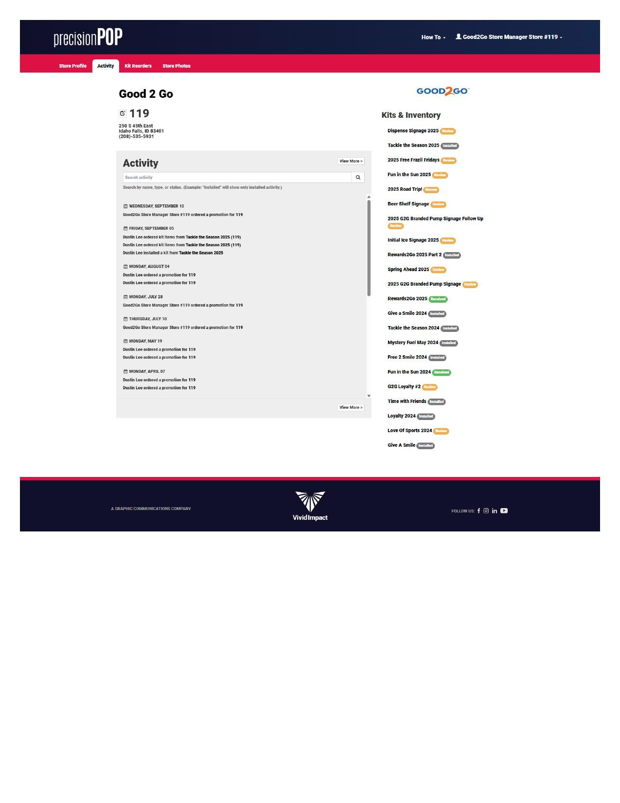
Activity view showing recent changes with Kits sidebar

Activity Types Tracked
The system logs: Kit status updates (received, installed, review requested), Store profile modifications, User actions and timestamps.
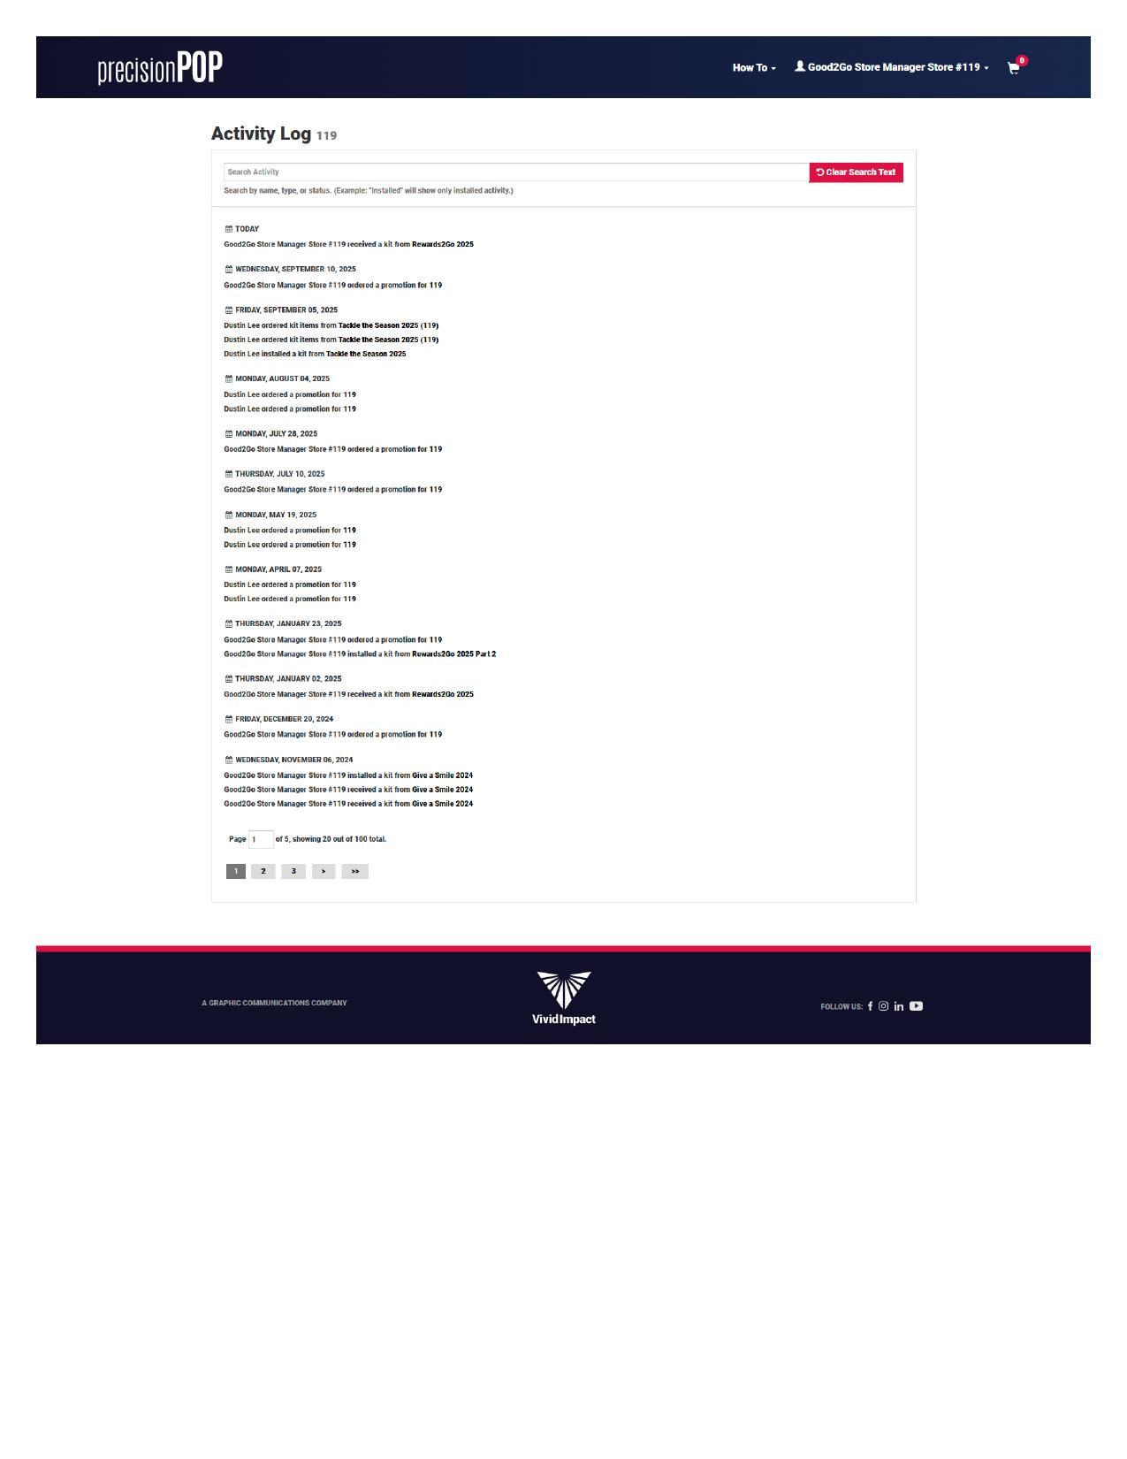
Full activity log with pagination (100 entries across 5 pages)

Evaluation Questions
• Is the activity log useful for accountability and troubleshooting?
• Can users easily filter or search for specific events?
• Does pagination support efficient review of historical data?

5. Managing Promotional Kits: Inventory Deep Dive
The Kits & Inventory system is the heart of PrecisionPOP, allowing store managers to track promotional materials from production through installation.

Kit List View
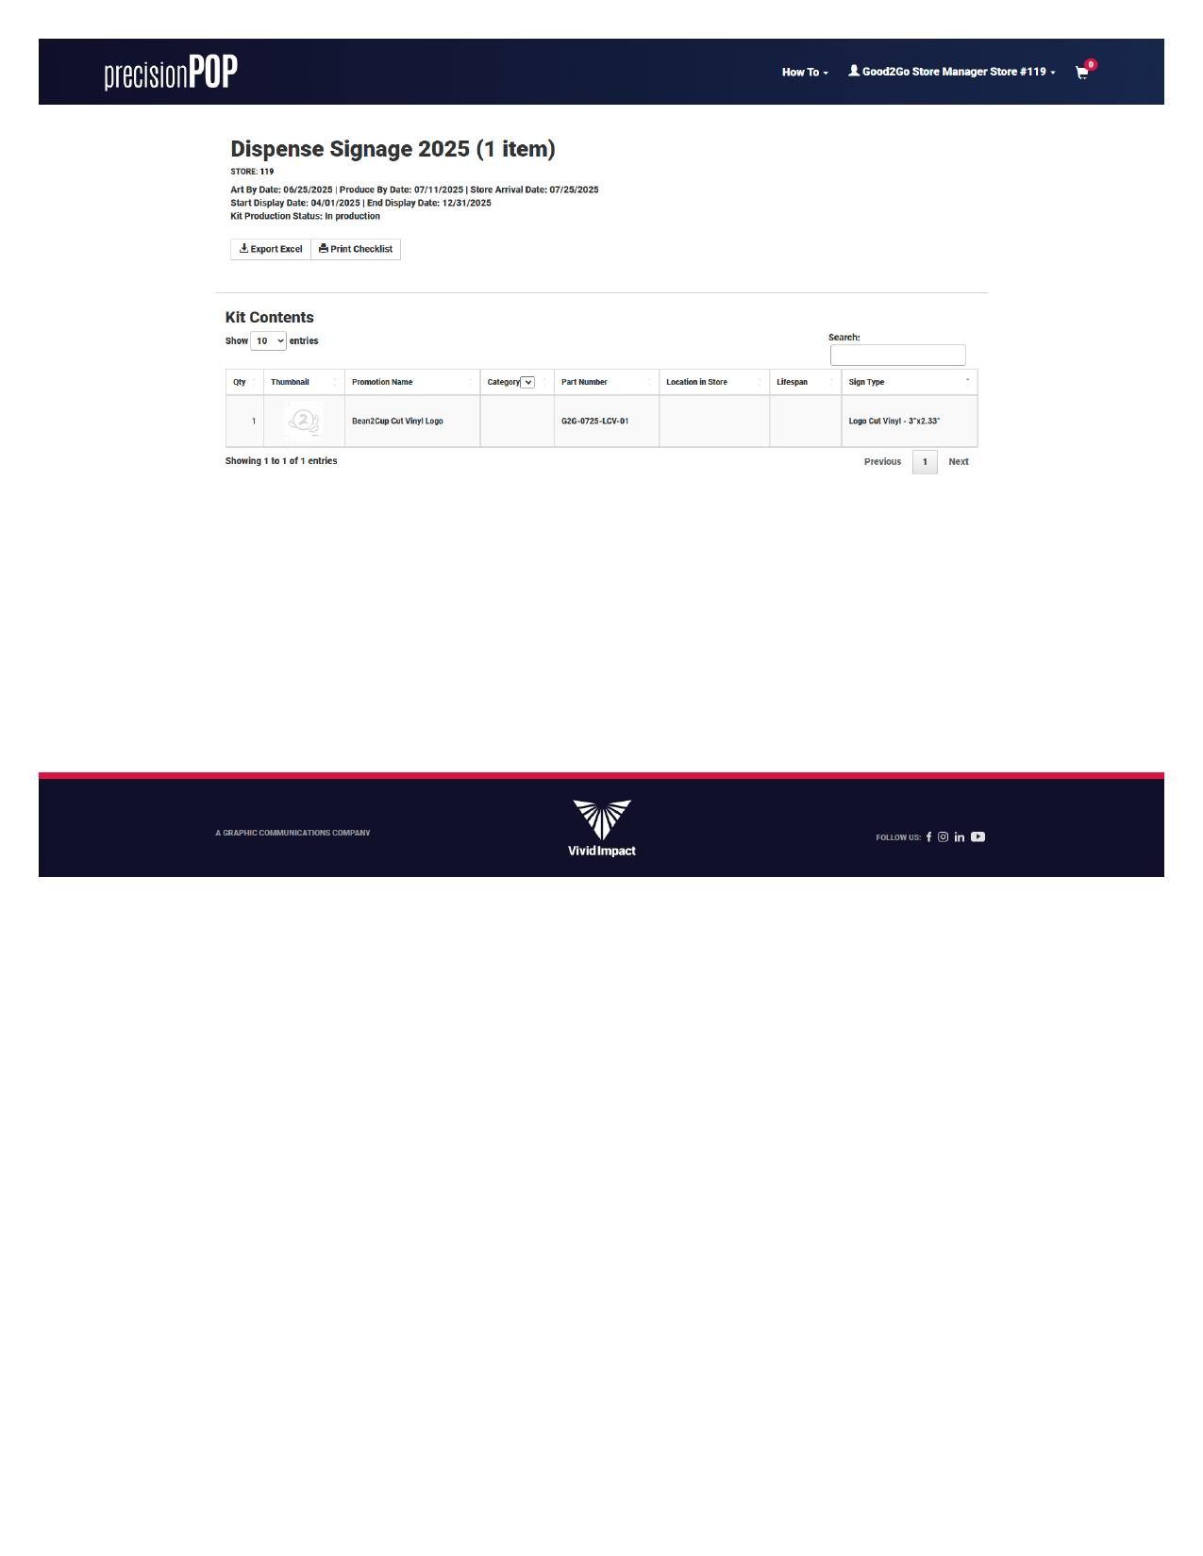
Kits & Inventory - Single item kit view
Each kit entry shows: Kit name, Store number, Production dates, Status badge (Review, Installed, Received, Pending).

Large Kit Management
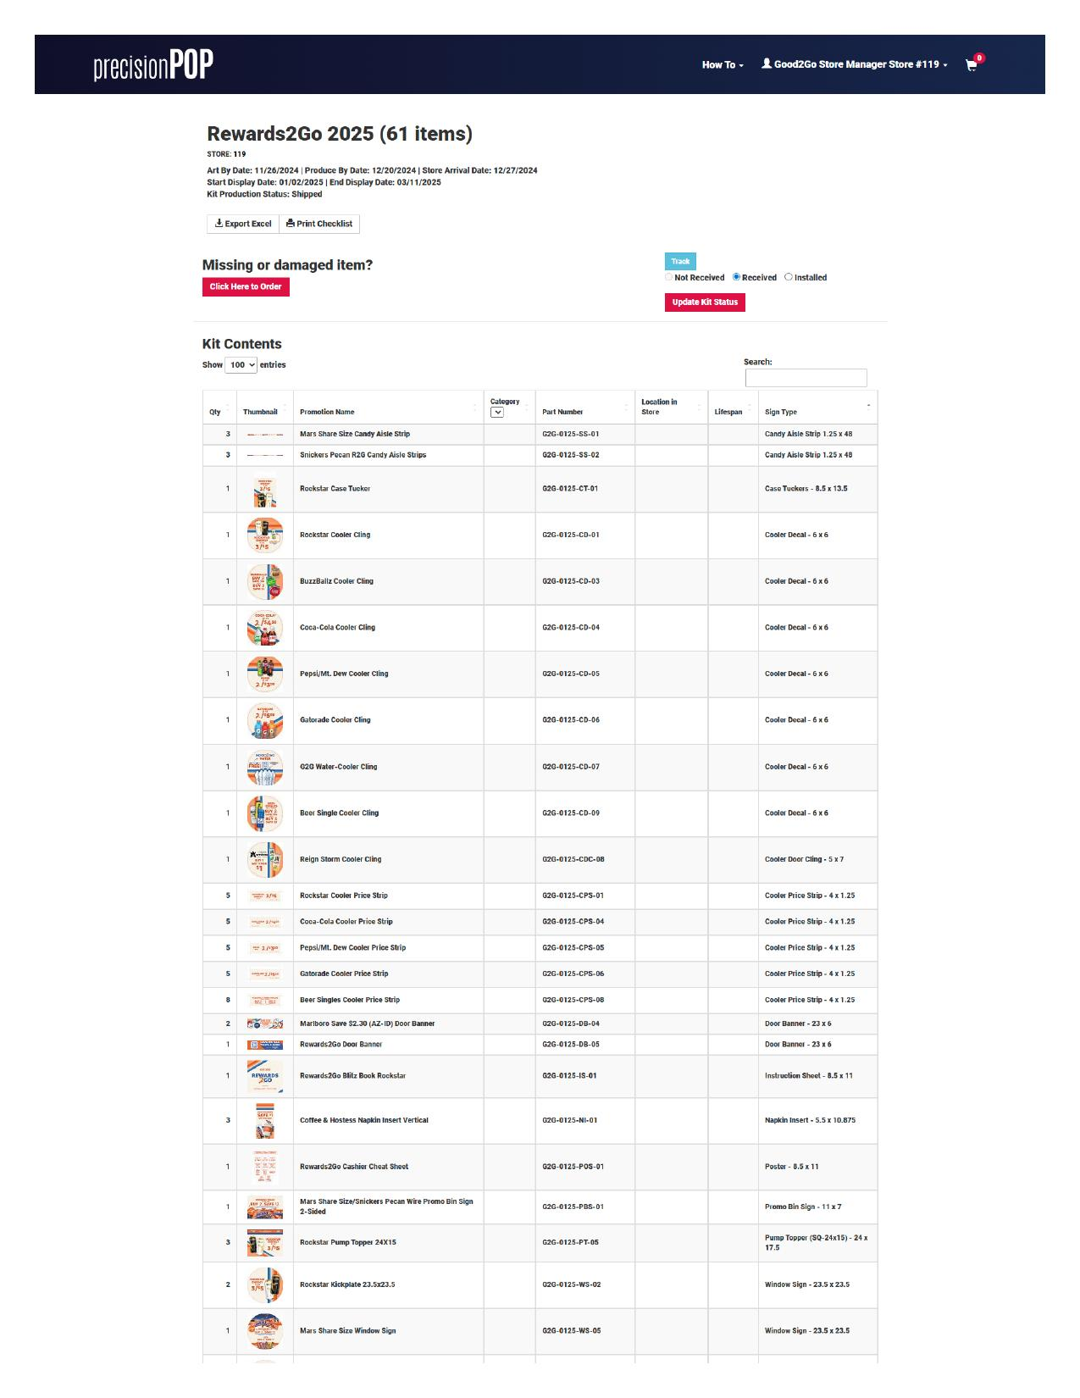
Kits & Inventory - Large list view (61 items)
Larger kits like 'Rewards2Go 2025 (61 items)' present unique challenges. The interface must help users navigate extensive inventories while maintaining context.

Image Preview Feature
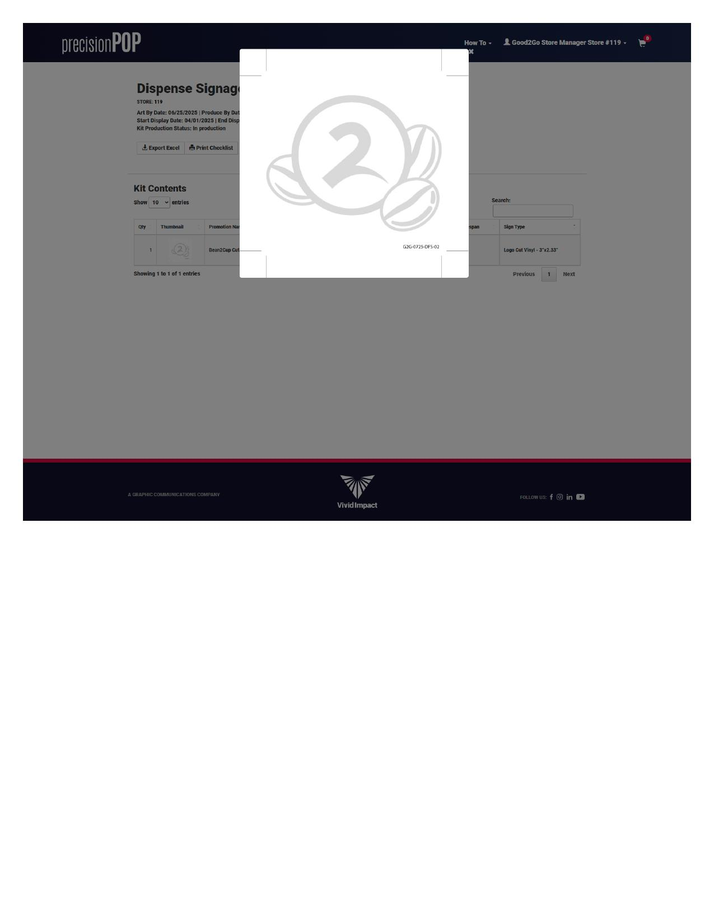
Kits & Inventory - Image preview modal
Clicking thumbnails opens a larger preview, helping users identify signage items visually.

Evaluation Questions
• Does the kit list provide adequate filtering and sorting options?
• How well does the interface scale from 1-item to 61-item kits?
• Is the thumbnail preview helpful for item identification?

6. Handling Issues: Kit Reorders
When items are missing or damaged, the Kit Reorders section provides the workflow for requesting replacements.

Reorder History
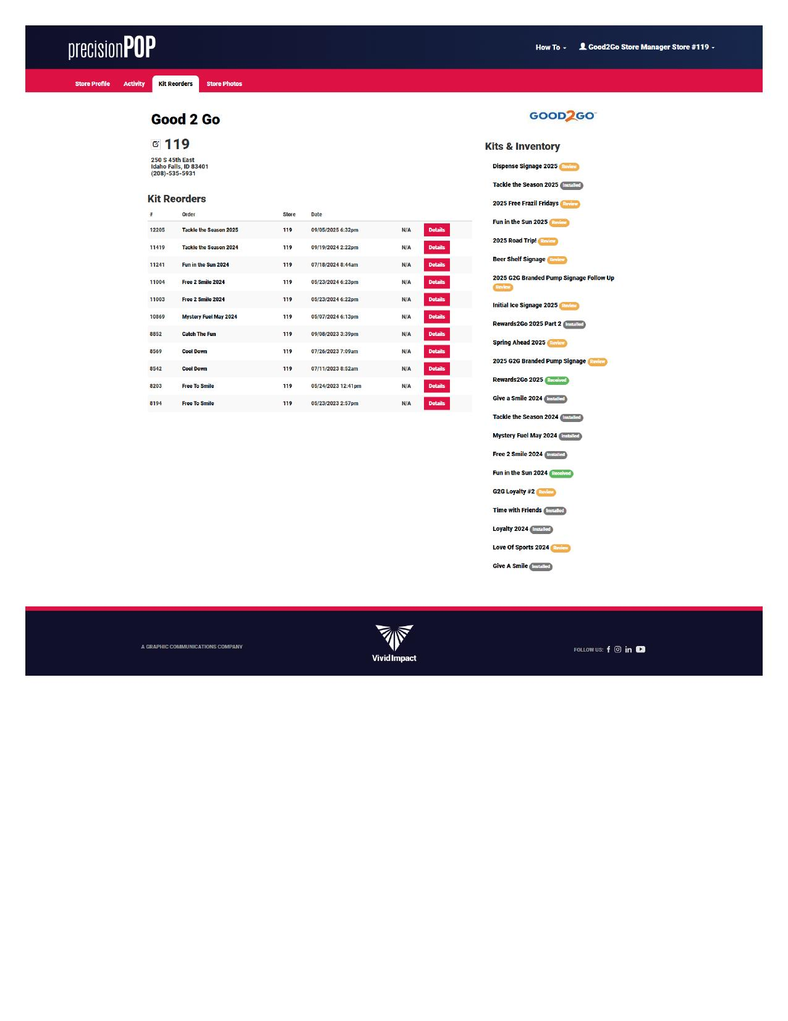
Kit Reorders - Historical reorder list
The reorder list shows: Order ID and kit name, Store number, Date and time of request, Details link for each reorder.

Missing or Damaged Item Workflow
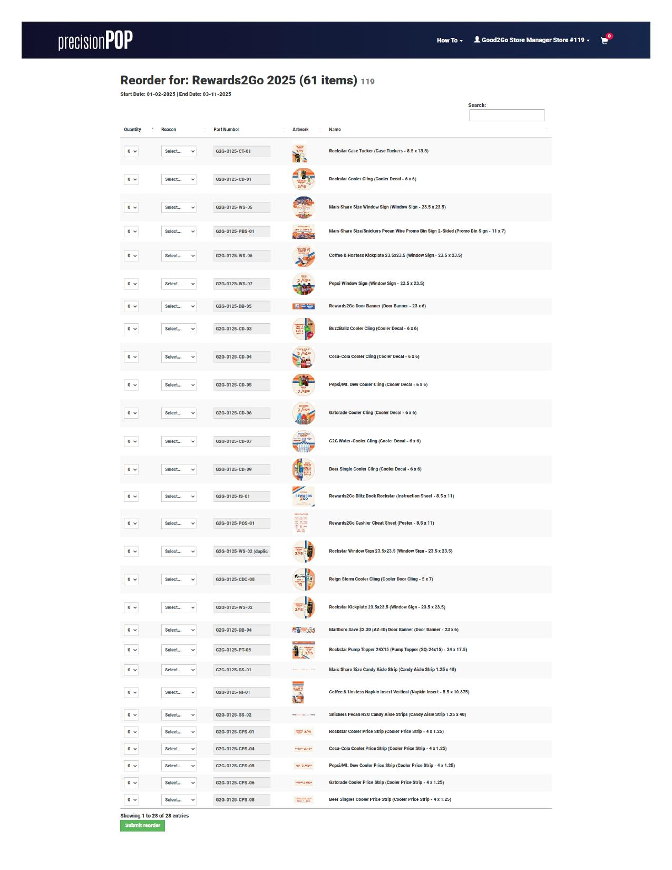
Missing or Damaged Item - Reorder form
The 'Click Here to Order' button leads to a reorder form where users can: Select quantity and reason for each item, Review artwork thumbnails, Submit the complete reorder request.

Evaluation Questions
• Is the reorder process discoverable from the kit detail page?
• Does the form capture sufficient information for fulfillment?
• How might users track the status of their reorder requests?

7. Visual Documentation: Store Photos
The Store Photos section allows managers to upload images documenting their store's promotional displays.
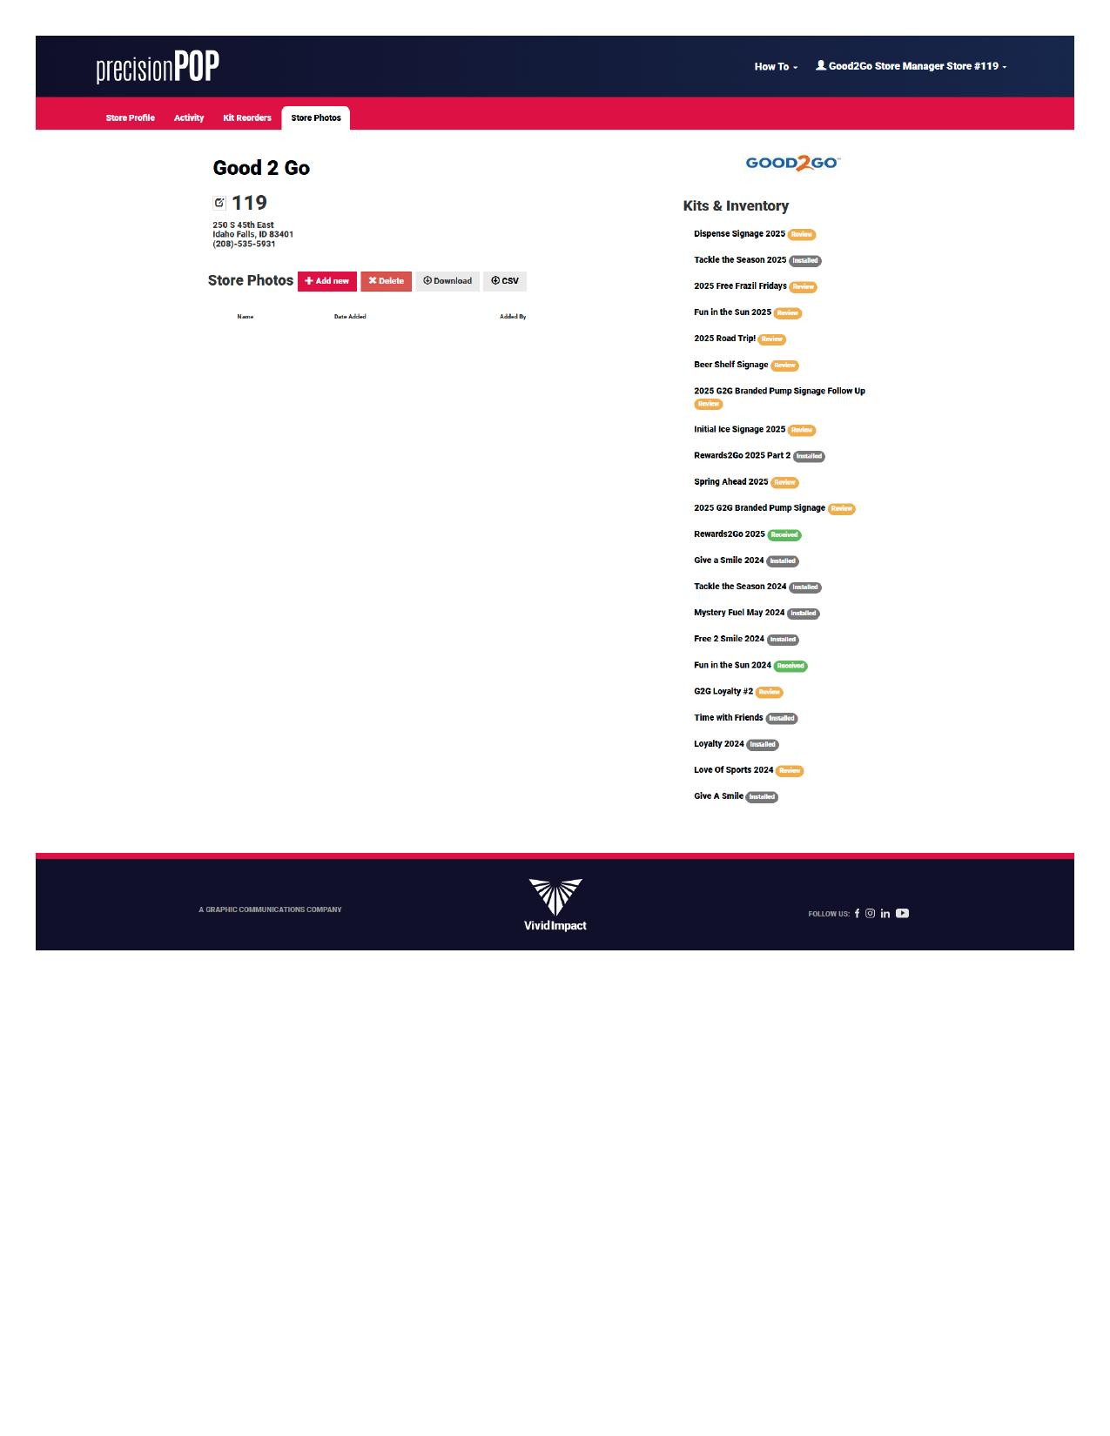
Store Photos - Upload interface

Photo Management Features
The interface provides: Add new photo button, Delete selected photos, Download functionality, CSV export option. Photos are organized by name, date added, and who added them.

Evaluation Questions
• What photo categories or purposes would be most valuable?
• How might photos integrate with kit installation verification?
• Is the current empty state providing adequate guidance?

8. Getting Help: How-To Videos
The How To dropdown in the header provides access to tutorial videos that explain platform features.
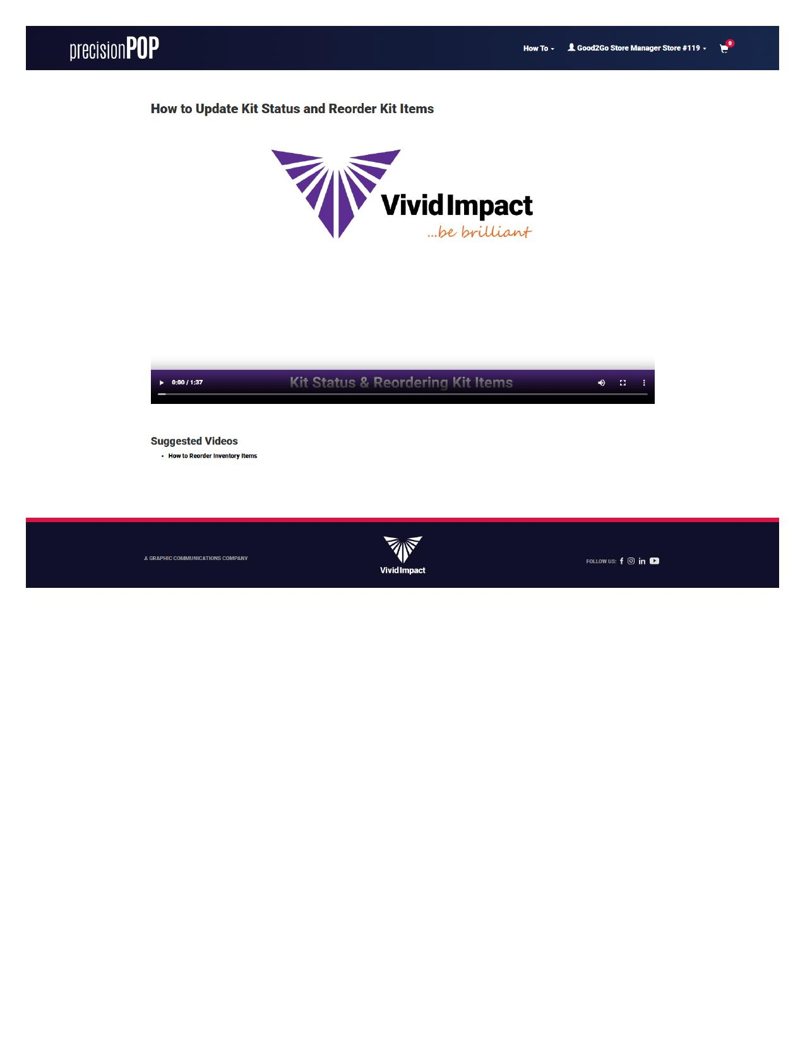
How-To Videos page showing available training content

Available Resources
Current tutorials include: Kit status update walkthrough (1:37), Additional training videos. Videos are embedded directly in the platform for easy access.

Evaluation Questions
• Are the video topics aligned with common user questions?
• What additional training content would be most valuable?
• How discoverable is the help system for new users?

9. Behind the Scenes: Account & Cart
Account settings and the promotion cart round out the platform's functionality.

Account Profile
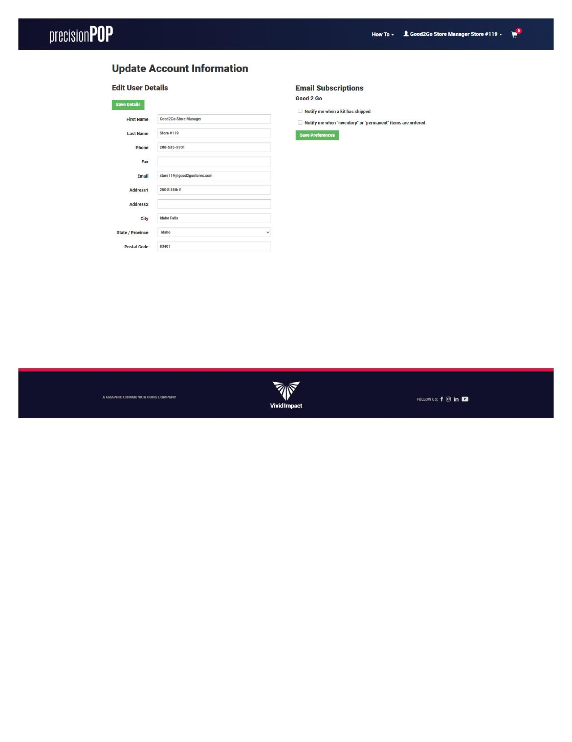
Account Profile with email notification subscriptions
The account page shows: User details (Good2Go Store Manager Store #119), Email subscriptions for new kits and store profile updates, Role and permissions information.

Promotion Cart
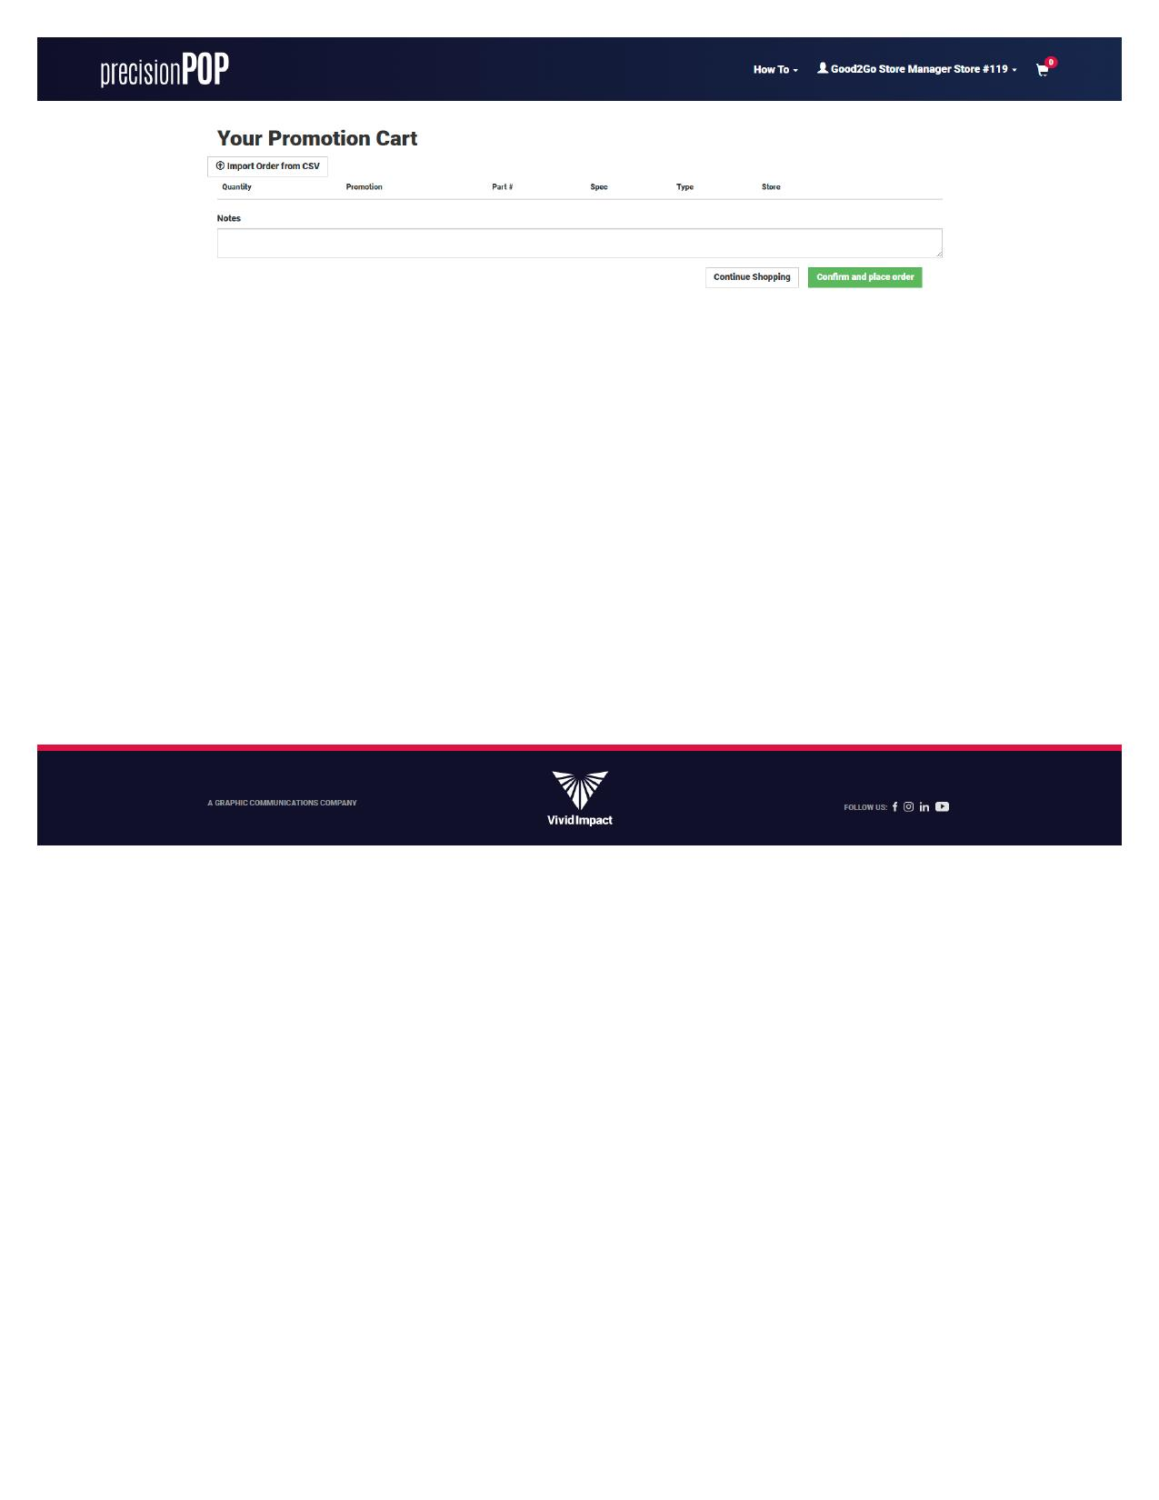
Empty Promotion Cart with CSV import option
The cart supports: Individual item additions, Bulk CSV import for large orders, Order review and checkout.

Evaluation Questions
• Are email subscription options appropriately granular?
• How might the cart experience be improved for bulk operations?
• What account self-service features would users value?

10. Privacy and Compliance
The Privacy Policy link in the footer leads to comprehensive data handling documentation.
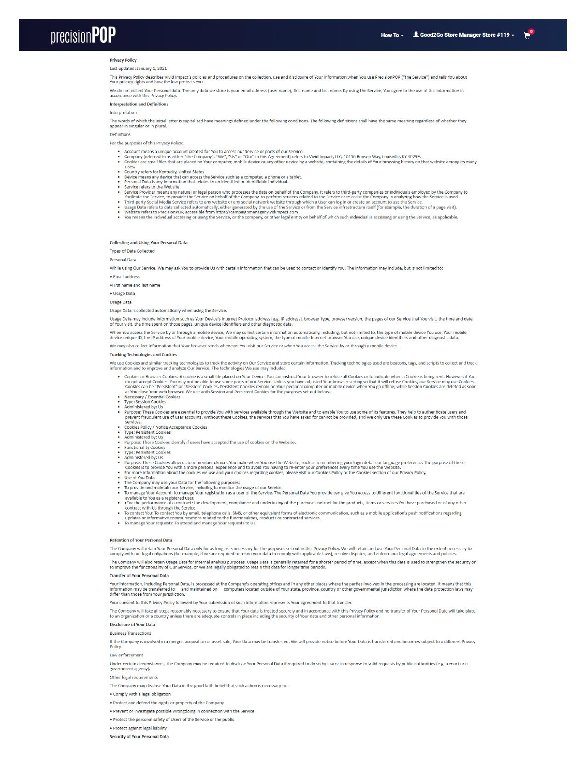
Privacy Policy page (partial view)

Policy Coverage
The policy addresses: Data collection and usage, Cookie technologies, User rights and choices, Contact information for privacy inquiries. Last updated January 1, 2021—Vivid Impact manages the policy.

Evaluation Questions
• Is the privacy policy easily accessible throughout the platform?
• Does the policy adequately address user concerns about data usage?
• Should policy update dates be more prominently displayed?

11. Walkthrough Summary
This walkthrough has explored the complete PrecisionPOP experience from the perspective of a Good 2 Go store manager. Key areas for v2 redesign consideration include:

Information Architecture
Navigation between Store Profile, Activity, Kit Reorders, and Store Photos tabs. Relationship between the main content area and Kits & Inventory sidebar. Discoverability of help resources and account settings.

Core Workflows
Kit receipt and installation status updates. Missing/damaged item reorder process. Store attribute survey completion. Photo documentation and management.

Data Visualization
Kit status badges and color coding. Activity log pagination and filtering. Large inventory list management (61+ items).

This document serves as a foundation for UX discussions and should be referenced alongside the detailed audit markdown files for each section.

Appendix. Screenshot Reference
All screenshots captured from PrecisionPOP platform using Good 2 Go Store #119 test account.

# | Screenshot | Section
1 | Dashboard - Exterior Tab | 2. First Impressions
2 | Dashboard - Interior Tab | 3. Understanding Your Store
3 | Activity View | 4. Tracking Changes
4 | Activity - Full Log | 4. Tracking Changes
5 | Kits & Inventory - Single Item | 5. Managing Kits
6 | Kits & Inventory - Large List (61 items) | 5. Managing Kits
7 | Kits & Inventory - Image Preview | 5. Managing Kits
8 | Kit Reorders - History | 6. Kit Reorders
9 | Missing/Damaged Item - Reorder Form | 6. Kit Reorders
10 | Store Photos | 7. Visual Documentation
11 | How-To Videos | 8. Getting Help
12 | Account Profile | 9. Account & Cart
13 | Promotion Cart | 9. Account & Cart
14 | Privacy Policy | 10. Privacy & Compliance

