Using AI (Claude) to Plan, Draft, and Refine a Student Article
Final Assessment Submission
Name | Gouravam Viswa Datta Reddy
Register Number | 99230040557
Email ID | 99230040557@klu.ac.in
AI Interface Used | Claude (Anthropic) — Chat Interface

Scenario and Goal
For this assessment, I used Claude as a writing assistant to turn a set of raw notes on "Artificial Intelligence in Education" into a polished, student-friendly article of no more than 500 words.
The goal was to demonstrate a structured, three-step workflow with an AI tool: first planning and outlining the content, then drafting the full article, and finally critiquing and refining the draft before producing a final version. Each step below shows the exact prompt I gave Claude and the response it generated.

Step 1 — Structuring & Planning
Prompt 1:
Act as an expert educational content writer. I am going to give you raw notes about Artificial Intelligence in Education. Your task: Extract the main points from these notes and create a structured outline for a 500-word student-friendly article. [Insert the notes below] Artificial intelligence is increasingly being used in education. It can provide personalized learning based on a student's performance. AI tools can help teachers create content, quizzes and learning materials. Chatbots can answer common student questions. AI can also help identify students who may need additional support. However, AI can produce incorrect information. Students may become too dependent on AI instead of thinking independently. Privacy is another concern because educational systems may collect student data. Teachers still need to supervise the use of AI. The future of AI in education will likely involve AI working together with teachers rather than completely replacing them.
Claude Response 1:
Here's a structured outline for your 500-word article:
Title Suggestion
"AI in Education: A Helpful Tool, Not a Replacement"
I. Introduction (~60 words)
- Hook: AI is becoming a common part of the classroom experience
- Brief framing: AI offers real benefits but also raises real concerns
- Thesis: AI works best as a support tool alongside teachers, not a replacement for them
II. How AI Helps Students and Teachers (~150 words)
- A. Personalized Learning — Adapts to each student's performance and pace; helps students learn at a level suited to them
- B. Support for Teachers — Assists in creating content, quizzes, and learning materials; saves teachers time on repetitive tasks
- C. Instant Help via Chatbots — Answers common student questions quickly; available outside class hours
- D. Identifying Students Who Need Support — Flags patterns showing a student may be struggling; allows teachers to step in earlier
III. The Risks and Challenges (~150 words)
- A. Accuracy Issues — AI can produce incorrect or misleading information; students need to verify AI-generated answers
- B. Over-Dependence — Risk of relying on AI instead of building independent thinking skills; critical thinking still needs to be practiced
- C. Privacy Concerns — Educational AI tools often collect student data; raises questions about how that data is stored and used
- D. Need for Teacher Oversight — AI should be supervised, not left unchecked; teachers play a key role in guiding proper use
IV. Looking Ahead: AI + Teachers, Not AI vs. Teachers (~100 words)
- Future points toward collaboration, not replacement
- AI as an assistant that enhances the human side of teaching
- Teachers bring judgment, empathy, and context AI cannot replicate
V. Conclusion (~40 words)
- Recap: AI offers powerful tools for personalization and efficiency
- But success depends on balancing innovation with caution and human guidance

Step 2 — Drafting
Prompt 2:
Excellent. Now, using only the outline you just generated, write the first draft of the article. Constraints: ● Keep the language simple and student-friendly. ● Use clear headings. ● Do not exceed 500 words. ● Include both benefits and challenges. ● End with a short conclusion.
Claude Response 2:
AI in Education: A Helpful Tool, Not a Replacement
Artificial intelligence (AI) is showing up more and more in classrooms and online learning. From personalized lessons to instant homework help, AI is changing the way students learn and teachers teach. But like any powerful tool, it comes with both benefits and challenges. Understanding both sides can help students use AI wisely.
How AI Helps Students and Teachers
Personalized Learning
One of AI's biggest strengths is its ability to adapt to each student. By looking at how a student is performing, AI can adjust lessons to match their pace and skill level, helping them learn more effectively.
Support for Teachers
AI also makes life easier for teachers. It can help create quizzes, lesson materials, and other content, freeing up time that teachers can spend directly helping students.
Instant Help via Chatbots
Many schools now use AI chatbots to answer common student questions. These chatbots are available anytime, so students can get quick answers even outside of class hours.
Identifying Students Who Need Support
AI can also spot patterns that suggest a student is struggling. This allows teachers to step in early and offer extra help before problems grow bigger.
The Risks and Challenges
Accuracy Issues
Despite its usefulness, AI is not perfect. It can sometimes give incorrect or misleading information. Students should always double-check important facts rather than trusting AI completely.
Over-Dependence
Relying too heavily on AI can also be a problem. If students let AI do all the thinking, they may miss out on building their own problem-solving and critical-thinking skills.
Privacy Concerns
Since many AI tools collect data about students—like their answers, habits, and progress—privacy becomes an important issue. Schools need to be careful about how this data is stored and used.
Need for Teacher Oversight
Because of these risks, AI should never be used without supervision. Teachers play a key role in making sure AI is used responsibly and effectively in the classroom.
Looking Ahead: AI + Teachers, Not AI vs. Teachers
The future of AI in education isn't about robots replacing teachers—it's about AI and teachers working together. AI can handle repetitive tasks and offer personalized support, while teachers provide the guidance, empathy, and human connection that technology simply can't replace. This partnership can make learning more effective for everyone involved.
Conclusion
AI offers exciting possibilities for personalized learning and classroom efficiency, but it also comes with real risks like inaccuracy, over-reliance, and privacy concerns. By using AI as a helpful tool—guided by teachers—students can enjoy its benefits while still developing the skills they need to think and learn independently.

Step 3 — Critique and Refinement
Prompt 3:
Before we finalize this, act as a strict editor. Review the article you just wrote against the following checklist: 1. Did you stay within the 500-word limit? 2. Did you include the main points from the outline? 3. Is the language clear and student-friendly? 4. Did you avoid adding information that was not in the original notes? First, list out your critique and identify any problems. Second, output the final corrected version of the article that fixes those problems.
Claude Response 3:
Editor's Critique
1. Word limit (500 words): ✅ Pass. The draft totals approximately 430–440 words (including headings), well within the limit.
2. Main points from outline: ✅ Pass. All key points from the outline are present: personalized learning, teacher support, chatbots, identifying struggling students, accuracy issues, over-dependence, privacy concerns, teacher oversight, and the future-collaboration conclusion.
3. Clear, student-friendly language: ⚠️ Minor issues. Most of the article reads well, but a few words/phrases are slightly more advanced than necessary for a general student audience (e.g., "over-reliance," "inaccuracy," "partnership"). These aren't wrong, but simpler phrasing would improve accessibility.
4. No information beyond the original notes: ❌ Fails in a few places. The draft adds details not present in the notes:
- "Instant homework help" (intro) — the notes only mention chatbots answering questions, not homework help specifically.
- "Available anytime... outside of class hours" (chatbots section) — an assumption not stated in the notes.
- "Empathy and human connection" (Looking Ahead section) — these concepts do not appear anywhere in the original notes and represent added interpretation.
- "Freeing up time that teachers can spend directly helping students" — a reasonable-sounding but unstated inference.
Fixes needed: Remove the four additions above and simplify a few word choices, while keeping structure, headings, and word count intact.

Final Output
AI in Education: A Helpful Tool, Not a Replacement
Artificial intelligence (AI) is showing up more and more in classrooms and online learning. It can support personalized lessons, help teachers with their work, and answer student questions. But like any powerful tool, it comes with both benefits and challenges. Understanding both sides can help students use AI wisely.
How AI Helps Students and Teachers
Personalized Learning
One of AI's biggest strengths is its ability to adapt to each student. By looking at how a student is performing, AI can adjust lessons to match their pace and skill level, helping them learn more effectively.
Support for Teachers
AI also makes life easier for teachers. It can help create quizzes, lesson materials, and other learning content.
Instant Help via Chatbots
Many schools now use AI chatbots to answer common student questions, giving students quick responses when they need them.
Identifying Students Who Need Support
AI can also spot patterns that suggest a student is struggling. This allows teachers to step in early and offer extra help before problems grow bigger.
The Risks and Challenges
Accuracy Issues
Despite its usefulness, AI is not perfect. It can sometimes give incorrect or misleading information. Students should always double-check important facts rather than trusting AI completely.
Over-Dependence
Relying too heavily on AI can also be a problem. If students let AI do all the thinking, they may miss out on building their own problem-solving and thinking skills.
Privacy Concerns
Since many AI tools collect data about students, privacy becomes an important issue. Schools need to be careful about how this data is stored and used.
Need for Teacher Oversight
Because of these risks, AI should never be used without supervision. Teachers play a key role in making sure AI is used responsibly in the classroom.
Looking Ahead: AI + Teachers, Not AI vs. Teachers
The future of AI in education will likely involve AI working together with teachers, rather than replacing them. AI can support tasks and offer personalized help, while teachers continue to guide and support students in ways only they can.
Conclusion
AI offers real benefits for personalized learning and classroom support, but it also comes with risks like incorrect information, over-dependence, and privacy concerns. By using AI as a helpful tool—guided by teachers—students can enjoy its benefits while still developing the skills they need to think and learn on their own.

Evidence of Live Claude Conversation
The following screenshots and link provide evidence that this work was completed through a live conversation with Claude.
[ Screenshot 1: Step 1 conversation — Structuring & Planning ]
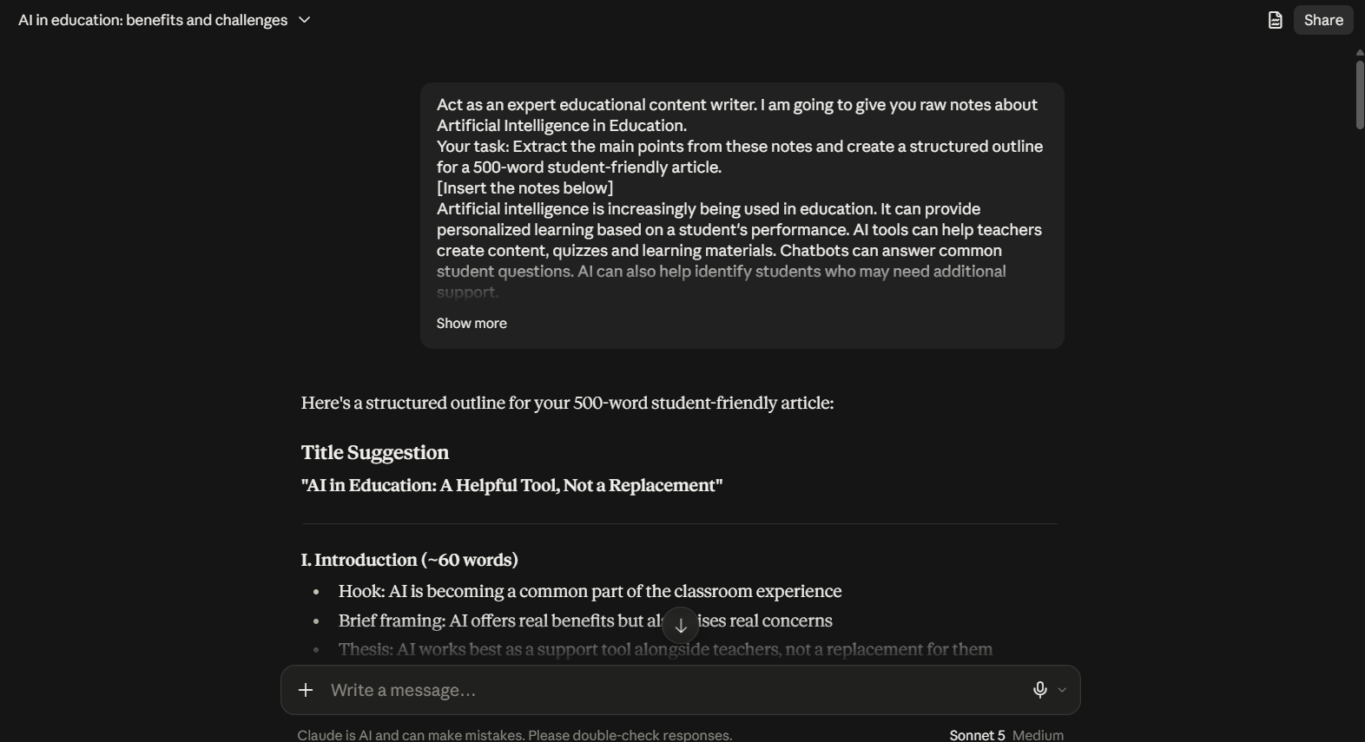

[ Screenshot 2: Step 2 conversation — Drafting ]
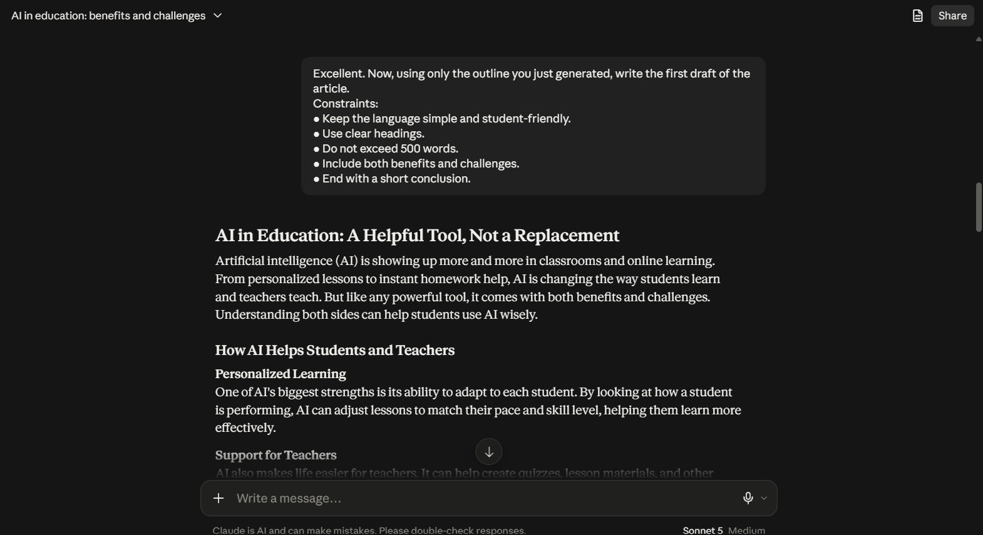
[ Screenshot 3: Step 3 conversation — Critique and Refinement ]
