Exercise 2: E-commerce Platform Search Function Solution
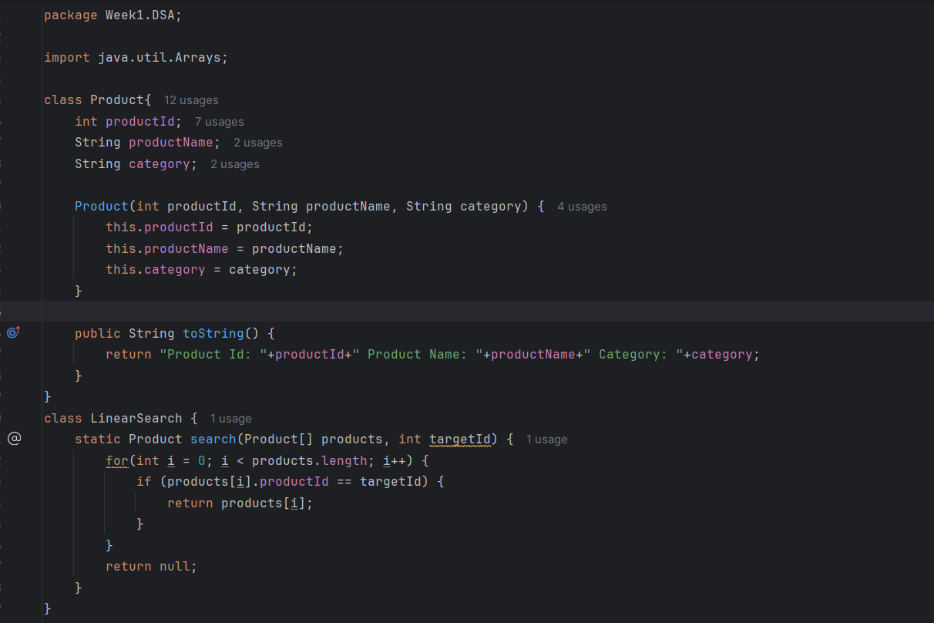
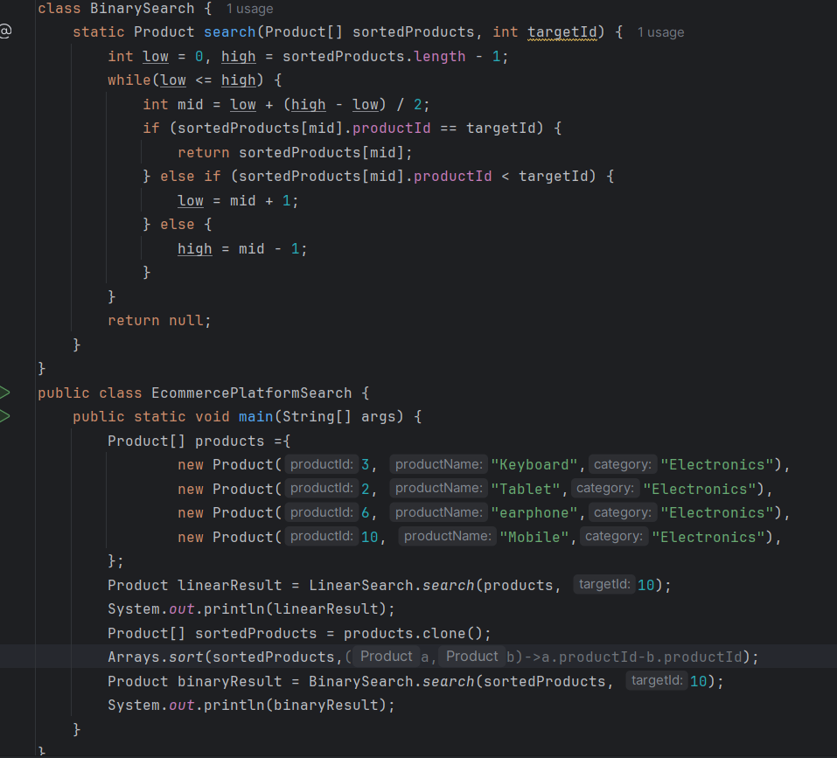
Output:
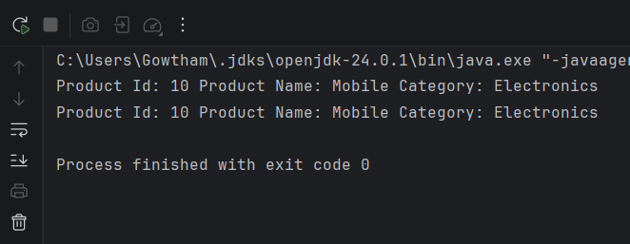

Exercise 7: Financial Forecasting Solution

