Ex : 1 Junit5 Setup

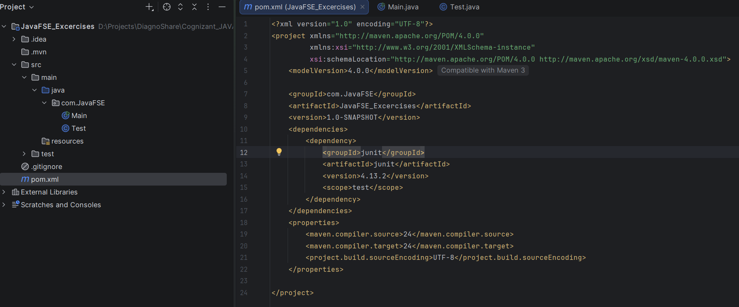

Ex : 3 Assertions in Junit

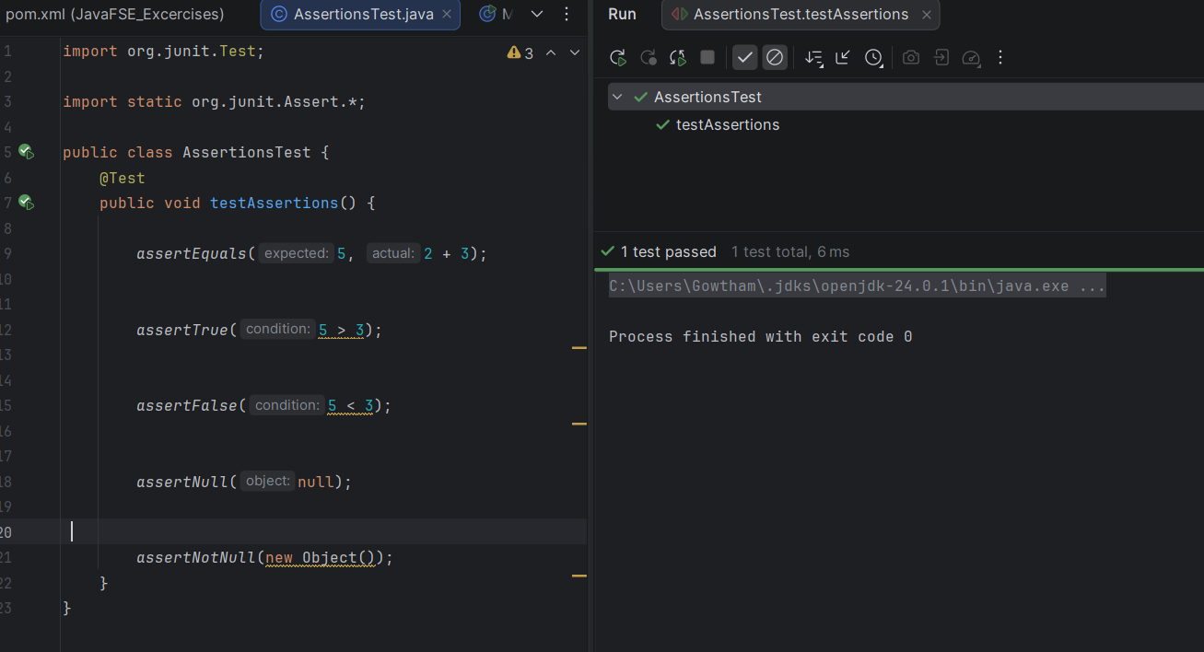

Ex :4 Arrange-Act-Assert (AAA) Pattern, Test Fixtures, Setup and Teardown Methods in Junit
