Ex 1: Mocking and Stubbing

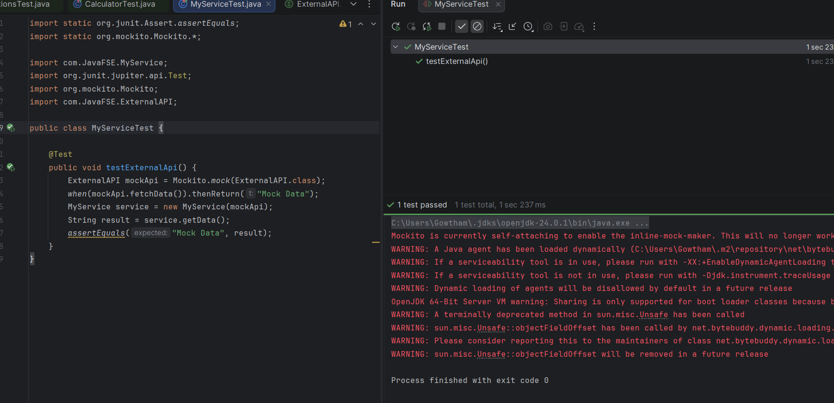

Ex 2: Verifying Interactions
