EX 1 : Configuring a Basic Spring Application

EX 2 : Implementing Dependency Injection

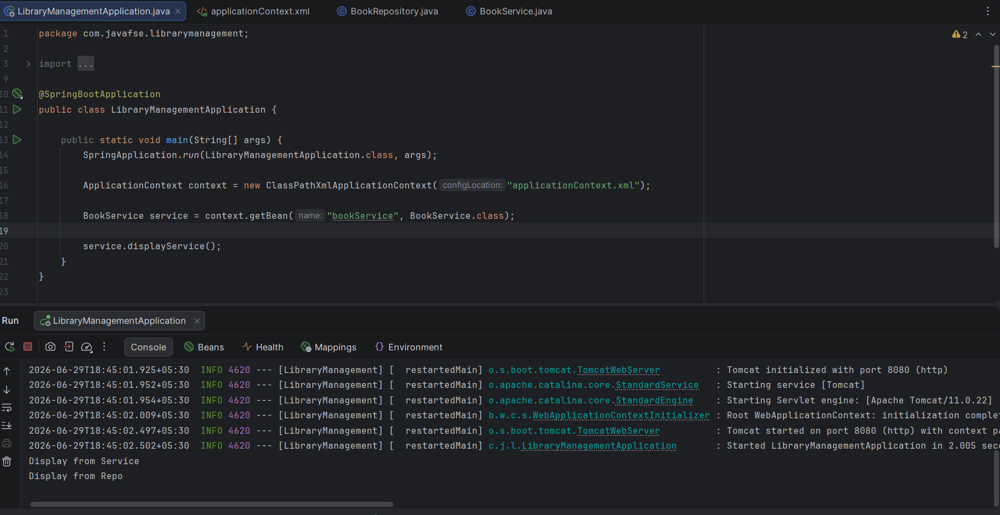

Ex 4: Creating and Configuring a Maven Project

