Front-End UI/UX Mini Project

Personal Portfolio Website

Submitted By:K. Viswakowsik – 2462374
Shreya Joseph Elizabeth – 2462364
Irene Ajay K – 2462329

College-E-mail id- viswakowsik.k@btech.christuniversity.in
- shreya.elizabeth@btech.christuniversity.in
- irene.ajay@btech.christuniversity.in

Course: UI/UX Design Fundamentals
Instructor Name: Madam Nagaveena
Institution: Christ University, Kengeri
Date of Submission: 12/08/2025

Abstract
This project aims to design and develop a responsive personal portfolio website using only HTML and CSS. The website showcases the user's skills, projects, resume, and contact form. The focus was on clean UI, responsive layout, and visual hierarchy. The site includes sections for About, Projects, and Contact, ensuring accessibility and optimized performance across devices.

Objectives
• Design a user-friendly interface using modern UI principles
• Develop a fully responsive layout using only HTML and CSS
• Implement structured HTML5 semantic elements
• Apply CSS styling for branding, layout, and responsive behavior
• Ensure accessibility and readability across devices

Scope of the Project
The project focuses exclusively on front-end design without the use of JavaScript or server-side integration. It is designed for desktop, tablet, and mobile viewports using open-source tools. Only HTML and CSS are used, ensuring a lightweight and fast-loading interface.

Tools & Technologies Used
HTML5 - Markup and content structure
CSS3 - Styling and layout management
VS Code - Code editor
Chrome DevTools - Testing and debugging

HTML Structure Overview
Semantic HTML5 tags such as <header>, <nav>, <main>, <section>, and <footer> are used. The website is divided into reusable sections including About, Projects, and Contact. Navigation is built using unordered lists (<ul>) with anchor links.

CSS Styling Strategy
An external CSS file (style.css) is used to manage styling. Layouts are built using Flexbox and Grid, with media queries ensuring responsiveness. CSS variables allow theme customization, while hover effects and transitions enhance interactivity.
Feature | Description
Responsive Design | Adapts seamlessly to all screen sizes (desktop, tablet, mobile).
Smooth Navigation | Fixed top navigation bar with anchor links for easy access.
Project Showcase | Visually appealing project cards with hover effects.
Contact Form | Non-functional placeholder for user inquiries with styled inputs.
Accessible Fonts & Colors | High contrast and readable typography for better accessibility.
Key Features

Challenges Faced & Solutions
Challenge | Solution
Overlapping elements on small screens | Used media queries to stack and resize elements appropriately.
Difficulty aligning items using float | Shifted to Flexbox and CSS Grid for modern layout handling.
Typography scaling issues | Used relative units (em/rem) instead of fixed px values.
Inconsistent spacing between elements | Implemented CSS variables and consistent margin/padding rules.
Color contrast issues on dark backgrounds | Adjusted color palette for WCAG accessibility compliance.

Outcome
A clean, consistent, and visually engaging front-end layout was achieved. The site works well across devices with only HTML and CSS. The project deepened knowledge of responsive design and UI hierarchy.

Future Enhancements
• Add JavaScript for interactivity (form validation, dynamic content)
• Integrate animations or transitions
• Backend integration for form submission
• Theme toggler (light/dark mode)

Sample Code
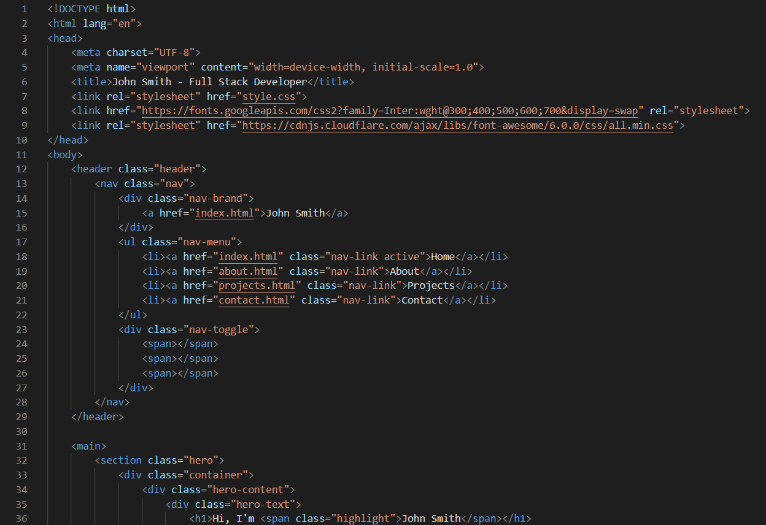
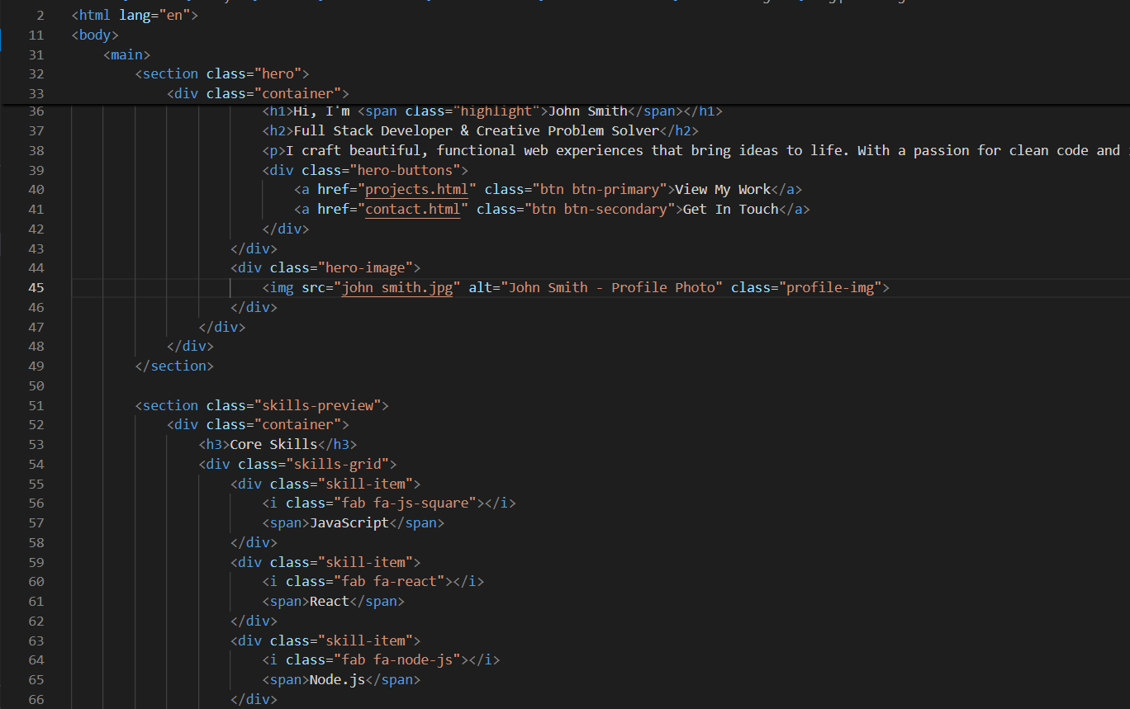

Screen shorts of final output
Home page

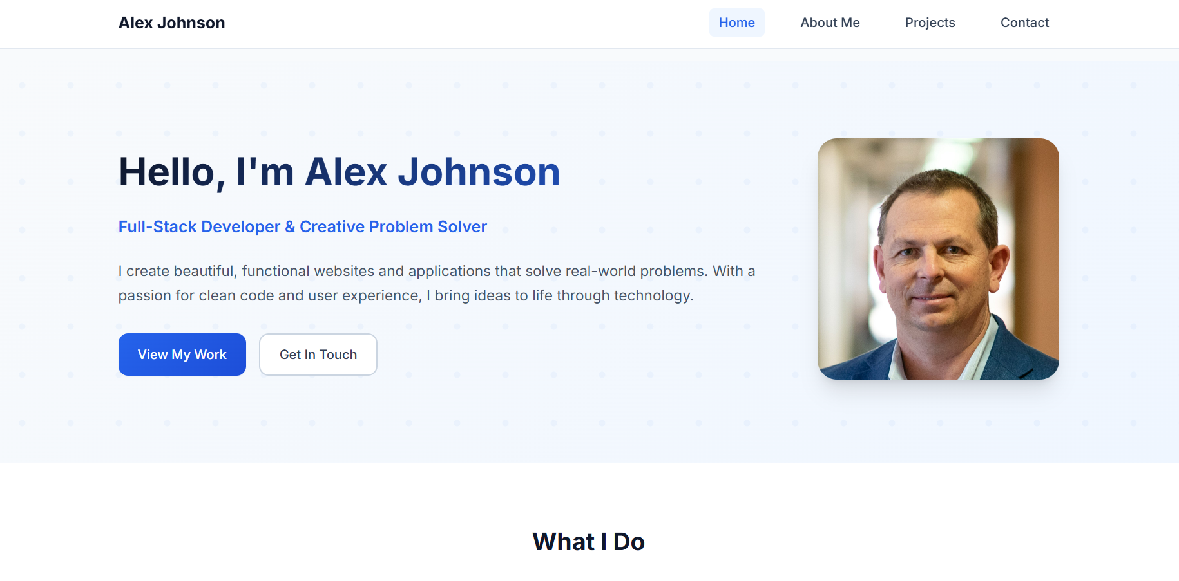

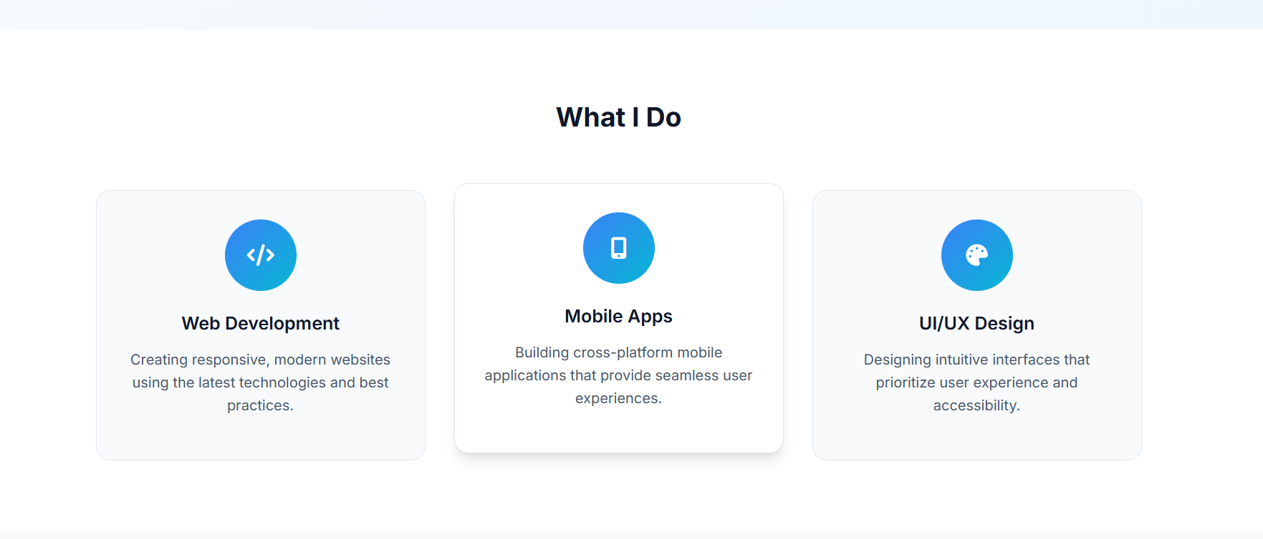
About me page
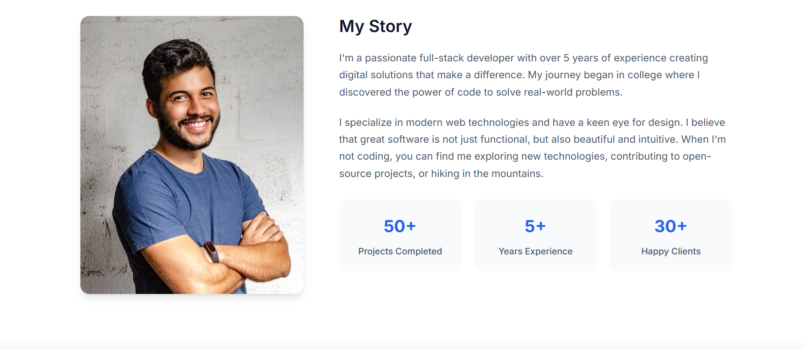
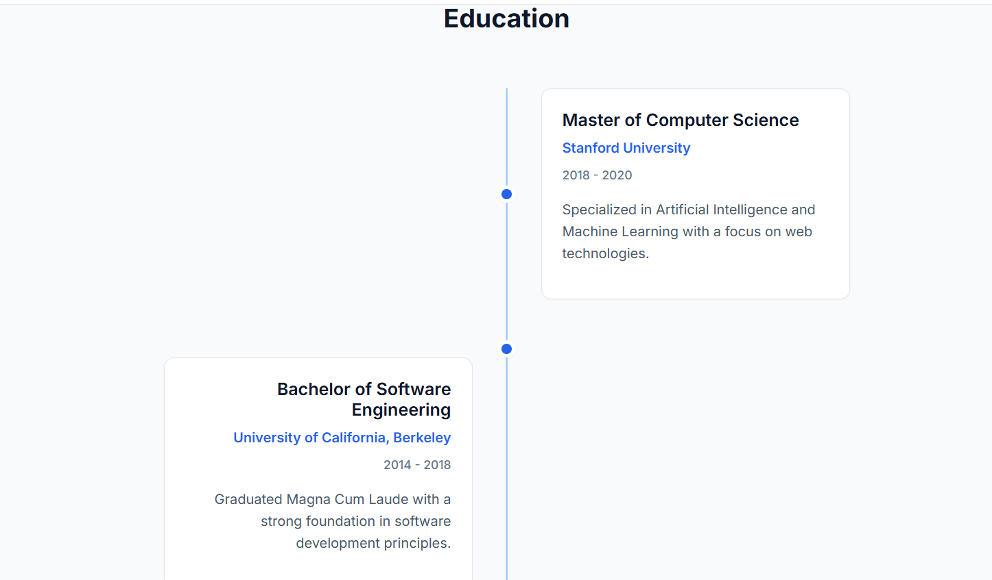

Projects
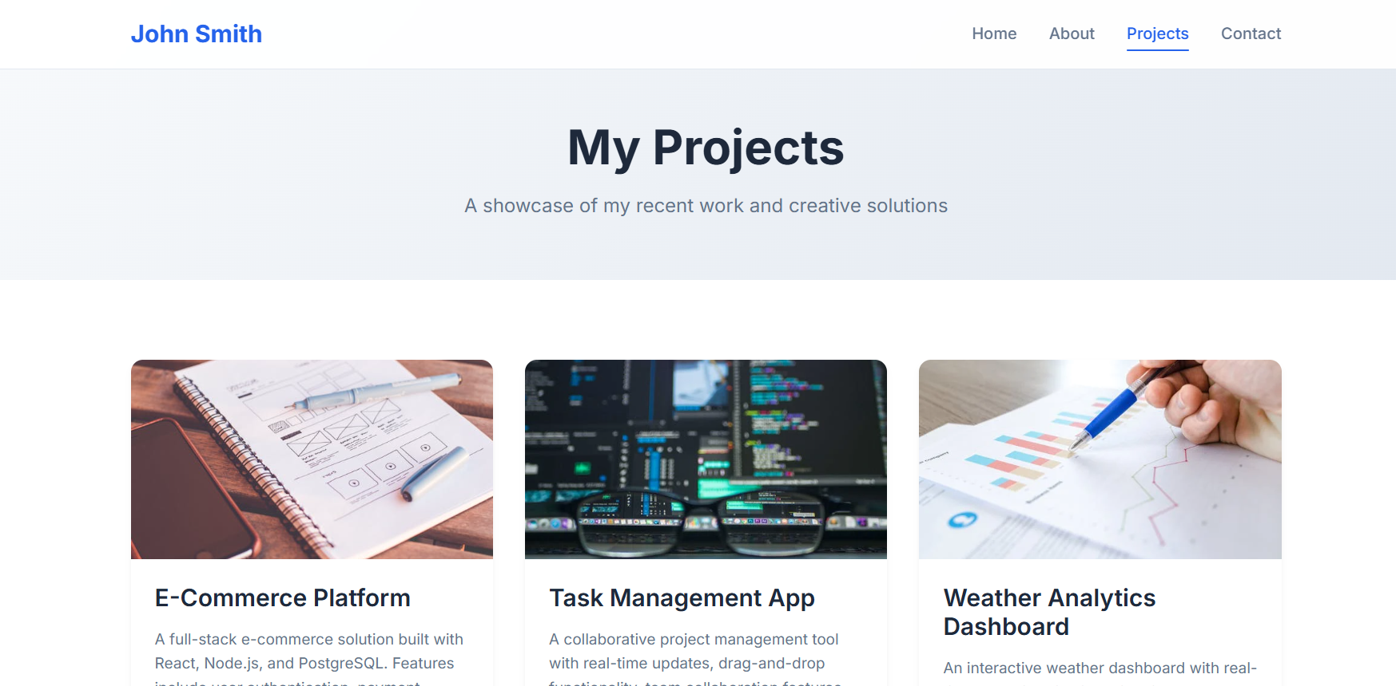
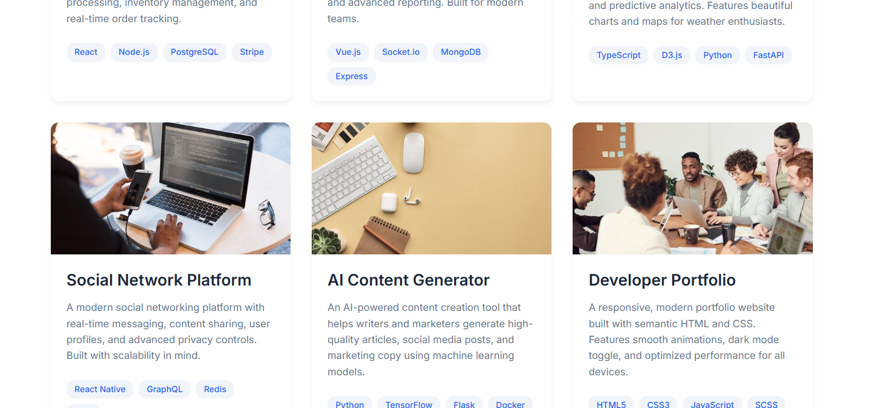

Contact
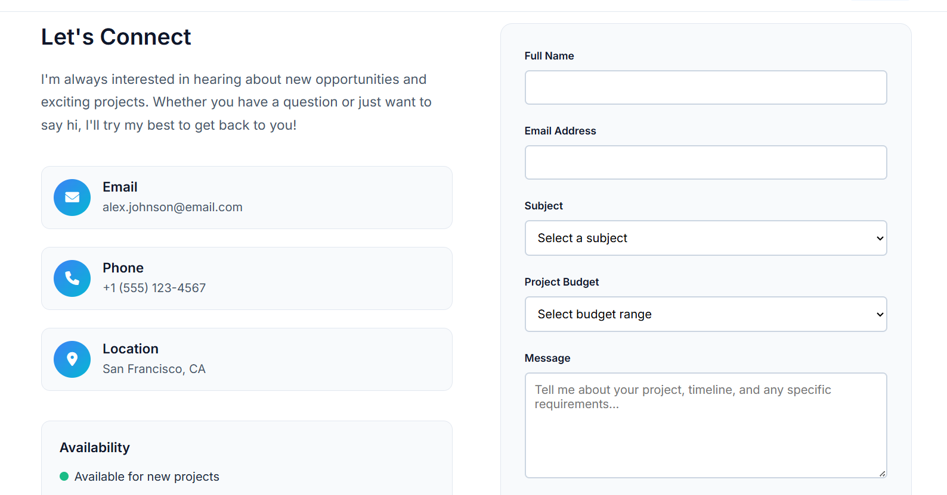

Conclusion
This personal portfolio website highlights the user's skills, projects, and contact information. It improved my front-end development skills, particularly in responsive layouts and UI design.

References
L&T LMS: https://learn.Intedutech.com/Landing/MyCourse

