TECHNICAL REPORT
Machine Learning-Based Credit Risk Assessment System
Professional Consulting Version

1. Executive Summary
This project developed a production-ready machine learning pipeline to predict credit risk using the German Credit dataset. The objective was to identify high-risk loan applicants while maintaining business growth through balanced risk management.
Four classification models were developed and evaluated: Logistic Regression, Decision Tree, Random Forest, and XGBoost. Each model was trained using structured preprocessing pipelines, stratified cross-validation, and hyperparameter tuning with MLflow-based experiment tracking.
XGBoost emerged as the strongest performer with:
- ROC-AUC: 0.955
- Accuracy: 0.895
- Recall (Risk Detection): 0.848
- Precision: 0.882
Threshold optimization analysis demonstrated that adjusting the classification threshold from 0.50 to 0.40 increases recall to 0.873, improving risk detection while maintaining acceptable precision.
Based on performance, stability, and risk sensitivity, XGBoost with a threshold of 0.40 is recommended for deployment.

2. Business Problem Context
Credit risk modeling aims to classify loan applicants as either:
- Low Risk (Good Credit)
- High Risk (Bad Credit)
The financial implications are asymmetric:
- False Negative (approving a risky borrower) → Direct financial loss
- False Positive (rejecting a safe borrower) → Opportunity cost
Therefore, the modeling strategy prioritized:
- Strong discrimination capability (ROC-AUC)
- High recall for risky applicants
- Balanced precision to protect business growth

3. Data Analysis & Feature Engineering
3.1 Data Overview
- Dataset size: 1000 observations
- Target variable: Binary (Good / Bad Risk)
- Class imbalance observed
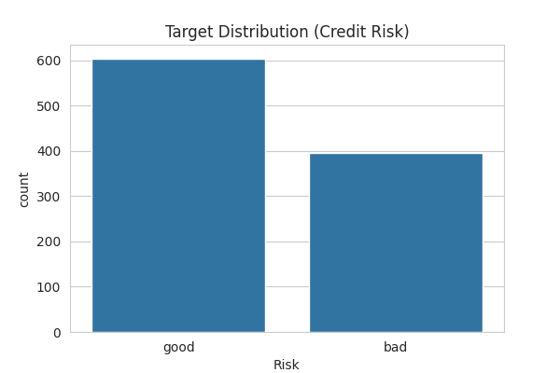
3.2 Exploratory Insights
Key observations:
- Credit duration and credit amount strongly influence default risk.
- Certain categorical features (housing, purpose, savings status) show clear risk differentiation.
- No severe multicollinearity issues detected that would compromise modeling.
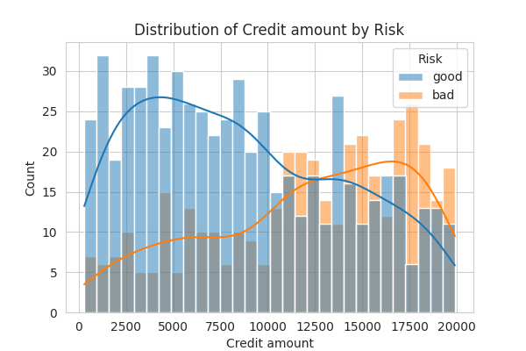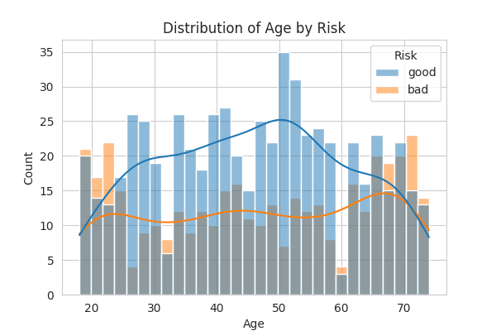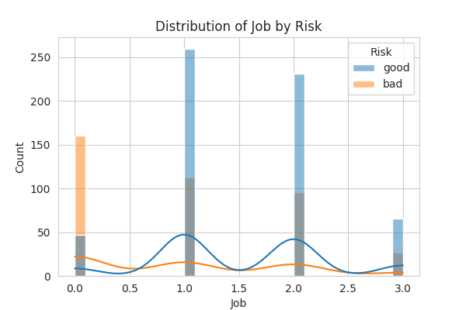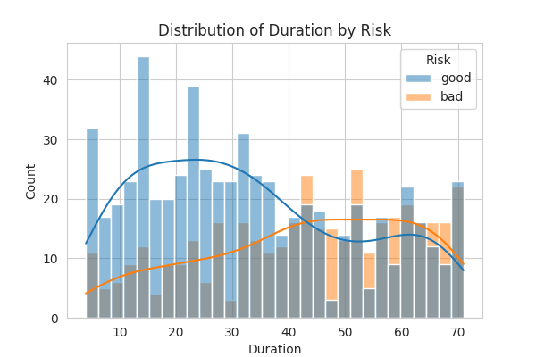
3.3 Feature Engineering
A derived variable was introduced:
- Credit Amount per Month = Credit Amount / Duration
This ratio better captures repayment burden and improved model discrimination.
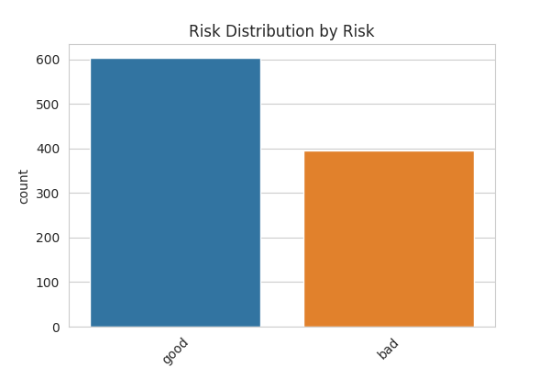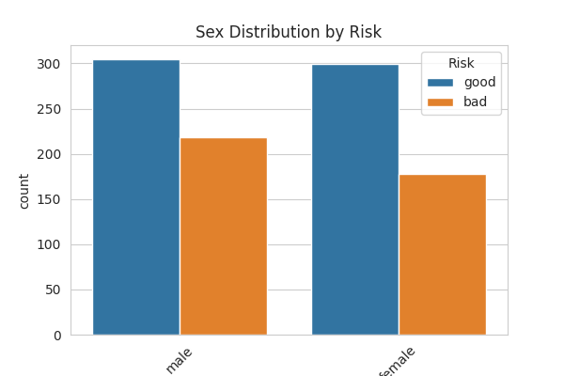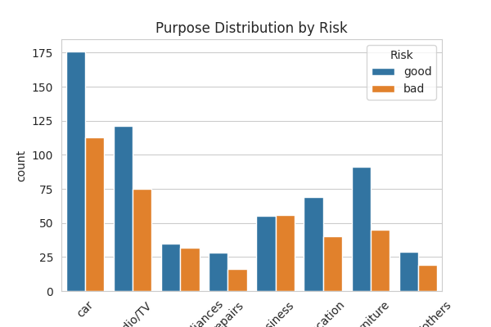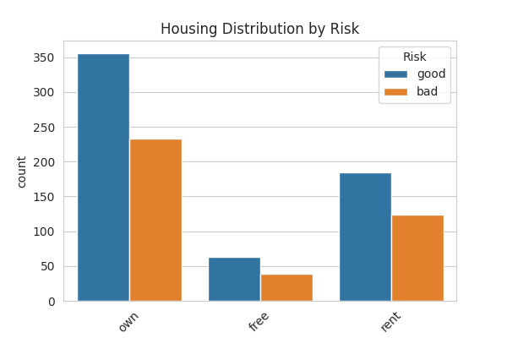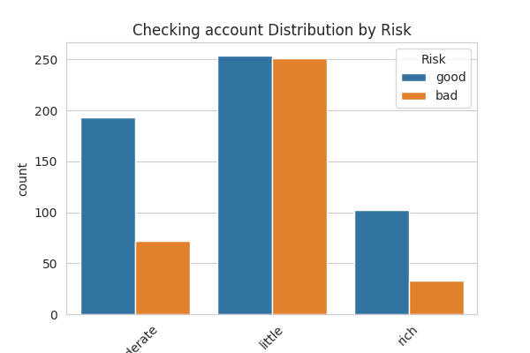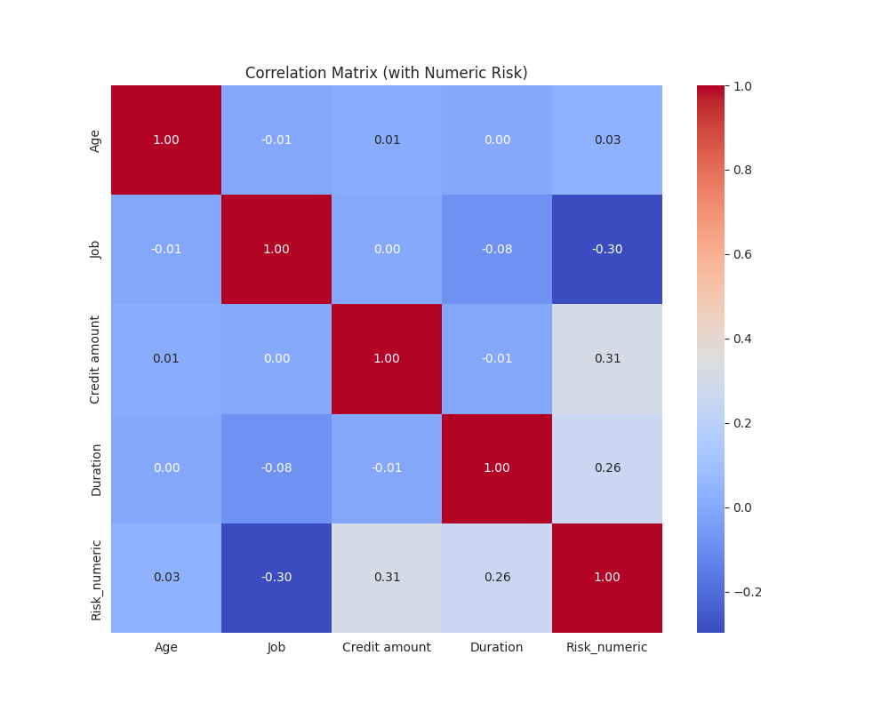

4. Methodology
4.1 Modeling Strategy
Each model was built using:
- Stratified train-test split (80/20)
- ColumnTransformer preprocessing pipeline
- StandardScaler for numerical features
- OneHotEncoder for categorical features
- Stratified 5-fold cross-validation
- GridSearchCV hyperparameter tuning
- MLflow experiment tracking
4.2 Models Implemented
- Logistic Regression (interpretable baseline)
- Decision Tree (nonlinear baseline)
- Random Forest (ensemble method)
- XGBoost (gradient boosting framework)

5. Model Performance Comparison
Model | Accuracy | Precision | Recall | F1 Score | ROC-AUC
XGBoost | 0.895 | 0.882 | 0.848 | 0.865 | 0.955
Random Forest | 0.840 | 0.822 | 0.759 | 0.789 | 0.935
Logistic Regression | 0.830 | 0.759 | 0.835 | 0.795 | 0.898
Decision Tree | 0.810 | 0.747 | 0.785 | 0.765 | 0.866
Key Findings
- XGBoost dominates across all major metrics.
- Logistic Regression offers interpretability but lower discrimination power.
- Decision Tree exhibits higher variance risk.
- Random Forest performs strongly but below XGBoost.
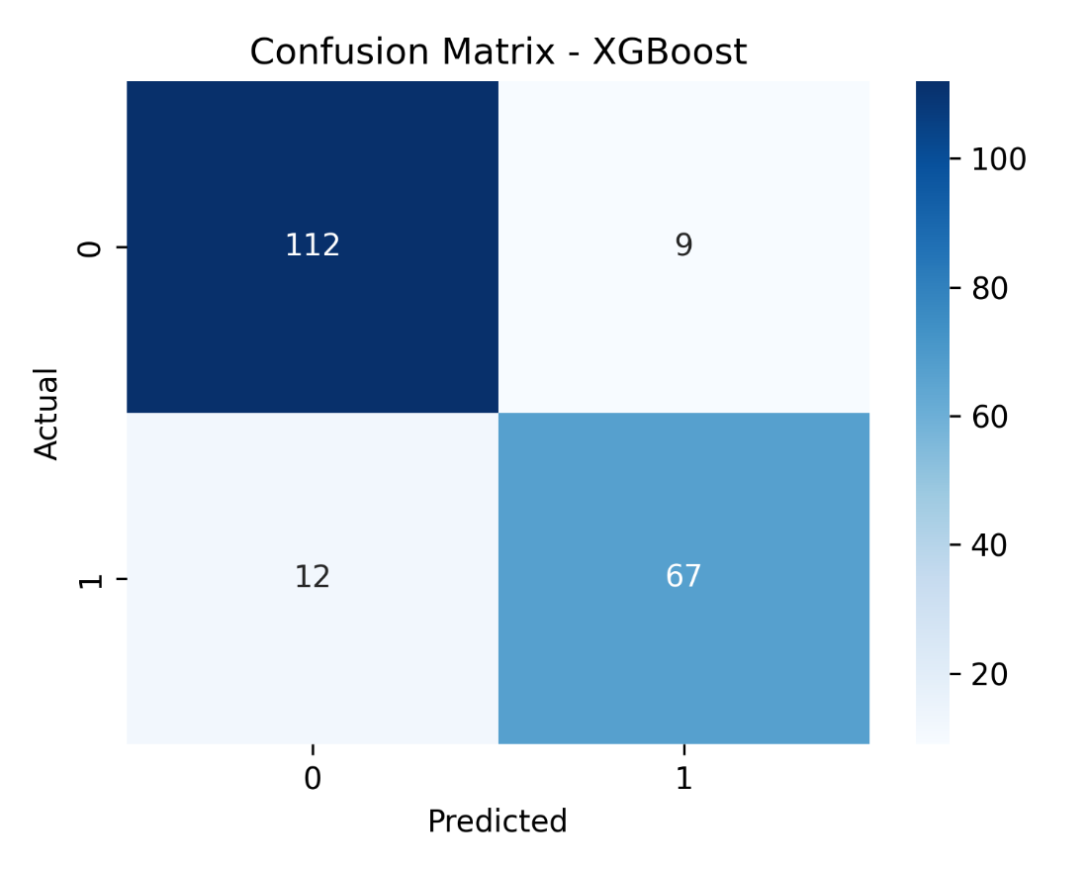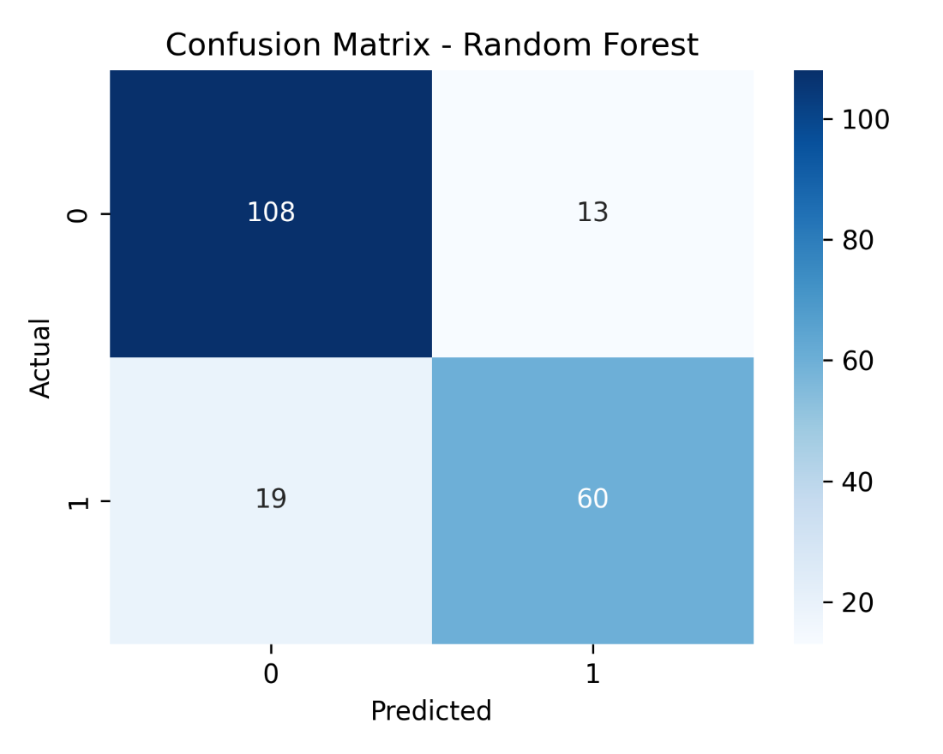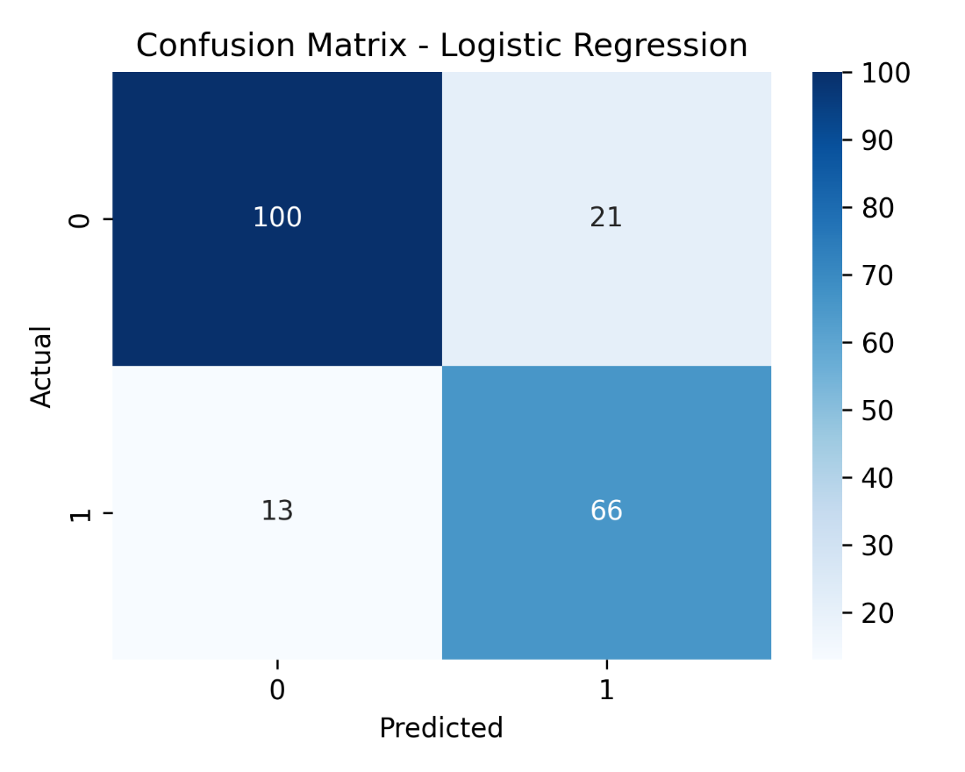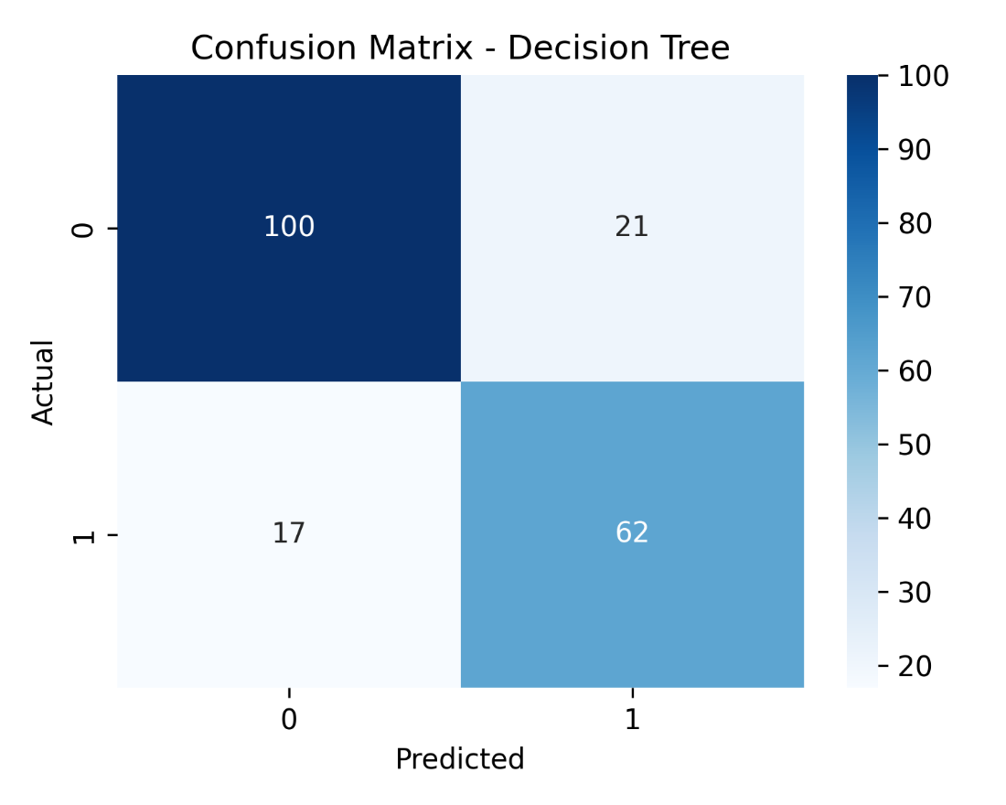

6. Threshold Optimization & Risk Sensitivity
Default threshold (0.50):
- Recall: 0.848
- Precision: 0.882
Adjusted threshold (0.40):
- Recall: 0.873
- Precision: 0.821
Lowering the threshold increases detection of high-risk applicants while maintaining acceptable precision.
Recommendation:
Deploy XGBoost with threshold = 0.40 for conservative risk environments.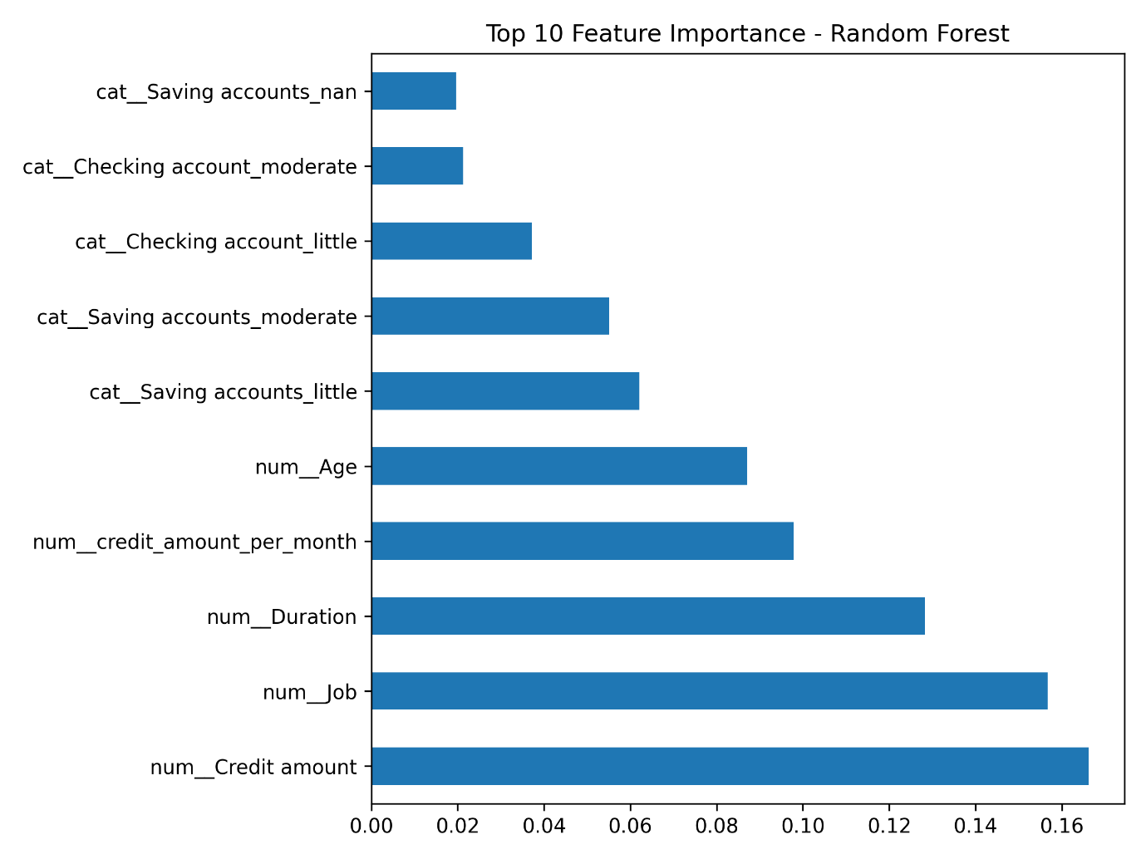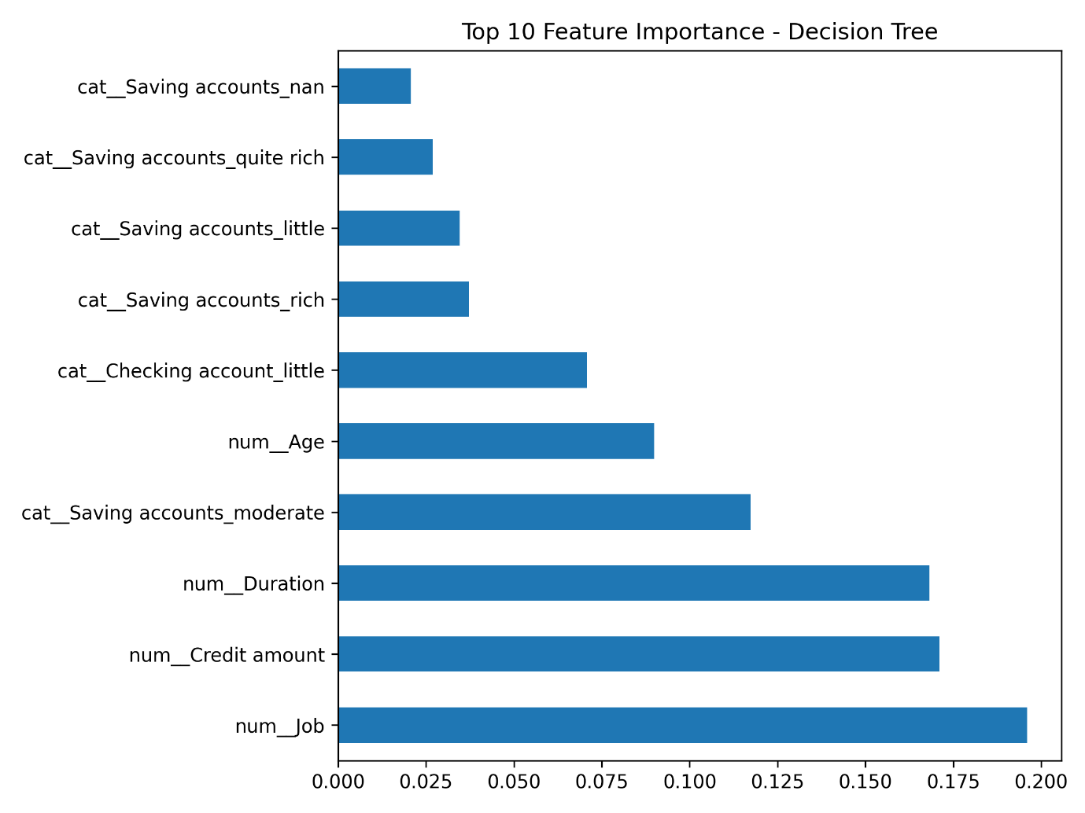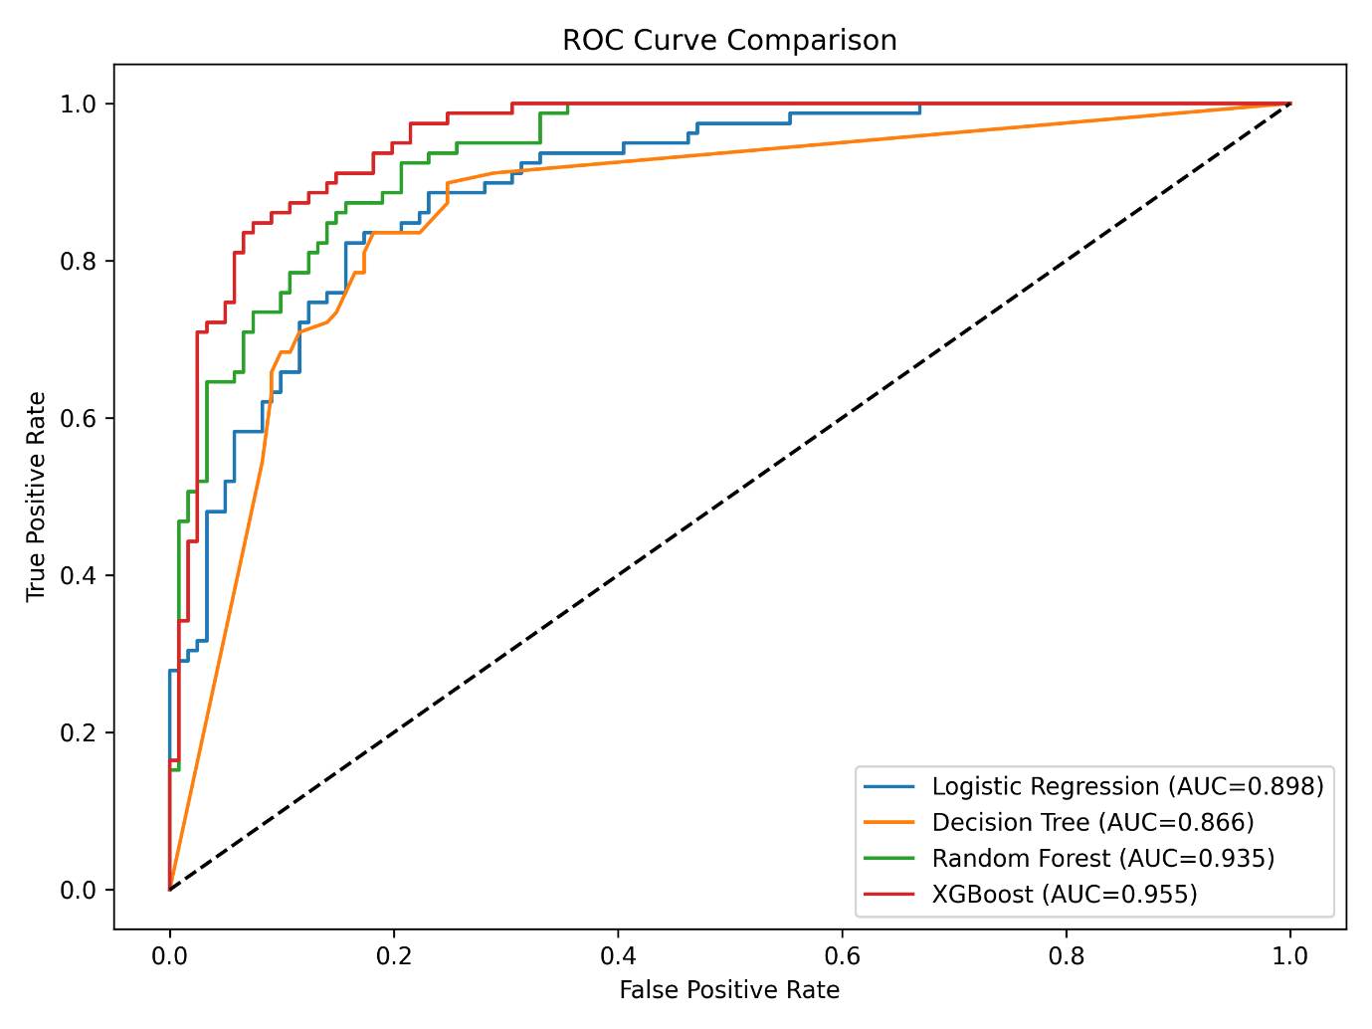

7. Deployment Considerations
7.1 Technical Deployment
- Deploy model via REST API (FastAPI/Flask)
- Integrate into loan approval decision system
- Log all predictions for audit traceability
7.2 Monitoring Strategy
Monitor:
- Recall degradation
- Data drift (feature distribution changes)
- Concept drift (relationship changes)
- Model confidence distribution
Retraining frequency: Quarterly or performance-triggered.

8. Risk & Governance Considerations
- Ensure explainability using SHAP values (future enhancement)
- Conduct bias testing for fairness
- Maintain regulatory compliance for lending decisions
- Implement model performance dashboards

9. Conclusion
This project demonstrates a full end-to-end machine learning lifecycle:
- Data analysis
- Feature engineering
- Pipeline-based modeling
- Hyperparameter tuning
- MLflow experiment tracking
- Business-driven evaluation
- Deployment planning
XGBoost provides superior predictive performance and strong risk detection capability.

