**K VISWANADH CHOWDARY**

**22MC3018**

**LABFILE 2**

**Q1:**

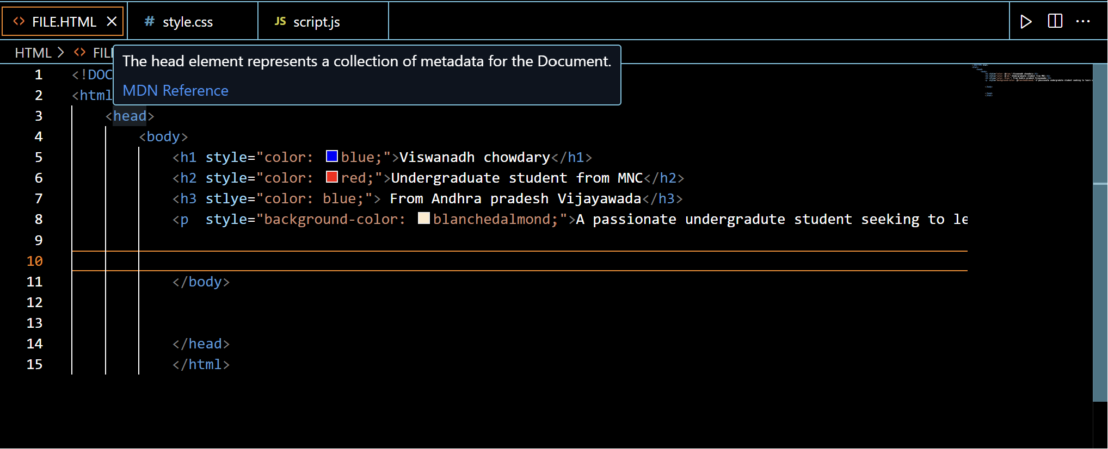

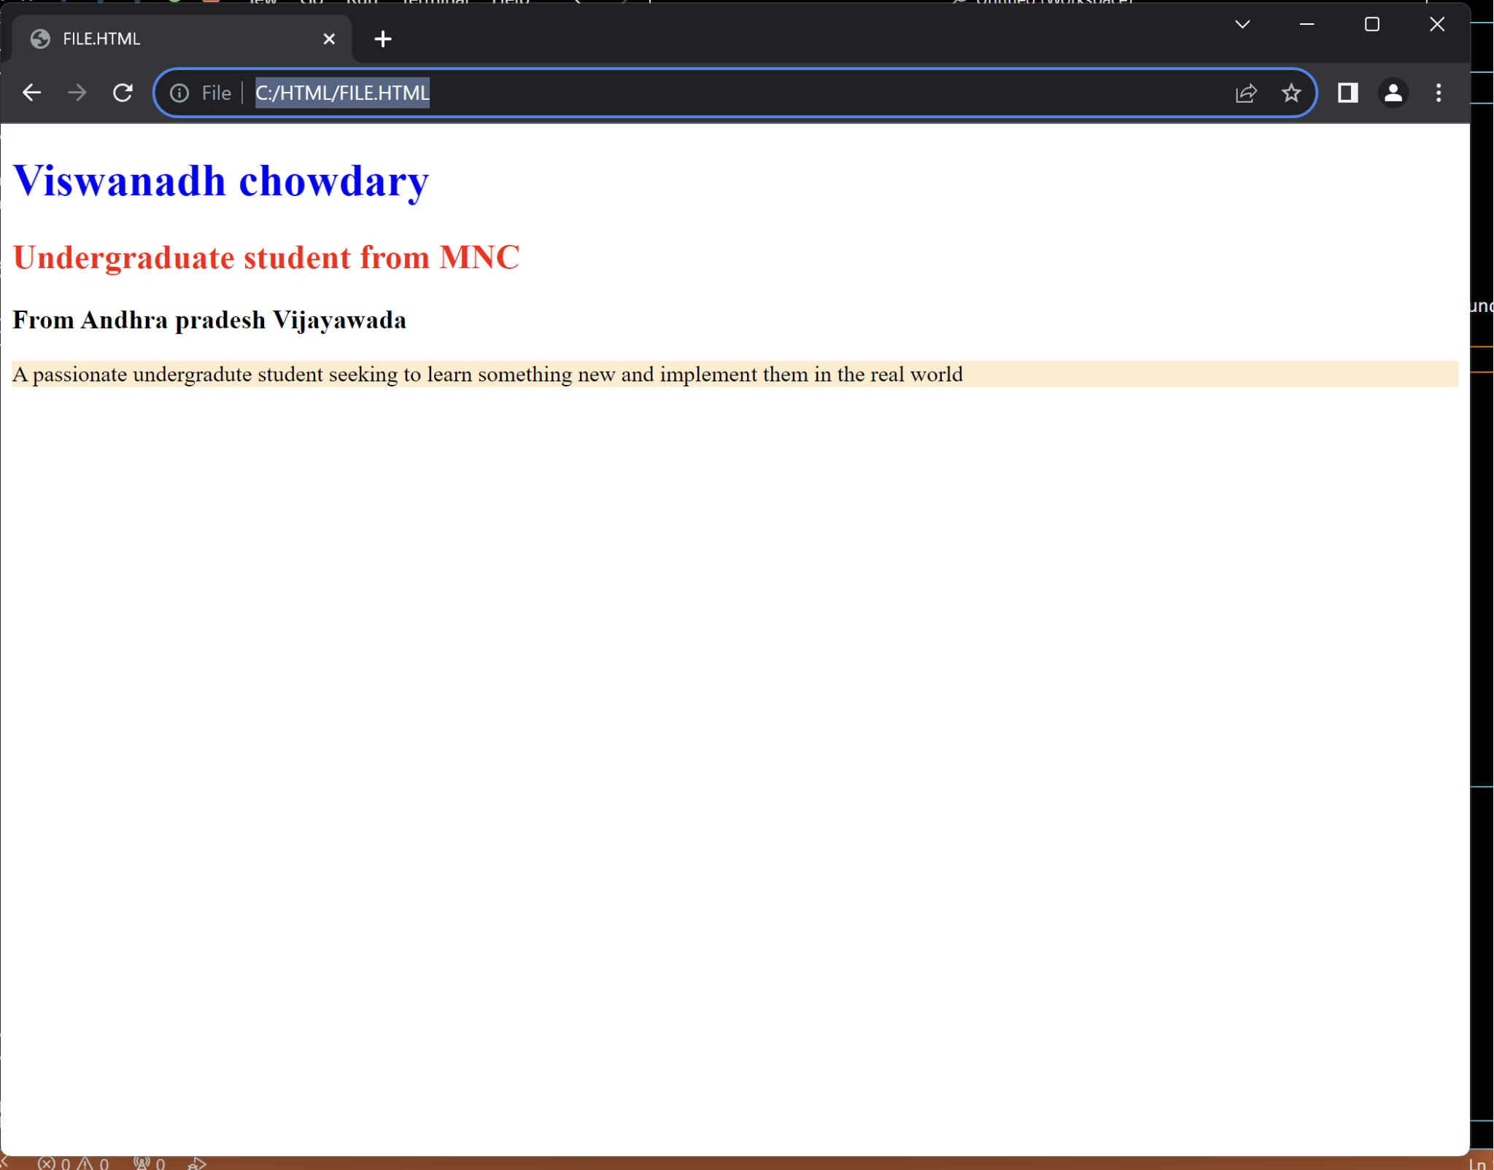

**Q2:**

<!DOCTYPE html>

<html>

<head>

<body>

<h1 style="color:blue;">Virat Kohli</h1>

<img src="https://www.crictracker.com/_next/image/?url=https%3A%2F%2Fmedia.crictracker.com%2Fmedia%2Ffeatureimage%2F2018%2F10%2FVirat-Kohli-7.jpg&w=1200&q=75" style="height: 220px; width: 220px;">

<p style="color: black;">Virat Kohli ( born 5 November 1988) is an Indian international cricketer and the former captain of the Indian national cricket team. He is a right-handed batsman and an occasional medium-fast bowler. He currently represents Royal Challengers Bangalore in the IPL and Delhi in domestic cricket. Kohli is widely regarded as one of the greatest batsmen in the history of cricket and among the best of the 21st century.[3] He holds the record as the highest run-scorer in T20I and IPL, ranks third in ODI, and stands as the fourth-highest in international cricket.[4] He also holds the record for scoring the most centuries in ODI cricket and stands second in the list of most international centuries scored.</p>

</body>

</head>

</html>

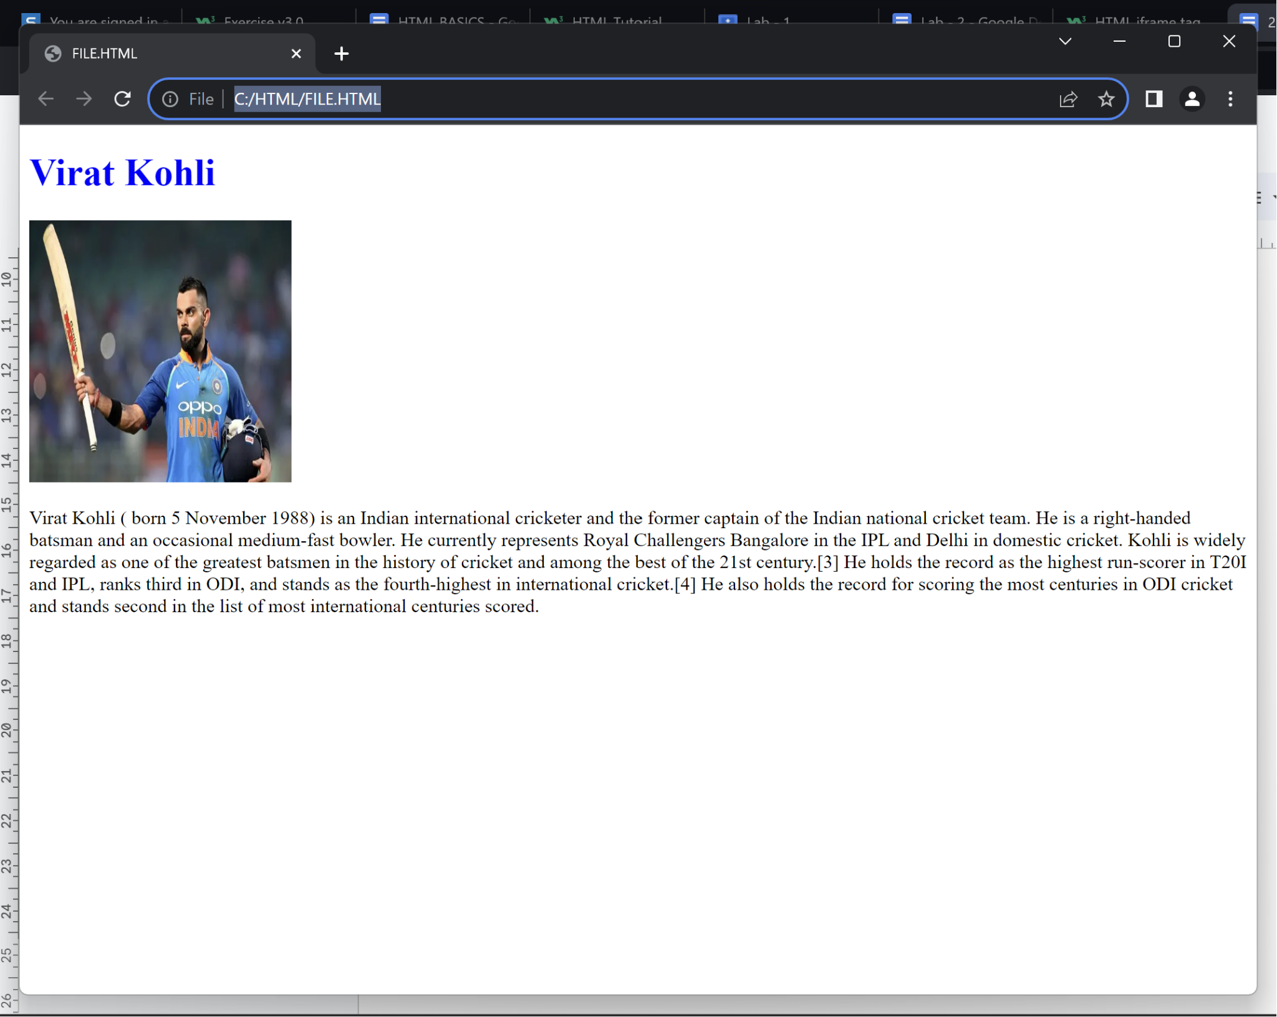

**Q3:**

**<!DOCTYPE html>**

**<html lang="en">**

**<head>**

**<title>Two languages from three countries each</title>**

**</head>**

**<body>**

**<ol type="I">**

**<li>**

**<p>INDIA</p>**

**<ol type="i">**

**<li>Hindi</li>**

**<li>Telugu</li>**

**</ol>**

**</li>**

**<li>**

**<p>USA</p>**

**<ol type="i">**

**<li>English</li>**

**<li>Spanish</li>**

**</ol>**

**</li>**

**<li>**

**<p>Japan</p>**

**<ol type="i">**

**<li>Japanese</li>**

**<li>Ainu</li>**

**</ol>**

**</li>**

**</ol>**

**</body>**

**</html>**

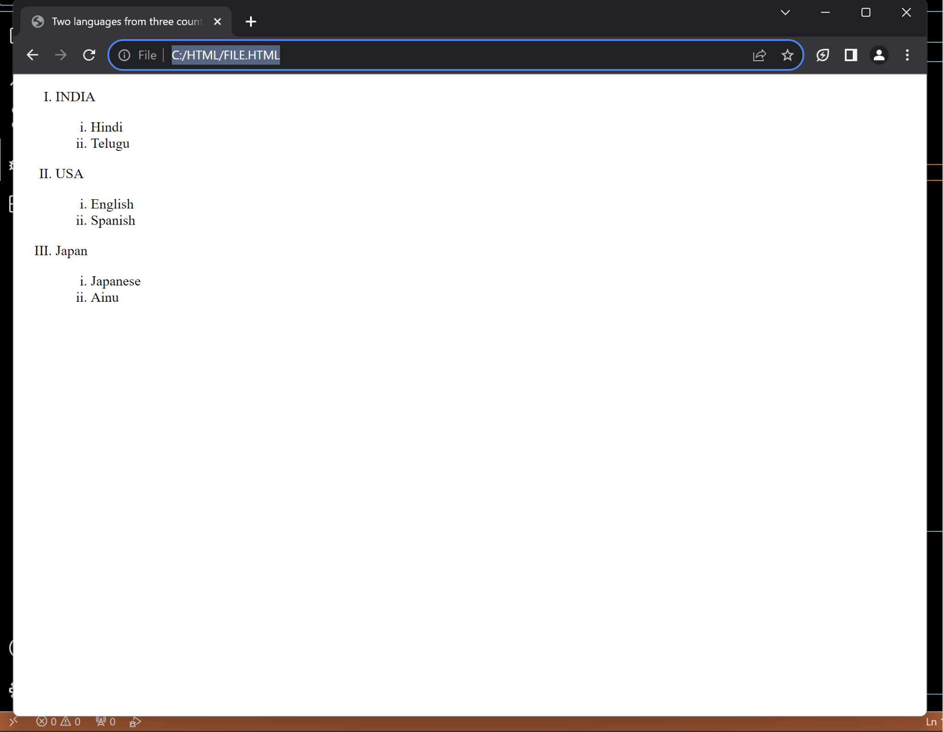

**Q4:**

**<!DOCTYPE html>**

**<html lang="en">**

**<head>**

**<title>Countries and Capitals</title>**

**<style>**

**table {**

**width: 100%;**

**border-collapse: collapse;**

**}**

**td {**

**border: 1px solid #dddddd;**

**padding: 8px;**

**text-align: left;**

**}**

**</style>**

**</head>**

**<body>**

**<h1>Countries and Their Capitals</h1>**

**<table>**

**<tr>**

**<td>**

**<ul>**

**<li>INDIA</li>**

**<li>Australia</li>**

**<li>China</li>**

**<li>Brazil</li>**

**<li>Bangladesh</li>**

**</ul>**

**</td>**

**<td>**

**<ol>**

**<li>New Delhi</li>**

**<li>Cranberra</li>**

**<li>Bejiing</li>**

**<li>Brasília</li>**

**<li>Dhaka</li>**

**</ol>**

**</td>**

**</tr>**

**</table>**

**</body>**

**</html>**

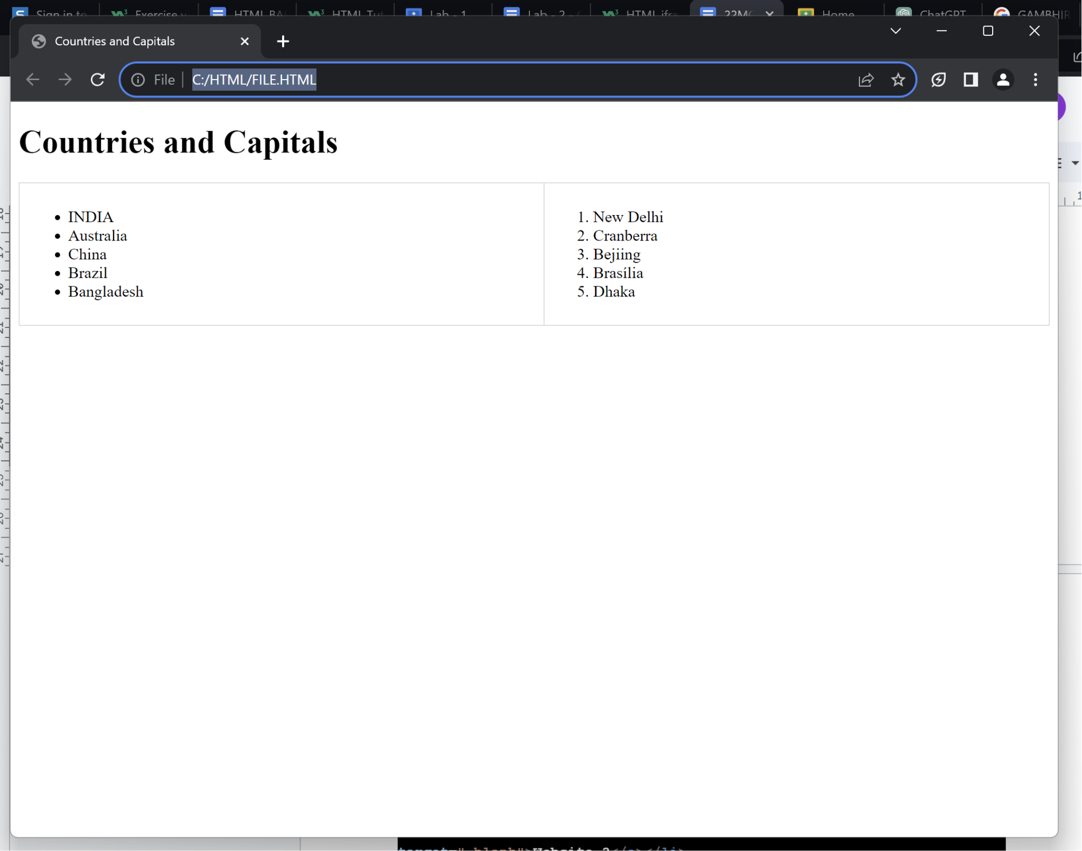

**Q5:**

**<!DOCTYPE html>**

**<html lang="en">**

**<head>**

**<title>Country Politicians</title>**

**<style>**

**table {**

**width: 60%;**

**border-collapse: collapse;**

**margin-top: 20px;**

**}**

**th, td {**

**border: 1px solid #dddddd;**

**padding: 10px;**

**text-align: left;**

**}**

**</style>**

**</head>**

**<body>**

**<h2>Country Politicians</h2>**

**<table>**

**<tr>**

**<th>Country</th>**

**<th colspan="2">Politicians</th>**

**</tr>**

**<tr>**

**<td rowspan="2">Turkmenistan</td>**

**<td><strong>President:</strong></td>**

**<td>Gurbanguly Berdimuhamedow</td>**

**</tr>**

**<tr>**

**<td><strong>Vice-President:</strong></td>**

**<td>Raşit Meredow</td>**

**</tr>**

**<tr>**

**<td rowspan="2">Eritrea</td>**

**<td><strong>President:</strong></td>**

**<td>Isaias Afwerki</td>**

**</tr>**

**<tr>**

**<td><strong>Vice-President:</strong></td>**

**<td>None</td>**

**</tr>**

**</table>**

**</body>**

**</html>**

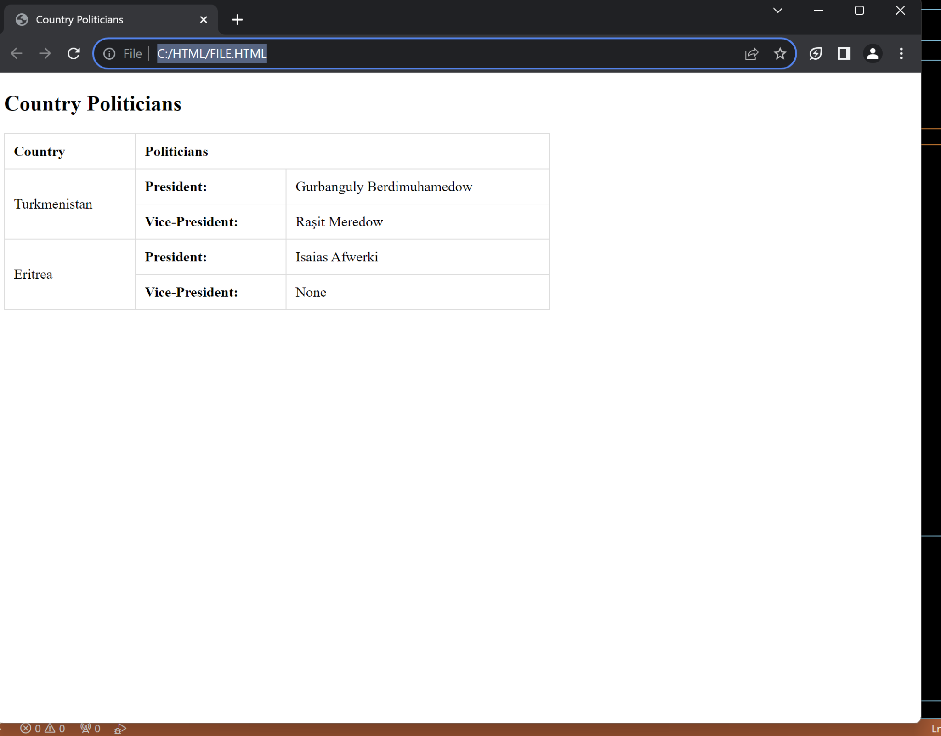

**Q6:**

**<!DOCTYPE html>**

**<html>**

**<head>**

**<title>These are my Favorite Websites</title>**

**</head>**

**<body>**

**<h1>My Favorite Websites</h1>**

**<ul>**

**<li><a href="https://www.instagram.com/" target="_blank">Website 1(Instagram)</a></li>**

**<li><a href="https://www.w3schools.com/html/" target="_blank">Website 2(W3SCHOOL)</a></li>**

**<li><a href="http://192.168.100.1:8090/httpclient.html" target="_blank">Website 3</a></li>**

**<li><a href="https://docs.google.com/document/d/1VWJMLqLuWKQ_29nVN042JQZkJZtxdDm7NBQlkQtGzWo/edit" target="_blank"> Website 4</a></li>**

**</ul>**

**</body>**

**</html>**

**```**

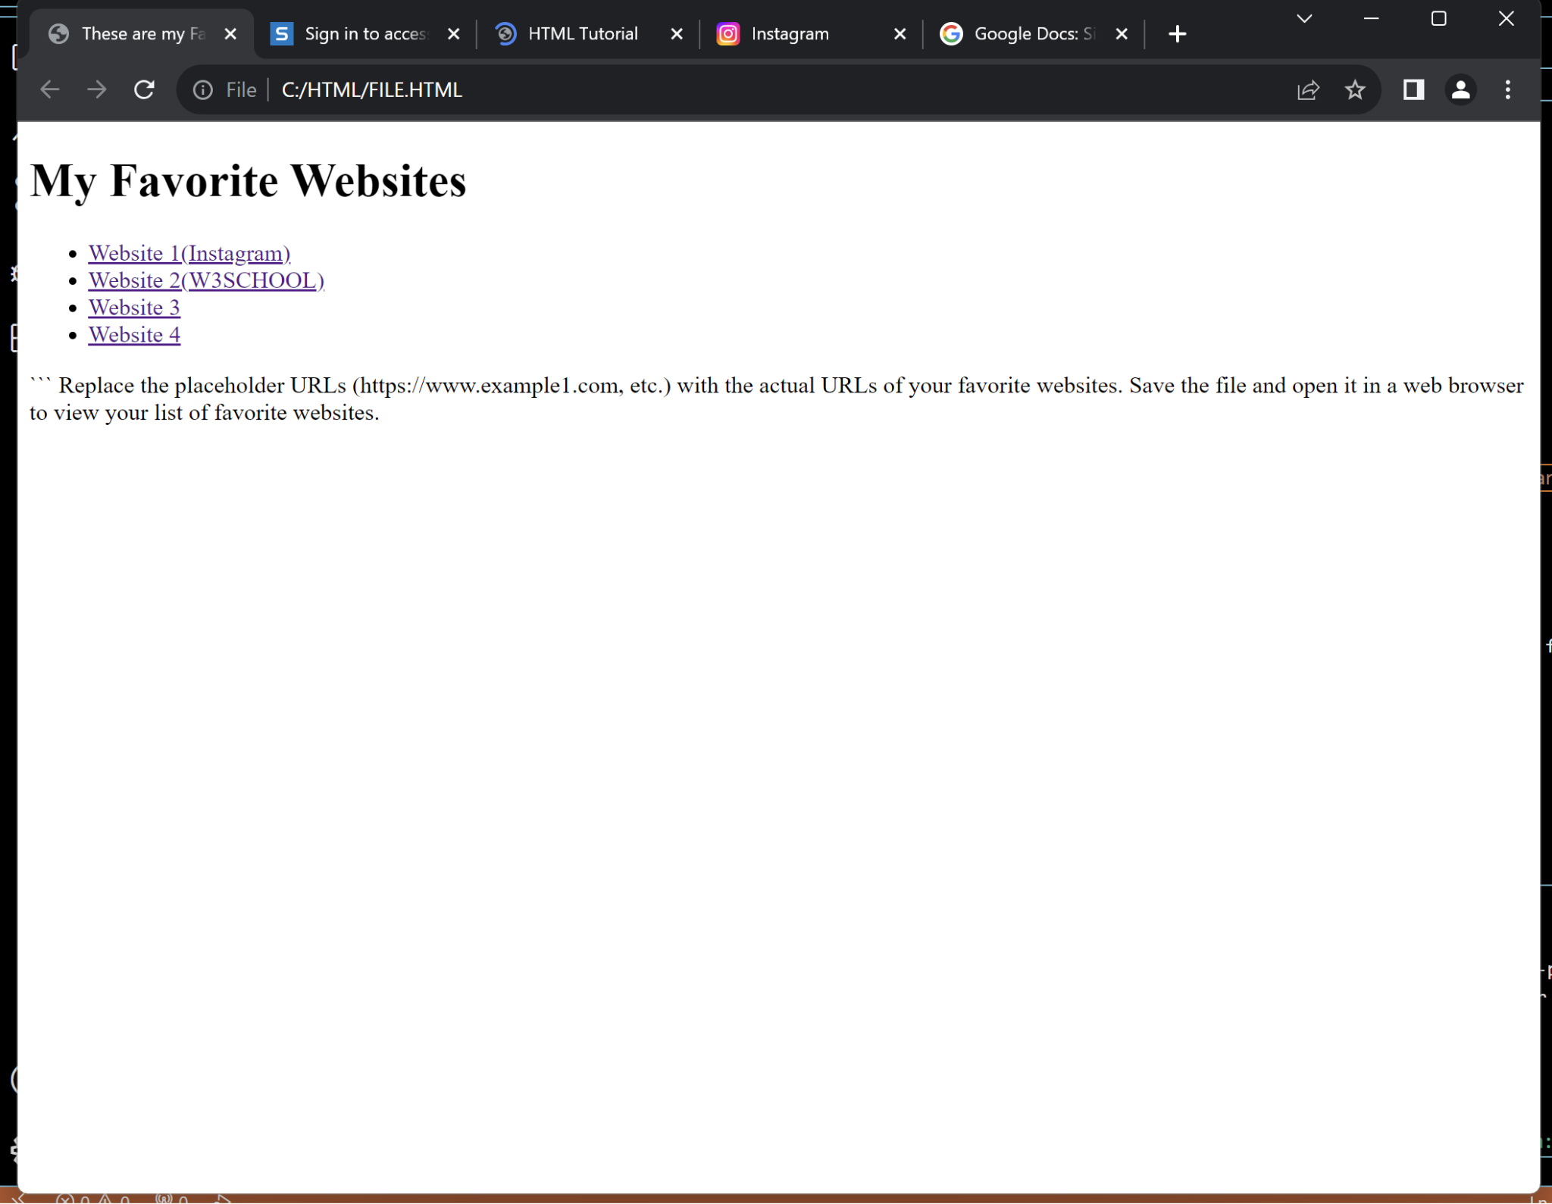

**Q7:**

**<!DOCTYPE html>**

**<html lang="en">**

**<head>**

**<title>Jump to Top</title>**

**<style>**

**body {**

**height: 1600px;**

**margin: 0;**

**padding: 0;**

**}**

**</style>**

**</head>**

**<body>**

**<h1>Regarding Jump To Top</h1>**

**<p><a href="#top">Jump to Top</a></p>**

**<div id="top"></div>**

**</body>**

**</html>**

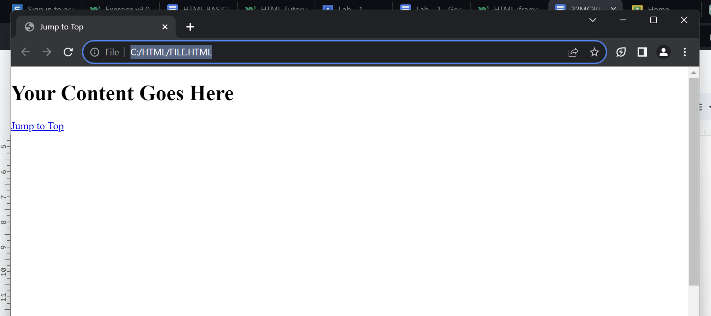

**Q8:<!DOCTYPE html>**

**<html lang="en">**

**<head>**

**<title>Scroll Links</title>**

**<style>**

**body {**

**}**

**#topLink, #bottomLink {**

**display: block;**

**text-align: center;**

**padding: 10px;**

**background-color: #007bff;**

**color: #fff;**

**text-decoration: none;**

**border-radius: 5px;**

**margin-bottom: 10px;**

**}**

**#bottomLink {**

**position: fixed;**

**bottom: 20px;**

**right: 20px;**

**}**

**</style>**

**</head>**

**<body>**

**<a href="#bottom" id="topLink">Jump to Bottom</a>**

**<h1>Welcome to My Page</h1>**

**<a href="#top" id="bottomLink">Back to Top</a>**

**<script>**

**document.getElementById('topLink').addEventListener('click', function() {**

**document.getElementById('bottom').scrollIntoView({ behavior: 'smooth' });**

**});**

**document.getElementById('bottomLink').addEventListener('click', function() {**

**document.getElementById('top').scrollIntoView({ behavior: 'smooth' });**

**});**

**</script>**

**</body>**

**</html>**

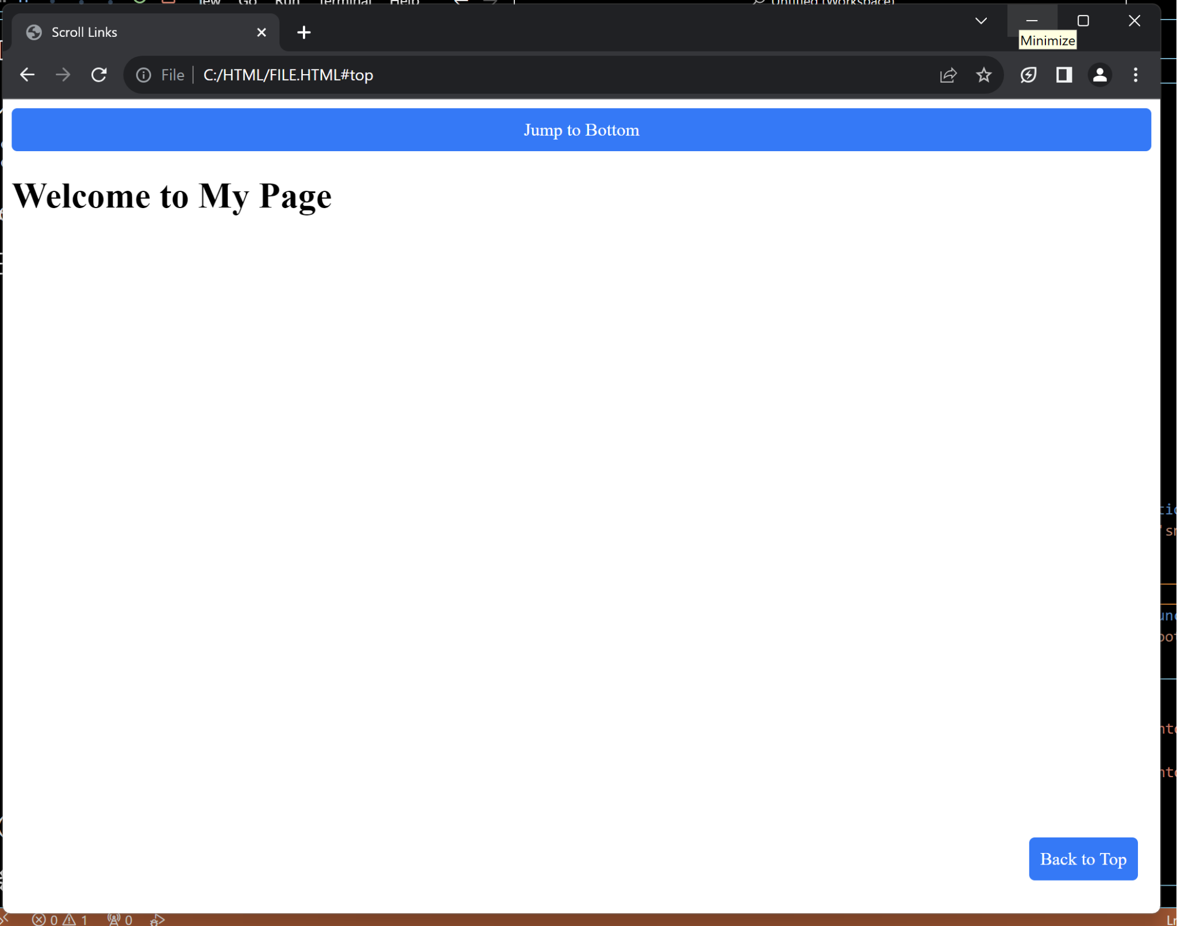

**Q9:**

**<!DOCTYPE html>**

**<html lang="en">**

**<head>**

**<title>Image with Border</title>**

**<style>**

**img {**

**border: 2px solid #000;**

**width: 200px;**

**height: 200px;**

**display: block;**

**margin: 20px auto;**

**}**

**</style>**

**</head>**

**<body>**

**<img src="https://akm-img-a-in.tosshub.com/indiatoday/images/story/202311/gautam-gambhir--kolkata-and-kkrs-favourite-son--returns-to-his-den-courtesy-getty-images-224100995-16x9_0.jpg?VersionId=3t3hFqM0H8rB9Yry9zeI6ZgJQWrcyt.X&size=690:388" alt="Your Image Description">**

**</body>**

**</html>**

**Q10:**

**<!DOCTYPE html>**

**<html lang="en">**

**<head>**

**<title>Photos of Gautam Gambhir</title>**

**<style>**

**img {**

**border: 2px solid #000; /* Optional: Add a border to the images */**

**width: 300px;**

**height: auto;**

**margin: 10px;**

**}**

**.caption {**

**text-align: center;**

**margin: 5px;**

**}**

**</style>**

**</head>**

**<body>**

**<img src="https://feeds.abplive.com/onecms/images/uploaded-images/2023/07/13/0c56634be69c8ea7824039062c63ed541689255507449625_original.jpg?impolicy=abp_cdn&imwidth=650" alt="Gambhir 1" />**

**<p class="caption">Gambhir 1</p>**

**<br>**

**<img src="https://encrypted-tbn0.gstatic.com/images?q=tbn:ANd9GcQxrkTgSi_N6dD9bHsvD9DqEb8dRPpFKxnpJA&usqp=CAU" alt="Gambhir 2" />**

**<p class="caption">Gambhir 2</p>**

**<br>**

**<img src="https://crictoday.com/wp-content/uploads/2021/01/gautamgambhir-1568967918.jpg" alt="Gambhir 3" />**

**<p class="caption">Gambhir 3</p>**

**<br>**

**<img src="https://encrypted-tbn0.gstatic.com/images?q=tbn:ANd9GcQQiphMExPTyhKMKfkr2NElcucaVbrNm8wNbC_HyFfqItRTOo0fOJeASaEFAefIv1gmbv4&usqp=CAU" alt="Image 4" />**

**<p class="caption">Gambhir 4</p>**

**<br>**

**<img src="https://encrypted-tbn0.gstatic.com/images?q=tbn:ANd9GcSPefBNZI6_y8VPfViRhqplSxdyeem-ZyrrMdZEpjQp_gMmHxjh8amiUOrJ2dbZRdw2pK8&usqp=CAU" alt="Image 5" />**

**<p class="caption">Gambhir 5</p>**

**</body>**

**</html>**

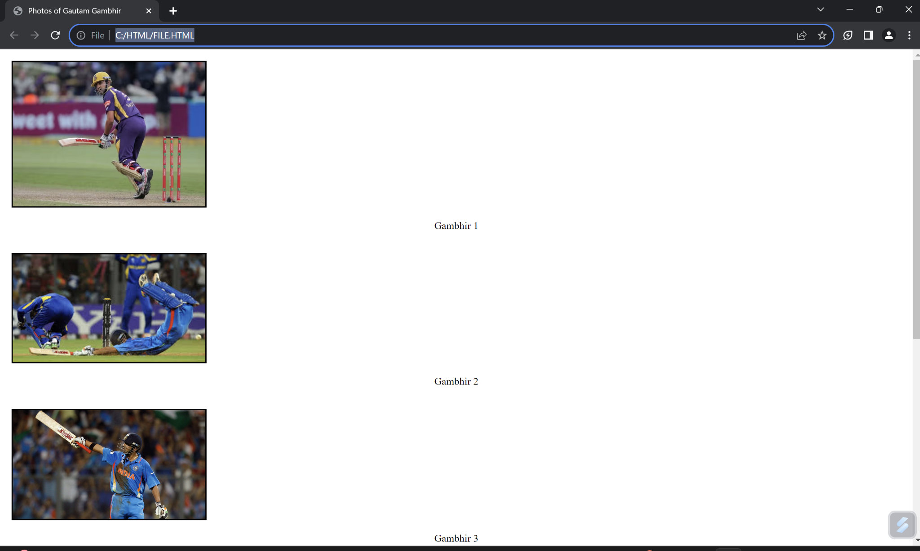

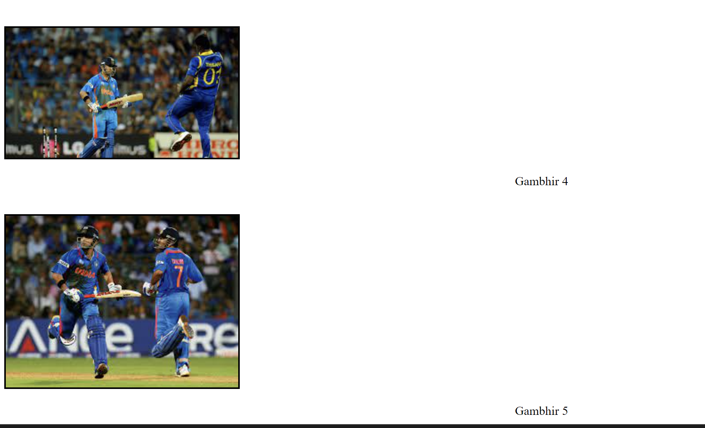

**Q11:**

**<!DOCTYPE html>**

**<html lang="en">**

**<head>**

**<title>Search Engine Link</title>**

**</head>**

**<body>**

**<a href="https://www.google.com" target="_blank">**

**<img src="https://media.gcflearnfree.org/content/572a1c7fdba9160e5c387cb6_05_04_2016/2016_search_start.png" alt="Search Engine" width="200" height="200">**

**</a>**

**</body>**

**</html>**

