INVENTION DISCLOSURE FORM
1. TITLE: Profile Picture Analysis for Fake Detection System
2. INTERNAL INVENTOR(S)/ STUDENT(S): All fields in this column are mandatory to be filled.
A. Full name | N.Viswanath rao
Mobile Number | 8885282315
Email (personal) | viswanathrao7@gmail.com
UID/Registration number | 12311011
Address of Internal Inventors | Lovely Professional University, Punjab-144411, India
Signature (Mandatory) | 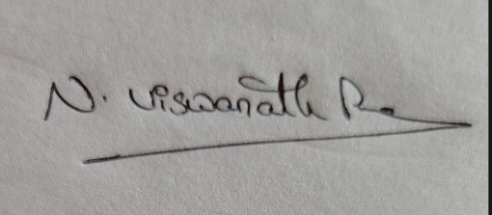
B. Full name
Mobile Number
Email (personal)
UID/Registration number
Address of Internal
Inventors
Signature (Mandatory)
C. Full name
Mobile Number
Email (personal)

UID/Registration number
Address of Internal
Inventors
Signature (Mandatory)
3. Description of the Project
The Profile Picture Analysis for Fake Account Detection is a software-based computer vision system designed to analyze user profile images and identify potentially fake or suspicious accounts based on visual characteristics.
This system uses image processing techniques and pre-trained models to examine profile pictures and extract meaningful features such as the presence, number, and size of human faces. It is implemented using Python and the OpenCV library, and operates as a lightweight, rule-based analytical tool.
The system takes profile images as input and processes them through a sequence of steps including image preprocessing, grayscale conversion, and face detection using a Haar Cascade classifier. The classifier scans the image to identify face-like patterns based on trained features and returns the coordinates of detected faces.
Once faces are detected, the system performs analysis by counting the number of faces present in the image. Additional parameters such as the relative size of the detected face with respect to the overall image are also considered to improve detection reliability. This allows the system to differentiate between clear profile images and images where the face is too small or unclear.
Based on this analysis, a rule-based classification mechanism is applied. If no face is detected, the profile is flagged as suspicious, as it may indicate the use of logos, cartoons, or non-human images. If multiple faces are detected, the profile is also considered suspicious, as personal accounts typically contain a single individual. If exactly one clear face is detected, the profile is classified as likely genuine.
To enhance usability and interpretability, the system provides additional outputs such as confidence scores and reasons for classification. It also visually highlights detected faces using bounding boxes, enabling users to easily understand the analysis.
The system supports batch processing, allowing multiple profile images to be analyzed sequentially, making it scalable for analyzing multiple accounts. Although the current implementation is rule-based, it serves as a foundational model that can be extended using advanced machine learning or deep learning techniques such as Convolutional Neural Networks for improved accuracy.
This project demonstrates how computer vision can be applied in social media platforms to assist in identifying suspicious or fake accounts based on profile image characteristics.
ABSTRACT
The Profile Picture Analysis for Fake Account Detection project aims to identify potentially fake or suspicious user accounts by analyzing their profile images using computer vision techniques. With the increasing use of social media platforms, detecting fake accounts has become an important challenge, and this project provides a simple automated approach to address this issue.
The system uses image processing methods along with a pre-trained Haar Cascade classifier to detect human faces in profile pictures. The input images are first converted into grayscale to improve processing efficiency, after which the system scans for facial features and determines the number of faces present in each image.
Based on the detection results, a rule-based classification approach is applied. If no face is detected or multiple faces are found, the profile is considered suspicious. If exactly one face is detected, the profile is classified as likely genuine. Additional analysis such as face size and confidence scoring is incorporated to improve the reliability and interpretability of the results.
The system also provides visual outputs by marking detected faces with bounding boxes and displaying classification results along with reasoning. It supports processing multiple images, making it efficient and scalable for analyzing several profile pictures.
This project demonstrates how basic computer vision techniques can be effectively used to assist in detecting fake accounts, while also providing a foundation for future enhancements using advanced machine learning and deep learning methods.

B. Objectives of the Project
The objective of this project is to design and implement a computer vision-based system that analyzes profile images to detect the presence and number of human faces using pre-trained models, enabling identification of potentially fake or suspicious accounts. The system aims to develop an efficient image processing pipeline that performs preprocessing, grayscale conversion, and face detection, while providing clear visual outputs such as bounding boxes and classification results. It also incorporates rule-based logic to classify images based on facial characteristics, such as detecting no face, multiple faces, or unclear facial regions, along with generating confidence scores and reasoning for the output. Additionally, the project focuses on creating a scalable and user-friendly solution capable of processing multiple profile images, demonstrating how basic computer vision techniques can be applied for fake account detection in a simple and effective manner.

C. DETAILED DESCRIPTION
The Profile Picture Analysis for Fake Account Detection is a computer vision-based system that enables automated analysis of user profile images to identify potentially fake or suspicious accounts. The system is designed as a software-only solution consisting of three main components: the image input and preprocessing module, the face detection and analysis module, and the output visualization and classification module.
The image input module allows users to upload one or multiple profile images, which are then processed sequentially. Each image is first converted into grayscale format to reduce computational complexity and improve the efficiency of feature detection. This preprocessing step helps the system focus on structural patterns rather than color information, which is not essential for face detection tasks.
The core functionality of the system lies in the face detection and analysis module, which utilizes a pre-trained Haar Cascade classifier provided by OpenCV. This model scans the image using trained features to identify regions that resemble human faces. Once detected, the system extracts the coordinates and dimensions of each face and computes additional parameters such as face count and relative face size with respect to the entire image. These parameters provide useful context for determining whether the image represents a valid personal profile or a suspicious one.
The classification process is based on a rule-driven approach. If no face is detected in the image, the system flags it as suspicious, as such images often correspond to logos, objects, or non-human visuals. If multiple faces are detected, the image is again classified as suspicious since typical personal profile pictures contain only a single individual. In cases where exactly one face is detected, further evaluation is performed based on the size of the face. If the detected face occupies a very small portion of the image, it may indicate a distant or unclear subject, and the profile may still be marked as suspicious. Otherwise, the profile is classified as likely genuine.
The output module presents the results in a clear and interpretable format. The system displays the number of detected faces, classification result, and a confidence score to simulate intelligent decision-making. Additionally, it highlights detected faces using bounding boxes on the image, allowing users to visually verify the detection process. The system also provides reasoning for its classification, such as “no face detected,” “multiple faces detected,” or “face too small,” enhancing transparency and explainability.
The system supports batch processing, enabling multiple images to be analyzed in a single execution, which demonstrates scalability for handling larger datasets. Although the current implementation relies on rule-based logic, it establishes a foundational framework that can be extended with advanced techniques such as deep learning models, including Convolutional Neural Networks, for improved accuracy and robustness.
Overall, this project demonstrates how computer vision techniques can be effectively applied to analyze profile images and assist in identifying suspicious or fake accounts in a simple, efficient, and interpretable manner.
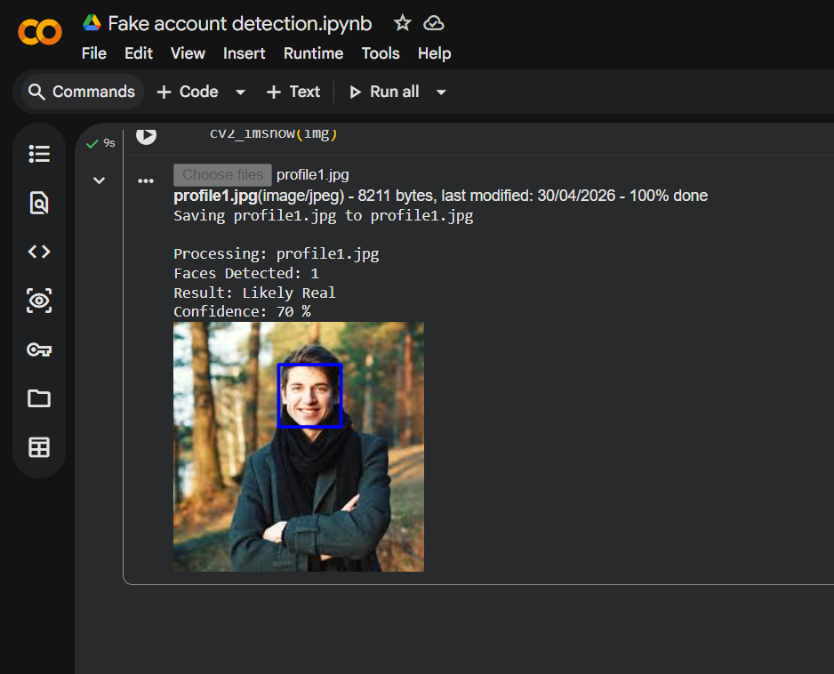

D. RESULTS AND ADVANTAGES
The Profile Picture Analysis for Fake Account Detection system provides several practical results and advantages compared to basic manual inspection methods of identifying fake accounts.
- Automated detection of suspicious profiles:
The system can automatically analyze profile images and detect whether they contain no face, a single face, or multiple faces, reducing the need for manual verification.
- Improved accuracy using visual analysis:
By applying computer vision techniques, the system is able to identify patterns that are commonly associated with fake accounts, such as the absence of human faces or the presence of multiple individuals in a profile image.
- Real-time and efficient processing:
The system processes images quickly and provides immediate results, making it suitable for analyzing multiple profile pictures in a short amount of time.
- Enhanced interpretability and visualization:
The system displays detected faces with bounding boxes and provides additional outputs such as confidence scores and reasoning, allowing users to clearly understand how the classification was made.
- Scalability through batch processing:
The system supports processing multiple images in a single run, demonstrating its ability to scale for analyzing larger datasets or multiple user accounts efficiently.
- Foundation for advanced systems:
Although the current implementation is rule-based, it serves as a strong baseline that can be extended with advanced machine learning or deep learning models to improve detection accuracy and handle more complex scenarios.
METHODOLOGY
The methodology of the Profile Picture Analysis for Fake Account Detection system is based on a structured computer vision pipeline that processes profile images and classifies them using rule-based analysis. The system follows a sequence of steps starting from image acquisition to final classification and visualization.
Initially, profile images are provided as input to the system through a user upload interface. The system supports multiple image inputs, allowing batch processing of several profile pictures in a single execution. Each uploaded image is read and prepared for further processing.
In the preprocessing stage, the input image is converted into grayscale format. This step reduces computational complexity and enhances the performance of the face detection algorithm, as color information is not required for detecting facial features. Grayscale images allow the model to focus on structural patterns such as edges and textures.
The core of the system is the face detection stage, which uses a pre-trained Haar Cascade classifier from the OpenCV library. This model scans the image at multiple scales and identifies regions that match human facial patterns. The output of this stage includes the number of faces detected and their corresponding coordinates in the image.
Following detection, the system performs feature analysis by calculating parameters such as the total number of detected faces and the relative size of each face compared to the overall image. These parameters are used to determine whether the detected face is prominent and suitable for a profile image.
Based on the extracted features, a rule-based classification approach is applied. If no face is detected, the image is classified as suspicious, as it may represent a non-human object such as a logo or graphic. If more than one face is detected, the image is also marked as suspicious, since personal profile pictures generally contain a single individual. If exactly one face is detected, the system further evaluates the size of the face; if the face is too small relative to the image, the profile is considered suspicious, otherwise it is classified as likely genuine.
Finally, the system generates output results including the classification label, confidence score, and reasoning behind the decision. It also visualizes the detection by drawing bounding boxes around detected faces on the image. These outputs help users understand the system’s decision-making process clearly.
This methodology demonstrates a simple yet effective application of computer vision techniques for identifying potentially fake accounts based on profile image characteristics, while maintaining computational efficiency and ease of implementation.
CONCLUSION
The Profile Picture Analysis for Fake Account Detection project demonstrates how computer vision techniques can be effectively applied to identify potentially fake or suspicious user accounts based on their profile images. By using a pre-trained Haar Cascade classifier, the system is able to detect human faces and analyze key features such as the number of faces and their relative size within the image.
The implementation follows a simple yet efficient rule-based approach, where images with no face or multiple faces are classified as suspicious, while images containing a single clear face are considered likely genuine. The addition of confidence scores, reasoning, and visual outputs enhances the interpretability of the system and makes the results easy to understand.
Although the current system is based on basic image processing and rule-based logic, it successfully demonstrates the core concept of automated fake account detection using visual data. The project is scalable, supports multiple image inputs, and can be extended further by integrating advanced machine learning or deep learning models for improved accuracy and robustness.
Overall, this project provides a practical and efficient solution for analyzing profile images and highlights the potential of computer vision in addressing real-world challenges such as fake account detection on digital platforms.
.

