 | SIMATS ENGINEERING  Department of Computer Science and Engineering  CSA15 Cloud Computing and Big Data Analytics  CO2 AT2 - VM Configuration and Security Evidence Workbook  Guided practical workbook for Azure VM, local VM, Docker container, security checks, recovery evidence and GitHub submission
Assessment Metadata
Course Code | CSA15
Course Title | Cloud Computing and Big Data Analytics
Assessment | CO2 AT2 - VM Configuration and Security Evidence
Submission Type | Individual digital workbook based on the same capstone title used in CO1 and CO2 AT1
Faculty | Dr C. Rajesh Babu
Employee ID | SSETSCS415
Submission Mode | Completed workbook, evidence screenshots and GitHub repository link through Google Classroom
How This Workbook Works
- Use the same capstone title carried from CO1 and CO2 AT1.
- Read each procedure block, perform the action, verify the checkpoint and then fill the response table.
- Use Azure first when account activation is available. Use the local VM path when Azure is blocked. Use Docker for container comparison. Use simulation only when practical deployment is blocked.
- Screenshots must show the student's actual configuration or verified simulation work. Hide credentials, keys, tokens and sensitive account details.
- Upload the completed workbook and evidence to GitHub, then submit the GitHub repository link through Google Classroom.
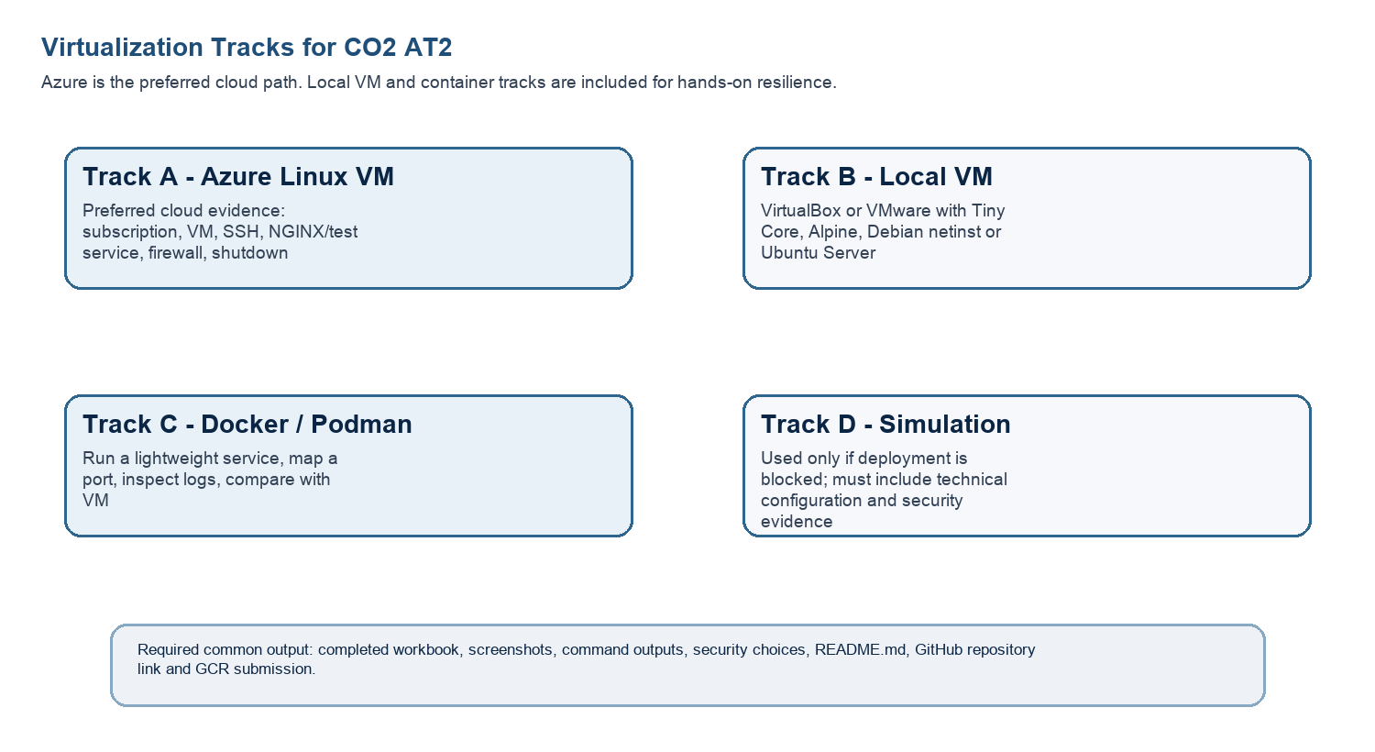
Technical Orientation
The practical work is not limited to clicking through screens. Each checkpoint requires observation: what appeared on screen, why it appeared, what it proves and how it connects to the capstone infrastructure plan.
Part 1: Student and Capstone Baseline
Student Name | VISWANATH SAI SANDEEP
Register Number | 192324029
Class / Slot | Slot B
Capstone Title | SecureVote: A Green Cloud-Based Campus Election Management System Using Audit Logs and Result Integrity
CO2 AT1 Recommended VM Size | vCPU: 2 RAM: 4GB Disk: 25GB
Selected Practical Track | Local VM
GitHub Repository Link | https://github.com/ViswanathSaiSandeep/CSA15-CO-Assesments-192324029/tree/main/CO2_AT2
Google Classroom Submission Date | 3/8/26
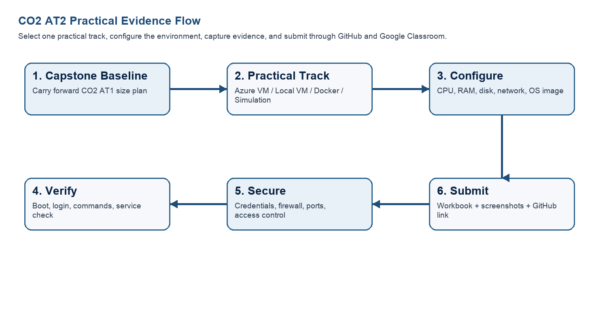
Capstone Infrastructure Element | Carry-Forward from CO2 AT1
Workload type | Cloud-based Web Application
Main application modules | User Authentication, Candidate Management, Voter Dashboard, Vote Casting, Audit Log System, Result Verification
Expected users / traffic assumption | Around 1000–5000 users during campus elections
Database need | Firebase
File storage need | Candidate Images, Election Documents, Audit Log Reports
AI/Python/analytics need | Python for result analysis, fraud detection and voting analytics
Security concern | Unauthorized voting, data tampering, SQL injection, identity verification
Recovery concern | Automated database backup, VM snapshot recovery, audit log restoration
Part 2: OS Image Selection Guide
Select the operating system image based on the available network, device capacity and learning objective. The objective is to complete VM creation, boot, login, basic command verification, snapshot/clone planning and security reflection.
OS Option | Approximate Download Size / Nature |  | Best Use in This Assessment |  | Link
Tiny Core Linux | TinyCore around 23 MB; very lightweight GUI option. |  | Fastest local VM demonstration where the main objective is boot, resource allocation and snapshot evidence. |  | https://distro.ibiblio.org/tinycorelinux/downloads.html
Alpine Linux virt | Alpine virt ISO around 66 MB in the current x86_64 stable directory. |  | Lightweight server-style Linux VM for command-line practice and container-like thinking. |  | https://dl-cdn.alpinelinux.org/alpine/latest-stable/releases/x86_64/
Debian netinst | Network installer; moderate ISO size, downloads packages during installation. |  | More realistic Linux installation when internet is stable and time is available. |  | https://www.debian.org/download
Ubuntu Server | Larger server ISO; familiar cloud VM image. |  | Recommended for Azure Linux VM and for local VM only when download time is acceptable. |  | https://ubuntu.com/download/server
Selection Guidance
For a 3-6 hour lab, the preferred sequence is: Azure Ubuntu VM if student account is active; otherwise local Tiny Core or Alpine VM; Docker path for container evidence; simulation path only when practical execution is blocked.
Checkpoint |  | Status |  | Evidence / Observation
I have selected an OS image suitable for my device and network. |  | [✅] Yes [ ] Rework
I have recorded the official download page or cloud image name. |  | [✅] Yes [ ] Rework
I have checked whether the ISO is small enough for the lab duration. |  | [✅] Yes [ ] Rework
Student Entry: Selected OS image, version, reason and link used
Selected OS: Ubuntu Server 24.04 LTS
Reason: Stable, secure, cloud-ready Linux server suitable for deploying SecureVote.
Official Download: https://ubuntu.com/download/server

Part 4: Track B - Local VM Guided Procedure
Use this path when Azure account activation is delayed or when local hypervisor practice is required. VirtualBox is recommended for broad accessibility. VMware Workstation/Fusion may be used where available.
VirtualBox downloads: https://www.virtualbox.org/wiki/Downloads
VMware Workstation and Fusion: https://www.vmware.com/products/desktop-hypervisor/workstation-and-fusion
A. Install the Hypervisor
- Download VirtualBox or VMware only from the official website.
- Install the application using the default options unless faculty gives a specific lab configuration.
- Restart the system if the installer requests it.
- Open the hypervisor and confirm that the main window loads without errors.
- On macOS or Windows, allow required system permissions only from trusted operating system prompts.
Item |  | Student Entry
Hypervisor selected |  | VirtualBox
Version |  | Oracle VM VirtualBox 7.x
Host operating system |  | Windows 11
Host CPU and RAM |  | AMD Ryzen 5 5500U, 16 GB RAM
Reason for selected hypervisor |  | VirtualBox is free, lightweight, easy to configure, and suitable for creating Linux virtual machines for SecureVote deployment and testing.
Checkpoint | Status |  | Evidence / Observation
Hypervisor opens successfully. | [✅ ] Yes [ ] Rework |  | VirtualBox launched without errors.
Student can locate New VM/Create VM option. | [✅ ] Yes [ ] Rework |  | "New" option is available on the VirtualBox dashboard.
Student has downloaded or selected a suitable OS image. | [✅] Yes [ ] Rework |  | Ubuntu Server 24.04 LTS ISO downloaded from the official website.
B. Create the VM
- Choose New VM or Create a New Virtual Machine.
- Enter a clear VM name such as csa15-localvm-yourregno.
- Select Linux as the type and the closest version available.
- Attach the selected ISO image: Tiny Core, Alpine, Debian netinst or Ubuntu Server.
- Allocate CPU based on CO2 AT1 sizing, but keep within safe host limits.
- Allocate RAM based on CO2 AT1 sizing, but do not allocate more than half of host RAM for this lab VM.
- Create a virtual disk. For Tiny Core or Alpine, 2-8 GB is enough for evidence. For Debian/Ubuntu, use 15-25 GB when storage permits.
- Finish creation and start the VM.
VM Setting | Recommended Lab Range | Student Value
VM name | csa15-localvm-regno | SecureVote-VM
OS image | Tiny Core / Alpine / Debian / Ubuntu | Ubuntu Server 24.04 LTS
vCPU | 1-2 for lightweight OS; 2+ if host allows | 2
RAM | 512 MB-2 GB lightweight; 2-4 GB Ubuntu | 4096MB (4GB)
Virtual disk | 2-8 GB lightweight; 15-25 GB Debian/Ubuntu | 25GB
Network mode | NAT for normal lab use | NAT
Display / boot mode | Default unless OS requires change | DEFAULT
Host Safety Guidance
Do not allocate all host resources to the VM. Keep enough CPU and RAM for the host operating system, browser and documentation work. If the host has 8 GB RAM, a 1 GB or 2 GB VM is more appropriate than a 6 GB VM.
Evidence Space: Paste VM settings screenshot before first boot

C. Boot and Verify the VM
- Start the VM and wait for the OS boot screen.
- For Tiny Core, confirm that the graphical desktop appears.
- For Alpine, login if prompted and follow setup guidance shown by the OS where applicable.
- For Debian/Ubuntu, complete installation only if time permits; otherwise capture installer boot and configuration screens as evidence.
- Open terminal inside the VM where possible.
- Run or record equivalent commands: uname -a, free -h, df -h and ip addr.
Checkpoint | Status | Evidence / Observation
VM starts without boot error. | [ ] Yes [ ] Rework | Ubuntu Server booted successfully without any startup errors.
OS screen or terminal is visible. | [ ] Yes [ ] Rework | Ubuntu terminal/login screen displayed successfully after boot.
CPU/RAM/disk allocation is verified. | [ ] Yes [ ] Rework | System information commands confirmed the configured CPU, RAM (4 GB), and 25 GB virtual disk allocation.
Network mode is recorded. | [ ] Yes [ ] Rework | NAT networking mode was successfully configured and the VM received a private IP address.
Evidence Space: Paste VM boot/login/terminal screenshots

D. Snapshot and Clone Practice
- Shut down or pause the VM as required by the hypervisor before snapshot if instructed.
- Create a snapshot named before-update-or-demo.
- Record snapshot name, date and reason.
- Create a linked clone or full clone if the device has enough storage. If not, write the reason and create a clone plan.
- Start the VM again and confirm it still boots.
Recovery Item | Student Evidence / Decision
Snapshot name | Before-Update
Snapshot timing | After Ubuntu installation and initial configuration
Snapshot reason | To restore the VM to a stable state before installing additional software.
Clone attempted? | Yes
Clone type | Full Clone
Storage impact observed | Additional storage was required for the cloned virtual machine.
Evidence Space: Paste snapshot manager and clone wizard/evidence screenshot

E. Local VM Security Reflection
Security Area | Student Decision
VM network mode | NAT
Why this mode is selected | NAT provides internet access while preventing direct inbound connections, making it safer for development.
Guest password policy | Strong password with uppercase, lowercase, numbers, and special characters.
Shared folders enabled? | No
Clipboard/drag-drop enabled? | Yes
Risk if VM is exposed to public network | Unauthorized access, brute-force attacks, malware, and potential data compromise.

Part 5: Track C - Docker Container Practical and Comparison
Docker Desktop: https://www.docker.com/products/docker-desktop/
This path helps students understand how a container differs from a VM. A VM virtualizes hardware and runs a guest OS. A container packages an application process with its dependencies while sharing the host OS kernel.
Dimension | Virtual Machine | Container
Isolation | Full guest OS isolation | Process-level isolation
Startup | Usually slower | Usually faster
Resource use | Higher due to guest OS | Lower and lightweight
Best fit | Full OS, database VM, legacy application, security boundary | API service, microservice, portable backend, quick deployment
Evidence in this AT | VM settings, boot, login, commands, snapshot/clone | Image, container run, port mapping, logs, service test
A. Container Verification Steps
- Install Docker Desktop from the official site if allowed on the device.
- Open Terminal or PowerShell and run: docker --version.
- Run a lightweight container such as: docker run --rm hello-world.
- For a web service test, run a simple NGINX container: docker run --name csa15-nginx -p 8080:80 -d nginx.
- Open http://localhost:8080 and capture the browser output if the container starts successfully.
- Check logs using: docker logs csa15-nginx.
- Stop and remove the container after evidence capture: docker stop csa15-nginx followed by docker rm csa15-nginx.
Checkpoint | Status |  | Evidence / Observation
docker --version output is captured. | [ ] Yes [ ] Rework |  | Docker Desktop version was displayed successfully in PowerShell/Terminal.
A container run command is captured. | [ ] Yes [ ] Rework |  | The hello-world and NGINX containers executed successfully without errors.
Port mapping or service evidence is captured if web test is used. | [ ] Yes [ ] Rework |  | NGINX container was mapped to port 8080, and the default web page was accessible through http://localhost:8080.
Container logs or status are captured. | [ ] Yes [ ] Rework |  | Container logs confirmed that the NGINX service started and ran successfully.
Container is stopped/removed after evidence capture. | [ ] Yes [ ] Rework |  | The container was stopped and removed successfully using docker stop and docker rm.
Docker Evidence |  | Student Observation
Docker version |  | Docker Desktop (Latest Installed Version)
Image used |  | nginx:latest
Container name |  | csa15-nginx
Port mapping |  | 8080:80
Service URL tested |  | http://localhost:8080
Log/status observation |  | Container started successfully and served the default NGINX webpage.
Stop/remove evidence |  | Container stopped and removed successfully using docker stop and docker rm.
Evidence Space: Paste Docker command and browser/service screenshots

B. Capstone Module Decision
Capstone Module | VM / Container / Managed Service | Technical Reason
Frontend | Container | Easy deployment and scalability for the web interface.
Backend/API | Container | Portable API service with consistent runtime.
Database | Virtual Machine | Better isolation, persistent storage, and secure database management.
File storage | Managed Service | Reliable, scalable, and durable storage for documents and reports.
AI/Python module | Container | Simplifies dependency management and deployment.
Analytics/dashboard | Container | Independent scaling and maintenance.
Notification/background job | Container | Lightweight service that can run independently.
C. Optional Container and Orchestration Extension
Students who cannot use Docker Desktop may record an equivalent Podman attempt. Students with stronger device support may add a Minikube/Kubernetes observation, but this is an extension and not a replacement for the VM evidence.
Podman: https://podman.io/
Minikube: https://minikube.sigs.k8s.io/docs/start/
Kubernetes documentation: https://kubernetes.io/docs/home/
Optional Tool | Possible Evidence | Student Observation
Podman | podman --version, image pull/run, logs, stop/remove evidence | Not attempted. Docker Desktop was used for the container practical.
Minikube | minikube start/status, kubectl get nodes/pods evidence | Not attempted due to time constraints and assignment scope.
Kubernetes | Simple deployment/service YAML or command evidence if attempted | Not attempted. Basic Docker container deployment was completed successfully for this assessment.

Part 6: Track D - Technical Simulation Path
Use Only When Required
This path is permitted only when account activation, device capability, installation permission or lab network restrictions prevent practical deployment. The student must record the blocker clearly and still produce engineering-level configuration evidence.
CloudSim: https://github.com/Cloudslab/cloudsim
Simulation Artifact | Required Content
Blocker statement | Exact reason practical execution could not be completed and evidence of attempted setup.
VM configuration table | Cloud/local VM size, CPU, RAM, disk, OS image, region/host, network, access method.
Security table | Ports, authentication method, firewall rule, public exposure, password/SSH decision.
Snapshot/clone plan | Names, timing, retention and rollback purpose.
Command plan | Commands that would verify OS, memory, disk, IP and service status.
Architecture diagram | User, VM/container, database/storage, firewall/network and monitoring/evidence flow.
Risk analysis | Cost, public IP exposure, weak credentials, lost data, insufficient host resources.
Blocker Evidence and Justification

Planned Configuration | Student Value
Platform | VirtualBox
OS image | Ubuntu Server 24.04 LTS
vCPU | 2
RAM | 4GB
Disk | 25GB
Network mode / firewall | NAT Networking with Ubuntu Firewall (UFW) enabled
Access method | Local Console / Terminal
Service to verify | NGINX Web Server
Paste or draw the simulation architecture diagram here

Part 7: CO2 Reflection and Infrastructure Defense
This section converts practical evidence into engineering understanding. The student must explain how the selected VM, container or simulation work supports the capstone infrastructure plan.
Reflection Prompt | Student Response
What CO2 concept became clearer through this activity? | This activity improved my understanding of virtualization, resource allocation, Linux server configuration, and how virtual machines support cloud-based application deployment.
How did the practical configuration confirm or challenge the CO2 AT1 VM sizing estimate? | The practical confirmed that a VM with 2 vCPUs, 4 GB RAM, and 25 GB storage provides sufficient resources for deploying and testing the SecureVote application in a development environment.
Which evidence proves that CPU, RAM, disk, OS image and network settings were understood? | The VM configuration screenshots, Linux command outputs (uname -a, free -h, df -h, ip addr), Docker execution results, and VirtualBox settings provide evidence that the infrastructure configuration was successfully understood and verified.
Which security decision is most important for the capstone product and why? | Restricting unnecessary network access and implementing strong authentication are the most important security decisions because SecureVote stores sensitive voter information and election results. These measures help prevent unauthorized access and protect data integrity.
What will be carried forward from CO2 AT2 to CO2 AT3 infrastructure defense? | Before production deployment, I would enable HTTPS, configure firewall rules, automate database backups, implement multi-factor authentication, monitor server health, and deploy the application on a secure cloud platform with high availability.
Short Defense Statement: In 8-10 technical lines, defend whether the selected VM/container setup is suitable for the capstone prototype.
The selected VirtualBox-based Ubuntu Server environment is suitable for developing and testing the SecureVote application because it provides an isolated and secure platform for deployment. The allocated resources (2 vCPUs, 4 GB RAM, and 25 GB storage) are sufficient for running the backend, database, and supporting services during development. NAT networking minimizes unnecessary public exposure while still allowing internet connectivity for software installation and updates. VM snapshots provide a reliable recovery mechanism before major configuration changes. Docker containers can be used for deploying application modules such as the backend API and analytics services, improving portability and scalability. The selected infrastructure supports secure development, audit logging, result integrity verification, and future migration to Microsoft Azure or another cloud platform. Overall, the chosen VM and container setup offers a cost-effective, secure, and scalable environment for the SecureVote prototype.

Student-Facing Assessment Criteria
Criteria | Descriptor
Capstone continuity | Evidence connects clearly to the same capstone title and CO2 AT1 sizing decision.
Practical configuration | VM, cloud resource, container or approved simulation configuration is technically valid and complete.
Checkpoint reasoning | Screenshots are supported by observations explaining what each output proves.
Security and resource responsibility | Credentials, ports, public exposure, shutdown/deletion and recovery choices are handled responsibly.
Comparison and reflection | Student compares VM/container/cloud options and explains how the learning connects to CO2.
Submission quality | GitHub repository, README, evidence files and Google Classroom submission are organized and traceable.
Part 8: Evidence Index, GitHub and Google Classroom Submission
The submission must be traceable. The GitHub repository is the digital evidence folder, while Google Classroom is the official submission channel.
Repository Item |  | Expected Content
README.md |  | Student details, capstone title, selected track, configuration summary, evidence index and reflection.
Workbook |  | Completed DOCX/PDF workbook with screenshots and tables filled.
Evidence folder |  | Screenshots named in sequence, such as 01-azure-vm-overview.png.
Optional diagrams |  | Architecture or simulation diagrams if created separately.
Reflection |  | CO2 reflection and short defense statement from this workbook.
Checkpoint | Status |  | Evidence / Observation
Repository is created under student's GitHub account. | [ ] Yes [ ] Rework
README.md is complete. | [ ] Yes [ ] Rework
Workbook is uploaded. | [ ] Yes [ ] Rework
Screenshots are uploaded and named clearly. | [ ] Yes [ ] Rework
Google Classroom submission contains the GitHub repository link. | [ ] Yes [ ] Rework
No passwords, private keys, tokens or sensitive account details are uploaded. | [ ] Yes [ ] Rework

Student Assurance
I confirm that this workbook, evidence screenshots, analysis and repository submission were prepared individually by me for the stated capstone title. I have not uploaded passwords, tokens, private keys or sensitive account information.
Student Name | VISWANATH SAI SANDEEP
Register Number | 192324029
Signature
Date
Faculty Verification
Faculty Name | Dr C. Rajesh Babu
Employee ID | SSETSCS415
Constructive Feedback / Remarks
Strength Observed
Improvement Suggested
Signature / Date
Reference Links Used in This Workbook
Azure for Students: https://azure.microsoft.com/en-us/free/students
Azure for Students offer details: https://azure.microsoft.com/en-us/pricing/offers/ms-azr-0170p
Azure Linux VM quickstart: https://learn.microsoft.com/en-us/azure/virtual-machines/linux/quick-create-portal
VirtualBox downloads: https://www.virtualbox.org/wiki/Downloads
VMware Workstation and Fusion: https://www.vmware.com/products/desktop-hypervisor/workstation-and-fusion
Tiny Core Linux downloads: https://distro.ibiblio.org/tinycorelinux/downloads.html
Alpine Linux downloads: https://alpinelinux.org/downloads/
Alpine virt ISO directory: https://dl-cdn.alpinelinux.org/alpine/latest-stable/releases/x86_64/
Debian netinst: https://www.debian.org/download
Debian network install: https://www.debian.org/CD/netinst/
Ubuntu Server: https://ubuntu.com/download/server
Docker Desktop: https://www.docker.com/products/docker-desktop/
Podman: https://podman.io/
Minikube: https://minikube.sigs.k8s.io/docs/start/
Kubernetes: https://kubernetes.io/docs/home/
CloudSim: https://github.com/Cloudslab/cloudsim

