 | SIMATS ENGINEERING  Department of Computer Science and Engineering
CSA15 Cloud Computing and Big Data Analytics
CO3 AT2 - Capstone Cloud Access and Service Integration Case Study Student Template
Course Code | CSA15 | Course Title | Cloud Computing and Big Data Analytics
Assessment | CO3 AT2 - Capstone Cloud Access and Service Integration Case Study | Submission Type | Individual digital case-study document
Faculty | Dr C. Rajesh Babu | Employee ID | SSETSCS415
Mode | Case study / capstone design reasoning | Submission | GitHub repository link through Google Classroom

How This Template Works
Read each case, connect it to the technical ideas learned in CO3 AT1, and then extend the design to your own capstone product. The answer must show cloud access, APIs, storage, serverless/event flow and edge/fog/cloud reasoning. Do not upload passwords, private keys, API tokens or sensitive personal data.

Student and Capstone Details
Student Name | VISWANATH SAI SANDEEP
Register Number | 192324029
Class / Slot | Slot B
Capstone Title | SecureVote: A Green Cloud-Based Campus Election Management System Using Audit Logs and Result Integrity
CO3 AT1 Evidence Link | https://github.com/ViswanathSaiSandeep/CSA15-CO-Assesments-192324029/tree/main/CO3_AT1
GitHub Repository Link | https://github.com/ViswanathSaiSandeep/CSA15-CO-Assesments-192324029/tree/main/CO3_AT2
Submission Date | 26-08-2026

Case 1: Cloud-Native Backend and Web API Architecture
Scenario
A food delivery company wants to deploy a cloud-native backend with web APIs, browser/mobile clients and shared cloud storage for receipts and delivery images. Design the architecture and explain the role of each component.

A. Case Architecture Diagram
Type response / paste diagram / add evidence here.
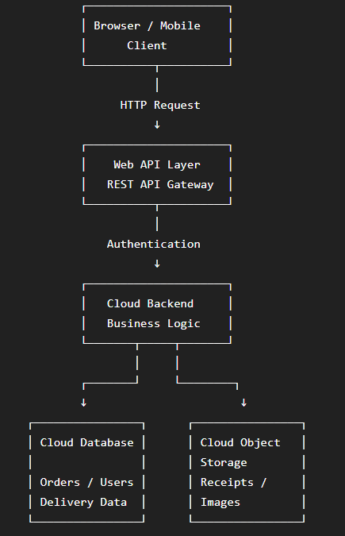

B. Component Role Explanation
Type response / paste diagram / add evidence here.
Browser / Mobile Client
The browser or mobile application provides the interface through which customers interact with the food-delivery system. It sends requests to the cloud application through web APIs.
Web API
The REST API provides a controlled communication layer between the client and the cloud backend. It receives requests, validates them and returns responses to the client.
Authentication
Authentication verifies the identity of the user before allowing access to protected operations such as placing orders or viewing personal information.
Cloud Backend
The cloud backend contains the business logic of the application. It processes requests, validates data and communicates with the database and cloud storage.
Cloud Database
The database stores structured application information such as users, restaurants, orders and delivery status.
Cloud Object Storage
Object storage stores files such as receipts and delivery images. It is suitable for file-based data because objects can be stored with associated metadata.
Monitoring / Logging
Monitoring and logging record application activity, errors and important events. This helps administrators identify failures and maintain the reliability of the application.

C. Capstone Extension: user-to-cloud workflow for your product
Type response / paste diagram / add evidence here.
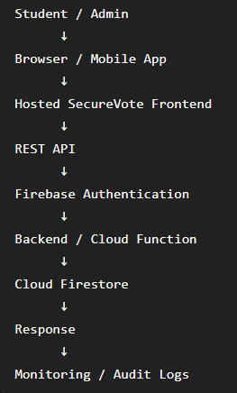

Case 2: Storage and Serverless Upload Workflow
Scenario
A media startup must decide between SAN-backed storage, object storage and serverless processing for upload workflows. Recommend a deployment model and justify it.
Data / Event | Best Storage | Serverless Action | Reason
Uploaded media files | Object Storage | Trigger processing function | Suitable for large files and scalable storage
Media metadata | Cloud Database | Validate and update metadata | Structured information needs database access
Image upload | Object Storage | Resize/validate image | Function can process the uploaded file automatically
Processing failure | Object Storage+Logs | Retry and record error | Prevents loss of processing information

A. Storage and Serverless Recommendation
Type response / paste diagram / add evidence here.
Object storage should be used as the primary storage model for uploaded media because it is suitable for large files and can scale as the amount of uploaded content increases. Serverless processing should be triggered when a new object is uploaded. The serverless function can validate the file, process it and update the related metadata. This avoids continuously running a server for event-based processing and allows processing to occur only when required.

B. Failure Handling and Cost/Performance Explanation
Type response / paste diagram / add evidence here.
If the serverless function fails during processing, the event should be retried where supported and the failure should be recorded in the application logs. Repeated failures can be sent for administrator or developer review. Object storage provides scalable storage for uploaded files, while serverless processing avoids the cost of keeping a dedicated processing server continuously active. However, frequent or large processing tasks can increase serverless execution costs and may be affected by execution or timeout limits.

C. Capstone Extension: one upload/event workflow
Type response / paste diagram / add evidence here.
In SecureVote, an administrator can upload a candidate image or election document through the application. The file is stored in Firebase Storage. The upload event can trigger a Firebase Cloud Function that validates the file type and performs any required processing. After successful processing, the related metadata can be stored in Cloud Firestore and the operation can be recorded in the audit log. If processing fails, the event can be retried and the failure can be recorded for administrator review.

Case 3: Edge, Fog and Cloud Placement
Scenario
A smart-city platform needs low-latency decision-making near sensors while still using the cloud for analytics. Decide what runs at edge, fog and cloud.
Task | Layer | Latency Need | Data Volume | Reason
Emergency vehicle detection | Edge | Very low | Medium | Immediate decision is required near the sensor
Traffic signal control | Edge | Very low | Low | Signal decisions should happen locally
Junction-level traffic aggregation | Fog | Low | High | Processes data from multiple nearby edge devices
Regional traffic coordination | Fog | Low –Medium | High | Coordinates multiple junctions before sending data to cloud

A. Edge/Fog/Cloud Architecture Explanation
Type response / paste diagram / add evidence here.
Edge computing should handle time-critical decisions directly near the sensors, such as emergency vehicle detection and traffic signal control. This reduces network delay because the data does not need to travel to the central cloud before a decision is made. Fog computing should handle intermediate processing such as junction-level aggregation and regional traffic coordination. It provides a processing layer between edge devices and the cloud. Cloud computing should handle long-term storage, city-wide analytics and dashboards because these workloads involve larger volumes of data and do not require immediate responses.

B. Capstone Extension or Direct Cloud Access Justification
Type response / paste diagram / add evidence here.
SecureVote can use direct cloud access for the current prototype because its main operations do not require physical sensors or extremely low-latency local processing. Students and administrators can access the system through a browser or mobile application. Authentication, voting operations, audit logging, storage and result processing can be handled by cloud services. Therefore, an edge or fog layer is not necessary for the current system.
If the system is extended in the future with offline polling-station devices, local QR verification or other location-sensitive operations, edge processing could be introduced for immediate local decisions. A fog layer could then coordinate multiple polling stations, while the cloud would remain responsible for centralized storage, analytics and reporting.

Final Capstone Cloud Access Architecture
☐ Show Browser/Mobile Client.
☐ Show hosted frontend or app access path.
☐ Show REST API endpoint and authentication check.
☐ Show backend/serverless logic.
☐ Show database, object/blob storage, logs and monitoring.
☐ Label the arrows: request, response, upload, event, notification or monitoring signal.

Final Diagram and Explanation
Type response / paste diagram / add evidence here.
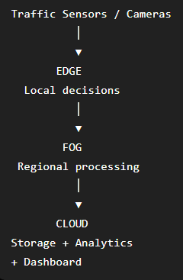

Submission Checklist
☐ Template completed in DOCX format.
☐ Diagrams pasted clearly in the document.
☐ GitHub repository contains DOCX/PDF, diagrams and README.
☐ Google Classroom submission contains GitHub link.
☐ Sensitive credentials are not visible anywhere.

Student Assurance
Declaration
I confirm that this case-study answer, cloud access design, diagrams and capstone extensions were prepared individually by me for the stated capstone title.
Student Signature: ___VISWANATH SAI SANDEEP___ Date: ______26-08-2026_______

