 | SIMATS ENGINEERING  Department of Computer Science and Engineering  CSA15 Cloud Computing and Big Data Analytics  CO2 AT3 - Capstone Cloud Infrastructure Case Analysis and Defense  Editable student template for application-based cloud virtualization and SDDC/cloud operations defense
Assessment Metadata
Course Code | CSA15
Course Title | Cloud Computing and Big Data Analytics
Assessment | CO2 AT3 - Capstone Cloud Infrastructure Case Analysis and Defense
Submission Type | Individual digital case analysis and infrastructure defense based on the same capstone title used in CO1, CO2 AT1 and CO2 AT2
Faculty | Dr C. Rajesh Babu
Employee ID | SSETSCS415
Submission Mode | Completed DOCX template and GitHub repository link through Google Classroom
How This Template Works
- Use the same capstone title used in CO1, CO2 AT1 and CO2 AT2.
- Do not recalculate all VM sizing or repeat all configuration screenshots. Summarize the final AT1/AT2 evidence and use it for design defense.
- Answer all five questions with application-oriented reasoning connected to the capstone product.
- Include sustainable cloud operation decisions wherever relevant: right-sized resources, log retention, storage lifecycle, scheduled shutdown, API-call reduction and VM/container/serverless comparison.
- Paste the final topology diagram in the given response area. The sample diagram is only a structure; redraw it for the student's own product.
- Upload this completed document and supporting evidence to GitHub, then submit the repository link through Google Classroom.
Assessment Focus
AT1 answered what VM is required. AT2 showed configuration or simulation evidence. AT3 asks whether the student can defend the complete infrastructure design under application, security, operations and failure conditions.
Student and Capstone Details
Student Name | VISWANATH SAI SANDEEP
Register Number | 192324029
Class / Slot | Slot B
Capstone Title | SecureVote: A Green Cloud-Based Campus Election Management System Using Audit Logs and Result Integrity
CO1 Evidence Link | https://github.com/ViswanathSaiSandeep/CSA15-CO-Assesments-192324029/tree/main/C02_AT1
CO2 AT1 VM Recommendation | vCPU: 4 RAM: 8GB Storage: 50GB VM Class: Medium Virtual Machine
CO2 AT2 Evidence Link | https://github.com/ViswanathSaiSandeep/CSA15-CO-Assesments-192324029/tree/main/CO2_AT2
GitHub Repository Link | https://github.com/ViswanathSaiSandeep/CSA15-CO-Assesments-192324029/tree/main/CO2_AT3
Submission Date | 5-08-2026
Evidence Carry-Forward Summary
Evidence Source | Student Entry | How It Supports AT3 Defense
CO1 concept map / presentation | SecureVote cloud architecture with Firebase services, audit logs and secure voting workflow | Provides the functional cloud architecture and identifies the major cloud services used in the capstone.
CO2 AT1 sizing workbook | VM sizing completed (4 vCPU, 8 GB RAM, 50 GB SSD), workload analysis and virtualization planning | Justifies infrastructure sizing, resource allocation and deployment strategy for the application.
VM calibration sheet | CPU, RAM, storage, workload and virtualization calculations | Demonstrates that the selected VM resources are technically suitable for the expected workload.
CO2 AT2 practical evidence | Ubuntu Server VM, VirtualBox, Docker container, snapshot, clone and security configuration | Confirms the practical implementation of virtualization, security configuration and recovery mechanisms.
Capstone architecture decision | Managed Firebase services with VM support and containerized application modules | Supports the final cloud deployment model used throughout the infrastructure defense.
Q1: Virtualization Value and Capstone Cloud Deployment Summary
Explain your capstone product, expected workload, cloud need and deployment context. Analyze how virtualization improves cost efficiency, resource utilization, workload isolation, infrastructure flexibility and cloud deployment readiness for your product.
Design Point | Student Response
Capstone product and users | SecureVote is a cloud-based campus election management system used by students, election officers, and administrators for secure voting, election management, audit logging, and result verification.
Expected workload | Moderate workload during normal days and high concurrent traffic during campus elections, with approximately 1,000–5,000 active users accessing the system simultaneously.
Cloud need | Cloud infrastructure provides scalability, high availability, secure data storage, backup, authentication, and remote access while reducing infrastructure management overhead.
Virtualization value | Virtualization enables isolated virtual machines for secure application deployment, efficient resource allocation, simplified management, rapid provisioning, and easy migration to cloud platforms.
Cost and utilization benefit | Virtualization allows multiple workloads to share physical hardware efficiently, reducing infrastructure cost while improving CPU, memory, and storage utilization. Resources can also be scaled based on application demand.
Isolation and flexibility benefit | Each virtual machine operates independently, preventing failures in one service from affecting others. Snapshots, cloning, and migration improve flexibility for testing, maintenance, and disaster recovery.
Case Analysis Response: Write 8-12 technical lines connecting virtualization value to your capstone product.
The SecureVote application is a cloud-based campus election management system designed to provide secure voting, audit logging, and result integrity for students and election administrators. The application experiences moderate traffic during normal operation and significantly higher traffic during election periods, making cloud infrastructure an appropriate deployment choice. Virtualization provides isolated computing environments that improve security, simplify deployment, and efficiently utilize hardware resources. A properly sized virtual machine supports application hosting while managed cloud services such as Firebase handle authentication, database management, and storage. Resource isolation reduces the risk of application failures affecting other services. Virtual machines also simplify maintenance through snapshots, cloning, and rollback capabilities before major updates. The infrastructure can easily scale to accommodate increasing user demand without redesigning the entire system. This approach provides a secure, reliable, and cost-effective cloud environment while supporting future migration to larger cloud platforms if required. This aligns with the AT3 requirement to connect virtualization benefits to your capstone deployment.
Q2: Rapid Provisioning, Testing and Virtual Machine Lifecycle Case
Using your CO2 AT1 VM recommendation and CO2 AT2 practical evidence, explain how virtual machines, VM images, templates, snapshots, clones or containers support rapid provisioning, testing, deployment, rollback and maintenance for your capstone product.
Lifecycle Element | AT1/AT2 Evidence Used | Capstone Use / Justification
VM image or base environment | Ubuntu Server 24.04 LTS Virtual Machine created in VirtualBox. | Provides a stable, secure, and cloud-compatible operating system for developing and testing the SecureVote application.
Template or repeatable setup | Standard VM configuration (4 GB RAM, 2 vCPU for practical, Ubuntu Server, NAT networking). | Allows identical environments to be recreated quickly for development, testing, and demonstrations.
Snapshot / rollback | Snapshot created before software installation and configuration changes. | Enables quick recovery if updates fail or configuration errors occur, ensuring minimal downtime.
Clone / testing copy | Full VM clone created during the practical session. | Creates an independent testing environment where new features can be evaluated without affecting the main system.
Container or VM decision | Docker containers for backend services and Virtual Machine for secure operating environment. | Containers improve portability and scalability, while the VM provides isolation and security for application deployment.
Maintenance and update plan | Regular VM snapshots, Docker image updates, system patches, database backups, and security monitoring. | Ensures the SecureVote platform remains secure, reliable, and easy to maintain throughout its lifecycle.
Case Analysis Response: Explain how lifecycle practices reduce deployment delay and risk.
Virtual machine lifecycle management significantly reduces deployment time and operational risk for the SecureVote application. A standardized Ubuntu Server VM image enables rapid provisioning of new development and testing environments. Using repeatable VM templates ensures that every deployment follows the same secure configuration, reducing setup errors. VM snapshots provide a reliable rollback mechanism before software updates or configuration changes, allowing quick recovery if problems occur. Full VM clones create isolated testing environments where new features can be validated without affecting the production system. Docker containers simplify application deployment by packaging the backend with all required dependencies, ensuring consistent execution across environments. Regular maintenance through operating system updates, Docker image updates, automated backups, and security monitoring improves reliability and system availability. These lifecycle practices minimize deployment delays, reduce operational risks, and provide a stable, secure, and scalable infrastructure for the SecureVote cloud platform.

Q3: Final Cloud Deployment Topology and SOA/API Service Integration Case
Draw and explain the final deployment topology for your capstone product. Show frontend, backend/API, database, storage, authentication, notification, analytics and any VM/container/managed cloud service components. Explain how SOA/API-based integration connects these modules and supports modular cloud service design.
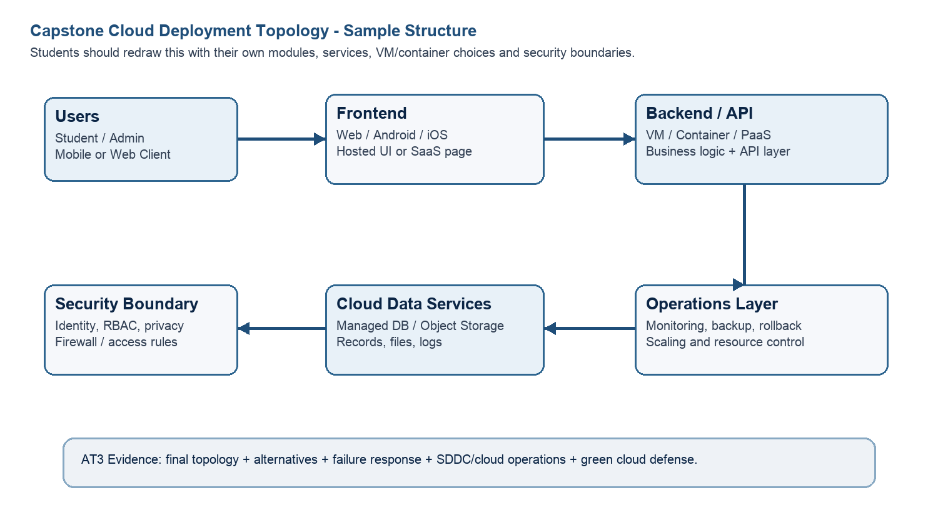
Architecture Component | Technology / Service | VM / Container / Managed Service / SaaS | Integration Method
Frontend | HTML, CSS, JavaScript, Firebase Hosting | Managed Service | HTTPS requests and Firebase SDK
Backend/API | Firebase Cloud Functions (Node.js) | Serverless Managed Service | REST API / HTTPS API Calls
Database | Cloud Firestore | Managed Service | Firebase SDK & REST API
Storage | Firebase Storage | Managed Service | Secure File Upload API
Authentication | Firebase Auth | Managed Service | Email/Password Authentication with JWT Tokens
Notification | Firebase Cloud Messaging (FCM) | Managed Service | Push Notification API
Analytics / AI module | Firebase Analytics & Python Result Analysis | Container (Python) + Managed Analytics | REST API and Firestore Data Access
Paste or draw the final capstone deployment topology diagram here.
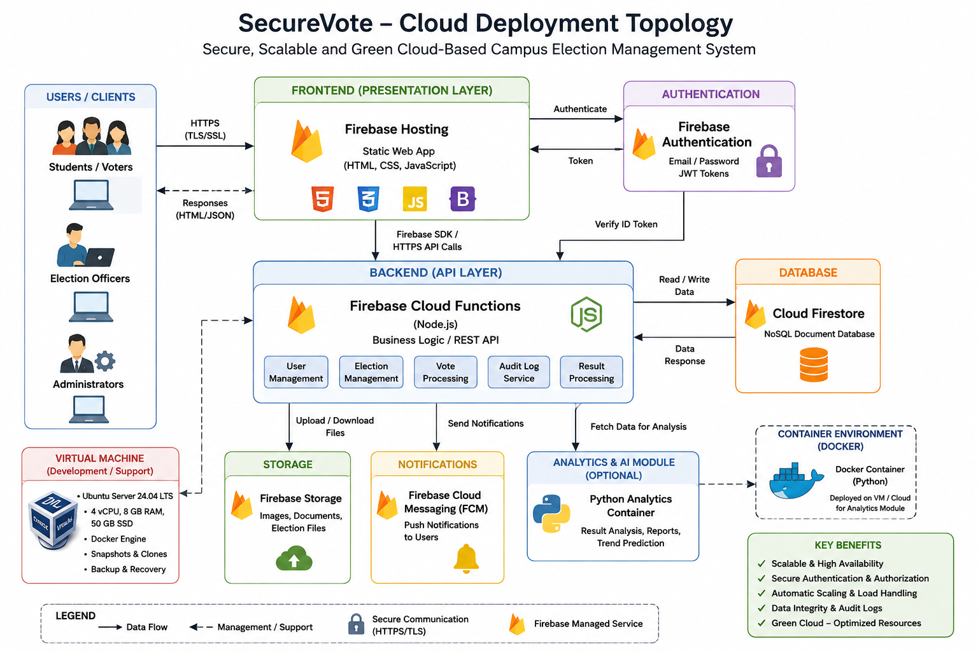
SOA/API Integration Explanation: Explain how services communicate and why modular service design is useful.
The SecureVote platform follows a Service-Oriented Architecture (SOA) where each cloud service performs a dedicated function while communicating through secure APIs. The frontend interacts with Firebase Authentication to verify user identity before accessing protected services. Business operations such as vote submission, election management, and audit logging are processed through Firebase Cloud Functions, which communicate with Cloud Firestore using secure API calls. Firebase Storage manages candidate images and election documents independently, while Firebase Cloud Messaging delivers notifications to users. The Python analytics module retrieves voting data from Firestore to generate reports and detect voting trends without affecting the core application. This modular architecture improves scalability, maintainability, fault isolation, and future service expansion because each component can be updated or scaled independently without impacting the overall system.
Q4: Design Alternatives, Identity, Access and Federated Cloud Privacy Case
Compare at least two deployment alternatives for your capstone product, such as single VM, multi-tier VM, containerized deployment, managed backend, federated cloud or hybrid cloud model. Justify the selected design by analyzing identity management, role-based access control, federated access, data sharing, privacy protection and security risks.
Deployment Alternative | Advantages | Limitations / Risks | Identity and Privacy Impact
Alternative 1 | Easy to deploy, low cost, simple management for small applications. | Limited scalability, single point of failure, higher maintenance effort. | User authentication and data protection depend on manual server configuration.
Alternative 2 | High availability, automatic scaling, built-in authentication, managed database, backup, and security. | Internet dependency and limited server-level customization. | Strong identity management using Firebase Authentication, encrypted communication, and secure cloud-managed access control.
Selected design | Automatic scaling, reduced maintenance, secure authentication, high reliability, simplified deployment, and easy future expansion. | Vendor dependency and cloud service costs as usage increases. | Provides centralized identity management, role-based access control, encrypted data transmission, and secure handling of sensitive election information.
Security Area |  | Student Decision
User roles |  | Student, Election Officer, Administrator
Authentication method |  | Firebase Authentication using Email/Password with secure authentication tokens
Role-based access control |  | Firebase Security Rules restrict access according to user roles and permissions
Federated access / partner access |  | Can be extended to Google Sign-In or institutional Single Sign-On (SSO) if required in future
Sensitive data handled |  | Student information, voter identity, election records, votes, audit logs, and result data
Privacy protection decision |  | HTTPS communication, Firebase Security Rules, encrypted cloud storage, least-privilege access, regular backups, and audit logging protect sensitive information.
Case Analysis Response: Defend why the selected design is better for identity, access and privacy.
The selected managed cloud architecture using Firebase services provides stronger identity management and privacy protection than a traditional single virtual machine deployment. Firebase Authentication securely verifies user identities while role-based access control ensures that students, election officers, and administrators can access only authorized resources. Sensitive information such as voter identities, election records, audit logs, and results is protected through encrypted communication using HTTPS and Firebase Security Rules. Managed cloud services automatically provide backup, high availability, and security updates, reducing operational complexity and minimizing configuration errors. The architecture can also support federated authentication such as Google Sign-In or institutional Single Sign-On in future deployments. Compared with a standalone VM, the selected design offers better scalability, stronger security, simplified management, and improved protection of confidential election data, making it well suited for the SecureVote cloud platform.
Q5: Software-Defined Datacenter and Cloud Operations Defense Case
Analyze how your infrastructure will respond to operational and failure scenarios such as VM failure, database growth, traffic spike, credential leakage, service outage, resource contention or cost increase. Explain how SDDC concepts and cloud operations practices such as automated provisioning, software-defined networking, software-defined storage, monitoring, logging, backup, rollback, scaling, resource control and maintenance improve the final infrastructure design. Include Green Computing decisions such as resource right-sizing, storage lifecycle control, log retention, API-call reduction, scheduled shutdown, VM/container/serverless comparison and carbon/energy proxy indicators where relevant.
Operational / Failure Scenario | Expected Impact | SDDC / Cloud Operations Response | Evidence or Control
VM failure | Application becomes temporarily unavailable. | Restore the VM using snapshots or redeploy from the VM image. | VM snapshots, VirtualBox backup, GitHub documentation
Database growth | Increased storage usage and slower queries. | Cloud Firestore automatically scales storage and indexing. | Firebase managed database with automatic scaling.
Traffic spike | High CPU usage and increased response time. | Firebase Hosting, Cloud Functions, and Firestore automatically scale resources. | Cloud auto-scaling and load balancing.
Credential leakage | Unauthorized access to cloud resources. | Reset credentials immediately, enable MFA, rotate API keys, and review audit logs. | Firebase Authentication, Security Rules, Audit Logs.
Service outage | Temporary interruption of application services. | Deploy backups, use redundant cloud services, and restore from snapshots or backups. | Backup strategy and cloud redundancy.
Resource contention | Reduced VM performance due to limited CPU/RAM. | Allocate additional resources or migrate services to containers or managed cloud services. | Resource monitoring and VM resizing.
Cost increase | Higher cloud operating expenses. | Optimize resources, remove unused services, monitor usage, and implement cost alerts. | Cloud monitoring and billing dashboard.
Operational Readiness Area |  | Student Plan
Automated provisioning |  | Deploy standard VM templates and Infrastructure-as-Code (IaC) where applicable for repeatable deployments
Software-defined networking |  | Secure virtual networking with HTTPS communication, firewall rules, NAT networking, and controlled API access
Software-defined storage |  | Use Firebase Storage with automatic redundancy, scalable object storage, and lifecycle management.
Monitoring and logging |  | Monitor application health, authentication events, audit logs, and cloud resource usage using Firebase and cloud monitoring tools.
Backup and rollback |  | Create VM snapshots before major changes and maintain automated database backups for disaster recovery.
Scaling and elasticity |  | Use managed cloud services that automatically scale based on workload and user demand.
Resource control and maintenance |  | Perform regular operating system updates, dependency updates, security patches, and resource optimization.
Green Computing and sustainability control |  | Use right-sized resources, managed cloud services, optimized storage, efficient APIs, and automatic scaling to reduce energy consumption.
Green Cloud Decision |  | Student Justification
VM right-sizing from CO2 AT1 |  | Use a 4 vCPU, 8 GB RAM, and 50 GB SSD VM to avoid unnecessary resource allocation while supporting the expected workload.
VM vs container vs serverless choice |  | Managed Firebase services and serverless Cloud Functions reduce infrastructure overhead, while containers are used only where portability is required.
Scheduled shutdown / idle-resource control |  | Shut down development VMs when not in use to reduce power consumption and operational costs.
Log and file retention policy |  | Retain audit logs according to institutional policy and archive or remove outdated logs periodically.
Storage lifecycle and backup cleanup |  | Delete unnecessary backups, temporary files, and obsolete documents after the retention period to optimize storage usage.
API-call or polling reduction |  | Use event-driven Firebase listeners instead of continuous polling to reduce unnecessary API requests and improve efficiency.
Carbon/energy proxy indicator to track |  | Monitor CPU utilization, storage consumption, network usage, and cloud resource utilization to improve energy efficiency and reduce infrastructure waste.
Final Infrastructure Defense Statement: State whether the design is ready for prototype, pilot or production. Defend reliability, security, SDDC/cloud operations and Green Computing improvements required next.
The proposed SecureVote cloud infrastructure is suitable for a prototype deployment and can be extended to a pilot deployment with minimal architectural changes. The combination of managed Firebase services, VirtualBox-based development, and containerized analytics provides a secure, scalable, and cost-effective solution. Virtualization simplifies deployment, testing, backup, and recovery through snapshots and cloned environments. Managed cloud services automatically provide scalability, authentication, storage management, and high availability while reducing administrative effort. Software-Defined Datacenter principles such as automated provisioning, virtual networking, software-defined storage, monitoring, backup, rollback, and elastic resource allocation improve operational reliability. Green Computing practices including right-sized virtual machines, serverless services, efficient API usage, storage lifecycle management, and scheduled shutdown of development resources further reduce operational costs and energy consumption. Overall, the infrastructure provides strong security, high reliability, operational flexibility, and sustainable cloud computing practices while supporting future production deployment.
CO2 Reflection and Individual Defense
This section must be individually written. It should show what the student understands from the complete CO2 chain: infrastructure sizing, practical configuration evidence and final operations defense.
Reflection Prompt | Student Response
What is the strongest infrastructure decision in your capstone design? | Using managed Firebase cloud services combined with a right-sized virtual machine is the strongest infrastructure decision because it provides scalability, security, automatic backup, and reduced maintenance while supporting secure election management.
Which CO2 concept became clearer after AT1, AT2 and AT3? | The relationship between virtualization, cloud deployment, resource sizing, VM lifecycle management, containers, and Software-Defined Datacenter operations became much clearer after completing all three assessments.
Which risk is most serious for your capstone: failure, cost, privacy, scaling or sustainability? | Privacy and security are the most critical risks because the SecureVote system stores sensitive voter information, authentication details, audit logs, and election results that must remain confidential and tamper-proof.
What evidence would you show during viva to defend your infrastructure design? | I would present the CO1 architecture diagram, CO2 AT1 VM sizing calculations, VirtualBox configuration, Ubuntu Server deployment, Docker container execution, snapshot and clone evidence, GitHub repository, and the final deployment topology to demonstrate that the infrastructure was properly designed, implemented, and validated.
What will you improve before final capstone deployment? | Before production deployment, I will implement Multi-Factor Authentication (MFA), HTTPS with SSL certificates, continuous monitoring, automated backup scheduling, disaster recovery planning, container orchestration, cost optimization, advanced logging, and security auditing to improve reliability, security, and scalability.

Student-Facing Assessment Criteria
Criteria | Descriptor
Capstone continuity | The answer uses the same capstone title and connects CO1, CO2 AT1 and CO2 AT2 evidence.
Virtualization and lifecycle reasoning | VM, image, snapshot, clone, container or managed-service decisions are technically justified.
Topology and integration clarity | Architecture diagram and SOA/API explanation show clear module interaction.
Identity, access and privacy | Roles, authentication, RBAC, federated access, sensitive data and privacy decisions are defended.
SDDC/cloud operations | Failure response, monitoring, logging, scaling, backup, rollback and resource control are addressed.
Green Computing defense | Right-sizing, retention, API efficiency, idle-resource control and sustainable cloud choices are explained.
Submission quality | GitHub, template completion, evidence references and individual reflection are complete.
GitHub and Google Classroom Submission
Repository Item | Expected Content
README.md | Capstone title, student details, final VM recommendation, deployment topology summary and AT3 evidence index.
Completed AT3 document | This completed editable DOCX or exported PDF if instructed.
Diagram image | Final topology diagram if created separately.
Evidence references | Links or screenshots from CO1, CO2 AT1 and CO2 AT2 as needed.
Green Computing note | Short README section explaining sustainable cloud choices and resource-control decisions.
Google Classroom | Submit the GitHub repository link through GCR.
Student Assurance
I confirm that this case analysis, design reasoning, topology diagram and final defense statement were prepared individually by me for the stated capstone title. I have not uploaded passwords, tokens, private keys or sensitive account information.
Student Name
Register Number
Signature
Date

Faculty Verification
Faculty Name | Dr C. Rajesh Babu
Employee ID | SSETSCS415
Constructive Feedback / Remarks
Strength Observed
Improvement Suggested
Signature / Date

