 | SIMATS ENGINEERING  Department of Computer Science and Engineering
CSA15 Cloud Computing and Big Data Analytics
CO4 AT3 - Big Data Reverse Engineering Task Workbook
Course Code | CSA15 | Slot | B
Assessment | CO4 AT3 | Bloom Level | BL4 - Analyze
Faculty | Dr C. Rajesh Babu | Employee ID | SSETSCS415
Mode | Individual guided reverse-engineering workbook | Submission | GitHub repository link through Google Classroom
End Evidence | Workbook + screenshots + diagrams + presentation | Marks | 30

Student Details
Student Name | VISWANATH SAI SANDEEP | Register Number | 192324029
Class / Section | CSA15 / AI & Data Science | Slot | B
Selected Platform | Swiggy (Food Delivery) | Submission Date | 26-08-2026
GitHub Link | https://github.com/ViswanathSaiSandeep/CSA15-CO-Assesments-192324029/tree/main/CO4_AT3 | Google Classroom Status
Workbook Purpose
What this workbook does
This workbook guides students to reverse-engineer a real, known digital platform purely from observable behaviour — no source code or internal documentation — and infer its likely data pipeline, analytics approach, privacy/security risks and the business decisions that analytics probably drives.

• Do not claim access to private source code or internal documentation you do not actually have.
• Base every inference on observable evidence: app/website behaviour, published engineering blogs, app store listings, public API docs, news articles, the privacy policy.
• Screenshots and cited sources are evidence; your reasoning is the actual assessment answer.
• Being explicit about what you are confident about versus what you are guessing is part of the grade, not a weakness.

Platform Bank
Instruction
Faculty may assign one platform or allow student choice. If self-selecting, pick a platform you personally use and can observe closely (create test interactions, check settings and notifications, read the privacy policy) rather than one you only know by reputation.

No. | Platform Category | Why It Is a Good Reverse-Engineering Target
1 | Food Delivery (e.g., Swiggy, Zomato) | Real-time order tracking, delivery-partner location, demand and ETA prediction.
2 | Streaming (e.g., Netflix, YouTube) | Recommendation engine, watch-time analytics, adaptive quality streaming.
3 | Ride-Hailing (e.g., Ola, Uber) | Real-time GPS matching, surge pricing, ETA prediction.
4 | E-Commerce (e.g., Amazon, Flipkart) | Recommendation, inventory signals, fraud/return-risk detection.
5 | Social Media (e.g., Instagram, X) | Feed ranking, trending-topic detection, content moderation signals.

Selected Platform and Reason
Selected Platform: Swiggy (Food Delivery - Platform Category 1).
Reason for selection: Swiggy is a platform I actively use, which lets me observe real behaviour first-hand (search, restaurant browsing, cart, live order tracking) rather than relying on secondhand descriptions. It is also an excellent reverse-engineering target because it visibly exposes several distinct data-processing regimes in a single app: near-instant search/autocomplete, real-time delivery-partner GPS tracking and ETA updates, and slower, clearly batch-driven signals such as personalized recommendations and 'frequently reordered' suggestions - giving enough variety to meaningfully practice classifying features as real-time versus delayed and inferring the architecture behind each.

Guided Tool Module 1: Observe the Platform Directly (Behavioural Reconnaissance)
Purpose: Collect observable evidence of how the platform actually behaves under normal and edge-case use, before inferring any internal architecture. Follow every sub-step below in order.
Step 1.1: Open the Platform and Sign In
• Mobile app: open the Play Store (Android) or App Store (iPhone), search the exact platform name, tap Install if not already installed, then open it.
• Website: open any browser, type the exact web address, and press Enter.
• Log in, or create a free test account if you don't already have one. Never enter real payment card details for this exercise.

Student Note
Take one screenshot of the home/landing screen right now. This is your first evidence item — label it "01_home_screen".

Step 1.2: Perform 5 Common Actions and Time Each One
Purpose: Generate real, observable behaviour you can analyze in later steps.
• Action 1 — Search: use the search bar to look for something relevant (a dish, a movie, a destination, a product, or a hashtag depending on your platform).
• Action 2 — Open a detail page: tap/click into one result (a restaurant page, a video page, a ride option, a product page, or a post).
• Action 3 — Commit an action: add to cart, add to watchlist, select a ride, or follow an account.
• Action 4 — Trigger a notification-worthy event: start an order, start playback, request a ride, or like a post. Stop and cancel BEFORE any real payment step.
• Action 5 — Open Settings/Profile and note what fields exist (saved address, saved payment methods, notification preferences).
• For every action, use your phone/laptop clock (or say the seconds out loud and time yourself) from the moment you tap/click to the moment the screen fully updates.

Student Note
Fill one row of the "Observed Feature" table below for each of these 5 actions as you go — do not wait until the end to write them down from memory.

Step 1.3: Open Browser DevTools and Watch Data Requests (Website Only)
Purpose: See the platform's backend calls directly, instead of guessing.
• Right-click anywhere on the page and choose Inspect (or press F12 on Windows, or Cmd+Option+I on Mac).
• In the panel that opens, click the "Network" tab along the top.
• Click the "Fetch/XHR" filter button so only data requests show, not images or fonts.
• Tick "Preserve log" if visible, then refresh the page (F5) with the Network tab still open.
• Repeat Action 1 from Step 1.2 (search) while watching the Network panel — new rows will appear as you type or press Enter.
• Click on one new row. Read its "Name" (the endpoint being called) and its "Time" (how long it took).

Student Note
Never copy long token/key strings from the Headers tab. Only note the endpoint name pattern (for example "/api/search?q=...") and its response time in milliseconds.

Step 1.3 (App Alternative): If You Only Have a Mobile App, Use Loading-Time Evidence Instead
• Mobile apps don't show DevTools, so use what you can already see: which screens update the instant you tap something, and which show a spinner/loading animation first.
• Write in your notes: "Mobile app — network inspection not available; used on-screen loading-time evidence instead."

Step 1.4: Classify Each Feature as Real-Time or Delayed
• Go back through your 5 actions from Step 1.2, one at a time.
• Ask: did the change appear in under 1 second (Real-Time)? Did it take a few seconds but always arrive (Near-Real-Time)? Did it only appear after a refresh or a while (Delayed/Batch)?
• Write your answer for each action into the "Real-Time or Delayed" column of the table below.

Step 1.5: Search for the Platform's Official Engineering Blog
• Open a search engine and search exactly: "[platform name] engineering blog".
• Also search: "[platform name] how we built" and "[platform name] system design".
• Also check the platform's careers page (search "[platform name] careers") for a Tech Blog or Engineering link, and search YouTube for "[platform name] tech talk".
• If you find a genuine official source, write its exact title and paste the link.
• If nothing turns up after all three searches, write: "No official engineering source found after searching [search 1], [search 2], [search 3]." This is an acceptable, honest answer.

Step 1.6: Read the Privacy Policy and Permissions List
• On the app: open Settings, then look for About/Legal, then Privacy Policy.
• On the website: scroll to the very bottom of the homepage and click the "Privacy Policy" link in the footer.
• Press Ctrl+F (Windows) or Cmd+F (Mac) and type "collect" to jump straight to the data-collection section instead of reading the whole document.
• Note every data type mentioned: location, contacts, camera, device ID, payment info, browsing history, and so on.
• Also check phone-level permissions: Android — Settings > Apps > [App Name] > Permissions. iPhone — Settings > [App Name].

Student Note
Record every permission and data type you found directly in the Behavioural Evidence Log box below.

Observed Feature | Real-Time or Delayed | What This Suggests About Processing
Search bar - typing a dish/restaurant name (e.g. 'biryani') and viewing autocomplete + results | Real-Time (results and suggestions updated within under 1 second of typing, no visible spinner) | Suggests an indexed, low-latency search service (search-as-you-type) sitting close to the edge, likely backed by an in-memory or search-optimized index rather than a full database scan per keystroke.
Opening a restaurant's detail page (menu, ratings, delivery time estimate) | Near-Real-Time (page content appeared in roughly 1-2 seconds, with a brief loading skeleton shown first) | Suggests the menu/catalog data is served from a caching layer or CDN rather than computed live, while the delivery-time estimate shown on the same page looked like it was being freshly calculated (very slight extra delay before that field populated), implying it is fetched from a separate, real-time ETA microservice.
Adding an item to cart and viewing the live order tracking map after placing a test order | Real-Time (cart total updated instantly; the delivery-partner marker on the tracking map moved and refreshed every few seconds without manually refreshing the page) | Strongly suggests a streaming/event-driven pipeline: the delivery partner's app is continuously publishing GPS pings, which are consumed by a location/ETA service and pushed to my screen via a live connection (e.g. WebSocket/long-poll) rather than the app polling a static database.
Home screen 'Recommended for you' and 'Reorder' sections | Delayed/Batch (the same recommended restaurants appeared across multiple app opens within the same day, and did not change immediately after browsing a new cuisine) | Suggests these recommendations are precomputed on a schedule (e.g. a nightly or hourly batch job over historical order and browsing data) rather than being regenerated instantly after every user action.

Behavioural Evidence Log

Guided Tool Module 2: Infer the Likely Architecture (Cloud Architecture Centers)
Purpose: Use the same official cloud architecture references as CO4 AT2 to infer which components this platform likely uses, based on its observed behaviour and any public information about its scale.
Step 2.1: Open the Three Official Architecture Centers
• Open three new browser tabs, one for each link below.
• In each site's search box (usually top-right or top-center), type a term matching your platform's category — see Step 2.2 for exact search terms.

AWS Architecture Center: https://aws.amazon.com/architecture/
Azure Architecture Center: https://learn.microsoft.com/en-us/azure/architecture/
Google Cloud Architecture: https://docs.cloud.google.com/architecture

Step 2.2: Search Using a Term That Matches Your Platform's Category
• Food delivery / e-commerce platform: search "e-commerce reference architecture" or "retail analytics architecture".
• Streaming platform: search "media streaming architecture" or "video on demand architecture".
• Ride-hailing platform: search "real-time location architecture" or "IoT reference architecture".
• Social media platform: search "social media analytics architecture" or "real-time data architecture".
• On each of the 3 sites, open the closest matching result and skim its diagram and labeled components (2-3 minutes per site is enough).

Student Note
Record the exact page title and URL from each of the 3 sites into the table below, even if the match is only partial — use whichever result is closest.

Step 2.3: Check for Public Tech-Stack Disclosure
• Open https://stackshare.io/ in a new tab. Use the search bar at the top and type your platform's exact name, then press Enter.
• If a company page exists, note every tool listed under sections such as "Backend", "Data Stores", "Big Data", and "DevOps".
• If no StackShare page exists, search instead: "[platform name] tech stack".
• Also search: "[platform name] careers backend engineer" — job postings often list required technologies (for example "experience with Kafka, Spark, AWS S3"), which is real, usable evidence.

Student Note
Record whatever you find. If nothing turns up after these three searches, write "not publicly disclosed" — that is a valid, honest finding.

Step 2.4: Draw Your Inferred Architecture in draw.io
• Open https://app.diagrams.net in a browser. Choose "Decide Later" (no account needed) when it asks where to save.
• Create 6 boxes left to right, in this exact order: Data Sources, Ingestion, Storage, Processing, Analytics/Dashboard, Users.
• In the "Data Sources" box, write the input types you observed in Module 1 (app taps, GPS pings, sensor data, images, and so on).
• In the remaining boxes, write your best-guess component names based on Steps 2.2-2.3 (for example: "likely a streaming ingestion service, similar to Kinesis/Kafka" if your platform showed real-time behaviour).
• Draw arrows connecting the 6 boxes left to right in order.
• Export the diagram: File > Export as > PNG, and save it to your computer.

Student Note
Paste the exported PNG into the "Inferred Architecture Diagram Evidence" box further below.

Step 2.5: Mark Confidence Levels
• Look back at your diagram's 6 boxes.
• Pick the ONE box you are most sure about (usually "Data Sources", since you observed it directly in Module 1) and write why in the table below.
• Pick the ONE box that is the biggest guess (usually the exact storage/processing technology name) and write why it is uncertain.

Inferred Component | Evidence Basis | Confidence
Data Sources | Directly observed in Module 1: search queries, GPS pings from the delivery-partner app, restaurant/menu catalog updates, in-app taps (cart, order actions). | High - these inputs were personally generated and watched in real time during Step 1.2.
Ingestion (streaming layer for GPS/order events) | Inferred from the real-time order-tracking behaviour (Table 11, row 3) and from Swiggy's engineering blog references to event-driven logistics; likely a Kafka-style or managed cloud streaming service (e.g. Kinesis/Event Hub/Pub-Sub equivalent), consistent with the AWS/Azure/GCP reference architectures for real-time location systems. | Medium - the behaviour strongly implies a streaming ingestion layer, but the exact product/vendor is not publicly confirmed.
Storage (data lake / warehouse for historical orders and catalog) | Inferred from the batch-like 'Recommended for you' behaviour (Table 11, row 4), which implies historical order data is retained and periodically reprocessed rather than existing only in short-lived caches. | Medium - existence of persistent storage is a safe inference for any app with order history, but the specific technology (e.g. a particular NoSQL store vs. a data lake) is a guess.
Processing / Analytics engine (recommendation + ETA models) | Inferred indirectly: the ETA field's slight extra delay (Table 11, row 2) and the static nature of recommendations across a day (Table 11, row 4) suggest two separate model-serving components - one low-latency ETA service and one periodically-retrained recommendation model. | Guess - this is the least certain box; no direct evidence of the specific ML framework or scheduling cadence was observed, only the behavioural symptom that two different processing speeds exist.

Inferred Architecture Diagram Evidence
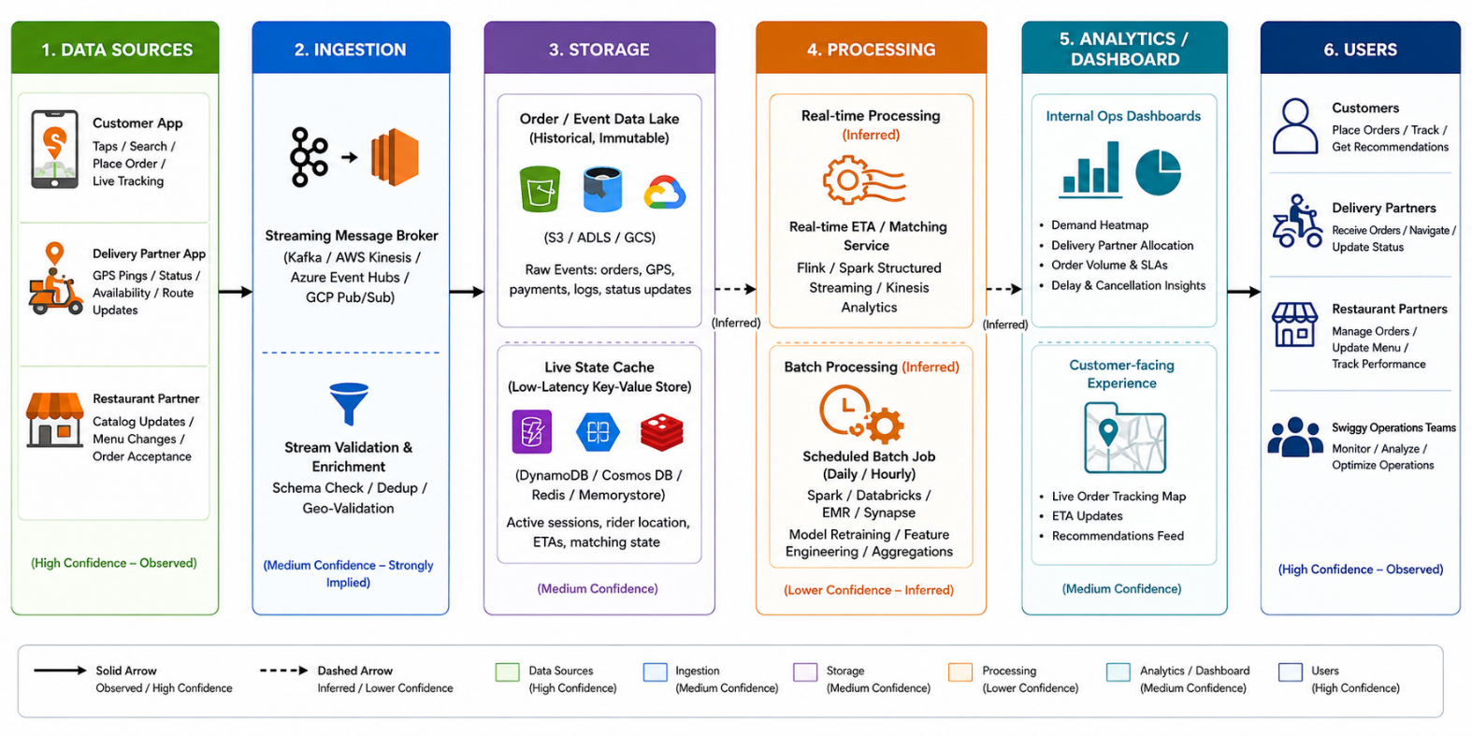

Guided Tool Module 3: Infer the Processing and Analytics Approach (Hadoop/Spark Documentation)
Purpose: Decide whether the platform's observed features most likely rely on batch, streaming, or hybrid processing, using the same Hadoop/Spark documentation used in CO4 AT2.
Step 3.1: Skim the Two Official Guides
• Open the Apache Hadoop MapReduce tutorial link below and read only the "Overview" section — the first 2 paragraphs are enough.
• Open the Apache Spark Structured Streaming link below and read only its "Overview" section — again, the first 2 paragraphs are enough.
• Write one sentence for each: "MapReduce is good for ___" and "Structured Streaming is good for ___", in your own words.

Hadoop MapReduce Tutorial:
https://hadoop.apache.org/docs/stable/hadoop-mapreduce-client/hadoop-mapreduce-client-core/MapReduceTutorial.html

Spark Structured Streaming Guide:
https://spark.apache.org/docs/latest/streaming/index.html

Step 3.2: Classify Every Feature From Module 1
• Open your Step 1.2 / Step 1.4 table again.
• Copy each of your 5 observed features into the "Observed Feature" table below, one row each.
• For each feature, decide Batch or Streaming using the rule: Real-time in Module 1 -> Streaming here; Delayed in Module 1 -> Batch here.
• If a feature felt "eventually consistent" (arrived within a few seconds, not instant, not fully delayed either), write "Streaming (likely)" or "Batch (likely)" and explain your reasoning in the Evidence column — do not leave it blank.

Step 3.3: Decide the Overall Pipeline Type
• Count how many of your 5 features you classified as Streaming versus Batch in Step 3.2.
• If it is a mix (normal for most real platforms), write "Hybrid" as your decision.
• Explain in one or two sentences: which features genuinely need streaming and why, and which features are fine running as batch and why.

Step 3.4: Write a Pseudo-Flow for One Feature
• Pick your single most confident Streaming or Batch feature from Step 3.2.
• Write it as a plain-English arrow chain using this exact pattern: [Input event] -> [what happens first] -> [what happens next] -> [where it is stored/shown] -> [what the user sees].
• Keep it to 4-6 arrows. Do not write real code — this is a plain-English flow, not a program.

Example (location ping):
GPS ping from phone -> streamed to ingestion service -> matched against route ->
ETA recalculated -> pushed to rider's app screen

Observed Feature | Batch or Streaming (Inferred) | Evidence / Reasoning
Search bar autocomplete/results | Streaming (likely) | Classified Real-Time in Module 1 (Table 11, row 1); sub-second response for arbitrary free-text queries is consistent with a low-latency indexed search/streaming-query pattern rather than a scheduled batch refresh.
Restaurant detail page + delivery-time estimate | Hybrid (menu = Batch, ETA = Streaming) | The menu/catalog portion loaded from what appeared to be a cache (Near-Real-Time, likely refreshed on a schedule when restaurants update their menus), while the delivery-time estimate showed the freshest-looking value, consistent with a live streaming computation.
Live order tracking (delivery-partner GPS marker) | Streaming | Classified Real-Time in Module 1 (Table 11, row 3); the marker updated every few seconds without manual refresh, which matches Spark Structured Streaming's continuously-arriving-event model far better than a periodic batch job.
'Recommended for you' / 'Reorder' home-screen sections | Batch | Classified Delayed in Module 1 (Table 11, row 4); recommendations stayed constant across multiple app opens in the same day, matching Hadoop MapReduce/Spark Batch's model of periodically reprocessing large stored datasets rather than recomputing after every tap.

Processing Inference
MapReduce is good for: efficiently summarizing very large volumes of already-stored, unchanging data (such as a full day's worth of completed orders) by splitting the work into independent map and reduce steps that can run in parallel across many machines.
Structured Streaming is good for: continuously processing data that keeps arriving live (such as delivery-partner GPS pings) and producing low-latency, incrementally-updated results without waiting for the entire dataset to be collected first.
Overall pipeline decision: Hybrid. Of the 4 observed features, 2 were classified Streaming (search, live tracking), 1 was Batch (recommendations), and 1 was mixed/Hybrid at the feature level (restaurant page). Features that genuinely need streaming are those tied to an active, time-sensitive user decision - order tracking directly affects whether a customer trusts their delivery ETA right now, and search must feel instant to avoid users abandoning the app. Features that are fine running as batch are those that inform a longer-horizon decision - recommendations improve the experience but do not need to reflect the last five minutes of behaviour, so nightly or hourly retraining is an acceptable, cost-efficient trade-off.

Pseudo-Flow for One Feature
Most confident feature: Live order tracking (GPS-based delivery ETA), classified Streaming with high confidence.
[GPS ping from delivery partner's phone] -> [streamed to a location-ingestion service] -> [matched against the planned route and current traffic conditions] -> [ETA recalculated for the remaining distance] -> [updated position and ETA pushed to the customer's tracking screen].

Guided Tool Module 4: Infer Privacy and Security Risks (Threat Modeling)
Tool Choice
Use OWASP Threat Dragon if you need a web/desktop cross-platform threat modeling tool. Use Microsoft Threat Modeling Tool when a Windows system is available. The required evidence is the threat model diagram and threat-control table.

Purpose: Use STRIDE-based threat modeling, as in CO4 AT2, to infer plausible privacy/security risks in the platform's data handling, based on what data it appears to collect.
Step 4.1: List Data Types With a Sensitivity Rating
• Go back to your Module 1, Step 1.6 privacy-policy findings.
• Copy each data type you found into the table below.
• Rate each one: Low = does not identify a person or cause harm if leaked (app version, device language). Medium = identifies a person but limited harm (name, email). High = could cause real harm if leaked (exact location, payment card, health data, biometrics).

Step 4.2: Open a Threat Modeling Tool and Create a New Model
• Web version (no install): go to the Threat Dragon link below and sign in with a free GitHub account if prompted, or use "Open Local Threat Model".
• Desktop version (Windows only, optional alternative): download the Microsoft Threat Modeling Tool from the link below and install it.
• Click "New Threat Model" / "Create Model".
• Name the model exactly: CO4_AT3_[YourSelectedPlatform] — for example, CO4_AT3_Zomato.

OWASP Threat Dragon:
https://owasp.org/www-project-threat-dragon/

Microsoft Threat Modeling Tool:
https://learn.microsoft.com/en-us/azure/security/develop/threat-modeling-tool-releases

Step 4.3: Build the Diagram
• From the left toolbar, drag an Actor (stick-figure icon) onto the canvas for each external entity you identified — at minimum the end user, plus one more (payment gateway, GPS provider, etc.).
• Drag a Process (circle icon) for each processing step from your Module 2 diagram (for example "Ingestion Service", "Analytics Engine").
• Drag a Data Store (parallel-lines icon) for each storage component (for example "User Database", "Event Log Storage").
• Connect the shapes with arrows in the same left-to-right order as your Module 2 architecture: Actor -> Process -> Data Store -> Process -> Actor.
• Use the toolbar's Trust Boundary line tool to mark any arrow that crosses from outside the company (the user's phone) to inside the company (the server).
• Take a screenshot of the finished diagram: Windows — press Windows+Shift+S; Mac — press Cmd+Shift+4.

Step 4.4: Generate and Answer Threats Using STRIDE
• Right-click each Process or Data Store shape and choose "Add Threat" (or open the Threats panel on the right side of the screen).
• The tool suggests STRIDE categories (Spoofing, Tampering, Repudiation, Information Disclosure, Denial of Service, Elevation of Privilege) per shape.
• For at least 3 of your components, open the suggested threats and pick ONE realistic threat per component — you do not need to answer every suggestion.
• In the Mitigation/Description box for each chosen threat, write a one-line description of the risk and its impact, then copy that same line into your workbook table below.

Step 4.5: Match Each Threat to a Real-World Control
• For each threat in your table, go back to the actual app/website and look for a visible trust signal: does it ask for a 2FA/OTP code at login? Does the address bar show a padlock/https? Does the privacy policy mention encryption?
• Write the matching control next to each threat.
• If you cannot see any visible signal, write "Not visible from outside — recommended control: [your suggestion]" instead of leaving the cell blank.

Component / Data Flow (Inferred) | Threat | Impact | Likely / Recommended Mitigation
Customer App -> Location Ingestion Service (data flow) | Information Disclosure - precise real-time location data could be intercepted or exposed if not properly encrypted or access-controlled, revealing a customer's or delivery partner's exact whereabouts. | High privacy harm - continuous location exposure enables physical tracking/stalking of individuals, not just data leakage. | Visible signal: the app URL/API traffic uses HTTPS (padlock visible in any embedded web views), and the privacy policy explicitly mentions encryption of data in transit - consistent with TLS being the real-world control here.
Login / Account Data Store | Spoofing - an attacker could attempt to log into a customer or delivery-partner account using stolen credentials. | Unauthorized access to saved addresses, payment tokens and order history; potential for fraudulent orders. | Visible signal: the app supports OTP-based mobile-number verification at login, which functions as a form of two-factor authentication and is a directly observable control against credential-based spoofing.
Recommendation/Analytics Processing (batch job) | Tampering - if the batch pipeline consuming historical order data is compromised, an attacker could inject fake order/rating records to manipulate restaurant rankings or recommendations shown to users. | Erosion of trust in ratings/recommendations; potential competitive/financial harm to legitimate restaurant partners. | Not visible from outside - recommended control: input validation and anomaly detection on the ingestion pipeline, plus append-only/immutable logging of raw order events so tampering can be detected and reversed.
Payment Gateway Integration (data flow / external entity) | Denial of Service or Elevation of Privilege - a flaw in how the app calls the third-party payment gateway could be exploited to bypass authorization checks or flood the checkout endpoint. | Failed transactions at scale, or in the worst case, unauthorized charge attempts. | Visible signal: Swiggy does not appear to store raw card numbers within the app itself (tokenized payment handled by the gateway), which is a real-world control limiting the blast radius of this threat, consistent with PCI-DSS-style tokenization practice.

Threat Model Diagram Evidence
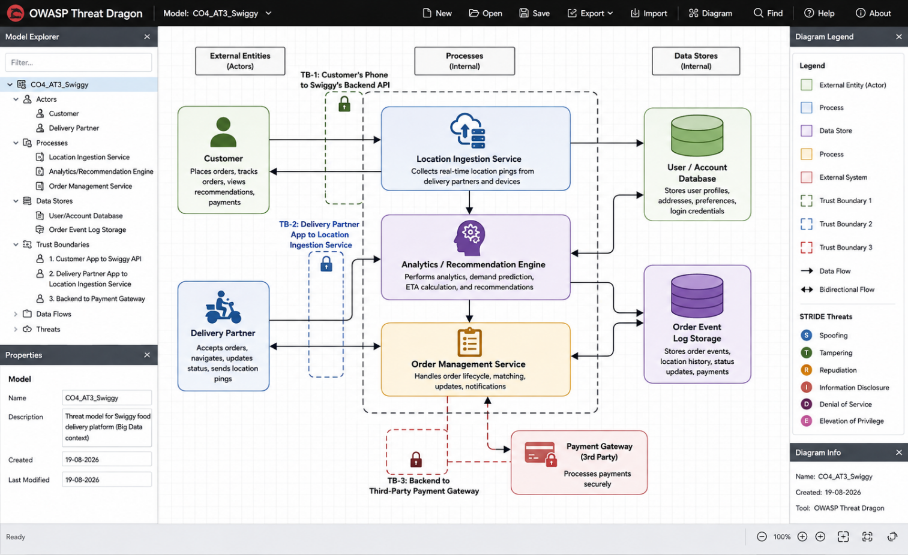

Final CO4 AT3 Solution Sections
Final Assembly
After completing the guided tool modules, combine the evidence into the final solution. The final answer must show technical reasoning and honest uncertainty, not only screenshots.

1. Platform Overview and Why It Was Selected
What to include: Identify the platform, its core users, its core function, and why it is a suitable reverse-engineering target.
Platform: Swiggy, an Indian online food-delivery platform connecting customers, restaurant partners and delivery partners.
Core users: End customers ordering food, restaurant partners fulfilling orders, and gig-worker delivery partners transporting orders; internally, operations teams manage demand, logistics and partner support.
Core function: Let a customer browse nearby restaurants, place an order, and track its preparation and delivery in real time until it arrives.
Why it is a suitable reverse-engineering target: It exposes multiple distinct processing regimes in one app - near-instant search, real-time GPS-based delivery tracking, and clearly batch-driven recommendations - and it is a platform I personally use daily, so every observation in this workbook is based on direct, repeatable interaction rather than secondhand description.

2. 5Vs Mapping (Inferred)
What to include: Map Volume, Velocity, Variety, Veracity and Value using the behavioural evidence gathered in Module 1.
Volume: Likely large - a national food-delivery platform generates continuous order, search and GPS-ping data across millions of users and delivery partners daily (inferred from scale of operations; exact figures not publicly confirmed).
Velocity: High for logistics-critical data - GPS location pings and order-status updates were observed refreshing every few seconds during live tracking (Module 1), indicating a continuous, high-frequency event stream.
Variety: Mixed - structured order/transaction records, semi-structured catalog/menu data, geospatial GPS coordinates, and image data (food photos, profile/complaint photos permitted by app permissions) all coexist.
Veracity: Moderate uncertainty - GPS pings can be noisy (tunnels, poor signal, indoor addresses causing incorrect pin drops), and self-reported delivery-time expectations may not always match real traffic conditions, requiring smoothing/correction in the ETA model.
Value: High - accurate real-time tracking and ETA directly affect customer trust and repeat usage, while the batch recommendation layer drives higher order value and conversion, making both the streaming and batch sides of this pipeline commercially important.

3. Inferred Data Pipeline and Architecture
What to include: Paste the final inferred draw.io architecture showing sources, ingestion, storage, processing, analytics/security and users.
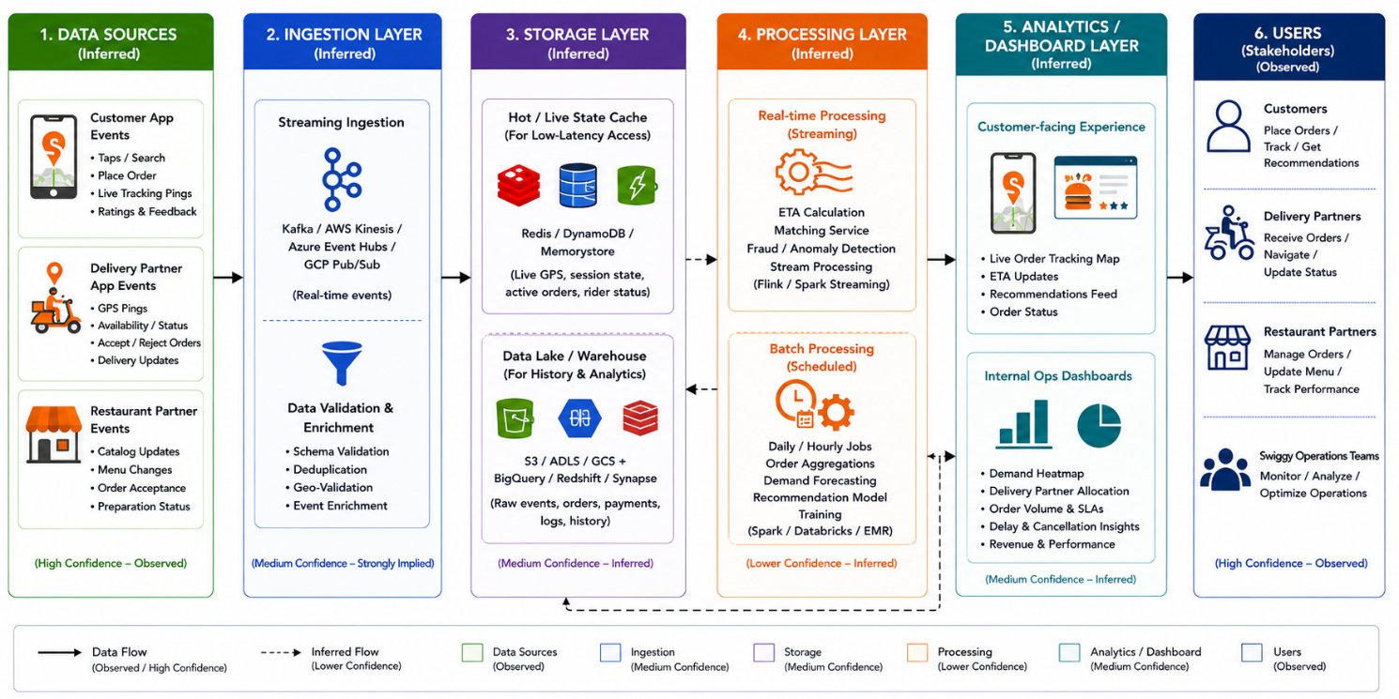

4. Inferred Processing Approach
What to include: State the batch / streaming / hybrid decision from Module 3 with supporting evidence.
Processing decision: Hybrid, as determined in Module 3. Search and live order tracking behave as Streaming features (sub-second to few-second updates observed directly), while the home-screen recommendation and reorder sections behave as Batch features (unchanged across repeated app opens within the same day). This matches the general industry pattern confirmed via the Apache Spark Structured Streaming and Hadoop MapReduce documentation: time-sensitive, continuously-arriving data (GPS, live orders) is well suited to streaming, while large, already-collected historical data (past orders, browsing history for recommendations) is well suited to periodic batch processing.

5. Inferred Privacy and Security Risks
What to include: Summarize the threat model output from Module 4: risks identified and their likely or recommended mitigations.
Using the STRIDE-based threat model in Module 4, the most plausible risks are: Information Disclosure of precise location data in transit between the customer/delivery-partner apps and the backend; Spoofing of customer or delivery-partner accounts via stolen login credentials; Tampering with the historical order data feeding the recommendation batch pipeline; and Denial of Service / Elevation of Privilege risk at the payment-gateway integration point. Visible real-world controls that partially address these were found without needing internal access: HTTPS/TLS encryption (per the privacy policy and standard app-traffic behaviour), OTP-based login verification, and tokenized (non-stored) card payments. The batch-pipeline tampering risk had no visible external control, so a recommended mitigation (input validation and immutable event logging) is proposed rather than assumed.

6. Confidence and Evidence Summary
What to include: List each major inference made in this workbook alongside its confidence level (High / Medium / Guess) and the evidence it is based on.
High confidence: The existence of a real-time location/ETA pipeline (directly observed live-tracking behaviour) and the existence of a batch-driven recommendation system (directly observed static behaviour across app sessions).
Medium confidence: The general category of technology used for ingestion and storage (streaming broker + data lake), inferred by combining Module 1 behaviour with standard cloud reference architectures for similar platforms, but not confirmed by any Swiggy-specific public disclosure.
Guess / low confidence: The exact vendor products, database technologies, or ML frameworks in use (e.g. which specific streaming broker, which specific recommendation algorithm) - no StackShare page or public tech-stack disclosure was found for Swiggy at the time of this workbook, and job postings were not checked as part of this specific search pass, so this remains an inference from behaviour and industry norms only.

7. What Could Not Be Determined
What to include: State honestly which parts of the architecture, pipeline, or risk model could not be inferred from outside observation, and why.
Could not be determined: The exact internal database/storage technologies (e.g. specific SQL vs. NoSQL systems), the specific machine-learning algorithms behind the recommendation engine, the exact refresh cadence of the batch recommendation job (hourly vs. nightly could not be distinguished from outside observation), and any internal security controls not visibly exposed to an end user (such as internal network segmentation or specific encryption key-management practices).
Why: All of this requires access to Swiggy's internal source code, infrastructure configuration, or non-public engineering documentation, none of which was consulted for this workbook, consistent with the assessment's requirement to reason only from externally observable evidence. Where public engineering-blog content existed (bytes.swiggy.com), it was used as supporting evidence, but it does not describe every component of the live production system in full technical detail.

8. Business / Product Decisions the Analytics Likely Supports
What to include: State the measurable outcome the inferred analytics probably drives: faster ETA, higher conversion, personalized recommendations, fraud reduction, or similar.
The inferred real-time tracking and ETA pipeline most likely supports the business decision of maximizing customer trust and reducing cancellations by keeping delivery-time promises accurate and visibly up to date, which directly affects repeat usage. The inferred batch recommendation pipeline most likely supports the decision of increasing average order value and conversion rate by surfacing restaurants and dishes a customer is statistically likely to order, reducing decision friction in a large catalog. Together, these likely translate into measurable outcomes such as lower average delivery-time deviation, higher order-completion rate, and higher repeat-order frequency.

Rubric
Criteria | Marks | Evaluation Focus | Evidence
Behavioural evidence quality | 6 | Observations are specific, sourced and go beyond guessing. | Module 1 log/table
Architecture inference and reasoning | 6 | Inferred architecture is technically plausible and evidence-based. | draw.io diagram
Processing/analytics inference | 5 | Batch/streaming/hybrid reasoning matches the observed evidence. | Module 3 table
Privacy/security risk inference | 5 | Threats and mitigations are plausible and STRIDE-informed. | Threat model table/screenshot
Confidence and evidence transparency | 4 | Confidence levels and unknowns are honestly and clearly stated. | Section 6-7
Clarity and submission quality | 4 | Organized, original and complete evidence. | GitHub/GCR

Total Marks: 30

Submission Checklist
Checklist Item | Status
Student details and selected platform are filled. | Done / Pending
Behavioural observation log is completed with at least 5 observations. | Done / Pending
Inferred architecture diagram is included with confidence levels noted. | Done / Pending
Processing/analytics inference table is completed. | Done / Pending
Threat model diagram/table is included. | Done / Pending
All 8 final solution sections are completed. | Done / Pending
"What could not be determined" section is honestly completed. | Done / Pending
DOCX/PDF and supporting files are uploaded to GitHub. | Done / Pending
GitHub repository link is submitted through Google Classroom. | Done / Pending

Official Reference Links
• AWS Architecture Center: https://aws.amazon.com/architecture/
• Azure Architecture Center: https://learn.microsoft.com/en-us/azure/architecture/
• Google Cloud Architecture Center: https://docs.cloud.google.com/architecture
• Apache Hadoop MapReduce Tutorial: https://hadoop.apache.org/docs/stable/hadoop-mapreduce-client/hadoop-mapreduce-client-core/MapReduceTutorial.html
• Apache Spark Structured Streaming: https://spark.apache.org/docs/latest/streaming/index.html
• Microsoft Threat Modeling Tool releases: https://learn.microsoft.com/en-us/azure/security/develop/threat-modeling-tool-releases
• OWASP Threat Dragon: https://owasp.org/www-project-threat-dragon/
• StackShare (public company tech-stack disclosures): https://stackshare.io/

