
CSA15 Cloud Computing and Big Data Analytics
CO1 AT2 - Digital Concept Map and Service Model Matrix
Individual Student Submission Template

Student and Faculty Details
Student Name | VISWANATH SAI SANDEEP | Register Number | 192324029
Class / Section | - | Slot | B
Course Code | CSA1512 | Course Title | Cloud Computing & Big Data Analytics
Capstone Title | SecureVote Cloud Campus Polling Platform with Audit Logs and Result Integrity
Submission Date | 13-7-2026
Faculty Name | Dr. Rajesh Babu.C | Employee ID | -
Department | Computer Science & Engineering – Artificial Intelligence & Data Science

Assessment Brief
Course Outcome | CO1 - Explain the evolution, architecture, characteristics, service models, and emerging paradigms of cloud computing.
Assessment Type | Individual concept mapping, service-model responsibility analysis, and capstone-cloud interpretation.
Assessment Focus | Each map must show key nodes, link labels, relationship meaning, and a logical hierarchy. The response must connect cloud fundamentals to the student's own perception of the capstone title.
Submission Mode | Editable DOCX + exported diagram evidence + GitHub repository link submitted in Google Classroom.
Permitted Tools | draw.io / diagrams.net, Lucidchart, Miro, Canva, PowerPoint, Google Drawings, or equivalent diagramming tool.
Individual Rule | Every student must submit their own concept map, matrix, capstone-cloud mapping, and reflection. The capstone title may be shared by a team, but the assessment answer must not be common.
Total Marks | 100 marks

Code of Conduct and Student Assurance
Academic Integrity Statement
This assessment must be completed individually. Students may discuss the capstone domain with their team, but the concept map, service model matrix, explanations, GitHub evidence, and reflection submitted here must be individually prepared.
Student Assurance | I confirm that this submission represents my own understanding of CO1 concepts and my individual interpretation of the selected capstone title.
Tool Use | I have used digital tools only for diagram preparation, organization, and presentation. I have not copied another student's diagram, matrix, or explanation.
Evidence | I have uploaded the required files to my GitHub repository and submitted the repository link / evidence link through Google Classroom.
Student Signature | V. SAI SANDEEP
Date | 13-7-2026

Procedure for Preparing the Digital Concept Map
Use the following procedure to prepare the diagram and upload evidence. Students who already know another diagramming tool may use it, but the exported evidence and source file must still be submitted.
- Open https://app.diagrams.net/ or the desktop version of draw.io / diagrams.net.
- Choose Device, Google Drive, or OneDrive as the save location according to availability.
- Create a blank diagram and name the file as CSA15_CO1_AT2_RegisterNumber_Concept_Map.drawio.
- Place the capstone title at the center or as a clearly visible anchor node.
- Add major cloud nodes: cloud definition, cloud evolution, cloud architecture, service models, deployment models, virtualization, web services, SOAP, REST, APIs, elasticity, scalability, resource pooling, measured service, and emerging paradigms.
- Connect nodes with labeled arrows such as uses, depends on, enables, scales through, communicates through, belongs to, supports, provides, consumes, or controls.
- Use colors meaningfully: one color for service models, one for cloud characteristics, one for API/web-service concepts, and one for capstone-specific elements.
- Export the final diagram as PNG or PDF. Keep the editable .drawio source file also.
- Paste the exported diagram image or screenshot in this DOCX under Task 1.
- Upload the DOCX, exported PNG/PDF, and .drawio file to GitHub, then submit the GitHub link in Google Classroom.

GitHub Submission Procedure
Step | Required Action | Expected Evidence
1 | Create or use your individual GitHub account. | GitHub profile link.
2 | Create a repository named CSA15-CO-Assessments-RegisterNumber or use the repository instructed by faculty. | Repository URL.
3 | Create a folder named CO1_AT2 inside the repository. | Folder visible in repository.
4 | Upload this completed DOCX, exported diagram PNG/PDF, and editable .drawio source file. | At least three evidence files uploaded.
5 | Add a short README.md explaining the capstone title and files submitted. | README visible in the AT2 folder.
6 | Submit the GitHub folder link in Google Classroom. | GCR submission with repository/folder link.

Assessment Questions and Student Response Sections
Important
The capstone project may be developed by a team, but every response below must be written from the individual student's own perspective. Do not submit a common team answer.

Task 1 - Digital Cloud Concept Map
Create one integrated digital concept map for CO1. The map must show key nodes, link labels, relationship meaning, and a logical hierarchy. It must also connect the concepts to your selected capstone title from your individual perspective.
Mandatory Concept Group | Minimum Concepts / Nodes to Include
Cloud Fundamentals | Definition, characteristics, benefits, limitations, on-demand access, measured service.
Cloud Evolution and Drivers | Hardware evolution, internet software evolution, distributed systems, cost economics, mobility, remote access, big data growth.
Architecture and Deployment | Front-end, back-end, network layer, data center, management software, public/private/hybrid/community cloud.
Service Models and Responsibility | IaaS, PaaS, SaaS, XaaS, provider responsibility, user responsibility, shared responsibility.
Virtualization and Web/API Layer | Virtual machine, hypervisor, abstraction, resource pooling, multi-tenancy, web services, SOAP, REST, API request/response.
Capstone Connection | Your capstone users, app/module, cloud backend, database/storage, dashboard/analytics, scalability and elasticity idea.
Paste exported concept map image / screenshot here. Resize neatly within this white space.

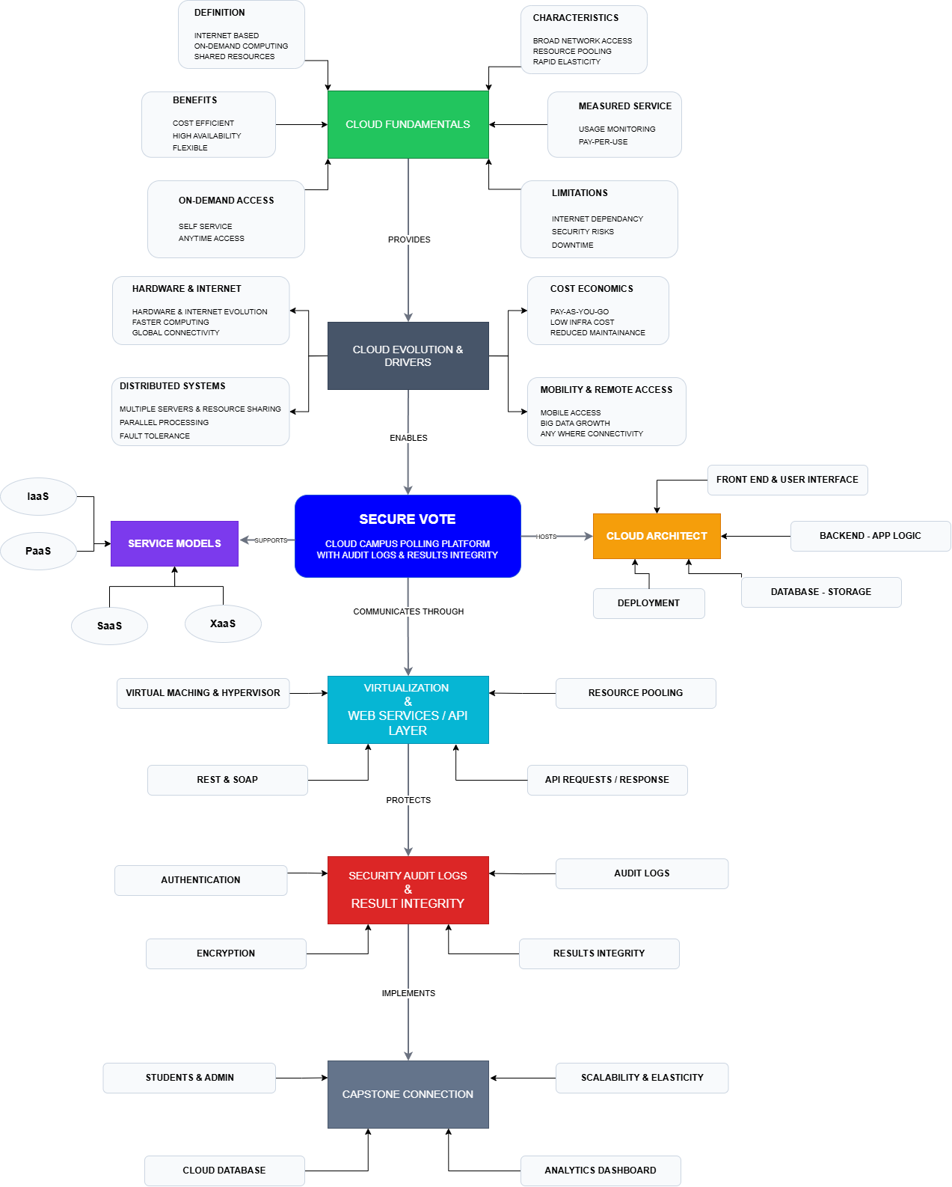

Brief explanation of your concept map: explain the most important nodes, link labels, hierarchy, and capstone connection.
The concept map presents the key concepts of cloud computing and their relationship with the SecureVote Cloud Campus Polling Platform with Audit Logs and Result Integrity. The hierarchy begins with Cloud Fundamentals, which introduces the basic principles, characteristics, benefits, and limitations of cloud computing. These concepts lead to Cloud Evolution & Drivers, highlighting how advancements in hardware, internet technologies, distributed systems, and cost-effective computing have enabled modern cloud platforms. The Service Models (IaaS, PaaS, SaaS, and XaaS) and Cloud Architecture & Deployment illustrate how cloud resources, infrastructure, and deployment strategies support the SecureVote application. Virtualization and Web Services/API demonstrate how REST APIs, virtualization, and resource sharing enable efficient communication between the frontend, backend, and cloud services. Finally, Security, Audit Logs, and Result Integrity emphasize authentication, encryption, secure logging, and data integrity, ensuring that the voting system is reliable, transparent, and scalable. The capstone connection shows how all these cloud computing concepts work together to build a secure, cloud-based campus polling platform.

Task 2 - Service Model Matrix
Complete the matrices by making technical decisions for your capstone project. Select only the rows that are relevant to your capstone design. If a row is not used, write a short technical reason instead of leaving it blank.
Your answer should show how responsibility shifts between cloud provider and student development team, and how the chosen services support the capstone workflow, API design, storage, security, scalability, and evidence submission.

Task 2A - Service Model Responsibility Matrix
Service Model | Capstone Role / Module | Provider Responsibility | Student Responsibility | Evidence to Submit
IaaS | Virtual server, network and storage infrastructure | Manage virtual machines, networking, storage, availability & hardware | Configure server environment, deploy backend, manage application files | Cloud infrastructure configuration / deployment screenshot
PaaS | Backend API and application hosting | Manage runtime, operating system, middleware and automatic scaling | Develop REST APIs, business logic, integrate database and testing | Backend source code, API screenshots, GitHub repository
SaaS | Authentication, email notifications and collaboration tools | Maintain software availability, updates and security | Configure services, manage user roles and integrate with application | Authentication setup, email service screenshots
XaaS / Specialized Service | Audit logging, analytics and notification services | Provide specialized cloud services and APIs | Integrate APIs, process audit logs, generate reports and dashboards | API integration screenshots, analytics dashboard

Task 2B - Capstone Cloud Service Decision Matrix
Cloud Layer / Function | Selected Tool or Service | Data / Resource Handled | API or Integration Path | Security / Scaling Note
Client access and UI | Flutter Web / Web Browser | User interface, vote forms | HTTPS REST API | Responsive UI, secure HTTPS communication
API / backend logic | Node.js / Spring Boot REST API | Vote processing, validation, business rules | REST API | Input validation, scalable backend
Authentication and identity | Firebase Authentication | Student login, identity verification | Authentication SDK / OAuth | Secure login, role-based access
Database / structured records | Firebase Firestore / MySQL | Student records, votes, election data | Database Connector | Encrypted data, access control
File / object storage | Firebase Storage / Cloud Storage | Audit log files, reports | Storage API | Secure storage with backup
Monitoring / logs / usage metrics | Firebase Analytics / Cloud Monitoring | Activity logs, audit logs, performance metrics | Monitoring APIs | Continuous monitoring and alerts
Analytics / reporting output | Dashboard (Power BI / Firebase Analytics) | Election results, voting statistics | Dashboard Integration | Read-only reporting, scalable analytics
Technical justification: Explain why the selected cloud service pattern fits your capstone project's users, data, API flow, scalability, and security needs.
The SecureVote Cloud Campus Polling Platform uses cloud services to provide secure, reliable, and scalable online voting. REST APIs connect the user interface with the backend for real-time vote processing. Authentication ensures that only authorized students can vote once. The cloud database securely stores voting records, while audit logs maintain transparency and result integrity. Cloud infrastructure supports scalability during peak election periods, ensuring high availability and secure access for all users.

Task 3 - Capstone Cloud Flow Mapping
Study the sample architecture-flow template below. Redraw it in draw.io / diagrams.net using your own capstone architecture. Replace every generic label with your actual user role, screen, API endpoint, backend logic, cloud storage, analytics output, security control, and scalability or elasticity decision.
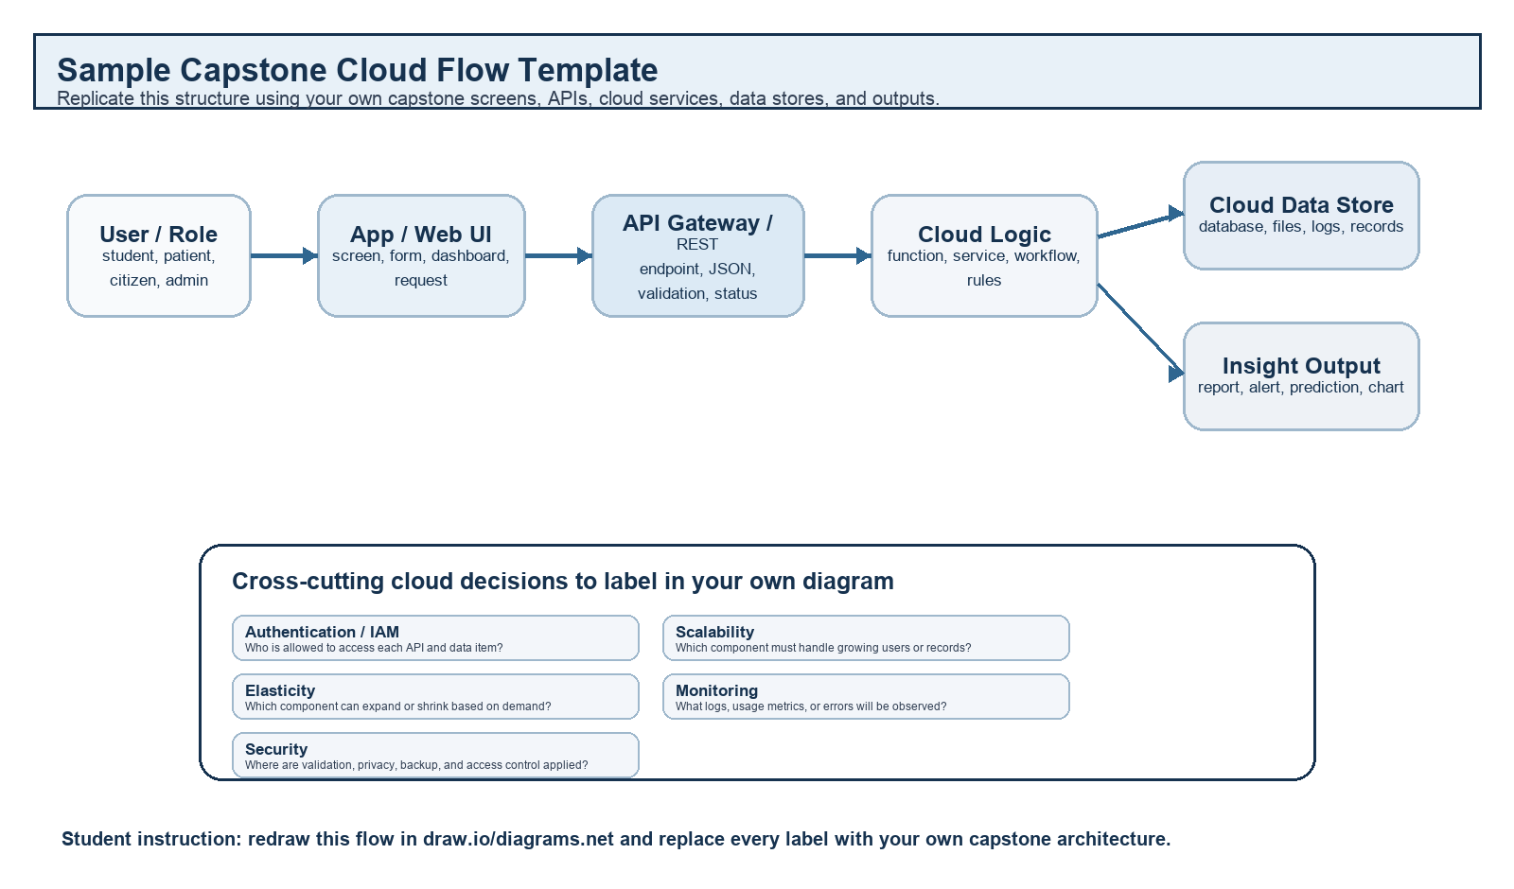
Student Drawing Requirement
Do not copy the sample as it is. Use it as a layout model, then create your own capstone-specific flow diagram with meaningful labels, arrows, data movement, API names, and cloud service choices.
Flow Component | Student Entry
User role and action | Student/Admin logs in and casts a secure vote through the SecureVote application.
Frontend / app screen | SecureVote Web Portal & Mobile App (Flutter)
API endpoint and method | POST /api/vote (REST API)
Backend processing rule | Verify user authentication, validate vote, prevent duplicate voting, store vote and generate audit log.
Cloud database / storage operation | Store vote records in Cloud Database and save audit logs in Cloud Storage.
Response, alert, report, or dashboard output | Vote confirmation sent to the student and real-time results displayed on the Admin Dashboard.
Security, scalability, and elasticity labels added in diagram | HTTPS, Firebase Authentication, Encryption, Role-Based Access Control (RBAC), Auto Scaling, Load Balancing, Audit Logs.
Paste your redrawn capstone cloud-flow diagram here.

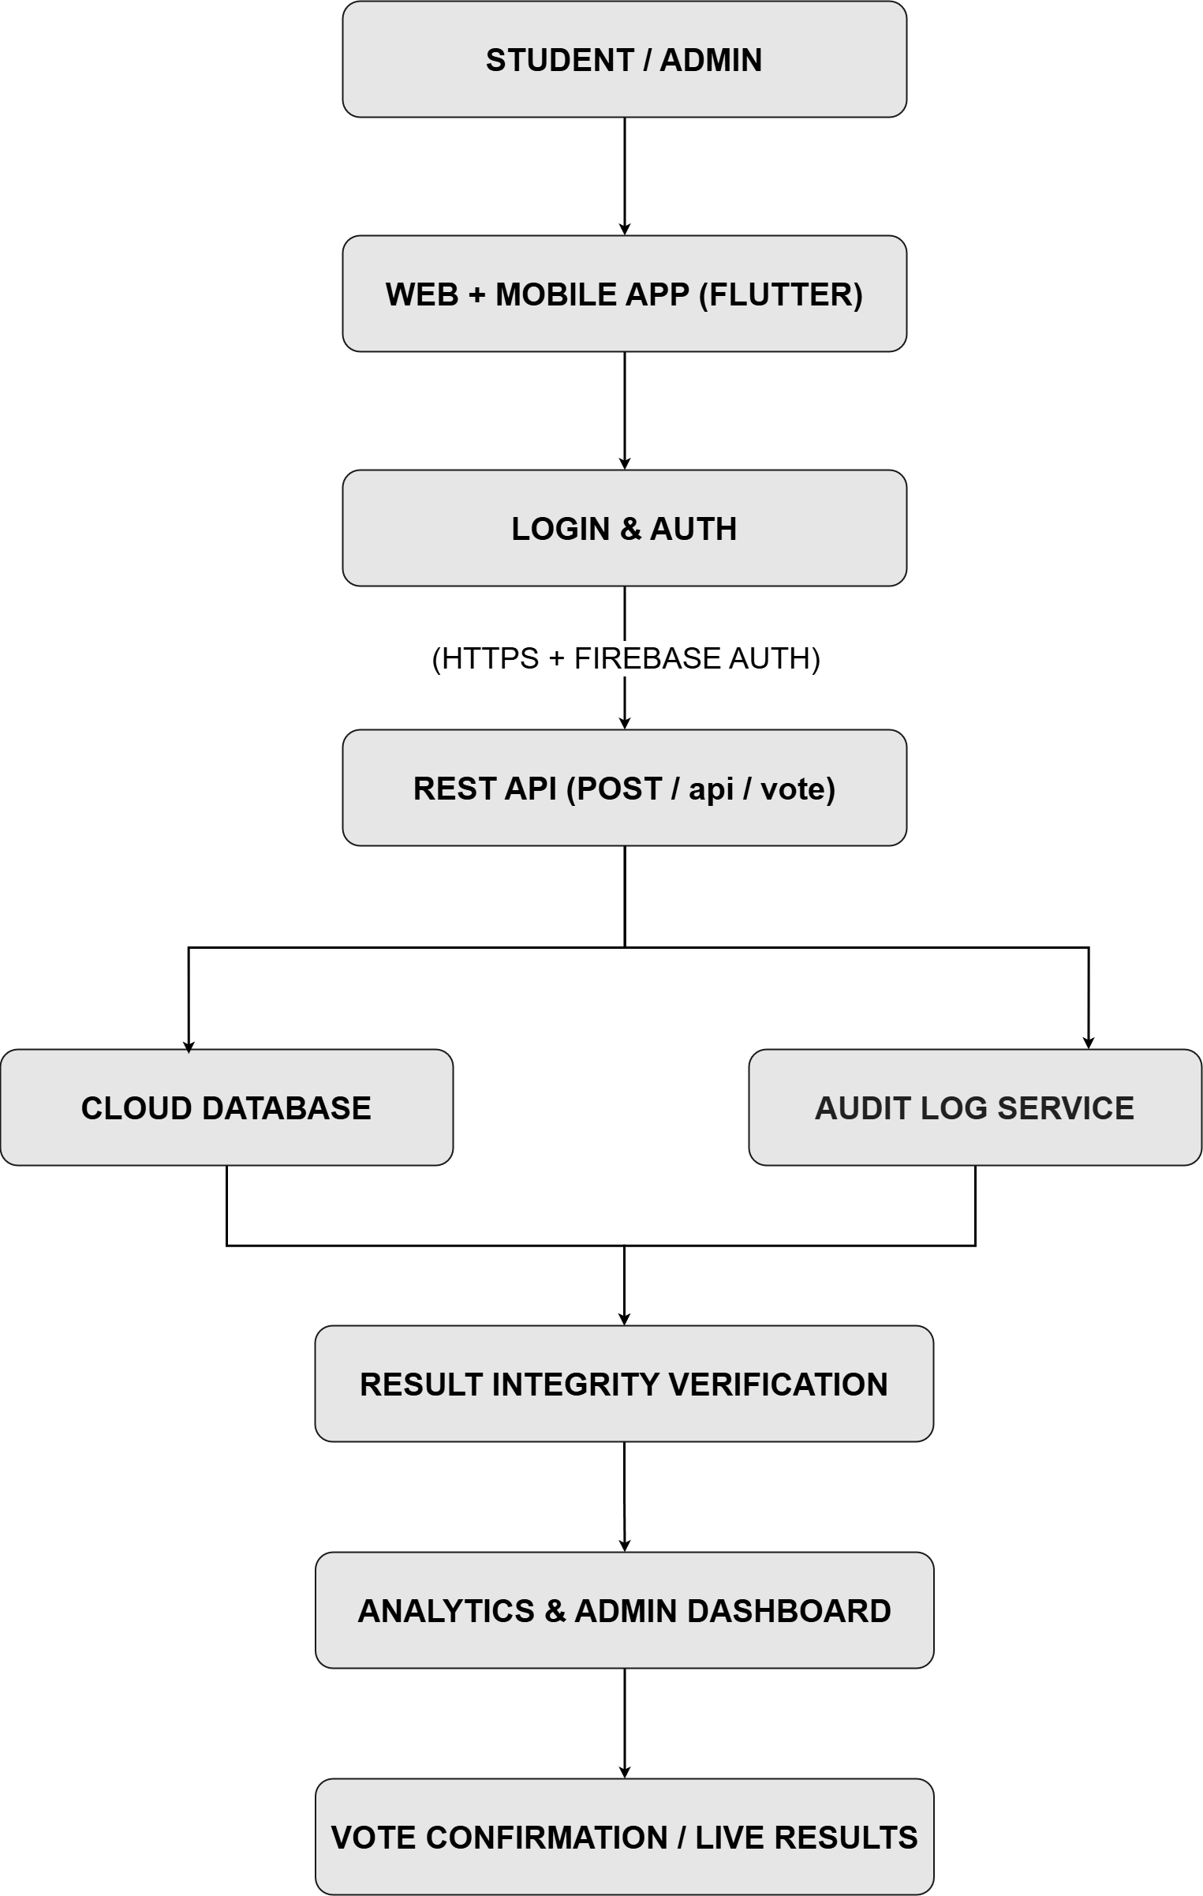

Brief explanation: explain one complete request-response path from user action to cloud response.
When a student logs into the SecureVote application, the system authenticates the user's identity using Firebase Authentication. The student submits a vote through the REST API (POST /api/vote), where the backend validates the request and prevents duplicate voting. The vote is securely stored in the cloud database, and an audit log is generated to maintain transparency and result integrity. Finally, the system sends a confirmation to the student while updating the administrator dashboard with real-time election statistics.

Task 4 - Individual Reflection
Answer the following from your own perspective. Avoid team-common wording.
1. What is the strongest cloud concept represented in your capstone project?
The strongest cloud concept in my capstone project is cloud scalability and secure data management. Cloud services enable SecureVote to handle multiple users simultaneously while securely storing voting data and audit logs.
2. Where will elasticity or scalability become important in your capstone product?
Elasticity becomes important during campus elections when many students access the platform at the same time. Cloud resources can automatically scale to handle increased traffic without affecting system performance or availability.
3. Which API or web-service idea is most relevant to your project and why?
REST APIs are the most relevant because they provide secure and efficient communication between the web/mobile application, backend services, authentication system, and cloud database. They enable real-time vote processing and result updates.
4. What did you personally understand better after preparing this concept map and matrix?
After preparing the concept map and service model matrix, I gained a better understanding of how cloud computing components work together to build secure, scalable, and reliable applications. I also learned how service models, cloud architecture, APIs, and security mechanisms are integrated in a real-world cloud-based solution like SecureVote.

Evaluation Rubric - 100 Marks
Criteria | Marks | Expected Standard
Concept identification | 20 | Major CO1 concepts are accurately identified: cloud fundamentals, characteristics, evolution, service models, deployment models, virtualization, web services, SOAP/REST, APIs, elasticity, and scalability.
Relationship mapping | 20 | Links between concepts are accurate, meaningful, and labeled. The map should explain how concepts depend on, enable, consume, provide, scale, or control one another.
Hierarchy and organization | 15 | Concepts are arranged in a logical hierarchy with clear grouping, readable flow, and no disconnected keyword clusters.
Technical relevance | 15 | The map strongly reflects cloud course content and avoids decorative or generic non-technical content.
Service model matrix | 15 | IaaS, PaaS, SaaS, and XaaS are compared with provider responsibility, user responsibility, examples, capstone usage, and risks or limitations.
Capstone alignment and individual reflection | 10 | The student's own capstone interpretation is visible in the concept map, flow mapping, justification, and reflection. Team-common answers are avoided.
Visual clarity and digital evidence | 5 | Diagram is neat, readable, exported properly, and supported with GitHub evidence including source and exported files.

Faculty Evaluation Record
Evaluator Name |  | Marks Awarded
Observation |  | Signature

