 | SIMATS ENGINEERING  Department of Computer Science and Engineering
CSA15 Cloud Computing and Big Data Analytics
CO4 AT2 - Big Data Industry Problem Solving Guided Tool Workbook
Course Code | CSA15 | Slot | B
Assessment | CO4 AT2 | Bloom Level | BL4 - Analyze
Faculty | Dr C. Rajesh Babu | Employee ID | SSETSCS415
Mode | Individual guided tool-based workbook | Submission | GitHub repository link through Google Classroom
End Evidence | Workbook + screenshots + diagrams + dashboard/mockup | Marks | 30

Student Details
Student Name | VISWANATH SAI SANDEEP | Register Number | 192324029
Class / Section | CSA15 / AI & Data Science | Slot | B
Selected Scenario | Scenario 4 - Cybersecurity Threat Monitoring | Submission Date | 26-08-2026
GitHub Link | https://github.com/ViswanathSaiSandeep/CSA15-CO-Assesments-192324029/tree/main/CO4_AT2 | Google Classroom Status | To be submitted via Google Classroom

Workbook Purpose
What this workbook does
This workbook guides students to use real software tools and official technical references to derive a big-data industry solution. Students should learn from the tool, observe patterns, record evidence and then write their own technical explanation.
- Do not copy full text from websites or AI tools.
- Use official references to justify architecture, processing and security decisions.
- Screenshots are evidence; explanations are the actual assessment answer.

Scenario Bank
Instruction
Faculty may assign one scenario or ask students to complete more than one. If no specific scenario is assigned, select one scenario and complete all tool-guided sections for that scenario.
No. | Scenario | Data Context
1 | Healthcare Emergency Analytics | Emergency department data, ambulance updates, bed availability, alerts and treatment delays.
2 | E-Commerce Customer Behavior Intelligence | Clickstream events, cart abandonment, payment failure, campaign traffic and recommendation impact.
3 | Smart Agriculture Advisory Platform | Weather, soil sensors, crop advisories, pest reports, market prices and farmer app interactions.
4 | Cybersecurity Threat Monitoring | Authentication logs, firewall alerts, API access logs, failed login attempts and suspicious network events.
5 | Public Transport Demand Analytics | Ticketing data, bus GPS, passenger count, route delay, peak-hour demand and crowding alerts.

Selected Scenario and Reason
Selected Scenario: Scenario 4 - Cybersecurity Threat Monitoring.
Reason for selection: Modern enterprises generate continuous authentication logs, firewall alerts, API access records and network telemetry, and a single missed anomaly (e.g., a brute-force login or an unusual data-exfiltration pattern) can lead to significant financial and reputational damage. This scenario was chosen because it combines high-velocity streaming data (live login attempts, network events) with historical batch data (past incident logs), making it an ideal case to apply both batch and streaming big-data processing, and because security monitoring inherently requires a strong data-privacy and threat-modeling component, allowing every guided-tool module (cloud architecture, Hadoop/Spark, threat modeling, dashboarding) to be meaningfully exercised.

Guided Tool Module 1: Use Cloud Architecture Centers
Purpose: Use official cloud architecture references to identify suitable ingestion, storage, processing, analytics and security components for the selected scenario.
No. | Perform |  | Observe / Decide |  | Record in Workbook
1 | Open AWS Architecture Center, Azure Architecture Center and Google Cloud Architecture Center in three browser tabs. |  | You are not copying a full architecture. You are learning common cloud patterns and service categories. |  | Paste the three page titles or URLs.
2 | Search each site using terms from your scenario, such as healthcare analytics, streaming analytics, data lake, retail analytics, IoT analytics or security monitoring. |  | Notice which patterns repeatedly appear: ingestion, data lake, warehouse, processing, ML/analytics, visualization and security. |  | Record at least one useful reference from each cloud provider.
3 | Identify the services/components mentioned in the reference diagrams. |  | Separate service category from vendor-specific service name. Example: object storage is the category; Amazon S3/Azure Blob Storage/Cloud Storage are service examples. |  | Complete the tool-category table.
4 | Compare the three references. |  | Choose the most suitable architecture pattern for your scenario and explain why. |  | Write a short justification.
5 | Draw your own provider-neutral architecture in draw.io. |  | Your diagram must show data sources -> ingestion -> storage -> processing -> analytics/dashboard -> users, with security controls. |  | Paste the diagram screenshot/link.
Cloud Provider |  | Reference Page / URL |  | Useful Pattern Found |  | Useful Service Categories
AWS |  | AWS Architecture Center - Security, Identity & Compliance / Big Data Analytics reference architectures (aws.amazon.com/architecture/security-identity-compliance) |  | Centralized log ingestion into a data lake, real-time stream analytics for security events, SIEM-style correlation before alerting. |  | Streaming ingestion (Kinesis), object storage / data lake (S3), stream processing (Kinesis Data Analytics / Lambda), analytics (Athena, OpenSearch), identity and access management (IAM), key management (KMS).
Azure |  | Azure Architecture Center - Security & Threat Detection reference architecture (learn.microsoft.com/en-us/azure/architecture/reference-architectures) |  | Event Hub based ingestion feeding a SIEM (Microsoft Sentinel), with a lakehouse for long-term log retention and ML-based anomaly scoring. |  | Event ingestion (Event Hubs), data lake storage (ADLS Gen2), stream processing (Azure Stream Analytics / Databricks), SIEM/analytics (Microsoft Sentinel), identity (Azure AD / Entra ID), encryption/Key Vault.
Google Cloud |  | Google Cloud Architecture Center - Security foundations and log analytics reference architecture (docs.cloud.google.com/architecture/security) |  | Centralized log sink into BigQuery with Pub/Sub as the streaming backbone and Chronicle/Security Command Center for threat detection. |  | Streaming ingestion (Pub/Sub), data lake/warehouse (Cloud Storage, BigQuery), processing (Dataflow), security analytics (Security Command Center, Chronicle), IAM, Cloud KMS.

Cloud Architecture Justification
All three cloud providers converge on the same conceptual pattern for security analytics: a streaming ingestion layer (Kinesis / Event Hubs / Pub-Sub) collects logs in near real time, a durable data lake stores both raw and processed logs for compliance and forensic replay, a stream/batch processing layer enriches and correlates events, and a dedicated security-analytics or SIEM layer scores and surfaces alerts to analysts.
For this scenario, the Google Cloud pattern (Pub/Sub -> Dataflow -> BigQuery -> Security Command Center) is chosen as the primary reference because it cleanly separates the streaming path (needed for failed-login and firewall alert detection within seconds) from the batch/warehouse path (needed for historical trend analysis and audit reporting), and because BigQuery's ability to run SQL directly over both streamed and historical data simplifies the analytics layer for a student project. AWS's Kinesis + OpenSearch combination and Azure's Event Hub + Sentinel combination are used as supporting references to confirm that identity/IAM, encryption and centralized log correlation are consistent industry practices across vendors, regardless of which provider is finally used.

Architecture Diagram Evidence
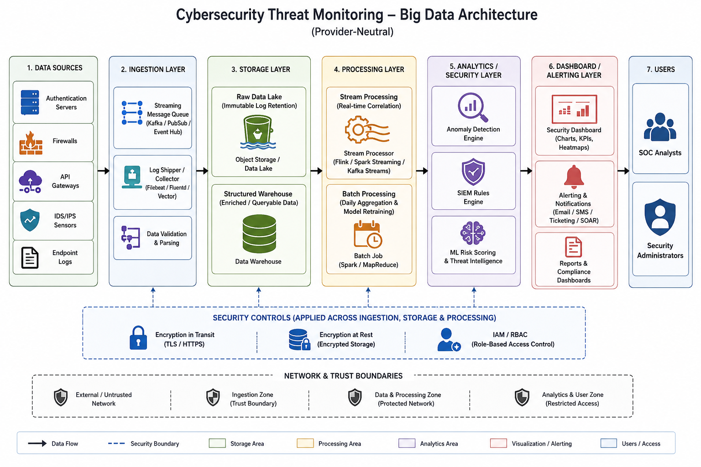

Guided Tool Module 2: Use Hadoop and Spark Documentation
Purpose: Decide whether your problem needs batch processing, streaming processing or hybrid processing by reading official Hadoop/Spark documentation.
No. | Perform |  | Observe / Decide |  | Record in Workbook
1 | Open the Apache Hadoop MapReduce tutorial. |  | MapReduce is suitable when large stored data can be processed in batches, such as daily logs or historical transactions. |  | Write one sentence on what mapper and reducer mean.
2 | Open the Apache Spark Structured Streaming guide. |  | Structured Streaming is suitable when new events continuously arrive, such as sensors, clickstream, live alerts or location updates. |  | Write one sentence on what streaming source, processing and sink mean.
3 | Classify your scenario data into batch data and streaming data. |  | Historical records normally become batch data; live sensor/log/API updates normally become streaming data. |  | Complete the batch-vs-stream table.
4 | Choose one processing approach for your scenario: Hadoop/MapReduce, Spark batch, Spark streaming or hybrid. |  | The decision must match the data velocity and decision urgency. |  | Write your processing decision.
5 | Prepare a simple pseudo-flow, not full code. |  | Example: Mapper reads log line -> emits hour, count. Reducer sums counts. Dashboard shows peak hour. |  | Write pseudo-flow or paste diagram.
Data Item |  | Batch / Streaming |  | Why |  | Suggested Framework
Failed login attempts |  | Streaming |  | Must be detected within seconds to block brute-force/credential-stuffing attacks before account compromise. |  | Spark Structured Streaming
Firewall alerts |  | Streaming |  | Live network intrusion attempts require immediate correlation and alerting to stop an active attack. |  | Spark Structured Streaming
API access logs (live) |  | Streaming |  | Abnormal API call spikes (e.g., data scraping, token abuse) need near-real-time rate-limiting decisions. |  | Spark Structured Streaming
Historical authentication logs |  | Batch |  | Used for trend analysis, monthly audit reports and training the anomaly-detection baseline model, where daily/weekly latency is acceptable. |  | Hadoop MapReduce / Spark Batch
Suspicious network event archive |  | Batch |  | Forensic investigation of past incidents does not require millisecond latency; large historical volumes are better processed in scheduled batches. |  | Hadoop MapReduce
Risk-scoring model retraining data |  | Batch |  | Machine-learning model retraining is a periodic (e.g., weekly) job that consumes large accumulated batches of labeled events. |  | Spark Batch (MLlib)

Processing Framework Decision
Mapper and Reducer (Hadoop MapReduce): The Mapper reads raw log records and emits key-value pairs such as (user_id / source_IP, event_type), while the Reducer aggregates all values for the same key - for example, summing failed-login counts per IP address per hour - to produce a compact, analysis-ready summary.
Streaming source, processing and sink (Spark Structured Streaming): The source is the continuous input feed (e.g., a Kafka/Event Hub topic of authentication events), the processing step applies windowed aggregation and rule/ML-based scoring to that unbounded stream, and the sink is the destination (dashboard, alert queue or storage table) where the processed, low-latency results are written.
Processing decision: A hybrid approach is selected. Spark Structured Streaming handles the velocity-sensitive path (failed logins, firewall alerts, live API abuse) where detection must occur within seconds, while Hadoop MapReduce / Spark Batch handles the historical path (daily/weekly aggregation, audit reporting and periodic model retraining) where throughput over large stored volumes matters more than latency. This hybrid decision matches both the data velocity (real-time threats) and the decision urgency (immediate blocking vs periodic review) required by a security-monitoring platform.

MapReduce / Spark Pseudo-Flow
Streaming path (Spark Structured Streaming):
1. Source: authentication/firewall event stream (Kafka/Event Hub topic).
2. Map: extract (source_IP, user_id, event_type, timestamp) from each event.
3. Window + Aggregate: group by source_IP over a 5-minute sliding window, count failed_login events.
4. Filter: if count > threshold (e.g., 5 failed logins in 5 minutes) -> emit ALERT record.
5. Sink: write ALERT records to the alert dashboard/notification queue; write all raw events to the data lake.

Batch path (MapReduce, daily job):
1. Mapper: read yesterday's log file line-by-line -> emit (source_IP, 1) for every failed_login event.
2. Reducer: sum counts per source_IP -> emit (source_IP, total_failed_logins).
3. Output: write ranked list of top offending IPs to the warehouse for the daily security report and dashboard.

Guided Tool Module 3: Threat Modeling with OWASP Threat Dragon / Microsoft Tool
Purpose: Identify privacy and security risks in the big-data solution before proposing controls.
Tool Choice
Use OWASP Threat Dragon if you need a web/desktop cross-platform threat modeling tool. Use Microsoft Threat Modeling Tool when a Windows system is available. The required evidence is the threat model diagram and threat-control table.
No. | Perform |  | Observe / Decide |  | Record in Workbook
1 | Open OWASP Threat Dragon or Microsoft Threat Modeling Tool. |  | A threat model is a security diagram that shows components, data flows, trust boundaries and possible threats. |  | Write which tool you used.
2 | Create a new threat model named with your scenario. |  | Use a clear title such as CO4_AT2_Healthcare_Emergency_Analytics. |  | Paste model name.
3 | Add external entities. |  | External entities are users/systems outside your platform: patient, customer, sensor, payment gateway, bus GPS device, public API. |  | List at least two external entities.
4 | Add processes and data stores. |  | Processes transform data; data stores hold data. Example: ingestion API, stream processor, data lake, warehouse, dashboard. |  | List processes and stores.
5 | Draw data flows and trust boundaries. |  | Trust boundaries mark where security assumptions change: public internet to cloud, app to API, processing layer to storage. |  | Paste screenshot of DFD.
6 | Identify threats using STRIDE thinking. |  | Spoofing, Tampering, Repudiation, Information Disclosure, Denial of Service and Elevation of Privilege help structure risks. |  | Complete the threat table.
7 | Write mitigations. |  | Controls may include authentication, authorization, encryption, masking, audit logs, rate limits, backup and monitoring. |  | Map every threat to one control.
Component / Data Flow |  | Threat |  | Impact |  | Mitigation
User -> Authentication API (data flow) |  | Spoofing - attacker impersonates a legitimate user with stolen or guessed credentials. |  | Unauthorized account access, potential lateral movement into internal systems. |  | Multi-factor authentication (MFA), strong password policy, account lockout after repeated failures.
Log Ingestion Service (process) |  | Tampering - attacker modifies log events in transit to hide malicious activity. |  | Loss of audit trail integrity; attacker activity goes undetected. |  | TLS encryption in transit, message signing/checksums, write-once (immutable) storage for raw logs.
Security Data Lake (data store) |  | Information Disclosure - unauthorized access to stored logs containing sensitive user/IP/session data. |  | Exposure of personal data and internal network topology; regulatory/compliance violation. |  | Encryption at rest, role-based access control (RBAC), data masking of sensitive fields, least-privilege IAM policies.
Stream Processing Engine (process) |  | Denial of Service - attacker floods the ingestion pipeline with junk events to overwhelm processing. |  | Delayed or dropped alerts, real threats missed during the flood. |  | Rate limiting at the API gateway, auto-scaling of the streaming cluster, anomaly-based traffic throttling.
Analyst -> Alert action (data flow / process) |  | Repudiation - an analyst or admin denies having dismissed or actioned a critical alert. |  | Accountability gap during incident investigation; unclear response timeline. |  | Immutable audit logging of every analyst action with timestamp and user ID, digitally signed action logs.
Admin Console (process/trust boundary) |  | Elevation of Privilege - a low-privilege user exploits a flaw to gain admin rights over the monitoring platform. |  | Full compromise of the security platform itself, allowing the attacker to disable detection. |  | Strict role separation, regular privilege audits, patching/vulnerability management, principle of least privilege.

Threat Model Diagram Evidence

Guided Tool Module 4: Dashboard or Analytics Output Mockup
Purpose: Show how raw big data becomes useful decisions through a dashboard, alert, forecast, recommendation or report.
Beginner-Friendly Choice
Use any one: Power BI, Looker Studio, Tableau Public or Canva. If login/install is difficult, Canva dashboard mockup is acceptable. If data connection is possible, Power BI/Looker Studio/Tableau Public is stronger.
No. | Perform |  | Observe / Decide |  |  | Record in Workbook
1 | Prepare a small sample dataset in Excel or Google Sheets with 10-20 rows. |  | Columns should match your scenario. Example: timestamp, user/location, event type, value, status, risk level. |  |  | Paste column names.
2 | Choose the dashboard tool. |  | Power BI/Tableau/Looker are analytics tools; Canva is acceptable for visual mockup when live data connection is blocked. |  |  | Write chosen tool and reason.
3 | Import or recreate the sample data. |  | In Power BI/Looker/Tableau, connect data. In Canva, manually create charts from sample values. |  |  | Paste screenshot of data/chart setup.
4 | Create at least three visual elements. |  | Use KPI card, bar chart, line chart, table, map, alert count or pie/donut chart as appropriate. |  |  | List the visuals.
5 | Add decision labels. |  | A dashboard is useful only if it supports a decision: allocate beds, detect fraud, reroute buses, restock products, warn farmers. |  |  | Write decision supported by each visual.
6 | Export/share screenshot. |  | Paste the final dashboard screenshot or public/report link if available. |  |  | Paste evidence.
Dataset Column |  | Meaning |  |  | Example Value
timestamp |  | Date and time the event was recorded |  |  | 2026-08-26 09:14:32
source_ip |  | Originating IP address of the request/login attempt |  |  | 203.0.113.45
user_id |  | Identifier of the account involved in the event |  |  | u_10234
event_type |  | Category of the recorded event |  |  | failed_login / firewall_block / api_access
status |  | Outcome of the event |  |  | Blocked / Allowed / Flagged
risk_level |  | Computed risk score bucket for the event |  |  | Low / Medium / High / Critical
Visual Element |  | Metric Shown |  | Decision Supported
KPI Card - Active Critical Alerts |  | Count of unresolved High/Critical risk events in the last hour |  | Decide whether to immediately escalate to the incident-response team.
Line Chart - Failed Logins Over Time |  | Failed login attempts per 15-minute interval over the last 24 hours |  | Detect brute-force spikes and decide whether to trigger temporary account lockouts.
Bar Chart - Top Offending IPs |  | Top 10 source IPs ranked by number of flagged events today |  | Decide which IP addresses to block at the firewall.
Table - Recent High-Risk Events |  | Latest 20 events with risk_level = High/Critical, with user, IP and timestamp |  | Support manual analyst review and case assignment for investigation.

Dashboard / Analytics Output Evidence

Final CO4 AT2 Solution Sections
Final Assembly
After completing the guided tool modules, combine the evidence into the final solution. The final answer must show technical reasoning, not only screenshots.

1. Problem Understanding
What to include: Identify stakeholders, decisions required, data produced, expected analytics output and urgency.

Student Response
Stakeholders: SOC (Security Operations Center) analysts, IT security administrators, compliance/audit officers, and indirectly, every employee/customer whose accounts are protected by the monitoring system.
Decisions required: Whether to block a source IP or lock an account in real time; which alerts to escalate to incident response; how to prioritize analyst investigation queues; which historical patterns should update detection rules.
Data produced: Continuous authentication logs, firewall alerts, API access logs, failed-login events and network intrusion telemetry, generated 24/7 across all system endpoints.
Expected analytics output: Real-time risk-scored alerts, a live SOC dashboard, and periodic (daily/weekly) trend reports summarizing attack patterns and top offending sources.
Urgency: High for live threats (seconds-to-minutes response required to block an active attack) and moderate for trend/audit reporting (daily/weekly cadence is acceptable).

2. 5Vs Mapping
What to include: Map Volume, Velocity, Variety, Veracity and Value using scenario evidence.

Student Response
Volume: Large - a mid-size enterprise can generate millions of authentication and API access log lines per day across all servers, endpoints and network devices, requiring scalable distributed storage.
Velocity: Very high for security-critical events - failed logins, firewall triggers and intrusion alerts must be captured and analyzed within seconds to enable real-time blocking.
Variety: Mixed - structured log fields (timestamp, IP, status code), semi-structured JSON API logs, and unstructured free-text firewall/IDS alert messages must all be ingested together.
Veracity: Moderate risk of noise - false positives from misconfigured devices, clock-skew across servers, and spoofed IP addresses reduce raw data trustworthiness, requiring validation and enrichment before scoring.
Value: High - correctly detecting and blocking a single credential-stuffing or intrusion attempt early can prevent a costly data breach, making the business value of this pipeline very high relative to its infrastructure cost.

3. Big Data Architecture
What to include: Paste final draw.io architecture showing sources, ingestion, storage, processing, analytics/security and users.

Student Response
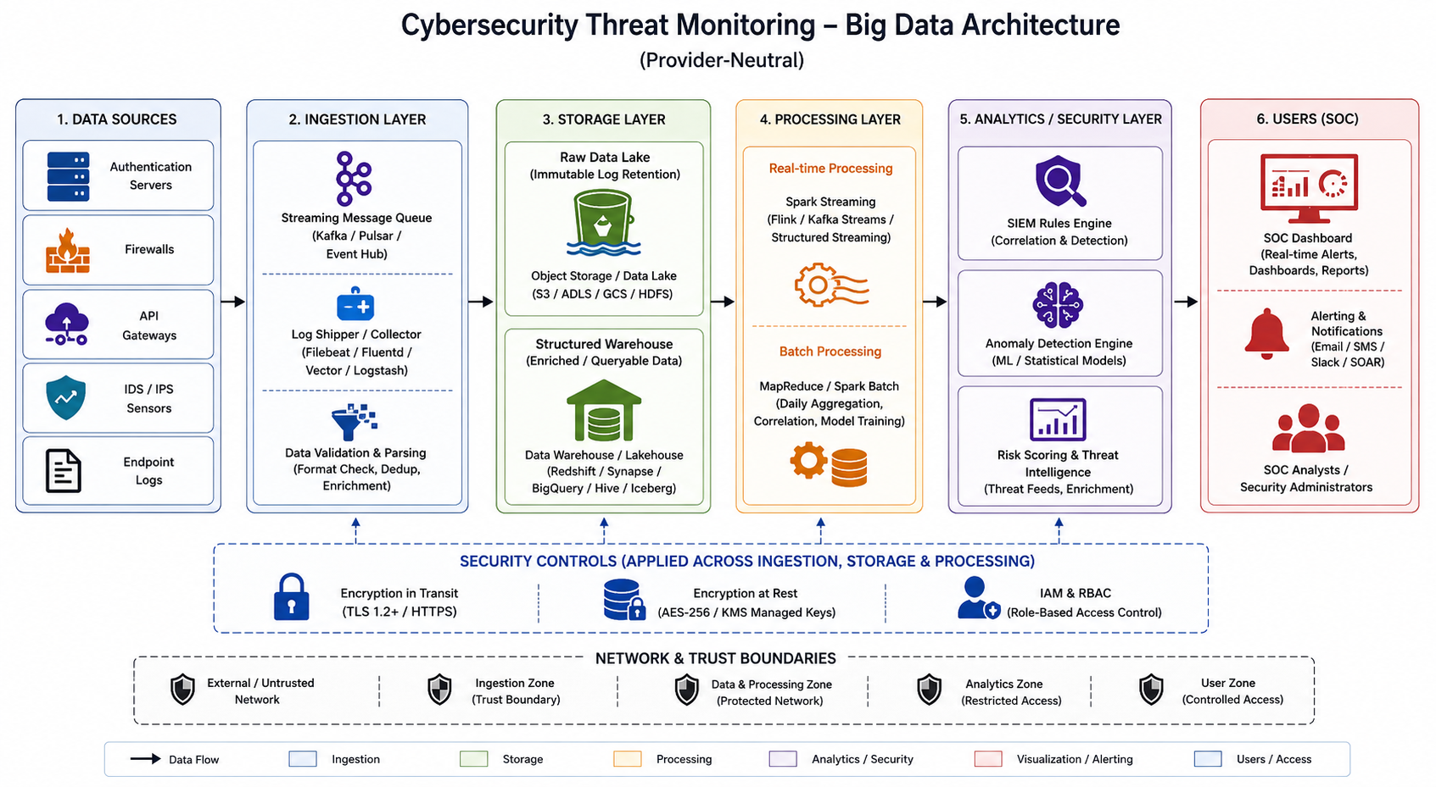

4. Data Flow Pipeline
What to include: Explain how raw data moves, gets cleaned, stored, processed and converted into dashboard/alert/decision.

Student Response
Raw events (login attempts, firewall triggers, API calls) are generated at each endpoint and pushed to a streaming ingestion queue in near real time. The ingestion layer performs light validation (schema check, timestamp normalization) before writing two copies of the data: an immutable raw copy to the data lake (for audit/forensics) and a live copy to the stream processor. The stream processor cleans the data further (deduplication, IP geolocation enrichment), applies windowed aggregation (e.g., failed-login counts per IP per 5 minutes) and rule/ML-based risk scoring, then writes high-risk results to an alert sink that immediately updates the SOC dashboard and can trigger an automated block action. In parallel, a scheduled batch job reads the accumulated raw data lake nightly, runs MapReduce/Spark Batch aggregation to build daily summary tables in the warehouse, and retrains the risk-scoring model on the latest labeled incident data, so the streaming detection logic continually improves.

5. Tool and Technology Justification
What to include: Use cloud architecture references and Hadoop/Spark documentation to justify chosen tools.

Student Response
Cloud architecture tools: The AWS, Azure and Google Cloud Architecture Centers were used to confirm the standard ingestion -> data lake -> processing -> analytics/security industry pattern (see Module 1); Google Cloud's Pub/Sub -> Dataflow -> BigQuery -> Security Command Center pattern was adopted as the primary reference for this design because it unifies streaming and batch SQL analytics in one warehouse, simplifying the analyst-facing query layer.
Processing tools: Apache Spark Structured Streaming documentation confirmed that windowed, continuously-arriving event processing (source -> processing -> sink) is the correct fit for live failed-login and firewall-alert detection, while the Apache Hadoop MapReduce tutorial confirmed that large stored historical logs are efficiently summarized using the classic mapper/reducer batch pattern, justifying the hybrid Spark Streaming + MapReduce/Spark Batch decision made in Module 2.

6. Security and Privacy Strategy
What to include: Use threat model output to explain threats and controls.

Student Response
Using the OWASP Threat Dragon model built in Module 3, the platform's highest risks are spoofed/stolen credentials at the authentication API (Spoofing), tampering with log data in transit (Tampering), unauthorized access to the security data lake (Information Disclosure), flooding of the ingestion pipeline (Denial of Service), disputed analyst actions (Repudiation), and privilege escalation on the admin console (Elevation of Privilege). Controls are mapped one-to-one to each threat: MFA and account lockout for spoofing; TLS encryption and message signing for tampering; encryption at rest, RBAC and data masking for information disclosure; rate limiting and auto-scaling for denial of service; immutable, signed audit logs for repudiation; and least-privilege role separation with regular privilege audits for elevation of privilege. Together these controls ensure that the monitoring platform protecting the organization does not itself become the weakest link.

7. Challenges and Solutions
What to include: Write at least four big-data implementation challenges and one practical solution for each.

Student Response
Challenge 1 - High false-positive rate: Naive threshold-based rules (e.g., 'more than 3 failed logins') generate too many false alerts, causing analyst fatigue. Solution: Use adaptive, ML-based risk scoring trained on historical labeled incidents rather than static thresholds, and continuously retrain the model with the nightly batch job.
Challenge 2 - Data volume and storage cost: Storing every raw log line indefinitely across millions of daily events becomes expensive. Solution: Apply tiered storage - keep recent raw logs in fast storage for real-time queries and move older logs to low-cost archival/cold storage, retaining only aggregated summaries in the hot warehouse.
Challenge 3 - Real-time latency under load: During an active attack, event volume spikes sharply, risking delayed alerts exactly when speed matters most. Solution: Auto-scale the streaming cluster based on incoming event rate and apply backpressure-aware processing so the pipeline degrades gracefully rather than dropping critical alerts.
Challenge 4 - Data privacy and compliance: Logs contain personally identifiable information (usernames, IP addresses) that must be protected under data-protection regulations. Solution: Apply field-level masking/tokenization of PII before analysts view raw logs, and enforce role-based access control so only authorized personnel can see unmasked data.

8. Business Outcome
What to include: State measurable outcome: faster decision, reduced fraud, lower waiting time, improved prediction, lower downtime or better user experience.

Student Response
The primary measurable business outcome is a reduction in Mean Time to Detect (MTTD) and Mean Time to Respond (MTTR) for security incidents - moving from a manual, log-review-based detection process (often hours to days) to a streaming-analytics pipeline that flags high-risk events within minutes. This translates directly into fewer successful account compromises, reduced financial exposure from breaches, improved audit/compliance reporting through automated daily summaries, and a measurable reduction in SOC analyst workload as false positives are filtered out by adaptive risk scoring rather than manual triage.

Rubric
Criteria | Marks | Evaluation Focus | Evidence
Problem and 5Vs analysis | 6 | Scenario-specific analysis and correct big-data reasoning | Workbook tables
Architecture and data flow | 6 | Correct pipeline, cloud components and flow clarity | draw.io diagram
Processing framework decision | 5 | Batch/streaming/hybrid justification using Hadoop/Spark concepts | Decision table
Security and privacy | 5 | Threat model, risks and controls | Threat model table/screenshot
Dashboard/output design | 4 | Useful decision-oriented analytics output | Dashboard/mockup
Clarity and submission quality | 4 | Organized, original, complete evidence | GitHub/GCR

Submission Checklist
- Student details and selected scenario are filled.
- Cloud architecture references are recorded.
- Hadoop/Spark processing decision is completed.
- Threat model diagram/table is included.
- Dashboard/mockup screenshot or link is included.
- Final solution sections are completed.
- DOCX/PDF and supporting files are uploaded to GitHub.
- GitHub repository link is submitted through Google Classroom.

Official Reference Links
AWS Architecture Center: https://aws.amazon.com/architecture/
Azure Architecture Center: https://learn.microsoft.com/en-us/azure/architecture/
Google Cloud Architecture Center: https://docs.cloud.google.com/architecture
Apache Hadoop MapReduce Tutorial: https://hadoop.apache.org/docs/stable/hadoop-mapreduce-client/hadoop-mapreduce-client-core/MapReduceTutorial.html
Apache Spark Structured Streaming: https://spark.apache.org/docs/latest/streaming/index.html
Microsoft Threat Modeling Tool releases: https://learn.microsoft.com/en-us/azure/security/develop/threat-modeling-tool-releases
OWASP Threat Dragon: https://owasp.org/www-project-threat-dragon/
Power BI documentation: https://learn.microsoft.com/en-us/power-bi/
Looker Studio create report: https://docs.cloud.google.com/data-studio/create-a-report
Tableau Public: https://www.tableau.com/community/public
Canva Charts: https://www.canva.com/help/charts/

