Ansys Fluent Simulation Report



|  |  |
| --- | --- |
| **Analyst** | M. Sunil Kumar |
| **Date** | 7/26/2023 09:26 PM |

Table of Contents

1 System Information 2 Geometry and Mesh

* 1. Mesh Size
  2. Mesh Quality
  3. Orthogonal Quality 3 Simulation Setup
  4. Physics
     1. Models
     2. Material Properties 3.1.3 Cell Zone Conditions 3.1.4 Boundary Conditions

3.1.5 Reference Values

* 1. Solver Settings 4 Run Information

1. Solution Status
2. Report Definitions 7 Plots

8 Contours 9 Vectors

System Information

|  |  |
| --- | --- |
| **Application** | Fluent |
| **Settings** | 3d, pressure-based, SST k-omega |
| **Version** | 23.2.0-10212 |
| **Source Revision** | 27b6146783 |
| **Build Time** | May 29 2023 07:59:57 EDT |
| **CPU** | 12th Gen Intel(R) Core(TM) i7-12650H |
| **OS** | Windows |

Geometry and Mesh

# Mesh Size

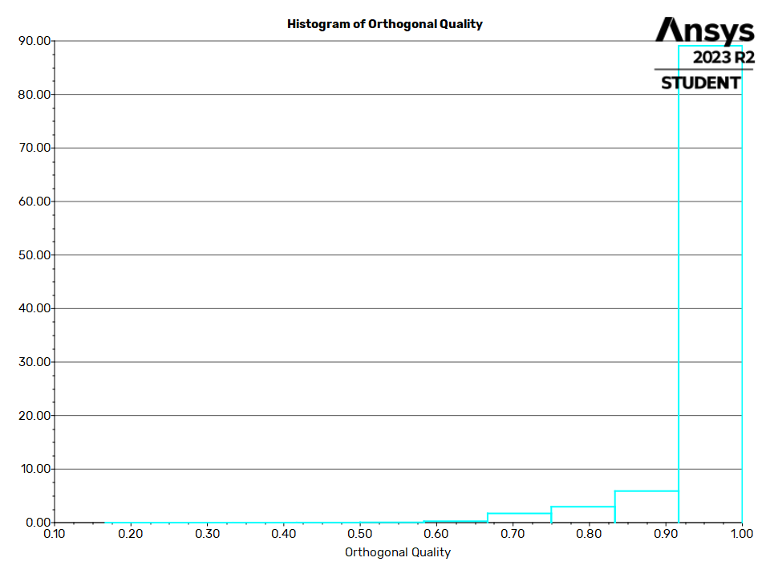

Simulation Setup

Physics

Models

|  |  |  |
| --- | --- | --- |
| **Cells** | **Faces** | **Nodes** |
| 801677 | 4202721 | 2885363 |

Mesh Quality

|  |  |  |  |
| --- | --- | --- | --- |
| **Name** | **Type** | **Min Orthogonal Quality** | **Max Aspect Ratio** |
| air | Poly Cell | 0.1667636 | 53.96682 |

# Orthogonal Quality

|  |  |
| --- | --- |
| **Model** | **Settings** |
| Space | 3D |

|  |  |
| --- | --- |
| **Model** | **Settings** |
| Time | Steady |
| Viscous | SST k-omega turbulence model |
| Heat Transfer | Enabled |



Material Properties

|  |  |
| --- | --- |
| Fluid |  |
| air |  |
| Density | ideal gas |
| Cp (Specific Heat) | 1006.43 J/(kg K) |
| Thermal Conductivity | 0.0242 W/(m K) |
| Viscosity | 1.7894e-05 kg/(m s) |
| Molecular Weight | 28.966 kg/kmol |
| Solid |  |
| aluminum |  |
| Density | 2719 kg/m^3 |
| Cp (Specific Heat) | 871 J/(kg K) |
| Thermal Conductivity | 202.4 W/(m K) |

# Cell Zone Conditions

|  |  |
| --- | --- |
| Fluid |  |
| air |  |
| Material Name | air |
| Specify source terms? | no |
| Specify fixed values? | no |
| Frame Motion? | no |
| Laminar zone? | no |
| Porous zone? | no |
| 3D Fan Zone? | no |

Boundary Conditions

|  |  |
| --- | --- |
| Inlet |  |
| inlet |  |
| Reference Frame | Absolute |
| Gauge Total Pressure [Pa] | 56400 |
| Supersonic/Initial Gauge Pressure [Pa] | 0 |
| Total Temperature [K] | 339 |
| Direction Specification Method | Normal to Boundary |
| Build artificial walls to prevent reverse flow? | no |
| Turbulent Specification Method | Intensity and Viscosity Ratio |
| Turbulent Intensity [%] | 5 |
| Turbulent Viscosity Ratio | 10 |
| Note: Reinjected particles do not change their injection association | no |
| Outlet |  |

|  |  |
| --- | --- |
| outlet |  |
| Gauge Pressure [Pa] | 11426.2 |
| Pressure Profile Multiplier | 1 |
| Note: Reinjected particles do not change their injection association | no |
| Build artificial walls to prevent reverse flow? | yes |
| Radial Equilibrium Pressure Distribution | no |
| Average Pressure Specification? | no |
| Specify targeted mass flow rate | no |
| Wall |  |
| body:33 |  |
| Wall Thickness [m] | 0 |
| Heat Generation Rate [W/m^3] | 0 |
| Material Name | aluminum |
| Thermal BC Type | Heat Flux |
| Heat Flux [W/m^2] | 0 |
| Enable shell conduction? | no |
| Wall Motion | Stationary Wall |
| Shear Boundary Condition | No Slip |
| Wall Surface Roughness | rough bc standard |
| Wall Roughness Height [m] | 0 |
| Wall Roughness Constant | 0.5 |
| Convective Augmentation Factor | 1 |
| body |  |
| Wall Thickness [m] | 0 |
| Heat Generation Rate [W/m^3] | 0 |
| Material Name | aluminum |
| Thermal BC Type | Heat Flux |
| Heat Flux [W/m^2] | 0 |
| Enable shell conduction? | no |
| Wall Motion | Stationary Wall |
| Shear Boundary Condition | No Slip |
| Wall Surface Roughness | rough bc standard |
| Wall Roughness Height [m] | 0 |
| Wall Roughness Constant | 0.5 |
| Convective Augmentation Factor | 1 |
| walls |  |
| Wall Thickness [m] | 0 |
| Heat Generation Rate [W/m^3] | 0 |
| Material Name | aluminum |
| Thermal BC Type | Heat Flux |
| Heat Flux [W/m^2] | 0 |
| Enable shell conduction? | no |
| Wall Motion | Stationary Wall |
| Shear Boundary Condition | No Slip |
| Wall Surface Roughness | rough bc standard |



|  |  |
| --- | --- |
| Wall Roughness Height [m] | 0 |
| Wall Roughness Constant | 0.5 |
| Convective Augmentation Factor | 1 |
| tailfins-canards-air |  |
| Wall Thickness [m] | 0 |
| Heat Generation Rate [W/m^3] | 0 |
| Material Name | aluminum |
| Thermal BC Type | Heat Flux |
| Heat Flux [W/m^2] | 0 |
| Enable shell conduction? | no |
| Wall Motion | Stationary Wall |
| Shear Boundary Condition | No Slip |
| Wall Surface Roughness | rough bc standard |
| Wall Roughness Height [m] | 0 |
| Wall Roughness Constant | 0.5 |
| Convective Augmentation Factor | 1 |



# Reference Values



|  |  |
| --- | --- |
| **Area** | 1 m^2 |
| **Density** | 0.0002327881 kg/m^3 |
| **Enthalpy** | 41112.64 J/kg |
| **Length** | 1 m |
| **Pressure** | 1 Pa |
| **Temperature** | 14.96558 K |
| **Velocity** | 807.6131 m/s |
| **Viscosity** | 1.789399e-05 kg/(m s) |
| **Ratio of Specific Heats** | 1.4 |
| **Yplus for Heat Tran. Coef.** | 300 |
| **Reference Zone** | air |

Solver Settings

|  |  |
| --- | --- |
| Equations |  |
| Flow | True |
| Turbulence | True |
| Energy | True |
| Numerics |  |
| Absolute Velocity Formulation | True |
| Pseudo Time Explicit Relaxation Factors |  |
| Density | 1 |
| Body Forces | 1 |
| Turbulent Kinetic Energy | 0.75 |
| Specific Dissipation Rate | 0.75 |
| Turbulent Viscosity | 1 |

|  |  |
| --- | --- |
| Energy | 0.75 |
| Explicit Momentum | 0.5 |
| Explicit Pressure | 0.5 |
| Pressure-Velocity Coupling |  |
| Type | Coupled |
| Pseudo Time Method (Global Time Step) | True |
| Discretization Scheme |  |
| Pressure | Second Order |
| Density | Second Order Upwind |
| Momentum | Second Order Upwind |
| Turbulent Kinetic Energy | Second Order Upwind |
| Specific Dissipation Rate | Second Order Upwind |
| Energy | Second Order Upwind |
| Solution Limits |  |
| Minimum Absolute Pressure [Pa] | 1 |
| Maximum Absolute Pressure [Pa] | 5e+10 |
| Minimum Static Temperature [K] | 1 |
| Maximum Static Temperature [K] | 5000 |
| Minimum Turb. Kinetic Energy [m^2/s^2] | 1e-14 |
| Minimum Spec. Dissipation Rate [s^-1] | 1e-20 |
| Maximum Turb. Viscosity Ratio | 100000 |



Run Information

Solution Status

Iterations: 500

|  |  |
| --- | --- |
| **Number of Machines** | 1 |
| **Number of Cores** | 1 |
| **Case Read** | 23.84 seconds |
| **Data Read** | 12.156 seconds |
| **Virtual Current Memory** | 2.50046 GB |
| **Virtual Peak Memory** | 2.69012 GB |
| **Memory Per M Cell** | 2.35746 |

|  |  |  |  |
| --- | --- | --- | --- |
|  | **Value** | **Absolute Criteria** | **Convergence Status** |
| **continuity** | 0.00723801 | 0.001 | Not Converged |
| **x-velocity** | 3.602506e-05 | 0.001 | Converged |
| **y-velocity** | 3.358796e-06 | 0.001 | Converged |
| **z-velocity** | 3.384285e-06 | 0.001 | Converged |

|  |  |  |  |
| --- | --- | --- | --- |
|  | **Value** | **Absolute Criteria** | **Convergence Status** |
| **energy** | 8.322667e-06 | 1e-06 | Not Converged |
| **k** | 0.0003327912 | 0.001 | Converged |
| **omega** | 4.224698e-06 | 0.001 | Converged |

|  |  |  |
| --- | --- | --- |
| fz | -0.007031343 | N |
| fy | -0.03443933 | N |
| fx | 58.22655 | N |

# Plots

Report Definitions

Residuals

## Residuals

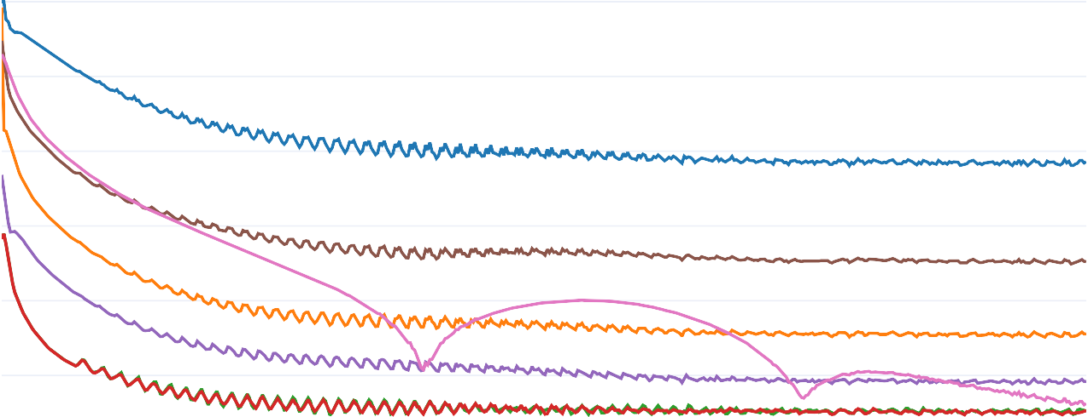1.00e+0

1.00e−1

1.00e−2

Residuals

1.00e−3

1.00e−4

1.00e−5

|  |  |  |  |  |
| --- | --- | --- | --- | --- |
|  |  |  |  |  |

100 200 300 400 500

continuity x-velocity y-velocity z-velocity energy

k omega

Iterations

# fx-rplot

## fx-rplot

6.05e+1 fx

6.00e+1

5.95e+1

Force (N)

5.90e+1

5.85e+1

5.80e+1

200 250 300 350 400 450 500

iteration

# fy-rplot

## fy-rplot

3.00e−2

|  |  |  |  |  |  |  |
| --- | --- | --- | --- | --- | --- | --- |
|  |  |  |  |  |  |  |
|  |  |  |  |  |  |  |
|  |  |  |  |  |  |  |
|  |  |  |  |  |  |  |
|  |  |  |  |  |  |  |
|  |  |  |  |  |  |  |
|  |  |  |  |  |  |  |
|  |  |  |  |  |  |  |

2.00e−2

1.00e−2

Force (N)

3.47e−18

−1.00e−2

−2.00e−2

−3.00e−2

−4.00e−2

fy

200 250 300 350 400 450 500

iteration

# fz-rplot

## fz-rplot

−5.00e−3

|  |  |  |  |  |  |  |
| --- | --- | --- | --- | --- | --- | --- |
|  |  |  |  |  |  |  |
|  |  |  |  |  |  |  |
|  |  |  |  |  |  |  |
|  |  |  |  |  |  |  |
|  |  |  |  |  |  |  |
|  |  |  |  |  |  |  |
|  |  |  |  |  |  |  |
|  |  |  |  |  |  |  |

−1.00e−2

−1.50e−2

−2.00e−2

Force (N)

−2.50e−2

−3.00e−2

−3.50e−2

−4.00e−2

fz

200 250 300 350 400 450 500

### iteration

Contours

contour-1

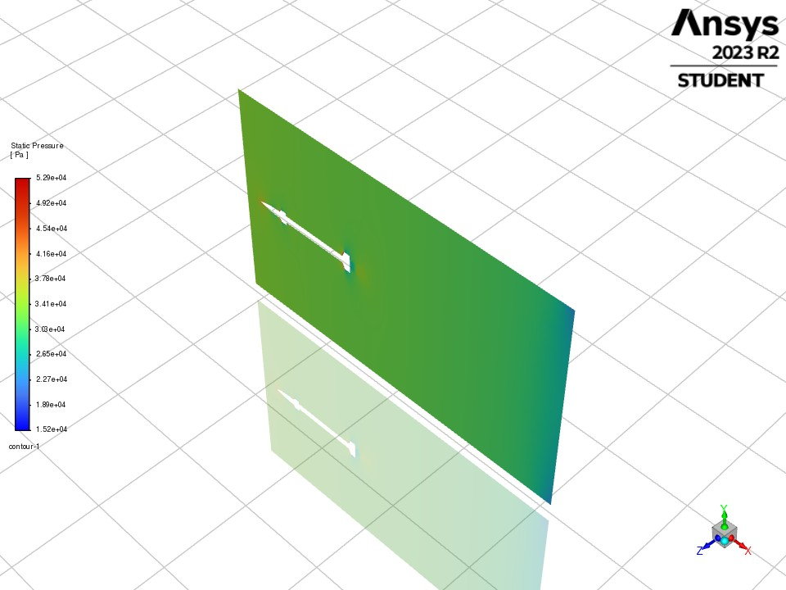

Vectors

vector-1

