**Surround View Camera Technology For Advanced Collision Detection**

**Viswanathan Krishnan, Dr.R.Elavarasan**

**Emails of authors :** [**vish2004k@gmail.com**](mailto:vish2004k@gmail.com)**,** [**elavarasan1304@gmail.com**](mailto:elavarasan1304@gmail.com)

**Affiliations : St. Joseph’s College of Engineering, St. Joseph’s College of Engineering**

**Abstract**

The proposed Vehicle Collision Detection System employs a 360-degree surround view camera and advanced computer vision methods and deep learning methodologies for the supply of real-time road safety. Using the YOLO algorithm for object detection and Convolutional Neural Networks (CNNs) for collision prediction with MobileNetV2, the system keeps the vehicle's surrounding scene under constant observation and identifies and tracks close objects such as cars, pedestrians, and stationary objects. Surround camera feed is processed on OpenCV library and objects are tracked in order to determine relative motion parameters like speed, direction, and distance. This enables the system to predict potential collisions safely and initiate warnings in a timely fashion through an innate alarm module with alarms of varying severity levels. As opposed to traditional systems such as radar, ultrasonic sensors, or LIDAR, vision-based this solution is more accurate, more environmentally sensed, and less expensive. The solution is designed to function under many different conditions of weather and light and can be made to fit on an incredibly broad base of vehicles. Experimental evaluation demonstrates improved object detection capability and collision anticipation, 94.8% F1-score and 90.4% accuracy overall, and is representative of the ability of the system to reduce road accidents significantly and enhance automobile security.

**Keywords:** Collision Detection • YOLO • Dashboard Cameras • Bounding Box • Machine Learning • CNN

1. **Introduction**

Road accidents everywhere in the globe are an extremely important matter that is leading to a humongous number of deaths and loss of funds. Automobile accidents take a massive amount of people's lives annually, especially in vulnerable places such as urban intersections, roads, and densely populated urban residential areas. There are many causes of car accidents, which can kill over one person and lead to a range of outcomes. Once two automobiles collide, there is a need to know how and who. Despite the use of safety features such as ADAS, accidents never disappear. New car safety technologies rely primarily on technology such as ultrasonic sensors, radar-implanted CPR devices, and most recently LIDAR. These types of technologies are used for the detection of probable obstructions in the path of a car, so the car can notify the driver or initiate a change such as automatic braking. Despite the ubiquity of such technologies, they are woefully impaired by cost, precision, range of detection, and availability. The most ubiquitous technology used in modern-day automobiles is the radar collision avoidance system. To sense objects and their proximity and velocity from the vehicle, radio waves are used in this technology. There are several radar system drawbacks, but first among these under conditions of snow, rain, and fog are signal interference that reduces precision.

Radar systems possess a low detection of objects, thus it is challenging to chase speeding or far-off vehicles, especially in congested intersections. In addition, radar systems are not desirable in detecting risks from sides or rears of vehicles. Ultrasonic sensors constitute another widely used technology, applied ubiquitously for near-range purposes such as parking aid and low-speed collision warning. Sensors employ sound waves to detect obstacles and are less accurate in range(typically a few meters only) and less so at high speed or when attempting to detect pedestrians or quickly moving vehicles. Moreover, as with radar technology, ultrasonic sensors are mounted in full zones around the vehicle and are sometimes bothersome depending on the environment, limiting their capacity to provide full 360-degree coverage. LIDAR (Light Detection and Ranging) technology is utilized in a few of the more advanced and autonomous cars, whereby laser pulses are utilized to establish the nearness to surrounding objects and provides accurate measurement. The prohibitively high price of LIDAR makes it impractical for use on a daily basis in ordinary vehicles, though its object detection and depth sensing are better. In addition, meteorological conditions like rain, dust, or fog may disrupt LIDAR technology and lead to beam breaks and inefficiency. Therefore, the technology of LIDAR manifests itself through the forms of costly luxury vehicles or futuristic self-driving car prototypes.

By integrating computer vision technology with a 360-degree camera system, the proposed Vehicle Collision Detection System is an alternative option that costs less, is priced lower, and is more secure in terms of addressing such limitations. A 360-degree camera system provides a real-time, around-the-view of the vehicle's surrounding environment, which is in contrast to radar, ultrasonic, or LIDAR technology that detects objects through radiated electromagnetic or acoustical waves. One of the sophisticated features not typically part of default systems, the camera sequence is dynamically scanning the surroundings in every direction possible, offering priceless vision to detect side and rear collisions. Convolutional Neural Networks (CNNs) provide top-level object recognition and classifying capabilities, with OpenCV providing the ability to process the video feeds of the cameras. CNN is able to identify objects such as pedestrians, cars, and walls even in complicated settings. The technology is also able to potentiate collision anticipation and notify the driver in advance utilizing the observation of the object's velocity, direction, and distance. Giving the driver an extra reaction time, the technology reduces collisions.

The capability of the system to function under all manner of lighting and weather conditions is a first-order advantage to which radar and LIDAR systems are not privy. The utilization of commercially produced camera equipment and that it doesn't need radar implies that the system will be cheaper compared to LIDAR systems and can be fitted into any car size from public transport buses and commercial buses to private vehicles. As there is an embedded real-time alarm system, the Vehicle Collision Detection System prevents drivers from colliding with other vehicles. The Vehicle Collision Detection System is superior to the current radar and ultrasonic systems because it provides a 360-degree field of vision and collision prediction through object movement tracking. The product is an innovative device to improve road safety for drivers, passengers, and pedestrians because it can work well in various vehicles and situations.

1. **Related Works**

Video-based, segment-based, and frame-based identification are the three dominant methods to identify traffic incidents in autonomous vehicles' dashcam videos discussed in the paper [**1**]. In an effort to delineate normal and anomalous sequences, video-based approaches examine the whole video by classifiers or reconstruction error models like autoencoders and GANs. Dynamic conditions like those in dashcam videos become challenging to handle for these means to dominate. Clipping is segmented into pieces in videos for segment-based detection, which uses methods such as Multiple Instance Learning (MIL) for assigning a score of unusual nature to each piece. Although this approach is effective, it has difficulty in complicated scenarios involving large road users. Frame-based detection compares expected and real frames to identify anomalies. It predicts the current frame from the previous frames. This method although very accurate in identifying anomalies, but it requires a lot of computing resources. Object detection, tracking, and motion analysis are all employed by the three methods to recognize dangerous events, improving accident-prone decision-making by autonomous cars.

An automatic system for the detection and assessment of traffic accidents from monitoring video is illustrated in Article [**2**]. The procedure is initiated by the MIF model, in which accidents are detected and their locations determined in streams of video. The cars vulnerable vehicles from the collision are then identified with the assistance of YOLO v3. Vehicle trajectories preceding the collision are recovered using hierarchical clustering and consequently projected onto a vertical view using perspective transformation. UFIR filtering is utilized in the computation of the collision angle in addition to estimating the velocities of the cars from the recovered trajectories for accident investigation. Finally, all the algorithms were successfully validated on real-time computation on a Huawei HiKey970 AI demo board, assuring trajectory recovery and accident detection. HiKey970 performance was changed from 28.85% to 45.72% compared with an Intel Core i7-9750H CPU. This system offers a practical traffic police solution for accident judgment through integrating advanced AI models and hardware for efficient crash analysis.

Similarly, [**5**] explores the significant issue of traffic accidents through a deep descriptive analysis on a quest to establish the determining variables of accident severity. The study makes an effort to explore cause determinants such as location, time, infrastructure, and weather to severe human and economic losses in road accidents. The goal of the project is to forecast accident severity on the basis of machine learning techniques in a bid to offer usable insight towards enhanced road safety. According to the study, relatively severe accidents to take place more often than low- or extreme risk ones. This finding underscores the significance of eliminating the underlying causes of the latter category of accidents. Rightful conclusions mean day of the week, road surface, and weather all have different effects on accident severity. For instance, poor road conditions and bad weather are frequently associated with severe accidents, and different traffic patterns result accidents to occur more frequently on certain days of the week. The Random Forest algorithm was better than other machine learning models in testing, accurately predicting accident severity at a high percentage of 97.2%. As the highest accuracy, Random Forest appears best poised to work with the complexity and instability of traffic accident data. For policymakers like politicians and traffic managers, the study results are important to the extent that they offer evidence-based support for the implementation of targeted programs. In risk identification situations and prediction of accident severity, the study offers important guidance for programming to mitigate risks and enhance overall road safety.

The global crisis issue of road accidents, a main cause of damage, death, and permanent disability, is discussed in article [**7**]. Almost 1.20 million individuals are annually murdered by road accidents and 20 to 40 million are wounded, of whom most turn into permanent disability, the World Health Organization's Road Traffic Injuries Report 2021 estimates. For enhancing road safety and reduction of the horrific human and financial toll of road accidents, the report calls for innovative initiatives to tackle the problem at a swift pace. It is feasible to have more scope to work on intelligent traffic management systems since computer vision and artificial intelligence technology has been progressing at a very rapid pace. Such sensors can potentially significantly improve response time, accident detection, and anticipation. This research is centered on one such innovative solution: a computer vision-based solution utilizing dashboard camera (dashcam) data for accident detection and anticipation. Driver-owned and driverless vehicles are increasingly incorporating dashcams, offering an affordable and readily available source of real-time roadway information.

For enhancing road safety, an alarm system-based real-time vehicle crash detection system utilizing bounding boxes is presented in paper [**11**]. With more and more vehicles being present on roads, effective crash detection systems are no longer a choice. The approach employs bounding boxes for vehicle size and location detection using a video stream to detect and monitor possible collisions. The technology applies computer vision as well as image processing methods to scan video from strategically positioned cameras. The warning system is triggered to notify drivers and pedestrians of a possible collision, which allows them to respond effectively. The procedure attempts to enhance road safety in general by reducing the incidence of accidents by identifying specific, real-time collisions.

Similarly, the paper [**12**] is on enhancing road efficiency and safety with autonomous vehicles based on machine learning and computer vision. From dashcam footage, the paper applies deep learning models, YOLO v8 in this instance, to detect six large categories: human, vehicle, bicycle, motorcycle, bus, and truck. Vehicle-pedestrian impact prediction is to avoid collisions. The perceivable gains, including safer roads, reduced traffic, improved air quality, and enhanced mobility, are achieved through the installation of sensors and machine learning on cars. To counterbalance other safety issues, the research also supports the use of night vision equipment that improves the detection of cyclists, pedestrians, and wildlife at night.

1. **Implementation**

From the shots taken by a set of 360° cameras mounted on the vehicle, the system captures a broad view of all that is in and out. The system gives the real-time-wide-angle view through erasing blind spots which could not be reached with regular mirrors or cameras. The video frames are resized and normalized in order to meet the input requirement of the Convolutional Neural Network (CNN) model (for instance, 224x224 pixels). The pre-processing process normalizes images to standardize for proper analysis. The procedure is programmed to eliminate size variation and differences in lighting by resizing frames and normalizing them to establish the data prior to the CNN scanning effectively and uniformly. These pre-processed frames are afterwards inspected for instant-time detection of possible traffic incidents or hazards surrounding the vehicle in order to feel immediately and respond to hazardous events.

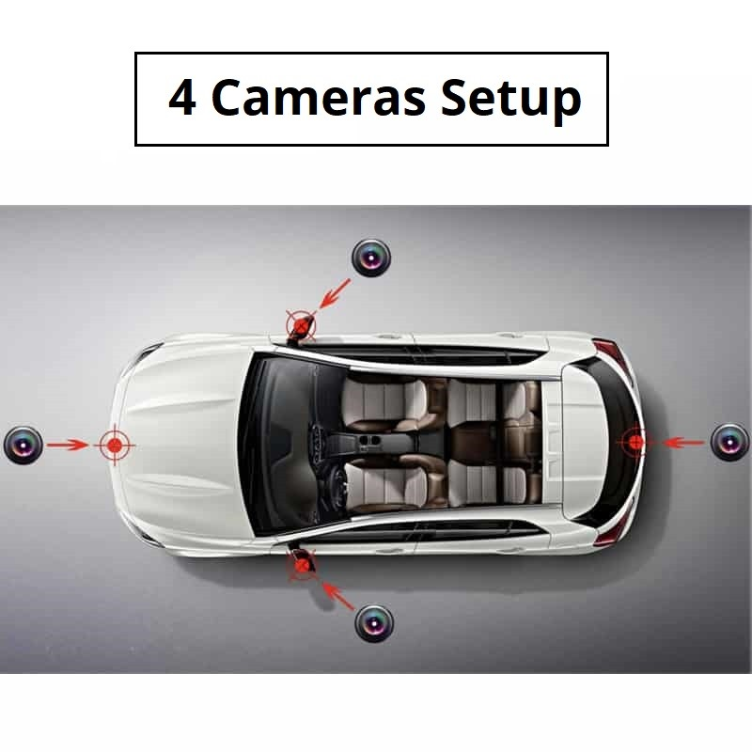

**Fig. 1** Camera Input points for the vehicle

The object detection module is invoked once the video stream has been processed. The module detects and classifies objects in the environment surrounding the vehicle based on pre-trained computer vision algorithms such as YOLO (You Only Look Once). They may include obstacles, bicycles, pedestrians, and other cars. The system labels bounding boxes and the objects based on its real-time observation of their position, size, and movement. There is a cutting-edge deep model called YOLO (You Only Look Once) which has the ability to identify many objects in real-time from video or image inputs. The YOLO model is widely employed since it possesses the ability of effectively and efficiently distinguishing objects in an input video frame or image within one pass. YOLO splits the input picture into a grid of cells and encloses each cell with bounding boxes to search for possible objects. The object's class prediction and location are done by the system using regression techniques after training on a vast number of labelled images.

The collision prediction module utilizes a Convolutional Neural Network (CNN) to analyse the object detection system data and establish the likelihood of a collision. The CNN can predict upcoming crashes by considering factors such as object size, speed, distance, and direction relative to the vehicle. This module can ascertain whether a collision is imminent or has already taken place because it has learned a large dataset of diverse collision and non-collision cases.  
Impact detection and alarm system module senses whether the impact is light or heavy depending on known thresholds depending on the size of the incoming object and speed of the vehicle. The alarm system and notification system trigger if the system identifies a high-risk, serious crash. Upon sensing a severe impact by the system, the warning system is programmed to send alerts to the concerned agencies or authorities in real-time. Examples of organizations that need emergency responders, manufacturers, fleet managers, and insurance firms. The most sensitive information such as vehicle GPS coordinates, impact time and severity of collision are part of the alert. Some of the other methods to send notification are SMS and Firebase Cloud Messaging (FCM), in-app push notifications etc.

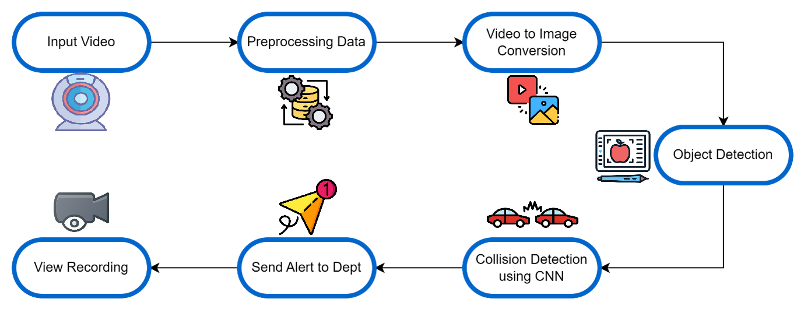

**Fig. 2** Overall Architecture of the proposed system

1. **Modules**

**Data Collection and Preprocessing**

The process begins with the setting and gathering the data from real footages of the vehicle's 360° camera. Training data collection is conducted by collecting the dataset from varied sources including images that comprise accident and no accident images. After collecting the data, the quality datasets are labelled accordingly.

**Object Detection using YOLO**

YOLO-based Object Detection module leverages 360° camera video feed for detecting objects in real-time and identifying objects around the vehicle. Image grid division and bounding box estimation, confidence, and class probabilities per grid cell, not only with the benefit of speed but also with the accuracy aspect, handles such input frames. YOLO performs very well in real-time processing since, unlike the other default object detection models, it makes one pass through the network to perform the detection. The algorithm recognizes an unimaginably wide range of objects such as cars, bicycles, and pedestrians by estimating their class label and location within the image and confidence-score.  
To retain only the most prominent detections, the module discards low-confidence predictions following object detection and applies non-maximum suppression to eliminate duplicate bounding boxes. Object tracking algorithms are also utilized by the system to track from frame-to-frame objects' motion once detected so as to give an estimation of the direction and speed of their motion. Collision prediction based on the prediction of relative motion of objects by the system to determine collision probability is dependent on such information. Real-time detection information like object coordinates, class, and confidence values is provided by the module because of the efficiency and speed of YOLO. Such information is presented to the module for collision prediction, which calculates them further in order to examine any future risk. Generally, the YOLO object detection module is a backbone of its system enabling it to sense environmental threat and make timely judgments for automotive safety.

**Collision Detection using CNN model**

The pre-trained model applied in CNN collision detection is MobileNetV2, a light and efficient pre-trained feature extractor that can effectively be applied in real time. MobileNetV2 is initialized with include_top as False to remove its own classification layers to serve as an image size 224x224 generic feature extractor. The base layers of the model are frozen to keep pre-trained weights for ImageNet as constants and not trainable during train time. It greatly reduces overfitting, particularly with processing of a small database, and greatly reduces training time. High-dimensional feature maps of the base model are input into a Global Average Pooling layer in order to allow them to be transformed into a one-dimensional vector. It possesses a specially fine-tuned classification head that is also specifically trained to detect collision detection-related features like object proximity and direction.

The head is of the type where two Dense layers with ReLU activation are used to reduce the dimensionality of the feature vector and provide non-linear learning to detect complex relations between the features. The last output layer is a neuron with sigmoid activation that provides a probability of 0 to 1 for whether there could be a collision or not. It is trained with the Adam optimizer and learning rate of 0.0001 in order to allow controlled weight updating during training. Binary cross-entropy loss is used as the loss function because it is most appropriate for this binary problem, and accuracy as the metric. This architecture is a fair trade-off between performance and computational cost and is extremely appropriate for vehicle safety real-time and embedded computing. By piling up on MobileNetV2's light-weighted base and enhancing it with task-specific classification head, the model offers an effective and efficient solution towards predicting collisions in intelligent transportation systems.

**Severity-Based Alert System**

It is the Severity-Based Alert System module that sends alarms on detection of a probable collision and on reaching its own severity level as critical. It is this module that measures the severity of the situation and responds accordingly on being activated by feedback from the collision detection module, which computes the probability and outcome of the impending collision. On the basis of a number of different factors such as the estimated force of impact and relative size, speed, and distance of the objects, the system rates the severity. A set of alarm is triggered when the estimated collision is beyond a certain threshold of severity. The primary contribution of the alert system is to respond timely in situations of need, especially where serious impact has been determined and measures must be set in motion. With regard to prevention of false alarms or excessive warning for low-severity accidents and providing severity-based classification for easy prioritization of serious accidents, the module makes it easy to manage vehicle security and response during emergency through the configuration that severe accidents trigger outer alarms.

1. **Results and Discussions**

**Table 1** Summary Statistics for performance results.

|  |  |
| --- | --- |
| **Performance measures** | **Performance rate** |
| Accuracy | 90.4% |
| Precision | 94% |
| Recall | 93.1% |
| F1-Score | 94.8% |
| AUC/ROC | 0.904 |
| PR | 0.932 |

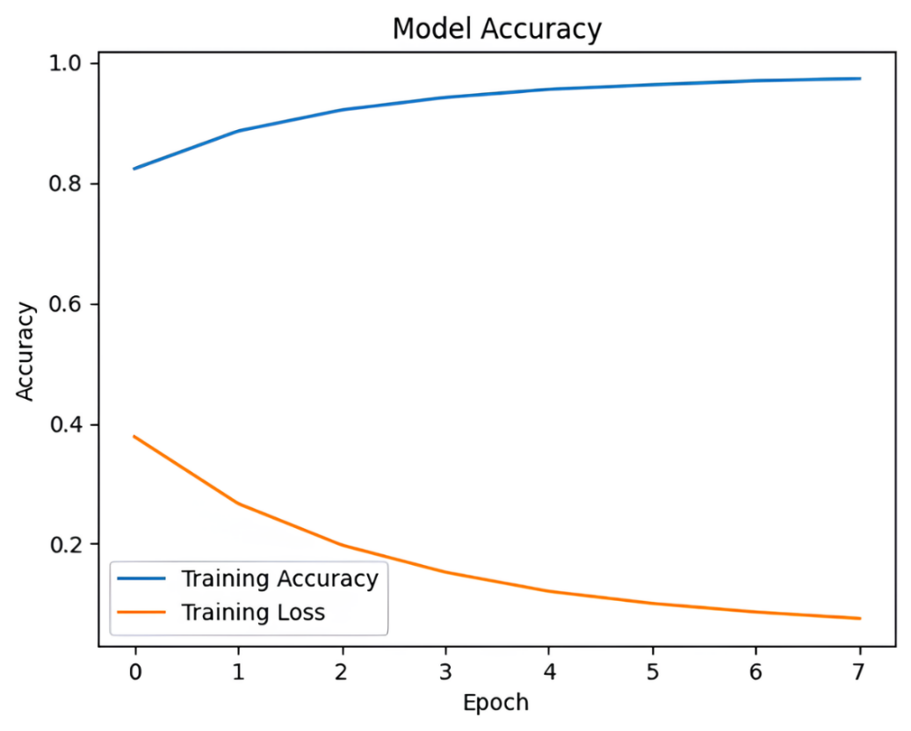

**Fig. 3** Training Accuracy and Loss curve

1. **Conclusion**

With anticipation and expectation of any possible crashes, this 360° cam and CNN-based car crash warning system is a step towards road safety. The system takes a 360° perspective and scans through all the things surrounding the vehicle, and with that, end-to-end real-time object recognition is enabled. The CNN analyzes the data to forecast collisions, estimating the likelihood of an intended collision using measures like trajectory, speed, and proximity. The system then alerts the drivers in advance to allow them to respond promptly and potentially avoid the crash.

The technology is not without an enhanced security and response time during emergencies benefit but also possesses some disbenefits. Disbursement of funds may be hindered by the comparatively high initial cost of 360° camera systems and computationally demanding models. Further, the system works at its best in best-case conditions, i.e., good weather and well-calibrated cameras, and can compromise on its reliability in worse-case conditions. Performance is also undermined by the high processing load required in handling vast amounts of real-time data, particularly on older or less advanced vehicles.

**References**

1. Rocky, Q. J. Wu and W. Zhang, “Review of Accident Detection Methods Using Dashcam Videos for Autonomous Driving Vehicles,” in *IEEE Transactions on Intelligent Transportation Systems*, vol. 25, no. 8, pp. 8356-8374, Aug. 2024.
2. Y. Sui, S. Zhou, Z. Ju and H. Zhang, “A Vision-Based System Design and Implementation for Accident Detection and Analysis via Traffic Surveillance Video,” in *IEEE Canadian Journal of Electrical and Computer Engineering*, vol. 45, no. 2, pp. 171-181, Spring 2022.
3. H. A. Yawovi, M. Kikuchi and T. Ozono, “Responsibility Evaluation in Vehicle Collisions From Driving Recorder Videos Using Open Data,” in *IEEE Access*, vol. 12, pp. 49962-49975, 2024.
4. J. Fang, J. Qiao, J. Xue and Z. Li, “Vision-Based Traffic Accident Detection and Anticipation: A Survey,” in *IEEE Transactions on Circuits and Systems for Video Technology*, vol. 34, no. 4, pp. 1983-1999, April 2024.
5. R. Vijithasena and W. Herath, “Data Visualization and Machine Learning Approach for Analysing Severity of Road Accidents,” *2022 International Conference for Advancement in Technology (ICONAT)*, Goa, India, 2022, pp. 1-6.
6. I. E. Mallahi, A. Dlia, J. Riffi, M. A. Mahraz and H. Tairi, “Prediction of Traffic Accidents using Random Forest Model,” *2022 International Conference on Intelligent Systems and Computer Vision (ISCV)*, Fez, Morocco, 2022, pp. 1-7.
7. A. Verma and M. Khari, “Vision-Based Accident Anticipation and Detection Using Deep Learning,” in *IEEE Instrumentation & Measurement Magazine*, vol. 27, no. 3, pp. 22-29, May 2024.
8. E. V. Hemanth Nag , Maulik Dev , R. Beaulah Jeyavathana, *“Vehicle Collision Detection and Alert System using Data Science”*  in International Journal of Scientific Engineering and Research (IJSER), ISSN (Online): 2347-3878.
9. G. A. Senthil, R. V. Lakshmi Priya, S. Geerthik, G. Karthick and R. Lavanya, “Safe Road AI: Real-Time Smart Accident Detection for Multi-Angle Crash Videos using Deep Learning Techniques and Computer Vision,” *2024 3rd International Conference on Applied Artificial Intelligence and Computing (ICAAIC)*, Salem, India, 2024, pp. 617-622.
10. N. Bhatia, Y. Dixit and K. M. Balamurugan, “Accident Emergency Alert System using Deep Learning,” *2023 Third International Conference on Artificial Intelligence and Smart Energy (ICAIS)*, Coimbatore, India, 2023, pp. 1-6.
11. S. R. Chandra Goud Bandi, V. G. Bezawada, M. P. Selvan, V. A. Mary, M. Posonia and A. Praveena, “Real Time Vehicle Collision Using Bounding Box Methodology with Alert System,” *2024 International Conference on Science Technology Engineering and Management (ICSTEM)*, Coimbatore, India, 2024, pp.1-6.
12. N. Vijayan, S. Pandey and P. R M, "Collision Detection and Prevention for Automobiles using Machine Learning," *2024 International Conference on Trends in Quantum Computing and Emerging Business Technologies*, Pune, India, 2024, pp. 1-4.
13. D. V P, A. M and A. V M, "Vehicle Collision Detection and Emergency Contact," *2024 2nd International Conference on Artificial Intelligence and Machine Learning Applications Theme: Healthcare and Internet of Things (AIMLA)*, Namakkal, India, 2024, pp. 1-5.