**Environmental Monitoring using IOT:**

**INTERFACING DHT22 SENSOR WITH ESP32 IN WOKWI SIMULATOR**

**INTERFACING DIAGRAM:**

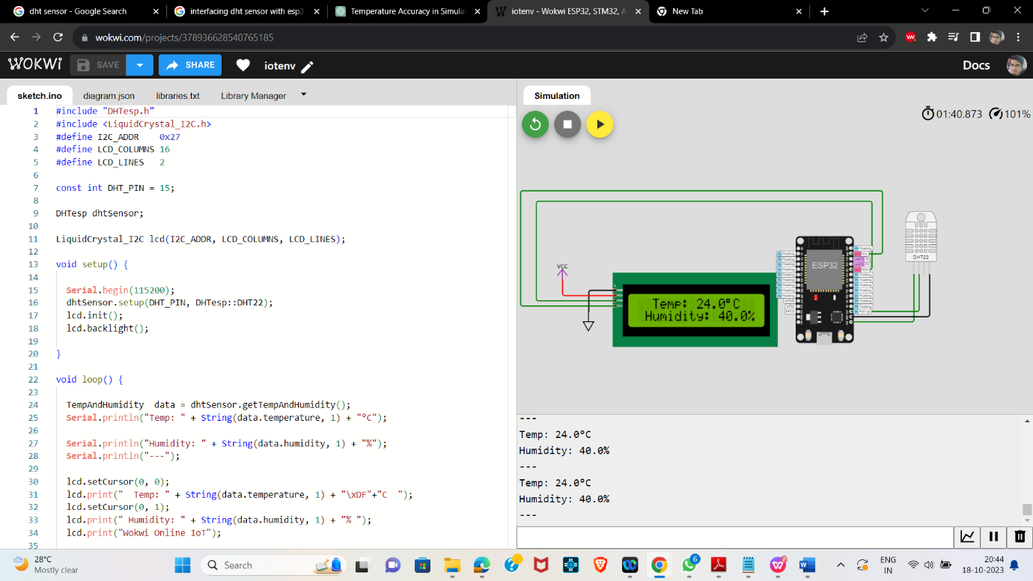

**CODE:**

#include "DHTesp.h"

#include <LiquidCrystal_I2C.h>

#define I2C_ADDR    0x27

#define LCD_COLUMNS 16

#define LCD_LINES   2

const int DHT_PIN = 15;

DHTesp dhtSensor;

LiquidCrystal_I2C lcd(I2C_ADDR, LCD_COLUMNS, LCD_LINES);

void setup() {

**Serial**.begin(115200);

  dhtSensor.setup(DHT_PIN, DHTesp::DHT22);

  lcd.init();

  lcd.backlight();

}

void loop() {

  TempAndHumidity  data = dhtSensor.getTempAndHumidity();

**Serial**.println("Temp: " + String(data.temperature, 1) + "°C");

**Serial**.println("Humidity: " + String(data.humidity, 1) + "%");

**Serial**.println("---");

  lcd.setCursor(0, 0);

  lcd.print("  Temp: " + String(data.temperature, 1) + "\xDF"+"C  ");

  lcd.setCursor(0, 1);

  lcd.print(" Humidity: " + String(data.humidity, 1) + "% ");

  lcd.print("Wokwi Online IoT");

  delay(1000);

}

**OUTPUT:**

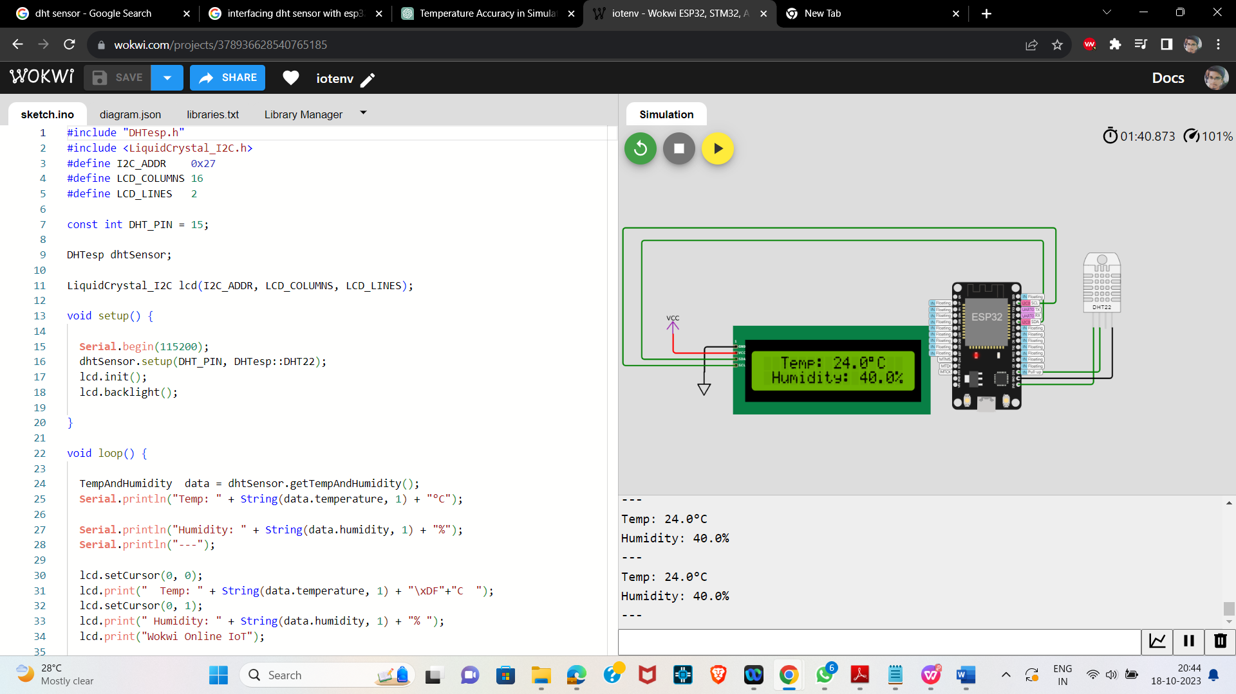

**SIMULATION LINK:**

[**https://wokwi.com/projects/378936628540765185**](https://wokwi.com/projects/378936628540765185)