**Environmental Monitoring using IOT:**

**INTRODUCTION:**

In some non-daily office spaces, such as operating stations, reception centers, etc.,there are always blind spots in management such as temperature,humidity,and lighting.Permanent lights, poor exhaust air,and failure to turn off air conditioners in a timely manner cause energy waste,and intelligent management and control need to be strengthened. In order to solve the above problems,this paper proposes the design of an environmental monitoring system based on the narrowband Internet of Things.Narrow Band Internet of Things (NB-IoT) is built on cellular networks and consumes only about 180kHz of bandwidth.It can be directly deployed on GSM networks,UMTS networks or LTE networks to reduce deployment costs and achieve smooth upgrades.The reason why it is used in this system is mainly because it is suitable for the characteristics of communication technology in application fields such as remote environmental monitoring.To strengthen the intelligent management and control of non-daily office spaces and realize real-time monitoring, it is first necessary to build an on-site environment perception system.Narrowband Internet of Things can well realize this function .In addition,the sensor module can be designed to measure the environmental parameters of sites and other places in real time and upload the measured parameters in time.Users can remotely monitor the sites anytime and anywhere without being present.It greatly saves manpower and material resources and avoids unnecessary waste of resources.

**Environmental real-time monitoring system design:**

The system structure design adopted in this article mainly involves three layers,which respectively realize the functions of data collection,data upload and data supervision.As shown in the figure below the system first collects all kinds of data in the environment,and then uploads these environmental data to the cloud on the Internet after collection,and then can perform real-time monitoring of these data anytime and anywhere without the need to be present.The cloud is what we now call the Internet of Things,which can easily receive,store,and manage data

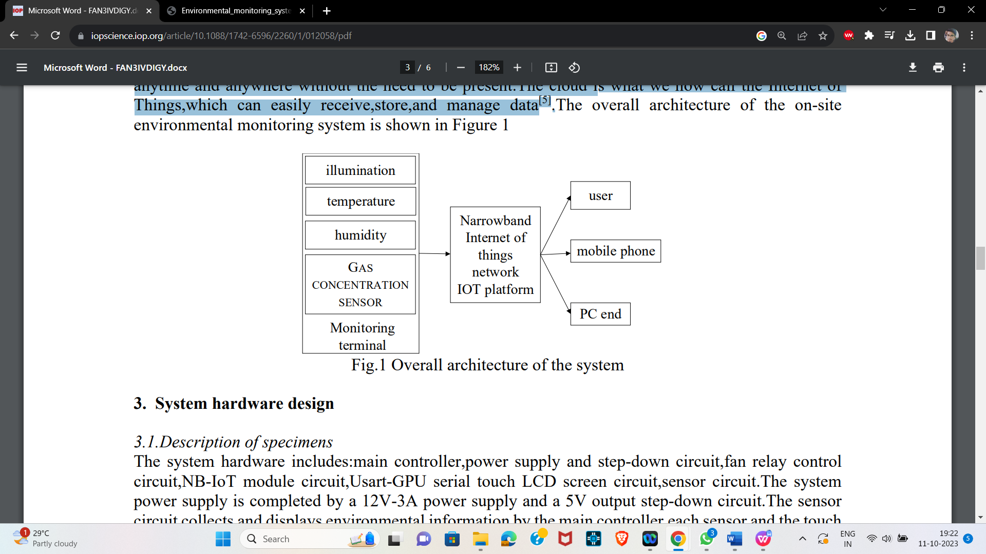.

**System hardware design:**

* The system hardware includes: main controller,power supply and step-down circuit,fan relay control circuit,NB-IoT module circuit,Usart-GPU serial touch LCD screen circuit,sensor circuit.
* The system power supply is completed by a 12V-3A power supply and a 5V output step-down circuit.The sensor circuit collects and displays environmental information by the main controller,each sensor and the touch screen.
* The connection between the entire system and the cloud platform is done by NB-IoT The module is complete.
* The microcontroller will remotely report the converted environmental data to the cloud platform through the narrowband IoT communication module,and the user can view the field site environmental data in real time through the cloud platform display interface.

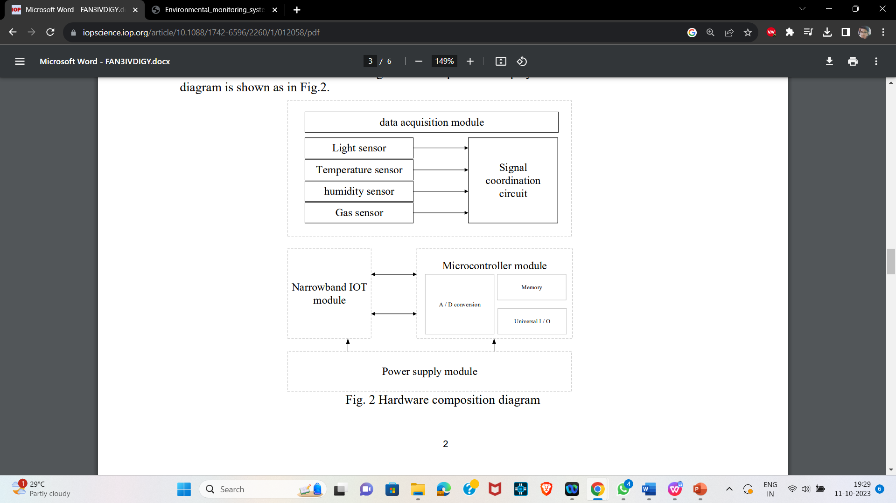

**System software design:**

The main control program of the system includes the main controller to collect, display and report data on the environment’s light intensity, temperature, humidity, and gas concentration. After the system is started, reset the device, reset the peripheral interface of the micro controller various sensors in the system, and the narrowband IoT communication module Then, the system checks whether the narrowband IoT communication module is successfully connected to the operator’s network.

