Assignment

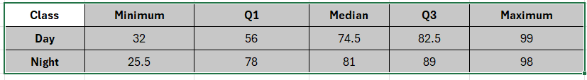
Finding IQR:
Day:
IQR = Q3 – Q1 = 82.5 – 56 = 26.5
Night:
IQR = Q3 – Q1 = 89 – 78 = 11
Lesser Range of Outlier:
Day:
Lesser Range = Q1-(1.5 * IQR)
= 56 – (1.5 * 26.5)
= 56 - 39.75 = 16.25
Night:
Lesser Range = Q1-(1.5 * IQR)
= 78 – (1.5 * 11)
= 78 – 16.5 = 61.5
Greater Range of Outlier:
Day:
Greater Range = Q3 + (1.5 * IQR)
= 82.5 + (1.5 * 26.5)
= 82.5 + 39.75 = 122.25
Night:
Greater Range = Q3 + (1.5 * IQR)
= 89 + (1.5 * 11)
= 89 + 16.5 = 105.5
Summary:
Day Class: Outlier Range – Lesser = 16.5, Greater = 122.5
In given all data between 32 to 99 there is No Outlier.

Night Class: Outlier Range – Lesser = 61.5, Greater = 105.5
In given all data between 25.5 to 98, Lesser outlier is detected (25.5)

