**Results Q2**

1. Visualization 1

From the below boxplot, we can understand that female gender has higher average scores in reading and writing, but in math male are slightly higher.

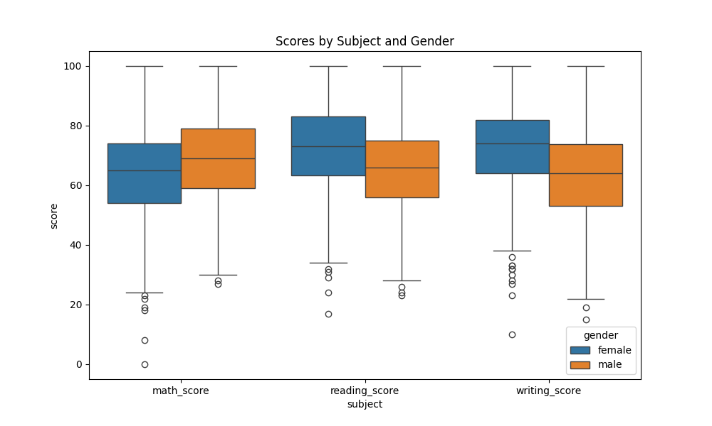

1. Visualization 2

It can be observed that group E has higher scores in all the 3 subjects.

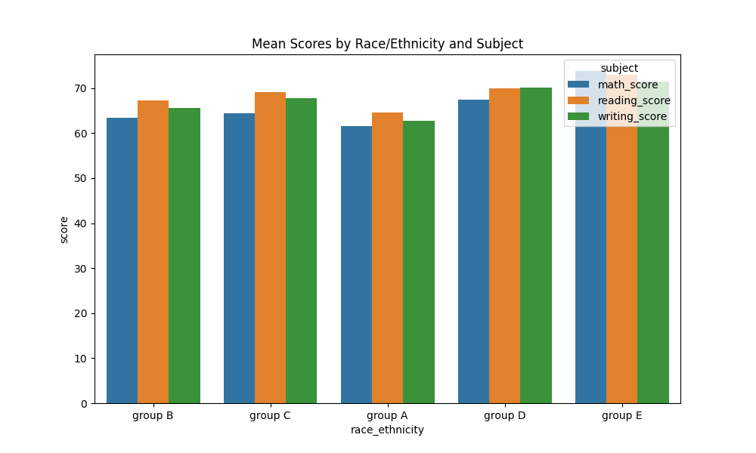

1. Visualization 3

We can infer from this visualization that the students with standard lunch type have scored better than the other type.

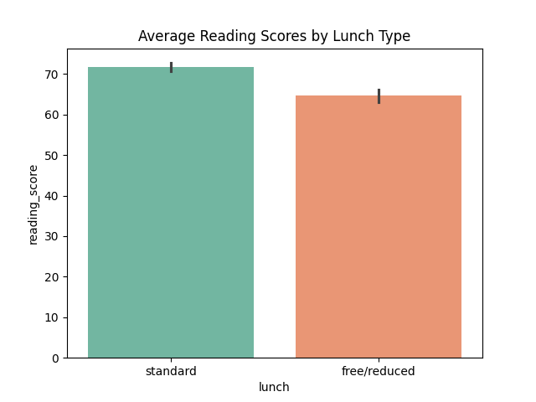

1. Visualization 4

The above visualization is a Relationship between parental education and math score. Seems like the parameter "parental_level_of_education" does not have much effect on the math scores of the students.

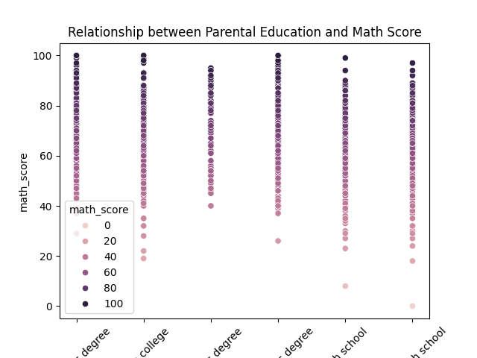

1. Visualization 5

This is a bar chart comparing average scores by test preparation course. Students who have completed preparation have scored better.

