**Assignment 2 – PDS**

**Viswanth Tammana**

**16352538**

1. The columns with missing values are ‘Mileage’, ‘Engine’ , ‘Power’ , ‘Seats’, ‘New_Price’.

I have replaced the missing values in ‘Mileage’, ‘Engine’, ‘Power’ with median. I have not chosen to mean, since it is can be altered easily even if there is a single outlier.

For the ‘Seats’ column, I have chosen mode because the number of seats will be a whole number.

I have dropped the column ‘New_Price’ since lot of values are missing in it.

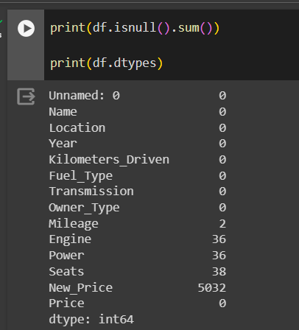

1. The new features calculated are ‘Age_of_Car’ which is the difference of the current year and the ‘Year’ in the particular row. Others are ‘Power_per_Liter’ and ‘Mileage_per_Seat’.