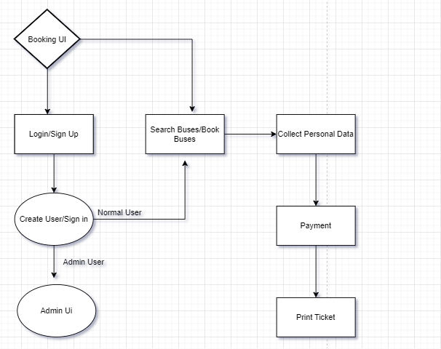

**End points required:**

1. List of cities(source,destination):

Get

Request data : NA

Response data: list of bus stops(string[])

for source and destination

1. Search

Get

Request Data: source, destination, date

Response Data: {Type(sleeper, super lux, delux),Ac(or non Ac), Start Time, Reach Time, Bus Name, Bus number, }

1. Create User

Post

Request Data: email, password

Response data: bool isSuccess

1. Login

Post

Request Data: email, password

Response data: bool isAuthorised

1. Book Ticket Api

DATABASE DESIGN

Tickets : ticketID, bus number, pick up city,drop city, userId(cannot be null), IsPaymentDone

Users: UserId, email, phoneNumber, password, isLoggedin, isAdmin,

Buses: Type(sleeper, super lux, delux),Ac(or non Ac), Start TimeDate, Reach DateTime, Bus Name, Bus number,

Cities: city

Allow user to book ticket even if they are not loggedin