**DAY4**

Viswas GA

727721EUCS184

1)

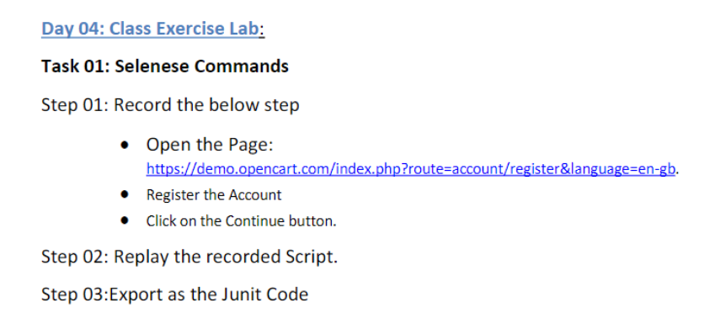

OUTPUT:

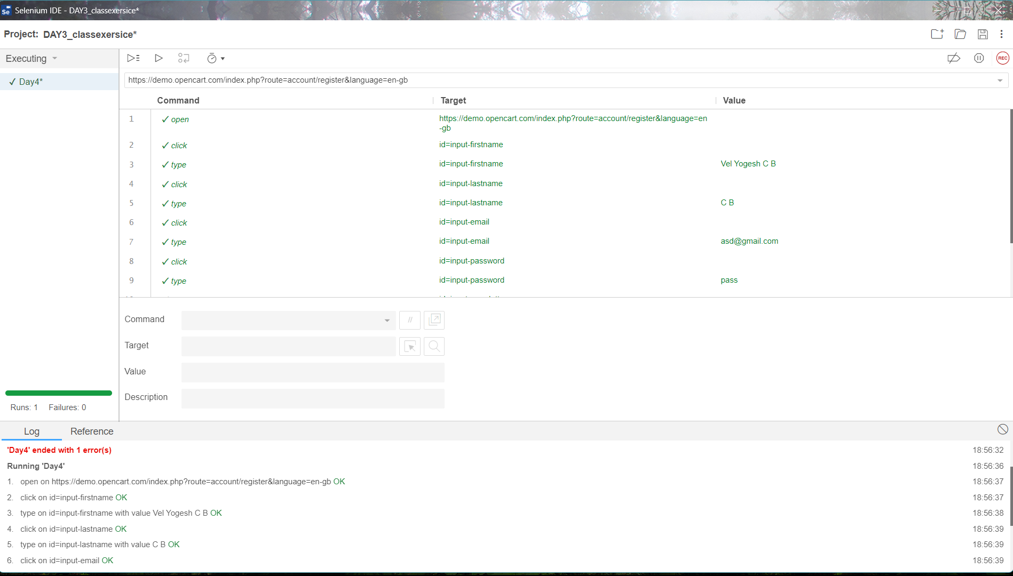

2)

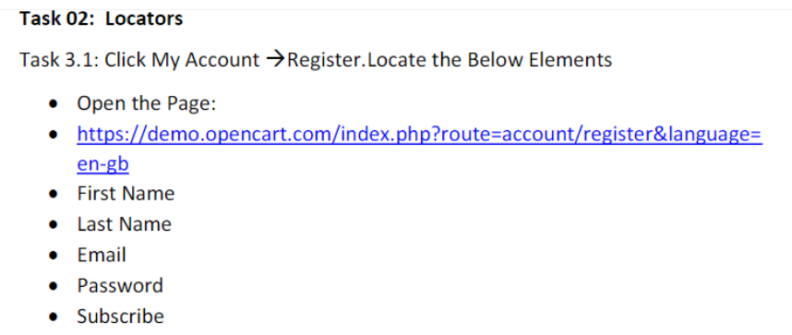

CODING:

package com.day4;

import org.openqa.selenium.By;

import org.openqa.selenium.WebDriver;

import org.openqa.selenium.WebElement;

import org.openqa.selenium.chrome.ChromeDriver;

import org.openqa.selenium.chrome.ChromeOptions;

import org.openqa.selenium.edge.EdgeDriver;

import io.github.bonigarcia.wdm.WebDriverManager;

public class ce2 {

public static void main(String[] args) throws InterruptedException {

ChromeOptions co=new ChromeOptions();

co.addArguments("--remote-allow-origins=*");

WebDriverManager.*chromedriver*().setup();

WebDriver driver=new EdgeDriver();

driver.get("https://demo.opencart.com/index.php?route=account/register&language=en-gb");

driver.manage().window().maximize();

WebElement fname=driver.findElement(By.*id*("input-firstname"));

fname.sendKeys("Surya");

Thread.*sleep*(3000);

WebElement lname=driver.findElement(By.*id*("input-lastname"));

lname.sendKeys("Prakash");

Thread.*sleep*(3000);

WebElement email=driver.findElement(By.*id*("input-email"));

email.sendKeys("surya9@gmail.com");

Thread.*sleep*(3000);

WebElement pswrd=driver.findElement(By.*id*("input-password"));

pswrd.sendKeys("Surydfe1.");

driver.findElement(By.*id*("input-newsletter-yes")). click();

Thread.*sleep*(3000);

driver.findElement(By.*name*("agree")). click();

Thread.*sleep*(3000);

driver.findEleMent(By.*xpath*("//button[@type=\"submit\"]")). click();

}

OUTPUT:

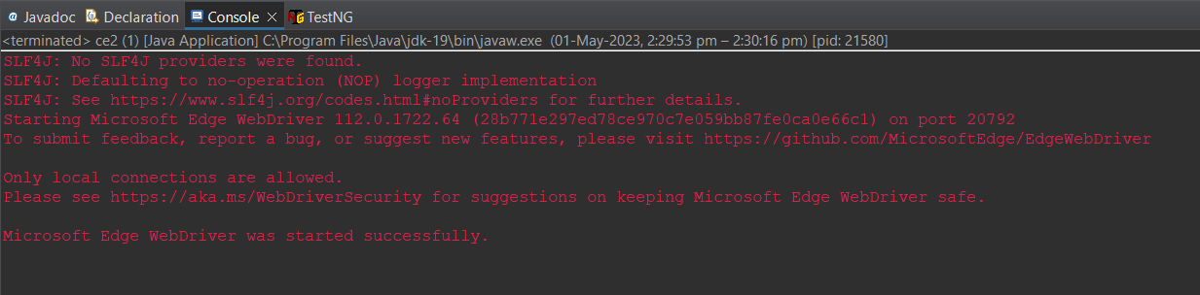

3)

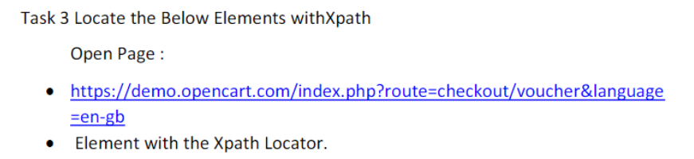

CODING:

package com.day4;

import org.openqa.selenium.By;

import org.openqa.selenium.WebDriver;

import org.openqa.selenium.WebElement;

//import org.openqa.selenium.chrome.ChromeDriver;

import org.openqa.selenium.chrome.ChromeOptions;

import org.openqa.selenium.edge.EdgeDriver;

import io.github.bonigarcia.wdm.WebDriverManager;

public class ce3 {

public static void main(String[] args) throws InterruptedException {

// TODO Auto-generated method stub

ChromeOptions co=new ChromeOptions();

co.addArguments("--remote-allow-origins=*");

WebDriverManager.chromedriver().setup();

WebDriver driver = new EdgeDriver();

driver.get("https://demo.opencart.com/index.php?route=account/register&language=en-gb");

driver.manage().window().maximize();

WebElement fname=driver.findElement(By.xpath("//*[@id=\"input-firstname\"]"));

fname.sendKeys("Viswas GA");

WebElement lname=driver.findElement(By.xpath("//*[@id=\"input-lastname\"]"));

lname.sendKeys("TGA");

WebElement email=driver.findElement(By.xpath("//*[@id=\"input-email\"]"));

email.sendKeys("Viswas@gmail.com");

WebElement pswrd=driver.findElement(By.xpath("//*[@id=\"input-password\"]"));

pswrd.sendKeys(“gfwyf3892.");

Thread.sleep(3000);

driver.findElement(By.id("input-newsletter-yes")).click();

Thread.sleep(3000);

driver.findElement(By.name("agree")). click();

Thread.sleep(4000);

driver.findElement(By.xpath("//button[@type=\"submit\"]")). click();

}

}

OUTPUT:

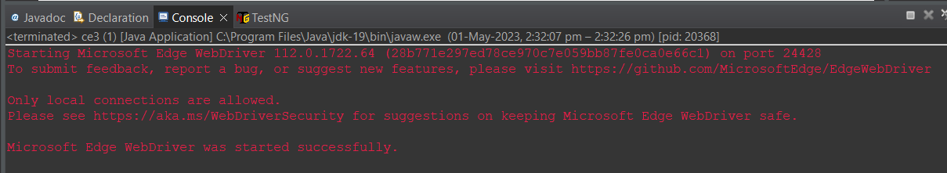

4)

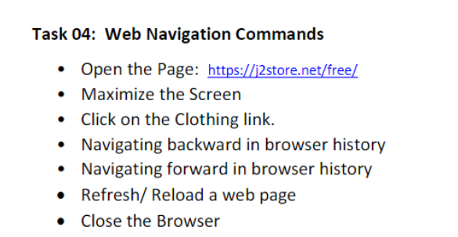

CODING:

package com.day4;

import org.openqa.selenium.By;

import org.openqa.selenium.WebDriver;

import org.openqa.selenium.chrome.ChromeOptions;

import org.openqa.selenium.edge.EdgeDriver;

import io.github.bonigarcia.wdm.WebDriverManager;

public class ce4 {

public static void main(String[] args) throws InterruptedException {

// TODO Auto-generated method stub

ChromeOptions co = new ChromeOptions();

co.addArguments("--remote-allow-origins=*");

WebDriverManager.chromedriver().setup();

WebDriver driver=new EdgeDriver();

driver.get("https://j2store.net/free/");

driver.manage().window().maximize();

Thread.sleep(4000);

driver.findElement(By.xpath("//*[@id=\"Mod112\"]/div/div/ul/li[1]/h4/a")).click();

driver.navigate().to("https://j2store.net/free/");

driver.navigate().back();

driver.navigate().forward();

driver.navigate().refresh();

driver.close();

}

}

OUTPUT:

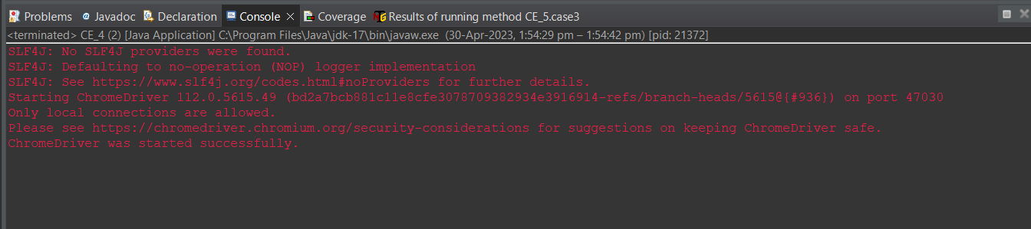

5.1)

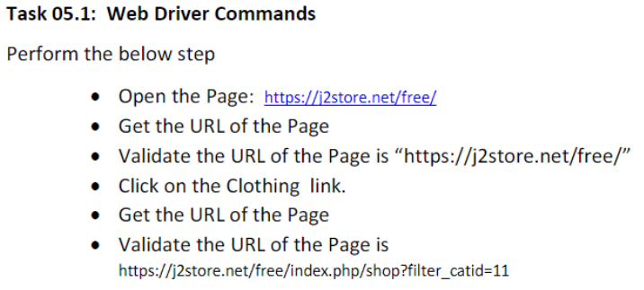

CODING:

package com.day4;

import org.openqa.selenium.By;

import org.openqa.selenium.WebDriver;

//import org.openqa.selenium.chrome.ChromeDriver;

import org.openqa.selenium.chrome.ChromeOptions;

import org.openqa.selenium.edge.EdgeDriver;

import io.github.bonigarcia.wdm.WebDriverManager;

public class ce51 {

public static void main(String[] args) throws InterruptedException {

// TODO Auto-generated method stub

ChromeOptions co = new ChromeOptions();

co.addArguments("--remote-allow-origins=*");

WebDriverManager.chromedriver().setup();

WebDriver driver=new EdgeDriver();

driver.get("https://j2store.net/free/");

driver.manage().window().maximize();

String actualURL="https://placement.skcet.ac.in/";

String expectedURL="https://j2store.net/free/";

if(expectedURL.equals(actualURL))

{

System.out.println("URL MATCHED");

}

else

{

System.out.println("URL NOT MATCHED");

}

driver.findElement(By.linkText("Clothing (5)")).click(); }

}

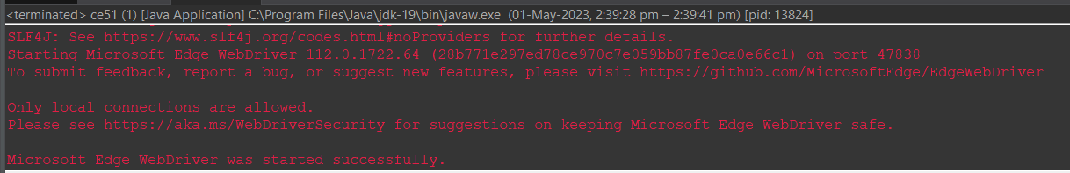

5.2)

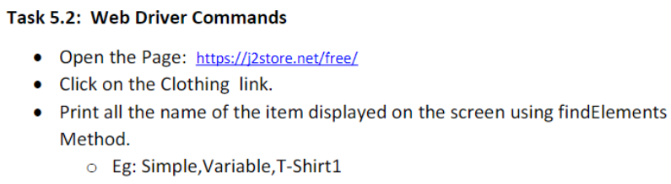

CODING:

package com.day4;

import java.util.List;

import org.openqa.selenium.By;

import org.openqa.selenium.WebDriver;

import org.openqa.selenium.WebElement;

//import org.openqa.selenium.chrome.ChromeDriver;

import org.openqa.selenium.chrome.ChromeOptions;

import org.openqa.selenium.edge.EdgeDriver;

import io.github.bonigarcia.wdm.WebDriverManager;

public class ce52 {

public static void main(String[] args) {

ChromeOptions co=new ChromeOptions();

co.addArguments("--remote-allow-origin=*");

WebDriverManager.chromedriver().setup();

WebDriver driver=new EdgeDriver();

driver.get("https://j2store.net/free/");

driver.findElement(By.linkText("Clothing (5)")).click();

List<WebElement> test=driver.findElements(By.xpath("//h2[@itemprop=\"name\"]"));

for(int i=0;i<test.size();i++)

{

System.out.println(test.get(i).getText());

}

}

}

OUTPUT:



