Usecase Iteration
Wiki Link: https://github.com/ViswasS/GDP_Group_02/wiki/Usecase-Iteration-2
1:Update Demographic Information
Goal: Allow patients to update or correct their own individual details.
Actor: Patient
Inputs:
Updated demographic data (e.g., gender, age, allergies, known conditions).
System Actions:
Confirm the input data.
Update the patient's record within the database.
Securely store the updated data.
Outputs:
Success message for demographic data update. 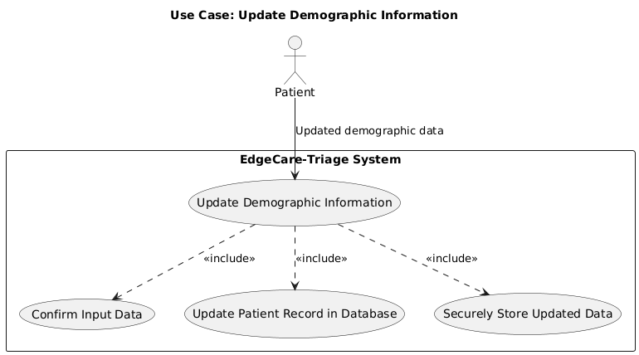
2:Submit Symptoms or Upload Photos
Goal: Send confirmation messages to patients immediately after successful transmission of symptom details or images.
Actor: Patient
Inputs:
Symptom details and/or images uploaded.
System Actions:
Validate the text and image inputs.
Transmit and save the information securely.
Trigger confirmation message on successful submission.
Outputs:
Visual confirmation message displayed to the patient, acknowledging their data has been submitted successfully. 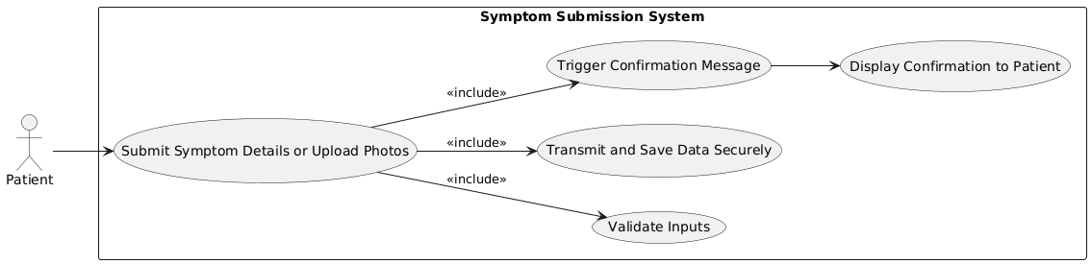
3: View Latest Triage Results
Goal: Allow patients to view their latest triage results before the app or web session is closed.
Actor: Patient
Inputs:
Patient request to view the patient's recent triage report.
System Actions:
Retrieve the patient's most recent triage record from the database.
Format and display the results in a readable, user-friendly format.
Outputs:
Triage summary displayed, for example, severity level and next steps. 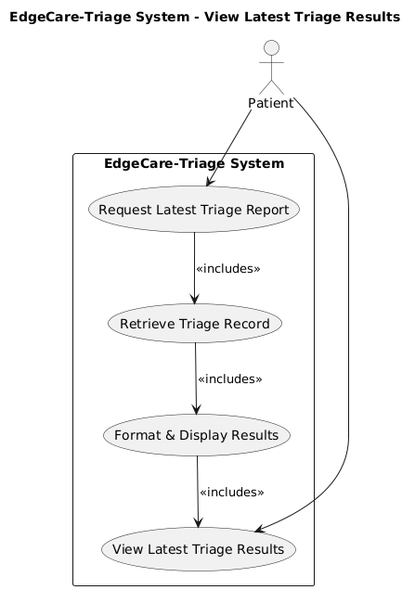
4: Offer Emergency Contact Numbers Access
Goal: Give patients direct access to emergency contact numbers upon identifying risky symptoms.
Actor: Patient
Inputs:
High-risk symptom information recognized by the system.
System Actions:
Evaluate patient symptoms and risk level.
If high risk level, invoke emergency response interface.
Display emergency contact numbers (e.g., 911) on screen.
Outputs:
Emergency numbers highlighted with call or quick-access options. 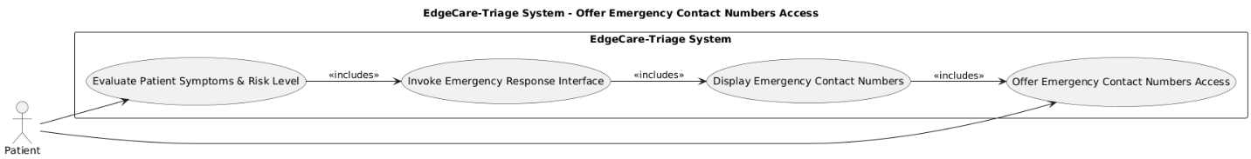
5: Session Timeout for Privacy
Goal: Protect patient privacy by logging out inactive users after a timeout session.
Actor: System (Patient indirectly affected)
Inputs:
System-detected inactivity period.
System Actions:
Track inactivity time for each session.
Issue a warning prior to the timeout.
In case of no user interaction, log the patient out automatically.
Send the user to the login screen.
Outputs:
User is securely logged out and session is terminated to protect privacy. 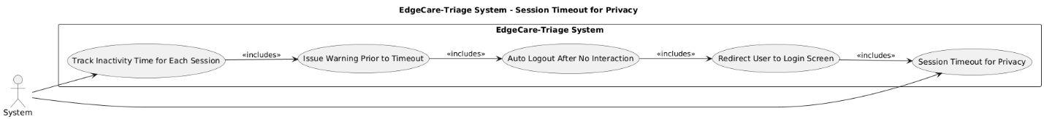
6: Dynamic triage questionnaire adaptation
Goal: Dynamically adapt triage questionnaires based on patient responses.
Actor: Patient
Inputs:
Patient response on the questionnaire (e.g., pain rating > 7).
System Actions:
Monitor patient responses as the patient completes the questionnaire.
Detect specific trigger conditions (e.g., high pain rating).
Load and display dynamically follow-up questions pertinent to the detected condition.
incorporate new responses into the current triage process.
Outputs:
Personalized and adaptive questionnaire shown to the patient in real time. 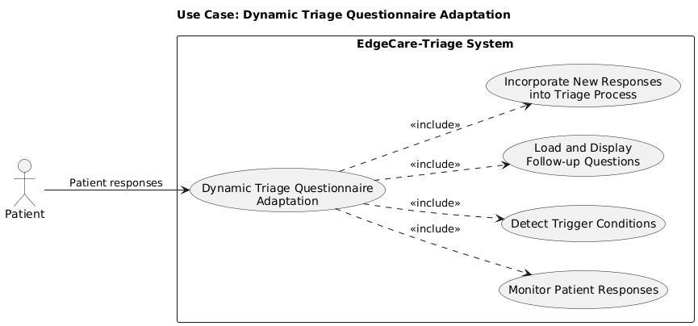
7: Personalized Health Dashboard
Goal: Display patients with a personalized health dashboard of significant health facts.
Actor: Patient
Inputs:
Patient's clinical information such as symptoms, AI severity ratings, and reminders.
System Actions:
Fetch patient information from secure storage applicable to the case.
Integrate and process the information to highlight the key points.
Display data as unambiguous, structured dashboard displays (e.g., charts, lists).
Outputs:
Personalized dashboard displaying key measures instead of raw history. 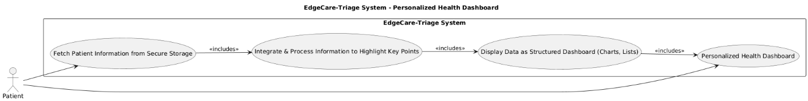
8: Selective Data Export
Goal: Allow patients to export portions of their data based on filters.
Actor: Patient
Inputs:
Filters selected by patient (e.g., last month's data, AI reports only).
System Actions:
Apply selected filters to patient's stored data.
Generate a file containing only the filtered data.
Prepare the file for secure download.
Outputs:
Export file containing only the desired data, available to be downloaded or shared. 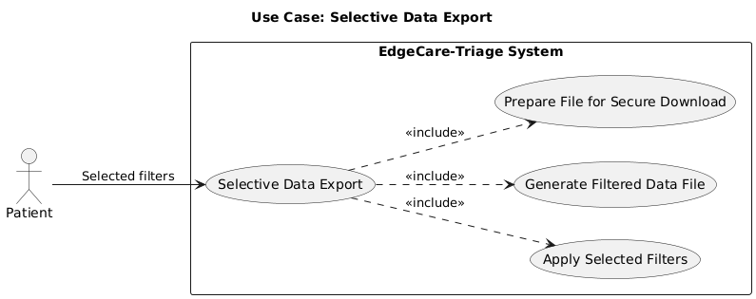
9: Regional Customization of Questionnaires
Goal: Triage questionnaires personalized based on regional medical guidelines.
Actor: Patient
Inputs:
Patient's region (detected automatically or entered manually).
System Actions:
Determine region via location services or manual entry.
Retrieve region-specific medical guidelines (e.g., local diseases).
Personalize the questionnaire with relevant regional questions.
Present the personalized questionnaire to the patient.
Outputs:
Region-specific questionnaire presented to the patient, with increased contextual relevance.

