# Question 1

## Briefly describe the context and the application of the database under development. Why is this system needed? Who will need access to the database?

The database under development is within the context of elderly healthcare. Specifically, it is for the elderly who live alone and have access to internet technology. The application of the database within this context is to store personal information of those elderly who have selected to be part of the system and include diagnostic data either gathered by sensors without supervision or conducted by the monitored person. The stored data will be accessibly by healthcare professionals for analysis and follow-up consultations and services.

This system is needed because elderly living alone at home do not necessarily receive an adequate amount of care. By using this system, they will be monitored carefully by healthcare professionals who can then provide care to the right person at the right time. Without this system, diagnosis of potential health problems may go unnoticed or be delayed causing undue harm to the elderly in question.

The central office will need to be able to both read and write to the database. Reading is essential to retrieve the diagnostic data and personal information of those elderly in the system. Many of the home-collected data may be physically transported to the central office which would then need to be written to the database by employees at the central office. There must also be write access to the database over an internet connection. The internet connection is used by electronic sensors which collect diagnostic data from the monitored persons without supervision or intervention.

## ERD

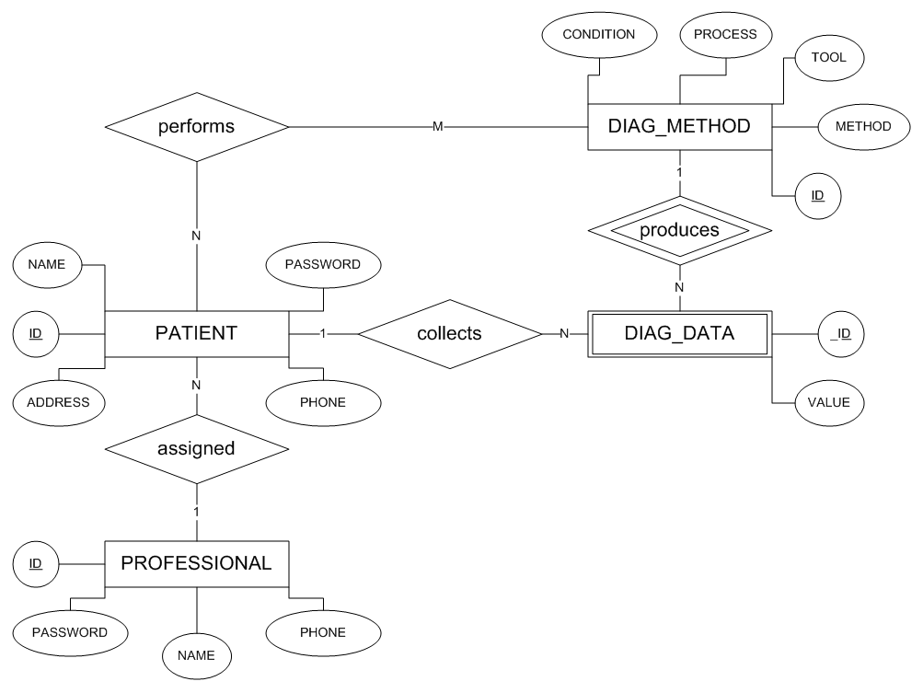

### Professional

The professional entity represents the healthcare professional users of the system whose information must be stored in the database. Each healthcare professional can be assigned many patients. The following list of attributes describes the information associated with each healthcare professional.

* ID – The unique identification of each professional. This is the Primary Key of the Professional Table as mapped from the ERD.
* PASSWORD – The password used by the healthcare professional to access the system.
* NAME – The name used by the healthcare professional to access the system.
* PHONE – The primary telephone number for contacting the healthcare professional

### Patient

The PATIENT entity represents patients who have subscribed to the system. Each patient is assigned to a professional who can monitor the patient’s information. Each patient can also be associated with diagnostic methods which their assigned healthcare professional has prescribed for them to perfom. The following list of attributes describes the information associated with each patient.

* ID – The unique identification of each patient. This is the Primary Key of the Patient Table as mapped from the ERD.
* PASSWORD – The password used by patient to access the system.
* NAME – The name used by the patient to access the system.
* PHONE – The primary telephone number for contacting the patient
* ADDRESS – The home address of the patient. Needed for home care and emergency situations.

The PATIENT entity has a Foreign Key relationship with the PROFESSIONAL entity through PROFESSIONAL.ID. There is a hidden foreign key relationship between the PATIENT entity and the DIAG\_METHOD entity via the PERFORMS relationship. The PERFORMS relationship contains the foreign keys to both PATIENT and DIAG\_METHOD through their respective ID attributes.

### Diag\_Method

The DIAG\_METHOD entity represents the different diagnostic methods that can be prescribed to patents by healthcare professionals. Each diagnostic method can be performed by different patients and will produce many instances of diagnostic data. The following list of attributes describes the information associated with each diagnostic method.

* ID – The unique identification of each diagnostic method. This is the Primary Key of the DIAG\_METHOD table as mapped from the ERD.
* CONDITION – The health condition associated with this diagnostic method.
* PROCESS – The testing process used to produce diagnostic data.
* TOOL – The tool used by the patient to perform the diagnostic method.
* METHOD – The method which must be performed by the patient to accurately use the tool.

The DIAG\_METHOD entity has a Foreign Key relationship with the PATIENT entity via the PERFORMS relationship. The PERFORMS relationship contains the foreign keys to both PATIENT and DIAG\_METHOD through their respective ID attributes.

### Diag\_Data

The DIAG\_DATA entity represents the diagnostic data which comes out of each diagnostic method. It is also associated with the patient who performed the diagnostic method from which the diagnostic data came. The following list of attributes describes the information associated with each diagnostic method.

* ID – The unique identification of each diagnostic data entry. This is a partial primary key of the DIAG\_DATA table as mapped from the ERD. The other partial primary key comes from DIAG\_METHOD.ID since diagnostic data can only exist when gathered from a diagnostic method.
* Value – The value of the diagnostic data gathered.

The DIAG\_DATA entity has a Foreign Key relationship with the DIAG\_METHOD entity through DIAG\_METHOD.ID. It also has a Foreign Key relationship with the PATIENT entity through PATIENT.ID.

## J:\INFS2200\DFD_Context.pngDFD

### Context Diagram

### Level-0

