**Ex.No:04** **JavaScript**

**Date:26.02.24**

**Aim:**

To develp javascript programs for the given problem statements.

**Algorithm:**

**Step 1 :** Create class employee and array object employee ,sort it and display by using for each loop.

**Step 2 :** Replace all digits with an empty string and show the result.

**Step 3 :**If the string has new word return the same string else return new+string.

**Step 4 :** Split the CSV string into rows based on newline characters, Split the row into columns based on commas,finally display the 2D array.

**Step 5 :** Ask the user to enter the name by using prompt function ,Welcome the user by alert function display the current date by modifying the date ,finally display the last modified date.

**Problem Statement:**

Write a program to display employee objects based on salary (descending order).

[use Objects]

**Program:**

class Employee {

constructor(name, salary) {

this.name = name;

this.salary = salary; }

}

let employees = [ new Employee("Mithun", 50000) , new Employee("Prajin", 60000),

new Employee("Ram", 55000) , new Employee("Dinesh", 70000) ];

employees.sort((a, b) => b.salary - a.salary);

employees.forEach(employee => {

console.log(`Name: ${employee.name}, Salary: ${employee.salary}`);

});

**Output:**

Name: Dinesh, Salary: 70000

Name: Prajin, Salary: 60000

Name: Ram, Salary: 55000

Name: Mithun, Salary: 50000

**Problem Statement:**

Write a JavaScript program to remove all of the numbers from 'A1B2C3D4E5F6G7H8I9J10'

**Program:**

let str = 'A1B2C3D4E5F6G7H8I9J10';

let result = str.replace(/\d+/g, '');

console.log(result);

**Output:**

ABCDEFGHIJ

**Problem Statement:**

Write a JavaScript programs to create a new String adding “New!” in front of a given String. If the given String begins with “New!” already then return the original String.

**Program:**

function addNewPrefix(str) {

if (str.startsWith("New!")) {

return str;

} else {

return "New!" + str; }

}

let givenString = "Example";

let newString = addNewPrefix(givenString);

console.log(newString);

**Output:**

New!Example

**Problem Statement:**

Write a JavaScript to convert a comma-separated values (CSV) String to a 2D array. A new line indicates a new row in the array.

**Program:**

function csvTo2DArray(csvString) {

let rows = csvString.split('\n');

let array2D = [];

rows.forEach(row => {

let columns = row.split(',');

array2D.push(columns);

});

return array2D;

}

let csvString = "1,John,Doe\n2,Jane,Smith\n3,Jim,Brown";

let array2D = csvTo2DArray(csvString);

console.log(array2D);

**Output:**

[

  [ '1', 'John', 'Doe' ],

  [ '2', 'Jane', 'Smith' ],

  [ '3', 'Jim', 'Brown' ]

]

**Problem Statement:**

Create a page with JavaScript to do the following. These can all be on one page.

(a) Prompt the user for their name.

(b) Use a pop-up box to welcome the user by name.

(c) Display the current date on the page in the following format: April 30, 2014.Do not display the time. Do not "hardcode" the date; if I load the page tomorrow,I should get a different date than if I load it today.

(d) Display the last modified date of the document

**Program:**

<!DOCTYPE html>

<html>

<head>

<title>JavaScript Page</title>

</head>

<body>

<h1>JavaScript Page</h1>

<p>Welcome, <span id="Name"></span>!</p>

<p>Current date: <span id="Date"></span></p>

<p>Last modified date: <span id="lastModifiedDate"></span></p>

<script>

let userName = prompt("Please enter your name:");

alert("Welcome, " + userName + "!");

let currentDate = new Date();

let options = { year: 'numeric', month: 'long', day: 'numeric' };

let formattedDate = currentDate.toLocaleDateString('en-US', options);

document.getElementById('Date').textContent = formattedDate;

let lastModifiedDate = document.lastModified;

document.getElementById('lastModifiedDate').textContent = lastModifiedDate;

document.getElementById('Name').textContent=userName;

</script>

</body>

</html>

**Output:**

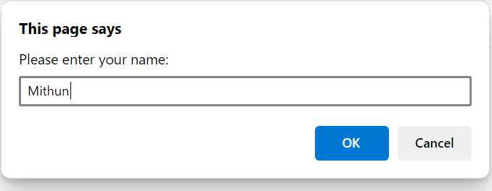

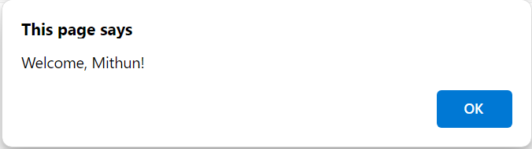

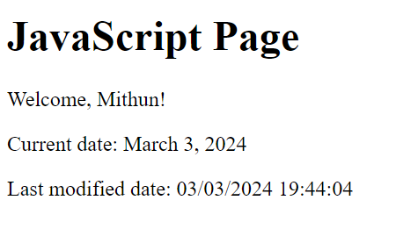

|  |  |
| --- | --- |
| **Code and output(20)** |  |
| **Quiz(5)** |  |
| **Timely submission(5)** |  |
| **Total(30)** |  |
| **Initial** |  |

**Result:**Thus the programs has been executed successfully and the output was verified.