Week:05-01
Rool no:241801319
Name-Viswesh R K

Q1)Problem Statement:
Write a program that prints a simple chessboard.
Input format:
The first line contains the number of inputs T.
The lines after that contain a different value for size of the chessboard.
Output format:
Print a chessboard of dimensions size * size.
Print W for white spaces and B for black spaces.
Sample Input:
2
3
5
Sample Output:
WBW
BWB
WBW
WBWBW
BWBWB
WBWBW
BWBWB
WBWBW

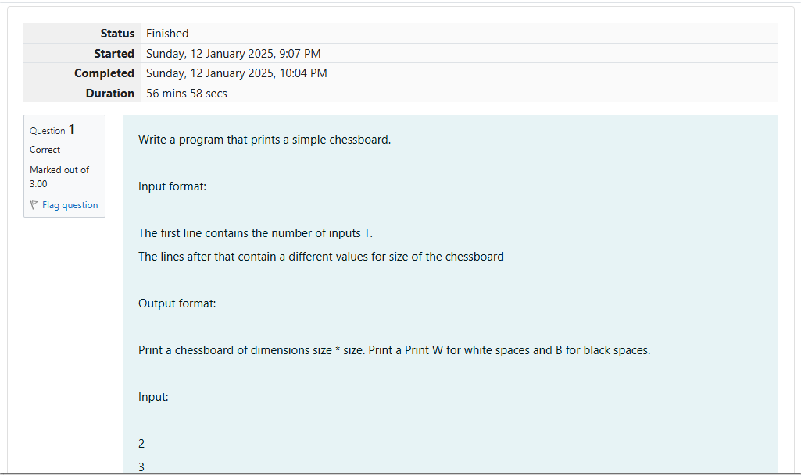
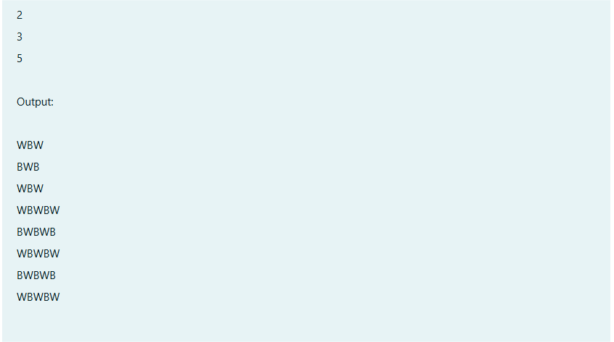
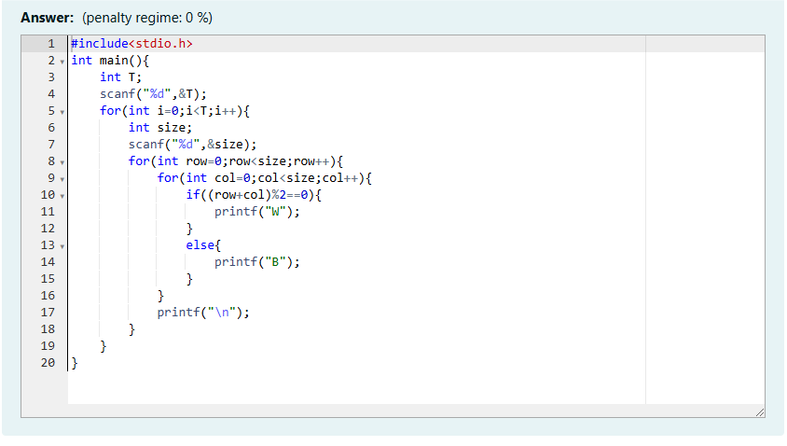
Output:

Q2)Problem Statement:
Let's print a chessboard!
Write a program that takes input:
The first line contains T, the number of test cases.
Each test case contains an integer N and also the starting character of the chessboard.
Output Format:
Print the chessboard as per the given examples.
Sample Input:
2
2 W
3 B
Sample Output:
WB
BW
BWB
WBW
BWB

output:

Q3)Problem Statement:
Decode the logic and print the pattern that corresponds to the given input.
If \( N = 3 \), then the pattern will be:
10203010011012
**4050809
***607
If \( N = 4 \), then the pattern will be:
1020304017018019020
**50607014015016
***809012013
****10011
Constraints: ( 2 <= N<= 100 )
Input Format:
First line contains \( T \), the number of test cases. Each test case contains a single integer \( N \).
Output Format:
First line print Case #i where \( i \) is the test case number. In the subsequent line, print the pattern.
Sample Input:
3
3
4
5
Sample Output:
Case #1
10203010011012
**4050809
***607
Case #2
1020304017018019020
**50607014015016
***809012013
****10011
Case #3
1020304050206027028029030
**6070809022030204025
***10011012019020021
****13014017018
*****15016

Output:

week:05-02
Roll No:241801319
Name:Viswesh R K
Q1)Problem Statement:
The k-digit number N is an Armstrong number if and only if the k-th power of each digit sums to N.
Given a positive integer N, return true if and only if it is an Armstrong number.
Note: 1 <= N <= 10^8
Hint:153 is a 3-digit number, and 153 = 1^3 + 5^3 + 3^3.
Sample Input:
153
Sample Output:
true
Sample Input:
123
Sample Output:
false
Sample Input:
1634
Sample Output:
true

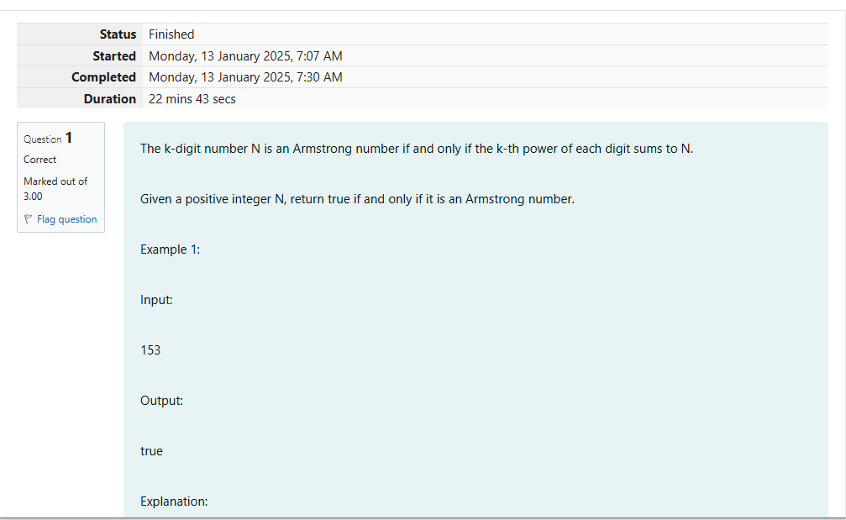
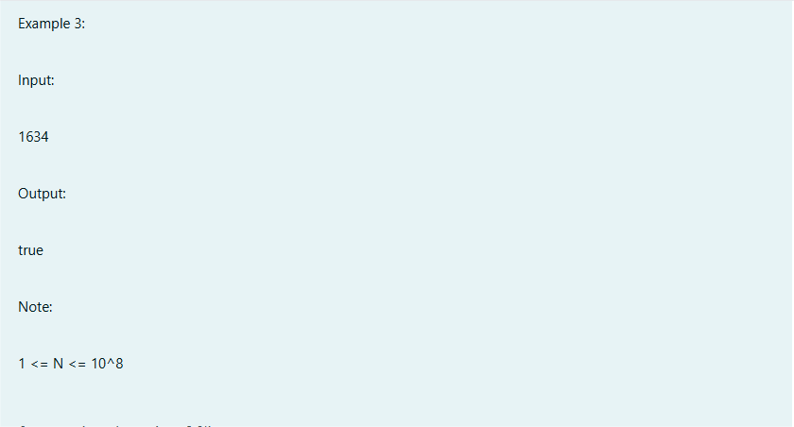
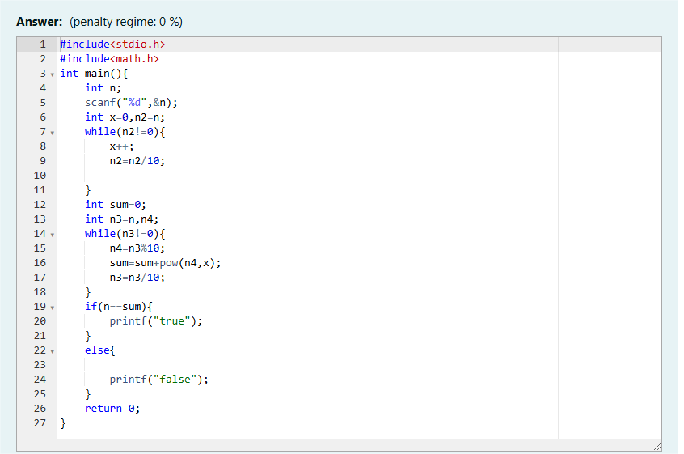
Output:

Q2)Problem statement:
Take a number, reverse it and add it to the original number until the obtained number is a palindrome.
Constraints: (1<=num<=999999999)
Sample Input 1:
32
Sample Output 1:
55
Sample Input 2:
789
Sample Output 2:
66866

Q3)problem statement:
A number is considered lucky if it contains either 3 or 4 or both in it. Write a program to print the nth lucky number. For example, the 1st lucky number is 3, the 2nd lucky number is 4, the 3rd lucky number is 33, the 4th lucky number is 34, and so on. Note that numbers like 13, 40, etc., are not considered lucky as they contain other digits.
The program should accept a number 'n' as input and display the nth lucky number as output
Sample Input 1:
3
Sample Output 1:
33
output:

