Game Design Document

Fill up the following document

1. Write the title of your project.

Rangers Escape

1. What is the goal of the game?

The goal of the game is that the Ranger/Player needs to reach the temple of swords escaping the ghosts and overcoming the zombies.

1. Write a brief story of your game.

There are rangers in the city who protect the city from the two ghosts troubling all the people. These ghosts have killed many people and have turned all the rangers into zombies by their bite. Now there is only one ranger left to protect the city and save everyone, for that he has to run to the outskirts of the city to the temple of swords. The ghosts cannot enter the temple. Once he reaches there he can kill the ghosts with the sword and all other zombies would be free and the city would be safe.

1. Which are the playing characters of this game?

* Playing characters are the ones who respond to the user based on the input from the user.
* Cars, monkeys, dinos, wizards, etc., are the playing characters in the game.

|  |  |  |
| --- | --- | --- |
| Number | Character Name | What can this character do? |
| 1 | Ranger | He has to run to the outskirts of the city to the temple of swords to save the people. |
| 2 | Ghosts | They chase the ranger. |

1. Which are the Non-Playing Characters of this game?

* Non-Playing characters are the ones that don't have an action or behavior when the user interacts with the game.
* Hurdles, stones, bananas, coins, etc., are non-playing characters in the game.

|  |  |  |
| --- | --- | --- |
| Number | Character Name | What can this character do? |
| 1 | Zombies | They are rangers turned into zombies. They are like obstacles to the ranger running to the temple of swords |
| 2 | Coins | Helpful for the player to reach the temple of swords faster |
| 3 | Magic Portions | Help the player in various ways such as increasing his speed, but only for ten seconds |

1. Draw your imagination of this game. What does this game look like?

* Draw the game either on your computer or on paper.
* Add images of the game scenes to show each of the playing and non-playing characters at least once.

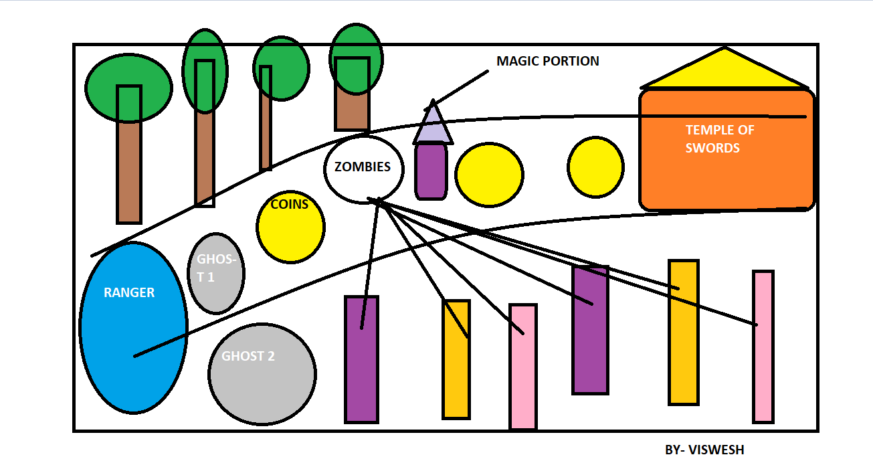

1. How do you plan to make your game engaging?

I plan to make the game engaging by giving the user advantages as well as disadvantages which would make the user more interested to play and win the game. There would be zombies from all sides and the ranger has to overcome them whatsoever, that is a disadvantage. Getting a magic portion is a advantage but having it only for ten seconds is also again a disadvantage. Advantages and disadvantages together only make the game adventurous and interesting.

**______________**