OMNILEGAL

Design Thinking Project Report
Verified Legal Intelligence for International and Comparative Law
Prepared for team presentation and project explanation
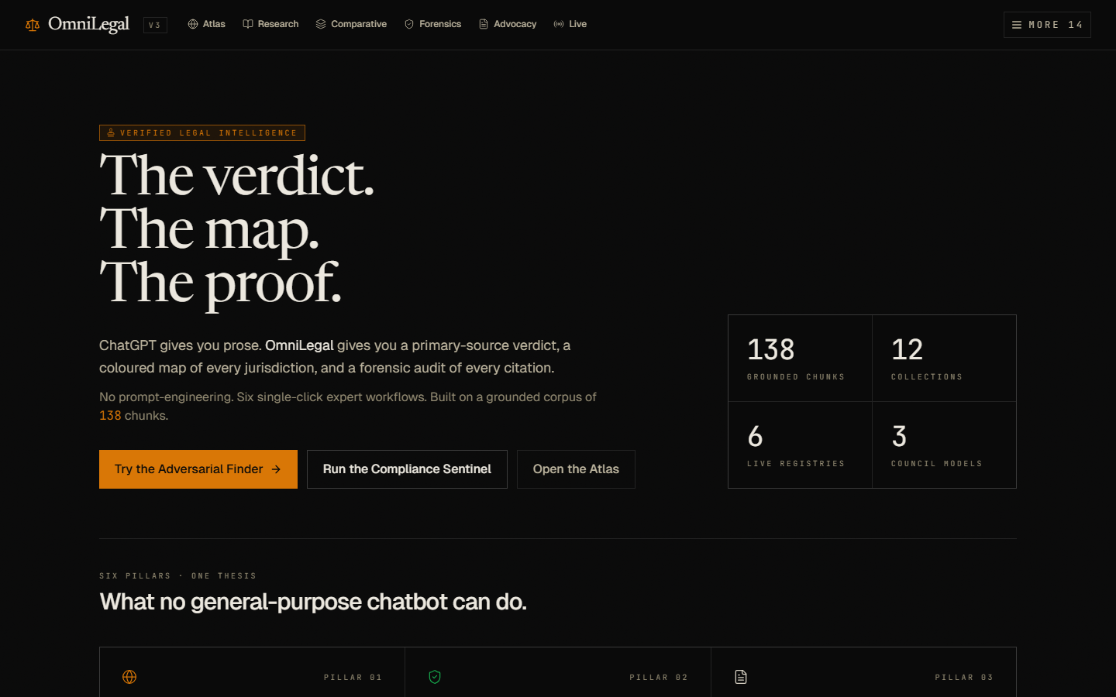
Cover screenshot from the running OmniLegal interface.
Project Thesis
OmniLegal turns a high-value legal corpus into an interactive research system: users ask legal questions, retrieve relevant primary/legal sources, compare jurisdictions, and present the answer with visible proof instead of unsupported prose.

Executive Summary
OmniLegal is an AI-assisted legal research and analysis platform built around a corpus of international law, country law, legal doctrines, treaties, cases, and registry data. Its core purpose is to help users move from a complex legal question to a grounded answer that includes the reasoning path, source material, and comparative context.
The project is especially useful for students, legal researchers, policy teams, Model UN participants, human rights researchers, and presentation teams who need to understand cross-border legal issues quickly without losing traceability to source documents.
Unlike a general chatbot, OmniLegal is designed around a knowledge base. Its strongest value is not simply generating text; it is finding the right parts of the corpus, using legal reasoning patterns, showing citations, and allowing users to explore the same issue across countries and doctrines.
Area | What it means for the team
Project type | Design thinking project, AI research tool, legal knowledge platform, and presentation-ready prototype.
Main problem | Legal information is rich but hard to query, compare, verify, and present clearly.
Core users | Law students, research teams, MUN/debate teams, advocates, policy analysts, and civic/legal education groups.
Main promise | The verdict, the map, and the proof: answer, jurisdictional comparison, and cited evidence.
Current demo strength | A working web interface with research, atlas, comparative analysis, citation-aware retrieval, and a cleaner presentation navigation model.

Contents
How to read this document
- Project overview: what OmniLegal is and why it matters.
- User problem and opportunity: the human need behind the product.
- Feature walkthrough with screenshots from the live prototype.
- System architecture and query flow: how the application works.
- Design thinking framework: empathize, define, ideate, prototype, test, and iterate.
- Evaluation plan, roadmap, and team presentation guide.

Problem And Opportunity
Legal researchers often know that the answer exists somewhere in treaties, judgments, statutes, reports, or local legal materials, but the practical difficulty is finding the relevant passage, interpreting it correctly, and explaining it in a way that others can trust. This becomes harder when a question crosses jurisdictions or asks for a doctrine such as erga omnes obligations, jus cogens, self-determination, armed conflict, detention, surveillance, or human rights duties.
The opportunity for OmniLegal is that the corpus is already valuable. The project challenge is to turn that corpus into a product experience where the system understands intent, retrieves the important material, explains the answer, and makes the proof visible.
User pain point | Product response
I do not know which source controls the answer. | Retrieve across corpus collections and surface source-backed snippets.
The legal issue is comparative, not single-country. | Use atlas and comparative workflows to map similarities and conflicts between jurisdictions.
The answer must be defensible in a class or presentation. | Show citations, retrieved sources, and a concise reasoning trail.
Generic chatbot answers miss legal nuance. | Use domain-specific retrieval, legal query expansion, and structured legal reasoning.
Too many tools in the UI confuse the demo story. | Keep the strongest features in top navigation and move specialist/lab features into a side menu.
Example Query Problem
A question such as 'What erga omnes obligations does each country have on their laws?' is not a simple keyword search. It requires doctrine recognition, source expansion, international-law grounding, and a comparative response structure. This is the type of query OmniLegal is designed to improve.

Who The Project Helps
Persona | Need | How OmniLegal helps
Law student | Understand doctrines and prepare assignments. | Explains issues with citations and lets students compare countries or doctrines.
MUN or debate delegate | Prepare fast, credible legal arguments. | Turns complex international law into cited arguments and jurisdictional positions.
Research teammate | Find source passages quickly. | Uses retrieval and citation panels so the team can trace the answer back to documents.
Presentation lead | Explain the project clearly to evaluators. | Provides a clean UI story: verdict, map, proof, and design thinking impact.
Policy/legal analyst | Compare laws and obligations across countries. | Supports comparative workflows and evidence-first legal summaries.

What OmniLegal Does
The platform combines a legal corpus, retrieval-augmented generation, structured legal workflows, and a presentation-grade web interface. The user experience is organized around practical work: search, compare, audit citations, and explain legal conclusions.
Capability | Description | Value
Legal Research | Ask a natural-language legal question and receive a grounded answer with citations. | Makes the corpus usable without needing exact document titles or keywords.
Conflict Atlas | Analyze a legal topic across jurisdictions and color/map positions. | Helps users see where countries align, diverge, or lack clear data.
Comparative IRAC | Frame legal issues using issue, rule, application, and conclusion across countries. | Improves academic and presentation quality of legal reasoning.
Citation Forensics | Inspect whether an answer is tied to retrieved sources. | Builds trust and reduces unsupported AI output.
Advocacy Workflows | Turn research into legal arguments or policy positions. | Supports debating, briefing, and strategic presentation work.
Feature Sidebar | Keep specialist tools available but off the main demo path. | Makes the product easier to explain during a presentation.

Feature Walkthrough With Screenshots
The screenshots below were captured from the running local OmniLegal prototype. They show how the project looks in practice and can be reused by the team while explaining the demo.
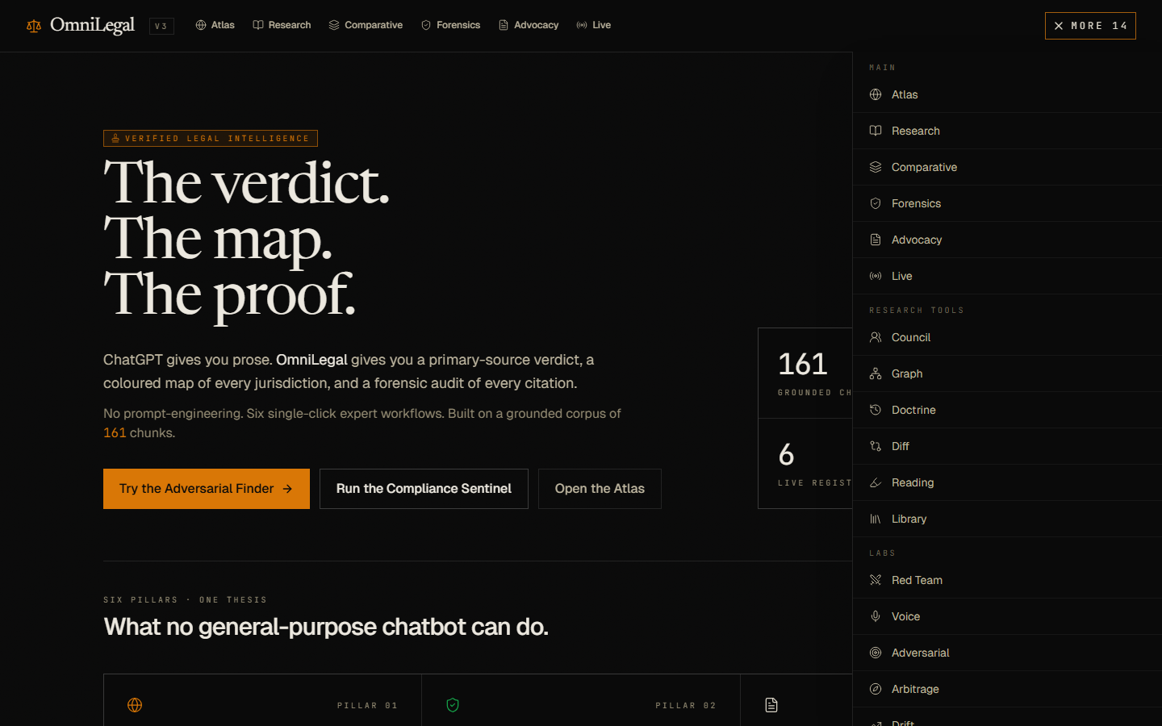
Figure 2. Navigation design: presentation-critical workflows stay in the top bar while specialist tools move into the side menu.

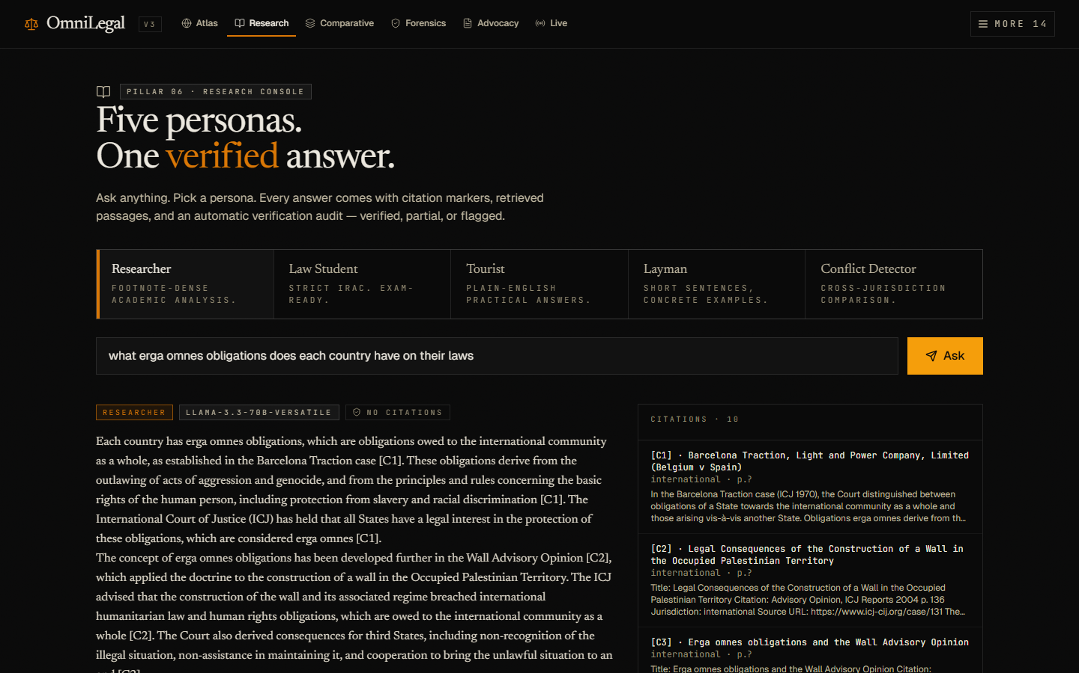
Figure 3. Research workflow: an erga omnes query returns a grounded answer with source citations and retrieval transparency.

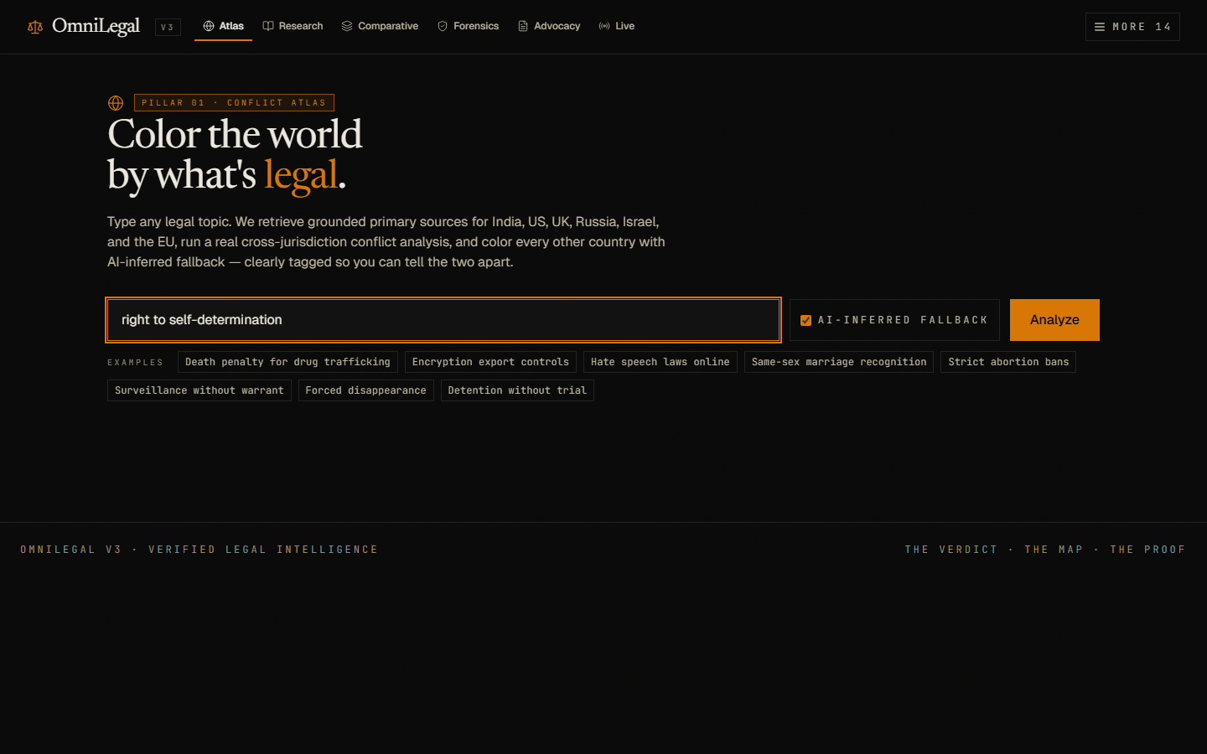
Figure 4. Conflict Atlas: users can test legal questions across jurisdictions and visualize jurisdictional positions.
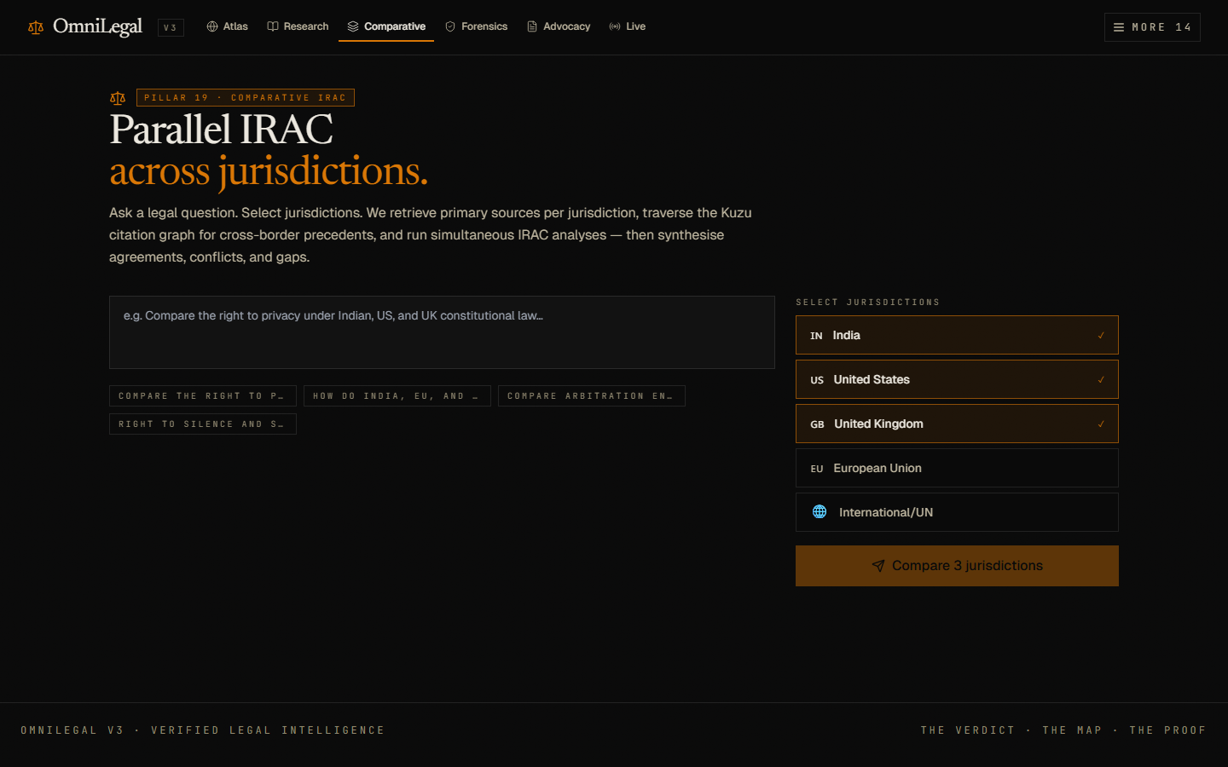
Figure 5. Comparative analysis: the system frames legal issues across countries using an IRAC-style workflow.

What The Screens Prove
- The landing page communicates the product thesis clearly: legal answers must include verdict, map, and proof.
- The navigation is now presentation-friendly: the top bar shows the most attractive workflows, while secondary or experimental tools are grouped into the side menu.
- The research screen demonstrates the most important product value: a difficult international-law query can produce a cited, source-aware answer.
- The atlas and comparative screens show that the project is not only a chatbot; it is a legal analysis workspace.

How The System Works
OmniLegal uses a frontend for interaction, a backend for legal workflows and retrieval, and a corpus layer that stores legal documents and registry metadata. When the user asks a question, the system tries to understand the legal intent, retrieve relevant material, and generate a grounded answer with visible sources.
Layer | Role in the project
Frontend | React-based user interface for research, atlas, comparative analysis, navigation, and presentation-ready workflows.
Backend API | FastAPI service that receives queries, coordinates retrieval, and returns structured answers to the frontend.
Corpus and registries | International law, country law, parsed PDFs, donor registry, dataset registry, ingestion logs, and local legal text sources.
Retrieval layer | Searches the corpus using semantic and local text retrieval so the answer is based on project data.
LLM layer | Generates explanations, summaries, legal reasoning, and comparative responses from retrieved context.
Citation layer | Shows evidence and retrieved sources so users can verify the legal basis of the answer.

Query Flow
- User enters a legal question in plain language.
- The system detects legal concepts, jurisdictions, and doctrine signals such as erga omnes, treaty duties, jus cogens, or self-determination.
- The retriever expands the query with related legal terms and searches the available corpus.
- The best passages are selected, scored, and passed into the answer-generation layer.
- The model generates a legal answer using the retrieved evidence rather than relying only on general memory.
- The frontend displays the answer, citations, retrieval metadata, and related source context.
Why Better Querying Matters
The value of the project depends on retrieval quality. If the corpus is gold but the query layer misses the right passages, users experience the product as weak. Better query understanding, source selection, reranking, and citation visibility directly unlock the value of the legal data.

Recent Querying Improvements
Improvement | Why it matters
Legal query expansion | Questions now have a better chance of matching doctrine vocabulary used inside legal texts.
Local corpus fallback | When vector search misses material, the system can still search parsed legal text and registries.
Comparative query handling | Broad country-law questions are treated as comparative research tasks, not simple single-document lookups.
Citation-aware response display | Users can see evidence instead of receiving an answer with no visible support.
Cleaner navigation | The strongest product workflows are easier to find during a live presentation.

Design Thinking In OmniLegal
Design thinking is not only a section in the presentation. It should guide how the team decides what to build, what to test, and what to improve. For OmniLegal, the human problem is clear: users have access to legal information, but they struggle to convert that information into trustworthy, understandable, and usable legal insight.
Stage | How to apply it in this project | Project output
Empathize | Talk to students, legal researchers, MUN delegates, and teammates. Observe where they get stuck when researching legal issues. | User interviews, empathy map, pain-point list, example research queries.
Define | Turn the observations into a sharp problem statement: users need grounded legal answers they can verify and explain. | Problem statement, target users, success criteria.
Ideate | Brainstorm workflows beyond a chatbot: atlas, comparative law, citation forensics, advocacy briefs, doctrine explorer. | Feature ideas ranked by usefulness and demo impact.
Prototype | Build screens and flows that let users ask, compare, verify, and present legal findings. | Clickable UI, working search, cited research answers, screenshots.
Test | Give users realistic tasks and measure whether they find the answer, trust the citations, and understand the output. | Feedback notes, usability issues, retrieval failures, improvement backlog.
Iterate | Improve retrieval, simplify navigation, add source previews, and keep the product focused on user proof needs. | Better query quality, clearer UI, stronger presentation story.

Design Thinking Problem Statement
Problem Statement
Legal learners and research teams need a way to ask complex international and comparative-law questions and receive answers that are understandable, source-backed, and presentation-ready, because ordinary search tools and chatbots often miss doctrine, context, and proof.

How Might We Questions
- How might we help users ask legal questions in natural language without losing doctrinal precision?
- How might we make international-law obligations visible across countries and legal systems?
- How might we show the proof behind an AI answer in a way that non-experts can understand?
- How might we reduce navigation complexity so the best project features are obvious during a presentation?
- How might we help teams turn research into arguments, slides, and briefings faster?

Empathy Map
User says | User thinks | User feels | User does
I know the law is somewhere in the documents. | Maybe I am searching with the wrong words. | Overwhelmed by legal volume. | Tries multiple queries and scans long PDFs.
I need citations for my presentation. | The answer is useless if I cannot prove it. | Anxious about credibility. | Copies snippets into notes and checks source names.
Different countries treat this differently. | A single answer is not enough. | Confused by contradictions. | Compares jurisdictions manually.
The tool has many features. | Which one should I show first? | Distracted during demo prep. | Clicks through navigation to find a strong workflow.

User Journey
Step | User action | Expected product support
1. Start | User enters a broad legal topic or doctrine. | Suggest examples and accept natural-language legal questions.
2. Retrieve | System searches legal corpus. | Use semantic search, local corpus fallback, and legal term expansion.
3. Understand | User reads answer. | Structure answer with rule, application, comparison, and caveats.
4. Verify | User checks citations and source snippets. | Show retrieved documents, source names, relevance, and evidence.
5. Compare | User asks how countries differ. | Use atlas and comparative workflows.
6. Present | User explains findings to others. | Provide clean visuals, concise language, and screenshot-ready UI.

Feature-To-Need Mapping
User need | Feature response | Design principle
Trust | Citations, source previews, retrieval transparency. | Make evidence visible.
Speed | Natural-language query and automatic retrieval. | Reduce research friction.
Comparison | Atlas and comparative IRAC workflows. | Show differences clearly.
Clarity | Cleaner top navigation and side menu. | Prioritize the main user journey.
Presentation | Screens with strong visual hierarchy and concise outputs. | Make the project easy to explain.

Testing Plan
The project should be tested with realistic legal tasks, not only with simple keywords. The most important test is whether the system finds useful legal sources and helps the user explain the answer confidently.
Test task | What to observe | Success metric
Ask an erga omnes obligations question. | Does the answer cite doctrine-relevant sources and avoid vague generalities? | User can identify at least three useful cited points.
Compare self-determination across jurisdictions. | Does the atlas/comparative workflow organize the issue clearly? | User can explain similarities and differences in under three minutes.
Find the source behind a legal claim. | Does the citation panel make verification easy? | User can locate the supporting source without leaving the page.
Prepare a short argument from research output. | Does the output help users move from answer to advocacy? | User produces a defensible argument with source references.
Navigate the demo without guidance. | Are the main features obvious? | User reaches Research, Atlas, and Comparative without confusion.

Evaluation Metrics
- Retrieval relevance: percentage of retrieved passages that directly support the answer.
- Citation usefulness: whether users can verify claims from shown sources.
- Answer completeness: whether doctrine, jurisdiction, rule, and caveats are covered.
- Time to useful answer: how long it takes a user to get a defensible response.
- Navigation success: whether users find the right workflow without explanation.
- Presentation readiness: whether teammates can explain the project using screenshots and outputs.

Risks And Responsible Use
Risk | Mitigation
AI may overstate a legal conclusion. | Show citations, confidence, caveats, and source previews; frame outputs as research assistance.
Corpus may contain uneven country coverage. | Display source availability and distinguish strong evidence from inferred fallback.
Users may treat the answer as legal advice. | Use clear disclaimers and position the product as research support, not legal representation.
Broad queries may need multiple sources. | Use query expansion, multi-step retrieval, and comparative answer templates.
Feature overload may weaken the demo. | Keep only the most compelling workflows in top navigation and move specialist tools to the sidebar.

Roadmap
Phase | Focus | Suggested work
Short term | Make querying feel powerful. | Improve legal query expansion, reranking, citation display, and source previews.
Short term | Polish presentation flow. | Keep top navigation focused and create a guided demo path through Research, Atlas, and Comparative.
Medium term | Improve comparative law quality. | Add jurisdiction-specific metadata, coverage indicators, and comparison templates.
Medium term | Measure answer quality. | Create a test set of legal questions with expected sources and evaluate retrieval hit rate.
Long term | Team collaboration. | Add saved research folders, exportable briefs, and shared evidence boards.
Long term | Deployment readiness. | Add authentication, corpus management UI, monitoring, and robust ingestion dashboards.

Recommended Demo Script
- Open the landing page and explain the thesis: OmniLegal gives the verdict, the map, and the proof.
- Open Research and ask a difficult legal question such as erga omnes obligations.
- Point out that the answer is not just prose; it includes source-backed reasoning and citations.
- Open Atlas and show how a legal topic can be tested across jurisdictions.
- Open Comparative and explain how IRAC helps turn research into structured legal analysis.
- Close with the design thinking story: the product was shaped around user pain points, source trust, and presentation clarity.

Team Roles For Presentation
Role | What this teammate explains
Problem presenter | Why legal research is hard and why a corpus alone is not enough.
Product presenter | What OmniLegal does and how the main screens work.
Technical presenter | How retrieval, backend, frontend, and citations connect.
Design thinking presenter | How empathize, define, ideate, prototype, test, and iterate shaped the project.
Demo presenter | Runs the live workflow using Research, Atlas, and Comparative.
Final Message For Evaluators
OmniLegal is not just an AI chatbot for law. It is a design-thinking response to a real research problem: users need legal answers they can understand, compare, verify, and present.

Appendix

Glossary
Key terms for teammates
Term | Meaning
RAG | Retrieval-augmented generation: the model answers using retrieved project documents as context.
Corpus | The project knowledge base containing legal documents, parsed text, registries, and source material.
Citation | A visible link between an answer and the source material that supports it.
Erga omnes | Obligations owed toward the international community as a whole, often discussed in international-law doctrine.
Jus cogens | Peremptory norms of international law from which no derogation is permitted.
IRAC | Issue, Rule, Application, Conclusion: a common structure for legal reasoning.

One-Minute Explanation
OmniLegal is a legal intelligence platform that helps users ask difficult international and comparative-law questions and receive answers backed by legal sources. The project combines a legal corpus, AI retrieval, structured workflows, citations, and a presentation-ready interface. Using design thinking, the team focuses on the real user problem: people do not only need legal text; they need a way to understand it, compare it, verify it, and explain it clearly.

