**The Nvidia-Led Tech Bubble**

**Time Series Analysis in Finance (FS24)**

Lucerne University of Applied Sciences and Arts

*Master of Science in Applied Information and Data Science*

Authors:  
Kovacheva Natasha   
Vedenikova Vitalia

Date: 24th of May 2024

Table of contents

1. Introduction 2

2. Literature Review 2

3. Descriptive Analysis 2

4. Methods and Hypotheses 3

4.1 Data Preparation and Preprocessing 3

4.2 Stationarity 3

4.3 Methods 3

5. Results 4

6. Conclusion 6

7. Appendix 7

References 13

# Introduction

In April 2024, the semiconductor sector's ratio to the S&P 500 surpassed levels from the dot-com bubble peak, driven by the rise of artificial intelligence (AI) and significant investments in semiconductors (Marimar24). Nvidia Corporation stands out as a leader in this market rally, engineering some of the most advanced chips available. Its share price grew by 239% in 2023 (WhatIs24) and concerns are arising among commentators, suggesting that failure to meet NVIDIA’s earnings estimates could eventually precipitate a market crash (YahooFinance24).  
Historically, major market crashes tend to occur approximately every decade, often driven by speculative excesses. The latest one was the 1990s tech bubble, fueled by excessive speculation on tech companies. Today, ongoing concerns surround the potential for AI's evolution to trigger a new market bubble, prompting questions about the financial landscape's current state and associated risks. In this brief paper, we focus on NVIDIA's share price.

The proposed research question is: Can the recent surge and sharp decline in NVIDIA's stock price precipitate a market crash? What is the projected volatility for its future performance?

We aim to first understand its impact on the S&P 500, and then simulate a sharp drop in NVIDIA's share price to evaluate the potential effects on the stock market. Then, we examine its current volatility and try to predict the volatility in the upcoming period. Lastly, we examine its value at risk and how value at risk could be impacted by a sudden depreciation.

# Literature Review

Nvidia Corporation, one of the largest producers of GPUs worldwide, exceeded stock forecasts in 2022 and 2023, emerging as the best-performing S&P Index stock in 2023 (Mohit24). The company reported revenue of $29 billion in 2022, which surged to $61 billion in 2023, marking a remarkable 125% increase (Tikr24). Particularly noteworthy is the exponential growth in EPS (GAAP), which soared by 585.6% from 2022 to 2023.   
Additionally, as the GenAI market continues to expand amidst increasing regulations and rules, it is anticipated that this growth trajectory will influence NVIDIA's AI chip production (Mohit24). However, some investors speculate that these factors, among others, could lead to a stagnation (WhatIs24). Several experts have even started comparing Nvidia’s valuation growth to that of Cisco Systems, a leading tech company in the 90s whose stock devaluated 80% after the early 2000s crash (Financial Times23).

# Descriptive Analysis

In this section, we visualize trends and illustrate concerns of a possible AI bubble forming as a result of the increasing stock price of NVIDIA. Below, we can see an OHCL graph on the left hand-side showing the upward trend of the stock price from 01.02.2019 to 29.04.2024 and a cumulative return graph showing a 2500% growth relative to 2019 on the same period with a sharp increase in upward trend starting in 2023.

Ein Bild, das Text, Diagramm, Reihe, Screenshot enthält.
Ein Bild, das Text, Reihe, Diagramm, Screenshot enthält.

Figure 1: NVIDIA Stock Price Development and cumulative Returns.

# Methods and Hypotheses

## 4.1 Data Preparation and Preprocessing

We downloaded share prices of Nvidia (NVDA), Meta (META), Amazon (AMZN), Tesla (TSLA), Google (GOOG), Microsoft (MSFT), Apple (AAPL) and the S&P 500 index (GSPC) from Yahoo Finance for the period from 02.01.2019 to 29.04.2024. We had to make sure that each column has an appropriate data type and in some cases that the appropriate period had been selected before building our time series objects for each company. For Cisco (CSCO), we extracted data for the period from 10.03.2000 to 03.10.2002 which coincides with the market crash that took place after the dot-com bubble burst (Investopedia23).   
For simulating the sudden drop of Nvidia stock price we took the cumulative return rates of Cisco shares during the above-mentioned period, applied them to the last Nvidia share price in our time series and from there obtained new relative Nvidia prices (see Figures 10 & 11).  
When calculating a stock’s daily return, we needed to address the special case of NA values. Specifically, on the first day of the period, the return is not defined because there are no values for the previous day. Therefore, we omitted the return calculation for day 1.

## 4.2 Stationarity

For our analyses, we had to make sure that the time series were stationary, so we applied differentiation and log transformation. After checking the decomposed time series, we however noticed heteroskedasticity in the Nvidia time series, followed by some seasonality and trends. This was the case with the rest of the series as well. We therefore made sure to apply log transformation and did a second differentiation in cases where trends were still present. As a final step, we performed an “Augmented Dickey Fuller Test” to make sure that the time series were stationary.

## 4.3 Methods

Once we obtained stationarity, we constructed two vector autoregression (VAR) models, whose endogenous variables are determined by their own lagged values and those of other variables (Hochschule Luzern24). The variables in the first model were Nvidia share prices and the S&P 500 index values. After fitting the VAR, we applied a “Granger causality test” to verify if Nvidia did significantly influence the S&P 500. The Granger causality tests the null hypothesis that every coefficient in the model is null. Accepting the null hypothesis implies that there is no past information from the explanatory variable(s) that can be used to predict the explained variable (Hochschule Luzern24). A second VAR model was also constructed using share prices of companies part of the so-called “Magnificent Seven”, a group of high performing and influential companies in the US stock market (CNN24), to see if other stocks also had significant influence on the S&P 500.   
Once the influence of Nvidia stock was established, we used the cumulative return rates of Cisco shares as a “shock” to our VAR model with the predict() function taking the model, the amount of periods ahead of the present value and the return rates as the shock data. To then visualize the effect of the shock data, we reverted the differenced time series to the original time series with expm1() and cumsum(). For future returns analysis and prediction, we fit an ARMA model and for future volatility prediction we used a GARCH model. Finally, to better understand the risks undertaken when investing in Nvidia stock, we calculated the value at risk (VaR) now and if the value of Nvidia drastically fell.

# Results

Our VAR model revealed that the lagged values of NVIDIA’s stock prices have a strongly significant positive effect on the S&P 500 index. Its coefficient is however quite small at 0.0486. We also confirmed that Nvidia stock is a causal driver for the S&P 500 index with a small p-value for the Granger causality test.   
This is unsurprising, as especially in 2024, Nvidia has contributed the most to S&P 500 gains with a 3.9% contribution (Yahoo Finance24), that is 4 to 8 times more than the rest of the top contributing stocks and especially the rest of the “Magnificent 7”.   
However, looking at a VAR model including all these stocks and the S&P 500 index, we can see that Amazon and Apple were also significant contributors for the period from 2019 to 2024, meaning that Nvidia stock might not be as much of a market driver as some articles imply. In fact, once we simulated the shock of a sharp depreciation of the Nvidia stock on the S&P 500 index in our first VAR model, it was unsurprising to find that the drop of Nvidia’s stock price by itself is not sufficient to strongly affect the S&P 500. With a weight of only 5% in the S&P 500 and contributing 3.9% to the growth of the index (YahooFinance24), it would need to act as the driver to burst a bubble, that is, many stocks would need to significantly drop in price to have an effect on the S&P 500, perhaps even beyond the chipmaking sector as the significance of Amazon and Apple suggests in our second VAR model (see Figure 8).

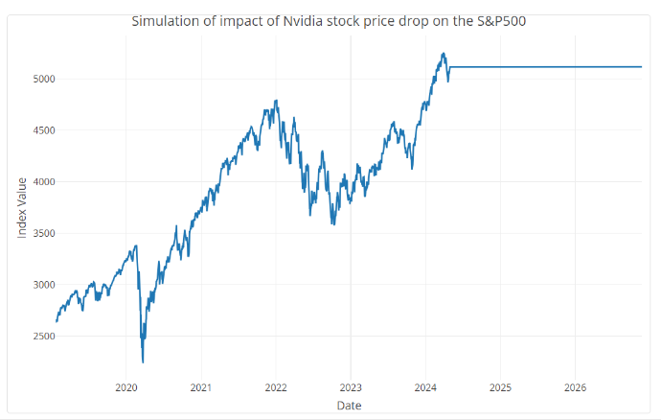

Figure 2: Simulation of the impact of a drop in NVDA stock prices on the S&P 500 for the same time interval as the early 2000s market crash (2 years starting from 29.04.24)

NVIDIA returns are characterized by the volatilities shown in **Fehler! Verweisquelle konnte nicht gefunden werden.**.



Figure 3: Calculated volatility on transformed returns.

As one can conclude the daily volatility is significantly high, which implies that the relative stock returns on a daily basis are deviating on a large scale around the mean. Based on these results, we tried modelling the future returns and volatility of the NVIDIA stock, with the help of ARMA and GARCH models, respectively. The ARIMA (2,0,1) model predicts the relative returns in the next 50 days. According to the results, with 95% CI, the returns are remaining in the same range.

The GARCH (1,1) model (blue line, Figure 4) successfully captures the overall volatility trend and specific spikes of NVIDIA’s returns. The rolling volatility (red line) calculated using a moving window of 22 days (corresponding the working days within a 1 month of the stock exchange), is used as a benchmark for comparison. Both the GARCH and rolling volatility estimates align closely, especially during periods of heightened volatility, indicating that the GARCH model accurately reflects historical market behavior. For fitting the model, we used the fGarch library in R, which resulted with (1,1) model, which appears to be good at capturing the conditional volatility based on past return data. Furthermore, the model indicates that future volatility will exhibit patterns similar to those observed in the past, particularly during periods of high market uncertainty, as now (Figure 5). The wide range of the confidence interval underscores big uncertainty in forecasting future volatility. This is not surprising to us, because future outcomes are influenced by numerous unpredictable factors, which is very common for financial series.

Ein Bild, das Text, Screenshot, Schrift, Reihe enthält.

Figure 4: GARCH (1,1) on historical data.

Ein Bild, das Text, Diagramm, Reihe, Screenshot enthält.

Figure 5: GARCH Forecast for next 100 days with 95% CI.

However, what would a sudden drop in price mean for an investor? In the situation as of 29.04.24, the monthly returns were no lower than -100% in 95% of cases with a 5% chance of losing more than USD 1500 for an initial investment of USD 1000 for any month (Figures 12 & 14). This tells us that Nvidia is already considered risky due to its high volatility. In an event where the prices would go tumbling, the ECDF could go down to –130% with a 5% chance of losing more than around USD 1800 for an initial investment of USD 1000 for any month (Figures 13 & 15). This is a substantial increase in risk, but a well-diversified and weighed investment portfolio could mitigate such losses.

# Conclusion

To conclude, Nvidia's stock has a notable impact on the market, particularly the S&P 500 index, but, as suggested by our VAR models, its influence might not be decisive without a collective negative outlook by investors which would lead to a major sell-off. Even without adverse sentiments on the market, the stock’s returns are highly volatile.

The GARCH (1,1) model is effective in replicating the historical volatility trends. While the model captures historical volatility patterns accurately, it acknowledges the increased uncertainty in the future. Periods of high volatility followed by further high volatility, are expected to persist.

There is a big uncertainty in the future of NVIDIA’s stock prices and returns, followed by high volatility and potential bubble behavior.

# Appendix

In the following are presented figures which support our analysis and decision making described in the report. The figures are also to be found in the R Markdown, where the official code is contained.

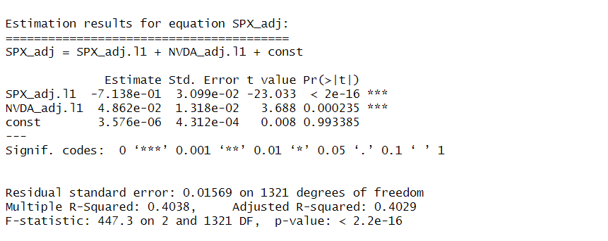

Figure 6: VAR model with S&P 500 index and NVDA share price as variables.

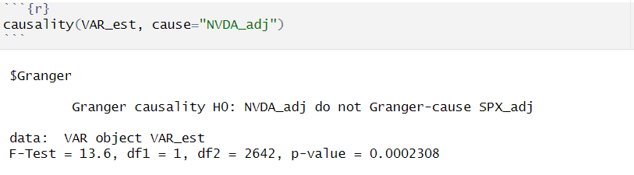

Figure 7: Granger causality test for the VAR model with with S&P 500 index and NVDA share price as variables.

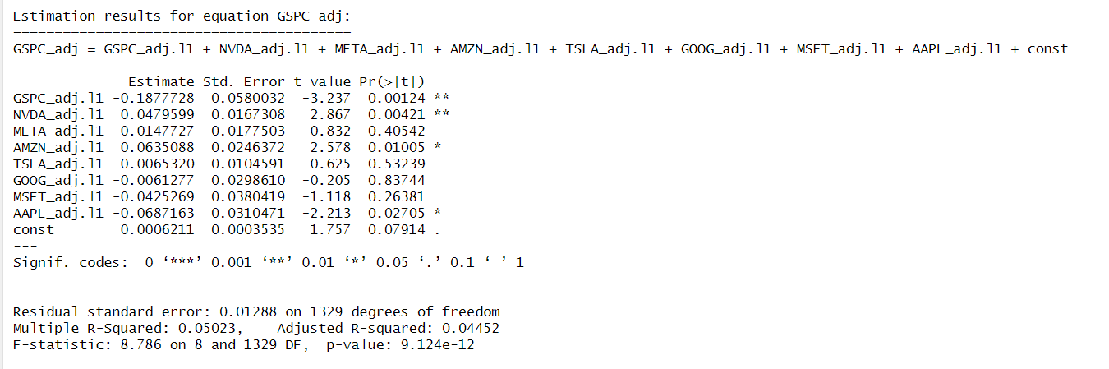

Figure 8: VAR model with S&P 500 and the ”Magnificent 7” as predictors.

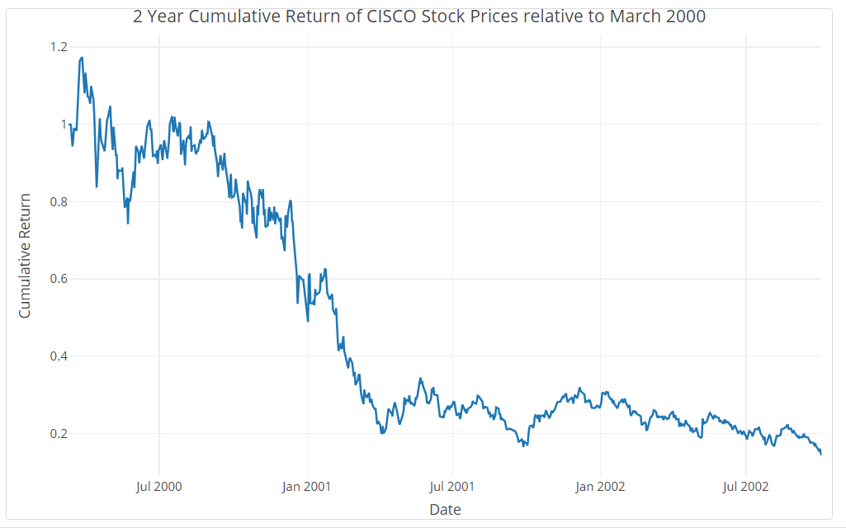

Figure 9: year cumulative return of CISCO share prices relative to March 2020 until October 2002

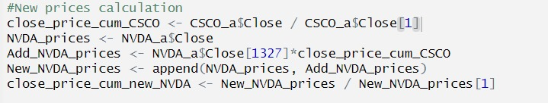

Figure 10: New Nvidia prices calculation using the cumulative return rates of Cisco shares from March 2020 until October 2002 applied to the last Nvidia share price in the time series on the date of 29.04.24

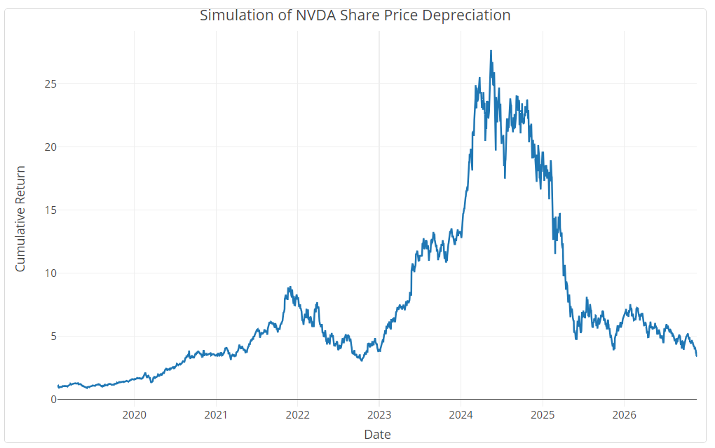

Figure 11: Cumulative return of NVIDIA share prices relative to 22 January 2019 with simulated depreciation starting from 29 April 2024 identical to the one CISCO experienced from 2000 to 2002.

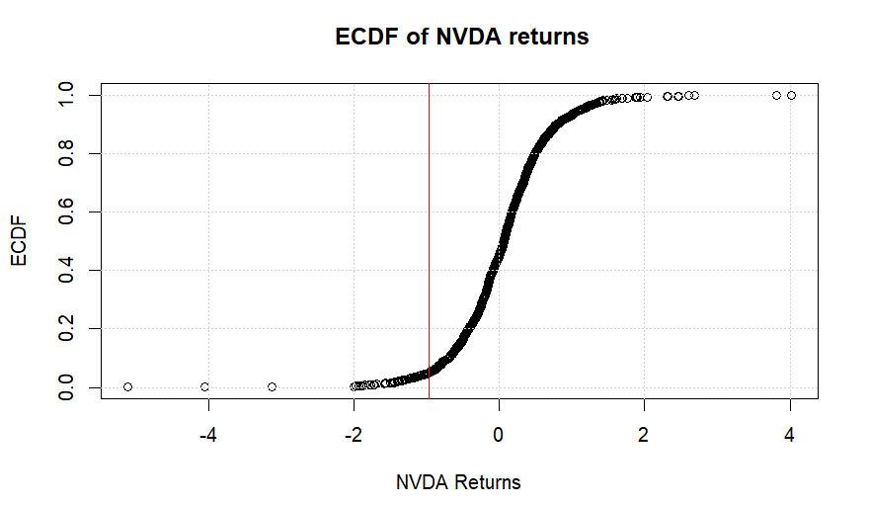

Figure 12: ECDF of Nvidia returns in the situation as of 29.04.24.

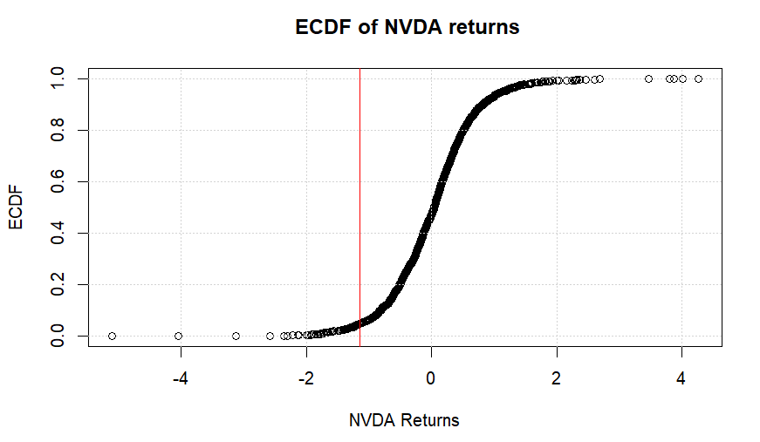

Figure 13: ECDF of Nvidia returns in a situation where the share price would go tumbling.

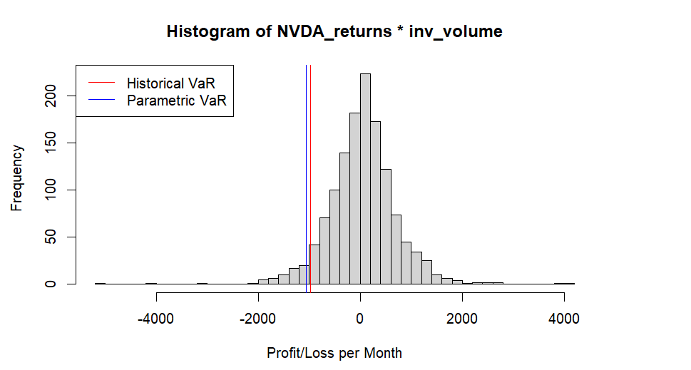

Figure 14: Histogram of the parametric and historical values at risk as of 29.04.24 on a monthly basis.

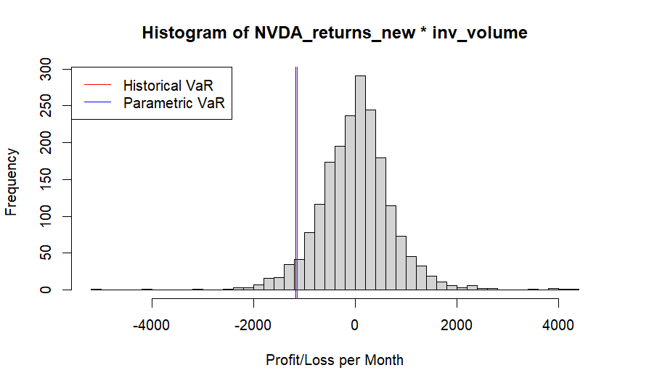

Figure 15: Histogram of the parametric and historical values at risk in the situation where the prices would go tumbling on a monthly basis.

Before the actual modelling, we had to make sure that the residuals of the returns are normally distributed, and we run a Box Cox transformation. That that is the case, we also made sure visually with QQ plots and residuals’ ACF, PACF and distribution plot. As next we run a Ljung box test to see if there is any significant residual autocorrelation in the model. Then we modelled ARIMA (2,0,1) model based on the (minimized) AIC method.

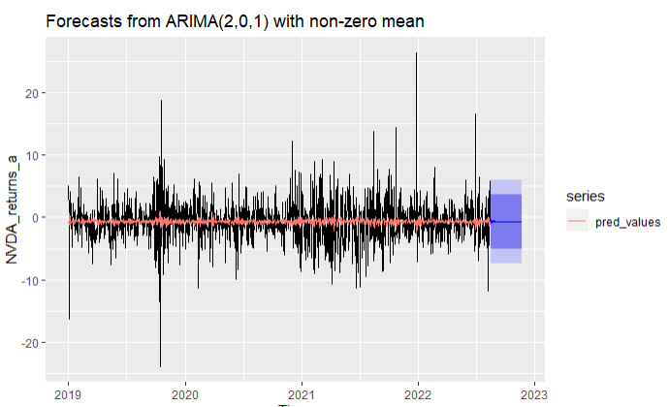

Figure 16: ARMA (1,0,0) for NVIDIA returns.

Our next goal was to examine volatility. For the GARCH model we used the fGarch library in R.

Ein Bild, das Text, Screenshot, Schrift enthält.

Figure 17: Code for GARCH model.

We calculated the rolling volatility for the window of last 22 days, to see how the trained model catches the actual volatility, access with sigma.t attribute. We plotted the result and forecasted the next period with the predict function within this library. For the GARCH order, we simply started with (1,1) which is the model the function fitted first (suggested) for the log returns. In Figure 18: GARCH (1,1) summary. is the summary of the model presented.

The generalized error distribution was used over general error distribution, to enable more flexibility to the model. All coefficients in the test are significant. Judging on the log likelihood the model is a good fit. The residual tests also look good, where the Ljung-Box once again proves the absence of heteroskedasticity in the model. All in all, this Garch (1,1) appears to be a good fit in our case in catching the conditional variance. A further investigation might be needed based on the Jarque-Bera test for normality, which suggests that there is not normality among residuals.

Ein Bild, das Text, Screenshot, Schrift, Dokument enthält.

Figure 18: GARCH (1,1) summary.

# References

(Hochschule Luzern24) Ankenbrand, T., & Bieri, D. “Msc ids time series analysis in finance”. <https://elearning.hslu.ch/ilias/ilias.php?baseClass=ilrepositorygui&ref_id=6153234>, ((Accessed on 23/05/2024))

(Financial Times23) Armstrong, R., & Wu, E., “Nvidia circa 2023, Cisco circa 2000”,

Financial Times, 14 August 2023, [https://www.ft.com/content/bdf843ed-6a6d-4f23-](https://www.ft.com/content/bdf843ed-6a6d-4f23-ae76-ebb618b495bd) ae76-ebb618b495bd

(YahooFinance24) Foelber, Daniel. “Meet the 5 Stocks That Have Contributed Almost All of the S&P 500’s 2024 Gains.” Yahoo Finance, 10 Mar. 2024,

<https://finance.yahoo.com/news/meet-5-stocks-contributed-almost-100500978.html>.

(WhatIs24) Hetler, Amanda. “What’s Going on with Nvidia Stock and the Booming AI Market?” WhatIs, [https://www.techtarget.com/whatis/feature/Whats-going-on-with-](https://www.techtarget.com/whatis/feature/Whats-going-on-with-Nvidia-stock-and-the-booming-AI-market) Nvidia-stock-and-the-booming-AI-market.

(Marimar24) Jiménez, Marimar. “Artificial Intelligence Sparks ‘Game of Thrones’ in the Chip Industry.” EL PAÍS English, 12 Apr. 2024.

[https://english.elpais.com/technology/2024-04-12/artificial-intelligence-sparks-game-](https://english.elpais.com/technology/2024-04-12/artificial-intelligence-sparks-game-of-thrones-in-the-chip-industry.html) of-thrones-in-the-chip-industry.html.

(Mohit24) Oberoi, Mohit. “As ‘AI Bubble’ Chatter Grows, Is Nvidia Stock Overvalued?” Barchart.Com, [https://www.barchart.com/story/news/24561387/as-ai-bubble-chatter-](https://www.barchart.com/story/news/24561387/as-ai-bubble-chatter-grows-is-nvidia-stock-overvalued) grows-is-nvidia-stock-overvalued.

(CNN24) Pendola, R., Curcio, P. & Tody D., “What Are the Magnificent 7 Stocks?” CNN

Underscored Money, 7 May 2024.

<https://www.cnn.com/cnn-underscored/money/magnificent-7-stocks>.

(YahooFinance24) Sozzi, Brian. “Yep, You Are Living in a Nvidia-Led Tech Bubble.” Yahoo Finance, 25 Feb. 2024, [https://finance.yahoo.com/news/yep-you-are-living-in-a-](https://finance.yahoo.com/news/yep-you-are-living-in-a-nvidia-led-tech-bubble-110014738.html)

nvidia-led-tech-bubble-110014738.html.

(Tikr24) “TIKR: Institutional-Grade Investing for Individuals.” TIKR Terminal,

<https://app.tikr.com>.