CC6001ES Advanced Database Systems Development

Coursework Assignment

The coursework assignment is an individual assessment weighted 40% of the marks for the module. It is designed mainly to assess students’ practical problem-solving skills and critical thinking/evaluation on the design and development of database systems. It requires the student to analyze, design and implement a web-based database application based on a given business case study. You are asked to provide a software solution as well as appropriate documentation detailing the design and implementation of the system.

- Introduction - DreamD (Pvt.) Ltd.
DreamD Wedding Planners is a medium scale company, which handle wedding day in very smooth manner. It is located in Colombo 7, Sri Lanka. At present, wedding event bookings and documents management is done using a manual system.
With a significant increase of business since the beginning of last year, the management of DreamD is keen on improving the efficiency of the operations within the company as well as the quality of the service provided to its clients. As a software developer, you have been given the responsibility to design and implement a web-based system for DreamD meet their requirements.
- Case Study
DreamD (Pvt.) Ltd. is well known organization in Sri Lanka, which provide an immense service for the wedding planning. It has become a highly reputed organization in the society within a short time period. Customers initially discuss their requirements for a wedding event with one of the DreamD team's project consultants. The Project Consultant will then complete a Project Requirements Form, an example of which is given in Figure 1.
A particular wedding event will require both resources (e.g.: flower arrangement, Poruwa Decoration) and staff service providers (e.g.: makeup artist, photographers). Resources are provided either from those available in house or by external suppliers in the companies authorized suppliers list. Similarly, staff required for the wedding event may be drawn from the full-time staff of the company or from external contract staff in the companies’ approved contract staff list. Therefore, it is mandatory for company to maintain updated list of resources and external resource providers (including the information of service type, charges etc.). Meanwhile, list of internal service providing staff and external contract staff (including their service type, expertise level).
Following the initial discussion with their client on their requirement for the event. The forementioned project consultant will calculate the total cost of providing these services and then a copy of completed event requirement form will be handed over to the customer. If client accept the quotation, a copy of event requirement form will be forwarded to Operation Manger.
Then the operation manager will arrange everything for the wedding using as possible as full-time service providing staff and as much as possible of the companies’ internal resources. If the full-time service providers are not available, the operation manager will contact the contract service providing staff from the companies approved contract service provider list. Occasionally, some special resources may be required for the wedding and those will be hired from the companies’ authorized suppliers.
The Office Manager adds, in manuscript, to the original Event Requirements Form the names and other relevant details of staff, resources, etc., which have been reserved for the wedding. Then a copy of completed form is sent to the original Project Consultant. This completed form is known as a “Wedding Planning Form”.
The Operation Manager regularly produces several other forms on request. These forms include Client Details Forms, Staff Details Forms, Resource Details Forms, Wedding Details Forms, Wedding Service Schedule Forms, Event-Resource Schedule Forms, and so on.
The introduction of a fully operational database system will eliminate many of the limitations of the current operations going in the company and facilitate a much-awaited improvement to the services provided by DreamD.

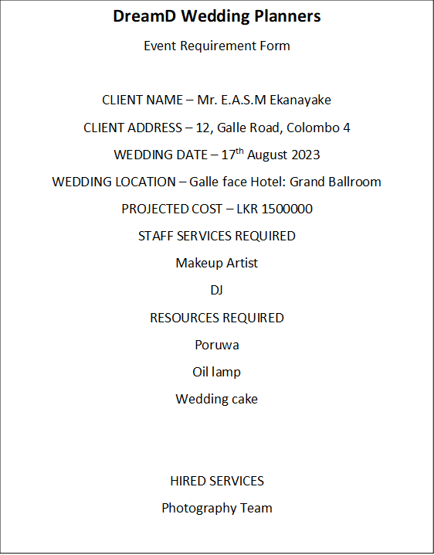

Figure 1

- Requirements of the Coursework
Marks are awarded for producing a working and properly documented system that meets the requirements specified below as deliverables:
3.1. Contents Page
A list of sections/subsections of the document, including page numbers.
3.2 Conceptual Model
Use Oracle Designer or any suitable tool to produce the Entity Relationship Diagram. Submit a copy of the ERD.
3 3 Logical Model & Normalization
Produce a set of fully normalized tables for the system
- You may add additional attributes where appropriate,
- Show clearly all the steps of normalization, up to the 3rd normal form
3.4. Generation of Database (using Oracle or Suitable RDBMS)
- Show the DDL script for generating the relations (relevant ‘CREATE statements only).
- Populate these relations with suitable data values.
- Provide a print-out of contents for all the tables (using ‘SELECT’ statements).

3.5. Data Dictionary
Show the description of each relation with meta data
3.6 Implementation of Web-based Database Application using ASP.Net or PHP
Implementation of a web-based database application which includes the following webforms (web pages)
- Basic Webforms:

  - Client Details
  - Wedding Details
  - Staff Details
  - Resource Details
  - Supplier Details
All these forms should facilitate input, update and delete of information.

- Wedding -Staff Schedule Form (for any scheduled event, show details of the event chosen and the details of all the staff assigned to it, including their job roles).
This form should facilitate the allocation of existing staff to a Particular wedding

- Wedding - Resources Schedule Form (For any scheduled event, show details of the event chosen and the details of all the equipment required).
This form should facilitate the allocation of existing resources to a scheduled event.
Event Requirement Form, as a slightly modified version of the form given in Figure 1 (for any scheduled event, show the details of the event, client, staff and equipment requirement).
Implementation of a homepage website which includes an option menu.

3.7 Documentation of the system (as implemented in 3.6)
FOR EACH ORACLE FORM
Implementation document
- Provide a set of screen dumps for all the web pages (webforms) you have produced.

Testing Document
- Provide a copy of the initial data (table contents) in your system.
- For each form implemented, list the individual tests that have been carried out together with their results.

FOR THE APPLICATION
User Manual (up to 5 pages)
- The User Manual should have a contents page and separate sections for each form provided.
- The User Manual should contain clear instructions on how to use the system and how to run each of the forms available to it.

3.8 Further Discussion
Your discussion should summarize your experience in undertaking this Coursework.
Your work must be submitted in a single document, with all output including diagrams, tables, forms, SQL scripts clearly labelled and presented.

END,

Marking Scheme for CC6001ES Individual Coursework

No | Assessment Items | Marks
1 | Specification of database relations (25 marks)
 | · Normalization of Figures 1 & 2, and then consolidate | 10
 | · ER diagram, consistent with normalization outcome | 10
 | · Data dictionary (print-out of attribute list for each table) | 5
2 | Generation of database (10 marks)
 | · Use Designer to convert ER to DB tables | 3
 | · Input data into DB tables (INSERT) | 4
 | · Display data in the tables (SELECT) | 3
3 | Implementation of Database Application (50 marks)
 | Basic Forms X 5 (min 4) | 20
 | Complex Forms X 5 (min 3) | 15
 | Home Page | 5
 | Testing | 5
 | User Manual | 5
4 | Further discussion (5 marks)
 | · Discussion of own experience | 5
5 | Professional documentation (overall packaging) (10 marks)
 | · Clarity of presentation, including clear labeling | 5
 | · Structure and format of presentation, including contents page | 5
Total |  | 100

