Problem:
SNAP ECG does not have a clearly defined method of installation on PCB. It has been done, and I am 100% certain it can be done. How it is done, is uncertain

RESEARCH

TWO METHODS HAVE BEEN EXPLORED
- ECG CLAW
Designed specifically for PCB’s however the footprint is harder to make.

- BUMP SNAP ELECTRODES
Easier to make, and $μ$emg has done it that way. Due to the slanted sides, I’m not certain I want to go with this
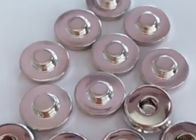
- SHORT COLUMN ECG
This one is made for PCB’s but once again there’s a slant
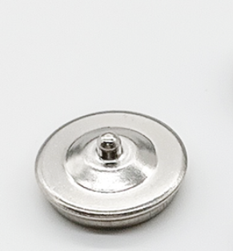

Potential implementation
How does a rivot work
So it requires a small hole. Which as of now I have not found


Resources

https://www.alibaba.com/product-detail/Nickel-Plating-4-0mm-ECG-Female_1601408208499.html - best documentation with sizes

https://www.alibaba.com/product-detail/4_0mm_Short_Column_ECG_Female_Buckle_with_PCB_Easy_Welding_Terminal_Physiotherapy_Medical_Electronic_Buckle_1601408263267.html?spm=a2700.shop_index.133801.5.70b0fbfa2qeuuV – this one is “PCB easy”

