Requirements
There are no specific requirements for the VL project.
However, for the biomedical engineering project, we want high control over the gain and filtering. The client is said to have very weak muscle signal.
Aim for HIGHEST GAIN
What is the expected signal strength?
Adaptable filtering
Noise? be weary about noise. This is a serious problem as false triggers make this a serious issue.
What sources of noise?

What is ECG/EMG
By measuring the voltage across the body amplifying it, you can get heart rate or muscle activity. Depending upon the band-pass filter frequency you get heart rate or muscle activity.

Heart rate: (ECG)
The heart generates voltage differences across the skin
Signals of the heart reach UP TO$±5mV$ [1]
0.5Hz to 150Hz
Electrodes must be placed equidistant from the heart for 1 Lead ECG. “Einthoven triangle”

Muscle activity
Amplitude varies depending upon age, sex, strength, etc. Try to maximize the resolution to the best of our ability as we don’t know.
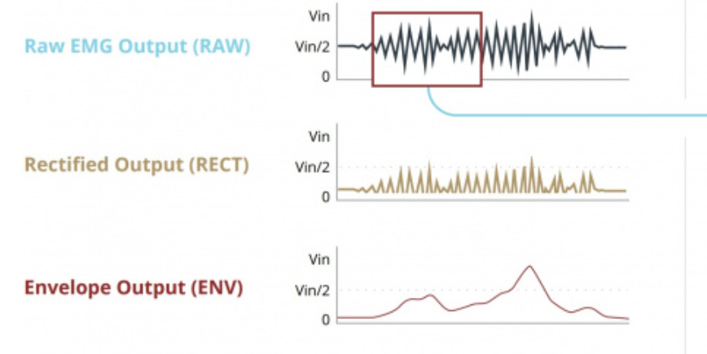
- The way EMG works is you filter raw signal 20Hz - 500Hz
- Rectify it, remove the negative components
- Put a HP filter to extract the envelope 3.6Hz

Gain and filter
Ideally, we would be able to tune all this with programmable gain and filter. I don’t know if there’s a programmable filter.
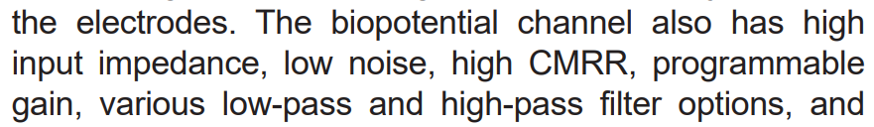
Max30003 does not have programmable filter.

Hardware components
We want the highest resolution possible for the ADC especially since our signal is so small. Delta-sigma ADC
Programmable gain, programmable filter
LDO power supply

Wet vs Dry electrodes

Why did I choose wet electrodes for ECG?
- Wet electrodes stick onto the body making node look nicer.
- On demo day, nobody wants to stick something on their heart that has touched 100 people’s hearts. So, it would just be a visual demo
- Cleaner signal, reducing concern about extraction of respiration rate.

Why did I choose dry electrodes for EMG?
- Cool engineering
- Re-usable and therefore allows people to play with it on DEMO Day (flappy bird, control UI of computer, etc.)

Connectors

Requirements
We want minimal noise introduced, strong enough connections such that they don’t fall off, yet detachable and replicable.

Sources
Source 1: “High-resolution portable bluetooth module for ECG and EMG acquisition
”https://www.sciencedirect.com/science/article/pii/S2001037025001394
Source 2: https://learn.sparkfun.com/tutorials/getting-started-with-the-myoware-20-muscle-sensor-ecosystem/myoware-20-muscle-sensor
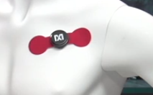 this is the goal for ECG. WET ELECTRODES. IDC

