XIAO NRF52840 board or CUSTOM BOARD
 | Pros
Xiao | - More reliable as it already works  - Very small PCB(hard to beat)  - cheaper
Custom pcb | - More learning  - Slightly more customizable
Verdict:
By default, we will be using the XIAO board, unless there is a reason that the board needs to be more customizable

In terms of learning, I will be working on my own project which includes a lot of the xiao board anyways on the side to build the skills that I want.

How is the Generic NODE board going to be connected to the sensor board?
We will have a battery sandwich

Node
---------
Battery
---------
Custom SensorPCB

https://www.seeedstudio.com/Seeed-Studio-XIAO-24Ghz-mmwave-Human-Static-Presence-Module-p-6266.html

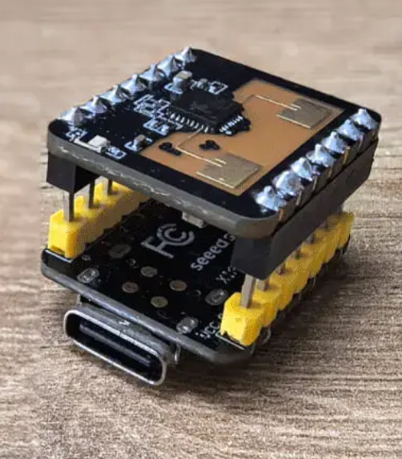s

