What is ECG/EMG
By measuring the voltage across the body amplifying it, you can get heart rate or muscle activity. Depending upon the band-pass filter frequency you get heart rate or muscle activity.

Heart rate: (ECG)
Signals of the heart reach UP TO$±5mV$ [1]
0.5Hz to 150Hz
Electrodes must be placed equidistant from the heart for 1 Lead ECG. “Einthoven triangle”

Muscle activity
Amplitude varies depending upon age, sex, strength, etc. Try to maximize the resolution to the best of our ability as we don’t know.
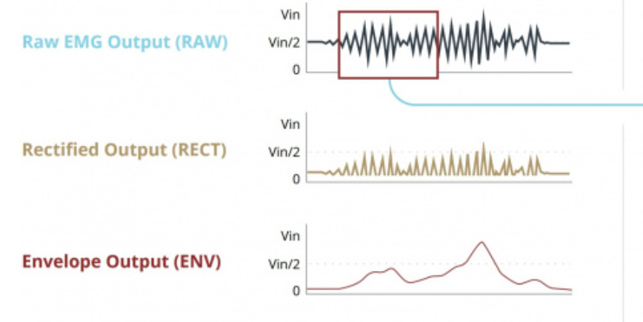
- The way EMG works is you filter raw signal 20Hz - 500Hz
- Rectify it, remove the negative components
- Put a HP filter to extract the envelope 3.6Hz

Gain and filter
Ideally, we would be able to tune all this with programmable gain and filter. I don’t know if there’s a programmable filter.
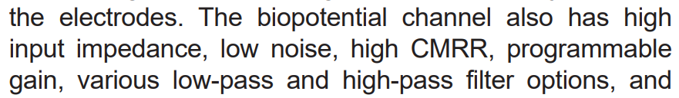
Max30003 does not have programmable filter.

Hardware components
We want the highest resolution possible for the ADC especially since our signal is so small. Delta-sigma ADC
Programmable gain, programmable filter
LDO power supply

Connectors

Requirements
We want minimal noise introduced, strong enough connections such that they don’t fall off, yet detachable and replicable.

Sources
Source 1: “High-resolution portable bluetooth module for ECG and EMG acquisition
”https://www.sciencedirect.com/science/article/pii/S2001037025001394
Source 2: https://learn.sparkfun.com/tutorials/getting-started-with-the-myoware-20-muscle-sensor-ecosystem/myoware-20-muscle-sensor

