VoIP Recorder Module
Software Design Document

Table of Contents
1 Introduction 3
1.1. Purpose 3
1.2. Glossary 3
1.3 References 4
1.4. Overview of Document 4
2. Overview of Recorder System key’s components 5
2.1 Structure of Recording Solution 5
2.2 Overview of VoIP Recording methods 6
2.2.1 Passive VoIP Recording 6
2.2.1.1 Passive Recording Issues 6
2.2.2 Active VoIP Recording 9
2.3 VoIP Recorder module for Passive Mode Recording 9
3. VoIP module Objects and Objects relationships 11
3.1 UPD Packet Filter 11
3.2 Control Packets Parser 13
3.3 Device Manager 14
3.3.1 The Device Object 15
3.4 RTP Packet Parser 15
3.5 Audio Decoder 16
3.6 Common Class Diagram 17
4. MultiXtR API 17
4.1 Functions which affect the entire system 18
4.2 Functions to determine Port numbers of connected devices 19
4.3 Functions which affect a single connected agent 19
4.4 Constants 22
Appendix A. Third party libraries and components 24
WinPcap 24
jrtplib 24
reSIProcate 25

1 Introduction

This document is elaborated on Software Requirements for VoIP Recorder Windows Dynamic Link Library (further stated as Recorder DLL). The Recorder DLL is a plugin for BackOffice Recorder software product that realize functionality for recording voice data into VoIP networks.

1.1. Purpose
This document provides a comprehensive architectural overview of the VoIP Recorder, using a number of different architectural views to depict different aspects of the system. It is intended to capture and convey the significant architectural decisions which have been made on the VoIP Recorder.

This document describes architecture of VoIP Recorder DLL

This document is intended to:

- present clear architectural model of Recorder DLL for software developers;
- help project manager to evaluate tasks to be done;
- give base for elaborating implementation design for all software components of the VoIP Recorder.

1.2. Glossary
VoIP – Voice over Internet Protocol, is a general term for a family of methodologies, communication protocols, and transmission technologies for delivery of voice communications and multimedia sessions over Internet Protocol (IP) networks, such as the Internet.

SIP – The Session Initiation Protocol (SIP) is an IETF-defined signaling protocol, widely used for controlling multimedia communication sessions such as voice and video calls over IP. The protocol can be used for creating, modifying and terminating two-party (unicast) or multiparty (multicast) sessions consisting of one or several media streams.

SDP – The Session Description Protocol (SDP) is a format for describing streaming media initialization parameters in an ASCII string.

RTP – The Real-time Transport Protocol (RTP) defines a standardized packet format for delivering audio and video over the Internet. It was developed by the Audio-Video Transport Working Group of the IETF and first published in 1996 as RFC 1889, superseded by RFC 3550 in 2003.

Skinny -The Skinny Call Control Protocol (SCCP, or short Skinny) is a proprietary network terminal control protocol. The SCCP technology is now owned and defined by Cisco Systems, Inc. as a messaging system between a Skinny client and the Cisco CallManager.

UNISTIM - UNIStim (or Unified Networks IP Stimulus) is a Telecommunications protocol developed by Nortel (now acquired by Avaya) for IP Phone (terminals and soft phones) and IP PBX communications.

DLL – Dynamic-link library (also written without the hyphen), or DLL, is Microsoft's implementation of the shared library concept in the Microsoft Windows.

1.3 References
RFC 3261 - SIP: Session Initiation Protocol
RFC 4566 - SDP: Session Description Protocol
RFC 3550 - RTP: A Transport Protocol for Real-Time Applications

1.4. Overview of Document
The Document contains following sections:

- Section 2 contains overview of the recorder system illustrated with components diagrams;
- Section 3 describe low-level objects of VoIP recorder module and its relationships;
- Section 4 describe IR MultiXtr API
- Appendix A gives a brief overview of proposed third parties libraries;

2. Overview of Recorder System key’s components

2.1 Structure of Recording Solution
Intelligent Recording Limited business has traditionally supplied USB based recorders that interface to propriety digital and analogue PBX systems these being either single port or multi port devices. Theses recorders have been highly successfully, however as telephony technology changes and with several PBX manufactures starting to release VoIP systems they has been a need to venture into the world of Voice over Internet Protocol.

BackOffice Recorder software resides on a PC/Server in the PBX room. Combined with either the Digital 04, Digital 16, Analogue 02, Analogue 04 or Analogue 08 hardware solutions that in turn are connected to the station wiring, BackOffice Recorder provides a true digital centralized recording solution for both large and small applications.

Intelligent Recording propose 'PBX-2-USB' technology delivers superb 'True Digital' call recording for professional business and small office/home office applications. But for VoIP systems recording occurs without any additional hardware, only by using standard Ethernet adapter and, in case of using passive recording, network switch with port mirroring feature.

The following deployment diagram shows the place of VoIP recorder module, into common structure of BackOffice Recording solution.
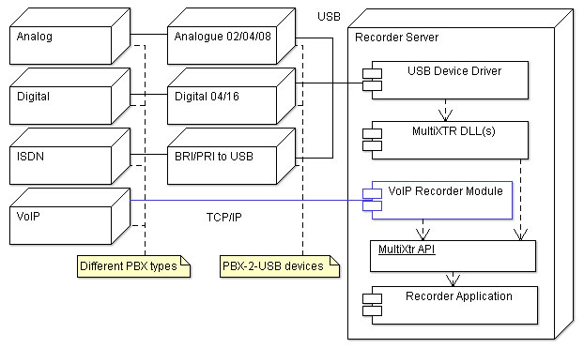

2.2 Overview of VoIP Recording methods
VoIP recording presents a bit more of a challenge for call recorders as there is often no physical audio path to connect into, as the traffic is communicated through IP packets. Depending on the requested system configuration, the VoIP recording solution offers different ways to plug in.

2.2.1 Passive VoIP Recording
Passive recording is done by tapping into the computer network. Usually this is done by connecting to a router, switch, hub on the network, or through the PC attached to the VoIP phone. One way of doing this is by connecting to the SPAN (Switched Port ANalyzer) port which allows the VoIP recording PC to monitor all network traffic and pick out only the VoIP traffic to record. This is usually done by connecting an Ethernet cable being between the VoIP recording unit and the router, switch, or hub. Via the SPAN port, the recorder will "sniff" for signaling and RTP packets that have the identifying information contained in the headers of the packets is designated to record.

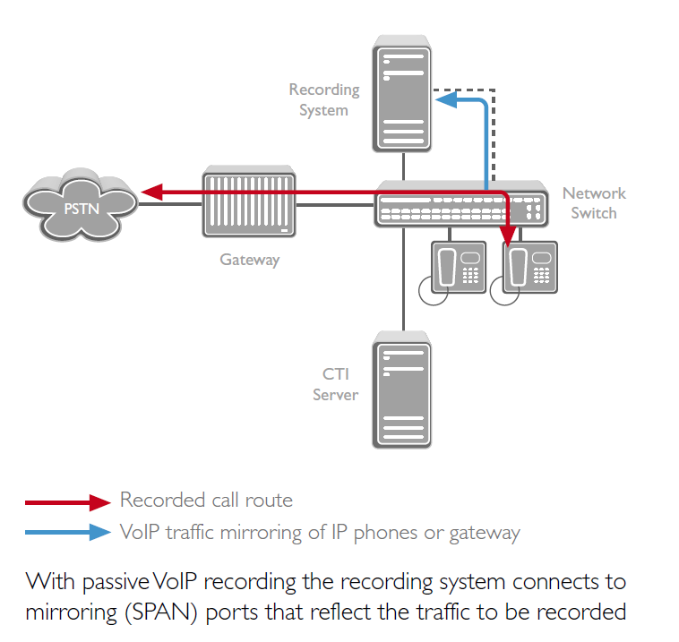
There are two main ways to capture the RTP packets with the SPAN port. You can SPAN the VoIP Gateway port, giving you all the in/out bound traffic and offers one point of contact for recording.

2.2.1.1 Passive Recording Issues
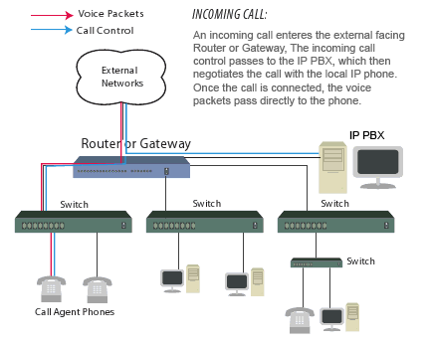
On traditional telephone networks, all voice and call control information passes through a central location - the PBX. Each channel on the network is tapped individually, and a single tap point obtains all voice data and call control information. With VoIP, only the call control information is guaranteed to passed along the Ethernet to the IP PBX. After call setup is complete, the voice packets are routed along a different path from the signalling data. An IP network does not offer a central location to tap all voice and call control information.
The following diagram illustrates the path of both the signalling data and the voice RTP media packets during an incoming call. To capture all packets a logger can position a tap between the Router/Gateway and each workgroup switch:
This second diagram illustrates a peer to peer call scenario where both phones are positioned on the same workgroup switch. Voice RTP media packets are routed directly between endpoints. As a result the voice packets never leave the local subnet:
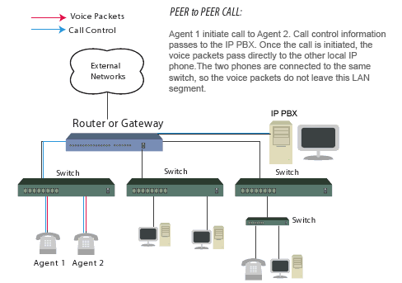
Ultimately, VoIP recording components are only capable of processing packets that
are capable of seeing. Applications that are required to record all voice packets on the network (agent to agent conversations) must position taps deeper in the network. Loggers can choose to position taps between phones and the workgroup switch or to rely on the switch’s mirror port. When using Cisco switches these are known as SPAN ports.

When the mirror port is used, data packets processed by the switch are replicated and passed off the network via this specialized port. From here, the mirror port is connected to a VoIP monitoring component that is capable of decoding signaling packets and processing RTP media.

Before tapping a VoIP network with mirror ports it is important to understand that capacity limitations can be reached which result in packet loss. When mirror ports are used, data from multiple ports on the switch is aggregated and passed onto a single port. Access to full-duplex traffic is constrained by the mirror port capacity. If a single10/100 Mbps port attempts to monitor multiple 10/100 Mpbs ports data packets are dropped when the mirror port reaches it’s capacity. Many switch manufacturers are designing mirror ports with larger capacities to compensate for this. Users must determine the capacity of the mirror port on their system before assuming that this single port can handle the traffic load.

Another consideration is the inherit design of the switch itself. When packet mirroring is used, the switch is now responsible for moving all network traffic, as well as duplicating packets passed to the mirror port. This added burden to the switch’s processors does impact it’s performance. Some switch manufacturers, such as Cisco, build safeguards into their products. In this scenario, the switch treats mirrored data with a lower priority than regular port-to-port data. In other words, if any resource under load must choose between passing normal traffic and mirrored data, the mirrored packets lose and the mirrored frames are arbitrarily discarded. When the network is running at high capacity it can overload the switch. As a result, packet loss can occur even if the switch is designed with
a gigabit mirror port.

2.2.2 Active VoIP Recording
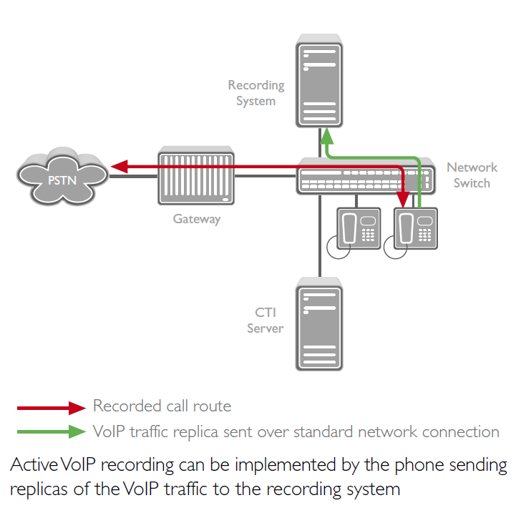
Active recording involves sending a replica of captured audio interactions from a gateway, conference bridge or IP-phone to the recording system using standard network routing. Active VoIP recording operates like an VoIP softphone. To record a call, a conference is initiated to the recorder, or the audio streams are routed to the recorder. It supports the industry standard SIP protocol and preserves call-index information, such as incoming and outgoing phone numbers, time of call, etc., to facilitate search-and-replay.

2.3 VoIP Recorder module for Passive Mode Recording
For passive VoIP recording, recorder module contains five main components:

- UDP Packet Filter
- Control Packet Parser
- Device Manager
- RTP Packets Parser
- Audio Data Decoder

UDP Packet Filter
This component captures UDP packets from selected network interface and bypasses it to Control and RTP Packets Parsers.

Control Packet Parser
The objective of this component is to determine Control packets in general UDP packets stream, and bypass it to Device Manager.

Device Manager

This is one of the most famous component of VoIP recorder. An analysis of received Control packets, Device Manager must determine registered VoIP terminals, and it states. When new call session is started Device Manager initiates capturing of RTP packets associated with current terminal.

RTP Packets Parser
Detects RTP packets belonged to defined session from common UDP packets stream. Information about active session received from Device Manager. Captured RTP packets split to media stream then obtained media data send back to Device Manager.

Audio Data Decoder
Depending on the used audio codec, decode received media data.

VoIP Recorder Module Components Diagram:
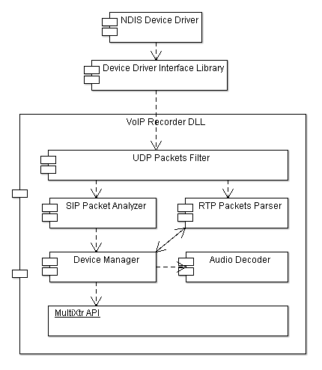

3. VoIP module Objects and Objects relationships

This section defines VoIP recorder module objects and objects relationships. Considered objects and their interaction on the example of SIP based systems. For UNISTIM and Skinny systems changes in the basic structure are not fundamental. This object model is applicable for passive recording mode. Active recording mode will be considered at the next stage of development process.

3.1 UPD Packet Filter
First, a capture system needs to bypass the operating system’s protocol stack in order to access the raw data transiting on the network. This requires a portion running inside the kernel of OS, interacting directly with the network interface drivers. This portion is very system dependent, and will be realized as a device driver. These driver offer basic features like packet capture, as well as more advanced ones like a programmable filtering system engine.

Second, the capture system must export an interface that user-level applications will use to take advantage of the features provided by the kernel driver.

And finally UDP packet filter contain sets of classes that encapsulate all low-level functionality and represent simply and clear interface to captured UDP data. These classes are part of VoIP Recorder DLL.

Captured UDP packets represent as objects of CUDPPacket type. This object type provide interface for raw UDP datagram data and IP/UDP headers. For transferring packets to other objects UDP packet filter use special interface IUDPPacketListener. This interface contains only one virtual method – OnUdpPacket. Root object include a list of pointers to objects that realize IUDPPacketListener interface, and when new packet captured it call OnUdpPacket method for each registered packet listener.

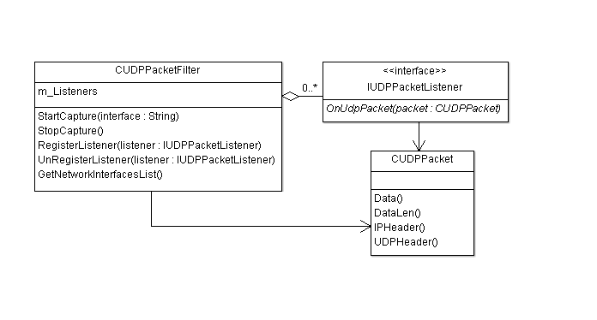
UDP Packet filter class diagram:

CUDPPacketFilter Class key methods:
Method | Description
StartCapture(string) | Start capture UDP packet from defined network interface, this function is non blocked, return immediately.
StopCapture | Stop capturing session
RegisterListener(IUDPPacketListener*) | Add interface to list of UDP packets listeners
UnRegisterListener(IUDPPacketListener*) | Remove interface from list of UDP packets listeners
GetNetworkInterfacesList() | Return list of strings that contain all installed network interfaces

CUDPPacket Class key methods:
Method | Description
char *Data() | Return pointer to UDP datagram data without headers
int DataLen() | Return data size exclude IP/UDP headers
Ip_header *IPHeader() | Return pointer to IP header struct
Udp_header *UDPHeader() | Return pointer to UDP header struct

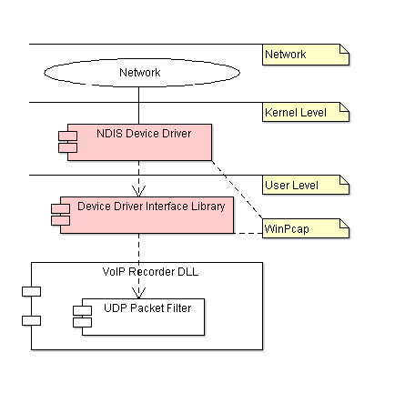
To speedup development of the VoIP recorder it is proposed to use well-developed and tested Windows Packet Capture Library. WinPcap (http://www.winpcap.org) proposes such a library under modified BSD license. Along with the Device Driver this solution has interface libraries that are necessary for developing packet capturing applications. WinPcap is the packet capture and filtering engine of many open source and commercial network tools, including protocol analyzers, network monitors, network intrusion detection systems, sniffers, traffic generators and network testers.

3.2 Control Packets Parser
SIP Parser detects SIP packets from common UDP packets stream, and bypassing it to Device Manager. Received and recognized SIP packets represent as objects of CSIPPacket type. This object type provides interface for SIP packet body data and his headers. Also for transferring packets to other objects SIP parser uses special interface ISIPPacketListener. This interface contains only one virtual method – OnSIPPacket.

SIP packets parser realizes an IUDPPacketListener interface for receiving UDP packets from Packet Filter. So this object needs to be registered as UDP packets listener by calling RegisterListener method of CUDPPacketFilter object. When SIP parser receives a CUDPPacket object, first it checks the ports numbers of the recipient and sender, and if they meet the specified condition is trying to recognize SIP headers, methods, etc.

If received UDP datagram contain valid SIP packet then SIP parser create a CSIPPacket object and receive it to registered SIP listener. Unlike UDP packet filter, SIP parser have only single SIP listener – Device manager.

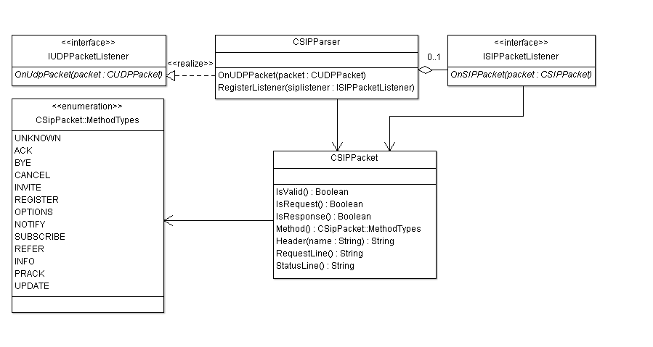
SIP Parser Class Diagram:

CSIPParser Class key methods:
Method | Description
OnUDPPacket(CUDPPacket *) | Implementation of IUDPPacketListener interface. This method called when UDP packet filter receive UDP datagram.
RegisterListener(ISIPPacketListener *listener) | Registering listener of SIP packets

3.3 Device Manager
Device manager contain map of device objects. Each object of device type represents a unique User Agent. Device manager realizes an ISIPPacketListener interface for receiving SIP packets from SIP Parser. So this object needs to be registered as SIP packets listener by calling appropriate method of SIP parser.

Device Manager Class Diagram:
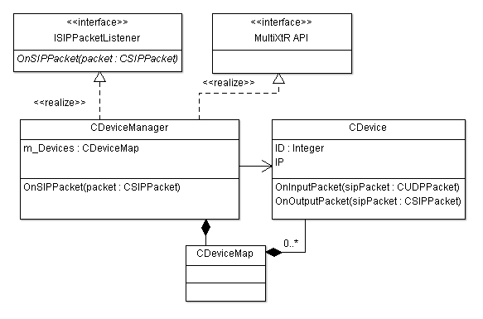
The main purpose of Device Manager is the management and creation of device objects. Also device manger determines which SIP packet belongs to the device and sends it to appropriate object. For sending packets to device object, it simply calls OnInputPacket/OnOutputPacket methods of appropriate object.

When device manager detect REGISTER packet from unknown unregistered UA (with unknown Call-ID header), it create new CDevice object copy and add it to map. Every Device object has a live time, so if Device manager not receive any packets associated with device more when defined time period, this device will be removed from map of connected devices. Device manager provides everything needed for implementation of MultiXtR API.

For mapping MultiXtR iSerialNumber to device (device ID) used 32 bit FNV hash value from Call-ID header. FNV hashes are designed to be fast while maintaining a low collision rate. The FNV speed allows one to quickly hash lots of data while maintaining a reasonable collision rate. The high dispersion of the FNV hashes makes them well suited for hashing nearly identical strings such as URLs, hostnames, filenames, text, IP addresses, etc.

3.3.1 The Device Object
Device object depending on the received Control packets changes its state. When object receive INVITE packet and appropriate confirmation, it start RTP packet capturing session. These occur through calling RTP Packets Parser methods.

Device objects contain methods for determine his current statuses and calling states.

CRTPParser key methods:

Method | Description
OnInputPacket(CSIPPacket *) | Called by Device manager when received control packet associated with current device object. Called when received packet is addressed to IP terminal that refers to current object.
OnOutputPacket(CSIPPacket *) | Called by Device manager when received control packet associated with current device object. Called when received packet source is IP terminal that refers to current object.
OnBearerData(const char *, int size) | Called by RTP packet parser, when portion of bearer data is ready.

3.4 RTP Packet Parser
RTP Packet parser receives data about media session from device manager (more precisely from the object of a specific device). For realization of this module it is proposed to use one of the open source library under BSD license or Public Domain code. One from this library is a C++ jrtplib (http://research.edm.uhasselt.be/~jori/page/index.php?n=CS.Jrtplib).

The library makes it possible to send and receive data using RTP, without worrying about SSRC collisions, scheduling and transmitting RTCP data etc. The user only needs to provide the library with the payload data to be sent and the library give the user access to incoming RTP and RTCP data.

The library provides several classes which can be helpful in creating RTP applications. Most users will probably need just the RTPSession class for building an application. This class provides the necessary functions for sending RTP data and handles the RTCP part internally.

For using library without sockets transport layer, we need only write class derived from RTPTransmitter, which will transmit packets to library core. Also RTP Packet Parser realizes an IUDPPacketListener interface for receiving UDP packets from Packet Filter.

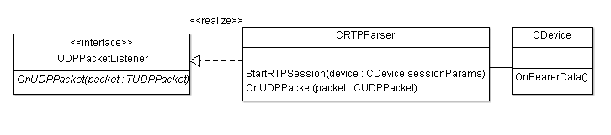
RTP Parser Class Diagram:

CRTPParser key methods:

Method | Description
OnUDPPacket(CUDPPacket *) | Implementation of IUDPPacketListener interface. This method called when UDP packet filter receive UDP datagram.
StartRTPSession(CDevice*, sessionParams) | Start RTP session associated with device. When bearer data is received, RTP parser call OnBearerData method of the defined device object

3.5 Audio Decoder
Used for decoding audio streams from defined audio formats. For G711 decoding used part of speak_freely open source project, it released under BSD license.
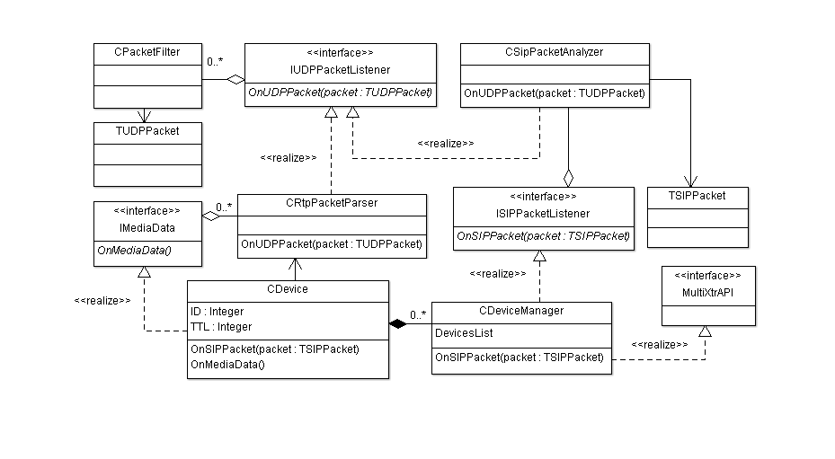

3.6 Common Class Diagram

4. MultiXtR API

IR will provide the header file. This file is guaranteed to be compatible with the latest version of Microsoft C++ Developer Studio. No guarantees can made for other systems. The Header file will be ‘MultiXtR.h’, and will contain all the function definitions. The library file will be MultiXtR.lib. This contains definitions used for importing the DLL at compile time.

The Dynamic Link Library will be ‘MultiXtR.DLL’. This will contain the code necessary for driving the appropriate VoIP protocol interface. There will be different versions of the DLL file for different VoIP protocol interfaces. The Lib and Header files for all VoIP protocol interfaces will be identical.

Functions which affect the entire system
- MP_Open
- MP_Close
- MP_GetSwType
- MP_GetSwVersion
- MP_SetCallback
- MP_GetDataFormat
- MP_ConvertData

Functions to determine Port numbers of connected devices
- MP_GetMaxNumPorts
- MP_GetIfSerialNo

Functions which affect a single connected port
- MP_GetStatus
- MP_GetCallState
- MP_GetIfType
- MP_SetAudioGain
- MP_GetAudioData
- MP_AudioMonitor
- MP_AutoRecord
- MP_ControlMonitor
- MP_GetControlDataPBX
- MP_GetControlDataPhone
- MP_GetCallerID

MP_Open and MP_Close should be called from the same thread as each other. All other functions should be thread safe and may be called from any thread at any time. Function calls should be protect internally to prevent any data corruption between threads.

4.1 Functions which affect the entire system
void MP_Open( void )
This function will attempt to open the link to the Telephone system. Since it cannot immediately determine success or failure, this function has no return value. The MP_GetStatus function should be called after MP_Open to determine whether required devices are correctly connected.

void MP_Close( void )
This function will close the link to the Telephone system. It will release the ports and all allocated software devices, returning them to the Windows system.

void MP_SetCallback( (void *MyProc)( int SerialNumber, int Event, int Data ) )
This function sets a callback which will be used by the library to identify significant events taking place on the telephone lines. The events provided to the callback are described below. MyProc may be NULL, which disables the further sending of callbacks. Note that callbacks should come from an independent thread.

LPCSTR MP_GetSwType( void )
This function will return the version type of the current software library. This is a Intelligent Recording product code, which is a string containing manufacturer, hardware interface and audio encoding type. This string consists of 5 characters e.g. AVfUS, TOfUK. Currently supported types are as follows. There may be more in the future.

Position | Chars | Meaning
1st and 2nd | AV | Avaya Definity
1st and 2nd | AM | Avaya Magix (Merlin Magix)
1st and 2nd | NE | NEC
1st and 2nd | NO | Nortel Norstar
1st and 2nd | NM | Nortel Meridian
1st and 2nd | PA | Panasonic DBS
1st and 2nd | PK | Panasonic KXTD
1st and 2nd | SI | Siemens (HiPath & HiCom)
1st and 2nd | TO | Toshiba (DK + CTX)
3rd | f | Always lower case f
4th and 5th | US | United States
4th and 5th | UK | United Kingdom

LPCSTR MP_GetSwVersion( void )
This function will return the version number of the current software library. This is an ASCII string of the format “nn.nn.nn”

int MP_GetDataFormat( void )
This function will return the data format being used by the attached telephone system. Current supported values are WAVE_FORMAT_MULAW for American µ-law or WAVE_FORMAT_ALAW for European A-law.

short MP_ConvertData( const char Data )
This function converts received telephone data into 16 bit data suitable for use in Windows WAV files, or by a soundcard. This function works correctly regardless of whether the data received from the telephone is in European A-law or American µ-law.

4.2 Functions to determine Port numbers of connected devices
int MP_GetMaxNumPorts ( void )
This function will return the maximum number of connected devices connected to the PC. Not necessarily the number which currently are connected.

int MP_GetIfSerialNo( int Virtual )
This function will return the serial number of the connected virtual device. If no device is present in this slot it returns 0. Even if the device has a serial number, it might still be faulty. You will need to check the status to ensure that the device is working.

Please note that this information will NOT be available at program start up, due to the time delay necessary to initialise the devices.

4.3 Functions which affect a single connected agent

int MP_GetStatus( int SerialNumber )
This function will return the current status of the requested device, and the status of the connected exchange and telephone. Possible return values from this function are as follows

Value | Meaning
STATUS_GOOD | The device, Exchange and Telephone are all functioning correctly
+1 to +100 | The device initialising, percentage complete
STATUS_NOTPRESENT | Unable to open the link to the device
STATUS_UNLICENSED | Incorrect device type. i.e. MP_GetIfType not compatible with MP_GetSwType
STATUS_NOEXCHANGE | Device ok, Exchange not connected.
STATUS_NOPHONE | Device ok, Exchange ok, Keyset not connected
STATUS_UNKNOWNERROR | Device ok. Keyset OR Exchange not connected or not communicating. Unable to determine which is at fault.
STATUS_NOTINITIALISED | Interface not initialised by Open, or has been Closed.
STATUS_INTERNALERROR | Internal error. Some error has occurred which has stopped the device functioning. May have just been disconnected
STATUS_TOOMANY | Too many devices are connected to this PC. So unable to initialise this one.

NOTE: Unless MP_GetStatus shows the device is connected and initialised, most of the following functions are to return defaults. The status can change to faulty after being connected ok.

int MP_GetCallState( int SerialNumber )
This function will return the state of the keyset connected to the device. Some systems can return more information on the connected telephone than others. So you should ensure you cope with all the possible return values from this function.

Value | Meaning
CALL_IDLE | The keyset is at rest, and not in use.
CALL_ACTIVE | The keyset is in use. The DLL is unable to determine the type of activity in progress
CALL_INCOMING | The keyset is in use on an incoming call
CALL_OUTGOING | The keyset is in use on an outgoing call
CALL_INCOMING_INTERNAL | The keyset is in use on an incoming call from an internal extension
CALL_INCOMING_EXTERNAL | The keyset is in use on an incoming call from an external line
CALL_OUTGOING_INTERNAL | The keyset is in use on an outgoing call to an internal extension
CALL_OUTGOING_EXTERNAL | The keyset is in use on an outgoing call to an external line

const char * MP_GetIfType( int SerialNumber )
This function will return a pointer to a string describing the currently connected device type. i.e. What manufacturer or phone types it is compatible with. Return values exactly the format as MP_GetSwType.

void MP_AudioMonitor( int SerialNumber, BOOL OnOff)
Use this function to manually start and stop monitoring of Bearer Channel (audio) data. No B Channel Data or events can be received until recording is started. Once started, audio data will come in as standard telephone data rate of 8kHz.
The OnOff parameter is used to tell the DLL which information is required.

void MP_AutoRecord(int SerialNumber, BOOL OnOff)
Auto record will automatically start recording when data is available. As soon as the telephone is in use, the system will automatically start streaming data. When the line again becomes idle the streaming of audio data will stop. The OnOff parameter is exactly as described for MP_AudioMonitor above.

int MP_GetAudioData( int SerialNumber, int MaxLength, unsigned char *pPBXData, unsigned char *pPhoneData, unsigned char *pMergedData )
Use this function to recover monitored Bearer (audio) channel data. This method delivers audio data sent in either/both directions to and from the telephone and/or a merged data channel. The amount of available data for all three channels is always identical. This function returns the amount of data available (the same for each channel). This may be 0, and will be if Bearer Channel monitoring with MP_AudioMonitor is not enabled. This function erases all returned data from the low level interface buffer.

Any or all of the three pointers may be NULL, in which case MaxLength bytes are deleted from all received channels, in order that the amount of data available from each channel remains identical.

You can check the amount of data available by calling this function with MaxLength=0. This returns the amount of data available from each separate buffer. This does not erase any data from any channel.

void MP_SetAudioGain( int SerialNumber, BOOL Remote, int Gain )
This function boosts or reduces the audio signal. There are two separate gains for each port. Remote=TRUE sets the gain on the speaker i.e. the remote caller. Remote=FALSE sets the gain from the local microphone. Gain is a fixed point modifier, and will be divided by 256. A value of 256 gives no boost, i.e. exactly what is seen on the line. A value >256 will amplify the signal. A value <256 will attenuate the signal. Both values default to unmodified. i.e. 256.

void MP_ControlMonitor( int SerialNumber, BOOL OnOff )
Use this function to manually start and stop monitoring of Data Channel (control) data.

int MP_GetControlDataPBX(int SerialNumber, int MaxLength, unsigned char *pPBXData)
Use this function to recover monitored D channel data sent to the telephone from the exchange. The low level interface can buffer approx 8kbytes of data. A buffer is provided with the maximum amount of data required. This function returns the amount of data available, which may be 0, and will be if you have not enabled monitoring with MP_ControlMonitor. This method erases any returned data from the low level interface buffer.

If pPBXData is NULL, calling this function will erase MaxLength bytes of data without returning them.

You can check the amount of data available by calling this function with MaxLength=0. This does not erase any data from the buffer.

int MP_GetControlDataPhone(int SerialNumber, int MaxLength, unsigned char *pPhoneData)
Use this function to recover monitored D channel data sent from the telephone to the exchange. All other details are exactly as for GetControlDataPBX above.

LPCSTR MP_GetCallerID( int SerialNumber )
This function returns the caller ID, of the current active telephone call. This may be an empty string if no call is currently in progress. Note that caller id changes do not necessarily occur at the beginning and end of calls. They may be delayed, or on some systems may even precede active call data.
Callbacks

void MyProc(int SerialNumber, int Event, int Data )
This is the method which is provided to allow the low level interface to tell about received data events. Providing a pointer to the function to MP_SetCallback is set, it will be called whenever any significant events occur.

Note that the Callback function will be called from an independent child thread, not from the Application’s

All the functions provided by this library should be thread safe (except MP_Start and MP_Stop) and may be called from the callback’s thread, or from the main Windows thread (or indeed from any other thread). So it is possible to recover data, manipulate and even record it from the callback, if desired.

4.4 Constants
The constants for the Event parameter are defined in MultiXtR.h. Possible values and their meanings are discussed in the following sections.

MP_STATUS
The callback function will be called with this event whenever a interface device changes status. The Data parameter is the new status, and the possible values and meanings of these values are described in MP_GetStatus.

MP_BCHANNELDATA
The Callback function will be called with this event when B channel data recording is enabled and data is available from this device. The Data parameter gives the number of available bytes.

MP_DCHANNELDATAPBX
The Callback function will be called with this event when a D channel data packet is sent from the exchange to the telephone. The Data parameter will give the number of bytes available.

MP_DCHANNELDATAPHONE
Same as above, except it reports data from the phone to the exchange.

MP_CALLSTATE
This event is sent whenever the call state changes on an interface. Note that you may receive multiple call state messages for a single call, as the interface determines what the user is doing with his telephone. Possible Data values are any of the return values from MP_GetCallState.

MP_CALLERIDUPDATE
This event is sent whenever the caller id string returned by MP_GetCallerID changes. Note that caller id changes do not necessarily occur at the beginning and end of calls. They may be delayed, or on some systems may even precede active call data.

Appendix A. Third party libraries and components

WinPcap
WinPcap is the industry-standard tool for link-layer network access in Windows environments: it allows applications to capture and transmit network packets bypassing the protocol stack, and has additional useful features, including kernel-level packet filtering, a network statistics engine and support for remote packet capture.

WinPcap consists of a driver that extends the operating system to provide low-level network access, and a library that is used to easily access the low-level network layers. This library also contains the Windows version of the well known libpcap Unix API.

Home:
http://www.winpcap.org

License:
Several modified BSD licenses
http://www.winpcap.org/misc/copyright.htm

jrtplib
JRTPLIB is an object-oriented RTP library written in C++. The library offers support for the Real-time Transport Protocol (RTP), defined in RFC 3550. It makes it very easy to send and receive RTP packets and the RTCP (RTP Control Protocol) functions are handled entirely internally. For more detailed information you should take a look at the documentation included in the package.

Home:
http://research.edm.uhasselt.be/~jori/page/index.php?n=CS.Jrtplib

License:
Permission is hereby granted, free of charge, to any person obtaining a copy of this software and associated documentation files (the "Software"), to deal in the Software without restriction, including without limitation the rights to use, copy, modify, merge, publish, distribute, sublicense, and/or sell copies of the Software, and to permit persons to whom the Software is furnished to do so, subject to the following conditions:
The above copyright notice and this permission notice shall be included in all copies or substantial portions of the Software.

THE SOFTWARE IS PROVIDED "AS IS", WITHOUT WARRANTY OF ANY KIND, EXPRESS OR IMPLIED, INCLUDING BUT NOT LIMITED TO THE WARRANTIES OF MERCHANTABILITY, FITNESS FOR A PARTICULAR PURPOSE AND NONINFRINGEMENT. IN NO EVENT SHALL THE AUTHORS OR COPYRIGHT HOLDERS BE LIABLE FOR ANY CLAIM, DAMAGES OR OTHER LIABILITY, WHETHER IN AN ACTION OF CONTRACT, TORT OR OTHERWISE, ARISING FROM, OUT OF OR IN CONNECTION WITH THE SOFTWARE OR THE USE OR OTHER DEALINGS IN THE SOFTWARE.

reSIProcate
The reSIProcate components, particularly the SIP stack, are in use in both commercial and open-source products. The project is dedicated to maintaining a complete, correct, and commercially usable implementation of SIP and a few related protocols.

Home:
http://www.resiprocate.org

License:
The Vovida Software License, Version 1.0

Copyright (c) 2000 Vovida Networks, Inc. All rights reserved.

Redistribution and use in source and binary forms, with or without modification, are permitted provided that the following conditions are met:

1. Redistributions of source code must retain the above copyright notice, this list of conditions and the following disclaimer.

2. Redistributions in binary form must reproduce the above copyright notice, this list of conditions and the following disclaimer in the documentation and/or other materials provided with the
distribution.

3. The names "VOCAL", "Vovida Open Communication Application Library", and "Vovida Open Communication Application Library (VOCAL)" must not be used to endorse or promote products derived from this software without prior written permission. For written permission, please contact vocal@vovida.org.

4. Products derived from this software may not be called "VOCAL", nor may "VOCAL" appear in their name, without prior written permission of Vovida Networks, Inc.

THIS SOFTWARE IS PROVIDED "AS IS" AND ANY EXPRESSED OR IMPLIED WARRANTIES, INCLUDING, BUT NOT LIMITED TO, THE IMPLIED WARRANTIES OF MERCHANTABILITY, FITNESS FOR A PARTICULAR PURPOSE, TITLE AND NON-INFRINGEMENT ARE DISCLAIMED. IN NO EVENT SHALL VOVIDA NETWORKS, INC. OR ITS CONTRIBUTORS BE LIABLE FOR ANY DIRECT DAMAGES IN EXCESS OF $1,000, NOR FOR ANY INDIRECT, INCIDENTAL, SPECIAL, EXEMPLARY, OR CONSEQUENTIAL DAMAGES (INCLUDING, BUT NOT LIMITED TO, PROCUREMENT OF SUBSTITUTE GOODS OR SERVICES; LOSS OF USE, DATA, OR PROFITS; OR BUSINESS INTERRUPTION) HOWEVER CAUSED AND ON ANY THEORY OF LIABILITY, WHETHER IN CONTRACT, STRICT LIABILITY, OR TORT (INCLUDING NEGLIGENCE OR OTHERWISE) ARISING IN ANY WAY OUT OF THE USE OF THIS SOFTWARE, EVEN IF ADVISED OF THE POSSIBILITY OF SUCH DAMAGE.

