VoIP Recorder
Sample Application

Table of Contents
1 Introduction 3
1.1 Overview 3
1.2 Limitations 3
1.3 Recording method 3
1.4 Recording Issues 4
2. Installation and configuration 7
3 User Interface 8
3.1 Settings area 9
3.2 The list of detected terminal IPs 9
3.3 Information about selected terminal 10
3.4 List of recognized control packets 10
3.5 The list of the recorded calls 11

1 Introduction

This document contains the description of demo test application which implements functionality of recording VoIP calls, and also control SIP data in passive mode, to close 2 stage of the project.

1.1 Overview
The program captures and analyzes UDP packets received from mirror port of network switch. When SIP packets are detected in main stream of UDP traffic, on the basis of their content and direction it detects the VoIP terminals registered in network, and active calls.

The application automatically starts record telephone calls in 16 bit 8Khz.wav files which can be played by standard player. Capture and detection of audio data transferred by RTP protocol is produced on the basis of information received as result of SIP packets analysis. RTP sessions are decoded by G711 decoder into linear PCM data and saved to disk in WAVE container.

Saved telephone calls are stored at following path:
<Drive> \<All Users Documents> \Calls\

1.2 Limitations
The current version of application has a number of restrictions:

• Only audio data compressed by codec G711 Alaw/Mulaw can be decoded
• Only simple calls scenarios are supported: without holding line, call transfer etc.
• Only compatibility with PBX SV8100, and terminals DT700 from NEC Was checked. Operation with software VoIP phones SP300 from NEC, and standard SIP phones from third party vendors was not checked, that is why correct operation of the application with these terminals is not guaranteed.

1.3 Recording method
Passive recording is done by tapping into the computer network. Usually this is done by connecting to a router, switch, hub on the network, or through the PC attached to the VoIP phone. One way of doing this is by connecting to the SPAN (Switched Port ANalyzer) port which allows the VoIP recording PC to monitor all network traffic and pick out only the VoIP traffic to record. This is usually done by connecting an Ethernet cable being between the VoIP recording unit and the router, switch, or hub. Via the SPAN port, the recorder will "sniff" for signaling and RTP packets that have the identifying information contained in the headers of the packets is designated to record.

There are two main ways to capture the RTP packets with the SPAN port. You can SPAN the VoIP Gateway port, giving you all the in/out bound traffic and offers one point of contact for recording.

1.4 Recording Issues
On traditional telephone networks, all voice and call control information passes through a central location - the PBX. Each channel on the network is tapped individually, and a single tap point obtains all voice data and call control information. With VoIP, only the call control information is guaranteed to passed along the Ethernet to the IP PBX. After call setup is complete, the voice packets are routed along a different path from the signalling data. An IP network does not offer a central location to tap all voice and call control information.
The following diagram illustrates the path of both the signalling data and the voice RTP media packets during an incoming call. To capture all packets a logger can position a tap between the Router/Gateway and each workgroup switch:
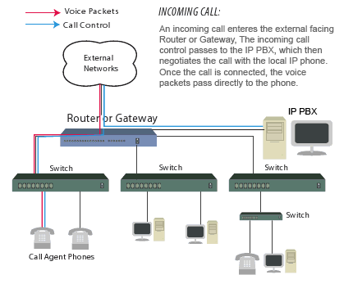
Fig. 1
This second diagram illustrates a peer to peer call scenario where both phones are positioned on the same workgroup switch. Voice RTP media packets are routed directly between endpoints. As a result the voice packets never leave the local subnet:
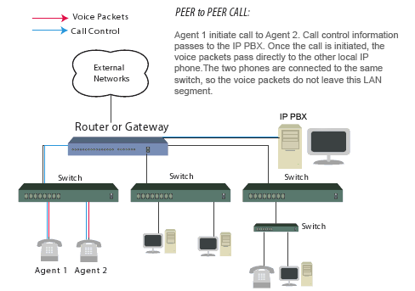
Fig. 2

Ultimately, VoIP recording components are only capable of processing packets that
are capable of seeing. Applications that are required to record all voice packets on the network (agent to agent conversations) must position taps deeper in the network. Loggers can choose to position taps between phones and the workgroup switch or to rely on the switch’s mirror port. When using Cisco switches these are known as SPAN ports.

When the mirror port is used, data packets processed by the switch are replicated and passed off the network via this specialized port. From here, the mirror port is connected to a VoIP monitoring component that is capable of decoding signaling packets and processing RTP media.

Before tapping a VoIP network with mirror ports it is important to understand that capacity limitations can be reached which result in packet loss. When mirror ports are used, data from multiple ports on the switch is aggregated and passed onto a single port. Access to full-duplex traffic is constrained by the mirror port capacity. If a single10/100 Mbps port attempts to monitor multiple 10/100 Mpbs ports data packets are dropped when the mirror port reaches it’s capacity. Many switch manufacturers are designing mirror ports with larger capacities to compensate for this. Users must determine the capacity of the mirror port on their system before assuming that this single port can handle the traffic load.

Another consideration is the inherit design of the switch itself. When packet mirroring is used, the switch is now responsible for moving all network traffic, as well as duplicating packets passed to the mirror port. This added burden to the switch’s processors does impact it’s performance. Some switch manufacturers, such as Cisco, build safeguards into their products. In this scenario, the switch treats mirrored data with a lower priority than regular port-to-port data. In other words, if any resource under load must choose between passing normal traffic and mirrored data, the mirrored packets lose and the mirrored frames are arbitrarily discarded. When the network is running at high capacity it can overload the switch. As a result, packet loss can occur even if the switch is designed with
a gigabit mirror port.

2 Installation and configuration

Application contains the installer which copies necessary files to hard disk, and also installs necessary components.

Application uses library WinPcap and also its driver for capture of network packets. Thus before using the application it is necessary to install latest version of this library in system in which you plan to use it. Currently the last version of library WinPcap - 4.1.2 can be downloaded from the following link: <http://www.winpcap.org/install/bin/WinPcap_4_1_2.exe>

The computer with installed demo application should be connected to mirror port of the switch to which PBX and terminals is connected. The mirror port (SPAN port in Cisco terminology) should be configured and adjusted in appropriate way by means of switch control interface. For example, for D-Link DES 3026 it may look as following (WEB interface is used):

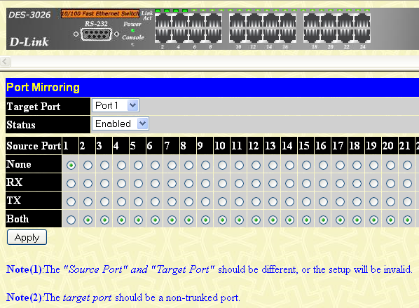

Fig. 3

3 User Interface

The application interface is simple enough and consists of one window. The primary window is divided to several blocks:

1. Setting area.
2. Detected Terminals area
3. Information about the selected terminal
4. The List of recognized control packets
5. The List of recorded calls
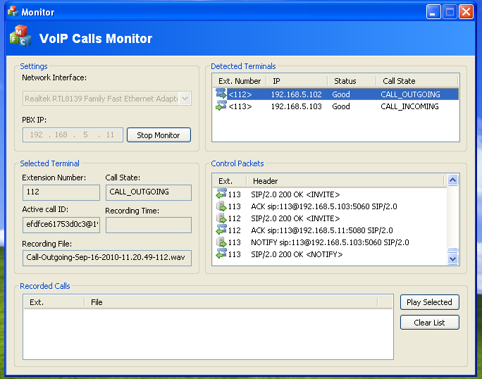

Fig. 4

3.1 Settings area
Before we start monitoring calls, it is necessary to specify which network interface is connected to mirror port of the switch, and also the IP address of the main device. The network interface is installed by means of the drop down list, which enlists all interfaces. It is very important to specify the correct interface, otherwise the application will not be able to specify, what computer interface is connected to necessary VoIP networks

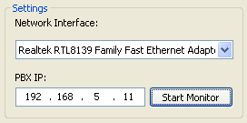

Fig. 5

IP address of the main device is needed for correct detection of registered IP Terminals, and also to reduce loads on SIP packet parser as only those UDP packets which are sent to the main device or received from it are considered as SIP packets.

After specifying necessary parameters push “Start Monitor” to start monitoring.

3.2 The list of detected IP Terminals
To start call recording by the application, it should detect registered terminals. The terminal is considered registered and is displayed in the list, in two cases: affirmative reply upon request REGISTER sent from the terminal to main device, or affirmative reply on request NOTIFY. Hence, to make the terminal to be displayed in the list, it should send request about registration to main device or in case if it is already registered to generate any event.

On test system with SV8100 as the main device and DT700 as IP terminals, the client sends request about registration after switching it on. Also clients will be automatically re-registered by the main device approximately every 5 minute. To increase speed of terminals detection by test application, without waiting completions of re-registration timeout, you can just push any button on the terminal, or pick up and hang up the phone.

The registered terminal is displayed in the list with following fields:

1. Extension Number.
2. IP address of the terminal
3. The terminal status, possible states are described in description of function MP_GetStatus from MultiXtr API
4. The call status, possible states are described in the description of function MP_GetCallState from MultiXtr API

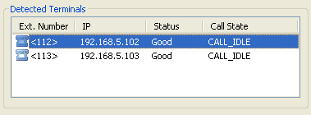

Fig. 6

3.3 Information about selected terminal
The information area about selected terminal is automatically renewed depending on the selected line in the list of registered terminals. This area contains the following information:

1. Extension number of the selected terminal
2. Call status
3. Call object ID
4. Record Time
5. File Name to which the audio data is recorded.

3.4 List of recognized control packets
The list contains titles of SIP packets recognized by test application. Extension number of terminal which is connected to appropriate packet is displayed in the first column of the list. The packet direction, from the main device or from the terminal is underlined by an appropriate icon.

The list describes only those packets, which were sent and received by registered device. If the application receives the package, which does not belong to any registered terminals, then this package will be ignored. The list of SIP packages will be automatically scrolled down when new package is added.

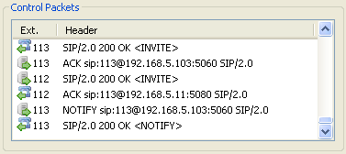

Fig. 7

3.5 The list of the recorded calls
The list contains file names of the last recorded calls. Also allows to playback saved calls by running the default player installed for .wav files. This list displays calls saved during current of network monitoring session only.

