— title: "Legally Subjective: How Much Vote Predictability Survives a Strong Ideological Baseline?" author: - Amine Harch El Korane - Ghali El Alj —

Abstract. We ask how predictable U.S. Supreme Court decisions are from public information, and whether modeling individual justices improves that predictability. We assemble a frozen, hash-chained corpus of 569 argued cases (OT2015–OT2023, 13 justices, 4,569 coded votes) and fix the price of admission with pre-registered baselines: a per-justice ideological rule that reaches 63.7% of votes on the held-out window, a bar that three families of structured-feature challengers fail to clear. The pre-registered test of the written record is a sealed exam on fifty hash-frozen 5–4 decisions—zero-shot, persona (biographical prompt plus a QLoRA adapter fine-tuned on each justice’s past opinions), retrieval, and the re-fit ideological prior—with predictions frozen before any answer key existed and scored exactly once. Personalization does not detectably improve prediction of the Court’s hardest cases: on the primary endpoint, case-direction accuracy, the persona scores 59.18% against the zero-shot’s 61.22% (exact McNemar, $p=1.00$). Even the ideological prior collapses to a coin flip at case level on these one-vote-margin decisions (50.0%), while at vote level it still dominates every language condition (75.9% against 50–60%). Personalization does, however, change the model: it moves individual votes (nominally, $p=.047$, unadjusted) without improving case-direction prediction; every simulated justice votes more conservatively than the justice it imitates; the biographical prompt, not the fine-tuned adapter, does most of the moving; a pre-registered stylistic account of persona quality is falsified ($ρ=−0.72$); and personas misvote on the very training cases whose texts they absorbed. Taken together, these results provide no evidence that modeling how an individual justice writes adds detectable predictive power for close case outcomes beyond the information captured by the ideological baseline. All code, frozen artifacts, and sealed predictions are public.
Keywords: judicial prediction; Supreme Court; pre-registration; negative result; large language models; personalization; attitudinal model; open data.

Introduction
Supreme Court votes are the most consequential binary predictions in American public life, and they are made under conditions that should humiliate any forecaster: the inputs are thousands of pages of legal argument, the decision rule is nine human beings, and the outcome distribution is close enough to a coin flip that luck is difficult to rule out. Yet a long line of work has shown that the task is not entirely random. Statistical models built on case attributes have predicted affirm/reverse outcomes at rates far above chance for two decades (Ruger et al. 2004; Katz, Bommarito, and Blackman 2017), and the dominant theoretical account of the Court—the attitudinal model (Segal and Spaeth 2002) — holds that ideology, not legal doctrine, explains most of the variance in votes.
This paper reports the completed experiment of Legally Subjective, an independently conducted, zero-budget test of a narrower and, we argue, more honest version of the prediction question. Rather than asking how accurately a court’s output can be retrofitted by a flexible learner with centuries of data, we ask two questions that can both fail loudly. First, is each justice’s vote predictable from the public case file alone, on a fixed, modern window, against a pre-registered bar? Second—and this is the experiment’s live wire—if a language model is fine-tuned on one justice’s own past opinions, does it predict that justice’s future votes better than the same model without the persona? We built a stringent test of the second question. It did not detectably improve prediction: on the sealed holdout of fifty hash-frozen 5–4 decisions, scored once, the persona called one case right that the zero-shot missed and two cases wrong that the zero-shot called right (exact McNemar, $p=1.00$), and the rest of the experiment is the investigation of why. The two branches of the fork read differently now that it is resolved. Had the persona helped, a justice-specific textual signal would have existed: the written voice would carry predictive information about future decisions that ideology alone does not encode (whether that signal would be personality, drafting style, subject-matter specialization, or something else entirely is a distinct question the design does not settle—persona improvement is evidence of a signal, not of its nature). It did not help, and the null is sharper than a bare absence: personalization changed the model measurably—it moved individual votes, and it made every simulated justice vote more conservatively than the justice it imitates—without improving prediction of the outcome by a single case. What is predictable about a close decision, at the resolution this design can detect, is who the justice is; the written voice, through a persona pipeline at this scale, adds nothing that the ideological bit does not already carry.
Three design commitments distinguish the project from prior work. First, everything is pre-registered before the models see the sealed holdout: the baselines, the split, the metrics, and the fifty-case test set are frozen in the repository, with the selection seed and the SHA-256 of the sealed list published in advance. There is no second holdout and no post hoc tuning. Second, the experiment is built to be audited by a stranger: the corpus is assembled from public sources with every raw file hash-chained; every CPU-side number in this paper regenerates from scripts in the repository, and the GPU-dependent stages are preserved as frozen, hash-verified artifacts. Third, the budget is zero by construction—public data, free API tiers, and free-tier compute. We present this strictly as a reproducibility and accessibility constraint, not as evidence of scientific quality: it bounds what can be tested (model scale, hyper-parameter search, number of seeds) and it makes every result replicable by any researcher with a laptop, but a larger budget would not weaken the design—only widen the set of testable conditions.
The contributions of this paper are: (i) a frozen, provenance-complete corpus of 569 argued Supreme Court cases spanning OT2015 through OT2023, fusing CourtListener metadata with Supreme Court Database (SCDB) vote coding, with 98.6% oral-argument coverage for future multimodal conditions; (ii) pre-registered statistical baselines, of which the strongest—per-justice modal ideological direction—sets a vote-level bar of 63.7% on the held-out window; (iii) a trained challenger, a family of structured-feature models whose null result is itself informative: nothing in the pre-decision metadata adds stable signal beyond who the justice is (Section 4); (iv) the sealed, hash-frozen exam on fifty 5–4 decisions, executed exactly once under pre-registered conditions—zero-shot, persona, retrieval, and the re-fit ideological prior—whose primary outcome is a null: personalization brings no detectable gain in case-direction prediction over the zero-shot (59.2% against 61.2%, $p=1.00$), while the re-fit ideological prior itself collapses to a coin flip at case level on the same one-vote-margin decisions (Section 5); and (v) a pre-registered mechanistic decomposition of what personalization did do: it displaces the simulated ideological dial, the biographical prompt rather than the fine-tuned adapter does the moving, a pre-registered stylistic account of persona quality is falsified ($ρ=−0.72$), and personas misvote on the very training cases whose texts they absorbed (Section 5).
We emphasize what this paper does not claim. It does not claim that Supreme Court votes are unpredictable; two decades of literature and our own baselines say otherwise. It does not treat the 63.7% bar as trivial: as Section 4 shows, three families of supervised models failed to clear it on the same rows, which is precisely why the bar is interesting. And it does not claim that personalization is inert: the persona condition measurably changes vote-level behavior and the model’s ideological posture—what it never becomes is better prediction of the Court’s hardest cases. The displacement of the simulated dial is a property of the model and its training distribution, not a causal claim about the justices themselves.

Related work

Statistical forecasting of the Court.
The modern line begins with the Supreme Court Forecasting Project: Ruger et al. (2004) built a conditional-choice model with input from political science theory and, over a single term, predicted 75% of the Court’s affirm/reverse outcomes—against 59.1% for a panel of legal experts. The lesson was bruising for doctrine: a small regression with ideological covariates beat trained lawyers reading the briefs. A decade later, Katz, Bommarito, and Blackman (2017) scaled the exercise with a random forest over 628 features and nearly two centuries of decisions (1816–2013), reporting 70.2% accuracy at the case level and 71.9% at the individual vote level, and concluding that the Court behaves in a way that is, in their words, remarkably consistent with a machine-learning account. The two efforts stop short of the modern test in different ways: Ruger et al. (2004)’s forecast was prospective, but for a single term, with its model fitted on earlier years; Katz, Bommarito, and Blackman (2017) evaluates in sample across history—the model sees two centuries, including eras with much higher unanimity rates, and predicts votes whose contemporaneous context is far removed from today’s Court.

The attitudinal model.
Political science supplies the theoretical prior for why such models work. Segal and Spaeth (2002) argue that justices decide largely as attitudes wrapped in legal reasoning: revealed ideology dominates doctrine, and case facts matter mostly as triggers for those attitudes. Methodologically, Martin and Quinn (2002) estimate dynamic ideal points for every justice since 1953, giving the field a continuous measure of the very covariate that our strongest baseline — per-justice modal direction—approximates with a single bit per justice. Our results in Section 4 are, in effect, a modern, pre-registered replication of the attitudinal prior on a nine-term window: the ideology bit is the signal; the structured case context is not.

Authorship and style.
The persona condition is a stylometry question in modern dress. Mosteller and Wallace (1964) settled the authorship of the disputed Federalist papers with function-word frequencies; the field they founded has since shown that individual writing style is persistent, measurable, and hard to disguise (Juola 2006). If a justice’s voice is a stable individual signature, fine-tuning a language model on their opinions should transfer to their future opinions; the open question—the one this experiment isolates — is whether that stylistic footprint carries decision-relevant information beyond the ideology bit, or merely rhetorical habits.

Language models as forecasters of the Court.
A newer line replaces the regression with a prompt. Stillwell and Harrington (2026) evaluate four frontier models as forecasters of Supreme Court decisions and conclude that much of the models’ justice-level accuracy reflects the Court’s ordinary ideological alignment rather than case-specific legal analysis. Their result supplies context for ours, not confirmation of it: the designs ask different questions, and ours is the stricter one—conditioning a model on one justice alone (biography plus a fine-tuned adapter) and asking it to predict that justice’s own sealed 5–4 votes against a like-for-like statistical prior, rather than forecasting the ordinary docket with a frontier model. Where the two designs overlap, they agree: at the vote level, the per-justice prior dominates every language condition (75.9% against 50–60%). Where ours stands alone, it returns the null at the center of this paper: at the case level, the persona adds no detectable gain to the zero-shot. Posner and Saran (2025) run the mirror-image experiment, asking whether a model can replicate the decisions of human judges in a factorial experiment originally conducted on U.S. federal judges. What that line has not yet produced is the test this experiment runs: a sealed, pre-registered evaluation in which the model is conditioned on one decision-maker alone—biography and a fine-tuned adapter—and asked to predict that justice’s own future votes against a like-for-like statistical prior. The slot is exactly the one our exam fills, and the null it returns—a persona that changes the model without improving its predictions—is a boundary condition that prompt-era claims should now be tested against, not a ceiling they cannot pass.

Simulated respondents and personas.
The persona condition also lands inside the debate on language-model-simulated people. Argyle et al. (2023) show that biography-conditioned models can reproduce the survey-response distributions of specific human subpopulations—“silicon samples”; Horton (2023) proposes such agents as simulated homo silicus for economic inquiry; Dillion et al. (2023) ask whether models can replace human research participants altogether. Our null is a boundary condition on the optimistic reading, and we state its scope precisely. Silicon samples are validated against population distributions of stated attitudes; we test an individual expert against that expert’s own future record, on the hardest decisions in the domain, under seal. At that resolution—biography plus fine-tuning on the person’s own corpus—the simulated persona acquires surface posture (a displaced ideological dial, a recognizable style) but not the decision function (misvotes on its own training cases; the stylistic account of fidelity falsified). The two results are compatible: a model can proxy the marginals of a population’s attitudes while carrying no individual decision signal at the one-vote margin.

Tooling.
QLoRA (Dettmers et al. 2023) makes full-model fine-tuning tractable on free single-GPU tiers by quantizing the base model and training low-rank adapters, which is what converts the persona question from an institutional project into a zero-budget one. The base itself, Qwen2.5-3B-Instruct (Yang, Yang, et al. 2024), is deliberately small: the design asks whether personalization adds signal, not whether scale supplies it. Seven adapters were trained—one per justice with training-window opinions—plus two pre-inscribed prompt-only seats for the justices without any, each adapter sealed alongside the data that produced it.

Positioning.
Against this background, the present project narrows the claim in four ways that we believe matter for honesty of the result. The window is short and modern (OT2015–OT2023, an era of narrow majorities), so historical unanimity cannot inflate accuracy. The evaluation is pre-registered and forward-holding: a sealed set of fifty 5–4 decisions, chosen deterministically before any model touched them, was the only arbiter of the final conditions, and it was scored exactly once. The bar was fixed before the challengers ran, at the vote level, where the attitudinal bit is strongest—63.7% on our window—so that any reported improvement is an improvement over ideology itself, not over a straw man. And when the answer came back null, the protocol did not stop at the headline: the pre-registered probes that explain the null—the prompt-versus-adapter decomposition, the falsified stylistic account, and the training-case auto-coherence failure—are what make the null informative rather than empty.

Data: Corpus-Monde v1

Sources and fusion
The corpus fuses two public sources, each chosen for a different epistemic role. CourtListener (Free Law Project) (Free Law Project, n.d.) supplies the case universe: dockets, dates, parties, opinion clusters, and oral-argument audio with transcripts, harvested from the 2026-06-30 bulk release and cross-checked against the REST API. The Supreme Court Database (SCDB), 2025_01 release, justice-centered case citation file (Spaeth et al. 2025), supplies the ground truth: per-justice vote directions coded by a single, long-running editorial team whose coding conventions are public and whose known limitations are documented in the database itself. CourtListener defines what happened procedurally; SCDB defines what we count as a liberal or conservative vote.
The corpus rule is deliberately narrow: every case argued before the Court in the window from 1 October 2015 through 30 June 2024 (terms OT2015 through OT2023) is included if it was argued and decided with a full opinion. Per curiams, memorandum decisions, and cases decided without argument are excluded—not because they are uninformative, but because the prediction task is defined over argued cases whose written record a model could read. Applying the rule yields 569 cases. Fusion keys on docket number with sub-docket-aware matching (a nontrivial step: consolidated dockets appear in SCDB as comma-separated lists and occasionally in variant forms such as original-jurisdiction numbering), and every matched pair is checked for term and case-name agreement.
Corpus-Monde v1 at a glance (frozen 2026-08-28).
Quantity | Value
Argued cases, OT2015–OT2023 | 569
Justices appearing on the bench | 13
Opinions (majority, dissent, concurrence) | 1,778
Justice$×$case votes, coded direction | 4,569
Cases with SCDB vote coding | 96.1%
Cases with oral-argument audio + transcript | 98.6%
5–4 decisions | 79
of which sealed for the exam | 50
Window | 2015-10-01 to 2024-06-30

Freeze and provenance
The corpus is frozen: the identity of the data is fixed by a rule, and every artifact carries the hashes of everything upstream. The SHA-256 of every raw source file (bulk archives, API pages, the SCDB zip) is recorded at download time; the corpus build script recomputes them before running; and the sealed-case list (below) is itself committed as a SHA-256 of its JSON serialization. The intent is that a skeptical reader can verify, without trusting the author, that the data evaluated in Section 5 is the data described here—and that nothing was edited between the freeze and the test.
Coverage statistics are reported with their failures rather than their successes: 22 cases carry no SCDB match at all (mostly original-jurisdiction and consolidated matters under variant docketing), 27 additional cases match but have no coded issue area, and audio coverage, while high (98.6%), is absent for a handful of late-window matters. These gaps flow through the pipeline as explicit missing-value categories rather than silent deletions, and the vote analyses of Sections 4 and 5 simply operate on the rows where a coded direction exists (4,569 of an expected 4,730 vote slots).
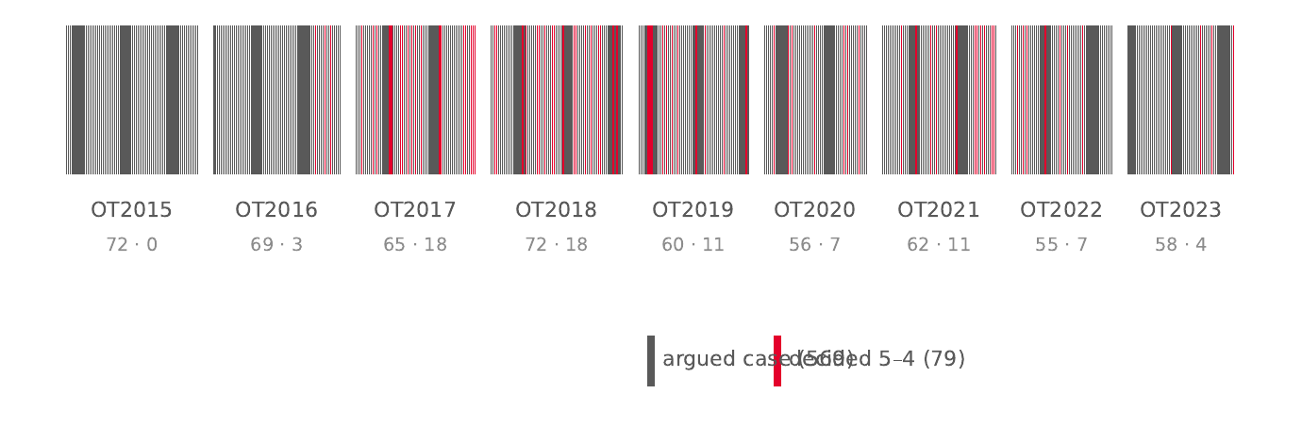
The corpus window. Each tick is one argued case, grouped by term (counts below each group as argued $⋅$ 5–4). Red ticks are the 79 decisions that came down 5–4; the experiment’s window is deliberately the modern era of narrow majorities.

The bench
Thirteen justices appear on the bench in the window, spanning three natural cohorts: the five-justice block that opened the window (Roberts, Scalia, Kennedy, Thomas, Ginsburg), the mid-window joiners (Sotomayor, Kagan, Gorsuch, Kavanaugh, Barrett), and the closers (Breyer’s long service ending in 2021, Jackson arriving in 2022). The 2020 death of Ginsburg and the two 2020 arrivals mean that no single nine-member configuration spans the whole window; vote-level analyses therefore condition on the justices actually sitting, and pairwise agreement (Section 4) is computed on common cases only, keeping the 60 pairs with at least 50 shared votes. Scalia sits for only ten coded votes (he died in February 2016) and is excluded from the pairwise matrix by the $n≥50$ rule—retained everywhere else with his small-sample intervals displayed honestly.

Protocol: pre-registration and the sealed holdout

Split and baselines
The experiment fixes its evaluation before fitting anything. The corpus splits temporally: OT2015–OT2019 (2,314 coded votes) is the training window, and OT2020–OT2023 is the evaluation window. All hyper-parameter selection for the structured challengers of this section uses grouped 5-fold cross-validation inside the training window only, with the group being the case — votes of the same case never straddle a fold boundary, because votes within a case are correlated by construction and leaking them across folds silently inflates validation accuracy.
On this skeleton, five statistical baselines were computed and committed before the first challenger was trained:
- B1—majority class: predict the modal decision direction of the training window (liberal, at 51.6% of coded training votes) for every vote.
- B2—always conservative (the stronger of the two constant policies on this window).
- B3—always reverse: predict that the Court upends the court below; evaluated on the subset with a clean affirm/reverse disposition.
- B4c/B4—per-justice ideology: predict each justice’s vote as that justice’s modal direction in the training window, at the case level (majority of simulated votes) and the vote level respectively.
- B5—pairwise agreement, a descriptive baseline that calibrates how differently the justices actually vote.
B4 is the bar: 63.7% of votes on the full evaluation window (Wilson 95% CI [61.3; 65.9]). It deserves emphasis that this bar is not a floor to be cleared trivially—it is the accuracy of a model that knows one bit per justice (their revealed ideological lean) and nothing about the case. Any claim that a system “reads the law” must beat an adversary that cannot read at all.

Sealing fifty of the seventy-nine
Seventy-nine decisions in the corpus came down 5–4—the narrowest possible majority and, folklore holds, the least predictable ones. Fifty of them are sealed. The selection is deterministic and was committed before any model training: the sorted list of 79 five-four identifiers seeds a Mersenne Twister (seed derived from the SHA-256 of the sorted list), which draws 50; the resulting list is frozen by the SHA-256 of its JSON serialization, published in the repository’s statistics file. Sealed cases are excluded from the training window, from every cross-validation fold, and from the transparent evaluation reported in this paper—they were touched exactly once, by the final conditions, in the sealed exam.
The sealing rule exists to make the headline question unfakeable. The persona condition (below) claims to extract a justice’s decision-relevant voice from their past opinions; such a claim is only meaningful against cases the extraction pipeline never saw, and only meaningful once. A sealed, hash-frozen, pre-registered holdout is the cheapest device that makes retro-fitting detectable: any post-hoc adjustment to the models after the seal is broken leaves a git trail.
The four final conditions, evaluated once on the sealed holdout.
Condition | Description
A—Zero-shot | An open-weight 3B language model (Qwen/Qwen2.5-3B-Instruct) reads the case dossier (briefs, oral-argument transcript, question presented) and answers with a vote direction. No learning from this corpus.
B—Persona | The same base model, QLoRA-fine-tuned on one justice’s past opinions, tested on that justice’s future and sealed cases.
C—Context | The same base model with retrieval of similar earlier opinions (RAG), no fine-tuning.
D—Statistical | The pre-registered baselines of Section 4; B4 is the bar.

The decisive test
The sealed exam compares conditions A–D on the sealed fifty. The pre-registered claim structure is deliberately symmetric: if B $>$ A on never-seen future cases, the persona is extractible from public text—judicial subjectivity leaves a measurable footprint. If B $=$ A, the justice’s personality is not in the public data, and whatever is predictable is already priced by ideology. Both outcomes are results; the experiment is built so that neither can be quietly discarded.
One more protocol commitment, unusual for machine-learning papers and central to this one: the public site that displays the experiment’s state is forbidden from showing any model output that does not exist. Until a condition is trained, its pages show the statistical baseline’s call, labeled as such. This is not an aesthetic preference; it is a control on the author’s own incentive to narrate success before the seal is broken.

Baselines: the price of admission
Table 3 and Figure 2 report the pre-registered baselines on the evaluation window. The ordering is informative. The majority-class and constant policies (B1, B2) land in the 44–56% band—barely better than their own training-window priors, a first sign that the evaluation window is not an easy era. The reversal heuristic (B3) reaches 60.1% but on the affirm/reverse subset only, with an interval that warns against taking the point estimate seriously. The per-justice ideology rules dominate: 55.8% at the case level (B4c) and 63.7% at the vote level (B4) on the full evaluation window. On the transparent (sealed-excluded) subset used for challenger comparison below, B4 scores 63.1% (n $=$ 1,522, CI [60.6; 65.5]).
Pre-registered baselines on the evaluation window (OT2020–OT2023). Wilson 95% intervals.
Baseline | Accuracy (%) | 95% CI
B1—majority class (liberal) | 43.6 | [37.2; 50.1]
B2—always conservative | 56.4 | [49.9; 62.8]
B3—always reverse | 60.1 | [51.8; 67.9]
B4c—per-justice ideology, case level | 55.8 | [49.3; 62.2]
B4—per-justice ideology, vote level | 63.7 | [61.3; 65.9]
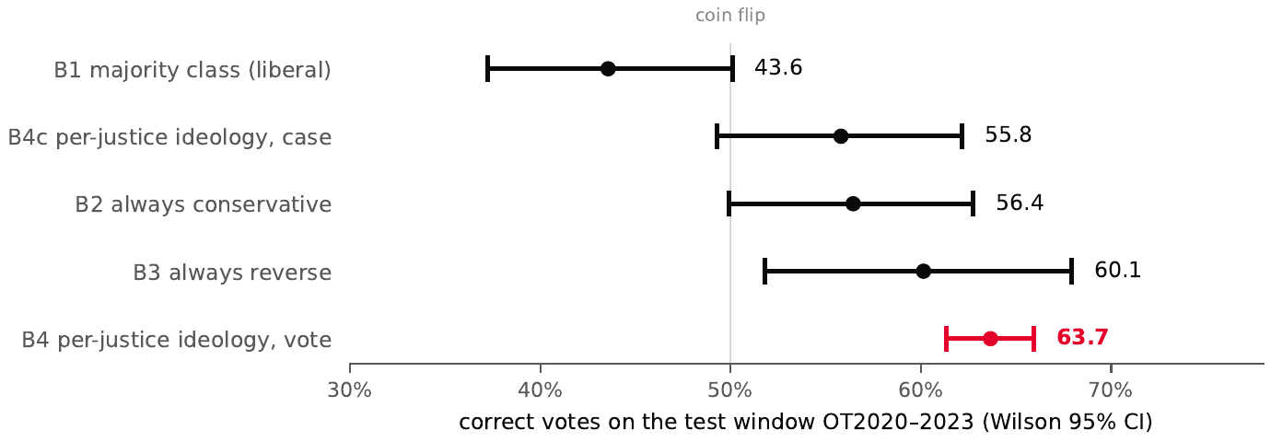
The number to beat. Wilson 95% intervals for the five baselines on the test window; B4 (red) is the vote-level bar of 63.7%.

Pairwise agreement
The descriptive baseline B5 measures how often two justices vote the same way on their common cases. The extremes frame the scale: Kavanaugh and Roberts agree on 94.6% of their 333 common coded votes (CI [91.6; 96.8]), while Sotomayor and Thomas agree on only 54.3% of 518 (CI [50.0; 58.5])—statistically indistinguishable from two justices flipping independent coins that share a slight bias. Figure 3 shows the full matrix, ordered by mean agreement with the conservative anchor block (Thomas and Alito). The block structure is visible without statistics: the modern conservative five form a dark square in one corner, the liberal three-plus in the other, and the two red-outlined extremes are, on inspection, the two ends of the Court’s ideological span. This matrix is the empirical picture of what B4 compresses into one bit per justice.
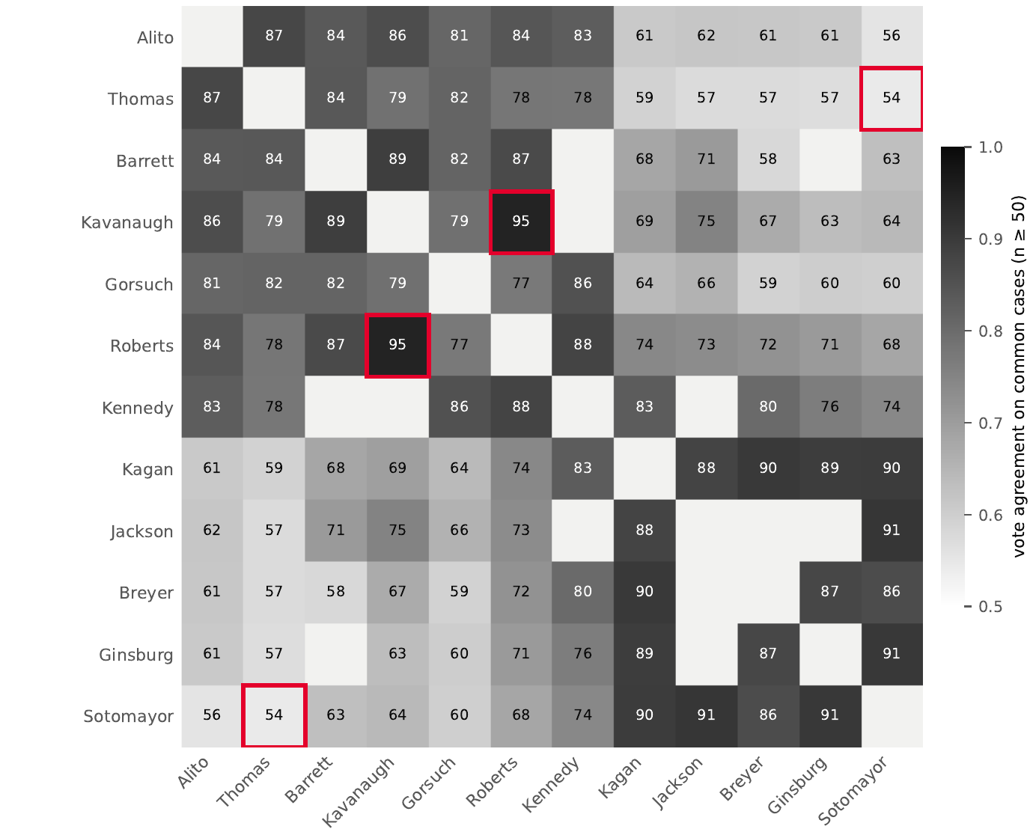
Vote-level agreement across the 60 pairs with at least 50 common coded votes (values are percent agreement). Darker cells are higher agreement; the diagonal is undefined. Red outlines mark the closest (Kavanaugh–Roberts, 94.6%) and widest (Sotomayor–Thomas, 54.3%) pairs. Ordering is by mean agreement with the conservative anchor block.

M3a: the structured challengers—and the bar holds
The first trained condition, M3a, asks whether the structured, pre-decision attributes of a case—issue area, lower-court disposition, term, and oral-argument duration, joined with justice identity—predict vote direction better than the one-bit ideological rule. Three challengers were trained on the sealed-excluded training window with grouped cross-validation for all hyper-parameter choice: an additive logistic regression (M3a-LR), the same with explicit justice$×$issue interactions (M3a-IX), and a histogram gradient-boosting classifier that learns interactions natively (M3a-GB).
M3a challengers vs. the bar, transparent test (sealed-excluded; $n=1,522$ rows common to all rows where B4 is defined). McNemar exact test against B4’s paired predictions.
Model | CV (%) | Test (%) | 95% CI | $p$
M3a-LR (additive) | 56.2 | 58.6 | [56.1; 61.1] | 0.002
M3a-GB (boosting) | 56.1 | 59.8 | [57.3; 62.2] | 0.009
M3a-IX (interactions) | 57.1 | 60.4 | [57.9; 62.8] | 0.047
B4 (bar) | — | 63.1 | [60.6; 65.5] | —
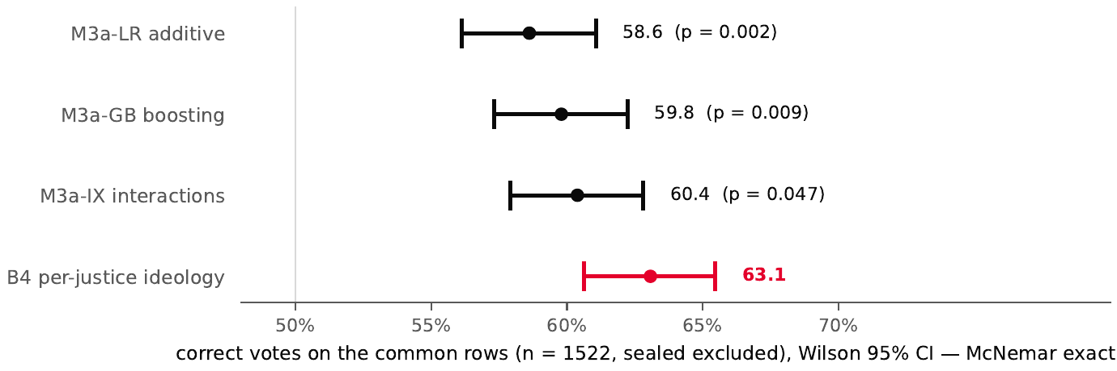
The first challenger fails against the bar. Wilson 95% intervals on the common rows; $p$-values are exact McNemar tests against B4’s paired predictions.
Table 4 and Figure 4 give the result: every challenger lands between 58.6% and 60.4% on the common rows, and every comparison against B4 favors the bar (McNemar exact $p≤0.047$). The failure is not an artifact of regularization strength or model family; it is robust across three families and survives the interaction model that the site’s per-justice domain-divergence displays would suggest. It is also not a power issue in the usual direction—the challengers are significantly worse, not merely insignificantly different.
The ablation in Table 5 locates the failure precisely. Removing justice identity from the feature set collapses cross-validated accuracy from 56.2% to 47.6%—below the class base rate—while removing any other feature group improves it (issue area is the most harmful to keep, at $+1.7$ points when dropped). In other words, on this window, who votes is signal; what the case is about is noise. The structured challenger did not fail because the metadata was too thin; it failed because the only stable generalizable structure in the data is the attitudinal bit that B4 already uses.
Feature-group ablation (grouped 5-fold CV on the training window, additive logistic regression).
Feature set | CV accuracy (%)
Full (justice, issue, lc, term, duration) | 56.2
drop justice identity | 47.6
drop issue area | 57.9
drop lower-court disposition | 56.7
drop term | 56.5
drop argument duration | 56.1
The case-level reading is the same. Simulating each case’s outcome as the majority of the challenger’s predicted votes yields 58.3% (CI [51.5; 64.9]) on the transparent subset—above the case-level ideological baseline (55.8%), but the interval is wide enough that the honest summary is “not distinguishable”, and the vote-level failure stands regardless.

What the null prices
Read together, the results give the experiment its current shape. The predictable component of a justice’s vote on this window is, to the resolution that nine terms of structured data can detect, the justice’s ideological direction—exactly what the attitudinal model predicts and exactly what B4 encodes. We phrase the implication precisely: the tested structured features add no stable signal beyond the ideological bit on this window. This does not price all non-textual information—untested structured sources (parties, counsel, finer temporal or institutional variables) or richer encodings of the same file could in principle hold residual signal; what our result establishes is that the standard SCDB-style coding of the case file does not. The cheapest rich representation that this null leaves open is the text—the briefs, the transcript, the opinion language itself. That is where the pre-registered conditions A–C operate, and the M3a null result is what makes them the critical path rather than a side quest: the structured bar is now empirically priced for this representation, so any claim of textual signal is a claim against a known, pre-registered number—the number that Section 5 now reports.

Results
Judge-specific personalization did not significantly improve case-direction prediction on the sealed 5–4 test set. In the pre-registered comparison that the seal exists to protect—persona against zero-shot, condition B against condition A, evaluated once on the fifty hash-frozen 5–4 decisions—B calls one case right that A misses and two cases wrong that A gets right (exact McNemar: $b=1$, $c=2$, $p=1.00$). The point estimates sit inside each other’s intervals, 59.2% for B against 61.2% for A, and the sign of the difference is, if anything, negative. We state this first and without qualification because it is the primary outcome of the experiment; the remainder of the section is about what that null does and does not mean. It does not mean the two conditions are interchangeable. Personalization changes the model, measurably and systematically: it displaces the simulated voting distribution toward the base model’s conservative default, it does so by different amounts for different justices, and the displacement is visible at every level of analysis we ran beneath the case outcome. What it never becomes is better prediction of the outcome of the Court’s hardest cases. The section traces that contrast from the primary outcome (Section 5.1) through vote-level behavior (Section 5.2) to its mechanism: a conservative default with a displaced ideological dial (Section 5.3), a prompt-versus-adapter decomposition with a pre-registered counter-example (Section 5.4), and a falsified stylistic explanation (Section 5.5).

Primary outcome: the sealed 5–4 exam
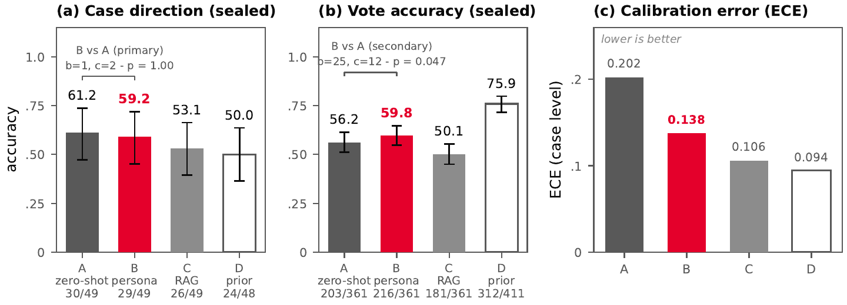
Primary result on the sealed 5–4 exam (phase S, $n=50$). Accuracy of the four pre-registered conditions with Wilson 95% intervals: A (zero-shot), B (persona: biographical prompt + QLoRA adapter), C (RAG), D (per-justice ideological prior, drawn hollow as a reference rule rather than a language model). (a) Case-direction accuracy, the primary endpoint: the pre-registered McNemar test of B vs. A is null ($b=1$, $c=2$, $p=1.00$) — personalization does not significantly improve case-level prediction on close cases. (b) Vote-level accuracy (D evaluated on $n=411$ votes including historical justices; A/B/C on $n=361$): the secondary, vote-level McNemar test is nominally significant ($b=25$, $c=12$, $p=.047$) and the trivial per-justice prior D dominates every language condition. (c) Expected calibration error at the case level (lower is better; vote-level ECE: A .226, B .169, C .137, D .094). All conditions are poorly calibrated; the prior rule is the best calibrated of the four.
The sealed 5–4 exam (phase S), exact values. One original-jurisdiction case carries no coded decision direction and is excluded from case-level scoring for every condition ($n=49$); the ideological prior D also loses one tie ($n=48$). Vote-level scoring: A/B/C on the nine current seats ($n=361$); D on the ten justices with a training-window voting record ($n=411$, departed members included). Pre-registered primary test: exact McNemar B vs. A on case direction, $b=1$, $c=2$, $p=1.00$; secondary vote-level test: $b=25$, $c=12$, $p=.047$.
Condition | Case dir. (%) | 95% CI | Votes (%) | 95% CI
A—zero-shot | 61.2 | [47.3; 73.6] | 56.2 | [51.1; 61.3]
B—persona | 59.2 | [45.3; 71.8] | 59.8 | [54.7; 64.8]
C—retrieval | 53.1 | [39.4; 66.3] | 50.1 | [45.0; 55.3]
D—ideological prior | 50.0 | [36.4; 63.6] | 75.9 | [71.6; 79.8]
The four conditions were scored exactly once, on the sealed fifty, after the completeness chain from the training freeze to the exam was verified. Figure 5(a) and Table 6 give the outcome. The three language conditions share one open-weight base model (Qwen/Qwen2.5-3B-Instruct); B adds, per seat, a biographical system prompt and a QLoRA adapter fine-tuned on that justice’s training-window opinions; C adds retrieval over earlier opinions; D is the re-fit per-justice ideological prior of Section 4, included as the like-for-like statistical comparator. Two seats have no adapter by construction—Barrett and Jackson joined the Court after the training window closed and authored no training-window opinions—so their condition B degenerates, by pre-inscription, to the biographical prompt alone. On the primary endpoint, case-direction accuracy, A scores 61.2% (Wilson 95% CI [47.3; 73.6]), B 59.2% [45.3; 71.8], C 53.1% [39.4; 66.3], and D 50.0% [36.4; 63.6]. With three discordant cases out of 49, only a large true effect would have been detectable; the pre-registered test returns $p=1.00$, and the honest summary is that personalization brings no detectable gain on the sealed 5–4 outcomes, with a point estimate two points below the zero-shot baseline.
Two details sharpen the null. First, the 49 scored cases of the sealed exam split into 29 interleaved cases—5–4 decisions handed down inside the training era, contemporaneous with (but excluded from, by the seal) the persona training texts—and 20 future cases decided after the training window closed. On the interleaved stratum, A and B produce identical case-direction calls on every single case ($b=0$, $c=0$); all three disagreements fall in the future stratum. The one place the persona could plausibly have helped—cases decided after the texts it was trained on—is exactly where its few disagreements with A concentrate, to no net effect. Second, the re-fit ideological prior D scores exactly 50.0%: a coin flip, with agreement against the always-conservative majority class of $κ=−0.11$. The 5–4 population removes precisely the margin that makes ideology informative at the case level, while leaving it intact at the vote level (75.9%, Section 5.2). The language conditions sit between these poles, and none of them is doing much beyond the majority class: case-direction kappa against always-conservative is 0.09 for A, 0.02 for B, 0.06 for C. On one-vote-margin decisions, every condition—language model and statistical rule alike—is a small perturbation of “always guess conservative”.
The contrast with the transparent window completes the statistical picture. Phase T—the same machinery scored on the 211 evaluation-window casefiles with every sealed case excluded, 205 of them carrying a coded direction—had given B a $+4.9$-point advantage over A at case level (55.1% vs. 50.2%; McNemar $b=42$, $c=32$, $p=0.30$, not significant). Between the transparent window and the sealed exam, the sign of the B$−$A difference flips while remaining statistically indistinguishable from zero in both places. The honest reading is that case-level deltas of this magnitude are noise-dominated at these sample sizes; the sealed exam, evaluated once under a pre-registered test, is the number that counts, and it is null.

Vote-level behavior: changed votes, unchanged outcomes
Case-direction prediction and vote prediction are different tasks. The first asks which side wins a one-vote-margin case; the second asks how each of the nine justices individually votes. A model can move many individual votes without moving a single outcome—and that, it turns out, is what personalization does. On the sealed exam’s 361 current-court votes, B scores 59.8% [54.7; 64.8] against A’s 56.2% [51.1; 61.3], and the secondary, vote-level McNemar test is nominally significant ($b=25$, $c=12$, $p=.047$). We report this with its full fragility on display: it is a secondary endpoint; it has been subjected to no multiplicity correction; and with 37 discordant votes the $p$-value sits one tail-flip from convention. We read it as evidence of behavioral change to be investigated—which is what the rest of this section does—not as a confirmatory claim of improvement. The absence of a case-level gain does not mean the absence of a vote-level effect.
Vote-level accuracy per seat on the sealed exam (phase S): condition A (zero-shot) vs. condition B (persona), with the difference in percentage points computed from exact fractions. Barrett and Jackson have no adapter (pre-inscribed degraded mode: biographical prompt alone). Jackson sat for nine of the fifty sealed cases.
Seat | $n$ | A (%) | B (%) | $Δ$ (pp) | Adapter
Thomas | 49 | 73.5 | 83.7 | $+10.2$ | yes
Alito | 49 | 73.5 | 83.7 | $+10.2$ | yes
Barrett | 20 | 65.0 | 75.0 | $+10.0$ | —
Kavanaugh | 39 | 71.8 | 74.4 | $+2.6$ | yes
Gorsuch | 48 | 62.5 | 68.8 | $+6.3$ | yes
Roberts | 49 | 69.4 | 63.3 | $−6.1$ | yes
Jackson | 9 | 33.3 | 44.4 | $+11.1$ | —
Sotomayor | 49 | 20.4 | 24.5 | $+4.1$ | yes
Kagan | 49 | 26.5 | 20.4 | $−6.1$ | yes
The ideological prior D dominates every language condition at the vote level: 75.9% [71.6; 79.8] on the 411 sealed votes cast by the ten justices with a training-window voting record (the three departed members included; Barrett and Jackson are necessarily outside D’s coverage, which cuts against D rather than for it). On the seven current seats that both D and B cover, D’s per-justice accuracies run from 0.63 (Roberts) to 0.86 (Sotomayor); B’s run from 0.20 (Kagan) to 0.84 (Thomas). D thus supplies the mirror image of its case-level failure: it wins three individual votes in four and precisely cannot predict the one-vote majority those votes aggregate into, while the language conditions guess case direction at 53–61% on top of per-justice votes that are barely better than chance. The trivial statistic captures the block structure of the Court on close cases; the language layer does not.
Table 7 shows where B’s vote-level movement comes from, and the pattern is the first appearance of the mechanism the rest of this section diagnoses. B’s largest gains are conservative seats—Thomas and Alito at $+10.2$ points each, Barrett at $+10.0$ (without an adapter), Gorsuch at $+6.3$—plus Jackson ($+11.1$, no adapter, $n=9$) and a modest $+4.1$ for Sotomayor. The two seats where B loses ground are Kagan ($−6.1$) and Roberts ($−6.1$). The adapter helps where the seat already aligns with the base model’s default behavior and hurts where it does not; a model fine-tuned on a justice’s own prose ends up most accurate for the justices whose recorded votes sit closest to that default. On the transparent window the same contrast is larger: B beats A by 5.8 points over 1,713 votes (53.8% vs. 48.0%; McNemar $b=364$, $c=265$, $p=9×{10}^{−5}$), with B’s accuracy on the two liberal seats at 0.45 (Sotomayor) and 0.33 (Kagan) against D’s 0.67 and 0.66, while the five conservative seats never differ by more than 0.045 between the two (Kavanaugh; all others at or below 0.02). The vote-level shift is consistent across windows and evaluation regimes; what it never converts into is case-direction improvement on the sealed set.
Calibration completes the picture, and it is poor everywhere. Expected calibration error at case level is 0.202 for A, 0.138 for B, 0.106 for C, and 0.094 for D; at vote level, 0.226, 0.169, 0.137, and 0.094 respectively (Figure 5(c)). The language models are confidently wrong in the tail that matters most: condition A assigns a mean liberal probability of 0.07 to 209 votes whose observed liberal rate is 0.40. The best-calibrated of the four conditions is the one that does not read the case at all—the prior rule, whose outputs barely move. Probabilistic predictions from these pipelines should not be taken at face value for any downstream use that consumes them as probabilities.

The ideological dial
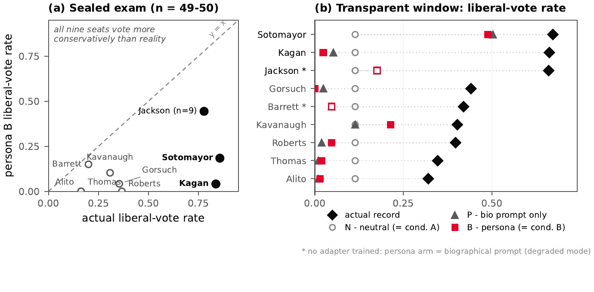
The ideological dial: actual vs. simulated liberal-vote rates. (a) On the sealed exam, every seat’s persona (condition B) votes more conservatively than the justice it imitates; filled markers denote the liberal bloc. The persona-predicted rate never exceeds 0.44 while the actual rate spans 0.16–0.86 (Jackson: $n=9$ votes). (b) The same dial, decomposed on the transparent window ($n=211$ casefiles, sealed cases excluded): the actual record, the neutral arm N ($≡$ condition A scheme), the biographical prompt alone (P), and the full persona B (E1 arm “A”, byte-identical to condition B). The base model pins every seat near $0.11$; the prompt moves Sotomayor to $0.50$ but barely moves Kagan ($0.05$); the adapter’s marginal pull on top of the prompt is small everywhere (Gorsuch ends at $0.00$). Actual rates are derived from the frozen corpus and validated exactly against the published E1 arm-N accuracies. Barrett and Jackson have no adapter (degraded, pre-inscribed mode): their persona arm is the biographical prompt (open red squares).
To see what personalization actually moved, we measure, for each seat, the share of cases on which a condition casts a liberal vote—the simulated counterpart of the justice’s liberal-vote rate. This dial requires no ground truth, which lets us read it on any window. Figure 6(a) shows it on the sealed exam. Every one of the nine seats lies strictly below the diagonal: every persona, including those imitating liberal justices, votes more conservatively than the justice it imitates. The persona-predicted liberal rate never exceeds 0.44 (Jackson, $n=9$), while the actual rates span 0.16 (Thomas, Alito) to 0.86 (Sotomayor). The seat-level failures of Table 7 are not scattered noise—they are one systematic displacement: Kagan’s persona votes liberal on 4.1% of her sealed cases where the justice herself votes liberal on 83.7%; Thomas’s votes liberal on 0% where the justice does on 16.3%. The mechanism is compression rather than collapse. Condition B’s mean predicted probability of a liberal vote spans only 0.16–0.39 across seats, so the Court’s real ideological span is re-anchored into a narrow band whose upper edge stays below one half. Justices already inside that band are “imitated” almost perfectly; justices above it are structurally mis-imitated, whatever the fidelity of their adapter’s prose.
Two seats in Figure 6(a) do move materially toward the truth—the two without adapters. Jackson’s prompt-only persona predicts a 44.4% liberal rate against an actual 77.8% ($n=9$; small), and Barrett’s 15.0% against an actual 20.0% ($n=20$), against Kagan’s adapter-backed 4.1%. The identity carried by the biographical prompt moves the dial more than fine-tuning on the justice’s own texts does; this observation, visible in the sealed numbers, is what the decomposition experiment of Section 5.4 was designed to test.
Figure 6(b) decomposes the dial on the transparent window (211 casefiles, sealed cases excluded, one run, fixed seed 271828) under three arms: N, a neutral system prompt with no justice identity—the condition-A scheme; P, the biographical prompt alone on the base model; and B, the biographical prompt plus the seat’s adapter—the condition-B pipeline, byte-for-byte (same prompts, same adapters). Arm N is seat-independent by construction, and it returns 24 liberal calls in 211 cases (0.114) for every seat: the base model, asked to vote as a neutral legal analyst, has a strong conservative default on this task. This is the first of the three pre-registered predictions of the decomposition experiment, and it is confirmed. The prompt arm then moves seats in opposite directions—Sotomayor to 0.50 and Jackson to 0.18, but Kagan only to 0.05, four of the five conservative seats down to 0.01–0.02, and Kavanaugh not at all—while the adapter’s marginal effect on top of the prompt never exceeds a tenth of the dial (at most $+0.10$, taking Kavanaugh to 0.21): Kagan ends at 0.02, Gorsuch at 0.00, and Sotomayor holds 0.49. The persona is not a louder version of the justice; it is the base model’s default, nudged by the biography, with the adapter contributing only a small marginal pull.

Prompt versus adapter—and what the adapter did not learn
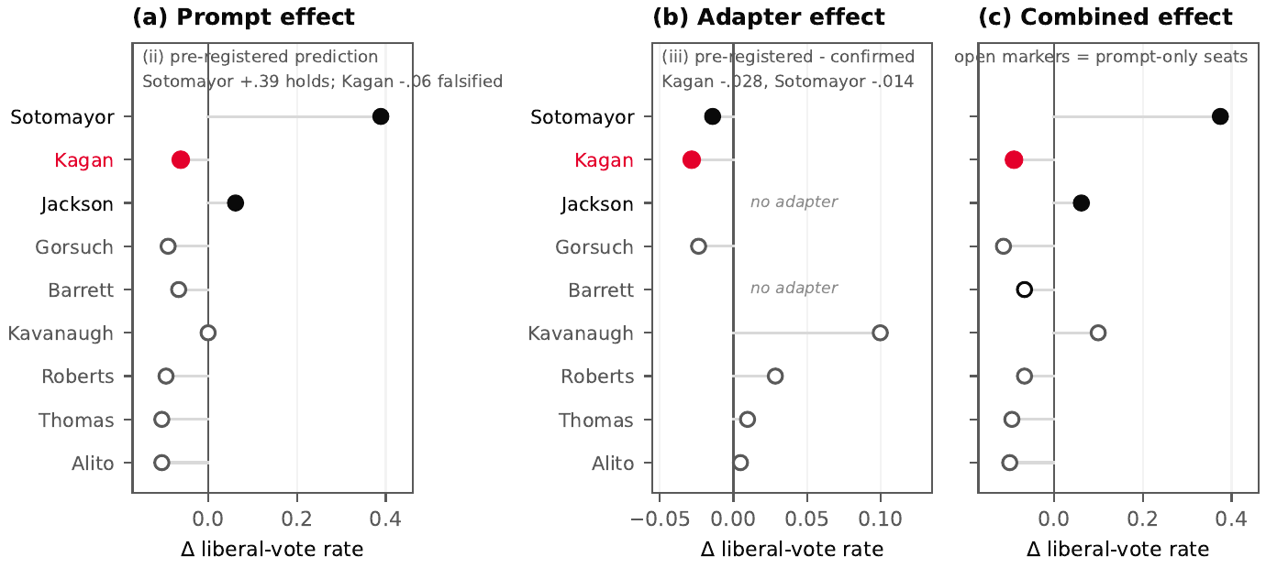
E1: causal decomposition of the dial (transparent window, $n=211$; single run, seed 271828). Change in predicted liberal-vote rate per seat. (a) Prompt effect $Δ\left(P−N\right)$: the pre-registered prediction (ii) — the biography lifts liberal seats — holds spectacularly for Sotomayor ($+0.39$) and modestly for Jackson ($+0.06$), but is falsified for Kagan ($−0.06$), highlighted in red. (b) Adapter effect $Δ\left(B−P\right)$: the marginal effect of adding the adapter on top of the prompt is small everywhere ($≤+0.10$) and negative for the two pre-registered targets, confirming prediction (iii) — the adapter erases the prompt’s gain for Kagan ($−0.028$) and Sotomayor ($−0.014$). (c) Combined effect $Δ\left(B−N\right)$; open markers mark the prompt-only seats (Barrett, Jackson — no adapter exists). Arms: N $=$ neutral base model ($≡$ condition A scheme; conservative default $0.114$ for all seats — prediction (i), confirmed), P $=$ biographical prompt, B $=$ persona (E1 artifact arm “A” $≡$ condition B). Identity injected in the prompt is not behavior learned by the adapter.
The decomposition experiment (E1) ran one identical vote query per case under the three system prompts of Figure 6(b), on the transparent window only, with its hypotheses committed to the repository before execution. It is confirmatory within its own frame—a causal decomposition on non-sealed data—and it has no bearing on the sealed primary test, which is never recomputed. Its three pre-registered predictions and their fates are as follows. Prediction (i), a conservative default of the neutral arm for all seats, is confirmed ($N=0.114$ everywhere). Prediction (ii), a positive prompt effect $Δ\left(P−N\right)$ for each of the three liberal seats, holds spectacularly for Sotomayor ($+0.39$) and modestly for Jackson ($+0.06$), and is falsified for Kagan ($−0.06$); the broader contrast the prediction encoded—a positive mean shift for liberal seats ($+0.13$) against a negative one for conservative seats ($−0.08$)—is confirmed. Prediction (iii), that the adapter erases the prompt’s gain for Kagan and Sotomayor, is confirmed: $Δ\left(B−P\right)=−0.028$ and $−0.014$ respectively (Figure 7).
Read together, the decomposition supports one central claim: the identity injected through the prompt is not the behavior learned by the adapter. Where the biography is ideologically legible, the prompt alone recovers half of the dial (Sotomayor, 0.11 $→$ 0.50); the adapter’s marginal effect on top of the prompt is small everywhere (at most $+0.10$, for Kavanaugh) and negative for its two pre-registered targets. In combined terms $Δ\left(B−N\right)$, only Sotomayor ($+0.37$) and Kavanaugh ($+0.10$) end above the neutral default; every other adapted seat ends at or below it. The persona pipeline does not add the justice to the model: the closest any persona comes to its justice’s record—Sotomayor’s 0.49 against an actual 0.67—owes that position to the biography, and the adapter’s marginal contribution there is negative.
One measurement caveat must be stated exactly. A pre-inscribed fidelity regression re-scored E1’s arm B against the published phase-T condition-B per-justice accuracies—same prompts, same adapters, deterministic scoring, so exact equality was expected. Five of the seven adapter-backed seats match exactly; Kagan (0.343 vs. 0.333) and Kavanaugh (0.534 vs. 0.554) diverge slightly, as do the two prompt-only seats (0.560 vs. 0.565; 0.400 vs. 0.440). For the neutral arm—seat-independent by construction, one vote query per case replicated to the nine seats exactly as the frozen condition-A scheme prescribes—the pre-inscribed check was a single-seat spot-check (Roberts, the first seat of the frozen bench ordering): 0.544 vs. 0.515. Extending that comparison to all nine seats was not part of the pre-inscribed regression; it is a post-hoc recomputation from the two published artifacts, and it widens the picture considerably. The neutral arm’s per-justice gaps run from $−8.8$ points (Sotomayor, 0.319 vs. 0.407) to $+10.0$ points (Alito, 0.625 vs. 0.525) with a mean absolute gap of 5.8 points, against an aggregate shift of only $+1.5$ points (848 vs. 823 of 1,713 votes); the recorded persona-arm comparisons never diverge by more than four votes on any seat. Inter-run divergences thus appear between logically identical re-executions—small on the persona arms, considerably larger and unevenly distributed across seats on the seat-independent neutral arm—and their cause is unisolated: consistent with, but not demonstrated to be, cuBLAS non-determinism on the T4 GPU. The divergences themselves are a solid observation; their cause remains a diagnostic hypothesis, not an experimental conclusion, and pinning it down would require a dedicated experiment (identical inputs, repeated runs, one environment) that we have not run; nor do we have an explanation for why the neutral arm diverges more than the persona arms. Accordingly, every cross-arm comparison in this subsection uses E1’s internal numbers from its single seeded run, and phase-T values are quoted only as published figures, never mixed into the same computation.
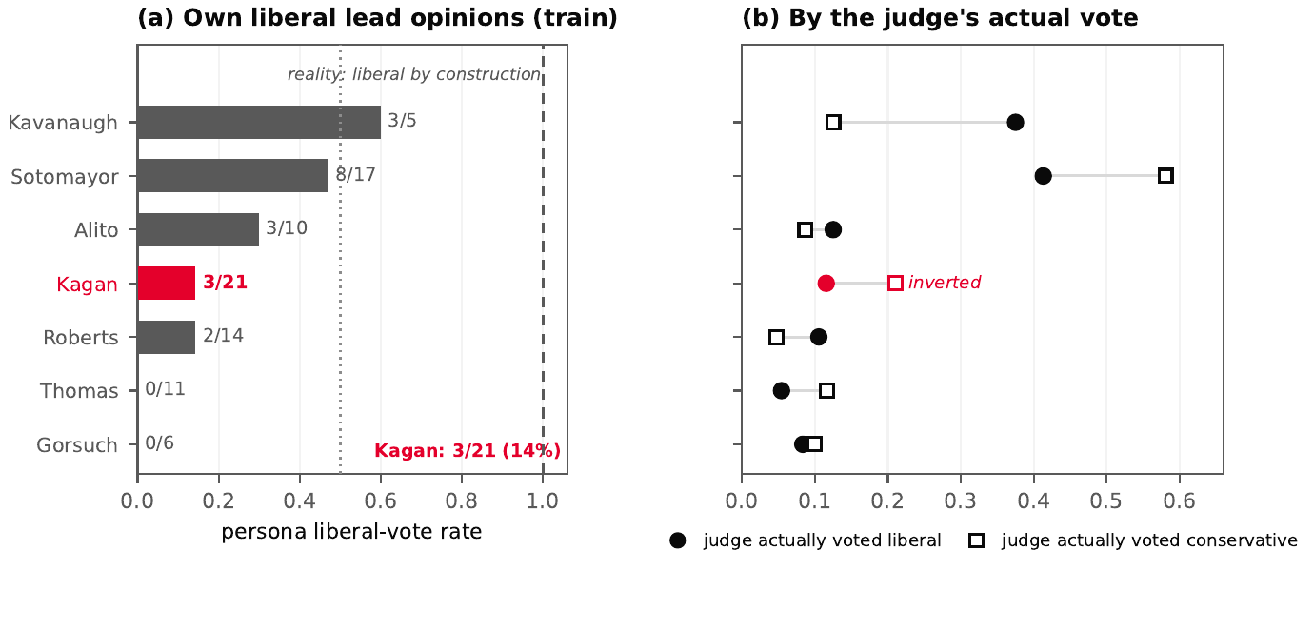
E3: auto-coherence probe — the persona does not reproduce the judge’s votes even on the cases it was trained on (pre-specified, exploratory). (a) Persona liberal-vote rate on the training cases where the justice authored the lead opinion and voted liberal; by construction the actual rate is 1.0 (dashed line). Kagan’s persona, trained on 21 such opinions, votes liberal on 3 of 21 (14%). No persona reaches even two-thirds. (b) The persona’s liberal-vote rate split by the judge’s actual vote on his or her own training cases: for Kagan the relationship is inverted — her persona votes liberal more often on cases where she voted conservative (21%) than on cases where she voted liberal (12%). The same inversion affects Sotomayor, Thomas and Gorsuch (4 of 7 adapters). The adapter has seen the judge’s words on these very cases; it did not learn the vote that produced them.
If the adapter does not transfer the justice’s decision function, it should fail most transparently on the cases whose texts it was trained on. The auto-coherence probe (E3, pre-specified and exploratory) tests this directly: it takes the training-era cases where the justice both voted liberal and authored the lead opinion whose text entered the adapter’s training set, and asks the persona to vote on them. By construction, the actual liberal rate on these cases is 1.0. Kagan’s persona, trained on 21 such opinions, votes liberal on 3 of them (14%); no persona reaches even two-thirds of its own probe set (the maxima are Kavanaugh’s 60% on five cases and Sotomayor’s 47% on seventeen; Thomas’s and Gorsuch’s personas vote liberal on none) (Figure 8). The split by the judge’s actual vote is more damning than the level: for Kagan, the persona votes liberal more often on cases where she voted conservative (21%) than on cases where she voted liberal (12%), and the same inversion affects Sotomayor, Thomas, and Gorsuch—four of the seven adapters. The adapter has read the judge’s words on these very cases; it did not learn the vote that produced them.
We delimit what these two experiments establish. They are evidence about this pipeline: one open-weight 3B base model, seven QLoRA adapters trained on sealed-excluded opinion corpora, biographical prompts of one fixed form, one task phrasing. Kagan’s seat falsifies the generalization “biographical prompts lift liberal justices”; Sotomayor’s seat confirms it; the heterogeneity between them—not either seat alone—is the finding. Nothing here licenses a claim about LLM personas at large, and the Kagan observation in particular is a single-seat result on 21 cases. What the two experiments do establish, for this pipeline, is a mechanism: the persona’s simulated voting behavior is governed by the base model’s default plus whatever identity the prompt injects, and the adapter’s contribution on top of the prompt is, if anything, a pull back toward that default.

Stylistic distinctiveness: a pre-registered prediction, falsified
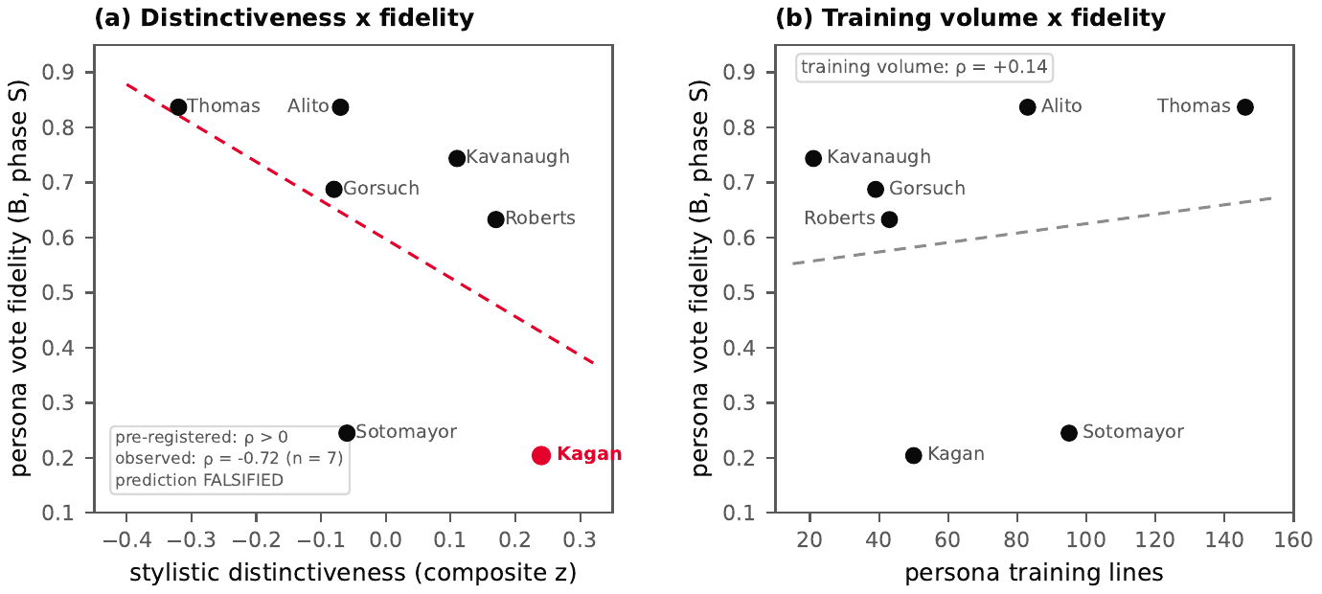
E2: stylistic distinctiveness does not predict persona fidelity — a pre-registered prediction, falsified ($n=7$ adapters). (a) Composite stylistic distinctiveness (lexical richness, sentence-length variance, function-word and authorial-marker signatures, TF-IDF/JSD distance to the other judges) against persona vote fidelity on the sealed exam. The pre-registered prediction was a positive correlation; the observed Spearman correlation is $ρ=−0.72$ in phase S ($−0.61$ in phase T). Kagan is the most distinctive writer and the worst persona; Thomas the least distinctive and among the best. (b) Training volume explains nothing ($ρ=+0.14$). The surface style transfers; the decision function does not: persona fidelity tracks the justice’s alignment with the base model’s conservative default, not the distinctiveness of the pen. Exploratory label (measures chosen after observing fidelities; the correlation predictions themselves were inscribed in the freeze document before execution—with the provenance caveat stated in the text: plan and results share one commit).
The natural explanation left standing after E1 and E3 is stylistic: perhaps persona fidelity tracks how distinctive a writer the justice is, in the stylometric sense of a persistent, hard-to-fake signature (Mosteller and Wallace 1964; Juola 2006). This explanation was itself pre-registered—as two predictions inscribed before any measurement—and then falsified. The distinctiveness study (E2, local and corpus-side) scores each of the seven adapted judges on a composite of surface measures over the clean pre-guard corpus: sliding-window lexical richness, sentence-length variance, a function-word signature, authorial markers such as “I dissent” per ten thousand words, and TF-IDF/Jensen–Shannon distance to the other judges (18–70 texts per judge, 76k–276k words each). The first inscribed prediction fixed an expected ranking, with Kagan the least distinctive writer; the observed ranking inverts it at both ends—Kagan is the most distinctive writer in the corpus ($+0.24$ composite $z$) and Thomas the least ($−0.32$). The second inscribed prediction was a positive correlation between distinctiveness and persona vote fidelity, exceeding the volume–fidelity correlation. The observed Spearman correlation is $ρ=−0.72$ on the sealed exam and $−0.61$ on the transparent window, against $+0.14$ for training volume (Figure 9): distinctiveness of the pen predicts persona fidelity with the wrong sign.
The label discipline here matters and we keep it explicit. $ρ=−0.72$ is the falsification of a prediction inscribed in advance, not a hypothesis invented after seeing the results: both correlation predictions and the full expected ranking were written into the freeze document before the distinctiveness measures were computed, and both were falsified—which is itself evidence against post-hoc construction, since a prediction invented after the fact would predict the observed sign. We state the provenance precisely: the E2 predictions share a single freeze commit with the E2 results (a local, CPU-side computation), so the git record alone cannot establish their ordering; it rests on the authors’ contemporaneous records. For the kernel-executed probes E1 and E3, the git record does establish the ordering: the plan was committed under the a1-freeze tag, the pinned head is cited by the running kernel’s manifest, and the results were committed three hours later. The distinctiveness measures were chosen after the fidelities had been observed, and for that reason the study carries an exploratory label on its instruments. One axis of Kagan’s composite rests on a small sample (the Jensen–Shannon distance over her separate opinions uses two texts), but the negative correlation survives on the all-texts axis alone, and no surface measure we computed correlates positively with fidelity.
The falsification, read in the direction the data point, sharpens the mechanism of Section 5.3. The seven judges’ surface signatures sit at tiny Jensen–Shannon distances from one another (0.155–0.212: American legal English is a shared register), and the judges closest to the shared register obtain the best personas. The persona failure is therefore not a failure of style transfer—the style visibly moves—but of decision transfer: what varies between justices, and what the adapter does not carry, is the voting function, not the voice. Persona fidelity tracks the justice’s alignment with the base model’s conservative default, not the distinctiveness of the pen. A companion descriptive statistic from the phase-0 analysis points the same way (share of majority-authored opinions against fidelity: $ρ=−0.74$, $n=7$, no inferential status): majority writing is coalition writing, and coalition prose is the least individual prose a justice produces. The adapter moves words, not votes.

Discussion

Who votes beats what the case is about
The M3a null result is a negative finding with a positive reading. The failure of three model families to convert issue areas, lower-court dispositions, terms, and argument lengths into votes tells us that the mapping from case facts to outcomes is either unstable across time or not expressible in these coarse codes. The ablation sharpens this: keeping issue area actively hurt generalization, which is the signature of a signal that shifted between the training and evaluation windows—the mix and meaning of “economic activity” cases in OT2015 is not the mix of OT2022. Justice identity, by contrast, travels intact across the split, because it is a property of the voter, not of the era.
This is a modern, pre-registered echo of the attitudinal model’s central claim (Segal and Spaeth 2002), obtained with none of its theoretical apparatus: one revealed-ideology bit per justice carries more predictive weight than the entire structured case file. It also explains, mechanically, why the earlier literature’s headlines sit above our bar. Katz, Bommarito, and Blackman (2017) report 71.9% at the vote level—but over 1816–2013, an era range containing long stretches of 80–90% unanimity that no modern model enjoys; on the modern, 5–4-heavy window, the honest point of comparison is closer to our setting, and the 63.7% bar is what an ideology-only adversary achieves when unanimity is gone.

The sealed exam delivered the designed outcome
Had a structured challenger cleared the bar, the persona experiment would have been partially redundant: some of the textual signal would already be recoverable from codes. The M3a null did the opposite—it made the text conditions the critical path—and the seal has now been broken on them, exactly once, under the pre-registered protocol. The persona condition was the strongest version of that probe: any residual textual signal would have to be individual and prospective, and the stylometry lineage (Mosteller and Wallace 1964; Juola 2006) gave the instrument a principled footing, since style is known to be persistent and hard to fake. The result is the outcome the protocol was built to deliver cleanly, not a failure state. On the primary endpoint—case-direction accuracy on the fifty hash-frozen 5–4 decisions—the persona scores 59.2% against the zero-shot’s 61.2%, three discordant cases apart (exact McNemar, $p=1.00$); the point estimate sits two points on the wrong side of zero, and the interval admits no honest reading except no detectable gain. The retrieval condition fares worse (53.1%). On the transparent window, the same comparison had shown a $+4.9$-point edge for the persona, not significant; on the sealed exam the sign flips. Case-level deltas of this magnitude are noise-dominated at these sample sizes—which is precisely why the seal, and the one-shot pre-registered test it protects, existed.
The re-fit ideological prior sharpens the reading from the other side. On the same one-vote-margin decisions it collapses to a coin flip at case level (50.0%), while at vote level it still dominates every language condition (75.9% against 50–60%). Close cases remove exactly the case-level margin that ideology exploits elsewhere, and none of the conditions—statistical rule or language model—does much beyond the always-conservative majority class. To our knowledge, no public test of this question has combined a sealed holdout, single scoring, and audited anti-memorization checks; under that combination, at this scale, the result is null. We phrase the scope exactly: the claim is not that all textual signal is absent—richer models, other windows, or full-dossier encodings may yet find some—it is that the strongest individual-prospective probe, run under the strongest integrity constraints we could construct, found none.

Why: the persona learns the voice, not the vote
A null invites the question the mechanistic half of the experiment was pre-registered to answer: what did personalization actually do to the model? Three probes converge on one answer. First, it moved votes without moving outcomes: thirty-seven discordant votes against the zero-shot on the sealed set, a nominal vote-level edge ($p=.047$, secondary, unadjusted) that never converts into a single case-level gain. Second, it moved the model’s ideological posture rather than its judgment: on the sealed exam every simulated justice votes more conservatively than the justice it imitates, and on the transparent window, where the arms decompose, the biographical prompt does most of the moving—it lifts one liberal seat substantially toward its justice’s record (Sotomayor $+0.39$) while the other moves the wrong way (Kagan, $−0.06$; Section 5 treats the heterogeneity as the finding) and the conservative seats barely move—while the fine-tuned adapter’s marginal contribution on top of the prompt never exceeds a tenth and is negative for its two pre-registered targets. Identity injected in the prompt is not behavior learned by the adapter. Third, the accounts that would have made persona quality legible fail on contact with the data: the pre-registered stylistic story—that the most distinctive pens yield the best personas—is falsified ($ρ=−0.72$, the sign opposite the prediction), with fidelity instead tracking each justice’s alignment with the base model’s conservative default; and the auto-coherence probe shows personas misvoting on the very training cases whose texts they absorbed, the relationship inverted for four of the seven adapters. The adapter has seen the justice’s words; it did not learn the vote that produced them.
The surface style transfers; the decision function does not. What personalization learned is the voice, and what prediction needed was the vote—and on this evidence the two are separable: a model can absorb a justice’s prose without absorbing anything that predicts that justice’s hardest calls. This is the sense in which the null is informative rather than empty. It separates two things the literature on judicial prediction and the literature on stylometry had reason to believe were entangled, and it locates the predictable component of a close decision in who the justice is, not in how the justice writes.

Limitations

Ground truth is a single coding.
Our outcome variable—vote direction, liberal vs. conservative — is SCDB’s editorial coding, produced and maintained by a small team applying published conventions (Spaeth et al. 2025). That coding is the field’s standard, but it is one team’s reading of the cases: directional coding of some opinions (especially mixed or narrow ones) is contestable, and the database’s own documentation flags categories with known unreliability. We did not recode anything; all weaknesses of the coding are inherited as measurement error that attenuates every accuracy in this paper, the bar included.

A short, modern window.
Nine terms is a small epoch by the standards of the forecasting literature, and it is deliberately the hardest modern stretch: benches changed twice, 5–4 rates are high, and the ideological middle (Kennedy, then Roberts) moved. Consequences are concrete — the training window contains no votes at all for Barrett and Jackson, so challengers receive no signal for them, and the B4 comparison excludes them by the $n≥20$ rule. The sealed-exam results therefore separate known-justice forecasting (justices with training history, where the prior and the persona are both defined) from new-justice forecasting (Barrett, Jackson: the prior is undefined by construction, the adapter is impossible, and their persona degenerates, by pre-inscription, to the biographical prompt alone). These are different questions—a model that cannot know a new justice is not the same failure as one that knows a justice and still misses—and aggregating across that boundary without labeling it would blur both. We consider the window a feature (the numbers describe this Court, not a historical average) but it bounds external validity: nothing here transfers automatically to other eras or other courts.

The transparent test is exploratory.
The M3a comparison in Section 4 runs on the non-sealed evaluation window. Although every hyper-parameter was selected by grouped cross-validation inside the training window and the three model families were fixed in advance, the transparent test was run once, on data we had already seen while computing baselines; the multiple comparisons across three challengers are not corrected. The sealed fifty existed precisely to absorb this residual degrees-of-freedom problem, and the primary outcome was scored under that seal exactly once.

The text conditions are now tested.
The opinion-text corpus (M1.5) is complete: all 1,778 targeted opinion texts were collected, normalized, and deduplicated to 793 distinct texts (the remainder are documented textual duplicates across docket aliases), with a zero-leak audit of fourteen checks committed and re-executed on every push. The memorization risk we flagged before training was checked with the pre-committed audits after the adapters were trained: the min-20% log-probability probe never flags an adapter (base-vs-adapter deltas stay below half a nat on all seven, against a one-nat flag), and verbatim cloze recall is zero for base and adapter alike on every sampled span. The auto-coherence probe (Section 5) adds the sharpest evidence from the opposite side: personas misvote on the very cases whose texts they absorbed, so whatever the adapters learned, it was not the votes. This paper’s null now bounds the structured world and the tested textual probe—not all textual representations (richer models, full dossiers, other windows remain open), and not other modalities.

Base-model pretraining contamination.
The zero-shot and retrieval conditions read a base model whose pretraining corpus is undisclosed and may contain reporting on the sealed cases themselves. Thirty of the fifty sealed decisions date from the training era (the interleaved stratum), and their outcomes were public before the base model’s cutoff; the twenty future stratum decisions were decided largely after it. The stratified analysis of Section 5 is the design’s answer: on the interleaved stratum the zero-shot and persona conditions make identical case-direction calls on every case, and on the future stratum every condition, the re-fit ideological prior included, lands at or near one half. The primary comparison (persona versus zero-shot) conditions the same base model on the same possibly-contaminated inputs in both arms, so contamination cancels in the contrast even where it may inflate both arms equally—but the absolute case-level accuracies of the language conditions on the interleaved stratum should not be read as uncontaminated forecasting skill, and we do not read them that way.

One rater of the pipeline.
The corpus fusion, the docket matching, and the sealed selection were implemented and audited by the first author alone, with scripts, hashes, and logs—not by an institutional team; the legal-research side of the project (framing, doctrinal reading, jurisprudential interpretation) was carried by the second author and does not re-audit the code. The machinery is public and every claim regenerates from the repository, but the code-level human audit trail is one person deep, and we count that as a limitation of confidence rather than of method.

Ethics
The experiment touches only public records: published opinions, docket metadata, and audio of public oral arguments, all released by the Court and mirrored by public-interest archives. No private data, no sealed-at-source material, and no personal data beyond the public professional conduct of public officials is used. The justices are public figures acting in an official capacity; the measured quantities (vote directions, agreement rates, writing style of signed opinions) are matters of public record and public commentary.
Two commitments go beyond data source. First, counterfactual labels are labeled as counterfactuals: when the site or the models display “what the baseline would have voted” for a case a justice never heard (bench turnover makes this common), the row is marked as a simulated call, never presented as a prediction the justice could have made. Second, the project is explicitly non-commercial: no paywall, no product, no data licensing — the corpus, the scripts, the trained adapters, and this paper are published for replication and criticism. The zero-budget constraint is partly ethical in origin: results that can only be reproduced with institutional compute are claims that can only be audited by institutions, and judicial-prediction claims should be auditable by anyone.
A final note on downstream use. A high-accuracy vote predictor would be commercially interesting to lobbyists and litigators; the current state of the project—a 63.7% ideological bar that structured models fail to beat—is, we note dryly, a result with no immediate commercial application, and we are in no hurry to change that.

Reproducibility
Every CPU-side number in this paper regenerates from the public repository https://github.com/Vitalcheffe/legally-subjective with three commands and no credentials; the GPU-dependent stages are frozen as executed artifacts, as described at the end of this section. The corpus rebuild chain is scripts/build_corpus.py (raw sources $→$ frozen corpus with recomputed hashes); the baselines are scripts/m2_baselines.py; the M3a challengers, including the grouped cross-validation, the McNemar tests, and the ablation, are scripts/m3a_train.py. The paper figures are produced by scripts/paper_figures.py and scripts/paper_figures_d1bis.py. All randomness is seeded and the seeds are printed in the outputs; re-running the M3a script reproduces the numbers of Table 4 exactly.
Provenance is structural, not narrative. The SHA-256 of every raw source file is recorded at download; the frozen corpus recomputes and checks them; the sealed fifty are identified by a deterministic seeded draw whose seed derivation and resulting list hash are both committed. A reader who wishes to verify that the sealed list was not regenerated after training can do so from the git history alone. The dataset rule, the known exclusions (ghost docket groups, consolidated matters without SCDB matches), and the coding caveats are documented in the repository’s docs/ rather than hidden in prose.
The opinion-text corpus (M1.5) is complete: 1,778 collected texts, normalized and deduplicated to 793 distinct documents with full provenance, committed with a fourteen-check zero-leak audit that the repository’s continuous integration re-executes on every push.
The GPU-dependent stages are frozen as executed artifacts rather than re-runnable scripts, and the freeze is the point: a sealed exam that can be re-taken is not sealed. The persona training (M3b) ran on free-tier GPU sessions under the pre-committed notebook (notebooks/m3b_qlora_personas.ipynb, machinery audited in results/m3b_*), and its training report—including the anti-memorization audits cited in Section 7—is exported by the finalize session. The sealed exam (M4) was scored once: predictions were generated by a kernel pinned to the m4-freeze head, frozen under a one-time seal whose lock records the head and the predictions’ own SHA-256 (results/m4_exam.lock, results/m4_predictions.json, commit f6145a5) before any scoring was run, and the scoring (results/m4_report.json) is a deterministic function of those predictions and the frozen corpus. The mechanistic probes E1 and E3 ran under a kernel frozen before execution (tag a1-freeze); their outputs are committed under results/a1_*.json. Inter-run comparisons in this paper follow the pre-registered rule of quoting each experiment’s internal numbers from its own single seeded run, never mixing runs in one computation.

Conclusion
This paper filed both halves of a pre-registered experiment on the predictability of Supreme Court votes. The frozen corpus exists, is hash-chained, and is public; the strongest statistical baseline—one bit of revealed ideology per justice—set a vote-level bar of 63.7% that three families of structured challengers failed to clear; and the sealed fifty were scored exactly once, by a zero-shot reader, a retrieval reader, and nine per-justice personas (seven QLoRA adapters and, by pre-inscription, two biographical-prompt-only seats). The predictable part of a modern justice’s vote, to the resolution that the tested metadata can see, is the justice. The written record was the remaining candidate, and the strongest individual-prospective probe of it returned null: the persona did not detectably improve prediction of the Court’s hardest cases.
What the persona did instead is now mapped. It moved individual votes without moving outcomes; it made every simulated justice vote more conservatively than the justice it imitates; the moving was done by the biographical prompt, not the fine-tuned adapter; and the pre-registered accounts of persona quality failed where they were testable and were falsified where they were decisive. The adapter absorbs the voice and withholds the vote. All code, frozen artifacts, and sealed predictions are public, so the finding is not an appeal to authority but an invitation: the design survives replication at larger scale unchanged, and any future claim that personalization improves judicial prediction now has a pre-registered null to beat. Beyond ideology, at the scale and under the constraints tested here, the written record keeps its counsel.

Declarations
Author contributions. Both authors conceived the project and designed the protocol jointly. Amine Harch El Korane led the computational side: corpus engineering, baseline and challenger implementations, the persona pipeline, the sealed-exam machinery, and the reproducibility infrastructure. Ghali El Alj led the legal side: jurisprudential framing, doctrinal reading of the opinion corpus, legal interpretation of the results, and manuscript development. Both authors analyzed the results, drafted and revised the manuscript, and approved the final version.
Use of AI assistance. This research was conducted with the help of large-language-model coding and writing assistants, used as instruments under the authors’ direction and supervision. The authors specified the experimental design decisions, the acceptance criteria, and the analyses to run; the assistants produced draft code, draft text, and documentation that the authors reviewed, tested, corrected, and take full responsibility for. No reported number was accepted on an assistant’s word: every figure regenerates from the committed scripts and frozen artifacts described in Section 9, and the sealed-exam chain of Section 4 ran under the authors’ control with a lock that is independently verifiable from the public repository. We disclose this use in accordance with the ACM policy on authorship (which requires describing AI used to conduct research) and the policies of the journals and conferences to which this work may be submitted.
Funding. None; the project ran on free-tier services and public data.
Competing interests. The authors declare none.
Data and code availability. All code, frozen artifacts, sealed predictions, and audit reports are public at https://github.com/Vitalcheffe/legally-subjective (release tags a1-freeze, m4-freeze, m4-exam). The authors’ institutional affiliation is stated for identification only and does not imply endorsement of the research by the school or any network to which it belongs.
Argyle, Lisa P., Ethan C. Busby, Nancy Fulda, Joshua R. Gubler, Christopher Rytting, and David Wingate. 2023. “Out of One, Many: Using Language Models to Simulate Human Samples.” Political Analysis 31 (3): 337–51.
Dettmers, Tim, Artidoro Pagnoni, Ari Holtzman, and Luke Zettlemoyer. 2023. “QLoRA: Efficient Finetuning of Quantized LLMs.” In Advances in Neural Information Processing Systems. Vol. 36.
Dillion, Danica, Niket Tandon, Yulin Gu, and Kurt Gray. 2023. “Can AI Language Models Replace Human Participants?” Trends in Cognitive Sciences 27 (7): 597–600.
Free Law Project. n.d. “CourtListener: U.S. Case Law, Dockets, and Oral-Argument Archive.” https://www.courtlistener.com.
Horton, John J. 2023. “Large Language Models as Simulated Economic Agents: What Can We Learn from Homo Silicus?” Working Paper. National Bureau of Economic Research.
Juola, Patrick. 2006. “Authorship Attribution.” Foundations and Trends in Information Retrieval 1 (3): 233–334.
Katz, Daniel Martin, II Bommarito Michael J., and Josh Blackman. 2017. “A General Approach for Predicting the Behavior of the Supreme Court of the United States.” PLOS ONE 12 (4): e0174698.
Martin, Andrew D., and Kevin M. Quinn. 2002. “Dynamic Ideal Point Estimation via Markov Chain Monte Carlo for the U.S. Supreme Court, 1953–1999.” Political Analysis 10 (2): 134–53.
Mosteller, Frederick, and David L. Wallace. 1964. Inference and Disputed Authorship: The Federalist. Reading, MA: Addison-Wesley.
Posner, Eric A., and Shivam Saran. 2025. “Judge AI: Assessing Large Language Models in Judicial Decision-Making.” Coase-Sandor Institute for Law and Economics Working Paper.
Ruger, Theodore W., Pauline T. Kim, Andrew D. Martin, and Kevin M. Quinn. 2004. “The Supreme Court Forecasting Project: Legal and Political Science Approaches to Predicting Supreme Court Decisionmaking.” Columbia Law Review 104 (4): 1150–210.
Segal, Jeffrey A., and Harold J. Spaeth. 2002. The Supreme Court and the Attitudinal Model Revisited. Cambridge: Cambridge University Press.
Spaeth, Harold J., Lee Epstein, Andrew D. Martin, Jeffrey A. Segal, Theodore J. Ruger, and Sara C. Benesh. 2025. Supreme Court Database, Version 2025 Release 01. St. Louis, MO: Washington University in St. Louis. http://scdb.wustl.edu.
Stillwell, Hayley, and Sean A. Harrington. 2026. “Predicting the Court: Evaluating Large Language Models as Forecasters of Supreme Court Decisions.” SSRN Preprint.
Yang, An, Baosong Yang, et al. 2024. “Qwen2.5 Technical Report.” arXiv Preprint arXiv:2412.15115.

