LIMBA ROMÂNĂ PENTRU STRĂINI
Romanian Language for Foreign Workers
SUPORT DE CURS
MODULE 11 — TRAVEL, FREE TIME, WORK AND THE RIGHTS OF FOREIGNERS
MODULUL 11 — CĂLĂTORII, TIMP LIBER, MUNCA ȘI DREPTURILE STRĂINILOR
Nivelul A2 / Level A2
LEVEL / NIVEL | DURATION / DURATĂ | LANGUAGE OF TEACHING
A2 — after Module 10 | 12 hours · Sessions 41–44 · Weeks 21–22 | English → Romanian

LEGAL BASIS / TEMEI LEGAL
Curs de limbă română cu elemente de integrare culturală și socială, organizat în conformitate cu O.U.G. nr. 32/2026, art. 7 alin. (1) lit. g) — minimum 6 luni, cel puțin 6 ore pe săptămână.
Romanian language course with cultural and social integration elements, organised under Government Emergency Ordinance no. 32/2026, art. 7(1)(g) — at least 6 months, at least 6 hours per week.
This module ends with ONE cumulative multiple-choice test (20 questions), signed and dated by the student and kept on file as proof of completion.

Before you start
Module 11 is about your life outside work and at work. You will travel between cities, spend a free day around Bucharest, talk about animals and visit the places every Romanian knows. Then you will read your employment contract and your payslip, and learn your rights as a foreign worker: the residence permit, the CNP, lost documents, the Labour Inspectorate and how to recognise a scam. There is no new grammar — you use what you know.
You need these lessons first — look back at them if you are not sure:
YOU NEED | WHERE | WHY
orders and requests — Nu te apropia! | Lesson 3.13 | warnings about animals, safety
the future — voi merge, o să merg | Lesson 3.16 | plans for the weekend, trips
transport in town, tickets, CFR | Lesson 5.3 | now: between cities
ITM, IGI, the 30-day rule | Lesson 5.2 | your rights — only what is new
the legal days off | Lesson 5.6 | not repeated — see the table there
CASS, health insurance | Lesson 8.7 | the payslip
bank account, card, PIN, scams | Lessons 10.5, 10.6 | the salary card, fraud
the polite conditional, emails | Lessons 10.1, 10.2 | at the ticket office, at ITM

Where this module sits in the course
SESSION | DURATION | CONTENT
Session 41 | 3 hours | Lesson 11.1 Travelling between cities · 11.2 Free time around Bucharest · 11.3 Animals
Session 42 | 3 hours | Lesson 11.4 Tourist sights of Romania · 11.5 The traditional costume and the ia
Session 43 | 3 hours | Lesson 11.6 The employment contract and working time · 11.7 The payslip
Session 44 | 3 hours | Lesson 11.8 Residence permit and CNP · 11.9 Lost documents, complaints to ITM · 11.10 Scams · 11.11 Recap · Module 11 test

THE LAW IN THIS MODULE
Sessions 43 and 44 explain rules from the Labour Code (Codul muncii, Law no. 53/2003), the Fiscal Code and the foreigners' law (O.U.G. 194/2002), checked on official sites (see the last page). Laws change: for your own case, always ask ITM, IGI or your employer's HR office — in writing, and keep a copy.

SESSION 41 — TRAVEL, FREE TIME, ANIMALS
SESIUNEA 41 — TRANSPORT, TIMP LIBER, ANIMALE · 3 hours

By the end of this session you will be able to:
☐ | choose a train, a coach or a plane and buy a ticket
☐ | plan a free day around Bucharest
☐ | name 16 animals and say simple things about pets and wild animals

Lesson 11.1 — Travelling between cities / Călătorii între orașe
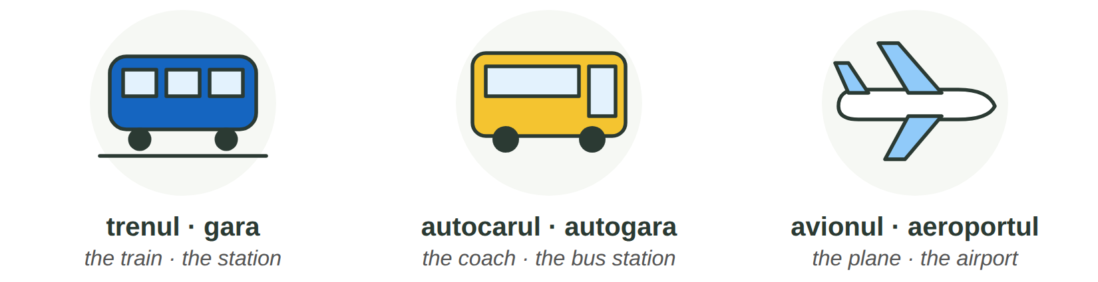
Fig. 11.1 — Trei feluri de a călători între orașe / Three ways to travel between cities
 | WHERE FROM | GOOD TO KNOW
trenul | gara — in Bucharest: Gara de Nord | CFR Călători and other rail companies. R (Regio) stops at every station; IR (InterRegio) is faster. Buy online or in the CFR app: the ticket has a QR code you show on the train.
autocarul · microbuzul | autogara (bus station) | many private companies; often cheaper and faster to small towns. You buy from the driver, at the counter or online.
avionul | aeroportul — Bucharest: Henri Coandă (Otopeni) | for far cities (Cluj, Iași, Timișoara). Be there early, with your passport or ID and your residence permit.

AT THE TICKET OFFICE / LA CASA DE BILETE | ENGLISH
— Bună ziua! Aș vrea un bilet dus-întors la Brașov, pentru sâmbătă. (Lesson 10.2) | Hello! I'd like a return ticket to Brasov for Saturday.
— Cu trenul de la 8:15? E un IR. Clasa a doua? | The 8:15 train? It's an IR. Second class?
— Da. De la ce linie pleacă? | Yes. Which platform does it leave from?
— Linia 5. Aveți vagonul 3, locul 42. | Platform 5. You have coach 3, seat 42.
— Trebuie să schimb trenul? — Nu, e direct. | Do I have to change trains? — No, it's direct.
— Anunț: Trenul IR 1735 are o întârziere de 20 de minute. | Announcement: the train is 20 minutes late.

11.1 Train, coach or plane?
Write: gara · autogara · aeroportul · linia · dus-întors · întârziere.
1. Trenul pleacă din ______________. | 2. Autocarul pleacă de la ______________.
3. Avionul pleacă de la ______________. | 4. Trenul pleacă de la ______________ 5.
5. Vreau să mă și întorc: un bilet ______________. | 6. Trenul are 20 de minute ______________.

CUVINTE ȘI EXPRESII UZUALE / USEFUL WORDS AND PHRASES
bilet dus / dus-întors | one-way / return ticket | plecări · sosiri | departures · arrivals
linia · peronul | the track · the platform | vagonul · locul | the coach · the seat
a schimba trenul | to change trains | întârzierea | the delay
direct | direct, non-stop | bagajul | the luggage

Lesson 11.2 — Free time around Bucharest / Timp liber în jurul Bucureștiului
A free Sunday does not cost much. Many places near Bucharest are free or cheap and easy to reach. Before you go, check the program de vizitare (opening hours) and the price of the bilet de intrare on the official website.
FOTO:  Grădina Zoologică București (Băneasa) | Grădina Zoologică București — Băneasa  CE E / WHAT IT IS: the Bucharest Zoo, in the north of the city, next to the Băneasa forest.  CUM AJUNGI / HOW TO GET THERE: inside Bucharest: by bus or by car; plan the route in the STB / Info Trafic app.  CE POȚI FACE / WHAT YOU CAN DO: see the animals of Lesson 11.3, walk in the forest, a day out with children.
FOTO:  Palatul Mogoșoaia | Palatul Mogoșoaia  CE E / WHAT IT IS: a palace built by the ruler Constantin Brâncoveanu in 1702, today a museum of Brâncovenesc art, with gardens and a lake.  CUM AJUNGI / HOW TO GET THERE: about 17 km north of Bucharest, on the DN1A road, in the village of Mogoșoaia.  CE POȚI FACE / WHAT YOU CAN DO: visit the museum, walk in the park and along the lake, take photos.
FOTO:  Lacul și Mănăstirea Snagov | Snagov  CE E / WHAT IT IS: a large lake in a forest north of Bucharest, with an old monastery on an island. Tradition says that Vlad Țepeș (Lesson 11.4) is buried there.  CUM AJUNGI / HOW TO GET THERE: north of Bucharest, in Ilfov County — by car, or by train / minibus to the nearby villages.  CE POȚI FACE / WHAT YOU CAN DO: walk, picnic, a boat trip on the lake, visit the monastery.
FOTO:  Parcul Natural Comana | Parcul Natural Comana  CE E / WHAT IT IS: a natural park of about 25,000 ha in Giurgiu County: forest, marshes and birds; a protected wetland of international importance (Ramsar).  CUM AJUNGI / HOW TO GET THERE: south of Bucharest, in Giurgiu County — by car or with an organised trip.  CE POȚI FACE / WHAT YOU CAN DO: walking trails, bird watching, boat or canoe trips, a picnic in nature.
FOTO:  Parcul Regele Mihai I (Herăstrău) / Parcul Tineretului | The big parks of Bucharest  CE E / WHAT IT IS: Parcul Regele Mihai I (Herăstrău) with its lake, Cișmigiu in the centre (Lesson 5.1), Tineretului, Carol, IOR (Titan).  CUM AJUNGI / HOW TO GET THERE: by metro: Aviatorilor (Herăstrău), Izvor (Cișmigiu), Tineretului, Titan (IOR).  CE POȚI FACE / WHAT YOU CAN DO: walk, run, cycle, a boat on the lake, playgrounds, cafés — free entry.

MAKING PLANS / PLANURI | ENGLISH
Ce faci duminică? — O să merg la Mogoșoaia. (Lesson 3.16) | What are you doing on Sunday? — I'm going to Mogoșoaia.
Hai la o plimbare în parc! — Mi-ar plăcea! (Lesson 10.2) | Let's go for a walk in the park! — I'd love to!
Cât costă intrarea? · E deschis lunea? | How much is the entrance? · Is it open on Mondays?
Cum ajung la...? · Ce autobuz merge la...? | How do I get to...? · Which bus goes to...?

11.2 Where do they go?
Read and write the place.
1. Ana vrea să vadă un palat din 1702. → ______________ | 2. Ravi vrea să vadă un leu. → ______________
3. Omar vrea păsări și o plimbare cu canoea. → ______________ | 4. Aziz vrea să alerge lângă un lac, cu metroul. → ______________

CUVINTE ȘI EXPRESII UZUALE / USEFUL WORDS AND PHRASES
timpul liber | free time | o excursie · o plimbare | a trip · a walk
intrarea gratuită | free entry | programul de vizitare | opening hours
un picnic | a picnic | o plimbare cu barca | a boat trip

Lesson 11.3 — Animals / Animalele
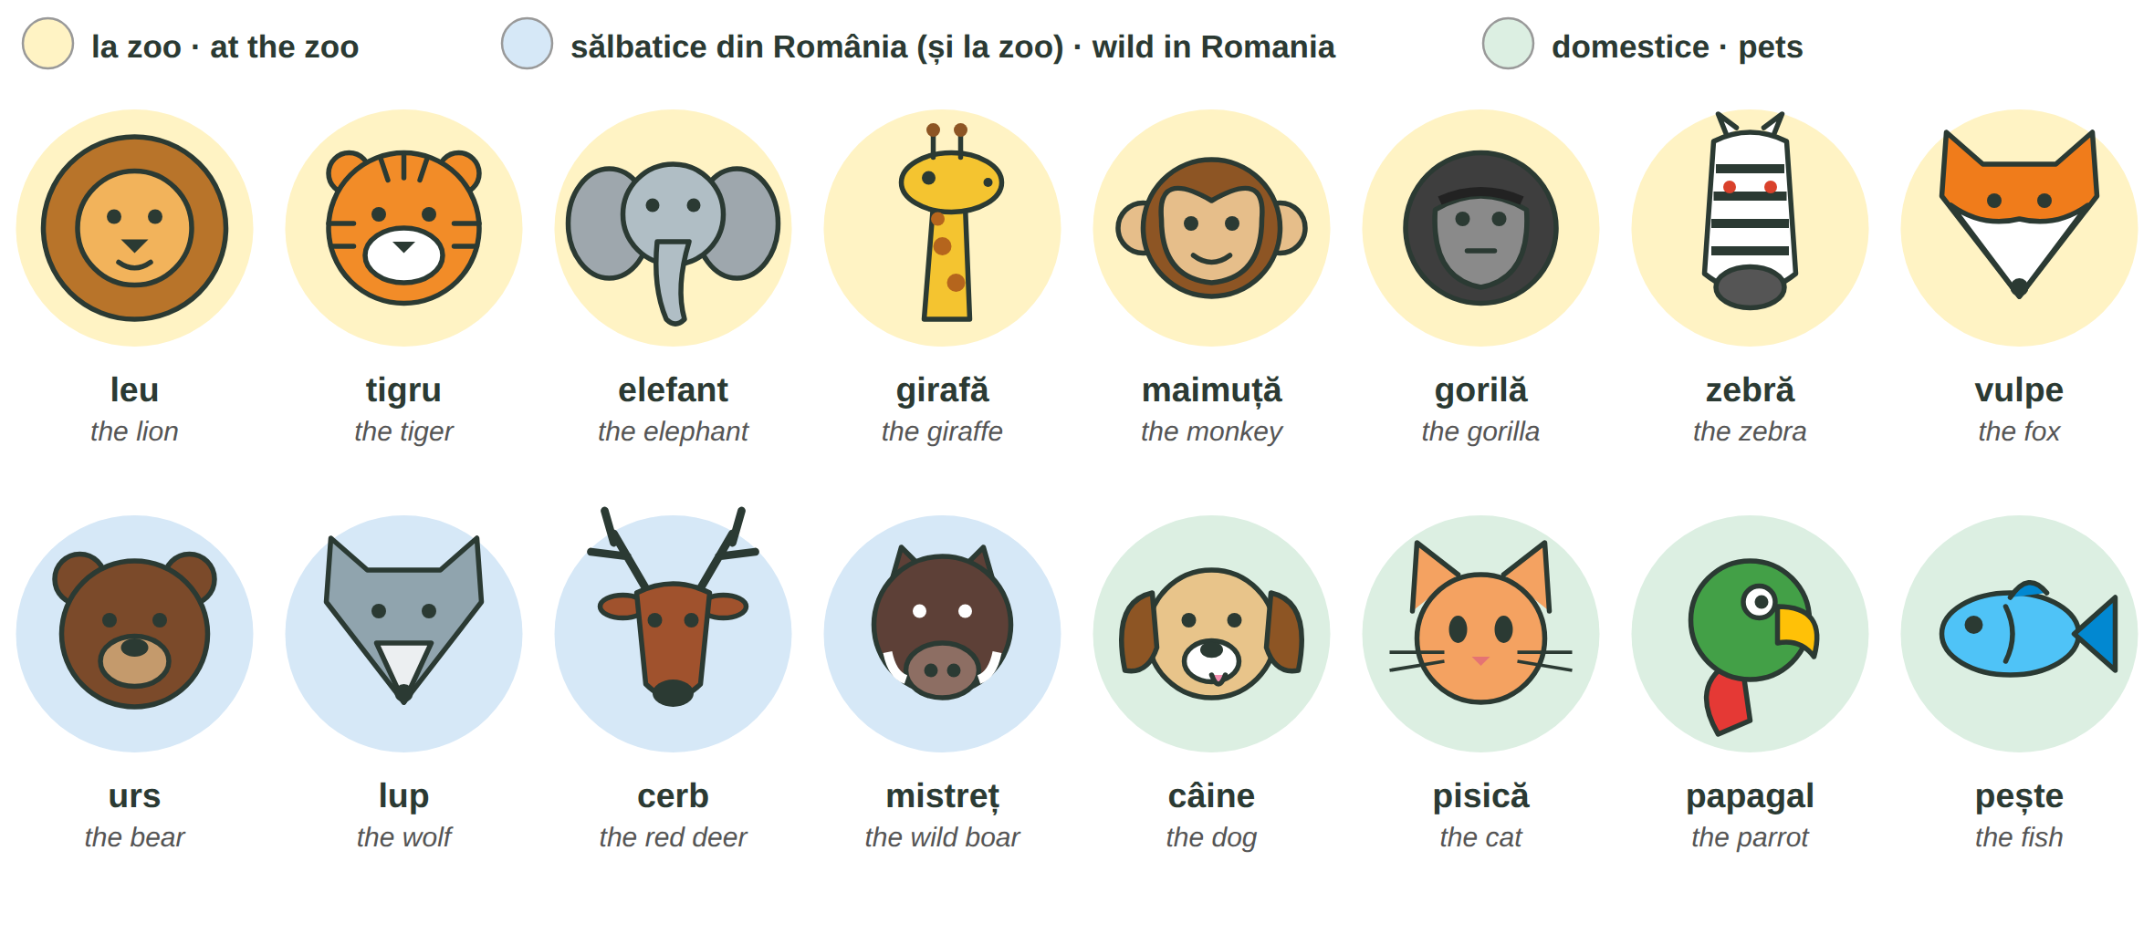
Fig. 11.2 — Animale la zoo, animale sălbatice din România, animale de companie / Zoo animals, wild animals in Romania, pets
PETS / ANIMALE DE COMPANIE | ENGLISH | WILD ANIMALS / ANIMALE SĂLBATICE | ENGLISH
Ai un câine? — Da, am un câine. | Do you have a dog? — Yes, I do. | Nu te apropia de urs! | Don't go near the bear!
Cum se numește pisica ta? | What is your cat called? | Nu hrăni animalele sălbatice! | Don't feed wild animals!
Câinele meu nu mușcă. | My dog doesn't bite. | Atenție, urs în zonă! | Warning, bear in the area!
Îmi plac pisicile. · Mi-e frică de câini. | I like cats. · I'm afraid of dogs. | În pădure trăiesc lupi și mistreți. | Wolves and wild boars live in the forest.

ATTENTION — BEARS IN ROMANIA
Romania has many brown bears (urși bruni), and in mountain areas they sometimes come into villages, near roads and rubbish bins. The authorities warn people by RO-ALERT messages on the phone. Do not approach a bear, film it or feed it; keep your distance, go inside or leave the area slowly, and call 112 if a bear is in a village (Romanian Gendarmerie).

11.3 Which group?
Write Z (zoo), S (wild in Romania) or D (pet). Some animals are in two groups.
1. girafa → ___ 2. pisica → ___ | 3. cerbul → ___ 4. zebra → ___
5. papagalul → ___ 6. mistrețul → ___ | 7. ursul → ___ / ___ 8. peștele → ___

CUVINTE ȘI EXPRESII UZUALE / USEFUL WORDS AND PHRASES
animalul de companie | pet | sălbatic · domestic | wild · tame, domestic
a mușca · a lătra | to bite · to bark | a hrăni | to feed
pădurea | the forest | Mi-e frică de... | I am afraid of...

GREȘELI FRECVENTE LA SCRIS / COMMON WRITING MISTAKES
WRITE | WHAT IT IS | EXAMPLE | THE TEST
fi | the infinitive: to be — after pot, poți, a, vei, o să | Poți fi liniștit. · Vei fi acolo? | you can say a fi
fii | (you) be! · să fii — for tu | Fii atent la tren! · Vreau să fii acolo. | it goes with tu
mi-e | îmi + e = îmi este (feelings) | Mi-e frică de urși. · Mi-e dor de casă. | you can say îmi este
mie | to me (strong form) | Mie îmi plac pisicile. · Dă-l mie! | answers Cui? (To whom?)

HOMEWORK — AFTER SESSION 41 / TEMĂ PENTRU ACASĂ
H41.1 Plan a free day: write five sentences with O să merg la... / Hai la...! and say how you get there.
H41.2 Write about an animal you like (or a pet from your country): what it is, where it lives, what it eats.

SESSION 42 — TOURISM
SESIUNEA 42 — TURISM · 3 hours

By the end of this session you will be able to:
☐ | find ten famous places on the map of Romania
☐ | say where they are and what you can see there
☐ | know the difference between Vlad Țepeș and Dracula
☐ | describe the traditional costume and the ia

Lesson 11.4 — Tourist sights of Romania / Obiective turistice
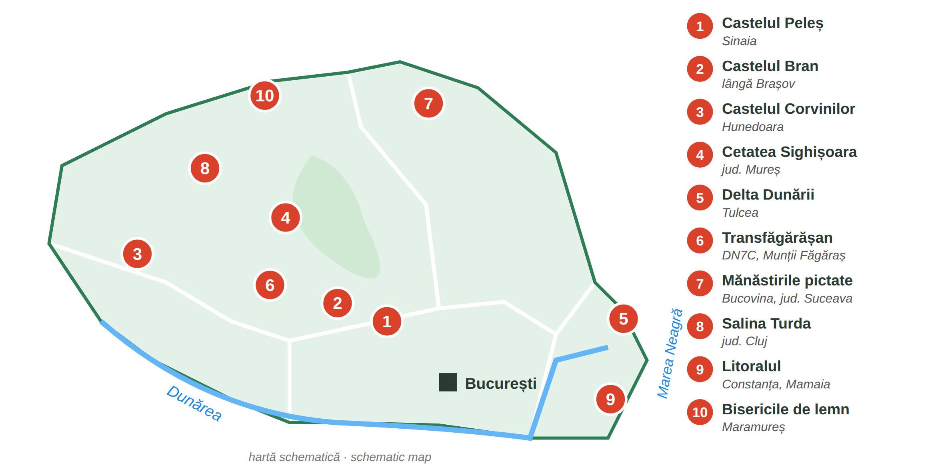
Fig. 11.3 — Zece obiective turistice / Ten tourist sights (the regions: Lesson 5.1)
FOTO:  Castelul Peleș | 1 Castelul Peleș — Sinaia, Prahova. The royal castle built for King Carol I at the end of the 19th century; today a museum in the mountains. | FOTO:  Castelul Bran | 2 Castelul Bran — near Brașov. A medieval castle on a rock. Famous abroad as „the castle of Dracula” — read the box below.
FOTO:  Castelul Corvinilor | 3 Castelul Corvinilor — Hunedoara. A large Gothic castle of the Corvin (Hunyadi) family, with towers and a bridge. | FOTO:  Cetatea Sighișoara | 4 Sighișoara — Mureș. A medieval citadel where people still live; the Clock Tower. UNESCO World Heritage since 1999.
FOTO:  Delta Dunării | 5 Delta Dunării — Tulcea. Where the Danube meets the Black Sea: channels, lakes, pelicans. UNESCO since 1991. You travel by boat. | FOTO:  Transfăgărășan | 6 Transfăgărășan (DN7C) — a mountain road over the Făgăraș Mountains, to Bâlea Lac. The high part is closed in winter; check the Police traffic info.
FOTO:  Mănăstirea Voroneț | 7 Mănăstirile pictate din Bucovina — Suceava. Churches painted outside, 15th–16th centuries (Voroneț, Humor, Moldovița, Sucevița...). UNESCO. | FOTO:  Salina Turda | 8 Salina Turda — Cluj. An old salt mine, now visited deep underground: salt halls, a lake, a wheel.
FOTO:  Litoralul, Mamaia | 9 Litoralul — the Black Sea coast: Constanța, Mamaia, Eforie, Vama Veche. Beaches in summer. | FOTO:  Biserica de lemn, Maramureș | 10 Bisericile de lemn din Maramureș — tall wooden churches in the north. UNESCO since 1999.

VLAD ȚEPEȘ IS NOT DRACULA / VLAD ȚEPEȘ NU ESTE DRACULA
Vlad Țepeș (Vlad the Impaler) was a real person: a ruler of Țara Românească in the 15th century, known as a very harsh prince. Count Dracula is a character in a novel: Dracula, written by the Irish writer Bram Stoker and published in 1897. Stoker took the name, but his vampire is literature, not history. Bran became „Dracula's castle” because it looks like the castle in the book (Bran Castle Museum).

11.4 Where is it?
Look at Fig. 11.3 and write the place.
1. Castelul regelui Carol I → ______________ | 2. Pelicani, bărci, canale → ______________
3. Biserici pictate afară → ______________ | 4. Un drum sus pe munte → ______________
5. O mină de sare → ______________ | 6. Plajă la Marea Neagră → ______________

CUVINTE ȘI EXPRESII UZUALE / USEFUL WORDS AND PHRASES
castelul · cetatea | the castle · the citadel | mănăstirea · biserica | the monastery · the church
muntele · marea | the mountain · the sea | ghidul · excursia | the guide · the trip
cazarea | accommodation | obiectiv turistic | tourist sight

Lesson 11.5 — The traditional costume / Costumul tradițional
FOTO:  ia românească (bluza cu altiță), de aproape | Ia is the white embroidered blouse of the Romanian folk costume, made of cotton, linen, hemp or silk. The embroidery on the shoulder is the altiță. In 2022 UNESCO added the art of the traditional blouse with embroidery on the shoulder (altiță) of Romania and the Republic of Moldova to the intangible cultural heritage of humanity. 24 June is celebrated as Ziua Iei (the Day of the Ia) — a tradition, not a day off.
FOTO:  costum popular complet — femeie și bărbat | Every region has its own colours and patterns. Romanians wear the costume at festivals, weddings, national days (1 December, Lesson 5.6) and to folk shows; many people wear an ia in the city in summer.

WOMEN / FEMEI | ENGLISH | MEN / BĂRBAȚI | ENGLISH
ia (cămașa) | embroidered blouse | cămașa | the shirt
fota · catrința | wrap-around skirt | ițarii | tight white trousers
brâul | woven belt | pieptarul · vesta | sheepskin vest · waistcoat
basmaua | headscarf | pălăria · căciula | hat · fur cap
opincile | traditional leather shoes | opincile | traditional leather shoes

11.5 True or false?
Write A (adevărat) or F (fals).
1. Ia este o bluză brodată. ___ | 2. Altița este pe umăr. ___
3. 24 iunie este zi liberă legală. ___ | 4. Fiecare regiune are costumul ei. ___

CUVINTE ȘI EXPRESII UZUALE / USEFUL WORDS AND PHRASES
costumul popular | folk costume | broderia · a broda | embroidery · to embroider
modelul · culorile | the pattern · the colours | tradițional | traditional

GREȘELI FRECVENTE LA SCRIS / COMMON WRITING MISTAKES
WRITE | WHAT IT IS | EXAMPLE | THE TEST
copii | children — no article: doi copii, niște copii | Am doi copii. | you can say niște before it
copiii | the children — with the article (-i) | Copiii mei sunt la școală. | you can say the: the children
cea | the (feminine) before mai, a number or an adjective | cea mai frumoasă mănăstire · cea de-a doua | no verb after it
ce-a | ce + a — what has / what did | Ce-a spus ghidul? · Ce-a văzut? | you can say ce a

HOMEWORK — AFTER SESSION 42 / TEMĂ PENTRU ACASĂ
H42.1 Choose one sight from Lesson 11.4. Write five sentences: where it is, what you see, how you get there, why you want to go.
H42.2 Describe the traditional costume of your country with five words from Lesson 11.5.

SESSION 43 — WORK: THE CONTRACT AND THE PAYSLIP
SESIUNEA 43 — MUNCA: CONTRACTUL ȘI FLUTURAȘUL · 3 hours

By the end of this session you will be able to:
☐ | understand the main parts of your employment contract
☐ | know the legal rules for probation, working time, overtime and leave
☐ | read your payslip: gross, contributions, tax, net
☐ | check your salary every month

Lesson 11.6 — The contract and working time / Contractul și timpul de muncă
The contractul individual de muncă (CIM) is written, in Romanian, and signed before you start work. You receive your own copy. The employer registers it in the electronic register of employees REGES-ONLINE (Labour Inspection). No contract = muncă la negru (undeclared work) — you have no pension, no health insurance and no proof of your work (Lesson 5.2).
IN YOUR CONTRACT / ÎN CONTRACT | WHAT THE LAW SAYS (Codul muncii) | ENGLISH
perioada de probă | maximum 90 calendar days (execution jobs); 120 days for management jobs | probation period
programul de lucru — durata normală | 8 hours a day, 40 hours a week | normal working time
orele suplimentare | at the employer's request; in total maximum 48 hours a week, overtime included | overtime
— cum se plătesc | first paid time off in the next 90 days; if not possible, a bonus of at least 75% | how overtime is compensated
concediul de odihnă | at least 20 working days a year, paid | paid annual leave
sărbătorile legale | days off — the list is in Lesson 5.6. If you work that day: time off in the next 30 days or a bonus of at least 100% | public holidays
salariul de bază brut | written in the contract; the payslip shows it every month (Lesson 11.7) | gross base salary
felul muncii · locul muncii | your job (funcția) and where you work | job title · place of work

AT WORK / LA LUCRU | ENGLISH
Aș putea să văd contractul înainte să semnez? (Lesson 10.2) | Could I see the contract before I sign?
Când se termină perioada de probă? | When does the probation period end?
Cum se plătesc orele suplimentare? | How is overtime paid?
Aș dori să-mi iau concediu în august. · Îmi dați o copie, vă rog? | I'd like to take leave in August. · Can you give me a copy, please?

11.6 Complete with the numbers
Write: 8 · 20 · 40 · 48 · 90.
1. Perioada de probă: maximum ______ de zile. | 2. Programul normal: ______ ore pe zi.
3. Pe săptămână: ______ de ore. | 4. Cu orele suplimentare: maximum ______ de ore.
5. Concediul de odihnă: minimum ______ de zile lucrătoare.

CUVINTE ȘI EXPRESII UZUALE / USEFUL WORDS AND PHRASES
angajatorul · salariatul | employer · employee | a semna | to sign
tura de zi · de noapte | day shift · night shift | pontajul | time sheet
cererea de concediu | leave request | demisia | resignation

Lesson 11.7 — The payslip / Fluturașul de salariu
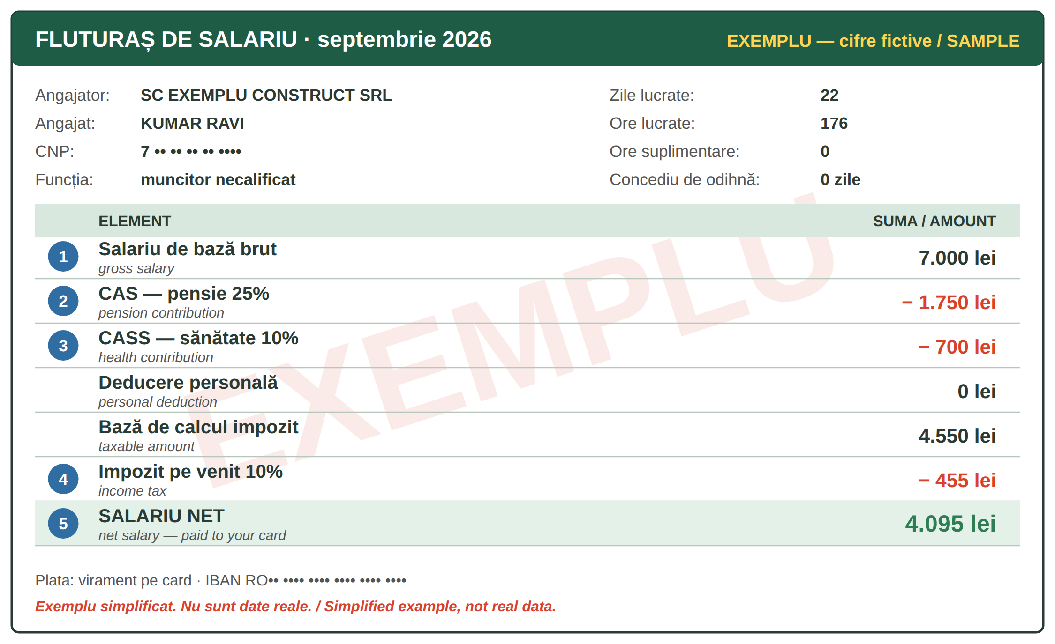
Fig. 11.4 — Un fluturaș de salariu. EXEMPLU cu cifre fictive / A payslip. SAMPLE with invented figures
NR. | ON THE PAYSLIP | WHAT IT MEANS
1 | salariul brut | the salary before anything is taken — the one in your contract
2 | CAS — 25% | contribuția de asigurări sociale: for your pension (pensia) — also for foreigners who work here
3 | CASS — 10% | contribuția de asigurări sociale de sănătate: your health insurance (Lesson 8.7)
4 | impozitul pe venit — 10% | the income tax: 10% of the gross minus CAS, CASS and the personal deduction (deducerea personală), if you have one
5 | salariul net | what you receive on your card (Lesson 10.5): gross − CAS − CASS − tax

Example (Fig. 11.4): 7,000 − 1,750 (CAS) − 700 (CASS) = 4,550; tax 10% = 455; net = 4,550 − 455 = 4,095 lei. The figures are invented. Your own payslip may also show a personal deduction, bonuses (sporuri), meal vouchers (tichete de masă) or leave.
CHECK YOUR PAYSLIP EVERY MONTH / VERIFICĂ FLUTURAȘUL
☐ your name and CNP are correct ☐ the month and the days / hours worked ☐ the overtime you worked is there ☐ the gross is the one in your contract ☐ the net is the amount that arrived in your bank account. Keep all your payslips. If something is wrong, ask the HR office (resurse umane) in writing; if it is not solved: ITM (Lesson 11.9).

11.7 Read the payslip
Look at Fig. 11.4 and answer.
1. Cât este salariul brut? → ______________ | 2. Cât plătește pentru pensie? → ______________
3. Cât este impozitul? → ______________ | 4. Cât primește pe card? → ______________

CUVINTE ȘI EXPRESII UZUALE / USEFUL WORDS AND PHRASES
salariul brut · net | gross · net salary | contribuțiile | contributions
impozitul | the tax | sporul | bonus, allowance
tichetele de masă | meal vouchers | resursele umane (HR) | human resources

GREȘELI FRECVENTE LA SCRIS / COMMON WRITING MISTAKES
WRITE | WHAT IT IS | EXAMPLE | THE TEST
n-ai | nu + ai — you don't have / you haven't | N-ai primit salariul? · N-ai semnat? | you can say nu ai
nai | the pan flute — a Romanian instrument | Cântă la nai. | it is a thing
altfel | otherwise · differently — one word | Semnează azi, altfel nu primești banii. · Lucrez altfel. | you can say în alt mod
alt fel | another kind — de comes after it | Am un alt fel de contract. | followed by de

HOMEWORK — AFTER SESSION 43 / TEMĂ PENTRU ACASĂ
H43.1 Find in your contract (or ask HR): your probation period, your working hours, your leave days. Write them in Romanian.
H43.2 Look at your last payslip. Write: brut ___, CAS ___, CASS ___, impozit ___, net ___. Is the net the same as in your bank app?

SESSION 44 — THE RIGHTS OF FOREIGNERS, RECAP AND TEST
SESIUNEA 44 — DREPTURILE STRĂINILOR, RECAPITULARE ȘI TEST · 3 hours

By the end of this session you will be able to:
☐ | explain how the residence permit for work is extended
☐ | use your CNP
☐ | know what to do if you lose your documents
☐ | complain to ITM
☐ | recognise a scam

Lesson 11.8 — The residence permit and the CNP / Permisul de ședere și CNP-ul
THE PRINCIPLE | WHAT IT MEANS FOR YOU (IGI)
the chain of documents | the employer gets the aviz de muncă (work permit) → you get the long-stay visa for work → in Romania, IGI gives you the permis de ședere (residence permit) for work
the extension (prelungirea) | you apply at IGI at least 30 days before the permit expires (Lesson 5.2). A late application is a fine (100–500 lei)
the conditions | a full-time contract, registered in the employee register, with a salary at least the national minimum gross salary; plus the documents on IGI's list
changes | a new address, a new employer, a new passport, marriage — inform IGI; ask IGI before you change employer
always | carry the permit, check the expiry date, keep copies; appointments and forms: portaligi.mai.gov.ro

The CNP (codul numeric personal) has 13 digits. For foreigners it is given by IGI and it is written on your residence permit. You need it at the bank (Lesson 10.5), the doctor (Lesson 8.7), your employer, ANAF and the town hall. Do not publish it online and give it only to institutions.
AT IGI / LA IGI | ENGLISH
Aș dori să-mi prelungesc dreptul de ședere. | I would like to extend my right of residence.
Permisul meu expiră pe 15 noiembrie. · Ce acte trebuie? | My permit expires on 15 November. · Which documents are needed?
Mi-am schimbat adresa / angajatorul. | I have changed my address / my employer.
Care este CNP-ul dumneavoastră? — E pe permis. | What is your CNP? — It's on the permit.

11.8 True or false?
Write A or F.
1. Cer prelungirea cu cel puțin 30 de zile înainte. ___ | 2. CNP-ul are 10 cifre. ___
3. CNP-ul este scris pe permisul de ședere. ___ | 4. Dacă schimb adresa, nu spun nimănui. ___

CUVINTE ȘI EXPRESII UZUALE / USEFUL WORDS AND PHRASES
permisul de ședere | residence permit | prelungirea | the extension
avizul de muncă | work permit | expiră pe... | it expires on...
programarea online | online appointment | CNP-ul | personal numeric code

Lesson 11.9 — Lost documents and complaints / Acte pierdute și reclamații
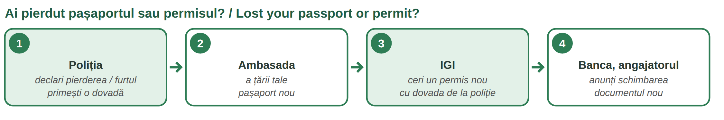
Fig. 11.5 — Ce faci dacă pierzi actele / What to do if you lose your documents
Passport lost or stolen? Declare it to the Police — IGI says within 48 hours. With the police paper go to your embassy for a new passport, then to IGI. Residence permit lost? Declare it and ask IGI for a new one — not declaring it in time is also a fine. Bank card? Block it at once (Lesson 10.6).
PROBLEM AT WORK | WHERE TO GO — ITM (Inspectoratul Teritorial de Muncă)
you are not paid, or paid less | send a petiție (complaint) to the ITM of the county where you work
you work without a contract | the same — undeclared work is illegal for the employer
too many hours, no leave, unsafe work | the same — also an email to HR first, and keep a copy
how | online on inspectiamuncii.ro („Petiții și sesizări”), by post, by e-mail or at the ITM office; write in Romanian (Lesson 10.1)
what happens | ITM must answer in 30 days; the inspectors must keep your identity confidential

A COMPLAINT TO ITM — MODEL
Către Inspectoratul Teritorial de Muncă ________. Subsemnatul Ravi Kumar, cetățean nepalez, angajat la SC ________ SRL, vă aduc la cunoștință că nu am primit salariul pe lunile iulie și august 2026. Vă rog să verificați situația. Atașez contractul și fluturașii. Data ________ Semnătura ________

11.9 Where do you go?
Write: Poliția · ambasada · IGI · ITM · banca.
1. Nu am primit salariul. → ______________ | 2. Mi-au furat pașaportul. → ______________ (first)
3. Vreau un pașaport nou. → ______________ | 4. Am pierdut cardul. → ______________
5. Vreau un permis de ședere nou. → ______________ | 6. Lucrez fără contract. → ______________

CUVINTE ȘI EXPRESII UZUALE / USEFUL WORDS AND PHRASES
am pierdut · mi-au furat | I lost · they stole | dovada | the proof, certificate
petiția · reclamația | complaint | a depune | to submit
vă aduc la cunoștință | I inform you | munca la negru | undeclared work

Lesson 11.10 — Scams / Înșelătoriile
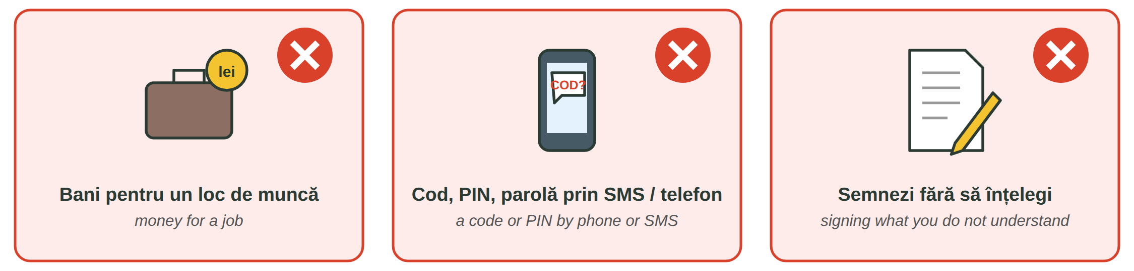
Fig. 11.6 — Trei semnale de alarmă / Three warning signs
THE SCAM | WHAT YOU SEE | WHAT YOU DO
a false job agency | someone asks you for money for a job, a contract, a „permit”, a visa. The Labour Code says a temporary work agency may not charge workers for recruitment or for the contract | do not pay; ask for the company's name and check it; ask ITM
calls and messages | a „bank”, „police”, „IGI” or „courier” asks for your PIN, card code, SMS code, password, or sends a link | banks and institutions never ask for codes (Lesson 10.6); hang up, call the bank on its own number; report to DNSC — 1911
papers you do not understand | a paper in Romanian you cannot read; a blank page to sign; a „resignation” without a date | do not sign; ask for time and a translation; show it to someone you trust
your passport | someone wants to keep your original passport or permit | your documents are yours — give a copy, keep the original

SAY NO / SPUNE NU | ENGLISH
Nu plătesc pentru un loc de muncă. | I don't pay for a job.
Nu dau codul nimănui. · Închid și sun eu la bancă. | I don't give the code to anyone. · I'll hang up and call the bank.
Nu semnez acum. Aș vrea să citesc acasă. | I won't sign now. I'd like to read it at home.
Vă dau o copie, originalul rămâne la mine. | I'll give you a copy; the original stays with me.

11.10 Scam or not?
Write DA (a scam) or NU.
1. „Plătești 500 de euro și primești contract.” ___ | 2. Banca îți cere codul primit pe SMS. ___
3. HR îți dă contractul să-l citești acasă. ___ | 4. „Semnează aici, pe foaia goală.” ___

CUVINTE ȘI EXPRESII UZUALE / USEFUL WORDS AND PHRASES
înșelătoria · frauda | scam · fraud | a înșela | to cheat
un link suspect | a suspicious link | a raporta | to report
foaia goală | blank page | originalul · copia | the original · the copy

Lesson 11.11 — Recap / Recapitulare
TOPIC | EXAMPLE | LESSON
gara · autogara · aeroportul · bilet dus-întors | Aș vrea un bilet dus-întors. | 11.1
Mogoșoaia 1702 · Comana · Snagov · parcurile | O să merg duminică la Mogoșoaia. | 11.2
16 animale · Nu te apropia de urs! · 112 | Mi-e frică de urși. | 11.3
10 obiective · Vlad Țepeș ≠ Dracula (Stoker, 1897) | Vreau să văd Delta Dunării. | 11.4
ia · altița · 24 iunie | Ia este o bluză brodată. | 11.5
probă 90 · 8 / 40 · max 48 · 20 zile · 75% · 100% | Cum se plătesc orele suplimentare? | 11.6
brut − CAS 25% − CASS 10% − impozit 10% = net | Salariul net vine pe card. | 11.7
prelungirea: 30 de zile înainte · CNP pe permis | Aș dori să-mi prelungesc dreptul de ședere. | 11.8
Poliția · ambasada · IGI · ITM | Nu am primit salariul. | 11.9
nu plătesc · nu dau codul · nu semnez · DNSC 1911 | Nu semnez acum. | 11.10

GREȘELI FRECVENTE LA SCRIS / COMMON WRITING MISTAKES
WRITE | WHAT IT IS | EXAMPLE | THE TEST
mi-a | îmi + a — (he / she) has ... me | Șeful mi-a dat salariul. · Cine mi-a cerut codul? | you can say mi-au for many
mia | the thousand · a mia = the thousandth | Mia de lei a dispărut. · pentru a mia oară | it is a number
deloc | not at all — one word | Nu e deloc greu. · Nu dorm deloc. | after nu
de loc | from (a place) — where you were born | Sunt de loc din Nepal. | followed by din

11.11 Everything together
Circle the correct form.
1. ( Fi / Fii ) atent la bagaje! | 2. Am doi ( copii / copiii ).
3. ( Mie / Mi-e ) frică de câini. | 4. ( N-ai / Nai ) primit fluturașul?
5. Nu e ( deloc / de loc ) greu. | 6. ( Ce-a / Cea ) spus inspectorul?

HOMEWORK — AFTER SESSION 44 / TEMĂ PENTRU ACASĂ
H44.1 Write the dates of your documents: when your passport and your permit expire, and the date by which you must ask for the extension.
H44.2 Write three sentences you would say to a scammer on the phone, with Nu....

SECȚIUNE DETAȘABILĂ — EXEMPLAR FORMATOR
Detachable section — teacher's copy. Se detașează din suportul cursantului; testul completat, semnat și datat, se păstrează la dosarul cursantului. Conține: testul cumulativ, fișa de confirmare a Sesiunii 44, fișa de evidență a Modulului 11, cheia răspunsurilor, sursele.
TEST CUMULATIV — MODULUL 11
MODULE 11 — CUMULATIVE TEST · grilă, 20 de întrebări, 20 de puncte · semnat și datat de cursant

Nume și prenume cursant / Student name
Data / Date | _____ / _____ / 20_____
Semnătura cursantului / Student signature

Marcați cu X un singur răspuns la fiecare întrebare. Mark ONE answer with X for each question. Each correct answer = 1 point.
1. Trenul pleacă din: (1 p)
☐ a) autogară | ☐ b) gară | ☐ c) aeroport | ☐ d) port
2. „Un bilet dus-întors” înseamnă: (1 p)
☐ a) a one-way ticket | ☐ b) a return ticket | ☐ c) a seat | ☐ d) a delay
3. Palatul Mogoșoaia a fost construit de Constantin Brâncoveanu în: (1 p)
☐ a) 1602 | ☐ b) 1702 | ☐ c) 1859 | ☐ d) 1918
4. Parcul Natural Comana este în județul: (1 p)
☐ a) Ilfov | ☐ b) Prahova | ☐ c) Giurgiu | ☐ d) Tulcea
5. Vezi un urs în sat. Ce faci? (1 p)
☐ a) îl hrănești | ☐ b) îl filmezi de aproape | ☐ c) te apropii | ☐ d) păstrezi distanța și suni la 112
6. Care animal este de companie? (1 p)
☐ a) mistrețul | ☐ b) papagalul | ☐ c) lupul | ☐ d) cerbul
7. Castelul Peleș este la: (1 p)
☐ a) Sinaia | ☐ b) Hunedoara | ☐ c) Sighișoara | ☐ d) Turda
8. Dracula este: (1 p)
☐ a) un rege al României | ☐ b) un personaj dintr-un roman de Bram Stoker | ☐ c) Vlad Țepeș | ☐ d) un castel
9. Unde sunt mănăstirile pictate pe dinafară? (1 p)
☐ a) în Delta Dunării | ☐ b) în Bucovina | ☐ c) la Constanța | ☐ d) la Turda
10. Altița este: (1 p)
☐ a) o fustă | ☐ b) broderia de pe umărul iei | ☐ c) o pălărie | ☐ d) un pantof
11. Perioada de probă pentru un post de execuție este de maximum: (1 p)
☐ a) 30 de zile | ☐ b) 60 de zile | ☐ c) 90 de zile | ☐ d) 1 an
12. Durata normală a timpului de muncă este: (1 p)
☐ a) 6 ore pe zi | ☐ b) 8 ore pe zi, 40 pe săptămână | ☐ c) 10 ore pe zi | ☐ d) 12 ore pe zi
13. Concediul de odihnă este de cel puțin: (1 p)
☐ a) 10 zile lucrătoare | ☐ b) 15 zile lucrătoare | ☐ c) 20 de zile lucrătoare | ☐ d) 30 de zile lucrătoare
14. CAS (25%) este contribuția pentru: (1 p)
☐ a) sănătate | ☐ b) pensie | ☐ c) impozit | ☐ d) bancă
15. Salariul net este: (1 p)
☐ a) salariul din contract, înainte de taxe | ☐ b) suma pe care o primești pe card | ☐ c) impozitul | ☐ d) CASS
16. Prelungirea dreptului de ședere se cere la IGI: (1 p)
☐ a) cu cel puțin 30 de zile înainte să expire | ☐ b) după ce expiră | ☐ c) o dată la 10 ani | ☐ d) la ITM
17. CNP-ul unui străin este scris: (1 p)
☐ a) pe pașaport | ☐ b) pe permisul de ședere | ☐ c) pe card | ☐ d) pe fluturaș, numai
18. Nu ai primit salariul. Unde depui o petiție? (1 p)
☐ a) la IGI | ☐ b) la ITM | ☐ c) la ambasadă | ☐ d) la gară
19. O „agenție” îți cere bani ca să-ți dea un contract. Este: (1 p)
☐ a) normal | ☐ b) o înșelătorie — nu plătești | ☐ c) obligatoriu | ☐ d) o taxă de la IGI
20. Care propoziție este scrisă corect? (1 p)
☐ a) Mie frică de urși. | ☐ b) Mi-e frică de urși. | ☐ c) Mi e frică de urși. | ☐ d) Mi-ie frică de urși.

PUNCTAJ OBȚINUT / SCORE | _______ / 20
Semnătura formatorului / Teacher signature

SESSION COMPLETION RECORD
FIȘĂ DE CONFIRMARE A PARCURGERII SESIUNII — se păstrează la dosar

Module / Modul | Modulul 11 — Călătorii, timp liber, munca și drepturile străinilor (finalizat)
Session / Sesiunea | Sesiunea 44 — Drepturile străinilor, recapitulare. TEST CUMULATIV MODULUL 11
Duration / Durata | 3 ore
Date / Data | _____ / _____ / 20_____
Student name / Nume și prenume cursant
Score / Punctaj obținut | _______ / 20
Student signature / Semnătura cursantului
Teacher signature / Semnătura formatorului

DECLARAȚIE CURSANT / STUDENT DECLARATION
Declar că am participat la această sesiune de curs și am parcurs conținutul prezentat mai sus.
I declare that I attended this course session and covered the content presented above.

MODULE 11 — COMPLETION RECORD
FIȘĂ DE EVIDENȚĂ A PARCURGERII MODULULUI 11 — se păstrează la dosarul cursantului

Cursant / Student
Act de identitate / ID document
Angajator / Employer
Formator / Teacher
Modul / Module | Modulul 11 — Călătorii, timp liber, munca și drepturile străinilor (12 ore, Sesiunile 41–44)

NR. | SESIUNE / CONȚINUT | DATA | PUNCTAJ TEST | SEMNĂTURA CURSANTULUI
41 | Sesiunea 41 — Transport între orașe, timp liber, animale (3 ore) |  | —
42 | Sesiunea 42 — Obiective turistice, costumul tradițional (3 ore) |  | —
43 | Sesiunea 43 — Contractul de muncă, timpul de muncă, fluturașul (3 ore) |  | —
44 | Sesiunea 44 — Drepturile străinilor, recapitulare + TEST CUMULATIV (3 ore) |  | ___ / 20

CONFIRMARE FINALIZARE MODUL / MODULE COMPLETION
Confirm că cursantul a parcurs integral conținutul Modulului 11 — Călătorii, timp liber, munca și drepturile străinilor, în total 12 ore de curs, și a susținut testul de evaluare consemnat mai sus.
I confirm that the student completed the full content of Module 11 — Travel, Free Time, Work and the Rights of Foreigners, 12 course hours in total, and sat the assessment recorded above.
Data: _____ / _____ / 20_____ Semnătura formatorului: ______________________

ANSWER KEY — TEACHER COPY
CHEIA RĂSPUNSURILOR — pentru formator

11.1 gara · autogara · aeroportul · linia · dus-întors · întârziere
11.2 Palatul Mogoșoaia · Grădina Zoologică (Băneasa) · Parcul Natural Comana · Parcul Regele Mihai I (Herăstrău) / Tineretului
11.3 Z · D · S · Z · D · S · S / Z · D
11.4 Castelul Peleș · Delta Dunării · Mănăstirile din Bucovina · Transfăgărășan · Salina Turda · Litoralul
11.5 A · A · F · A 11.6 90 · 8 · 40 · 48 · 20
11.7 7.000 lei · 1.750 lei · 455 lei · 4.095 lei 11.8 A · F · A · F
11.9 ITM · Poliția · ambasada · banca · IGI · ITM 11.10 DA · DA · NU · DA
11.11 Fii · copii · Mi-e · N-ai · deloc · Ce-a

Cumulative test — grilă answer key
TOTAL: 20 de puncte. Un răspuns corect = 1 punct. Nemarcat sau dublu marcat = 0 puncte.
1 – b | 2 – b | 3 – b | 4 – c | 5 – d | 6 – b | 7 – a | 8 – b | 9 – b | 10 – b
11 – c | 12 – b | 13 – c | 14 – b | 15 – b | 16 – a | 17 – b | 18 – b | 19 – b | 20 – b

Surse și data verificării / Sources and date of verification
Informațiile factuale și legale din acest modul au fost verificate la 24.09.2026 pe surse oficiale. The factual and legal information was checked on 24 September 2026 against official sources.
INFORMAȚIA / INFORMATION | SURSA / SOURCE | UNDE ÎN MODUL / WHERE
Bilete CFR online / în aplicație, cu cod QR | CFR Călători — „Cum cumpăr bilete online”, Condiții generale de transport (cfrcalatori.ro) | Lesson 11.1
Palatul Mogoșoaia: Constantin Brâncoveanu, 1702; muzeu; 17 km nord de București, DN1A | Institutul Național al Patrimoniului (patrimoniu.ro); Muzeul Național al Palatelor Brâncovenești (palatebrancovenesti.ro) | Lesson 11.2, test q. 3
Parcul Natural Comana: jud. Giurgiu, 24.963 ha, sit Ramsar din 2011 | ANANP — Parcul Natural Comana (ananp.gov.ro) | Lesson 11.2, test q. 4
Urși în localități: nu vă apropiați, nu hrăniți, sunați la 112; RO-ALERT | Jandarmeria Română; IGSU — ISU județene (igsu.ro) | Lesson 11.3, test q. 5
UNESCO: Delta Dunării (1991), Bisericile din Moldova (1993, 2010), Sighișoara (1999), Bisericile de lemn din Maramureș (1999) | UNESCO World Heritage Centre (whc.unesco.org/en/statesparties/ro); Ministerul Culturii | Lesson 11.4, test q. 9
Transfăgărășan: sectorul înalt închis iarna | Poliția Română — Info trafic (politiaromana.ro) | Lesson 11.4
Dracula — romanul lui Bram Stoker, 1897; diferența față de Vlad Țepeș | Muzeul Castelul Bran (bran-castle.com) | Lesson 11.4, test q. 8
Ia cu altiță — UNESCO 2022; 24 iunie, Ziua Iei | UNESCO Intangible Cultural Heritage (ich.unesco.org); Ministerul Culturii (cultura.ro) | Lesson 11.5, test q. 10
Probă 90/120 zile; 8 h/zi, 40 h/săpt.; max. 48 h; ore suplimentare: timp liber în 90 de zile sau spor min. 75%; concediu min. 20 zile lucrătoare; sărbători lucrate: timp liber în 30 de zile sau spor min. 100% | Legea nr. 53/2003 — Codul muncii, republicată (legislatie.just.ro/Public/DetaliiDocument/128647); Inspecția Muncii — „Timpul de muncă și de odihnă” | Lesson 11.6, test q. 11–13
Registrul REGES-ONLINE (înlocuiește REVISAL) | H.G. nr. 295/2025; Inspecția Muncii (reges.inspectiamuncii.ro) | Lesson 11.6
CAS 25%, CASS 10%, impozit pe venit 10% | Legea nr. 227/2015 — Codul fiscal, art. 138 și urm.; Ministerul Finanțelor / ANAF (mfinante.gov.ro, anaf.ro) | Lesson 11.7, test q. 14–15
Prelungirea dreptului de ședere în scop de muncă: cu cel puțin 30 de zile înainte; amendă 100–500 lei; condiții (normă întreagă, salariu minim) | IGI — „Informare privind prelungirea dreptului de ședere temporară în scop de muncă”, „Sancționarea contravențională” (igi.mai.gov.ro); O.U.G. nr. 194/2002 | Lesson 11.8, test q. 16
CNP atribuit străinilor de IGI; 13 cifre | IGI (igi.mai.gov.ro); MAI — structura CNP (mai.gov.ro) | Lesson 11.8, test q. 17
Pierderea documentelor de trecere a frontierei: declarare la poliție în 48 de ore; amendă pentru nedeclararea pierderii permisului | IGI — „Sancționarea contravențională” (igi.mai.gov.ro) | Lesson 11.9
Petiții la ITM: online, poștă, e-mail, ghișeu; răspuns în 30 de zile; confidențialitate | Inspecția Muncii — „Petiții și sesizări” (inspectiamuncii.ro) | Lesson 11.9, test q. 18
Agentul de muncă temporară nu percepe taxe de la salariați | Codul muncii — munca prin agent de muncă temporară; Inspecția Muncii (reges.inspectiamuncii.ro) | Lesson 11.10, test q. 19
DNSC — numărul 1911 pentru raportarea fraudelor informatice | Directoratul Național de Securitate Cibernetică (dnsc.ro) | Lesson 11.10
Lecțiile anterioare citate | Modulele 3–10: 3.13, 3.16, 5.1, 5.2, 5.3, 5.6, 8.7, 10.1, 10.2, 10.5, 10.6 | whole module

Informații culturale generale, nu verificate pe surse oficiale: descrierile scurte pentru Peleș, Bran, Castelul Corvinilor, Salina Turda, litoral, Grădina Zoologică Băneasa și Snagov (inclusiv tradiția despre Vlad Țepeș). Stațiile de metrou sunt cele cunoscute; traseele se verifică în aplicațiile de transport. Cifrele din fluturaș sunt fictive. / General cultural information; figures on the payslip are invented.

