LIMBA ROMÂNĂ PENTRU STRĂINI
Romanian Language for Foreign Workers
SUPORT DE CURS
MODULE 10 — POLITENESS, EDUCATION, BANKING AND ROMANIA TODAY
MODULUL 10 — POLITEȚE, EDUCAȚIE, BANCA ȘI ROMÂNIA DE AZI
Începutul Nivelului A2 / The start of Level A2
LEVEL / NIVEL | DURATION / DURATĂ | LANGUAGE OF TEACHING
A2 — after Module 9 | 12 hours · Sessions 37–40 · Weeks 19–20 | English → Romanian

LEGAL BASIS / TEMEI LEGAL
Curs de limbă română cu elemente de integrare culturală și socială, organizat în conformitate cu O.U.G. nr. 32/2026, art. 7 alin. (1) lit. g) — minimum 6 luni, cel puțin 6 ore pe săptămână.
Romanian language course with cultural and social integration elements, organised under Government Emergency Ordinance no. 32/2026, art. 7(1)(g) — at least 6 months, at least 6 hours per week.
This module ends with ONE cumulative multiple-choice test (20 questions), signed and dated by the student and kept on file as proof of completion.

Before you start
With Module 10 you start Level A2. You will write and speak more politely — in an email, on the phone, at an office counter — with the only new grammar of the module, the polite conditional (aș vrea, ați putea). You will learn how Romanian schools work, how to open a bank account, and what Romania is today: its coat of arms and anthem, its recent history and some famous Romanians.
You need these lessons first — look back at them if you are not sure:
YOU NEED | WHERE | WHY
tu / dumneavoastră · politeness | Lessons 2.6, 5.3 | the polite forms
să + verb · pot, vreau | Lesson 3.11 | Aș vrea să deschid un cont.
short pronouns — îmi, vă, mi-e | Lesson 2.10 | mi-ar plăcea, v-ar deranja
Aș dori (fixed phrase) | Lesson 4.4 | now you learn how it is built
institutions, the town hall, 112 | Lesson 5.2 | at the counter
Romania: symbols, regions, holidays | Lessons 5.1, 5.6 | do not repeat — only what is new
payslip, salary card | Lesson 8.7 | your bank account

Where this module sits in the course
SESSION | DURATION | CONTENT
Session 37 | 3 hours | Lesson 10.1 Polite formulas: in writing, on the phone, at the counter · 10.2 The polite conditional
Session 38 | 3 hours | Lesson 10.3 The education system · 10.4 Enrolling a child at school
Session 39 | 3 hours | Lesson 10.5 Opening a bank account · 10.6 Card, PIN, ATM, statement
Session 40 | 3 hours | Lesson 10.7 Coat of arms and anthem · 10.8 Recent history · 10.9 Famous Romanians · 10.10 Recap · Module 10 test

ONE NEW GRAMMAR POINT — AND A NEW BOX
The only new grammar is the polite conditional (Lesson 10.2). From now on every session also has a red box Greșeli frecvente la scris / Common writing mistakes: words that sound the same but are written differently (să / s-a, la / l-a...). Two pairs per session.

SESSION 37 — POLITENESS AND THE CONDITIONAL
SESIUNEA 37 — POLITEȚE ȘI CONDIȚIONALUL · 3 hours

By the end of this session you will be able to:
☐ | write a short polite email or request
☐ | make and answer a phone call politely
☐ | ask for something at an office counter
☐ | use the polite conditional: aș vrea, ați putea, mi-ar plăcea

Lesson 10.1 — Polite formulas / Formule de politețe
IN WRITING — AN EMAIL | ENGLISH
Stimată doamnă Popescu, / Stimate domnule Ionescu, / Bună ziua, | Dear Mrs Popescu, / Dear Mr Ionescu, / Hello,
Vă scriu în legătură cu programarea de marți. | I am writing about Tuesday's appointment.
Aș dori să schimb ora. Vă rog să-mi spuneți dacă e posibil. | I would like to change the time. Please tell me if it is possible.
Vă mulțumesc anticipat. | Thank you in advance.
Cu stimă, / Cu respect, Ravi Kumar | Yours sincerely, / Respectfully, Ravi Kumar

A written request (o cerere) usually starts: Subsemnatul / Subsemnata Ravi Kumar, cu domiciliul în..., vă rog să-mi aprobați... and ends with Data and Semnătura. It is addressed to the person in charge: Doamnei Director / Domnului Director.
ON THE PHONE | ENGLISH | AT THE COUNTER | ENGLISH
Alo, bună ziua! Sunt Ravi Kumar, de la firma... | Hello! This is Ravi Kumar, from... | Bună ziua, am o programare la ora 10. | Hello, I have an appointment at 10.
Aș putea vorbi cu doamna Popescu? | Could I speak to Mrs Popescu? | Aș avea nevoie de o adeverință. | I would need a certificate.
Un moment, vă rog. Vă fac legătura. | One moment, please. I'll put you through. | Ați putea să-mi spuneți ce acte trebuie? | Could you tell me which documents I need?
Puteți vorbi mai rar, vă rog? | Could you speak more slowly, please? | Unde semnez? (Lesson 5.2) | Where do I sign?
Vă sun eu înapoi. | I'll call you back. | Vă mulțumesc pentru ajutor. | Thank you for your help.

10.1 Put the email in order
Write 1–5.
___ Cu stimă, Ana Rao | ___ Stimată doamnă Marin,
___ Vă scriu în legătură cu permisul de ședere. | ___ Vă mulțumesc anticipat.
___ Aș dori o programare săptămâna viitoare.

CUVINTE ȘI EXPRESII UZUALE / USEFUL WORDS AND PHRASES
în legătură cu | about, regarding | anticipat | in advance
atașat | attached | subsemnatul | I, the undersigned
a face legătura | to put through | a reveni | to come back to, get back to

Lesson 10.2 — The polite conditional / Condiționalul de politețe
In Lesson 4.4 you learned Aș dori as a fixed phrase. Now you see how it is built. The conditional makes a request softer and more polite: Vreau o cafea. → Aș vrea o cafea.
TIPAR — the polite conditional
aș · ai · ar · am · ați · ar | + | VERB (no a): vrea, dori, putea | = | Aș vrea. · Ați putea...?

PERSON | AUXILIARY | A VREA | EXAMPLE
eu | aș | aș vrea | Aș vrea să deschid un cont. — I'd like to open an account.
tu | ai | ai vrea | Ai vrea să vii la noi? — Would you like to come to us?
el / ea | ar | ar vrea | Ar vrea o programare. — He'd like an appointment.
noi | am | am vrea | Am vrea să plătim separat. — We'd like to pay separately.
voi / dvs. | ați | ați vrea | Ați putea repeta, vă rog? — Could you repeat, please?
ei / ele | ar | ar vrea | Ar vrea să vină mâine. — They'd like to come tomorrow.

USEFUL FORMS | ENGLISH
Aș dori... · Aș avea nevoie de... | I would like... · I would need...
Ați putea să...? · Ar fi posibil să...? | Could you...? · Would it be possible to...?
Mi-ar plăcea să... (îmi + ar, Lesson 2.10) | I would like to... (I would enjoy...)
V-ar deranja dacă...? · V-aș ruga să... | Would you mind if...? · I would ask you to...
N-aș vrea să vă deranjez. | I wouldn't want to disturb you.

10.2 Make it polite
Rewrite with the conditional.
1. Vreau un formular. → ______________________ | 2. Puteți repeta? → ______________________
3. Vrem o masă pentru doi. → ______________________ | 4. Îmi place să lucrez aici. → Mi-______ plăcea ______________
5. Vreți o cafea? → ______________________ | 6. Am nevoie de ajutor. → ______________________

CUVINTE ȘI EXPRESII UZUALE / USEFUL WORDS AND PHRASES
aș vrea · aș dori | I would like | ați putea | could you
mi-ar plăcea | I would like / enjoy | ar fi bine | it would be good
v-ar deranja | would you mind | cu plăcere | with pleasure

GREȘELI FRECVENTE LA SCRIS / COMMON WRITING MISTAKES
WRITE | WHAT IT IS | EXAMPLE | THE TEST
să | the little word before a verb (Lesson 3.11) | Vreau să plec. · Trebuie să semnez. | a verb comes after it
s-a | se + a — the past: it has / he has... | S-a terminat. · S-a dus acasă. | you can say s-au for many: s-au dus
la | at, to (a place, a time) | Merg la bancă. · La ora 8. | no verb in la
l-a | îl + a — he / she has ... him / it | Șeful l-a sunat. · L-a văzut. | you can say l-am: l-am sunat

HOMEWORK — AFTER SESSION 37 / TEMĂ PENTRU ACASĂ
H37.1 Write a short email to your manager: you would like a day off next Friday. Use Stimate domnule / Stimată doamnă, Aș dori..., Cu stimă.
H37.2 Write five polite questions with Ați putea...? for the bank, the doctor, the town hall.

SESSION 38 — EDUCATION
SESIUNEA 38 — EDUCAȚIA · 3 hours

By the end of this session you will be able to:
☐ | describe the levels of the Romanian school system
☐ | understand school words: marks, the class teacher, the school year
☐ | know how to enrol a child at school

Lesson 10.3 — The education system / Sistemul de educație
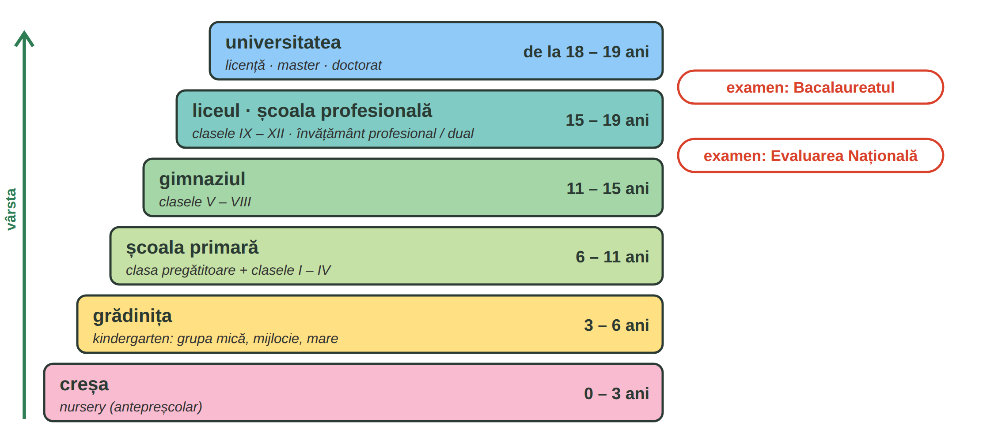
Fig. 10.1 — Sistemul de educație din România (vârste aproximative) / The Romanian education system (approximate ages)
Pre-university education is regulated by Law no. 198/2023. Public education is free in state schools. After clasa a VIII-a pupils take the Evaluarea Națională; after the liceu, the Bacalaureatul, which gives access to university. Instead of a liceu, pupils can go to a școală profesională (vocational school, also dual, with training at a company).
AT SCHOOL | ENGLISH | AT SCHOOL | ENGLISH
elevul · eleva | pupil | studentul · studenta | university student
învățătoarea | primary school teacher | profesorul · profesoara | teacher
dirigintele · diriginta | class teacher (form tutor) | ședința cu părinții | parents' meeting
nota (1–10) · media | mark (1–10) · average | calificativul (FB, B, S, I) | mark in primary school
anul școlar · vacanța | school year · holiday | catalogul | the class register

In gymnasium and high school marks go from 1 to 10; 5 is the minimum to pass. In primary school pupils get calificative: Foarte bine, Bine, Suficient, Insuficient.
10.3 Which level?
Write: grădiniță · școala primară · gimnaziu · liceu · universitate.
1. Un copil de 4 ani merge la ______________. | 2. Clasele V – VIII sunt la ______________.
3. Bacalaureatul se dă la sfârșitul ______________. | 4. Clasa pregătitoare e la ______________.

CUVINTE ȘI EXPRESII UZUALE / USEFUL WORDS AND PHRASES
a învăța · a preda | to learn · to teach | temele | homework
a trece clasa | to pass the year | absențele | absences
uniforma școlară | school uniform | after-school | after-school club

Lesson 10.4 — Enrolling a child at school / Înscrierea la școală
NR. | THE STEP | ENGLISH
1 | afli școala de circumscripție (the school for your address) și calendarul înscrierilor | find the school for your address and the enrolment dates
2 | mergi la secretariatul școlii și ceri lista de acte | go to the school office and ask for the list of documents
3 | de obicei: cererea, certificatul de naștere al copilului, actele părinților (pașaportul, permisul de ședere) | usually: the application, the child's birth certificate, the parents' documents
4 | dacă copilul a învățat în altă țară: documentele școlare și evaluarea pentru a stabili clasa | if the child studied abroad: school documents and an assessment to decide the class
5 | dacă nu vorbește română: un curs de inițiere în limba română, gratuit, organizat de inspectoratul școlar | if the child does not speak Romanian: a free Romanian initiation course organised by the county school inspectorate

ATTENTION — THE RIGHT TO EDUCATION
Children of foreigners who live legally in Romania have access to the Romanian state schools; the county inspectoratul școlar (ISJ / ISMB) decides the class after studies abroad and organises the free Romanian language course (Ministry of Education; IGI — „Acces la educație”). The exact documents and dates change every year — ask the school office.

AT THE SCHOOL OFFICE | ENGLISH
Bună ziua! Aș dori să-mi înscriu fiul în clasa a II-a. | Hello! I would like to enrol my son in year 2.
Ce acte ar trebui să aduc? | Which documents should I bring?
A învățat doi ani în Nepal. Ați putea să-mi spuneți cum se recunoaște? | He studied two years in Nepal. Could you tell me how it is recognised?
Nu vorbește încă bine românește. Există un curs de limba română? | He doesn't speak Romanian well yet. Is there a Romanian course?

10.4 Correct order
Write 1–4.
___ Aduc actele la secretariat. | ___ Aflu care e școala de circumscripție.
___ Copilul începe școala. | ___ Cer lista de acte.

CUVINTE ȘI EXPRESII UZUALE / USEFUL WORDS AND PHRASES
secretariatul | school office | a înscrie | to enrol
circumscripția școlară | school catchment area | inspectoratul școlar | county school inspectorate
echivalarea studiilor | recognition of studies | certificatul de naștere | birth certificate

GREȘELI FRECVENTE LA SCRIS / COMMON WRITING MISTAKES
WRITE | WHAT IT IS | EXAMPLE | THE TEST
ia | from a lua: he / she takes · Take! | Maria ia autobuzul. · Ia o foaie! | you can say iau: eu iau
i-a | îi + a — to him / her + has | Profesorul i-a dat o notă. · I-a spus. | you can say i-am: i-am dat
sau | or | Cash sau cu cardul? | you can say ori
s-au | se + au — the past, many people | Copiii s-au înscris. · S-au dus. | singular: s-a înscris

HOMEWORK — AFTER SESSION 38 / TEMĂ PENTRU ACASĂ
H38.1 Write five sentences about school in your country and compare with Romania: În țara mea, școala începe la... În România...
H38.2 Write the questions you would ask at the school office (four questions with the conditional).

SESSION 39 — THE BANK
SESIUNEA 39 — BANCA · 3 hours

By the end of this session you will be able to:
☐ | open a bank account: what to bring, what to ask
☐ | name the types of accounts and bank words
☐ | use the card, the PIN, the ATM and read a statement
☐ | protect your money: never give your PIN or codes

Lesson 10.5 — Opening a bank account / Deschiderea unui cont
WHAT TO BRING (usually) | WHY
pașaportul și permisul de ședere | the bank must identify you; the permit has your personal number (CNP)
uneori: contractul de muncă sau o adeverință de salariu | some banks ask where your money comes from
uneori: o dovadă a adresei | e.g. a rental contract or a bill
telefonul și adresa de e-mail | for the codes and the mobile app

ATTENTION — YOUR RIGHT TO A BASIC ACCOUNT
Every bank has its own list of documents — ask before you go. By law, consumers who live legally in the European Union have the right to a cont de plăți cu servicii de bază (basic payment account) and banks may not discriminate on grounds of nationality or place of residence (Law no. 258/2017). Read the fees (comisioanele) before you sign.

BANK WORD | ENGLISH | BANK WORD | ENGLISH
contul curent | current account | contul de economii | savings account
contul de salariu | salary account | depozitul | term deposit
IBAN-ul (RO + 22 caractere) | account number (24 characters) | transferul · plata | transfer · payment
comisionul | fee | soldul | balance
creditul · împrumutul | loan | dobânda | interest

AT THE BANK | ENGLISH
C: Bună ziua! Aș dori să deschid un cont curent. | Hello! I would like to open a current account.
B: Sigur. Aveți pașaportul și permisul de ședere? | Of course. Do you have your passport and residence permit?
C: Da, poftiți. Ați putea să-mi spuneți ce comisioane are contul? | Yes, here you are. Could you tell me what fees the account has?
B: Administrarea costă ... lei pe lună. Vă dăm și un card de debit. | The account fee is ... lei a month. We'll also give you a debit card.
C: Aș vrea și aplicația pe telefon. Pot să primesc salariul în acest cont? | I'd also like the phone app. Can I receive my salary in this account?
B: Da. Dați-i angajatorului IBAN-ul, pe care îl găsiți în contract și în aplicație. | Yes. Give your employer the IBAN, which you find in the contract and in the app.

10.5 At the bank
Complete with: cont · IBAN-ul · comisioane · pașaportul.
1. Aș dori să deschid un ______________. | 2. Am adus ______________ și permisul.
3. Ce ______________ are contul? | 4. Îi dau angajatorului ______________.

CUVINTE ȘI EXPRESII UZUALE / USEFUL WORDS AND PHRASES
a deschide · a închide un cont | to open · close an account | titularul contului | account holder
a semna contractul | to sign the contract | ghișeul · consilierul bancar | counter · bank adviser
programarea online | online appointment | sucursala · agenția | branch

Lesson 10.6 — Card, PIN, ATM, statement / Cardul, PIN-ul, bancomatul, extrasul
AT THE ATM / LA BANCOMAT | ENGLISH
Introduceți cardul. · Introduceți codul PIN. | Insert your card. · Enter your PIN.
Retragere numerar · Interogare sold | Cash withdrawal · Balance enquiry
Alegeți suma. · Doriți chitanță? | Choose the amount. · Would you like a receipt?
Ridicați cardul. · Ridicați banii. | Take your card. · Take your money.

Extrasul de cont (the statement) shows every payment: the date, the amount, încasare (money in) or plată (money out), and the sold (balance). You see it in the app or ask for it at the bank.
ATTENTION — PROTECT YOUR MONEY
Never tell anyone your PIN or the codes you receive by SMS — not even someone who says they are from the bank. The bank never asks for them by phone, SMS or e-mail. If you lose your card, block it at once in the app or by calling the bank (the number is on the back of the card and on the bank's website). More about scams in Module 11.

10.6 What do you do?
Write one sentence.
1. Vrei să scoți 200 de lei. → ______________________ | 2. Ai pierdut cardul. → ______________________
3. Cineva te sună și îți cere codul PIN. → ______________________ | 4. Vrei să vezi cât ai în cont. → ______________________

CUVINTE ȘI EXPRESII UZUALE / USEFUL WORDS AND PHRASES
a retrage bani · a depune bani | to withdraw · to deposit money | a bloca cardul | to block the card
cardul contactless | contactless card | plata a fost respinsă | the payment was declined
codul de confirmare | confirmation code | furtul · frauda | theft · fraud

GREȘELI FRECVENTE LA SCRIS / COMMON WRITING MISTAKES
WRITE | WHAT IT IS | EXAMPLE | THE TEST
va | the future: he / she will (Lesson 3.16) | Banca va fi deschisă. · Va veni mâine. | a verb follows: va veni
v-a | vă + a — to you + has | Banca v-a trimis codul. · V-a sunat. | you can say v-am: v-am trimis
numai | only (= doar) | Am numai 50 de lei. | you can say doar
nu mai | not ... any more / no more | Nu mai am bani. · Nu mai lucrez acolo. | it is nu + mai: the negative

HOMEWORK — AFTER SESSION 39 / TEMĂ PENTRU ACASĂ
H39.1 Write the list of documents you would bring to open an account, and three questions for the bank.
H39.2 Look at a statement in your bank app. Write in Romanian: the date, one payment, the balance.

SESSION 40 — ROMANIA TODAY, RECAP AND TEST
SESIUNEA 40 — ROMÂNIA DE AZI, RECAPITULARE ȘI TEST · 3 hours

By the end of this session you will be able to:
☐ | describe the coat of arms and its five fields
☐ | name the anthem and the days of the flag and the anthem
☐ | tell briefly about communism, the 1989 Revolution and Schengen
☐ | recognise six famous Romanians

RECAP — ALREADY IN MODULE 5 (Lessons 5.1 and 5.6)
The flag, the currency (leu), the capital, the regions, 24 January 1859 (the Union of the Principalities), 1 December 1918 (the Great Union), NATO (2004) and the EU (2007). They are not repeated here — see them on the timeline in Fig. 10.3.

Lesson 10.7 — The coat of arms and the anthem / Stema și imnul
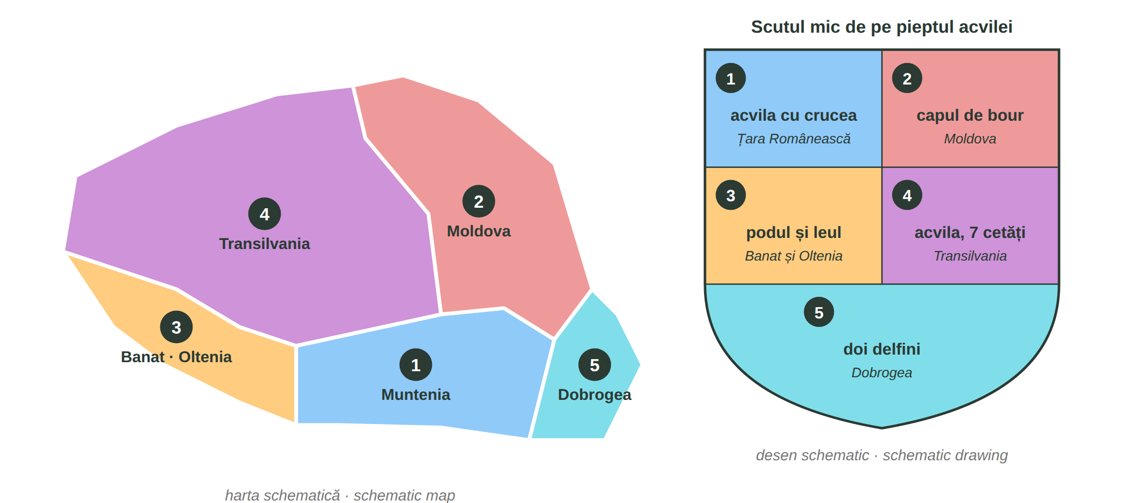
Fig. 10.2 — Cele cinci câmpuri ale stemei și regiunile lor / The five fields of the coat of arms and their regions
The coat of arms (stema) shows a golden eagle on blue, with a crown, holding an Orthodox cross, a sword and a sceptre. On its chest is a small shield with five fields, one for each group of historical regions (Law no. 102/1992, amended by Law no. 146/2016).
SYMBOL | WHAT / WHEN | SYMBOL | WHAT / WHEN
Imnul național | „Deșteaptă-te, române!” — versuri Andrei Mureșanu, muzica Anton Pann, 1848 | Ziua Imnului | 29 iulie (Law 99/1998)
Ziua Drapelului | 26 iunie (Law 96/1998) — the tricolour adopted in 1848 | Stema | eagle + 5 fields (Fig. 10.2)

10.7 Which field?
Look at Fig. 10.2 and write the region.
1. capul de bour → ______________ | 2. cei doi delfini → ______________
3. podul și leul → ______________ | 4. acvila cu crucea (câmpul 1) → ______________

CUVINTE ȘI EXPRESII UZUALE / USEFUL WORDS AND PHRASES
stema · scutul | coat of arms · shield | acvila · coroana | eagle · crown
imnul național | national anthem | versurile · muzica | the lyrics · the music

Lesson 10.8 — Recent history / Istoria recentă
Communism (1947–1989). On 30 December 1947 King Mihai I was forced to abdicate and the Republica Populară Română was proclaimed. For more than 40 years one party ruled; there were no free elections, no free press and no free travel. From 1965 the leader was Nicolae Ceaușescu; in the 1980s food and energy were rationed.
The Revolution (December 1989). The protests began on 16 December 1989 in Timișoara and reached Bucharest; on 22 December the communist regime fell. More than a thousand people were killed. In 1990 Romania held its first free elections, and in 1991 it adopted a democratic Constitution.
Schengen. Romania joined the Schengen area in two steps: controls at air and sea borders ended on 31 March 2024, and at land borders on 1 January 2025 (Romanian Border Police). You still need a valid document to travel — for you, the passport and the residence permit.
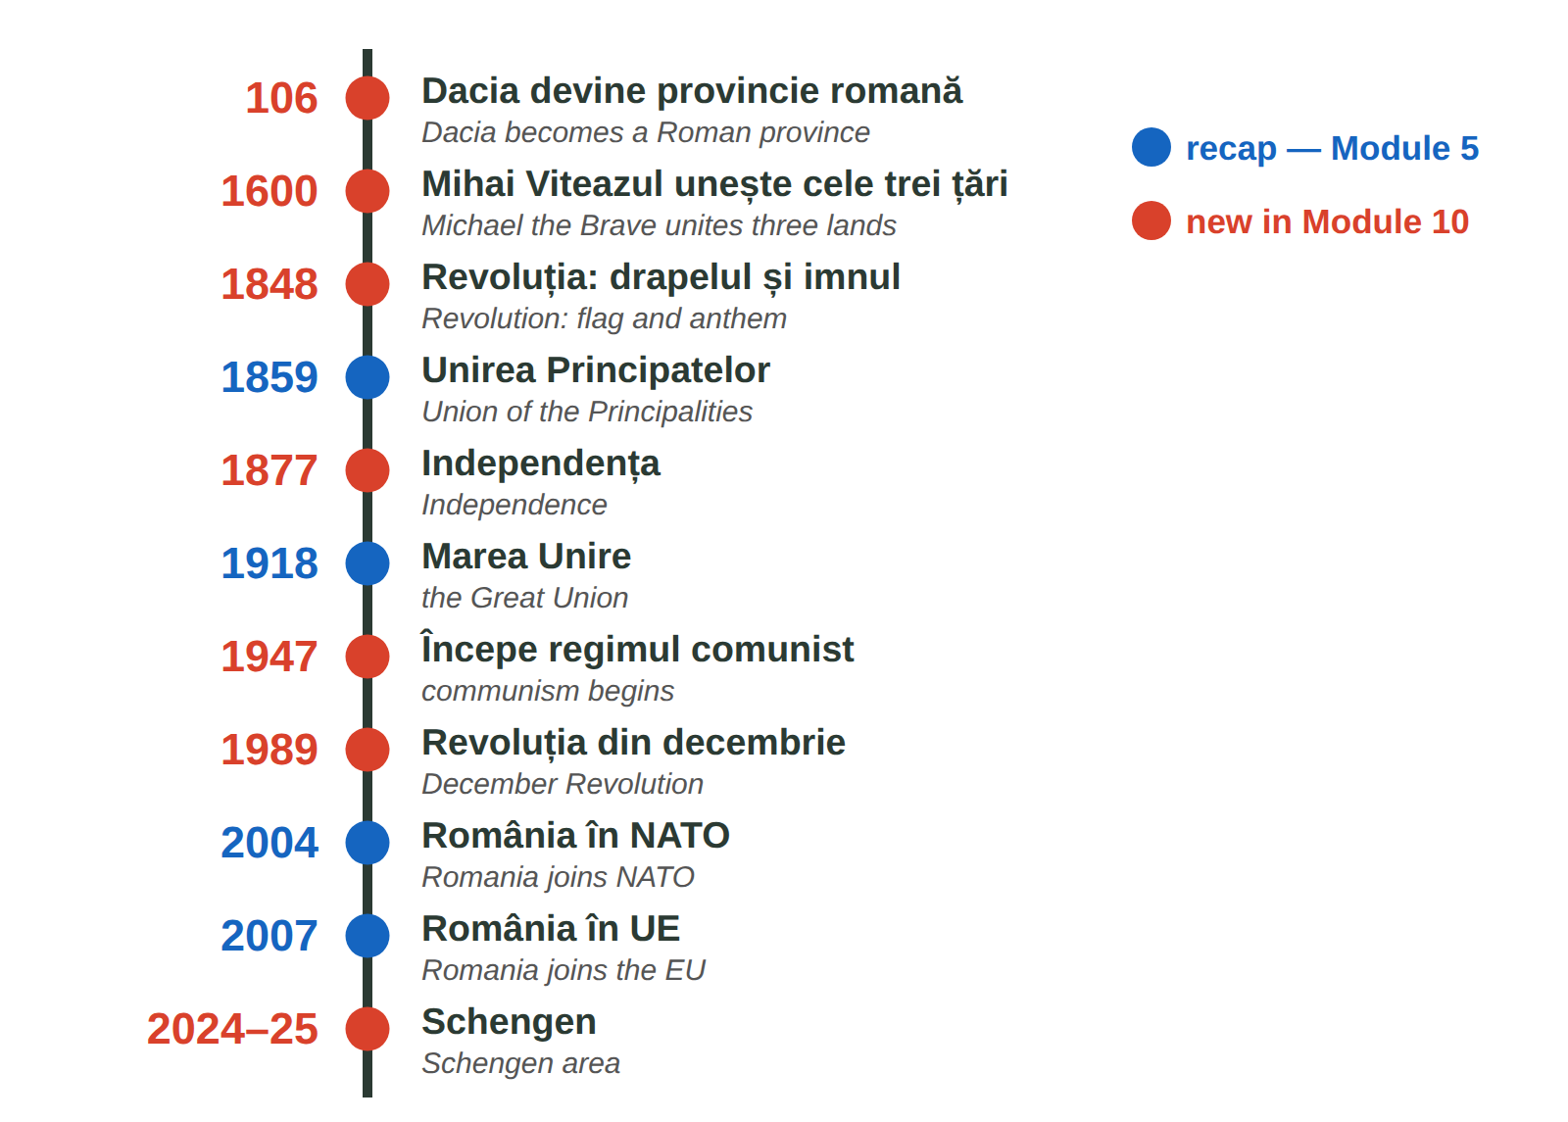
Fig. 10.3 — Axa timpului: istoria României / Timeline of Romanian history
10.8 Which year?
Write the year.
1. Revoluția din decembrie → ______ | 2. Schengen aerian și maritim → ______
3. Începe regimul comunist → ______ | 4. Marea Unire (recap) → ______

CUVINTE ȘI EXPRESII UZUALE / USEFUL WORDS AND PHRASES
regimul comunist | communist regime | dictatura · libertatea | dictatorship · freedom
alegerile libere | free elections | frontiera · controlul | border · check

Lesson 10.9 — Famous Romanians / Personalități românești
FOTO:  Mihai Eminescu | Mihai Eminescu (1850–1889) — the national poet. His poem Luceafărul is read in every school. — poetul național | FOTO:  Constantin Brâncuși | Constantin Brâncuși (1876–1957) — sculptor, a founder of modern sculpture; Coloana fără sfârșit is in Târgu Jiu. — sculptor
FOTO:  George Enescu | George Enescu (1881–1955) — composer and violinist; the Romanian Rhapsodies. The Enescu Festival is held in Bucharest. — compozitor | FOTO:  Nadia Comăneci | Nadia Comăneci (b. 1961) — gymnast, the first perfect 10 in Olympic history, Montreal 1976. — gimnastă
FOTO:  Henri Coandă | Henri Coandă (1886–1972) — engineer and inventor, pioneer of aerodynamics (the Coandă effect); Bucharest airport bears his name. — inventator | FOTO:  Gheorghe Hagi | Gheorghe Hagi (b. 1965) — footballer, captain of the national team, called Regele (the King). — fotbalist

10.9 Who is it?
Write the name.
1. primul 10 la Olimpiadă → ______________ | 2. Coloana fără sfârșit → ______________
3. poetul național → ______________ | 4. aeroportul din București → ______________

CUVINTE ȘI EXPRESII UZUALE / USEFUL WORDS AND PHRASES
celebru · cunoscut | famous · well known | s-a născut în | he / she was born in
opera | the work (of art) | campion · campioană | champion

Lesson 10.10 — Recap / Recapitulare
PATTERN · TOPIC | EXAMPLE | LESSON
aș / ai / ar / am / ați / ar + verb | Aș vrea. Ați putea repeta? | 10.2
email: Stimată doamnă... Cu stimă | Vă scriu în legătură cu... | 10.1
grădiniță → primar → gimnaziu → liceu → universitate | Evaluarea Națională · Bacalaureatul | 10.3
cont · IBAN · card · PIN · extras | Nu dau niciodată PIN-ul. | 10.5–10.6
stema: 5 câmpuri · imnul: 1848 · 26 iunie · 29 iulie | Deșteaptă-te, române! | 10.7
1947 · 1989 · 2024–2025 Schengen | Revoluția a început la Timișoara. | 10.8

GREȘELI FRECVENTE LA SCRIS / COMMON WRITING MISTAKES
WRITE | WHAT IT IS | EXAMPLE | THE TEST
odată | once (in the past), at some time · odată cu = together with | Am fost odată la Cluj. · Odată cu salariul... | it is not a number
o dată | one time (a number) · also: a date | Merg la bancă o dată pe lună. | you can say de două ori
niciun | no, not a (masculine / neuter) — one word | Nu am niciun frate. · niciun document | always together
nicio | no, not a (feminine) — one word | Nu e nicio problemă. | always together

10.10 Everything together
Circle the correct form.
1. ( Aș / Am ) vrea o programare. | 2. Nu e ( nicio / nici o ) problemă.
3. Trebuie ( să / s-a ) semnez. | 4. Banca ( va / v-a ) trimis codul.
5. Merg ( o dată / odată ) pe săptămână. | 6. ( Nu mai / Numai ) am bani.

HOMEWORK — AFTER SESSION 40 / TEMĂ PENTRU ACASĂ
H40.1 Write five sentences about Romania today with the new facts from Lessons 10.7–10.8.
H40.2 Choose one famous person from your country and write three sentences about them, like in Lesson 10.9.

SECȚIUNE DETAȘABILĂ — EXEMPLAR FORMATOR
Detachable section — teacher's copy. Se detașează din suportul cursantului; testul completat, semnat și datat, se păstrează la dosarul cursantului. Conține: testul cumulativ, fișa de confirmare a Sesiunii 40, fișa de evidență a Modulului 10, cheia răspunsurilor, sursele.
TEST CUMULATIV — MODULUL 10
MODULE 10 — CUMULATIVE TEST · grilă, 20 de întrebări, 20 de puncte · semnat și datat de cursant

Nume și prenume cursant / Student name
Data / Date | _____ / _____ / 20_____
Semnătura cursantului / Student signature

Marcați cu X un singur răspuns la fiecare întrebare. Mark ONE answer with X for each question. Each correct answer = 1 point.
1. Care formulă este potrivită la începutul unui e-mail oficial? (1 p)
☐ a) Salut, frate! | ☐ b) Stimată doamnă Popescu, | ☐ c) Hei! | ☐ d) Pa!
2. „Cu stimă” se scrie: (1 p)
☐ a) la începutul e-mailului | ☐ b) la sfârșitul e-mailului, înainte de nume | ☐ c) în subiect | ☐ d) nicăieri
3. Completează: „Eu ___ vrea o programare.” (1 p)
☐ a) aș | ☐ b) ar | ☐ c) ați | ☐ d) am
4. Completează: „___ putea repeta, vă rog?” (dumneavoastră) (1 p)
☐ a) Aș | ☐ b) Ați | ☐ c) Ar | ☐ d) Ai
5. „Mi-ar plăcea” înseamnă: (1 p)
☐ a) I liked | ☐ b) I would like | ☐ c) I like | ☐ d) I will like
6. Care cerere este cea mai politicoasă? (1 p)
☐ a) Vreau un formular! | ☐ b) Dă-mi un formular! | ☐ c) Aș avea nevoie de un formular, vă rog. | ☐ d) Formular!
7. Clasele V – VIII formează: (1 p)
☐ a) grădinița | ☐ b) gimnaziul | ☐ c) liceul | ☐ d) universitatea
8. Examenul de la sfârșitul liceului este: (1 p)
☐ a) Evaluarea Națională | ☐ b) Bacalaureatul | ☐ c) licența | ☐ d) masteratul
9. În gimnaziu, nota minimă de trecere este: (1 p)
☐ a) 1 | ☐ b) 3 | ☐ c) 5 | ☐ d) 10
10. Pentru un copil care nu vorbește româna, inspectoratul școlar organizează: (1 p)
☐ a) un curs gratuit de inițiere în limba română | ☐ b) un examen de admitere plătit | ☐ c) nimic | ☐ d) un curs obligatoriu de engleză
11. Pentru a deschide un cont, un cetățean străin aduce de obicei: (1 p)
☐ a) numai telefonul | ☐ b) pașaportul și permisul de ședere | ☐ c) certificatul de naștere | ☐ d) diploma de liceu
12. IBAN-ul este: (1 p)
☐ a) codul PIN | ☐ b) numărul contului | ☐ c) parola aplicației | ☐ d) soldul
13. Cineva te sună și îți cere codul PIN. Ce faci? (1 p)
☐ a) i-l spui | ☐ b) nu i-l spui niciodată | ☐ c) i-l trimiți pe SMS | ☐ d) i-l scrii pe e-mail
14. „Retragere numerar” la bancomat înseamnă: (1 p)
☐ a) cash withdrawal | ☐ b) balance enquiry | ☐ c) deposit | ☐ d) transfer
15. Câte câmpuri are scutul mic al stemei? (1 p)
☐ a) 3 | ☐ b) 4 | ☐ c) 5 | ☐ d) 7
16. Cei doi delfini de pe stemă reprezintă: (1 p)
☐ a) Moldova | ☐ b) Dobrogea | ☐ c) Banatul | ☐ d) Transilvania
17. Ziua Imnului Național este: (1 p)
☐ a) 1 decembrie | ☐ b) 26 iunie | ☐ c) 29 iulie | ☐ d) 24 ianuarie
18. Revoluția din 1989 a început la: (1 p)
☐ a) Iași | ☐ b) Timișoara | ☐ c) Constanța | ☐ d) Cluj
19. România a intrat complet în Schengen (și la frontierele terestre) pe: (1 p)
☐ a) 1 ianuarie 2007 | ☐ b) 31 martie 2024 | ☐ c) 1 ianuarie 2025 | ☐ d) 1 decembrie 1918
20. Care propoziție este scrisă corect? (1 p)
☐ a) Nu e nici o problemă. | ☐ b) Nu e nicio problemă. | ☐ c) Nu e nicioproblemă. | ☐ d) Nu e niciun problemă.

PUNCTAJ OBȚINUT / SCORE | _______ / 20
Semnătura formatorului / Teacher signature

SESSION COMPLETION RECORD
FIȘĂ DE CONFIRMARE A PARCURGERII SESIUNII — se păstrează la dosar

Module / Modul | Modulul 10 — Politețe, educație, banca și România de azi (finalizat)
Session / Sesiunea | Sesiunea 40 — România de azi, recapitulare. TEST CUMULATIV MODULUL 10
Duration / Durata | 3 ore
Date / Data | _____ / _____ / 20_____
Student name / Nume și prenume cursant
Score / Punctaj obținut | _______ / 20
Student signature / Semnătura cursantului
Teacher signature / Semnătura formatorului

DECLARAȚIE CURSANT / STUDENT DECLARATION
Declar că am participat la această sesiune de curs și am parcurs conținutul prezentat mai sus.
I declare that I attended this course session and covered the content presented above.

MODULE 10 — COMPLETION RECORD
FIȘĂ DE EVIDENȚĂ A PARCURGERII MODULULUI 10 — se păstrează la dosarul cursantului

Cursant / Student
Act de identitate / ID document
Angajator / Employer
Formator / Teacher
Modul / Module | Modulul 10 — Politețe, educație, banca și România de azi (12 ore, Sesiunile 37–40)

NR. | SESIUNE / CONȚINUT | DATA | PUNCTAJ TEST | SEMNĂTURA CURSANTULUI
37 | Sesiunea 37 — Formule de politețe, condiționalul de politețe (3 ore) |  | —
38 | Sesiunea 38 — Sistemul educațional, înscrierea la școală (3 ore) |  | —
39 | Sesiunea 39 — Contul bancar, cardul, bancomatul, extrasul (3 ore) |  | —
40 | Sesiunea 40 — România de azi, recapitulare + TEST CUMULATIV (3 ore) |  | ___ / 20

CONFIRMARE FINALIZARE MODUL / MODULE COMPLETION
Confirm că cursantul a parcurs integral conținutul Modulului 10 — Politețe, educație, banca și România de azi, în total 12 ore de curs, și a susținut testul de evaluare consemnat mai sus.
I confirm that the student completed the full content of Module 10 — Politeness, Education, Banking and Romania Today, 12 course hours in total, and sat the assessment recorded above.
Data: _____ / _____ / 20_____ Semnătura formatorului: ______________________

ANSWER KEY — TEACHER COPY
CHEIA RĂSPUNSURILOR — pentru formator

10.1 5 · 1 · 2 · 4 · 3
10.2 Aș vrea un formular. · Ați putea repeta? · Am vrea o masă pentru doi. · Mi-ar plăcea să lucrez aici. · Ați vrea o cafea? · Aș avea nevoie de ajutor.
10.3 grădiniță · gimnaziu · liceului · școala primară 10.4 3 · 1 · 4 · 2
10.5 cont · pașaportul · comisioane · IBAN-ul
10.6 e.g. Merg la bancomat, introduc cardul și PIN-ul, aleg 200 de lei. · Blochez cardul în aplicație / sun la bancă. · Nu i-l spun. Închid. · Mă uit în aplicație / cer extrasul.
10.7 Moldova · Dobrogea · Banat și Oltenia · Țara Românească 10.8 1989 · 2024 · 1947 · 1918
10.9 Nadia Comăneci · Constantin Brâncuși · Mihai Eminescu · Henri Coandă
10.10 Aș · nicio · să · v-a · o dată · Nu mai

Cumulative test — grilă answer key
TOTAL: 20 de puncte. Un răspuns corect = 1 punct. Nemarcat sau dublu marcat = 0 puncte.
1 – b | 2 – b | 3 – a | 4 – b | 5 – b | 6 – c | 7 – b | 8 – b | 9 – c | 10 – a
11 – b | 12 – b | 13 – b | 14 – a | 15 – c | 16 – b | 17 – c | 18 – b | 19 – c | 20 – b

Surse și data verificării / Sources and date of verification
Informațiile factuale și legale din acest modul au fost verificate la 24.09.2026 pe surse oficiale. The factual and legal information was checked on 24 September 2026 against official sources.
INFORMAȚIA / INFORMATION | SURSA / SOURCE | UNDE ÎN MODUL / WHERE
Structura învățământului preuniversitar; gratuitatea învățământului de stat | Legea nr. 198/2023 a învățământului preuniversitar — legislatie.just.ro/public/DetaliiDocument/271896; edu.ro | Lesson 10.3
Accesul la educație al copiilor străini; curs gratuit de inițiere în limba română; evaluarea pentru stabilirea clasei (ISJ/ISMB) | IGI — „Acces la educație” (igi.mai.gov.ro); Ministerul Educației — „Elevi non-UE” (edu.ro) | Lesson 10.4, test q. 10
Dreptul la cont de plăți cu servicii de bază; nediscriminarea pe criteriul cetățeniei sau al reședinței | Legea nr. 258/2017 — legislatie.just.ro/Public/DetaliiDocumentAfis/196233; ANPC | Lesson 10.5
Stema României: acvila, scutul mic cu cinci câmpuri; coroana (2016) | Legea nr. 102/1992 privind stema țării și sigiliul statului — .../DetaliiDocument/2381; Legea nr. 146/2016 | Lesson 10.7, test q. 15–16
Imnul: versuri Andrei Mureșanu, muzica Anton Pann, 1848; Ziua Imnului 29 iulie | Administrația Prezidențială — „Imnul României” (presidency.ro); Legea nr. 99/1998 | Lesson 10.7, test q. 17
Ziua Drapelului 26 iunie (tricolorul decretat în 1848) | Legea nr. 96/1998; MApN, MAE | Lesson 10.7
Revoluția: 16 decembrie 1989 Timișoara, 22 decembrie căderea regimului; peste o mie de morți; regimul comunist | Administrația Prezidențială; Guvernul României; Raportul final CPADCR (iiccmer.ro) | Lesson 10.8, test q. 18
Schengen: frontiere aeriene și maritime 31.03.2024; terestre 01.01.2025 | Poliția de Frontieră Română (politiadefrontiera.ro); MAI — schengen.mai.gov.ro | Lesson 10.8, test q. 19
Scrierea „niciun / nicio” | DOOM2 — normele ortografice ale Academiei Române | Lesson 10.10, test q. 20
Lecțiile anterioare citate | Modulele 2–8: 2.6, 2.10, 3.11, 3.16, 4.4, 5.1, 5.2, 5.6, 8.7 | whole module

Datele despre personalități (ani de naștere, opere cunoscute) sunt informații culturale generale. Lista de acte pentru școală și bancă diferă de la o instituție la alta — cursantul întreabă înainte. / Facts about famous people are general cultural information; document lists differ between schools and banks.

