LIMBA ROMÂNĂ PENTRU STRĂINI
Romanian Language for Foreign Workers

SUPORT DE CURS

MODULE 1 — THE ALPHABET, WRITING AND PRONUNCIATION
MODULUL 1 — ALFABETUL, SCRISUL ȘI PRONUNȚIA

LEVEL / NIVEL | DURATION / DURATĂ | LANGUAGE OF TEACHING
A1 — absolute beginner | 12 hours · Sessions 1–4 · Weeks 1–2 | English → Romanian

LEGAL BASIS / TEMEI LEGAL
Curs de limbă română cu elemente de integrare culturală și socială, organizat în conformitate cu O.U.G. nr. 32/2026, art. 7 alin. (1) lit. g) — minimum 6 luni, cel puțin 6 ore pe săptămână.
Romanian language course with cultural and social integration elements, delivered under Government Emergency Ordinance 32/2026. This module ends with ONE cumulative multiple-choice test (20 questions), signed and dated by the student and kept on file as proof of completion. There is no separate test after each session.

How to use this book
This book teaches the Romanian alphabet, how to read it, and how to write it to adults who already live and work in Romania. All explanations are in English. Everything you have to learn, read, say and write is in Romanian.

For the student
1 | Read the English explanation first. Then look at the picture or the pattern box. Then say the Romanian words out loud.
2 | Write in this book. Every empty line and every dotted line is for you.
3 | Do not skip the handwriting pages. If your first language uses a different alphabet, they are the most important part of Module 1.
4 | Each lesson ends with one short exercise. Do it only after you have read all the examples.
5 | At the end of Module 1 you take one test. You mark X in a box, then sign and date it. Your signature on the lesson plan is your proof that you attended each session.

For the teacher
TEACHING NOTES
Every lesson follows the same rhythm: EXPLAIN (English) → SHOW (pattern box or picture) → SAY (chorus, then individually) → WRITE (in the book) → CHECK (one exercise).
Letters are never taught as names only. Each letter always comes with a Romanian word from everyday life.
Fig. 1 and Fig. 3 are printed handwriting sheets inside this book. Fig. 2 (cursive model) and the spaces marked FOTO are for real photos or scans — insert them before printing.
The test, the completion records and the answer key are in the detachable section at the end. Remove it from the student copy.

Symbols used in this book
IPA | Sounds are written between slashes, for example /k/. This is the International Phonetic Alphabet. You do not need to learn it — it is there so the sound is never ambiguous.
bold | Romanian words are always printed in bold serif type: bună ziua.
~~italic~~ | The English meaning is printed in grey italics: apă — water
TIPAR | A green pattern box. This is the rule. Learn the pattern, not the English explanation.
Fig. / FOTO | A handwriting sheet or a photo.

Where this module sits in the course
SESSION | DURATION | CONTENT
Session 1 | 3 hours | Lesson 1.1 The alphabet · 1.2 Vowels and consonants · 1.3 The five Romanian letters · 1.4 K, Q, W, Y · 1.5 Handwriting
Session 2 | 3 hours | Lesson 2.1 Read as written · 2.2 C · 2.3 G · 2.4 CH and GH · 2.5 X · 2.6 Diphthongs and triphthongs
Session 3 | 3 hours | Lesson 3.1 Syllables · 3.2 Stress · 3.3 Capital letters and punctuation · 3.4 Real pronunciation
Session 4 | 3 hours | Lesson 4.1 The cratima (-) · 4.2 Spelling traps · 4.3 Practical writing: dates and forms · 4.4 Module recap · Module 1 cumulative test

SESSION 1 — THE LETTERS
SESIUNEA 1 — LITERELE · 3 hours · Saturday 9:00 – 12:00

By the end of this session you will be able to:
☐ | say all 31 letters of the Romanian alphabet out loud
☐ | tell a vowel from a consonant
☐ | recognise and write the five letters that exist only in Romanian: ă, â, î, ș, ț
☐ | explain why k, q, w and y are in the alphabet but not in Romanian words
☐ | write every letter in print, uppercase and lowercase, and read the cursive forms

Lesson 1.1 — The Romanian alphabet
The Romanian alphabet has 31 letters. It uses the same Latin letters as English, plus five letters that English does not have: ă, â, î, ș, ț.
Four letters — k, q, w, y — appear almost only in foreign words, names and units of measurement. Q, w and y were officially added to the alphabet only in 1982; k was already in use. You will see them on packaging, on signs and in names, almost never in a Romanian word.
THE GOOD NEWS
Romanian is read almost exactly as it is written. Once you know the 31 letters, the 8 letter groups of Session 2 and the two speech habits of Lesson 3.4, you can read any Romanian word out loud correctly — even a word you have never seen before. English does not work this way.

The table of letters
Read across each row: the letter in print, uppercase and lowercase (gold = the five Romanian letters, dashed grey = the four visitor letters); the name of the letter in Romanian (this is what you say when you spell a word on the phone); the sound in IPA; how to make the sound; and one Romanian word to remember it by.
LETTER | NAME | SOUND | HOW TO SAY IT | EXAMPLE
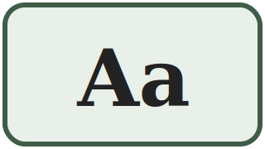 | a | /a/ | like the a in father, but shorter | apă water
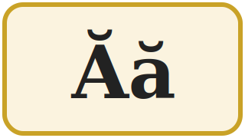 | ă | /ə/ | like the e in the (said fast) | casă house
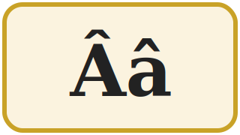 | â din a | /ɨ/ | no English sound: say i with a relaxed mouth | mână hand
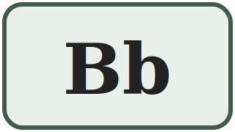 | be | /b/ | like the b in book | bun good
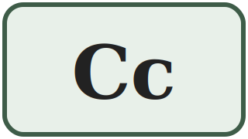 | ce | /k/ /tʃ/ | car — but church before e and i | casă / cinci house / five
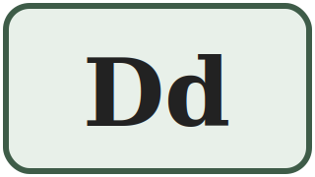 | de | /d/ | like the d in door | doi two
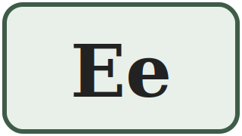 | e | /e/ | like the e in bed | elev pupil
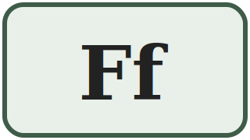 | ef | /f/ | like the f in fire | foc fire
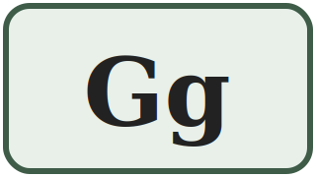 | ghe | /ɡ/ /dʒ/ | good — but gentle before e and i | gară / ger station / frost
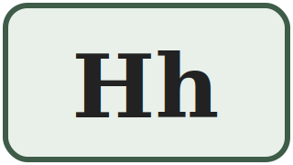 | haș | /h/ | like the h in house — never silent on its own | hartă map
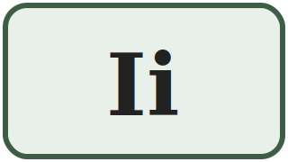 | i | /i/ | like the ee in see | inimă heart
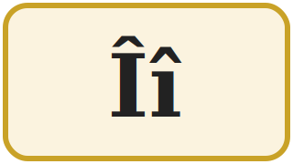 | î din i | /ɨ/ | exactly the same sound as â | început beginning
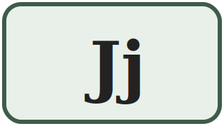 | je | /ʒ/ | like the s in measure | jos down
 | ca | /k/ | like the k in kilo — loanwords only | kilogram kilogram
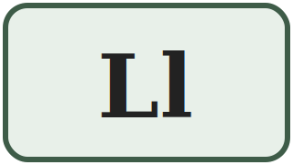 | el | /l/ | like the l in light | lapte milk
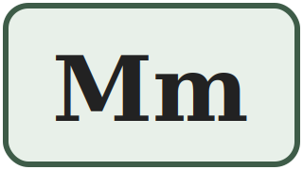 | em | /m/ | like the m in man | masă table
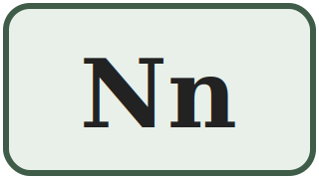 | en | /n/ | like the n in no | nou new
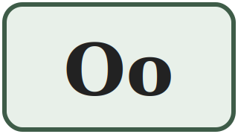 | o | /o/ | like the o in more, but shorter | om man / person
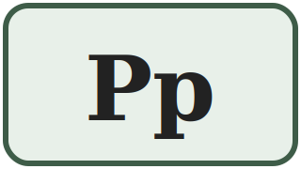 | pe | /p/ | like the p in spin — no puff of air | pâine bread
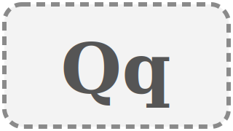 | chiu / cu | /k/ | foreign words and names only | Qatar Qatar
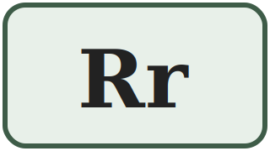 | er | /r/ | a short rolled r, like in Italian | roșu red
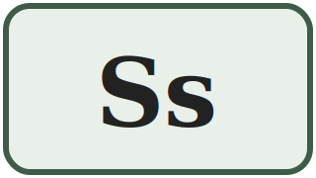 | es | /s/ | like the s in sun | sare salt
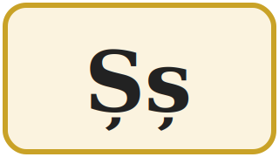 | șe | /ʃ/ | like the sh in shop | șapte seven
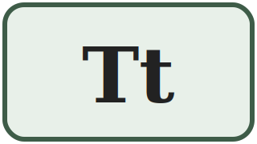 | te | /t/ | like the t in stop — no puff of air | trei three
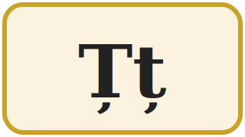 | țe | /ts/ | like the ts in cats | țară country
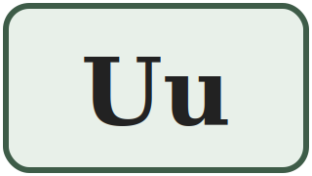 | u | /u/ | like the oo in book | unu one
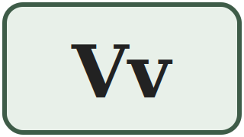 | ve | /v/ | like the v in very | verde green
 | dublu ve | /v/ /w/ | loanwords only: v or w | weekend weekend
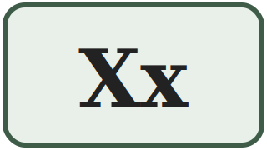 | ics | /ks/ /ɡz/ | taxi — but exam in a few words | taxi taxi
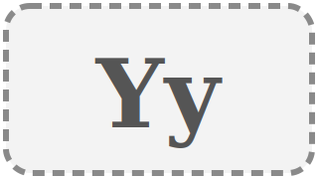 | i grec | /i/ /j/ | loanwords and names only | yoga yoga
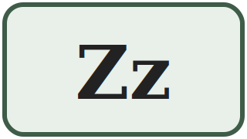 | ze | /z/ | like the z in zero | zero zero

SPELLING ON THE PHONE
When you spell a word on the phone in Romania, you use the letter NAMES: A-N-A is said a – en – a. For â and î you must say â din a and î din i — otherwise nobody knows which one you mean.
1.1 Write the missing letters
Fill in the gaps in the alphabet. Then say the whole alphabet out loud.
A ___ Â B ___ D E F ___ H I ___ J K ___ M
N ___ P Q R ___ Ș T ___ U ___ W X ___ Z

Lesson 1.2 — Vowels and consonants
Romanian has 8 vowel letters and 23 consonant letters. Four of the consonant letters (k, q, w, y) are used only in foreign words, so in practice you work with 19 consonants.

The 8 vowel letters — only 7 sounds
Look carefully: â and î are two different letters with exactly the same sound. The difference is only where in the word they appear — you learn that rule in Lesson 1.3.
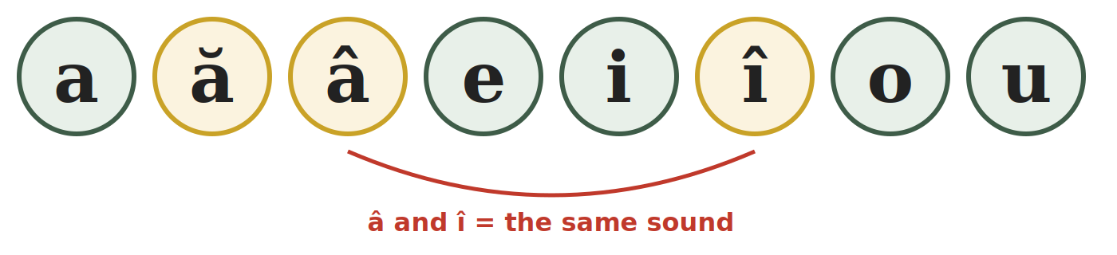
a | ă | â | e | i | î | o | u
/a/ | /ə/ | /ɨ/ | /e/ | /i/ | /ɨ/ | /o/ | /u/

Semivowels — a vowel that glides
Four letters — e, i, o, u — can lose their full vowel force and glide into the next vowel. When that happens we call them semivowels. Compare:
FULL VOWEL — its own syllable | SEMIVOWEL — glides, one syllable
i-ni-mă — heart: i is a full vowel | iar-nă — winter: i glides into a
u-nu — one: u is a full vowel | zi-ua — the day: u glides into a
o-mul — the man: o is a full vowel | noap-te — night: o glides into a

YOU DO NOT NEED THE THEORY YET
Just remember: a syllable always has exactly one full vowel sound. We come back to this in Lesson 2.6 and Lesson 3.1.
1.2 Vowel or consonant?
Write V for vocală (vowel) or C for consoană (consonant) next to each letter.
1. m ____ | 2. ă ____ | 3. t ____ | 4. o ____
5. ș ____ | 6. â ____ | 7. u ____ | 8. ț ____
9. e ____ | 10. r ____ | 11. î ____ | 12. j ____

Lesson 1.3 — The five Romanian letters
These five letters do not exist in English. They are not decoration — they change the meaning of the word. Leaving out the little sign under or above the letter is a spelling mistake, exactly like writing cat instead of cut.

1. Ă ă — the sound /ə/
This is the easiest of the five. Say the English word the — not carefully, but fast, the way you say it in the man. That short, relaxed vowel is Romanian ă.
IMPORTANT DIFFERENCE FROM ENGLISH
In English that sound is lazy and never stressed. In Romanian it is a full, clear vowel and it can even carry the stress of the word. Say it clearly — do not swallow it.
casă — house |  | masă — table | apă — water
ușă — door |  | scară — stairs | vară — summer
mamă — mother |  | față — face | stradă — street

Ă IS EVERYWHERE
Almost every feminine noun in Romanian ends in -ă. If you cannot hear it, you cannot tell casa (the house) from casă (a house). You will need this every single day.

2. Â â and Î î — one sound /ɨ/, two letters
There is no English equivalent for this sound. To find it: say ee as in see, hold the sound, then pull your tongue back and relax your lips into a neutral position, without moving your jaw. That is /ɨ/.
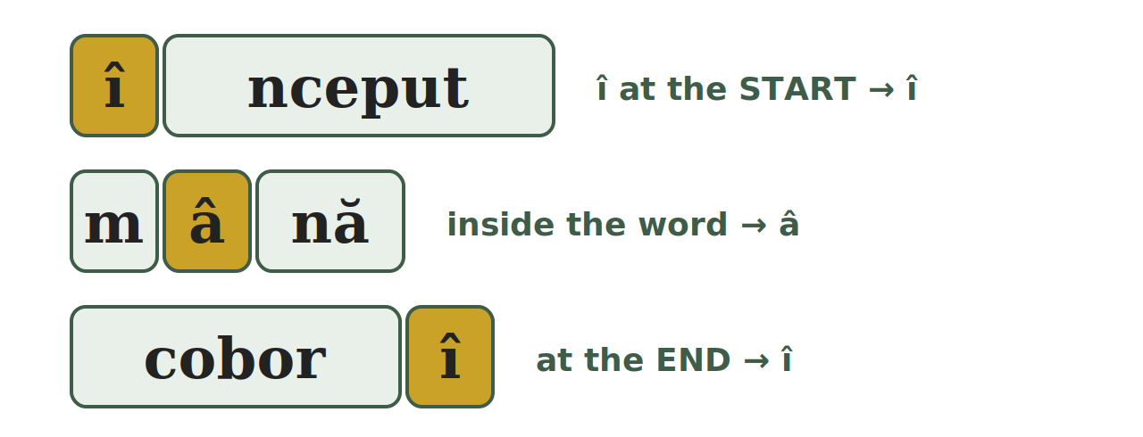
TIPAR — WHEN DO I WRITE Â AND WHEN Î?
START of the word | → | î
INSIDE the word | → | â
END of the word | → | î

Exception: after a prefix the î stays, even inside the word: a reîncepe — to start again, neîncetat — non-stop.

Î at the start or the end | Â inside the word
început — beginning | mână — hand
înainte — forward | pâine — bread
împreună — together | când — when
îngheț — frost | vânt — wind
a coborî — to go down | mâine — tomorrow
a urî — to hate | român — Romanian

3. Ș ș — the sound /ʃ/
Exactly the English sh in shop. The letter is an s with a little tail (a comma) below it. Without the tail the word changes or means nothing:
șase — six | sase — not a word
și — and (one of the most frequent words) | si — the musical note B
șapte — seven | ușă — door
școală — school | oraș — town

4. Ț ț — the sound /ts/
The ts at the end of the English word cats — but in Romanian this sound also comes at the beginning of a word, which is difficult for many learners at first.
țară — country | preț — price | față — face
soț — husband | cuțit — knife | ață — thread

CAREFUL — THESE ARE COMMAS, NOT CEDILLAS
The correct Romanian letters are ș and ț with a comma below. On some keyboards and old documents you will see ş and ţ with a cedilla (a hook). They are technically wrong, but everybody reads them the same way. Do not be confused when you see them on official papers.
1.3 Â or Î ?
Write â or î in each gap. Remember the position rule.
1. p___ine (bread) | 2. ___nceput (beginning)
3. c___nd (when) | 4. a cobor___ (to go down)
5. m___ine (tomorrow) | 6. ___mpreună (together)

Lesson 1.4 — K, Q, W, Y: the visitor letters
These four letters are part of the official alphabet, but they never appear in a word that is originally Romanian. They arrived with foreign words, brand names, personal names and units of measurement.

Where you will actually meet them
LETTER | WHERE IT APPEARS | EXAMPLES FROM DAILY LIFE
k | units of measurement, loanwords | kg — kilogram (packaging) · km — kilometre (road signs) · kWh — electricity bill
q | almost only foreign names | Qatar · names like Quentin
w | loanwords, names, units | W — watt (light bulb) · Wi-Fi · weekend · WC
y | loanwords, names | yoga · hobby · Yasmin

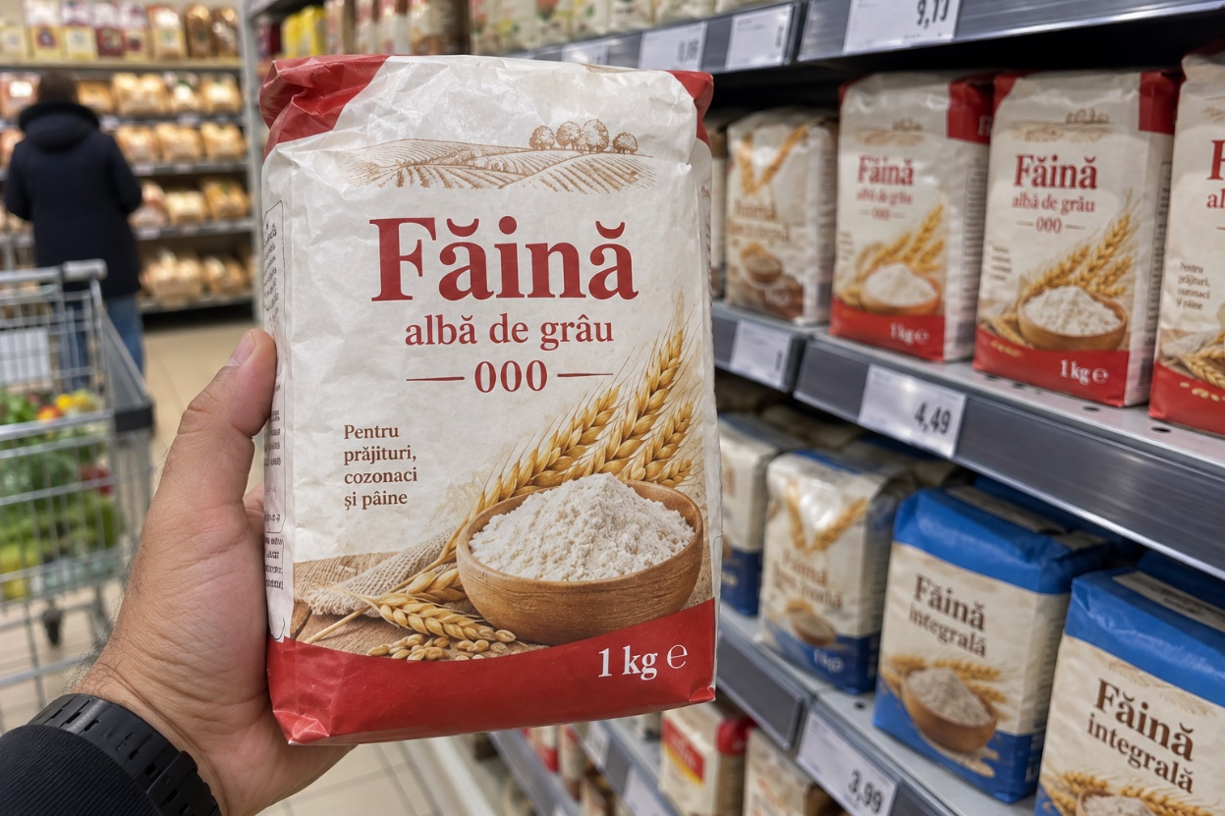

WHY THIS MATTERS FOR YOU
Shop labels, road signs, electricity bills and your phone all use these letters: kg, km, kWh, W, Wi-Fi. You need to read them, but you will never need them to spell a Romanian word.
1.4 Romanian word or foreign word?
Write RO if the word is Romanian, or STR (străin) if it came from another language.
1. kilogram ______ | 2. pâine ______ | 3. weekend ______
4. masă ______ | 5. yoga ______ | 6. țară ______

Lesson 1.5 — Handwriting
In Romania you often have to write by hand: forms at the town hall or the bank, a note for a neighbour, your signature on a contract. If your first language uses a different alphabet, take your time with this lesson.

Print and cursive
PRINT (litere de tipar) | CURSIVE (litere de mână)
Every letter is separate. This is what you see in books and on signs, and what official forms ask for: SE COMPLETEAZĂ CU MAJUSCULE — fill in using capital letters | The letters are joined together without lifting the pen. Romanians use it for notes and for their signature. You must be able to read it, even if you write in print.

PRACTICAL RULE FOR YOUR FIRST YEAR
On every official form, write in PRINT CAPITALS. It is accepted everywhere, it is always legible, and it is what the form asks for anyway. Learn cursive for reading, not for filling in papers.

The writing lines
The practice strips in this book have four lines. Every letter sits on the red line. Capitals and tall letters reach the top line; small letters reach the dotted line; tails go down to the bottom line.
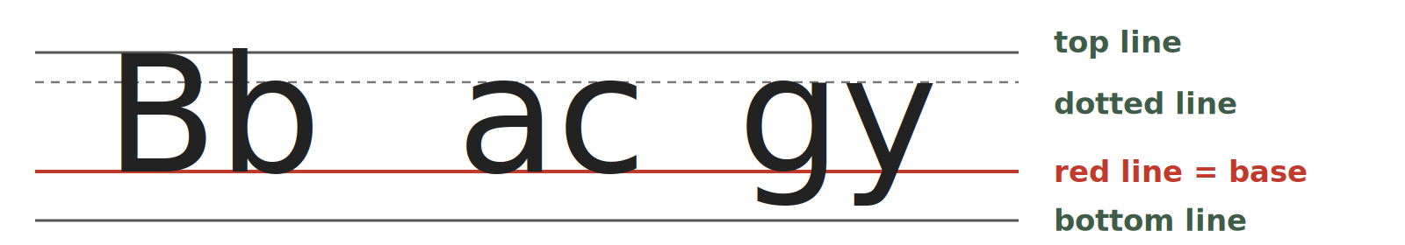
LINE | WHAT REACHES IT
top line | all capitals and the tall letters: b, d, f, h, k, l, t
dotted line | the top of small letters: a, c, e, m, n, o, s, u
red line | the base line — every letter sits on it
bottom line | the tails: g, j, p, q, y (and the comma of ș, ț)

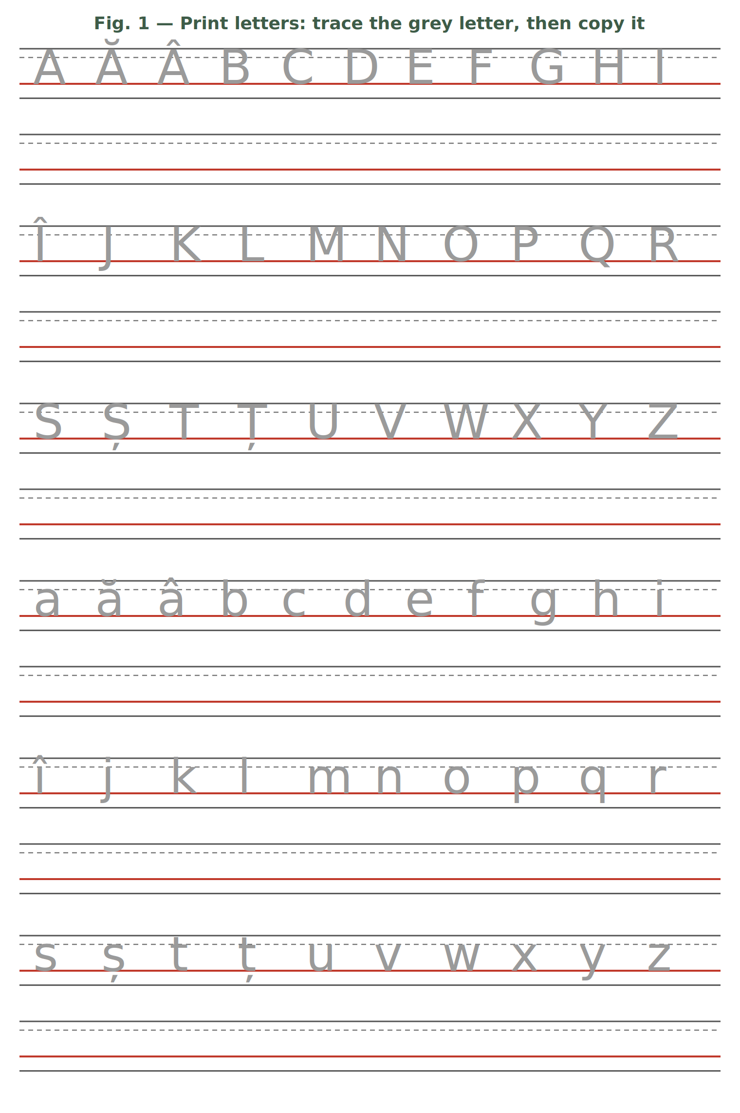
Trace the grey letters with a pencil, then copy each letter on the empty strip below it.

Fig. 2 — Cursive letters (for reading). Look at the joined letters and compare them with the print letters in Fig. 1. You only need to read them.
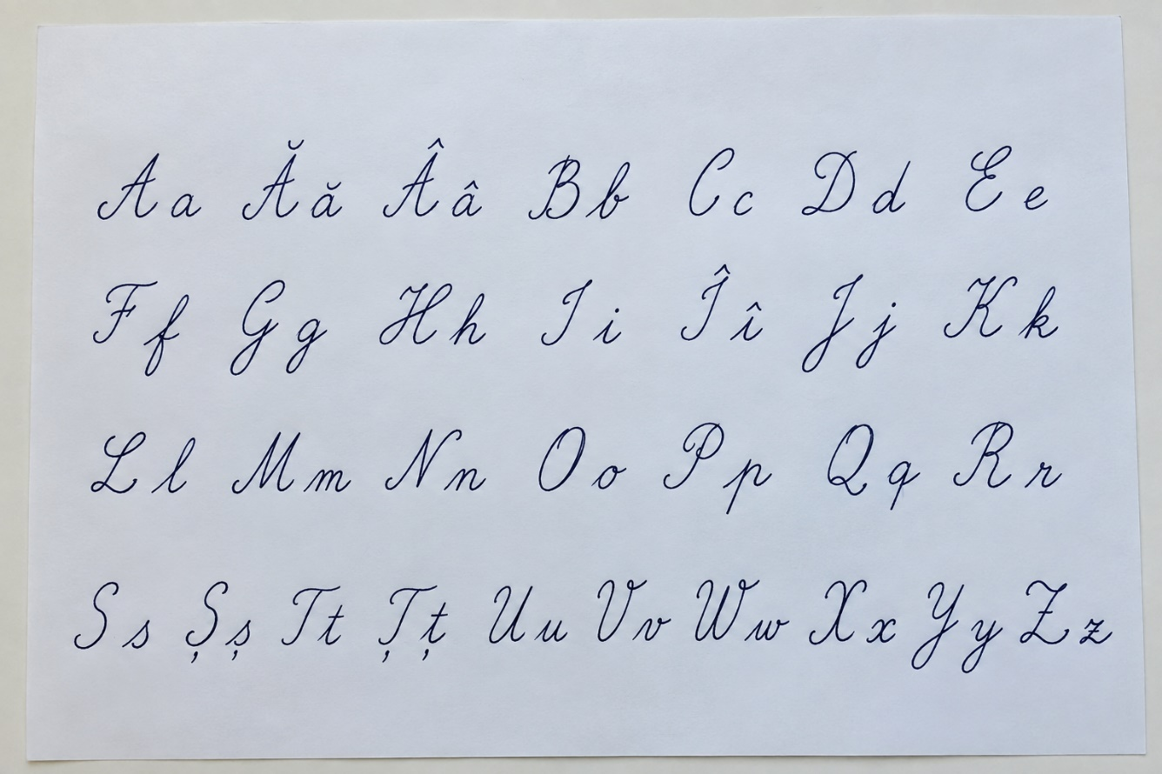

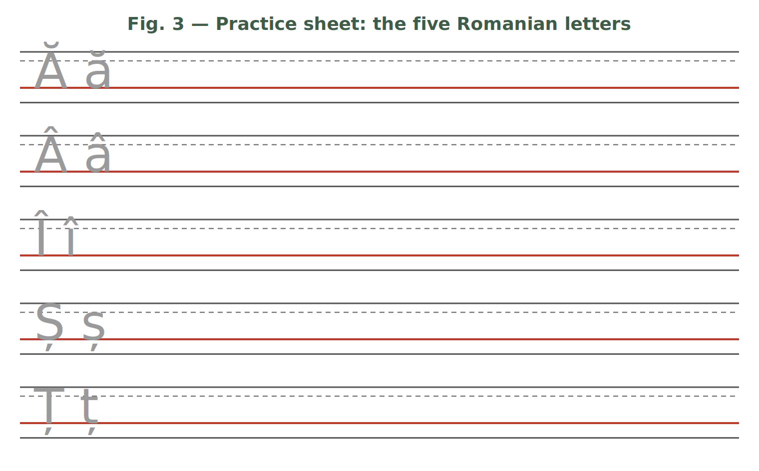
1.5 Copy the words
Copy each word twice on the lines of Fig. 3 or in your notebook — once in print capitals, once in print lowercase. Make the signs clearly visible.
ȘAPTE · ȚARĂ · MÂNĂ · ÎNCEPUT · PÂINE · UȘĂ

HOMEWORK — AFTER SESSION 1 / TEMĂ PENTRU ACASĂ · ABOUT 30 MINUTES
H1.1 Spell your first name, your family name and your town letter by letter, using the letter NAMES (as on the phone). Say them out loud three times.
H1.2 Write each Romanian letter ten times: Ă ă, Â â, Î î, Ș ș, Ț ț. Pay attention to the size of the sign.
H1.3 Look at a package, a shop sign or a bus stop. Copy five Romanian words that contain ă, â, î, ș or ț.

SESSION 2 — READING THE SOUNDS
SESIUNEA 2 — CITIREA SUNETELOR · 3 hours · Sunday 9:00 – 12:00

By the end of this session you will be able to:
☐ | read any Romanian word out loud, even one you have never seen
☐ | pronounce the eight letter groups: ce, ci, ge, gi, che, chi, ghe, ghi
☐ | read the letter x correctly in both of its sounds
☐ | recognise diphthongs and triphthongs and say them in one breath

Lesson 2.1 — Romanian is read as it is written
This is the single most useful fact about Romanian. Every letter keeps its sound, in almost every word. There is no silent e, no ough problem, no guessing.
THE COMPLETE LIST OF EXCEPTIONS
Only these need a rule: the groups ce · ci · ge · gi · che · chi · ghe · ghi and the letter x (today), a small number of recent loanwords that keep their foreign spelling (weekend, computer), and two habits of everyday speech that you learn in Lesson 3.4 (el is said "iel"; a final -i is almost silent). That is all.
2.1 Read out loud
Read each word letter by letter, exactly as it is written. You do not need to know the meaning yet.
1. apă | 2. bun | 3. doi | 4. foc
5. hartă | 6. lapte | 7. masă | 8. nou
9. sare | 10. trei | 11. verde | 12. zero

Lesson 2.2 — The letter C
C has two sounds. Which one you use depends only on the letter that comes after it.
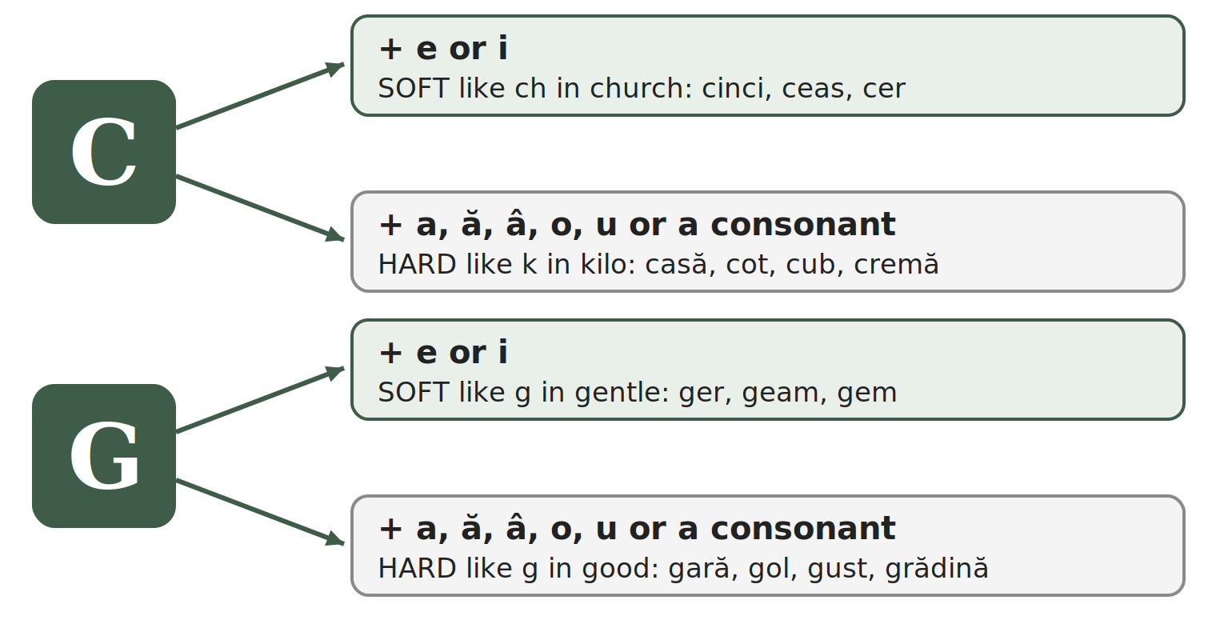
C = /k/ HARD (like k in kilo) | C = /tʃ/ SOFT (like ch in church)
casă — house | cinci — five
cot — elbow | ceas — clock, watch
cub — cube | cer — sky
când — when | cireșe — cherries
cafea — coffee | cină — dinner
cremă — cream: c before a consonant is hard | ciorbă — sour soup

SAY IT, THEN CHECK
The word cinci (five) has C twice — and both are soft: /tʃintʃ/. The word ciorbă starts soft: /ˈtʃorbə/. Listen for the ch of church.
2.2 Hard or soft?
Write K if the c is hard, or CH if it is soft.
1. casă ____ | 2. cer ____ | 3. cinci ____ | 4. cot ____
5. cină ____ | 6. cub ____ | 7. ceas ____ | 8. când ____

Lesson 2.3 — The letter G
G works exactly like C: the letter after it decides the sound.
G = /ɡ/ HARD (like g in good) | G = /dʒ/ SOFT (like g in gentle)
gară — railway station | ger — frost
gol — empty | ginere — son-in-law
gust — taste | geam — window pane
gând — thought | gem — jam
gură — mouth | geantă — bag
grădină — garden: g before a consonant is hard | gimnastică — gymnastics
2.3 Hard or soft?
Write G if the g is hard, or J if it is soft (like g in gentle).
1. gară ____ | 2. geam ____ | 3. gust ____
4. ginere ____ | 5. gol ____ | 6. ger ____

Lesson 2.4 — CH and GH: the silent h
Now the obvious problem. If c + e is always soft, how do you write a hard /k/ sound before e or i? You put an h between them. The h is never pronounced — it only blocks the softening.
TIPAR — THE SILENT H
c | + | h | + | e / i | = | hard k
g | + | h | + | e / i | = | hard g

WRITTEN | SOUND | EXAMPLE | MEANING
che | /ke/ | cheie | key
chi | /ki/ | chirie | rent
che | /ke/ | ureche | ear
chi | /ki/ | chibrit | match (to light a fire)
ghe | /ɡe/ | ghete | ankle boots
ghi | /ɡi/ | ghiveci | flower pot
ghi | /ɡi/ | unghie | fingernail

REAL PAIRS THAT PROVE THE RULE
ceară /tʃ/ — wax against chelner /k/ — waiter
ger /dʒ/ — frost against ghete /ɡ/ — ankle boots
Same vowel after the letter — the only difference is the h.
2.4 Choose the right spelling
Circle the correct word for the meaning given.
1. key: ceie / cheie | 2. rent: cirie / chirie
3. boots: gete / ghete | 4. clock: ceas / cheas
5. five: cinci / chinci | 6. frost: ger / gher

Lesson 2.5 — The letter X
One letter, but it stands for two sounds together. Usually /ks/. In a group of words that begin with ex- followed by a vowel, it becomes /ɡz/ — like the English word exam.
X = /ks/ | X = /ɡz/ (ex + vowel)
taxi — taxi | examen — exam
text — text | exemplu — example
fix — fixed, exactly | exact — exactly
extra — extra (ex + consonant) | exercițiu — exercise
2.5 /ks/ or /ɡz/ ?
Read the word, then write KS or GZ.
1. taxi ______ | 2. examen ______ | 3. text ______
4. exemplu ______ | 5. fix ______ | 6. exact ______

Lesson 2.6 — Two or three vowels in one syllable
When two vowel letters stand next to each other, Romanian usually says them together, in one push of air. That is a diphthong (diftong). With three vowel letters it is a triphthong (triftong).

The diphthongs you will meet most often
ea seară — evening | ia iarnă — winter | oa noapte — night | ua ziua — the day
ai mai — May | ei lei — lei (money) | oi doi — two | ui pui — chicken
au dau — I give | eu eu — I | iu iubire — love | ou ou — egg
ie miere — honey | io chioșc — kiosk | uă două — two (f.) | âi câine — dog

The triphthongs
eau beau — I drink | iau iau — I take | eai beai — you were drinking
oai leoaică — lioness | ioa aripioară — little wing

HOW TO TEST IT YOURSELF
Clap once for each syllable. doi = one clap, so oi is a diphthong. po-e-zi-e = four claps, so oe is NOT a diphthong — the two vowels belong to different syllables.
2.6 How many syllables?
Say the word, clap the syllables, then write the number.
1. doi ____ | 2. poezie ____ | 3. seară ____
4. aeroport ____ | 5. beau ____ | 6. stea ____

Handwriting — the letter groups
Write each group five times in your notebook, then each example word twice: ce ci ge gi che chi ghe ghi — cheie ghete cină geam.

HOMEWORK — AFTER SESSION 2 / TEMĂ PENTRU ACASĂ · ABOUT 30 MINUTES
H2.1 Sort the words by the sound of c or g: casă · cinci · gară · ger · cheie · ghete · cot · geam · chirie · gust
hard k | soft ch | hard g | soft g (gentle)
H2.2 Read this list out loud three times a day until the next session: cheie · cină · ghete · geam · cinci · gară · chirie · ger · examen · nouă
H2.3 Your teacher reads eight words at the start of Session 3 (dictation). Practise writing the eight letter groups.

SESSION 3 — FROM LETTERS TO SENTENCES
SESIUNEA 3 — DE LA LITERE LA PROPOZIȚII · 3 hours · Saturday 9:00 – 12:00

By the end of this session you will be able to:
☐ | cut any Romanian word into syllables
☐ | hear which syllable is stressed and say the word correctly
☐ | use capital letters correctly — and know when Romanian does NOT use them
☐ | use the full stop, the question mark, the exclamation mark and the comma
☐ | read el, ea, eu, este and words ending in -i the way Romanians really say them

Lesson 3.1 — Syllables
A syllable (silabă) is one push of air with exactly one full vowel sound in it. You need syllables for two practical reasons: to know where to break a word at the end of a line, and to know which part of the word to say louder.

Worked examples
WORD | SYLLABLES | WHY
masă | ma-să | vowel – consonant – vowel: the consonant goes to the right
apă | a-pă | the same rule: one consonant between two vowels goes right
carte | car-te | two consonants: one each side
lapte | lap-te | two consonants: one each side
fereastră | fe-reas-tră | three consonants (s, t, r): the first one left, the other two right
capră | ca-pră | exception: consonant + r or l stay together and go right
pâine | pâi-ne | âi is a diphthong: do not cut it
stea | stea | ea is a diphthong: one single syllable
telefon | te-le-fon | three vowels, so three syllables

NEVER DO THIS
Never break a diphthong, and never leave a single letter alone at the end of a line. a-pă is a correct syllable division, but you do not write a- at the end of one line and pă on the next.
3.1 Cut into syllables
Use a hyphen (-) between the syllables.
1. casă → ______________ | 2. lapte → ______________
3. telefon → ______________ | 4. școală → ______________
5. fereastră → ______________ | 6. dimineață → ______________
7. farmacie → ______________ | 8. salariu → ______________

Lesson 3.2 — Stress
In every Romanian word of two or more syllables, one syllable is said louder and longer than the others. This is the stress (accentul). Romanian does not mark it in writing — you have to hear it and learn it with the word. In this book we print the stressed syllable in CAPITALS.

Why it matters
Sometimes the stress is the only difference between two words:
SPELLING | STRESS ON THE 1st SYLLABLE | STRESS ON THE 2nd SYLLABLE
copii | CO-pii — copies (of a document) | co-PII — children
veselă | VE-se-lă — cheerful (f.) | ve-SE-lă — tableware, dishes
acele | A-ce-le — those | a-CE-le — the needles

USEFUL TENDENCIES (NOT RULES)
Most Romanian words are stressed on the last or second-to-last syllable: te-le-FON, CAR-te, fe-REAS-tră, pa-șa-PORT.
Verbs in the infinitive are usually stressed at the end: a lu-CRA — to work, a mân-CA — to eat.
There is no reliable rule. Repeat each new word after your teacher, out loud, at least three times.
3.2 Mark the stress
Write the word in syllables and put the stressed syllable in CAPITALS.
1. telefon → ______________ | 2. salariu → ______________
3. pașaport → ______________ | 4. fereastră → ______________
5. dimineață → ______________ | 6. farmacie → ______________

Lesson 3.3 — Capital letters and punctuation
You now have everything you need to read and write a complete Romanian sentence. This lesson gives you the rules for capital letters (litera mare) and for the four punctuation marks you will use every day.

Capital letters
USE A CAPITAL LETTER | DO NOT USE A CAPITAL LETTER
at the start of a sentence: Azi este luni. | days of the week: luni — Monday
names of people: Ahmed, Maria | months: ianuarie — January
countries: România, Nepal, India | nationalities: român, nepalez, indian
cities and towns: București, Cluj-Napoca | languages: română, engleză
names of institutions: Primăria, Poliția Română | ordinary nouns: stradă, oraș, bancă

THIS IS DIFFERENT FROM ENGLISH
In English you write Monday, January, Romanian, Nepalese with a capital letter. In Romanian you do not. It is one of the most common mistakes foreign learners make.
TIPAR — COUNTRY → NATIONALITY
România | → | român
Nepal | → | nepalez
India | → | indian
Vietnam | → | vietnamez
Filipine | → | filipinez
Italia | → | italian
Germania | → | german

Left: the country — always a CAPITAL letter. Right: the nationality — always a small letter, even at the end of a sentence: Sunt din Nepal. Sunt nepalez.

THE DAYS — always small letters | THE MONTHS — always small letters
luni · marți · miercuri · joi · vineri · sâmbătă · duminică | ianuarie · februarie · martie · aprilie · mai · iunie · iulie · august · septembrie · octombrie · noiembrie · decembrie

The four punctuation marks
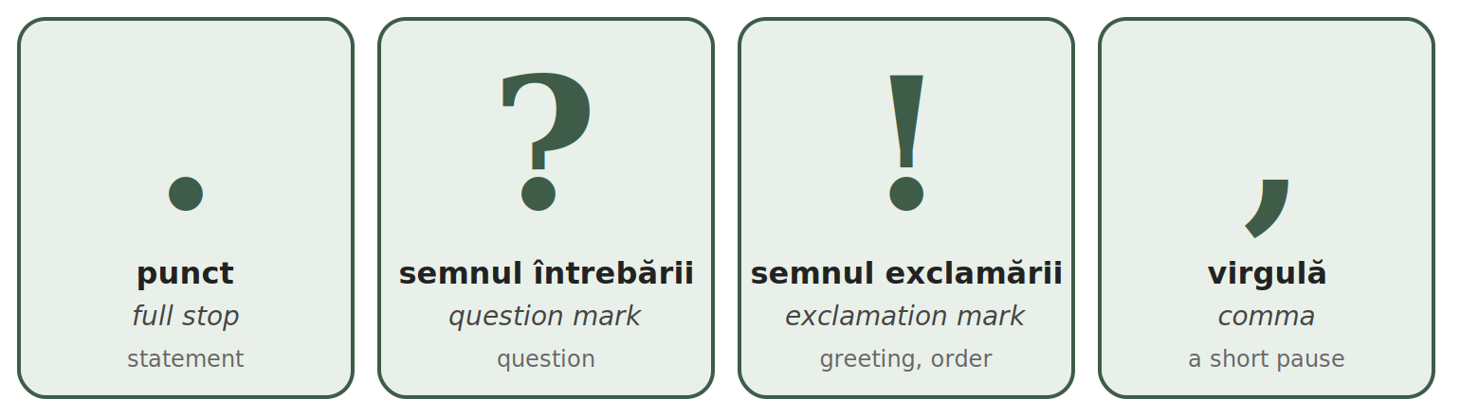
MARK | WHEN | EXAMPLES
. punct | at the end of a normal sentence | Sunt din India. Locuiesc în București.
? semnul întrebării | at the end of a question | Cum vă numiți? Unde locuiți?
! semnul exclamării | after a greeting, a strong feeling or an order | Bună ziua! Atenție! Mulțumesc mult!

The comma — three rules you need now
TIPAR — THE COMMA
Bună ziua | , | domnule Ionescu!
Da | , | mulțumesc.
Sunt obosit | , | dar sunt bine.

RULE |  | EXAMPLES
1. You speak to someone — the name or title is separated by a comma. |  | Bună ziua, domnule Ionescu! — Good afternoon, Mr Ionescu!
 |  | Maria, vino aici, te rog! — Maria, come here, please!
 |  | Mulțumesc, doamnă. — Thank you, madam.
 |  | Bună seara, Ana! — Good evening, Ana!
2. After da or nu at the start of an answer. |  | Da, sunt aici. — Yes, I am here.
 |  | Nu, nu lucrez azi. — No, I am not working today.
 |  | Da, mulțumesc. — Yes, thank you.
 |  | Nu, mulțumesc. — No, thank you.
3. Before dar (but). |  | Sunt obosit, dar sunt bine. — I am tired, but I am fine.
 |  | Vreau cafea, dar nu am bani. — I want coffee, but I have no money.
 |  | Casa este mică, dar este frumoasă. — The house is small, but it is nice.
 |  | Vorbesc engleză, dar nu vorbesc română. — I speak English, but I do not speak Romanian.

NO COMMA BEFORE ȘI
Romanian does not put a comma before și (and) in a simple list or sentence: Vorbesc engleză și hindi. Am un frate și o soră.

Read these sentences out loud
Bună ziua! Eu sunt Ahmed. | Good afternoon! I am Ahmed.
Sunt din India. Sunt indian. | I am from India. I am Indian.
Locuiesc în București. | I live in Bucharest.
Vorbesc hindi și engleză. | I speak Hindi and English.
Învăț limba română, dar este greu. | I am learning Romanian, but it is difficult.
Azi este luni, 12 ianuarie. | Today is Monday, 12 January.
3.3 Correct the mistakes
Each sentence has one or two mistakes: a capital letter, a full stop, a question mark or a comma. Rewrite it correctly.
1. eu sunt din india. → ________________________________
2. Azi este Luni. → ________________________________
3. Bună ziua domnule Ionescu! → ________________________________
4. Da mulțumesc. → ________________________________
5. Sunt obosit dar sunt bine. → ________________________________
6. Vorbiți Engleză? → ________________________________
7. Unde locuiți → ________________________________
8. El este Nepalez. → ________________________________

Lesson 3.4 — Real pronunciation
Romanian is read as it is written — with two small habits of everyday speech. They are in very frequent words, so you will hear them all day. Learn to recognise them first; your mouth will follow.

Habit 1 — e at the start of el, ea, eu, este... is said "ie"
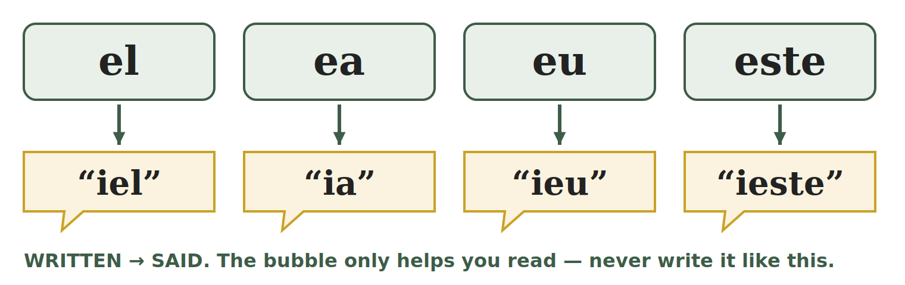
TIPAR — E AT THE START OF THESE SHORT WORDS
e | → | “ie”

WRITTEN | SAID LIKE | MEANING | EXAMPLE
el | "iel" | he | El este Ahmed.
ea | "ia" | she | Ea este Maria.
eu | "ieu" | I | Eu sunt din Nepal.
ei | "iei" | they (men / mixed) | Ei sunt colegi.
ele | "iele" | they (women) | Ele sunt surori.
este | "ieste" | is | Casa este mare.
e | "ie" | is (short, spoken) | E bine.
ești | "ieșt" | you are | Ești aici?
era | "iera" | was | Era frig.
eram | "ieram" | I was / we were | Eram acasă.

EXCEPTIONS — NEW WORDS KEEP A CLEAN E
The "ie" habit is only in the short, old words above: the words for he, she, I, they and the verb to be (este, e, ești, era). Most other words that start with e — usually newer words, similar in English — keep a clean e, as in bed:
ecran — screen · elev — pupil · economie — economy · echipă — team · exemplu — example · etaj — floor · euro — euro · energie — energy

Habit 2 — a final -i after a consonant is almost silent
When a word ends in consonant + i, the i is very short — you almost do not hear it. It only makes the consonant before it soft. Listen to your teacher: pom and pomi sound almost the same — only the end of pomi is a little softer.
TIPAR — CONSONANT + I AT THE END
consonant + i | → | very short i

ONE / BASE FORM | WITH FINAL -i | MEANING | ONE / BASE FORM | WITH FINAL -i | MEANING
pom | pomi | trees | prieten | prieteni | friends
lup | lupi | wolves | pantof | pantofi | shoes
an | ani | years | ban | bani | money, coins
bun | buni | good (pl.) | elev | elevi | pupils
lucrez | lucrezi | you work | văd | vezi | you see
merg | mergi | you go |  | ochi | eye, eyes

EXCEPTIONS — THE I IS SAID IN FULL
After consonant + r or consonant + l, the final i is a full vowel: codri — forests · socri — parents-in-law · membri — members · miniștri — ministers
In loanwords the final i is full: taxi · mini · schi — ski
Words ending in two i (copii) are explained in Lesson 4.2. Words ending in vowel + i (doi, mai) are diphthongs (Lesson 2.6).
3.4 Clean or changed?
A: write IE if the e is said "ie", or E if it is a clean e. B: write SHORT if the final i is almost silent, or FULL if it is said in full.
A — the first e | B — the final i
1. el ______ | 7. pomi ______
2. elev ______ | 8. codri ______
3. este ______ | 9. bani ______
4. ecran ______ | 10. taxi ______
5. ea ______ | 11. vezi ______
6. etaj ______ | 12. membri ______

HOMEWORK — AFTER SESSION 3 / TEMĂ PENTRU ACASĂ · ABOUT 30 MINUTES
H3.1 Write five sentences about yourself: your name, your country, your nationality, your town in Romania, the languages you speak. Check every capital letter, every comma and every full stop.
H3.2 Read out loud, three times a day: El este aici. · Ea este acasă. · Eu sunt bine. · Ei sunt prieteni. · Am doi pantofi noi.
H3.3 Cut into syllables and mark the stress: carte · telefon · școală · pașaport

SESSION 4 — CRATIMA, SPELLING AND PRACTICAL WRITING
SESIUNEA 4 — CRATIMA, ORTOGRAFIA ȘI SCRISUL PRACTIC · 3 hours · Sunday 9:00 – 12:00

By the end of this session you will be able to:
☐ | recognise and read the cratima (-) in the ten most frequent forms
☐ | tell the cratima from the syllable hyphen
☐ | recognise the difference between -i, -ii and -iii at the end of a word
☐ | write a date in numbers (zz.ll.aaaa) and in words (12 martie 2026)
☐ | fill in a simple form: name, date of birth, citizenship, address, phone, signature

Lesson 4.1 — The cratima (-)
The cratima (cratima) is a short line between two words. It shows two things: the two words are said together, like one word, and a sound has fallen out. You meet it in almost every Romanian text, so you must be able to read it.
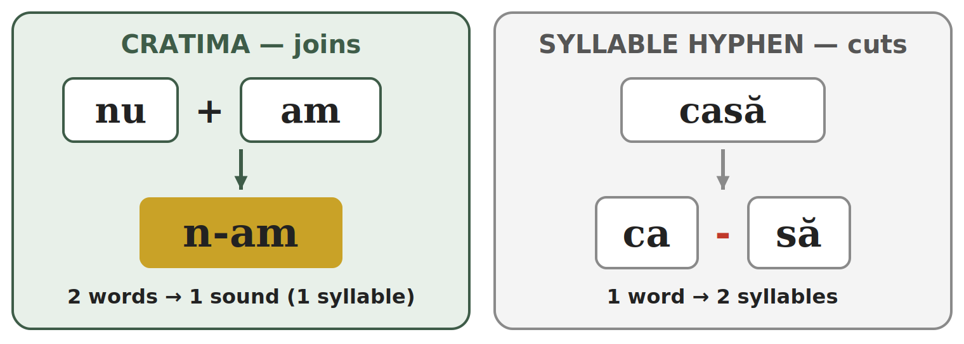
TIPAR — TWO WORDS → ONE SOUND
nu | + | am | → | n-am
se | + | a | → | s-a
mă | + | am | → | m-am
în | + | un | → | într-un
dă | + | îmi | → | dă-mi

The sound that falls out: the u of nu, the e of se, the ă of mă, the î of îmi. The word în becomes într before un / o.

Cratima or syllable hyphen?
It is the same sign (-), but it does the opposite job:
 | CRATIMA | SYLLABLE HYPHEN
What it does | joins two words into one sound | cuts one word into syllables
Example | s-a = se + a → 1 syllable | ca-să = 1 word → 2 syllables
Where you see it | everywhere, inside normal sentences | in exercises, dictionaries, and at the end of a line
Test | take the line away and put the lost letter back: you get two real words (nu am) | take the line away: you get one word (casă)

The ten forms to recognise
WRITTEN | THE TWO WORDS | SAID | EXAMPLE | ENGLISH
s-a | se + a | "sa" — 1 syllable | S-a terminat. | It is finished.
m-am | mă + am | "mam" — 1 syllable | M-am născut în India. | I was born in India.
nu-i | nu + e (spoken) | "nui" — 1 syllable | Nu-i nimic. | It is nothing. / No problem.
n-am | nu + am | "nam" — 1 syllable | N-am timp. | I do not have time.
într-un | în + un | "în-trun" | Locuiesc într-un apartament. | I live in a flat.
într-o | în + o | "în-tro" | Locuiesc într-o casă. | I live in a house.
dintr-un | din + un | "din-trun" | Beau apă dintr-un pahar. | I drink water from a glass.
dă-mi | dă + îmi | "dămi" — 1 syllable | Dă-mi apa, te rog. | Give me the water, please.
spune-mi | spune + îmi | "spu-nemi" | Spune-mi numele tău. | Tell me your name.
ce-i | ce + e (spoken) | "cei" — 1 syllable | Ce-i asta? | What is this?

ONLY READ AND RECOGNISE — FOR NOW
In this module you only read these forms and find the two words behind them. You will use them yourself later: dă-mi, spune-mi in Module 2 (short forms of the pronouns), n-am, s-a, m-am, nu-i, ce-i in Module 3 (verbs).
4.1 Find the two words
Write the two words behind each form.
1. n-am = ________ + ________ | 2. s-a = ________ + ________
3. într-o = ________ + ________ | 4. dă-mi = ________ + ________
5. ce-i = ________ + ________ | 6. dintr-un = ________ + ________

Lesson 4.2 — Spelling traps: -i, -ii, -iii
At the end of a Romanian word you can see one, two or even three i. It is not a mistake: each i has a job. Here you only learn to recognise them. How to build these forms comes in Module 2.
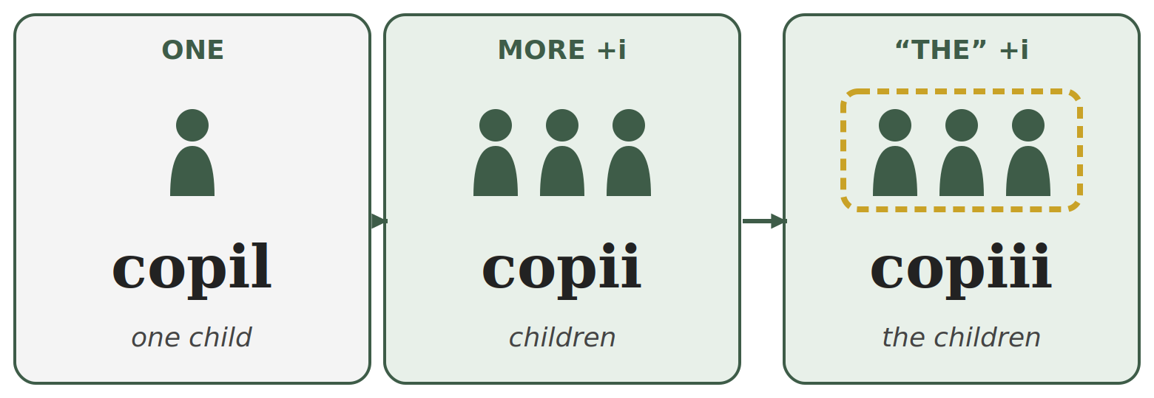
TIPAR — ONE → MORE → “THE”
copil | → | copii | → | copiii
elev | → | elevi | → | elevii

Left: one. Middle: more than one (+i). Right: the ones we already know — English “the” (+ one more i).

ONE | MORE THAN ONE | “THE” ... (the ones we know) | ENGLISH
elev | elevi | elevii | pupil — pupils — the pupils
pom | pomi | pomii | tree — trees — the trees
lup | lupi | lupii | wolf — wolves — the wolves
prieten | prieteni | prietenii | friend — friends — the friends
profesor | profesori | profesorii | teacher — teachers — the teachers
pantof | pantofi | pantofii | shoe — shoes — the shoes
câine | câini | câinii | dog — dogs — the dogs
frate | frați | frații | brother — brothers — the brothers
membru | membri | membrii | member — members — the members
ban | bani | banii | coin — money — the money
copil | copii | copiii | child — children — the children
fiu | fii | fiii | son — sons — the sons

YOU CAN HEAR THE DIFFERENCE
pomi — the final i is almost silent (Lesson 3.4). pomii — you hear a full i and then a short one: "po-mii".
copii — 2 syllables: co-pii. copiii — 3 syllables: co-pi-ii.

WHY THREE I?
copil loses its l in the plural and ends in -ii already: copii. When you add “the”, one more i comes: copiii. The same happens with fiu → fii → fiii. Three i in a row is correct Romanian.

Remember: small letters, big letters
CORRECT | WRONG | WHY
Azi este luni. | Azi este Luni. | days: small letter
12 martie | 12 Martie | months: small letter
Sunt nepalez. | Sunt Nepalez. | nationalities: small letter
Vorbesc română. | Vorbesc Română. | languages: small letter
Locuiesc în România. | Locuiesc în românia. | countries: CAPITAL letter
4.2 One, more, or “the”?
Write ONE, MORE or THE next to each word.
1. elevi ______ | 2. pomii ______ | 3. copil ______ | 4. copiii ______
5. prieteni ______ | 6. fiii ______ | 7. copii ______ | 8. lupii ______

Lesson 4.3 — Practical writing: dates and forms

Writing the date in numbers
In Romania the date always starts with the day, then the month, then the year. On forms it is written with dots: zz.ll.aaaa.
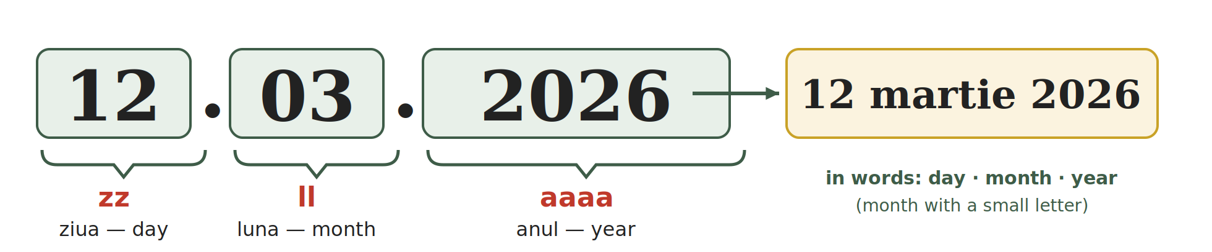
TIPAR — THE DATE
zz | . | ll | . | aaaa
ziua (day) |  | luna (month) |  | anul (year)

Always two digits for the day and the month: 5 July = 05.07; 1 May = 01.05.

NO. | MONTH | NO. | MONTH | NO. | MONTH
01 | ianuarie | 05 | mai | 09 | septembrie
02 | februarie | 06 | iunie | 10 | octombrie
03 | martie | 07 | iulie | 11 | noiembrie
04 | aprilie | 08 | august | 12 | decembrie

Writing the date in words
In a letter or a sentence you write: day (no zero in front) + month in words, with a small letter + year. No dots, no comma.
IN NUMBERS | IN WORDS
01.01.2026 | 1 ianuarie 2026 | 24.01.2026 | 24 ianuarie 2026
12.03.2026 | 12 martie 2026 | 01.05.2026 | 1 mai 2026
01.06.2026 | 1 iunie 2026 | 05.07.1995 | 5 iulie 1995
15.08.2026 | 15 august 2026 | 30.11.2026 | 30 noiembrie 2026
01.12.2026 | 1 decembrie 2026 | 25.12.2026 | 25 decembrie 2026

CAREFUL — DAY FIRST!
03.12.2026 is 3 December, not 12 March. In the United States the month comes first; in Romania never.
Wrong: 05 Iulie, 1995 → Correct: 5 iulie 1995.
You may also see 12/03/2026 with slashes: the order is the same — day, month, year.

Filling in a simple form
At the town hall, the bank, the doctor or the phone shop you will fill in a form (formular). The words are almost always the same:
ON THE FORM | ENGLISH | WHAT YOU WRITE | EXAMPLE
Nume | family name, surname | your family name, as in the passport | SHARMA
Prenume | first name(s) | your first name(s) | RAJESH KUMAR
Data nașterii | date of birth | zz.ll.aaaa | 05.07.1995
Cetățenia | citizenship | your citizenship (some forms ask for the country) | NEPALEZĂ / NEPAL
Adresa | address | street, number, block, entrance, floor, flat, town, county / sector | see Fig. 4
Telefon | phone | your Romanian mobile number (10 digits, starts with 07) | 0712 345 678
Data | date | the date you fill in the form | 12.03.2026
Semnătura | signature | your usual signature — not in capitals | —

ABBREVIATION | MEANS | ENGLISH | ABBREVIATION | MEANS | ENGLISH
Str. | strada | street | et. | etajul | floor
nr. | numărul | number | ap. | apartamentul | flat
bl. | blocul | block of flats | jud. | județul | county
sc. | scara | entrance / staircase | sect. | sectorul | sector (Bucharest)

RULES FOR EVERY FORM
Nume is your FAMILY name, Prenume your FIRST name — the opposite order from many other countries. Check twice.
Write in PRINT CAPITALS (SE COMPLETEAZĂ CU MAJUSCULE). If the form has boxes, write one letter in each box and leave one box empty between two names.
Copy your name exactly as in your passport or residence permit — same letters, same order.
Fig. 4 — A model form, filled in.
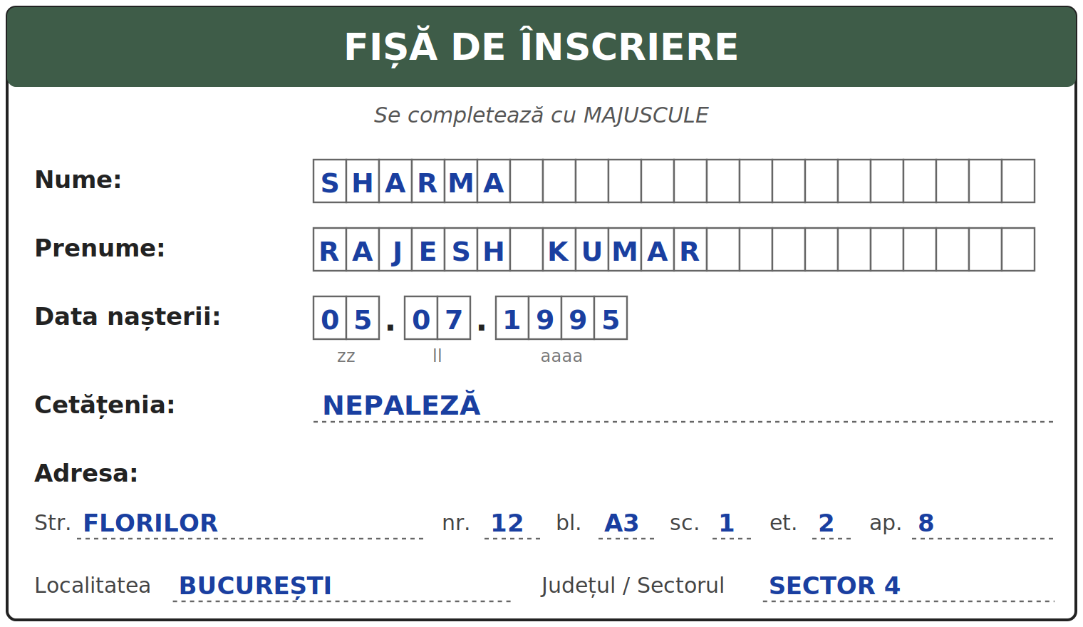
4.3 Fill in the form
Fill in the form with your own details, in print capitals. At the bottom, write today's date in numbers. Then write the same date in words on the line below the form.
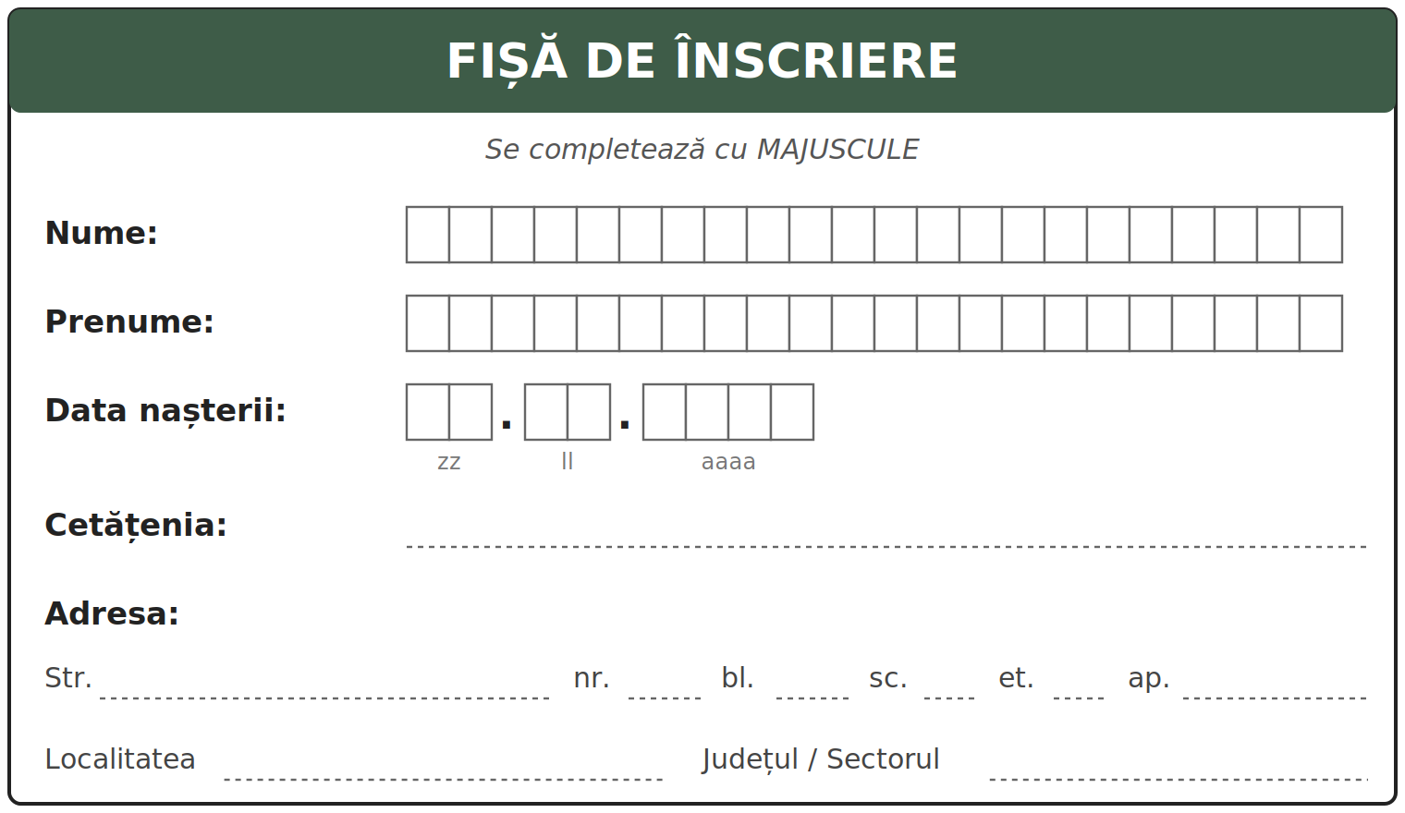
Today's date in words: ________________________________________

Lesson 4.4 — Module 1: everything in one page
THE ALPHABET | 31 letters. 8 vowel letters (7 sounds, because â = î), 19 consonants, plus k, q, w, y for foreign words only.
ROMANIAN LETTERS | ă /ə/ · â and î /ɨ/ · ș /ʃ/ · ț /ts/. The sign is part of the letter, not decoration.
Â OR Î | î at the start and the end of a word; â inside the word.
READING | Read as written. Exceptions: the eight letter groups, the letter x, a few loanwords, two speech habits.
C AND G | Hard before a, ă, â, o, u and consonants. Soft before e and i.
CH AND GH | The h is silent. It keeps the hard sound before e and i: che = /ke/, ghi = /ɡi/.
X | Usually /ks/ (taxi); /ɡz/ in ex + vowel (examen).
DIPHTHONGS | Two or three vowel letters said together in one syllable: seară, doi, miere, beau.
SYLLABLES | One full vowel sound = one syllable. Never break a diphthong.
STRESS | Not written. Usually on the last or second-to-last syllable. Learn it with each word.
CAPITALS | Sentence start, names, countries, cities, institutions. NOT days, months, languages, nationalities.
PUNCTUATION | . ? ! at the end. Comma: when you speak to someone, after da / nu, before dar. No comma before și.
REAL PRONUNCIATION | el, ea, eu, este → "iel, ia, ieu, ieste" (but a clean e in ecran, elev). Final consonant + i is almost silent: pomi.
CRATIMA | Joins two words into one sound: n-am = nu am. The syllable hyphen cuts one word: ca-să.
-I / -II / -III | copil (one) → copii (more) → copiii (the children).
DATES | 12.03.2026 = 12 martie 2026. Day first, month with a small letter.
FORMS | Nume = family name, Prenume = first name. PRINT CAPITALS. Signature in your usual hand.

WORDS FROM MODULE 1 THAT YOU ALREADY KNOW
apă · pâine · lapte · sare · masă · casă · ușă · stradă · oraș · țară · școală
unu · doi · trei · cinci · șase · șapte · nouă · zece
luni · marți · miercuri · joi · vineri · sâmbătă · duminică · ianuarie · martie · mai
nume · prenume · adresa · telefon · data nașterii · cetățenia · semnătura
4.4 Read and find
Read the text out loud. Underline the two words with a cratima. Circle the five words where e is said "ie".
Mă numesc Rajesh. Sunt din Nepal, dar locuiesc în București, într-un apartament mic. El este prietenul meu, Ahmed. Ea este Maria, colega noastră. Azi este sâmbătă. N-am mult timp, dar învăț limba română în fiecare zi.
My name is Rajesh. I am from Nepal, but I live in Bucharest, in a small flat. He is my friend, Ahmed. She is Maria, our colleague. Today is Saturday. I do not have much time, but I learn Romanian every day.

SECȚIUNE DETAȘABILĂ — EXEMPLAR FORMATOR
Detachable section — teacher's copy

Se detașează din suportul cursantului; testul completat, semnat și datat, se păstrează la dosarul cursantului. Conține: testul cumulativ, fișa de confirmare a Sesiunii 4, fișa de evidență a Modulului 1, cheia răspunsurilor.
INSTRUCȚIUNI DE ADMINISTRARE / HOW TO ADMINISTER
Testul este de tip grilă. Cursantul marchează cu X un singur răspuns pentru fiecare întrebare. Nu se scrie nimic altceva pe test, în afară de nume, dată și semnătură. Un răspuns corect = 1 punct. Răspuns nemarcat sau marcat dublu = 0 puncte. Timp alocat: 40 de minute.
The test is multiple choice. The student marks X in one box per question. Nothing else is written on the test, apart from name, date and signature. One correct answer = 1 point. Unmarked or double-marked = 0 points. Time: 40 minutes.

TEST CUMULATIV — MODULUL 1
MODULE 1 — CUMULATIVE TEST · grilă, 20 de întrebări, 20 de puncte · semnat și datat de cursant

Nume și prenume cursant / Student name
Data / Date | _____ / _____ / 20_____
Semnătura cursantului / Student signature
Marcați cu X un singur răspuns la fiecare întrebare. Mark ONE answer with X for each question. Each correct answer = 1 point.
1. Câte litere are alfabetul limbii române? (1 p)
☐ a) 26 | ☐ b) 28 | ☐ c) 31 | ☐ d) 33
2. Care grupă conține numai litere specifice limbii române? (1 p)
☐ a) ă â î ș ț | ☐ b) k q w y | ☐ c) a e i o u | ☐ d) b c d f g
3. Pe un formular, „Prenume” înseamnă: (1 p)
☐ a) family name | ☐ b) first name | ☐ c) date of birth | ☐ d) citizenship
4. Litera î se scrie: (1 p)
☐ a) numai în interiorul cuvântului | ☐ b) oriunde, fără regulă
☐ c) numai după consoane | ☐ d) la început și la sfârșit de cuvânt
5. Care literă apare numai în cuvinte împrumutate din alte limbi? (1 p)
☐ a) ț | ☐ b) ș | ☐ c) w | ☐ d) r
6. În cuvântul „cinci”, litera c se citește ca: (1 p)
☐ a) „k” din kilo | ☐ b) „ch” din church | ☐ c) „s” din sun | ☐ d) „ts” din cats
7. Data „12.03.2026”, scrisă cu luna în litere, este: (1 p)
☐ a) 3 decembrie 2026 | ☐ b) 12 Martie 2026 | ☐ c) martie 12 2026 | ☐ d) 12 martie 2026
8. În cuvântul „examen”, litera x se citește: (1 p)
☐ a) „gz” | ☐ b) „ks” | ☐ c) „s” | ☐ d) „z”
9. Câte silabe are cuvântul „doi”? (1 p)
☐ a) 1 | ☐ b) 2 | ☐ c) 3 | ☐ d) 4
10. Care este despărțirea corectă în silabe a cuvântului „fereastră”? (1 p)
☐ a) fe-rea-stră | ☐ b) fer-eas-tră | ☐ c) fe-reas-tră | ☐ d) fe-re-as-tră
11. În cuvântul „copii” care înseamnă „children”, accentul cade pe: (1 p)
☐ a) prima silabă (CO-pii) | ☐ b) a doua silabă (co-PII)
☐ c) nicio silabă | ☐ d) toate silabele
12. Care propoziție este scrisă corect? (1 p)
☐ a) Azi este Luni. | ☐ b) azi este luni. | ☐ c) Azi este luni. | ☐ d) Azi Este Luni.
13. Care variantă este scrisă corect? (1 p)
☐ a) Sunt din Nepal. Sunt nepalez. | ☐ b) Sunt din nepal. Sunt Nepalez.
☐ c) Sunt din Nepal. Sunt Nepalez. | ☐ d) sunt din nepal. sunt nepalez.
14. Unde este pusă corect virgula? (1 p)
☐ a) Bună, ziua domnule Ionescu! | ☐ b) Bună ziua domnule, Ionescu!
☐ c) Bună ziua domnule Ionescu, ! | ☐ d) Bună ziua, domnule Ionescu!
15. Care propoziție este scrisă corect? (1 p)
☐ a) Sunt obosit, dar sunt bine. | ☐ b) Sunt obosit dar, sunt bine.
☐ c) Sunt, obosit dar sunt bine. | ☐ d) Sunt obosit dar sunt bine
16. În cuvântul „el”, litera e se citește: (1 p)
☐ a) ca un „e” curat, ca în „ecran” | ☐ b) „ie”
☐ c) „a” | ☐ d) nu se citește
17. Care cuvânt începe cu un „e” curat, nu cu „ie”? (1 p)
☐ a) este | ☐ b) eu | ☐ c) ecran | ☐ d) ea
18. „N-am” înseamnă: (1 p)
☐ a) nu am | ☐ b) nu mai | ☐ c) în am | ☐ d) ne am
19. În „s-a”, liniuța (cratima): (1 p)
☐ a) desparte un cuvânt în silabe | ☐ b) leagă două cuvinte care se citesc împreună
☐ c) arată accentul | ☐ d) înlocuiește o virgulă
20. Cuvântul „copiii” înseamnă: (1 p)
☐ a) a child | ☐ b) children | ☐ c) the child | ☐ d) the children

PUNCTAJ OBȚINUT / SCORE | _______ / 20
Semnătura formatorului / Teacher signature

SESSION COMPLETION RECORD
FIȘĂ DE CONFIRMARE A PARCURGERII SESIUNII — se păstrează la dosar

Module / Modul | Modulul 1 — Alfabetul, scrisul și pronunția (finalizat)
Session / Sesiunea | Sesiunea 4 — Cratima, capcane de ortografie, scrierea datei, formularul, recapitulare. TEST CUMULATIV MODULUL 1
Duration / Durata | 3 ore
Date / Data | _____ / _____ / 20_____
Student name / Nume și prenume cursant
Score / Punctaj obținut | _______ / 20
Student signature / Semnătura cursantului
Teacher signature / Semnătura formatorului

DECLARAȚIE CURSANT / STUDENT DECLARATION
Declar că am participat la această sesiune de curs și am parcurs conținutul prezentat mai sus.
I declare that I attended this course session and covered the content presented above.

MODULE 1 — COMPLETION RECORD
FIȘĂ DE EVIDENȚĂ A PARCURGERII MODULULUI 1 — se păstrează la dosarul cursantului

Cursant / Student
Act de identitate / ID document
Angajator / Employer
Formator / Teacher
Modul / Module | Modulul 1 — Alfabetul, scrisul și pronunția (12 ore, Sesiunile 1–4)

NR. | SESIUNE / CONȚINUT | DATA | PUNCTAJ TEST | SEMNĂTURA CURSANTULUI
1 | Sesiunea 1 — Alfabetul, vocale și consoane, literele ă/â/î/ș/ț, literele k/q/w/y, scrierea de mână (3 ore) |  | —
2 | Sesiunea 2 — Citirea sunetelor: C, G, CH/GH, X, diftongi și triftongi (3 ore) |  | —
3 | Sesiunea 3 — Silabe, accent, majuscule și punctuație, pronunția reală (3 ore) |  | —
4 | Sesiunea 4 — Cratima, capcane de ortografie, data, formularul, recapitulare + TEST CUMULATIV (3 ore) |  | ___ / 20

CONFIRMARE FINALIZARE MODUL / MODULE COMPLETION
Confirm că cursantul a parcurs integral conținutul Modulului 1 — Alfabetul, scrisul și pronunția, în total 12 ore de curs, și a susținut testul de evaluare consemnat mai sus.
I confirm that the student completed the full content of Module 1 — The Alphabet, Writing and Pronunciation, 12 course hours in total, and sat the assessment recorded above.
Data: _____ / _____ / 20_____ Semnătura formatorului: ______________________

ANSWER KEY — TEACHER COPY
CHEIA RĂSPUNSURILOR — pentru formator

Session 1
1.1 Ă · C · G · Î · L · O · S · Ț · V · Y
1.2 m=C · ă=V · t=C · o=V · ș=C · â=V · u=V · ț=C · e=V · r=C · î=V · j=C
1.3 pâine · început · când · a coborî · mâine · împreună
1.4 kilogram=STR · pâine=RO · weekend=STR · masă=RO · yoga=STR · țară=RO
1.5 copiere — verificată de formator (copying — checked by the teacher)

Session 2
2.1 citire cu voce tare — verificată de formator (reading aloud — checked by the teacher)
2.2 casă=K · cer=CH · cinci=CH · cot=K · cină=CH · cub=K · ceas=CH · când=K
2.3 gară=G · geam=J · gust=G · ginere=J · gol=G · ger=J
2.4 cheie · chirie · ghete · ceas · cinci · ger
2.5 taxi=KS · examen=GZ · text=KS · exemplu=GZ · fix=KS · exact=GZ
2.6 doi=1 · poezie=4 · seară=2 · aeroport=4 · beau=1 · stea=1
H2.1 hard k: casă, cot, cheie, chirie · soft ch: cinci · hard g: gară, ghete, gust · soft g: ger, geam

Session 3
3.1 ca-să · lap-te · te-le-fon · școa-lă · fe-reas-tră · di-mi-nea-ță · far-ma-ci-e · sa-la-riu
3.2 te-le-FON · sa-LA-riu · pa-șa-PORT · fe-REAS-tră · di-mi-NEA-ță · far-ma-CI-e
3.3 Eu sunt din India. · Azi este luni. · Bună ziua, domnule Ionescu! · Da, mulțumesc. · Sunt obosit, dar sunt bine. · Vorbiți engleză? · Unde locuiți? · El este nepalez.
3.4 A: el=IE · elev=E · este=IE · ecran=E · ea=IE · etaj=E · B: pomi=SHORT · codri=FULL · bani=SHORT · taxi=FULL · vezi=SHORT · membri=FULL
H3.3 CAR-te · te-le-FON · ȘCOA-lă · pa-șa-PORT

Session 4
4.1 nu + am · se + a · în + o · dă + îmi · ce + e (este) · din + un
4.2 elevi=MORE · pomii=THE · copil=ONE · copiii=THE · prieteni=MORE · fiii=THE · copii=MORE · lupii=THE
4.3 răspunsuri personale — verificate de formator (personal answers — checked by the teacher)
4.4 cratima: într-un, N-am · „ie”: El, este (El este), Ea, este (Ea este), este (Azi este)

Cumulative test — grilă answer key
Un răspuns corect = 1 punct. Nemarcat sau dublu marcat = 0 puncte.
1 – c | 2 – a | 3 – b | 4 – d | 5 – c | 6 – b | 7 – d | 8 – a | 9 – a | 10 – c
11 – b | 12 – c | 13 – a | 14 – d | 15 – a | 16 – b | 17 – c | 18 – a | 19 – b | 20 – d
TOTAL: 20 puncte

