LIMBA ROMÂNĂ PENTRU STRĂINI
Romanian Language for Foreign Workers
SUPORT DE CURS
MODULE 5 — ROMANIA AND TIME
MODULUL 5 — ORIENTARE ROMÂNIA ȘI TIMPUL
LEVEL / NIVEL | DURATION / DURATĂ | LANGUAGE OF TEACHING
A1 — after Module 4 | 12 hours · Sessions 19–22 · Weeks 10–11 | English → Romanian

LEGAL BASIS / TEMEI LEGAL
Curs de limbă română cu elemente de integrare culturală și socială, organizat în conformitate cu O.U.G. nr. 32/2026, art. 7 alin. (1) lit. g) — minimum 6 luni, cel puțin 6 ore pe săptămână.
Romanian language course with cultural and social integration elements, organised under Government Emergency Ordinance no. 32/2026, art. 7(1)(g) — at least 6 months, at least 6 hours per week. Module 5 is the course’s main cultural and social orientation module. It ends with ONE cumulative multiple-choice test (20 questions), signed and dated by the student and kept on file as proof of completion. There is no separate test after each session.

Before you start
Module 4 taught you to talk in the classroom and in a shop. Module 5 is your orientation module. It explains the country you now live in — its regions and cities, its national symbols, the institutions you will deal with, the everyday social rules, the calendar and the celebrations — and it gives you the Romanian you need to talk about time, the weather and your day.
Many parts of this module are short texts about Romania. Read them like a story. You do not need to learn them by heart — you need to understand them, so that daily life in Romania is easier.
You need these lessons first — look back at them if you are not sure:
YOU NEED | WHERE | WHY
the numbers | Lesson 2.5 | hours, dates, prices, temperatures, the number 112
tu / dumneavoastră | Lesson 2.6 | how to speak to officials and to friends
greetings — Bună ziua, La revedere | Lesson 3.1 | at the town hall, on the phone, in a shop
question words — Unde? Când? Cât? | Lesson 3.7 | Unde este Primăria? Cât e ceasul?
short polite answers | Lesson 3.10 | Mulțumesc. Nu înțeleg. Puteți repeta?
reflexive verbs — mă trezesc | Lesson 3.12 | your day: Mă trezesc la ora șase.
the colours | Lesson 4.4 | the flag: albastru, galben, roșu

Where this module sits in the course
SESSION | DURATION | CONTENT
Session 19 | 3 hours | Lesson 5.1 Romania — regions, cities, national symbols · Lesson 5.2 The institutions you need
Session 20 | 3 hours | Lesson 5.2 (continued) Calling 112, at the town hall · Lesson 5.3 Everyday social rules
Session 21 | 3 hours | Lesson 5.4 Time — the clock, days, months, seasons · Lesson 5.5 The weather and your day
Session 22 | 3 hours | Lesson 5.6 Holidays and traditions · Lesson 5.7 General recap · Module 5 cumulative test

The language in this module
Only one small new thing at a time. Everything marked recap you already learned in Modules 2–4.
PATTERN | ENGLISH | NEW OR RECAP?
Sunt din... · Locuiesc în... | I am from... · I live in... | new (Lesson 5.1)
Este ora... / la ora... | it is ... o’clock / at ... o’clock | new (Lesson 5.4)
și un sfert · și jumătate · fără un sfert | quarter past · half past · quarter to | new (Lesson 5.4)
luni / lunea | on Monday (once) / on Mondays (every week) | new (Lesson 5.4)
în + month · pe + date · la + hour | în mai · pe 1 decembrie · la ora opt | new (Lesson 5.4)
Plouă. Ninge. Este frig. | weather sentences have no subject (no it) | new (Lesson 5.5)
luni, ianuarie (small letter) | days and months with a small letter | recap (Module 1)
mă trezesc · mă culc | reflexive verbs: mă, te, se, ne, vă, se + verb | recap (Lesson 3.12)

HOW TO USE THIS BOOK ON YOUR OWN / CUM FOLOSEȘTI SINGUR ACEST SUPORT
Read the theory text and the example table of each lesson first, out loud. The tables are there to teach you — read every example, not just the first one. Only then do the short exercise at the end of the lesson.
The green boxes with a pattern (A + B → C) are the rules. Learn the pattern, not the English explanation. The blue RECAP boxes show things you already know from earlier modules — nothing new to learn there. The grey boxes are cultural and practical notes about life in Romania; the yellow boxes say ATTENTION.
The figures (maps, clocks, calendar) are there to help you remember — look at them for a moment before you read the text. The spaces marked FOTO are for a photo added by your teacher.

SESSION 19 — ROMANIA, ITS SYMBOLS AND INSTITUTIONS
SESIUNEA 19 — ROMÂNIA, SIMBOLURILE ȘI INSTITUȚIILE ESENȚIALE · 3 hours

By the end of this session you will be able to:
☐ | say the basic facts about Romania: capital, currency, language, neighbours
☐ | recognise the flag and say its colours; say that Romania is in the EU and in NATO
☐ | name the historical regions and the biggest cities, and say what each city is known for
☐ | say where you are from, where you live and where you work: Sunt din... Locuiesc în... Lucrez în județul...
☐ | name the five institutions you need and know when to go to each one

Lesson 5.1 — Romania: regions, cities, symbols / România: regiuni, orașe, simboluri
Romania (România) is a country in South-Eastern Europe. About 19 million people live here (2021 census). Its language, Romanian (limba română), is a Latin language, like Italian, Spanish, French and Portuguese — this is why many Romanian words will look familiar to you if you know one of those languages: școală (school), familie (family), a lucra (to work).
Three natural features shape the country. The Carpathian Mountains (Munții Carpați) make a big arc through the middle. The Danube (Dunărea), Europe’s second-longest river, forms most of the southern border and ends in the Danube Delta (Delta Dunării), a protected nature reserve. In the east, Romania has a coast on the Black Sea (Marea Neagră).
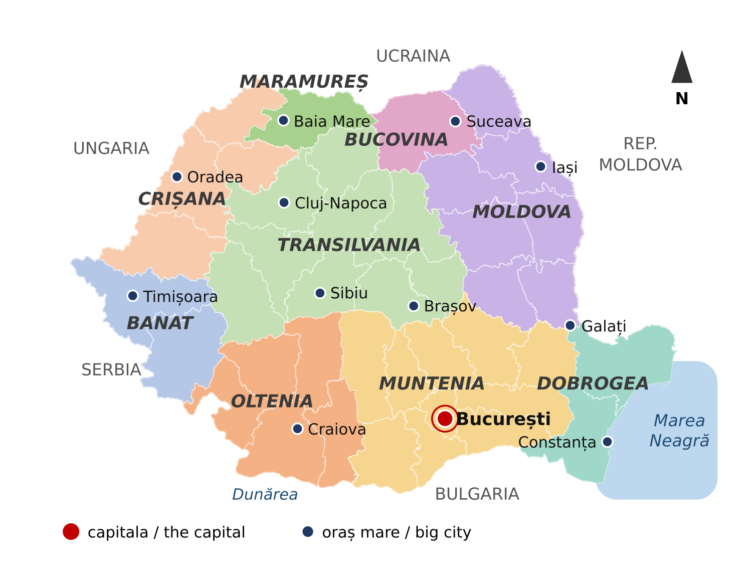
Fig. 5.1 — Harta României: regiunile istorice și orașele mari / Map of Romania: the historical regions and the main cities (schematic, drawn on county borders)

The symbols of Romania / Simbolurile României
Every country has symbols — things that everybody in the country knows and recognises. Here are the first ones you need. You will see them every day: on buildings, on money, on your documents.
The flag (drapelul or steagul) has three vertical stripes of the same size: blue, yellow and red — albastru, galben, roșu. You know these colours from Lesson 4.4. The blue stripe is always next to the pole. You see the flag on public buildings — the town hall, schools, the police — and everywhere on the national holidays (Lesson 5.6).
The capital (capitala) is București (Bucharest), the biggest city. The President, the Parliament and the Government of Romania are here.
The currency (moneda) is the leu (code RON). One leu has 100 bani. Romania is in the European Union, but it does not use the euro — in the shop you always pay in lei.
The official language (limba oficială) is Romanian. It is written in the Constitution, the most important law of the country. All official papers, forms and signs are in Romanian — this is why this course is important for you.
The European Union and NATO. Romania has been a member of NATO since 2004 and a member of the European Union (Uniunea Europeană, UE) since 2007. Next to the Romanian flag you will often see the EU flag: a circle of twelve yellow stars on blue.
Romania also has a coat of arms (stema). You see it on official documents, stamps and public buildings. You will learn what it shows in Module 10.
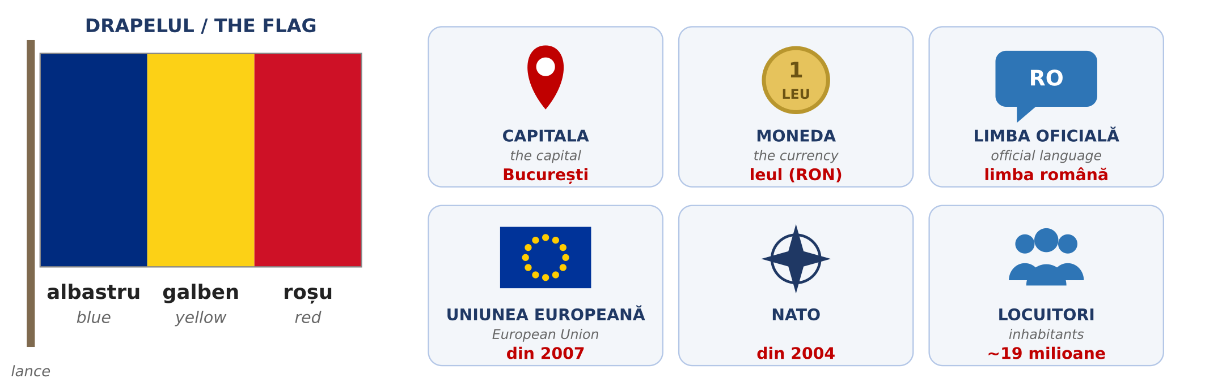
Fig. 5.2 — Simbolurile României / The symbols of Romania

Romania in short / România pe scurt
IN ENGLISH | IN ROMANIAN
The flag is blue, yellow and red. | Drapelul este albastru, galben și roșu.
The capital is Bucharest. | Capitala este București.
The currency is the leu (RON). 1 leu = 100 bani. | Moneda este leul. Un leu are 100 de bani.
The official language is Romanian. | Limba oficială este limba română.
Romania has been in the European Union since 2007. | România este membră a Uniunii Europene din 2007.
Romania has been in NATO since 2004. | România este membră NATO din 2004.
About 19 million inhabitants. | Aproximativ 19 milioane de locuitori.
The sea in the east is the Black Sea. | La est este Marea Neagră.
The mountains in the centre are the Carpathians. | În centru sunt Munții Carpați.
The river in the south is the Danube. | În sud curge Dunărea.

ATTENTION / ATENȚIE — ONE LEU, TWO LEI
The plural of leu is lei: un leu, doi lei, cinci lei. From 20 up you add de (Lesson 2.5): 20 de lei, 100 de lei. On a price tag you can see 25 lei or 25 RON — it is the same money.

The neighbours / Țările vecine
Romania has five neighbouring countries. Notice that most country names in Romanian end in -a — they are feminine: Ungaria, Bulgaria, Ucraina.
COUNTRY | IN ROMANIAN | CAPITAL | WHERE
Hungary | Ungaria | Budapesta | west
Serbia | Serbia | Belgrad | south-west
Bulgaria | Bulgaria | Sofia | south (across the Danube)
Moldova | Republica Moldova | Chișinău | east — people there also speak Romanian
Ukraine | Ucraina | Kiev | north and east

The historical regions / Regiunile istorice
For administration, Romania is divided into 41 counties (județe) plus the city of Bucharest. But in everyday life Romanians often talk about the old historical regions. Each region has its own accent, food and traditions, and people are proud of where they come from: Sunt ardelean (I’m from Transylvania), Sunt moldovean (I’m from Moldova).
REGION | MAIN CITY | WHERE | KNOWN FOR
Muntenia | București | south | the capital; flat farmland along the Danube
Oltenia | Craiova | south-west | old traditions, pottery, the Danube gorges
Dobrogea | Constanța | south-east | the Black Sea coast and the Danube Delta
Moldova | Iași | north-east | history, churches and vineyards (not the same as the Republic of Moldova!)
Bucovina | Suceava | far north-east | painted monasteries (UNESCO)
Maramureș | Baia Mare | north | wooden churches (UNESCO), village traditions
Transilvania (Ardeal) | Cluj-Napoca | centre | mountains, medieval towns, castles
Crișana | Oradea | west | Art Nouveau buildings, thermal spas
Banat | Timișoara | west | many nationalities living together; industry

ATTENTION / ATENȚIE — REGION, COUNTY, CITY
România is the country. Transilvania, Moldova, Banat... are historical regions — parts of the country, not separate states. Județul is the county: it appears in your address and on your documents. Example: Popești-Leordeni, județul Ilfov. On official forms you will almost always be asked for the județ, not the region.

The big cities and what to see / Orașele mari
CITY | REGION | PEOPLE (approx.)
București | Muntenia | 1.7 million
Cluj-Napoca | Transilvania | 290,000
Iași | Moldova | 270,000
Constanța | Dobrogea | 265,000
Timișoara | Banat | 250,000
Brașov | Transilvania | 240,000
Craiova | Oltenia | 235,000
Galați | Moldova | 215,000
Oradea | Crișana | 185,000
Ploiești | Muntenia | 180,000

Figures from the 2021 census, rounded. The whole metropolitan area of each city is bigger.
București — the capital, the political and business centre of the country. The Palace of the Parliament (Palatul Parlamentului) is one of the largest administrative buildings in the world. The Old Town (Centrul Vechi) is full of restaurants and cafés, and big parks like Herăstrău (Parcul Regele Mihai I) and Cișmigiu are good for a walk on Sunday.
FOTO: Palatul Parlamentului, București — vedere din față, zi senină
Fig. 5.3 — Palatul Parlamentului, București / The Palace of the Parliament, Bucharest
Brașov — a mountain city with a medieval centre around Piața Sfatului and the Black Church (Biserica Neagră), the biggest Gothic church in the region. Near Brașov is Bran Castle (Castelul Bran), known to tourists as “Dracula’s Castle”, and the ski resort Poiana Brașov.
Cluj-Napoca — the unofficial capital of Transylvania: a young, lively city with many students and IT companies, and big summer music festivals such as Untold and Electric Castle.
Timișoara — called “Little Vienna” for its elegant squares. The Romanian Revolution of December 1989 started here. It was European Capital of Culture in 2023.
Iași — an old cultural capital, with the Palace of Culture (Palatul Culturii), many churches and the oldest university in the country.
Constanța — the biggest port on the Black Sea. In summer, the beaches of Mamaia and the seaside resorts to the south are full of holidaymakers. On the seafront stands the old Casino (Cazinoul), a symbol of the city.
Sibiu is smaller, but worth a visit: a medieval town with painted roofs “with eyes” and Europe’s biggest open-air village museum (Muzeul ASTRA). And in Sighișoara you can walk through a medieval citadel where people still live.
FOTO: Piața Sfatului cu Biserica Neagră în fundal, Brașov
Fig. 5.4 — Piața Sfatului și Biserica Neagră, Brașov / The Council Square and the Black Church, Brașov

Where are you from? Where do you live?
TIPAR — three sentences about you / trei propoziții despre tine
Sunt din | + | COUNTRY

Locuiesc în | + | CITY / VILLAGE

Lucrez în județul | + | COUNTY

ROMANIAN | ENGLISH
Sunt din Nepal. / Sunt din India. | I’m from Nepal. / I’m from India.
Sunt din Sri Lanka. / Sunt din Vietnam. | I’m from Sri Lanka. / I’m from Vietnam.
Locuiesc în București, în sectorul 4. | I live in Bucharest, in District 4.
Locuiesc în Popești-Leordeni. | I live in Popești-Leordeni.
Locuiesc în Cluj-Napoca, pe strada Florilor. | I live in Cluj-Napoca, on Florilor street.
Lucrez în județul Ilfov. | I work in Ilfov county.
Lucrez în județul Cluj. | I work in Cluj county.
Lucrez în București, în sectorul 2. | I work in Bucharest, in District 2.
Din ce țară sunteți? | What country are you from? (formal)
Unde locuiți? | Where do you live? (formal)
Unde lucrați? | Where do you work? (formal)

PRACTICAL NOTE — BUCHAREST HAS SIX DISTRICTS
Bucharest is not part of any county. It is divided into six districts (sectoare), numbered 1 to 6. Your address in Bucharest says Sectorul 3, not a county — and each district has its own town hall (Primăria Sectorului 3).

5.1.a Romania — fill in
Complete with a word from the box. The English on the right helps you.
WORD BANK: București · Constanța · Transilvania · Banat · Moldova · leul · roșu

1. Capitala României este ______________. | The capital of Romania is...
2. Cel mai mare port la Marea Neagră este ______________. | The biggest port on the Black Sea is...
3. Cluj-Napoca este în ______________. | Cluj-Napoca is in...
4. Timișoara este în ______________. | Timișoara is in...
5. Iași este în ______________. | Iași is in...
6. Moneda României este ______________. | The currency of Romania is...
7. Drapelul României este albastru, galben și ______________. | The flag of Romania is blue, yellow and...

Lesson 5.2 — The institutions you need / Instituțiile esențiale
As a foreign worker in Romania you will deal with five institutions. You will not visit them often, but you must know what each one does and where to go when you have a problem. Your employer usually helps with the documents, but it is your stay and your rights — so it is good to understand the system yourself.
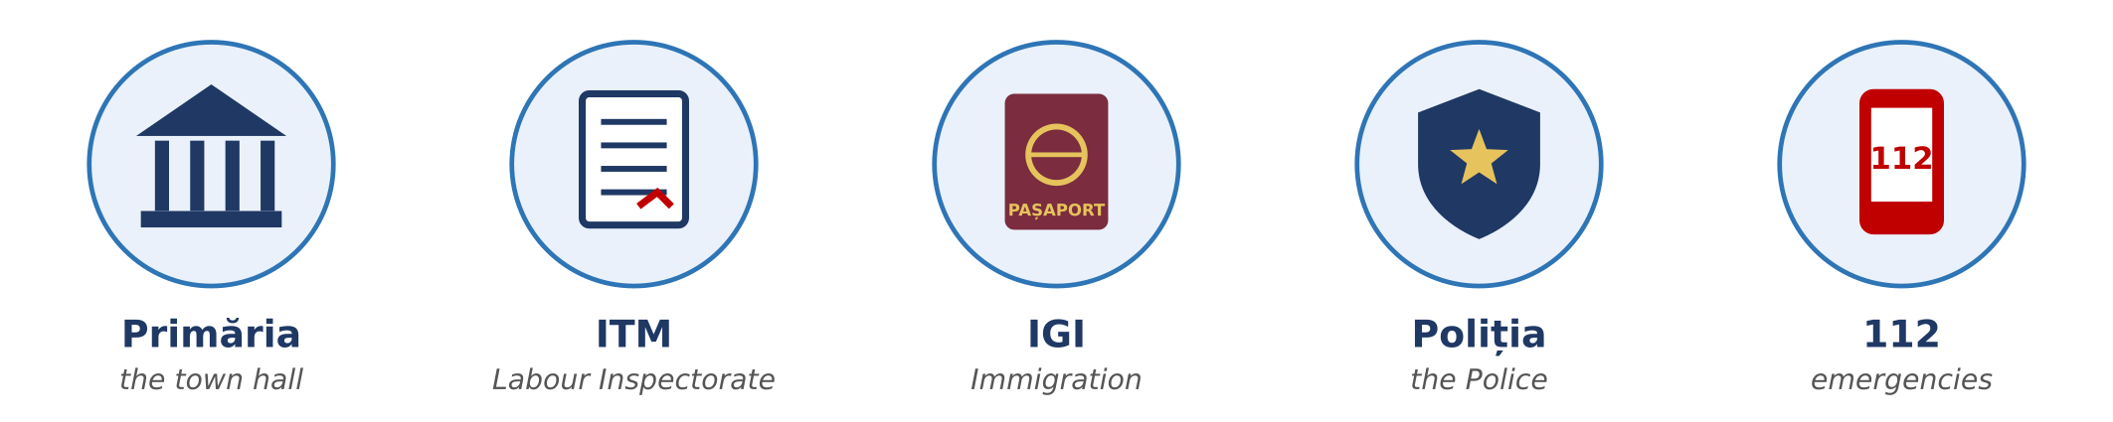
Fig. 5.5 — Cele cinci instituții esențiale / The five institutions you need
INSTITUTION | WHAT IT DOES | GO THERE WHEN...
Primăria | the town hall — the local administration of your city, commune or Bucharest district | you pay local taxes (for example for a car), you register a birth or a marriage (Starea civilă), you have a problem in your street
ITM Inspectoratul Teritorial de Muncă | the Labour Inspectorate — checks that employers respect the labour law | you are not paid, you work without a contract, work is unsafe, you work too many hours
IGI Inspectoratul General pentru Imigrări | the Immigration Office — manages the right of foreigners to stay in Romania | you apply for or extend your residence permit, you change your address or employer
Poliția | the Police — public order and safety | something is stolen, you lose your documents, you are threatened, you see a crime
112 | the single emergency number: police, ambulance, fire brigade | somebody’s life, health or safety is in danger — right now

PRACTICAL NOTE — YOUR CONTRACT AND ITM
You must receive a copy of your individual employment contract (contractul individual de muncă) before you start work, and your contract is registered electronically with ITM. If your employer does not solve a problem at work, you can send a written complaint (o sesizare) to the ITM of the county where you work. Keep copies of your contract, your payslips (fluturașii de salariu) and every paper you sign.

PRACTICAL NOTE — YOUR RESIDENCE PERMIT AND IGI
Your residence permit (permisul de ședere) has an expiry date. Ask for the extension in good time — at least 30 days before it expires. If you change your address or your employer, IGI must be informed. Check every change with your employer first, and always carry your permit or a copy of it.

Useful documents / Acte uzuale
ROMANIAN | ENGLISH
pașaportul | the passport
viza de lungă ședere | the long-stay visa
permisul de ședere | the residence permit
avizul de muncă | the work permit (approval)
contractul de muncă | the employment contract
contractul de închiriere | the rental contract
adeverința | an official certificate (e.g. from your employer)
cererea · formularul | the application · the form
programarea | the appointment

HOMEWORK — AFTER SESSION 19 / TEMĂ PENTRU ACASĂ
H19.1 Write three sentences about yourself with the patterns: Sunt din... · Locuiesc în... · Lucrez în județul... Say them out loud three times.
H19.2 Draw the Romanian flag and write under it: Drapelul României este ... Then write three more sentences from the table “Romania in short”.

SESSION 20 — EMERGENCIES, THE TOWN HALL, SOCIAL RULES
SESIUNEA 20 — APELUL LA 112, LA PRIMĂRIE, REGULI SOCIALE · 3 hours

By the end of this session you will be able to:
☐ | make an emergency call to 112 in simple Romanian
☐ | ask for what you need at the town hall: Am o programare. Ce acte trebuie să aduc? Unde semnez?
☐ | understand shop hours and the signs on doors: DESCHIS, ÎNCHIS, TRAGEȚI, ÎMPINGEȚI
☐ | use public transport: buy and validate a ticket, ask for a stop
☐ | choose tu or dumneavoastră and know the small social rules: greeting, Poftă bună, Sănătate, punctuality

Lesson 5.2 (continued) — Calling 112 and at the town hall / Apelul la 112 și la Primărie

Calling 112 / Apelul la 112
112 is the European emergency number. The call is free, and it works even with no credit on your phone. Call only for a real emergency: an accident, a fire, somebody hurt or ill, a crime happening now. The operator asks simple questions, one at a time. You do not need perfect Romanian — the key word and the address are enough.
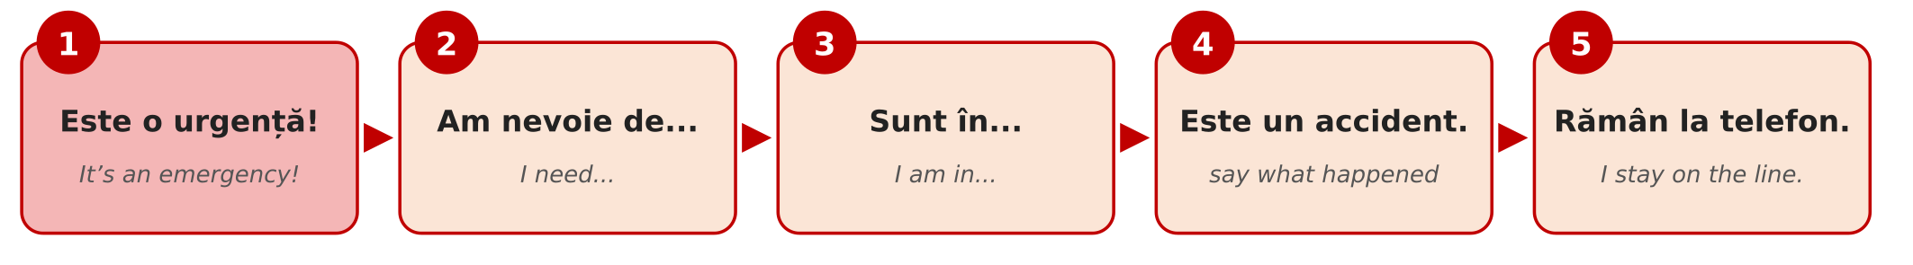
Fig. 5.6 — Pașii unui apel la 112 / The five steps of a 112 call
STEP | WHAT YOU SAY | ENGLISH
1 | Este o urgență! | It’s an emergency!
2 | Am nevoie de ambulanță / poliție / pompieri. | I need an ambulance / the police / the fire brigade.
3 | Sunt în Popești-Leordeni, strada Florilor, numărul 12. | I am in Popești-Leordeni, Florilor street, number 12.
4 | Un om este rănit. / Este un incendiu. / Este un accident. | A person is injured. / There is a fire. / There is an accident.
5 | Rămân la telefon. | I stay on the line.

Dialogue — an accident in the street
ROMANIAN | ENGLISH
O: 112, care este urgența? | 112, what is the emergency?
M: Este o urgență! Am nevoie de ambulanță. | It’s an emergency! I need an ambulance.
O: Ce s-a întâmplat? | What happened?
M: Un domn în vârstă a căzut pe trotuar. Este rănit la cap. | An elderly man fell on the pavement. His head is injured.
O: Unde sunteți? | Where are you?
M: Sunt în Popești-Leordeni, pe strada Florilor, lângă farmacie. | I’m in Popești-Leordeni, on Florilor street, next to the pharmacy.
O: Domnul respiră? Vorbește? | Is the man breathing? Is he talking?
M: Da, respiră și vorbește. | Yes, he is breathing and talking.
O: Nu-l mișcați. Ambulanța vine. Rămâneți la telefon. | Don’t move him. The ambulance is coming. Stay on the line.
M: Bine, rămân la telefon. | OK, I’m staying on the line.

MEMORISE THESE FOUR SENTENCES
Este o urgență! · Am nevoie de ambulanță. · Sunt în... · Un om este rănit.
It’s an emergency! · I need an ambulance. · I am in... · A person is injured.

At the town hall / La Primărie
At an office you speak slowly, say dumneavoastră, and bring all your documents — the original and a copy. Many offices work by appointment (cu programare). Here is a real situation: if you buy a car in Romania, you must declare it at the town hall within 30 days, so that you can pay the local tax on it.
ROMANIAN | ENGLISH
F: Bună ziua! Cu ce vă pot ajuta? | Hello! How can I help you?
C: Bună ziua! Vorbiți engleză? | Hello! Do you speak English?
F: Puțin. Încercăm în română. | A little. Let’s try in Romanian.
C: Bine. Am cumpărat o mașină. Trebuie să o declar? | OK. I bought a car. Do I have to declare it?
F: Da, în 30 de zile. Aveți programare? | Yes, within 30 days. Do you have an appointment?
C: Da, am o programare la ora zece. | Yes, I have an appointment at ten o’clock.
F: Ce acte aveți? | Which documents do you have?
C: Am pașaportul, permisul de ședere și contractul de cumpărare. Ce acte trebuie să mai aduc? | I have my passport, my residence permit and the purchase contract. Which other documents must I bring?
F: Cartea de identitate a mașinii. Completați acest formular, vă rog. | The car’s identity card (the vehicle registration book). Fill in this form, please.
C: Unde semnez? | Where do I sign?
F: Aici, jos. Mulțumesc! Plătiți impozitul la casierie sau online. | Here, at the bottom. Thank you! You pay the tax at the cash desk or online.
C: Mulțumesc mult! La revedere! | Thank you very much! Goodbye!

F = funcționara (the clerk) · C = cetățeanul (the citizen) · impozitul — the tax · casieria — the cash desk · Mi-am pierdut pașaportul. — I have lost my passport.
5.2.a Where do you go?
Read the situation in English. Write the institution: Primăria, ITM, IGI, Poliția or 112.
1. Your salary was not paid for two months. | → ______________
2. Your residence permit expires next month. | → ______________
3. Your baby was born in Romania. You must register the birth. | → ______________
4. Somebody stole your phone in the bus. | → ______________
5. A person fell in the street and cannot move. | → ______________
6. You work, but you have no contract. | → ______________

Lesson 5.3 — Everyday social rules / Reguli sociale de zi cu zi

Shops and opening hours / Magazinele și programul
In Romania most shops are open every day, Sunday included. At night, in every town some pharmacies are on duty (de gardă). On public holidays (Lesson 5.6) many shops have shorter hours, and on 1–2 January and 25 December most are closed.
TYPE OF SHOP | TYPICAL HOURS
supermarket / hipermarket | 8:00–22:00, every day; some non-stop
magazinul de cartier — the local shop | 7:00–22:00; some non-stop
farmacia — the pharmacy | 8:00–20:00; farmacia de gardă is open at night
banca, poșta — the bank, the post office | Monday–Friday, about 9:00–17:00
Primăria, IGI, ITM — offices | Monday–Friday; check the hours for the public (program cu publicul)

Signs you will see / Indicatoare
ON THE DOOR / SIGN | ENGLISH | ON THE DOOR / SIGN | ENGLISH
DESCHIS | open | ÎNCHIS | closed
TRAGEȚI | pull | ÎMPINGEȚI | push
INTRARE | entrance | IEȘIRE | exit
PROGRAM | opening hours | PAUZĂ | break
CASA | the till / checkout | FUMATUL INTERZIS | no smoking
TOALETA / WC | toilet | ATENȚIE! | caution!

Public transport / Transportul în comun
In the cities you travel by bus (autobuz), tram (tramvai) and trolleybus (troleibuz). Bucharest also has a metro (metrou) — the only one in Romania. You buy a ticket or a card from a machine, a kiosk or an app, and you must validate it (a valida) when you get on; in Bucharest you can also pay with a contactless bank card at the validator. No valid ticket means a fine (amendă). Between cities you travel by train (trenul, the national company is CFR) or by minibus (microbuzul).
ROMANIAN | ENGLISH | EXAMPLE
stația | the stop / station | Unde este stația de autobuz?
biletul | the ticket | Un bilet, vă rog.
abonamentul | the monthly pass | Am abonament lunar.
a valida | to validate | Validați biletul, vă rog!
a coborî | to get off | Cobor la următoarea stație.
a urca | to get on | Urc în autobuzul 116.
gara | the railway station | Trenul pleacă din Gara de Nord.

Coborâți la următoarea? — Are you getting off at the next stop? (people ask this in a full bus, to get to the door)

Tu or dumneavoastră? Domnul or doamna?
You learned tu and dumneavoastră in Lesson 2.6. In daily life the rule is simple: when in doubt, use dumneavoastră. The other person will tell you if you can say tu: Putem să ne tutuim — we can say tu to each other.
SITUATION | YOU SAY
family, friends, close colleagues of your age | tu
children | tu
a new colleague, your manager, your landlord | dumneavoastră — until they say tu
a shop assistant, a doctor, a stranger in the street | dumneavoastră
an official: Primăria, IGI, ITM, the police | always dumneavoastră, whatever their age

TIPAR — speaking politely to a person / adresarea politicoasă
domnul / doamna | + | SURNAME | → | Domnul Popescu · Doamna Ionescu

When you speak directly to someone, the form changes: Domnule Popescu! · Doamnă Ionescu! · Doamnă! · Domnule doctor! · Doamnă doctor! (a polite way to call a doctor).

Small rules, big difference / Reguli mici de politețe
Romanians are warm and direct, and they value a few small habits. Say Bună ziua when you enter a shop, an office, a doctor’s waiting room or the lift in your block, and La revedere when you leave. Men usually shake hands when they meet; close friends and family may kiss on both cheeks. Before a meal people say Poftă bună! (enjoy your meal); when somebody sneezes you say Sănătate! (health!); when you toast, Noroc! (cheers). Punctuality at work is taken seriously — if you will be late, phone your manager before. Smoking is forbidden in all closed public spaces, including restaurants and bars, and in closed workplaces.
CULTURAL NOTE — FLOWERS AND GIFTS
If you are invited to a Romanian home, bring something small: a cake, a bottle, chocolate or flowers. With flowers, remember: give an odd number (1, 3, 5, 7). An even number of flowers (2, 4, 6) is only for funerals and cemeteries. And do not forget to take your shoes off at the door — the host will give you slippers.

Dialogue — at the bus stop
ROMANIAN | ENGLISH
A: Bună ziua! Scuzați-mă, autobuzul 116 oprește aici? | Hello! Excuse me, does bus 116 stop here?
B: Da, oprește aici. Vine în cinci minute. | Yes, it stops here. It comes in five minutes.
A: Unde pot cumpăra un bilet? | Where can I buy a ticket?
B: La automatul de acolo. Sau plătiți cu cardul în autobuz. | At the machine over there. Or pay by card on the bus.
A: Mulțumesc! Știți dacă magazinele sunt deschise duminica? | Thank you! Do you know if the shops are open on Sundays?
B: Da, supermarketurile sunt deschise în fiecare zi. | Yes, the supermarkets are open every day.
A: Foarte bine. Mulțumesc mult! La revedere! | Very good. Thank you very much! Goodbye!

5.3.a Tu or dumneavoastră?
Read the situation in English. Write tu or dumneavoastră.
1. The clerk at the town hall | → ______________
2. Your close friend from home | → ______________
3. A police officer | → ______________
4. A seven-year-old child | → ______________
5. The doctor | → ______________
6. Your new manager, on the first day | → ______________

HOMEWORK — AFTER SESSION 20 / TEMĂ PENTRU ACASĂ
H20.1 Write the four sentences of an emergency call, with your real address. Keep the paper in your wallet or take a photo of it with your phone.
H20.2 Find three signs in your street or in a shop (DESCHIS, TRAGEȚI, IEȘIRE...). Copy them and write the English next to them.

SESSION 21 — TIME, THE WEATHER AND YOUR DAY
SESIUNEA 21 — TIMPUL, VREMEA ȘI ZIUA TA · 3 hours

By the end of this session you will be able to:
☐ | tell the time: Este ora șapte și jumătate. and say at what time: la ora opt
☐ | say the days, the months and the seasons, and say a date: pe 1 decembrie
☐ | say what the weather is like and the temperature: Plouă. Sunt 30 de grade.
☐ | understand the weather warnings: cod galben, cod portocaliu, cod roșu
☐ | describe your day from morning to evening, with the reflexive verbs you know: mă trezesc, mă culc

Lesson 5.4 — Time / Timpul

What time is it? / Cât e ceasul?
There are two ways to ask the time: Cât e ceasul? and Ce oră este? Both mean What time is it? The answer always starts with Este ora... (it is ... o’clock).
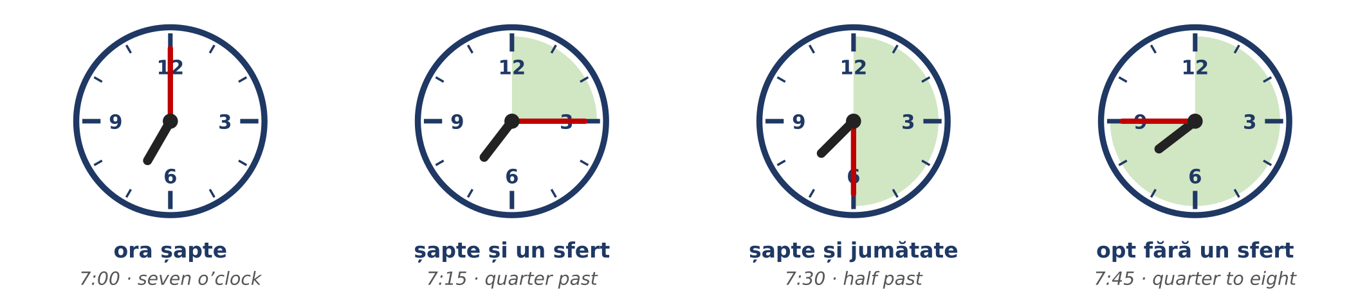
Fig. 5.7 — Ora exactă, sfertul, jumătatea / O’clock, quarter past, half past, quarter to
TIPAR — telling the time / cum spui ora
Este ora | + | HOUR | + | și un sfert · și jumătate

Este | + | NEXT HOUR | + | fără un sfert

TIME | ROMANIAN | ENGLISH
1:00 | Este ora unu. | It’s one o’clock.
2:00 | Este ora două. | It’s two o’clock.
7:00 | Este ora șapte. | It’s seven o’clock.
7:10 | Este ora șapte și zece. | It’s ten past seven.
7:15 | Este ora șapte și un sfert. | It’s quarter past seven.
7:30 | Este ora șapte și jumătate. | It’s half past seven.
7:45 | Este opt fără un sfert. | It’s quarter to eight.
7:50 | Este opt fără zece. | It’s ten to eight.
12:00 | Este ora douăsprezece. / Este amiaza. | It’s twelve o’clock. / It’s midday.
00:00 | Este miezul nopții. | It’s midnight.

ATTENTION / ATENȚIE — ORA DOUĂ, NOT ORA DOI
Ora is a feminine word, so the hour uses the feminine number: ora unu, ora două, ora douăsprezece — never ora doi. This is the same rule as două case in Lesson 2.5.

The 24-hour clock / Formatul de 24 de ore
Timetables, work schedules and official papers use the 24-hour clock. In speech people often use the 12-hour clock and add dimineața (in the morning), după-amiaza (in the afternoon) or seara (in the evening).
WRITTEN | OFFICIAL | EVERYDAY | ENGLISH
06:30 | ora șase și treizeci | șase și jumătate dimineața | 6:30 a.m.
14:00 | ora paisprezece | ora două după-amiaza | 2 p.m.
17:45 | ora șaptesprezece și patruzeci și cinci | șase fără un sfert seara | 5:45 p.m.
21:00 | ora douăzeci și unu | ora nouă seara | 9 p.m.

TIPAR — at what time? / la ce oră?
La ce oră...? | → | La ora | + | HOUR

TIPAR — from ... to ... / de la ... până la ...
de la ora | + | HOUR | + | până la ora | + | HOUR

ROMANIAN | ENGLISH
La ce oră începeți lucrul? — La ora șapte. | What time do you start work? — At seven.
La ce oră pleacă trenul? — La ora 9:15. | What time does the train leave? — At 9:15.
Am o programare la ora zece. | I have an appointment at ten.
Lucrez de la ora opt până la ora cinci. | I work from eight to five.
Pauza de masă este de la 12 la 12 și jumătate. | The lunch break is from 12 to 12:30.
Magazinul este deschis până la zece seara. | The shop is open until 10 p.m.

The days of the week / Zilele săptămânii
The Romanian week starts on Monday. Remember from Module 1: the names of the days are written with a small letter — luni, not Luni.
ROMANIAN | ENGLISH | EVERY WEEK | ENGLISH
luni | Monday | lunea | on Mondays
marți | Tuesday | marțea | on Tuesdays
miercuri | Wednesday | miercurea | on Wednesdays
joi | Thursday | joia | on Thursdays
vineri | Friday | vinerea | on Fridays
sâmbătă | Saturday | sâmbăta | on Saturdays
duminică | Sunday | duminica | on Sundays

TIPAR — once or every week? / o dată sau în fiecare săptămână?
Lucrez sâmbătă. | = | this Saturday (once)

Lucrez sâmbăta. | = | every Saturday

ROMANIAN | ENGLISH
Luni am o programare la IGI. | On Monday (this Monday) I have an appointment at IGI.
Lunea merg la curs. | On Mondays I go to the course.
Vineri plec acasă. | On Friday (this Friday) I go home.
Vinerea merg la piață. | On Fridays I go to the market.
Magazinul este închis duminica. | The shop is closed on Sundays.
Duminică mergem în parc. | On Sunday (this Sunday) we go to the park.

ROMANIAN | ENGLISH | ROMANIAN | ENGLISH
azi / astăzi | today | ieri | yesterday
mâine | tomorrow | poimâine | the day after tomorrow
săptămâna aceasta | this week | săptămâna viitoare | next week
weekendul | the weekend | în fiecare zi | every day

The months and the seasons / Lunile și anotimpurile
The months are also written with a small letter. Most of them look like the English names, so they are easy to learn. The seasons need no preposition: iarna = in winter, vara = in summer.
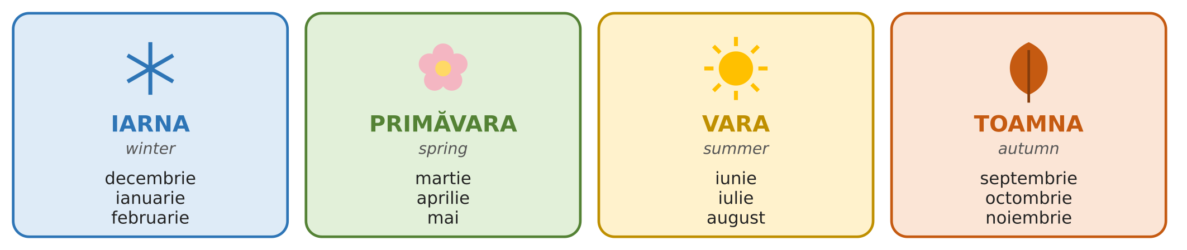
Fig. 5.8 — Anotimpurile și lunile / The seasons and the months
TIPAR — month and date / luna și data
în | + | MONTH | → | în mai

pe | + | DATE | → | pe 1 decembrie

ROMANIAN | ENGLISH
Concediul meu este în august. | My holiday is in August.
În ianuarie este frig. | In January it is cold.
Ziua mea de naștere este pe 5 mai. | My birthday is on 5 May.
Pe 1 decembrie este Ziua Națională. | On 1 December it is National Day.
Contractul meu începe pe 15 octombrie. | My contract starts on 15 October.
Ce dată este azi? — Azi este 23 septembrie. | What’s the date today? — Today is 23 September.
În ce lună suntem? — Suntem în septembrie. | What month is it? — It’s September.

ATTENTION / ATENȚIE — THE FIRST DAY OF THE MONTH
For the first day of a month Romanians say întâi: 1 decembrie = întâi decembrie, 1 martie = întâi martie. For all the other days use the normal numbers: doi mai, cincisprezece august. Dates are written day.month.year: 23.09.2026.

5.4.a Write the time
Write the time in Romanian, in words.
1. 1:00 → Este ora ______________. | 2. 3:30 → Este ora trei ______________.
3. 10:15 → Este ora zece ______________. | 4. 6:45 → Este ______________ fără un sfert.
5. 2:00 → Este ora ______________. | 6. 12:00 → Este ______________ (midday).

Lesson 5.5 — The weather and your day / Vremea și ziua ta

What’s the weather like? / Cum e vremea?
Romania has four clear seasons. Summers are hot — in the south 30–35 °C is normal in July and August. Winters are cold, with snow, and at night the temperature can fall to −10 °C or lower. Spring and autumn are short and pleasant, but it rains more. The weather decides a lot about your day: what you wear, how much water you drink, how you travel to work.
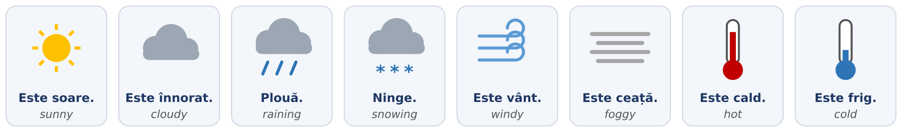
Fig. 5.9 — Vremea / The weather
TIPAR — weather sentences have no subject / fără subiect
Este | + | cald · frig · soare · vânt · înnorat · ceață

Plouă. · Ninge. | = | It’s raining. · It’s snowing.

ROMANIAN | ENGLISH | EXAMPLE
Este cald. | It’s warm / hot. | Vara este foarte cald.
Este frig. | It’s cold. | Iarna este frig afară.
Este soare. | It’s sunny. | Azi este soare și cald.
Este înnorat. | It’s cloudy. | Este înnorat, poate plouă.
Plouă. | It’s raining. | Plouă, luați o umbrelă!
Ninge. | It’s snowing. | Ninge de ieri.
Este vânt. | It’s windy. | Este vânt puternic — închideți fereastra!
Este ceață. | It’s foggy. | Dimineața este ceață pe drum.
Este polei. | It’s icy (roads). | Atenție, este polei!
Este răcoare. | It’s cool. | Seara este răcoare, luați o geacă.

TIPAR — the temperature / temperatura
Sunt | + | NUMBER | + | de grade | → | Sunt 30 de grade.

Remember Lesson 2.5: from 20 up you add de — 20 de grade, 35 de grade; but 5 grade, 12 grade. Below zero: minus 5 grade. Romania uses degrees Celsius.
PRACTICAL NOTE — WEATHER WARNINGS / AVERTIZĂRI METEO
The national weather service (ANM, Administrația Națională de Meteorologie) publishes warnings by colour, and on your phone you may receive an RO-ALERT message. Cod galben (yellow) = be careful. Cod portocaliu (orange) = dangerous weather. Cod roșu (red) = very dangerous. In a heat wave (caniculă) drink water often and stay out of the sun at midday. In strong wind (vânt puternic) stay away from trees and old buildings. With ice on the road (polei) walk and drive slowly. Always read the RO-ALERT message and do what it says.

The weather in each season
IARNA — winter | PRIMĂVARA — spring | VARA — summer | TOAMNA — autumn
Este frig. Ninge. | Este mai cald. | Este foarte cald. | Este răcoare.
Este polei. | Plouă des. | Este soare. | Plouă. Este ceață.
minus 5 grade | 15 grade | 35 de grade | 10 grade

Your day / Ziua ta
A day in Romania has four parts. For each part there is a word you will use every day: dimineața (in the morning), la prânz (at midday), după-amiaza (in the afternoon), seara (in the evening). At night is noaptea.
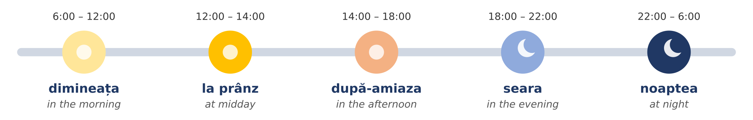
Fig. 5.10 — O zi obișnuită / An ordinary day
RECAP — REFLEXIVE VERBS (Lesson 3.12)
Nothing new here: you learned these verbs in Module 3. Some verbs always need a small word before them: mă, te, se, ne, vă, se. I wake up = mă trezesc (literally I wake myself). Now use them to talk about your day.

PERSON | A SE TREZI — to wake up | A SE CULCA — to go to bed | A SE ODIHNI — to rest
eu | mă trezesc | mă culc | mă odihnesc
tu | te trezești | te culci | te odihnești
el / ea | se trezește | se culcă | se odihnește
noi | ne trezim | ne culcăm | ne odihnim
voi / dvs. | vă treziți | vă culcați | vă odihniți
ei / ele | se trezesc | se culcă | se odihnesc

ROMANIAN | ENGLISH
La ce oră te trezești? — Mă trezesc la ora cinci. | What time do you wake up? — I wake up at five.
Copiii se culcă la ora nouă. | The children go to bed at nine.
Duminica ne odihnim. | On Sundays we rest.

More verbs for your day — eu
ROMANIAN (eu) | ENGLISH | ROMANIAN (eu) | ENGLISH
iau micul dejun | I have breakfast | iau prânzul | I have lunch
plec la lucru | I leave for work | lucrez | I work
merg cu autobuzul | I go by bus | termin lucrul | I finish work
mă întorc acasă | I come back home | gătesc | I cook
iau cina | I have dinner | mă uit la televizor | I watch TV
vorbesc cu familia | I talk to my family | dorm | I sleep

COMMON MISTAKE
a se trezi (to wake up) ≠ a se culca (to go to bed). Mă trezesc is in the morning, mă culc is in the evening. And a mânca (to eat) is correct, but for meals Romanians usually say iau micul dejun / prânzul / cina — I take breakfast / lunch / dinner.

Read — two days
Read each text twice, out loud. The English is on the right — cover it and try to understand the Romanian first.
Text 1 — Kumar, a working day Mă numesc Kumar și sunt din Sri Lanka. Lucrez într-un supermarket în județul Ilfov. Mă trezesc în fiecare zi la ora cinci și jumătate. Mă spăl și iau micul dejun. La ora șase și jumătate iau autobuzul. Lucrez de la ora șapte până la ora patru. La prânz, de la douăsprezece la douăsprezece și jumătate, iau prânzul cu colegii. Iarna este frig afară și aștept autobuzul în stație. Vara este foarte cald și beau multă apă. Seara mă întorc acasă, gătesc și vorbesc la telefon cu familia. Mă culc la ora zece. | My name is Kumar and I’m from Sri Lanka. I work in a supermarket in Ilfov county. I wake up every day at half past five. I wash and have breakfast. At half past six I take the bus. I work from seven to four. At midday, from twelve to half past twelve, I have lunch with my colleagues. In winter it is cold outside and I wait for the bus at the stop. In summer it is very hot and I drink a lot of water. In the evening I come back home, I cook and I talk on the phone with my family. I go to bed at ten.

Text 2 — Ana, a Saturday Sâmbăta mă trezesc târziu, la ora nouă. Afară este frumos: este soare și sunt 25 de grade. Iau micul dejun și apoi merg cu metroul în centru. La ora unsprezece am o programare la Primărie. Vorbesc cu funcționara și spun „dumneavoastră”. După-amiaza merg în parc. Seara iau cina cu prietenii și mă culc la ora douăsprezece. | On Saturdays I wake up late, at nine. Outside it is nice: it’s sunny and 25 degrees. I have breakfast and then I take the metro to the centre. At eleven I have an appointment at the town hall. I talk to the clerk and say “dumneavoastră”. In the afternoon I go to the park. In the evening I have dinner with friends and I go to bed at twelve.

în fiecare zi — every day · aștept — I wait · beau — I drink · târziu — late · funcționara — the (female) clerk · afară — outside
5.5.a Choose the correct word
Circle the correct form.
1. Iarna este ( cald / frig ). | 2. ( Plouă / Este plouă ). Luați o umbrelă!
3. Eu ( mă / se ) trezesc la ora șase. | 4. Noi ( ne / vă ) culcăm la ora zece.
5. Sunt 30 de ( grade / ore ). Este cald. | 6. Dimineața iau ( micul dejun / cina ).
7. Tu la ce oră ( te trezești / mă trezesc )? | 8. Seara ( mă culc / mă trezesc ).

HOMEWORK — AFTER SESSION 21 / TEMĂ PENTRU ACASĂ
H21.1 Every morning this week, say out loud the day, the date, the time and the weather: Azi este luni, 12 octombrie. Este ora șapte. Plouă. Sunt 10 grade.
H21.2 Write your own day, like Text 1, in six sentences with the hours: Mă trezesc la ora ... Plec la lucru la ...

SESSION 22 — HOLIDAYS, TRADITIONS, RECAP AND TEST
SESIUNEA 22 — SĂRBĂTORI ȘI TRADIȚII, RECAPITULARE ȘI TEST · 3 hours

By the end of this session you will be able to:
☐ | know which days are legal days off in Romania — all of them
☐ | tell the difference between a legal day off and a tradition
☐ | tell the story of the two national days: 24 January and 1 December
☐ | understand the main customs of Christmas, New Year, Easter, 1 March and other celebrations, and wish people well: Crăciun fericit! La mulți ani! Hristos a înviat!
☐ | revise the whole module and sit the Module 5 test

Lesson 5.6 — Holidays and traditions / Sărbători și tradiții
Romania has a rich calendar of celebrations. Most of them are religious — about three in four Romanians are Orthodox Christians (2021 census) — and some are national. There are two kinds of days, and it is important not to mix them up:
Zi liberă legală | a legal day off: the law (the Labour Code, Codul Muncii, art. 139) says that employees do not work that day. There are 17 such days a year.
Tradiție | a tradition: people celebrate it, give presents or cook special food, but it is a normal working day.

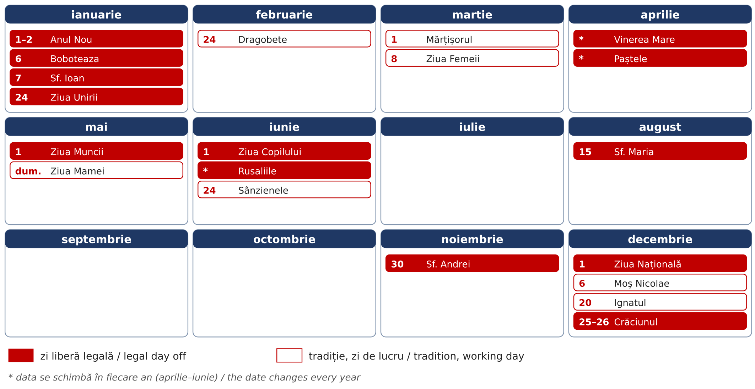
Fig. 5.11 — Calendarul sărbătorilor / The calendar of celebrations (red = legal day off, white = tradition)

Table 1 — the legal days off / zilele libere legale
DATE | IN ROMANIAN | IN ENGLISH | WHAT IT IS
1 and 2 January | Anul Nou | New Year | the first two days of the year
6 January | Boboteaza | Epiphany | the baptism of Jesus; priests bless the water
7 January | Sfântul Ioan | St John the Baptist | name day of everyone called Ion, Ioana, Ionuț
24 January | Ziua Unirii Principatelor | Union Day | the union of Moldova and Țara Românească in 1859 (see below)
changes every year | Vinerea Mare | Good Friday | the Friday before Orthodox Easter
changes every year | Paștele (2 days) | Easter Sunday and Monday | the most important Christian holiday
1 May | Ziua Muncii | Labour Day | the international day of workers
1 June | Ziua Copilului | Children’s Day | a day for children
changes every year | Rusaliile (2 days) | Pentecost | 50 days after Easter
15 August | Adormirea Maicii Domnului | St Mary’s Day | feast of the Virgin Mary; name day of Maria, Marian
30 November | Sfântul Andrei | St Andrew’s Day | the patron saint of Romania
1 December | Ziua Națională | National Day | the Great Union of 1918 (see below)
25 and 26 December | Crăciunul | Christmas | the birth of Jesus

Count them: 2 + 1 + 1 + 1 + 1 + 2 + 1 + 1 + 2 + 1 + 1 + 1 + 2 = 17 days. Some years two holidays fall on the same day (in 2026, Pentecost Monday was on 1 June).
PRACTICAL NOTE — IF YOU ARE NOT CHRISTIAN
The Labour Code also gives employees who belong to other legally recognised religions (for example Muslims or Jews) two days off for each of three annual religious holidays of their own faith. Tell your employer in advance which days you need. On the Christian legal holidays everyone has the day off, whatever their religion.

Table 2 — traditions (normal working days) / tradiții
DATE | IN ROMANIAN | IN ENGLISH | WHAT PEOPLE DO
24 February | Dragobete | Romanian Day of Love | couples give flowers; the old folk “Valentine’s Day”
1 March | Mărțișorul | Spring token day | men give women a red-and-white token (see below)
1–9 March | Babele | The Old Women’s days | each person chooses a day; its weather shows your year
8 March | Ziua Femeii | Women’s Day | flowers for mothers, wives, colleagues
changes | Lăsatul Secului | the start of the Easter fast | a big family meal before 40 days of fasting
changes | Floriile | Palm Sunday | one week before Easter; willow branches are blessed in church
first Sunday of May | Ziua Mamei | Mother’s Day | flowers and presents for mothers
24 June | Sânzienele | Midsummer | village girls wear crowns of yellow wild flowers
6 December | Moș Nicolae | St Nicholas | children clean their boots; in the morning they find sweets inside
20 December | Ignatul | St Ignatius | in villages, the family pig is killed for Christmas

Winter — Christmas and New Year / Crăciunul și Anul Nou
Crăciunul is the biggest family holiday of the year. The preparations start early. On 20 December, the day of Ignatul, many families in the villages kill the pig they have raised during the year (tăiatul porcului). From the meat they make the Christmas food: cârnați (sausages), tobă and caltaboș (traditional pork dishes), piftie (meat in jelly) and above all sarmale — cabbage leaves rolled around minced meat and rice. The sweet bread of every holiday is cozonac.
On Christmas Eve (Ajunul Crăciunului, 24 December) groups of children and young people go from house to house singing colinde (carols). The family opens the door, listens, and gives them apples, nuts, cozonac or a little money. At night Moș Crăciun (Father Christmas) brings presents under the decorated tree (bradul de Crăciun). On 25 December many people go to church in the morning and then eat together with the whole family.
FOTO: Grup de colindători (copii) la ușa unei case, în Ajunul Crăciunului, cu zăpadă
Fig. 5.12 — Colindători în Ajunul Crăciunului / Carol singers on Christmas Eve
On 31 December, Revelionul (New Year’s Eve), people celebrate with friends until midnight, with music and fireworks, and say La mulți ani! (literally to many years). On 31 December and 1 January children go round with two old customs: Plugușorul — a long rhyme about ploughing, with bells and a whip, wishing a rich harvest — and Sorcova — a decorated stick they touch you with, wishing you health. On 6 January, Boboteaza, priests bless the water; in some towns young men jump into an icy river to catch a wooden cross thrown by the priest.

Spring — Dragobete and Mărțișorul
Dragobete (24 February) is an old Romanian celebration of love. In folk stories Dragobete is a handsome young man who protects lovers, and this is the day when the birds choose their partners. Young people used to go into the forest to pick the first spring flowers. Today couples give each other flowers or a small present.
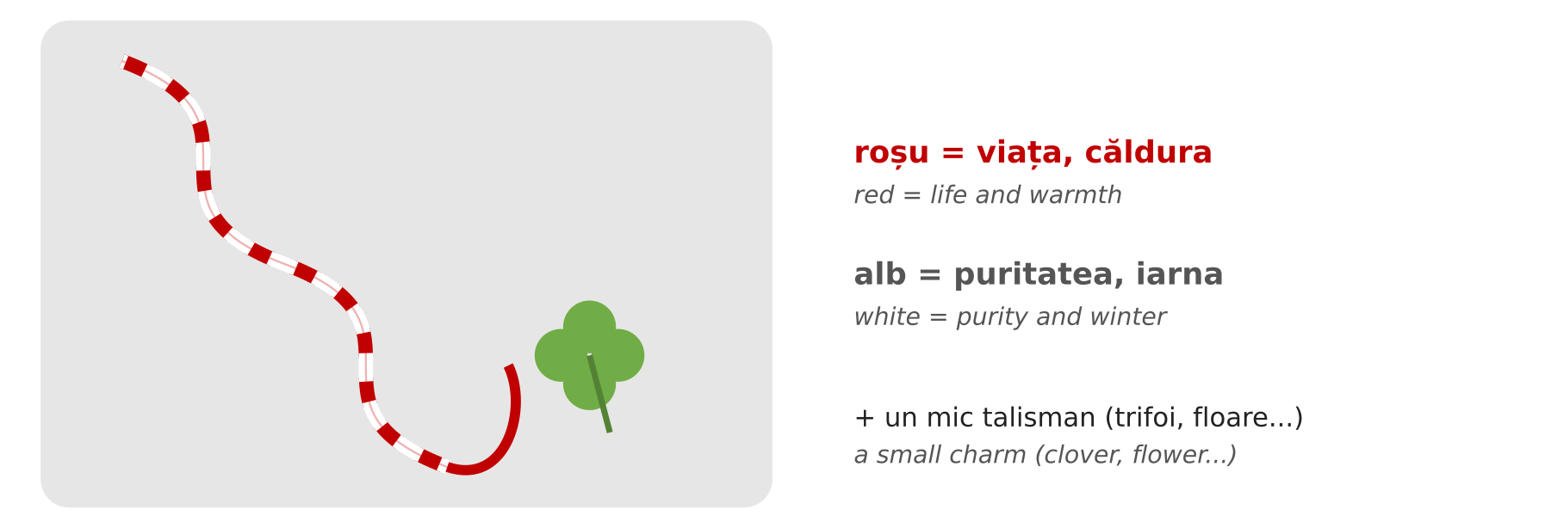
Fig. 5.13 — Un mărțișor / A mărțișor
Mărțișorul (1 March) welcomes the spring. A mărțișor is a thin cord of two twisted threads, one red and one white, with a small charm: a flower, a four-leaf clover, a ladybird, a chimney sweep or a horseshoe. The red stands for life and warmth, the white for purity and winter. Men give mărțișoare to the women in their life — mother, wife, daughter, sisters, female colleagues, even the lady at the shop they visit every day. Women pin it on their coat, near the heart, or wear it as a bracelet.
There are regional differences. Traditionally the mărțișor was worn for the whole month of March, or until you see the first tree in blossom — then you hang it on a branch of the tree, for good luck. In Moldova a small silver or gold coin was often tied to the cord. In some parts of Transylvania and Banat the cord was tied to gates, doors and even animals, to protect them. In a few places it is the women who give mărțișoare to the men. And from 1 to 9 March come Babele (the old women): everybody chooses one of these days, and if the weather is sunny on your day, your whole year will be good.
A week later, on 8 March, is Ziua Femeii (Women’s Day): again men bring flowers — to their mother, wife and female colleagues. On both days, a small bunch of snowdrops (ghiocei) is the classic present.

Spring — Easter / Paștele
Paștele, Easter, is the most important religious holiday in Romania. Its date follows the Orthodox calendar and changes every year (in April or early May). Before Easter comes a 40-day fast (Postul Paștelui), when believers eat no meat, no milk and no eggs. It begins after Lăsatul Secului — the Sunday when families meet for a last big meal with meat and cheese, make peace with anyone they have argued with, and in some villages light bonfires to chase away the winter. One week before Easter, on Floriile (Palm Sunday), people take willow branches (ramuri de salcie) to church to be blessed.
In the Holy Week (Săptămâna Mare) people clean the house and cook. Every evening there is a special church service called Denia; on Good Friday (Vinerea Mare) many people pass under the table with the icon of Christ in church. On Thursday, eggs are dyed red (vopsitul ouălor) — the red colour stands for the blood of Christ and for new life. In Bucovina, women decorate the eggs with fine patterns in wax (ouă încondeiate) — real works of art.
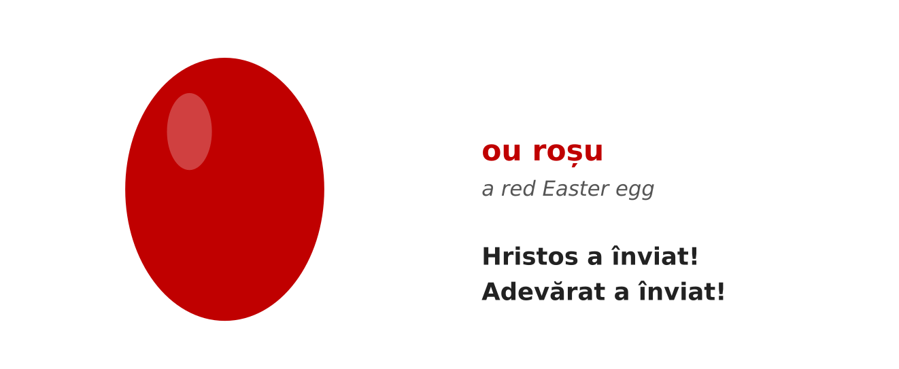
Fig. 5.14 — Un ou roșu de Paști / A red Easter egg
On Saturday night, just before midnight, people gather at the church with an unlit candle. At midnight the priest comes out with the Holy Light and says Hristos a înviat! (Christ is risen!); everybody answers Adevărat a înviat! (Truly he is risen!) and lights their candle from their neighbour’s — the whole churchyard fills with small flames. People carry the light of the Resurrection (Lumina de Înviere) carefully home, still burning, and many go to the cemetery to light candles on the graves of their family. On Easter Sunday the family eats together: red eggs, drob (a lamb and herb terrine), lamb soup (ciorbă de miel), roast lamb, cozonac and pască (a sweet cheese cake). Before the meal everyone knocks red eggs together (ciocnitul ouălor): one person says Hristos a înviat!, the other Adevărat a înviat! — and whoever keeps an unbroken egg is said to have a lucky year.
FOTO: Noaptea de Înviere: oameni cu lumânări aprinse în curtea unei biserici
Fig. 5.15 — Noaptea de Înviere: lumânări aprinse în curtea bisericii / Easter night: lit candles in the churchyard

Summer and autumn
Rusaliile (Pentecost) come 50 days after Easter; in the countryside houses are decorated with green branches of walnut or linden. On 24 June, Sânzienele, village girls wear crowns of yellow wild flowers (sânziene). On 15 August, Sfânta Maria, thousands of pilgrims go to monasteries — especially in Moldova and Maramureș. On 30 November, Sfântul Andrei, the patron saint of Romania, folk tradition says evil spirits walk in the night, so people rub garlic on doors and windows to protect the house.
CULTURAL NOTE — NAME DAYS / ZIUA NUMELUI
Romanians celebrate not only their birthday but also their name day (onomastica) — the feast of the saint with the same name. On 7 January everybody called Ion or Ioana celebrates, on 23 April every Gheorghe and George, on 21 May every Constantin and Elena, on 15 August every Maria and Marian, on 30 November every Andrei, on 6 December every Nicolae. At work, colleagues often bring cakes on their name day. The wish is the same as for a birthday: La mulți ani!

The two national days — 24 January and 1 December / Cele două uniri
Two legal days off tell the story of how Romania was born. Look at the timeline first, then read.
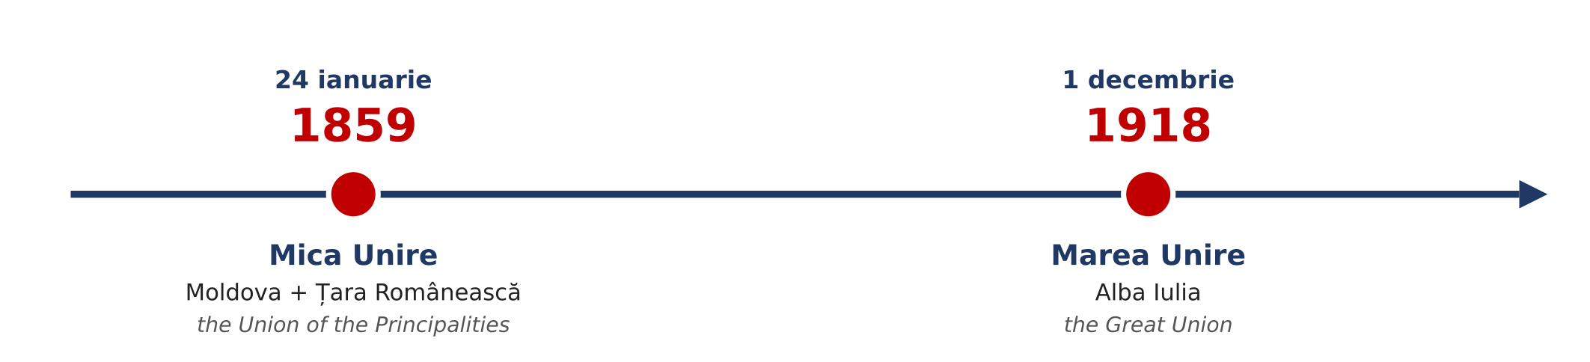
Fig. 5.16 — Cele două uniri / The two unions
24 January 1859 — the Union of the Principalities (Unirea Principatelor, also called Mica Unire, the Small Union). In the middle of the 19th century there was no country called Romania. People who spoke Romanian lived in several separate lands. Two of them were principalities (principate) — small states, each with its own ruler: Moldova in the east and Țara Românească (Wallachia) in the south. The people of both lands spoke the same language and wanted to live in one country. In January 1859 both chose the same man as their ruler (domnitor): Alexandru Ioan Cuza. Moldova elected him on 5 January and Țara Românească on 24 January 1859. From that day the two lands had one ruler, and in 1862 they had one government and one capital, Bucharest. This was the first step towards modern Romania. Cuza also made important reforms, and in his time the first Romanian universities opened, in Iași (1860) and Bucharest (1864).
Today 24 January is a legal day off. In Iași, in Focșani — the old border town between the two principalities — and in Bucharest, people meet in the main square and dance the Hora Unirii, “the round dance of the union”: everybody holds hands in a big circle, to show that they are together.
1 December 1918 — the Great Union (Marea Unire). After 1859 many Romanians still lived outside the country: in Transylvania, Banat, Crișana and Maramureș, which were then part of Austria-Hungary, and in Bessarabia and Bucovina. At the end of the First World War, in 1918, these lands decided one after another to join Romania: Bessarabia on 27 March, Bucovina on 28 November. On 1 December 1918, in the city of Alba Iulia, a great national assembly of 1,228 delegates — with around 100,000 people who came to watch — voted the union of Transylvania, Banat, Crișana and Maramureș with Romania. So in one year the country became more than twice as big, and nearly all Romanians lived in one state. Since 1990, 1 December is Romania’s National Day (Ziua Națională).
On 1 December there is a big military parade in Bucharest, under the Arch of Triumph (Arcul de Triumf), and another one in Alba Iulia. Soldiers march, planes fly over the city, and thousands of people watch. People hang the flag — blue, yellow and red (albastru, galben, roșu) — on houses, cars and balconies, and wish each other La mulți ani, România! The traditional dish of the day is fasole cu cârnați (beans with sausages), the soldiers’ food, often given out free to the public at the celebrations.
FOTO: Parada militară de 1 Decembrie la Arcul de Triumf, București, cu drapele tricolore
Fig. 5.17 — Parada de 1 Decembrie la Arcul de Triumf / The 1 December parade at the Arch of Triumph
ROMANIAN | ENGLISH
Pe 24 ianuarie sărbătorim Unirea Principatelor. | On 24 January we celebrate the Union of the Principalities.
În 1859, Moldova și Țara Românească au avut un singur domnitor: Alexandru Ioan Cuza. | In 1859, Moldova and Țara Românească had one ruler: Alexandru Ioan Cuza.
1 Decembrie este Ziua Națională a României. | 1 December is Romania’s National Day.
Marea Unire s-a votat la Alba Iulia, în 1918. | The Great Union was voted in Alba Iulia, in 1918.
La București este o paradă militară. | In Bucharest there is a military parade.
La mulți ani, România! | Happy birthday, Romania!

Wishes for every occasion / Urări
WHEN | ROMANIAN | ENGLISH
birthday, name day, New Year | La mulți ani! | Many happy returns! / Happy New Year!
Christmas | Crăciun fericit! | Merry Christmas!
New Year | Un An Nou fericit! | Happy New Year!
Easter (greeting) | Hristos a înviat! | Christ is risen!
Easter (answer) | Adevărat a înviat! | Truly he is risen!
any holiday | Sărbători fericite! | Happy holidays!
1 March, 8 March | O primăvară frumoasă! | Have a lovely spring!

5.6.a When is it?
Match the date with the celebration. Write the letter.
1. 24 februarie ____ | 2. 1 martie ____ | 3. 20 decembrie ____
4. 1 decembrie ____ | 5. 25 decembrie ____ | 6. 6 ianuarie ____
7. 15 august ____ | 8. 30 noiembrie ____ | 9. 24 ianuarie ____

A Boboteaza · B Crăciunul · C Ziua Națională · D Dragobete · E Sfânta Maria · F Mărțișorul · G Sfântul Andrei · H Ignatul · I Ziua Unirii Principatelor

Lesson 5.7 — General recap / Recapitulare generală
Before the test, look back over the whole module.

The words
ROMANIA | INSTITUTIONS | TIME | WEATHER & DAY
București · leul | Primăria | Este ora ... | Este cald / frig.
albastru, galben, roșu | ITM | și un sfert / și jumătate | Plouă. Ninge.
UE 2007 · NATO 2004 | IGI | fără un sfert | Sunt 20 de grade.
Marea Neagră · Dunărea · Carpații | Poliția | luni ... duminică | mă trezesc · mă culc
Transilvania · Moldova · Banat | 112 | ianuarie ... decembrie | iau micul dejun
județul · sectorul | Este o urgență! | iarna · primăvara · vara · toamna | dimineața · seara

The patterns
PATTERN | EXAMPLE
Sunt din... · Locuiesc în... · Lucrez în județul... | Sunt din Nepal. Locuiesc în Brașov.
officials → dumneavoastră | Unde semnez, vă rog? (to the clerk)
Este ora + hour · ora două (feminine) | Este ora două și jumătate.
la + hour · în + month · pe + date | la ora opt · în mai · pe 1 decembrie
luni (once) · lunea (every week) | Lucrez lunea și marțea.
weather: no subject | Plouă. Este frig. Sunt minus 5 grade.
mă, te, se, ne, vă, se + verb (recap, Lesson 3.12) | Mă trezesc. Ne culcăm. Se odihnește.
legal day off ≠ tradition | 1 Decembrie = liber · 1 Martie = zi de lucru
the two unions | 24 ianuarie 1859 · 1 decembrie 1918, Alba Iulia

5.7.a Everything together
Circle the correct word.
1. Locuiesc ( în / pe ) Brașov. | 2. Pentru permisul de ședere merg la ( IGI / ITM ).
3. La Poliție spun ( tu / dumneavoastră ). | 4. Este ora ( două / doi ).
5. Ziua mea de naștere este ( pe / în ) 5 mai. | 6. Concediul meu este ( în / pe ) august.
7. Afară ( ninge / este ninge ). | 8. Ea ( se / mă ) trezește devreme.

SECȚIUNE DETAȘABILĂ — EXEMPLAR FORMATOR
Detachable section — teacher’s copy. Se detașează din suportul cursantului; testul completat, semnat și datat, se păstrează la dosarul cursantului. Conține: testul cumulativ, fișa de confirmare a Sesiunii 22, fișa de evidență a Modulului 5, cheia răspunsurilor.
TEST CUMULATIV — MODULUL 5
MODULE 5 — CUMULATIVE TEST · grilă, 20 de întrebări, 20 de puncte · semnat și datat de cursant

Nume și prenume cursant / Student name
Data / Date | _____ / _____ / 20_____
Semnătura cursantului / Student signature

Marcați cu X un singur răspuns la fiecare întrebare. Mark ONE answer with X for each question. Each correct answer = 1 point.
1. Capitala României este: (1 p)
☐ a) Cluj-Napoca | ☐ b) București
☐ c) Iași | ☐ d) Constanța
2. Moneda României este: (1 p)
☐ a) euro | ☐ b) dolarul
☐ c) leul | ☐ d) forintul
3. Drapelul României are culorile: (1 p)
☐ a) roșu, alb, verde | ☐ b) albastru, galben, roșu
☐ c) alb, albastru, roșu | ☐ d) negru, roșu, galben
4. Orașul Timișoara este în regiunea: (1 p)
☐ a) Moldova | ☐ b) Banat
☐ c) Dobrogea | ☐ d) Oltenia
5. România este membră a Uniunii Europene din: (1 p)
☐ a) 1989 | ☐ b) 2004
☐ c) 2007 | ☐ d) 2018
6. Pentru permisul de ședere mergeți la: (1 p)
☐ a) Primărie | ☐ b) ITM
☐ c) IGI | ☐ d) Poliție
7. Nu ați primit salariul. Faceți o sesizare la: (1 p)
☐ a) ITM | ☐ b) IGI
☐ c) 112 | ☐ d) farmacie
8. Într-o urgență sunați la: (1 p)
☐ a) 911 | ☐ b) 100
☐ c) 112 | ☐ d) 999
9. La ghișeu, la Primărie, spuneți: (1 p)
☐ a) tu | ☐ b) dumneavoastră
☐ c) voi | ☐ d) el
10. Pe ușa magazinului scrie „ÎNCHIS”. Înseamnă: (1 p)
☐ a) open | ☐ b) closed
☐ c) push | ☐ d) pull
11. Ora 8:45 se spune: (1 p)
☐ a) opt și un sfert | ☐ b) nouă fără un sfert
☐ c) opt și jumătate | ☐ d) nouă și un sfert
12. „Lucrez lunea.” înseamnă: (1 p)
☐ a) I worked on Monday. | ☐ b) I work on Mondays.
☐ c) I don’t work on Monday. | ☐ d) I work in the morning.
13. Care lună este vara? (1 p)
☐ a) iulie | ☐ b) ianuarie
☐ c) octombrie | ☐ d) martie
14. „Plouă.” înseamnă: (1 p)
☐ a) It’s snowing. | ☐ b) It’s windy.
☐ c) It’s raining. | ☐ d) It’s sunny.
15. Care propoziție este corectă? (1 p)
☐ a) Eu mă trezesc la ora șase. | ☐ b) Eu se trezesc la ora șase.
☐ c) Eu ne trezim la ora șase. | ☐ d) Eu vă treziți la ora șase.
16. Ziua Națională a României este pe: (1 p)
☐ a) 24 ianuarie | ☐ b) 1 mai
☐ c) 1 decembrie | ☐ d) 1 iunie
17. Pe 24 ianuarie sărbătorim: (1 p)
☐ a) Ziua Muncii | ☐ b) Unirea Principatelor
☐ c) Crăciunul | ☐ d) Ziua Copilului
18. Marea Unire din 1918 s-a votat în orașul: (1 p)
☐ a) Iași | ☐ b) Constanța
☐ c) Alba Iulia | ☐ d) Timișoara
19. Mărțișorul se oferă pe: (1 p)
☐ a) 1 martie | ☐ b) 24 februarie
☐ c) 25 decembrie | ☐ d) 1 ianuarie
20. Care zi NU este zi liberă legală? (1 p)
☐ a) Crăciunul | ☐ b) 1 Mai
☐ c) Dragobete | ☐ d) Ziua Copilului

PUNCTAJ OBȚINUT / SCORE | _______ / 20
Semnătura formatorului / Teacher signature

SESSION COMPLETION RECORD
FIȘĂ DE CONFIRMARE A PARCURGERII SESIUNII — se păstrează la dosar

Module / Modul | Modulul 5 — Orientare România și Timpul (finalizat)
Session / Sesiunea | Sesiunea 22 — Sărbători și tradiții, recapitulare. TEST CUMULATIV MODULUL 5
Duration / Durata | 3 ore
Date / Data | _____ / _____ / 20_____
Student name / Nume și prenume cursant
Score / Punctaj obținut | _______ / 20
Student signature / Semnătura cursantului
Teacher signature / Semnătura formatorului

DECLARAȚIE CURSANT / STUDENT DECLARATION
Declar că am participat la această sesiune de curs și am parcurs conținutul prezentat mai sus.
I declare that I attended this course session and covered the content presented above.

MODULE 5 — COMPLETION RECORD
FIȘĂ DE EVIDENȚĂ A PARCURGERII MODULULUI 5 — se păstrează la dosarul cursantului

Cursant / Student
Act de identitate / ID document
Angajator / Employer
Formator / Teacher
Modul / Module | Modulul 5 — Orientare România și Timpul (12 ore, Sesiunile 19–22)

NR. | SESIUNE / CONȚINUT | DATA | PUNCTAJ TEST | SEMNĂTURA CURSANTULUI
19 | Sesiunea 19 — România: regiuni, orașe, simbolurile naționale; instituțiile esențiale (3 ore) |  | —
20 | Sesiunea 20 — Apelul la 112, la Primărie; reguli sociale (3 ore) |  | —
21 | Sesiunea 21 — Timpul: ora, zilele, lunile, anotimpurile; vremea și ziua ta (3 ore) |  | —
22 | Sesiunea 22 — Sărbători și tradiții, 24 Ianuarie și 1 Decembrie, recapitulare + TEST CUMULATIV (3 ore) |  | ___ / 20

CONFIRMARE FINALIZARE MODUL / MODULE COMPLETION
Confirm că cursantul a parcurs integral conținutul Modulului 5 — Orientare România și Timpul, în total 12 ore de curs, și a susținut testul de evaluare consemnat mai sus.
I confirm that the student completed the full content of Module 5 — Romania and Time, 12 course hours in total, and sat the assessment recorded above.
Data: _____ / _____ / 20_____ Semnătura formatorului: ______________________

ANSWER KEY — TEACHER COPY
CHEIA RĂSPUNSURILOR — pentru formator

Session 19
5.1.a București · Constanța · Transilvania · Banat · Moldova · leul · roșu

Session 20
5.2.a ITM · IGI · Primăria · Poliția · 112 · ITM
5.3.a dumneavoastră · tu · dumneavoastră · tu · dumneavoastră · dumneavoastră

Session 21
5.4.a unu · și jumătate · și un sfert · șapte · două · amiaza
5.5.a frig · Plouă · mă · ne · grade · micul dejun · te trezești · mă culc

Session 22
5.6.a 1-D · 2-F · 3-H · 4-C · 5-B · 6-A · 7-E · 8-G · 9-I
5.7.a în · IGI · dumneavoastră · două · pe · în · ninge · se

Cumulative test — grilă answer key
Un răspuns corect = 1 punct. Nemarcat sau dublu marcat = 0 puncte.
1 – b | 2 – c | 3 – b | 4 – b | 5 – c | 6 – c | 7 – a | 8 – c | 9 – b | 10 – b
11 – b | 12 – b | 13 – a | 14 – c | 15 – a | 16 – c | 17 – b | 18 – c | 19 – a | 20 – c

TOTAL: 20 puncte

Source check / Verificarea surselor — verified 23.09.2026
· Legal days off: Codul Muncii (Legea nr. 53/2003), art. 139 — 17 days, list unchanged in 2026; days for other legal religions: art. 139 alin. (2).
· 24 January as a national holiday: Legea nr. 171/2014; as a legal day off: Legea nr. 176/2016 (amending art. 139). Cuza elected ruler of Moldova on 5 January 1859 and of Țara Românească on 24 January 1859.
· 1 December as National Day: Legea nr. 10/1990. Great National Assembly of Alba Iulia, 1 December 1918; union of Bessarabia 27 March 1918, of Bucovina 28 November 1918.
· The flag (colours and order, blue next to the pole) and the official language: Constituția României, art. 12 and art. 13.
· NATO membership: 29 March 2004. European Union membership: 1 January 2007. Currency: leu (RON); Romania has not adopted the euro.
· Population, city populations and religion: 2021 census, rounded (Orthodox ≈ 73% of the total population).
· Weather warnings: ANM colour codes (yellow, orange, red); RO-ALERT. Residence permit extension: at least 30 days before expiry (IGI).
· Course basis: O.U.G. nr. 32/2026, art. 7 alin. (1) lit. g). The dates of Easter and Pentecost change every year.

