LIMBA ROMÂNĂ PENTRU STRĂINI
Romanian Language for Foreign Workers
SUPORT DE CURS COMPLET
Modulele 1–14 · Nivelurile A1–A2 · 52 de sesiuni · 156 de ore
Complete course book — Modules 1–14 · Levels A1–A2 · 52 sessions · 156 hours
EDIȚIA PENTRU DOMENIUL: CONSTRUCȚII
Edition for the field of work: Construction
TEMEI LEGAL / LEGAL BASIS
Curs de limbă română cu elemente de integrare culturală și socială, organizat în conformitate cu O.U.G. nr. 32/2026, art. 7 alin. (1) lit. g) — minimum 6 luni, cel puțin 6 ore pe săptămână.
Romanian language course with cultural and social integration elements, organised under Government Emergency Ordinance no. 32/2026, art. 7(1)(g) — at least 6 months, at least 6 hours per week.

CUPRINS / CONTENTS
M | MODULUL / MODULE | NIVEL | SESIUNI | ORE
1 | Alfabetul, scrisul și pronunția | A1 | 1–4 | 12
2 | Bazele gramaticii | A1 | 5–9 | 15
3 | Verbul și prima conversație | A1 | 10–15 | 18
4 | La curs și la cumpărături | A1 | 16–18 | 9
5 | Orientare România și timpul | A1 | 19–22 | 12
6 | Haine și casa mea | A1 | 23–25 | 9
7 | Familia mea și la restaurant | A1 | 26–28 | 9
8 | Supermarket, piață, farmacie și medic · test A1 | A1 | 29–32 | 12
9 | Domeniul de activitate: Construcții | A1–A2 | 33–36 | 12
10 | Politețe, educație, banca și România de azi | A2 | 37–40 | 12
11 | Călătorii, timp liber, munca și drepturile străinilor | A2 | 41–44 | 12
12 | Casa, viața la oraș și la țară, O.U.G. 32/2026 | A2 | 45–47 | 9
13 | Servicii de zi cu zi și sănătate | A2 | 48–49 | 6
14 | Emoții, viața socială, statul român și test final | A2 | 50–52 | 9
 | TOTAL |  | 52 | 156

CUPRINS DETALIAT / DETAILED CONTENTS
MODULE 1 — THE ALPHABET, WRITING AND PRONUNCIATION 5
SESSION 1 — THE LETTERS 8
Lesson 1.1 — The Romanian alphabet 8
Lesson 1.2 — Vowels and consonants 10
Lesson 1.3 — The five Romanian letters 11
Lesson 1.4 — K, Q, W, Y: the visitor letters 13
Lesson 1.5 — Handwriting 14
SESSION 2 — READING THE SOUNDS 18
Lesson 2.1 — Romanian is read as it is written 18
Lesson 2.2 — The letter C 18
Lesson 2.3 — The letter G 19
Lesson 2.4 — CH and GH: the silent h 19
Lesson 2.5 — The letter X 20
Lesson 2.6 — Two or three vowels in one syllable 21
SESSION 3 — FROM LETTERS TO SENTENCES 22
Lesson 3.1 — Syllables 22
Lesson 3.2 — Stress 23
Lesson 3.3 — Capital letters and punctuation 23
Lesson 3.4 — Real pronunciation 26
SESSION 4 — CRATIMA, SPELLING AND PRACTICAL WRITING 29
Lesson 4.1 — The cratima (-) 29
Lesson 4.2 — Spelling traps: -i, -ii, -iii 30
Lesson 4.3 — Practical writing: dates and forms 32
Lesson 4.4 — Module 1: everything in one page 34
TEST CUMULATIV — MODULUL 1
MODULE 2 — THE BASICS OF GRAMMAR 37
SESSION 5 — GENDER AND PLURAL 39
Lesson 2.1 — The gender of nouns / Genul substantivelor 39
Lesson 2.2 — The plural of nouns / Pluralul substantivelor 40
SESSION 6 — THE ARTICLE AND THE ADJECTIVE 43
Lesson 2.3 — A, some, the / Articolul 43
Lesson 2.4 — The adjective / Adjectivul 46
SESSION 7 — THE NUMBERS 49
Lesson 2.5 — The numbers / Numeralul 49
SESSION 8 — WHO, WHOSE, THIS AND THAT 52
Lesson 2.6 — The personal pronouns / Pronumele personale 52
Lesson 2.7 — My, your, his, her / Posesivele 53
Lesson 2.8 — This and that / Demonstrativele 54
Lesson 2.9 — Whose? / Al cui? Genitivul minim 55
SESSION 9 — SHORT PRONOUNS, WORD BUILDING, RECAP AND TEST 58
Lesson 2.10 — The short pronouns / Formele scurte ale pronumelor 58
Lesson 2.11 — Building words / Construirea cuvintelor 61
TEST CUMULATIV — MODULUL 2
MODULE 3 — THE VERB AND YOUR FIRST CONVERSATION 69
SESSION 10 — GREETINGS AND INTRODUCING YOURSELF 72
Lesson 3.1 — Greeting formulas / Formule de salut 72
Lesson 3.2 — Introducing yourself / Prezentarea proprie 73
SESSION 11 — THE VERB IN THE PRESENT AND SAYING NO 76
Lesson 3.3 — The verb in the present: four patterns / Verbul la prezent 76
Lesson 3.4 — The -ez and -esc verbs / Verbele cu -ez și -esc 78
Lesson 3.5 — Ten verbs you use every day / Zece verbe de fiecare zi 79
Lesson 3.6 — Saying no / Negația 81
SESSION 12 — QUESTIONS AND ANSWERS 83
Lesson 3.7 — The question words / Cuvintele interogative 83
Lesson 3.8 — Building a question / Formarea întrebărilor 83
Lesson 3.9 — The questions everyone asks you / Întrebări uzuale 85
Lesson 3.10 — Short, polite answers / Răspunsuri scurte și politicoase 85
SESSION 13 — "I WANT TO", REFLEXIVE VERBS, ORDERS 87
Lesson 3.11 — I want to, I have to: să + verb / Vreau să..., trebuie să... 87
Lesson 3.12 — Reflexive verbs / Verbele reflexive 88
Lesson 3.13 — Orders and requests / Imperativul de bază 90
SESSION 14 — THE PAST AND THE FUTURE 93
Lesson 3.14 — The past: am lucrat / Trecutul 93
Lesson 3.15 — The past: saying no, and the hyphen / Negația și cratima la trecut 95
Lesson 3.16 — The future / Viitorul 97
SESSION 15 — SPOKEN ROMANIAN, FULL DIALOGUE, RECAP AND TEST 99
Lesson 3.17 — What you hear on the street / Româna vorbită 99
Lesson 3.18 — The complete introduction dialogue / Dialogul complet de prezentare 100
Lesson 3.19 — Module recap / Recapitulare 102
TEST CUMULATIV — MODULUL 3
MODULE 4 — IN CLASS AND SHOPPING 105
SESSION 16 — IN THE CLASSROOM 107
Lesson 4.1 — Classroom objects / Obiectele din sala de curs 107
Lesson 4.2 — Plurals that change inside / Pluralul neregulat 108
Lesson 4.3 — Talking in class / Comunicarea la curs 109
SESSION 17 — SHOPPING: OBJECTS, COLOURS, SHAPES, MATERIALS 111
Lesson 4.4 — At the shop: objects and colours / Obiecte și culori 111
Lesson 4.5 — Shapes and materials / Forme și materiale 112
SESSION 18 — THE SIM CARD, SHOP DIALOGUE, RECAP AND TEST 114
Lesson 4.6 — Practical Romanian: the SIM card / Practic: cartela SIM 114
Lesson 4.7 — Dialogue at the shop / Dialog la magazin 116
Lesson 4.8 — Module recap / Recapitulare 117
TEST CUMULATIV — MODULUL 4
MODULE 5 — ROMANIA AND TIME 119
SESSION 19 — ROMANIA, ITS SYMBOLS AND INSTITUTIONS 122
Lesson 5.1 — Romania: regions, cities, symbols / România: regiuni, orașe, simboluri 122
Lesson 5.2 — The institutions you need / Instituțiile esențiale 127
SESSION 20 — EMERGENCIES, THE TOWN HALL, SOCIAL RULES 129
Lesson 5.2 (continued) — Calling 112 and at the town hall / Apelul la 112 și la Primărie 129
Lesson 5.3 — Everyday social rules / Reguli sociale de zi cu zi 131
SESSION 21 — TIME, THE WEATHER AND YOUR DAY 134
Lesson 5.4 — Time / Timpul 134
Lesson 5.5 — The weather and your day / Vremea și ziua ta 137
SESSION 22 — HOLIDAYS, TRADITIONS, RECAP AND TEST 141
Lesson 5.6 — Holidays and traditions / Sărbători și tradiții 141
Lesson 5.7 — General recap / Recapitulare generală 147
TEST CUMULATIV — MODULUL 5
MODULE 6 — CLOTHES AND MY HOME 148
SESSION 23 — CLOTHES, SIZES, AT THE CLOTHES SHOP 151
Lesson 6.1 — Clothes / Hainele 151
Lesson 6.2 — Sizes / Mărimile 153
Lesson 6.3 — At the clothes shop / La magazinul de haine 155
SESSION 24 — MY HOME: ROOMS, FURNITURE, OBJECTS 159
Lesson 6.4 — The rooms of a home / Camerele unei locuințe 159
Lesson 6.5 — Furniture and household objects / Mobila și obiectele casnice 161
SESSION 25 — DESCRIBING YOUR HOME, RECAP AND TEST 164
Lesson 6.6 — Describing your home / Descrierea locuinței 164
Lesson 6.7 — General recap / Recapitulare generală 166
TEST CUMULATIV — MODULUL 6
MODULE 7 — MY FAMILY AND AT THE RESTAURANT 168
SESSION 26 — MY FAMILY 170
Lesson 7.1 — My family / Familia mea 170
Lesson 7.2 — Marital status and the family / Starea civilă și familia 172
SESSION 27 — AT THE RESTAURANT 173
Lesson 7.3 — Food, drinks and the menu / Mâncare, băuturi și meniul 174
Lesson 7.4 — Ordering and paying / A comanda și a plăti 175
SESSION 28 — FEELINGS, RECAP AND TEST 177
Lesson 7.5 — How do you feel? / Cum te simți? 177
Lesson 7.6 — A full dialogue at the restaurant / Dialog complet la restaurant 179
Lesson 7.7 — General recap / Recapitulare generală 180
TEST CUMULATIV — MODULUL 7
MODULE 8 — SUPERMARKET, MARKET, PHARMACY AND DOCTOR 181
SESSION 29 — AT THE SUPERMARKET AND AT THE MARKET 183
Lesson 8.1 — Fruit and vegetables / Fructe și legume 183
Lesson 8.2 — Basic foods and quantities / Alimente de bază și cantități 185
Lesson 8.3 — At the market and at the supermarket / La piață și la supermarket 186
SESSION 30 — THE HUMAN BODY AND THE PHARMACY 188
Lesson 8.4 — The human body / Corpul uman 188
Lesson 8.5 — At the pharmacy / La farmacie 189
SESSION 31 — AT THE DOCTOR 190
Lesson 8.6 — At the doctor / La medic 190
Lesson 8.7 — Health insurance, the family doctor, sick leave / Asigurarea, medicul de familie, concediul medical 191
SESSION 32 — RIGHTS, RELIGIONS, A1 RECAP AND TEST 192
Lesson 8.8 — Rights, obligations and freedom of religion / Drepturi, obligații și libertatea religioasă 193
Lesson 8.9 — Level A1 recap / Recapitulare finală Nivel A1 194
TEST CUMULATIV — NIVELUL A1 (Modulele 1–8)
MODULE 9 — MY FIELD OF WORK 195
VARIANTA: CONSTRUCȚII / CONSTRUCTION
SESSION 33 — TOOLS, MATERIALS, EQUIPMENT 197
Lesson 9.1 — Tools / Uneltele 197
Lesson 9.2 — Materials / Materialele 198
Lesson 9.3 — Work clothes and protective equipment / Echipamentul de lucru 199
SESSION 34 — MEASUREMENTS AND CALCULATIONS 200
Lesson 9.4 — Units of measurement / Unitățile de măsură 200
Lesson 9.5 — Reading a tape measure / Cum citești ruleta 201
Lesson 9.6 — Simple calculations / Calcule simple 201
SESSION 35 — THE TYPES OF WORK 203
Lesson 9.7 — Masonry / Zidăria 203
Lesson 9.8 — Plastering / Tencuielile 204
Lesson 9.9 — Insulation and facades / Termoizolația și fațadele 205
Lesson 9.10 — Floor and wall tiles / Gresia și faianța 206
Lesson 9.11 — Painting / Zugrăvelile 206
SESSION 36 — ORDERS, SAFETY, EXPRESSIONS, RECAP AND TEST 207
Lesson 9.12 — Orders on site / Instrucțiuni și comenzi pe șantier 207
Lesson 9.13 — Health and safety at work / Securitatea și sănătatea în muncă (SSM) 208
Lesson 9.14 — Site expressions and recap / Expresii de șantier și recapitulare 209
TEST CUMULATIV — MODULUL 9 (CONSTRUCȚII)
MODULE 10 — POLITENESS, EDUCATION, BANKING AND ROMANIA TODAY 211
SESSION 37 — POLITENESS AND THE CONDITIONAL 213
Lesson 10.1 — Polite formulas / Formule de politețe 213
Lesson 10.2 — The polite conditional / Condiționalul de politețe 214
SESSION 38 — EDUCATION 215
Lesson 10.3 — The education system / Sistemul de educație 215
Lesson 10.4 — Enrolling a child at school / Înscrierea la școală 216
SESSION 39 — THE BANK 217
Lesson 10.5 — Opening a bank account / Deschiderea unui cont 217
Lesson 10.6 — Card, PIN, ATM, statement / Cardul, PIN-ul, bancomatul, extrasul 219
SESSION 40 — ROMANIA TODAY, RECAP AND TEST 220
Lesson 10.7 — The coat of arms and the anthem / Stema și imnul 220
Lesson 10.8 — Recent history / Istoria recentă 221
Lesson 10.9 — Famous Romanians / Personalități românești 222
Lesson 10.10 — Recap / Recapitulare 222
TEST CUMULATIV — MODULUL 10
MODULE 11 — TRAVEL, FREE TIME, WORK AND THE RIGHTS OF FOREIGNERS 224
SESSION 41 — TRAVEL, FREE TIME, ANIMALS 226
Lesson 11.1 — Travelling between cities / Călătorii între orașe 226
Lesson 11.2 — Free time around Bucharest / Timp liber în jurul Bucureștiului 227
Lesson 11.3 — Animals / Animalele 228
SESSION 42 — TOURISM 230
Lesson 11.4 — Tourist sights of Romania / Obiective turistice 230
Lesson 11.5 — The traditional costume / Costumul tradițional 232
SESSION 43 — WORK: THE CONTRACT AND THE PAYSLIP 233
Lesson 11.6 — The contract and working time / Contractul și timpul de muncă 233
Lesson 11.7 — The payslip / Fluturașul de salariu 234
SESSION 44 — THE RIGHTS OF FOREIGNERS, RECAP AND TEST 236
Lesson 11.8 — The residence permit and the CNP / Permisul de ședere și CNP-ul 236
Lesson 11.9 — Lost documents and complaints / Acte pierdute și reclamații 237
Lesson 11.10 — Scams / Înșelătoriile 238
Lesson 11.11 — Recap / Recapitulare 238
TEST CUMULATIV — MODULUL 11
MODULE 12 — HOME, LIFE IN THE CITY AND IN THE COUNTRYSIDE, O.U.G. 32/2026 240
SESSION 45 — RENTING AND LIFE IN A BLOCK OF FLATS 242
Lesson 12.1 — Renting a flat / Chiria 242
Lesson 12.2 — Life in a block of flats / Viața la bloc 243
SESSION 46 — CITY AND COUNTRYSIDE, THE IMPERFECT 245
Lesson 12.3 — City and countryside / Orașul și satul 245
Lesson 12.4 — The garden and the seasons / Grădina și anotimpurile 246
Lesson 12.5 — The imperfect: when I was a child / Imperfectul: când eram copil 247
SESSION 47 — O.U.G. 32/2026, RECAP AND TEST 248
Lesson 12.6 — O.U.G. 32/2026: your first 6 months / Primele 6 luni 249
Lesson 12.7 — Recap / Recapitulare 250
TEST CUMULATIV — MODULUL 12
MODULE 13 — EVERYDAY SERVICES AND HEALTH 252
SESSION 48 — SERVICES AND APPS 254
Lesson 13.1 — Ordering online / Comenzile online 254
Lesson 13.2 — The courier / Curierul 255
Lesson 13.3 — Taxi by app and public transport / Taxi prin aplicație și transportul în comun 256
SESSION 49 — HEALTH A2, RECAP AND TEST 257
Lesson 13.4 — Appointment, referral, tests / Programarea, trimiterea, analizele 258
Lesson 13.5 — The compensated prescription / Rețeta compensată 259
Lesson 13.6 — Your medical history / Istoricul medical 259
Lesson 13.7 — Recap / Recapitulare 260
TEST CUMULATIV — MODULUL 13
MODULE 14 — EMOTIONS, SOCIAL LIFE, THE ROMANIAN STATE AND FINAL TEST 262
SESSION 50 — EMOTIONS AND SOCIAL CUSTOMS 264
Lesson 14.1 — Moods and feelings / Stări și emoții 264
Lesson 14.2 — Opinions, comfort, congratulations / Păreri, consolare, felicitări 265
Lesson 14.3 — Social customs / Obiceiuri sociale 265
SESSION 51 — THE ROMANIAN STATE AND COURSE RECAP 267
Lesson 14.4 — The Constitution / Constituția României 267
Lesson 14.5 — The institutions of the state / Instituțiile statului 268
Lesson 14.6 — Course recap: six summary sheets / Recapitularea cursului 269
SESSION 52 — THE FINAL TEST 276
TEST FINAL CUMULATIV — MODULELE 1–14

LIMBA ROMÂNĂ PENTRU STRĂINI
Romanian Language for Foreign Workers

SUPORT DE CURS

MODULE 1 — THE ALPHABET, WRITING AND PRONUNCIATION
MODULUL 1 — ALFABETUL, SCRISUL ȘI PRONUNȚIA

LEVEL / NIVEL | DURATION / DURATĂ | LANGUAGE OF TEACHING
A1 — absolute beginner | 12 hours · Sessions 1–4 · Weeks 1–2 | English → Romanian

LEGAL BASIS / TEMEI LEGAL
Curs de limbă română cu elemente de integrare culturală și socială, organizat în conformitate cu O.U.G. nr. 32/2026, art. 7 alin. (1) lit. g) — minimum 6 luni, cel puțin 6 ore pe săptămână.
Romanian language course with cultural and social integration elements, delivered under Government Emergency Ordinance 32/2026. This module ends with ONE cumulative multiple-choice test (20 questions), signed and dated by the student and kept on file as proof of completion. There is no separate test after each session.

How to use this book
This book teaches the Romanian alphabet, how to read it, and how to write it to adults who already live and work in Romania. All explanations are in English. Everything you have to learn, read, say and write is in Romanian.
For the student
1 | Read the English explanation first. Then look at the picture or the pattern box. Then say the Romanian words out loud.
2 | Write in this book. Every empty line and every dotted line is for you.
3 | Do not skip the handwriting pages. If your first language uses a different alphabet, they are the most important part of Module 1.
4 | Each lesson ends with one short exercise. Do it only after you have read all the examples.
5 | At the end of Module 1 you take one test. You mark X in a box, then sign and date it. Your signature on the lesson plan is your proof that you attended each session.
For the teacher
TEACHING NOTES
Every lesson follows the same rhythm: EXPLAIN (English) → SHOW (pattern box or picture) → SAY (chorus, then individually) → WRITE (in the book) → CHECK (one exercise).
Letters are never taught as names only. Each letter always comes with a Romanian word from everyday life.
Fig. 1 and Fig. 3 are printed handwriting sheets inside this book. Fig. 2 (cursive model) and the spaces marked FOTO are for real photos or scans — insert them before printing.
The test, the completion records and the answer key are in the detachable section at the end. Remove it from the student copy.
Symbols used in this book
IPA | Sounds are written between slashes, for example /k/. This is the International Phonetic Alphabet. You do not need to learn it — it is there so the sound is never ambiguous.
bold | Romanian words are always printed in bold serif type: bună ziua.
~~italic~~ | The English meaning is printed in grey italics: apă — water
TIPAR | A green pattern box. This is the rule. Learn the pattern, not the English explanation.
Fig. / FOTO | A handwriting sheet or a photo.
Where this module sits in the course
SESSION | DURATION | CONTENT
Session 1 | 3 hours | Lesson 1.1 The alphabet · 1.2 Vowels and consonants · 1.3 The five Romanian letters · 1.4 K, Q, W, Y · 1.5 Handwriting
Session 2 | 3 hours | Lesson 2.1 Read as written · 2.2 C · 2.3 G · 2.4 CH and GH · 2.5 X · 2.6 Diphthongs and triphthongs
Session 3 | 3 hours | Lesson 3.1 Syllables · 3.2 Stress · 3.3 Capital letters and punctuation · 3.4 Real pronunciation
Session 4 | 3 hours | Lesson 4.1 The cratima (-) · 4.2 Spelling traps · 4.3 Practical writing: dates and forms · 4.4 Module recap · Module 1 cumulative test

SESSION 1 — THE LETTERS
SESIUNEA 1 — LITERELE · 3 hours · Saturday 9:00 – 12:00

By the end of this session you will be able to:
☐ | say all 31 letters of the Romanian alphabet out loud
☐ | tell a vowel from a consonant
☐ | recognise and write the five letters that exist only in Romanian: ă, â, î, ș, ț
☐ | explain why k, q, w and y are in the alphabet but not in Romanian words
☐ | write every letter in print, uppercase and lowercase, and read the cursive forms

Lesson 1.1 — The Romanian alphabet
The Romanian alphabet has 31 letters. It uses the same Latin letters as English, plus five letters that English does not have: ă, â, î, ș, ț.
Four letters — k, q, w, y — appear almost only in foreign words, names and units of measurement. Q, w and y were officially added to the alphabet only in 1982; k was already in use. You will see them on packaging, on signs and in names, almost never in a Romanian word.
THE GOOD NEWS
Romanian is read almost exactly as it is written. Once you know the 31 letters, the 8 letter groups of Session 2 and the two speech habits of Lesson 3.4, you can read any Romanian word out loud correctly — even a word you have never seen before. English does not work this way.
The table of letters
Read across each row: the letter in print, uppercase and lowercase (gold = the five Romanian letters, dashed grey = the four visitor letters); the name of the letter in Romanian (this is what you say when you spell a word on the phone); the sound in IPA; how to make the sound; and one Romanian word to remember it by.
LETTER | NAME | SOUND | HOW TO SAY IT | EXAMPLE
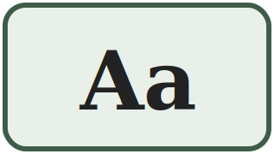 | a | /a/ | like the a in father, but shorter | apă water
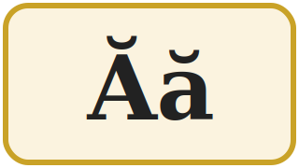 | ă | /ə/ | like the e in the (said fast) | casă house
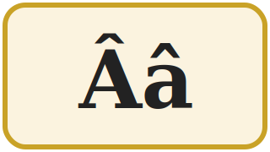 | â din a | /ɨ/ | no English sound: say i with a relaxed mouth | mână hand
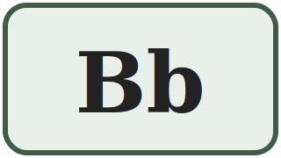 | be | /b/ | like the b in book | bun good
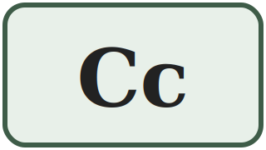 | ce | /k/ /tʃ/ | car — but church before e and i | casă / cinci house / five
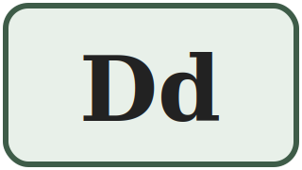 | de | /d/ | like the d in door | doi two
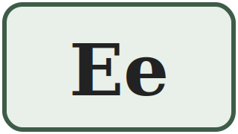 | e | /e/ | like the e in bed | elev pupil
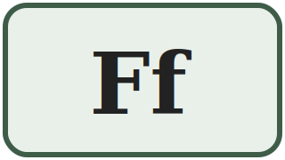 | ef | /f/ | like the f in fire | foc fire
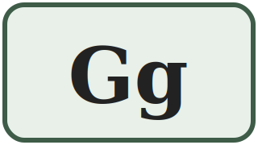 | ghe | /ɡ/ /dʒ/ | good — but gentle before e and i | gară / ger station / frost
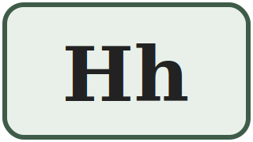 | haș | /h/ | like the h in house — never silent on its own | hartă map
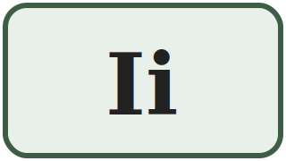 | i | /i/ | like the ee in see | inimă heart
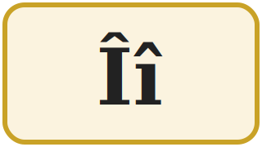 | î din i | /ɨ/ | exactly the same sound as â | început beginning
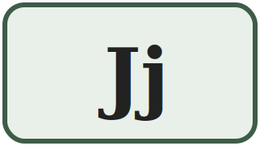 | je | /ʒ/ | like the s in measure | jos down
 | ca | /k/ | like the k in kilo — loanwords only | kilogram kilogram
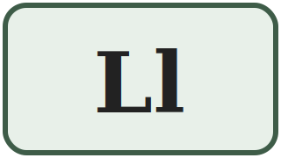 | el | /l/ | like the l in light | lapte milk
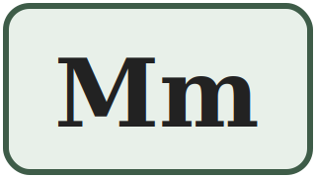 | em | /m/ | like the m in man | masă table
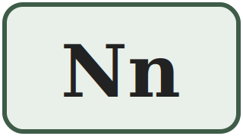 | en | /n/ | like the n in no | nou new
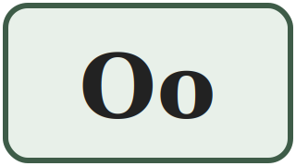 | o | /o/ | like the o in more, but shorter | om man / person
 | pe | /p/ | like the p in spin — no puff of air | pâine bread
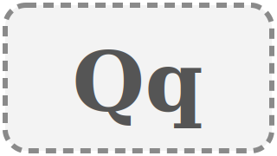 | chiu / cu | /k/ | foreign words and names only | Qatar Qatar
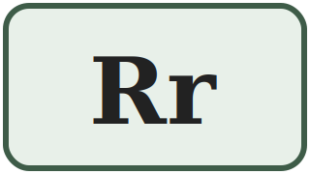 | er | /r/ | a short rolled r, like in Italian | roșu red
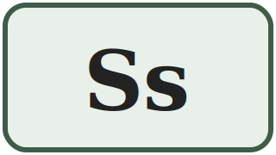 | es | /s/ | like the s in sun | sare salt
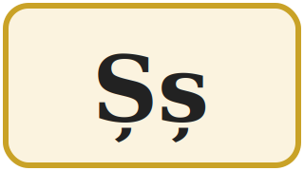 | șe | /ʃ/ | like the sh in shop | șapte seven
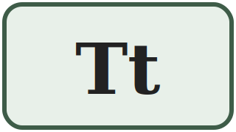 | te | /t/ | like the t in stop — no puff of air | trei three
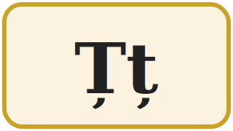 | țe | /ts/ | like the ts in cats | țară country
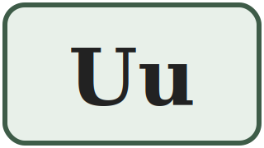 | u | /u/ | like the oo in book | unu one
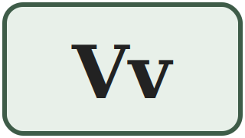 | ve | /v/ | like the v in very | verde green
 | dublu ve | /v/ /w/ | loanwords only: v or w | weekend weekend
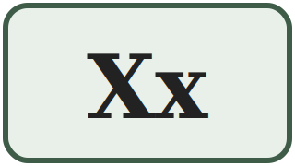 | ics | /ks/ /ɡz/ | taxi — but exam in a few words | taxi taxi
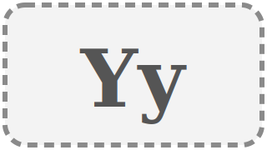 | i grec | /i/ /j/ | loanwords and names only | yoga yoga
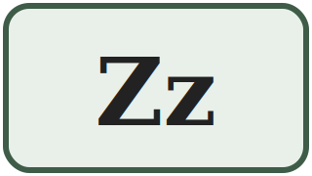 | ze | /z/ | like the z in zero | zero zero

SPELLING ON THE PHONE
When you spell a word on the phone in Romania, you use the letter NAMES: A-N-A is said a – en – a. For â and î you must say â din a and î din i — otherwise nobody knows which one you mean.
1.1 Write the missing letters
Fill in the gaps in the alphabet. Then say the whole alphabet out loud.
A ___ Â B ___ D E F ___ H I ___ J K ___ M
N ___ P Q R ___ Ș T ___ U ___ W X ___ Z

Lesson 1.2 — Vowels and consonants
Romanian has 8 vowel letters and 23 consonant letters. Four of the consonant letters (k, q, w, y) are used only in foreign words, so in practice you work with 19 consonants.
The 8 vowel letters — only 7 sounds
Look carefully: â and î are two different letters with exactly the same sound. The difference is only where in the word they appear — you learn that rule in Lesson 1.3.
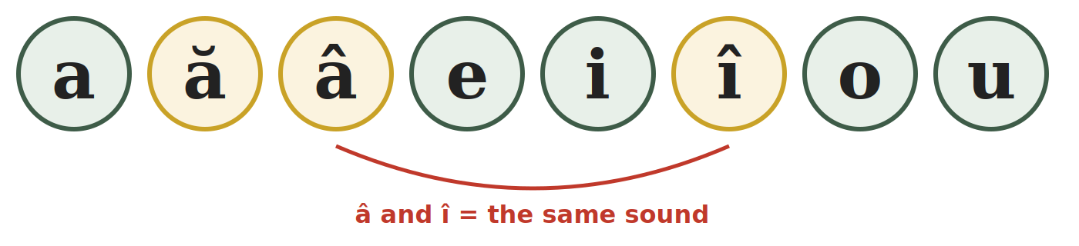
a | ă | â | e | i | î | o | u
/a/ | /ə/ | /ɨ/ | /e/ | /i/ | /ɨ/ | /o/ | /u/
Semivowels — a vowel that glides
Four letters — e, i, o, u — can lose their full vowel force and glide into the next vowel. When that happens we call them semivowels. Compare:
FULL VOWEL — its own syllable | SEMIVOWEL — glides, one syllable
i-ni-mă — heart: i is a full vowel | iar-nă — winter: i glides into a
u-nu — one: u is a full vowel | zi-ua — the day: u glides into a
o-mul — the man: o is a full vowel | noap-te — night: o glides into a

YOU DO NOT NEED THE THEORY YET
Just remember: a syllable always has exactly one full vowel sound. We come back to this in Lesson 2.6 and Lesson 3.1.
1.2 Vowel or consonant?
Write V for vocală (vowel) or C for consoană (consonant) next to each letter.
1. m ____ | 2. ă ____ | 3. t ____ | 4. o ____
5. ș ____ | 6. â ____ | 7. u ____ | 8. ț ____
9. e ____ | 10. r ____ | 11. î ____ | 12. j ____

Lesson 1.3 — The five Romanian letters
These five letters do not exist in English. They are not decoration — they change the meaning of the word. Leaving out the little sign under or above the letter is a spelling mistake, exactly like writing cat instead of cut.
1. Ă ă — the sound /ə/
This is the easiest of the five. Say the English word the — not carefully, but fast, the way you say it in the man. That short, relaxed vowel is Romanian ă.
IMPORTANT DIFFERENCE FROM ENGLISH
In English that sound is lazy and never stressed. In Romanian it is a full, clear vowel and it can even carry the stress of the word. Say it clearly — do not swallow it.
casă — house |  | masă — table | apă — water
ușă — door |  | scară — stairs | vară — summer
mamă — mother |  | față — face | stradă — street

Ă IS EVERYWHERE
Almost every feminine noun in Romanian ends in -ă. If you cannot hear it, you cannot tell casa (the house) from casă (a house). You will need this every single day.
2. Â â and Î î — one sound /ɨ/, two letters
There is no English equivalent for this sound. To find it: say ee as in see, hold the sound, then pull your tongue back and relax your lips into a neutral position, without moving your jaw. That is /ɨ/.
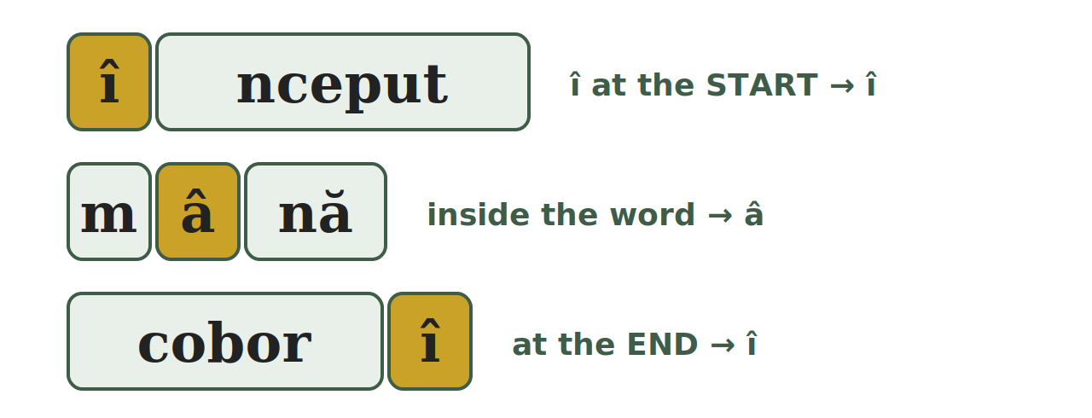
TIPAR — WHEN DO I WRITE Â AND WHEN Î?
START of the word | → | î
INSIDE the word | → | â
END of the word | → | î

Exception: after a prefix the î stays, even inside the word: a reîncepe — to start again, neîncetat — non-stop.

Î at the start or the end | Â inside the word
început — beginning | mână — hand
înainte — forward | pâine — bread
împreună — together | când — when
îngheț — frost | vânt — wind
a coborî — to go down | mâine — tomorrow
a urî — to hate | român — Romanian
3. Ș ș — the sound /ʃ/
Exactly the English sh in shop. The letter is an s with a little tail (a comma) below it. Without the tail the word changes or means nothing:
șase — six | sase — not a word
și — and (one of the most frequent words) | si — the musical note B
șapte — seven | ușă — door
școală — school | oraș — town
4. Ț ț — the sound /ts/
The ts at the end of the English word cats — but in Romanian this sound also comes at the beginning of a word, which is difficult for many learners at first.
țară — country | preț — price | față — face
soț — husband | cuțit — knife | ață — thread

CAREFUL — THESE ARE COMMAS, NOT CEDILLAS
The correct Romanian letters are ș and ț with a comma below. On some keyboards and old documents you will see ş and ţ with a cedilla (a hook). They are technically wrong, but everybody reads them the same way. Do not be confused when you see them on official papers.
1.3 Â or Î ?
Write â or î in each gap. Remember the position rule.
1. p___ine (bread) | 2. ___nceput (beginning)
3. c___nd (when) | 4. a cobor___ (to go down)
5. m___ine (tomorrow) | 6. ___mpreună (together)

Lesson 1.4 — K, Q, W, Y: the visitor letters
These four letters are part of the official alphabet, but they never appear in a word that is originally Romanian. They arrived with foreign words, brand names, personal names and units of measurement.
Where you will actually meet them
LETTER | WHERE IT APPEARS | EXAMPLES FROM DAILY LIFE
k | units of measurement, loanwords | kg — kilogram (packaging) · km — kilometre (road signs) · kWh — electricity bill
q | almost only foreign names | Qatar · names like Quentin
w | loanwords, names, units | W — watt (light bulb) · Wi-Fi · weekend · WC
y | loanwords, names | yoga · hobby · Yasmin

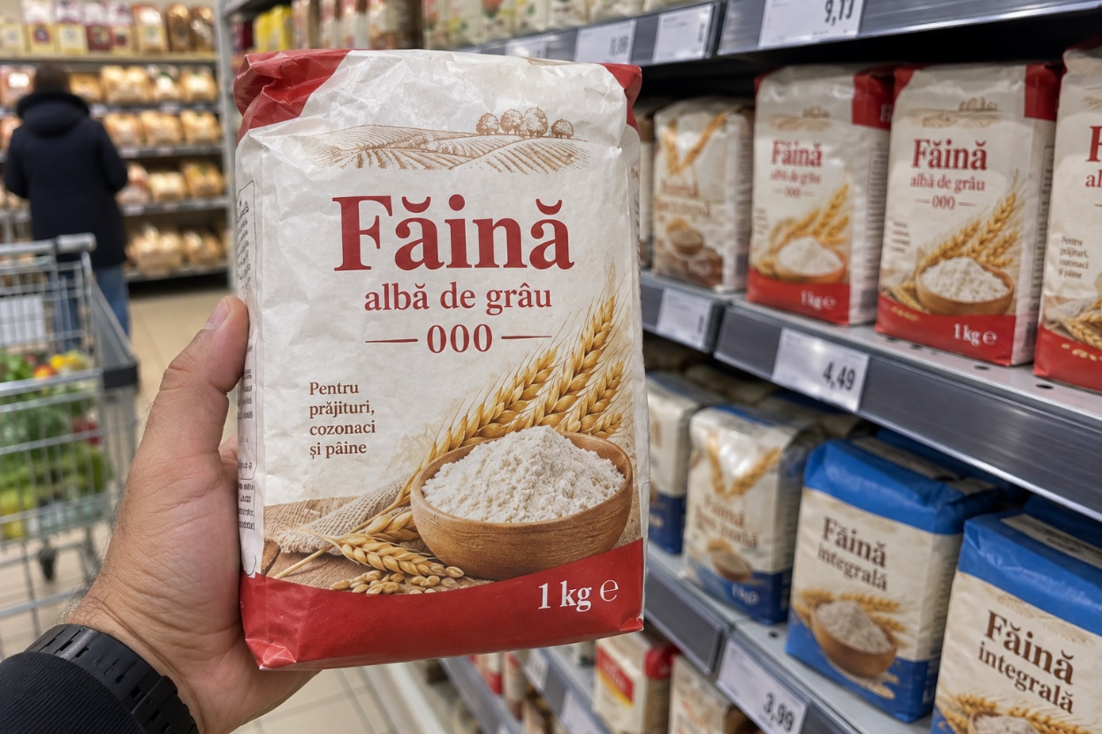

WHY THIS MATTERS FOR YOU
Shop labels, road signs, electricity bills and your phone all use these letters: kg, km, kWh, W, Wi-Fi. You need to read them, but you will never need them to spell a Romanian word.
1.4 Romanian word or foreign word?
Write RO if the word is Romanian, or STR (străin) if it came from another language.
1. kilogram ______ | 2. pâine ______ | 3. weekend ______
4. masă ______ | 5. yoga ______ | 6. țară ______

Lesson 1.5 — Handwriting
In Romania you often have to write by hand: forms at the town hall or the bank, a note for a neighbour, your signature on a contract. If your first language uses a different alphabet, take your time with this lesson.
Print and cursive
PRINT (litere de tipar) | CURSIVE (litere de mână)
Every letter is separate. This is what you see in books and on signs, and what official forms ask for: SE COMPLETEAZĂ CU MAJUSCULE — fill in using capital letters | The letters are joined together without lifting the pen. Romanians use it for notes and for their signature. You must be able to read it, even if you write in print.

PRACTICAL RULE FOR YOUR FIRST YEAR
On every official form, write in PRINT CAPITALS. It is accepted everywhere, it is always legible, and it is what the form asks for anyway. Learn cursive for reading, not for filling in papers.
The writing lines
The practice strips in this book have four lines. Every letter sits on the red line. Capitals and tall letters reach the top line; small letters reach the dotted line; tails go down to the bottom line.
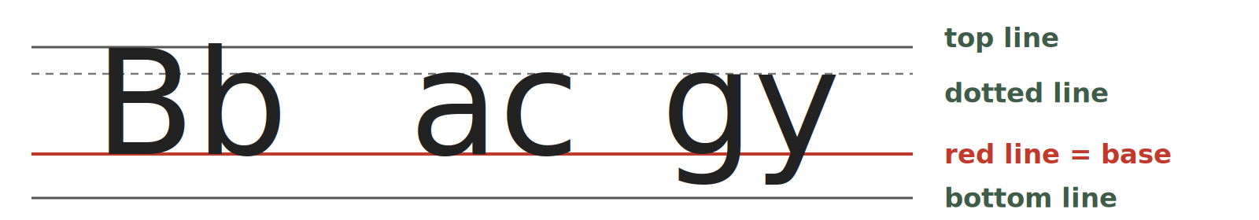
LINE | WHAT REACHES IT
top line | all capitals and the tall letters: b, d, f, h, k, l, t
dotted line | the top of small letters: a, c, e, m, n, o, s, u
red line | the base line — every letter sits on it
bottom line | the tails: g, j, p, q, y (and the comma of ș, ț)

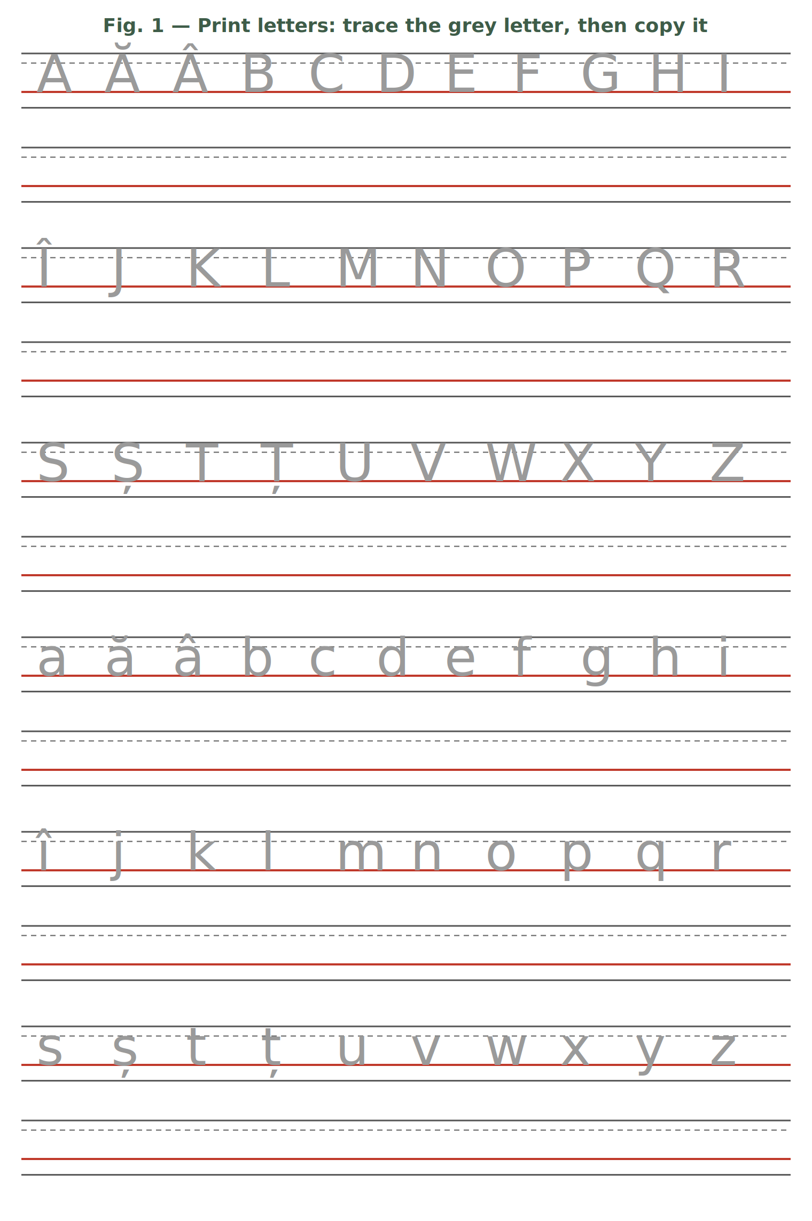
Trace the grey letters with a pencil, then copy each letter on the empty strip below it.

Fig. 2 — Cursive letters (for reading). Look at the joined letters and compare them with the print letters in Fig. 1. You only need to read them.
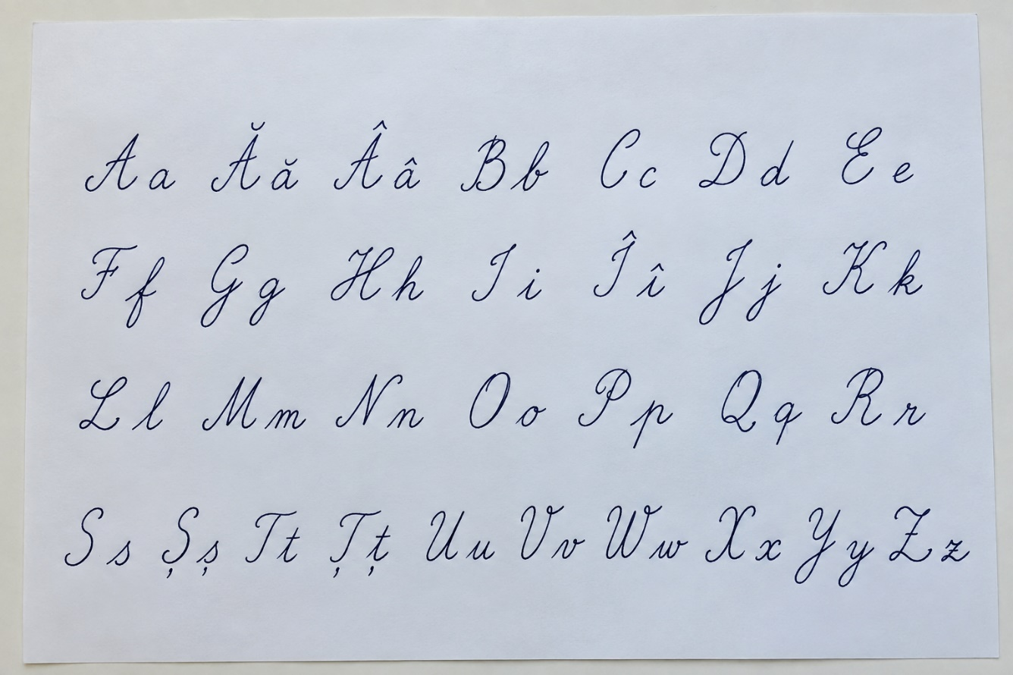

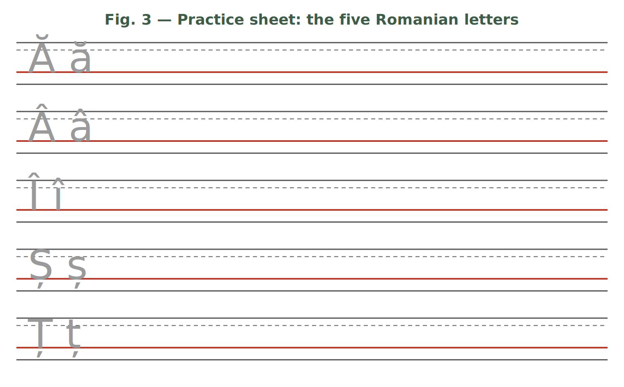
1.5 Copy the words
Copy each word twice on the lines of Fig. 3 or in your notebook — once in print capitals, once in print lowercase. Make the signs clearly visible.
ȘAPTE · ȚARĂ · MÂNĂ · ÎNCEPUT · PÂINE · UȘĂ

HOMEWORK — AFTER SESSION 1 / TEMĂ PENTRU ACASĂ · ABOUT 30 MINUTES
H1.1 Spell your first name, your family name and your town letter by letter, using the letter NAMES (as on the phone). Say them out loud three times.
H1.2 Write each Romanian letter ten times: Ă ă, Â â, Î î, Ș ș, Ț ț. Pay attention to the size of the sign.
H1.3 Look at a package, a shop sign or a bus stop. Copy five Romanian words that contain ă, â, î, ș or ț.

SESSION 2 — READING THE SOUNDS
SESIUNEA 2 — CITIREA SUNETELOR · 3 hours · Sunday 9:00 – 12:00

By the end of this session you will be able to:
☐ | read any Romanian word out loud, even one you have never seen
☐ | pronounce the eight letter groups: ce, ci, ge, gi, che, chi, ghe, ghi
☐ | read the letter x correctly in both of its sounds
☐ | recognise diphthongs and triphthongs and say them in one breath

Lesson 2.1 — Romanian is read as it is written
This is the single most useful fact about Romanian. Every letter keeps its sound, in almost every word. There is no silent e, no ough problem, no guessing.
THE COMPLETE LIST OF EXCEPTIONS
Only these need a rule: the groups ce · ci · ge · gi · che · chi · ghe · ghi and the letter x (today), a small number of recent loanwords that keep their foreign spelling (weekend, computer), and two habits of everyday speech that you learn in Lesson 3.4 (el is said "iel"; a final -i is almost silent). That is all.
2.1 Read out loud
Read each word letter by letter, exactly as it is written. You do not need to know the meaning yet.
1. apă | 2. bun | 3. doi | 4. foc
5. hartă | 6. lapte | 7. masă | 8. nou
9. sare | 10. trei | 11. verde | 12. zero

Lesson 2.2 — The letter C
C has two sounds. Which one you use depends only on the letter that comes after it.
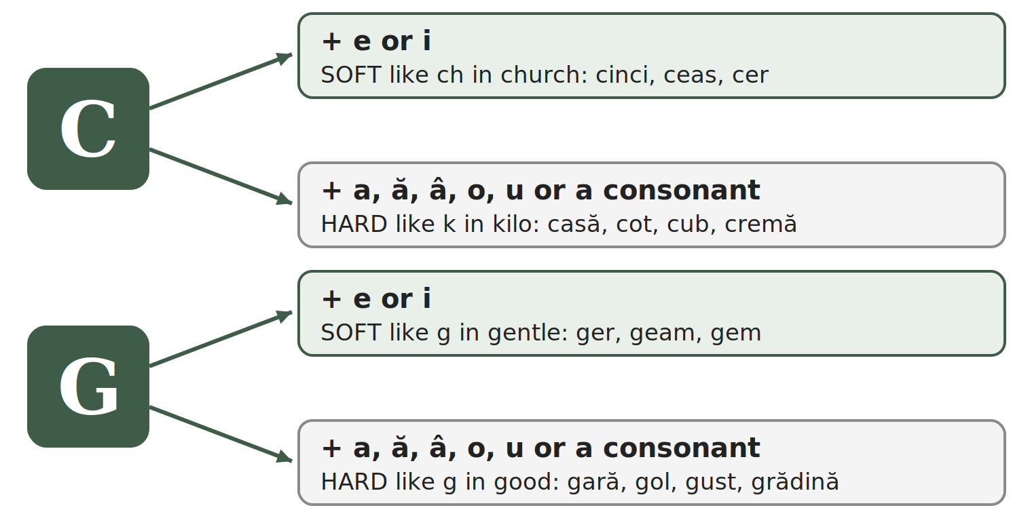
C = /k/ HARD (like k in kilo) | C = /tʃ/ SOFT (like ch in church)
casă — house | cinci — five
cot — elbow | ceas — clock, watch
cub — cube | cer — sky
când — when | cireșe — cherries
cafea — coffee | cină — dinner
cremă — cream: c before a consonant is hard | ciorbă — sour soup

SAY IT, THEN CHECK
The word cinci (five) has C twice — and both are soft: /tʃintʃ/. The word ciorbă starts soft: /ˈtʃorbə/. Listen for the ch of church.
2.2 Hard or soft?
Write K if the c is hard, or CH if it is soft.
1. casă ____ | 2. cer ____ | 3. cinci ____ | 4. cot ____
5. cină ____ | 6. cub ____ | 7. ceas ____ | 8. când ____

Lesson 2.3 — The letter G
G works exactly like C: the letter after it decides the sound.
G = /ɡ/ HARD (like g in good) | G = /dʒ/ SOFT (like g in gentle)
gară — railway station | ger — frost
gol — empty | ginere — son-in-law
gust — taste | geam — window pane
gând — thought | gem — jam
gură — mouth | geantă — bag
grădină — garden: g before a consonant is hard | gimnastică — gymnastics
2.3 Hard or soft?
Write G if the g is hard, or J if it is soft (like g in gentle).
1. gară ____ | 2. geam ____ | 3. gust ____
4. ginere ____ | 5. gol ____ | 6. ger ____

Lesson 2.4 — CH and GH: the silent h
Now the obvious problem. If c + e is always soft, how do you write a hard /k/ sound before e or i? You put an h between them. The h is never pronounced — it only blocks the softening.
TIPAR — THE SILENT H
c | + | h | + | e / i | = | hard k
g | + | h | + | e / i | = | hard g

WRITTEN | SOUND | EXAMPLE | MEANING
che | /ke/ | cheie | key
chi | /ki/ | chirie | rent
che | /ke/ | ureche | ear
chi | /ki/ | chibrit | match (to light a fire)
ghe | /ɡe/ | ghete | ankle boots
ghi | /ɡi/ | ghiveci | flower pot
ghi | /ɡi/ | unghie | fingernail

REAL PAIRS THAT PROVE THE RULE
ceară /tʃ/ — wax against chelner /k/ — waiter
ger /dʒ/ — frost against ghete /ɡ/ — ankle boots
Same vowel after the letter — the only difference is the h.
2.4 Choose the right spelling
Circle the correct word for the meaning given.
1. key: ceie / cheie | 2. rent: cirie / chirie
3. boots: gete / ghete | 4. clock: ceas / cheas
5. five: cinci / chinci | 6. frost: ger / gher

Lesson 2.5 — The letter X
One letter, but it stands for two sounds together. Usually /ks/. In a group of words that begin with ex- followed by a vowel, it becomes /ɡz/ — like the English word exam.
X = /ks/ | X = /ɡz/ (ex + vowel)
taxi — taxi | examen — exam
text — text | exemplu — example
fix — fixed, exactly | exact — exactly
extra — extra (ex + consonant) | exercițiu — exercise
2.5 /ks/ or /ɡz/ ?
Read the word, then write KS or GZ.
1. taxi ______ | 2. examen ______ | 3. text ______
4. exemplu ______ | 5. fix ______ | 6. exact ______

Lesson 2.6 — Two or three vowels in one syllable
When two vowel letters stand next to each other, Romanian usually says them together, in one push of air. That is a diphthong (diftong). With three vowel letters it is a triphthong (triftong).
The diphthongs you will meet most often
ea seară — evening | ia iarnă — winter | oa noapte — night | ua ziua — the day
ai mai — May | ei lei — lei (money) | oi doi — two | ui pui — chicken
au dau — I give | eu eu — I | iu iubire — love | ou ou — egg
ie miere — honey | io chioșc — kiosk | uă două — two (f.) | âi câine — dog
The triphthongs
eau beau — I drink | iau iau — I take | eai beai — you were drinking
oai leoaică — lioness | ioa aripioară — little wing

HOW TO TEST IT YOURSELF
Clap once for each syllable. doi = one clap, so oi is a diphthong. po-e-zi-e = four claps, so oe is NOT a diphthong — the two vowels belong to different syllables.
2.6 How many syllables?
Say the word, clap the syllables, then write the number.
1. doi ____ | 2. poezie ____ | 3. seară ____
4. aeroport ____ | 5. beau ____ | 6. stea ____
Handwriting — the letter groups
Write each group five times in your notebook, then each example word twice: ce ci ge gi che chi ghe ghi — cheie ghete cină geam.

HOMEWORK — AFTER SESSION 2 / TEMĂ PENTRU ACASĂ · ABOUT 30 MINUTES
H2.1 Sort the words by the sound of c or g: casă · cinci · gară · ger · cheie · ghete · cot · geam · chirie · gust
hard k | soft ch | hard g | soft g (gentle)
H2.2 Read this list out loud three times a day until the next session: cheie · cină · ghete · geam · cinci · gară · chirie · ger · examen · nouă
H2.3 Your teacher reads eight words at the start of Session 3 (dictation). Practise writing the eight letter groups.

SESSION 3 — FROM LETTERS TO SENTENCES
SESIUNEA 3 — DE LA LITERE LA PROPOZIȚII · 3 hours · Saturday 9:00 – 12:00

By the end of this session you will be able to:
☐ | cut any Romanian word into syllables
☐ | hear which syllable is stressed and say the word correctly
☐ | use capital letters correctly — and know when Romanian does NOT use them
☐ | use the full stop, the question mark, the exclamation mark and the comma
☐ | read el, ea, eu, este and words ending in -i the way Romanians really say them

Lesson 3.1 — Syllables
A syllable (silabă) is one push of air with exactly one full vowel sound in it. You need syllables for two practical reasons: to know where to break a word at the end of a line, and to know which part of the word to say louder.
Worked examples
WORD | SYLLABLES | WHY
masă | ma-să | vowel – consonant – vowel: the consonant goes to the right
apă | a-pă | the same rule: one consonant between two vowels goes right
carte | car-te | two consonants: one each side
lapte | lap-te | two consonants: one each side
fereastră | fe-reas-tră | three consonants (s, t, r): the first one left, the other two right
capră | ca-pră | exception: consonant + r or l stay together and go right
pâine | pâi-ne | âi is a diphthong: do not cut it
stea | stea | ea is a diphthong: one single syllable
telefon | te-le-fon | three vowels, so three syllables

NEVER DO THIS
Never break a diphthong, and never leave a single letter alone at the end of a line. a-pă is a correct syllable division, but you do not write a- at the end of one line and pă on the next.
3.1 Cut into syllables
Use a hyphen (-) between the syllables.
1. casă → ______________ | 2. lapte → ______________
3. telefon → ______________ | 4. școală → ______________
5. fereastră → ______________ | 6. dimineață → ______________
7. farmacie → ______________ | 8. salariu → ______________

Lesson 3.2 — Stress
In every Romanian word of two or more syllables, one syllable is said louder and longer than the others. This is the stress (accentul). Romanian does not mark it in writing — you have to hear it and learn it with the word. In this book we print the stressed syllable in CAPITALS.
Why it matters
Sometimes the stress is the only difference between two words:
SPELLING | STRESS ON THE 1st SYLLABLE | STRESS ON THE 2nd SYLLABLE
copii | CO-pii — copies (of a document) | co-PII — children
veselă | VE-se-lă — cheerful (f.) | ve-SE-lă — tableware, dishes
acele | A-ce-le — those | a-CE-le — the needles

USEFUL TENDENCIES (NOT RULES)
Most Romanian words are stressed on the last or second-to-last syllable: te-le-FON, CAR-te, fe-REAS-tră, pa-șa-PORT.
Verbs in the infinitive are usually stressed at the end: a lu-CRA — to work, a mân-CA — to eat.
There is no reliable rule. Repeat each new word after your teacher, out loud, at least three times.
3.2 Mark the stress
Write the word in syllables and put the stressed syllable in CAPITALS.
1. telefon → ______________ | 2. salariu → ______________
3. pașaport → ______________ | 4. fereastră → ______________
5. dimineață → ______________ | 6. farmacie → ______________

Lesson 3.3 — Capital letters and punctuation
You now have everything you need to read and write a complete Romanian sentence. This lesson gives you the rules for capital letters (litera mare) and for the four punctuation marks you will use every day.
Capital letters
USE A CAPITAL LETTER | DO NOT USE A CAPITAL LETTER
at the start of a sentence: Azi este luni. | days of the week: luni — Monday
names of people: Ahmed, Maria | months: ianuarie — January
countries: România, Nepal, India | nationalities: român, nepalez, indian
cities and towns: București, Cluj-Napoca | languages: română, engleză
names of institutions: Primăria, Poliția Română | ordinary nouns: stradă, oraș, bancă

THIS IS DIFFERENT FROM ENGLISH
In English you write Monday, January, Romanian, Nepalese with a capital letter. In Romanian you do not. It is one of the most common mistakes foreign learners make.
TIPAR — COUNTRY → NATIONALITY
România | → | român
Nepal | → | nepalez
India | → | indian
Vietnam | → | vietnamez
Filipine | → | filipinez
Italia | → | italian
Germania | → | german

Left: the country — always a CAPITAL letter. Right: the nationality — always a small letter, even at the end of a sentence: Sunt din Nepal. Sunt nepalez.

THE DAYS — always small letters | THE MONTHS — always small letters
luni · marți · miercuri · joi · vineri · sâmbătă · duminică | ianuarie · februarie · martie · aprilie · mai · iunie · iulie · august · septembrie · octombrie · noiembrie · decembrie
The four punctuation marks
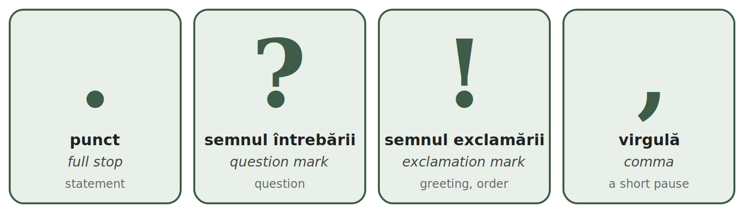
MARK | WHEN | EXAMPLES
. punct | at the end of a normal sentence | Sunt din India. Locuiesc în București.
? semnul întrebării | at the end of a question | Cum vă numiți? Unde locuiți?
! semnul exclamării | after a greeting, a strong feeling or an order | Bună ziua! Atenție! Mulțumesc mult!
The comma — three rules you need now
TIPAR — THE COMMA
Bună ziua | , | domnule Ionescu!
Da | , | mulțumesc.
Sunt obosit | , | dar sunt bine.

RULE |  | EXAMPLES
1. You speak to someone — the name or title is separated by a comma. |  | Bună ziua, domnule Ionescu! — Good afternoon, Mr Ionescu!
 |  | Maria, vino aici, te rog! — Maria, come here, please!
 |  | Mulțumesc, doamnă. — Thank you, madam.
 |  | Bună seara, Ana! — Good evening, Ana!
2. After da or nu at the start of an answer. |  | Da, sunt aici. — Yes, I am here.
 |  | Nu, nu lucrez azi. — No, I am not working today.
 |  | Da, mulțumesc. — Yes, thank you.
 |  | Nu, mulțumesc. — No, thank you.
3. Before dar (but). |  | Sunt obosit, dar sunt bine. — I am tired, but I am fine.
 |  | Vreau cafea, dar nu am bani. — I want coffee, but I have no money.
 |  | Casa este mică, dar este frumoasă. — The house is small, but it is nice.
 |  | Vorbesc engleză, dar nu vorbesc română. — I speak English, but I do not speak Romanian.

NO COMMA BEFORE ȘI
Romanian does not put a comma before și (and) in a simple list or sentence: Vorbesc engleză și hindi. Am un frate și o soră.
Read these sentences out loud
Bună ziua! Eu sunt Ahmed. | Good afternoon! I am Ahmed.
Sunt din India. Sunt indian. | I am from India. I am Indian.
Locuiesc în București. | I live in Bucharest.
Vorbesc hindi și engleză. | I speak Hindi and English.
Învăț limba română, dar este greu. | I am learning Romanian, but it is difficult.
Azi este luni, 12 ianuarie. | Today is Monday, 12 January.
3.3 Correct the mistakes
Each sentence has one or two mistakes: a capital letter, a full stop, a question mark or a comma. Rewrite it correctly.
1. eu sunt din india. → ________________________________
2. Azi este Luni. → ________________________________
3. Bună ziua domnule Ionescu! → ________________________________
4. Da mulțumesc. → ________________________________
5. Sunt obosit dar sunt bine. → ________________________________
6. Vorbiți Engleză? → ________________________________
7. Unde locuiți → ________________________________
8. El este Nepalez. → ________________________________

Lesson 3.4 — Real pronunciation
Romanian is read as it is written — with two small habits of everyday speech. They are in very frequent words, so you will hear them all day. Learn to recognise them first; your mouth will follow.
Habit 1 — e at the start of el, ea, eu, este... is said "ie"
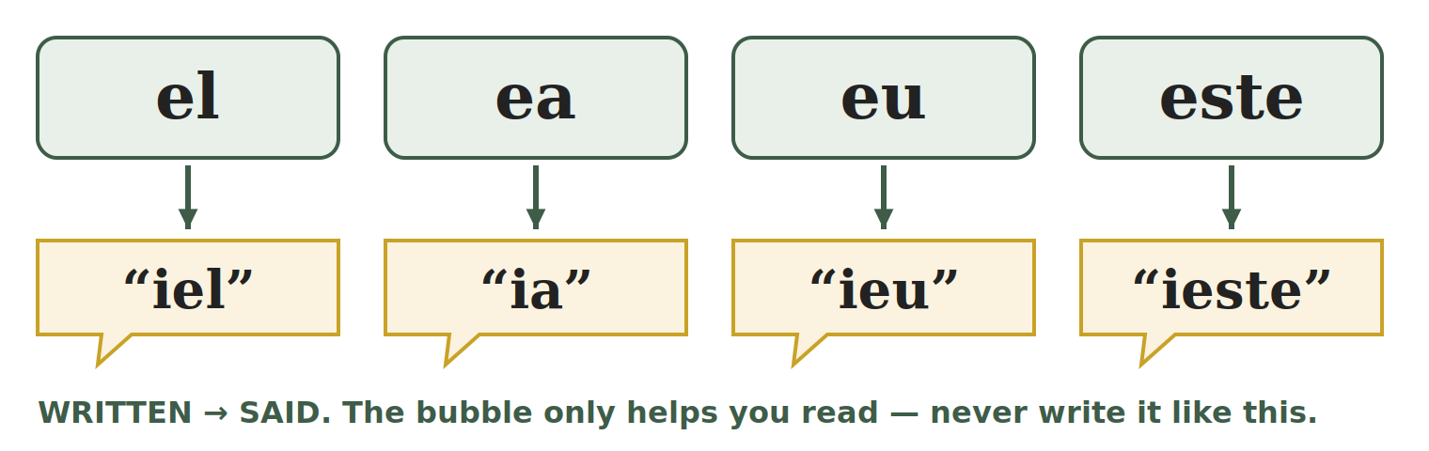
TIPAR — E AT THE START OF THESE SHORT WORDS
e | → | “ie”

WRITTEN | SAID LIKE | MEANING | EXAMPLE
el | "iel" | he | El este Ahmed.
ea | "ia" | she | Ea este Maria.
eu | "ieu" | I | Eu sunt din Nepal.
ei | "iei" | they (men / mixed) | Ei sunt colegi.
ele | "iele" | they (women) | Ele sunt surori.
este | "ieste" | is | Casa este mare.
e | "ie" | is (short, spoken) | E bine.
ești | "ieșt" | you are | Ești aici?
era | "iera" | was | Era frig.
eram | "ieram" | I was / we were | Eram acasă.

EXCEPTIONS — NEW WORDS KEEP A CLEAN E
The "ie" habit is only in the short, old words above: the words for he, she, I, they and the verb to be (este, e, ești, era). Most other words that start with e — usually newer words, similar in English — keep a clean e, as in bed:
ecran — screen · elev — pupil · economie — economy · echipă — team · exemplu — example · etaj — floor · euro — euro · energie — energy
Habit 2 — a final -i after a consonant is almost silent
When a word ends in consonant + i, the i is very short — you almost do not hear it. It only makes the consonant before it soft. Listen to your teacher: pom and pomi sound almost the same — only the end of pomi is a little softer.
TIPAR — CONSONANT + I AT THE END
consonant + i | → | very short i

ONE / BASE FORM | WITH FINAL -i | MEANING | ONE / BASE FORM | WITH FINAL -i | MEANING
pom | pomi | trees | prieten | prieteni | friends
lup | lupi | wolves | pantof | pantofi | shoes
an | ani | years | ban | bani | money, coins
bun | buni | good (pl.) | elev | elevi | pupils
lucrez | lucrezi | you work | văd | vezi | you see
merg | mergi | you go |  | ochi | eye, eyes

EXCEPTIONS — THE I IS SAID IN FULL
After consonant + r or consonant + l, the final i is a full vowel: codri — forests · socri — parents-in-law · membri — members · miniștri — ministers
In loanwords the final i is full: taxi · mini · schi — ski
Words ending in two i (copii) are explained in Lesson 4.2. Words ending in vowel + i (doi, mai) are diphthongs (Lesson 2.6).
3.4 Clean or changed?
A: write IE if the e is said "ie", or E if it is a clean e. B: write SHORT if the final i is almost silent, or FULL if it is said in full.
A — the first e | B — the final i
1. el ______ | 7. pomi ______
2. elev ______ | 8. codri ______
3. este ______ | 9. bani ______
4. ecran ______ | 10. taxi ______
5. ea ______ | 11. vezi ______
6. etaj ______ | 12. membri ______

HOMEWORK — AFTER SESSION 3 / TEMĂ PENTRU ACASĂ · ABOUT 30 MINUTES
H3.1 Write five sentences about yourself: your name, your country, your nationality, your town in Romania, the languages you speak. Check every capital letter, every comma and every full stop.
H3.2 Read out loud, three times a day: El este aici. · Ea este acasă. · Eu sunt bine. · Ei sunt prieteni. · Am doi pantofi noi.
H3.3 Cut into syllables and mark the stress: carte · telefon · școală · pașaport

SESSION 4 — CRATIMA, SPELLING AND PRACTICAL WRITING
SESIUNEA 4 — CRATIMA, ORTOGRAFIA ȘI SCRISUL PRACTIC · 3 hours · Sunday 9:00 – 12:00

By the end of this session you will be able to:
☐ | recognise and read the cratima (-) in the ten most frequent forms
☐ | tell the cratima from the syllable hyphen
☐ | recognise the difference between -i, -ii and -iii at the end of a word
☐ | write a date in numbers (zz.ll.aaaa) and in words (12 martie 2026)
☐ | fill in a simple form: name, date of birth, citizenship, address, phone, signature

Lesson 4.1 — The cratima (-)
The cratima (cratima) is a short line between two words. It shows two things: the two words are said together, like one word, and a sound has fallen out. You meet it in almost every Romanian text, so you must be able to read it.
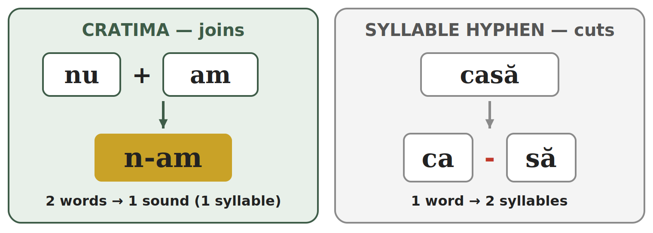
TIPAR — TWO WORDS → ONE SOUND
nu | + | am | → | n-am
se | + | a | → | s-a
mă | + | am | → | m-am
în | + | un | → | într-un
dă | + | îmi | → | dă-mi

The sound that falls out: the u of nu, the e of se, the ă of mă, the î of îmi. The word în becomes într before un / o.
Cratima or syllable hyphen?
It is the same sign (-), but it does the opposite job:
 | CRATIMA | SYLLABLE HYPHEN
What it does | joins two words into one sound | cuts one word into syllables
Example | s-a = se + a → 1 syllable | ca-să = 1 word → 2 syllables
Where you see it | everywhere, inside normal sentences | in exercises, dictionaries, and at the end of a line
Test | take the line away and put the lost letter back: you get two real words (nu am) | take the line away: you get one word (casă)
The ten forms to recognise
WRITTEN | THE TWO WORDS | SAID | EXAMPLE | ENGLISH
s-a | se + a | "sa" — 1 syllable | S-a terminat. | It is finished.
m-am | mă + am | "mam" — 1 syllable | M-am născut în India. | I was born in India.
nu-i | nu + e (spoken) | "nui" — 1 syllable | Nu-i nimic. | It is nothing. / No problem.
n-am | nu + am | "nam" — 1 syllable | N-am timp. | I do not have time.
într-un | în + un | "în-trun" | Locuiesc într-un apartament. | I live in a flat.
într-o | în + o | "în-tro" | Locuiesc într-o casă. | I live in a house.
dintr-un | din + un | "din-trun" | Beau apă dintr-un pahar. | I drink water from a glass.
dă-mi | dă + îmi | "dămi" — 1 syllable | Dă-mi apa, te rog. | Give me the water, please.
spune-mi | spune + îmi | "spu-nemi" | Spune-mi numele tău. | Tell me your name.
ce-i | ce + e (spoken) | "cei" — 1 syllable | Ce-i asta? | What is this?

ONLY READ AND RECOGNISE — FOR NOW
In this module you only read these forms and find the two words behind them. You will use them yourself later: dă-mi, spune-mi in Module 2 (short forms of the pronouns), n-am, s-a, m-am, nu-i, ce-i in Module 3 (verbs).
4.1 Find the two words
Write the two words behind each form.
1. n-am = ________ + ________ | 2. s-a = ________ + ________
3. într-o = ________ + ________ | 4. dă-mi = ________ + ________
5. ce-i = ________ + ________ | 6. dintr-un = ________ + ________

Lesson 4.2 — Spelling traps: -i, -ii, -iii
At the end of a Romanian word you can see one, two or even three i. It is not a mistake: each i has a job. Here you only learn to recognise them. How to build these forms comes in Module 2.
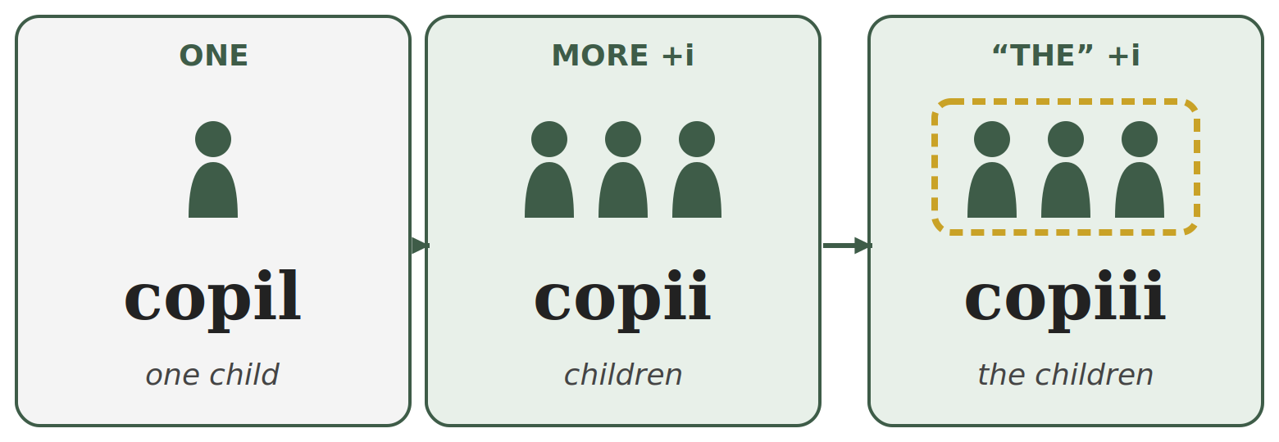
TIPAR — ONE → MORE → “THE”
copil | → | copii | → | copiii
elev | → | elevi | → | elevii

Left: one. Middle: more than one (+i). Right: the ones we already know — English “the” (+ one more i).

ONE | MORE THAN ONE | “THE” ... (the ones we know) | ENGLISH
elev | elevi | elevii | pupil — pupils — the pupils
pom | pomi | pomii | tree — trees — the trees
lup | lupi | lupii | wolf — wolves — the wolves
prieten | prieteni | prietenii | friend — friends — the friends
profesor | profesori | profesorii | teacher — teachers — the teachers
pantof | pantofi | pantofii | shoe — shoes — the shoes
câine | câini | câinii | dog — dogs — the dogs
frate | frați | frații | brother — brothers — the brothers
membru | membri | membrii | member — members — the members
ban | bani | banii | coin — money — the money
copil | copii | copiii | child — children — the children
fiu | fii | fiii | son — sons — the sons

YOU CAN HEAR THE DIFFERENCE
pomi — the final i is almost silent (Lesson 3.4). pomii — you hear a full i and then a short one: "po-mii".
copii — 2 syllables: co-pii. copiii — 3 syllables: co-pi-ii.

WHY THREE I?
copil loses its l in the plural and ends in -ii already: copii. When you add “the”, one more i comes: copiii. The same happens with fiu → fii → fiii. Three i in a row is correct Romanian.
Remember: small letters, big letters
CORRECT | WRONG | WHY
Azi este luni. | Azi este Luni. | days: small letter
12 martie | 12 Martie | months: small letter
Sunt nepalez. | Sunt Nepalez. | nationalities: small letter
Vorbesc română. | Vorbesc Română. | languages: small letter
Locuiesc în România. | Locuiesc în românia. | countries: CAPITAL letter
ATTENTION — HOLIDAY NAMES / NUMELE SĂRBĂTORILOR
Months are written with a small letter: 1 decembrie, 24 ianuarie. But when the date is the name of a holiday, it takes a capital letter: 1 Decembrie (Ziua Națională), 24 Ianuarie (Ziua Unirii), 1 Mai, 1 Iunie.
Pe 1 decembrie nu lucrez. — a date (on 1 December). · Anul acesta, de 1 Decembrie, merg la paradă. — the holiday.

4.2 One, more, or “the”?
Write ONE, MORE or THE next to each word.
1. elevi ______ | 2. pomii ______ | 3. copil ______ | 4. copiii ______
5. prieteni ______ | 6. fiii ______ | 7. copii ______ | 8. lupii ______

Lesson 4.3 — Practical writing: dates and forms
Writing the date in numbers
In Romania the date always starts with the day, then the month, then the year. On forms it is written with dots: zz.ll.aaaa.
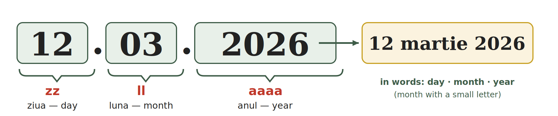
TIPAR — THE DATE
zz | . | ll | . | aaaa
ziua (day) |  | luna (month) |  | anul (year)

Always two digits for the day and the month: 5 July = 05.07; 1 May = 01.05.

NO. | MONTH | NO. | MONTH | NO. | MONTH
01 | ianuarie | 05 | mai | 09 | septembrie
02 | februarie | 06 | iunie | 10 | octombrie
03 | martie | 07 | iulie | 11 | noiembrie
04 | aprilie | 08 | august | 12 | decembrie
Writing the date in words
In a letter or a sentence you write: day (no zero in front) + month in words, with a small letter + year. No dots, no comma.
IN NUMBERS | IN WORDS
01.01.2026 | 1 ianuarie 2026 | 24.01.2026 | 24 ianuarie 2026
12.03.2026 | 12 martie 2026 | 01.05.2026 | 1 mai 2026
01.06.2026 | 1 iunie 2026 | 05.07.1995 | 5 iulie 1995
15.08.2026 | 15 august 2026 | 30.11.2026 | 30 noiembrie 2026
01.12.2026 | 1 decembrie 2026 | 25.12.2026 | 25 decembrie 2026

CAREFUL — DAY FIRST!
03.12.2026 is 3 December, not 12 March. In the United States the month comes first; in Romania never.
Wrong: 05 Iulie, 1995 → Correct: 5 iulie 1995.
You may also see 12/03/2026 with slashes: the order is the same — day, month, year.
Filling in a simple form
At the town hall, the bank, the doctor or the phone shop you will fill in a form (formular). The words are almost always the same:
ON THE FORM | ENGLISH | WHAT YOU WRITE | EXAMPLE
Nume | family name, surname | your family name, as in the passport | SHARMA
Prenume | first name(s) | your first name(s) | RAJESH KUMAR
Data nașterii | date of birth | zz.ll.aaaa | 05.07.1995
Cetățenia | citizenship | your citizenship (some forms ask for the country) | NEPALEZĂ / NEPAL
Adresa | address | street, number, block, entrance, floor, flat, town, county / sector | see Fig. 4
Telefon | phone | your Romanian mobile number (10 digits, starts with 07) | 0712 345 678
Data | date | the date you fill in the form | 12.03.2026
Semnătura | signature | your usual signature — not in capitals | —

ABBREVIATION | MEANS | ENGLISH | ABBREVIATION | MEANS | ENGLISH
Str. | strada | street | et. | etajul | floor
nr. | numărul | number | ap. | apartamentul | flat
bl. | blocul | block of flats | jud. | județul | county
sc. | scara | entrance / staircase | sect. | sectorul | sector (Bucharest)

RULES FOR EVERY FORM
Nume is your FAMILY name, Prenume your FIRST name — the opposite order from many other countries. Check twice.
Write in PRINT CAPITALS (SE COMPLETEAZĂ CU MAJUSCULE). If the form has boxes, write one letter in each box and leave one box empty between two names.
Copy your name exactly as in your passport or residence permit — same letters, same order.
Fig. 4 — A model form, filled in.
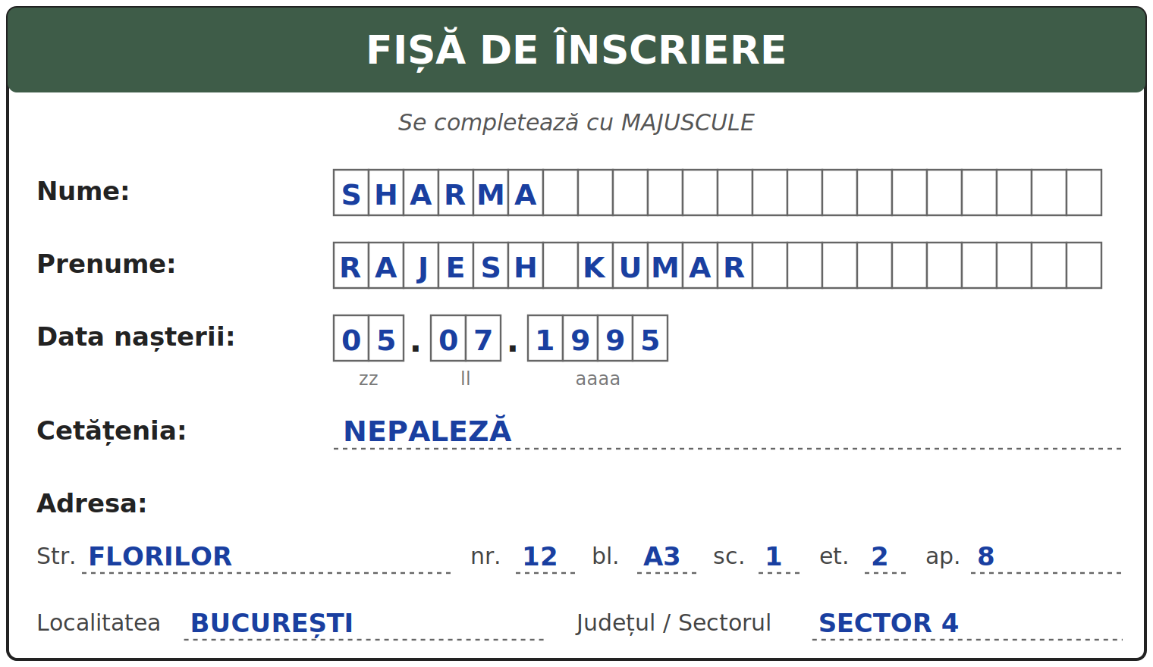
4.3 Fill in the form
Fill in the form with your own details, in print capitals. At the bottom, write today's date in numbers. Then write the same date in words on the line below the form.
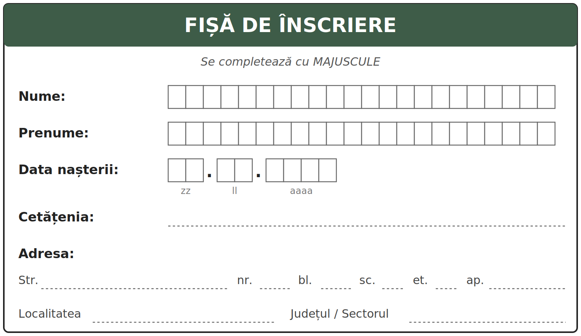
Today's date in words: ________________________________________

Lesson 4.4 — Module 1: everything in one page
THE ALPHABET | 31 letters. 8 vowel letters (7 sounds, because â = î), 19 consonants, plus k, q, w, y for foreign words only.
ROMANIAN LETTERS | ă /ə/ · â and î /ɨ/ · ș /ʃ/ · ț /ts/. The sign is part of the letter, not decoration.
Â OR Î | î at the start and the end of a word; â inside the word.
READING | Read as written. Exceptions: the eight letter groups, the letter x, a few loanwords, two speech habits.
C AND G | Hard before a, ă, â, o, u and consonants. Soft before e and i.
CH AND GH | The h is silent. It keeps the hard sound before e and i: che = /ke/, ghi = /ɡi/.
X | Usually /ks/ (taxi); /ɡz/ in ex + vowel (examen).
DIPHTHONGS | Two or three vowel letters said together in one syllable: seară, doi, miere, beau.
SYLLABLES | One full vowel sound = one syllable. Never break a diphthong.
STRESS | Not written. Usually on the last or second-to-last syllable. Learn it with each word.
CAPITALS | Sentence start, names, countries, cities, institutions. NOT days, months, languages, nationalities.
PUNCTUATION | . ? ! at the end. Comma: when you speak to someone, after da / nu, before dar. No comma before și.
REAL PRONUNCIATION | el, ea, eu, este → "iel, ia, ieu, ieste" (but a clean e in ecran, elev). Final consonant + i is almost silent: pomi.
CRATIMA | Joins two words into one sound: n-am = nu am. The syllable hyphen cuts one word: ca-să.
-I / -II / -III | copil (one) → copii (more) → copiii (the children).
DATES | 12.03.2026 = 12 martie 2026. Day first, month with a small letter.
FORMS | Nume = family name, Prenume = first name. PRINT CAPITALS. Signature in your usual hand.

WORDS FROM MODULE 1 THAT YOU ALREADY KNOW
apă · pâine · lapte · sare · masă · casă · ușă · stradă · oraș · țară · școală
unu · doi · trei · cinci · șase · șapte · nouă · zece
luni · marți · miercuri · joi · vineri · sâmbătă · duminică · ianuarie · martie · mai
nume · prenume · adresa · telefon · data nașterii · cetățenia · semnătura
4.4 Read and find
Read the text out loud. Underline the two words with a cratima. Circle the five words where e is said "ie".
Mă numesc Rajesh. Sunt din Nepal, dar locuiesc în București, într-un apartament mic. El este prietenul meu, Ahmed. Ea este Maria, colega noastră. Azi este sâmbătă. N-am mult timp, dar învăț limba română în fiecare zi.
My name is Rajesh. I am from Nepal, but I live in Bucharest, in a small flat. He is my friend, Ahmed. She is Maria, our colleague. Today is Saturday. I do not have much time, but I learn Romanian every day.

SECȚIUNE DETAȘABILĂ — EXEMPLAR FORMATOR
Detachable section — teacher's copy

Se detașează din suportul cursantului; testul completat, semnat și datat, se păstrează la dosarul cursantului. Conține: testul cumulativ, fișa de confirmare a Sesiunii 4, fișa de evidență a Modulului 1, cheia răspunsurilor.
INSTRUCȚIUNI DE ADMINISTRARE / HOW TO ADMINISTER
Testul este de tip grilă. Cursantul marchează cu X un singur răspuns pentru fiecare întrebare. Nu se scrie nimic altceva pe test, în afară de nume, dată și semnătură. Un răspuns corect = 1 punct. Răspuns nemarcat sau marcat dublu = 0 puncte. Timp alocat: 40 de minute.
The test is multiple choice. The student marks X in one box per question. Nothing else is written on the test, apart from name, date and signature. One correct answer = 1 point. Unmarked or double-marked = 0 points. Time: 40 minutes.

TEST CUMULATIV — MODULUL 1
MODULE 1 — CUMULATIVE TEST · grilă, 20 de întrebări, 20 de puncte · semnat și datat de cursant

Nume și prenume cursant / Student name
Data / Date | _____ / _____ / 20_____
Semnătura cursantului / Student signature
Marcați cu X un singur răspuns la fiecare întrebare. Mark ONE answer with X for each question. Each correct answer = 1 point.
1. Câte litere are alfabetul limbii române? (1 p)
☐ a) 26 | ☐ b) 28 | ☐ c) 31 | ☐ d) 33
2. Care grupă conține numai litere specifice limbii române? (1 p)
☐ a) ă â î ș ț | ☐ b) k q w y | ☐ c) a e i o u | ☐ d) b c d f g
3. Pe un formular, „Prenume” înseamnă: (1 p)
☐ a) family name | ☐ b) first name | ☐ c) date of birth | ☐ d) citizenship
4. Litera î se scrie: (1 p)
☐ a) numai în interiorul cuvântului | ☐ b) oriunde, fără regulă
☐ c) numai după consoane | ☐ d) la început și la sfârșit de cuvânt
5. Care literă apare numai în cuvinte împrumutate din alte limbi? (1 p)
☐ a) ț | ☐ b) ș | ☐ c) w | ☐ d) r
6. În cuvântul „cinci”, litera c se citește ca: (1 p)
☐ a) „k” din kilo | ☐ b) „ch” din church | ☐ c) „s” din sun | ☐ d) „ts” din cats
7. Data „12.03.2026”, scrisă cu luna în litere, este: (1 p)
☐ a) 3 decembrie 2026 | ☐ b) 12 Martie 2026 | ☐ c) martie 12 2026 | ☐ d) 12 martie 2026
8. În cuvântul „examen”, litera x se citește: (1 p)
☐ a) „gz” | ☐ b) „ks” | ☐ c) „s” | ☐ d) „z”
9. Câte silabe are cuvântul „doi”? (1 p)
☐ a) 1 | ☐ b) 2 | ☐ c) 3 | ☐ d) 4
10. Care este despărțirea corectă în silabe a cuvântului „fereastră”? (1 p)
☐ a) fe-rea-stră | ☐ b) fer-eas-tră | ☐ c) fe-reas-tră | ☐ d) fe-re-as-tră
11. În cuvântul „copii” care înseamnă „children”, accentul cade pe: (1 p)
☐ a) prima silabă (CO-pii) | ☐ b) a doua silabă (co-PII)
☐ c) nicio silabă | ☐ d) toate silabele
12. Care propoziție este scrisă corect? (1 p)
☐ a) Azi este Luni. | ☐ b) azi este luni. | ☐ c) Azi este luni. | ☐ d) Azi Este Luni.
13. Care variantă este scrisă corect? (1 p)
☐ a) Sunt din Nepal. Sunt nepalez. | ☐ b) Sunt din nepal. Sunt Nepalez.
☐ c) Sunt din Nepal. Sunt Nepalez. | ☐ d) sunt din nepal. sunt nepalez.
14. Unde este pusă corect virgula? (1 p)
☐ a) Bună, ziua domnule Ionescu! | ☐ b) Bună ziua domnule, Ionescu!
☐ c) Bună ziua domnule Ionescu, ! | ☐ d) Bună ziua, domnule Ionescu!
15. Care propoziție este scrisă corect? (1 p)
☐ a) Sunt obosit, dar sunt bine. | ☐ b) Sunt obosit dar, sunt bine.
☐ c) Sunt, obosit dar sunt bine. | ☐ d) Sunt obosit dar sunt bine
16. În cuvântul „el”, litera e se citește: (1 p)
☐ a) ca un „e” curat, ca în „ecran” | ☐ b) „ie”
☐ c) „a” | ☐ d) nu se citește
17. Care cuvânt începe cu un „e” curat, nu cu „ie”? (1 p)
☐ a) este | ☐ b) eu | ☐ c) ecran | ☐ d) ea
18. „N-am” înseamnă: (1 p)
☐ a) nu am | ☐ b) nu mai | ☐ c) în am | ☐ d) ne am
19. În „s-a”, liniuța (cratima): (1 p)
☐ a) desparte un cuvânt în silabe | ☐ b) leagă două cuvinte care se citesc împreună
☐ c) arată accentul | ☐ d) înlocuiește o virgulă
20. Cuvântul „copiii” înseamnă: (1 p)
☐ a) a child | ☐ b) children | ☐ c) the child | ☐ d) the children

PUNCTAJ OBȚINUT / SCORE | _______ / 20
Semnătura formatorului / Teacher signature

SESSION COMPLETION RECORD
FIȘĂ DE CONFIRMARE A PARCURGERII SESIUNII — se păstrează la dosar

Module / Modul | Modulul 1 — Alfabetul, scrisul și pronunția (finalizat)
Session / Sesiunea | Sesiunea 4 — Cratima, capcane de ortografie, scrierea datei, formularul, recapitulare. TEST CUMULATIV MODULUL 1
Duration / Durata | 3 ore
Date / Data | _____ / _____ / 20_____
Student name / Nume și prenume cursant
Score / Punctaj obținut | _______ / 20
Student signature / Semnătura cursantului
Teacher signature / Semnătura formatorului

DECLARAȚIE CURSANT / STUDENT DECLARATION
Declar că am participat la această sesiune de curs și am parcurs conținutul prezentat mai sus.
I declare that I attended this course session and covered the content presented above.

MODULE 1 — COMPLETION RECORD
FIȘĂ DE EVIDENȚĂ A PARCURGERII MODULULUI 1 — se păstrează la dosarul cursantului

Cursant / Student
Act de identitate / ID document
Angajator / Employer
Formator / Teacher
Modul / Module | Modulul 1 — Alfabetul, scrisul și pronunția (12 ore, Sesiunile 1–4)

NR. | SESIUNE / CONȚINUT | DATA | PUNCTAJ TEST | SEMNĂTURA CURSANTULUI
1 | Sesiunea 1 — Alfabetul, vocale și consoane, literele ă/â/î/ș/ț, literele k/q/w/y, scrierea de mână (3 ore) |  | —
2 | Sesiunea 2 — Citirea sunetelor: C, G, CH/GH, X, diftongi și triftongi (3 ore) |  | —
3 | Sesiunea 3 — Silabe, accent, majuscule și punctuație, pronunția reală (3 ore) |  | —
4 | Sesiunea 4 — Cratima, capcane de ortografie, data, formularul, recapitulare + TEST CUMULATIV (3 ore) |  | ___ / 20

CONFIRMARE FINALIZARE MODUL / MODULE COMPLETION
Confirm că cursantul a parcurs integral conținutul Modulului 1 — Alfabetul, scrisul și pronunția, în total 12 ore de curs, și a susținut testul de evaluare consemnat mai sus.
I confirm that the student completed the full content of Module 1 — The Alphabet, Writing and Pronunciation, 12 course hours in total, and sat the assessment recorded above.
Data: _____ / _____ / 20_____ Semnătura formatorului: ______________________

ANSWER KEY — TEACHER COPY
CHEIA RĂSPUNSURILOR — pentru formator
Session 1
1.1 Ă · C · G · Î · L · O · S · Ț · V · Y
1.2 m=C · ă=V · t=C · o=V · ș=C · â=V · u=V · ț=C · e=V · r=C · î=V · j=C
1.3 pâine · început · când · a coborî · mâine · împreună
1.4 kilogram=STR · pâine=RO · weekend=STR · masă=RO · yoga=STR · țară=RO
1.5 copiere — verificată de formator (copying — checked by the teacher)
Session 2
2.1 citire cu voce tare — verificată de formator (reading aloud — checked by the teacher)
2.2 casă=K · cer=CH · cinci=CH · cot=K · cină=CH · cub=K · ceas=CH · când=K
2.3 gară=G · geam=J · gust=G · ginere=J · gol=G · ger=J
2.4 cheie · chirie · ghete · ceas · cinci · ger
2.5 taxi=KS · examen=GZ · text=KS · exemplu=GZ · fix=KS · exact=GZ
2.6 doi=1 · poezie=4 · seară=2 · aeroport=4 · beau=1 · stea=1
H2.1 hard k: casă, cot, cheie, chirie · soft ch: cinci · hard g: gară, ghete, gust · soft g: ger, geam
Session 3
3.1 ca-să · lap-te · te-le-fon · școa-lă · fe-reas-tră · di-mi-nea-ță · far-ma-ci-e · sa-la-riu
3.2 te-le-FON · sa-LA-riu · pa-șa-PORT · fe-REAS-tră · di-mi-NEA-ță · far-ma-CI-e
3.3 Eu sunt din India. · Azi este luni. · Bună ziua, domnule Ionescu! · Da, mulțumesc. · Sunt obosit, dar sunt bine. · Vorbiți engleză? · Unde locuiți? · El este nepalez.
3.4 A: el=IE · elev=E · este=IE · ecran=E · ea=IE · etaj=E · B: pomi=SHORT · codri=FULL · bani=SHORT · taxi=FULL · vezi=SHORT · membri=FULL
H3.3 CAR-te · te-le-FON · ȘCOA-lă · pa-șa-PORT
Session 4
4.1 nu + am · se + a · în + o · dă + îmi · ce + e (este) · din + un
4.2 elevi=MORE · pomii=THE · copil=ONE · copiii=THE · prieteni=MORE · fiii=THE · copii=MORE · lupii=THE
4.3 răspunsuri personale — verificate de formator (personal answers — checked by the teacher)
4.4 cratima: într-un, N-am · „ie”: El, este (El este), Ea, este (Ea este), este (Azi este)
Cumulative test — grilă answer key
Un răspuns corect = 1 punct. Nemarcat sau dublu marcat = 0 puncte.
1 – c | 2 – a | 3 – b | 4 – d | 5 – c | 6 – b | 7 – d | 8 – a | 9 – a | 10 – c
11 – b | 12 – c | 13 – a | 14 – d | 15 – a | 16 – b | 17 – c | 18 – a | 19 – b | 20 – d
TOTAL: 20 puncte

LIMBA ROMÂNĂ PENTRU STRĂINI
Romanian Language for Foreign Workers
SUPORT DE CURS

MODULE 2 — THE BASICS OF GRAMMAR
MODULUL 2 — BAZELE GRAMATICII
LEVEL / NIVEL | DURATION / DURATĂ | LANGUAGE OF TEACHING
A1 — after Module 1 | 15 hours · Sessions 5–9 · Weeks 3–5 | English → Romanian

Legal basis / Temei legal
Curs de limbă română cu elemente de integrare culturală și socială, organizat în conformitate cu O.U.G. nr. 32/2026, art. 7 alin. (1) lit. g) — minimum 6 luni, cel puțin 6 ore pe săptămână.
This module ends with ONE cumulative multiple-choice test (25 questions), signed and dated by the student and kept on file as proof of completion. There is no separate test after each session.

Before you start
Module 1 taught you how to read and write Romanian. Module 2 teaches you how the language is put together: how nouns change, how to say a and the, how to describe things, how to count, how to say who does what and whose something is, and how new words are built from old ones.
You need Module 1 first. If you cannot yet read cheie, ghete and pâine out loud without hesitating, go back and repeat Session 2 of Module 1. Lesson 2.10 also uses the hyphen (cratima) from Module 1, Session 4.
Where this module sits in the course
SESSION | DURATION | CONTENT
Session 5 | 3 hours | Lesson 2.1 The gender of nouns · Lesson 2.2 The plural of nouns
Session 6 | 3 hours | Lesson 2.3 A, some, the — the article · Lesson 2.4 The adjective
Session 7 | 3 hours | Lesson 2.5 The numbers
Session 8 | 3 hours | Lesson 2.6 Personal pronouns, a fi, a avea, tu / dumneavoastră · Lesson 2.7 My, your, his, her · Lesson 2.8 This and that · Lesson 2.9 Whose?
Session 9 | 3 hours | Lesson 2.10 The short pronouns · Lesson 2.11 Building words · Module recap · Module 2 cumulative test

New grammar in this module
ROMANIAN | WHAT IT DOES / ENGLISH
un / o · doi / două | the gender test (Lesson 2.1)
-i · -e · -uri · -le | the plural endings (Lesson 2.2)
un · o · niște | a, an, some (Lesson 2.3)
-ul · -le · -a · -ua · -i · -le | the — added at the END of the noun: pomul, casa, florile (Lesson 2.3)
o casă mare | the adjective comes AFTER the noun and agrees with it (Lesson 2.4)
de | 20 de lei, but 5 lei (Lesson 2.5)
sunt · am | a fi (to be), a avea (to have) (Lesson 2.6)
meu · mea · mei · mele | my — agrees with the thing owned (Lesson 2.7)
acesta / ăsta · acela / ăla | this, that (Lesson 2.8)
lui · -ei · al / a / ai / ale | whose: telefonul lui Ion, telefonul Mariei, E al meu (Lesson 2.9)
mă, te, îl, o... · îmi, îți, îi... | short pronouns: Îl iau. Îmi place. (Lesson 2.10)
ne- · re- · -tor · -ie · -ime | building new words (Lesson 2.11)

How to use this book on your own / Cum folosești singur acest suport
Every lesson has one new idea. Read the TIPAR box (the green pattern) and then all the examples, out loud — the examples are there to teach you, not just the first one.
First recognise the pattern in the examples. Only then use it in the short exercise at the end of the lesson.
Learn the pattern (A + B = C), not the English explanation.

SESSION 5 — GENDER AND PLURAL
SESIUNEA 5 — GENUL ȘI PLURALUL SUBSTANTIVELOR · 3 hours

By the end of this session you will be able to:
☐ | name the three genders of Romanian nouns
☐ | find the gender of any noun with the un / o test
☐ | recognise the typical endings of each gender
☐ | form the plural of nouns from all three genders
☐ | recognise the sound changes inside the word in the plural

Lesson 2.1 — The gender of nouns / Genul substantivelor
In English a table is just a table. In Romanian every noun belongs to one of three genders, and the gender decides how the word changes in the plural, which numbers go with it, and which form of my you use.
Gender has nothing to do with meaning
A scaun (chair) is neuter. A masă (table) is feminine. A pom (tree) is masculine. There is no logic to find — you learn the gender together with the word, exactly like you learn the spelling.

The test that always works
Do not try to guess from the ending. Use the counting test instead: put un or o in front of the noun, then count two of them.
TIPAR — the counting test / testul un – o
one: un | + | two: doi | = | MASCULIN

one: o | + | two: două | = | FEMININ

one: un | + | two: două | = | NEUTRU

un pom · doi pomi | masculin — tree
o casă · două case | feminin — house
un tren · două trenuri | neutru — train

More examples / Mai multe exemple
ONE | TWO | GENDER | ENGLISH
un băiat | doi băieți | M | boy
un prieten | doi prieteni | M | friend
un câine | doi câini | M | dog
o fată | două fete | F | girl
o carte | două cărți | F | book
o cheie | două chei | F | key
o cafea | două cafele | F | coffee
un scaun | două scaune | N | chair
un telefon | două telefoane | N | phone
un oraș | două orașe | N | town
un pat | două paturi | N | bed
un măr | două mere | N | apple

Typical endings — a hint, not a rule
The endings below are right most of the time. Use them as a first guess, then confirm with the counting test.
GENDER | USUAL ENDING | EXAMPLES
masculin | consonant or -u | elev — pupil · frate — brother · metru — metre
feminin | -ă, -e, -a, -ea | casă — house · carte — book · cafea — coffee
neutru | consonant or -u | scaun — chair · oraș — town · lucru — thing

Why masculine and neuter look the same
In the singular they are identical — both take un. The only way to separate them is the plural: doi pomi (masculine) against două trenuri (neuter). In short: the neuter is masculine in the singular and feminine in the plural. This is why you must always learn a noun together with its plural.

2.1 Un or o?
Write un or o in front of each noun.
1. ____ casă | 2. ____ pom | 3. ____ scaun
4. ____ carte | 5. ____ tren | 6. ____ masă
7. ____ elev | 8. ____ oraș | 9. ____ ușă
10. ____ telefon | 11. ____ pat | 12. ____ cheie

Lesson 2.2 — The plural of nouns / Pluralul substantivelor
The plural ending depends on the gender. There are only four endings to learn: -i, -e, -uri, -le.
TIPAR — plural endings / terminațiile de plural
MASCULIN | → | -i

FEMININ | → | -e or -i (-le after -ea)

NEUTRU | → | -e or -uri

Masculine: always -i
SINGULAR | PLURAL | ENGLISH
elev | elevi | pupil
pom | pomi | tree
frate | frați | brother
metru | metri | metre
prieten | prieteni | friend
băiat | băieți | boy

The final -i is very short
In pomi the i at the end is barely a sound — a whisper that softens the consonant before it, not a full vowel like the ee in see. Listen to your teacher and copy exactly. This is the single most common pronunciation mistake in Romanian plurals.

Feminine: -e or -i (and -le after -ea)
PLURAL IN -E | PLURAL IN -I
casă → case — house | carte → cărți — book
masă → mese — table | floare → flori — flower
fată → fete — girl | cheie → chei — key
bluză → bluze — blouse | ușă → uși — door

Feminine nouns ending in -ea add -le: cafea → cafele — coffee stea → stele — star
Neuter: -e or -uri
PLURAL IN -E | PLURAL IN -URI
scaun → scaune — chair | tren → trenuri — train
oraș → orașe — town | lucru → lucruri — thing
obiect → obiecte — object | drum → drumuri — road

There is no rule for -e against -uri
Both are neuter, both are correct, and only the dictionary knows which. Learn the plural with the word: un tren, două trenuri — never just tren.

The sounds that change inside the word
This is the part that looks irregular but is not. The ending is still just -i or -e; what moves is the sound in front of it.
CHANGE | EXAMPLE | MORE WORDS LIKE IT
t → ț | băiat → băieți — boy | frate → frați · student → studenți
d → z | brad → brazi — fir tree | ud → uzi — wet · crud → cruzi — raw
s → ș | urs → urși — bear | gras → grași — fat
a → ă | carte → cărți — book | parte → părți — part
a → e | fată → fete — girl | masă → mese · față → fețe — face
oa → o | floare → flori — flower | școală → școli — school · poartă → porți — gate

2.2 Write the plural
Use the ending for that gender.
1. elev → ______________ | 2. casă → ______________
3. tren → ______________ | 4. carte → ______________
5. scaun → ______________ | 6. prieten → ______________
7. drum → ______________ | 8. masă → ______________

Homework — after Session 5 / Temă pentru acasă
H5.1 Choose ten things in your home. In your notebook write each one with un / o, then with doi / două, then the gender: un pat — două paturi — N.
H5.2 Read 20 nouns from Appendix 1 out loud, always in the form un tren, două trenuri.

SESSION 6 — THE ARTICLE AND THE ADJECTIVE
SESIUNEA 6 — ARTICOLUL ȘI ADJECTIVUL · 3 hours

By the end of this session you will be able to:
☐ | say a / an and some with un, o, niște
☐ | recognise the at the end of a noun: pomul, casa, florile
☐ | build the the form of a noun, in the singular and the plural
☐ | put the adjective after the noun: o casă mare
☐ | make the adjective agree with the noun: o casă mare — niște case mari

Lesson 2.3 — A, some, the / Articolul
English has two small words, a and the. Romanian has them too, but uses them differently. You learn them in two steps: first a / some, then the.
Step 1 — a, an, some: un, o, niște
You already know un and o from the gender test in Lesson 2.1. They mean a / an. For more than one thing you do not use doi / două (that means two) — you use niște (some).
TIPAR — a, an, some / un, o, niște
un | + | masculine or neuter noun | = | un pom · un scaun

o | + | feminine noun | = | o casă

niște | + | any plural noun | = | niște pomi · niște case

A / AN | SOME | ENGLISH
un pom | niște pomi | a tree — some trees
un elev | niște elevi | a pupil — some pupils
un băiat | niște băieți | a boy — some boys
un scaun | niște scaune | a chair — some chairs
un tren | niște trenuri | a train — some trains
un telefon | niște telefoane | a phone — some phones
un măr | niște mere | an apple — some apples
o casă | niște case | a house — some houses
o carte | niște cărți | a book — some books
o floare | niște flori | a flower — some flowers
o masă | niște mese | a table — some tables
o cheie | niște chei | a key — some keys
o cafea | niște cafele | a coffee — some coffees

Niște or două?
două case = two houses — you count them. niște case = some houses — you do not say how many.
Niște also works with things you cannot count: niște apă — some water · niște pâine — some bread · niște bani — some money.

Step 2 — the: at the END of the word
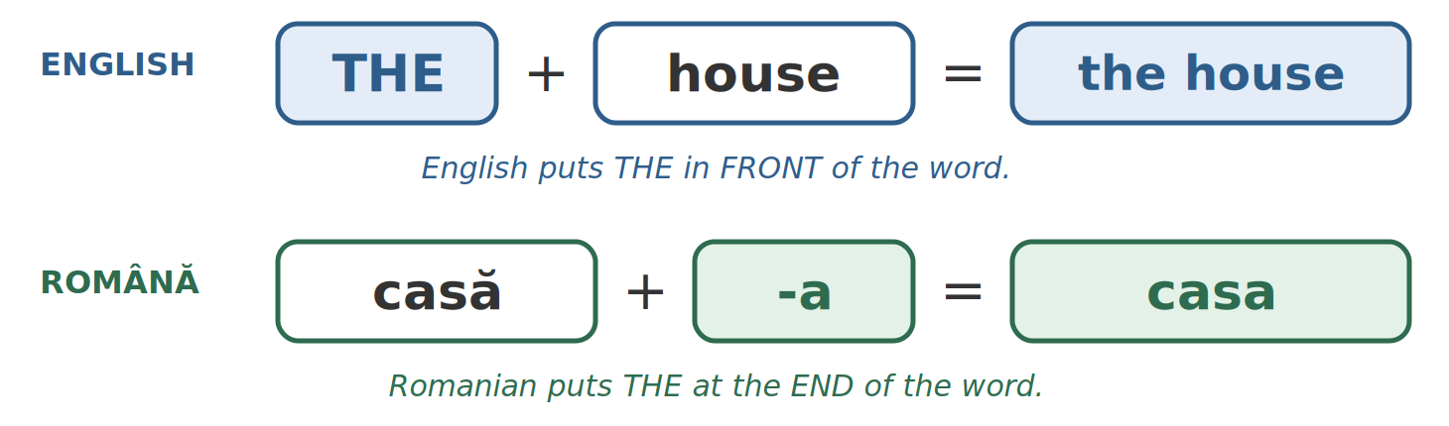
Fig. 2.1 — Unde stă articolul? / Where does "the" go?
The article goes at the END of the word
In English, the is a separate word in front: the house. In Romanian, the is a small ending glued to the back of the noun: casa. There is no separate word for the.
o casă = a house → casa = the house un telefon = a phone → telefonul = the phone

TIPAR — the — masculine and neuter, singular
ends in a consonant | + | -ul | = | pom → pomul

ends in -u | + | -l | = | lucru → lucrul

ends in -e | + | -le | = | frate → fratele

A | THE | ENGLISH
un pom | pomul | the tree
un băiat | băiatul | the boy
un elev | elevul | the pupil
un scaun | scaunul | the chair
un tren | trenul | the train
un telefon | telefonul | the phone
un oraș | orașul | the town
un lucru | lucrul | the thing
un tablou | tabloul | the picture
un frate | fratele | the brother
un câine | câinele | the dog
un nume | numele | the name

TIPAR — the — feminine, singular
ends in -ă | → | -ă becomes -a | = | casă → casa

ends in -e | + | -a | = | carte → cartea

ends in -ie | → | -ie becomes -ia | = | cheie → cheia

ends in stressed -a, -ea, or zi | + | -ua | = | cafea → cafeaua

A | THE | ENGLISH
o casă | casa | the house
o masă | masa | the table
o fată | fata | the girl
o mașină | mașina | the car
o carte | cartea | the book
o floare | floarea | the flower
o cheie | cheia | the key
o familie | familia | the family
o cafea | cafeaua | the coffee
o stea | steaua | the star
o zi | ziua | the day
o pijama | pijamaua | the pyjamas

TIPAR — the — plural
masculine plural (ends in -i) | + | -i | = | pomi → pomii

feminine and neuter plural | + | -le | = | case → casele

SOME | THE | ENGLISH
niște pomi | pomii | the trees
niște băieți | băieții | the boys
niște frați | frații | the brothers
niște câini | câinii | the dogs
niște case | casele | the houses
niște cărți | cărțile | the books
niște flori | florile | the flowers
niște chei | cheile | the keys
niște scaune | scaunele | the chairs
niște trenuri | trenurile | the trains
niște telefoane | telefoanele | the phones
niște orașe | orașele | the towns

Listen: pomi and pomii
In pomi the final i is almost silent (Lesson 2.2). In pomii the first i becomes a clear i sound: po-mii. The same in frații, câinii, băieții.

The whole picture — 15 everyday nouns
ENGLISH | GEN | A / UN, O | THE / SG. | SOME / NIȘTE | THE / PL.
tree | M | un pom | pomul | niște pomi | pomii
boy | M | un băiat | băiatul | niște băieți | băieții
brother | M | un frate | fratele | niște frați | frații
dog | M | un câine | câinele | niște câini | câinii
chair | N | un scaun | scaunul | niște scaune | scaunele
train | N | un tren | trenul | niște trenuri | trenurile
phone | N | un telefon | telefonul | niște telefoane | telefoanele
thing | N | un lucru | lucrul | niște lucruri | lucrurile
house | F | o casă | casa | niște case | casele
table | F | o masă | masa | niște mese | mesele
book | F | o carte | cartea | niște cărți | cărțile
flower | F | o floare | floarea | niște flori | florile
key | F | o cheie | cheia | niște chei | cheile
coffee | F | o cafea | cafeaua | niște cafele | cafelele
day | F | o zi | ziua | niște zile | zilele

Where Romanian uses "the" and English does not
Îmi place cafeaua. — I like coffee (Lesson 2.10). casa mea — my house (Lesson 2.7). For now, just notice them.

2.3 Add "the"
Write the form with the article at the end.
1. un telefon → ______________ | 2. o casă → ______________
3. o carte → ______________ | 4. niște scaune → ______________
5. niște flori → ______________ | 6. un frate → ______________
7. o cafea → ______________ | 8. niște băieți → ______________
9. un tren → ______________ | 10. o floare → ______________

Lesson 2.4 — The adjective / Adjectivul
An adjective describes a noun: big, small, new, good, cheap. In Romanian two things are different from English: where it goes, and how it changes.
Rule 1 — the adjective comes AFTER the noun
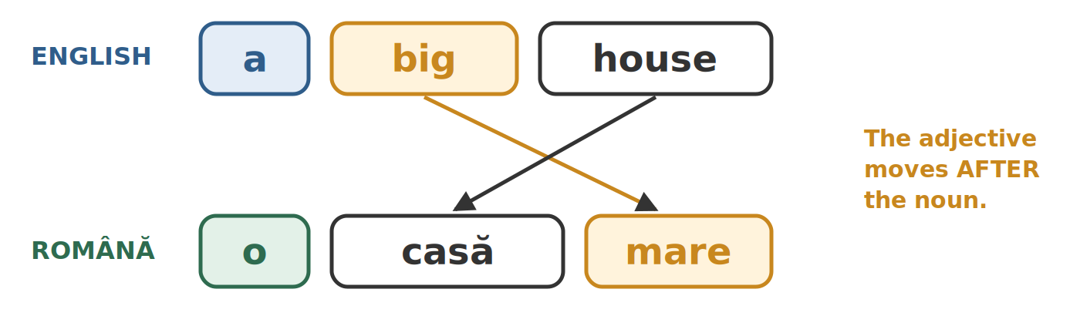
Fig. 2.2 — Adjectivul stă după substantiv / The adjective comes after the noun
TIPAR — position / poziția
NOUN | + | ADJECTIVE | = | o casă mare

o casă mare | a big house
un telefon nou | a new phone
o cafea bună | a good coffee
un oraș frumos | a beautiful town
o rochie ieftină | a cheap dress
apă rece | cold water

Rule 2 — the adjective agrees with the noun
The adjective copies the gender and the number of its noun. Most adjectives have four forms. The ones ending in -e have only two.
M / N SG. | F SG. | M PL. | F / N PL. | ENGLISH
bun | bună | buni | bune | good
frumos | frumoasă | frumoși | frumoase | beautiful
ieftin | ieftină | ieftini | ieftine | cheap
scump | scumpă | scumpi | scumpe | expensive
curat | curată | curați | curate | clean
mic | mică | mici | mici | small
nou | nouă | noi | noi | new
Only two forms — adjectives in -e / Doar două forme
mare | mare | mari | mari | big
verde | verde | verzi | verzi | green
rece | rece | reci | reci | cold
dulce | dulce | dulci | dulci | sweet

mic and nou are a little different: in the plural they have one form for everything — mici, noi.
TIPAR — one thing → more things
un scaun nou | → | niște scaune noi

o casă mare | → | niște case mari

ONE | MORE | ENGLISH
un băiat mic | niște băieți mici | a small boy
o fată mică | niște fete mici | a small girl
un pom frumos | niște pomi frumoși | a beautiful tree
o floare frumoasă | niște flori frumoase | a beautiful flower
un telefon scump | niște telefoane scumpe | an expensive phone
o carte bună | niște cărți bune | a good book
un scaun nou | niște scaune noi | a new chair
o casă mare | niște case mari | a big house
un câine mare | niște câini mari | a big dog
un oraș curat | niște orașe curate | a clean town
o rochie ieftină | niște rochii ieftine | a cheap dress
un măr verde | niște mere verzi | a green apple
o cafea bună | niște cafele bune | a good coffee
un ceai dulce | niște ceaiuri dulci | a sweet tea

The neuter again
un scaun bun — like masculine. niște scaune bune — like feminine. The rule from Lesson 2.1 works for adjectives too.

With "the"
The article goes on the noun; the adjective stays after it: casa mare — the big house · telefonul nou — the new phone · florile frumoase — the beautiful flowers.
After este / sunt the adjective still agrees: Casa este mare. Casele sunt mari.

2.4 Choose the right form
Circle the form that agrees with the noun.
1. o casă (mare / mari) | 2. niște case (mare / mari)
3. un telefon (nou / nouă) | 4. o carte (bun / bună)
5. niște flori (frumoși / frumoase) | 6. niște băieți (mici / mică)
7. un oraș (curat / curată) | 8. niște scaune (buni / bune)
9. o fată (frumos / frumoasă) | 10. niște mere (verde / verzi)

Homework — after Session 6 / Temă pentru acasă
H6.1 Look around your room. Write eight things, first with un / o, then with the: un pat → patul, o lampă → lampa.
H6.2 Write five sentences about things you have, each with an adjective: Am un telefon nou. Am o geantă mare.

SESSION 7 — THE NUMBERS
SESIUNEA 7 — NUMERALUL · 3 hours

By the end of this session you will be able to:
☐ | count from 0 to 1000
☐ | use un / o and doi / două with the right gender
☐ | know when to put de between the number and the noun
☐ | say a price, a quantity, an age, a date and the time
☐ | say first, second, third

Lesson 2.5 — The numbers / Numeralul
Here we build the whole number system, up to 1000, and use it for the things you need every day: money, quantities, age, dates and the clock.
0 to 10
0 | 1 | 2 | 3 | 4 | 5 | 6 | 7 | 8 | 9 | 10
zero | unu | doi | trei | patru | cinci | șase | șapte | opt | nouă | zece

11 to 19 — one "over" ten
TIPAR — 11 – 19
unit | + | spre (over) | + | zece (ten) | = | unsprezece

11 – 13 | 14 – 16 | 17 – 19
11 unsprezece | 14 paisprezece | 17 șaptesprezece
12 doisprezece | 15 cincisprezece | 18 optsprezece
13 treisprezece | 16 șaisprezece | 19 nouăsprezece

Watch out for 14 and 16
They are not patrusprezece and șasesprezece but paisprezece and șaisprezece. In speech everybody shortens them — unșpe, doișpe, treișpe — but you must write the full forms.

The tens, the hundreds
TENS |  | HUNDREDS, THOUSAND
20 | douăzeci | 100 | o sută
30 | treizeci | 200 | două sute
40 | patruzeci | 300 | trei sute
50 | cincizeci | 500 | cinci sute
60 | șaizeci | 1000 | o mie
70 | șaptezeci | 2000 | două mii
80 | optzeci
90 | nouăzeci

TIPAR — 21 – 99
tens | + | și (and) | + | unit | = | douăzeci și unu

21 douăzeci și unu | twenty-one
45 patruzeci și cinci | forty-five
99 nouăzeci și nouă | ninety-nine
250 două sute cincizeci | two hundred and fifty
1500 o mie cinci sute | one thousand five hundred

1 and 2 change with the gender
un pom, o casă · doi pomi, două case. The same in every number that ends in 2: doisprezece băieți — douăsprezece fete · douăzeci și doi de ani — douăzeci și două de ore. Every other number is fixed.

The little word DE
From 20 upwards you need DE
Up to 19 the number sits straight in front of the noun. From 20 on, you put de in between:
nouăsprezece ani — 19 years but douăzeci de ani — 20 years
cinci lei — 5 lei but o sută de lei — 100 lei
The rule looks only at the last two digits: 105 lei (o sută cinci lei) — no de; 120 de lei (o sută douăzeci de lei) — de.

Money, quantities, age, dates, the clock
USE | ROMANIAN | ENGLISH
money | treizeci de lei · doi lei și cincizeci de bani | 30 lei · 2.50 lei
quantity | cinci metri · douăzeci de kilograme · o sută de grame | 5 m · 20 kg · 100 g
age | Am treizeci și cinci de ani. | I am 35 years old — Romanian says "I have 35 years"
date | cincisprezece martie · două mii douăzeci și șase | 15 March · 2026
the clock | ora nouă · nouă și jumătate | nine o'clock · half past nine

First, second, third
The ordinals also change with the gender:
 | MASCULIN / NEUTRU | FEMININ | EXAMPLE
1st | primul | prima | primul etaj — the first floor · prima zi — the first day
2nd | al doilea | a doua | a doua ușă — the second door
3rd | al treilea | a treia | al treilea copil — the third child
4th | al patrulea | a patra | a patra lecție — the fourth lesson
5th | al cincilea | a cincea | al cincilea an — the fifth year

The little words al / a in al doilea, a doua come back in Lesson 2.9 (Whose?).
2.5 Write it in words
Careful with 14, 16 and the little word de.
1. 14 zile → ______________________ | 2. 16 ore → ______________________
3. 20 lei → ______________________ | 4. 45 minute → ______________________
5. 100 grame → ______________________ | 6. 250 lei → ______________________
7. 5 lei → ______________________ | 8. 19 ani → ______________________

Homework — after Session 7 / Temă pentru acasă
H7.1 Write in words: your age, today's date, and the prices of three things you bought this week.
H7.2 Read Appendix 2 (the numbers from 0 to 100) out loud twice.

SESSION 8 — WHO, WHOSE, THIS AND THAT
SESIUNEA 8 — PRONUMELE, POSESIVELE, DEMONSTRATIVELE, AL CUI? · 3 hours

By the end of this session you will be able to:
☐ | use all the personal pronouns, and choose tu or dumneavoastră correctly
☐ | say the present of a fi and a avea
☐ | say my, your, his, her, our, their
☐ | say this and that: telefonul acesta, casa aceea
☐ | ask and answer Whose is it?: E al lui Ion. E a Mariei.

Lesson 2.6 — The personal pronouns / Pronumele personale
ROMANIAN | ENGLISH | WHEN YOU USE IT
eu | I
tu | you | one person you know well: a friend, family, a child
el | he, it | a man; a masculine or neuter thing
ea | she, it | a woman; a feminine thing
noi | we
voi | you | two or more people you know well
ei | they | men, or a mixed group
ele | they | only women, or feminine things
dumneavoastră | you (polite) | one or more people: a stranger, an official, the boss

Romanian drops the pronoun
The verb ending already tells you who is speaking, so the pronoun is optional. Sunt student is the normal way to say "I am a student". Adding Eu puts weight on it: "I am a student (not him)". Do not use the pronoun in every sentence — it sounds heavy.

The two verbs you cannot avoid
 | A FI — to be | A AVEA — to have
eu | sunt — I am | am — I have
tu | ești | ai
el / ea | este / e | are
noi | suntem | avem
voi | sunteți | aveți
ei / ele | sunt | au
dumneavoastră | sunteți | aveți

Age is something you HAVE
Am treizeci de ani. — I am thirty (literally "I have thirty years"). Never Sunt treizeci de ani.
Hunger, thirst and cold use a different pattern: Mi-e foame — I am hungry · Mi-e sete — I am thirsty · Mi-e frig — I am cold. You will see why in Lesson 2.10.

TIPAR — age / vârsta
Am | + | number | + | (de) ani | = | Am 30 de ani.

Am nouăsprezece ani. | I am 19.
Am treizeci de ani. | I am 30.
Câți ani ai? | How old are you?

Formal and informal
INFORMAL — tu | FORMAL — dumneavoastră | ENGLISH
Ce faci? | Ce faceți? | How are you?
Unde lucrezi? | Unde lucrați? | Where do you work?
Ești student? | Sunteți student? | Are you a student?
Ai timp? | Aveți timp? | Do you have time?

Dumneavoastră takes the plural verb — sunteți, aveți — even for one person. In writing you will often see it shortened to dvs. — on forms, in emails, on notices.
2.6 Which pronoun?
Write the pronoun that matches the verb.
1. ____ sunt student. | 2. ____ ești acasă?
3. ____ suntem la magazin. | 4. ____ sunteți din Nepal?
5. ____ este medic. | 6. ____ au doi copii.

Lesson 2.7 — My, your, his, her / Posesivele
Here is the rule that surprises everybody: the possessive does not agree with the owner. It agrees with the thing owned.
The full set
 | M / N SG. | F SG. | M PL. | F / N PL.
my | meu | mea | mei | mele
your (tu) | tău | ta | tăi | tale
his | lui
her | ei
our | nostru | noastră | noștri | noastre
your (voi) | vostru | voastră | voștri | voastre
your (dvs.) | dumneavoastră
their | lor

Four of them never change
lui (his), ei (her), lor (their) and dumneavoastră (your, polite) have one single form. That is four fewer things to remember.

The noun takes "the" in front of the possessive
TIPAR — noun + the + possessive
NOUN + the | + | POSSESSIVE | = | fratele meu

ROMANIAN | ENGLISH | ROMANIAN | ENGLISH
fratele meu | my brother | sora mea | my sister
telefonul meu | my phone | casa ta | your house
prietenul tău | your friend | familia noastră | our family
copiii mei | my children | cheile mele | my keys
prietenii noștri | our friends | cărțile tale | your books
mașina lui | his car | casa ei | her house
copiii lor | their children | numele dumneavoastră | your name (polite)

Never frate meu — always fratele meu. The the ending comes from Lesson 2.3.
2.7 Meu, mea, mei or mele?
Look at the noun, not at yourself.
1. telefonul ________ | 2. casa ________
3. copiii ________ | 4. cheile ________
5. prietenul ________ | 6. familia ________
7. cărțile ________ | 8. frații ________

Lesson 2.8 — This and that / Demonstrativele
To point at something, English says this (near) and that (far). Romanian does the same — and, as always, the word agrees with the noun.
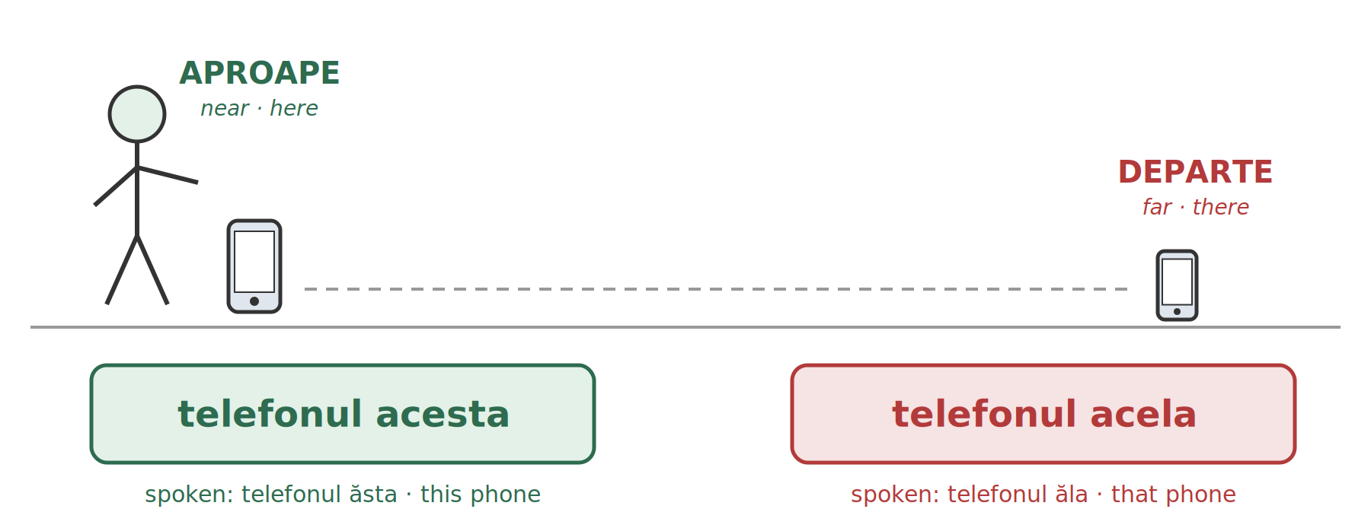
Fig. 2.3 — Aproape și departe / Near and far
TIPAR — this, that
NOUN + the | + | acesta (near) | = | telefonul acesta

NOUN + the | + | acela (far) | = | telefonul acela

 | M / N SG. | F SG. | M PL. | F / N PL.
this / these — written | acesta | aceasta | aceștia | acestea
this / these — spoken | ăsta | asta | ăștia | astea
that / those — written | acela | aceea | aceia | acelea
that / those — spoken | ăla | aia | ăia | alea

WRITTEN | SPOKEN | ENGLISH
telefonul acesta | telefonul ăsta | this phone
casa aceasta | casa asta | this house
copiii aceștia | copiii ăștia | these children
cheile acestea | cheile astea | these keys
scaunele acestea | scaunele astea | these chairs
băiatul acela | băiatul ăla | that boy
fata aceea | fata aia | that girl
magazinul acela | magazinul ăla | that shop
mașina aceea | mașina aia | that car
oamenii aceia | oamenii ăia | those people
florile acelea | florile alea | those flowers
Ce este aceasta? | Ce e asta? | What is this?
Aceasta este cheia mea. | Asta e cheia mea. | This is my key.
Aceea este mașina ta? | Aia e mașina ta? | Is that your car?

Written or spoken?
In the street, at the shop and at home, people say asta, ăsta, aia, ăla. On signs, on forms and in formal speech you see acesta, aceasta, acela, aceea.
When you point at a person, use the long form or the name: ăla about a person can sound rude.

You will also see
acest telefon, această casă, acești copii, aceste chei — in front of the noun, without the. Same meaning, more formal. Just recognise it.

2.8 Acesta, aceasta, aceștia or acestea?
Look at the gender and the number of the noun.
1. telefonul ________ | 2. casa ________
3. copiii ________ | 4. florile ________
5. scaunul ________ | 6. mașina ________
7. băieții ________ | 8. cheile ________

Lesson 2.9 — Whose? / Al cui? Genitivul minim
English says Ion's phone. Romanian says it the other way round: first the thing, then the owner — telefonul lui Ion.
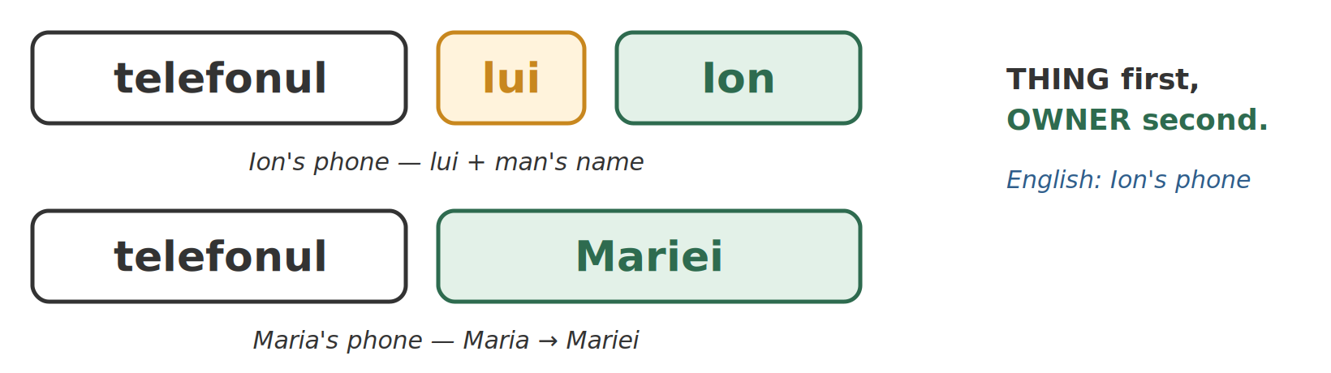
Fig. 2.4 — Întâi lucrul, apoi proprietarul / First the thing, then the owner
Step 1 — lui before a man's name, -ei on a woman's name
TIPAR — whose — a man / al cui — un bărbat
THING + the | + | lui | + | man's name | = | mașina lui Ion

TIPAR — whose — a woman / al cui — o femeie
THING + the | + | woman's name: -a → -ei | = | mașina Mariei

Maria → Mariei | Ana → Anei
Elena → Elenei | Ioana → Ioanei

ROMANIAN | ENGLISH | ROMANIAN | ENGLISH
mașina lui Ion | Ion's car | telefonul Mariei | Maria's phone
telefonul lui Andrei | Andrei's phone | casa Anei | Ana's house
casa lui Mihai | Mihai's house | cartea Elenei | Elena's book
copiii lui Radu | Radu's children | geanta Ioanei | Ioana's bag
cheile lui Ali | Ali's keys | fratele Mariei | Maria's brother
prietenul lui Raj | Raj's friend | copiii Anei | Ana's children

A woman's name that does not end in -a
It takes lui, like a man's name: telefonul lui Carmen · casa lui Alice.

lui and ei — you already know them
They are also his and her (Lesson 2.7): mașina lui Ion → mașina lui (his car) · telefonul Mariei → telefonul ei (her phone).

Step 2 — Whose is it? al, a, ai, ale
To ask Whose? you say Al cui? The little word in front — al, a, ai, ale — agrees with the thing, like the possessive in Lesson 2.7.
M / N SG. | F SG. | M PL. | F / N PL.
al | a | ai | ale
al cui? · al lui Ion | a cui? · a Mariei | ai cui? · ai lui Radu | ale cui? · ale Anei

QUESTION | ANSWER | ENGLISH
Al cui e telefonul? | E al lui Ion. | Whose is the phone? — It's Ion's.
A cui e mașina? | E a Mariei. | Whose is the car? — It's Maria's.
Ai cui sunt copiii? | Sunt ai lui Radu. | Whose are the children? — Radu's.
Ale cui sunt cheile? | Sunt ale Anei. | Whose are the keys? — Ana's.
A cui e geanta? | E a mea. | Whose is the bag? — It's mine.
Al cui e scaunul? | E al meu. | Whose is the chair? — It's mine.
Ai cui sunt copiii? | Sunt ai noștri. | Whose are the children? — Ours.
Ale cui sunt cărțile? | Sunt ale tale. | Whose are the books? — Yours.

AFTER UN / O | ENGLISH
un prieten al lui Ion | a friend of Ion's
o prietenă a Mariei | a friend of Maria's
un coleg al meu | a colleague of mine
o colegă a mea | a colleague of mine

When do you need al / a / ai / ale?
When the thing does not stand right in front of the owner with the on it: after e / sunt (E al lui Ion), after un / o (un prieten al meu), and in the question Al cui?.
In telefonul lui Ion you do not need it.

2.9 Al, a, ai or ale?
Look at the thing, not at the owner.
1. Telefonul e ____ lui Ion. | 2. Casa e ____ Mariei.
3. Copiii sunt ____ lui Radu. | 4. Cheile sunt ____ mele.
5. Mașina e ____ Anei. | 6. Scaunele sunt ____ noastre.
7. Cartea e ____ ei. | 8. Băieții sunt ____ lui Mihai.

Homework — after Session 8 / Temă pentru acasă
H8.1 Write six sentences about your family with a possessive: Fratele meu este... Sora mea are...
H8.2 Point at six things in your room. Write each one with acesta / aceasta and with the spoken form: patul acesta — patul ăsta.
H8.3 Write four answers to Al cui...? / A cui...? about things in your home: Telefonul e al meu.

SESSION 9 — SHORT PRONOUNS, WORD BUILDING, RECAP AND TEST
SESIUNEA 9 — FORMELE SCURTE ALE PRONUMELOR, CONSTRUIREA CUVINTELOR, RECAPITULARE · 3 hours

Note on this session
Session 9 closes Module 2. It ends with the cumulative test for the whole module (25 questions, multiple choice), in the teacher section at the end of this book.

By the end of this session you will be able to:
☐ | recognise the short pronouns in front of a verb: Îl văd. O iau.
☐ | use îl / o / îi / le for it and them
☐ | say what you like with îmi place / îți place
☐ | read the short forms with a hyphen: m-a, l-am, mi-e, dă-mi
☐ | guess the meaning of new words from prefixes and suffixes

Lesson 2.10 — The short pronouns / Formele scurte ale pronumelor
You already say Mă cheamă Ali — my name is Ali. The little word mă is a pronoun: a short form of eu. Romanian has short pronouns that stand in front of the verb. There are two sets. Learn to recognise them first — you will hear them in every conversation.
Look only at the small word
The verbs in this lesson are shown as whole phrases, with a translation. How the verbs change comes in Module 3. Here, look only at the small word in front of the verb.

Set 1 — me, you, him, her, it, us, them
FULL | SHORT | ENGLISH | FULL | SHORT | ENGLISH
eu | mă | me | noi | ne | us
tu | te | you | voi / dvs. | vă | you
el | îl | him, it | ei | îi | them
ea | o | her, it | ele | le | them

TIPAR — short pronoun + verb
SHORT FORM | + | VERB | = | Îl văd.

ROMANIAN | ENGLISH
Mă cheamă Ali. | My name is Ali. (literally: they call me Ali)
Te rog. | Please — to a friend. (literally: I ask you)
Vă rog. | Please — polite.
Te iubesc. | I love you.
Îl văd. | I see him. / I see it.
O văd. | I see her. / I see it.
Ne ajută. | He / She helps us.
Vă aștept. | I am waiting for you.
Îi cunosc. | I know them.
Le cunosc. | I know them (women, or feminine things).
Îl iau. | I'll take it. (telefonul)
O iau. | I'll take it. (geanta)

TIPAR — "it" and "them" depend on the gender
telefonul (M / N) | → | Îl iau.

geanta (F) | → | O iau.

pantofii (M pl.) | → | Îi iau.

cheile · scaunele (F / N pl.) | → | Le iau.

Set 2 — to me, to you, to him, to her...
The second set means to me, to you.... You hear it most in Îmi place — I like. Romanian says it the other way round: it is pleasing to me.
FULL | SHORT | ENGLISH | FULL | SHORT | ENGLISH
eu | îmi | to me | noi | ne | to us
tu | îți | to you | voi / dvs. | vă | to you
el / ea | îi | to him, to her | ei / ele | le | to them

TIPAR — I like / îmi place
îmi / îți / îi... | + | place (one thing) · plac (more) | + | THING + the | = | Îmi place cafeaua.

ROMANIAN | ENGLISH
Îmi place cafeaua. | I like coffee.
Îți place orașul? | Do you like the town?
Îi place muzica. | He / She likes music.
Ne place Bucureștiul. | We like Bucharest.
Vă place? | Do you like it? (polite)
Le place fotbalul. | They like football.
Îmi plac florile. | I like flowers. (plac — more than one thing)
Îmi pare rău. | I am sorry.
Îți dau telefonul. | I give you the phone.
Îi dau cheile. | I give him / her the keys.
Îmi trebuie un pix. | I need a pen.
Ne trebuie timp. | We need time.

Îi has two jobs
Îi văd. — I see them (set 1). Îi dau cheile. — I give him / her the keys (set 2).
Ne and vă are also the same in both sets. The rest of the sentence tells you which one it is.

Short forms with a hyphen
In Module 1, Session 4, you learned to read the hyphen (cratima). Short pronouns are where you will see it most often. When a short pronoun meets a vowel, a letter drops out and a hyphen joins the two words. You read them as one word.
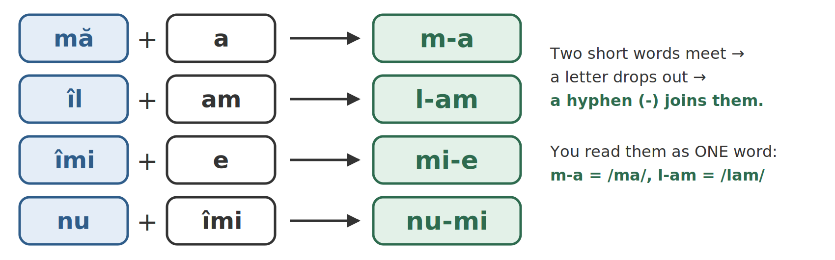
Fig. 2.5 — Cratima: două cuvinte citite ca unul / The hyphen: two words read as one
PARTS | WITH HYPHEN | EXAMPLE | ENGLISH
mă + a | m-a | M-a sunat Ana. | Ana called me.
te + a | te-a | Te-a căutat cineva. | Someone looked for you.
îl + am | l-am | L-am văzut. | I saw him / it.
îi + am | i-am | I-am spus. | I told him / her.
îmi + a | mi-a | Mi-a plăcut. | I liked it.
ne + a | ne-a | Ne-a ajutat. | He / She helped us.
vă + am | v-am | V-am spus. | I told you.
le + am | le-am | Le-am cumpărat. | I bought them.
îmi + e | mi-e | Mi-e foame. | I am hungry.
îți + e | ți-e | Ți-e frig? | Are you cold?
nu + îmi | nu-mi | Nu-mi place. | I don't like it.
nu + îl | nu-l | Nu-l văd. | I don't see him / it.
dă + îmi | dă-mi | Dă-mi apa, te rog. | Give me the water, please.
spune + îmi | spune-mi | Spune-mi. | Tell me.
dați + îmi | dați-mi | Dați-mi un bilet, vă rog. | Give me a ticket, please.

Read now, use later
am / a in these examples make the past tense (I did, he did); dă-mi, spune-mi are orders. Both are taught in Module 3. In this lesson, just read them and find the pronoun.
With the past tense, o goes AFTER the verb, again with a hyphen: Am văzut-o. — I saw her.

2.10 Îl, o, îi or le?
Look at the gender and the number of the thing.
1. Telefonul? ____ iau. | 2. Geanta? ____ iau.
3. Pantofii? ____ iau. | 4. Cheile? ____ iau.
5. Cartea? ____ iau. | 6. Pixul? ____ iau.
7. Florile? ____ iau. | 8. Copiii? ____ văd.

Lesson 2.11 — Building words / Construirea cuvintelor
Romanian builds new words out of old ones by adding a piece in front (a prefix) or a piece behind (a suffix). Once you know the common pieces, you can work out words nobody taught you — on a shop sign, on a form, in a notice.
TIPAR — building words
PREFIX | + | WORD | = | ne + plătit = neplătit

WORD | + | SUFFIX | = | brutar + ie = brutărie

Prefixes
PREFIX | MEANING | EXAMPLES
ne- | not, the opposite | fericit → nefericit — happy → unhappy · cunoscut → necunoscut — known → unknown
re- | again | a face → a reface — to do → to redo · a citi → a reciti — to read → to read again
des- / dez- | undo, take apart | a face → a desface — to undo · a îmbrăca → a dezbrăca — to dress → to undress
în- / îm- | makes a verb | bun → a îmbunătăți — good → to improve · pachet → a împacheta — parcel → to wrap, to pack
stră- | one generation further | bunic → străbunic — grandfather → great-grandfather

The one you will read on forms
ne- is everywhere in official Romanian: neplătit — unpaid · nesemnat — unsigned · necăsătorit — unmarried · nemotivat — unexcused (an unexcused absence). If you see ne at the start of a word you know, it means the opposite.

Suffixes
SUFFIX | MEANING | EXAMPLES
-tor / -ător | the person who does it | muncă → muncitor — work → worker · a vinde → vânzător — to sell → shop assistant
-ar | a trade, from a thing | grădină → grădinar — garden → gardener · bucate → bucătar — dishes → cook · poartă → portar — gate → doorman
-ie / -ărie | the shop, the place | brutar → brutărie — baker → bakery · cofetar → cofetărie — cake shop · frizer → frizerie — barber's · librar → librărie — bookshop · florar → florărie — flower shop
-ime | a measurement | lung → lungime — long → length · înalt → înălțime — high → height
-uț / -el / -ică / -ior | small (diminutive) | casă → căsuță — little house · băiat → băiețel — little boy · floare → floricică — little flower · frate → frățior — little brother

FOTO: [firma unei brutării sau cofetării dintr-un oraș românesc]
[ SPAȚIU PENTRU IMAGINE / SPACE FOR A PHOTO ]

Fig. 2.6 — Fotografie: firma unei brutării / Photo: a bakery sign — brutar + ie = brutărie
The measurement words are all -ime
You see them on furniture, on clothes labels and on parcels: lungime — length · lățime — width · înălțime — height · grosime — thickness · adâncime — depth.

Jobs / Meserii
ROMANIAN | ENGLISH | ROMANIAN | ENGLISH | ROMANIAN | ENGLISH
bucătar | cook | ospătar | waiter | vânzător | shop assistant
șofer | driver | frizer | barber, hairdresser | brutar | baker
medic | doctor | profesor | teacher | asistent medical | nurse
mecanic | mechanic | electrician | electrician | instalator | plumber
curier | courier | casier | cashier | grădinar | gardener

2.11 What does it mean?
Write the meaning in English. Use the prefix or the suffix.
1. nefericit → ____________________ | 2. necunoscut → ____________________
3. a reciti → ____________________ | 4. a dezbrăca → ____________________
5. brutărie → ____________________ | 6. cofetărie → ____________________
7. lungime → ____________________ | 8. căsuță → ____________________

Module 2 — Everything on one page / Totul pe o pagină
TOPIC | THE RULE
THREE GENDERS | masculin, feminin, neutru. Test with un / o, then count two: doi = masculin, două = feminin or neutru.
THE NEUTER | Masculine in the singular (un tren), feminine in the plural (două trenuri).
PLURAL | masculin -i · feminin -e or -i (-le after -ea) · neutru -e or -uri.
SOUND CHANGES | t→ț, d→z, s→ș, a→ă, a→e, oa→o. The ending stays the same; the sound before it moves.
A / SOME | un (M, N) · o (F) · niște (all plurals): un pom, o casă, niște case.
THE | At the END of the word. M / N: -ul, -l, -le (pomul, lucrul, fratele) · F: -a, -ua (casa, cartea, cafeaua) · plural: -i (pomii), -le (casele).
ADJECTIVE | After the noun, agrees with it: o casă mare — niște case mari · un scaun nou — niște scaune noi.
11 TO 19 | unit + spre + zece. Careful: paisprezece (14), șaisprezece (16).
21 TO 99 | tens + și + unit: douăzeci și unu.
THE WORD DE | From 20 up (last two digits): douăzeci de lei, but cinci lei, o sută cinci lei.
1 AND 2 | Change with the gender: un / o, doi / două. Every other number is fixed.
PRONOUNS | eu, tu, el, ea, noi, voi, ei, ele, dumneavoastră. Usually dropped — the verb ending says who.
POLITENESS | tu for friends and family; dumneavoastră (written dvs.) for everyone else. It takes a plural verb.
A FI / A AVEA | sunt, ești, este, suntem, sunteți, sunt · am, ai, are, avem, aveți, au. Age uses a avea.
POSSESSIVES | Agree with the thing owned: fratele meu, sora mea. lui, ei, lor, dumneavoastră never change.
THIS / THAT | telefonul acesta / ăsta (near) · telefonul acela / ăla (far). Agree with the noun.
WHOSE | mașina lui Ion · mașina Mariei. Al / a / ai / ale cui? — E al meu. E a Mariei.
SHORT PRONOUNS | mă, te, îl, o, ne, vă, îi, le (me, him...) · îmi, îți, îi, ne, vă, le (to me...). In front of the verb: Îl iau. Îmi place.
THE HYPHEN | Short pronoun + vowel: m-a, l-am, i-am, mi-a, mi-e, nu-mi, dă-mi. Read as one word.
WORD BUILDING | Prefixes: ne- (not), re- (again), des- / dez- (undo). Suffixes: -tor / -ar (the person), -ie (the shop), -ime (the measurement).

Words from Module 2 that you already know
WORD BANK: un / o · doi / două · niște · unsprezece · paisprezece · șaisprezece · douăzeci · o sută · o mie

WORD BANK: eu · tu · el · ea · noi · voi · ei · ele · dumneavoastră

WORD BANK: bucătar · ospătar · vânzător · șofer · frizer · brutar · medic · profesor · curier · casier

EXTRA PRACTICE — MODULE 2
EXERCIȚII SUPLIMENTARE — MODULUL 2 · for revision, or when a session finishes early

E1 Find the gender
Use the counting test, then write M, F or N.
1. pom — doi pomi → ____ | 2. tren — două trenuri → ____
3. casă — două case → ____ | 4. scaun — două scaune → ____
5. elev — doi elevi → ____ | 6. carte — două cărți → ____

E2 Singular or plural?
Write S or P.
1. orașe ____ | 2. telefon ____ | 3. chei ____
4. prieten ____ | 5. lucruri ____ | 6. mese ____

E3 Which sound changed?
Write the change, for example t → ț.
1. băiat → băieți → ______ | 2. fată → fete → ______
3. carte → cărți → ______ | 4. floare → flori → ______

E4 Some and the
Write the plural with niște, then with the.
1. un măr → niște ________ → ________
2. o fată → niște ________ → ________
3. un tren → niște ________ → ________
4. o cheie → niște ________ → ________

E5 With or without de?
Write de only where it is needed.
1. cinci ____ lei | 2. douăzeci ____ lei
3. nouăsprezece ____ ani | 4. treizeci ____ ani
5. trei ____ metri | 6. o sută ____ metri

E6 Un, o, doi or două?
The number has to match the gender of the noun.
1. ____ prieten | 2. ____ casă | 3. ____ prieteni
4. ____ case | 5. ____ trenuri | 6. ____ pomi

E7 Tu or dumneavoastră?
Write T or DVS for each person.
1. un prieten ____ | 2. un polițist ____
3. sora ta ____ | 4. medicul ____
5. vânzătorul din magazin ____ | 6. copilul tău ____

E8 A fi or a avea?
Complete with the correct form.
1. Eu ______ student și ______ un frate.
2. Noi ______ patru în familie.
3. Dumneavoastră ______ domnul Popescu?
4. Ei ______ la magazin.
5. Ea ______ douăzeci și cinci de ani.
6. Voi ______ copii?

E9 Translate
Watch the gender of the thing owned.
1. my salary → ____________________ | 2. your (tu) house → ____________________
3. his car → ____________________ | 4. her keys → ____________________
5. our family → ____________________ | 6. their documents → ____________________

E10 Say it the spoken way
Write the spoken form.
1. casa aceasta → ____________ | 2. băiatul acela → ____________
3. cheile acestea → ____________ | 4. fata aceea → ____________

E11 Whose?
Write lui, or change the woman's name.
1. mașina ______ Ion | 2. telefonul (Maria) → telefonul ______
3. casa (Ana) → casa ______ | 4. copiii ______ Radu

E12 Decode without a dictionary
You have never seen these words. Work them out.
1. necăsătorit → ____________ | 2. a rescrie → ____________
3. a desface → ____________ | 4. florărie → ____________
5. înălțime → ____________ | 6. băiețel → ____________

ANEXA 1 — 60 DE SUBSTANTIVE CU GEN ȘI PLURAL
APPENDIX 1 — the 60 nouns you need first, with their gender and plural

Learn each noun in this form: un tren, două trenuri. Never learn the singular alone — the plural and the gender come with it.
Oameni / People
SINGULAR | PLURAL | GEN | ENGLISH
om | oameni | M | man, person
bărbat | bărbați | M | man
femeie | femei | F | woman
copil | copii | M | child
prieten | prieteni | M | friend
coleg | colegi | M | colleague
șef | șefi | M | boss
vecin | vecini | M | neighbour
familie | familii | F | family
echipă | echipe | F | team
firmă | firme | F | company
act | acte | N | document, paper
Mâncare și bucătărie / Food and the kitchen
SINGULAR | PLURAL | GEN | ENGLISH
pâine | pâini | F | bread, loaf
măr | mere | N | apple
ou | ouă | N | egg
cartof | cartofi | M | potato
roșie | roșii | F | tomato
ceapă | cepe | F | onion
pahar | pahare | N | glass
cană | căni | F | mug, cup
farfurie | farfurii | F | plate
lingură | linguri | F | spoon
cuțit | cuțite | N | knife
furculiță | furculițe | F | fork
Casa / The house
SINGULAR | PLURAL | GEN | ENGLISH
casă | case | F | house
cameră | camere | F | room
bucătărie | bucătării | F | kitchen
ușă | uși | F | door
fereastră | ferestre | F | window
masă | mese | F | table
scaun | scaune | N | chair
pat | paturi | N | bed
apartament | apartamente | N | flat
bloc | blocuri | N | block of flats
etaj | etaje | N | floor, storey
acoperiș | acoperișuri | N | roof
Oraș și documente / Town and paperwork
SINGULAR | PLURAL | GEN | ENGLISH
oraș | orașe | N | town, city
drum | drumuri | N | road
autobuz | autobuze | N | bus
tren | trenuri | N | train
magazin | magazine | N | shop
spital | spitale | N | hospital
bancă | bănci | F | bank
cerere | cereri | F | application, request
adeverință | adeverințe | F | certificate
carte | cărți | F | book
pașaport | pașapoarte | N | passport
permis | permise | N | permit, licence
Timp și bani / Time and money
SINGULAR | PLURAL | GEN | ENGLISH
an | ani | M | year
leu | lei | M | leu (currency)
ban | bani | M | money; ban (1/100 leu)
oră | ore | F | hour
zi | zile | F | day
lună | luni | F | month
săptămână | săptămâni | F | week
zi de muncă | zile de muncă | F | working day
concediu | concedii | N | leave, holiday
preț | prețuri | N | price
salariu | salarii | N | salary
program | programe | N | schedule

ANEXA 2 — NUMERELE DE LA 0 LA 100
APPENDIX 2 — every number you need, written out in full

0 to 21
NUMBER | IN WORDS | NUMBER | IN WORDS
0 | zero | 11 | unsprezece
1 | unu / una | 12 | doisprezece / douăsprezece
2 | doi / două | 13 | treisprezece
3 | trei | 14 | paisprezece
4 | patru | 15 | cincisprezece
5 | cinci | 16 | șaisprezece
6 | șase | 17 | șaptesprezece
7 | șapte | 18 | optsprezece
8 | opt | 19 | nouăsprezece
9 | nouă | 20 | douăzeci
10 | zece | 21 | douăzeci și unu

The tens, the hundreds, the thousand
NUMBER | IN WORDS | NUMBER | IN WORDS
30 | treizeci | 100 | o sută
40 | patruzeci | 200 | două sute
50 | cincizeci | 300 | trei sute
60 | șaizeci | 500 | cinci sute
70 | șaptezeci | 1000 | o mie
80 | optzeci | 2000 | două mii
90 | nouăzeci | 2026 | două mii douăzeci și șase

The three things that catch everybody
1. paisprezece (14) and șaisprezece (16) — not the forms you would expect.
2. From 20 upwards you need de: douăzeci de lei, but cinci lei.
3. Only 1 and 2 (and the numbers ending in 2) change with the gender: un / o, doi / două.

SECȚIUNE DETAȘABILĂ — EXEMPLAR FORMATOR
DETACHABLE SECTION — TEACHER COPY
Se detașează din exemplarul cursantului. Testul completat, fișa de sesiune și fișa de evidență se păstrează la dosarul cursantului.
To be detached from the student's copy. The completed test, the session record and the module record are kept in the student's file.
Instrucțiuni de administrare / How to administer
Testul este de tip grilă. Cursantul marchează cu X un singur răspuns pentru fiecare întrebare. Nu se scrie nimic altceva pe test, în afară de nume, dată și semnătură.
The test is multiple choice. The student marks X in one box per question. Nothing else is written on the test, apart from name, date and signature.
Un răspuns corect = 1 punct. Răspuns nemarcat sau marcat dublu = 0 puncte. One correct answer = 1 point. No mark or two marks = 0 points.

TEST | ACOPERĂ / COVERS | ITEMI | TIMP ALOCAT
Test cumulativ — Modulul 2 (Sesiunea 9) | Lecțiile 2.1 – 2.11 | 25 | 40 de minute

TEST CUMULATIV — MODULUL 2
MODULE 2 — CUMULATIVE TEST · grilă, 25 de întrebări, 25 de puncte · Marchează cu X un singur răspuns / Mark X in one box only · 40 min

Nume / Name: ______________________________ | Data / Date: ____ / ____ / 20____
Semnătura cursantului / Signature: ______________________ | Punctaj / Score: ______ / 25

1. Genul unui substantiv se verifică cel mai sigur: (1 p)
 | a) după înțelesul cuvântului |  | b) după prima literă
 | c) cu testul un / o și doi / două |  | d) după numărul de silabe
2. Care este pluralul cuvântului carte ? (1 p)
 | a) cărți |  | b) carte |  | c) carturi |  | d) cartei
3. Cum spui corect „two houses”? (1 p)
 | a) doi case |  | b) doi casă |  | c) două casă |  | d) două case
4. Care este pluralul cuvântului floare ? (1 p)
 | a) floare |  | b) flori |  | c) floruri |  | d) floarele
5. Cum spui „the house”? (1 p)
 | a) o casă |  | b) casă |  | c) casa |  | d) casele
6. Cum spui „the flowers”? (1 p)
 | a) florile |  | b) niște flori |  | c) floarea |  | d) florii
7. Cum spui „some books”? (1 p)
 | a) două cărți |  | b) cărțile |  | c) o cărți |  | d) niște cărți
8. Unde se pune articolul hotărât („the”) în limba română? (1 p)
 | a) înaintea cuvântului |  | b) la sfârșitul cuvântului
 | c) după verb |  | d) nu există articol
9. Care variantă este corectă? (1 p)
 | a) o casă mari |  | b) mare o casă |  | c) o casă mare |  | d) o case mare
10. Care variantă este corectă? (1 p)
 | a) niște scaune noi |  | b) niște scaune nou
 | c) niște scaune nouă |  | d) niște scaun noi
11. Care variantă este corectă? (1 p)
 | a) o floare frumos |  | b) o floare frumoasă
 | c) o floare frumoși |  | d) o floare frumoase
12. Care variantă este corectă? (1 p)
 | a) douăzeci ani |  | b) de douăzeci ani |  | c) douăzeci ani de |  | d) douăzeci de ani
13. Cum se scrie corect? (1 p)
 | a) Mi e foame. |  | b) Mie foame. |  | c) Mi-e foame. |  | d) Mi-e-foame.
14. Care este forma corectă: Ei ____ un copil. (1 p)
 | a) am |  | b) ai |  | c) au |  | d) are
15. Cum spui corect „I am 30 years old”? (1 p)
 | a) Am treizeci de ani. |  | b) Sunt treizeci de ani.
 | c) Am treizeci ani. |  | d) Sunt treizeci ani.
16. Care este forma corectă: Dumneavoastră ____ din India? (1 p)
 | a) ești |  | b) este |  | c) sunt |  | d) sunteți
17. Cum spui corect „my keys”? (1 p)
 | a) cheile meu |  | b) cheile mele |  | c) cheile mea |  | d) cheile mei
18. Cum spui politicos „your name” (dvs.)? (1 p)
 | a) numele tău |  | b) numele vostru
 | c) numele dumneavoastră |  | d) numele lui
19. Cum spui „this house”? (1 p)
 | a) casa aceasta |  | b) casa acesta |  | c) casa aceștia |  | d) casa acestea
20. Ce înseamnă băiatul acela ? (1 p)
 | a) this boy |  | b) these boys |  | c) those boys |  | d) that boy
21. Cum spui „Maria's phone”? (1 p)
 | a) telefonul Maria |  | b) telefonul Mariei
 | c) telefonul lui Maria |  | d) Maria telefonul
22. Al cui e telefonul? — E ____ lui Ion. (1 p)
 | a) a |  | b) ai |  | c) al |  | d) ale
23. Telefonul? ____ iau. (1 p)
 | a) Îl |  | b) O |  | c) Le |  | d) Îi
24. „I like coffee” se spune: (1 p)
 | a) Mă place cafeaua. |  | b) Îmi place cafeaua.
 | c) Îl place cafeaua. |  | d) Eu place cafeaua.
25. Ce înseamnă brutărie ? (1 p)
 | a) baker |  | b) bread |  | c) cake |  | d) bakery

SESSION COMPLETION RECORD
FIȘĂ DE CONFIRMARE A PARCURGERII SESIUNII — se păstrează la dosar

Module / Modul | Modulul 2 — Bazele gramaticii
Session / Sesiunea | Sesiunea 9 — Formele scurte ale pronumelor, construirea cuvintelor, recapitulare. TEST CUMULATIV MODULUL 2
Duration / Durata | 3 ore (9:00 – 12:00)
Date / Data | _____ / _____ / 20_____
Student name / Nume și prenume cursant
Score / Punctaj obținut | _______ / 25
Student signature / Semnătura cursantului
Teacher signature / Semnătura formatorului

Declarație cursant / Student declaration
Declar că am participat la această sesiune de curs și am parcurs conținutul prezentat mai sus.
I declare that I attended this course session and covered the content presented above.

MODULE 2 — COMPLETION RECORD
FIȘĂ DE EVIDENȚĂ A PARCURGERII MODULULUI 2 — se păstrează la dosarul cursantului

Cursant / Student
Act de identitate / ID document
Angajator / Employer
Formator / Teacher
Modul / Module | Modulul 2 — Bazele gramaticii (15 ore, Sesiunile 5–9, săptămânile 3–5)

NR. | SESIUNE / CONȚINUT | DATA | PUNCTAJ TEST | SEMNĂTURA CURSANTULUI
5 | Sesiunea 5 — Genul și pluralul substantivelor (3 ore) |  | —
6 | Sesiunea 6 — Articolul și adjectivul (3 ore) |  | —
7 | Sesiunea 7 — Numeralul (3 ore) |  | —
8 | Sesiunea 8 — Pronumele, a fi / a avea, posesivele, demonstrativele, al cui? (3 ore) |  | —
9 | Sesiunea 9 — Formele scurte ale pronumelor, construirea cuvintelor, recapitulare + TEST CUMULATIV (3 ore) |  | ___ / 25

Confirmare finalizare modul / Module completion
Confirm că cursantul a parcurs integral conținutul Modulului 2 — Bazele gramaticii, în total 15 ore de curs, și a susținut testul de evaluare consemnat mai sus.
I confirm that the student completed the full content of Module 2 — The Basics of Grammar, 15 course hours in total, and sat the assessment recorded above.
Data: _____ / _____ / 20_____ Semnătura formatorului: ______________________

ANSWER KEY — TEACHER COPY
CHEIA RĂSPUNSURILOR — pentru formator

Lesson exercises / Exercițiile din lecții
2.1 | o casă · un pom · un scaun · o carte · un tren · o masă · un elev · un oraș · o ușă · un telefon · un pat · o cheie
2.2 | elevi · case · trenuri · cărți · scaune · prieteni · drumuri · mese
2.3 | telefonul · casa · cartea · scaunele · florile · fratele · cafeaua · băieții · trenul · floarea
2.4 | mare · mari · nou · bună · frumoase · mici · curat · bune · frumoasă · verzi
2.5 | paisprezece zile · șaisprezece ore · douăzeci de lei · patruzeci și cinci de minute · o sută de grame · două sute cincizeci de lei · cinci lei · nouăsprezece ani
2.6 | eu · tu · noi · voi (or dumneavoastră) · el / ea · ei / ele
2.7 | meu · mea · mei · mele · meu · mea · mele · mei
2.8 | acesta · aceasta · aceștia · acestea · acesta · aceasta · aceștia · acestea
2.9 | al · a · ai · ale · a · ale · a · ai
2.10 | Îl · O · Îi · Le · O · Îl · Le · Îi
2.11 | nefericit = unhappy · necunoscut = unknown · a reciti = to read again · a dezbrăca = to undress · brutărie = bakery · cofetărie = cake shop · lungime = length · căsuță = little house

Extra practice / Exerciții suplimentare
E1 | pom = M · tren = N · casă = F · scaun = N · elev = M · carte = F
E2 | orașe = P · telefon = S · chei = P · prieten = S · lucruri = P · mese = P
E3 | t → ț · a → e · a → ă · oa → o
E4 | niște mere → merele · niște fete → fetele · niște trenuri → trenurile · niște chei → cheile
E5 | cinci lei (no de) · douăzeci DE lei · nouăsprezece ani (no de) · treizeci DE ani · trei metri (no de) · o sută DE metri
E6 | un prieten · o casă · doi prieteni · două case · două trenuri · doi pomi
E7 | prieten = T · polițist = DVS · sora ta = T · medicul = DVS · vânzătorul = DVS · copilul tău = T
E8 | sunt / am · suntem · sunteți · sunt · are · aveți
E9 | salariul meu · casa ta · mașina lui · cheile ei · familia noastră · documentele lor
E10 | casa asta · băiatul ăla · cheile astea · fata aia
E11 | mașina lui Ion · telefonul Mariei · casa Anei · copiii lui Radu
E12 | necăsătorit = unmarried · a rescrie = to rewrite · a desface = to undo, to open · florărie = flower shop · înălțime = height · băiețel = little boy

Cumulative test / Test cumulativ — grilă
Un răspuns corect = 1 punct. Nemarcat sau dublu marcat = 0 puncte. TOTAL: 25 puncte
1 – c | 2 – a | 3 – d | 4 – b | 5 – c
6 – a | 7 – d | 8 – b | 9 – c | 10 – a
11 – b | 12 – d | 13 – c | 14 – c | 15 – a
16 – d | 17 – b | 18 – c | 19 – a | 20 – d
21 – b | 22 – c | 23 – a | 24 – b | 25 – d

LIMBA ROMÂNĂ PENTRU STRĂINI
Romanian Language for Foreign Workers
SUPORT DE CURS

MODULE 3 — THE VERB AND YOUR FIRST CONVERSATION
MODULUL 3 — VERBUL ȘI PRIMA CONVERSAȚIE

LEVEL / NIVEL | DURATION / DURATĂ | LANGUAGE OF TEACHING
A1 — after Module 2 | 18 hours · Sessions 10–15 · Weeks 5–8 | English → Romanian

Legal basis / Temei legal
Curs de limbă română cu elemente de integrare culturală și socială, organizat în conformitate cu O.U.G. nr. 32/2026, art. 7 alin. (1) lit. g) — minimum 6 luni, cel puțin 6 ore pe săptămână.
Romanian language course with cultural and social integration elements, delivered under Government Emergency Ordinance 32/2026. This module ends with ONE cumulative multiple-choice test (40 questions), signed and dated by the student and kept on file as proof of completion. There is no separate test after each session.

Before you start
Module 2 taught you the skeleton of Romanian: gender, plural, the article, numbers, pronouns, the verbs a fi and a avea, possessives and the short pronouns. Module 3 gives you the verb and puts everything to work. You will greet people, introduce yourself, say what you do every day, say what you did yesterday and what you will do tomorrow, ask for things politely — your first real conversations in Romanian.
You need Module 2 first. If you cannot yet say sunt, ești, este, suntem, sunteți, sunt (the verb a fi) without thinking, go back and repeat Lesson 2.6 before you start here. Lessons 3.6 and 3.15 also use the hyphen (cratima) from Module 1, Lesson 4.1, and the short pronouns from Lesson 2.10.
Where this module sits in the course
SESSION | DURATION | CONTENT
Session 10 | 3 hours | Lesson 3.1 Greetings · Lesson 3.2 Introducing yourself
Session 11 | 3 hours | Lesson 3.3 The verb in the present: four patterns · Lesson 3.4 The -ez and -esc verbs · Lesson 3.5 Ten verbs you use every day · Lesson 3.6 Saying no
Session 12 | 3 hours | Lesson 3.7 The question words · Lesson 3.8 Building a question · Lesson 3.9 The questions everyone asks you · Lesson 3.10 Short, polite answers
Session 13 | 3 hours | Lesson 3.11 I want to, I have to: să + verb · Lesson 3.12 Reflexive verbs · Lesson 3.13 Orders and requests
Session 14 | 3 hours | Lesson 3.14 The past: am lucrat · Lesson 3.15 The past: saying no, and the hyphen · Lesson 3.16 The future
Session 15 | 3 hours | Lesson 3.17 What you hear on the street · Lesson 3.18 The complete introduction dialogue · Lesson 3.19 Module recap · Module 3 cumulative test

New grammar in this module
ROMANIAN | WHAT IT DOES / ENGLISH
cânt · văd · merg · dorm | the present: the ending tells you who (Lesson 3.3)
lucrez · vorbesc | the verbs that add -ez or -esc (Lesson 3.4)
fac, vreau, pot, știu, iau... | ten everyday verbs to learn by heart (Lesson 3.5)
nu lucrez · n-am · nu-l | saying no; the short forms with a hyphen (Lesson 3.6)
Vreau să lucrez. | vreau / pot / trebuie / îmi place + să + verb (Lesson 3.11)
mă numesc · mă trezesc | reflexive verbs: mă, te, se, ne, vă, se + verb (Lesson 3.12)
Veniți! · Vino! · Nu pleca! | orders and requests, polite and direct (Lesson 3.13)
am lucrat · n-am lucrat · m-am născut | the past (Lessons 3.14–3.15)
o să lucrez · voi lucra | the future: spoken and written (Lesson 3.16)
e · ce-i · unde-i · o să | spoken Romanian (Lesson 3.17)

How to use this book on your own / Cum folosești singur acest suport
Every lesson has one new idea. Read the TIPAR box (the green pattern) and then all the examples, out loud — the examples are there to teach you, not just the first one. First recognise the pattern in the examples. Only then use it in the short exercise at the end of the lesson. Learn the pattern (A + B = C), not the English explanation.
The time line ieri – azi – mâine (Fig. 3.6) is the key to Session 14. Keep it in front of you: every verb form in this module belongs to one of its three points.

Teaching notes / Note pentru formator
Module 3 is the verb module: all the verb forms needed for A1–A2 communication are introduced here, so that from Module 4 onwards the language is practised only through communication. One new idea per lesson, always in the same order: TIPAR box → all examples read aloud → one exercise. Recognition first, use second. Keep grammar terms to a minimum: the words conjunctiv, imperativ, perfect compus do not appear in the student text — the students learn patterns (să + verb, am + lucrat, o să + verb).
The four present-tense patterns are taught through four model verbs (a cânta, a vedea, a merge, a dormi); a lucra is the model for -ez, a vorbi for -esc. The să-form is taught as "the present form you already know", with the he/she/they form as the only change to watch. All examples come from everyday life. There is ONE test, at the end of Session 15, multiple choice; the student marks X only. The test, the records and the answer key are in the detachable teacher section at the end of this book.

SESSION 10 — GREETINGS AND INTRODUCING YOURSELF
SESIUNEA 10 — FORMULE DE SALUT ȘI PREZENTAREA PROPRIE · 3 hours · Sunday 9:00 – 12:00

By the end of this session you will be able to:
☐ | greet someone correctly for the time of day
☐ | say goodbye correctly, formally or informally
☐ | answer How are you? in more than one way
☐ | introduce yourself: name, country, job, city
☐ | ask someone else their name, country and job

Lesson 3.1 — Greeting formulas / Formule de salut
The right greeting depends on the time of day and who you are talking to.
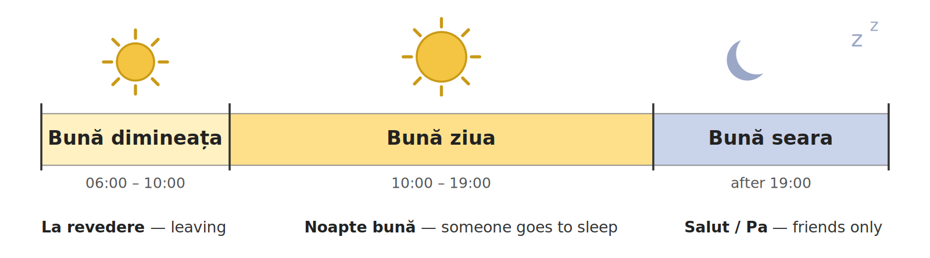
Fig. 3.1 — Salutul în funcție de ora din zi / The greeting depends on the time of day
The six formulas you need
ROMANIAN | WHEN | ENGLISH | EXAMPLE
Bună dimineața | 06:00 – 10:00 | Good morning | Bună dimineața, doamnă!
Bună ziua | 10:00 – 19:00, all-purpose | Good day / hello | Bună ziua! Ce mai faceți?
Bună seara | after 19:00 | Good evening | Bună seara, domnule Ion!
Salut | informal, friends only | Hi | Salut! Ce faci?
La revedere | when you leave, anyone | Goodbye | La revedere, pe mâine!
Noapte bună | someone going to sleep | Good night | Noapte bună, copii!

Formal and informal, side by side
FORMAL — safe with anyone | INFORMAL — friends, people your age
Bună ziua! / Bună seara! | Salut!
La revedere! | Pa! — bye

A short exchange
ROMANIAN | ENGLISH
A: Bună ziua! | Hello!
B: Bună ziua! Ce mai faceți? | Hello! How are you?
A: Bine, mulțumesc. Dumneavoastră? | Fine, thank you. And you?
B: Bine, mulțumesc. | Fine, thank you.

How are you? — the answers / Ce mai faci? — răspunsurile
ROMANIAN | ENGLISH | WHEN
Foarte bine, mulțumesc! | Very well, thank you! | the best answer
Bine, mulțumesc. | Fine, thank you. | the normal answer
Așa și așa. | So-so. | not good, not bad
Nu prea bine. | Not very well. | something is wrong
Mulțumesc! / Mersi! | Thank you! / Thanks! | Mersi is informal

Salut is not for the boss
Salut and Pa are informal only. With your boss, an official, a shop assistant or anyone new, use Bună ziua, Bună seara and La revedere.

Cultural note — how Romanians actually greet
A handshake is normal between men meeting for the first time. Between a man and a woman, let her offer her hand first. Friends and family often greet with a light cheek kiss or two — social, not romantic, and not expected with colleagues or strangers.

FOTO: [două persoane care își strâng mâna la prima întâlnire]
[ SPAȚIU PENTRU IMAGINE / SPACE FOR A PHOTO ]
Fig. 3.1a — Fotografie: strângerea de mână / Photo: a handshake at a first meeting
3.1 Which greeting?
Write the Romanian greeting that fits the situation.
1. It is 8:00 in the morning. | ____________________
2. It is 20:00 and dark outside. | ____________________
3. Your child is going to bed. | ____________________
4. An inspector walks in — pick the safe one. | ____________________

Lesson 3.2 — Introducing yourself / Prezentarea proprie
A full introduction has four parts: name, country, job, city.
ROMANIAN | ENGLISH | LITERALLY
Mă numesc Ana. | My name is Ana. | I call myself Ana
Mă cheamă Ana. | My name is Ana. | they call me Ana (Lesson 2.10)
Sunt din Nepal. | I am from Nepal. | I am from Nepal
Lucrez ca șofer. | I work as a driver. | I work as driver
Locuiesc în București. | I live in Bucharest. | I live in Bucharest

Put the four together and you have a full introduction:
A full introduction
Mă numesc Ana. Sunt din Nepal. Lucrez ca șoferiță. Locuiesc în București.
My name is Ana. I am from Nepal. I work as a driver. I live in Bucharest.

sunt + job or lucrez ca + job — both correct
Sunt șofer. (I am a driver) and Lucrez ca șofer. (I work as a driver) mean almost the same thing. Use whichever feels natural — a native speaker uses both. Why mă in Mă numesc? You will see it in Lesson 3.12.

Some countries
Nepal | India | Sri Lanka | Bangladesh
Pakistan | Vietnam | Filipine — Philippines | Republica Moldova
China | Turcia — Turkey | Egipt — Egypt | Maroc — Morocco

Nationalities — masculine and feminine
MASCULINE / MASCULIN | FEMININE / FEMININ | COUNTRY / ȚARA
român | româncă | România
nepalez | nepaleză | Nepal
indian | indiancă | India
vietnamez | vietnameză | Vietnam
pakistanez | pakistaneză | Pakistan
filipinez | filipineză | Filipine
moldovean | moldoveancă | Republica Moldova

Country with a capital, nationality with a small letter
Sunt din Nepal. but Sunt nepalez. In Romanian the country takes a capital letter, the nationality does not — the opposite of English Nepalese. Both sentences are correct and mean the same thing. A woman says Sunt nepaleză.

Some jobs — masculine and feminine (remember Lesson 2.1?)
MASCULINE / MASCULIN | FEMININE / FEMININ | ENGLISH
șofer | șoferiță | driver
bucătar | bucătăreasă | cook
vânzător | vânzătoare | salesperson
ospătar | ospătăriță | waiter / waitress
îngrijitor | îngrijitoare | caregiver
croitor | croitoreasă | tailor
curier | curieră | courier
casier | casieră | cashier
muncitor | muncitoare | worker (general)

3.2 Complete your own introduction
Fill in your own details, then read your introduction out loud.
Mă numesc ______________________________.
Sunt din ______________________________.
Lucrez ca ______________________________.
Locuiesc în ______________________________.

Homework — after Session 10 / Temă pentru acasă
H10.1 Write your full introduction (name, country, job, city) on a card and read it out loud three times.
H10.2 Tomorrow, greet three people with the right greeting for the time of day: Bună dimineața, Bună ziua or Bună seara.

SESSION 11 — THE VERB IN THE PRESENT AND SAYING NO
SESIUNEA 11 — VERBUL LA PREZENT ȘI NEGAȚIA · 3 hours · Saturday 9:00 – 12:00

By the end of this session you will be able to:
☐ | recognise the four patterns of the Romanian verb in the present
☐ | use the -ez and -esc verbs: lucrez, vorbesc
☐ | use ten everyday verbs: fac, merg, vreau, pot, știu, dau, iau, vin, mănânc, beau
☐ | say no: nu + verb, and read n-am, nu-l, n-o, nu-i

Lesson 3.3 — The verb in the present: four patterns / Verbul la prezent
In English the verb hardly changes: I sing, you sing, we sing. In Romanian the end of the verb changes for every person. The ending tells you who is doing it — that is why Romanian usually drops eu, tu, el (Lesson 2.6).
In the dictionary a verb has the little word a in front: a cânta — to sing. Take away a and the last vowel, and you have the part that does not change. Then add the ending.
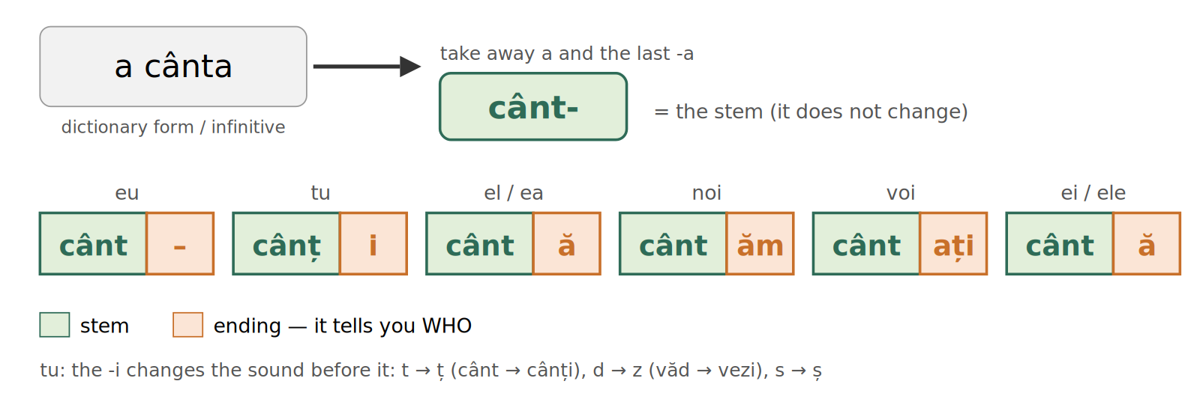
Fig. 3.2 — Verbul: partea care nu se schimbă + terminația / The verb: the part that stays + the ending
TIPAR — the verb in the present / verbul la prezent
the part that stays cânt- | + | ending -ă | = | Ana cântă.

Romanian verbs end in -a, -ea, -e or -i in the dictionary. Each ending has its own pattern. Here are the four model verbs — read every line out loud, down each column.
 | PATTERN 1 -a  a cânta — to sing | PATTERN 2 -ea  a vedea — to see | PATTERN 3 -e  a merge — to go | PATTERN 4 -i  a dormi — to sleep
eu | cânt | văd | merg | dorm
tu | cânți | vezi | mergi | dormi
el / ea | cântă | vede | merge | doarme
noi | cântăm | vedem | mergem | dormim
voi | cântați | vedeți | mergeți | dormiți
ei / ele | cântă | văd | merg | dorm
dumneavoastră | cântați | vedeți | mergeți | dormiți

Three things that help you remember
1. tu always ends in -i: cânți, vezi, mergi, dormi. The -i changes the sound before it: t → ț (cânt → cânți), d → z (văd → vezi), s → ș — the same changes you saw in the plural (Lesson 2.2).
2. noi and voi keep the vowel of the dictionary form: cântăm / cântați · vedem / vedeți · mergem / mergeți · dormim / dormiți.
3. ei / ele is the same as el / ea in Pattern 1 (el cântă — ei cântă). In Patterns 2, 3 and 4 it is the same as eu (eu văd — ei văd, eu merg — ei merg, eu dorm — ei dorm).

Examples / Exemple
ROMANIAN | ENGLISH
Cânt în fiecare seară. | I sing every evening.
Ana cântă frumos. | Ana sings beautifully.
Copiii cântă la școală. | The children sing at school.
Văd autobuzul. | I see the bus.
Vezi magazinul acela? | Do you see that shop?
Vedem un film în seara asta. | We are watching a film this evening.
Merg la piață. | I go to the market.
Mergem la mare vara. | We go to the seaside in summer.
Mergeți acasă? | Are you going home?
Dorm opt ore. | I sleep eight hours.
Dormi bine? | Do you sleep well?
Bebelușul doarme. | The baby is sleeping.
Ei dorm la hotel. | They are sleeping at a hotel.

One present for two English forms
Merg la piață. means I go to the market AND I am going to the market. Romanian has only one present. There is no -ing form.

3.3 Complete the verb
Write the right form of the verb in brackets.
1. Eu ________ la piață. (a merge) | 2. Tu ________ bine? (a dormi)
3. Ea ________ frumos. (a cânta) | 4. Noi ________ un film. (a vedea)
5. Voi ________ acasă? (a merge) | 6. Copiii ________ acum. (a dormi)

Lesson 3.4 — The -ez and -esc verbs / Verbele cu -ez și -esc
Many everyday verbs add a small extra piece: -ez (verbs in -a) or -esc (verbs in -i). The extra piece appears for eu, tu, el / ea, ei / ele — but not for noi and voi.
TIPAR — the -ez verbs
lucr- | + | -ez | = | lucrez

TIPAR — the -esc verbs
vorb- | + | -esc | = | vorbesc

 | a lucra — to work | a vorbi — to speak
eu | lucrez | vorbesc | EXTRA PIECE
tu | lucrezi | vorbești | EXTRA PIECE
el / ea | lucrează | vorbește | EXTRA PIECE
noi | lucrăm | vorbim | no extra piece
voi | lucrați | vorbiți | no extra piece
ei / ele | lucrează | vorbesc | EXTRA PIECE
dumneavoastră | lucrați | vorbiți | no extra piece

How do you know if a verb takes -ez or -esc?
You cannot see it from the dictionary form: a lucra → lucrez, but a cânta → cânt. Most verbs in -i take -esc (a vorbi → vorbesc), but a few do not (a dormi → dorm, a auzi → aud). So learn every new verb with its eu-form: a lucra (lucrez), a vorbi (vorbesc), a dormi (dorm). Good dictionaries show it the same way.

Everyday verbs with -ez and -esc
-EZ | ENGLISH | -ESC | ENGLISH
a lucra → lucrez | to work | a vorbi → vorbesc | to speak
a studia → studiez | to study | a locui → locuiesc | to live
a dansa → dansez | to dance | a citi → citesc | to read
a vizita → vizitez | to visit | a găti → gătesc | to cook
a desena → desenez | to draw | a plăti → plătesc | to pay
a telefona → telefonez | to phone | a folosi → folosesc | to use
a parca → parchez | to park | a mulțumi → mulțumesc | to thank

Examples / Exemple
ROMANIAN | ENGLISH
Lucrez la un magazin. | I work at a shop.
Unde lucrezi? | Where do you work?
Maria lucrează la spital. | Maria works at the hospital.
Lucrăm și sâmbăta. | We work on Saturdays too.
Studiez limba română. | I am studying Romanian.
Parchez mașina aici. | I park the car here.
Vorbesc puțin românește. | I speak a little Romanian.
Vorbești engleză? | Do you speak English?
El vorbește la telefon. | He is talking on the phone.
Acasă vorbim nepaleză. | At home we speak Nepali.
Locuiesc în Ploiești. | I live in Ploiești.
Citesc o carte. | I am reading a book.
Seara gătesc pentru familie. | In the evening I cook for the family.
Plătesc cu cardul. | I pay by card.
Mulțumesc! | Thank you! (literally: I thank)

3.4 Add the ending
Write the whole verb. Remember: no extra piece for noi and voi.
1. Eu lucr________ azi. | 2. Tu vorb________ engleză?
3. Ea găt________ foarte bine. | 4. Noi lucr________ sâmbăta.
5. Voi vorb________ românește? | 6. Ei locu________ în Cluj.

Lesson 3.5 — Ten verbs you use every day / Zece verbe de fiecare zi
These ten verbs are in almost every conversation. Most of them do not follow the patterns of Lesson 3.3 exactly, so learn them by heart, like a fi and a avea (Lesson 2.6). Two of them, a face and a merge, do follow Pattern 3 — they are here because you need them every day.
TIPAR — learn the whole verb, line by line
a face | → | fac, faci, face, facem, faceți, fac | = | Ce faci?

VERB | eu | tu | el / ea | noi | voi | ei / ele
a face  to do, to make | fac | faci | face | facem | faceți | fac
a merge  to go | merg | mergi | merge | mergem | mergeți | merg
a vrea  to want | vreau | vrei | vrea | vrem | vreți | vor
a putea  can, to be able | pot | poți | poate | putem | puteți | pot
a ști  to know | știu | știi | știe | știm | știți | știu

VERB | eu | tu | el / ea | noi | voi | ei / ele
a da  to give | dau | dai | dă | dăm | dați | dau
a lua  to take | iau | iei | ia | luăm | luați | iau
a veni  to come | vin | vii | vine | venim | veniți | vin
a mânca  to eat | mănânc | mănânci | mănâncă | mâncăm | mâncați | mănâncă
a bea  to drink | beau | bei | bea | bem | beți | beau

Watch out
ei vor — they want (not vreau!) · el poate — he can · tu vii — you come (two i) · a lua → iau, iei, ia — the beginning changes · a mânca → mănânc, but noi mâncăm, voi mâncați.
dumneavoastră takes the voi-form, as always: faceți, vreți, puteți, știți, luați, veniți.
In a shop, Vreau... is fine with vă rog: Vreau o pâine, vă rog. Many Romanians say Aș vrea... (I would like) — just recognise it for now.

Examples / Exemple
ROMANIAN | ENGLISH
Ce faci? — Fac cafea. | What are you doing? — I'm making coffee.
Mergem la serviciu cu autobuzul. | We go to work by bus.
Vreau apă, vă rog. | I want some water, please.
Vrei un ceai? | Do you want a tea?
Copiii vor înghețată. | The children want ice cream.
Poți veni mâine? — Pot. | Can you come tomorrow? — I can.
Știi unde e gara? — Știu. | Do you know where the station is? — I know.
Dau banii la casă. | I give the money at the till.
Iau autobuzul 312. | I take bus 312.
Ce iei? — Iau o cafea. | What are you having? — I'll have a coffee.
Vin acasă la ora șase. | I come home at six.
Vii cu noi? | Are you coming with us?
Mănânc la prânz la ora 12. | I have lunch at 12.
Ce mâncați azi? | What are you eating today?
Beau apă, nu cafea. | I drink water, not coffee.

3.5 Which form?
Write the right form of the verb in brackets.
1. Eu ________ o cafea. (a bea) | 2. Tu ________ cu noi? (a veni)
3. Ei ________ o pizza. (a vrea) | 4. Noi ________ autobuzul. (a lua)
5. Ea ________ la ora 12. (a mânca) | 6. Voi ________ unde e gara? (a ști)

Lesson 3.6 — Saying no / Negația
To say no, put nu in front of the verb. Nothing else changes. There is no helper word like English do / don't.
TIPAR — saying no
nu | + | verb | = | Nu lucrez azi.

ROMANIAN | ENGLISH
Nu lucrez azi. | I am not working today.
Nu vorbesc română. | I don't speak Romanian.
Nu știu. | I don't know.
Nu înțeleg. | I don't understand.
Nu mănânc carne. | I don't eat meat.
Nu beau alcool. | I don't drink alcohol.
Ana nu vine azi. | Ana is not coming today.
Nu mergem la piață. | We are not going to the market.
Nu vreau, mulțumesc. | I don't want (it), thank you.
Nu pot mâine. | I can't tomorrow.
Copiii nu dorm. | The children are not sleeping.
Nu e acasă. | He / She is not at home.

The short forms with a hyphen
In Module 1, Lesson 4.1, you learned to read the hyphen (cratima). Nu often joins the next word: a letter falls out, and the two words are said as one.
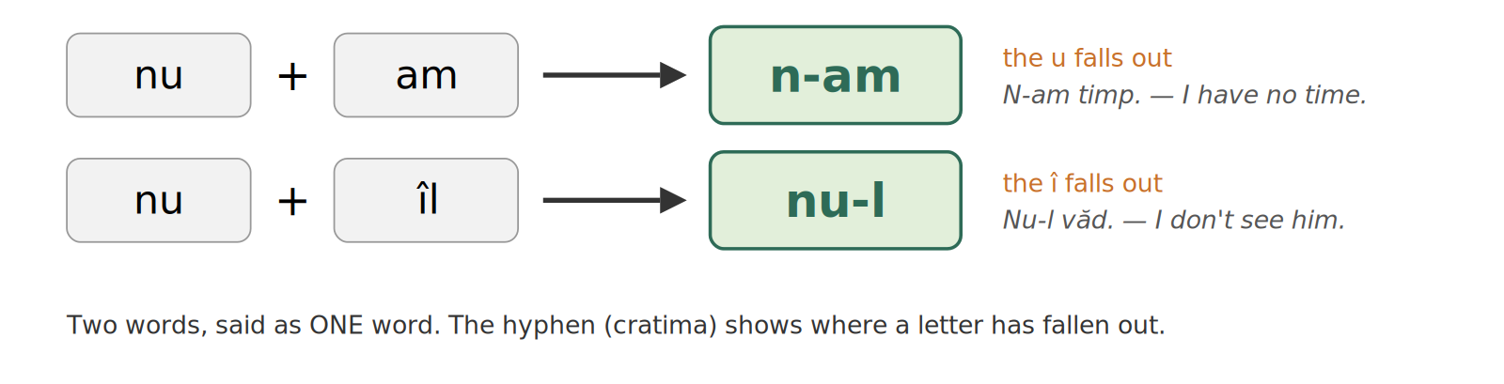
Fig. 3.3 — Nu + am = n-am: două cuvinte, spuse ca unul / Two words said as one
PARTS | SAID AS | EXAMPLES | ENGLISH
nu + am | n-am | N-am timp. · N-am bani. | I have no time. · I have no money.
nu + îl | nu-l | Nu-l cunosc. · Nu-l văd. | I don't know him. · I don't see him / it.
nu + o | n-o | N-o cunosc. · N-o iau. | I don't know her. · I won't take it (geanta).
nu + îi | nu-i | Nu-i spun. · Nu-i dau cheile. | I don't tell him / her. · I don't give him / her the keys.
nu + îmi | nu-mi | Nu-mi place. | I don't like it. (Lesson 2.10)
nu + a | n-a | N-a venit. | He / She didn't come. — the past, Lesson 3.15

Full form or short form?
Both are correct in writing: Nu am timp. = N-am timp. · Nu îl văd. = Nu-l văd. In speech Romanians almost always use the short form, so you must recognise it. Nu-i has a second meaning in spoken Romanian — is not — which you will meet in Lesson 3.17.

3.6 Say no
Make each sentence negative. Use the short form where you can.
1. Lucrez azi. → ____________________ | 2. Am timp. → ____________________
3. Îl văd. → ____________________ | 4. O cunosc. → ____________________
5. Vorbesc engleză. → ____________________ | 6. Îi spun. → ____________________

Homework — after Session 11 / Temă pentru acasă
H11.1 Write six sentences about your day, each with a different verb from Lessons 3.3–3.5: Merg... / Iau... / Lucrez... / Mănânc... / Beau... / Vorbesc....
H11.2 Write the same six sentences in the negative: Nu merg... / Nu mănânc...

SESSION 12 — QUESTIONS AND ANSWERS
SESIUNEA 12 — CUVINTE INTEROGATIVE, ÎNTREBĂRI UZUALE ȘI RĂSPUNSURI POLITICOASE · 3 hours · Sunday 9:00 – 12:00

By the end of this session you will be able to:
☐ | use all seven Romanian question words
☐ | form a yes/no question from a statement
☐ | form a question with a question word
☐ | ask and answer the questions every newcomer hears
☐ | give short, polite answers and ask someone to repeat

Lesson 3.7 — The question words / Cuvintele interogative
Seven small words open almost any question. Two examples for each, not one.
WORD | MEANING | EXAMPLES
cine | who | Cine ești? (Who are you?) · Cine este el? (Who is he?)
ce | what | Ce faci? (What are you doing?) · Ce este asta? (What is this?)
unde | where | Unde lucrezi? (Where do you work?) · Unde este Ana? (Where is Ana?)
când | when | Când lucrezi? (When do you work?) · Când pleci? (When are you leaving?)
cum | how | Cum te numești? (What's your name?) · Cum ești azi? (How are you today?)
de ce | why | De ce lucrezi aici? (Why do you work here?) · De ce nu? (Why not?)
cât / câtă / câți / câte | how much / how many | Câți ani ai? (How old are you?) · Cât costă? (How much does it cost?)

Cât changes — remember gender from Module 2
cât timp? (neuter) · câtă cafea? (feminine) · câți ani? (masculine plural) · câte ore? (feminine plural) — the same rule as un / o and doi / două (Lesson 2.1).

3.7 Which question word?
Fill in cine, ce, unde, când, cum, de ce or cât / câți / câte.
1. ____ te numești? | 2. ____ locuiești?
3. ____ ani ai? | 4. ____ nu lucrezi azi?

Lesson 3.8 — Building a question / Formarea întrebărilor
No helper word like English do. Two patterns only:
TIPAR 1 — yes / no question: just add ? / întrebare DA / NU
STATEMENT | + | ? | = | Lucrezi la Cluj?

STATEMENT | QUESTION
Lucrezi la Cluj. (You work in Cluj.) | Lucrezi la Cluj? (Do you work in Cluj?)
Ești din Nepal. (You are from Nepal.) | Ești din Nepal? (Are you from Nepal?)
Ai treizeci de ani. (You are 30.) | Ai treizeci de ani? (Are you 30?)

In speech: the voice goes up
In writing you see the ?. In speech you hear it: the voice goes up at the end of a yes / no question. Lucrezi la Cluj. (voice goes down) — Lucrezi la Cluj? (voice goes up)

TIPAR 2 — question with a question word: the word comes FIRST
QUESTION WORD | + | VERB | = | Unde lucrezi?

Unde lucrezi? (Where do you work?) | Cum te numești? (What is your name?)
De unde ești? (Where are you from?) | Câți ani ai? (How old are you?)

Answering: da or nu
QUESTION | ANSWER — yes / no (Lesson 3.6)
Lucrezi la Cluj? | Da, lucrez la Cluj. / Nu, nu lucrez la Cluj.
Ești din Vietnam? | Da, sunt din Vietnam. / Nu, nu sunt din Vietnam.
Ai treizeci de ani? | Da, am treizeci de ani. / Nu, n-am treizeci de ani.

Two negatives are correct in Romanian
Nu lucrez niciodată la Cluj. — I never work in Cluj. English forbids a double negative; Romanian requires one whenever niciodată (never) is used. Never remove the nu. The same with nimic (nothing): Nu știu nimic. — I know nothing.

3.8 Ask the question
Turn each statement into a question using the word given.
1. Lucrezi la Cluj. → (unde) ____________________
2. Ai douăzeci de ani. → (câți) ____________________
3. Te numești Ana. → (cum) ____________________
4. Ești din India. → (de unde) ____________________

Lesson 3.9 — The questions everyone asks you / Întrebări uzuale
Six questions come up in almost every first conversation — informal and formal together, as in Lesson 2.6.
Who are you talking to? / Cui te adresezi?
friend / colleague your age → TU | or | stranger / official / client → DUMNEAVOASTRĂ

QUESTION (tu) | QUESTION (dumneavoastră) | TYPICAL ANSWER
Cum te numești? | Cum vă numiți? | Mă numesc...
Unde locuiești? | Unde locuiți? | Locuiesc în...
Cu ce te ocupi? | Cu ce vă ocupați? | Sunt... / Lucrez ca...
De unde ești? | De unde sunteți? | Sunt din...
Câți ani ai? | Câți ani aveți? | Am ... ani.
Vorbești engleză? | Vorbiți engleză? | Vorbesc puțin. / Nu vorbesc.

Cu ce te ocupi? — an idiom, not a literal question
Literally "what do you occupy yourself with?" — it simply means "what do you do for a living?".

3.9 Answer about yourself
Answer all six questions with your own real details.
1. Cum te numești? → ____________________
2. Unde locuiești? → ____________________
3. Cu ce te ocupi? → ____________________
4. De unde ești? → ____________________
5. Câți ani ai? → ____________________
6. Vorbești engleză? → ____________________

Lesson 3.10 — Short, polite answers / Răspunsuri scurte și politicoase
You will not always understand everything — that is normal. These words matter more than grammar in week one.
Da. (Yes.) | Nu. (No.)
Da, mulțumesc. (Yes, thank you.) | Nu, mulțumesc. (No, thank you.)
Cu plăcere. (You're welcome.) | Poftim? (Sorry? Come again?)
Îmi pare rău, nu înțeleg. (I'm sorry, I don't understand.) | Puteți repeta, vă rog? (Could you repeat, please?)
Vorbiți mai rar, vă rog. (Please speak more slowly.) | Nu știu. (I don't know.)
Scuzați-mă! (Excuse me!) | Pardon! (Sorry! / Pardon me!)

Your two best friends
Poftim? and Puteți repeta, vă rog? get you through more conversations than any grammar rule. Nobody minds repeating themselves; everybody minds being misunderstood.

3.10 Which phrase fits?
Choose the polite phrase that fits each situation.
1. You did not hear the question at all. | ____________________
2. Someone thanks you. | ____________________
3. Someone speaks too fast for you. | ____________________
4. You genuinely have no idea. | ____________________

Homework — after Session 12 / Temă pentru acasă
H12.1 Write five questions you could ask a new neighbour — use a different question word each time.
H12.2 Write your own six-line introduction: name, country, job, city, age, and one sentence with niciodată. Say it out loud.

SESSION 13 — "I WANT TO", REFLEXIVE VERBS, ORDERS
SESIUNEA 13 — SĂ + VERB, VERBELE REFLEXIVE, IMPERATIVUL DE BAZĂ · 3 hours · Saturday 9:00 – 12:00

By the end of this session you will be able to:
☐ | say what you want, can, must and like to do: Vreau să lucrez. Trebuie să plec.
☐ | use the reflexive verbs a se numi, a se trezi, a se duce, a se simți
☐ | ask politely: Dați-mi..., Spuneți-mi..., Veniți!, Așteptați!
☐ | understand direct orders: Vino! Stai! Dă-mi! Nu atinge! Nu pleca!

Lesson 3.11 — I want to, I have to: să + verb / Vreau să..., trebuie să...
English says I want to work. Romanian says Vreau să lucrez — I want that I work. After vreau, pot, trebuie and îmi place comes the little word să and then the verb, in the same person.
TIPAR — să + verb
vreau · pot · trebuie · îmi place | + | să | + | verb | = | Vreau să lucrez.

The good news: for eu, tu, noi, voi the verb after să is exactly the present you learned in Session 11.
 | a vrea + să | trebuie + să | ENGLISH
eu | Vreau să lucrez. | Trebuie să plec. | I want to work. · I must leave.
tu | Vrei să lucrezi? | Trebuie să pleci. | Do you want to work? · You must leave.
noi | Vrem să lucrăm. | Trebuie să plecăm. | We want to work. · We must leave.
voi / dvs. | Vreți să lucrați? | Trebuie să plecați. | Do you want to work? · You must leave.

The one change: he, she, they
For el / ea / ei / ele the verb after să changes its last vowel: -ă becomes -e, and -e becomes -ă. The form is the same for he and they.
lucrează → să lucreze · pleacă → să plece · cântă → să cânte · merge → să meargă · face → să facă · vine → să vină · vorbește → să vorbească · doarme → să doarmă · mănâncă → să mănânce
Three to learn by heart: este → să fie · are → să aibă · bea → să bea.
Examples: Ana vrea să lucreze. (Ana wants to work.) · Ei trebuie să plece. (They must leave.)

Trebuie never changes
Trebuie is the same for everybody. Only the verb after să changes: Trebuie să plec. Trebuie să pleci. Trebuie să plece. Trebuie să plecăm.

Examples / Exemple
ROMANIAN | ENGLISH
Vreau să dorm. | I want to sleep.
Vrei să mănânci ceva? | Do you want to eat something?
Vrem să mergem la mare. | We want to go to the seaside.
Vreau să vorbesc cu doamna Popescu. | I want to speak to Mrs Popescu.
Pot să intru? | May I come in?
Poți să repeți, te rog? | Can you repeat, please?
Nu pot să vin mâine. | I can't come tomorrow.
Trebuie să plec. | I have to go.
Trebuie să plătesc chiria. | I have to pay the rent.
Trebuie să lucrăm sâmbătă. | We have to work on Saturday.
Îmi place să gătesc. | I like cooking.
Îmi place să citesc. | I like reading.
Îți place să dansezi? | Do you like dancing?
Nu-mi place să aștept. | I don't like waiting.

Pot + verb without să
After pot you will also hear the verb without să: Pot veni mâine. = Pot să vin mâine. Both are correct. Never say Vreau lucrez — after vreau you always need să.

3.11 Complete with să + verb
Write să and the right form of the verb.
1. Vreau ______________. (a dormi) | 2. Trebuie ______________ acum. (a pleca, eu)
3. Îmi place ______________. (a găti) | 4. Poți ______________ mâine? (a veni)
5. Vrem ______________ acum. (a mânca) | 6. Trebuie ______________ sâmbătă. (a lucra, eu)

Lesson 3.12 — Reflexive verbs / Verbele reflexive
You already say Mă numesc Ana — my name is Ana, literally I call myself Ana. Some Romanian verbs always have a small word in front: mă, te, se, ne, vă, se (myself, yourself...). In English you just say I wake up; in Romanian you say I wake myself up: mă trezesc. In the dictionary these verbs have se: a se trezi.
TIPAR — reflexive verbs
mă · te · se · ne · vă · se | + | verb | = | Mă trezesc la 6.

 | SMALL WORD | a se numi  to be called | a se trezi  to wake up | a se duce  to go | a se simți  to feel
eu | mă | numesc | trezesc | duc | simt
tu | te | numești | trezești | duci | simți
el / ea | se | numește | trezește | duce | simte
noi | ne | numim | trezim | ducem | simțim
voi / dvs. | vă | numiți | treziți | duceți | simțiți
ei / ele | se | numesc | trezesc | duc | simt

The verb itself follows the patterns you already know: numesc, trezesc take -esc (Lesson 3.4); duc and simt follow Pattern 3 and Pattern 4 (Lesson 3.3).
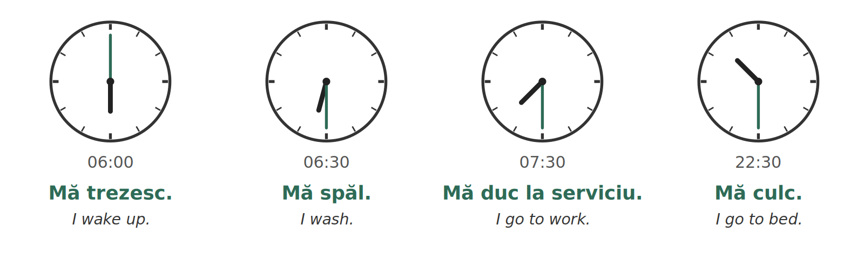
Fig. 3.4 — O dimineață obișnuită / An ordinary morning
Examples / Exemple
ROMANIAN | ENGLISH
Mă numesc Ana. | My name is Ana.
Cum te numești? | What's your name?
Cum se numește strada asta? | What is this street called?
Mă trezesc la 6. | I wake up at 6.
La ce oră te trezești? | What time do you wake up?
Copiii se trezesc devreme. | The children wake up early.
Mă duc la magazin. | I'm going to the shop.
Unde te duci? | Where are you going?
Ne ducem acasă. | We're going home.
Mă simt bine. | I feel well.
Cum vă simțiți? | How do you feel? (polite)
Nu mă simt bine. | I don't feel well.
Trebuie să mă trezesc devreme. | I have to wake up early.

Where do nu and să go?
Both go in front of the small word: Nu mă simt bine. · Trebuie să mă trezesc. The small word always stays glued to the verb.
a se duce and a merge both mean to go. Mă duc is very common in speech: Mă duc acasă. = Merg acasă.

3.12 Mă, te, se, ne or vă?
Write the small word that fits.
1. ____ numesc Ion. | 2. Cum ____ numiți? (dumneavoastră)
3. Ea ____ trezește la 7. | 4. Noi ____ ducem la piață.
5. Tu ____ simți bine? | 6. Ei ____ trezesc devreme.

Lesson 3.13 — Orders and requests / Imperativul de bază
An order or a request can be polite or direct. Which one you use depends on the same rule as tu / dumneavoastră (Lesson 2.6).
TIPAR 1 — polite: the voi-form is the request
voi-form of the verb | + | vă rog | = | Așteptați, vă rog!

The polite request is exactly the voi / dumneavoastră form you already know: voi veniți → Veniți! When you add me (-mi), it is joined with a hyphen: Dați-mi, Spuneți-mi (Lesson 2.10).
POLITE — to a stranger, an official, a client | ENGLISH
Veniți, vă rog! | Come, please!
Așteptați, vă rog. | Please wait.
Spuneți-mi, vă rog, unde e gara? | Tell me, please, where is the station?
Dați-mi o pâine, vă rog. | Give me a loaf of bread, please.
Intrați! | Come in!
Luați loc, vă rog. | Please take a seat.
Semnați aici, vă rog. | Sign here, please.
Scuzați-mă! | Excuse me!

TIPAR 2 — direct: to a friend, a child, family
short form of the verb | = | Vino! Stai! Dă-mi!

The direct forms are short, and many are not regular. Do not build them — learn them as words. Say them only to people you call tu.
DIRECT | ENGLISH | DIRECT | ENGLISH
Vino! | Come! | Stai! | Wait! / Stay!
Dă-mi! | Give me! | Spune-mi! | Tell me!
Ia! | Take (it)! | Uite! | Look!
Așteaptă! | Wait! | Du-te! | Go!
Ajută-mă! | Help me! | Hai! | Come on! / Let's go!

TIPAR 3 — don't: nu + the dictionary verb without a
nu | + | a pleca → pleca | = | Nu pleca!

DIRECT — tu | ENGLISH | POLITE — dvs. | ENGLISH
Nu atinge! | Don't touch! | Nu atingeți! | Don't touch! (polite)
Nu pleca! | Don't go! | Nu plecați! | Don't go! (polite)
Nu fuma! | Don't smoke! | Nu fumați! | No smoking. (polite)
Nu uita! | Don't forget! | Nu uitați! | Don't forget! (polite)

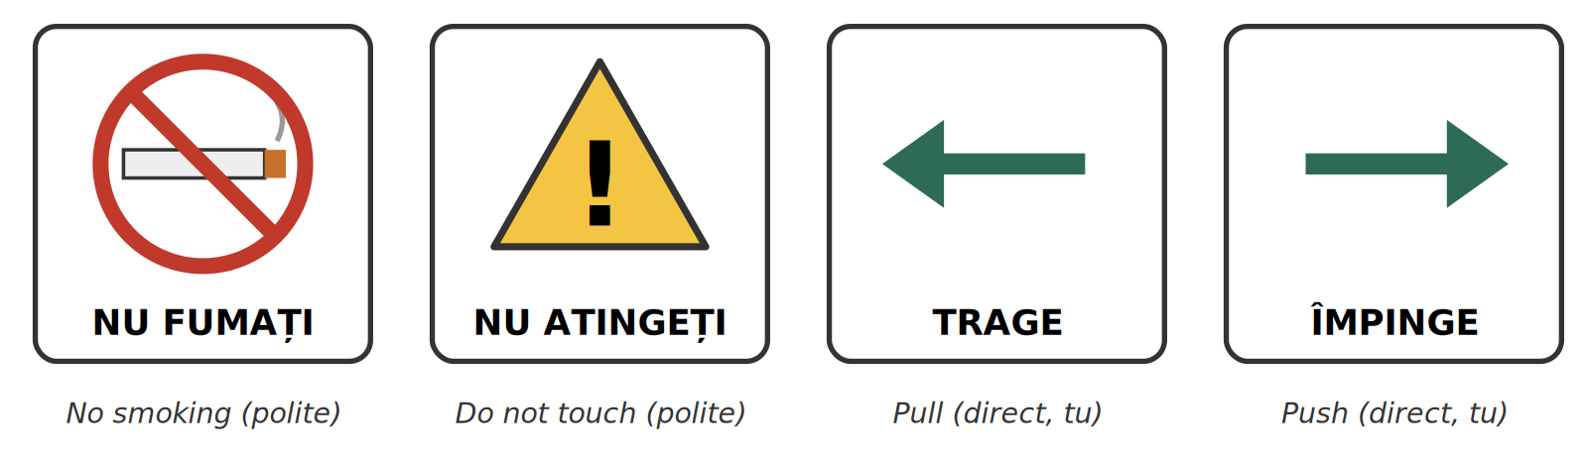
Fig. 3.5 — Ordine pe care le vezi pe uși și afișe / Orders you see on doors and notices
Direct is not rude — with the right person
Vino! to your child is normal. Vino! to a police officer is rude. When in doubt, use the polite form and add vă rog — you will never be wrong.

3.13 Make it polite
Rewrite each direct order in the polite form.
1. Vino! → ____________________ | 2. Așteaptă! → ____________________
3. Spune-mi! → ____________________ | 4. Dă-mi apa! → ____________________
5. Nu pleca! → ____________________ | 6. Stai! → ____________________

Homework — after Session 13 / Temă pentru acasă
H13.1 Write four sentences about yourself: one with Vreau să..., one with Pot să..., one with Trebuie să..., one with Îmi place să...
H13.2 Write your morning in four lines with reflexive verbs: Mă trezesc la... Mă spăl... Mă duc...
H13.3 Find two signs or notices with an order on them (a door, a shop, the bus) and copy them into your notebook.

SESSION 14 — THE PAST AND THE FUTURE
SESIUNEA 14 — TRECUTUL (PERFECTUL COMPUS) ȘI VIITORUL · 3 hours · Sunday 9:00 – 12:00

By the end of this session you will be able to:
☐ | place every verb form on the time line: yesterday – today – tomorrow
☐ | say what you did: Am lucrat. Am venit în 2025.
☐ | use the past forms of the 20 most frequent verbs
☐ | say what you did not do: N-am înțeles.; read m-am născut, s-a terminat
☐ | say what you will do: O să vin mâine. — and read Voi veni.

The time line / Axa timpului
Until now every verb in this book was in the present — azi (today), acum (now). In this session you add the two other points on the line: ieri (yesterday) and mâine (tomorrow).
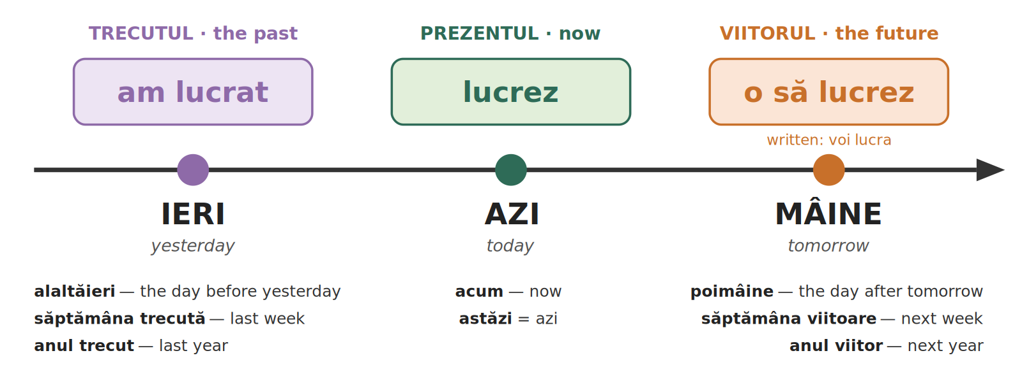
Fig. 3.6 — Ieri, azi, mâine: trecutul, prezentul, viitorul / Yesterday, today, tomorrow: past, present, future

Lesson 3.14 — The past: am lucrat / Trecutul
To say what you did, Romanian uses two words: a short helper that tells you who, and the past form of the verb, which never changes.
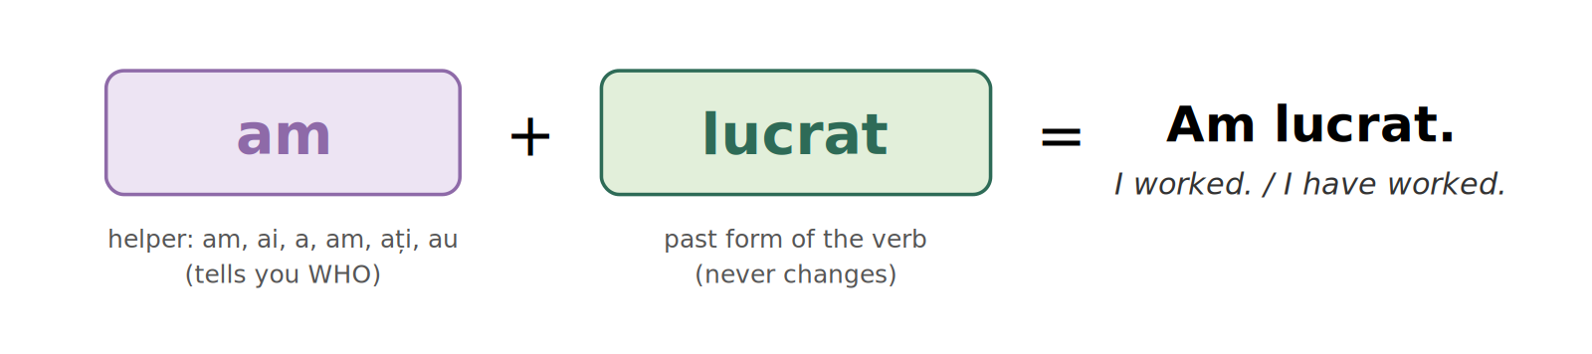
Fig. 3.7 — Trecutul se construiește din două piese / The past is built from two pieces
TIPAR — the past
am · ai · a · am · ați · au | + | past form | = | Am lucrat.

 | a lucra — to work | ENGLISH
eu | am lucrat | I worked
tu | ai lucrat | you worked
el / ea | a lucrat | he / she worked
noi | am lucrat | we worked
voi / dvs. | ați lucrat | you worked
ei / ele | au lucrat | they worked

The helper is a avea, made short
Compare with a avea (Lesson 2.6): am, ai, are, avem, aveți, au. The helper is: am, ai, a, am, ați, au. Careful: eu am and noi am look the same — the rest of the sentence tells you who.
One Romanian past = two English pasts: Am lucrat. = I worked AND I have worked.

How the past form is made
DICTIONARY FORM | EXAMPLE | EXAMPLE
-a → -at | a lucra → lucrat | a mânca → mâncat
-i → -it | a dormi → dormit | a vorbi → vorbit
-ea → -ut | a vedea → văzut | a avea → avut
-e → -ut, -s, -t | a face → făcut | a merge → mers · a scrie → scris

The first two lines are safe rules. For -ea and -e verbs, learn the past form with the verb.
The 20 past forms you need first
VERB | PAST FORM | EXAMPLE | ENGLISH
a fi | fost | Am fost la Iași. | I was in Iași.
a avea | avut | Am avut noroc. | I was lucky.
a face | făcut | Ce ai făcut ieri? | What did you do yesterday?
a merge | mers | Am mers la piață. | I went to the market.
a veni | venit | Am venit în 2025. | I came in 2025.
a lucra | lucrat | Ieri am lucrat opt ore. | Yesterday I worked eight hours.
a vorbi | vorbit | Am vorbit cu mama. | I spoke to my mother.
a mânca | mâncat | Ai mâncat? | Have you eaten?
a bea | băut | Am băut o cafea. | I had a coffee.
a dormi | dormit | Am dormit bine. | I slept well.
a vedea | văzut | Ați văzut filmul? | Have you seen the film?
a lua | luat | Am luat autobuzul. | I took the bus.
a da | dat | Am dat banii la casă. | I gave the money at the till.
a sta | stat | Duminică am stat acasă. | On Sunday I stayed at home.
a pleca | plecat | Trenul a plecat. | The train has left.
a ajunge | ajuns | Am ajuns acasă. | I got home.
a spune | spus | Ce a spus? | What did he / she say?
a scrie | scris | Am scris un mesaj. | I wrote a message.
a citi | citit | Ai citit mesajul? | Have you read the message?
a cumpăra | cumpărat | Am cumpărat pâine. | I bought bread.

Also useful
a putea → putut · a vrea → vrut · a ști → știut · a înțelege → înțeles · a plăti → plătit · a găti → gătit · a aștepta → așteptat

3.14 What happened yesterday?
Write the past: helper + past form.
1. Ieri eu ______________ opt ore. (a lucra) | 2. Tu ______________? (a mânca)
3. Ana ______________ ieri. (a veni) | 4. Noi ______________ la mare. (a merge)
5. Voi ______________ filmul? (a vedea) | 6. Ei ______________ acasă. (a pleca)

Lesson 3.15 — The past: saying no, and the hyphen / Negația și cratima la trecut
Nu goes in front of the helper. In speech, nu and the helper become one word with a hyphen — exactly as in Lesson 3.6.
TIPAR — the past, negative
nu + am | → | n-am | + | past form | = | N-am înțeles.

 | WRITTEN IN FULL | SAID (and written) | ENGLISH
eu | nu am lucrat | n-am lucrat | I didn't work
tu | nu ai lucrat | n-ai lucrat | you didn't work
el / ea | nu a lucrat | n-a lucrat | he / she didn't work
noi | nu am lucrat | n-am lucrat | we didn't work
voi / dvs. | nu ați lucrat | n-ați lucrat | you didn't work
ei / ele | nu au lucrat | n-au lucrat | they didn't work

ROMANIAN | ENGLISH
N-am lucrat ieri. | I didn't work yesterday.
N-am înțeles. Puteți repeta? | I didn't understand. Could you repeat?
N-am mâncat nimic. | I haven't eaten anything.
N-a venit azi. | He / She didn't come today.
N-ai văzut cheile mele? | Haven't you seen my keys?
Copiii n-au plecat încă. | The children haven't left yet.

Reflexive verbs in the past: m-am, s-a
With the reflexive verbs of Lesson 3.12, the small word joins the helper with a hyphen: mă + am → m-am, se + a → s-a.
 | PARTS | a se naște — to be born | ENGLISH
eu | mă + am | m-am născut | I was born
tu | te + ai | te-ai născut | you were born
el / ea | se + a | s-a născut | he / she was born
noi | ne + am | ne-am născut | we were born
voi / dvs. | vă + ați | v-ați născut | you were born
ei / ele | se + au | s-au născut | they were born

ROMANIAN | ENGLISH
M-am născut în 1995. | I was born in 1995.
Unde v-ați născut? | Where were you born? (polite)
M-am trezit târziu. | I woke up late.
Ne-am mutat în București. | We moved to Bucharest.
Filmul s-a terminat. | The film has ended.
Ce s-a întâmplat? | What happened?
S-a stricat telefonul. | The phone has broken.
Nu m-am simțit bine. | I didn't feel well.

Ce s-a întâmplat?
What happened? — one of the most useful questions in Romanian. Learn it as one piece, like Cu ce te ocupi?

3.15 No, and the hyphen
Rewrite or complete each sentence.
1. Am lucrat. → ____________________ | 2. A venit. → ____________________
3. Ai mâncat? → ____________________ | 4. ______________ în 1990. (a se naște, eu)
5. Filmul ______________. (a se termina) | 6. Ce ______________? (a se întâmpla)

Lesson 3.16 — The future / Viitorul
Romanian has two futures. They mean the same thing. One is for speaking, the other you mostly read and write.
TIPAR 1 — spoken: o să + verb (as after vreau să)
o să | + | verb as in Lesson 3.11 | = | O să lucrez.

O să never changes. The verb after it is the same form as after vreau să (Lesson 3.11) — you already know it.
 | SPOKEN FUTURE | ENGLISH
eu | o să lucrez | I will work
tu | o să lucrezi | you will work
el / ea | o să lucreze | he / she will work
noi | o să lucrăm | we will work
voi / dvs. | o să lucrați | you will work
ei / ele | o să lucreze | they will work

TIPAR 2 — written: voi · vei · va · vom · veți · vor + dictionary verb
voi · vei · va · vom · veți · vor | + | lucra | = | Voi lucra.

 | WRITTEN FUTURE | ENGLISH
eu | voi lucra | I will work
tu | vei lucra | you will work
el / ea | va lucra | he / she will work
noi | vom lucra | we will work
voi / dvs. | veți lucra | you will work
ei / ele | vor lucra | they will work

You will read the written future on notices, in letters, on official papers and in the news: Magazinul va fi închis luni. (The shop will be closed on Monday.)
Examples / Exemple
ROMANIAN | ENGLISH
O să vin mâine. | I'll come tomorrow.
Ce o să faci în weekend? | What will you do at the weekend?
O să mergem la mare. | We'll go to the seaside.
Mâine o să plouă. | It will rain tomorrow.
O să iau autobuzul. | I'll take the bus.
N-o să am timp. | I won't have time.
Magazinul va fi închis luni. | The shop will be closed on Monday.
Veți primi un răspuns în 30 de zile. | You will receive an answer within 30 days.
Trenul va pleca la ora 10. | The train will leave at 10.
Vom reveni cu detalii. | We will come back with details.

Two things that confuse everyone
1. vor = they want (Lesson 3.5) AND they will. Look at what follows: Ei vor să lucreze. — They want to work. · Ei vor lucra. — They will work.
2. Romanian often uses the present for the future, with a time word: Mâine lucrez. — I'm working tomorrow. This is correct and very common.
Saying no: N-o să vin. (spoken) · Nu voi veni. (written) — I won't come.

Fig. 3.6 (again) — Ieri, azi, mâine / Yesterday, today, tomorrow
3.16 What will happen?
Write the spoken future (1–4) and the written future (5–6).
1. ______________ mâine. (eu, a veni) | 2. ______________ la mare. (noi, a merge)
3. ______________ acasă? (tu, a mânca) | 4. ______________ sâmbătă. (ea, a lucra)
5. ______________ la ora 8. (ei, a pleca — written) | 6. ______________ acolo. (eu, a fi — written)

Homework — after Session 14 / Temă pentru acasă
H14.1 Write what you did yesterday in five sentences: Ieri m-am trezit la... Am mers... Am mâncat...
H14.2 Write what you will do next weekend in four sentences with o să: Sâmbătă o să...

SESSION 15 — SPOKEN ROMANIAN, FULL DIALOGUE, RECAP AND TEST
SESIUNEA 15 — LIMBA VORBITĂ, DIALOGUL COMPLET, RECAPITULARE ȘI TEST · 3 hours · Saturday 9:00 – 12:00

By the end of this session you will be able to:
☐ | understand the short forms you hear on the street: e, ce-i, unde-i, nu-i, o să
☐ | hold a complete first conversation, with the past and the future
☐ | recognise and use every form from Module 3
☐ | pass the Module 3 cumulative test

Lesson 3.17 — What you hear on the street / Româna vorbită
Romanians do not speak the way the grammar book writes. The words are the same, but short forms replace the long ones. You must understand the short forms. When you write something official — a form, an email to an office — use the full form.
WRITTEN / FULL | WHAT YOU HEAR | ENGLISH
Este acasă. | E acasă. | He / She is at home.
Ce este asta? | Ce-i asta? | What's this?
Unde este gara? | Unde-i gara? | Where's the station?
Cine este? | Cine-i? | Who is it?
Nu este acasă. | Nu-i acasă. | He / She isn't at home.
Nu este nimic. | Nu-i nimic. | It's nothing. / No problem.
Voi veni mâine. | O să vin mâine. | I'll come tomorrow.
Nu voi avea timp. | N-o să am timp. | I won't have time.
Nu am înțeles. | N-am înțeles. | I didn't understand.
Mulțumesc. | Mersi. | Thanks.
doisprezece | doișpe | twelve — also unșpe, treișpe, paișpe, cinșpe...

TIPAR — este becomes -i after a word
ce · unde · cine · nu | + | este | → | ce-i · unde-i · cine-i · nu-i

Nu-i: two meanings
Nu-i acasă. = Nu este acasă. — he / she isn't at home (this lesson).
Nu-i spun. = Nu îi spun. — I don't tell him / her (Lesson 3.6). The rest of the sentence tells you which one it is.
In the east of Romania (Moldova) you will also hear îi for este on its own: Îi bine. = E bine. Understand it; write e or este.

Small words you hear every day
WORD | ENGLISH | EXAMPLE
Hai! | Come on! / Let's go! | Hai acasă! — Let's go home!
Gata! | Ready! / Done! / That's it! | Gata, am terminat. — Done, I've finished.
Păi... | Well... | Păi, nu știu. — Well, I don't know.
Ceau! | Hi! / Bye! (friends only) | Ceau, ne vedem mâine! — Bye, see you tomorrow!
Mersi! | Thanks! | Mersi mult! — Thanks a lot!

FOTO: [doi oameni care vorbesc la o piață sau la o stație de autobuz]
[ SPAȚIU PENTRU IMAGINE / SPACE FOR A PHOTO ]
Fig. 3.8 — Fotografie: o conversație pe stradă / Photo: a conversation in the street
3.17 Write it in full
Write the full (written) form of each sentence.
1. Ce-i asta? → ____________________ | 2. Unde-i gara? → ____________________
3. Nu-i acasă. → ____________________ | 4. O să vin mâine. → ____________________
5. N-am timp. → ____________________ | 6. E frig. → ____________________

Lesson 3.18 — The complete introduction dialogue / Dialogul complet de prezentare
Two course participants meet for the first time. Read the dialogue with a partner, one part each, then swap parts.
Part 1 — Who are you? / Cine ești?
ROMANIAN | ENGLISH
A: Bună ziua! | Hello!
B: Bună ziua! Ce mai faci? | Hello! How are you?
A: Bine, mulțumesc. Cum te numești? | Fine, thank you. What's your name?
B: Mă numesc Rajan. Dar tu? | My name is Rajan. And you?
A: Mă numesc Sun Lin. De unde ești? | My name is Sun Lin. Where are you from?
B: Sunt din Nepal. Dar tu, de unde ești? | I'm from Nepal. And you, where are you from?
A: Sunt din Vietnam. Cu ce te ocupi? | I'm from Vietnam. What do you do?
B: Lucrez ca șofer. Dar tu? | I work as a driver. And you?
A: Sunt bucătar. Unde locuiești? | I'm a cook. Where do you live?
B: Locuiesc în Ploiești. Câți ani ai? | I live in Ploiești. How old are you?
A: Am douăzeci și opt de ani. Dar tu? | I'm 28. And you?
B: Am treizeci și doi de ani. Îmi pare bine! | I'm 32. Nice to meet you!
A: Îmi pare bine și mie! | Nice to meet you too!

Part 2 — Before and after / Înainte și după
ROMANIAN | ENGLISH
B: Când ai venit în România? | When did you come to Romania?
A: Am venit anul trecut, în martie. Dar tu? | I came last year, in March. And you?
B: Eu am venit acum doi ani. | I came two years ago.
A: Unde ai lucrat înainte? | Where did you work before?
B: Am lucrat ca șofer în Nepal. Tu? | I worked as a driver in Nepal. You?
A: Eu am lucrat într-un restaurant în Hanoi. | I worked in a restaurant in Hanoi.
B: Îți place în România? | Do you like it in Romania?
A: Da, îmi place mult. Dar iarna e frig! | Yes, I like it a lot. But it's cold in winter!
B: Ce o să faci în weekend? | What will you do at the weekend?
A: Sâmbătă o să lucrez. Duminică o să gătesc pentru prieteni. Vrei să vii? | On Saturday I'll work. On Sunday I'll cook for friends. Do you want to come?
B: Da, cu plăcere! La ce oră? | Yes, gladly! At what time?
A: La ora șase. Îți dau adresa. | At six. I'll give you the address.
B: Mulțumesc! Ne vedem duminică! | Thank you! See you on Sunday!
A: La revedere, pe duminică! | Goodbye, see you Sunday!

New fixed phrases
Îmi pare bine (să te cunosc). — Nice to meet you. The answer is Îmi pare bine și mie!
acum doi ani — two years ago (acum + time = ago) · înainte — before · Ne vedem! — See you! · Cu plăcere! — here: Gladly! · pe duminică — (see you) on Sunday

The same start, formal (dumneavoastră)
With an official, a client, or anyone you address formally, the same conversation changes like this:
ROMANIAN | ENGLISH
A: Bună ziua! Cum vă numiți? | Hello! What's your name?
B: Mă numesc Rajan. Dumneavoastră? | My name is Rajan. And you?
A: Mă numesc Ion Popescu. De unde sunteți? | My name is Ion Popescu. Where are you from?
B: Sunt din Nepal. Cu ce vă ocupați? | I'm from Nepal. What do you do?
A: Sunt inspector ITM. Când ați venit în România? | I'm a labour inspector. When did you come to Romania?
B: Am venit acum doi ani. | I came two years ago.
A: Mulțumesc. La revedere! | Thank you. Goodbye!
B: La revedere! | Goodbye!

3.18 Your own dialogue
Answer the three new questions with your own real details. Then perform Part 1 and Part 2 with a partner, using your answers.
1. Când ai venit în România? → ______________________________________________
2. Unde ai lucrat înainte? → ______________________________________________
3. Ce o să faci în weekend? → ______________________________________________

Lesson 3.19 — Module recap / Recapitulare
Before the test, look back over the whole module.
Greetings, questions, introducing yourself
Bună dimineața | Bună ziua | Bună seara
Salut (informal) | La revedere | Pa (informal) / Noapte bună

cine who | ce what | unde where | când when
cum how | de ce why | cât / câtă / câți / câte | how much / many

Mă numesc... | Sunt din... | Lucrez ca... | Locuiesc în... | Am ... ani.

Module 3 — Everything on one page / Totul pe o pagină
TOPIC | THE RULE
THE PRESENT | The ending tells you who. Four patterns: cânt, văd, merg, dorm. tu always ends in -i.
-EZ / -ESC | lucrez, vorbesc — the extra piece for eu, tu, el, ei; not for noi, voi (lucrăm, vorbim).
TEN EVERYDAY VERBS | fac, merg, vreau, pot, știu, dau, iau, vin, mănânc, beau — learn by heart. ei vor, el poate, tu vii.
SAYING NO | nu + verb. Short forms: n-am, nu-l, n-o, nu-i, nu-mi. With niciodată, nimic keep the nu.
QUESTIONS | Yes / no: add ? (voice goes up). With a question word: the word comes first: Unde lucrezi?
SĂ + VERB | vreau / pot / trebuie / îmi place + să + verb: Vreau să lucrez. For el / ei: să lucreze, să plece, să fie.
REFLEXIVE VERBS | mă, te, se, ne, vă, se + verb: Mă numesc. Mă trezesc. Mă duc. Mă simt bine.
ORDERS | Polite = the voi-form: Veniți! Așteptați! Dați-mi! Spuneți-mi! Direct: Vino! Stai! Dă-mi! Don't: Nu pleca! / Nu plecați!
THE PAST | am, ai, a, am, ați, au + past form: am lucrat, am venit, am fost. No: n-am lucrat. Reflexive: m-am născut, s-a terminat.
THE FUTURE | Spoken: o să + verb (o să lucrez). Written: voi, vei, va, vom, veți, vor + verb (voi lucra).
SPOKEN ROMANIAN | e = este · ce-i, unde-i, nu-i = ce / unde / nu este · o să = voi · mersi = mulțumesc

Fig. 3.6 — Ieri, azi, mâine / Yesterday, today, tomorrow
3.19 Everything together
Fill in the gaps with a greeting, a question word, a short answer or a verb, as needed.
1. ______________, mă numesc Ion. (morning greeting)
2. ______ te numești? → Mă numesc Maria.
3. ______ ani ai? → Am douăzeci și cinci de ani.
4. Lucrezi la Iași? → Nu, ______ lucrez la Iași.
5. ______________! Ne vedem mâine. (the informal goodbye)
6. Ieri ______________ la piață. (eu, a merge)
7. Mâine ______________ opt ore. (eu, a lucra — spoken)
8. ______ trezesc la ora șase.

APPENDIX — THE VERBS OF MODULE 3
ANEXĂ — VERBELE DIN MODULUL 3: prezent, să + verb, trecut

Learn each verb in this form: a lucra — lucrez — să lucreze — am lucrat. The future does not need its own column: it is o să + the să-form (o să lucrez) or voi + the dictionary verb (voi lucra).
VERB | ENGLISH | EU (present) | EL / EA (present) | SĂ + EL / EA | PAST FORM
a fi | to be | sunt | este | să fie | fost
a avea | to have | am | are | să aibă | avut
a face | to do, make | fac | face | să facă | făcut
a merge | to go | merg | merge | să meargă | mers
a veni | to come | vin | vine | să vină | venit
a vrea | to want | vreau | vrea | să vrea | vrut
a putea | can | pot | poate | să poată | putut
a ști | to know | știu | știe | să știe | știut
a da | to give | dau | dă | să dea | dat
a lua | to take | iau | ia | să ia | luat
a mânca | to eat | mănânc | mănâncă | să mănânce | mâncat
a bea | to drink | beau | bea | să bea | băut
a sta | to stay | stau | stă | să stea | stat
a cânta | to sing | cânt | cântă | să cânte | cântat
a vedea | to see | văd | vede | să vadă | văzut
a dormi | to sleep | dorm | doarme | să doarmă | dormit
a lucra | to work | lucrez | lucrează | să lucreze | lucrat
a vorbi | to speak | vorbesc | vorbește | să vorbească | vorbit
a locui | to live | locuiesc | locuiește | să locuiască | locuit
a citi | to read | citesc | citește | să citească | citit
a găti | to cook | gătesc | gătește | să gătească | gătit
a plăti | to pay | plătesc | plătește | să plătească | plătit
a pleca | to leave | plec | pleacă | să plece | plecat
a ajunge | to arrive | ajung | ajunge | să ajungă | ajuns
a spune | to say, tell | spun | spune | să spună | spus
a scrie | to write | scriu | scrie | să scrie | scris
a cumpăra | to buy | cumpăr | cumpără | să cumpere | cumpărat
a înțelege | to understand | înțeleg | înțelege | să înțeleagă | înțeles
a aștepta | to wait | aștept | așteaptă | să aștepte | așteptat
a se numi | to be called | mă numesc | se numește | să se numească | numit
a se trezi | to wake up | mă trezesc | se trezește | să se trezească | trezit
a se duce | to go | mă duc | se duce | să se ducă | dus
a se simți | to feel | mă simt | se simte | să se simtă | simțit

SECȚIUNE DETAȘABILĂ — EXEMPLAR FORMATOR
DETACHABLE SECTION — TEACHER COPY
Se detașează din exemplarul cursantului. Testul completat, fișa de sesiune și fișa de evidență se păstrează la dosarul cursantului.
To be detached from the student's copy. The completed test, the session record and the module record are kept in the student's file.
Instrucțiuni de administrare / How to administer
Testul este de tip grilă. Cursantul marchează cu X un singur răspuns pentru fiecare întrebare. Nu se scrie nimic altceva pe test, în afară de nume, dată și semnătură. The test is multiple choice. The student marks X in one box per question. Nothing else is written on the test, apart from name, date and signature.
Un răspuns corect = 1 punct. Răspuns nemarcat sau marcat dublu = 0 puncte. One correct answer = 1 point. No mark or two marks = 0 points.

TEST | ACOPERĂ / COVERS | ITEMI | TIMP ALOCAT
Test cumulativ — Modulul 3 (Sesiunea 15) | Lecțiile 3.1 – 3.19 | 40 | 60 de minute

TEST CUMULATIV — MODULUL 3
MODULE 3 — CUMULATIVE TEST · grilă, 40 de întrebări, 40 de puncte · Marchează cu X un singur răspuns / Mark X in one box only · 60 min

Nume / Name: ______________________________ | Data / Date: ____ / ____ / 20____
Semnătura cursantului / Signature: ______________________ | Punctaj / Score: ______ / 40

1. Care este salutul potrivit la ora 8:00? (1 p)
 |  | a) Bună seara |  | b) Noapte bună
 |  | c) Bună dimineața |  | d) Pa
2. Care salut este NUMAI informal? (1 p)
 |  | a) Bună ziua |  | b) Salut
 |  | c) La revedere |  | d) Bună seara
3. Cum spui „Good night” în română? (1 p)
 |  | a) Bună seara |  | b) Noapte bună
 |  | c) Bună dimineața |  | d) La revedere
4. Care variantă este corectă cu un inspector ITM? (1 p)
 |  | a) Salut! |  | b) Pa!
 |  | c) Bună ziua! |  | d) Ce faci?
5. „Mă numesc Ana.” înseamnă: (1 p)
 |  | a) I live in Ana |  | b) My name is Ana
 |  | c) I work with Ana |  | d) I am from Ana
6. Care propoziție e corectă pentru „I work as a driver”? (1 p)
 |  | a) Sunt din șofer |  | b) Lucrez ca șofer
 |  | c) Mă numesc șofer |  | d) Locuiesc șofer
7. Femininul cuvântului „bucătar” este: (1 p)
 |  | a) bucătară |  | b) bucătăriță
 |  | c) bucătăreasă |  | d) bucătoare
8. Care cuvânt înseamnă „where”? (1 p)
 |  | a) cine |  | b) când
 |  | c) unde |  | d) cum
9. Care cuvânt înseamnă „why”? (1 p)
 |  | a) de ce |  | b) cât
 |  | c) ce |  | d) cine
10. Completează: „____ ani ai?” — how old are you? (1 p)
 |  | a) Cât |  | b) Câtă
 |  | c) Câți |  | d) Câte
11. Completează: „____ cafea bei?” — how much coffee do you drink? (1 p)
 |  | a) Cât |  | b) Câtă
 |  | c) Câți |  | d) Câte
12. Care este întrebarea formală pentru „Unde locuiești?” (1 p)
 |  | a) Unde locuiește? |  | b) Unde locuiți?
 |  | c) Unde locuim? |  | d) Unde locuiesc?
13. „Lucrezi la Cluj?” — Nu, ____ lucrez la Cluj. (1 p)
 |  | a) nu |  | b) da
 |  | c) niciodată |  | d) poftim
14. Care propoziție are dubla negație corectă? (1 p)
 |  | a) Nu lucrez niciodată acolo. |  | b) Lucrez niciodată acolo.
 |  | c) Nu lucrez vreodată acolo. |  | d) Lucrez nu niciodată acolo.
15. Ce înseamnă „Poftim?” (1 p)
 |  | a) You're welcome |  | b) Sorry? / Come again?
 |  | c) Good evening |  | d) I don't know
16. Ce răspunzi când cineva îți mulțumește? (1 p)
 |  | a) Poftim? |  | b) Nu știu.
 |  | c) Cu plăcere. |  | d) De ce?
17. „Cu ce te ocupi?” înseamnă: (1 p)
 |  | a) Where do you live? |  | b) What do you do for a living?
 |  | c) How old are you? |  | d) Where are you from?
18. Ce spui când cunoști pe cineva prima dată? (1 p)
 |  | a) Noapte bună! |  | b) Îmi pare bine!
 |  | c) Poftim? |  | d) Nu știu.
19. Care întrebare este corectă? (1 p)
 |  | a) De unde ești? |  | b) Unde de ești?
 |  | c) Ești de unde tu? |  | d) De ești unde?
20. O femeie din Vietnam spune: Sunt ____. (1 p)
 |  | a) vietnamez |  | b) vietnameză
 |  | c) Vietnameză |  | d) vietnamezi
21. „Eu ____ la magazin.” (a merge) (1 p)
 |  | a) merge |  | b) mergi
 |  | c) merg |  | d) mergem
22. „Ea ____ opt ore pe noapte.” (a dormi) (1 p)
 |  | a) dorm |  | b) doarme
 |  | c) dormi |  | d) dormim
23. Care este forma pentru „eu” a verbului „a lucra”? (1 p)
 |  | a) lucru |  | b) lucrează
 |  | c) lucrăm |  | d) lucrez
24. „El ____ la telefon.” (a vorbi) (1 p)
 |  | a) vorbește |  | b) vorbesc
 |  | c) vorbim |  | d) vorbi
25. „Ei ____ să lucreze.” — they want to work. (1 p)
 |  | a) vreau |  | b) vrea
 |  | c) vor |  | d) vrem
26. „Eu ____ o cafea.” (a bea) (1 p)
 |  | a) bea |  | b) beau
 |  | c) bei |  | d) bem
27. „Nu am timp.” se spune de obicei: (1 p)
 |  | a) Nu-am timp. |  | b) Nam timp.
 |  | c) N am timp. |  | d) N-am timp.
28. „Vreau ____.” — I want to sleep. (1 p)
 |  | a) dorm |  | b) să dormi
 |  | c) să dorm |  | d) a dorm
29. „Trebuie ____ acum.” — I have to leave now. (1 p)
 |  | a) să plec |  | b) plec
 |  | c) să pleacă |  | d) pleca
30. „Cum ____ numiți?” (dumneavoastră) (1 p)
 |  | a) te |  | b) se
 |  | c) mă |  | d) vă
31. „Mă ____ la ora 6.” — I wake up at 6. (1 p)
 |  | a) trezește |  | b) trezesc
 |  | c) trezim |  | d) treziți
32. Ce spui politicos unui funcționar? (1 p)
 |  | a) Spune-mi! |  | b) Spune!
 |  | c) Spuneți-mi, vă rog. |  | d) Spun.
33. Ce înseamnă „Nu atinge!”? (1 p)
 |  | a) Don't touch! |  | b) Don't leave!
 |  | c) Come here! |  | d) Wait!
34. „Ieri ____ opt ore.” (eu, a lucra) (1 p)
 |  | a) lucrez |  | b) a lucrat
 |  | c) o să lucrez |  | d) am lucrat
35. Forma de trecut a verbului „a vedea” este: (1 p)
 |  | a) vedeat |  | b) văzut
 |  | c) vedut |  | d) văzat
36. „____ în 1995.” — I was born in 1995. (1 p)
 |  | a) Mă nasc |  | b) S-a născut
 |  | c) M-am născut |  | d) Mam născut
37. „Filmul ____.” — the film has ended. (1 p)
 |  | a) s-a terminat |  | b) sa terminat
 |  | c) se termina |  | d) s-au terminat
38. „Mâine ____ la piață.” — I'll go to the market (spoken). (1 p)
 |  | a) am mers |  | b) o să merge
 |  | c) mergeam |  | d) o să merg
39. Pe un afiș scrie: „Magazinul ____ închis luni.” (1 p)
 |  | a) vor fi |  | b) va fi
 |  | c) vei fi |  | d) voi fi
40. Ce înseamnă „Ce-i asta?” (1 p)
 |  | a) Who is this? |  | b) Where is it?
 |  | c) What is this? |  | d) Why this?

SESSION COMPLETION RECORD
FIȘĂ DE CONFIRMARE A PARCURGERII SESIUNII — se păstrează la dosar

Module / Modul | Modulul 3 — Verbul și prima conversație
Session / Sesiunea | Sesiunea 15 — Limba vorbită, dialogul complet, recapitulare. TEST CUMULATIV MODULUL 3
Duration / Durata | 3 ore (9:00 – 12:00)
Date / Data | _____ / _____ / 20_____
Student name / Nume și prenume cursant
Score / Punctaj obținut | _______ / 40
Student signature / Semnătura cursantului
Teacher signature / Semnătura formatorului

Declarație cursant / Student declaration
Declar că am participat la această sesiune de curs și am parcurs conținutul prezentat mai sus. I declare that I attended this course session and covered the content presented above.

MODULE 3 — COMPLETION RECORD
FIȘĂ DE EVIDENȚĂ A PARCURGERII MODULULUI 3 — se păstrează la dosarul cursantului

Cursant / Student
Act de identitate / ID document
Angajator / Employer
Formator / Teacher
Modul / Module | Modulul 3 — Verbul și prima conversație (18 ore, Sesiunile 10–15, săptămânile 5–8)

NR. | SESIUNE / CONȚINUT | DATA | PUNCTAJ TEST | SEMNĂTURA CURSANTULUI
10 | Sesiunea 10 — Formule de salut, prezentarea proprie (3 ore) |  | —
11 | Sesiunea 11 — Verbul la prezent, verbe neregulate, negația (3 ore) |  | —
12 | Sesiunea 12 — Cuvinte interogative, întrebări uzuale, răspunsuri politicoase (3 ore) |  | —
13 | Sesiunea 13 — Să + verb, verbele reflexive, imperativul de bază (3 ore) |  | —
14 | Sesiunea 14 — Trecutul (perfectul compus) și viitorul (3 ore) |  | —
15 | Sesiunea 15 — Limba vorbită, dialogul complet, recapitulare + TEST CUMULATIV (3 ore) |  | ___ / 40

Confirmare finalizare modul / Module completion
Confirm că cursantul a parcurs integral conținutul Modulului 3 — Verbul și prima conversație, în total 18 ore de curs, și a susținut testul de evaluare consemnat mai sus. I confirm that the student completed the full content of Module 3 — The Verb and Your First Conversation, 18 course hours in total, and sat the assessment recorded above.
Data: _____ / _____ / 20_____ Semnătura formatorului: ______________________

ANSWER KEY — TEACHER COPY
CHEIA RĂSPUNSURILOR — pentru formator

Lesson exercises / Exercițiile din lecții
3.1 | Bună dimineața · Bună seara · Noapte bună · Bună ziua
3.2 | răspunsuri personale — verificate de formator (personal answers — checked by the teacher)
3.3 | merg · dormi · cântă · vedem · mergeți · dorm
3.4 | lucrez · vorbești · gătește · lucrăm · vorbiți · locuiesc
3.5 | beau · vii · vor · luăm · mănâncă · știți
3.6 | Nu lucrez azi. · N-am timp. · Nu-l văd. · N-o cunosc. · Nu vorbesc engleză. · Nu-i spun. (full forms also accepted: Nu am timp. · Nu îl văd. · Nu o cunosc. · Nu îi spun.)
3.7 | Cum · Unde · Câți · De ce
3.8 | Unde lucrezi? · Câți ani ai? · Cum te numești? · De unde ești?
3.9 | răspunsuri personale — verificate de formator
3.10 | Poftim? (or Puteți repeta, vă rog?) · Cu plăcere. · Vorbiți mai rar, vă rog. · Nu știu.
3.11 | să dorm · să plec · să gătesc · să vii · să mâncăm · să lucrez
3.12 | Mă · vă · se · ne · te · se
3.13 | Veniți! · Așteptați! · Spuneți-mi! · Dați-mi apa! · Nu plecați! · Stați! (vă rog may be added)
3.14 | am lucrat · ai mâncat · a venit · am mers · ați văzut · au plecat
3.15 | N-am lucrat. · N-a venit. · N-ai mâncat? · M-am născut · s-a terminat · s-a întâmplat
3.16 | O să vin · O să mergem · O să mănânci · O să lucreze · Vor pleca · Voi fi
3.17 | Ce este asta? · Unde este gara? · Nu este acasă. · Voi veni mâine. · Nu am timp. · Este frig.
3.18 | răspunsuri personale — verificate de formator
3.19 | Bună dimineața · Cum · Câți · nu · Pa · am mers · o să lucrez · Mă

Cumulative test / Test cumulativ — grilă
Un răspuns corect = 1 punct. Nemarcat sau dublu marcat = 0 puncte. TOTAL: 40 puncte
1 – c | 2 – b | 3 – b | 4 – c | 5 – b
6 – b | 7 – c | 8 – c | 9 – a | 10 – c
11 – b | 12 – b | 13 – a | 14 – a | 15 – b
16 – c | 17 – b | 18 – b | 19 – a | 20 – b
21 – c | 22 – b | 23 – d | 24 – a | 25 – c
26 – b | 27 – d | 28 – c | 29 – a | 30 – d
31 – b | 32 – c | 33 – a | 34 – d | 35 – b
36 – c | 37 – a | 38 – d | 39 – b | 40 – c

LIMBA ROMÂNĂ PENTRU STRĂINI
Romanian Language for Foreign Workers
SUPORT DE CURS

MODULE 4 — IN CLASS AND SHOPPING
MODULUL 4 — LA CURS ȘI LA CUMPĂRĂTURI
LEVEL / NIVEL | DURATION / DURATĂ | LANGUAGE OF TEACHING
A1 — after Module 3 | 9 hours · Sessions 16–18 · Weeks 8–9 | English → Romanian

LEGAL BASIS / TEMEI LEGAL
Curs de limbă română cu elemente de integrare culturală și socială, organizat în conformitate cu O.U.G. nr. 32/2026, art. 7 alin. (1) lit. g) — minimum 6 luni, cel puțin 6 ore pe săptămână.
This module ends with ONE cumulative multiple-choice test (20 questions), signed and dated by the student and kept on file as proof of completion. There is no separate test after each session.

Before you start
Module 3 taught you the verb and your first conversation. Module 4 uses everything you know in two places you meet every day: the classroom and the shop. You will name the objects around you, ask for help in class, describe things by colour, shape and material, and buy a SIM card for your phone.
You need these lessons first — look back at them if you are not sure:
YOU NEED | WHERE | WHY
un / o, doi / două — the gender of nouns | Lesson 2.1 | every object has a gender: un pix, o carte
the plural (-i, -e, -uri) | Lesson 2.2 | caiet → caiete, pix → pixuri
the article (-ul, -a, -le) | Lesson 2.3 | Cartea este pe masă.
the adjective agrees with the noun | Lesson 2.4 | o cană albă, două căni albe
the numbers | Lesson 2.5 | prices, GB, minutes
the short pronouns o, îl | Lesson 2.10 | Cum o activez? — O iau.
the verb in the present | Lessons 3.3–3.5 | scriu, citesc, ascult, întreb, răspund
saying no | Lesson 3.6 | Nu înțeleg. N-am pix.
să + verb | Lesson 3.11 | Pot să întreb ceva?
orders and requests | Lesson 3.13 | Scrieți! Citiți! Ascultați!
Where this module sits in the course
SESSION | DURATION | CONTENT
Session 16 | 3 hours | Lesson 4.1 Classroom objects · Lesson 4.2 Plurals that change inside · Lesson 4.3 Talking in class
Session 17 | 3 hours | Lesson 4.4 At the shop: objects and colours · Lesson 4.5 Shapes and materials
Session 18 | 3 hours | Lesson 4.6 The SIM card · Lesson 4.7 Dialogue at the shop · Lesson 4.8 Module recap · Module 4 cumulative test

NO NEW GRAMMAR IN THIS MODULE
All the grammar you need was taught in Modules 2 and 3. Here you use it. When you see a green RECAP box, it tells you which lesson to look back at.
New in this module: classroom words · plurals that change a sound inside · phrases for the classroom · colours, shapes, materials · the SIM card and shop dialogue.

HOW TO USE THIS BOOK ON YOUR OWN / CUM FOLOSEȘTI SINGUR ACEST SUPORT
Read the pattern box (TIPAR) and the example table of each lesson first, out loud. Read every example, not just the first one. Only then do the short exercise at the end of the lesson.
The boxes with a pattern (A + B → C) are the rules. Learn the pattern, not the English explanation.

SESSION 16 — IN THE CLASSROOM
SESIUNEA 16 — ÎN SALA DE CURS · 3 hours

By the end of this session you will be able to:
☐ | name the objects and the people in the classroom, with un / o
☐ | ask and answer Ce este? / Ce sunt?
☐ | recognise plurals that change a sound inside the word: carte → cărți
☐ | understand the teacher's instructions: Scrieți! Citiți! Ascultați!
☐ | ask for help in class: Nu înțeleg. Puteți repeta, vă rog?

Lesson 4.1 — Classroom objects / Obiectele din sala de curs
Start with objects you can see and touch. The teacher points to the object and says the word; you repeat. Always learn the word with un or o.
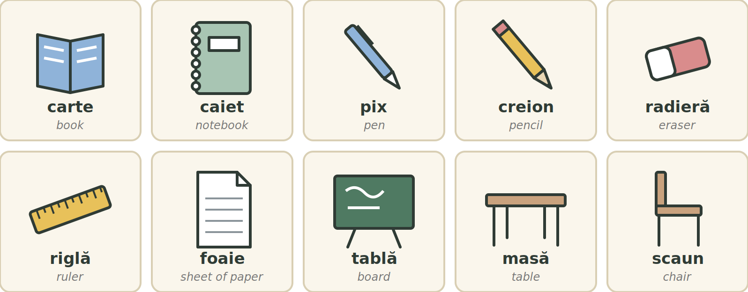
Fig. 4.1 — Obiecte din sala de curs / Classroom objects
ROMANIAN | PLURAL | ENGLISH | ROMANIAN | PLURAL | ENGLISH
o carte | cărți | book | o radieră | radiere | eraser
un caiet | caiete | notebook | o riglă | rigle | ruler
un pix | pixuri | pen | o foaie | foi | sheet of paper
un creion | creioane | pencil | o tablă | table | board
o masă | mese | table | un scaun | scaune | chair
People in the classroom / Oamenii din sala de curs
ROMANIAN | PLURAL | ENGLISH | ROMANIAN | PLURAL | ENGLISH
un profesor | profesori | teacher (man) | o profesoară | profesoare | teacher (woman)
un cursant | cursanți | student (man) | o cursantă | cursante | student (woman)

RECAP — THE GENDER OF NOUNS (Lesson 2.1)
Masculine: un profesor → doi profesori
Feminine: o carte → două cărți
Neuter: un caiet → două caiete · un pix → două pixuri (un in the singular, două in the plural)

TIPAR — what is it? / ce este?
Ce este? | → | Este | + | un / o + word

TIPAR — what are they? / ce sunt?
Ce sunt? | → | Sunt | + | doi / două + plural

ROMANIAN | ENGLISH | ROMANIAN | ENGLISH
Ce este? — Este un pix. | What is it? — It is a pen. | Ce sunt? — Sunt două caiete. | What are they? — Two notebooks.
Este o carte. | It is a book. | Sunt trei creioane. | They are three pencils.
Este un scaun. | It is a chair. | Sunt două foi. | They are two sheets.
Am un pix. | I have a pen. | Am două cărți. | I have two books.
N-am radieră. | I don't have an eraser. | Cartea este pe masă. | The book is on the table.
Profesorul scrie pe tablă. | The teacher writes on the board. | Cursanții sunt în clasă. | The students are in class.
Cartea, profesorul, cursanții — the word the at the end of the noun: Lesson 2.3.
COMMON MISTAKES / GREȘELI FRECVENTE
✗ doi caiete → ✓ două caiete ✗ Eu am una carte. → ✓ Am o carte.

4.1.a Classroom words / Cuvinte din clasă
Complete with a word from the box: carte · pix · caiet · foaie · scaun · radieră · tablă · riglă
1. Scriu în ____________ . | 2. Scriu cu un ____________ .
3. Citesc o ____________ . | 4. Stau pe un ____________ .
5. Profesorul scrie pe ____________ . | 6. Șterg cu o ____________ .
7. Desenez o linie cu o ____________ . | 8. O ____________ de hârtie.

Lesson 4.2 — Plurals that change inside / Pluralul neregulat
You know the plural endings -i, -e, -uri (Lesson 2.2). In some words a sound inside the word changes too. There is no rule for every word — look at the pattern, then learn singular + plural together.
TIPAR — ending + a sound changes inside
carte | → | cărți | = | a → ă · t → ț · + i

WHAT CHANGES | EXAMPLES (singular → plural)
a → ă | carte → cărți · bancă → bănci (school desk)
a → e | masă → mese · fată → fete (girl)
oa → o | foaie → foi · școală → școli (school)
ea → e | geantă → genți (bag) · seară → seri (evening)
o → oa | creion → creioane · telefon → telefoane
t → ț | student → studenți · cursant → cursanți
learn by heart | om → oameni (person) · copil → copii (child) · zi → zile (day)

LISTEN TO THE PLURAL
bănci — c before i sounds like ch: băn-chi. cărți — ț sounds like ts: cărts.

COMMON MISTAKES
foaie → foi, NOT foaieuri carte → cărți, NOT carteuri

4.2.a Write the plural / Scrie pluralul
Write the plural form.
1. carte → ____________ | 2. pix → ____________
3. foaie → ____________ | 4. caiet → ____________
5. bancă → ____________ | 6. creion → ____________
7. masă → ____________ | 8. telefon → ____________

Lesson 4.3 — Talking in class / Comunicarea la curs
No new grammar here. You already know how these five verbs change (Lessons 3.3–3.4) and how to give an order (Lesson 3.13). Now use them to talk in class.
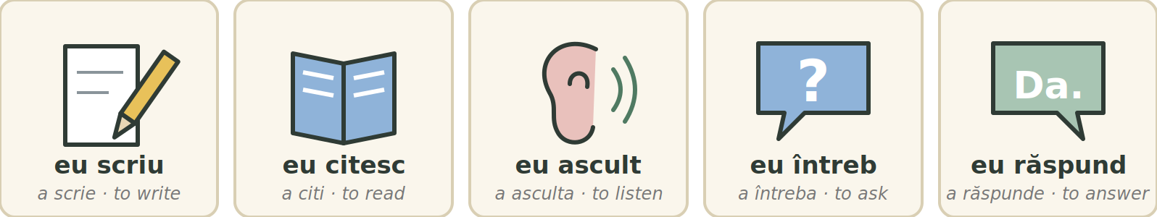
Fig. 4.2 — Cinci verbe pentru sala de curs / Five verbs for the classroom
TIPAR — the teacher asks, you do it
Profesorul: Scrieți! | → | Tu: Scriu.

THE TEACHER SAYS (to the class) | ENGLISH | YOU SAY | ENGLISH
Scrieți în caiet. | Write in your notebook. | Scriu în caiet. | I am writing in my notebook.
Citiți textul cu voce tare. | Read the text aloud. | Citesc textul. | I am reading the text.
Ascultați și repetați. | Listen and repeat. | Ascult. | I am listening.
Întrebați colegul. | Ask your classmate. | Întreb colegul. | I ask my classmate.
Răspundeți la întrebare. | Answer the question. | Răspund: „Da.” | I answer: "Yes."
Deschideți cartea la pagina 10. | Open the book at page 10. | Lucrați în perechi. | Work in pairs.
TIPAR — asking for permission (Lesson 3.11)
Pot să | + | întreb / scriu / citesc | ?

WHAT YOU SAY IN CLASS | ENGLISH | WHAT YOU SAY IN CLASS | ENGLISH
Pot să întreb ceva? | Can I ask something? | Nu înțeleg. | I don't understand.
Pot să citesc eu? | Can I read? | Puteți repeta, vă rog? | Can you repeat, please?
Am o întrebare. | I have a question. | Mai încet, vă rog. | Slower, please.
Ce înseamnă „...”? | What does "..." mean? | Pe ce pagină suntem? | What page are we on?
Cum se scrie „...”? | How do you write "..."? | Nu știu răspunsul. | I don't know the answer.
Puteți scrie pe tablă? | Can you write it on the board? | Am terminat. | I have finished.
4.3.a What do you say? / Ce spui?
Circle the right sentence for each situation.
1. Profesorul vorbește repede. ( Mai încet, vă rog. / Am o carte. )
2. Nu știi ce înseamnă „cartelă”. ( Ce înseamnă „cartelă”? / Cum vă numiți? )
3. Nu știi cum se scrie „mulțumesc”. ( Cum se scrie „mulțumesc”? / Cât costă? )
4. Nu ai auzit bine. ( Puteți repeta, vă rog? / Am terminat. )
5. Ai o întrebare. ( Pot să întreb ceva? / Nu scriu. )
6. Ai terminat exercițiul. ( Am terminat. / Nu înțeleg. )
7. Profesorul: „Scrieți în caiet!” Tu: ( Scriu în caiet. / Citesc cartea. )
8. Profesorul: „Ce citiți?” Tu: ( Citesc textul. / Ascult muzică. )

HOMEWORK — AFTER SESSION 16 / TEMĂ PENTRU ACASĂ
H16.1 Say these pairs out loud three times: carte – cărți · caiet – caiete · pix – pixuri · foaie – foi · bancă – bănci · masă – mese · creion – creioane · om – oameni.
H16.2 Write three questions you can ask in class: Pot să...? · Ce înseamnă...? · Cum se scrie...?

SESSION 17 — SHOPPING: OBJECTS, COLOURS, SHAPES, MATERIALS
SESIUNEA 17 — LA CUMPĂRĂTURI: OBIECTE, CULORI, FORME, MATERIALE · 3 hours

By the end of this session you will be able to:
☐ | name ten everyday objects you buy or carry
☐ | name the basic colours and make the colour agree: o cană albă, două căni albe
☐ | ask for something in a shop: Aveți...? Cât costă?
☐ | name five shapes and say what an object is made of: Masa este din lemn.

Lesson 4.4 — At the shop: objects and colours / Obiecte și culori
ROMANIAN | PLURAL | ENGLISH | ROMANIAN | PLURAL | ENGLISH
o pungă | pungi | bag (plastic, paper) | un pahar | pahare | drinking glass
o sticlă | sticle | bottle | o farfurie | farfurii | plate
o cutie | cutii | box | un telefon | telefoane | phone
o cană | căni | mug | un încărcător | încărcătoare | charger
o cheie | chei | key | un portofel | portofele | wallet
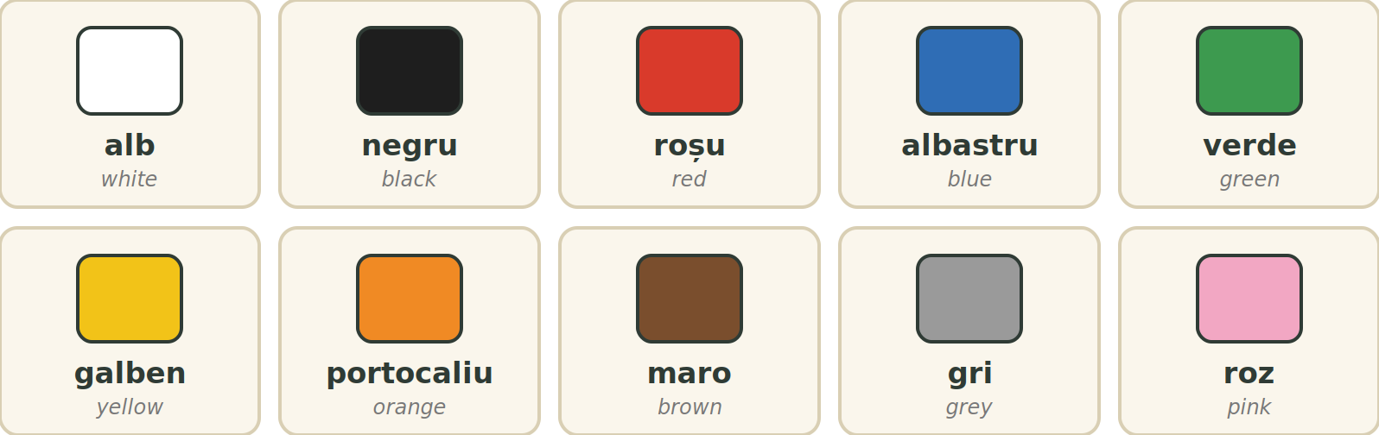
Fig. 4.3 — Culori de bază / Basic colours
RECAP — THE ADJECTIVE AGREES (Lesson 2.4)
The colour comes after the noun and changes with it. A neuter noun takes the masculine form in the singular and the feminine form in the plural: un caiet albastru → două caiete albastre.

TIPAR — object + colour
OBIECTUL | + | CULOAREA (same gender, same number)

COLOUR | UN (m / n) | O (f) | PLURAL m | PLURAL f / n
white | un pahar alb | o cană albă | pantofi albi | căni albe
black | un telefon negru | o pungă neagră | pantofi negri | telefoane negre
red | un portofel roșu | o cutie roșie | pantofi roșii | pungi roșii
blue | un caiet albastru | o sticlă albastră | pantofi albaștri | caiete albastre
green | un pahar verde | o cană verde | pantofi verzi | pahare verzi
yellow | un creion galben | o cheie galbenă | pantofi galbeni | chei galbene
orange | un încărcător portocaliu | o farfurie portocalie | pantofi portocalii | farfurii portocalii

THREE COLOURS NEVER CHANGE
maro · gri · roz — un portofel maro, o cutie gri, două căni roz.

Useful phrases in a shop / Fraze utile în magazin
ROMANIAN | ENGLISH | ROMANIAN | ENGLISH
Vreau o cană. | I want a mug. | Aveți încărcătoare? | Do you have chargers?
Aș dori un pahar. | I would like a glass. (more polite) | Ce culoare doriți? | What colour would you like?
Aveți și altă culoare? | Do you have another colour? | Cât costă? | How much does it cost?
O iau. / Îl iau. | I'll take it. (Lesson 2.10) | Mulțumesc! | Thank you!
Aș dori is a fixed polite phrase — learn it as it is. You will see how it is built in Module 10.
4.4.a Choose the colour / Alege culoarea
Circle the correct form.
1. o cană ( alb / albă ) | 2. un telefon ( negru / neagră )
3. două pahare ( verde / verzi ) | 4. o pungă ( roșu / roșie )
5. două telefoane ( alb / albe ) | 6. o cutie ( galben / galbenă )
7. două căni ( negre / negri ) | 8. un pahar ( albastru / albastră )

Lesson 4.5 — Shapes and materials / Forme și materiale
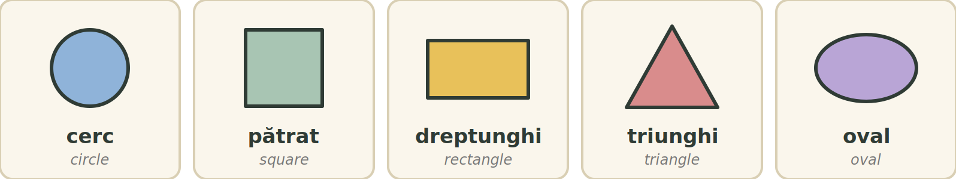
Fig. 4.4 — Forme / Shapes
SHAPE | ENGLISH | DESCRIBING WORD (m / f) | EXAMPLE
un cerc | circle | rotund / rotundă | o masă rotundă
un pătrat | square | pătrat / pătrată | o cutie pătrată
un dreptunghi | rectangle | dreptunghiular / dreptunghiulară | o foaie dreptunghiulară
un triunghi | triangle | triunghiular / triunghiulară | un semn triunghiular (sign)
un oval | oval | oval / ovală | o farfurie ovală
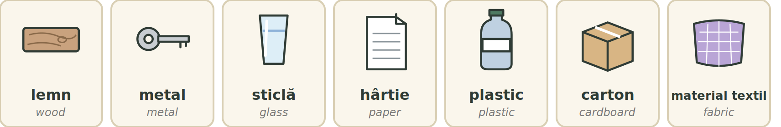
Fig. 4.5 — Materiale / Materials
TIPAR — what is it made of? / din ce este?
Din ce este? | → | Este din | + | material

ROMANIAN | ENGLISH | ROMANIAN | ENGLISH
Masa este din lemn. | The table is made of wood. | Cutia este din carton. | The box is made of cardboard.
Cheia este din metal. | The key is made of metal. | Punga este din plastic. | The bag is made of plastic.
Paharul este din sticlă. | The glass is made of glass. | Geanta este din material textil. | The bag is made of fabric.
Foaia este din hârtie. | The sheet is made of paper. | Scaunul este din lemn și metal. | The chair is made of wood and metal.
Sticla de apă este din plastic. | The water bottle is made of plastic. | Din ce este portofelul? | What is the wallet made of?

ONE WORD, TWO MEANINGS — STICLĂ
sticlă = glass (the material) and bottle (the object). un pahar din sticlă — a glass made of glass · o sticlă de apă — a bottle of water.
You will also hear de instead of din: o masă de lemn = o masă din lemn.

4.5.a Shapes and materials / Forme și materiale
Complete with: plastic, lemn, metal, sticlă, hârtie, rotundă, pătrată.
1. O foaie este din ____________ . | 2. O cheie este de obicei din ____________ .
3. O masă poate fi din ____________ . | 4. Un pahar poate fi din ____________ .
5. Un pix poate fi din ____________ . | 6. O masă în formă de cerc este ____________ .
7. O cutie în formă de pătrat este ____________ .

HOMEWORK — AFTER SESSION 17 / TEMĂ PENTRU ACASĂ
H17.1 Choose five objects at home. For each one write a sentence with the colour: Telefonul meu este negru.
H17.2 Write what the same five objects are made of: Masa este din lemn.

SESSION 18 — THE SIM CARD, SHOP DIALOGUE, RECAP AND TEST
SESIUNEA 18 — CARTELA SIM, DIALOG LA MAGAZIN, RECAPITULARE ȘI TEST · 3 hours

By the end of this session you will be able to:
☐ | know the difference between a prepaid card and a subscription
☐ | recognise the words you need to buy and use a SIM card
☐ | ask about data, minutes, price, documents, activation and recharge
☐ | perform a short dialogue with a salesperson
☐ | sit the Module 4 cumulative test

Lesson 4.6 — Practical Romanian: the SIM card / Practic: cartela SIM
In Romania there are three main mobile operators: Orange, Vodafone and DIGI. In 2025 Vodafone and DIGI bought Telekom Romania Mobile: its prepaid customers went to DIGI and its subscription customers to Vodafone. If you have an old Telekom card, ask in a shop what changes for you.
CHECK BEFORE YOU BUY
Offers, prices and activation steps change often. Always check the operator's official website or app, or ask in an authorised shop.

ROMANIAN | ENGLISH | ROMANIAN | ENGLISH
o cartelă SIM | SIM card | date mobile (GB) | mobile data
o cartelă preplătită | prepaid SIM | o opțiune | package, option
un abonament | subscription, contract | o reîncărcare · a reîncărca | top-up · to top up
un număr de telefon | phone number | a activa | to activate
credit | prepaid credit | o rețea | network
minute (naționale, internaționale) | minutes (national, international) | o factură | bill
un act de identitate | identity document | un pașaport · un permis de ședere | passport · residence permit
Prepaid or subscription? / Preplătită sau abonament?
CARTELĂ PREPLĂTITĂ — prepaid | ABONAMENT — subscription
You pay first, then you use it. | You sign a contract.
You top up when you need to. | You pay a bill every month.
The credit and options are valid for a limited time. | The contract has a fixed period.
Good for flexible or basic use. | Good for regular, long-term use.

DOCUMENTS
The documents you need can differ by operator and by product (prepaid, subscription, eSIM). The safe rule: take your passport or residence permit with you and ask Ce acte sunt necesare?

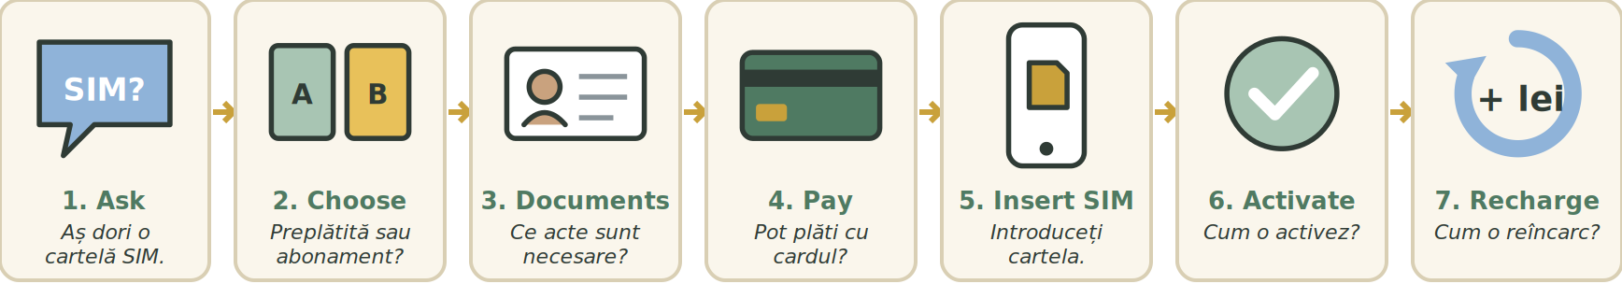
Fig. 4.6 — Pașii pentru o cartelă SIM / The steps for a SIM card
RECAP — O AND ÎL INSTEAD OF THE NOUN (Lesson 2.10)
You say o for a feminine thing (cartela) and îl for a masculine or neuter thing (telefonul), so you don't repeat the word.

TIPAR — o = cartela, îl = telefonul
Activez cartela. | → | O activez.

FULL SENTENCE | SHORT | ENGLISH
Cumpăr cartela. | O cumpăr. | I buy it.
Activez cartela. | O activez. | I activate it.
Reîncarc cartela. | O reîncarc. | I top it up.
Plătesc factura. | O plătesc. | I pay it.
Încarc telefonul. | Îl încarc. | I charge it.
Închid telefonul. | Îl închid. | I switch it off.

COMMON MISTAKE
date mobile = mobile data, NOT calendar dates.

4.6.a Match the words / Potrivește cuvintele
Match the Romanian word with the English meaning. Write the letter.
1. cartelă SIM ___ | 2. credit ___
3. reîncărcare ___ | 4. date mobile ___
5. abonament ___ | 6. factură ___
7. rețea ___ | 8. act de identitate ___

A. network B. mobile data C. identity document D. SIM card E. bill F. top-up G. subscription H. prepaid credit

Lesson 4.7 — Dialogue at the shop / Dialog la magazin
[ SPAȚIU PENTRU IMAGINE / SPACE FOR A PHOTO ]
FOTO: client și vânzător la ghișeul unui magazin de telefonie mobilă
Fig. 4.7 — Fotografie: la magazinul operatorului / Photo: at the operator's shop
TIPAR — asking politely
Aș dori | + | un / o + word | + | vă rog.

 | ROMANIAN | ENGLISH
V | Bună ziua! Cu ce vă pot ajuta? | Hello! How can I help you?
C | Bună ziua. Aș dori o cartelă SIM. | Hello. I would like a SIM card.
V | Doriți cartelă preplătită sau abonament? | Would you like prepaid or a subscription?
C | Cartelă preplătită, vă rog. | Prepaid, please.
V | Aveți nevoie de internet? | Do you need internet?
C | Da. Câți GB are? | Yes. How many GB does it have?
V | Avem mai multe opțiuni. Oferta este aici. | We have several options. The offer is here.
C | Are și minute incluse? | Does it include minutes too?
V | Da, are minute naționale. | Yes, it has national minutes.
C | Pot suna și în Nepal? | Can I also call Nepal?
V | Pentru apeluri internaționale verificăm oferta. | For international calls we check the offer.
C | Cât costă? | How much does it cost?
V | Prețul depinde de opțiune. | The price depends on the option.
C | Cât timp este valabilă? | How long is it valid?
V | Valabilitatea este scrisă aici. | The validity is written here.
C | Ce acte sunt necesare? | What documents are necessary?
V | Aveți pașaportul sau permisul de ședere? | Do you have your passport or residence permit?
C | Da, am pașaportul. | Yes, I have my passport.
V | Perfect. Introduceți cartela în telefon. | Perfect. Put the card in the phone.
C | Cum o activez? | How do I activate it?
V | Urmați instrucțiunile de pe ecran. | Follow the instructions on the screen.
C | Și cum o reîncarc? | And how do I top it up?
V | Online, din aplicație sau în magazin. | Online, in the app or in the shop.
C | Pot plăti cu cardul? | Can I pay by card?
V | Da, sigur. | Yes, of course.
C | Bine, o iau. Mulțumesc! | Good, I'll take it. Thank you!
V | Cu plăcere. O zi bună! | You're welcome. Have a nice day!
V = vânzător (salesperson) · C = client (customer)
LEARN THESE 7 QUESTIONS BY HEART
1. Cât costă? 2. Câți GB are? 3. Are minute incluse? 4. Cât timp este valabilă?
5. Ce acte sunt necesare? 6. Cum o activez? 7. Cum o reîncarc?

4.7.a Put the dialogue in order / Ordonează dialogul
Write the numbers 1–8 in the right order.
1. ___ Mulțumesc. La revedere!
2. ___ Bună ziua. Aș dori o cartelă SIM preplătită.
3. ___ Bună ziua. Cu ce vă pot ajuta?
4. ___ Da. Câți GB are?
5. ___ Doriți o cartelă cu internet?
6. ___ O iau. Pot plăti cu cardul?
7. ___ Da, puteți plăti cu cardul.
8. ___ Are internet inclus. Oferta este aici.

Lesson 4.8 — Module recap / Recapitulare
Module 4 in one page
IN CLASS | TALKING IN CLASS | SHOP AND PHONE
carte – cărți  caiet – caiete  pix – pixuri  foaie – foi  masă – mese  om – oameni | Scrieți! Citiți! Ascultați!  Pot să întreb ceva?  Nu înțeleg.  Puteți repeta, vă rog?  Ce înseamnă „...”? | Aș dori o cartelă SIM.  Cât costă?  Câți GB are?  Ce acte sunt necesare?  Cum o activez? Cum o reîncarc?

COLOURS | SHAPES | MATERIALS
alb · negru · roșu · albastru · verde · galben · portocaliu · maro · gri · roz | cerc · pătrat · dreptunghi · triunghi · oval | lemn · metal · sticlă · hârtie · plastic · carton · material textil
The patterns
PATTERN | EXAMPLE
Ce este? → Este un / o + word | Ce este? — Este un pix.
plural + a sound changes inside | carte → cărți · masă → mese · creion → creioane
Pot să + verb? | Pot să întreb ceva?
object + colour (same gender, same number) | o cană albă · două căni albe
Este din + material | Masa este din lemn.
o = cartela · îl = telefonul | Cum o activez? · Îl încarc.
Aș dori + un / o + word, vă rog. | Aș dori o cartelă SIM, vă rog.
4.8.a Everything together / Totul împreună
Circle the correct word.
1. două ( caiete / caieturi ) | 2. o cană ( roșu / roșie )
3. Masa este ( din / pe ) lemn. | 4. Cartela? ( O / Îl ) activez acum.
5. ( Pot să / Pot ) întreb ceva? | 6. un om — doi ( oameni / omi )
7. Cât ( costă / costați )? | 8. două telefoane ( albe / albi )

SECȚIUNE DETAȘABILĂ — EXEMPLAR FORMATOR
Detachable section — teacher's copy. Se detașează din suportul cursantului; testul completat, semnat și datat, se păstrează la dosarul cursantului. Conține: testul cumulativ, fișa de confirmare a Sesiunii 18, fișa de evidență a Modulului 4, cheia răspunsurilor.

TEST CUMULATIV — MODULUL 4
MODULE 4 — CUMULATIVE TEST · grilă, 20 de întrebări, 20 de puncte · semnat și datat de cursant

Nume și prenume cursant / Student name
Data / Date | _____ / _____ / 20_____
Semnătura cursantului / Student signature

Marcați cu X un singur răspuns la fiecare întrebare. Mark ONE answer with X for each question. Each correct answer = 1 point.
1. Ce înseamnă „caiet”? (1 p)
☐ a) pen  ☐ c) chair | ☐ b) notebook  ☐ d) board
2. Care formă este corectă? (1 p)
☐ a) doi caiete  ☐ c) două caiete | ☐ b) două caiet  ☐ d) doi caiet
3. Completează: „Pe masă este ____ carte.” (1 p)
☐ a) o  ☐ c) doi | ☐ b) un  ☐ d) niște
4. Pluralul cuvântului „carte” este: (1 p)
☐ a) carteuri  ☐ c) cartii | ☐ b) carte  ☐ d) cărți
5. Completează: „o masă — două ____” (1 p)
☐ a) mase  ☐ c) mese | ☐ b) mesi  ☐ d) masuri
6. Completează: „un om — doi ____” (1 p)
☐ a) omi  ☐ c) omuri | ☐ b) oameni  ☐ d) oame
7. Profesorul vorbește repede. Ce spui? (1 p)
☐ a) Mai încet, vă rog.  ☐ c) Cât costă? | ☐ b) Am terminat.  ☐ d) Bună seara.
8. Profesorul spune: „Scrieți în caiet!” Ce spui? (1 p)
☐ a) Citesc textul.  ☐ c) Închid caietul. | ☐ b) Ascult muzică.  ☐ d) Scriu în caiet.
9. Cum întrebi ce înseamnă un cuvânt? (1 p)
☐ a) Cum se scrie?  ☐ c) Ce înseamnă „...”? | ☐ b) Pe ce pagină suntem?  ☐ d) Cât costă?
10. Care formă este corectă? (1 p)
☐ a) o cană alb  ☐ c) o cană albi | ☐ b) o cană albă  ☐ d) o cană albe
11. Completează: „două telefoane ____” (1 p)
☐ a) negru  ☐ c) negri | ☐ b) neagră  ☐ d) negre
12. Care culoare NU se schimbă? (1 p)
☐ a) verde  ☐ c) maro | ☐ b) roșu  ☐ d) galben
13. „Din ce este paharul?” — „Paharul este din ____.” (1 p)
☐ a) sticlă  ☐ c) verde | ☐ b) rotund  ☐ d) pătrat
14. Ce înseamnă „cerc”? (1 p)
☐ a) circle  ☐ c) triangle | ☐ b) square  ☐ d) rectangle
15. Completează: „O cutie în formă de pătrat este ____.” (1 p)
☐ a) rotundă  ☐ c) ovală | ☐ b) pătrată  ☐ d) triunghiulară
16. Ce înseamnă „date mobile”? (1 p)
☐ a) calendar dates  ☐ c) minutes | ☐ b) mobile phones  ☐ d) mobile data
17. Cartela preplătită: (1 p)
☐ a) plătești întâi, apoi folosești  ☐ c) nu o poți reîncărca | ☐ b) plătești o factură în fiecare lună  ☐ d) este un act de identitate
18. Completează: „Am cartela. Cum ____ activez?” (1 p)
☐ a) îl  ☐ c) le | ☐ b) o  ☐ d) îi
19. Care întrebare este despre preț? (1 p)
☐ a) Câți GB are?  ☐ c) Cum o reîncarc? | ☐ b) Ce acte sunt necesare?  ☐ d) Cât costă?
20. Care este cererea cea mai politicoasă? (1 p)
☐ a) Dă cartela!  ☐ c) Aș dori o cartelă SIM, vă rog. | ☐ b) Cartelă acum!  ☐ d) Tu, cartelă.

PUNCTAJ OBȚINUT / SCORE | _______ / 20
Semnătura formatorului / Teacher signature

SESSION COMPLETION RECORD
FIȘĂ DE CONFIRMARE A PARCURGERII SESIUNII — se păstrează la dosar

Module / Modul | Modulul 4 — La curs și la cumpărături (finalizat)
Session / Sesiunea | Sesiunea 18 — Cartela SIM, dialog la magazin, recapitulare. TEST CUMULATIV MODULUL 4
Duration / Durata | 3 ore
Date / Data | _____ / _____ / 20_____
Student name / Nume și prenume cursant
Score / Punctaj obținut | _______ / 20
Student signature / Semnătura cursantului
Teacher signature / Semnătura formatorului

DECLARAȚIE CURSANT / STUDENT DECLARATION
Declar că am participat la această sesiune de curs și am parcurs conținutul prezentat mai sus. I declare that I attended this course session and covered the content presented above.

MODULE 4 — COMPLETION RECORD
FIȘĂ DE EVIDENȚĂ A PARCURGERII MODULULUI 4 — se păstrează la dosarul cursantului

Cursant / Student
Act de identitate / ID document
Angajator / Employer
Formator / Teacher
Modul / Module | Modulul 4 — La curs și la cumpărături (9 ore, Sesiunile 16–18)

NR. | SESIUNE / CONȚINUT | DATA | PUNCTAJ TEST | SEMNĂTURA CURSANTULUI
16 | Sesiunea 16 — Obiectele din sala de curs, pluralul neregulat, comunicarea la curs (3 ore) |  | —
17 | Sesiunea 17 — La cumpărături: obiecte, culori, forme, materiale (3 ore) |  | —
18 | Sesiunea 18 — Cartela SIM, dialog la magazin, recapitulare + TEST CUMULATIV (3 ore) |  | ___ / 20

CONFIRMARE FINALIZARE MODUL / MODULE COMPLETION
Confirm că cursantul a parcurs integral conținutul Modulului 4 — La curs și la cumpărături, în total 9 ore de curs, și a susținut testul de evaluare consemnat mai sus. I confirm that the student completed the full content of Module 4 — In Class and Shopping, 9 course hours in total, and sat the assessment recorded above.
Data: _____ / _____ / 20_____ Semnătura formatorului: ______________________

ANSWER KEY — TEACHER COPY
CHEIA RĂSPUNSURILOR — pentru formator

Session 16
4.1.a caiet · pix · carte · scaun · tablă · radieră · riglă · foaie
4.2.a cărți · pixuri · foi · caiete · bănci · creioane · mese · telefoane
4.3.a Mai încet, vă rog. · Ce înseamnă „cartelă”? · Cum se scrie „mulțumesc”? · Puteți repeta, vă rog? · Pot să întreb ceva? · Am terminat. · Scriu în caiet. · Citesc textul.
H16.2 answers vary — check the question form.
Session 17
4.4.a albă · negru · verzi · roșie · albe · galbenă · negre · albastru
4.5.a hârtie · metal · lemn · sticlă · plastic · rotundă · pătrată
H17.1–H17.2 personal answers — check colour agreement and din.
Session 18
4.6.a 1-D · 2-H · 3-F · 4-B · 5-G · 6-E · 7-A · 8-C
4.7.a numbers to write, line by line: 8 · 2 · 1 · 4 · 3 · 6 · 7 · 5 (dialogue order: line 3 → 2 → 5 → 4 → 8 → 6 → 7 → 1)
4.8.a caiete · roșie · din · O · Pot să · oameni · costă · albe
Cumulative test — grilă answer key
Un răspuns corect = 1 punct. Nemarcat sau dublu marcat = 0 puncte.
1 – b | 2 – c | 3 – a | 4 – d | 5 – c | 6 – b | 7 – a | 8 – d | 9 – c | 10 – b
11 – d | 12 – c | 13 – a | 14 – a | 15 – b | 16 – d | 17 – a | 18 – b | 19 – d | 20 – c
TOTAL: 20 puncte

LIMBA ROMÂNĂ PENTRU STRĂINI
Romanian Language for Foreign Workers
SUPORT DE CURS

MODULE 5 — ROMANIA AND TIME
MODULUL 5 — ORIENTARE ROMÂNIA ȘI TIMPUL
LEVEL / NIVEL | DURATION / DURATĂ | LANGUAGE OF TEACHING
A1 — after Module 4 | 12 hours · Sessions 19–22 · Weeks 10–11 | English → Romanian

LEGAL BASIS / TEMEI LEGAL
Curs de limbă română cu elemente de integrare culturală și socială, organizat în conformitate cu O.U.G. nr. 32/2026, art. 7 alin. (1) lit. g) — minimum 6 luni, cel puțin 6 ore pe săptămână.
Romanian language course with cultural and social integration elements, organised under Government Emergency Ordinance no. 32/2026, art. 7(1)(g) — at least 6 months, at least 6 hours per week. Module 5 is the course’s main cultural and social orientation module. It ends with ONE cumulative multiple-choice test (20 questions), signed and dated by the student and kept on file as proof of completion. There is no separate test after each session.

Before you start
Module 4 taught you to talk in the classroom and in a shop. Module 5 is your orientation module. It explains the country you now live in — its regions and cities, its national symbols, the institutions you will deal with, the everyday social rules, the calendar and the celebrations — and it gives you the Romanian you need to talk about time, the weather and your day.
Many parts of this module are short texts about Romania. Read them like a story. You do not need to learn them by heart — you need to understand them, so that daily life in Romania is easier.
You need these lessons first — look back at them if you are not sure:
YOU NEED | WHERE | WHY
the numbers | Lesson 2.5 | hours, dates, prices, temperatures, the number 112
tu / dumneavoastră | Lesson 2.6 | how to speak to officials and to friends
greetings — Bună ziua, La revedere | Lesson 3.1 | at the town hall, on the phone, in a shop
question words — Unde? Când? Cât? | Lesson 3.7 | Unde este Primăria? Cât e ceasul?
short polite answers | Lesson 3.10 | Mulțumesc. Nu înțeleg. Puteți repeta?
reflexive verbs — mă trezesc | Lesson 3.12 | your day: Mă trezesc la ora șase.
the colours | Lesson 4.4 | the flag: albastru, galben, roșu

Where this module sits in the course
SESSION | DURATION | CONTENT
Session 19 | 3 hours | Lesson 5.1 Romania — regions, cities, national symbols · Lesson 5.2 The institutions you need
Session 20 | 3 hours | Lesson 5.2 (continued) Calling 112, at the town hall · Lesson 5.3 Everyday social rules
Session 21 | 3 hours | Lesson 5.4 Time — the clock, days, months, seasons · Lesson 5.5 The weather and your day
Session 22 | 3 hours | Lesson 5.6 Holidays and traditions · Lesson 5.7 General recap · Module 5 cumulative test

The language in this module
Only one small new thing at a time. Everything marked recap you already learned in Modules 2–4.
PATTERN | ENGLISH | NEW OR RECAP?
Sunt din... · Locuiesc în... | I am from... · I live in... | new (Lesson 5.1)
Este ora... / la ora... | it is ... o’clock / at ... o’clock | new (Lesson 5.4)
și un sfert · și jumătate · fără un sfert | quarter past · half past · quarter to | new (Lesson 5.4)
luni / lunea | on Monday (once) / on Mondays (every week) | new (Lesson 5.4)
în + month · pe + date · la + hour | în mai · pe 1 decembrie · la ora opt | new (Lesson 5.4)
Plouă. Ninge. Este frig. | weather sentences have no subject (no it) | new (Lesson 5.5)
luni, ianuarie (small letter) | days and months with a small letter | recap (Module 1)
mă trezesc · mă culc | reflexive verbs: mă, te, se, ne, vă, se + verb | recap (Lesson 3.12)

HOW TO USE THIS BOOK ON YOUR OWN / CUM FOLOSEȘTI SINGUR ACEST SUPORT
Read the theory text and the example table of each lesson first, out loud. The tables are there to teach you — read every example, not just the first one. Only then do the short exercise at the end of the lesson.
The green boxes with a pattern (A + B → C) are the rules. Learn the pattern, not the English explanation. The blue RECAP boxes show things you already know from earlier modules — nothing new to learn there. The grey boxes are cultural and practical notes about life in Romania; the yellow boxes say ATTENTION.
The figures (maps, clocks, calendar) are there to help you remember — look at them for a moment before you read the text. The spaces marked FOTO are for a photo added by your teacher.

SESSION 19 — ROMANIA, ITS SYMBOLS AND INSTITUTIONS
SESIUNEA 19 — ROMÂNIA, SIMBOLURILE ȘI INSTITUȚIILE ESENȚIALE · 3 hours

By the end of this session you will be able to:
☐ | say the basic facts about Romania: capital, currency, language, neighbours
☐ | recognise the flag and say its colours; say that Romania is in the EU and in NATO
☐ | name the historical regions and the biggest cities, and say what each city is known for
☐ | say where you are from, where you live and where you work: Sunt din... Locuiesc în... Lucrez în județul...
☐ | name the five institutions you need and know when to go to each one

Lesson 5.1 — Romania: regions, cities, symbols / România: regiuni, orașe, simboluri
Romania (România) is a country in South-Eastern Europe. About 19 million people live here (2021 census). Its language, Romanian (limba română), is a Latin language, like Italian, Spanish, French and Portuguese — this is why many Romanian words will look familiar to you if you know one of those languages: școală (school), familie (family), a lucra (to work).
Three natural features shape the country. The Carpathian Mountains (Munții Carpați) make a big arc through the middle. The Danube (Dunărea), Europe’s second-longest river, forms most of the southern border and ends in the Danube Delta (Delta Dunării), a protected nature reserve. In the east, Romania has a coast on the Black Sea (Marea Neagră).

IMAGINE: harta României — regiunile istorice și orașele mari
Fig. 5.1 — Harta României: regiunile istorice și orașele mari / Map of Romania: the historical regions and the main cities (schematic, drawn on county borders)
The symbols of Romania / Simbolurile României
Every country has symbols — things that everybody in the country knows and recognises. Here are the first ones you need. You will see them every day: on buildings, on money, on your documents.
The flag (drapelul or steagul) has three vertical stripes of the same size: blue, yellow and red — albastru, galben, roșu. You know these colours from Lesson 4.4. The blue stripe is always next to the pole. You see the flag on public buildings — the town hall, schools, the police — and everywhere on the national holidays (Lesson 5.6).
The capital (capitala) is București (Bucharest), the biggest city. The President, the Parliament and the Government of Romania are here.
The currency (moneda) is the leu (code RON). One leu has 100 bani. Romania is in the European Union, but it does not use the euro — in the shop you always pay in lei.
The official language (limba oficială) is Romanian. It is written in the Constitution, the most important law of the country. All official papers, forms and signs are in Romanian — this is why this course is important for you.
The European Union and NATO. Romania has been a member of NATO since 2004 and a member of the European Union (Uniunea Europeană, UE) since 2007. Next to the Romanian flag you will often see the EU flag: a circle of twelve yellow stars on blue.
Romania also has a coat of arms (stema). You see it on official documents, stamps and public buildings. You will learn what it shows in Module 10.
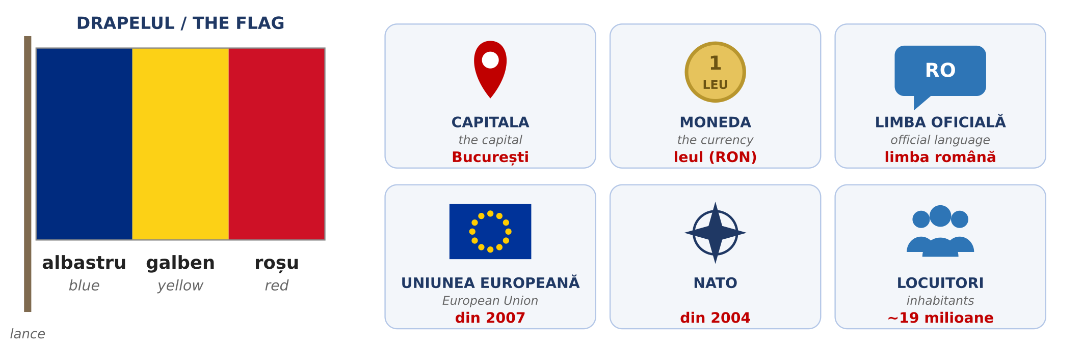
Fig. 5.2 — Simbolurile României / The symbols of Romania
Romania in short / România pe scurt
IN ENGLISH | IN ROMANIAN
The flag is blue, yellow and red. | Drapelul este albastru, galben și roșu.
The capital is Bucharest. | Capitala este București.
The currency is the leu (RON). 1 leu = 100 bani. | Moneda este leul. Un leu are 100 de bani.
The official language is Romanian. | Limba oficială este limba română.
Romania has been in the European Union since 2007. | România este membră a Uniunii Europene din 2007.
Romania has been in NATO since 2004. | România este membră NATO din 2004.
About 19 million inhabitants. | Aproximativ 19 milioane de locuitori.
The sea in the east is the Black Sea. | La est este Marea Neagră.
The mountains in the centre are the Carpathians. | În centru sunt Munții Carpați.
The river in the south is the Danube. | În sud curge Dunărea.

ATTENTION / ATENȚIE — ONE LEU, TWO LEI
The plural of leu is lei: un leu, doi lei, cinci lei. From 20 up you add de (Lesson 2.5): 20 de lei, 100 de lei. On a price tag you can see 25 lei or 25 RON — it is the same money.

The neighbours / Țările vecine
Romania has five neighbouring countries. Notice that most country names in Romanian end in -a — they are feminine: Ungaria, Bulgaria, Ucraina.
COUNTRY | IN ROMANIAN | CAPITAL | WHERE
Hungary | Ungaria | Budapesta | west
Serbia | Serbia | Belgrad | south-west
Bulgaria | Bulgaria | Sofia | south (across the Danube)
Moldova | Republica Moldova | Chișinău | east — people there also speak Romanian
Ukraine | Ucraina | Kiev | north and east

The historical regions / Regiunile istorice
For administration, Romania is divided into 41 counties (județe) plus the city of Bucharest. But in everyday life Romanians often talk about the old historical regions. Each region has its own accent, food and traditions, and people are proud of where they come from: Sunt ardelean (I’m from Transylvania), Sunt moldovean (I’m from Moldova).
REGION | MAIN CITY | WHERE | KNOWN FOR
Muntenia | București | south | the capital; flat farmland along the Danube
Oltenia | Craiova | south-west | old traditions, pottery, the Danube gorges
Dobrogea | Constanța | south-east | the Black Sea coast and the Danube Delta
Moldova | Iași | north-east | history, churches and vineyards (not the same as the Republic of Moldova!)
Bucovina | Suceava | far north-east | painted monasteries (UNESCO)
Maramureș | Baia Mare | north | wooden churches (UNESCO), village traditions
Transilvania (Ardeal) | Cluj-Napoca | centre | mountains, medieval towns, castles
Crișana | Oradea | west | Art Nouveau buildings, thermal spas
Banat | Timișoara | west | many nationalities living together; industry

ATTENTION / ATENȚIE — REGION, COUNTY, CITY
România is the country. Transilvania, Moldova, Banat... are historical regions — parts of the country, not separate states. Județul is the county: it appears in your address and on your documents. Example: Popești-Leordeni, județul Ilfov. On official forms you will almost always be asked for the județ, not the region.

The big cities and what to see / Orașele mari
CITY | REGION | PEOPLE (approx.)
București | Muntenia | 1.7 million
Cluj-Napoca | Transilvania | 290,000
Iași | Moldova | 270,000
Constanța | Dobrogea | 265,000
Timișoara | Banat | 250,000
Brașov | Transilvania | 240,000
Craiova | Oltenia | 235,000
Galați | Moldova | 215,000
Oradea | Crișana | 185,000
Ploiești | Muntenia | 180,000

Figures from the 2021 census, rounded. The whole metropolitan area of each city is bigger.
București — the capital, the political and business centre of the country. The Palace of the Parliament (Palatul Parlamentului) is one of the largest administrative buildings in the world. The Old Town (Centrul Vechi) is full of restaurants and cafés, and big parks like Herăstrău (Parcul Regele Mihai I) and Cișmigiu are good for a walk on Sunday.
FOTO: Palatul Parlamentului, București — vedere din față, zi senină
Fig. 5.3 — Palatul Parlamentului, București / The Palace of the Parliament, Bucharest
Brașov — a mountain city with a medieval centre around Piața Sfatului and the Black Church (Biserica Neagră), the biggest Gothic church in the region. Near Brașov is Bran Castle (Castelul Bran), known to tourists as “Dracula’s Castle”, and the ski resort Poiana Brașov.
Cluj-Napoca — the unofficial capital of Transylvania: a young, lively city with many students and IT companies, and big summer music festivals such as Untold and Electric Castle.
Timișoara — called “Little Vienna” for its elegant squares. The Romanian Revolution of December 1989 started here. It was European Capital of Culture in 2023.
Iași — an old cultural capital, with the Palace of Culture (Palatul Culturii), many churches and the oldest university in the country.
Constanța — the biggest port on the Black Sea. In summer, the beaches of Mamaia and the seaside resorts to the south are full of holidaymakers. On the seafront stands the old Casino (Cazinoul), a symbol of the city.
Sibiu is smaller, but worth a visit: a medieval town with painted roofs “with eyes” and Europe’s biggest open-air village museum (Muzeul ASTRA). And in Sighișoara you can walk through a medieval citadel where people still live.
FOTO: Piața Sfatului cu Biserica Neagră în fundal, Brașov
Fig. 5.4 — Piața Sfatului și Biserica Neagră, Brașov / The Council Square and the Black Church, Brașov
Where are you from? Where do you live?
TIPAR — three sentences about you / trei propoziții despre tine
Sunt din | + | COUNTRY

Locuiesc în | + | CITY / VILLAGE

Lucrez în județul | + | COUNTY

ROMANIAN | ENGLISH
Sunt din Nepal. / Sunt din India. | I’m from Nepal. / I’m from India.
Sunt din Sri Lanka. / Sunt din Vietnam. | I’m from Sri Lanka. / I’m from Vietnam.
Locuiesc în București, în sectorul 4. | I live in Bucharest, in District 4.
Locuiesc în Popești-Leordeni. | I live in Popești-Leordeni.
Locuiesc în Cluj-Napoca, pe strada Florilor. | I live in Cluj-Napoca, on Florilor street.
Lucrez în județul Ilfov. | I work in Ilfov county.
Lucrez în județul Cluj. | I work in Cluj county.
Lucrez în București, în sectorul 2. | I work in Bucharest, in District 2.
Din ce țară sunteți? | What country are you from? (formal)
Unde locuiți? | Where do you live? (formal)
Unde lucrați? | Where do you work? (formal)

PRACTICAL NOTE — BUCHAREST HAS SIX DISTRICTS
Bucharest is not part of any county. It is divided into six districts (sectoare), numbered 1 to 6. Your address in Bucharest says Sectorul 3, not a county — and each district has its own town hall (Primăria Sectorului 3).

5.1.a Romania — fill in
Complete with a word from the box. The English on the right helps you.
WORD BANK: București · Constanța · Transilvania · Banat · Moldova · leul · roșu

1. Capitala României este ______________. | The capital of Romania is...
2. Cel mai mare port la Marea Neagră este ______________. | The biggest port on the Black Sea is...
3. Cluj-Napoca este în ______________. | Cluj-Napoca is in...
4. Timișoara este în ______________. | Timișoara is in...
5. Iași este în ______________. | Iași is in...
6. Moneda României este ______________. | The currency of Romania is...
7. Drapelul României este albastru, galben și ______________. | The flag of Romania is blue, yellow and...

Lesson 5.2 — The institutions you need / Instituțiile esențiale
As a foreign worker in Romania you will deal with five institutions. You will not visit them often, but you must know what each one does and where to go when you have a problem. Your employer usually helps with the documents, but it is your stay and your rights — so it is good to understand the system yourself.
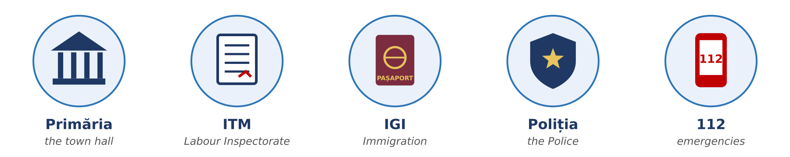
Fig. 5.5 — Cele cinci instituții esențiale / The five institutions you need
INSTITUTION | WHAT IT DOES | GO THERE WHEN...
Primăria | the town hall — the local administration of your city, commune or Bucharest district | you pay local taxes (for example for a car), you register a birth or a marriage (Starea civilă), you have a problem in your street
ITM Inspectoratul Teritorial de Muncă | the Labour Inspectorate — checks that employers respect the labour law | you are not paid, you work without a contract, work is unsafe, you work too many hours
IGI Inspectoratul General pentru Imigrări | the Immigration Office — manages the right of foreigners to stay in Romania | you apply for or extend your residence permit, you change your address or employer
Poliția | the Police — public order and safety | something is stolen, you lose your documents, you are threatened, you see a crime
112 | the single emergency number: police, ambulance, fire brigade | somebody’s life, health or safety is in danger — right now

PRACTICAL NOTE — YOUR CONTRACT AND ITM
You must receive a copy of your individual employment contract (contractul individual de muncă) before you start work, and your contract is registered electronically with ITM. If your employer does not solve a problem at work, you can send a written complaint (o sesizare) to the ITM of the county where you work. Keep copies of your contract, your payslips (fluturașii de salariu) and every paper you sign.

PRACTICAL NOTE — YOUR RESIDENCE PERMIT AND IGI
Your residence permit (permisul de ședere) has an expiry date. Ask for the extension in good time — at least 30 days before it expires. If you change your address or your employer, IGI must be informed. Check every change with your employer first, and always carry your permit or a copy of it.

Useful documents / Acte uzuale
ROMANIAN | ENGLISH
pașaportul | the passport
viza de lungă ședere | the long-stay visa
permisul de ședere | the residence permit
avizul de muncă | the work permit (approval)
contractul de muncă | the employment contract
contractul de închiriere | the rental contract
adeverința | an official certificate (e.g. from your employer)
cererea · formularul | the application · the form
programarea | the appointment

HOMEWORK — AFTER SESSION 19 / TEMĂ PENTRU ACASĂ
H19.1 Write three sentences about yourself with the patterns: Sunt din... · Locuiesc în... · Lucrez în județul... Say them out loud three times.
H19.2 Draw the Romanian flag and write under it: Drapelul României este ... Then write three more sentences from the table “Romania in short”.

SESSION 20 — EMERGENCIES, THE TOWN HALL, SOCIAL RULES
SESIUNEA 20 — APELUL LA 112, LA PRIMĂRIE, REGULI SOCIALE · 3 hours

By the end of this session you will be able to:
☐ | make an emergency call to 112 in simple Romanian
☐ | ask for what you need at the town hall: Am o programare. Ce acte trebuie să aduc? Unde semnez?
☐ | understand shop hours and the signs on doors: DESCHIS, ÎNCHIS, TRAGEȚI, ÎMPINGEȚI
☐ | use public transport: buy and validate a ticket, ask for a stop
☐ | choose tu or dumneavoastră and know the small social rules: greeting, Poftă bună, Sănătate, punctuality

Lesson 5.2 (continued) — Calling 112 and at the town hall / Apelul la 112 și la Primărie
Calling 112 / Apelul la 112
112 is the European emergency number. The call is free, and it works even with no credit on your phone. Call only for a real emergency: an accident, a fire, somebody hurt or ill, a crime happening now. The operator asks simple questions, one at a time. You do not need perfect Romanian — the key word and the address are enough.
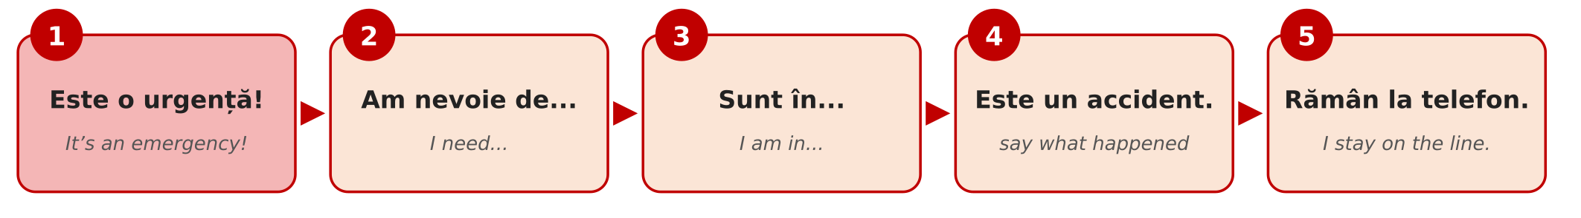
Fig. 5.6 — Pașii unui apel la 112 / The five steps of a 112 call
STEP | WHAT YOU SAY | ENGLISH
1 | Este o urgență! | It’s an emergency!
2 | Am nevoie de ambulanță / poliție / pompieri. | I need an ambulance / the police / the fire brigade.
3 | Sunt în Popești-Leordeni, strada Florilor, numărul 12. | I am in Popești-Leordeni, Florilor street, number 12.
4 | Un om este rănit. / Este un incendiu. / Este un accident. | A person is injured. / There is a fire. / There is an accident.
5 | Rămân la telefon. | I stay on the line.

Dialogue — an accident in the street
ROMANIAN | ENGLISH
O: 112, care este urgența? | 112, what is the emergency?
M: Este o urgență! Am nevoie de ambulanță. | It’s an emergency! I need an ambulance.
O: Ce s-a întâmplat? | What happened?
M: Un domn în vârstă a căzut pe trotuar. Este rănit la cap. | An elderly man fell on the pavement. His head is injured.
O: Unde sunteți? | Where are you?
M: Sunt în Popești-Leordeni, pe strada Florilor, lângă farmacie. | I’m in Popești-Leordeni, on Florilor street, next to the pharmacy.
O: Domnul respiră? Vorbește? | Is the man breathing? Is he talking?
M: Da, respiră și vorbește. | Yes, he is breathing and talking.
O: Nu-l mișcați. Ambulanța vine. Rămâneți la telefon. | Don’t move him. The ambulance is coming. Stay on the line.
M: Bine, rămân la telefon. | OK, I’m staying on the line.

MEMORISE THESE FOUR SENTENCES
Este o urgență! · Am nevoie de ambulanță. · Sunt în... · Un om este rănit.
It’s an emergency! · I need an ambulance. · I am in... · A person is injured.

At the town hall / La Primărie
At an office you speak slowly, say dumneavoastră, and bring all your documents — the original and a copy. Many offices work by appointment (cu programare). Here is a real situation: if you buy a car in Romania, you must declare it at the town hall within 30 days, so that you can pay the local tax on it.
ROMANIAN | ENGLISH
F: Bună ziua! Cu ce vă pot ajuta? | Hello! How can I help you?
C: Bună ziua! Vorbiți engleză? | Hello! Do you speak English?
F: Puțin. Încercăm în română. | A little. Let’s try in Romanian.
C: Bine. Am cumpărat o mașină. Trebuie să o declar? | OK. I bought a car. Do I have to declare it?
F: Da, în 30 de zile. Aveți programare? | Yes, within 30 days. Do you have an appointment?
C: Da, am o programare la ora zece. | Yes, I have an appointment at ten o’clock.
F: Ce acte aveți? | Which documents do you have?
C: Am pașaportul, permisul de ședere și contractul de cumpărare. Ce acte trebuie să mai aduc? | I have my passport, my residence permit and the purchase contract. Which other documents must I bring?
F: Cartea de identitate a mașinii. Completați acest formular, vă rog. | The car’s identity card (the vehicle registration book). Fill in this form, please.
C: Unde semnez? | Where do I sign?
F: Aici, jos. Mulțumesc! Plătiți impozitul la casierie sau online. | Here, at the bottom. Thank you! You pay the tax at the cash desk or online.
C: Mulțumesc mult! La revedere! | Thank you very much! Goodbye!

F = funcționara (the clerk) · C = cetățeanul (the citizen) · impozitul — the tax · casieria — the cash desk · Mi-am pierdut pașaportul. — I have lost my passport.
5.2.a Where do you go?
Read the situation in English. Write the institution: Primăria, ITM, IGI, Poliția or 112.
1. Your salary was not paid for two months. | → ______________
2. Your residence permit expires next month. | → ______________
3. Your baby was born in Romania. You must register the birth. | → ______________
4. Somebody stole your phone in the bus. | → ______________
5. A person fell in the street and cannot move. | → ______________
6. You work, but you have no contract. | → ______________

Lesson 5.3 — Everyday social rules / Reguli sociale de zi cu zi
Shops and opening hours / Magazinele și programul
In Romania most shops are open every day, Sunday included. At night, in every town some pharmacies are on duty (de gardă). On public holidays (Lesson 5.6) many shops have shorter hours, and on 1–2 January and 25 December most are closed.
TYPE OF SHOP | TYPICAL HOURS
supermarket / hipermarket | 8:00–22:00, every day; some non-stop
magazinul de cartier — the local shop | 7:00–22:00; some non-stop
farmacia — the pharmacy | 8:00–20:00; farmacia de gardă is open at night
banca, poșta — the bank, the post office | Monday–Friday, about 9:00–17:00
Primăria, IGI, ITM — offices | Monday–Friday; check the hours for the public (program cu publicul)

Signs you will see / Indicatoare
ON THE DOOR / SIGN | ENGLISH | ON THE DOOR / SIGN | ENGLISH
DESCHIS | open | ÎNCHIS | closed
TRAGEȚI | pull | ÎMPINGEȚI | push
INTRARE | entrance | IEȘIRE | exit
PROGRAM | opening hours | PAUZĂ | break
CASA | the till / checkout | FUMATUL INTERZIS | no smoking
TOALETA / WC | toilet | ATENȚIE! | caution!

Public transport / Transportul în comun
In the cities you travel by bus (autobuz), tram (tramvai) and trolleybus (troleibuz). Bucharest also has a metro (metrou) — the only one in Romania. You buy a ticket or a card from a machine, a kiosk or an app, and you must validate it (a valida) when you get on; in Bucharest you can also pay with a contactless bank card at the validator. No valid ticket means a fine (amendă). Between cities you travel by train (trenul, the national company is CFR) or by minibus (microbuzul).
ROMANIAN | ENGLISH | EXAMPLE
stația | the stop / station | Unde este stația de autobuz?
biletul | the ticket | Un bilet, vă rog.
abonamentul | the monthly pass | Am abonament lunar.
a valida | to validate | Validați biletul, vă rog!
a coborî | to get off | Cobor la următoarea stație.
a urca | to get on | Urc în autobuzul 116.
gara | the railway station | Trenul pleacă din Gara de Nord.

Coborâți la următoarea? — Are you getting off at the next stop? (people ask this in a full bus, to get to the door)
Tu or dumneavoastră? Domnul or doamna?
You learned tu and dumneavoastră in Lesson 2.6. In daily life the rule is simple: when in doubt, use dumneavoastră. The other person will tell you if you can say tu: Putem să ne tutuim — we can say tu to each other.
SITUATION | YOU SAY
family, friends, close colleagues of your age | tu
children | tu
a new colleague, your manager, your landlord | dumneavoastră — until they say tu
a shop assistant, a doctor, a stranger in the street | dumneavoastră
an official: Primăria, IGI, ITM, the police | always dumneavoastră, whatever their age

TIPAR — speaking politely to a person / adresarea politicoasă
domnul / doamna | + | SURNAME | → | Domnul Popescu · Doamna Ionescu

When you speak directly to someone, the form changes: Domnule Popescu! · Doamnă Ionescu! · Doamnă! · Domnule doctor! · Doamnă doctor! (a polite way to call a doctor).
Small rules, big difference / Reguli mici de politețe
Romanians are warm and direct, and they value a few small habits. Say Bună ziua when you enter a shop, an office, a doctor’s waiting room or the lift in your block, and La revedere when you leave. Men usually shake hands when they meet; close friends and family may kiss on both cheeks. Before a meal people say Poftă bună! (enjoy your meal); when somebody sneezes you say Sănătate! (health!); when you toast, Noroc! (cheers). Punctuality at work is taken seriously — if you will be late, phone your manager before. Smoking is forbidden in all closed public spaces, including restaurants and bars, and in closed workplaces.
CULTURAL NOTE — FLOWERS AND GIFTS
If you are invited to a Romanian home, bring something small: a cake, a bottle, chocolate or flowers. With flowers, remember: give an odd number (1, 3, 5, 7). An even number of flowers (2, 4, 6) is only for funerals and cemeteries. And do not forget to take your shoes off at the door — the host will give you slippers.

Dialogue — at the bus stop
ROMANIAN | ENGLISH
A: Bună ziua! Scuzați-mă, autobuzul 116 oprește aici? | Hello! Excuse me, does bus 116 stop here?
B: Da, oprește aici. Vine în cinci minute. | Yes, it stops here. It comes in five minutes.
A: Unde pot cumpăra un bilet? | Where can I buy a ticket?
B: La automatul de acolo. Sau plătiți cu cardul în autobuz. | At the machine over there. Or pay by card on the bus.
A: Mulțumesc! Știți dacă magazinele sunt deschise duminica? | Thank you! Do you know if the shops are open on Sundays?
B: Da, supermarketurile sunt deschise în fiecare zi. | Yes, the supermarkets are open every day.
A: Foarte bine. Mulțumesc mult! La revedere! | Very good. Thank you very much! Goodbye!

5.3.a Tu or dumneavoastră?
Read the situation in English. Write tu or dumneavoastră.
1. The clerk at the town hall | → ______________
2. Your close friend from home | → ______________
3. A police officer | → ______________
4. A seven-year-old child | → ______________
5. The doctor | → ______________
6. Your new manager, on the first day | → ______________

HOMEWORK — AFTER SESSION 20 / TEMĂ PENTRU ACASĂ
H20.1 Write the four sentences of an emergency call, with your real address. Keep the paper in your wallet or take a photo of it with your phone.
H20.2 Find three signs in your street or in a shop (DESCHIS, TRAGEȚI, IEȘIRE...). Copy them and write the English next to them.

SESSION 21 — TIME, THE WEATHER AND YOUR DAY
SESIUNEA 21 — TIMPUL, VREMEA ȘI ZIUA TA · 3 hours

By the end of this session you will be able to:
☐ | tell the time: Este ora șapte și jumătate. and say at what time: la ora opt
☐ | say the days, the months and the seasons, and say a date: pe 1 decembrie
☐ | say what the weather is like and the temperature: Plouă. Sunt 30 de grade.
☐ | understand the weather warnings: cod galben, cod portocaliu, cod roșu
☐ | describe your day from morning to evening, with the reflexive verbs you know: mă trezesc, mă culc

Lesson 5.4 — Time / Timpul
What time is it? / Cât e ceasul?
There are two ways to ask the time: Cât e ceasul? and Ce oră este? Both mean What time is it? The answer always starts with Este ora... (it is ... o’clock).
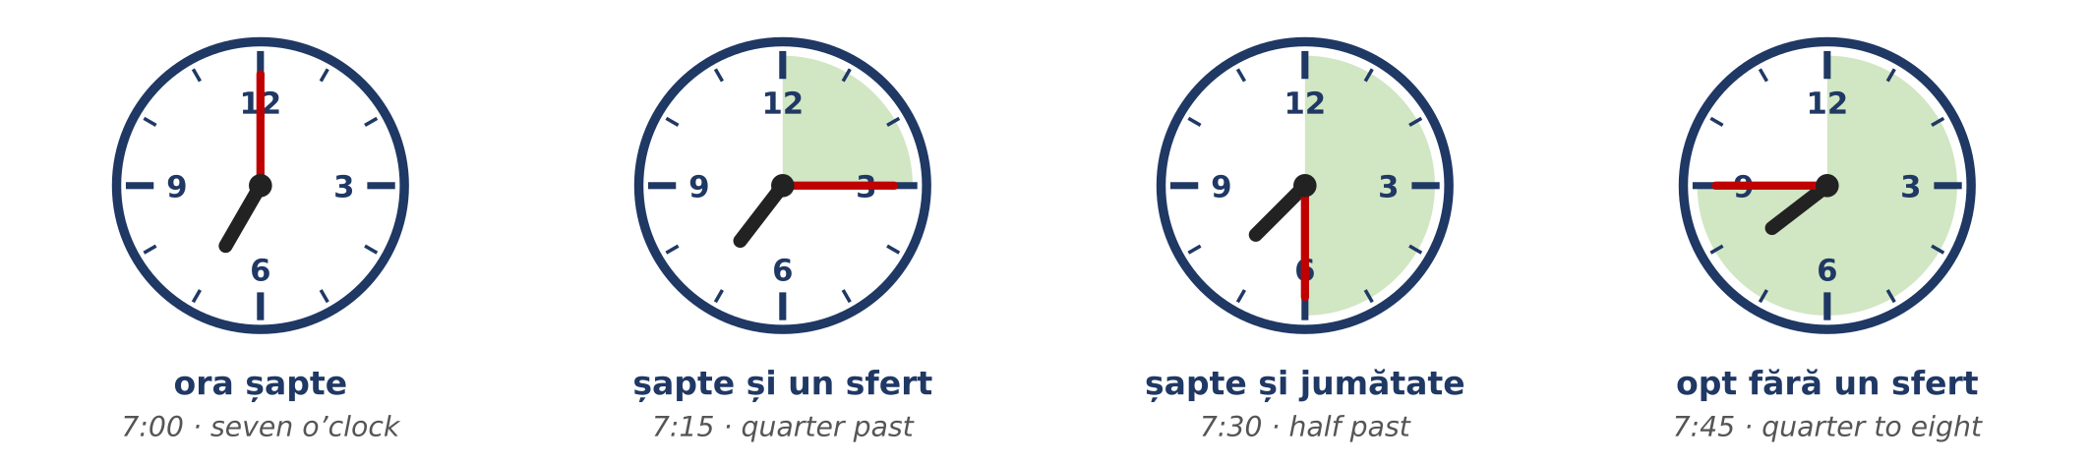
Fig. 5.7 — Ora exactă, sfertul, jumătatea / O’clock, quarter past, half past, quarter to
TIPAR — telling the time / cum spui ora
Este ora | + | HOUR | + | și un sfert · și jumătate

Este | + | NEXT HOUR | + | fără un sfert

TIME | ROMANIAN | ENGLISH
1:00 | Este ora unu. | It’s one o’clock.
2:00 | Este ora două. | It’s two o’clock.
7:00 | Este ora șapte. | It’s seven o’clock.
7:10 | Este ora șapte și zece. | It’s ten past seven.
7:15 | Este ora șapte și un sfert. | It’s quarter past seven.
7:30 | Este ora șapte și jumătate. | It’s half past seven.
7:45 | Este opt fără un sfert. | It’s quarter to eight.
7:50 | Este opt fără zece. | It’s ten to eight.
12:00 | Este ora douăsprezece. / Este amiaza. | It’s twelve o’clock. / It’s midday.
00:00 | Este miezul nopții. | It’s midnight.

ATTENTION / ATENȚIE — ORA DOUĂ, NOT ORA DOI
Ora is a feminine word, so the hour uses the feminine number: ora unu, ora două, ora douăsprezece — never ora doi. This is the same rule as două case in Lesson 2.5.

The 24-hour clock / Formatul de 24 de ore
Timetables, work schedules and official papers use the 24-hour clock. In speech people often use the 12-hour clock and add dimineața (in the morning), după-amiaza (in the afternoon) or seara (in the evening).
WRITTEN | OFFICIAL | EVERYDAY | ENGLISH
06:30 | ora șase și treizeci | șase și jumătate dimineața | 6:30 a.m.
14:00 | ora paisprezece | ora două după-amiaza | 2 p.m.
17:45 | ora șaptesprezece și patruzeci și cinci | șase fără un sfert seara | 5:45 p.m.
21:00 | ora douăzeci și unu | ora nouă seara | 9 p.m.

TIPAR — at what time? / la ce oră?
La ce oră...? | → | La ora | + | HOUR

TIPAR — from ... to ... / de la ... până la ...
de la ora | + | HOUR | + | până la ora | + | HOUR

ROMANIAN | ENGLISH
La ce oră începeți lucrul? — La ora șapte. | What time do you start work? — At seven.
La ce oră pleacă trenul? — La ora 9:15. | What time does the train leave? — At 9:15.
Am o programare la ora zece. | I have an appointment at ten.
Lucrez de la ora opt până la ora cinci. | I work from eight to five.
Pauza de masă este de la 12 la 12 și jumătate. | The lunch break is from 12 to 12:30.
Magazinul este deschis până la zece seara. | The shop is open until 10 p.m.

The days of the week / Zilele săptămânii
The Romanian week starts on Monday. Remember from Module 1: the names of the days are written with a small letter — luni, not Luni.
ROMANIAN | ENGLISH | EVERY WEEK | ENGLISH
luni | Monday | lunea | on Mondays
marți | Tuesday | marțea | on Tuesdays
miercuri | Wednesday | miercurea | on Wednesdays
joi | Thursday | joia | on Thursdays
vineri | Friday | vinerea | on Fridays
sâmbătă | Saturday | sâmbăta | on Saturdays
duminică | Sunday | duminica | on Sundays

TIPAR — once or every week? / o dată sau în fiecare săptămână?
Lucrez sâmbătă. | = | this Saturday (once)

Lucrez sâmbăta. | = | every Saturday

ROMANIAN | ENGLISH
Luni am o programare la IGI. | On Monday (this Monday) I have an appointment at IGI.
Lunea merg la curs. | On Mondays I go to the course.
Vineri plec acasă. | On Friday (this Friday) I go home.
Vinerea merg la piață. | On Fridays I go to the market.
Magazinul este închis duminica. | The shop is closed on Sundays.
Duminică mergem în parc. | On Sunday (this Sunday) we go to the park.

ROMANIAN | ENGLISH | ROMANIAN | ENGLISH
azi / astăzi | today | ieri | yesterday
mâine | tomorrow | poimâine | the day after tomorrow
săptămâna aceasta | this week | săptămâna viitoare | next week
weekendul | the weekend | în fiecare zi | every day

The months and the seasons / Lunile și anotimpurile
The months are also written with a small letter. Most of them look like the English names, so they are easy to learn. The seasons need no preposition: iarna = in winter, vara = in summer.
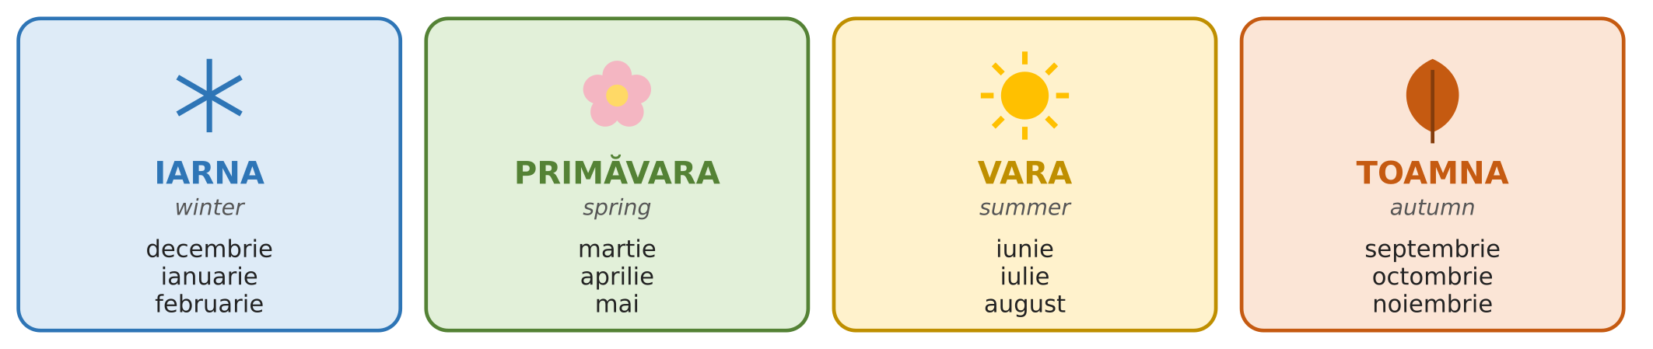
Fig. 5.8 — Anotimpurile și lunile / The seasons and the months
TIPAR — month and date / luna și data
în | + | MONTH | → | în mai

pe | + | DATE | → | pe 1 decembrie

ROMANIAN | ENGLISH
Concediul meu este în august. | My holiday is in August.
În ianuarie este frig. | In January it is cold.
Ziua mea de naștere este pe 5 mai. | My birthday is on 5 May.
Pe 1 decembrie este Ziua Națională. | On 1 December it is National Day.
Contractul meu începe pe 15 octombrie. | My contract starts on 15 October.
Ce dată este azi? — Azi este 23 septembrie. | What’s the date today? — Today is 23 September.
În ce lună suntem? — Suntem în septembrie. | What month is it? — It’s September.

ATTENTION / ATENȚIE — THE FIRST DAY OF THE MONTH
For the first day of a month Romanians say întâi: 1 decembrie = întâi decembrie, 1 martie = întâi martie. For all the other days use the normal numbers: doi mai, cincisprezece august. Dates are written day.month.year: 23.09.2026.

5.4.a Write the time
Write the time in Romanian, in words.
1. 1:00 → Este ora ______________. | 2. 3:30 → Este ora trei ______________.
3. 10:15 → Este ora zece ______________. | 4. 6:45 → Este ______________ fără un sfert.
5. 2:00 → Este ora ______________. | 6. 12:00 → Este ______________ (midday).

Lesson 5.5 — The weather and your day / Vremea și ziua ta
What’s the weather like? / Cum e vremea?
Romania has four clear seasons. Summers are hot — in the south 30–35 °C is normal in July and August. Winters are cold, with snow, and at night the temperature can fall to −10 °C or lower. Spring and autumn are short and pleasant, but it rains more. The weather decides a lot about your day: what you wear, how much water you drink, how you travel to work.
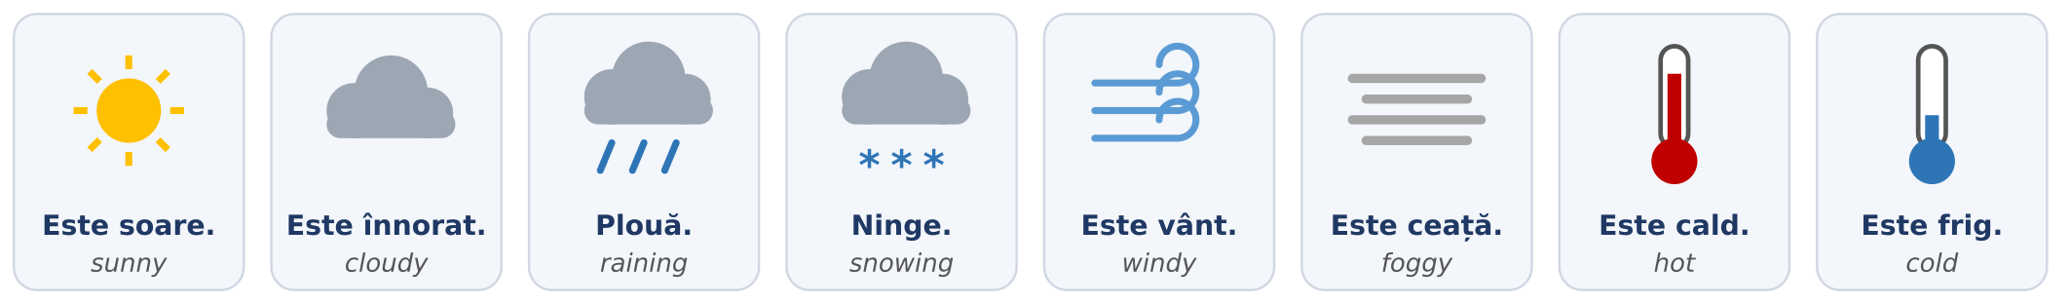
Fig. 5.9 — Vremea / The weather
TIPAR — weather sentences have no subject / fără subiect
Este | + | cald · frig · soare · vânt · înnorat · ceață

Plouă. · Ninge. | = | It’s raining. · It’s snowing.

ROMANIAN | ENGLISH | EXAMPLE
Este cald. | It’s warm / hot. | Vara este foarte cald.
Este frig. | It’s cold. | Iarna este frig afară.
Este soare. | It’s sunny. | Azi este soare și cald.
Este înnorat. | It’s cloudy. | Este înnorat, poate plouă.
Plouă. | It’s raining. | Plouă, luați o umbrelă!
Ninge. | It’s snowing. | Ninge de ieri.
Este vânt. | It’s windy. | Este vânt puternic — închideți fereastra!
Este ceață. | It’s foggy. | Dimineața este ceață pe drum.
Este polei. | It’s icy (roads). | Atenție, este polei!
Este răcoare. | It’s cool. | Seara este răcoare, luați o geacă.

TIPAR — the temperature / temperatura
Sunt | + | NUMBER | + | de grade | → | Sunt 30 de grade.

Remember Lesson 2.5: from 20 up you add de — 20 de grade, 35 de grade; but 5 grade, 12 grade. Below zero: minus 5 grade. Romania uses degrees Celsius.
PRACTICAL NOTE — WEATHER WARNINGS / AVERTIZĂRI METEO
The national weather service (ANM, Administrația Națională de Meteorologie) publishes warnings by colour, and on your phone you may receive an RO-ALERT message. Cod galben (yellow) = be careful. Cod portocaliu (orange) = dangerous weather. Cod roșu (red) = very dangerous. In a heat wave (caniculă) drink water often and stay out of the sun at midday. In strong wind (vânt puternic) stay away from trees and old buildings. With ice on the road (polei) walk and drive slowly. Always read the RO-ALERT message and do what it says.

The weather in each season
IARNA — winter | PRIMĂVARA — spring | VARA — summer | TOAMNA — autumn
Este frig. Ninge. | Este mai cald. | Este foarte cald. | Este răcoare.
Este polei. | Plouă des. | Este soare. | Plouă. Este ceață.
minus 5 grade | 15 grade | 35 de grade | 10 grade

Your day / Ziua ta
A day in Romania has four parts. For each part there is a word you will use every day: dimineața (in the morning), la prânz (at midday), după-amiaza (in the afternoon), seara (in the evening). At night is noaptea.
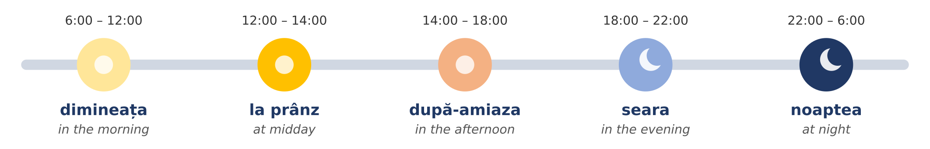
Fig. 5.10 — O zi obișnuită / An ordinary day
RECAP — REFLEXIVE VERBS (Lesson 3.12)
Nothing new here: you learned these verbs in Module 3. Some verbs always need a small word before them: mă, te, se, ne, vă, se. I wake up = mă trezesc (literally I wake myself). Now use them to talk about your day.

PERSON | A SE TREZI — to wake up | A SE CULCA — to go to bed | A SE ODIHNI — to rest
eu | mă trezesc | mă culc | mă odihnesc
tu | te trezești | te culci | te odihnești
el / ea | se trezește | se culcă | se odihnește
noi | ne trezim | ne culcăm | ne odihnim
voi / dvs. | vă treziți | vă culcați | vă odihniți
ei / ele | se trezesc | se culcă | se odihnesc

ROMANIAN | ENGLISH
La ce oră te trezești? — Mă trezesc la ora cinci. | What time do you wake up? — I wake up at five.
Copiii se culcă la ora nouă. | The children go to bed at nine.
Duminica ne odihnim. | On Sundays we rest.

More verbs for your day — eu
ROMANIAN (eu) | ENGLISH | ROMANIAN (eu) | ENGLISH
iau micul dejun | I have breakfast | iau prânzul | I have lunch
plec la lucru | I leave for work | lucrez | I work
merg cu autobuzul | I go by bus | termin lucrul | I finish work
mă întorc acasă | I come back home | gătesc | I cook
iau cina | I have dinner | mă uit la televizor | I watch TV
vorbesc cu familia | I talk to my family | dorm | I sleep

COMMON MISTAKE
a se trezi (to wake up) ≠ a se culca (to go to bed). Mă trezesc is in the morning, mă culc is in the evening. And a mânca (to eat) is correct, but for meals Romanians usually say iau micul dejun / prânzul / cina — I take breakfast / lunch / dinner.

Read — two days
Read each text twice, out loud. The English is on the right — cover it and try to understand the Romanian first.
Text 1 — Kumar, a working day Mă numesc Kumar și sunt din Sri Lanka. Lucrez într-un supermarket în județul Ilfov. Mă trezesc în fiecare zi la ora cinci și jumătate. Mă spăl și iau micul dejun. La ora șase și jumătate iau autobuzul. Lucrez de la ora șapte până la ora patru. La prânz, de la douăsprezece la douăsprezece și jumătate, iau prânzul cu colegii. Iarna este frig afară și aștept autobuzul în stație. Vara este foarte cald și beau multă apă. Seara mă întorc acasă, gătesc și vorbesc la telefon cu familia. Mă culc la ora zece. | My name is Kumar and I’m from Sri Lanka. I work in a supermarket in Ilfov county. I wake up every day at half past five. I wash and have breakfast. At half past six I take the bus. I work from seven to four. At midday, from twelve to half past twelve, I have lunch with my colleagues. In winter it is cold outside and I wait for the bus at the stop. In summer it is very hot and I drink a lot of water. In the evening I come back home, I cook and I talk on the phone with my family. I go to bed at ten.

Text 2 — Ana, a Saturday Sâmbăta mă trezesc târziu, la ora nouă. Afară este frumos: este soare și sunt 25 de grade. Iau micul dejun și apoi merg cu metroul în centru. La ora unsprezece am o programare la Primărie. Vorbesc cu funcționara și spun „dumneavoastră”. După-amiaza merg în parc. Seara iau cina cu prietenii și mă culc la ora douăsprezece. | On Saturdays I wake up late, at nine. Outside it is nice: it’s sunny and 25 degrees. I have breakfast and then I take the metro to the centre. At eleven I have an appointment at the town hall. I talk to the clerk and say “dumneavoastră”. In the afternoon I go to the park. In the evening I have dinner with friends and I go to bed at twelve.

în fiecare zi — every day · aștept — I wait · beau — I drink · târziu — late · funcționara — the (female) clerk · afară — outside
5.5.a Choose the correct word
Circle the correct form.
1. Iarna este ( cald / frig ). | 2. ( Plouă / Este plouă ). Luați o umbrelă!
3. Eu ( mă / se ) trezesc la ora șase. | 4. Noi ( ne / vă ) culcăm la ora zece.
5. Sunt 30 de ( grade / ore ). Este cald. | 6. Dimineața iau ( micul dejun / cina ).
7. Tu la ce oră ( te trezești / mă trezesc )? | 8. Seara ( mă culc / mă trezesc ).

HOMEWORK — AFTER SESSION 21 / TEMĂ PENTRU ACASĂ
H21.1 Every morning this week, say out loud the day, the date, the time and the weather: Azi este luni, 12 octombrie. Este ora șapte. Plouă. Sunt 10 grade.
H21.2 Write your own day, like Text 1, in six sentences with the hours: Mă trezesc la ora ... Plec la lucru la ...

SESSION 22 — HOLIDAYS, TRADITIONS, RECAP AND TEST
SESIUNEA 22 — SĂRBĂTORI ȘI TRADIȚII, RECAPITULARE ȘI TEST · 3 hours

By the end of this session you will be able to:
☐ | know which days are legal days off in Romania — all of them
☐ | tell the difference between a legal day off and a tradition
☐ | tell the story of the two national days: 24 January and 1 December
☐ | understand the main customs of Christmas, New Year, Easter, 1 March and other celebrations, and wish people well: Crăciun fericit! La mulți ani! Hristos a înviat!
☐ | revise the whole module and sit the Module 5 test

Lesson 5.6 — Holidays and traditions / Sărbători și tradiții
Romania has a rich calendar of celebrations. Most of them are religious — about three in four Romanians are Orthodox Christians (2021 census) — and some are national. There are two kinds of days, and it is important not to mix them up:
Zi liberă legală | a legal day off: the law (the Labour Code, Codul Muncii, art. 139) says that employees do not work that day. There are 17 such days a year.
Tradiție | a tradition: people celebrate it, give presents or cook special food, but it is a normal working day.

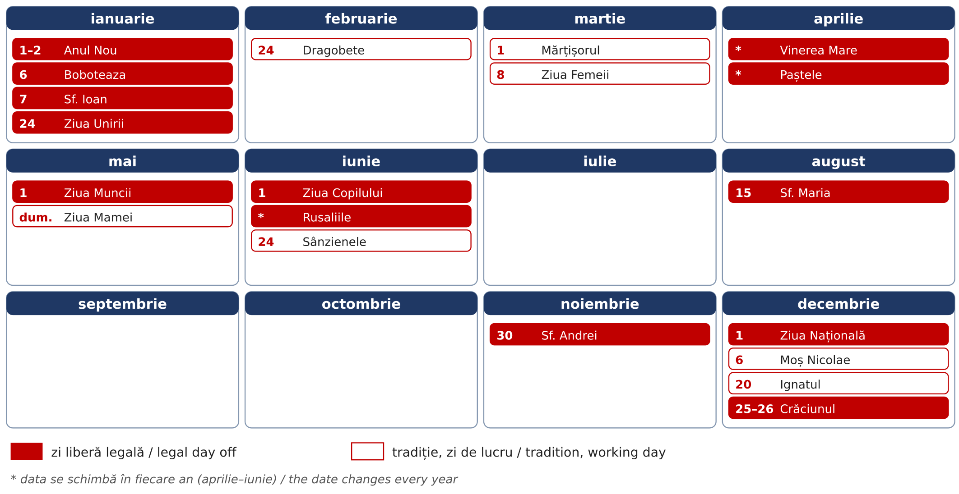
Fig. 5.11 — Calendarul sărbătorilor / The calendar of celebrations (red = legal day off, white = tradition)
Table 1 — the legal days off / zilele libere legale
DATE | IN ROMANIAN | IN ENGLISH | WHAT IT IS
1 and 2 January | Anul Nou | New Year | the first two days of the year
6 January | Boboteaza | Epiphany | the baptism of Jesus; priests bless the water
7 January | Sfântul Ioan | St John the Baptist | name day of everyone called Ion, Ioana, Ionuț
24 January | Ziua Unirii Principatelor | Union Day | the union of Moldova and Țara Românească in 1859 (see below)
changes every year | Vinerea Mare | Good Friday | the Friday before Orthodox Easter
changes every year | Paștele (2 days) | Easter Sunday and Monday | the most important Christian holiday
1 May | Ziua Muncii | Labour Day | the international day of workers
1 June | Ziua Copilului | Children’s Day | a day for children
changes every year | Rusaliile (2 days) | Pentecost | 50 days after Easter
15 August | Adormirea Maicii Domnului | St Mary’s Day | feast of the Virgin Mary; name day of Maria, Marian
30 November | Sfântul Andrei | St Andrew’s Day | the patron saint of Romania
1 December | Ziua Națională | National Day | the Great Union of 1918 (see below)
25 and 26 December | Crăciunul | Christmas | the birth of Jesus

Count them: 2 + 1 + 1 + 1 + 1 + 2 + 1 + 1 + 2 + 1 + 1 + 1 + 2 = 17 days. Some years two holidays fall on the same day (in 2026, Pentecost Monday was on 1 June).
PRACTICAL NOTE — IF YOU ARE NOT CHRISTIAN
The Labour Code also gives employees who belong to other legally recognised religions (for example Muslims or Jews) two days off for each of three annual religious holidays of their own faith. Tell your employer in advance which days you need. On the Christian legal holidays everyone has the day off, whatever their religion.

Table 2 — traditions (normal working days) / tradiții
DATE | IN ROMANIAN | IN ENGLISH | WHAT PEOPLE DO
24 February | Dragobete | Romanian Day of Love | couples give flowers; the old folk “Valentine’s Day”
1 March | Mărțișorul | Spring token day | men give women a red-and-white token (see below)
1–9 March | Babele | The Old Women’s days | each person chooses a day; its weather shows your year
8 March | Ziua Femeii | Women’s Day | flowers for mothers, wives, colleagues
changes | Lăsatul Secului | the start of the Easter fast | a big family meal before 40 days of fasting
changes | Floriile | Palm Sunday | one week before Easter; willow branches are blessed in church
first Sunday of May | Ziua Mamei | Mother’s Day | flowers and presents for mothers
24 June | Sânzienele | Midsummer | village girls wear crowns of yellow wild flowers
6 December | Moș Nicolae | St Nicholas | children clean their boots; in the morning they find sweets inside
20 December | Ignatul | St Ignatius | in villages, the family pig is killed for Christmas

Winter — Christmas and New Year / Crăciunul și Anul Nou
Crăciunul is the biggest family holiday of the year. The preparations start early. On 20 December, the day of Ignatul, many families in the villages kill the pig they have raised during the year (tăiatul porcului). From the meat they make the Christmas food: cârnați (sausages), tobă and caltaboș (traditional pork dishes), piftie (meat in jelly) and above all sarmale — cabbage leaves rolled around minced meat and rice. The sweet bread of every holiday is cozonac.
On Christmas Eve (Ajunul Crăciunului, 24 December) groups of children and young people go from house to house singing colinde (carols). The family opens the door, listens, and gives them apples, nuts, cozonac or a little money. At night Moș Crăciun (Father Christmas) brings presents under the decorated tree (bradul de Crăciun). On 25 December many people go to church in the morning and then eat together with the whole family.
FOTO: Grup de colindători (copii) la ușa unei case, în Ajunul Crăciunului, cu zăpadă
Fig. 5.12 — Colindători în Ajunul Crăciunului / Carol singers on Christmas Eve
On 31 December, Revelionul (New Year’s Eve), people celebrate with friends until midnight, with music and fireworks, and say La mulți ani! (literally to many years). On 31 December and 1 January children go round with two old customs: Plugușorul — a long rhyme about ploughing, with bells and a whip, wishing a rich harvest — and Sorcova — a decorated stick they touch you with, wishing you health. On 6 January, Boboteaza, priests bless the water; in some towns young men jump into an icy river to catch a wooden cross thrown by the priest.
Spring — Dragobete and Mărțișorul
Dragobete (24 February) is an old Romanian celebration of love. In folk stories Dragobete is a handsome young man who protects lovers, and this is the day when the birds choose their partners. Young people used to go into the forest to pick the first spring flowers. Today couples give each other flowers or a small present.
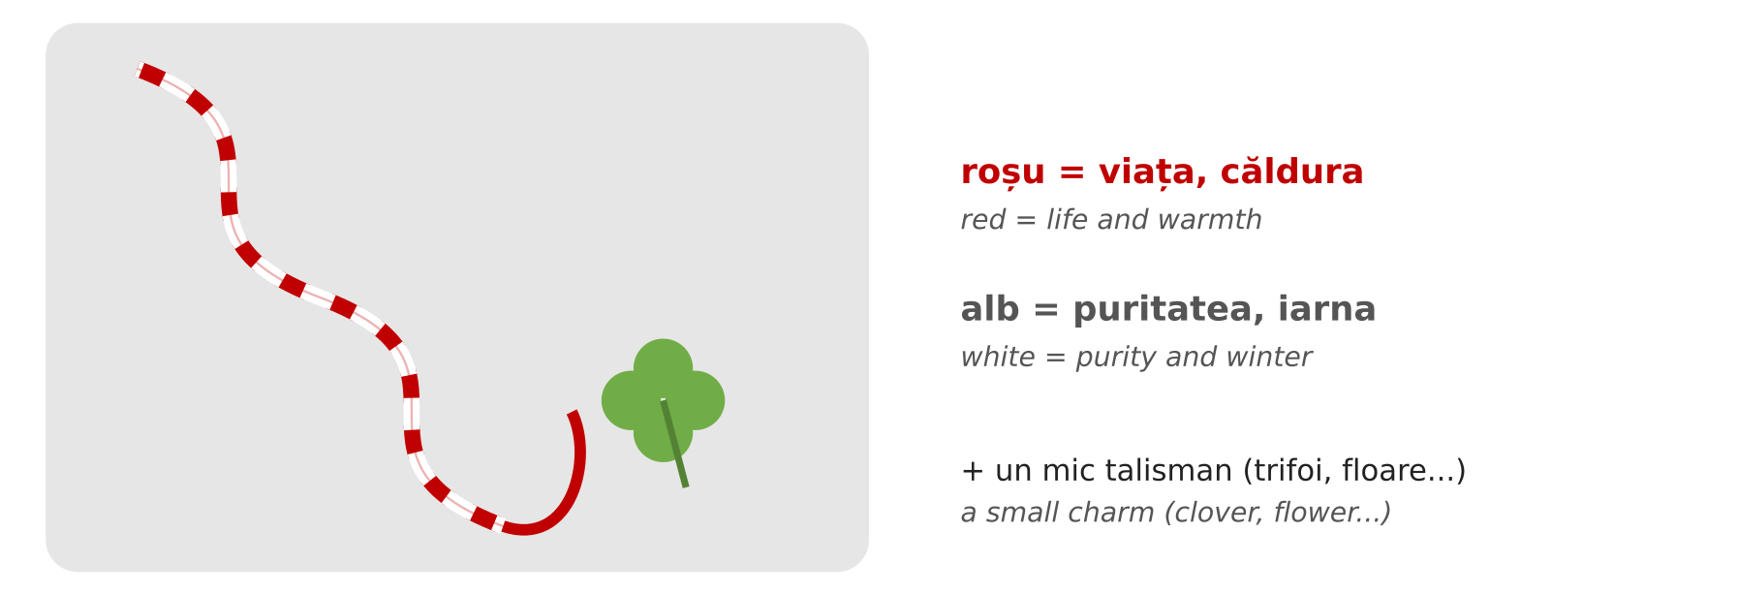
Fig. 5.13 — Un mărțișor / A mărțișor
Mărțișorul (1 March) welcomes the spring. A mărțișor is a thin cord of two twisted threads, one red and one white, with a small charm: a flower, a four-leaf clover, a ladybird, a chimney sweep or a horseshoe. The red stands for life and warmth, the white for purity and winter. Men give mărțișoare to the women in their life — mother, wife, daughter, sisters, female colleagues, even the lady at the shop they visit every day. Women pin it on their coat, near the heart, or wear it as a bracelet.
There are regional differences. Traditionally the mărțișor was worn for the whole month of March, or until you see the first tree in blossom — then you hang it on a branch of the tree, for good luck. In Moldova a small silver or gold coin was often tied to the cord. In some parts of Transylvania and Banat the cord was tied to gates, doors and even animals, to protect them. In a few places it is the women who give mărțișoare to the men. And from 1 to 9 March come Babele (the old women): everybody chooses one of these days, and if the weather is sunny on your day, your whole year will be good.
A week later, on 8 March, is Ziua Femeii (Women’s Day): again men bring flowers — to their mother, wife and female colleagues. On both days, a small bunch of snowdrops (ghiocei) is the classic present.
Spring — Easter / Paștele
Paștele, Easter, is the most important religious holiday in Romania. Its date follows the Orthodox calendar and changes every year (in April or early May). Before Easter comes a 40-day fast (Postul Paștelui), when believers eat no meat, no milk and no eggs. It begins after Lăsatul Secului — the Sunday when families meet for a last big meal with meat and cheese, make peace with anyone they have argued with, and in some villages light bonfires to chase away the winter. One week before Easter, on Floriile (Palm Sunday), people take willow branches (ramuri de salcie) to church to be blessed.
In the Holy Week (Săptămâna Mare) people clean the house and cook. Every evening there is a special church service called Denia; on Good Friday (Vinerea Mare) many people pass under the table with the icon of Christ in church. On Thursday, eggs are dyed red (vopsitul ouălor) — the red colour stands for the blood of Christ and for new life. In Bucovina, women decorate the eggs with fine patterns in wax (ouă încondeiate) — real works of art.

IMAGINE: ouă roșii de Paști
Fig. 5.14 — Un ou roșu de Paști / A red Easter egg
On Saturday night, just before midnight, people gather at the church with an unlit candle. At midnight the priest comes out with the Holy Light and says Hristos a înviat! (Christ is risen!); everybody answers Adevărat a înviat! (Truly he is risen!) and lights their candle from their neighbour’s — the whole churchyard fills with small flames. People carry the light of the Resurrection (Lumina de Înviere) carefully home, still burning, and many go to the cemetery to light candles on the graves of their family. On Easter Sunday the family eats together: red eggs, drob (a lamb and herb terrine), lamb soup (ciorbă de miel), roast lamb, cozonac and pască (a sweet cheese cake). Before the meal everyone knocks red eggs together (ciocnitul ouălor): one person says Hristos a înviat!, the other Adevărat a înviat! — and whoever keeps an unbroken egg is said to have a lucky year.
FOTO: Noaptea de Înviere: oameni cu lumânări aprinse în curtea unei biserici
Fig. 5.15 — Noaptea de Înviere: lumânări aprinse în curtea bisericii / Easter night: lit candles in the churchyard
Summer and autumn
Rusaliile (Pentecost) come 50 days after Easter; in the countryside houses are decorated with green branches of walnut or linden. On 24 June, Sânzienele, village girls wear crowns of yellow wild flowers (sânziene). On 15 August, Sfânta Maria, thousands of pilgrims go to monasteries — especially in Moldova and Maramureș. On 30 November, Sfântul Andrei, the patron saint of Romania, folk tradition says evil spirits walk in the night, so people rub garlic on doors and windows to protect the house.
CULTURAL NOTE — NAME DAYS / ZIUA NUMELUI
Romanians celebrate not only their birthday but also their name day (onomastica) — the feast of the saint with the same name. On 7 January everybody called Ion or Ioana celebrates, on 23 April every Gheorghe and George, on 21 May every Constantin and Elena, on 15 August every Maria and Marian, on 30 November every Andrei, on 6 December every Nicolae. At work, colleagues often bring cakes on their name day. The wish is the same as for a birthday: La mulți ani!

The two national days — 24 January and 1 December / Cele două uniri
Two legal days off tell the story of how Romania was born. Look at the timeline first, then read.
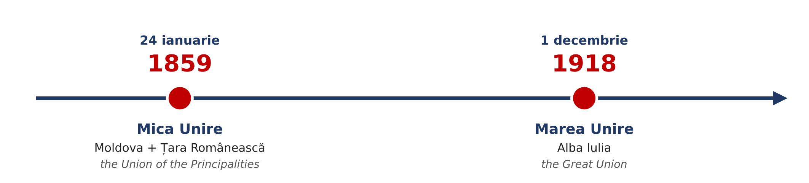
Fig. 5.16 — Cele două uniri / The two unions
24 January 1859 — the Union of the Principalities (Unirea Principatelor, also called Mica Unire, the Small Union). In the middle of the 19th century there was no country called Romania. People who spoke Romanian lived in several separate lands. Two of them were principalities (principate) — small states, each with its own ruler: Moldova in the east and Țara Românească (Wallachia) in the south. The people of both lands spoke the same language and wanted to live in one country. In January 1859 both chose the same man as their ruler (domnitor): Alexandru Ioan Cuza. Moldova elected him on 5 January and Țara Românească on 24 January 1859. From that day the two lands had one ruler, and in 1862 they had one government and one capital, Bucharest. This was the first step towards modern Romania. Cuza also made important reforms, and in his time the first Romanian universities opened, in Iași (1860) and Bucharest (1864).
Today 24 January is a legal day off. In Iași, in Focșani — the old border town between the two principalities — and in Bucharest, people meet in the main square and dance the Hora Unirii, “the round dance of the union”: everybody holds hands in a big circle, to show that they are together.
1 December 1918 — the Great Union (Marea Unire). After 1859 many Romanians still lived outside the country: in Transylvania, Banat, Crișana and Maramureș, which were then part of Austria-Hungary, and in Bessarabia and Bucovina. At the end of the First World War, in 1918, these lands decided one after another to join Romania: Bessarabia on 27 March, Bucovina on 28 November. On 1 December 1918, in the city of Alba Iulia, a great national assembly of 1,228 delegates — with around 100,000 people who came to watch — voted the union of Transylvania, Banat, Crișana and Maramureș with Romania. So in one year the country became more than twice as big, and nearly all Romanians lived in one state. Since 1990, 1 December is Romania’s National Day (Ziua Națională).
On 1 December there is a big military parade in Bucharest, under the Arch of Triumph (Arcul de Triumf), and another one in Alba Iulia. Soldiers march, planes fly over the city, and thousands of people watch. People hang the flag — blue, yellow and red (albastru, galben, roșu) — on houses, cars and balconies, and wish each other La mulți ani, România! The traditional dish of the day is fasole cu cârnați (beans with sausages), the soldiers’ food, often given out free to the public at the celebrations.
FOTO: Parada militară de 1 Decembrie la Arcul de Triumf, București, cu drapele tricolore
Fig. 5.17 — Parada de 1 Decembrie la Arcul de Triumf / The 1 December parade at the Arch of Triumph
ROMANIAN | ENGLISH
Pe 24 ianuarie sărbătorim Unirea Principatelor. | On 24 January we celebrate the Union of the Principalities.
În 1859, Moldova și Țara Românească au avut un singur domnitor: Alexandru Ioan Cuza. | In 1859, Moldova and Țara Românească had one ruler: Alexandru Ioan Cuza.
1 Decembrie este Ziua Națională a României. | 1 December is Romania’s National Day.
Marea Unire s-a votat la Alba Iulia, în 1918. | The Great Union was voted in Alba Iulia, in 1918.
La București este o paradă militară. | In Bucharest there is a military parade.
La mulți ani, România! | Happy birthday, Romania!

Wishes for every occasion / Urări
WHEN | ROMANIAN | ENGLISH
birthday, name day, New Year | La mulți ani! | Many happy returns! / Happy New Year!
Christmas | Crăciun fericit! | Merry Christmas!
New Year | Un An Nou fericit! | Happy New Year!
Easter (greeting) | Hristos a înviat! | Christ is risen!
Easter (answer) | Adevărat a înviat! | Truly he is risen!
any holiday | Sărbători fericite! | Happy holidays!
1 March, 8 March | O primăvară frumoasă! | Have a lovely spring!

5.6.a When is it?
Match the date with the celebration. Write the letter.
1. 24 februarie ____ | 2. 1 martie ____ | 3. 20 decembrie ____
4. 1 decembrie ____ | 5. 25 decembrie ____ | 6. 6 ianuarie ____
7. 15 august ____ | 8. 30 noiembrie ____ | 9. 24 ianuarie ____

A Boboteaza · B Crăciunul · C Ziua Națională · D Dragobete · E Sfânta Maria · F Mărțișorul · G Sfântul Andrei · H Ignatul · I Ziua Unirii Principatelor

Lesson 5.7 — General recap / Recapitulare generală
Before the test, look back over the whole module.
The words
ROMANIA | INSTITUTIONS | TIME | WEATHER & DAY
București · leul | Primăria | Este ora ... | Este cald / frig.
albastru, galben, roșu | ITM | și un sfert / și jumătate | Plouă. Ninge.
UE 2007 · NATO 2004 | IGI | fără un sfert | Sunt 20 de grade.
Marea Neagră · Dunărea · Carpații | Poliția | luni ... duminică | mă trezesc · mă culc
Transilvania · Moldova · Banat | 112 | ianuarie ... decembrie | iau micul dejun
județul · sectorul | Este o urgență! | iarna · primăvara · vara · toamna | dimineața · seara

The patterns
PATTERN | EXAMPLE
Sunt din... · Locuiesc în... · Lucrez în județul... | Sunt din Nepal. Locuiesc în Brașov.
officials → dumneavoastră | Unde semnez, vă rog? (to the clerk)
Este ora + hour · ora două (feminine) | Este ora două și jumătate.
la + hour · în + month · pe + date | la ora opt · în mai · pe 1 decembrie
luni (once) · lunea (every week) | Lucrez lunea și marțea.
weather: no subject | Plouă. Este frig. Sunt minus 5 grade.
mă, te, se, ne, vă, se + verb (recap, Lesson 3.12) | Mă trezesc. Ne culcăm. Se odihnește.
legal day off ≠ tradition | 1 Decembrie = liber · 1 Martie = zi de lucru
the two unions | 24 ianuarie 1859 · 1 decembrie 1918, Alba Iulia

5.7.a Everything together
Circle the correct word.
1. Locuiesc ( în / pe ) Brașov. | 2. Pentru permisul de ședere merg la ( IGI / ITM ).
3. La Poliție spun ( tu / dumneavoastră ). | 4. Este ora ( două / doi ).
5. Ziua mea de naștere este ( pe / în ) 5 mai. | 6. Concediul meu este ( în / pe ) august.
7. Afară ( ninge / este ninge ). | 8. Ea ( se / mă ) trezește devreme.

SECȚIUNE DETAȘABILĂ — EXEMPLAR FORMATOR
Detachable section — teacher’s copy. Se detașează din suportul cursantului; testul completat, semnat și datat, se păstrează la dosarul cursantului. Conține: testul cumulativ, fișa de confirmare a Sesiunii 22, fișa de evidență a Modulului 5, cheia răspunsurilor.

TEST CUMULATIV — MODULUL 5
MODULE 5 — CUMULATIVE TEST · grilă, 20 de întrebări, 20 de puncte · semnat și datat de cursant

Nume și prenume cursant / Student name
Data / Date | _____ / _____ / 20_____
Semnătura cursantului / Student signature

Marcați cu X un singur răspuns la fiecare întrebare. Mark ONE answer with X for each question. Each correct answer = 1 point.
1. Capitala României este: (1 p)
☐ a) Cluj-Napoca | ☐ b) București
☐ c) Iași | ☐ d) Constanța
2. Moneda României este: (1 p)
☐ a) euro | ☐ b) dolarul
☐ c) leul | ☐ d) forintul
3. Drapelul României are culorile: (1 p)
☐ a) roșu, alb, verde | ☐ b) albastru, galben, roșu
☐ c) alb, albastru, roșu | ☐ d) negru, roșu, galben
4. Orașul Timișoara este în regiunea: (1 p)
☐ a) Moldova | ☐ b) Banat
☐ c) Dobrogea | ☐ d) Oltenia
5. România este membră a Uniunii Europene din: (1 p)
☐ a) 1989 | ☐ b) 2004
☐ c) 2007 | ☐ d) 2018
6. Pentru permisul de ședere mergeți la: (1 p)
☐ a) Primărie | ☐ b) ITM
☐ c) IGI | ☐ d) Poliție
7. Nu ați primit salariul. Faceți o sesizare la: (1 p)
☐ a) ITM | ☐ b) IGI
☐ c) 112 | ☐ d) farmacie
8. Într-o urgență sunați la: (1 p)
☐ a) 911 | ☐ b) 100
☐ c) 112 | ☐ d) 999
9. La ghișeu, la Primărie, spuneți: (1 p)
☐ a) tu | ☐ b) dumneavoastră
☐ c) voi | ☐ d) el
10. Pe ușa magazinului scrie „ÎNCHIS”. Înseamnă: (1 p)
☐ a) open | ☐ b) closed
☐ c) push | ☐ d) pull
11. Ora 8:45 se spune: (1 p)
☐ a) opt și un sfert | ☐ b) nouă fără un sfert
☐ c) opt și jumătate | ☐ d) nouă și un sfert
12. „Lucrez lunea.” înseamnă: (1 p)
☐ a) I worked on Monday. | ☐ b) I work on Mondays.
☐ c) I don’t work on Monday. | ☐ d) I work in the morning.
13. Care lună este vara? (1 p)
☐ a) iulie | ☐ b) ianuarie
☐ c) octombrie | ☐ d) martie
14. „Plouă.” înseamnă: (1 p)
☐ a) It’s snowing. | ☐ b) It’s windy.
☐ c) It’s raining. | ☐ d) It’s sunny.
15. Care propoziție este corectă? (1 p)
☐ a) Eu mă trezesc la ora șase. | ☐ b) Eu se trezesc la ora șase.
☐ c) Eu ne trezim la ora șase. | ☐ d) Eu vă treziți la ora șase.
16. Ziua Națională a României este pe: (1 p)
☐ a) 24 ianuarie | ☐ b) 1 mai
☐ c) 1 decembrie | ☐ d) 1 iunie
17. Pe 24 ianuarie sărbătorim: (1 p)
☐ a) Ziua Muncii | ☐ b) Unirea Principatelor
☐ c) Crăciunul | ☐ d) Ziua Copilului
18. Marea Unire din 1918 s-a votat în orașul: (1 p)
☐ a) Iași | ☐ b) Constanța
☐ c) Alba Iulia | ☐ d) Timișoara
19. Mărțișorul se oferă pe: (1 p)
☐ a) 1 martie | ☐ b) 24 februarie
☐ c) 25 decembrie | ☐ d) 1 ianuarie
20. Care zi NU este zi liberă legală? (1 p)
☐ a) Crăciunul | ☐ b) 1 Mai
☐ c) Dragobete | ☐ d) Ziua Copilului

PUNCTAJ OBȚINUT / SCORE | _______ / 20
Semnătura formatorului / Teacher signature

SESSION COMPLETION RECORD
FIȘĂ DE CONFIRMARE A PARCURGERII SESIUNII — se păstrează la dosar

Module / Modul | Modulul 5 — Orientare România și Timpul (finalizat)
Session / Sesiunea | Sesiunea 22 — Sărbători și tradiții, recapitulare. TEST CUMULATIV MODULUL 5
Duration / Durata | 3 ore
Date / Data | _____ / _____ / 20_____
Student name / Nume și prenume cursant
Score / Punctaj obținut | _______ / 20
Student signature / Semnătura cursantului
Teacher signature / Semnătura formatorului

DECLARAȚIE CURSANT / STUDENT DECLARATION
Declar că am participat la această sesiune de curs și am parcurs conținutul prezentat mai sus.
I declare that I attended this course session and covered the content presented above.

MODULE 5 — COMPLETION RECORD
FIȘĂ DE EVIDENȚĂ A PARCURGERII MODULULUI 5 — se păstrează la dosarul cursantului

Cursant / Student
Act de identitate / ID document
Angajator / Employer
Formator / Teacher
Modul / Module | Modulul 5 — Orientare România și Timpul (12 ore, Sesiunile 19–22)

NR. | SESIUNE / CONȚINUT | DATA | PUNCTAJ TEST | SEMNĂTURA CURSANTULUI
19 | Sesiunea 19 — România: regiuni, orașe, simbolurile naționale; instituțiile esențiale (3 ore) |  | —
20 | Sesiunea 20 — Apelul la 112, la Primărie; reguli sociale (3 ore) |  | —
21 | Sesiunea 21 — Timpul: ora, zilele, lunile, anotimpurile; vremea și ziua ta (3 ore) |  | —
22 | Sesiunea 22 — Sărbători și tradiții, 24 Ianuarie și 1 Decembrie, recapitulare + TEST CUMULATIV (3 ore) |  | ___ / 20

CONFIRMARE FINALIZARE MODUL / MODULE COMPLETION
Confirm că cursantul a parcurs integral conținutul Modulului 5 — Orientare România și Timpul, în total 12 ore de curs, și a susținut testul de evaluare consemnat mai sus.
I confirm that the student completed the full content of Module 5 — Romania and Time, 12 course hours in total, and sat the assessment recorded above.
Data: _____ / _____ / 20_____ Semnătura formatorului: ______________________

ANSWER KEY — TEACHER COPY
CHEIA RĂSPUNSURILOR — pentru formator

Session 19
5.1.a București · Constanța · Transilvania · Banat · Moldova · leul · roșu
Session 20
5.2.a ITM · IGI · Primăria · Poliția · 112 · ITM
5.3.a dumneavoastră · tu · dumneavoastră · tu · dumneavoastră · dumneavoastră
Session 21
5.4.a unu · și jumătate · și un sfert · șapte · două · amiaza
5.5.a frig · Plouă · mă · ne · grade · micul dejun · te trezești · mă culc
Session 22
5.6.a 1-D · 2-F · 3-H · 4-C · 5-B · 6-A · 7-E · 8-G · 9-I
5.7.a în · IGI · dumneavoastră · două · pe · în · ninge · se
Cumulative test — grilă answer key
Un răspuns corect = 1 punct. Nemarcat sau dublu marcat = 0 puncte.
1 – b | 2 – c | 3 – b | 4 – b | 5 – c | 6 – c | 7 – a | 8 – c | 9 – b | 10 – b
11 – b | 12 – b | 13 – a | 14 – c | 15 – a | 16 – c | 17 – b | 18 – c | 19 – a | 20 – c

TOTAL: 20 puncte
Source check / Verificarea surselor — verified 23.09.2026
· Legal days off: Codul Muncii (Legea nr. 53/2003), art. 139 — 17 days, list unchanged in 2026; days for other legal religions: art. 139 alin. (2).
· 24 January as a national holiday: Legea nr. 171/2014; as a legal day off: Legea nr. 176/2016 (amending art. 139). Cuza elected ruler of Moldova on 5 January 1859 and of Țara Românească on 24 January 1859.
· 1 December as National Day: Legea nr. 10/1990. Great National Assembly of Alba Iulia, 1 December 1918; union of Bessarabia 27 March 1918, of Bucovina 28 November 1918.
· The flag (colours and order, blue next to the pole) and the official language: Constituția României, art. 12 and art. 13.
· NATO membership: 29 March 2004. European Union membership: 1 January 2007. Currency: leu (RON); Romania has not adopted the euro.
· Population, city populations and religion: 2021 census, rounded (Orthodox ≈ 73% of the total population).
· Weather warnings: ANM colour codes (yellow, orange, red); RO-ALERT. Residence permit extension: at least 30 days before expiry (IGI).
· Course basis: O.U.G. nr. 32/2026, art. 7 alin. (1) lit. g). The dates of Easter and Pentecost change every year.

LIMBA ROMÂNĂ PENTRU STRĂINI
Romanian Language for Foreign Workers
SUPORT DE CURS

MODULE 6 — CLOTHES AND MY HOME
MODULUL 6 — HAINE ȘI CASA MEA
LEVEL / NIVEL | DURATION / DURATĂ | LANGUAGE OF TEACHING
A1 — after Module 5 | 9 hours · Sessions 23–25 · Weeks 12–13 | English → Romanian

LEGAL BASIS / TEMEI LEGAL
Curs de limbă română cu elemente de integrare culturală și socială, organizat în conformitate cu O.U.G. nr. 32/2026, art. 7 alin. (1) lit. g) — minimum 6 luni, cel puțin 6 ore pe săptămână.
Romanian language course with cultural and social integration elements, organised under Government Emergency Ordinance no. 32/2026, art. 7(1)(g) — at least 6 months, at least 6 hours per week.
This module ends with ONE cumulative multiple-choice test (20 questions), signed and dated by the student and kept on file as proof of completion. There is no separate test after each session.

Before you start
Module 5 taught you about Romania, time, the calendar and the weather. Module 6 brings Romanian into two places you use every day: the clothes shop and your home. You will name clothes and shoes, ask for your size, buy something in a shop, name the rooms and the furniture of a home, and describe where you live.
You need these lessons first — look back at them if you are not sure:
YOU NEED | WHERE | WHY
un / o — the gender of nouns | Lesson 2.1 | every clothes and furniture word has a gender
the plural (-i, -e, -uri) | Lesson 2.2 | tricou → tricouri, cameră → camere
the article — -ul, -a, -i, -le | Lesson 2.3 | tricoul, geaca, pantofii, fustele
the adjective agrees | Lesson 2.4 | o geacă neagră, pantofi negri, o casă mică
the numbers | Lesson 2.5 | sizes, shoe numbers, prices, floors
short pronouns — îl, o, îi, le · îmi place | Lesson 2.10 | Îl iau. · Îmi place geaca.
the cratima (-) | Module 1, Lesson 4.1 | într-un, într-o, nu-mi
the verb in the present | Lessons 3.3–3.5 | port, caut, locuiesc, dorm
reflexive verbs — mă îmbrac | Lesson 3.12 | Mă îmbrac repede.
the colours | Lesson 4.4 | alb, negru, roșu, albastru
the seasons and the weather | Lessons 5.4–5.5 | what you wear in winter and in summer

Where this module sits in the course
SESSION | DURATION | CONTENT
Session 23 | 3 hours | Lesson 6.1 Clothes · Lesson 6.2 Sizes · Lesson 6.3 At the clothes shop
Session 24 | 3 hours | Lesson 6.4 The rooms of a home · Lesson 6.5 Furniture, objects, where things are
Session 25 | 3 hours | Lesson 6.6 Describing your home · Lesson 6.7 General recap · Module 6 cumulative test

NO NEW GRAMMAR IN THIS MODULE
All the grammar you need was taught in Modules 2 and 3. Here you use it to talk about clothes and your home. When you see a blue RECAP box, it tells you which lesson to look back at — there is nothing new to learn in it.
New in this module: words and phrases only — clothes, sizes, the clothes shop, rooms, furniture, and where things are.

The language in this module
PATTERN | ENGLISH | NEW OR RECAP?
Port mărimea M. · Port numărul 42. | I wear size M. · I wear size 42 (shoes). | new phrase (Lesson 6.2)
Îmi vine bine. · Îmi vin mici. | It fits me well. · They are small on me. | new phrase — works like îmi place (Lesson 6.2)
o pereche de + plural | a pair of ... | new phrase (Lesson 6.1)
Locuiesc la bloc / la casă. | I live in a block of flats / in a house. | new phrase (Lesson 6.4)
în · pe · sub · lângă · între + noun without the | in · on · under · next to · between | new phrase (Lesson 6.5)
tricoul, geaca, pantofii, fustele | the T-shirt, the jacket, the shoes, the skirts | recap (Lesson 2.3)
o geacă neagră · pantofi negri | the adjective agrees | recap (Lesson 2.4)
Îmi place / Îmi plac | I like it / I like them | recap (Lesson 2.10)
Îl / O / Îi / Le iau. | I'll take it / them. | recap (Lesson 2.10)
mă îmbrac | I get dressed | recap (Lesson 3.12)
într-un / într-o | in a ... | recap (Module 1, Lesson 4.1)

HOW TO USE THIS BOOK ON YOUR OWN / CUM FOLOSEȘTI SINGUR ACEST SUPORT
Read the theory text and the example table of each lesson first, out loud. The tables are there to teach you — read every example, not just the first one. Only then do the short exercise at the end of the lesson.
The green boxes with a pattern (A + B → C) are the rules. Learn the pattern, not the English explanation. The blue RECAP boxes show things you already know from earlier modules. The grey boxes are cultural and practical notes; the yellow boxes say ATTENTION. The spaces marked FOTO are for a photo added by your teacher.

SESSION 23 — CLOTHES, SIZES, AT THE CLOTHES SHOP
SESIUNEA 23 — HAINE, MĂRIMI, LA MAGAZINUL DE HAINE · 3 hours

By the end of this session you will be able to:
☐ | name the most common clothes, shoes and accessories, with un / o
☐ | say what you wear, with port, porți, poartă
☐ | ask for your clothes size and your shoe number, and say if something fits: îmi vine bine
☐ | say what you like and what you will buy: Îmi place. O iau.
☐ | follow and act out a dialogue in a clothes shop

Lesson 6.1 — Clothes / Hainele
Haine = clothes. Every clothes word is a noun, so every clothes word has a gender (Lesson 2.1). Always learn it with un or o — never alone.
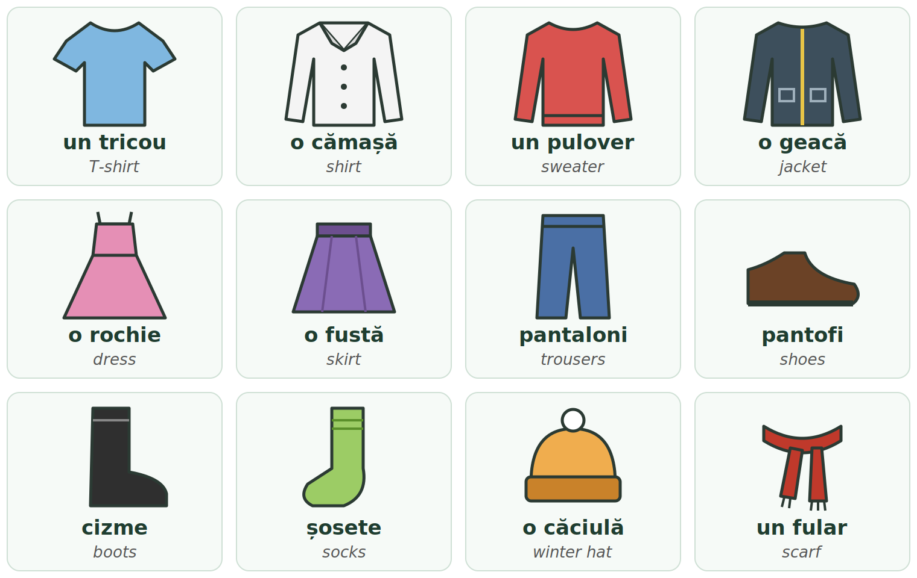
Fig. 6.1 — Haine, încălțăminte și accesorii / Clothes, shoes and accessories
Clothes / Îmbrăcăminte
WITH UN / O | PLURAL | ENGLISH | WITH UN / O | PLURAL | ENGLISH
un tricou | tricouri | T-shirt | o rochie | rochii | dress
o cămașă | cămăși | shirt | o fustă | fuste | skirt
un pulover | pulovere | sweater, jumper | un costum | costume | suit
un hanorac | hanorace | hoodie | pantaloni (plural only) | — | trousers
o geacă | geci | jacket | blugi (plural only) | — | jeans
un palton | paltoane | long winter coat | pantaloni scurți (plural only) | — | shorts

Shoes and accessories / Încălțăminte și accesorii
Shoes come in pairs, so you almost always use the plural.
SHOES — ONE | MORE | ENGLISH | ACCESSORIES | PLURAL | ENGLISH
un pantof | pantofi | shoes | o căciulă | căciuli | winter hat, beanie
un adidas | adidași | trainers | un fular | fulare | scarf
o cizmă | cizme | high boots | o mănușă | mănuși | glove
o gheată | ghete | ankle boots | o șapcă | șepci | cap
o sandală | sandale | sandals | o curea | curele | belt
un papuc · o șosetă | papuci · șosete | slippers · socks | o geantă | genți | bag, handbag

HAINĂ — ONE WORD, TWO MEANINGS
o haină = a coat, a jacket (one piece of outerwear) · haine (plural) = clothes in general.
Îmi cumpăr haine. — I am buying clothes. Am multe haine. — I have a lot of clothes.

TIPAR — things that come in pairs / lucruri în perechi
o pereche de | + | PLURAL | = | o pereche de pantofi

o pereche de șosete | a pair of socks
o pereche de mănuși | a pair of gloves
două perechi de blugi | two pairs of jeans
o pereche de ochelari | a pair of glasses

The verb a purta — to wear
A purta is a Pattern 1 verb, like a cânta (Lesson 3.3). Watch the vowel inside: port · poartă · purtăm.
PERSON | A PURTA | EXAMPLE | ENGLISH
eu | port | Port blugi și un tricou. | I wear jeans and a T-shirt.
tu | porți | Ce porți azi? | What are you wearing today?
el / ea | poartă | Ea poartă o rochie roșie. | She wears a red dress.
noi | purtăm | La muncă purtăm haine de lucru. | At work we wear work clothes.
voi | purtați | Purtați uniformă? | Do you wear a uniform?
ei / ele | poartă | Copiii poartă căciuli. | The children wear winter hats.

RECAP — MĂ ÎMBRAC (Lesson 3.12)
Mă îmbrac = I get dressed. It is a reflexive verb, like mă trezesc: Mă îmbrac repede dimineața. — I get dressed quickly in the morning. Mă îmbrac gros iarna. — I dress warmly in winter.
Two more useful phrases: Îmi pun geaca. — I put on my jacket. · Îmi scot pantofii. — I take off my shoes.

CULTURAL NOTE — SHOES OFF AT THE DOOR
In most Romanian homes people take off their shoes at the door. The host will often give you papuci (slippers). If you are not sure, ask: Să mă descalț? — Should I take off my shoes?

RECAP — THE COLOUR AGREES (Lesson 2.4)
The colour comes after the noun and changes with it: un tricou alb · o cămașă albă · pantofi albi · șosete albe.
un palton negru · o geacă neagră · pantofi negri · cizme negre · blugi albaștri · o rochie roșie.
gri, maro, roz never change: un tricou gri, o geacă gri, pantofi maro, șosete roz.

What do you wear in each season?
WINTER — IARNA, e frig | SPRING / AUTUMN — PRIMĂVARA / TOAMNA | SUMMER — VARA, e cald
un palton, o geacă groasă | o geacă, un hanorac | un tricou
o căciulă, un fular | un pulover | pantaloni scurți, o fustă
mănuși, cizme sau ghete | adidași | sandale, o șapcă

Iarna port palton, căciulă și mănuși. Vara port tricou și sandale. — In winter I wear a coat, a winter hat and gloves. In summer I wear a T-shirt and sandals.
6.1 Talk about your clothes
Answer about yourself, with the colours. Then ask a colleague the same questions and listen to the answers.
1. Ce porți azi? — Azi port ____________________.
2. Ce porți iarna? — Iarna port ____________________.
3. Ce porți vara? — Vara port ____________________.
4. Ce porți la muncă? — La muncă port ____________________.
5. Ce culoare are geaca ta? — Geaca mea este ____________________.
6. Ce încălțăminte porți acum? — Acum port ____________________.

Lesson 6.2 — Sizes / Mărimile
Romanian uses two different words for size. This is the most important point of the lesson:
TIPAR — which word for size?
HAINE (clothes) | → | MĂRIMEA · S, M, L... / 38, 40...

ÎNCĂLȚĂMINTE (shoes) | → | NUMĂRUL · 39, 40, 41, 42...

LABEL | HOW PEOPLE SAY IT | MEANING
XS | ics-es | extra small — foarte mic
S | es | small — mic
M | em | medium — mediu
L | el | large — mare
XL | ics-el | extra large — foarte mare
XXL | doi ics-el | extra extra large

Some shops also use numbers for clothes (for example 38, 40, 42 for women). They are not the same in every shop — look at the size chart (tabelul de mărimi) or try the clothes on. Romania uses EU shoe numbers; UK and US numbers are different, so learn your EU number: 39 treizeci și nouă · 40 patruzeci · 41 patruzeci și unu · 42 patruzeci și doi · 43 patruzeci și trei · 44 patruzeci și patru.
RECAP — THE ARTICLE IS AN ENDING (Lesson 2.3)
In a shop you will hear tricoul, geaca, pantofii. The is not a separate word — it is an ending:
-ul / -l → puloverul, pantoful, tricoul · -a → geaca, fusta, rochia · -i → pantofii, blugii · -le → fustele, cizmele, tricourile
o geacă — a jacket → geaca — the jacket · pantofi — shoes → pantofii — the shoes

Asking and answering about size
FORMAL (dumneavoastră) | INFORMAL (tu) | ANSWER | ENGLISH
Ce mărime purtați? | Ce mărime porți? | Port mărimea M. | What size do you wear? — I wear size M.
Ce număr purtați? | Ce număr porți? | Port numărul 42. / Port 42. | What shoe size? — I wear 42.
Aveți mărimea L? | Ai mărimea L? | Da, avem. / Nu mai avem. | Do you have L? — Yes. / Sold out.
Aveți o mărime mai mare? | — | Da, poftiți. | A bigger size? — Yes, here you are.
Aveți un număr mai mic? | — | Da, imediat. | A smaller shoe size? — Yes, right away.

Does it fit? — îmi vine
To say that clothes fit you, Romanian uses îmi vine (literally it comes to me). It works exactly like îmi place (Lesson 2.10): the verb follows the clothes, not you. One thing → vine. More things → vin. The adjective also follows the clothes.
TIPAR — one thing
HAINA (the ...) | + | ÎMI VINE | + | bine / mare / mic(ă)

TIPAR — more things
PANTOFII / BLUGII | + | ÎMI VIN | + | bine / mari / mici

ROMANIAN | ENGLISH | ROMANIAN | ENGLISH
Geaca îmi vine bine. | The jacket fits me well. | Pantofii îmi vin mici. | The shoes are small on me.
Tricoul îmi vine mare. | The T-shirt is big on me. | Blugii îmi vin lungi. | The jeans are long on me.
Rochia îmi vine mică. | The dress is small on me. | Fusta îmi vine prea scurtă. | The skirt is too short for me.
Puloverul îmi vine larg. | The sweater is loose on me. | Cămașa îmi vine puțin strâmtă. | The shirt is a bit tight on me.

prea = too · puțin = a bit · foarte = very · Îmi vine perfect! — It fits me perfectly! · E prea scump. — It's too expensive.
6.2 Ask and answer
Circle the right answer to each question. Then read each question and its answer out loud with a colleague.
1. Ce mărime purtați?  ( Port mărimea M. / Port numărul 42. ) | 2. Ce număr purtați la pantofi?  ( Port 43. / Port mărimea L. )
3. Cum vă vine geaca?  ( Îmi vine bine. / Îmi vin bine. ) | 4. Cum vă vin pantofii?  ( Îmi vin mici. / Îmi vine mic. )
5. Aveți mărimea S?  ( Da, avem. / Da, port. ) | 6. Aveți un număr mai mare?  ( Da, poftiți. / Nu-mi place. )

Lesson 6.3 — At the clothes shop / La magazinul de haine
Words in a clothes shop
ROMANIAN | ENGLISH | EXAMPLE | ENGLISH
magazinul de haine | the clothes shop | Magazinul este la mall. | The shop is at the mall.
raionul de bărbați / femei / copii | men's / women's / children's section | Raionul de bărbați este la etaj. | The men's section is upstairs.
vânzătorul / vânzătoarea | the shop assistant | Vânzătoarea mă ajută. | The shop assistant helps me.
cabina de probă | the fitting room | Cabina de probă este în dreapta. | The fitting room is on the right.
casa | the checkout, the till | Plătiți la casă. | Pay at the checkout.
eticheta | the label, the price tag | Mărimea este pe etichetă. | The size is on the label.
reducerea / reduceri | discount / sale | Azi sunt reduceri. | There is a sale today.
bonul (fiscal) | the receipt | Păstrați bonul! | Keep the receipt!
punga | the (shopping) bag | Doriți o pungă? | Would you like a bag?

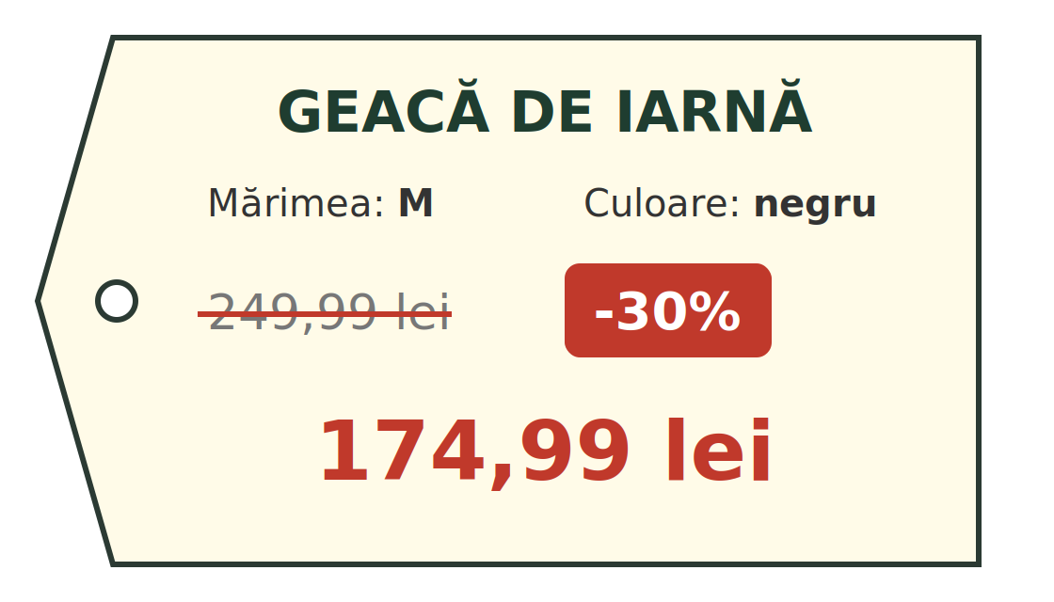
Fig. 6.2 — O etichetă de preț / A price tag
Read the tag: Geaca de iarnă costă 249,99 lei. Acum are o reducere de 30% (treizeci la sută). Prețul nou este 174,99 lei. — The winter jacket costs 249.99 lei. Now it has a 30% discount. The new price is 174.99 lei.
HOW TO READ A PRICE
174,99 lei = o sută șaptezeci și patru de lei și nouăzeci și nouă de bani. Romanian writes a comma where English writes a point: 174,99 (not 174.99). 1 leu = 100 de bani. From 20 up, say de: douăzeci de lei, 99 de bani.

FOTO: interiorul unui magazin de haine, cu indicatorul „CABINĂ DE PROBĂ”
Fig. 6.3 — Inside a clothes shop

RECAP — ÎMI PLACE / ÎMI PLAC (Lesson 2.10)
The verb follows the thing you like: one thing → place, more things → plac.
Îmi place geaca. · Îmi plac pantofii. · Îți place rochia? · Nu-mi place culoarea. · Nu-mi plac adidașii.
With a verb, add să (Lesson 3.11): Îmi place să port blugi. — I like wearing jeans.

RECAP — ÎL / O / ÎI / LE IAU (Lesson 2.10)
When you decide to buy, the small word for it / them follows the gender and number of the item:
tricoul → Îl iau. · geaca → O iau. · pantofii → Îi iau. · șosetele → Le iau.

Useful sentences in the shop
WHO SAYS IT | ROMANIAN | ENGLISH
shop assistant | Bună ziua! Vă pot ajuta? | Hello! Can I help you?
shop assistant | Cabina de probă este acolo, în dreapta. | The fitting room is there, on the right.
shop assistant | Cum vă vine? | How does it fit?
shop assistant | Plătiți cash sau cu cardul? | Are you paying cash or by card?
you | Caut o geacă de iarnă. | I'm looking for a winter jacket.
you | Mă uit doar, mulțumesc. | I'm just looking, thank you.
you | Pot să probez? | Can I try it on?
you | Aveți și în altă culoare? | Do you have it in another colour too?
you | Cât costă? | How much is it?
you | Pot să o schimb, dacă nu-mi vine? | Can I exchange it if it doesn't fit?

Dialogue 1 — Ravi buys a winter jacket
ROMANIAN | ENGLISH
V: Bună ziua! Vă pot ajuta? | Hello! Can I help you?
R: Bună ziua! Caut o geacă de iarnă. Port mărimea L. | Hello! I'm looking for a winter jacket. I wear size L.
V: Vă place geaca neagră? | Do you like the black jacket?
R: Da, îmi place. Pot să o probez? | Yes, I like it. Can I try it on?
V: Sigur. Cabina de probă este acolo, în dreapta. | Sure. The fitting room is there, on the right.
(după câteva minute) | (a few minutes later)
V: Cum vă vine? | How does it fit?
R: Îmi vine puțin mare. Aveți mărimea M? | It's a bit big on me. Do you have size M?
V: Da, poftiți. | Yes, here you are.
R: Mărimea M îmi vine bine. Cât costă? | Size M fits me well. How much is it?
V: Acum are o reducere de 30%. Costă 174,99 lei. | Now it has a 30% discount. It costs 174.99 lei.
R: Foarte bine! O iau. Plătesc cu cardul. | Very good! I'll take it. I'll pay by card.
V: Poftiți bonul. Dacă nu vă vine, puteți s-o schimbați în 30 de zile. | Here is your receipt. If it doesn't fit, you can exchange it within 30 days.
R: Mulțumesc! La revedere! | Thank you! Goodbye!

Dialogue 2 — at the shoe shop
ROMANIAN | ENGLISH
C: Bună ziua! Aveți adidași albi în numărul 43? | Hello! Do you have white trainers in size 43?
V: Un moment, verific... Da, avem. | One moment, I'll check... Yes, we do.
C: Pot să probez? | Can I try them on?
C: Îmi vin mici. Aveți numărul 44? | They are small on me. Do you have 44?
V: Da, poftiți numărul 44. | Yes, here is 44.
C: Acum îmi vin bine. Îi iau! | Now they fit well. I'll take them!

LOOK AT THE DIALOGUES — ONLY THINGS YOU KNOW
geaca (one, feminine) → O iau. · Îmi vine puțin mare. · adidașii (more, masculine) → Îi iau. · Îmi vin mici.
s-o schimbați = să o schimbați — the cratima joins two words said as one (Module 1, Lesson 4.1).

PRACTICAL NOTE — RECEIPTS, RETURNS AND SALES
Always keep the receipt (bonul fiscal). Whether you can exchange or return clothes bought in a shop depends on the shop's own rules — many shops accept it within 14–30 days, with the receipt and the label still on. Ask before you pay: Pot să o schimb?
For clothes bought online, EU law gives you 14 days to send them back. Big sales (reducerile) usually come in January–February and July–August. Second-hand shops are common and cheap.

6.3 Complete the dialogue
Use: Vă pot ajuta · Ce mărime purtați · cabina de probă · O iau · Cu cardul. Then act it out with a colleague.
V: Bună ziua! ______________________________?
C: Bună ziua! Caut o cămașă albă.
V: ______________________________?
C: Port mărimea M. Pot să probez?
V: Sigur, ______________________________ este acolo.
C: Îmi vine bine. ______________________________!
V: Plătiți cash sau cu cardul?
C: ______________________________, vă rog.

HOMEWORK — AFTER SESSION 23 / TEMĂ PENTRU ACASĂ
H23.1 Write what you are wearing today, with the colours: Azi port... (at least 4 pieces of clothing). Write your clothes size and your shoe number in two full sentences.
H23.2 Write four sentences about clothes you like and don't like, with îmi place / îmi plac / nu-mi place / nu-mi plac.

SESSION 24 — MY HOME: ROOMS, FURNITURE, OBJECTS
SESIUNEA 24 — CASA MEA: CAMERE, MOBILĂ, OBIECTE · 3 hours

By the end of this session you will be able to:
☐ | say what kind of home you live in: la bloc, la casă, într-o garsonieră
☐ | say on which floor you live
☐ | name the rooms of a home and what you do in each
☐ | name the furniture and the objects of each room
☐ | say where things are: în, pe, sub, lângă, între
☐ | say what there is in a room: este, sunt, am

Lesson 6.4 — The rooms of a home / Camerele unei locuințe
Locuința = your home, any place where you live. In Romanian towns and cities most people live la bloc — in a block of flats. In villages most people live la casă — in a house.
ROMANIAN | PLURAL | ENGLISH | ROMANIAN | PLURAL | ENGLISH
o casă | case | house | o cameră | camere | room
un apartament | apartamente | flat, apartment | un balcon | balcoane | balcony
un bloc | blocuri | block of flats | un etaj | etaje | floor, storey
o garsonieră | garsoniere | studio flat | parterul | — | the ground floor
un lift | lifturi | lift, elevator | cazarea | — | accommodation (e.g. from your employer)

FOTO: un bloc de locuințe tipic din România
Fig. 6.4 — A typical Romanian block of flats

TIPAR — where do you live?
Locuiesc | + | LA BLOC / LA CASĂ

Locuiesc la bloc. — I live in a block of flats. Locuiesc la casă. — I live in a house. Here Romanian uses la — do not translate in a word for word.
ROMANIAN | ENGLISH
Locuiesc la parter. | I live on the ground floor.
Locuiesc la etajul 1 (unu). | I live on the first floor (one floor above the ground).
Locuiesc la etajul 4 (patru). | I live on the fourth floor.
Locuiesc la ultimul etaj. | I live on the top floor.
La ce etaj locuiești? | Which floor do you live on?

CULTURAL NOTE — HOW ROMANIANS COUNT ROOMS
When Romanians say un apartament cu două camere (a two-room flat), they count only the living room and the bedrooms. The kitchen, the bathroom and the hallway are not counted. So: apartament cu 2 camere = 1 living room + 1 bedroom (+ kitchen + bathroom). Apartament cu 3 camere = 1 living room + 2 bedrooms. A garsonieră has only one room. This is very important when you look for a flat to rent.

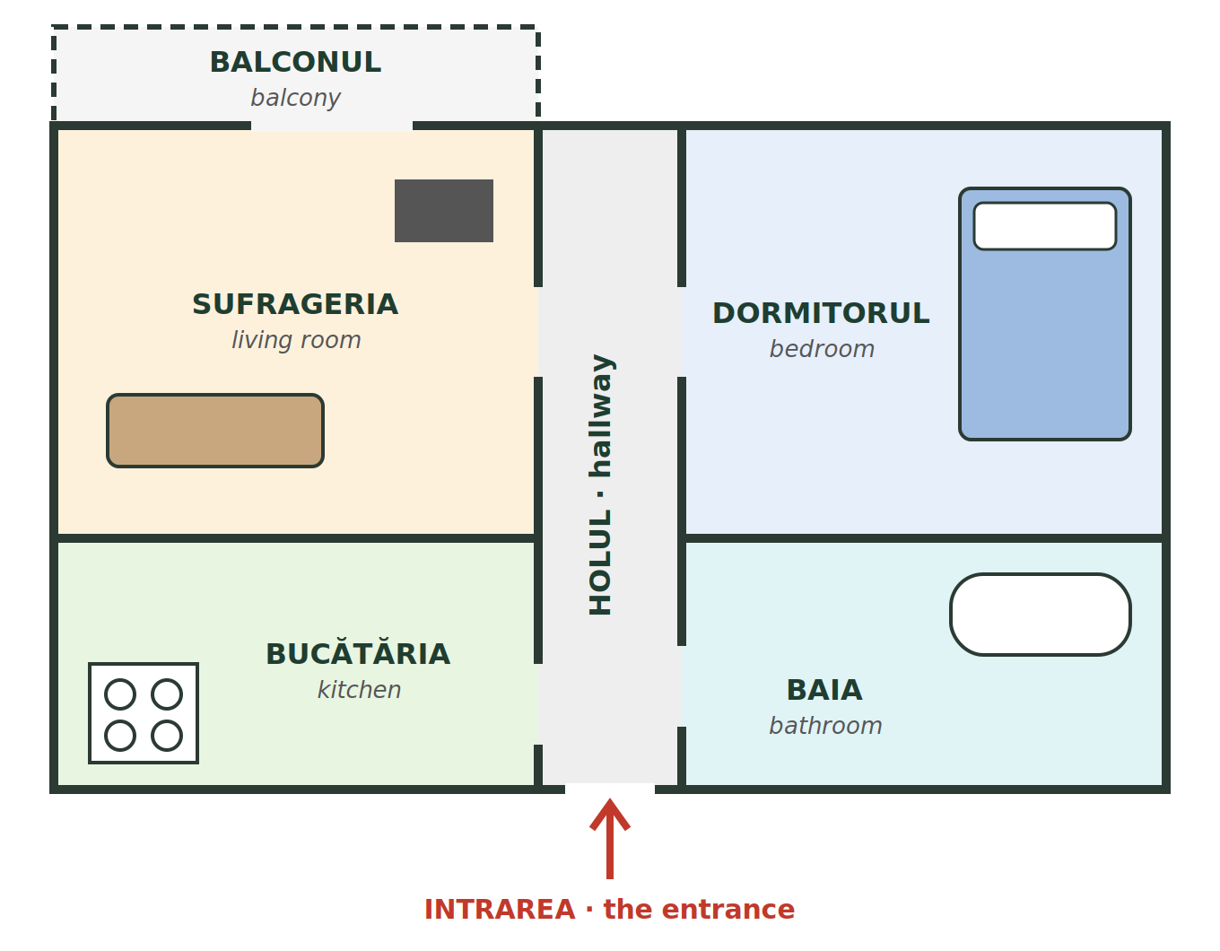
Fig. 6.5 — Planul unui apartament cu două camere / Plan of a two-room flat
ROOM (with the) | PLURAL | ENGLISH | WHAT YOU DO THERE | ENGLISH
holul | holuri | hallway | Aici las pantofii și geaca. | Here I leave my shoes and jacket.
sufrageria | sufragerii | living room | Aici mă uit la televizor. | Here I watch TV.
dormitorul | dormitoare | bedroom | Aici dorm. | Here I sleep.
bucătăria | bucătării | kitchen | Aici gătesc și mănânc. | Here I cook and eat.
baia | băi | bathroom | Aici mă spăl și fac duș. | Here I wash and have a shower.
toaleta / WC-ul | toalete | toilet | — | —
balconul | balcoane | balcony | Aici usuc rufele. | Here I dry the laundry.
debaraua | debarale | storage room | Aici țin lucruri vechi. | Here I keep old things.

In everyday speech many people say livingul instead of sufrageria.
TIPAR — in the room
ÎN | + | ROOM WITHOUT THE ENDING | = | în bucătărie (not: în bucătăria)

în hol | în sufragerie | în dormitor
în bucătărie | în baie | pe balcon

6.4 Which room?
Write the name of the room (without the ending).
1. Gătesc în ____________________. | 2. Dorm în ____________________.
3. Fac duș în ____________________. | 4. Las pantofii în ____________________.
5. Mă uit la televizor în ____________________. | 6. Usuc rufele pe ____________________.

Lesson 6.5 — Furniture and household objects / Mobila și obiectele casnice
Mobila = furniture. Like in English, it is one word for all the pieces together: Am mobilă nouă. — I have new furniture.
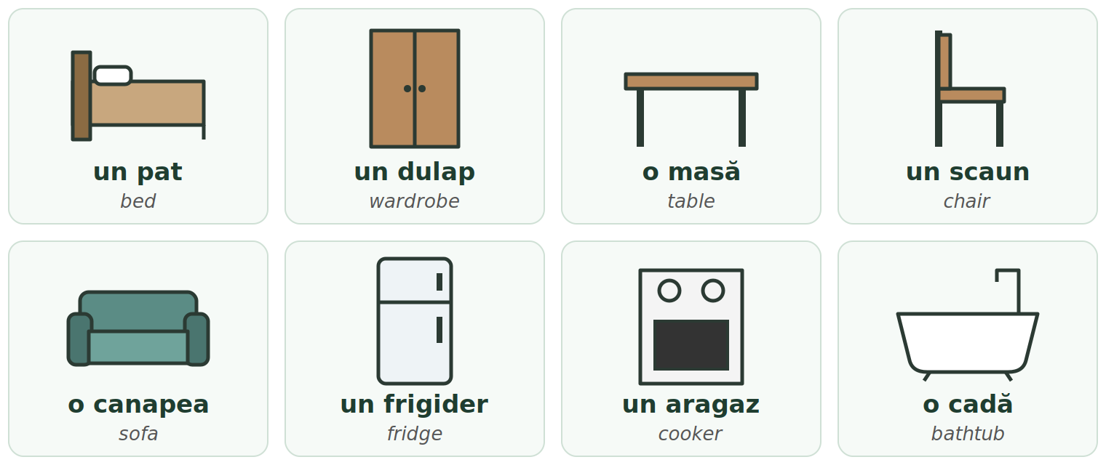
Fig. 6.6 — Mobilă și obiecte casnice / Furniture and household objects
LIVING ROOM | PLURAL | ENGLISH | BEDROOM | PLURAL | ENGLISH
o canapea | canapele | sofa | un pat | paturi | bed
un fotoliu | fotolii | armchair | un dulap | dulapuri | wardrobe, cupboard
o masă | mese | table | o noptieră | noptiere | bedside table
un scaun | scaune | chair | o pernă | perne | pillow
un televizor | televizoare | TV set | o plapumă | plăpumi | duvet
un covor | covoare | carpet, rug | o oglindă | oglinzi | mirror

KITCHEN | PLURAL | ENGLISH | BATHROOM & EVERYWHERE | PLURAL | ENGLISH
un frigider | frigidere | fridge | o cadă · un duș | căzi · dușuri | bathtub · shower
un aragaz | aragazuri | cooker, stove | un prosop | prosoape | towel
o chiuvetă | chiuvete | sink | o mașină de spălat | mașini de spălat | washing machine
o farfurie | farfurii | plate | o ușă · o fereastră | uși · ferestre | door · window
un pahar | pahare | glass | o cheie · un perete | chei · pereți | key · wall
o cană | căni | mug, cup | o podea · un calorifer | podele · calorifere | floor · radiator

ONE ENGLISH WORD, TWO ROMANIAN WORDS
floor = etaj (the level of the building: etajul 3) or podea (the surface you walk on: Cheile sunt pe podea.)
dulap = wardrobe in the bedroom, but also cupboard in the kitchen. masă = table, but also meal.

Where is it? — în, pe, sub, lângă, între
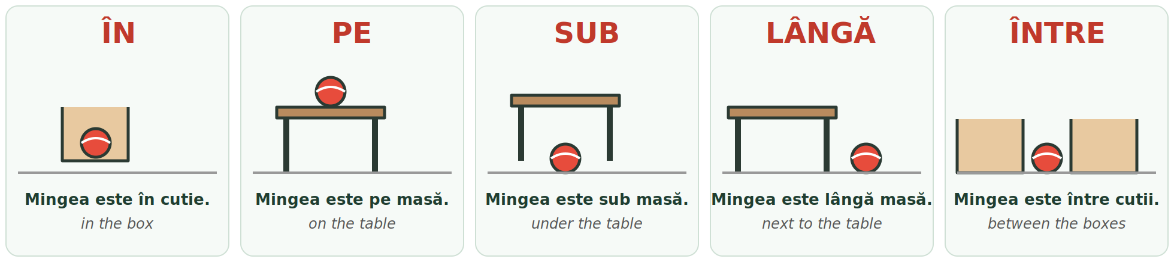
Fig. 6.7 — Unde este mingea? / Where is the ball? (mingea = the ball · cutie = box)
TIPAR
THE THING (the ...) | + | ESTE / SUNT | + | ÎN · PE · SUB · LÂNGĂ | + | THE PLACE (no ending)

WORD | ENGLISH | EXAMPLE | ENGLISH
în | in | Hainele sunt în dulap. | The clothes are in the wardrobe.
pe | on | Cheile sunt pe masă. | The keys are on the table.
sub | under | Papucii sunt sub pat. | The slippers are under the bed.
lângă | next to | Lampa este lângă pat. | The lamp is next to the bed.
între ... și ... | between | Noptiera este între pat și fereastră. | The bedside table is between the bed and the window.
în stânga / în dreapta | on the left / right | Baia este în dreapta. | The bathroom is on the right.

AFTER ÎN, PE, SUB, LÂNGĂ, ÎNTRE — NO ENDING
Say the place without -ul / -a: în dormitor, pe masă, sub pat, lângă fereastră. Not: în dormitorul ✗. Learn it as a fixed pattern, like în bucătărie in Lesson 6.4.

What is there in the room? — este / sunt / am
Este and sunt are the verb a fi (Lesson 2.6). One thing → este, more things → sunt.
ROMANIAN | ENGLISH
În sufragerie este o canapea. | In the living room there is a sofa.
În bucătărie sunt patru scaune. | In the kitchen there are four chairs.
În dormitor am un pat și un dulap. | In the bedroom I have a bed and a wardrobe.
În baie nu este cadă, este duș. | In the bathroom there is no bathtub, there is a shower.

6.5 Where is it?
Use: în · pe · sub · lângă · între
1. Frigiderul este ______ bucătărie. | 2. Farfuriile sunt ______ masă.
3. Papucii sunt ______ pat. | 4. Noptiera este ______ pat.
5. Canapeaua este ______ fotoliu și televizor. | 6. Hainele sunt ______ dulap.

HOMEWORK — AFTER SESSION 24 / TEMĂ PENTRU ACASĂ
H24.1 Draw a simple plan of your home in your notebook, like Fig. 6.5. Write the name of every room in Romanian.
H24.2 Write five sentences about your room: În camera mea este... / sunt... / Patul este lângă...

SESSION 25 — DESCRIBING YOUR HOME, RECAP AND TEST
SESIUNEA 25 — DESCRIEREA LOCUINȚEI, RECAPITULARE ȘI TEST · 3 hours

By the end of this session you will be able to:
☐ | answer the usual questions about where and how you live
☐ | read and write într-un / într-o correctly
☐ | describe your home with adjectives that agree: un apartament mic, o casă mică
☐ | understand a short text about someone's home
☐ | use every form from Module 6 and pass the Module 6 cumulative test

Lesson 6.6 — Describing your home / Descrierea locuinței
RECAP — THE CRATIMA: ÎNTR-UN / ÎNTR-O (Module 1, Lesson 4.1 · Module 2, Lesson 2.10)
The cratima (-) joins two words that are said together, like one word. You read it in Module 1 and saw it with the short pronouns in Module 2: nu-mi place, s-o schimbați.
în + un → într-un · în + o → într-o · din + un → dintr-un · din + o → dintr-o
Never write în un ✗ or în o ✗.

ROMANIAN | ENGLISH
Locuiesc într-un apartament. | I live in a flat.
Locuiesc într-o casă. | I live in a house.
Locuiesc într-o garsonieră. | I live in a studio flat.
Locuiesc într-un bloc nou. | I live in a new block of flats.
Locuiesc într-o cameră cu doi colegi. | I live in a room with two colleagues.
Beau cafea dintr-o cană. | I drink coffee from a mug.

Questions about your home
QUESTION (tu / dumneavoastră) | ENGLISH | ANSWER | ENGLISH
Unde locuiești? / Unde locuiți? | Where do you live? | Locuiesc în Ploiești, pe strada Florilor. | I live in Ploiești, on Florilor Street.
Locuiești la bloc sau la casă? / Locuiți...? | Do you live in a block or a house? | Locuiesc la bloc. | I live in a block of flats.
La ce etaj locuiești? / locuiți? | Which floor do you live on? | Locuiesc la etajul trei. | I live on the third floor.
Câte camere are apartamentul? | How many rooms has the flat? | Are două camere. | It has two rooms.
Cu cine locuiești? / locuiți? | Who do you live with? | Locuiesc cu doi colegi. / Locuiesc singur. / singură. | I live with two colleagues. / I live alone (man / woman).
Cum este casa ta? / casa dumneavoastră? | What is your home like? | Este mică, dar luminoasă. | It is small, but bright.
Blocul are lift? | Does the block have a lift? | Da, are. / Nu, nu are. | Yes, it does. / No, it doesn't.

Adjectives for a home
RECAP — the adjective agrees (Lesson 2.4). Apartamentul is neuter → the adjective looks masculine. Casa and camera are feminine → the adjective takes the feminine ending.
UN APARTAMENT... | O CASĂ... | ENGLISH | UN APARTAMENT... | O CASĂ... | ENGLISH
mare | mare | big | frumos | frumoasă | beautiful
mic | mică | small | luminos | luminoasă | bright
nou | nouă | new | curat | curată | clean
vechi | veche | old | liniștit | liniștită | quiet
scump | scumpă | expensive | zgomotos | zgomotoasă | noisy

Apartamentul este mic și luminos. | Casa este mică și luminoasă.
Blocul este vechi. | Camera este veche.
Dormitorul este liniștit. | Strada este zgomotoasă.

foarte = very: Camera este foarte mică. · destul de = quite: Bucătăria este destul de mare. · prea = too: Chiria este prea mare. — The rent is too high. · dar = but: Blocul este vechi, dar apartamentul este nou.
Read — two homes
Read each text twice, out loud. The English is on the right — cover it and try to understand the Romanian first.
Text 1 — Ravi  Mă numesc Ravi și sunt din Nepal. Locuiesc în Ploiești, într-un apartament cu două camere. Apartamentul este la etajul patru. Blocul este vechi, dar are lift. Locuiesc cu un coleg de muncă. Eu dorm în dormitor, el doarme în sufragerie, pe canapea. Bucătăria este mică, dar avem tot ce trebuie: frigider, aragaz și mașină de spălat. | My name is Ravi and I'm from Nepal. I live in Ploiești, in a two-room flat. The flat is on the fourth floor. The block is old, but it has a lift. I live with a work colleague. I sleep in the bedroom, he sleeps in the living room, on the sofa. The kitchen is small, but we have everything we need: a fridge, a cooker and a washing machine.
Text 2 — Tran  Mă numesc Tran și sunt din Vietnam. Firma îmi oferă cazare. Locuiesc într-o cameră cu încă doi colegi. În cameră sunt trei paturi, trei dulapuri și o masă. Baia și bucătăria sunt comune. Camera este curată și destul de spațioasă. | My name is Tran and I'm from Vietnam. The company gives me accommodation. I live in a room with two other colleagues. In the room there are three beds, three wardrobes and a table. The bathroom and the kitchen are shared. The room is clean and quite spacious.

tot ce trebuie — everything we need · încă doi colegi — two more colleagues · comune — shared · spațioasă — spacious
6.6 Describe your own home
Complete every sentence with your real details. Then read your text out loud to a colleague and ask: Tu unde locuiești?**
1. Locuiesc în ______________________________ (oraș / sat).
2. Locuiesc într-un / într-o ______________________ (apartament / casă / garsonieră / cameră).
3. Locuiesc la ______________________________ (bloc / casă).
4. Locuința mea are ____________ camere. Locuiesc la etajul ____________ / la parter.
5. Locuiesc cu ______________________________ / singur(ă).
6. Locuința mea este ______________________ și ______________________.
7. În camera mea este / sunt ______________________________.

Lesson 6.7 — General recap / Recapitulare generală
Before the test, look back over the whole module.
CLOTHES | SHOES & ACCESSORIES | ROOMS | FURNITURE & OBJECTS
un tricou · o cămașă | pantofi · adidași | holul | un pat · un dulap
un pulover · un hanorac | cizme · ghete · sandale | sufrageria | o masă · un scaun
o geacă · un palton | papuci · șosete | dormitorul | o canapea · un fotoliu
o rochie · o fustă | o căciulă · un fular | bucătăria | un frigider · un aragaz
pantaloni · blugi | mănuși · o curea | baia | o cadă · un duș · un prosop
un costum | o geantă | balconul | o ușă · o fereastră · o cheie

PATTERN | EXAMPLE | LEARNED IN
clothes → mărimea · shoes → numărul | Port mărimea M. Port numărul 42. | Lesson 6.2
one thing → îmi vine · more → îmi vin | Geaca îmi vine bine. Pantofii îmi vin mici. | Lesson 6.2
Locuiesc la bloc / la casă · la etajul... | Locuiesc la bloc, la etajul 4. | Lesson 6.4
în · pe · sub · lângă · între + no ending | Cheile sunt pe masă. Papucii sunt sub pat. | Lesson 6.5
the = ending: -ul · -a · -i · -le | tricoul · geaca · pantofii · fustele | recap — Lesson 2.3
the adjective agrees | o geacă neagră · pantofi negri · o casă mică | recap — Lesson 2.4
one thing → îmi place · more → îmi plac | Îmi place rochia. Îmi plac blugii. | recap — Lesson 2.10
îl / o / îi / le iau | Îl iau. O iau. Îi iau. Le iau. | recap — Lesson 2.10
într-un / într-o (cratima) | Locuiesc într-un apartament / într-o casă. | recap — M1, Lesson 4.1

6.7 Everything together
Circle the correct word.
1. un pulover ( roșu / roșie ) | 2. Ce ( mărime / număr ) purtați la pantofi?
3. Îmi ( place / plac ) geaca. | 4. Pantofii îmi vin bine. ( Îi / O ) iau!
5. Locuiesc ( într-un / într-o ) garsonieră. | 6. Cheile sunt ( pe / la ) masă.
7. Gătesc în ( bucătărie / dormitor ). | 8. Casa mea este ( mic / mică ).

SECȚIUNE DETAȘABILĂ — EXEMPLAR FORMATOR
Detachable section — teacher's copy. Se detașează din suportul cursantului; testul completat, semnat și datat, se păstrează la dosarul cursantului. Conține: testul cumulativ, fișa de confirmare a Sesiunii 25, fișa de evidență a Modulului 6, cheia răspunsurilor.

TEST CUMULATIV — MODULUL 6
MODULE 6 — CUMULATIVE TEST · grilă, 20 de întrebări, 20 de puncte · semnat și datat de cursant

Nume și prenume cursant / Student name
Data / Date | _____ / _____ / 20_____
Semnătura cursantului / Student signature

Marcați cu X un singur răspuns la fiecare întrebare. Mark ONE answer with X for each question. Each correct answer = 1 point.
1. Pluralul cuvântului „geacă” este: (1 p)
☐ a) geace | ☐ b) gecuri
☐ c) geci | ☐ d) gecă
2. Completează: „Nu-mi ____ culoarea.” (1 p)
☐ a) plac | ☐ b) place
☐ c) plăcem | ☐ d) placi
3. Completează: „Pantofii mei sunt ____.” (1 p)
☐ a) negru | ☐ b) neagră
☐ c) negri | ☐ d) negre
4. Ce înseamnă „mănuși”? (1 p)
☐ a) socks | ☐ b) shoes
☐ c) scarf | ☐ d) gloves
5. Iarna, când este frig, port: (1 p)
☐ a) sandale | ☐ b) pantaloni scurți
☐ c) căciulă și fular | ☐ d) doar un tricou
6. Cum întrebi politicos ce mărime poartă cineva la haine? (1 p)
☐ a) Ce număr purtați? | ☐ b) Ce mărime purtați?
☐ c) Cât costă? | ☐ d) Unde locuiți?
7. La pantofi spui: „Port ____ 42.” (1 p)
☐ a) numărul | ☐ b) mărimea
☐ c) etajul | ☐ d) camera
8. Rochia este prea mică. Spui: „Rochia îmi vine ____.” (1 p)
☐ a) mic | ☐ b) mică
☐ c) mici | ☐ d) mare
9. Completează: „Pantofii îmi ____ mici.” (1 p)
☐ a) vine | ☐ b) vinem
☐ c) vii | ☐ d) vin
10. Ce este „cabina de probă”? (1 p)
☐ a) the till | ☐ b) the fitting room
☐ c) the shop window | ☐ d) the size chart
11. Completează: „Îmi ____ blugii negri.” (1 p)
☐ a) plac | ☐ b) place
☐ c) placi | ☐ d) plăcem
12. Vânzătoarea întreabă: „Plătiți cash sau cu cardul?” Care răspuns este potrivit? (1 p)
☐ a) Port mărimea M. | ☐ b) Locuiesc la bloc.
☐ c) Îmi vine bine. | ☐ d) Cu cardul, vă rog.
13. Geaca îți vine bine și vrei s-o cumperi. Spui: „____ iau!” (1 p)
☐ a) Îl | ☐ b) O
☐ c) Îi | ☐ d) Le
14. În ce cameră gătești? (1 p)
☐ a) în dormitor | ☐ b) în baie
☐ c) în bucătărie | ☐ d) în hol
15. În „într-o”, cratima unește cuvintele: (1 p)
☐ a) într + o | ☐ b) în + tro
☐ c) în + o | ☐ d) într + un
16. „Un apartament cu două camere” are, de obicei: (1 p)
☐ a) două dormitoare și o sufragerie | ☐ b) o sufragerie și un dormitor, plus bucătărie și baie
☐ c) doar bucătărie și baie | ☐ d) două etaje
17. Completează: „Locuiesc ____ apartament.” (1 p)
☐ a) în un | ☐ b) într-o
☐ c) într-un | ☐ d) întru
18. Completează: „Frigiderul este ____ bucătărie.” (1 p)
☐ a) în | ☐ b) pe
☐ c) sub | ☐ d) între
19. „Cheile sunt pe masă.” înseamnă: (1 p)
☐ a) The keys are under the table. | ☐ b) The keys are next to the table.
☐ c) The keys are in the table. | ☐ d) The keys are on the table.
20. Care propoziție este corectă? (1 p)
☐ a) Casa mea este mare și luminoasă. | ☐ b) Casa mea este mare și luminos.
☐ c) Casa mea este mari și luminoasă. | ☐ d) Casa mea sunt mare și luminoasă.

PUNCTAJ OBȚINUT / SCORE | _______ / 20
Semnătura formatorului / Teacher signature

SESSION COMPLETION RECORD
FIȘĂ DE CONFIRMARE A PARCURGERII SESIUNII — se păstrează la dosar

Module / Modul | Modulul 6 — Haine și casa mea (finalizat)
Session / Sesiunea | Sesiunea 25 — Descrierea locuinței, recapitulare. TEST CUMULATIV MODULUL 6
Duration / Durata | 3 ore
Date / Data | _____ / _____ / 20_____
Student name / Nume și prenume cursant
Score / Punctaj obținut | _______ / 20
Student signature / Semnătura cursantului
Teacher signature / Semnătura formatorului

DECLARAȚIE CURSANT / STUDENT DECLARATION
Declar că am participat la această sesiune de curs și am parcurs conținutul prezentat mai sus.
I declare that I attended this course session and covered the content presented above.

MODULE 6 — COMPLETION RECORD
FIȘĂ DE EVIDENȚĂ A PARCURGERII MODULULUI 6 — se păstrează la dosarul cursantului

Cursant / Student
Act de identitate / ID document
Angajator / Employer
Formator / Teacher
Modul / Module | Modulul 6 — Haine și casa mea (9 ore, Sesiunile 23–25)

NR. | SESIUNE / CONȚINUT | DATA | PUNCTAJ TEST | SEMNĂTURA CURSANTULUI
23 | Sesiunea 23 — Haine, mărimi, îmi vine; la magazinul de haine, dialog (3 ore) |  | —
24 | Sesiunea 24 — Camerele locuinței, mobilă, obiecte casnice, prepoziții de loc (3 ore) |  | —
25 | Sesiunea 25 — Descrierea locuinței, recapitulare + TEST CUMULATIV (3 ore) |  | ___ / 20

CONFIRMARE FINALIZARE MODUL / MODULE COMPLETION
Confirm că cursantul a parcurs integral conținutul Modulului 6 — Haine și casa mea, în total 9 ore de curs, și a susținut testul de evaluare consemnat mai sus.
I confirm that the student completed the full content of Module 6 — Clothes and My Home, 9 course hours in total, and sat the assessment recorded above.
Data: _____ / _____ / 20_____ Semnătura formatorului: ______________________

ANSWER KEY — TEACHER COPY
CHEIA RĂSPUNSURILOR — pentru formator

Session 23
6.1 personal answers — checked by the teacher (răspunsuri personale). Model: Azi port blugi albaștri și un tricou alb. Iarna port palton, căciulă și mănuși.
6.2 Port mărimea M. · Port 43. · Îmi vine bine. · Îmi vin mici. · Da, avem. · Da, poftiți.
6.3 Vă pot ajuta · Ce mărime purtați · cabina de probă · O iau · Cu cardul
Session 24
6.4 bucătărie · dormitor · baie · hol · sufragerie · balcon
6.5 în · pe · sub · lângă · între · în
Session 25
6.6 personal answers — checked by the teacher. Check item 2: într-un apartament · într-o casă / garsonieră / cameră.
6.7 roșu · număr · place · Îi · într-o · pe · bucătărie · mică
Cumulative test — grilă answer key
Un răspuns corect = 1 punct. Nemarcat sau dublu marcat = 0 puncte.
1 – c | 2 – b | 3 – c | 4 – d | 5 – c | 6 – b | 7 – a | 8 – b | 9 – d | 10 – b
11 – a | 12 – d | 13 – b | 14 – c | 15 – c | 16 – b | 17 – c | 18 – a | 19 – d | 20 – a

TOTAL: 20 puncte

LIMBA ROMÂNĂ PENTRU STRĂINI
Romanian Language for Foreign Workers
SUPORT DE CURS

MODULE 7 — MY FAMILY AND AT THE RESTAURANT
MODULUL 7 — FAMILIA MEA ȘI LA RESTAURANT
LEVEL / NIVEL | DURATION / DURATĂ | LANGUAGE OF TEACHING
A1 — after Module 6 | 9 hours · Sessions 26–28 · Weeks 13–14 | English → Romanian

LEGAL BASIS / TEMEI LEGAL
Curs de limbă română cu elemente de integrare culturală și socială, organizat în conformitate cu O.U.G. nr. 32/2026, art. 7 alin. (1) lit. g) — minimum 6 luni, cel puțin 6 ore pe săptămână.
Romanian language course with cultural and social integration elements, organised under Government Emergency Ordinance no. 32/2026, art. 7(1)(g) — at least 6 months, at least 6 hours per week.
This module ends with ONE cumulative multiple-choice test (20 questions), signed and dated by the student and kept on file as proof of completion. There is no separate test after each session.

Before you start
Module 6 took your Romanian into the clothes shop and into your home. Module 7 is about the people in your life and about eating out. You will talk about your family — at home and in Romania —, say your marital status, understand how a Romanian family lives, order and pay in a restaurant, and say how you feel.
You need these lessons first — look back at them if you are not sure:
YOU NEED | WHERE | WHY
the article · my, your | Lessons 2.3, 2.7 | fratele meu, soția mea, părinții mei
whose — lui Ion, Mariei | Lesson 2.9 | mama lui Suresh, fratele Mariei
short pronouns — îmi, îi, le · mi-e | Lesson 2.10 | Îi dau cheile. · Mi-e foame.
jobs · mă simt · orders | Lessons 3.2, 3.12, 3.13 | ospătar / ospătăriță · Mă simt bine. · Dați-mi..., vă rog.
Aș dori (fixed phrase) | Lesson 4.4 | Aș dori o ciorbă, vă rog.
Poftă bună! Noroc! · the meals | Lessons 5.3, 5.5 | micul dejun, prânzul, cina
Este frig / cald — the weather | Lesson 5.5 | Este frig. is not Mi-e frig.

Where this module sits in the course
SESSION | DURATION | CONTENT
Session 26 | 3 hours | Lesson 7.1 My family · Lesson 7.2 Marital status and the Romanian family
Session 27 | 3 hours | Lesson 7.3 Food, drinks and the menu · Lesson 7.4 Ordering and paying
Session 28 | 3 hours | Lesson 7.5 How do you feel? · Lesson 7.6 A full dialogue at the restaurant · Lesson 7.7 General recap · Module 7 cumulative test

NO NEW GRAMMAR IN THIS MODULE
All the grammar you need was taught in Modules 2 and 3. When you see a blue RECAP box, it tells you which lesson to look back at — there is nothing new to learn in it.
Forms like fratele soției (my wife's brother) or Îi trimit bani mamei (I send money to my mother) are learned here as ready-made phrases, not as a new rule.
New in this module: words and phrases only — family and relatives, marital status, the menu, Romanian dishes, ordering and paying, feelings. Every lesson ends with a green box Useful words and phrases.

SESSION 26 — MY FAMILY
SESIUNEA 26 — FAMILIA MEA · 3 hours

By the end of this session you will be able to:
☐ | name the people in your family and in your wife's or husband's family
☐ | say whose relative someone is: mama lui Suresh, fratele soției
☐ | say your marital status: căsătorit, necăsătorit, divorțat, văduv
☐ | talk about the family at home: Îi trimit bani mamei.
☐ | understand what nașii, the christening and the wedding mean in Romania, and compare with your country

Lesson 7.1 — My family / Familia mea
Familia = the family. Look at Suresh's family. Every word is said from Suresh's point of view — he is EU (me).
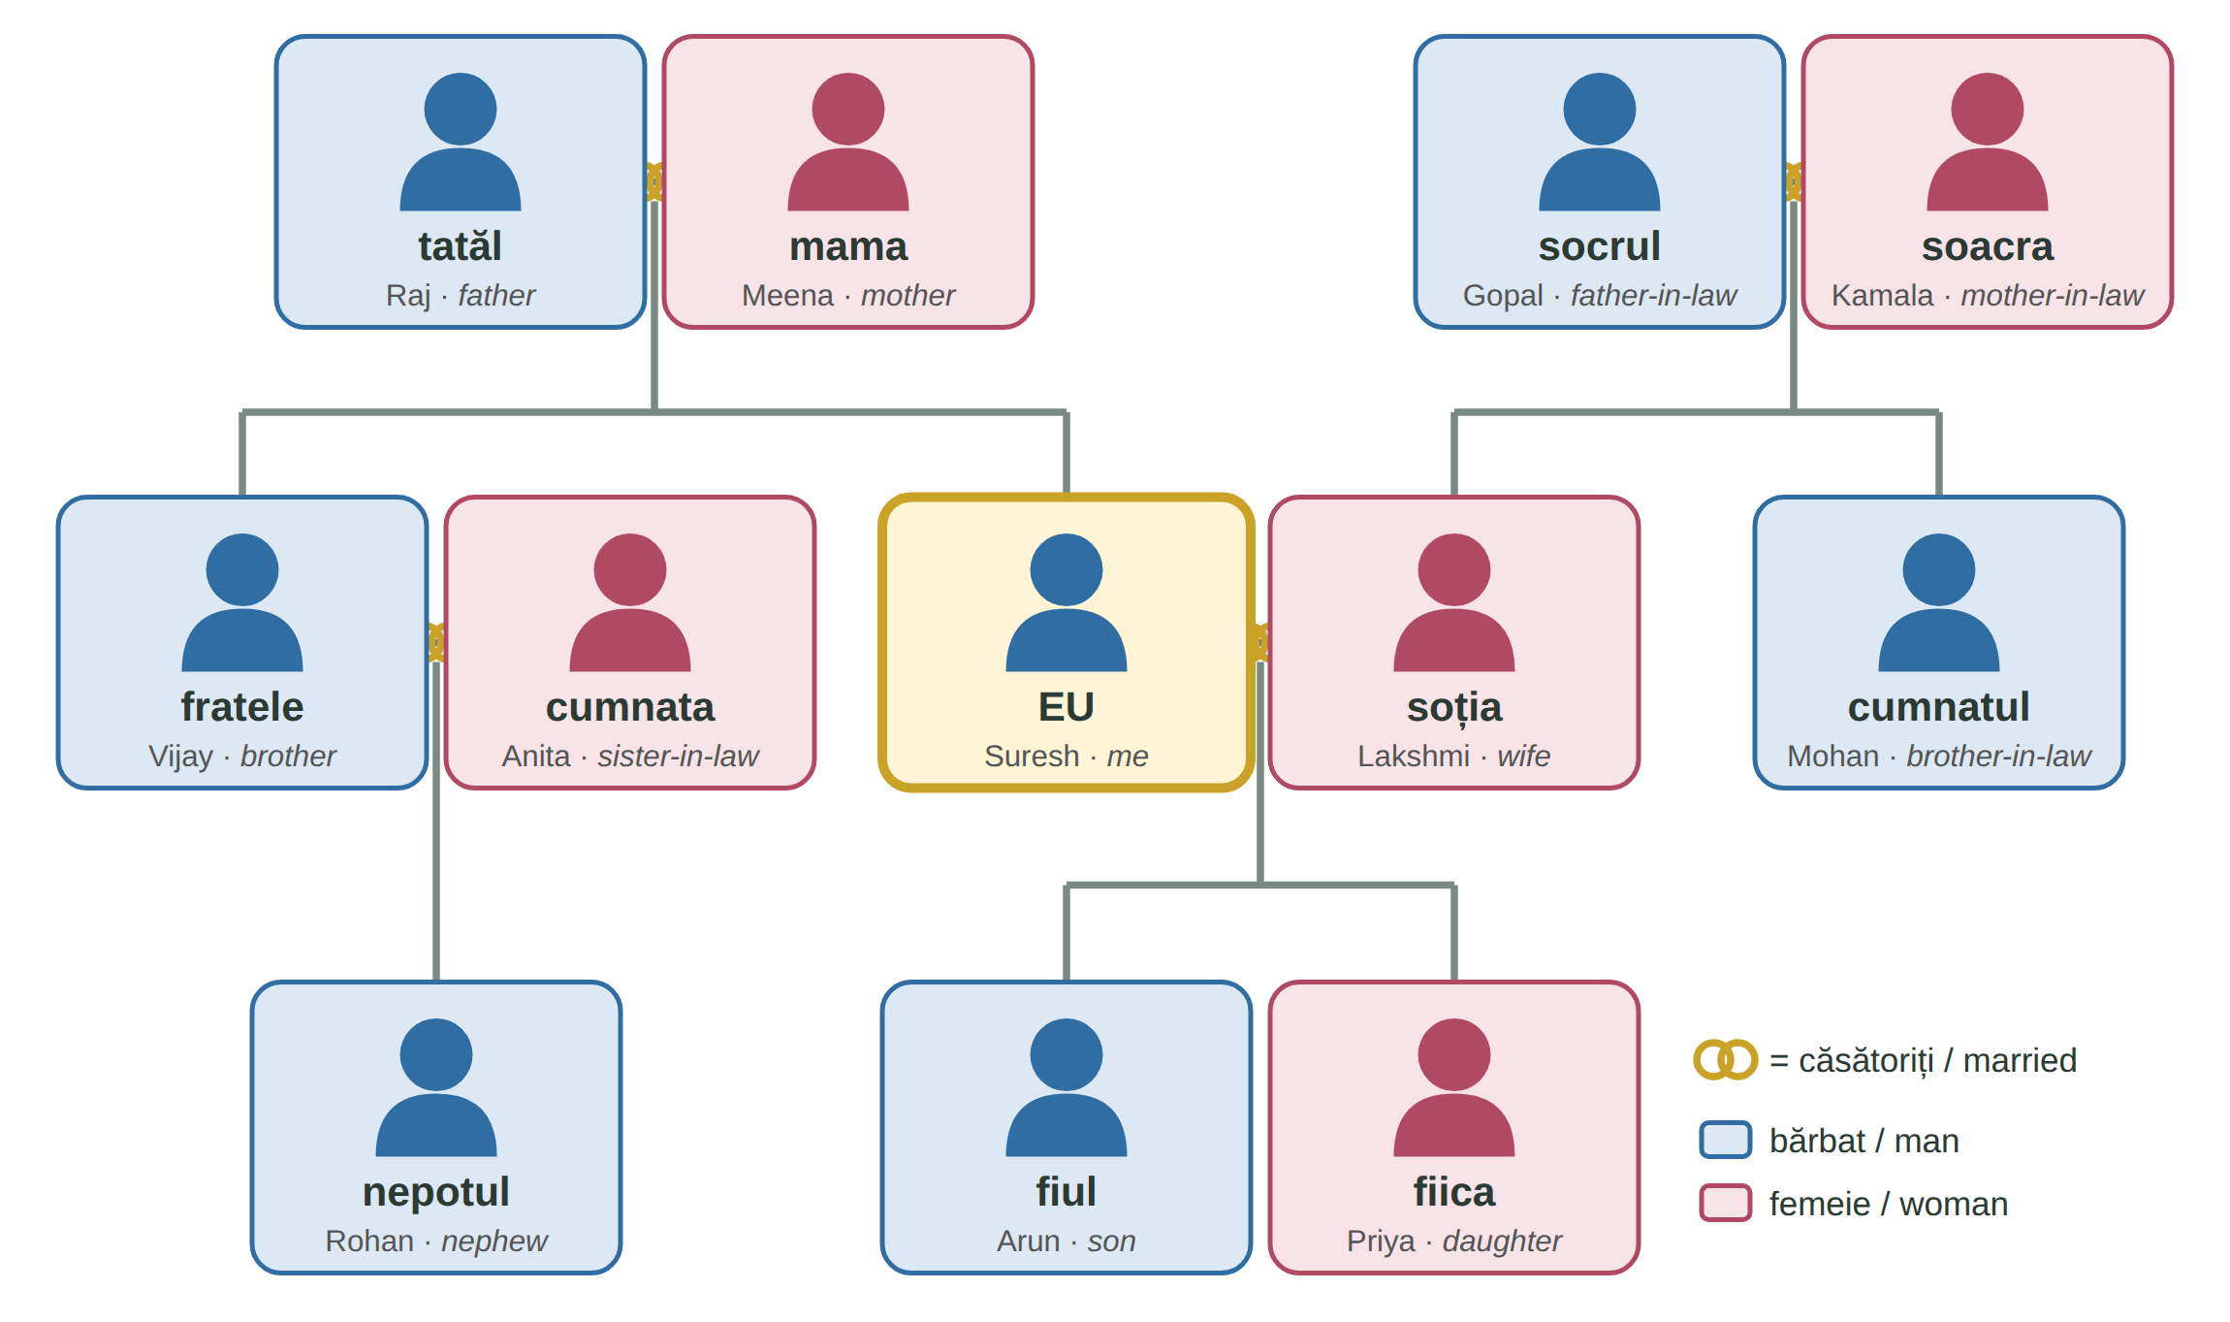
Fig. 7.1 — Familia lui Suresh / Suresh's family
Close family / Familia apropiată
MAN — UN | PLURAL | ENGLISH | WOMAN — O | PLURAL | ENGLISH
un tată | tați | father | o mamă | mame | mother
un frate | frați | brother | o soră | surori | sister
un soț | soți | husband | o soție | soții | wife
un fiu | fii | son | o fiică | fiice | daughter
un bunic | bunici | grandfather | o bunică | bunici | grandmother
un nepot | nepoți | grandson; nephew | o nepoată | nepoate | granddaughter; niece

părinții — the parents · copiii — the children · bunicii — the grandparents · frații — brothers and sisters. People often say băiatul meu / fata mea (my boy / my girl) for my son / my daughter.
The extended family / Familia extinsă
MAN — UN | PLURAL | ENGLISH | WOMAN — O | PLURAL | ENGLISH
un socru | socri | father-in-law | o soacră | soacre | mother-in-law
un cumnat | cumnați | brother-in-law | o cumnată | cumnate | sister-in-law
un ginere | gineri | son-in-law | o noră | nurori | daughter-in-law
un unchi | unchi | uncle | o mătușă | mătuși | aunt
un văr | veri | cousin (man) | o verișoară | verișoare | cousin (woman)

FALSE FRIENDS — PĂRINȚI, RUDE, NEPOT
părinții = only mother and father. Relatives = rudele: Am rude în Italia. · nepotul = grandson and nephew; nepoata = granddaughter and niece.

RECAP — MY AND WHOSE (Lessons 2.7 and 2.9)
fratele meu · sora mea · părinții mei (never frate meu ✗) · mama lui Suresh · fratele Mariei · fiica lui Lakshmi (a woman's name not in -a takes lui).
The same endings work with family words — learn the phrases below as they are: -ei for a woman (soției, mamei — like Mariei), -ului / -lui for a man (soțului, fratelui), -lor for more (părinților).

TIPAR — whose relative? (learn the phrases, not a rule)
RELATIVE + the | + | soției · mamei · soțului · fratelui · părinților | = | fratele soției

ROMANIAN | ENGLISH | ROMANIAN | ENGLISH
fratele soției | my wife's brother | sora soțului | my husband's sister
părinții soției | my wife's parents | mama soțului | my husband's mother
soția fratelui meu | my brother's wife | fiul surorii mele | my sister's son
casa părinților | my parents' house | numele copilului | the child's name

7.1 Who is it? / Cine este?
Use: bunica · cumnatul · socrul · soacra · nepotul · copiii. Then say the sentences about your own family.
1. Mama soției mele este ______________ mea. | 2. Tatăl soției mele este ______________ meu.
3. Fratele soției mele este ______________ meu. | 4. Fiul fratelui meu este ______________ meu.
5. Mama mamei mele este ______________ mea. | 6. Fiul meu și fiica mea sunt ______________ mei.

CUVINTE ȘI EXPRESII UZUALE / USEFUL WORDS AND PHRASES
Câți frați ai? | How many brothers and sisters do you have? | Am doi frați și o soră. | I have two brothers and a sister.
Ai copii? | Do you have children? | Am un băiat și o fată. | I have a boy and a girl.
Câți ani are fiul tău? | How old is your son? | Are șapte ani. | He is seven.
fratele cel mare / sora cea mică | my older brother / my younger sister | Suntem cinci în familie. | There are five of us in the family.

Lesson 7.2 — Marital status and the family / Starea civilă și familia
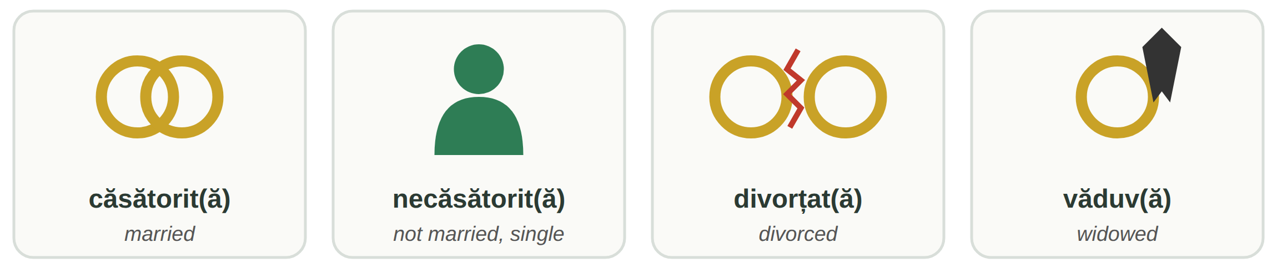
Fig. 7.2 — Starea civilă / Marital status
A woman adds -ă: căsătorită, necăsătorită, divorțată, văduvă. logodit(ă) = engaged. · Sunteți căsătorit? — Da, sunt căsătorit. Soția mea e în Nepal. — Are you married? — Yes, I am. My wife is in Nepal. · Nu, nu sunt căsătorită. — No, I am not married.
ATTENTION — STAREA CIVILĂ ON FORMS AND IN LAW
Official forms — for example the IGI forms for the residence permit — ask for starea civilă: căsătorit(ă), necăsătorit(ă), divorțat(ă), văduv(ă). Tick the one that matches your documents.
In Romania a marriage is concluded at the town hall, before the civil status officer (ofițerul de stare civilă). The religious wedding can take place only after the civil one (Constitution, art. 48).
certificatul de căsătorie — marriage certificate · certificatul de naștere — birth certificate · reîntregirea familiei — family reunification (a right of residence; ask IGI for the conditions).

Sending money and presents home — îi / le + family word
RECAP — ÎI AND LE (Lesson 2.10)
Îi dau cheile. — I give him / her the keys. îi = to him / to her · le = to them. Romanian says the person twice: Îi trimit bani mamei. This is normal.

TIPAR
ÎI / LE | + | VERB + THING | + | mamei · copilului · părinților | = | Îi trimit bani mamei.

ROMANIAN | ENGLISH | ROMANIAN | ENGLISH
Îi trimit bani soției în fiecare lună. | I send money to my wife every month. | Le trimit bani părinților. | I send money to my parents.
Îi cumpăr un cadou fiicei mele. | I buy a present for my daughter. | Îi dau copilului o jucărie. | I give the child a toy.
Îi telefonez fratelui meu duminica. | I phone my brother on Sundays. | Le spun copiilor „Noapte bună!” | I say "Good night!" to the children.

The family in Romania / Familia la români
CULTURAL NOTE — PARENTS, NAȘII, THE CHRISTENING AND THE WEDDING
Parents. Family ties are strong. Grown-up children stay close to their parents and visit them on Sundays and holidays; grandparents often help to raise the grandchildren. Many Romanians also work abroad and send money home — like you.
Nașii (the godparents) are a married couple chosen by the bride and groom. They lead the couple at the religious wedding (nașii de cununie) and often become the godparents of the first child (nașii de botez). They stay close to the family for life. The godchild is finul / fina.
Botezul (the christening): in the Orthodox Church a baby is usually christened in the first months of life; after the church there is a party with family and friends.
Nunta (the wedding): first cununia civilă at the town hall, then cununia religioasă at church, then a big party with music and dancing, often until morning. Guests usually give the couple money in an envelope — darul.

FOTO: nuntă românească — mirii și nașii la ieșirea din biserică
Fig. 7.3 — Mirii și nașii / The bride and groom with the godparents

7.2 Your family and a Romanian family
Read the Romanian answer. Write a short answer about your country, then tell a colleague: La noi... (In my country...) / În țara mea...
ÎNTREBARE | ÎN ROMÂNIA | ÎN ȚARA MEA
1. Cine locuiește împreună? | Părinții și copiii; uneori și bunicii.
2. Cine ajută la creșterea copiilor? | Părinții, adesea și bunicii.
3. Unde este nunta? | La Primărie, la biserică și la restaurant.
4. Există nași? | Da, nașii sunt foarte importanți.
5. Ce faceți duminica? | Mulți merg la părinți.

CUVINTE ȘI EXPRESII UZUALE / USEFUL WORDS AND PHRASES
mirele / mireasa | the groom / the bride | nașul / nașa | the godfather / the godmother
finul / fina | the godson / the goddaughter | Felicitări! | Congratulations!
Casă de piatră! | wish to newlyweds ("a house of stone") | Să vă trăiască! | wish to parents of a new baby
La noi... | In my country... / At home... | Aștept un copil. | I am expecting a baby.

HOMEWORK — AFTER SESSION 26 / TEMĂ PENTRU ACASĂ
H26.1 Draw your family tree like Fig. 7.1. Under every person write the Romanian word: tatăl meu, soția mea, cumnatul meu...
H26.2 Write five sentences about your family: your marital status, your brothers and sisters, and who you send money or presents to (Îi trimit... / Le trimit...).

SESSION 27 — AT THE RESTAURANT
SESIUNEA 27 — LA RESTAURANT · 3 hours

By the end of this session you will be able to:
☐ | read a Romanian menu: ciorbe, fel principal, garnituri, desert, băuturi
☐ | recognise seven Romanian dishes and ask what is in them: Conține carne de porc?
☐ | ask for a table and order food and drinks politely: Aș dori..., Aduceți-mi...
☐ | ask for the bill, pay and leave a tip
☐ | name the jobs in a restaurant

Lesson 7.3 — Food, drinks and the menu / Mâncare, băuturi și meniul
Meniul = the menu. A Romanian menu follows the order of the meal: soup first, then the main course with a side dish, then dessert. Next to each dish you see the weight (gramajul) and the price.
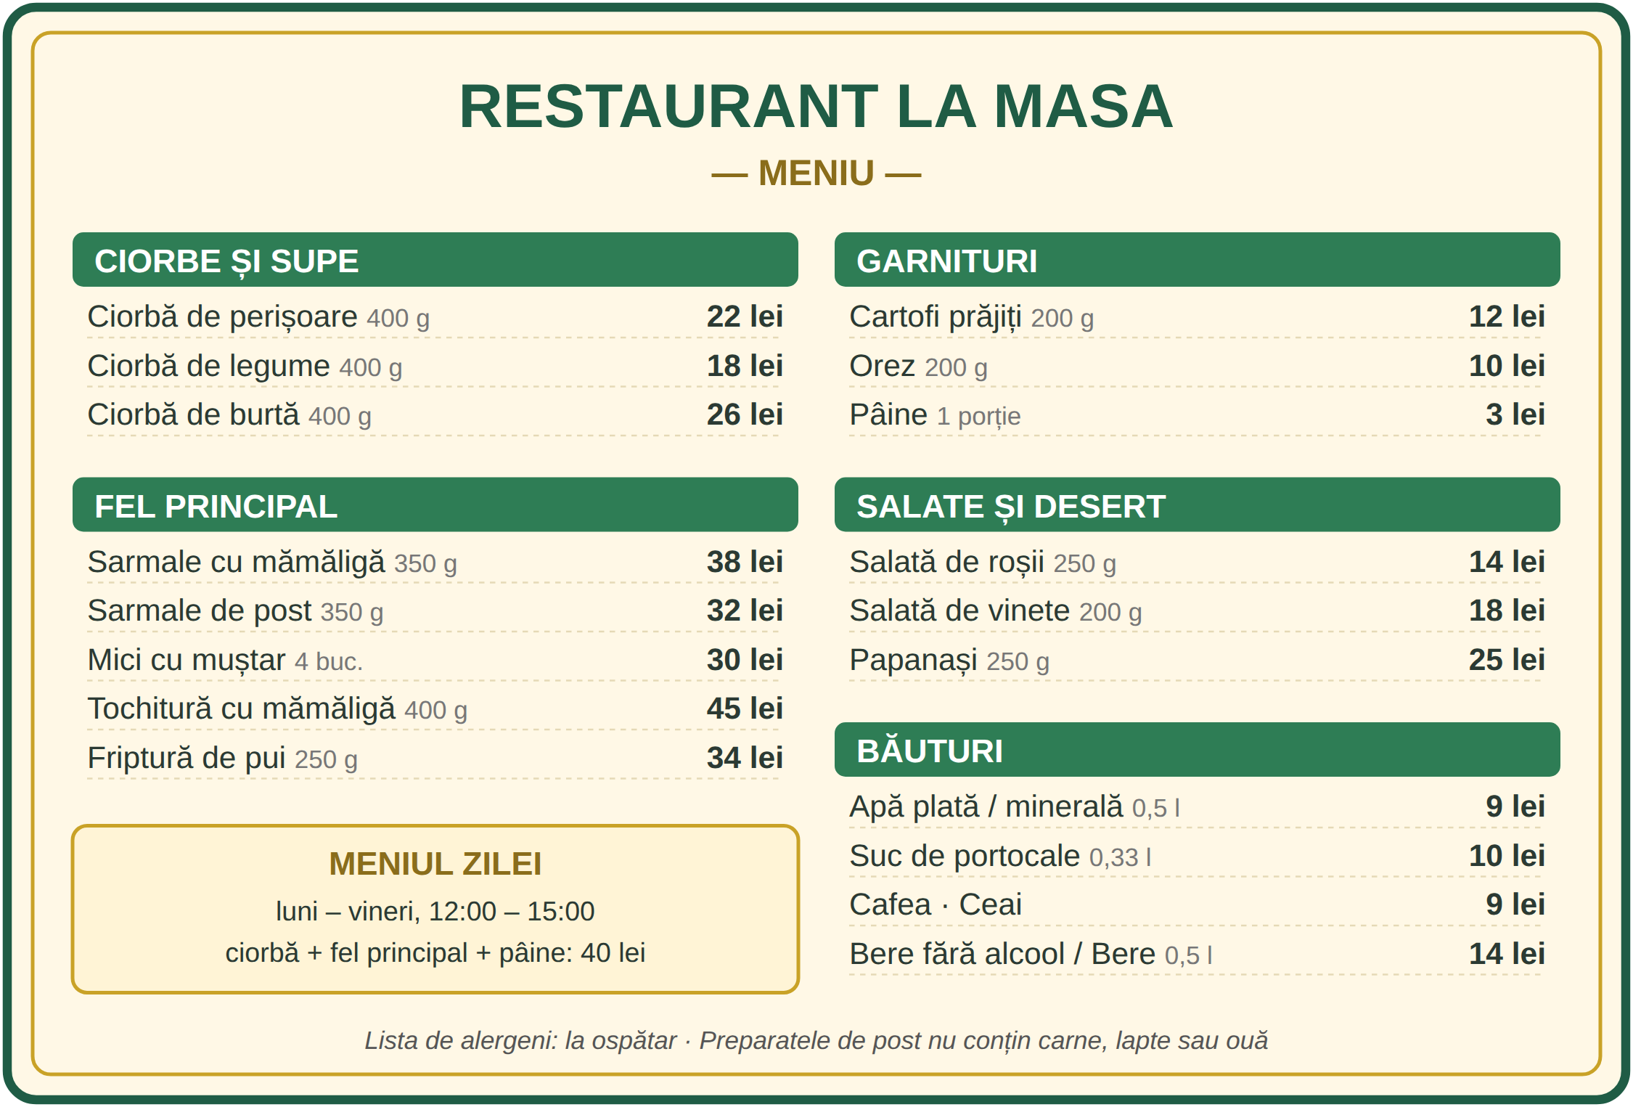
Fig. 7.4 — Un meniu (exemplu, prețuri orientative) / A menu (example, sample prices)
aperitive — starters · ciorbe și supe — soups · fel principal — main course · garnituri — side dishes: cartofi prăjiți (chips), orez (rice), mămăligă · salate — salads · desert — dessert · băuturi — drinks: apă plată (still) / minerală (sparkling), suc, cafea, ceai, bere, vin · meniul zilei — a cheaper lunch menu on weekdays, in many restaurants.
The meat: carne de pui (chicken) · de porc (pork) · de vită (beef) · de miel (lamb) · pește (fish). De post = without meat, milk or eggs (Orthodox fasting food) — good for vegetarians, but ask.
Seven Romanian dishes / Șapte feluri românești
FOTO:  ciorbă (de perișoare, de legume) | ciorba — sour soup  Many kinds: with meatballs (de perișoare), with vegetables (de legume), with beef tripe (de burtă). Often served with smântână (sour cream) and ardei iute (chilli). | FOTO:  sarmale cu mămăligă | sarmalele — cabbage rolls  Cabbage or vine leaves rolled with minced meat (usually pork) and rice. Sarmale de post have no meat.
FOTO:  mici cu muștar | micii / mititeii — grilled meat rolls  Small grilled rolls of minced meat — often beef mixed with pork or lamb. Eaten with muștar (mustard). Ask what meat. | FOTO:  mămăligă cu brânză și smântână | mămăliga — cornmeal porridge  Made from mălai (cornmeal). A side dish, or a meal with brânză (cheese) and smântână. No meat.
FOTO:  tochitură cu mămăligă și ou | tochitura — meat stew  Pieces of pork (sometimes sausages) in sauce, with mămăligă, cheese and a fried egg. | FOTO:  salată de vinete pe pâine | salata de vinete — aubergine spread  Roasted aubergine mashed with oil and onion, eaten on bread. No meat — close to baingan bharta.
FOTO:  papanași cu smântână și dulceață | papanașii — cheese doughnuts  Fried doughnuts made with fresh cheese, with smântână and dulceață (jam). The most popular dessert. |  | The spaces marked FOTO are for photos of the dishes, added by your teacher.
Fig. 7.5 — Feluri românești de bază / Basic Romanian dishes
ATTENTION — PORK, BEEF, ALLERGIES: ASK!
Many Romanian dishes contain pork. If you do not eat pork or beef, or if you have an allergy, ask before you order: Conține carne de porc? · Este cu carne de vită? · Este fără carne? · Sunt alergic la... (alune, lapte...).
In the European Union a restaurant must tell you which of the main allergens are in each dish (Regulation (EU) 1169/2011). Ask for lista de alergeni — the list of allergens.

7.3 Read the menu
Look at Fig. 7.4. Write the part of the menu for each dish, then answer the two questions.
1. papanași → ____________________ | 2. cartofi prăjiți → ____________________
3. ciorbă de legume → ____________________ | 4. bere → ____________________
5. sarmale → ____________________ | 6. salată de roșii → ____________________
7. Cât costă meniul zilei? — ________ lei. | 8. Cât costă o apă plată? — ________ lei.

CUVINTE ȘI EXPRESII UZUALE / USEFUL WORDS AND PHRASES
Ce ne recomandați? | What do you recommend? | Este picant? | Is it spicy?
Nu mănânc carne de porc. | I don't eat pork. | Sunt vegetarian / vegetariană. | I am vegetarian.
fără ceapă, fără gheață | without onion, without ice | o porție | a portion
Pot să iau la pachet? | Can I take it away? | tacâmurile: furculița, cuțitul, lingura | the cutlery: fork, knife, spoon
un șervețel | a napkin | Poftă bună! (Lesson 5.3) | Enjoy your meal!

Lesson 7.4 — Ordering and paying / A comanda și a plăti
Who works in a restaurant? / Cine lucrează la restaurant?
MAN / WOMAN | JOB | MAN / WOMAN | JOB
ospătar / ospătăriță (Lesson 3.2) | waiter / waitress | bucătar / bucătăreasă · bucătar-șef | cook · chef
ajutor de bucătar | kitchen assistant | spălător / spălătoare de vase | dishwasher
barman / barmaniță | bartender | livrator / livratoare | delivery driver

Lucrez ca ajutor de bucătar într-un restaurant din Cluj. — I work as a kitchen assistant in a restaurant in Cluj.
RECAP — POLITE REQUESTS (Lesson 3.13 and Lesson 4.4)
A polite request is the voi / dumneavoastră form + -mi with a hyphen: Aduceți-mi o apă, vă rog. · Dați-mi meniul, vă rog. · Spuneți-mi, vă rog, ce conține?
Even more polite, the fixed phrase Aș dori (Lesson 4.4): Aș dori o ciorbă de legume. In a group you can also say Pentru mine... — For me...

WHO SAYS IT | ROMANIAN | ENGLISH
waiter | Bună seara! Câte persoane? | Good evening! How many people?
you | O masă pentru doi, vă rog. / Am o rezervare. | A table for two, please. / I have a booking.
waiter | Poftiți meniul. Ce doriți să comandați? | Here is the menu. What would you like to order?
you | Aș dori o ciorbă de perișoare. Pentru mine, sarmale. | I would like meatball soup. For me, cabbage rolls.
waiter · you | Și de băut? — Aduceți-mi o apă plată, vă rog. | And to drink? — Bring me a still water, please.
waiter · you | Altceva? — Nu, mulțumesc, deocamdată atât. | Anything else? — No, thank you, that's all for now.
you | Nota, vă rog! / Ne aduceți nota, vă rog? | The bill, please! / Could you bring us the bill?
waiter | Plătiți împreună sau separat? Cash sau cu cardul? | Together or separately? Cash or card?
you | Separat, vă rog. · Păstrați restul. | Separately, please. · Keep the change.

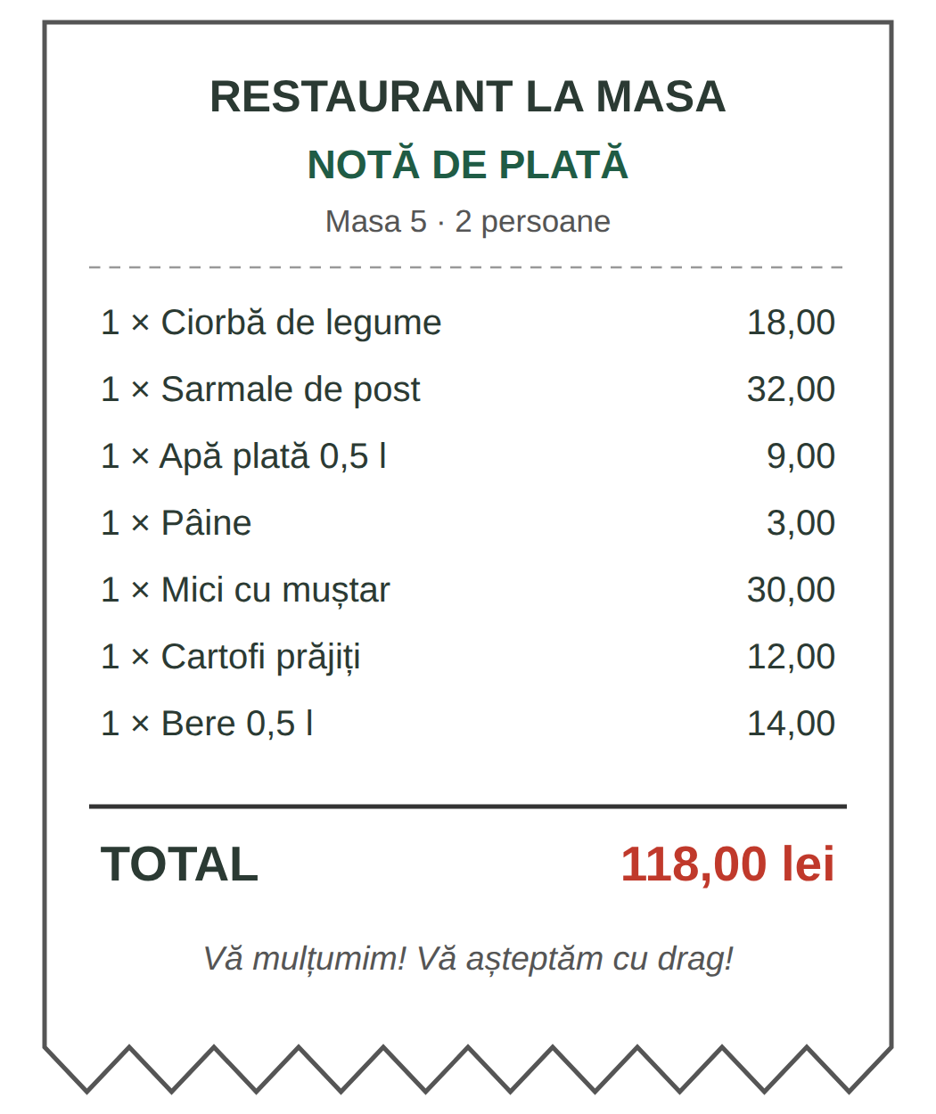  Fig. 7.6 — Nota de plată / The bill | PRACTICAL NOTE — THE BILL AND THE TIP / NOTA ȘI BACȘIȘUL  Nota de plată shows what you ordered; you then receive the bon fiscal (the official receipt). Check the bill and keep the receipt.  Bacșișul (the tip) is a common habit in Romanian restaurants, but it is voluntary: the law describes it as money the customer gives of their own free will (Law 376/2022). There is no fixed amount — people usually leave more when they are happy with the service.  You can leave the tip in cash or add it when you pay by card. Since 2023 restaurants and bars must record the tip on the fiscal receipt, however you pay (Law 376/2022).

7.4 Complete the dialogue
Use: O masă · Aș dori · de băut · Aduceți-mi · Nota · Cu cardul. Then act it out with a colleague.
O: Bună seara! Câte persoane?
C: ______________________ pentru doi, vă rog.
O: Ce doriți să comandați?
C: ______________________ o ciorbă de legume.
O: Și ______________________?
C: ______________________ o apă plată, vă rog.
C: (mai târziu) ______________________, vă rog!
O: Plătiți cash sau cu cardul? C: ______________________.

CUVINTE ȘI EXPRESII UZUALE / USEFUL WORDS AND PHRASES
Masa asta e liberă? | Is this table free? | Mai aduceți o pâine, vă rog. | Another bread, please.
Mâncarea e rece. | The food is cold. | Am comandat altceva. | I ordered something else.
Totul a fost foarte bun! | Everything was very good! | Îmi dați și bonul, vă rog? | Can I have the receipt too, please?

HOMEWORK — AFTER SESSION 27 / TEMĂ PENTRU ACASĂ
H27.1 Choose a lunch from the menu in Fig. 7.4: a soup, a main course, a side dish and a drink. Write your order with Aș dori... / Aduceți-mi... and the total price.
H27.2 Write four sentences: a Romanian dish you want to try, what you do not eat, a dish from your country, and your job if you work in a restaurant.

SESSION 28 — FEELINGS, RECAP AND TEST
SESIUNEA 28 — EMOȚII, RECAPITULARE ȘI TEST · 3 hours

By the end of this session you will be able to:
☐ | say how you feel: Sunt obosit. Mă simt bine.
☐ | name six basic feelings, for a man and for a woman
☐ | say you are hungry, thirsty, cold, hot or sleepy, and that you miss someone: Mi-e foame. Mi-e dor de copii.
☐ | follow and act out a full dialogue at the restaurant
☐ | use every form from Module 7 and pass the Module 7 cumulative test

Lesson 7.5 — How do you feel? / Cum te simți?
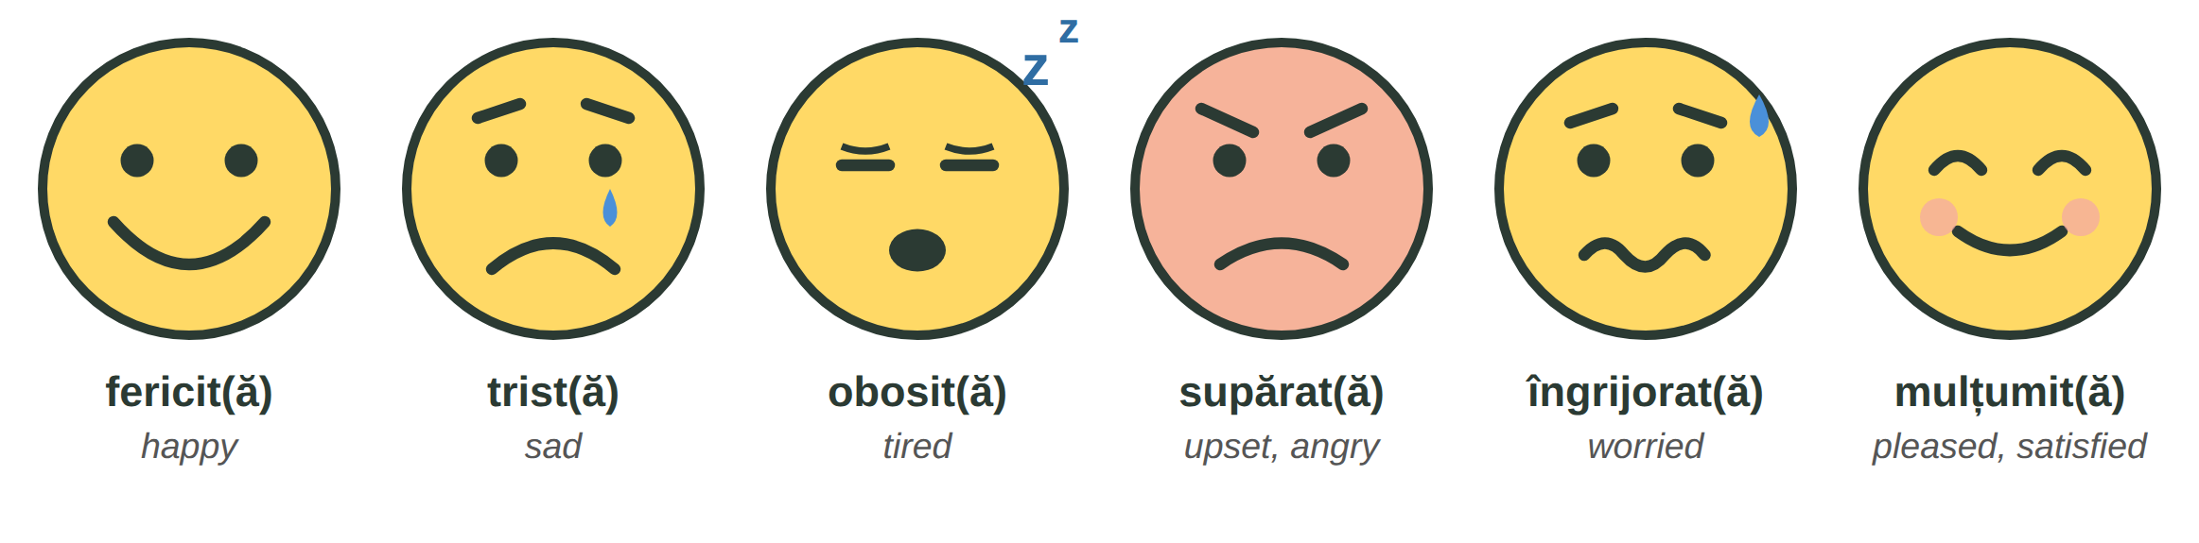
Fig. 7.7 — Emoții și stări / Feelings
A woman adds -ă: fericită, tristă, obosită. More people: fericiți · triști · obosiți · supărați · îngrijorați · mulțumiți.
RECAP — THE ADJECTIVE AGREES · MĂ SIMT (Lessons 2.4 and 3.12)
The feeling word agrees with the person: El este obosit. Ea este obosită. Ei sunt obosiți.
With mă simt (I feel) you use the same words, or bine / rău: Mă simt obosită. · Cum vă simțiți? — Mă simt bine, mulțumesc.

TIPAR — how you feel
SUNT / MĂ SIMT | + | fericit · obosită · îngrijorat... | = | Mă simt obosit.

ROMANIAN | ENGLISH | ROMANIAN | ENGLISH
Sunt fericit, azi e ziua fiului meu. | I am happy, today is my son's birthday. | Sunt tristă, familia mea e departe. | I am sad, my family is far away.
Sunt obosit după tura de noapte. | I am tired after the night shift. | Sunt îngrijorat, mama e bolnavă. | I am worried, my mother is ill.
Șeful e supărat azi. | The boss is upset today. | Suntem mulțumiți de cazare. | We are pleased with the accommodation.

Mi-e foame — I am hungry
Hunger, thirst, cold, heat and sleep are not said with sunt. Romanian says hunger is to me: mi-e = îmi + e (Lesson 2.10). The same pattern gives one of the most important sentences for you: Mi-e dor de... — I miss...
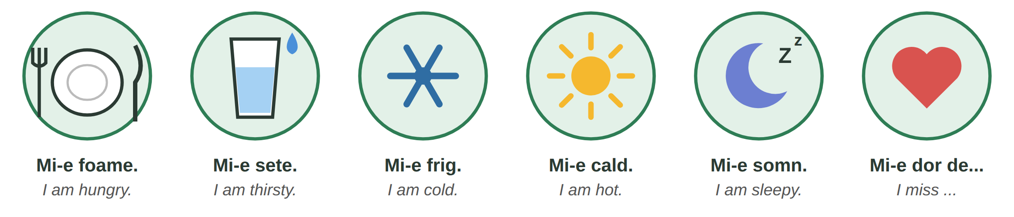
Fig. 7.8 — Mi-e... / I am... (hungry, thirsty, cold, hot, sleepy) · I miss...
TIPAR
MI-E / ȚI-E / ÎI E / VĂ E | + | foame · sete · frig · cald · somn · dor de... | = | Mi-e foame.

ROMANIAN | ENGLISH | ROMANIAN | ENGLISH
Ți-e foame? | Are you hungry? | Nu mi-e foame. | I am not hungry.
Vă e sete? | Are you thirsty? (polite) | Îi e frig copilului. | The child is cold.
Mi-e dor de copii. | I miss my children. | Mi-e dor de casă. | I am homesick.

ATTENTION — ESTE FRIG IS NOT MI-E FRIG · NERVOS IS NOT NERVOUS
Este frig. — It is cold (the weather, Lesson 5.5). Mi-e frig. — I am cold (my body). Never Sunt frig ✗ or Sunt foame ✗.
nervos means irritated, angry — not nervous. Before an exam or an interview you say Am emoții. — I am nervous.

7.5 Choose the right word
Circle the correct form. Then say each sentence about yourself.
1. Ea este ( obosit / obosită ). | 2. ( Mi-e / Sunt ) foame.
3. Afară ( este / mi-e ) frig. | 4. Ei sunt ( fericiți / fericit ).
5. Nu mă ( simt / sunt ) bine. | 6. ( Mi-e / Sunt ) dor de familie.
7. Copilul plânge, e ( trist / tristă ). | 8. Am lucrat 12 ore. Sunt ( obosit / sete ).

CUVINTE ȘI EXPRESII UZUALE / USEFUL WORDS AND PHRASES
Ce ai? | What's wrong? | Nimic, sunt doar obosit. | Nothing, I'm just tired.
Nu-ți face griji! | Don't worry! | Totul e bine. | Everything is fine.
Mă bucur! | I'm glad! | Îmi pare rău. | I'm sorry.
Am emoții. | I'm nervous. | Mi-e frică. | I'm scared.

Lesson 7.6 — A full dialogue at the restaurant / Dialog complet la restaurant
Suresh and his Romanian colleague Mihai go out after work. O = ospătărița (the waitress). Read it in groups of three, then act it out.
ROMANIAN | ENGLISH
O: Bună seara! Aveți rezervare? | Good evening! Do you have a booking?
M: Nu. Aveți o masă liberă pentru două persoane? | No. Do you have a free table for two?
O: Da, poftiți aici, lângă fereastră. Poftiți meniul. | Yes, here, by the window. Here is the menu.
M: Ce zici, Suresh, ți-e foame? | What do you say, Suresh — are you hungry?
S: Da, mi-e foarte foame. Și sunt obosit — am lucrat zece ore azi. | Yes, I'm very hungry. And I'm tired — I worked ten hours today.
O: Ce doriți să comandați? | What would you like to order?
S: Ce ne recomandați? | What do you recommend?
O: Sarmalele cu mămăligă sunt foarte bune azi. | The cabbage rolls with polenta are very good today.
S: Conțin carne de porc? | Do they contain pork?
O: Da. Dar avem și sarmale de post, fără carne. | Yes. But we also have sarmale de post, without meat.
S: Atunci aș dori o ciorbă de legume și sarmale de post. | Then I would like a vegetable soup and meat-free sarmale.
M: Pentru mine, mici cu cartofi prăjiți. | For me, mici with chips.
O: Și de băut? M: O bere, vă rog. | And to drink? — A beer, please.
S: Aduceți-mi o apă plată și o pâine, vă rog. | Bring me a still water and some bread, please.
(mai târziu) M: Cum e mâncarea? | (later) How is the food?
S: Foarte bună! Sunt mulțumit. Soția mea gătește ceva asemănător acasă. | Very good! I'm pleased. My wife cooks something similar at home.
M: Ți-e dor de familie? | Do you miss your family?
S: Da, mi-e dor de soție și de copii. Le telefonez în fiecare seară. | Yes, I miss my wife and children. I phone them every evening.
M: Ne aduceți nota, vă rog? | Could you bring us the bill, please?
O: Imediat. Plătiți împreună sau separat? | Right away. Together or separately?
M: Separat. Eu plătesc cu cardul. S: Eu plătesc cash. Păstrați restul. | Separately. I'm paying by card. — I'm paying cash. Keep the change.
O: Mulțumesc frumos! O seară bună! | Thank you very much! Have a nice evening!

LOOK AT THE DIALOGUE — ONLY THINGS YOU KNOW
ți-e foame, mi-e dor de (Lesson 7.5) · sunt obosit, sunt mulțumit (Lesson 7.5) · Aduceți-mi, Ne aduceți (Lesson 3.13) · aș dori (Lesson 4.4) · Le telefonez — to them, the wife and the children (Lesson 7.2) · am lucrat (Lesson 3.14).

7.6 True or false? / Adevărat sau fals?
Write A (adevărat) or F (fals).
1. Suresh este obosit. ____ | 2. Suresh mănâncă sarmale cu carne de porc. ____
3. Mihai bea o bere. ____ | 4. Suresh vorbește cu familia în fiecare seară. ____
5. Suresh și Mihai plătesc împreună. ____ | 6. Suresh lasă bacșiș. ____

CUVINTE ȘI EXPRESII UZUALE / USEFUL WORDS AND PHRASES
Ce zici? | What do you say? / What do you think? | Imediat. | Right away.
o masă liberă | a free table | lângă fereastră | by the window
asemănător | similar | Mulțumesc frumos! | Thank you very much!
O seară bună! | Have a nice evening! | Noroc! (Lesson 5.3) | Cheers!

Lesson 7.7 — General recap / Recapitulare generală
FAMILY | MARITAL STATUS & CULTURE | AT THE RESTAURANT | FEELINGS
părinții · frații · copiii | căsătorit(ă) | meniul · nota | fericit(ă)
soțul · soția | necăsătorit(ă) | ciorbe · fel principal | trist(ă)
socrul · soacra | divorțat(ă) · văduv(ă) | garnituri · desert · băuturi | obosit(ă) · supărat(ă)
cumnatul · cumnata | nașii · finul / fina | ospătar · bucătar · barman | îngrijorat(ă) · mulțumit(ă)
nepotul · nepoata | botezul · nunta · darul | bacșișul · bonul fiscal | Mi-e foame / sete / dor de...

PATTERN | EXAMPLE | LEARNED IN
relative + soției / soțului / părinților | fratele soției · mama soțului | Lesson 7.1
îi / le + verb + mamei / copilului | Îi trimit bani mamei. Le telefonez copiilor. | Lesson 7.2 (recap 2.10)
Sunt căsătorit / căsătorită. | Sunteți căsătorit? — Nu, sunt necăsătorit. | Lesson 7.2
Aș dori... · Pentru mine... | Aș dori o ciorbă. Pentru mine, mici. | Lesson 7.4 (recap 4.4)
Aduceți-mi..., vă rog. · Nota, vă rog! | Aduceți-mi o apă, vă rog. | recap — Lesson 3.13
Sunt / Mă simt + feeling that agrees | Ea e obosită. Mă simt bine. | Lesson 7.5 (recap 2.4, 3.12)
Mi-e + foame / sete / frig / cald / somn | Mi-e frig. (≠ Este frig.) | Lesson 7.5 (recap 2.10)

7.7 Everything together
Circle the correct word.
1. Mama soției este ( soacra / cumnata ). | 2. Aceasta este casa ( lui / a ) Suresh.
3. ( Îi / Le ) trimit bani părinților. | 4. Ea este ( căsătorit / căsătorită ).
5. ( Aduceți-mi / Aduc-mi ) nota, vă rog. | 6. Sarmalele de post nu conțin ( carne / varză ).
7. ( Mi-e / Sunt ) sete. | 8. După tura de noapte suntem ( obosiți / obosit ).

HOMEWORK — AFTER SESSION 28 / TEMĂ PENTRU ACASĂ
H28.1 Write five sentences about how you feel this week and why: Sunt obosit, pentru că... · Mi-e dor de...
H28.2 Prepare Module 8 (supermarket and market): write five foods you buy every week, in Romanian if you know them.

SECȚIUNE DETAȘABILĂ — EXEMPLAR FORMATOR
Detachable section — teacher's copy. Se detașează din suportul cursantului; testul completat, semnat și datat, se păstrează la dosarul cursantului. Conține: testul cumulativ, fișa de confirmare a Sesiunii 28, fișa de evidență a Modulului 7, cheia răspunsurilor, sursele.

TEST CUMULATIV — MODULUL 7
MODULE 7 — CUMULATIVE TEST · grilă, 20 de întrebări, 20 de puncte · semnat și datat de cursant

Nume și prenume cursant / Student name
Data / Date | _____ / _____ / 20_____
Semnătura cursantului / Student signature

Marcați cu X un singur răspuns la fiecare întrebare. Mark ONE answer with X for each question. Each correct answer = 1 point.
1. Mama soției mele este: (1 p)
☐ a) cumnata | ☐ b) soacra | ☐ c) nepoata | ☐ d) bunica
2. Fratele meu are un fiu. Fiul lui este ____ meu. (1 p)
☐ a) nepotul | ☐ b) socrul | ☐ c) unchiul | ☐ d) ginerele
3. Completează: „Sora mea are doi ____.” (1 p)
☐ a) copil | ☐ b) copiii | ☐ c) copii | ☐ d) copile
4. Ce înseamnă „părinții”? (1 p)
☐ a) the relatives | ☐ b) the parents | ☐ c) the children | ☐ d) the grandparents
5. Completează: „Aceasta este casa ____ Suresh.” (1 p)
☐ a) lui | ☐ b) a | ☐ c) al | ☐ d) ei
6. „Fratele soției” este: (1 p)
☐ a) socrul | ☐ b) ginerele | ☐ c) cumnatul | ☐ d) nepotul
7. O femeie care are soț spune: „Sunt ____.” (1 p)
☐ a) căsătorit | ☐ b) căsătorită | ☐ c) necăsătorită | ☐ d) divorțați
8. Completează: „____ trimit bani mamei în fiecare lună.” (1 p)
☐ a) Îl | ☐ b) O | ☐ c) Îi | ☐ d) Le
9. Completează: „Le telefonez ____ în fiecare seară.” (1 p)
☐ a) părinților | ☐ b) mamei | ☐ c) fratelui | ☐ d) soției
10. În România, căsătoria religioasă are loc: (1 p)
☐ a) înainte de căsătoria civilă | ☐ b) numai după căsătoria civilă | ☐ c) la IGI | ☐ d) fără căsătorie civilă
11. Cine sunt „nașii”? (1 p)
☐ a) the bride's parents | ☐ b) the godparents | ☐ c) the neighbours | ☐ d) the grandchildren
12. Ce înseamnă „felul principal”? (1 p)
☐ a) the main course | ☐ b) the dessert | ☐ c) the drinks | ☐ d) the side dish
13. Mămăliga se face din: (1 p)
☐ a) orez | ☐ b) mălai | ☐ c) cartofi | ☐ d) carne
14. Nu mănânci carne de porc. Ce întrebi? (1 p)
☐ a) Conține carne de porc? | ☐ b) Cât costă? | ☐ c) Unde este toaleta? | ☐ d) Aveți o masă liberă?
15. Cum ceri nota politicos? (1 p)
☐ a) Dă nota! | ☐ b) Nota, vă rog! | ☐ c) Nota mea! | ☐ d) Ai nota?
16. Completează: „____-mi o apă plată, vă rog.” (1 p)
☐ a) Aduceți | ☐ b) Aduc | ☐ c) Aducem | ☐ d) Adus
17. Cine gătește într-un restaurant? (1 p)
☐ a) ospătarul | ☐ b) casierul | ☐ c) bucătarul | ☐ d) barmanul
18. În România, bacșișul la restaurant este: (1 p)
☐ a) obligatoriu | ☐ b) interzis | ☐ c) voluntar — îl dai dacă vrei | ☐ d) inclus în chirie
19. O femeie a lucrat 12 ore. Ea spune: „Sunt ____.” (1 p)
☐ a) obosit | ☐ b) obosită | ☐ c) obosiți | ☐ d) obosite
20. Care propoziție este corectă? (1 p)
☐ a) Sunt foame. | ☐ b) Mi-e foame. | ☐ c) Am foame. | ☐ d) Este foame mie.

PUNCTAJ OBȚINUT / SCORE | _______ / 20
Semnătura formatorului / Teacher signature

SESSION COMPLETION RECORD
FIȘĂ DE CONFIRMARE A PARCURGERII SESIUNII — se păstrează la dosar

Module / Modul | Modulul 7 — Familia mea și la restaurant (finalizat)
Session / Sesiunea | Sesiunea 28 — Emoții, dialog complet la restaurant, recapitulare. TEST CUMULATIV MODULUL 7
Duration / Durata | 3 ore
Date / Data | _____ / _____ / 20_____
Student name / Nume și prenume cursant
Score / Punctaj obținut | _______ / 20
Student signature / Semnătura cursantului
Teacher signature / Semnătura formatorului

DECLARAȚIE CURSANT / STUDENT DECLARATION
Declar că am participat la această sesiune de curs și am parcurs conținutul prezentat mai sus.
I declare that I attended this course session and covered the content presented above.

MODULE 7 — COMPLETION RECORD
FIȘĂ DE EVIDENȚĂ A PARCURGERII MODULULUI 7 — se păstrează la dosarul cursantului

Cursant / Student
Act de identitate / ID document
Angajator / Employer
Formator / Teacher
Modul / Module | Modulul 7 — Familia mea și la restaurant (9 ore, Sesiunile 26–28)

NR. | SESIUNE / CONȚINUT | DATA | PUNCTAJ TEST | SEMNĂTURA CURSANTULUI
26 | Sesiunea 26 — Familia, rudele, starea civilă, familia la români (3 ore) |  | —
27 | Sesiunea 27 — La restaurant: meniul, feluri românești, a comanda și a plăti, profesiile din restaurant (3 ore) |  | —
28 | Sesiunea 28 — Emoții, dialog complet la restaurant, recapitulare + TEST CUMULATIV (3 ore) |  | ___ / 20

CONFIRMARE FINALIZARE MODUL / MODULE COMPLETION
Confirm că cursantul a parcurs integral conținutul Modulului 7 — Familia mea și la restaurant, în total 9 ore de curs, și a susținut testul de evaluare consemnat mai sus.
I confirm that the student completed the full content of Module 7 — My Family and at the Restaurant, 9 course hours in total, and sat the assessment recorded above.
Data: _____ / _____ / 20_____ Semnătura formatorului: ______________________

ANSWER KEY — TEACHER COPY
CHEIA RĂSPUNSURILOR — pentru formator

Session 26
7.1 soacra · socrul · cumnatul · nepotul · bunica · copiii
7.2 personal answers — checked by the teacher (răspunsuri personale). Check that the student starts with La noi... / În țara mea...
Session 27
7.3 salate și desert · garnituri · ciorbe și supe · băuturi · fel principal · salate și desert · 40 (de lei) · 9 (lei)
7.4 O masă · Aș dori · de băut · Aduceți-mi · Nota · Cu cardul
Session 28
7.5 obosită · Mi-e · este · fericiți · simt · Mi-e · trist · obosit
7.6 1 A · 2 F (sarmale de post) · 3 A · 4 A · 5 F (separat) · 6 A (Păstrați restul)
7.7 soacra · lui · Le · căsătorită · Aduceți-mi · carne · Mi-e · obosiți
Cumulative test — grilă answer key
Un răspuns corect = 1 punct. Nemarcat sau dublu marcat = 0 puncte.
1 – b | 2 – a | 3 – c | 4 – b | 5 – a | 6 – c | 7 – b | 8 – c | 9 – a | 10 – b
11 – b | 12 – a | 13 – b | 14 – a | 15 – b | 16 – a | 17 – c | 18 – c | 19 – b | 20 – b

TOTAL: 20 puncte
Surse și data verificării / Sources and date of verification
Informațiile legale și administrative din acest modul au fost verificate la 24.09.2026 pe surse oficiale. The legal and administrative information in this module was checked on 24 September 2026 against official sources.
INFORMAȚIA / INFORMATION | SURSA / SOURCE | UNDE ÎN MODUL / WHERE
Căsătoria religioasă numai după cea civilă / religious wedding only after the civil one | Constituția României, art. 48 — legislatie.just.ro/Public/DetaliiDocument/47355 | Lesson 7.2, test q. 10
Căsătoria se încheie în fața ofițerului de stare civilă / marriage before the civil status officer | Codul civil (Legea nr. 287/2009, rep.), Cartea a II-a „Despre familie”; Legea nr. 119/1996 privind actele de stare civilă — legislatie.just.ro | Lesson 7.2
Starea civilă pe formulare; reîntregirea familiei / marital status on forms; family reunification | Formularele IGI (cereri de prelungire a dreptului de ședere) — igi.mai.gov.ro/en/forms | Lesson 7.2
Bacșișul: sumă oferită voluntar; evidențiat pe bonul fiscal la restaurante (CAEN 5610) și baruri (CAEN 5630), indiferent de modul de plată, din 2023 / the tip | Legea nr. 376/2022 (modifică O.U.G. nr. 28/1999) — legislatie.just.ro/Public/DetaliiDocument/263133; materiale informative ANAF | Lesson 7.4, test q. 18
Informarea obligatorie despre alergeni, inclusiv la alimentele neambalate din restaurante / allergens | Regulamentul (UE) nr. 1169/2011 — eur-lex.europa.eu (CELEX 32011R1169); ANSVSA, pagina „Alergeni” — ansvsa.ro | Lesson 7.3
Lecțiile anterioare citate / earlier lessons referred to | Modulele 2–6 revizuite: 2.3, 2.4, 2.7, 2.9, 2.10, 3.2, 3.12, 3.13, 3.14, 4.4, 5.3, 5.5, 5.6 | whole module

Descrierile felurilor de mâncare și notele culturale (nași, botez, nuntă, familia) sunt informații culturale generale, nu date oficiale; de aceea sunt formulate cu „de obicei”, „adesea”. Meniul și nota de plată sunt exemple, cu prețuri orientative. / The dish descriptions and cultural notes are general cultural information, not official data; the menu and the bill are examples with sample prices.

LIMBA ROMÂNĂ PENTRU STRĂINI
Romanian Language for Foreign Workers
SUPORT DE CURS

MODULE 8 — SUPERMARKET, MARKET, PHARMACY AND DOCTOR
MODULUL 8 — SUPERMARKET, PIAȚĂ, FARMACIE ȘI MEDIC
Finalul Nivelului A1 / The end of Level A1
LEVEL / NIVEL | DURATION / DURATĂ | LANGUAGE OF TEACHING
A1 — after Module 7 · end of A1 | 12 hours · Sessions 29–32 · Weeks 15–16 | English → Romanian

LEGAL BASIS / TEMEI LEGAL
Curs de limbă română cu elemente de integrare culturală și socială, organizat în conformitate cu O.U.G. nr. 32/2026, art. 7 alin. (1) lit. g) — minimum 6 luni, cel puțin 6 ore pe săptămână.
Romanian language course with cultural and social integration elements, organised under Government Emergency Ordinance no. 32/2026, art. 7(1)(g) — at least 6 months, at least 6 hours per week.
This module ends with the LEVEL A1 CUMULATIVE TEST (50 multiple-choice questions, Modules 1–8), signed and dated by the student and kept on file as proof of completion of Level A1.

Before you start
Module 8 is the last module of Level A1. It takes your Romanian to four places you cannot avoid: the supermarket, the market, the pharmacy and the doctor. You will also learn how health insurance and sick leave work for an employee, and what the Constitution says about your rights, your obligations and freedom of religion. The module ends with the Level A1 test.
You need these lessons first — look back at them if you are not sure:
YOU NEED | WHERE | WHY
numbers, money · de after 20 | Lesson 2.5 | 200 de grame, 2,50 lei, 20 de ouă
colours — the adjective agrees | Lessons 2.4, 4.4 | un măr roșu, o pară verde
îmi place / îmi plac · short pronouns | Lesson 2.10 | mă doare / mă dor works the same way
orders and requests · aș dori | Lessons 3.13, 4.4 | Îmi dați..., Deschideți gura!
the past — am lucrat | Lesson 3.14 | Am răcit. Am căzut.
112 · farmacia de gardă | Lessons 5.2, 5.3 | emergencies, the pharmacy at night
at the shop — casa, bonul, reducerea, punga | Lesson 6.3 | the supermarket
mă simt · mi-e frig / cald | Lessons 3.12, 7.5 | Nu mă simt bine. Mi-e frig.

Where this module sits in the course
SESSION | DURATION | CONTENT
Session 29 | 3 hours | Lesson 8.1 Fruit and vegetables · Lesson 8.2 Basic foods and quantities · Lesson 8.3 At the market and at the supermarket
Session 30 | 3 hours | Lesson 8.4 The human body · Lesson 8.5 At the pharmacy
Session 31 | 3 hours | Lesson 8.6 At the doctor · Lesson 8.7 Health insurance, the family doctor, sick leave
Session 32 | 3 hours | Lesson 8.8 Rights, obligations, freedom of religion · Lesson 8.9 Level A1 recap · Level A1 cumulative test

NO NEW GRAMMAR IN THIS MODULE
All the grammar was taught in Modules 2 and 3. Blue RECAP boxes tell you where to look back. Two new phrase patterns: un kilogram de... (Lesson 8.2) and mă doare / mă dor (Lesson 8.5) — they work like patterns you already know.
New in this module: words and phrases — fruit, vegetables, food, quantities, the market, the supermarket, the body, symptoms, the pharmacy, the doctor, health papers, rights and religions.

SESSION 29 — AT THE SUPERMARKET AND AT THE MARKET
SESIUNEA 29 — LA SUPERMARKET ȘI LA PIAȚĂ · 3 hours

By the end of this session you will be able to:
☐ | name 16 fruits and 16 vegetables, with un / o
☐ | name the basic foods and ask for a quantity: un kilogram de roșii, o sticlă de ulei
☐ | buy at the market: Cât costă kilogramul? Îmi dați...
☐ | find your way in a supermarket, read the price tags, the promotions and the receipt

Lesson 8.1 — Fruit and vegetables / Fructe și legume
Fructele = fruit · legumele = vegetables. Learn every word with un or o (Lesson 2.1). Struguri, cireșe, ciuperci, mazăre are almost always used in the plural or without un / o.

IMAGINE | IMAGINE | IMAGINE | IMAGINE | IMAGINE | IMAGINE | IMAGINE | IMAGINE
un măr | o pară | o banană | o portocală | o mandarină | o lămâie | struguri | o căpșună
IMAGINE | IMAGINE | IMAGINE | IMAGINE | IMAGINE | IMAGINE | IMAGINE | IMAGINE
cireșe | o piersică | o caisă | o prună | un pepene verde | un pepene galben | un kiwi | un ananas
Fig. 8.1 — Fructe / Fruit
ROMANIAN (cu un / o) | PLURAL | ENGLISH
un măr | mere | an apple
o pară | pere | a pear
o banană | banane | a banana
o portocală | portocale | an orange
o mandarină | mandarine | a mandarin
o lămâie | lămâi | a lemon
un strugure | struguri | a grape · grapes
o căpșună | căpșuni | a strawberry
o cireașă | cireșe | a cherry
o piersică | piersici | a peach
o caisă | caise | an apricot
o prună | prune | a plum
un pepene verde | pepeni verzi | a watermelon
un pepene galben | pepeni galbeni | a melon
un kiwi | kiwi | a kiwi
un ananas | ananași | a pineapple

IMAGINE | IMAGINE | IMAGINE | IMAGINE | IMAGINE | IMAGINE | IMAGINE | IMAGINE
o roșie | un castravete | un cartof | o ceapă | un usturoi | un morcov | un ardei | un ardei iute
IMAGINE | IMAGINE | IMAGINE | IMAGINE | IMAGINE | IMAGINE | IMAGINE | IMAGINE
o varză | o vânătă | un dovlecel | o salată verde | o conopidă | ciuperci | mazăre | o ridiche
Fig. 8.2 — Legume / Vegetables
ROMANIAN (cu un / o) | PLURAL | ENGLISH
o roșie | roșii | a tomato
un castravete | castraveți | a cucumber
un cartof | cartofi | a potato
o ceapă | cepe | an onion
un cățel de usturoi | căței de usturoi | a clove of garlic (usturoi = garlic)
un morcov | morcovi | a carrot
un ardei | ardei | a pepper
un ardei iute | ardei iuți | a chilli
o varză | verze | a cabbage
o vânătă | vinete | an aubergine
un dovlecel | dovlecei | a courgette
o salată verde | salate verzi | a lettuce
o conopidă | conopide | a cauliflower
o ciupercă | ciuperci | a mushroom
mazăre | — (no plural) | peas
o ridiche | ridichi | a radish

RECAP — THE COLOUR AGREES (Lessons 2.4 and 4.4)
un măr roșu · o pară verde · o banană galbenă · niște struguri negri / albi · roșii coapte (ripe tomatoes) · ardei verzi. Note: o roșie = a tomato, roșie = red (feminine).

8.1 What colour is it?
Write the colour so that it agrees. Then say: Îmi plac... / Nu-mi plac... (Lesson 2.10).
1. O banană coaptă este ______________. | 2. Castravetele este ______________.
3. Portocala este ______________. | 4. Vânăta este ______________ închis (dark).
5. Morcovii sunt ______________. | 6. Lămâia este ______________.

CUVINTE ȘI EXPRESII UZUALE / USEFUL WORDS AND PHRASES
proaspăt / proaspătă | fresh | copt / coaptă | ripe
românesc / din import | Romanian / imported | de sezon | in season
Sunt dulci? | Are they sweet? | Pot să gust? | Can I taste?
o legătură de pătrunjel / mărar | a bunch of parsley / dill | verdețuri | fresh herbs

Lesson 8.2 — Basic foods and quantities / Alimente de bază și cantități
ROMANIAN | ENGLISH | ROMANIAN | ENGLISH | ROMANIAN | ENGLISH
pâine | bread | lapte | milk | ouă (un ou) | eggs
brânză | cheese | unt | butter | iaurt | yoghurt
carne de pui | chicken | carne de porc / vită | pork / beef | pește | fish
orez | rice | făină | flour | paste | pasta
ulei | cooking oil | zahăr | sugar | sare | salt
apă plată / minerală | still / sparkling water | cafea · ceai | coffee · tea | condimente | spices

IMAGINE | IMAGINE | IMAGINE | IMAGINE | IMAGINE | IMAGINE | IMAGINE | IMAGINE
un kilogram | ½ kilogram | 200 de grame | o bucată | un pachet | o sticlă | o cutie | o legătură
Fig. 8.3 — Cantități / Quantities
TIPAR — how much? / cât?
QUANTITY | + | de | + | FOOD | = | un kilogram de roșii

ROMANIAN | ENGLISH | ROMANIAN | ENGLISH
un kilogram de cartofi | a kilo of potatoes | jumătate de kilogram de brânză | half a kilo of cheese
200 de grame de măsline | 200 g of olives | un kilogram și jumătate de mere | 1.5 kg of apples
o bucată de pâine | a loaf / piece of bread | un pachet de unt | a packet of butter
o sticlă de ulei | a bottle of oil | o cutie de lapte | a carton of milk
un ou · zece ouă | one egg · ten eggs | o legătură de pătrunjel | a bunch of parsley

RECAP — NUMBERS AND MONEY (Lesson 2.5 and Lesson 6.3)
From 20 up you add de: 200 de grame, 20 de ouă, but 5 ouă, 500 de grame. Prices: 5,49 lei = cinci lei și patruzeci și nouă de bani (comma, not point). kg = kilogram (Module 1, Lesson 1.4).

8.2 Which food?
Complete with a food that fits: ulei · unt · lapte · pâine · ouă · pătrunjel.
1. o sticlă de ______________ | 2. un pachet de ______________
3. o cutie de ______________ | 4. o bucată de ______________
5. zece ______________ | 6. o legătură de ______________

CUVINTE ȘI EXPRESII UZUALE / USEFUL WORDS AND PHRASES
Cât cântărește? | How much does it weigh? | Mai puțin / mai mult | a bit less / a bit more
Atât, mulțumesc. | That's all, thank you. | o felie / felii | a slice / slices
la kilogram · la bucată | by the kilo · by the piece | Expiră pe... | It expires on...

Lesson 8.3 — At the market and at the supermarket / La piață și la supermarket
At the market / La piață
Piața (the open-air market) sells fruit, vegetables, cheese and meat, often from local farmers. The seller weighs the food on the scale — cântarul. Prices are usually per kilogram.
ROMANIAN | ENGLISH
C: Bună ziua! Cât costă kilogramul de roșii? | Hello! How much is a kilo of tomatoes?
V: Opt lei kilogramul. Sunt românești, de la țară. | Eight lei a kilo. They are Romanian, from the countryside.
C: Îmi dați un kilogram și jumătate, vă rog. | Give me 1.5 kilos, please. (Îmi dați = Dați-mi, Lesson 3.13)
V: Poftiți. Un kilogram și șase sute de grame. E bine? | Here you are. 1.6 kg. Is that OK?
C: Da, e bine. Și o legătură de mărar. Cât fac toate? | Yes, fine. And a bunch of dill. How much is it all?
V: Paisprezece lei și optzeci de bani. | Fourteen lei eighty.
C: Poftiți cincisprezece lei. Păstrați restul. | Here are fifteen lei. Keep the change.

At the supermarket / La supermarket
IN THE SHOP | ENGLISH | IN THE SHOP | ENGLISH
raionul de legume-fructe | fruit & veg section | raionul de lactate | dairy section
raionul de carne · de pâine | meat · bakery section | raionul de băuturi | drinks section
coșul · căruciorul | basket · trolley | casa · casa self-service | checkout · self-checkout
cântarul (la legume) | the scale (weigh it yourself) | cardul de fidelitate | loyalty card

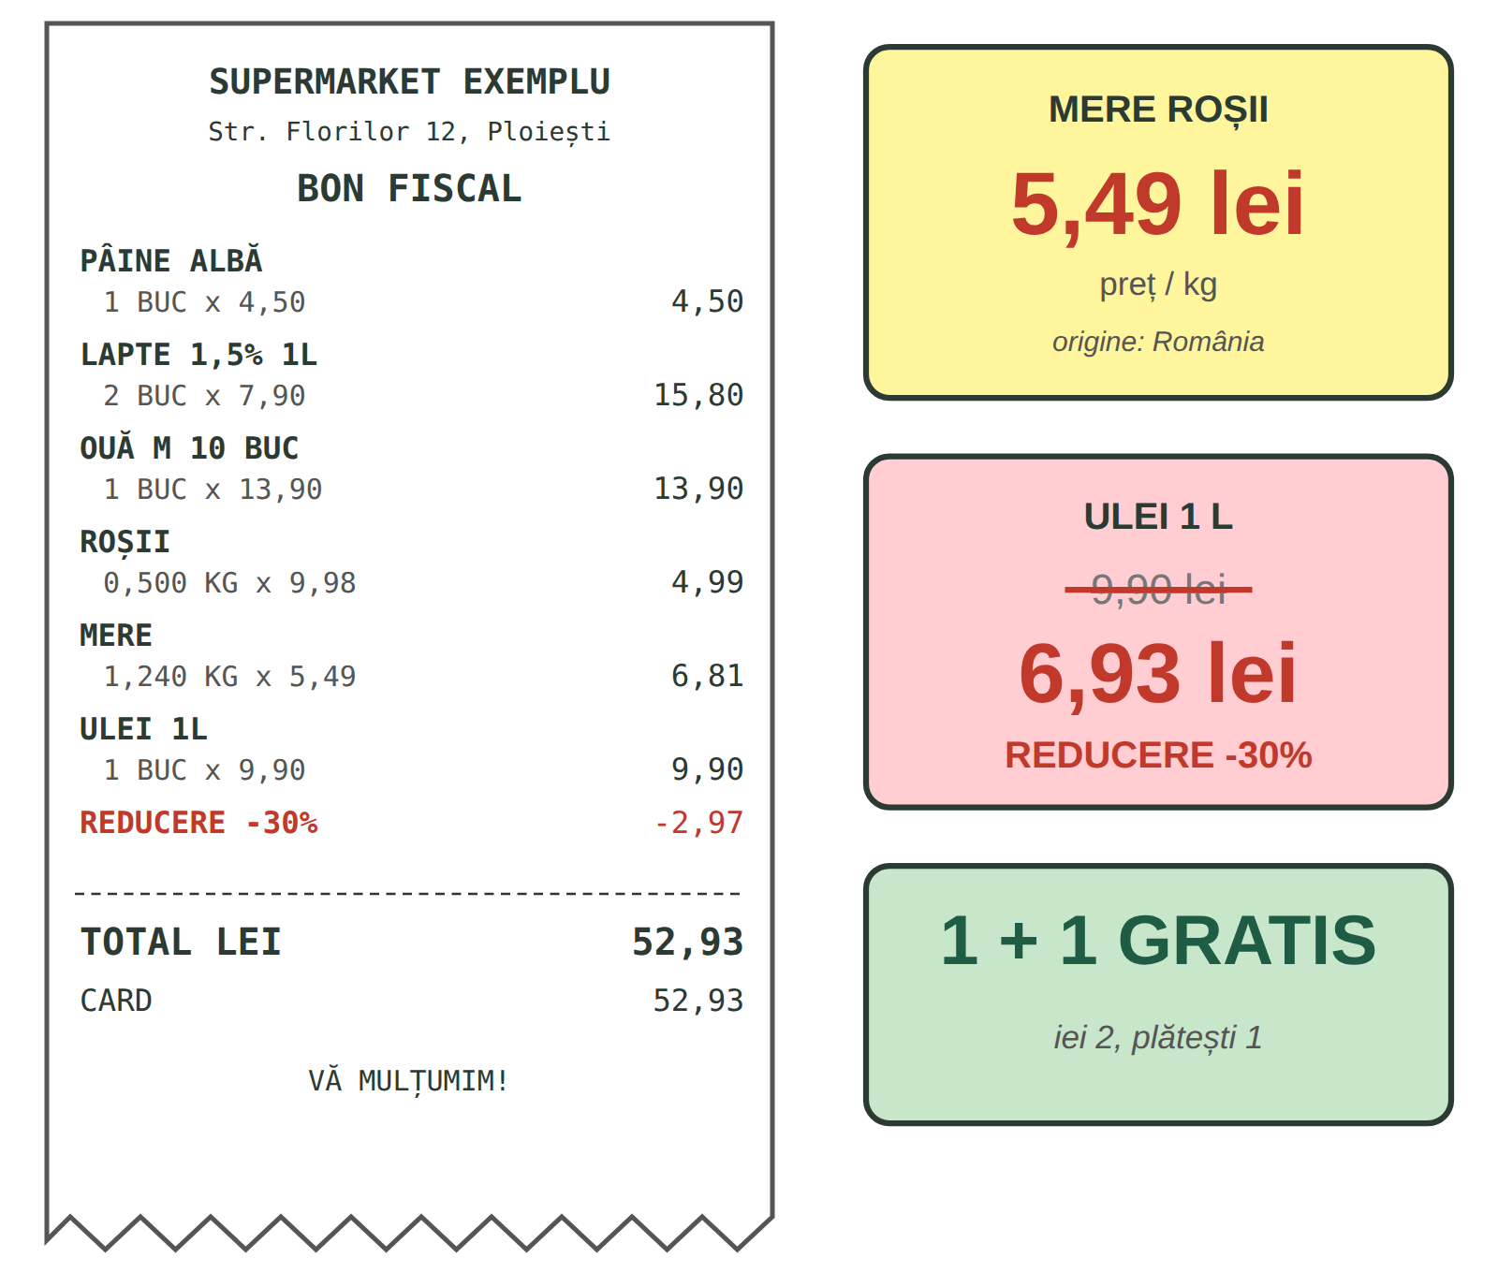
Fig. 8.4 — Bonul fiscal și etichetele de preț (exemplu) / The receipt and price tags (example)
RECAP — IN THE SHOP (Lesson 6.3)
reducerea — the discount · bonul (fiscal) — the receipt · punga — the bag: Doriți o pungă? · casa — the checkout: Plătiți cash sau cu cardul?
New on the tags: preț / kg — price per kilo · preț vechi / preț nou — old / new price · 1 + 1 gratis — buy one, get one free · ofertă · promoție — special offer.

8.3 Read the receipt and the tags
Look at Fig. 8.4 and answer.
1. Cât costă un kilogram de mere? — ______ lei. | 2. Câte kilograme de roșii sunt pe bon? — ______
3. Cât este reducerea la ulei? — ______ % | 4. Cât este totalul? — ______ lei.
5. Cum s-a plătit? — cash / cu cardul | 6. „1 + 1 gratis” = iei ___, plătești ___.

CUVINTE ȘI EXPRESII UZUALE / USEFUL WORDS AND PHRASES
Unde găsesc orezul? | Where can I find the rice? | Aveți pungă de hârtie? | Do you have a paper bag?
Mai aveți pâine proaspătă? | Do you still have fresh bread? | E în ofertă? | Is it on offer?
Nu merge cardul. | The card doesn't work. | Îmi dați bonul, vă rog? | Can I have the receipt, please?

HOMEWORK — AFTER SESSION 29 / TEMĂ PENTRU ACASĂ
H29.1 Write your shopping list for the week in Romanian, with quantities: un kilogram de..., o sticlă de..., zece ouă...
H29.2 Keep a real receipt from a supermarket. Find three products on it and write them in Romanian with the price.

SESSION 30 — THE HUMAN BODY AND THE PHARMACY
SESIUNEA 30 — CORPUL UMAN ȘI FARMACIA · 3 hours

By the end of this session you will be able to:
☐ | name the parts of the body
☐ | say what hurts: Mă doare capul. Mă dor dinții.
☐ | describe simple symptoms: Am febră. Tușesc. Sunt răcit.
☐ | ask for medicine at the pharmacy, with or without a prescription

Lesson 8.4 — The human body / Corpul uman
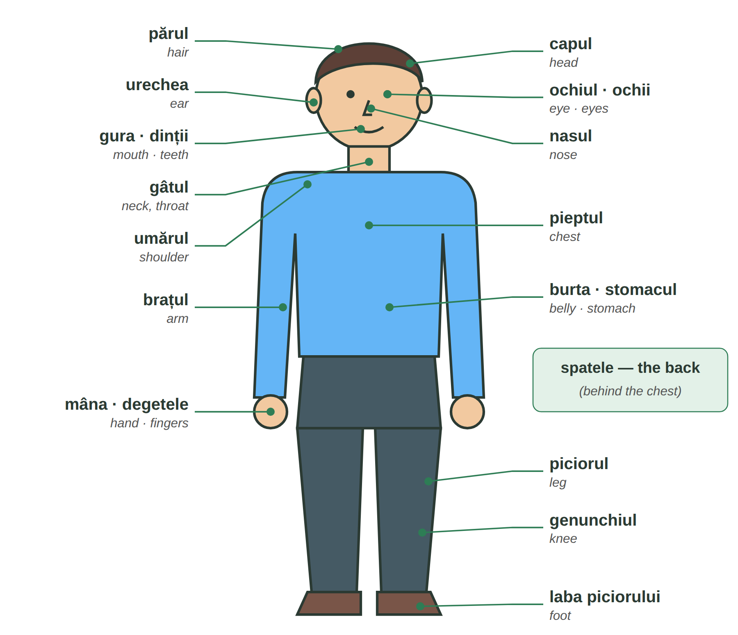
Fig. 8.5 — Corpul uman / The human body
ONE | MORE | ONE | MORE | ONE | MORE
un ochi | ochi | o ureche | urechi | o mână | mâini
un deget | degete | un dinte | dinți | un picior | picioare
un braț | brațe | un umăr | umeri | un genunchi | genunchi

8.4 Which part of the body?
Complete with: ochii · urechile · dinții · picioarele · mâinile · nasul.
1. Văd cu ______________. | 2. Aud (I hear) cu ______________.
3. Mestec (I chew) cu ______________. | 4. Merg pe jos cu ______________.
5. Scriu și lucrez cu ______________. | 6. Miros (I smell) cu ______________.

CUVINTE ȘI EXPRESII UZUALE / USEFUL WORDS AND PHRASES
stânga · dreapta | left · right | piciorul stâng / drept | the left / right leg
pielea | the skin | inima | the heart

Lesson 8.5 — At the pharmacy / La farmacie
RECAP — IT WORKS LIKE ÎMI PLACE (Lesson 2.10)
In Romanian the body part hurts me: mă (me, Lesson 2.10) + doare for one thing, dor for more things — like place / plac. The body part takes the: capul, dinții.

TIPAR — what hurts?
MĂ DOARE / MĂ DOR | + | one thing / more things + the | = | Mă doare capul. · Mă dor dinții.

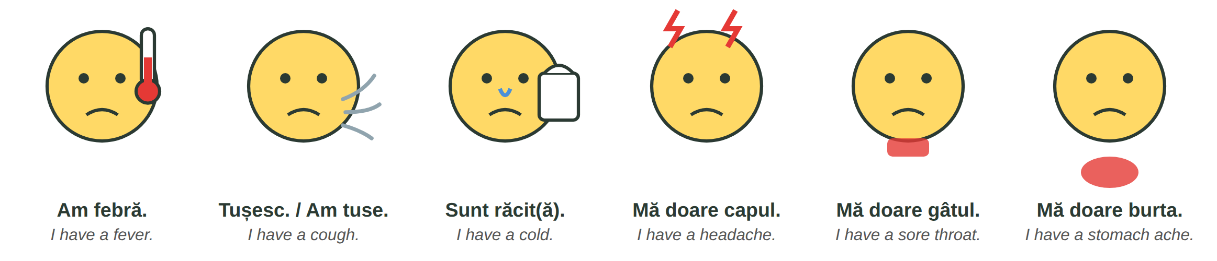
Fig. 8.6 — Simptome / Symptoms
ROMANIAN | ENGLISH | ROMANIAN | ENGLISH
Am febră. · Am temperatură. | I have a fever. | Am gripă. | I have the flu.
Am tuse. · Tușesc. | I have a cough. | Am greață. | I feel sick (nausea).
Sunt răcit / răcită. · Am răcit. | I have a cold. | Am diaree. | I have diarrhoea.
Mi-e rău. (Lesson 7.5) | I feel unwell. | M-am tăiat. · M-am ars. | I cut myself. · I burnt myself.
Îl doare spatele. | His back hurts. | O dor picioarele. | Her legs hurt.

AT THE PHARMACY | ENGLISH
C: Bună ziua! Aveți ceva pentru durere de cap? | Hello! Do you have something for a headache?
F: Da. Aveți și febră? | Yes. Do you also have a fever?
C: Puțin. Și mă doare gâtul. | A little. And I have a sore throat.
F: Vă dau acest medicament. Luați o pastilă de trei ori pe zi, după masă. | I'll give you this medicine. Take one tablet three times a day, after meals.
C: Pot să iau și un antibiotic? | Can I take an antibiotic too?
F: Antibioticul se dă numai cu rețetă de la medic. | Antibiotics are given only with a doctor's prescription.
C: Înțeleg. Mulțumesc! | I understand. Thank you!

ATTENTION — WITH OR WITHOUT A PRESCRIPTION
Some medicines are sold fără rețetă (over the counter): for pain, fever, a cold. Others only cu rețetă (with a doctor's prescription) — for example antibiotics (Order of the Ministry of Health no. 63/2024).
Read prospectul (the leaflet) and tell the pharmacist if you are allergic or take other medicines. At night, look for the farmacia de gardă (Lesson 5.3).

8.5 Mă doare or mă dor?
Circle the correct form.
1. Mă ( doare / dor ) capul. | 2. Mă ( doare / dor ) dinții.
3. Mă ( doare / dor ) ochii. | 4. Mă ( doare / dor ) burta.
5. Am ( febră / febril ). | 6. ( Sunt / Am ) răcit.

CUVINTE ȘI EXPRESII UZUALE / USEFUL WORDS AND PHRASES
o pastilă · un comprimat | a pill · a tablet | un sirop · o cremă | a syrup · a cream
un plasture · un termometru | a plaster · a thermometer | de trei ori pe zi | three times a day
înainte de / după masă | before / after meals | Sunt alergic la... | I am allergic to...

HOMEWORK — AFTER SESSION 30 / TEMĂ PENTRU ACASĂ
H30.1 Draw a person and write ten parts of the body in Romanian.
H30.2 Write what you say at the pharmacy when you have a cough and a fever (four sentences).

SESSION 31 — AT THE DOCTOR
SESIUNEA 31 — LA MEDIC · 3 hours

By the end of this session you will be able to:
☐ | make an appointment and describe your symptoms to the doctor
☐ | understand the doctor's questions and instructions
☐ | know when to call 112
☐ | understand health insurance, the family doctor, the health card and sick leave

Lesson 8.6 — At the doctor / La medic
THE DOCTOR ASKS | ENGLISH | YOU ANSWER | ENGLISH
Ce vă doare? | What hurts? | Mă doare gâtul. | My throat hurts.
De când? | Since when? | De ieri. · De trei zile. | Since yesterday. · For three days.
Aveți febră? | Do you have a fever? | Da, 38 de grade. | Yes, 38 degrees.
Luați medicamente? | Do you take medicines? | Nu, nu iau nimic. | No, I take nothing.
Sunteți alergic la ceva? | Are you allergic to anything? | Nu știu. / Da, la... | I don't know. / Yes, to...
Ce s-a întâmplat? | What happened? | Am căzut pe șantier. | I fell at the building site.

The doctor's instructions (Lesson 3.13): Luați loc. — Sit down. · Deschideți gura. — Open your mouth. · Respirați adânc. — Breathe deeply. · Dezbrăcați-vă. — Get undressed. · Întindeți-vă aici. — Lie down here.
AT THE FAMILY DOCTOR | ENGLISH
A: Aveți programare? P: Da, la ora zece. Mă numesc Rahul Singh. | Do you have an appointment? — Yes, at ten. My name is Rahul Singh.
M: Luați loc. Ce vă doare? | Take a seat. What hurts?
P: Am febră și tușesc de trei zile. Mă doare și pieptul. | I have had a fever and a cough for three days. My chest hurts too.
M: Deschideți gura... Respirați adânc... Aveți o infecție respiratorie. | Open your mouth... Breathe deeply... You have a respiratory infection.
P: Pot să merg la muncă? | Can I go to work?
M: Nu. Vă dau o rețetă și concediu medical cinci zile. Anunțați angajatorul. | No. I'll give you a prescription and five days' sick leave. Tell your employer.
P: Mulțumesc, domnule doctor! | Thank you, doctor!

A = asistenta (the nurse) · P = pacientul · M = medicul
RECAP — 112 (Lesson 5.2)
Call 112 only for a real emergency — someone cannot breathe, is unconscious, is bleeding badly, has had a serious accident. Say: Este o urgență! · Am nevoie de ambulanță. · Sunt în... · Un om este rănit. For a cold or a fever, go to your family doctor.

8.6 Answer the doctor
Write an answer about yourself or an invented situation.
1. Ce vă doare? — ____________________________________________
2. De când? — ____________________________________________
3. Aveți febră? — ____________________________________________
4. Sunteți alergic la ceva? — ____________________________________________

CUVINTE ȘI EXPRESII UZUALE / USEFUL WORDS AND PHRASES
programarea | the appointment | cabinetul medical | the doctor's surgery
rețeta | the prescription | analizele | the (blood) tests
Mă simt mai bine. | I feel better. | Nu mă simt bine. (Lesson 3.12) | I don't feel well.

Lesson 8.7 — Health insurance, the family doctor, sick leave / Asigurarea, medicul de familie, concediul medical
PRACTICAL NOTE — YOU ARE INSURED THROUGH YOUR WORK CONTRACT
Every month your employer withholds the health insurance contribution (CASS, 10% of the gross salary, Tax Code art. 156) and pays it to the state. This makes you asigurat (insured) in the public health system. Check it on your payslip — fluturașul de salariu.
Medicul de familie (the family doctor): you choose freely and ask to be put on the doctor's list with a cerere de înscriere (enrolment form, at the surgery or on the website of the County Health Insurance House — Casa de Asigurări de Sănătate). Take your identity document (for you: the residence permit) and the health card, or proof that you are insured. Ask at the surgery if anything else is needed.
Cardul de sănătate (the national health card) is issued by the health insurance system (CNAS) and you show it at the doctor. If you lose it, ask your Health Insurance House for a duplicate (application + a fee); until it arrives you receive a temporary certificate.

ATTENTION — SICK LEAVE / CONCEDIUL MEDICAL
If you are ill, tell your employer straight away and go to the doctor. The doctor gives you a certificat de concediu medical (sick-leave certificate). You must give it to your employer by the 5th of the next month at the latest (OUG 158/2005).
To be paid during sick leave you normally need at least 6 months of contributions in the last 12 months. The rules for how much you are paid were changed in 2025 (Law 141/2025) — ask your employer or HR how much you receive. Do not work while you are on sick leave.

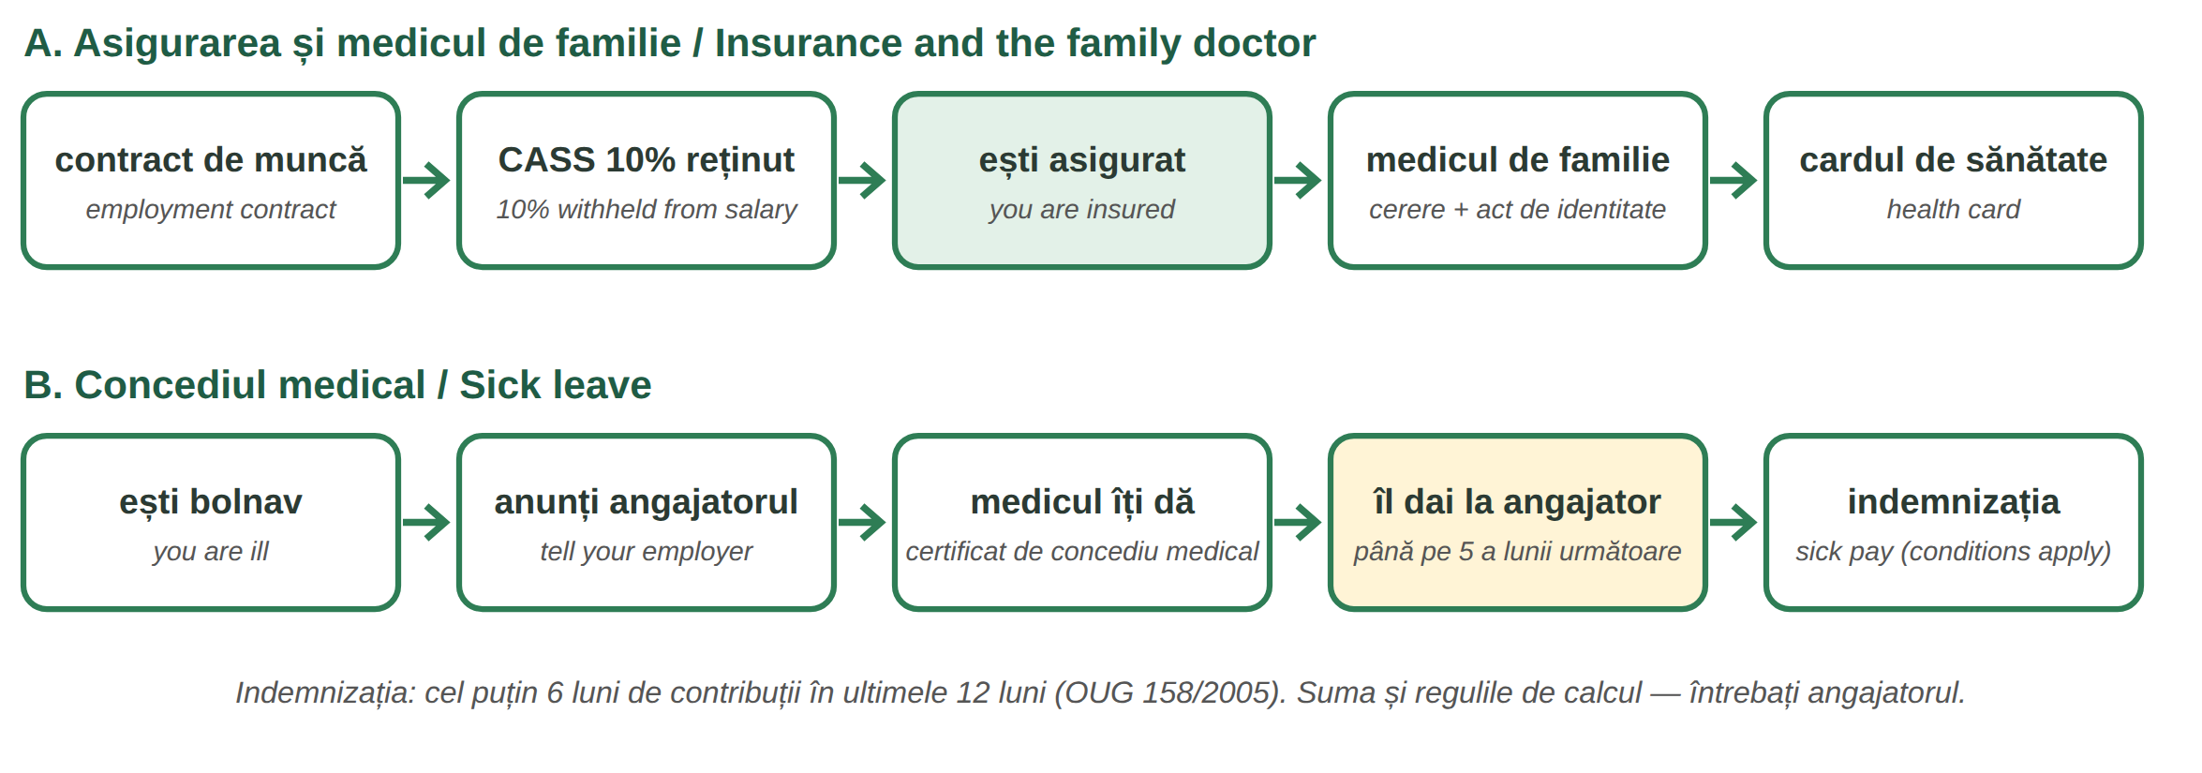
Fig. 8.7 — Sănătatea ta ca angajat / Your health as an employee
8.7 True or false? / Adevărat sau fals?
Write A (adevărat) or F (fals).
1. Angajatorul reține CASS din salariu. ____ | 2. Medicul de familie îl alege IGI. ____
3. Pentru înscriere completezi o cerere. ____ | 4. Certificatul medical îl păstrezi acasă. ____
5. Anunți angajatorul când ești bolnav. ____ | 6. Dacă pierzi cardul, poți cere un duplicat. ____

CUVINTE ȘI EXPRESII UZUALE / USEFUL WORDS AND PHRASES
asigurat / asigurată | insured | Casa de Asigurări de Sănătate | County Health Insurance House
cererea de înscriere | the enrolment form | certificatul de concediu medical | the sick-leave certificate
Sunt în concediu medical. | I am on sick leave. | Mă întorc la muncă luni. | I am back at work on Monday.

HOMEWORK — AFTER SESSION 31 / TEMĂ PENTRU ACASĂ
H31.1 Find the name, address and phone number of a family doctor near your home. Write them in Romanian.
H31.2 Write the message you send to your manager when you are ill: Bună ziua, sunt bolnav. Am febră... Merg la medic...

SESSION 32 — RIGHTS, RELIGIONS, A1 RECAP AND TEST
SESIUNEA 32 — DREPTURI, RELIGII, RECAPITULARE A1 ȘI TEST · 3 hours

By the end of this session you will be able to:
☐ | name some basic rights and obligations from the Romanian Constitution
☐ | understand freedom of religion and the religions of Romania
☐ | check everything you can do at Level A1
☐ | pass the Level A1 cumulative test

Lesson 8.8 — Rights, obligations and freedom of religion / Drepturi, obligații și libertatea religioasă
Constituția României is the basic law of the country. Foreign citizens who live in Romania enjoy the general protection of persons and property given by the Constitution and the laws (art. 18).
ROMANIAN | ENGLISH | CONSTITUTION
Dreptul la viață și la integritate fizică | the right to life and to physical integrity | art. 22
Libertatea conștiinței (și religioasă) | freedom of conscience and of religion | art. 29
Libertatea de exprimare | freedom of expression | art. 30
Dreptul la ocrotirea sănătății | the right to health care | art. 34
Munca și protecția socială a muncii | work and the protection of workers | art. 41
Respectarea Constituției și a legilor este obligatorie. | Respecting the Constitution and the laws is compulsory. | art. 1 (5)
Exercitarea drepturilor cu bună-credință | you use your rights in good faith, without harming the rights of others | art. 57
Contribuțiile financiare — taxele și impozitele | contributing to public expenses through taxes | art. 56

Freedom of religion / Libertatea religioasă
The Constitution guarantees freedom of conscience: nobody can be forced to adopt a religious belief, and it must be practised in a spirit of tolerance and mutual respect. Religious communities (cultele) are autonomous from the state (art. 29). Law no. 489/2006 on religious freedom lists 18 recognised religious denominations in its annex.
RELIGION (2021 census) | % | RELIGION | %
ortodoxă — Orthodox | 85,3 | greco-catolică — Greek Catholic | 0,7
romano-catolică — Roman Catholic | 4,5 | baptistă — Baptist | 0,6
reformată — Reformed (Calvinist) | 3,0 | adventistă — Seventh-day Adventist | 0,4
penticostală — Pentecostal | 2,5 | musulmană — Muslim | 0,4

% of the people who declared a religion, 2021 census (INS); 0,9% declared no religion. biserica — church · moscheea — mosque · sinagoga — synagogue. Religious days off: Lesson 5.6.
8.8 Speak — in my country / în țara mea
Complete about your country, then tell a colleague. You decide what you share about your own beliefs.
1. În țara mea, religiile principale sunt ________________________________.
2. Oamenii se roagă la ______________________ (biserică / moschee / templu...).
3. În România, Constituția garantează ________________________________.

CUVINTE ȘI EXPRESII UZUALE / USEFUL WORDS AND PHRASES
drepturile · obligațiile | the rights · the obligations | legea · legile | the law · the laws
a respecta | to respect | credința | the faith, belief
a se ruga · rugăciunea | to pray · the prayer | Respect credința ta. | I respect your faith.

Lesson 8.9 — Level A1 recap / Recapitulare finală Nivel A1
At the end of Level A1 you can do all of this in Romanian. Tick what you can do — go back to the lesson if you are not sure.
☐ | I CAN... | KEY PHRASE · LESSON
☐ | read and write Romanian, with ă, â, î, ș, ț and the cratima | M1 — Lessons 1.3, 4.1
☐ | say who I am, where I am from, what work I do | Mă numesc... Sunt din... Lucrez ca... — 3.2
☐ | say what I do, did and will do | lucrez · am lucrat · o să lucrez — 3.3, 3.14, 3.16
☐ | ask questions and ask politely | Unde...? Cât costă? Dați-mi..., vă rog. — 3.8, 3.13
☐ | use numbers, prices, the time and dates | 20 de lei · la ora opt · pe 1 decembrie — 2.5, 5.4
☐ | buy things, clothes and food | O iau. Port mărimea M. Un kilogram de... — 4.4, 6.3, 8.2
☐ | talk about my home and my family | Locuiesc la bloc. Fratele soției... — 6.6, 7.1
☐ | order and pay at a restaurant | Aș dori... Nota, vă rog! — 7.4
☐ | say how I feel and what hurts | Mi-e foame. Mă doare capul. — 7.5, 8.5
☐ | handle emergencies and the doctor | Este o urgență! Am febră de trei zile. — 5.2, 8.6
☐ | know the institutions and my basic rights | Primăria, ITM, IGI, CAS · Constituția — 5.2, 8.7, 8.8

8.9 Everything together
Circle the correct word.
1. un kilogram ( de / din ) mere | 2. Mă ( doare / dor ) picioarele.
3. o sticlă de ( ulei / pâine ) | 4. ( Îmi / Mă ) dați două pâini, vă rog?
5. Am ( febră / frig ), 39 de grade. | 6. Certificatul medical îl dai la ( angajator / farmacie ).
7. Antibioticul se dă ( cu / fără ) rețetă. | 8. Constituția garantează libertatea ( religioasă / obligatorie ).

HOMEWORK — AFTER SESSION 32 / TEMĂ PENTRU ACASĂ
H32.1 Write ten sentences about your life in Romania with everything from Level A1: who you are, your work, your home, your family, your week.
H32.2 Prepare Module 9: write in Romanian five tools or materials you use at work.

SECȚIUNE DETAȘABILĂ — EXEMPLAR FORMATOR
Detachable section — teacher's copy. Se detașează din suportul cursantului; testul completat, semnat și datat, se păstrează la dosarul cursantului. Conține: testul cumulativ Nivel A1, fișa de confirmare a Sesiunii 32, fișa de evidență a Modulului 8, cheia răspunsurilor, sursele.

TEST CUMULATIV — NIVELUL A1 (Modulele 1–8)
LEVEL A1 — CUMULATIVE TEST · grilă, 50 de întrebări, 50 de puncte · semnat și datat de cursant

Nume și prenume cursant / Student name
Data / Date | _____ / _____ / 20_____
Semnătura cursantului / Student signature

Marcați cu X un singur răspuns la fiecare întrebare. Mark ONE answer with X for each question. Each correct answer = 1 point.
1. Care literă NU este o literă specifică limbii române? (1 p)
☐ a) ă | ☐ b) ș | ☐ c) w | ☐ d) ț
2. În cuvântul „cinci”, litera c se citește ca: (1 p)
☐ a) k | ☐ b) ch din „church” | ☐ c) s | ☐ d) g
3. Care variantă este scrisă corect? (1 p)
☐ a) Luni, 5 Mai | ☐ b) luni, 5 mai | ☐ c) Luni, 5 Mai | ☐ d) luni 5 Mai
4. „N-am” înseamnă: (1 p)
☐ a) nu am | ☐ b) noi am | ☐ c) nu are | ☐ d) am nu
5. Pe un formular, „Nume” înseamnă: (1 p)
☐ a) first name | ☐ b) date of birth | ☐ c) address | ☐ d) surname / family name
6. Pluralul cuvântului „copil” este: (1 p)
☐ a) copili | ☐ b) copii | ☐ c) copile | ☐ d) copiluri
7. Completează: „___ carte” (1 p)
☐ a) un | ☐ b) doi | ☐ c) o | ☐ d) niște
8. „Casa” înseamnă: (1 p)
☐ a) a house | ☐ b) the house | ☐ c) houses | ☐ d) some houses
9. Completează: „o mașină ___” (1 p)
☐ a) nou | ☐ b) noi | ☐ c) noul | ☐ d) nouă
10. Care variantă este corectă? (1 p)
☐ a) 25 lei | ☐ b) 25 de lei | ☐ c) 5 de lei | ☐ d) 2 de lei
11. Completează: „Telefonul ___ Ion.” (1 p)
☐ a) lui | ☐ b) a | ☐ c) ei | ☐ d) al
12. Completează: „___ place cafeaua.” (eu) (1 p)
☐ a) Mă | ☐ b) Îl | ☐ c) Îmi | ☐ d) Eu
13. Ce salut folosești la ora 20:00? (1 p)
☐ a) Bună dimineața! | ☐ b) Bună seara! | ☐ c) Bună ziua! | ☐ d) Noapte bună!
14. Completează: „Eu ___ în Ploiești.” (a locui) (1 p)
☐ a) locuiesc | ☐ b) locuiește | ☐ c) locuim | ☐ d) locui
15. „Nu am timp” se spune de obicei: (1 p)
☐ a) Nam timp. | ☐ b) Nu-m timp. | ☐ c) N-am timp. | ☐ d) Am nu timp.
16. Completează: „Unde ___?” (dumneavoastră, a lucra) (1 p)
☐ a) lucrezi | ☐ b) lucrează | ☐ c) lucrăm | ☐ d) lucrați
17. „I want to sleep.” = (1 p)
☐ a) Vreau să dorm. | ☐ b) Vreau dorm. | ☐ c) Vreau să dormi. | ☐ d) Vreau a dormi.
18. Completează: „Ieri ___ opt ore.” (eu, a lucra) (1 p)
☐ a) lucrez | ☐ b) o să lucrez | ☐ c) am lucrat | ☐ d) lucram
19. Care cerere este politicoasă? (1 p)
☐ a) Dă-mi pașaportul! | ☐ b) Dați-mi pașaportul, vă rog. | ☐ c) Pașaport! | ☐ d) Tu dai pașaport.
20. „Mâine ___ la piață.” — I will go (1 p)
☐ a) am mers | ☐ b) merg ieri | ☐ c) o să merg | ☐ d) mergeam
21. Pluralul cuvântului „carte” este: (1 p)
☐ a) carteuri | ☐ b) cărți | ☐ c) carte | ☐ d) cartii
22. Completează: „două căni ___” (1 p)
☐ a) albe | ☐ b) alb | ☐ c) albă | ☐ d) albi
23. Completează: „Masa este ___ lemn.” (1 p)
☐ a) pe | ☐ b) din | ☐ c) la | ☐ d) cu
24. Cartela SIM? „Cum ___ activez?” (1 p)
☐ a) îl | ☐ b) le | ☐ c) îi | ☐ d) o
25. Capitala României este: (1 p)
☐ a) Cluj-Napoca | ☐ b) Iași | ☐ c) București | ☐ d) Brașov
26. Numărul unic de urgență în România este: (1 p)
☐ a) 112 | ☐ b) 911 | ☐ c) 999 | ☐ d) 100
27. Nu ți-a plătit salariul angajatorul. Unde te plângi? (1 p)
☐ a) la IGI | ☐ b) la ITM | ☐ c) la farmacie | ☐ d) la 112
28. „Este ora opt și jumătate.” = (1 p)
☐ a) 8:15 | ☐ b) 7:30 | ☐ c) 8:45 | ☐ d) 8:30
29. Ziua Națională a României este: (1 p)
☐ a) 24 ianuarie | ☐ b) 1 mai | ☐ c) 1 decembrie | ☐ d) 25 decembrie
30. La pantofi, vânzătorul întreabă: (1 p)
☐ a) Ce număr purtați? | ☐ b) Ce etaj? | ☐ c) Ce culoare aveți? | ☐ d) Unde locuiți?
31. Completează: „Pantofii îmi ___ mici.” (1 p)
☐ a) vine | ☐ b) vii | ☐ c) vin | ☐ d) vinem
32. Completează: „Locuiesc ___ garsonieră.” (1 p)
☐ a) într-un | ☐ b) în o | ☐ c) în un | ☐ d) într-o
33. „Cheile sunt pe masă.” = (1 p)
☐ a) The keys are on the table. | ☐ b) The keys are under the table. | ☐ c) The keys are next to the table. | ☐ d) The keys are in the table.
34. În ce cameră gătești? (1 p)
☐ a) în dormitor | ☐ b) în bucătărie | ☐ c) în baie | ☐ d) în hol
35. Mama soției mele este: (1 p)
☐ a) cumnata | ☐ b) bunica | ☐ c) nora | ☐ d) soacra
36. Completează: „___ trimit bani părinților.” (1 p)
☐ a) Le | ☐ b) Îi | ☐ c) Îl | ☐ d) O
37. Nu mănânci carne de porc. Ce întrebi la restaurant? (1 p)
☐ a) Cât costă? | ☐ b) Conține carne de porc? | ☐ c) Unde este toaleta? | ☐ d) Aveți masă liberă?
38. Cum ceri nota politicos? (1 p)
☐ a) Dă nota! | ☐ b) Nota mea! | ☐ c) Nota, vă rog! | ☐ d) Ai nota?
39. O femeie a lucrat 12 ore. Ea spune: „Sunt ___.” (1 p)
☐ a) obosit | ☐ b) obosită | ☐ c) obosiți | ☐ d) obosite
40. Care propoziție este corectă? (1 p)
☐ a) Sunt sete. | ☐ b) Am sete. | ☐ c) Este sete mie. | ☐ d) Mi-e sete.
41. Ce înseamnă „castravete”? (1 p)
☐ a) cucumber | ☐ b) carrot | ☐ c) cabbage | ☐ d) courgette
42. Completează: „un kilogram ___ roșii” (1 p)
☐ a) din | ☐ b) de | ☐ c) cu | ☐ d) la
43. Ce cumperi într-o sticlă? (1 p)
☐ a) pâine | ☐ b) ouă | ☐ c) ulei | ☐ d) varză
44. La piață întrebi prețul: (1 p)
☐ a) Cât costă kilogramul? | ☐ b) Ce număr purtați? | ☐ c) Unde locuiți? | ☐ d) Câți ani aveți?
45. Completează: „Mă ___ dinții.” (1 p)
☐ a) doare | ☐ b) doar | ☐ c) dori | ☐ d) dor
46. Completează: „Mă ___ capul.” (1 p)
☐ a) doare | ☐ b) dor | ☐ c) dori | ☐ d) durea
47. Antibioticele se dau la farmacie: (1 p)
☐ a) fără rețetă | ☐ b) numai cu rețetă de la medic | ☐ c) numai la supermarket | ☐ d) numai la IGI
48. Ești bolnav și medicul îți dă concediu medical. Ce faci? (1 p)
☐ a) Nu spui nimănui. | ☐ b) Suni la 112. | ☐ c) Mergi la ITM. | ☐ d) Anunți angajatorul și îi dai certificatul.
49. Contribuția de sănătate a salariatului (CASS) este reținută din salariu de: (1 p)
☐ a) angajator | ☐ b) medic | ☐ c) farmacie | ☐ d) IGI
50. Constituția României garantează: (1 p)
☐ a) o singură religie obligatorie | ☐ b) libertatea conștiinței și a religiei | ☐ c) religia aleasă de angajator | ☐ d) interzicerea religiilor

PUNCTAJ OBȚINUT / SCORE | _______ / 50
Semnătura formatorului / Teacher signature

SESSION COMPLETION RECORD
FIȘĂ DE CONFIRMARE A PARCURGERII SESIUNII — se păstrează la dosar

Module / Modul | Modulul 8 — Supermarket, piață, farmacie și medic (finalizat) · final Nivel A1
Session / Sesiunea | Sesiunea 32 — Drepturi, religii, recapitulare finală A1. TEST CUMULATIV NIVEL A1
Duration / Durata | 3 ore
Date / Data | _____ / _____ / 20_____
Student name / Nume și prenume cursant
Score / Punctaj obținut | _______ / 50
Student signature / Semnătura cursantului
Teacher signature / Semnătura formatorului

DECLARAȚIE CURSANT / STUDENT DECLARATION
Declar că am participat la această sesiune de curs și am parcurs conținutul prezentat mai sus.
I declare that I attended this course session and covered the content presented above.

MODULE 8 — COMPLETION RECORD
FIȘĂ DE EVIDENȚĂ A PARCURGERII MODULULUI 8 — se păstrează la dosarul cursantului

Cursant / Student
Act de identitate / ID document
Angajator / Employer
Formator / Teacher
Modul / Module | Modulul 8 — Supermarket, piață, farmacie și medic (12 ore, Sesiunile 29–32)

NR. | SESIUNE / CONȚINUT | DATA | PUNCTAJ TEST | SEMNĂTURA CURSANTULUI
29 | Sesiunea 29 — Fructe, legume, alimente, cantități; la piață și la supermarket (3 ore) |  | —
30 | Sesiunea 30 — Corpul uman; la farmacie, simptome, rețeta (3 ore) |  | —
31 | Sesiunea 31 — La medic; asigurarea, medicul de familie, cardul de sănătate, concediul medical (3 ore) |  | —
32 | Sesiunea 32 — Drepturi și obligații, libertatea religioasă, recapitulare A1 + TEST CUMULATIV NIVEL A1 (3 ore) |  | ___ / 50

CONFIRMARE FINALIZARE MODUL ȘI NIVEL A1 / MODULE AND LEVEL A1 COMPLETION
Confirm că cursantul a parcurs integral conținutul Modulului 8 — Supermarket, piață, farmacie și medic, în total 12 ore de curs, și a susținut testul cumulativ al Nivelului A1 consemnat mai sus.
I confirm that the student completed the full content of Module 8 — Supermarket, Market, Pharmacy and Doctor, 12 course hours in total, and sat the Level A1 cumulative test recorded above.
Data: _____ / _____ / 20_____ Semnătura formatorului: ______________________

ANSWER KEY — TEACHER COPY
CHEIA RĂSPUNSURILOR — pentru formator

Sessions 29–32
8.1 galbenă · verde · portocalie · mov (vânătă) · portocalii · galbenă (accept any colour that agrees)
8.2 ulei · unt · lapte · pâine · ouă · pătrunjel
8.3 5,49 · 0,500 kg (jumătate de kilogram) · 30 % · 52,93 · cu cardul · 2, 1
8.4 ochii · urechile · dinții · picioarele · mâinile · nasul
8.5 doare · dor · dor · doare · febră · Sunt
8.6 · 8.8 personal answers — checked by the teacher (răspunsuri personale). 8.8: the student chooses what to share about their beliefs; do not ask more.
8.7 1 A · 2 F (îl alegi tu) · 3 A · 4 F (îl dai angajatorului) · 5 A · 6 A
8.9 de · dor · ulei · Îmi · febră · angajator · cu · religioasă
Level A1 test — grilă answer key
TOTAL: 50 puncte. Un răspuns corect = 1 punct. Nemarcat sau dublu marcat = 0 puncte. Modules: 1–5 M1 · 6–12 M2 · 13–20 M3 · 21–24 M4 · 25–29 M5 · 30–34 M6 · 35–40 M7 · 41–50 M8.
1 – c | 2 – b | 3 – b | 4 – a | 5 – d | 6 – b | 7 – c | 8 – b | 9 – d | 10 – b
11 – a | 12 – c | 13 – b | 14 – a | 15 – c | 16 – d | 17 – a | 18 – c | 19 – b | 20 – c
21 – b | 22 – a | 23 – b | 24 – d | 25 – c | 26 – a | 27 – b | 28 – d | 29 – c | 30 – a
31 – c | 32 – d | 33 – a | 34 – b | 35 – d | 36 – a | 37 – b | 38 – c | 39 – b | 40 – d
41 – a | 42 – b | 43 – c | 44 – a | 45 – d | 46 – a | 47 – b | 48 – d | 49 – a | 50 – b

Surse și data verificării / Sources and date of verification
Informațiile legale și administrative din acest modul au fost verificate la 24.09.2026 pe surse oficiale. The legal and administrative information in this module was checked on 24 September 2026 against official sources.
INFORMAȚIA / INFORMATION | SURSA / SOURCE | UNDE ÎN MODUL / WHERE
Antibioticele se eliberează numai pe bază de prescripție medicală; OTC fără prescripție | Ordinul ministrului sănătății nr. 63/2024 — legislatie.just.ro/Public/DetaliiDocument/278215; ms.ro | Lesson 8.5, test q. 47
CASS 10% reținut la sursă de angajator din salariu | Codul fiscal (Legea nr. 227/2015), art. 156; ghid ANAF privind contribuțiile sociale — static.anaf.ro | Lesson 8.7, test q. 49
Înscrierea la medicul de familie: cerere de înscriere + card / act de identitate și dovada calității de asigurat; alegere liberă | CNAS / Casele de Asigurări de Sănătate — „Cum ne înscriem la medicul de familie?” (casan.ro/casar); „Ce trebuie să facă un cetățean străin?” (cas.cnas.ro) | Lesson 8.7
Cardul național de sănătate; duplicat la CAS, cu cerere și cost; adeverință de înlocuire până la primire | CNAS — „Procedura de obținere a cardului național duplicat” (cas.cnas.ro) | Lesson 8.7
Concediul medical: stagiu minim 6 luni în ultimele 12; certificatul se depune la angajator până la data de 5 a lunii următoare; modificări 2025 | O.U.G. nr. 158/2005 — legislatie.just.ro/public/DetaliiDocument/66305; Legea nr. 141/2025, art. IX | Lesson 8.7, test q. 48
Drepturi și obligații: art. 1 alin. (5), 18, 22, 29, 30, 34, 41, 56, 57 | Constituția României — legislatie.just.ro/Public/DetaliiDocument/47355 | Lesson 8.8, test q. 50
18 culte recunoscute (anexa legii); libertatea religioasă | Legea nr. 489/2006 (republicată) — legislatie.just.ro/Public/DetaliiDocument/156588; culte.gov.ro | Lesson 8.8
Structura după religie (% din persoanele care și-au declarat religia) | INS — Recensământul Populației și Locuințelor 2021 — recensamantromania.ro | Lesson 8.8
Lecțiile anterioare citate | Modulele 1–7: 1.4, 2.4, 2.5, 2.10, 3.12–3.14, 4.4, 5.2, 5.3, 5.6, 6.3, 7.5 | whole module

Prețurile din dialoguri, de pe bon și de pe etichete sunt exemple. Pentru regulile de calcul al indemnizației de concediu medical și pentru actele cerute la înscriere, cursantul verifică la angajator și la medicul de familie, deoarece acestea se pot schimba. / Prices in the dialogues, on the receipt and on the tags are examples.

LIMBA ROMÂNĂ PENTRU STRĂINI
Romanian Language for Foreign Workers
SUPORT DE CURS

MODULE 9 — MY FIELD OF WORK
MODULUL 9 — DOMENIUL DE ACTIVITATE

VARIANTA: CONSTRUCȚII / CONSTRUCTION
LEVEL / NIVEL | DURATION / DURATĂ | LANGUAGE OF TEACHING
A1+ — after Level A1 | 12 hours · Sessions 33–36 · Weeks 17–18 | English → Romanian

LEGAL BASIS / TEMEI LEGAL
Curs de limbă română cu elemente de integrare culturală și socială, organizat în conformitate cu O.U.G. nr. 32/2026, art. 7 alin. (1) lit. g) — minimum 6 luni, cel puțin 6 ore pe săptămână.
Romanian language course with cultural and social integration elements, organised under Government Emergency Ordinance no. 32/2026, art. 7(1)(g) — at least 6 months, at least 6 hours per week.
This module ends with ONE cumulative multiple-choice test (25 questions), signed and dated by the student and kept on file as proof of completion.

ONE MODULE, SEVERAL FIELDS / UN MODUL, MAI MULTE DOMENII
Module 9 is about the Romanian you need at your own workplace. It exists in several versions — one for each field of work (construction, hotels and restaurants, cleaning, agriculture and others). All versions have the same four sessions: tools and materials · measurements · the types of work · instructions, safety and the language of the workplace. The student follows the version for their own job. This book is the construction version.

Before you start
You have finished Level A1. Module 9 uses everything you know on the building site (șantierul). You will name tools, materials and protective equipment, measure and calculate, describe the main types of work step by step, understand the orders of your team leader, and know your rights and duties for health and safety at work (SSM — securitate și sănătate în muncă).
You need these lessons first — look back at them if you are not sure:
YOU NEED | WHERE | WHY
numbers · de after 20 · decimals with a comma | Lesson 2.5 | 20 de saci, 2,50 m, 1,20 m
materials, shapes — din lemn, dreptunghi | Lessons 4.5 | the shape of a wall, what it is made of
short pronouns — îl, o, le | Lesson 2.10 | Dă-mi-l! Ține-o! Taie-le!
să + verb · trebuie să | Lesson 3.11 | Trebuie să purtăm casca.
orders and requests | Lesson 3.13 | Adu! Ține! Aduceți, vă rog!
the past · the future | Lessons 3.14, 3.16 | Am terminat. O să turnăm mâine.
112 · ITM | Lesson 5.2 | an accident, a problem at work
the body · Mă doare | Lessons 8.4, 8.5 | M-am lovit la mână. Mă doare spatele.
quantities — un sac, un palet | Lesson 8.2 | zece saci de adeziv

Where this module sits in the course
SESSION | DURATION | CONTENT
Session 33 | 3 hours | Lesson 9.1 Tools · Lesson 9.2 Materials · Lesson 9.3 Work clothes and protective equipment
Session 34 | 3 hours | Lesson 9.4 Units of measurement · Lesson 9.5 Reading a tape measure · Lesson 9.6 Simple calculations
Session 35 | 3 hours | Lesson 9.7 Masonry · 9.8 Plastering · 9.9 Insulation and facades · 9.10 Floor and wall tiles · 9.11 Painting
Session 36 | 3 hours | Lesson 9.12 Orders on site · 9.13 Health and safety · 9.14 Site expressions and recap · Module 9 cumulative test

NO NEW GRAMMAR IN THIS MODULE
The orders on site are the forms from Lesson 3.13 — here you only use them. Everything else is words and phrases of your job: tools, materials, measurements, the steps of each type of work, safety signs and site expressions.
Words differ from site to site. Your team may use another word for the same thing (for example boloboc for nivelă). When you hear a new word, ask: Cum se numește asta? · Ce înseamnă...? (Lesson 4.3).

SESSION 33 — TOOLS, MATERIALS, EQUIPMENT
SESIUNEA 33 — UNELTE, MATERIALE, ECHIPAMENT · 3 hours

By the end of this session you will be able to:
☐ | name 20 hand and power tools
☐ | name 16 building materials and ask for them
☐ | name your work clothes and protective equipment
☐ | ask for a tool or a material: Adu-mi..., Unde e...?, Mai avem...?

Lesson 9.1 — Tools / Uneltele
Uneltele de mână = hand tools · sculele electrice = power tools (scula is the word used on site). Learn each tool with its article — that is how you hear it: Unde e ciocanul? Dă-mi șurubelnița!
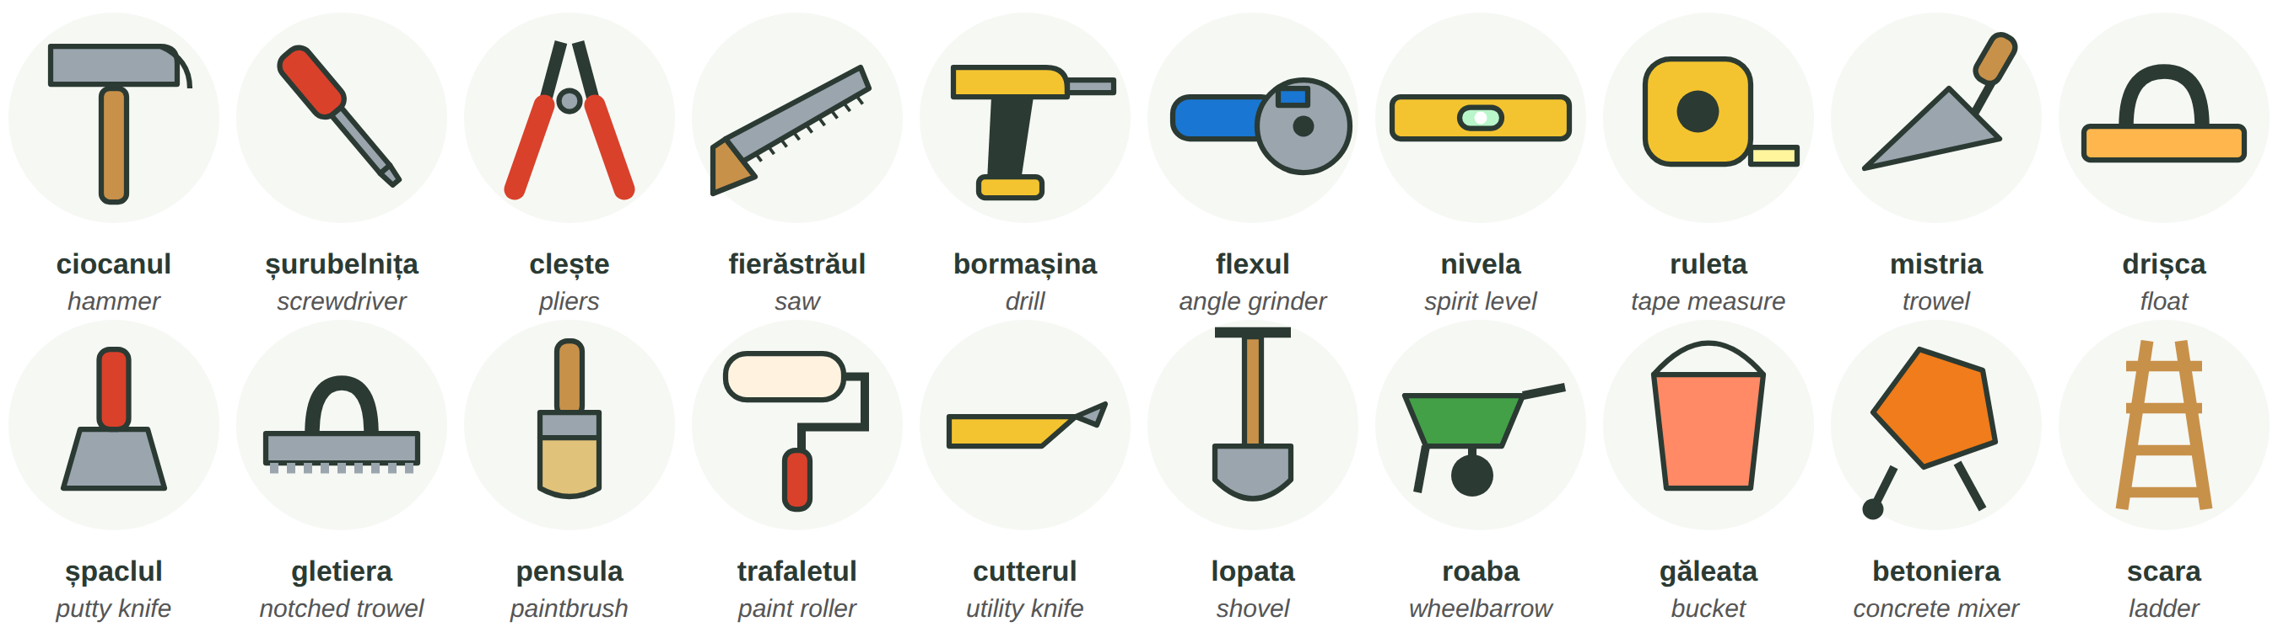
Fig. 9.1 — Unelte de mână și scule electrice / Hand tools and power tools
THE TOOL | PLURAL · NOTE | THE TOOL | PLURAL · NOTE
un ciocan | ciocane | o șurubelniță | șurubelnițe
un clește | clești | un fierăstrău | fierăstraie · also flexul cuts
o bormașină | bormașini · mașina de găurit | un flex | flexuri · = polizorul unghiular
o nivelă | nivele · on site also boloboc | o ruletă | rulete · also metrul
o mistrie | mistrii | o drișcă | drișce
un șpaclu · o gletieră | șpacluri · gletiere | o pensulă · un trafalet | pensule · trafalete

ATTENTION — FLEX AND POLIZOR
Flexul is the everyday name of the polizor unghiular (angle grinder). Many workers simply say polizorul. The polizorul de banc is the fixed bench grinder. Ask if you are not sure: Care polizor? Flexul?

9.1 Which tool?
Write the tool. Then ask a colleague for it: Dă-mi..., te rog!
1. Bat un cui (a nail) cu ______________. | 2. Fac o gaură (a hole) cu ______________.
3. Tai o placă de gresie cu ______________. | 4. Verific dacă e drept cu ______________.
5. Pun mortarul cu ______________. | 6. Vopsesc peretele cu ______________.

CUVINTE ȘI EXPRESII UZUALE / USEFUL WORDS AND PHRASES
Dă-mi ciocanul! | Give me the hammer! | Unde e ruleta? | Where is the tape measure?
Nu merge bormașina. | The drill doesn't work. | S-a descărcat acumulatorul. | The battery is flat.
burghiul · discul · lama | drill bit · (grinder) disc · blade | prelungitorul · priza | extension lead · socket

Lesson 9.2 — Materials / Materialele
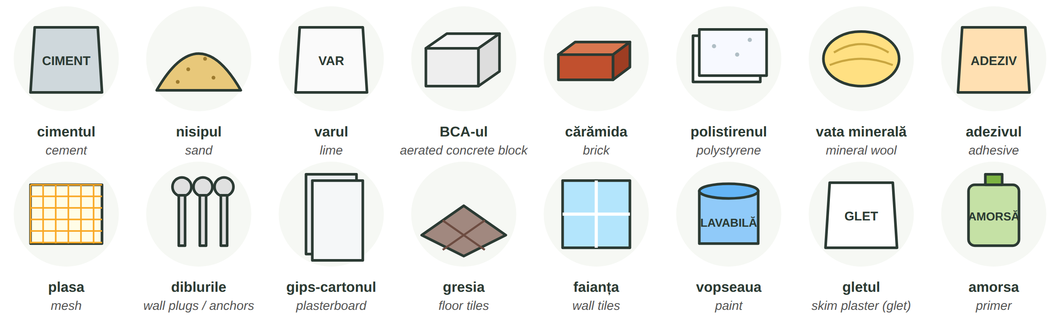
Fig. 9.2 — Materiale de construcții / Building materials
MATERIAL | HOW YOU BUY IT | MATERIAL | HOW YOU BUY IT
cimentul · varul · adezivul | un sac de... (25 or 40 kg) | nisipul | o tonă, un mc (m³)
BCA-ul · cărămida | o bucată, un palet de... | polistirenul · vata minerală | o placă, un pachet, o rolă
plasa (din fibră de sticlă) | o rolă de plasă | diblurile | o cutie de dibluri
gips-cartonul | o placă de gips-carton | gresia · faianța | o cutie, un mp (m²)
vopseaua · amorsa | o găleată, un bidon (litri) | gletul · mortarul | un sac de...

RECAP — QUANTITY + DE (Lesson 8.2)
un sac de ciment · doi saci de adeziv · 20 de saci de glet · un palet de BCA · o rolă de plasă · o găleată de vopsea. Read the bag: Pe sac scrie... — It says on the bag...

ON SITE | ENGLISH
Mai avem ciment? — Nu, s-a terminat. Mai trebuie cinci saci. | Do we still have cement? — No, it's finished. We need five more bags.
Unde punem paleții de BCA? — Lângă betonieră. | Where do we put the pallets of BCA? — Next to the mixer.
Amestecă adezivul cu apă, cum scrie pe sac. | Mix the adhesive with water, as it says on the bag.

9.2 How do you buy it?
Complete with: un sac · un palet · o rolă · o cutie · o găleată · o tonă.
1. ______________ de ciment | 2. ______________ de cărămizi
3. ______________ de plasă | 4. ______________ de dibluri
5. ______________ de vopsea | 6. ______________ de nisip

CUVINTE ȘI EXPRESII UZUALE / USEFUL WORDS AND PHRASES
s-a terminat | it's finished / run out | mai trebuie... | we need more...
materialul a venit | the material has arrived | a descărca un camion | to unload a lorry
a amesteca | to mix | uscat · ud | dry · wet

Lesson 9.3 — Work clothes and protective equipment / Echipamentul de lucru
Echipamentul individual de protecție (EIP) is the equipment that protects you: helmet, glasses, gloves, boots, harness. Your employer must give it to you free of charge (HG 1048/2006), and you must wear it correctly (Law 319/2006). More in Lesson 9.13.
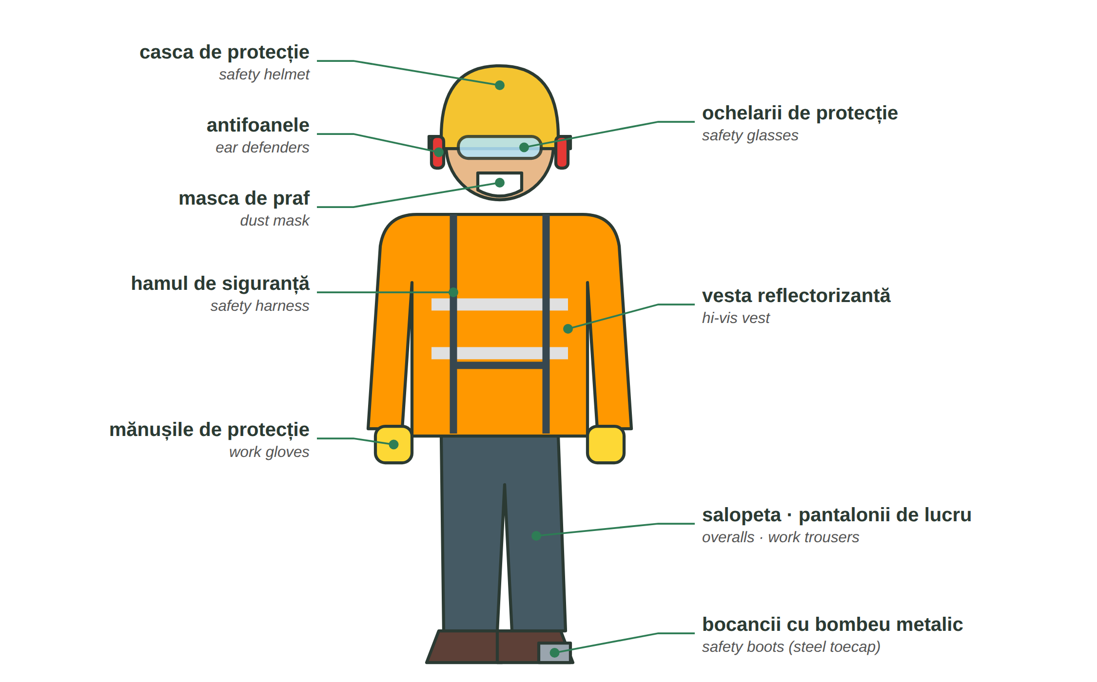
Fig. 9.3 — Echipamentul de lucru și de protecție / Work and protective equipment
9.3 What do you wear?
Write the equipment.
1. Pe cap port ______________. | 2. Pe mâini port ______________.
3. În picioare port ______________. | 4. Pentru ochi port ______________.
5. Când tai cu flexul port ______________ și antifoane. | 6. Când lucrez la înălțime port ______________.

CUVINTE ȘI EXPRESII UZUALE / USEFUL WORDS AND PHRASES
Mi s-a rupt mănușa. | My glove is torn. | Am nevoie de o cască nouă. | I need a new helmet.
Ce mărime? — Port 43. | What size? — I wear 43 (Lesson 6.2). | la înălțime | at height
vestiarul | the changing room | dulapul | the locker

HOMEWORK — AFTER SESSION 33 / TEMĂ PENTRU ACASĂ
H33.1 Write the ten tools and five materials you use most at work, with un / o and the plural.
H33.2 Write what protective equipment you wear every day, and what you wear only for some jobs.

SESSION 34 — MEASUREMENTS AND CALCULATIONS
SESIUNEA 34 — MĂSURĂTORI ȘI CALCULE · 3 hours

By the end of this session you will be able to:
☐ | read and say units of measurement: mm, cm, m, mp, mc, kg, l
☐ | read a tape measure to the millimetre
☐ | calculate the surface of a wall and how many bags or boxes you need
☐ | understand and give short measuring instructions: Cât măsoară? Mai taie doi centimetri.

Lesson 9.4 — Units of measurement / Unitățile de măsură
WRITTEN | YOU SAY | ENGLISH | EXAMPLE
mm | milimetru · milimetri | millimetre | o fisură de 2 mm
cm | centimetru · centimetri | centimetre | polistiren de 10 cm
m · ml | metru · metri · metru liniar | metre · running metre | 25 de metri de plintă
m² · mp | metru pătrat · metri pătrați | square metre | 40 de metri pătrați de gresie
m³ · mc | metru cub · metri cubi | cubic metre | 3 metri cubi de beton
kg · t | kilogram · tonă | kilo · tonne | un sac de 40 de kilograme
l | litru · litri | litre | o găleată de 15 litri
buc. · sac · palet | bucată · sac · palet | piece · bag · pallet | 2 paleți de BCA

1 m = 100 cm = 1 000 mm · 1 m³ = 1 000 l · 1 t = 1 000 kg. On site people say mp (em-pe) and mc (em-ce).
RECAP — NUMBERS WITH A COMMA (Lesson 2.5)
Romanian writes a comma: 2,50 m = doi metri și cincizeci (de centimetri) · 1,20 m = un metru douăzeci · 0,5 m = jumătate de metru · 12,5 mp = doisprezece virgulă cinci metri pătrați. After 20 add de: 25 de metri, 40 de kilograme.

9.4 Say it and write it
Write the words, then read them out loud.
1. 3 m² = ______________________ | 2. 2,5 m = ______________________
3. 40 kg = ______________________ | 4. 1 m³ = ______ litri
5. 150 cm = ______ m | 6. 1 m = ______ mm

CUVINTE ȘI EXPRESII UZUALE / USEFUL WORDS AND PHRASES
lungimea · lățimea | the length · the width | înălțimea · grosimea | the height · the thickness
adâncimea | the depth | cam · aproximativ | about, roughly
exact | exactly | în plus · în minus | more · less

Lesson 9.5 — Reading a tape measure / Cum citești ruleta
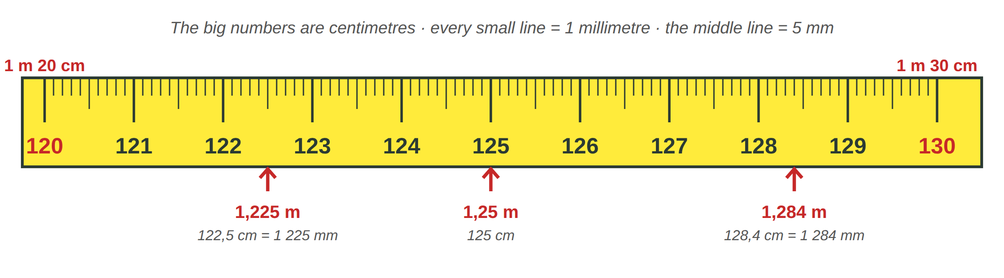
Fig. 9.4 — Citirea ruletei / Reading a tape measure
On most tapes the big numbers are centimetres; after 100 you read 1 m 20 = 120 cm. Each small line is 1 mm; the longer line in the middle is 5 mm. Say: un metru douăzeci și doi și jumătate (122,5 cm) or un metru, douăzeci și doi de centimetri și cinci milimetri.
DIALOGUE | ENGLISH
A: Cât măsoară geamul? | How much does the window measure?
B: Un metru douăzeci pe un metru. | 1.20 by 1 metre.
A: Și placa asta? | And this board?
B: Un metru douăzeci și opt și patru milimetri. E prea lungă. | 1 m 28 and 4 millimetres. It's too long.
A: Mai taie doi centimetri. Măsoară de două ori, taie o dată! | Cut two more centimetres. Measure twice, cut once!
B: Gata. Acum e bună. | Done. Now it's right.

9.5 Read the tape
Look at Fig. 9.4. Write the measurement in cm and in m.
1. the line between 121 and 122 → ______ cm = ______ m | 2. 3 small lines after 124 → ______ cm
3. the middle line after 127 → ______ cm | 4. 130 cm = ______ m

CUVINTE ȘI EXPRESII UZUALE / USEFUL WORDS AND PHRASES
Cât măsoară? | How long is it? / What does it measure? | ... pe ... | ... by ... (1,20 pe 1)
Mai taie doi centimetri. | Cut two more centimetres. | E prea lung / scurt. | It's too long / short.
Ține capătul! | Hold the end! | Măsoară încă o dată. | Measure again.

Lesson 9.6 — Simple calculations / Calcule simple
Suprafața (the surface, area) of a wall or a floor = lungimea × înălțimea (or × lățimea). A wall is a dreptunghi (rectangle, Lesson 4.5). From the surface you take away the doors and the windows.
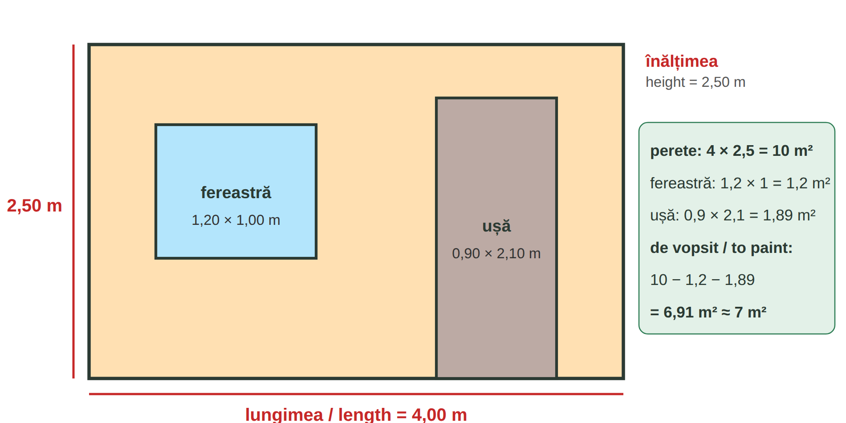
Fig. 9.5 — Suprafața unui perete / The surface of a wall
QUESTION | CALCULATION | ANSWER
Câți saci de adeziv pentru 20 mp? Pe sac scrie: 5 kg/mp, sac de 25 kg. | 20 × 5 = 100 kg · 100 : 25 = 4 | 4 saci de adeziv
Câte cutii de gresie pentru o cameră de 3 × 2 m? O cutie = 1,44 mp. | 3 × 2 = 6 mp · + tăieturi (cuts) ≈ 6,6 mp · 6,6 : 1,44 ≈ 4,6 | 5 cutii (you always round up)
Câți metri cubi de beton pentru o placă de 3 × 2 m, groasă de 10 cm? | 3 × 2 × 0,10 = 0,6 mc | 0,6 mc = 600 de litri
Câte găleți de vopsea pentru 7 mp, două straturi? Pe găleată: 10 mp/litru, 5 l. | 7 × 2 = 14 mp · 14 : 10 = 1,4 l | o găleată de 5 l ajunge

The figures on bags and boxes are examples. Always read the real consumption (consumul) on the product and ask your team leader how much to order. For cuts, many teams add about 10% — the team leader decides.
SAY IT | ENGLISH | SAY IT | ENGLISH
ori · × | times | plus · minus | plus · minus
împărțit la · : | divided by | egal · = | equals
Ajunge? | Is it enough? | Nu ajunge. | It's not enough.

9.6 Calculate
Write the calculation and the answer in Romanian.
1. Un perete de 5 m × 3 m = ______ mp | 2. Pentru 30 mp, cu 4 kg/mp: ______ kg = ______ saci de 25 kg
3. O podea de 4 × 3 m = ______ mp | 4. O placă de 4 × 2 m, groasă de 0,10 m = ______ mc

CUVINTE ȘI EXPRESII UZUALE / USEFUL WORDS AND PHRASES
Cât iese? | What does it come to? | Fă socoteala! | Do the sum!
Mai comandăm doi saci. | We'll order two more bags. | rotunjim în sus | we round up
consumul · pe sac scrie | the consumption · it says on the bag | o rezervă | a spare, extra

HOMEWORK — AFTER SESSION 34 / TEMĂ PENTRU ACASĂ
H34.1 Measure a wall in your room. Write the length, the height, the window and the door, and calculate the surface to paint.
H34.2 Write four sentences with measurements from your work: Placa are 1,20 pe 0,60...

SESSION 35 — THE TYPES OF WORK
SESIUNEA 35 — TIPURILE DE LUCRĂRI · 3 hours

By the end of this session you will be able to:
☐ | say what work you do: Lucrez la zidărie / la fațade / la finisaje
☐ | name the steps of five types of work, in order
☐ | name the layers of a plaster and of an insulated facade
☐ | use: întâi..., apoi..., după aceea..., la sfârșit...

Lucrările (the types of work) on a site go from structura (the structure: foundation, walls, floor slabs) to finisajele (the finishes: plaster, tiles, paint). Say what you do: Sunt zidar. · Lucrez la termoizolații. · Fac finisaje. The order of the steps: întâi → apoi → după aceea → la sfârșit (first → then → after that → at the end).
THE WORK | THE WORKER | THE WORK | THE WORKER
zidăria — masonry | zidarul | tencuiala — plastering | tencuitorul
termoizolația, fațada — insulation | fațadistul | gresia și faianța — tiling | faianțarul
zugrăveala — painting | zugravul | betonul, cofrajul — concrete, formwork | dulgherul · fierarul-betonist

Lesson 9.7 — Masonry / Zidăria
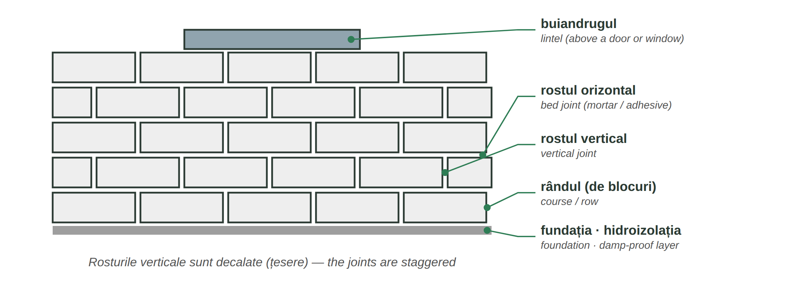
Fig. 9.6 — Un zid de BCA / A BCA wall
NR. | THE STEP | ENGLISH
1 | trasarea peretelui | marking out where the wall goes
2 | primul rând pe mortar, în nivel | the first course, on mortar, level
3 | adezivul / mortarul pe blocuri, cu mistria | adhesive / mortar on the blocks, with the trowel
4 | rândurile următoare, cu rosturile decalate (țesere) | the next courses, joints staggered
5 | verificarea cu nivela și firul cu plumb | checking with the level and the plumb line
6 | buiandrugul deasupra ușii și a ferestrei | the lintel above the door and the window

9.7 Put the steps in order
Write 1–4.
___ Pun al doilea rând, cu rosturile decalate. | ___ Trasez peretele.
___ Verific cu nivela. | ___ Pun primul rând pe mortar.

CUVINTE ȘI EXPRESII UZUALE / USEFUL WORDS AND PHRASES
e în nivel · e pe fir | it's level · it's plumb | e strâmb · e drept | it's crooked · it's straight
un rând de BCA | a course of BCA | mortarul e prea moale | the mortar is too soft

Lesson 9.8 — Plastering / Tencuielile
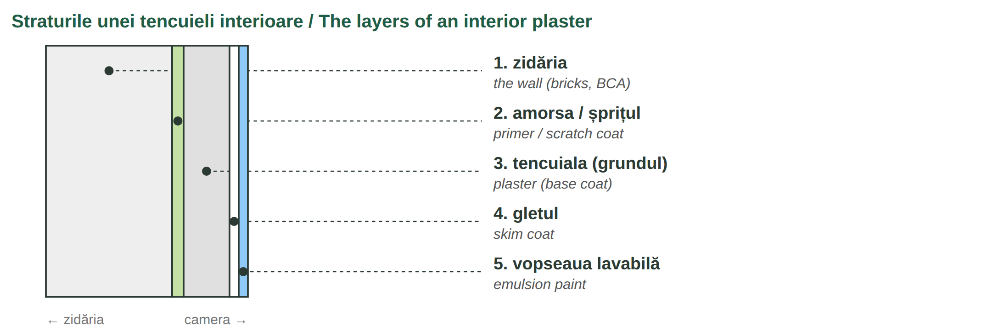
Fig. 9.7 — Straturile tencuielii / The layers of plaster
NR. | THE STEP | ENGLISH
1 | curățarea și umezirea peretelui | clean and wet the wall
2 | montarea profilelor (ghidajelor) și a colțarelor | fix the guide profiles and the corner beads
3 | amorsa sau șprițul | primer or scratch coat
4 | tencuiala — manual sau cu mașina — trasă cu dreptarul | the plaster — by hand or by machine — levelled with the straightedge
5 | drișcuirea cu drișca | floating with the float
6 | după uscare: gletul și șlefuirea | when dry: skim coat and sanding

9.8 Which layer?
Complete with: amorsa · tencuiala · gletul · vopseaua.
1. Pe perete, întâi pun ______________. | 2. Apoi pun ______________, groasă de 1–2 cm.
3. După uscare pun ______________ și șlefuiesc. | 4. La sfârșit, zugravul dă cu ______________.

CUVINTE ȘI EXPRESII UZUALE / USEFUL WORDS AND PHRASES
a tencui · a gletui | to plaster · to skim | dreptarul | the straightedge
profilele · colțarele | guide profiles · corner beads | e uscat? — mai așteaptă | is it dry? — wait a bit more

Lesson 9.9 — Insulation and facades / Termoizolația și fațadele
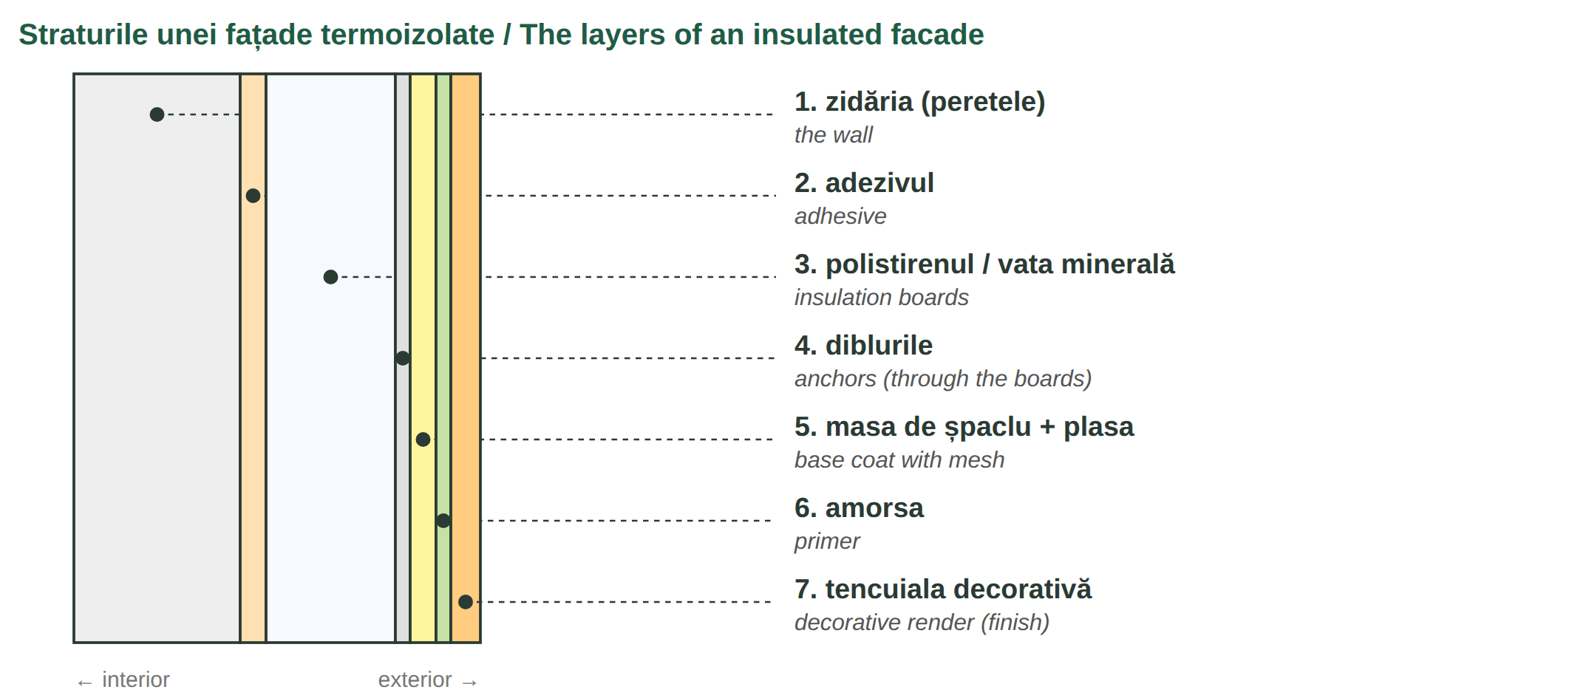
Fig. 9.8 — Straturile unei fațade termoizolate / The layers of an insulated facade
NR. | THE STEP | ENGLISH
1 | montarea schelei și pregătirea peretelui | put up the scaffolding and prepare the wall
2 | profilul de soclu jos, în nivel | the starter (base) profile at the bottom, level
3 | lipirea plăcilor de polistiren / vată cu adeziv, decalate | glue the boards with adhesive, staggered
4 | diblurile prin plăci, în perete | the anchors through the boards into the wall
5 | masa de șpaclu cu plasa înglobată | the base coat with the mesh embedded
6 | amorsa, apoi tencuiala decorativă | primer, then the decorative render

ATTENTION — THE SCAFFOLDING
Work on the schelă (scaffolding) only when it is complete, stable and checked, and with the protection your team leader tells you to use (hamul, balustrada). If a part is missing, say so and do not climb: Lipsește balustrada. Nu urc.

9.9 What comes next?
Complete the sentence.
1. După adeziv, pun ______________. | 2. După plăci, bat ______________.
3. În masa de șpaclu pun ______________. | 4. La sfârșit dau cu ______________.

CUVINTE ȘI EXPRESII UZUALE / USEFUL WORDS AND PHRASES
schela · a urca · a coborî | scaffolding · to climb up · to come down | polistiren de 10 (cm) | 10 cm polystyrene
a lipi · a bate diblurile | to glue · to put in the anchors | soclul | the plinth, base of the wall

Lesson 9.10 — Floor and wall tiles / Gresia și faianța
Gresia goes on the floor, faianța on the walls (bathroom, kitchen).
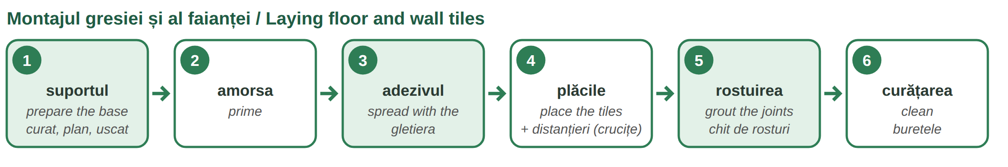
Fig. 9.9 — Pașii montajului / The steps of tiling
ROMANIAN | ENGLISH | ROMANIAN | ENGLISH
adezivul pentru gresie | tile adhesive | gletiera (șpaclul dințat) | notched trowel
distanțierii (crucițele) | tile spacers | chitul de rosturi | grout
mașina de tăiat gresie | tile cutter | ciocanul de cauciuc | rubber mallet
rostul de 2 mm | a 2 mm joint | plăcile · o placă | the tiles · a tile

9.10 Gresie or faianță?
Write gresie or faianță.
1. Pe podeaua din bucătărie pun ______________. | 2. Pe peretele din baie pun ______________.
3. Pe terasă (outside) pun ______________ de exterior. | 4. În spatele chiuvetei pun ______________.

CUVINTE ȘI EXPRESII UZUALE / USEFUL WORDS AND PHRASES
în nivel · pe diagonală | level · diagonally | o placă spartă | a broken tile
tăietura · a tăia | the cut · to cut | Lasă să se usuce 24 de ore. | Let it dry for 24 hours.

Lesson 9.11 — Painting / Zugrăvelile
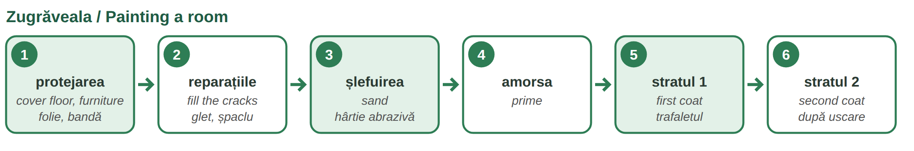
Fig. 9.10 — Pașii zugrăvelii / The steps of painting
ROMANIAN | ENGLISH | ROMANIAN | ENGLISH
vopseaua lavabilă | emulsion paint (washable) | banda de hârtie | masking tape
folia de protecție | protective sheet | hârtia abrazivă · șmirghel | sandpaper
un strat · două straturi | one coat · two coats | a dilua cu apă | to thin with water

9.11 Put the steps in order
Write 1–5.
___ Dau primul strat de vopsea. | ___ Acopăr mobila cu folie.
___ Pun amorsa. | ___ Repar fisurile cu glet.
___ Dau al doilea strat.

CUVINTE ȘI EXPRESII UZUALE / USEFUL WORDS AND PHRASES
a zugrăvi · a vopsi | to paint (walls) · to paint (other things) | a acoperi | to cover
e pătat · a curs vopseaua | it's stained · the paint has run | Mai dă o mână. | Give it another coat (literally: a hand).

HOMEWORK — AFTER SESSION 35 / TEMĂ PENTRU ACASĂ
H35.1 Choose the type of work you do most. Write its steps in order with întâi, apoi, după aceea, la sfârșit.
H35.2 Draw the layers of a facade or of a plaster from memory and write their names.

SESSION 36 — ORDERS, SAFETY, EXPRESSIONS, RECAP AND TEST
SESIUNEA 36 — INSTRUCȚIUNI, SSM, EXPRESII, RECAPITULARE ȘI TEST · 3 hours

By the end of this session you will be able to:
☐ | understand and give orders on site
☐ | know the compulsory protective equipment and read the safety signs
☐ | know what the SSM training is and what you sign
☐ | know what to do in an accident
☐ | recognise the expressions you hear on site and in the street

Lesson 9.12 — Orders on site / Instrucțiuni și comenzi pe șantier
RECAP — ORDERS (Lesson 3.13)
On site the team leader usually says tu, so you hear the direct form: Adu! Ține! Taie! To a group or politely you hear the voi / dumneavoastră form: Aduceți! Țineți! With a short pronoun: Dă-mi-l! · Ține-o! · Pune-le aici!

DIRECT (tu) | TO A GROUP / POLITE | ENGLISH — EXAMPLE
Adu! | Aduceți! | Bring! — Adu doi saci de adeziv!
Dă-mi! | Dați-mi! | Give me! — Dă-mi nivela!
Ține! | Țineți! | Hold! — Ține scara!
Taie! | Tăiați! | Cut! — Taie placa la 60!
Măsoară! | Măsurați! | Measure! — Măsoară geamul!
Pune! | Puneți! | Put! — Pune paletul lângă betonieră!
Ridică! · Coboară! | Ridicați! · Coborâți! | Lift! · Lower / come down!
Amestecă! · Toarnă! | Amestecați! · Turnați! | Mix! · Pour! — Toarnă betonul!
Pornește! · Oprește! | Porniți! · Opriți! | Start! · Stop! — Oprește betoniera!
Curăță! · Verifică! | Curățați! · Verificați! | Clean! · Check! — Curăță sculele!
Stai! · Nu atinge! | Stați! · Nu atingeți! | Stop! Wait! · Don't touch!
Ai grijă! · Atenție! | Aveți grijă! | Be careful! · Watch out!

Answer: Am înțeles. · Gata! · Imediat. · Nu am înțeles, mai spuneți o dată, vă rog. — never do a job you have not understood.
9.12 Say the order
Write the direct order (tu).
1. (a aduce) ______________ o găleată de apă! | 2. (a ține) ______________ scara, te rog!
3. (a opri) ______________ flexul! | 4. (a măsura) ______________ peretele!
5. (a pune) ______________ casca! | 6. (a curăța) ______________ mistria!

CUVINTE ȘI EXPRESII UZUALE / USEFUL WORDS AND PHRASES
Am înțeles. | Understood. | Unde îl pun? | Where do I put it?
Cu ce încep? | What do I start with? | Am terminat. Ce fac acum? | I've finished. What do I do now?

Lesson 9.13 — Health and safety at work / Securitatea și sănătatea în muncă (SSM)
Your duties and your rights
YOU MUST (Law 319/2006, art. 22–23) | YOUR EMPLOYER MUST
work as you were trained, without putting yourself or others in danger | give you the protective equipment free of charge (HG 1048/2006)
use machines and tools correctly and wear the EIP | train you in SSM before you start work (HG 1425/2006)
never remove or switch off a safety device | explain the risks of your workplace
report at once any danger you see | repeat the training periodically
tell your team leader / employer about any accident you have | If there is a problem: ITM (Lesson 5.2)

PRACTICAL NOTE — THE SSM TRAINING / INSTRUCTAJUL SSM
Before you start work you receive the instructajul introductiv-general, then the instructajul la locul de muncă (the risks of your own workplace), and later the instructajul periodic — the interval between two periodic trainings cannot be longer than 6 months (HG 1425/2006). At the end there is a short test and you sign the fișa individuală de instruire.
Sign only what you have understood. If the training is only in Romanian and you do not understand, say: Nu am înțeles. Puteți să-mi explicați, vă rog?

ATTENTION — WHAT TO DO IN AN ACCIDENT / CE FACI LA UN ACCIDENT
1. Stop the work and make the place safe (Opriți! Opriți curentul!). 2. If someone is badly hurt, call 112 (Lesson 5.2): Este un accident pe șantier. Un om a căzut de pe schelă. 3. Do not move the injured person unless there is danger; give first aid only if you know how. 4. Tell the team leader and the employer at once — also if you are hurt, even a little (Law 319/2006, art. 23).

Safety signs / Semnele de avertizare
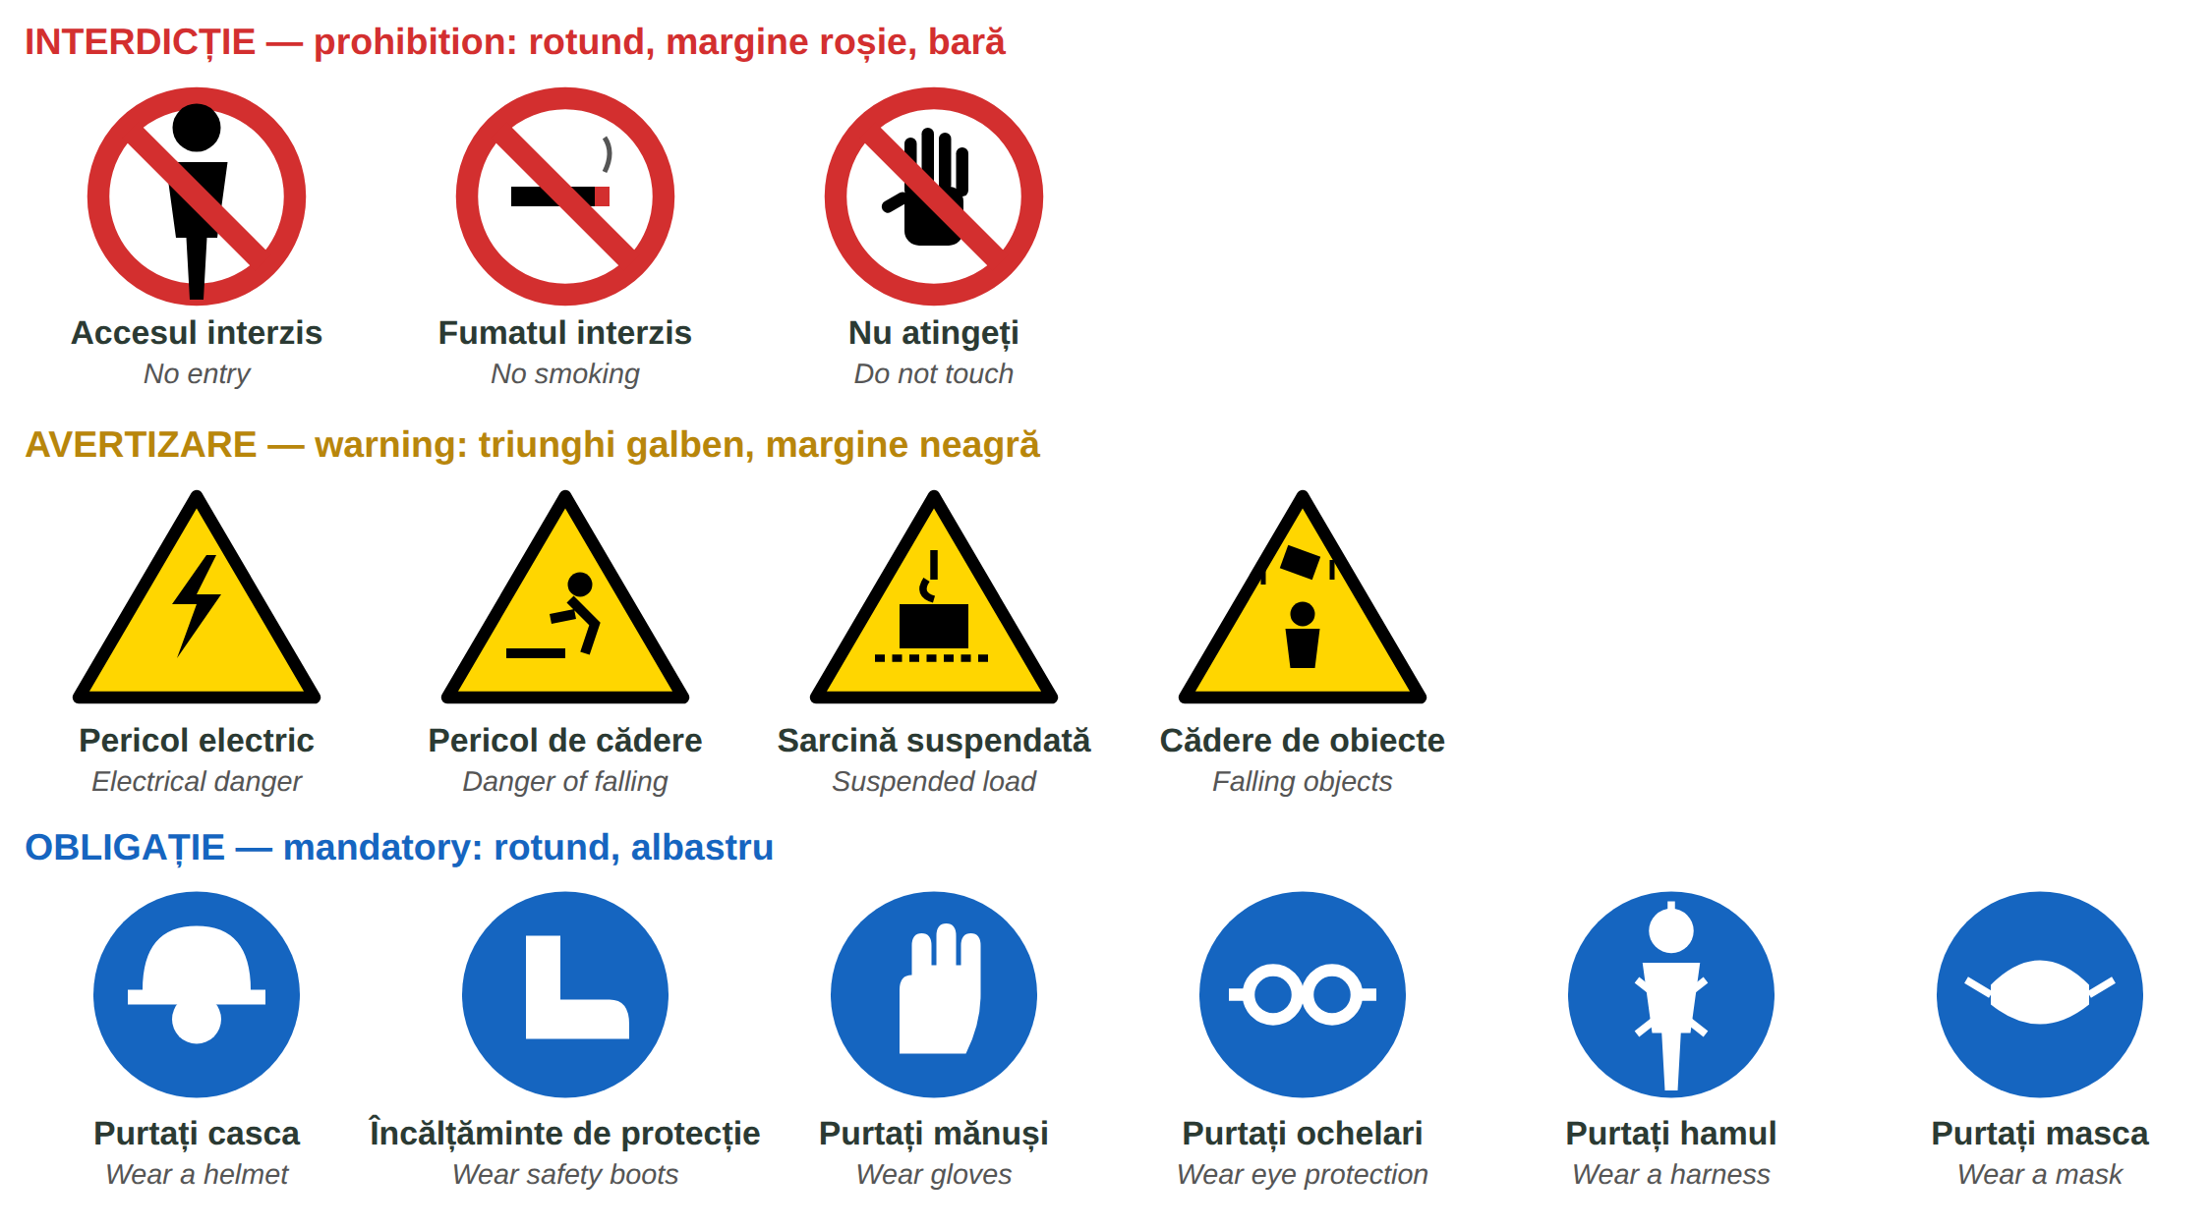
Fig. 9.11 — Indicatoare de securitate: interdicție, avertizare, obligație / Safety signs
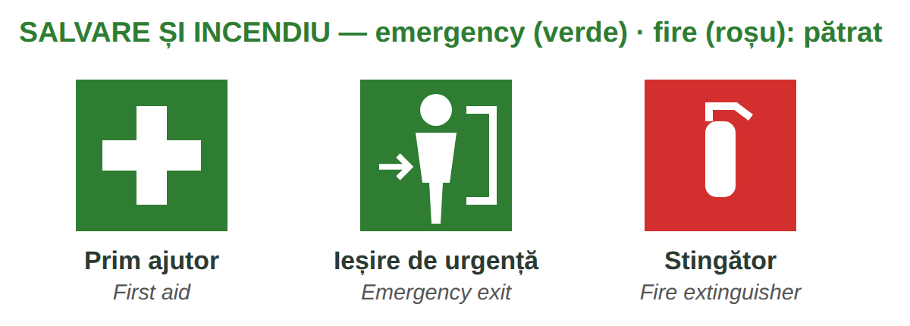
Fig. 9.12 — Salvare și incendiu / Emergency and fire
Shapes and colours of safety signs: HG 971/2006 (EU Directive 92/58/EEC). The pictograms above are simplified drawings.
9.13 Which sign?
Write the type: interdicție · avertizare · obligație · salvare.
1. un cerc albastru cu o cască → ______________ | 2. un triunghi galben cu un fulger → ______________
3. un cerc roșu cu o țigară tăiată → ______________ | 4. un pătrat verde cu o cruce albă → ______________

CUVINTE ȘI EXPRESII UZUALE / USEFUL WORDS AND PHRASES
M-am lovit. | I hurt myself / I got hit. | M-am tăiat la deget. | I cut my finger.
A căzut de pe schelă. | He / She fell off the scaffolding. | trusa de prim ajutor | the first-aid kit
E periculos. | It's dangerous. | Nu lucrez fără ham. | I don't work without a harness.

Lesson 9.14 — Site expressions and recap / Expresii de șantier și recapitulare
EXPRESSIONS YOU HEAR ON SITE AND IN THE STREET — FOR RECOGNITION ONLY
Informal. Understand them; use them only with colleagues you know well — never with a client, an official or the police.

YOU HEAR | WHAT IT MEANS | ENGLISH
Hai! | haide — hai să mergem, hai să începem | Come on! · Let's go!
Gata! | am terminat · e pregătit · ajunge | Done! · Ready! · That's enough!
Las' că merge. | nu-i nimic, e bine și așa | Never mind, it'll work.
Nu-i bai. | nu e nicio problemă (mai ales în Ardeal și Banat) | No problem.
Stai puțin! | așteaptă un moment | Wait a moment!
Bagă mare! | dă-i drumul, cu toată puterea | Go for it! · Full speed!
Merge și așa. | e destul de bine, nu mai reparăm | It's good enough like that.
N-ai grijă! | nu-ți face griji, mă ocup eu | Don't worry!
Ce faci, mă? | salut prietenesc (sau: ce tot faci acolo?) | Hey, how's it going? / Hey, what are you doing?
Pe bune? | serios? adevărat? | Really? · Seriously?
Lasă-l! | nu-l mai deranja · lasă lucrul acolo | Leave him alone! · Leave it!

ATTENTION — „LAS' CĂ MERGE” IS NEVER ABOUT SAFETY
Las' că merge and merge și așa (it is good enough) are never acceptable for safety: a scaffold without a guardrail, a harness not attached, a cable in water. Answer calmly: Nu, așa nu e sigur. — No, it's not safe like that. Mă, măi is familiar: fine between friends, rude to a stranger.

Module 9 in one table
TOOLS | MATERIALS | MEASURING | SAFETY
ciocan · șurubelniță · clește | ciment · nisip · var | mm · cm · m | cască · ochelari · mănuși
bormașină · flex · fierăstrău | BCA · cărămidă · mortar | mp · mc · ml | bocanci · vestă · ham
nivelă · ruletă · mistrie · drișcă | polistiren · vată · plasă · dibluri | kg · t · l · sac · palet | instructajul · interdicție · avertizare
pensulă · trafalet · găleată | gresie · faianță · vopsea | Cât măsoară? Mai taie... | obligație · salvare · 112

9.14 Everything together
Circle the correct word.
1. Fac o gaură cu ( bormașina / mistria ). | 2. un sac ( de / din ) ciment
3. 4 m × 2,5 m = 10 ( mp / mc ) | 4. ( Ține / Ține-l ) scara, te rog!
5. Pe cap port ( casca / hamul ). | 6. Un triunghi galben este un semn de ( avertizare / obligație ).
7. La un accident grav sun la ( 112 / ITM ). | 8. „Nu-i bai” înseamnă: ( nu e nicio problemă / e periculos ).

HOMEWORK — AFTER SESSION 36 / TEMĂ PENTRU ACASĂ
H36.1 Write five orders you hear every day at work and what they mean.
H36.2 Look at the safety signs on your site. Draw three of them and write what they mean.

SECȚIUNE DETAȘABILĂ — EXEMPLAR FORMATOR
Detachable section — teacher's copy. Se detașează din suportul cursantului; testul completat, semnat și datat, se păstrează la dosarul cursantului. Conține: testul cumulativ, fișa de confirmare a Sesiunii 36, fișa de evidență a Modulului 9, cheia răspunsurilor, sursele.

TEST CUMULATIV — MODULUL 9 (CONSTRUCȚII)
MODULE 9 — CUMULATIVE TEST · CONSTRUCTION · grilă, 25 de întrebări, 25 de puncte · semnat și datat de cursant

Nume și prenume cursant / Student name
Data / Date | _____ / _____ / 20_____
Semnătura cursantului / Student signature

Marcați cu X un singur răspuns la fiecare întrebare. Mark ONE answer with X for each question. Each correct answer = 1 point.
1. Cu ce faci o gaură în perete? (1 p)
☐ a) cu mistria | ☐ b) cu bormașina | ☐ c) cu drișca | ☐ d) cu pensula
2. „Flexul” este: (1 p)
☐ a) polizorul unghiular | ☐ b) nivela | ☐ c) ruleta | ☐ d) scara
3. Cu ce verifici dacă un perete e drept (în nivel)? (1 p)
☐ a) cu ciocanul | ☐ b) cu clește | ☐ c) cu nivela | ☐ d) cu lopata
4. Cu ce vopsești un perete mare? (1 p)
☐ a) cu trafaletul | ☐ b) cu cutterul | ☐ c) cu fierăstrăul | ☐ d) cu roaba
5. Completează: „un sac ___ ciment” (1 p)
☐ a) din | ☐ b) cu | ☐ c) la | ☐ d) de
6. BCA-ul se cumpără de obicei la: (1 p)
☐ a) litru | ☐ b) palet | ☐ c) rolă | ☐ d) găleată
7. Ce pui între plăcile de polistiren și perete? (1 p)
☐ a) adeziv | ☐ b) vopsea | ☐ c) glet | ☐ d) gresie
8. Cine dă gratuit echipamentul individual de protecție? (1 p)
☐ a) lucrătorul | ☐ b) angajatorul | ☐ c) ITM | ☐ d) magazinul
9. Pentru ochi porți: (1 p)
☐ a) antifoane | ☐ b) mănuși | ☐ c) ochelari de protecție | ☐ d) vestă
10. 1 m = ___ cm (1 p)
☐ a) 10 | ☐ b) 1 000 | ☐ c) 100 | ☐ d) 50
11. „mp” înseamnă: (1 p)
☐ a) metru pătrat | ☐ b) metru cub | ☐ c) milimetru | ☐ d) metru liniar
12. Un perete de 4 m × 2,5 m are: (1 p)
☐ a) 6,5 mp | ☐ b) 10 mp | ☐ c) 10 mc | ☐ d) 8 mp
13. „2,50 m” se citește: (1 p)
☐ a) doi metri cincizeci | ☐ b) douăzeci și cinci de metri | ☐ c) doi metri cinci | ☐ d) două sute cincizeci de metri
14. „Mai taie doi centimetri.” înseamnă: (1 p)
☐ a) Measure two centimetres. | ☐ b) Cut two more centimetres. | ☐ c) It's two centimetres short. | ☐ d) Hold two centimetres.
15. La o fațadă, după lipirea plăcilor de polistiren pui: (1 p)
☐ a) gresia | ☐ b) diblurile | ☐ c) faianța | ☐ d) cofrajul
16. În masa de șpaclu a fațadei se înglobează: (1 p)
☐ a) plasa | ☐ b) cărămida | ☐ c) vata | ☐ d) nisipul
17. Gresia se pune: (1 p)
☐ a) pe tavan | ☐ b) pe podea | ☐ c) pe acoperiș | ☐ d) în perete
18. Ce pui între plăcile de gresie ca rostul să fie egal? (1 p)
☐ a) dibluri | ☐ b) distanțieri (crucițe) | ☐ c) cuie | ☐ d) bandă
19. La zugrăveală, înainte de vopsea pui: (1 p)
☐ a) amorsa | ☐ b) adezivul de gresie | ☐ c) polistirenul | ☐ d) mortarul
20. Ordinul direct „Ține scara!” vine de la verbul: (1 p)
☐ a) a lua | ☐ b) a ține | ☐ c) a tăia | ☐ d) a da
21. Șeful spune: „Oprește betoniera!” Ce faci? (1 p)
☐ a) O pornesc. | ☐ b) O opresc. | ☐ c) O curăț. | ☐ d) O mut.
22. Un semn rotund, albastru, cu o cască înseamnă: (1 p)
☐ a) Casca e interzisă. | ☐ b) Purtați casca! (obligație) | ☐ c) Pericol electric. | ☐ d) Prim ajutor.
23. Un triunghi galben cu margine neagră este un semn de: (1 p)
☐ a) interdicție | ☐ b) obligație | ☐ c) avertizare | ☐ d) salvare
24. Te-ai lovit ușor la mână pe șantier. Ce faci? (1 p)
☐ a) Nu spui nimic. | ☐ b) Anunți șeful de echipă / angajatorul. | ☐ c) Pleci acasă fără să spui. | ☐ d) Suni la ITM.
25. „Nu-i bai” înseamnă: (1 p)
☐ a) E periculos. | ☐ b) Nu e nicio problemă. | ☐ c) Stai puțin. | ☐ d) Am terminat.

PUNCTAJ OBȚINUT / SCORE | _______ / 25
Semnătura formatorului / Teacher signature

SESSION COMPLETION RECORD
FIȘĂ DE CONFIRMARE A PARCURGERII SESIUNII — se păstrează la dosar

Module / Modul | Modulul 9 — Domeniul de activitate: Construcții (finalizat)
Session / Sesiunea | Sesiunea 36 — Instrucțiuni, SSM, expresii, recapitulare. TEST CUMULATIV MODULUL 9
Duration / Durata | 3 ore
Date / Data | _____ / _____ / 20_____
Student name / Nume și prenume cursant
Score / Punctaj obținut | _______ / 25
Student signature / Semnătura cursantului
Teacher signature / Semnătura formatorului

DECLARAȚIE CURSANT / STUDENT DECLARATION
Declar că am participat la această sesiune de curs și am parcurs conținutul prezentat mai sus.
I declare that I attended this course session and covered the content presented above.

MODULE 9 — COMPLETION RECORD
FIȘĂ DE EVIDENȚĂ A PARCURGERII MODULULUI 9 — se păstrează la dosarul cursantului

Cursant / Student
Act de identitate / ID document
Angajator / Employer
Formator / Teacher
Modul / Module | Modulul 9 — Domeniul de activitate: Construcții (12 ore, Sesiunile 33–36)

NR. | SESIUNE / CONȚINUT | DATA | PUNCTAJ TEST | SEMNĂTURA CURSANTULUI
33 | Sesiunea 33 — Unelte, materiale, echipament de lucru și de protecție (3 ore) |  | —
34 | Sesiunea 34 — Unități de măsură, ruleta, calcule simple (3 ore) |  | —
35 | Sesiunea 35 — Zidărie, tencuieli, termoizolații și fațade, gresie și faianță, zugrăveli (3 ore) |  | —
36 | Sesiunea 36 — Instrucțiuni pe șantier, SSM, expresii, recapitulare + TEST CUMULATIV (3 ore) |  | ___ / 25

CONFIRMARE FINALIZARE MODUL / MODULE COMPLETION
Confirm că cursantul a parcurs integral conținutul Modulului 9 — Domeniul de activitate: Construcții, în total 12 ore de curs, și a susținut testul de evaluare consemnat mai sus.
I confirm that the student completed the full content of Module 9 — My Field of Work: Construction, 12 course hours in total, and sat the assessment recorded above.
Data: _____ / _____ / 20_____ Semnătura formatorului: ______________________

ANSWER KEY — TEACHER COPY
CHEIA RĂSPUNSURILOR — pentru formator

9.1 ciocanul · bormașina · flexul (mașina de tăiat gresie) · nivela · mistria · trafaletul / pensula
9.2 un sac · un palet · o rolă · o cutie · o găleată · o tonă
9.3 casca · mănușile · bocancii · ochelarii de protecție · masca / ochelarii · hamul
9.4 trei metri pătrați · doi metri și cincizeci / doi virgulă cinci metri · patruzeci de kilograme · 1 000 · 1,5 · 1 000
9.5 121,5 cm = 1,215 m · 124,3 cm · 127,5 cm · 1,30 m
9.6 15 mp · 120 kg = 5 saci (4,8 → rotunjim în sus) · 12 mp · 0,8 mc
9.7 3 · 1 · 4 · 2 9.8 amorsa · tencuiala · gletul · vopseaua
9.9 plăcile (de polistiren / vată) · diblurile · plasa · amorsa, apoi tencuiala decorativă
9.10 gresie · faianță · gresie · faianță
9.11 4 · 1 · 3 · 2 · 5 (order: folie → glet → amorsă → stratul 1 → stratul 2)
9.12 Adu · Ține · Oprește · Măsoară · Pune · Curăță
9.13 obligație · avertizare · interdicție · salvare
9.14 bormașina · de · mp · Ține · casca · avertizare · 112 · nu e nicio problemă
Cumulative test — grilă answer key
TOTAL: 25 de puncte. Un răspuns corect = 1 punct. Nemarcat sau dublu marcat = 0 puncte.
1 – b | 2 – a | 3 – c | 4 – a | 5 – d | 6 – b | 7 – a | 8 – b | 9 – c | 10 – c
11 – a | 12 – b | 13 – a | 14 – b | 15 – b | 16 – a | 17 – b | 18 – b | 19 – a | 20 – b
21 – b | 22 – b | 23 – c | 24 – b | 25 – b

Surse și data verificării / Sources and date of verification
Informațiile legale din acest modul au fost verificate la 24.09.2026 pe surse oficiale. The legal information in this module was checked on 24 September 2026 against official sources.
INFORMAȚIA / INFORMATION | SURSA / SOURCE | UNDE ÎN MODUL / WHERE
Obligațiile lucrătorilor: activitate conform instruirii; utilizarea corectă a echipamentelor și a EIP; nu se scot dispozitivele de securitate; comunicarea imediată a pericolelor; informarea despre accidente | Legea nr. 319/2006 a securității și sănătății în muncă, art. 22–23 — legislatie.just.ro/Public/DetaliiDocumentAfis/73772 | Lessons 9.3, 9.13, test q. 24
EIP se acordă gratuit de angajator | HG nr. 1048/2006, art. 10 — legislatie.just.ro/Public/DetaliiDocumentAfis/74559 | Lessons 9.3, 9.13, test q. 8
Instructajul introductiv-general, la locul de muncă, periodic (interval de max. 6 luni); fișa individuală de instruire | HG nr. 1425/2006 — Normele metodologice de aplicare a Legii nr. 319/2006 — legislatie.just.ro/Public/DetaliiDocument/76337; ITM | Lesson 9.13
Semnalizarea de securitate: forme și culori (interdicție, avertizare, obligație, salvare, incendiu) | HG nr. 971/2006 — legislatie.just.ro/Public/DetaliiDocumentAfis/74127; Directiva 92/58/CEE — eur-lex.europa.eu | Lesson 9.13, test q. 22–23
Lecțiile anterioare citate | Modulele 1–8: 2.5, 2.10, 3.11, 3.13, 3.14, 3.16, 4.3, 4.5, 5.2, 6.2, 8.2, 8.4, 8.5 | whole module

Pașii lucrărilor, straturile și cifrele de consum din exerciții sunt exemple didactice de vocabular, nu instrucțiuni tehnice: pe șantier se respectă proiectul, fișa tehnică a produsului și indicațiile șefului de echipă. / The work steps, layers and consumption figures are teaching examples for vocabulary, not technical instructions.

LIMBA ROMÂNĂ PENTRU STRĂINI
Romanian Language for Foreign Workers
SUPORT DE CURS

MODULE 10 — POLITENESS, EDUCATION, BANKING AND ROMANIA TODAY
MODULUL 10 — POLITEȚE, EDUCAȚIE, BANCA ȘI ROMÂNIA DE AZI
Începutul Nivelului A2 / The start of Level A2
LEVEL / NIVEL | DURATION / DURATĂ | LANGUAGE OF TEACHING
A2 — after Module 9 | 12 hours · Sessions 37–40 · Weeks 19–20 | English → Romanian

LEGAL BASIS / TEMEI LEGAL
Curs de limbă română cu elemente de integrare culturală și socială, organizat în conformitate cu O.U.G. nr. 32/2026, art. 7 alin. (1) lit. g) — minimum 6 luni, cel puțin 6 ore pe săptămână.
Romanian language course with cultural and social integration elements, organised under Government Emergency Ordinance no. 32/2026, art. 7(1)(g) — at least 6 months, at least 6 hours per week.
This module ends with ONE cumulative multiple-choice test (20 questions), signed and dated by the student and kept on file as proof of completion.

Before you start
With Module 10 you start Level A2. You will write and speak more politely — in an email, on the phone, at an office counter — with the only new grammar of the module, the polite conditional (aș vrea, ați putea). You will learn how Romanian schools work, how to open a bank account, and what Romania is today: its coat of arms and anthem, its recent history and some famous Romanians.
You need these lessons first — look back at them if you are not sure:
YOU NEED | WHERE | WHY
tu / dumneavoastră · politeness | Lessons 2.6, 5.3 | the polite forms
să + verb · pot, vreau | Lesson 3.11 | Aș vrea să deschid un cont.
short pronouns — îmi, vă, mi-e | Lesson 2.10 | mi-ar plăcea, v-ar deranja
Aș dori (fixed phrase) | Lesson 4.4 | now you learn how it is built
institutions, the town hall, 112 | Lesson 5.2 | at the counter
Romania: symbols, regions, holidays | Lessons 5.1, 5.6 | do not repeat — only what is new
payslip, salary card | Lesson 8.7 | your bank account

Where this module sits in the course
SESSION | DURATION | CONTENT
Session 37 | 3 hours | Lesson 10.1 Polite formulas: in writing, on the phone, at the counter · 10.2 The polite conditional
Session 38 | 3 hours | Lesson 10.3 The education system · 10.4 Enrolling a child at school
Session 39 | 3 hours | Lesson 10.5 Opening a bank account · 10.6 Card, PIN, ATM, statement
Session 40 | 3 hours | Lesson 10.7 Coat of arms and anthem · 10.8 Recent history · 10.9 Famous Romanians · 10.10 Recap · Module 10 test

ONE NEW GRAMMAR POINT — AND A NEW BOX
The only new grammar is the polite conditional (Lesson 10.2). From now on every session also has a red box Greșeli frecvente la scris / Common writing mistakes: words that sound the same but are written differently (să / s-a, la / l-a...). Two pairs per session.

SESSION 37 — POLITENESS AND THE CONDITIONAL
SESIUNEA 37 — POLITEȚE ȘI CONDIȚIONALUL · 3 hours

By the end of this session you will be able to:
☐ | write a short polite email or request
☐ | make and answer a phone call politely
☐ | ask for something at an office counter
☐ | use the polite conditional: aș vrea, ați putea, mi-ar plăcea

Lesson 10.1 — Polite formulas / Formule de politețe
IN WRITING — AN EMAIL | ENGLISH
Stimată doamnă Popescu, / Stimate domnule Ionescu, / Bună ziua, | Dear Mrs Popescu, / Dear Mr Ionescu, / Hello,
Vă scriu în legătură cu programarea de marți. | I am writing about Tuesday's appointment.
Aș dori să schimb ora. Vă rog să-mi spuneți dacă e posibil. | I would like to change the time. Please tell me if it is possible.
Vă mulțumesc anticipat. | Thank you in advance.
Cu stimă, / Cu respect, Ravi Kumar | Yours sincerely, / Respectfully, Ravi Kumar

A written request (o cerere) usually starts: Subsemnatul / Subsemnata Ravi Kumar, cu domiciliul în..., vă rog să-mi aprobați... and ends with Data and Semnătura. It is addressed to the person in charge: Doamnei Director / Domnului Director.
ON THE PHONE | ENGLISH | AT THE COUNTER | ENGLISH
Alo, bună ziua! Sunt Ravi Kumar, de la firma... | Hello! This is Ravi Kumar, from... | Bună ziua, am o programare la ora 10. | Hello, I have an appointment at 10.
Aș putea vorbi cu doamna Popescu? | Could I speak to Mrs Popescu? | Aș avea nevoie de o adeverință. | I would need a certificate.
Un moment, vă rog. Vă fac legătura. | One moment, please. I'll put you through. | Ați putea să-mi spuneți ce acte trebuie? | Could you tell me which documents I need?
Puteți vorbi mai rar, vă rog? | Could you speak more slowly, please? | Unde semnez? (Lesson 5.2) | Where do I sign?
Vă sun eu înapoi. | I'll call you back. | Vă mulțumesc pentru ajutor. | Thank you for your help.

10.1 Put the email in order
Write 1–5.
___ Cu stimă, Ana Rao | ___ Stimată doamnă Marin,
___ Vă scriu în legătură cu permisul de ședere. | ___ Vă mulțumesc anticipat.
___ Aș dori o programare săptămâna viitoare.

CUVINTE ȘI EXPRESII UZUALE / USEFUL WORDS AND PHRASES
în legătură cu | about, regarding | anticipat | in advance
atașat | attached | subsemnatul | I, the undersigned
a face legătura | to put through | a reveni | to come back to, get back to

Lesson 10.2 — The polite conditional / Condiționalul de politețe
In Lesson 4.4 you learned Aș dori as a fixed phrase. Now you see how it is built. The conditional makes a request softer and more polite: Vreau o cafea. → Aș vrea o cafea.
TIPAR — the polite conditional
aș · ai · ar · am · ați · ar | + | VERB (no a): vrea, dori, putea | = | Aș vrea. · Ați putea...?

PERSON | AUXILIARY | A VREA | EXAMPLE
eu | aș | aș vrea | Aș vrea să deschid un cont. — I'd like to open an account.
tu | ai | ai vrea | Ai vrea să vii la noi? — Would you like to come to us?
el / ea | ar | ar vrea | Ar vrea o programare. — He'd like an appointment.
noi | am | am vrea | Am vrea să plătim separat. — We'd like to pay separately.
voi / dvs. | ați | ați vrea | Ați putea repeta, vă rog? — Could you repeat, please?
ei / ele | ar | ar vrea | Ar vrea să vină mâine. — They'd like to come tomorrow.

USEFUL FORMS | ENGLISH
Aș dori... · Aș avea nevoie de... | I would like... · I would need...
Ați putea să...? · Ar fi posibil să...? | Could you...? · Would it be possible to...?
Mi-ar plăcea să... (îmi + ar, Lesson 2.10) | I would like to... (I would enjoy...)
V-ar deranja dacă...? · V-aș ruga să... | Would you mind if...? · I would ask you to...
N-aș vrea să vă deranjez. | I wouldn't want to disturb you.

10.2 Make it polite
Rewrite with the conditional.
1. Vreau un formular. → ______________________ | 2. Puteți repeta? → ______________________
3. Vrem o masă pentru doi. → ______________________ | 4. Îmi place să lucrez aici. → Mi-______ plăcea ______________
5. Vreți o cafea? → ______________________ | 6. Am nevoie de ajutor. → ______________________

CUVINTE ȘI EXPRESII UZUALE / USEFUL WORDS AND PHRASES
aș vrea · aș dori | I would like | ați putea | could you
mi-ar plăcea | I would like / enjoy | ar fi bine | it would be good
v-ar deranja | would you mind | cu plăcere | with pleasure

GREȘELI FRECVENTE LA SCRIS / COMMON WRITING MISTAKES
WRITE | WHAT IT IS | EXAMPLE | THE TEST
să | the little word before a verb (Lesson 3.11) | Vreau să plec. · Trebuie să semnez. | a verb comes after it
s-a | se + a — the past: it has / he has... | S-a terminat. · S-a dus acasă. | you can say s-au for many: s-au dus
la | at, to (a place, a time) | Merg la bancă. · La ora 8. | no verb in la
l-a | îl + a — he / she has ... him / it | Șeful l-a sunat. · L-a văzut. | you can say l-am: l-am sunat

HOMEWORK — AFTER SESSION 37 / TEMĂ PENTRU ACASĂ
H37.1 Write a short email to your manager: you would like a day off next Friday. Use Stimate domnule / Stimată doamnă, Aș dori..., Cu stimă.
H37.2 Write five polite questions with Ați putea...? for the bank, the doctor, the town hall.

SESSION 38 — EDUCATION
SESIUNEA 38 — EDUCAȚIA · 3 hours

By the end of this session you will be able to:
☐ | describe the levels of the Romanian school system
☐ | understand school words: marks, the class teacher, the school year
☐ | know how to enrol a child at school

Lesson 10.3 — The education system / Sistemul de educație
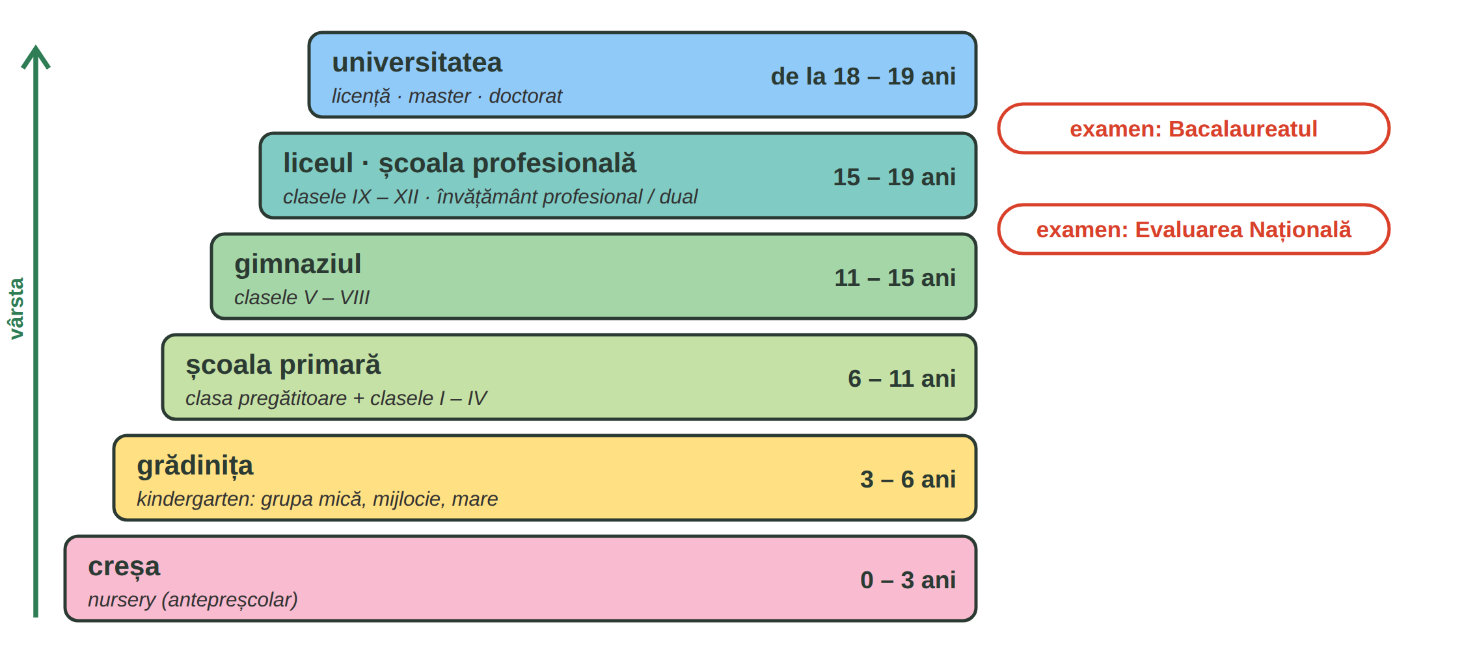
Fig. 10.1 — Sistemul de educație din România (vârste aproximative) / The Romanian education system (approximate ages)
Pre-university education is regulated by Law no. 198/2023. Public education is free in state schools. After clasa a VIII-a pupils take the Evaluarea Națională; after the liceu, the Bacalaureatul, which gives access to university. Instead of a liceu, pupils can go to a școală profesională (vocational school, also dual, with training at a company).
AT SCHOOL | ENGLISH | AT SCHOOL | ENGLISH
elevul · eleva | pupil | studentul · studenta | university student
învățătoarea | primary school teacher | profesorul · profesoara | teacher
dirigintele · diriginta | class teacher (form tutor) | ședința cu părinții | parents' meeting
nota (1–10) · media | mark (1–10) · average | calificativul (FB, B, S, I) | mark in primary school
anul școlar · vacanța | school year · holiday | catalogul | the class register

In gymnasium and high school marks go from 1 to 10; 5 is the minimum to pass. In primary school pupils get calificative: Foarte bine, Bine, Suficient, Insuficient.
10.3 Which level?
Write: grădiniță · școala primară · gimnaziu · liceu · universitate.
1. Un copil de 4 ani merge la ______________. | 2. Clasele V – VIII sunt la ______________.
3. Bacalaureatul se dă la sfârșitul ______________. | 4. Clasa pregătitoare e la ______________.

CUVINTE ȘI EXPRESII UZUALE / USEFUL WORDS AND PHRASES
a învăța · a preda | to learn · to teach | temele | homework
a trece clasa | to pass the year | absențele | absences
uniforma școlară | school uniform | after-school | after-school club

Lesson 10.4 — Enrolling a child at school / Înscrierea la școală
NR. | THE STEP | ENGLISH
1 | afli școala de circumscripție (the school for your address) și calendarul înscrierilor | find the school for your address and the enrolment dates
2 | mergi la secretariatul școlii și ceri lista de acte | go to the school office and ask for the list of documents
3 | de obicei: cererea, certificatul de naștere al copilului, actele părinților (pașaportul, permisul de ședere) | usually: the application, the child's birth certificate, the parents' documents
4 | dacă copilul a învățat în altă țară: documentele școlare și evaluarea pentru a stabili clasa | if the child studied abroad: school documents and an assessment to decide the class
5 | dacă nu vorbește română: un curs de inițiere în limba română, gratuit, organizat de inspectoratul școlar | if the child does not speak Romanian: a free Romanian initiation course organised by the county school inspectorate

ATTENTION — THE RIGHT TO EDUCATION
Children of foreigners who live legally in Romania have access to the Romanian state schools; the county inspectoratul școlar (ISJ / ISMB) decides the class after studies abroad and organises the free Romanian language course (Ministry of Education; IGI — „Acces la educație”). The exact documents and dates change every year — ask the school office.

AT THE SCHOOL OFFICE | ENGLISH
Bună ziua! Aș dori să-mi înscriu fiul în clasa a II-a. | Hello! I would like to enrol my son in year 2.
Ce acte ar trebui să aduc? | Which documents should I bring?
A învățat doi ani în Nepal. Ați putea să-mi spuneți cum se recunoaște? | He studied two years in Nepal. Could you tell me how it is recognised?
Nu vorbește încă bine românește. Există un curs de limba română? | He doesn't speak Romanian well yet. Is there a Romanian course?

10.4 Correct order
Write 1–4.
___ Aduc actele la secretariat. | ___ Aflu care e școala de circumscripție.
___ Copilul începe școala. | ___ Cer lista de acte.

CUVINTE ȘI EXPRESII UZUALE / USEFUL WORDS AND PHRASES
secretariatul | school office | a înscrie | to enrol
circumscripția școlară | school catchment area | inspectoratul școlar | county school inspectorate
echivalarea studiilor | recognition of studies | certificatul de naștere | birth certificate

GREȘELI FRECVENTE LA SCRIS / COMMON WRITING MISTAKES
WRITE | WHAT IT IS | EXAMPLE | THE TEST
ia | from a lua: he / she takes · Take! | Maria ia autobuzul. · Ia o foaie! | you can say iau: eu iau
i-a | îi + a — to him / her + has | Profesorul i-a dat o notă. · I-a spus. | you can say i-am: i-am dat
sau | or | Cash sau cu cardul? | you can say ori
s-au | se + au — the past, many people | Copiii s-au înscris. · S-au dus. | singular: s-a înscris

HOMEWORK — AFTER SESSION 38 / TEMĂ PENTRU ACASĂ
H38.1 Write five sentences about school in your country and compare with Romania: În țara mea, școala începe la... În România...
H38.2 Write the questions you would ask at the school office (four questions with the conditional).

SESSION 39 — THE BANK
SESIUNEA 39 — BANCA · 3 hours

By the end of this session you will be able to:
☐ | open a bank account: what to bring, what to ask
☐ | name the types of accounts and bank words
☐ | use the card, the PIN, the ATM and read a statement
☐ | protect your money: never give your PIN or codes

Lesson 10.5 — Opening a bank account / Deschiderea unui cont
WHAT TO BRING (usually) | WHY
pașaportul și permisul de ședere | the bank must identify you; the permit has your personal number (CNP)
uneori: contractul de muncă sau o adeverință de salariu | some banks ask where your money comes from
uneori: o dovadă a adresei | e.g. a rental contract or a bill
telefonul și adresa de e-mail | for the codes and the mobile app

ATTENTION — YOUR RIGHT TO A BASIC ACCOUNT
Every bank has its own list of documents — ask before you go. By law, consumers who live legally in the European Union have the right to a cont de plăți cu servicii de bază (basic payment account) and banks may not discriminate on grounds of nationality or place of residence (Law no. 258/2017). Read the fees (comisioanele) before you sign.

BANK WORD | ENGLISH | BANK WORD | ENGLISH
contul curent | current account | contul de economii | savings account
contul de salariu | salary account | depozitul | term deposit
IBAN-ul (RO + 22 caractere) | account number (24 characters) | transferul · plata | transfer · payment
comisionul | fee | soldul | balance
creditul · împrumutul | loan | dobânda | interest

AT THE BANK | ENGLISH
C: Bună ziua! Aș dori să deschid un cont curent. | Hello! I would like to open a current account.
B: Sigur. Aveți pașaportul și permisul de ședere? | Of course. Do you have your passport and residence permit?
C: Da, poftiți. Ați putea să-mi spuneți ce comisioane are contul? | Yes, here you are. Could you tell me what fees the account has?
B: Administrarea costă ... lei pe lună. Vă dăm și un card de debit. | The account fee is ... lei a month. We'll also give you a debit card.
C: Aș vrea și aplicația pe telefon. Pot să primesc salariul în acest cont? | I'd also like the phone app. Can I receive my salary in this account?
B: Da. Dați-i angajatorului IBAN-ul, pe care îl găsiți în contract și în aplicație. | Yes. Give your employer the IBAN, which you find in the contract and in the app.

10.5 At the bank
Complete with: cont · IBAN-ul · comisioane · pașaportul.
1. Aș dori să deschid un ______________. | 2. Am adus ______________ și permisul.
3. Ce ______________ are contul? | 4. Îi dau angajatorului ______________.

CUVINTE ȘI EXPRESII UZUALE / USEFUL WORDS AND PHRASES
a deschide · a închide un cont | to open · close an account | titularul contului | account holder
a semna contractul | to sign the contract | ghișeul · consilierul bancar | counter · bank adviser
programarea online | online appointment | sucursala · agenția | branch

Lesson 10.6 — Card, PIN, ATM, statement / Cardul, PIN-ul, bancomatul, extrasul
AT THE ATM / LA BANCOMAT | ENGLISH
Introduceți cardul. · Introduceți codul PIN. | Insert your card. · Enter your PIN.
Retragere numerar · Interogare sold | Cash withdrawal · Balance enquiry
Alegeți suma. · Doriți chitanță? | Choose the amount. · Would you like a receipt?
Ridicați cardul. · Ridicați banii. | Take your card. · Take your money.

Extrasul de cont (the statement) shows every payment: the date, the amount, încasare (money in) or plată (money out), and the sold (balance). You see it in the app or ask for it at the bank.
ATTENTION — PROTECT YOUR MONEY
Never tell anyone your PIN or the codes you receive by SMS — not even someone who says they are from the bank. The bank never asks for them by phone, SMS or e-mail. If you lose your card, block it at once in the app or by calling the bank (the number is on the back of the card and on the bank's website). More about scams in Module 11.

10.6 What do you do?
Write one sentence.
1. Vrei să scoți 200 de lei. → ______________________ | 2. Ai pierdut cardul. → ______________________
3. Cineva te sună și îți cere codul PIN. → ______________________ | 4. Vrei să vezi cât ai în cont. → ______________________

CUVINTE ȘI EXPRESII UZUALE / USEFUL WORDS AND PHRASES
a retrage bani · a depune bani | to withdraw · to deposit money | a bloca cardul | to block the card
cardul contactless | contactless card | plata a fost respinsă | the payment was declined
codul de confirmare | confirmation code | furtul · frauda | theft · fraud

GREȘELI FRECVENTE LA SCRIS / COMMON WRITING MISTAKES
WRITE | WHAT IT IS | EXAMPLE | THE TEST
va | the future: he / she will (Lesson 3.16) | Banca va fi deschisă. · Va veni mâine. | a verb follows: va veni
v-a | vă + a — to you + has | Banca v-a trimis codul. · V-a sunat. | you can say v-am: v-am trimis
numai | only (= doar) | Am numai 50 de lei. | you can say doar
nu mai | not ... any more / no more | Nu mai am bani. · Nu mai lucrez acolo. | it is nu + mai: the negative

HOMEWORK — AFTER SESSION 39 / TEMĂ PENTRU ACASĂ
H39.1 Write the list of documents you would bring to open an account, and three questions for the bank.
H39.2 Look at a statement in your bank app. Write in Romanian: the date, one payment, the balance.

SESSION 40 — ROMANIA TODAY, RECAP AND TEST
SESIUNEA 40 — ROMÂNIA DE AZI, RECAPITULARE ȘI TEST · 3 hours

By the end of this session you will be able to:
☐ | describe the coat of arms and its five fields
☐ | name the anthem and the days of the flag and the anthem
☐ | tell briefly about communism, the 1989 Revolution and Schengen
☐ | recognise six famous Romanians

RECAP — ALREADY IN MODULE 5 (Lessons 5.1 and 5.6)
The flag, the currency (leu), the capital, the regions, 24 January 1859 (the Union of the Principalities), 1 December 1918 (the Great Union), NATO (2004) and the EU (2007). They are not repeated here — see them on the timeline in Fig. 10.3.

Lesson 10.7 — The coat of arms and the anthem / Stema și imnul

IMAGINE: harta schematică a regiunilor istorice | IMAGINE: stema României — scutul cu cinci câmpuri
harta regiunilor | stema României
Fig. 10.2 — Cele cinci câmpuri ale stemei și regiunile lor / The five fields of the coat of arms and their regions
ROMANIAN (cu un / o) | PLURAL | ENGLISH | CÂMPUL / FIELD
o acvilă cu o cruce în cioc | acvile | an eagle with a cross in its beak | 1 — Țara Românească
un cap de bour | capete de bour | the head of an aurochs (wild ox) | 2 — Moldova
un pod · un leu | poduri · lei | a bridge · a lion | 3 — Banat și Oltenia
o acvilă · o cetate | acvile · cetăți (șapte cetăți) | an eagle · a fortress (seven fortresses) | 4 — Transilvania
un delfin | delfini (doi delfini) | a dolphin (two dolphins) | 5 — Dobrogea

The coat of arms (stema) shows a golden eagle on blue, with a crown, holding an Orthodox cross, a sword and a sceptre. On its chest is a small shield with five fields, one for each group of historical regions (Law no. 102/1992, amended by Law no. 146/2016).
SYMBOL | WHAT / WHEN | SYMBOL | WHAT / WHEN
Imnul național | „Deșteaptă-te, române!” — versuri Andrei Mureșanu, muzica Anton Pann, 1848 | Ziua Imnului | 29 iulie (Law 99/1998)
Ziua Drapelului | 26 iunie (Law 96/1998) — the tricolour adopted in 1848 | Stema | eagle + 5 fields (Fig. 10.2)

10.7 Which field?
Look at Fig. 10.2 and write the region.
1. capul de bour → ______________ | 2. cei doi delfini → ______________
3. podul și leul → ______________ | 4. acvila cu crucea (câmpul 1) → ______________

CUVINTE ȘI EXPRESII UZUALE / USEFUL WORDS AND PHRASES
stema · scutul | coat of arms · shield | acvila · coroana | eagle · crown
imnul național | national anthem | versurile · muzica | the lyrics · the music

Lesson 10.8 — Recent history / Istoria recentă
Communism (1947–1989). On 30 December 1947 King Mihai I was forced to abdicate and the Republica Populară Română was proclaimed. For more than 40 years one party ruled; there were no free elections, no free press and no free travel. From 1965 the leader was Nicolae Ceaușescu; in the 1980s food and energy were rationed.
The Revolution (December 1989). The protests began on 16 December 1989 in Timișoara and reached Bucharest; on 22 December the communist regime fell. More than a thousand people were killed. In 1990 Romania held its first free elections, and in 1991 it adopted a democratic Constitution.
Schengen. Romania joined the Schengen area in two steps: controls at air and sea borders ended on 31 March 2024, and at land borders on 1 January 2025 (Romanian Border Police). You still need a valid document to travel — for you, the passport and the residence permit.
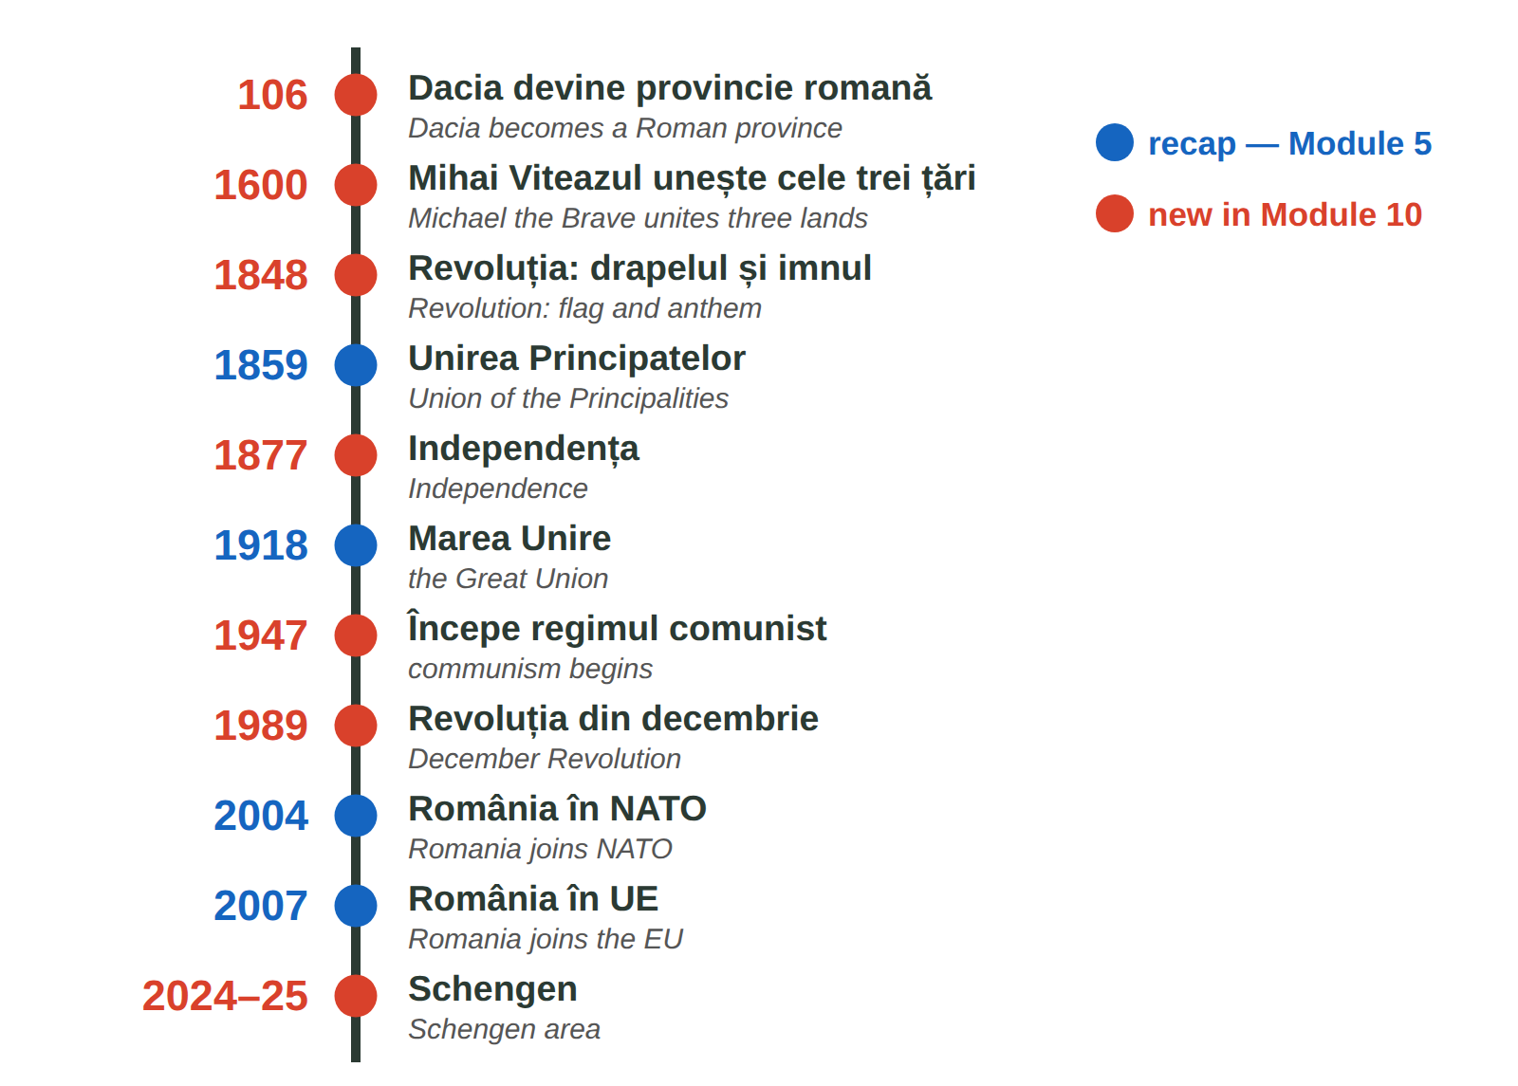
Fig. 10.3 — Axa timpului: istoria României / Timeline of Romanian history
10.8 Which year?
Write the year.
1. Revoluția din decembrie → ______ | 2. Schengen aerian și maritim → ______
3. Începe regimul comunist → ______ | 4. Marea Unire (recap) → ______

CUVINTE ȘI EXPRESII UZUALE / USEFUL WORDS AND PHRASES
regimul comunist | communist regime | dictatura · libertatea | dictatorship · freedom
alegerile libere | free elections | frontiera · controlul | border · check

Lesson 10.9 — Famous Romanians / Personalități românești
FOTO:  Mihai Eminescu | Mihai Eminescu (1850–1889) — the national poet. His poem Luceafărul is read in every school. — poetul național | FOTO:  Constantin Brâncuși | Constantin Brâncuși (1876–1957) — sculptor, a founder of modern sculpture; Coloana fără sfârșit is in Târgu Jiu. — sculptor
FOTO:  George Enescu | George Enescu (1881–1955) — composer and violinist; the Romanian Rhapsodies. The Enescu Festival is held in Bucharest. — compozitor | FOTO:  Nadia Comăneci | Nadia Comăneci (b. 1961) — gymnast, the first perfect 10 in Olympic history, Montreal 1976. — gimnastă
FOTO:  Henri Coandă | Henri Coandă (1886–1972) — engineer and inventor, pioneer of aerodynamics (the Coandă effect); Bucharest airport bears his name. — inventator | FOTO:  Gheorghe Hagi | Gheorghe Hagi (b. 1965) — footballer, captain of the national team, called Regele (the King). — fotbalist

10.9 Who is it?
Write the name.
1. primul 10 la Olimpiadă → ______________ | 2. Coloana fără sfârșit → ______________
3. poetul național → ______________ | 4. aeroportul din București → ______________

CUVINTE ȘI EXPRESII UZUALE / USEFUL WORDS AND PHRASES
celebru · cunoscut | famous · well known | s-a născut în | he / she was born in
opera | the work (of art) | campion · campioană | champion

Lesson 10.10 — Recap / Recapitulare
PATTERN · TOPIC | EXAMPLE | LESSON
aș / ai / ar / am / ați / ar + verb | Aș vrea. Ați putea repeta? | 10.2
email: Stimată doamnă... Cu stimă | Vă scriu în legătură cu... | 10.1
grădiniță → primar → gimnaziu → liceu → universitate | Evaluarea Națională · Bacalaureatul | 10.3
cont · IBAN · card · PIN · extras | Nu dau niciodată PIN-ul. | 10.5–10.6
stema: 5 câmpuri · imnul: 1848 · 26 iunie · 29 iulie | Deșteaptă-te, române! | 10.7
1947 · 1989 · 2024–2025 Schengen | Revoluția a început la Timișoara. | 10.8

GREȘELI FRECVENTE LA SCRIS / COMMON WRITING MISTAKES
WRITE | WHAT IT IS | EXAMPLE | THE TEST
odată | once (in the past), at some time · odată cu = together with | Am fost odată la Cluj. · Odată cu salariul... | it is not a number
o dată | one time (a number) · also: a date | Merg la bancă o dată pe lună. | you can say de două ori
niciun | no, not a (masculine / neuter) — one word | Nu am niciun frate. · niciun document | always together
nicio | no, not a (feminine) — one word | Nu e nicio problemă. | always together

10.10 Everything together
Circle the correct form.
1. ( Aș / Am ) vrea o programare. | 2. Nu e ( nicio / nici o ) problemă.
3. Trebuie ( să / s-a ) semnez. | 4. Banca ( va / v-a ) trimis codul.
5. Merg ( o dată / odată ) pe săptămână. | 6. ( Nu mai / Numai ) am bani.

HOMEWORK — AFTER SESSION 40 / TEMĂ PENTRU ACASĂ
H40.1 Write five sentences about Romania today with the new facts from Lessons 10.7–10.8.
H40.2 Choose one famous person from your country and write three sentences about them, like in Lesson 10.9.

SECȚIUNE DETAȘABILĂ — EXEMPLAR FORMATOR
Detachable section — teacher's copy. Se detașează din suportul cursantului; testul completat, semnat și datat, se păstrează la dosarul cursantului. Conține: testul cumulativ, fișa de confirmare a Sesiunii 40, fișa de evidență a Modulului 10, cheia răspunsurilor, sursele.

TEST CUMULATIV — MODULUL 10
MODULE 10 — CUMULATIVE TEST · grilă, 20 de întrebări, 20 de puncte · semnat și datat de cursant

Nume și prenume cursant / Student name
Data / Date | _____ / _____ / 20_____
Semnătura cursantului / Student signature

Marcați cu X un singur răspuns la fiecare întrebare. Mark ONE answer with X for each question. Each correct answer = 1 point.
1. Care formulă este potrivită la începutul unui e-mail oficial? (1 p)
☐ a) Salut, frate! | ☐ b) Stimată doamnă Popescu, | ☐ c) Hei! | ☐ d) Pa!
2. „Cu stimă” se scrie: (1 p)
☐ a) la începutul e-mailului | ☐ b) la sfârșitul e-mailului, înainte de nume | ☐ c) în subiect | ☐ d) nicăieri
3. Completează: „Eu ___ vrea o programare.” (1 p)
☐ a) aș | ☐ b) ar | ☐ c) ați | ☐ d) am
4. Completează: „___ putea repeta, vă rog?” (dumneavoastră) (1 p)
☐ a) Aș | ☐ b) Ați | ☐ c) Ar | ☐ d) Ai
5. „Mi-ar plăcea” înseamnă: (1 p)
☐ a) I liked | ☐ b) I would like | ☐ c) I like | ☐ d) I will like
6. Care cerere este cea mai politicoasă? (1 p)
☐ a) Vreau un formular! | ☐ b) Dă-mi un formular! | ☐ c) Aș avea nevoie de un formular, vă rog. | ☐ d) Formular!
7. Clasele V – VIII formează: (1 p)
☐ a) grădinița | ☐ b) gimnaziul | ☐ c) liceul | ☐ d) universitatea
8. Examenul de la sfârșitul liceului este: (1 p)
☐ a) Evaluarea Națională | ☐ b) Bacalaureatul | ☐ c) licența | ☐ d) masteratul
9. În gimnaziu, nota minimă de trecere este: (1 p)
☐ a) 1 | ☐ b) 3 | ☐ c) 5 | ☐ d) 10
10. Pentru un copil care nu vorbește româna, inspectoratul școlar organizează: (1 p)
☐ a) un curs gratuit de inițiere în limba română | ☐ b) un examen de admitere plătit | ☐ c) nimic | ☐ d) un curs obligatoriu de engleză
11. Pentru a deschide un cont, un cetățean străin aduce de obicei: (1 p)
☐ a) numai telefonul | ☐ b) pașaportul și permisul de ședere | ☐ c) certificatul de naștere | ☐ d) diploma de liceu
12. IBAN-ul este: (1 p)
☐ a) codul PIN | ☐ b) numărul contului | ☐ c) parola aplicației | ☐ d) soldul
13. Cineva te sună și îți cere codul PIN. Ce faci? (1 p)
☐ a) i-l spui | ☐ b) nu i-l spui niciodată | ☐ c) i-l trimiți pe SMS | ☐ d) i-l scrii pe e-mail
14. „Retragere numerar” la bancomat înseamnă: (1 p)
☐ a) cash withdrawal | ☐ b) balance enquiry | ☐ c) deposit | ☐ d) transfer
15. Câte câmpuri are scutul mic al stemei? (1 p)
☐ a) 3 | ☐ b) 4 | ☐ c) 5 | ☐ d) 7
16. Cei doi delfini de pe stemă reprezintă: (1 p)
☐ a) Moldova | ☐ b) Dobrogea | ☐ c) Banatul | ☐ d) Transilvania
17. Ziua Imnului Național este: (1 p)
☐ a) 1 decembrie | ☐ b) 26 iunie | ☐ c) 29 iulie | ☐ d) 24 ianuarie
18. Revoluția din 1989 a început la: (1 p)
☐ a) Iași | ☐ b) Timișoara | ☐ c) Constanța | ☐ d) Cluj
19. România a intrat complet în Schengen (și la frontierele terestre) pe: (1 p)
☐ a) 1 ianuarie 2007 | ☐ b) 31 martie 2024 | ☐ c) 1 ianuarie 2025 | ☐ d) 1 decembrie 1918
20. Care propoziție este scrisă corect? (1 p)
☐ a) Nu e nici o problemă. | ☐ b) Nu e nicio problemă. | ☐ c) Nu e nicioproblemă. | ☐ d) Nu e niciun problemă.

PUNCTAJ OBȚINUT / SCORE | _______ / 20
Semnătura formatorului / Teacher signature

SESSION COMPLETION RECORD
FIȘĂ DE CONFIRMARE A PARCURGERII SESIUNII — se păstrează la dosar

Module / Modul | Modulul 10 — Politețe, educație, banca și România de azi (finalizat)
Session / Sesiunea | Sesiunea 40 — România de azi, recapitulare. TEST CUMULATIV MODULUL 10
Duration / Durata | 3 ore
Date / Data | _____ / _____ / 20_____
Student name / Nume și prenume cursant
Score / Punctaj obținut | _______ / 20
Student signature / Semnătura cursantului
Teacher signature / Semnătura formatorului

DECLARAȚIE CURSANT / STUDENT DECLARATION
Declar că am participat la această sesiune de curs și am parcurs conținutul prezentat mai sus.
I declare that I attended this course session and covered the content presented above.

MODULE 10 — COMPLETION RECORD
FIȘĂ DE EVIDENȚĂ A PARCURGERII MODULULUI 10 — se păstrează la dosarul cursantului

Cursant / Student
Act de identitate / ID document
Angajator / Employer
Formator / Teacher
Modul / Module | Modulul 10 — Politețe, educație, banca și România de azi (12 ore, Sesiunile 37–40)

NR. | SESIUNE / CONȚINUT | DATA | PUNCTAJ TEST | SEMNĂTURA CURSANTULUI
37 | Sesiunea 37 — Formule de politețe, condiționalul de politețe (3 ore) |  | —
38 | Sesiunea 38 — Sistemul educațional, înscrierea la școală (3 ore) |  | —
39 | Sesiunea 39 — Contul bancar, cardul, bancomatul, extrasul (3 ore) |  | —
40 | Sesiunea 40 — România de azi, recapitulare + TEST CUMULATIV (3 ore) |  | ___ / 20

CONFIRMARE FINALIZARE MODUL / MODULE COMPLETION
Confirm că cursantul a parcurs integral conținutul Modulului 10 — Politețe, educație, banca și România de azi, în total 12 ore de curs, și a susținut testul de evaluare consemnat mai sus.
I confirm that the student completed the full content of Module 10 — Politeness, Education, Banking and Romania Today, 12 course hours in total, and sat the assessment recorded above.
Data: _____ / _____ / 20_____ Semnătura formatorului: ______________________

ANSWER KEY — TEACHER COPY
CHEIA RĂSPUNSURILOR — pentru formator

10.1 5 · 1 · 2 · 4 · 3
10.2 Aș vrea un formular. · Ați putea repeta? · Am vrea o masă pentru doi. · Mi-ar plăcea să lucrez aici. · Ați vrea o cafea? · Aș avea nevoie de ajutor.
10.3 grădiniță · gimnaziu · liceului · școala primară 10.4 3 · 1 · 4 · 2
10.5 cont · pașaportul · comisioane · IBAN-ul
10.6 e.g. Merg la bancomat, introduc cardul și PIN-ul, aleg 200 de lei. · Blochez cardul în aplicație / sun la bancă. · Nu i-l spun. Închid. · Mă uit în aplicație / cer extrasul.
10.7 Moldova · Dobrogea · Banat și Oltenia · Țara Românească 10.8 1989 · 2024 · 1947 · 1918
10.9 Nadia Comăneci · Constantin Brâncuși · Mihai Eminescu · Henri Coandă
10.10 Aș · nicio · să · v-a · o dată · Nu mai
Cumulative test — grilă answer key
TOTAL: 20 de puncte. Un răspuns corect = 1 punct. Nemarcat sau dublu marcat = 0 puncte.
1 – b | 2 – b | 3 – a | 4 – b | 5 – b | 6 – c | 7 – b | 8 – b | 9 – c | 10 – a
11 – b | 12 – b | 13 – b | 14 – a | 15 – c | 16 – b | 17 – c | 18 – b | 19 – c | 20 – b

Surse și data verificării / Sources and date of verification
Informațiile factuale și legale din acest modul au fost verificate la 24.09.2026 pe surse oficiale. The factual and legal information was checked on 24 September 2026 against official sources.
INFORMAȚIA / INFORMATION | SURSA / SOURCE | UNDE ÎN MODUL / WHERE
Structura învățământului preuniversitar; gratuitatea învățământului de stat | Legea nr. 198/2023 a învățământului preuniversitar — legislatie.just.ro/public/DetaliiDocument/271896; edu.ro | Lesson 10.3
Accesul la educație al copiilor străini; curs gratuit de inițiere în limba română; evaluarea pentru stabilirea clasei (ISJ/ISMB) | IGI — „Acces la educație” (igi.mai.gov.ro); Ministerul Educației — „Elevi non-UE” (edu.ro) | Lesson 10.4, test q. 10
Dreptul la cont de plăți cu servicii de bază; nediscriminarea pe criteriul cetățeniei sau al reședinței | Legea nr. 258/2017 — legislatie.just.ro/Public/DetaliiDocumentAfis/196233; ANPC | Lesson 10.5
Stema României: acvila, scutul mic cu cinci câmpuri; coroana (2016) | Legea nr. 102/1992 privind stema țării și sigiliul statului — .../DetaliiDocument/2381; Legea nr. 146/2016 | Lesson 10.7, test q. 15–16
Imnul: versuri Andrei Mureșanu, muzica Anton Pann, 1848; Ziua Imnului 29 iulie | Administrația Prezidențială — „Imnul României” (presidency.ro); Legea nr. 99/1998 | Lesson 10.7, test q. 17
Ziua Drapelului 26 iunie (tricolorul decretat în 1848) | Legea nr. 96/1998; MApN, MAE | Lesson 10.7
Revoluția: 16 decembrie 1989 Timișoara, 22 decembrie căderea regimului; peste o mie de morți; regimul comunist | Administrația Prezidențială; Guvernul României; Raportul final CPADCR (iiccmer.ro) | Lesson 10.8, test q. 18
Schengen: frontiere aeriene și maritime 31.03.2024; terestre 01.01.2025 | Poliția de Frontieră Română (politiadefrontiera.ro); MAI — schengen.mai.gov.ro | Lesson 10.8, test q. 19
Scrierea „niciun / nicio” | DOOM2 — normele ortografice ale Academiei Române | Lesson 10.10, test q. 20
Lecțiile anterioare citate | Modulele 2–8: 2.6, 2.10, 3.11, 3.16, 4.4, 5.1, 5.2, 5.6, 8.7 | whole module

Datele despre personalități (ani de naștere, opere cunoscute) sunt informații culturale generale. Lista de acte pentru școală și bancă diferă de la o instituție la alta — cursantul întreabă înainte. / Facts about famous people are general cultural information; document lists differ between schools and banks.

LIMBA ROMÂNĂ PENTRU STRĂINI
Romanian Language for Foreign Workers
SUPORT DE CURS

MODULE 11 — TRAVEL, FREE TIME, WORK AND THE RIGHTS OF FOREIGNERS
MODULUL 11 — CĂLĂTORII, TIMP LIBER, MUNCA ȘI DREPTURILE STRĂINILOR
Nivelul A2 / Level A2
LEVEL / NIVEL | DURATION / DURATĂ | LANGUAGE OF TEACHING
A2 — after Module 10 | 12 hours · Sessions 41–44 · Weeks 21–22 | English → Romanian

LEGAL BASIS / TEMEI LEGAL
Curs de limbă română cu elemente de integrare culturală și socială, organizat în conformitate cu O.U.G. nr. 32/2026, art. 7 alin. (1) lit. g) — minimum 6 luni, cel puțin 6 ore pe săptămână.
Romanian language course with cultural and social integration elements, organised under Government Emergency Ordinance no. 32/2026, art. 7(1)(g) — at least 6 months, at least 6 hours per week.
This module ends with ONE cumulative multiple-choice test (22 questions), signed and dated by the student and kept on file as proof of completion.

Before you start
Module 11 is about your life outside work and at work. You will travel between cities, spend a free day around Bucharest, talk about animals and visit the places every Romanian knows. Then you will read your employment contract and your payslip, and learn your rights as a foreign worker: the residence permit, the CNP, lost documents, the Labour Inspectorate and how to recognise a scam. There is no new grammar — you use what you know.
You need these lessons first — look back at them if you are not sure:
YOU NEED | WHERE | WHY
orders and requests — Nu te apropia! | Lesson 3.13 | warnings about animals, safety
the future — voi merge, o să merg | Lesson 3.16 | plans for the weekend, trips
transport in town, tickets, CFR | Lesson 5.3 | now: between cities
ITM, IGI, the 30-day rule | Lesson 5.2 | your rights — only what is new
the legal days off | Lesson 5.6 | not repeated — see the table there
CASS, health insurance | Lesson 8.7 | the payslip
bank account, card, PIN, scams | Lessons 10.5, 10.6 | the salary card, fraud
the polite conditional, emails | Lessons 10.1, 10.2 | at the ticket office, at ITM

Where this module sits in the course
SESSION | DURATION | CONTENT
Session 41 | 3 hours | Lesson 11.1 Travelling between cities · 11.2 Free time around Bucharest · 11.3 Animals
Session 42 | 3 hours | Lesson 11.4 Tourist sights of Romania · 11.5 The traditional costume and the ia
Session 43 | 3 hours | Lesson 11.6 The employment contract and working time · 11.7 The payslip
Session 44 | 3 hours | Lesson 11.8 Residence permit and CNP · 11.9 Lost documents, complaints to ITM · 11.10 Scams · 11.11 Recap · Module 11 test

THE LAW IN THIS MODULE
Sessions 43 and 44 explain rules from the Labour Code (Codul muncii, Law no. 53/2003), the Fiscal Code and the foreigners' law (O.U.G. 194/2002), checked on official sites (see the last page). Laws change: for your own case, always ask ITM, IGI or your employer's HR office — in writing, and keep a copy.

SESSION 41 — TRAVEL, FREE TIME, ANIMALS
SESIUNEA 41 — TRANSPORT, TIMP LIBER, ANIMALE · 3 hours

By the end of this session you will be able to:
☐ | choose a train, a coach or a plane and buy a ticket
☐ | plan a free day around Bucharest
☐ | name 16 animals and say simple things about pets and wild animals

Lesson 11.1 — Travelling between cities / Călătorii între orașe
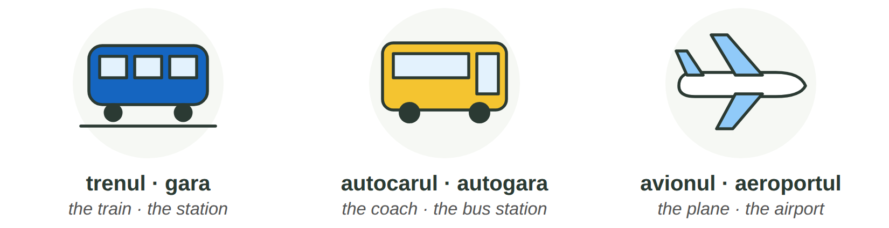
Fig. 11.1 — Trei feluri de a călători între orașe / Three ways to travel between cities
 | WHERE FROM | GOOD TO KNOW
trenul | gara — in Bucharest: Gara de Nord | CFR Călători and other rail companies. R (Regio) stops at every station; IR (InterRegio) is faster. Buy online or in the CFR app: the ticket has a QR code you show on the train.
autocarul · microbuzul | autogara (bus station) | many private companies; often cheaper and faster to small towns. You buy from the driver, at the counter or online.
avionul | aeroportul — Bucharest: Henri Coandă (Otopeni) | for far cities (Cluj, Iași, Timișoara). Be there early, with your passport or ID and your residence permit.

AT THE TICKET OFFICE / LA CASA DE BILETE | ENGLISH
— Bună ziua! Aș vrea un bilet dus-întors la Brașov, pentru sâmbătă. (Lesson 10.2) | Hello! I'd like a return ticket to Brasov for Saturday.
— Cu trenul de la 8:15? E un IR. Clasa a doua? | The 8:15 train? It's an IR. Second class?
— Da. De la ce linie pleacă? | Yes. Which platform does it leave from?
— Linia 5. Aveți vagonul 3, locul 42. | Platform 5. You have coach 3, seat 42.
— Trebuie să schimb trenul? — Nu, e direct. | Do I have to change trains? — No, it's direct.
— Anunț: Trenul IR 1735 are o întârziere de 20 de minute. | Announcement: the train is 20 minutes late.

11.1 Train, coach or plane?
Write: gara · autogara · aeroportul · linia · dus-întors · întârziere.
1. Trenul pleacă din ______________. | 2. Autocarul pleacă de la ______________.
3. Avionul pleacă de la ______________. | 4. Trenul pleacă de la ______________ 5.
5. Vreau să mă și întorc: un bilet ______________. | 6. Trenul are 20 de minute ______________.

CUVINTE ȘI EXPRESII UZUALE / USEFUL WORDS AND PHRASES
bilet dus / dus-întors | one-way / return ticket | plecări · sosiri | departures · arrivals
linia · peronul | the track · the platform | vagonul · locul | the coach · the seat
a schimba trenul | to change trains | întârzierea | the delay
direct | direct, non-stop | bagajul | the luggage

Lesson 11.2 — Free time around Bucharest / Timp liber în jurul Bucureștiului
A free Sunday does not cost much. Many places near Bucharest are free or cheap and easy to reach. Before you go, check the program de vizitare (opening hours) and the price of the bilet de intrare on the official website.
FOTO:  Grădina Zoologică București (Băneasa) | Grădina Zoologică București — Băneasa  CE E / WHAT IT IS: the Bucharest Zoo, in the north of the city, next to the Băneasa forest.  CUM AJUNGI / HOW TO GET THERE: inside Bucharest: by bus or by car; plan the route in the STB / Info Trafic app.  CE POȚI FACE / WHAT YOU CAN DO: see the animals of Lesson 11.3, walk in the forest, a day out with children.
FOTO:  Palatul Mogoșoaia | Palatul Mogoșoaia  CE E / WHAT IT IS: a palace built by the ruler Constantin Brâncoveanu in 1702, today a museum of Brâncovenesc art, with gardens and a lake.  CUM AJUNGI / HOW TO GET THERE: about 17 km north of Bucharest, on the DN1A road, in the village of Mogoșoaia.  CE POȚI FACE / WHAT YOU CAN DO: visit the museum, walk in the park and along the lake, take photos.
FOTO:  Lacul și Mănăstirea Snagov | Snagov  CE E / WHAT IT IS: a large lake in a forest north of Bucharest, with an old monastery on an island. Tradition says that Vlad Țepeș (Lesson 11.4) is buried there.  CUM AJUNGI / HOW TO GET THERE: north of Bucharest, in Ilfov County — by car, or by train / minibus to the nearby villages.  CE POȚI FACE / WHAT YOU CAN DO: walk, picnic, a boat trip on the lake, visit the monastery.
FOTO:  Parcul Natural Comana | Parcul Natural Comana  CE E / WHAT IT IS: a natural park of about 25,000 ha in Giurgiu County: forest, marshes and birds; a protected wetland of international importance (Ramsar).  CUM AJUNGI / HOW TO GET THERE: south of Bucharest, in Giurgiu County — by car or with an organised trip.  CE POȚI FACE / WHAT YOU CAN DO: walking trails, bird watching, boat or canoe trips, a picnic in nature.
FOTO:  Parcul Regele Mihai I (Herăstrău) / Parcul Tineretului | The big parks of Bucharest  CE E / WHAT IT IS: Parcul Regele Mihai I (Herăstrău) with its lake, Cișmigiu in the centre (Lesson 5.1), Tineretului, Carol, IOR (Titan).  CUM AJUNGI / HOW TO GET THERE: by metro: Aviatorilor (Herăstrău), Izvor (Cișmigiu), Tineretului, Titan (IOR).  CE POȚI FACE / WHAT YOU CAN DO: walk, run, cycle, a boat on the lake, playgrounds, cafés — free entry.

MAKING PLANS / PLANURI | ENGLISH
Ce faci duminică? — O să merg la Mogoșoaia. (Lesson 3.16) | What are you doing on Sunday? — I'm going to Mogoșoaia.
Hai la o plimbare în parc! — Mi-ar plăcea! (Lesson 10.2) | Let's go for a walk in the park! — I'd love to!
Cât costă intrarea? · E deschis lunea? | How much is the entrance? · Is it open on Mondays?
Cum ajung la...? · Ce autobuz merge la...? | How do I get to...? · Which bus goes to...?

11.2 Where do they go?
Read and write the place.
1. Ana vrea să vadă un palat din 1702. → ______________ | 2. Ravi vrea să vadă un leu. → ______________
3. Omar vrea păsări și o plimbare cu canoea. → ______________ | 4. Aziz vrea să alerge lângă un lac, cu metroul. → ______________

CUVINTE ȘI EXPRESII UZUALE / USEFUL WORDS AND PHRASES
timpul liber | free time | o excursie · o plimbare | a trip · a walk
intrarea gratuită | free entry | programul de vizitare | opening hours
un picnic | a picnic | o plimbare cu barca | a boat trip

Lesson 11.3 — Animals / Animalele

LA ZOO / AT THE ZOO
IMAGINE | IMAGINE | IMAGINE | IMAGINE | IMAGINE | IMAGINE | IMAGINE | IMAGINE
un leu | un tigru | un urs | un elefant | o girafă | o zebră | o maimuță | o gorilă
IMAGINE | IMAGINE | IMAGINE | IMAGINE | IMAGINE
un hipopotam | un crocodil | un șarpe | un pinguin | un papagal
SĂLBATICE DIN ROMÂNIA / WILD IN ROMANIA
IMAGINE | IMAGINE | IMAGINE | IMAGINE | IMAGINE | IMAGINE | IMAGINE | IMAGINE
un urs | un lup | o vulpe | un cerb | o căprioară | un mistreț | un iepure | o veveriță
DE COMPANIE / PETS
IMAGINE | IMAGINE | IMAGINE | IMAGINE | IMAGINE
un câine | o pisică | un papagal | un pește | un hamster
Fig. 11.2 — Animale la zoo, animale sălbatice din România, animale de companie / Zoo animals, wild animals in Romania, pets
ROMANIAN (cu un / o) | PLURAL | ENGLISH
LA ZOO / AT THE ZOO
un leu | lei | a lion
un tigru | tigri | a tiger
un urs | urși | a bear
un elefant | elefanți | an elephant
o girafă | girafe | a giraffe
o zebră | zebre | a zebra
o maimuță | maimuțe | a monkey
o gorilă | gorile | a gorilla
un hipopotam | hipopotami | a hippo
un crocodil | crocodili | a crocodile
un șarpe | șerpi | a snake
un pinguin | pinguini | a penguin
un papagal | papagali | a parrot
SĂLBATICE DIN ROMÂNIA / WILD ANIMALS IN ROMANIA
un urs | urși | a (brown) bear
un lup | lupi | a wolf
o vulpe | vulpi | a fox
un cerb | cerbi | a red deer
o căprioară | căprioare | a roe deer
un mistreț | mistreți | a wild boar
un iepure | iepuri | a hare
o veveriță | veverițe | a squirrel
DE COMPANIE / PETS
un câine | câini | a dog
o pisică | pisici | a cat
un papagal | papagali | a parrot
un pește | pești | a fish
un hamster | hamsteri | a hamster

AT THE ZOO / LA GRĂDINA ZOOLOGICĂ | ENGLISH
— Tată, unde sunt leii? — Lângă tigri, în stânga. | Dad, where are the lions? — Next to the tigers, on the left.
— Pot să dau mâncare maimuțelor? — Nu, e interzis! Scrie pe tăbliță. | Can I give the monkeys food? — No, it's forbidden! It says so on the sign.
— Uite, un hipopotam în apă! E uriaș! | Look, a hippo in the water! It's huge!
— La ce oră mănâncă pinguinii? — La ora trei. | What time do the penguins eat? — At three o'clock.
— Mi-e frică de șerpi. Hai la girafe! — Bine, hai! | I'm afraid of snakes. Let's go to the giraffes! — OK, let's go!

PETS / ANIMALE DE COMPANIE | ENGLISH | WILD ANIMALS / ANIMALE SĂLBATICE | ENGLISH
Ai un câine? — Da, am un câine. | Do you have a dog? — Yes, I do. | Nu te apropia de urs! | Don't go near the bear!
Cum se numește pisica ta? | What is your cat called? | Nu hrăni animalele sălbatice! | Don't feed wild animals!
Câinele meu nu mușcă. | My dog doesn't bite. | Atenție, urs în zonă! | Warning, bear in the area!
Îmi plac pisicile. · Mi-e frică de câini. | I like cats. · I'm afraid of dogs. | În pădure trăiesc lupi și mistreți. | Wolves and wild boars live in the forest.

ATTENTION — BEARS IN ROMANIA
Romania has many brown bears (urși bruni), and in mountain areas they sometimes come into villages, near roads and rubbish bins. The authorities warn people by RO-ALERT messages on the phone. Do not approach a bear, film it or feed it; keep your distance, go inside or leave the area slowly, and call 112 if a bear is in a village (Romanian Gendarmerie).

11.3 Which group?
Write Z (zoo), S (wild in Romania) or D (pet). Some animals are in two groups.
1. girafa → ___ 2. pisica → ___ | 3. cerbul → ___ 4. zebra → ___
5. papagalul → ___ 6. mistrețul → ___ | 7. ursul → ___ / ___ 8. peștele → ___

CUVINTE ȘI EXPRESII UZUALE / USEFUL WORDS AND PHRASES
animalul de companie | pet | sălbatic · domestic | wild · tame, domestic
a mușca · a lătra | to bite · to bark | a hrăni | to feed
pădurea | the forest | Mi-e frică de... | I am afraid of...

GREȘELI FRECVENTE LA SCRIS / COMMON WRITING MISTAKES
WRITE | WHAT IT IS | EXAMPLE | THE TEST
fi | the infinitive: to be — after pot, poți, a, vei, o să | Poți fi liniștit. · Vei fi acolo? | you can say a fi
fii | (you) be! · să fii — for tu | Fii atent la tren! · Vreau să fii acolo. | it goes with tu
mi-e | îmi + e = îmi este (feelings) | Mi-e frică de urși. · Mi-e dor de casă. | you can say îmi este
mie | to me (strong form) | Mie îmi plac pisicile. · Dă-l mie! | answers Cui? (To whom?)

HOMEWORK — AFTER SESSION 41 / TEMĂ PENTRU ACASĂ
H41.1 Plan a free day: write five sentences with O să merg la... / Hai la...! and say how you get there.
H41.2 Write about an animal you like (or a pet from your country): what it is, where it lives, what it eats.

SESSION 42 — TOURISM
SESIUNEA 42 — TURISM · 3 hours

By the end of this session you will be able to:
☐ | find ten famous places on the map of Romania
☐ | say where they are and what you can see there
☐ | know the difference between Vlad Țepeș and Dracula
☐ | describe the traditional costume and the ia

Lesson 11.4 — Tourist sights of Romania / Obiective turistice

IMAGINE: harta României cu cele zece obiective turistice
Fig. 11.3 — Zece obiective turistice / Ten tourist sights (the regions: Lesson 5.1)
FOTO:  Castelul Peleș | 1 Castelul Peleș — Sinaia, Prahova. The royal castle built for King Carol I at the end of the 19th century; today a museum in the mountains. | FOTO:  Castelul Bran | 2 Castelul Bran — near Brașov. A medieval castle on a rock. Famous abroad as „the castle of Dracula” — read the box below.
FOTO:  Castelul Corvinilor | 3 Castelul Corvinilor — Hunedoara. A large Gothic castle of the Corvin (Hunyadi) family, with towers and a bridge. | FOTO:  Cetatea Sighișoara | 4 Sighișoara — Mureș. A medieval citadel where people still live; the Clock Tower. UNESCO World Heritage since 1999.
FOTO:  Delta Dunării | 5 Delta Dunării — Tulcea. Where the Danube meets the Black Sea: channels, lakes, pelicans. UNESCO since 1991. You travel by boat. | FOTO:  Transfăgărășan | 6 Transfăgărășan (DN7C) — a mountain road over the Făgăraș Mountains, to Bâlea Lac. The high part is closed in winter; check the Police traffic info.
FOTO:  Mănăstirea Voroneț | 7 Mănăstirile pictate din Bucovina — Suceava. Churches painted outside, 15th–16th centuries (Voroneț, Humor, Moldovița, Sucevița...). UNESCO. | FOTO:  Salina Turda | 8 Salina Turda — Cluj. An old salt mine, now visited deep underground: salt halls, a lake, a wheel.
FOTO:  Litoralul, Mamaia | 9 Litoralul — the Black Sea coast: Constanța, Mamaia, Eforie, Vama Veche. Beaches in summer. | FOTO:  Biserica de lemn, Maramureș | 10 Bisericile de lemn din Maramureș — tall wooden churches in the north. UNESCO since 1999.

VLAD ȚEPEȘ IS NOT DRACULA / VLAD ȚEPEȘ NU ESTE DRACULA
Vlad Țepeș (Vlad the Impaler) was a real person: a ruler of Țara Românească in the 15th century, known as a very harsh prince. Count Dracula is a character in a novel: Dracula, written by the Irish writer Bram Stoker and published in 1897. Stoker took the name, but his vampire is literature, not history. Bran became „Dracula's castle” because it looks like the castle in the book (Bran Castle Museum).

11.4 Where is it?
Look at Fig. 11.3 and write the place.
1. Castelul regelui Carol I → ______________ | 2. Pelicani, bărci, canale → ______________
3. Biserici pictate afară → ______________ | 4. Un drum sus pe munte → ______________
5. O mină de sare → ______________ | 6. Plajă la Marea Neagră → ______________

CUVINTE ȘI EXPRESII UZUALE / USEFUL WORDS AND PHRASES
castelul · cetatea | the castle · the citadel | mănăstirea · biserica | the monastery · the church
muntele · marea | the mountain · the sea | ghidul · excursia | the guide · the trip
cazarea | accommodation | obiectiv turistic | tourist sight

Lesson 11.5 — The traditional costume / Costumul tradițional
FOTO:  ia românească (bluza cu altiță), de aproape | Ia is the white embroidered blouse of the Romanian folk costume, made of cotton, linen, hemp or silk. The embroidery on the shoulder is the altiță. In 2022 UNESCO added the art of the traditional blouse with embroidery on the shoulder (altiță) of Romania and the Republic of Moldova to the intangible cultural heritage of humanity. 24 June is celebrated as Ziua Iei (the Day of the Ia) — a tradition, not a day off.
FOTO:  costum popular complet — femeie și bărbat | Every region has its own colours and patterns. Romanians wear the costume at festivals, weddings, national days (1 December, Lesson 5.6) and to folk shows; many people wear an ia in the city in summer.

WOMEN / FEMEI | ENGLISH | MEN / BĂRBAȚI | ENGLISH
ia (cămașa) | embroidered blouse | cămașa | the shirt
fota · catrința | wrap-around skirt | ițarii | tight white trousers
brâul | woven belt | pieptarul · vesta | sheepskin vest · waistcoat
basmaua | headscarf | pălăria · căciula | hat · fur cap
opincile | traditional leather shoes | opincile | traditional leather shoes

11.5 True or false?
Write A (adevărat) or F (fals).
1. Ia este o bluză brodată. ___ | 2. Altița este pe umăr. ___
3. 24 iunie este zi liberă legală. ___ | 4. Fiecare regiune are costumul ei. ___

CUVINTE ȘI EXPRESII UZUALE / USEFUL WORDS AND PHRASES
costumul popular | folk costume | broderia · a broda | embroidery · to embroider
modelul · culorile | the pattern · the colours | tradițional | traditional

GREȘELI FRECVENTE LA SCRIS / COMMON WRITING MISTAKES
WRITE | WHAT IT IS | EXAMPLE | THE TEST
copii | children — no article: doi copii, niște copii | Am doi copii. | you can say niște before it
copiii | the children — with the article (-i) | Copiii mei sunt la școală. | you can say the: the children
cea | the (feminine) before mai, a number or an adjective | cea mai frumoasă mănăstire · cea de-a doua | no verb after it
ce-a | ce + a — what has / what did | Ce-a spus ghidul? · Ce-a văzut? | you can say ce a

HOMEWORK — AFTER SESSION 42 / TEMĂ PENTRU ACASĂ
H42.1 Choose one sight from Lesson 11.4. Write five sentences: where it is, what you see, how you get there, why you want to go.
H42.2 Describe the traditional costume of your country with five words from Lesson 11.5.

SESSION 43 — WORK: THE CONTRACT AND THE PAYSLIP
SESIUNEA 43 — MUNCA: CONTRACTUL ȘI FLUTURAȘUL · 3 hours

By the end of this session you will be able to:
☐ | understand the main parts of your employment contract
☐ | know the legal rules for probation, working time, overtime and leave
☐ | read your payslip: gross, contributions, tax, net
☐ | check your salary every month

Lesson 11.6 — The contract and working time / Contractul și timpul de muncă
The contractul individual de muncă (CIM) is written, in Romanian, and signed before you start work. You receive your own copy. The employer registers it in the electronic register of employees REGES-ONLINE (Labour Inspection). No contract = muncă la negru (undeclared work) — you have no pension, no health insurance and no proof of your work (Lesson 5.2).
IN YOUR CONTRACT / ÎN CONTRACT | WHAT THE LAW SAYS (Codul muncii) | ENGLISH
perioada de probă | maximum 90 calendar days (execution jobs); 120 days for management jobs | probation period
programul de lucru — durata normală | 8 hours a day, 40 hours a week | normal working time
orele suplimentare | at the employer's request; in total maximum 48 hours a week, overtime included | overtime
— cum se plătesc | first paid time off in the next 90 days; if not possible, a bonus of at least 75% | how overtime is compensated
concediul de odihnă | at least 20 working days a year, paid | paid annual leave
sărbătorile legale | days off — the list is in Lesson 5.6. If you work that day: time off in the next 30 days or a bonus of at least 100% | public holidays
salariul de bază brut | written in the contract; the payslip shows it every month (Lesson 11.7) | gross base salary
felul muncii · locul muncii | your job (funcția) and where you work | job title · place of work

AT WORK / LA LUCRU | ENGLISH
Aș putea să văd contractul înainte să semnez? (Lesson 10.2) | Could I see the contract before I sign?
Când se termină perioada de probă? | When does the probation period end?
Cum se plătesc orele suplimentare? | How is overtime paid?
Aș dori să-mi iau concediu în august. · Îmi dați o copie, vă rog? | I'd like to take leave in August. · Can you give me a copy, please?

11.6 Complete with the numbers
Write: 8 · 20 · 40 · 48 · 90.
1. Perioada de probă: maximum ______ de zile. | 2. Programul normal: ______ ore pe zi.
3. Pe săptămână: ______ de ore. | 4. Cu orele suplimentare: maximum ______ de ore.
5. Concediul de odihnă: minimum ______ de zile lucrătoare.

CUVINTE ȘI EXPRESII UZUALE / USEFUL WORDS AND PHRASES
angajatorul · salariatul | employer · employee | a semna | to sign
tura de zi · de noapte | day shift · night shift | pontajul | time sheet
cererea de concediu | leave request | demisia | resignation

Lesson 11.7 — The payslip / Fluturașul de salariu
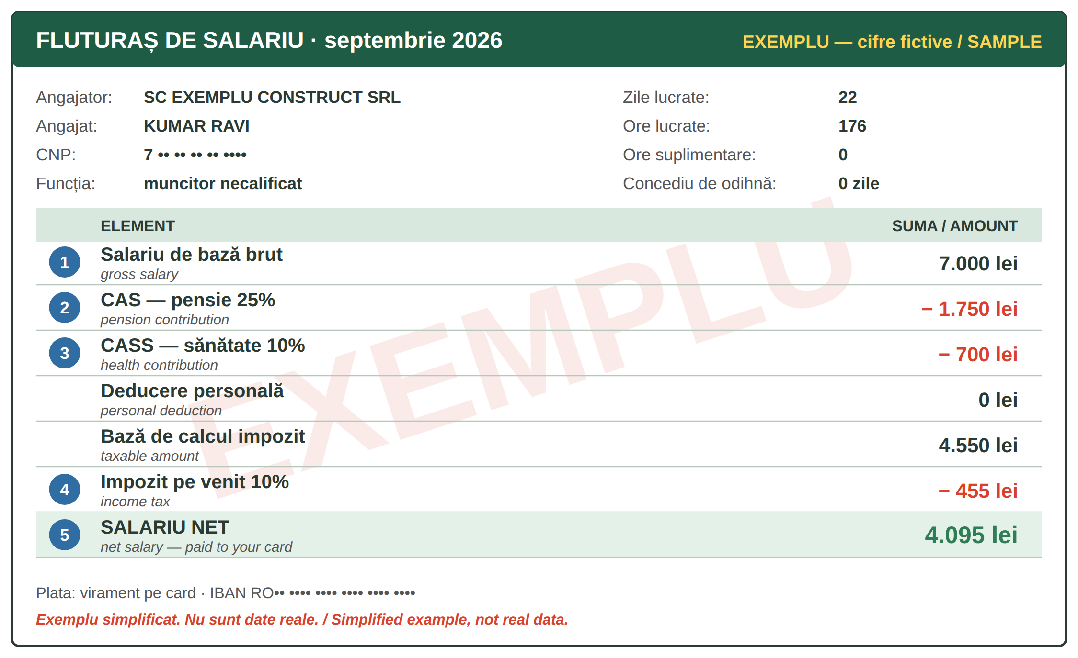
Fig. 11.4 — Un fluturaș de salariu. EXEMPLU cu cifre fictive / A payslip. SAMPLE with invented figures
NR. | ON THE PAYSLIP | WHAT IT MEANS
1 | salariul brut | the salary before anything is taken — the one in your contract
2 | CAS — 25% | contribuția de asigurări sociale: for your pension (pensia) — also for foreigners who work here
3 | CASS — 10% | contribuția de asigurări sociale de sănătate: your health insurance (Lesson 8.7)
4 | impozitul pe venit — 10% | the income tax: 10% of the gross minus CAS, CASS and the personal deduction (deducerea personală), if you have one
5 | salariul net | what you receive on your card (Lesson 10.5): gross − CAS − CASS − tax

Example (Fig. 11.4): 7,000 − 1,750 (CAS) − 700 (CASS) = 4,550; tax 10% = 455; net = 4,550 − 455 = 4,095 lei. The figures are invented. Your own payslip may also show a personal deduction, bonuses (sporuri), meal vouchers (tichete de masă) or leave.
CHECK YOUR PAYSLIP EVERY MONTH / VERIFICĂ FLUTURAȘUL
☐ your name and CNP are correct ☐ the month and the days / hours worked ☐ the overtime you worked is there ☐ the gross is the one in your contract ☐ the net is the amount that arrived in your bank account. Keep all your payslips. If something is wrong, ask the HR office (resurse umane) in writing; if it is not solved: ITM (Lesson 11.9).

11.7 Read the payslip
Look at Fig. 11.4 and answer.
1. Cât este salariul brut? → ______________ | 2. Cât plătește pentru pensie? → ______________
3. Cât este impozitul? → ______________ | 4. Cât primește pe card? → ______________

CUVINTE ȘI EXPRESII UZUALE / USEFUL WORDS AND PHRASES
salariul brut · net | gross · net salary | contribuțiile | contributions
impozitul | the tax | sporul | bonus, allowance
tichetele de masă | meal vouchers | resursele umane (HR) | human resources

GREȘELI FRECVENTE LA SCRIS / COMMON WRITING MISTAKES
WRITE | WHAT IT IS | EXAMPLE | THE TEST
n-ai | nu + ai — you don't have / you haven't | N-ai primit salariul? · N-ai semnat? | you can say nu ai
nai | the pan flute — a Romanian instrument | Cântă la nai. | it is a thing
altfel | otherwise · differently — one word | Semnează azi, altfel nu primești banii. · Lucrez altfel. | you can say în alt mod
alt fel | another kind — de comes after it | Am un alt fel de contract. | followed by de

HOMEWORK — AFTER SESSION 43 / TEMĂ PENTRU ACASĂ
H43.1 Find in your contract (or ask HR): your probation period, your working hours, your leave days. Write them in Romanian.
H43.2 Look at your last payslip. Write: brut ___, CAS ___, CASS ___, impozit ___, net ___. Is the net the same as in your bank app?

SESSION 44 — THE RIGHTS OF FOREIGNERS, RECAP AND TEST
SESIUNEA 44 — DREPTURILE STRĂINILOR, RECAPITULARE ȘI TEST · 3 hours

By the end of this session you will be able to:
☐ | explain how the residence permit for work is extended
☐ | use your CNP
☐ | know what to do if you lose your documents
☐ | complain to ITM
☐ | recognise a scam

Lesson 11.8 — The residence permit and the CNP / Permisul de ședere și CNP-ul
THE PRINCIPLE | WHAT IT MEANS FOR YOU (IGI)
the chain of documents | the employer gets the aviz de muncă (work permit) → you get the long-stay visa for work → in Romania, IGI gives you the permis de ședere (residence permit) for work
the extension (prelungirea) | you apply at IGI at least 30 days before the permit expires (Lesson 5.2). A late application is a fine (100–500 lei)
the conditions | a full-time contract, registered in the employee register, with a salary at least the national minimum gross salary; plus the documents on IGI's list
changes | a new address, a new employer, a new passport, marriage — inform IGI; ask IGI before you change employer
always | carry the permit, check the expiry date, keep copies; appointments and forms: portaligi.mai.gov.ro

The CNP (codul numeric personal) has 13 digits. For foreigners it is given by IGI and it is written on your residence permit. You need it at the bank (Lesson 10.5), the doctor (Lesson 8.7), your employer, ANAF and the town hall. Do not publish it online and give it only to institutions.
AT IGI / LA IGI | ENGLISH
Aș dori să-mi prelungesc dreptul de ședere. | I would like to extend my right of residence.
Permisul meu expiră pe 15 noiembrie. · Ce acte trebuie? | My permit expires on 15 November. · Which documents are needed?
Mi-am schimbat adresa / angajatorul. | I have changed my address / my employer.
Care este CNP-ul dumneavoastră? — E pe permis. | What is your CNP? — It's on the permit.

11.8 True or false?
Write A or F.
1. Cer prelungirea cu cel puțin 30 de zile înainte. ___ | 2. CNP-ul are 10 cifre. ___
3. CNP-ul este scris pe permisul de ședere. ___ | 4. Dacă schimb adresa, nu spun nimănui. ___

CUVINTE ȘI EXPRESII UZUALE / USEFUL WORDS AND PHRASES
permisul de ședere | residence permit | prelungirea | the extension
avizul de muncă | work permit | expiră pe... | it expires on...
programarea online | online appointment | CNP-ul | personal numeric code

Lesson 11.9 — Lost documents and complaints / Acte pierdute și reclamații
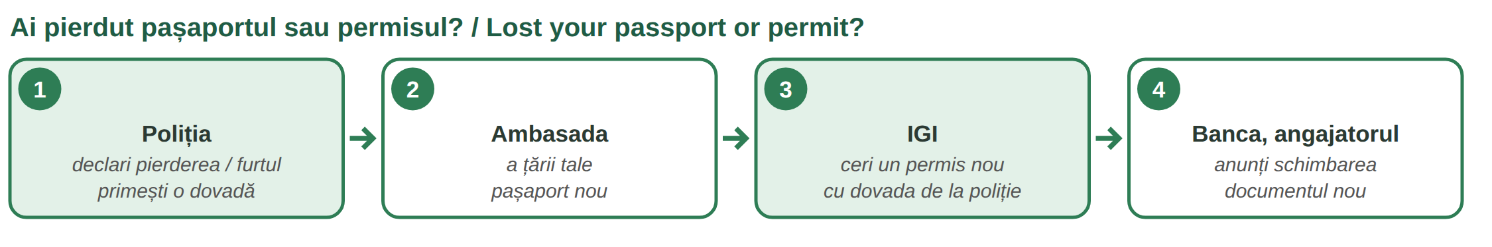
Fig. 11.5 — Ce faci dacă pierzi actele / What to do if you lose your documents
Passport lost or stolen? Declare it to the Police — IGI says within 48 hours. With the police paper go to your embassy for a new passport, then to IGI. Residence permit lost? Declare it and ask IGI for a new one — not declaring it in time is also a fine. Bank card? Block it at once (Lesson 10.6).
PROBLEM AT WORK | WHERE TO GO — ITM (Inspectoratul Teritorial de Muncă)
you are not paid, or paid less | send a petiție (complaint) to the ITM of the county where you work
you work without a contract | the same — undeclared work is illegal for the employer
too many hours, no leave, unsafe work | the same — also an email to HR first, and keep a copy
how | online on inspectiamuncii.ro („Petiții și sesizări”), by post, by e-mail or at the ITM office; write in Romanian (Lesson 10.1)
what happens | ITM must answer in 30 days; the inspectors must keep your identity confidential

A COMPLAINT TO ITM — MODEL
Către Inspectoratul Teritorial de Muncă ________. Subsemnatul Ravi Kumar, cetățean nepalez, angajat la SC ________ SRL, vă aduc la cunoștință că nu am primit salariul pe lunile iulie și august 2026. Vă rog să verificați situația. Atașez contractul și fluturașii. Data ________ Semnătura ________

11.9 Where do you go?
Write: Poliția · ambasada · IGI · ITM · banca.
1. Nu am primit salariul. → ______________ | 2. Mi-au furat pașaportul. → ______________ (first)
3. Vreau un pașaport nou. → ______________ | 4. Am pierdut cardul. → ______________
5. Vreau un permis de ședere nou. → ______________ | 6. Lucrez fără contract. → ______________

CUVINTE ȘI EXPRESII UZUALE / USEFUL WORDS AND PHRASES
am pierdut · mi-au furat | I lost · they stole | dovada | the proof, certificate
petiția · reclamația | complaint | a depune | to submit
vă aduc la cunoștință | I inform you | munca la negru | undeclared work

Lesson 11.10 — Scams / Înșelătoriile
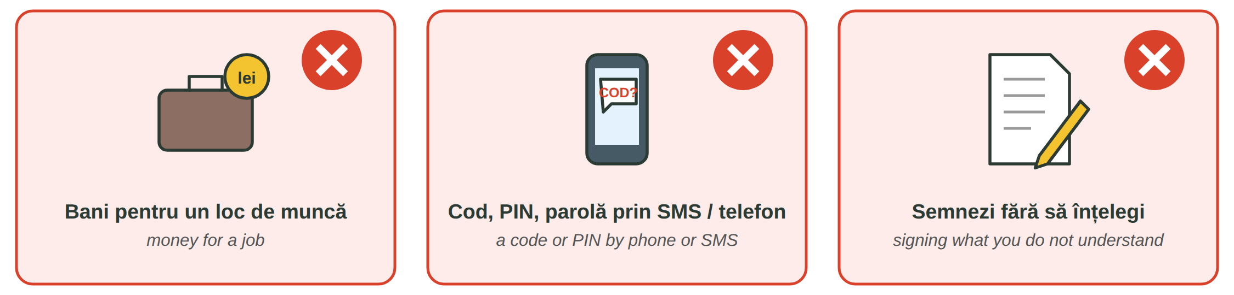
Fig. 11.6 — Trei semnale de alarmă / Three warning signs
THE SCAM | WHAT YOU SEE | WHAT YOU DO
a false job agency | someone asks you for money for a job, a contract, a „permit”, a visa. The Labour Code says a temporary work agency may not charge workers for recruitment or for the contract | do not pay; ask for the company's name and check it; ask ITM
calls and messages | a „bank”, „police”, „IGI” or „courier” asks for your PIN, card code, SMS code, password, or sends a link | banks and institutions never ask for codes (Lesson 10.6); hang up, call the bank on its own number; report to DNSC — 1911
papers you do not understand | a paper in Romanian you cannot read; a blank page to sign; a „resignation” without a date | do not sign; ask for time and a translation; show it to someone you trust
your passport | someone wants to keep your original passport or permit | your documents are yours — give a copy, keep the original

SAY NO / SPUNE NU | ENGLISH
Nu plătesc pentru un loc de muncă. | I don't pay for a job.
Nu dau codul nimănui. · Închid și sun eu la bancă. | I don't give the code to anyone. · I'll hang up and call the bank.
Nu semnez acum. Aș vrea să citesc acasă. | I won't sign now. I'd like to read it at home.
Vă dau o copie, originalul rămâne la mine. | I'll give you a copy; the original stays with me.

11.10 Scam or not?
Write DA (a scam) or NU.
1. „Plătești 500 de euro și primești contract.” ___ | 2. Banca îți cere codul primit pe SMS. ___
3. HR îți dă contractul să-l citești acasă. ___ | 4. „Semnează aici, pe foaia goală.” ___

CUVINTE ȘI EXPRESII UZUALE / USEFUL WORDS AND PHRASES
înșelătoria · frauda | scam · fraud | a înșela | to cheat
un link suspect | a suspicious link | a raporta | to report
foaia goală | blank page | originalul · copia | the original · the copy

Lesson 11.11 — Recap / Recapitulare
TOPIC | EXAMPLE | LESSON
gara · autogara · aeroportul · bilet dus-întors | Aș vrea un bilet dus-întors. | 11.1
Mogoșoaia 1702 · Comana · Snagov · parcurile | O să merg duminică la Mogoșoaia. | 11.2
16 animale · Nu te apropia de urs! · 112 | Mi-e frică de urși. | 11.3
10 obiective · Vlad Țepeș ≠ Dracula (Stoker, 1897) | Vreau să văd Delta Dunării. | 11.4
ia · altița · 24 iunie | Ia este o bluză brodată. | 11.5
probă 90 · 8 / 40 · max 48 · 20 zile · 75% · 100% | Cum se plătesc orele suplimentare? | 11.6
brut − CAS 25% − CASS 10% − impozit 10% = net | Salariul net vine pe card. | 11.7
prelungirea: 30 de zile înainte · CNP pe permis | Aș dori să-mi prelungesc dreptul de ședere. | 11.8
Poliția · ambasada · IGI · ITM | Nu am primit salariul. | 11.9
nu plătesc · nu dau codul · nu semnez · DNSC 1911 | Nu semnez acum. | 11.10

GREȘELI FRECVENTE LA SCRIS / COMMON WRITING MISTAKES
WRITE | WHAT IT IS | EXAMPLE | THE TEST
mi-a | îmi + a — (he / she) has ... me | Șeful mi-a dat salariul. · Cine mi-a cerut codul? | you can say mi-au for many
mia | the thousand · a mia = the thousandth | Mia de lei a dispărut. · pentru a mia oară | it is a number
deloc | not at all — one word | Nu e deloc greu. · Nu dorm deloc. | after nu
de loc | from (a place) — where you were born | Sunt de loc din Nepal. | followed by din

11.11 Everything together
Circle the correct form.
1. ( Fi / Fii ) atent la bagaje! | 2. Am doi ( copii / copiii ).
3. ( Mie / Mi-e ) frică de câini. | 4. ( N-ai / Nai ) primit fluturașul?
5. Nu e ( deloc / de loc ) greu. | 6. ( Ce-a / Cea ) spus inspectorul?

HOMEWORK — AFTER SESSION 44 / TEMĂ PENTRU ACASĂ
H44.1 Write the dates of your documents: when your passport and your permit expire, and the date by which you must ask for the extension.
H44.2 Write three sentences you would say to a scammer on the phone, with Nu....

SECȚIUNE DETAȘABILĂ — EXEMPLAR FORMATOR
Detachable section — teacher's copy. Se detașează din suportul cursantului; testul completat, semnat și datat, se păstrează la dosarul cursantului. Conține: testul cumulativ, fișa de confirmare a Sesiunii 44, fișa de evidență a Modulului 11, cheia răspunsurilor, sursele.

TEST CUMULATIV — MODULUL 11
MODULE 11 — CUMULATIVE TEST · grilă, 22 de întrebări, 22 de puncte · semnat și datat de cursant

Nume și prenume cursant / Student name
Data / Date | _____ / _____ / 20_____
Semnătura cursantului / Student signature

Marcați cu X un singur răspuns la fiecare întrebare. Mark ONE answer with X for each question. Each correct answer = 1 point.
1. Trenul pleacă din: (1 p)
☐ a) autogară | ☐ b) gară | ☐ c) aeroport | ☐ d) port
2. „Un bilet dus-întors” înseamnă: (1 p)
☐ a) a one-way ticket | ☐ b) a return ticket | ☐ c) a seat | ☐ d) a delay
3. Palatul Mogoșoaia a fost construit de Constantin Brâncoveanu în: (1 p)
☐ a) 1602 | ☐ b) 1702 | ☐ c) 1859 | ☐ d) 1918
4. Parcul Natural Comana este în județul: (1 p)
☐ a) Ilfov | ☐ b) Prahova | ☐ c) Giurgiu | ☐ d) Tulcea
5. Vezi un urs în sat. Ce faci? (1 p)
☐ a) îl hrănești | ☐ b) îl filmezi de aproape | ☐ c) te apropii | ☐ d) păstrezi distanța și suni la 112
6. Care animal este de companie? (1 p)
☐ a) mistrețul | ☐ b) papagalul | ☐ c) lupul | ☐ d) cerbul
7. Castelul Peleș este la: (1 p)
☐ a) Sinaia | ☐ b) Hunedoara | ☐ c) Sighișoara | ☐ d) Turda
8. Dracula este: (1 p)
☐ a) un rege al României | ☐ b) un personaj dintr-un roman de Bram Stoker | ☐ c) Vlad Țepeș | ☐ d) un castel
9. Unde sunt mănăstirile pictate pe dinafară? (1 p)
☐ a) în Delta Dunării | ☐ b) în Bucovina | ☐ c) la Constanța | ☐ d) la Turda
10. Altița este: (1 p)
☐ a) o fustă | ☐ b) broderia de pe umărul iei | ☐ c) o pălărie | ☐ d) un pantof
11. Perioada de probă pentru un post de execuție este de maximum: (1 p)
☐ a) 30 de zile | ☐ b) 60 de zile | ☐ c) 90 de zile | ☐ d) 1 an
12. Durata normală a timpului de muncă este: (1 p)
☐ a) 6 ore pe zi | ☐ b) 8 ore pe zi, 40 pe săptămână | ☐ c) 10 ore pe zi | ☐ d) 12 ore pe zi
13. Concediul de odihnă este de cel puțin: (1 p)
☐ a) 10 zile lucrătoare | ☐ b) 15 zile lucrătoare | ☐ c) 20 de zile lucrătoare | ☐ d) 30 de zile lucrătoare
14. CAS (25%) este contribuția pentru: (1 p)
☐ a) sănătate | ☐ b) pensie | ☐ c) impozit | ☐ d) bancă
15. Salariul net este: (1 p)
☐ a) salariul din contract, înainte de taxe | ☐ b) suma pe care o primești pe card | ☐ c) impozitul | ☐ d) CASS
16. Prelungirea dreptului de ședere se cere la IGI: (1 p)
☐ a) cu cel puțin 30 de zile înainte să expire | ☐ b) după ce expiră | ☐ c) o dată la 10 ani | ☐ d) la ITM
17. CNP-ul unui străin este scris: (1 p)
☐ a) pe pașaport | ☐ b) pe permisul de ședere | ☐ c) pe card | ☐ d) pe fluturaș, numai
18. Nu ai primit salariul. Unde depui o petiție? (1 p)
☐ a) la IGI | ☐ b) la ITM | ☐ c) la ambasadă | ☐ d) la gară
19. O „agenție” îți cere bani ca să-ți dea un contract. Este: (1 p)
☐ a) normal | ☐ b) o înșelătorie — nu plătești | ☐ c) obligatoriu | ☐ d) o taxă de la IGI
20. Care propoziție este scrisă corect? (1 p)
☐ a) Mie frică de urși. | ☐ b) Mi-e frică de urși. | ☐ c) Mi e frică de urși. | ☐ d) Mi-ie frică de urși.
21. Veverița este: (1 p)
☐ a) o pasăre de apă | ☐ b) un animal de companie | ☐ c) un animal sălbatic din România | ☐ d) un pește
22. Pluralul lui „un urs” este: (1 p)
☐ a) două urse | ☐ b) doi ursuri | ☐ c) doi ursei | ☐ d) doi urși

PUNCTAJ OBȚINUT / SCORE | _______ / 22
Semnătura formatorului / Teacher signature

SESSION COMPLETION RECORD
FIȘĂ DE CONFIRMARE A PARCURGERII SESIUNII — se păstrează la dosar

Module / Modul | Modulul 11 — Călătorii, timp liber, munca și drepturile străinilor (finalizat)
Session / Sesiunea | Sesiunea 44 — Drepturile străinilor, recapitulare. TEST CUMULATIV MODULUL 11
Duration / Durata | 3 ore
Date / Data | _____ / _____ / 20_____
Student name / Nume și prenume cursant
Score / Punctaj obținut | _______ / 22
Student signature / Semnătura cursantului
Teacher signature / Semnătura formatorului

DECLARAȚIE CURSANT / STUDENT DECLARATION
Declar că am participat la această sesiune de curs și am parcurs conținutul prezentat mai sus.
I declare that I attended this course session and covered the content presented above.

MODULE 11 — COMPLETION RECORD
FIȘĂ DE EVIDENȚĂ A PARCURGERII MODULULUI 11 — se păstrează la dosarul cursantului

Cursant / Student
Act de identitate / ID document
Angajator / Employer
Formator / Teacher
Modul / Module | Modulul 11 — Călătorii, timp liber, munca și drepturile străinilor (12 ore, Sesiunile 41–44)

NR. | SESIUNE / CONȚINUT | DATA | PUNCTAJ TEST | SEMNĂTURA CURSANTULUI
41 | Sesiunea 41 — Transport între orașe, timp liber, animale (3 ore) |  | —
42 | Sesiunea 42 — Obiective turistice, costumul tradițional (3 ore) |  | —
43 | Sesiunea 43 — Contractul de muncă, timpul de muncă, fluturașul (3 ore) |  | —
44 | Sesiunea 44 — Drepturile străinilor, recapitulare + TEST CUMULATIV (3 ore) |  | ___ / 22

CONFIRMARE FINALIZARE MODUL / MODULE COMPLETION
Confirm că cursantul a parcurs integral conținutul Modulului 11 — Călătorii, timp liber, munca și drepturile străinilor, în total 12 ore de curs, și a susținut testul de evaluare consemnat mai sus.
I confirm that the student completed the full content of Module 11 — Travel, Free Time, Work and the Rights of Foreigners, 12 course hours in total, and sat the assessment recorded above.
Data: _____ / _____ / 20_____ Semnătura formatorului: ______________________

ANSWER KEY — TEACHER COPY
CHEIA RĂSPUNSURILOR — pentru formator

11.1 gara · autogara · aeroportul · linia · dus-întors · întârziere
11.2 Palatul Mogoșoaia · Grădina Zoologică (Băneasa) · Parcul Natural Comana · Parcul Regele Mihai I (Herăstrău) / Tineretului
11.3 Z · D · S · Z · D · S · S / Z · D
11.4 Castelul Peleș · Delta Dunării · Mănăstirile din Bucovina · Transfăgărășan · Salina Turda · Litoralul
11.5 A · A · F · A 11.6 90 · 8 · 40 · 48 · 20
11.7 7.000 lei · 1.750 lei · 455 lei · 4.095 lei 11.8 A · F · A · F
11.9 ITM · Poliția · ambasada · banca · IGI · ITM 11.10 DA · DA · NU · DA
11.11 Fii · copii · Mi-e · N-ai · deloc · Ce-a
Cumulative test — grilă answer key
TOTAL: 22 de puncte. Un răspuns corect = 1 punct. Nemarcat sau dublu marcat = 0 puncte.
1 – b | 2 – b | 3 – b | 4 – c | 5 – d | 6 – b | 7 – a | 8 – b | 9 – b | 10 – b
11 – c | 12 – b | 13 – c | 14 – b | 15 – b | 16 – a | 17 – b | 18 – b | 19 – b | 20 – b
21 – c | 22 – d

Surse și data verificării / Sources and date of verification
Informațiile factuale și legale din acest modul au fost verificate la 24.09.2026 pe surse oficiale. The factual and legal information was checked on 24 September 2026 against official sources.
INFORMAȚIA / INFORMATION | SURSA / SOURCE | UNDE ÎN MODUL / WHERE
Bilete CFR online / în aplicație, cu cod QR | CFR Călători — „Cum cumpăr bilete online”, Condiții generale de transport (cfrcalatori.ro) | Lesson 11.1
Palatul Mogoșoaia: Constantin Brâncoveanu, 1702; muzeu; 17 km nord de București, DN1A | Institutul Național al Patrimoniului (patrimoniu.ro); Muzeul Național al Palatelor Brâncovenești (palatebrancovenesti.ro) | Lesson 11.2, test q. 3
Parcul Natural Comana: jud. Giurgiu, 24.963 ha, sit Ramsar din 2011 | ANANP — Parcul Natural Comana (ananp.gov.ro) | Lesson 11.2, test q. 4
Urși în localități: nu vă apropiați, nu hrăniți, sunați la 112; RO-ALERT | Jandarmeria Română; IGSU — ISU județene (igsu.ro) | Lesson 11.3, test q. 5
UNESCO: Delta Dunării (1991), Bisericile din Moldova (1993, 2010), Sighișoara (1999), Bisericile de lemn din Maramureș (1999) | UNESCO World Heritage Centre (whc.unesco.org/en/statesparties/ro); Ministerul Culturii | Lesson 11.4, test q. 9
Transfăgărășan: sectorul înalt închis iarna | Poliția Română — Info trafic (politiaromana.ro) | Lesson 11.4
Dracula — romanul lui Bram Stoker, 1897; diferența față de Vlad Țepeș | Muzeul Castelul Bran (bran-castle.com) | Lesson 11.4, test q. 8
Ia cu altiță — UNESCO 2022; 24 iunie, Ziua Iei | UNESCO Intangible Cultural Heritage (ich.unesco.org); Ministerul Culturii (cultura.ro) | Lesson 11.5, test q. 10
Probă 90/120 zile; 8 h/zi, 40 h/săpt.; max. 48 h; ore suplimentare: timp liber în 90 de zile sau spor min. 75%; concediu min. 20 zile lucrătoare; sărbători lucrate: timp liber în 30 de zile sau spor min. 100% | Legea nr. 53/2003 — Codul muncii, republicată (legislatie.just.ro/Public/DetaliiDocument/128647); Inspecția Muncii — „Timpul de muncă și de odihnă” | Lesson 11.6, test q. 11–13
Registrul REGES-ONLINE (înlocuiește REVISAL) | H.G. nr. 295/2025; Inspecția Muncii (reges.inspectiamuncii.ro) | Lesson 11.6
CAS 25%, CASS 10%, impozit pe venit 10% | Legea nr. 227/2015 — Codul fiscal, art. 138 și urm.; Ministerul Finanțelor / ANAF (mfinante.gov.ro, anaf.ro) | Lesson 11.7, test q. 14–15
Prelungirea dreptului de ședere în scop de muncă: cu cel puțin 30 de zile înainte; amendă 100–500 lei; condiții (normă întreagă, salariu minim) | IGI — „Informare privind prelungirea dreptului de ședere temporară în scop de muncă”, „Sancționarea contravențională” (igi.mai.gov.ro); O.U.G. nr. 194/2002 | Lesson 11.8, test q. 16
CNP atribuit străinilor de IGI; 13 cifre | IGI (igi.mai.gov.ro); MAI — structura CNP (mai.gov.ro) | Lesson 11.8, test q. 17
Pierderea documentelor de trecere a frontierei: declarare la poliție în 48 de ore; amendă pentru nedeclararea pierderii permisului | IGI — „Sancționarea contravențională” (igi.mai.gov.ro) | Lesson 11.9
Petiții la ITM: online, poștă, e-mail, ghișeu; răspuns în 30 de zile; confidențialitate | Inspecția Muncii — „Petiții și sesizări” (inspectiamuncii.ro) | Lesson 11.9, test q. 18
Agentul de muncă temporară nu percepe taxe de la salariați | Codul muncii — munca prin agent de muncă temporară; Inspecția Muncii (reges.inspectiamuncii.ro) | Lesson 11.10, test q. 19
DNSC — numărul 1911 pentru raportarea fraudelor informatice | Directoratul Național de Securitate Cibernetică (dnsc.ro) | Lesson 11.10
Lecțiile anterioare citate | Modulele 3–10: 3.13, 3.16, 5.1, 5.2, 5.3, 5.6, 8.7, 10.1, 10.2, 10.5, 10.6 | whole module

Informații culturale generale, nu verificate pe surse oficiale: descrierile scurte pentru Peleș, Bran, Castelul Corvinilor, Salina Turda, litoral, Grădina Zoologică Băneasa și Snagov (inclusiv tradiția despre Vlad Țepeș). Stațiile de metrou sunt cele cunoscute; traseele se verifică în aplicațiile de transport. Cifrele din fluturaș sunt fictive. / General cultural information; figures on the payslip are invented.

LIMBA ROMÂNĂ PENTRU STRĂINI
Romanian Language for Foreign Workers
SUPORT DE CURS

MODULE 12 — HOME, LIFE IN THE CITY AND IN THE COUNTRYSIDE, O.U.G. 32/2026
MODULUL 12 — CASA, VIAȚA LA ORAȘ ȘI LA ȚARĂ, O.U.G. 32/2026
Nivelul A2 / Level A2
LEVEL / NIVEL | DURATION / DURATĂ | LANGUAGE OF TEACHING
A2 — after Module 11 | 9 hours · Sessions 45–47 · Weeks 23–24 | English → Romanian

LEGAL BASIS / TEMEI LEGAL
Curs de limbă română cu elemente de integrare culturală și socială, organizat în conformitate cu O.U.G. nr. 32/2026, art. 7 alin. (1) lit. g) — minimum 6 luni, cel puțin 6 ore pe săptămână.
Romanian language course with cultural and social integration elements, organised under Government Emergency Ordinance no. 32/2026, art. 7(1)(g) — at least 6 months, at least 6 hours per week.
This module ends with ONE cumulative multiple-choice test (22 questions), signed and dated by the student and kept on file as proof of completion.

Before you start
Module 12 is about where and how you live: renting a flat, living in a block of flats with neighbours, and the difference between life in the city and in the village. You learn the imperfect (eram, locuiam, aveam) — the second new grammar point of Level A2 — to tell stories about your childhood. Finally, you read the rules of O.U.G. 32/2026 — the law behind this course — that concern you: the first 6 months with your employer.
You need these lessons first — look back at them if you are not sure:
YOU NEED | WHERE | WHY
the rooms, the furniture, describing a home | Lessons 6.4, 6.5, 6.6 | not repeated — the flat in the ad
reflexive verbs — mă trezesc | Lesson 3.12 | ne trezeam devreme
the past — am lucrat | Lessons 3.14, 3.15 | past vs imperfect
seasons and months | Lesson 5.4 | the work in the village
fruit and vegetables | Lesson 8.1 | the garden, the fruit trees
the polite conditional | Lesson 10.2 | with the landlord, the neighbours
IGI, ITM, contract, REGES-ONLINE | Lessons 5.2, 11.6, 11.8, 11.9 | O.U.G. 32/2026

Where this module sits in the course
SESSION | DURATION | CONTENT
Session 45 | 3 hours | Lesson 12.1 Renting a flat · 12.2 Life in a block of flats
Session 46 | 3 hours | Lesson 12.3 City and countryside, farm animals · 12.4 The garden and the seasons · 12.5 The imperfect
Session 47 | 3 hours | Lesson 12.6 O.U.G. 32/2026: your first 6 months · 12.7 Recap · Module 12 test

SESSION 45 — RENTING AND LIFE IN A BLOCK OF FLATS
SESIUNEA 45 — CHIRIA ȘI VIAȚA LA BLOC · 3 hours

By the end of this session you will be able to:
☐ | read a rental ad and ask the right questions at a viewing
☐ | understand the rental contract, the deposit and the utilities
☐ | pay the maintenance and respect the rules of the block
☐ | sort the rubbish and talk politely with a neighbour

Lesson 12.1 — Renting a flat / Chiria
The rooms and the furniture are in Lessons 6.4–6.6 — here you learn how to rent. Most foreign workers live in a flat in a bloc (block of flats), rented from an owner (proprietarul) or given by the employer.
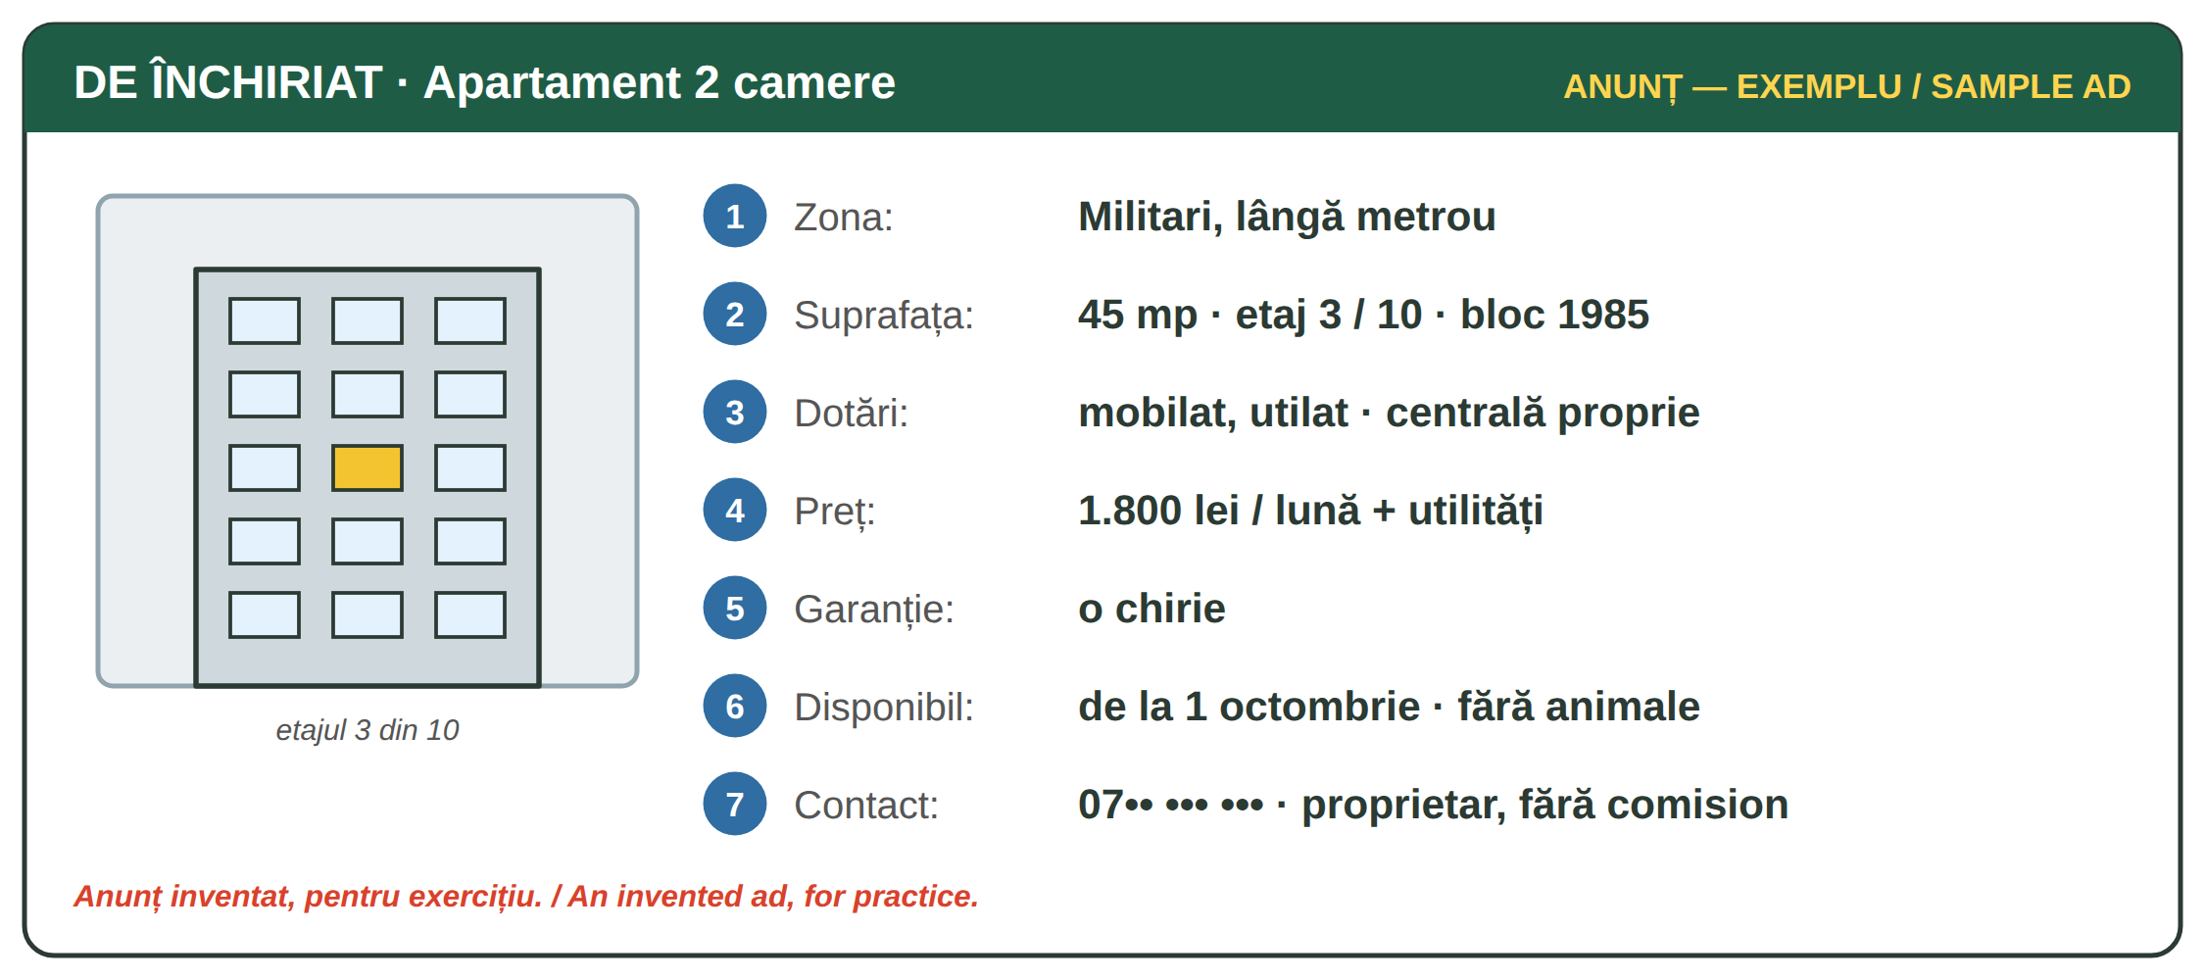
Fig. 12.1 — Un anunț de închiriere. EXEMPLU inventat / A rental ad. Invented SAMPLE
NR. | IN THE AD | WHAT IT MEANS
2 | 45 mp · etaj 3 / 10 | 45 square metres; 3rd floor of 10. Bloc 1985 = the year the block was built
3 | mobilat, utilat · centrală proprie | with furniture and appliances (Lesson 6.5); its own gas boiler — you pay your own heating
4 | + utilități | the rent does not include electricity, gas, water, internet, maintenance
5 | garanție | a deposit, here equal to one month's rent; you get it back at the end if there is no damage or debt
7 | fără comision | no agency fee — you speak directly with the owner

AT THE VIEWING / LA VIZIONARE | ENGLISH
Aș dori să văd apartamentul. Când ar fi posibil? | I'd like to see the flat. When would it be possible?
Cât vine întreținerea iarna? | How much is the maintenance in winter?
Chiria include utilitățile? — Nu, se plătesc separat. | Does the rent include utilities? — No, they are paid separately.
Facem un contract scris? · Îmi dați o chitanță? | Shall we make a written contract? · Will you give me a receipt?
Pot să-mi declar adresa aici? (for IGI, Lesson 11.8) | Can I declare this address as mine?

ATTENTION — THE RENTAL CONTRACT / CONTRACTUL DE ÎNCHIRIERE
Ask for a written contract: the names, the address, the rent and the date of payment, the deposit, who pays the utilities and the maintenance, the duration and the notice to leave. The owner must register the contract at ANAF within 30 days (ANAF). With a contract you can prove your address — IGI asks for it when you change address (Lesson 11.8). Never pay a deposit before you see the flat and the owner's documents.

12.1 Read the ad
Look at Fig. 12.1 and answer.
1. Câte camere are apartamentul? → ______________ | 2. Cât este chiria? → ______________
3. Chiria include utilitățile? → ______________ | 4. Cât este garanția? → ______________

CUVINTE ȘI EXPRESII UZUALE / USEFUL WORDS AND PHRASES
chiria · chiriașul | the rent · the tenant | proprietarul | the owner, landlord
a închiria | to rent | vizionarea | the viewing
garanția | the deposit | utilitățile | utilities
chitanța | the receipt | preavizul | notice (to leave)

Lesson 12.2 — Life in a block of flats / Viața la bloc
AT THE BLOCK | WHAT IT IS
asociația de proprietari | the owners' association of the block (Law no. 196/2018); it pays the common costs: stairs, lift, cleaning, lighting, water for the block
administratorul | the manager: calculates what each flat must pay and posts it
întreținerea | the monthly maintenance payment of each flat; your contract says if you or the owner pays it
lista de plată · avizierul | the monthly list of payments, posted on the notice board at the entrance; the owners can contest it in writing within 10 days
orele de liniște | quiet hours: 22:00–08:00 and 13:00–14:00 (Law no. 61/1991); loud noise is fined 500–1,500 lei (Romanian Police)

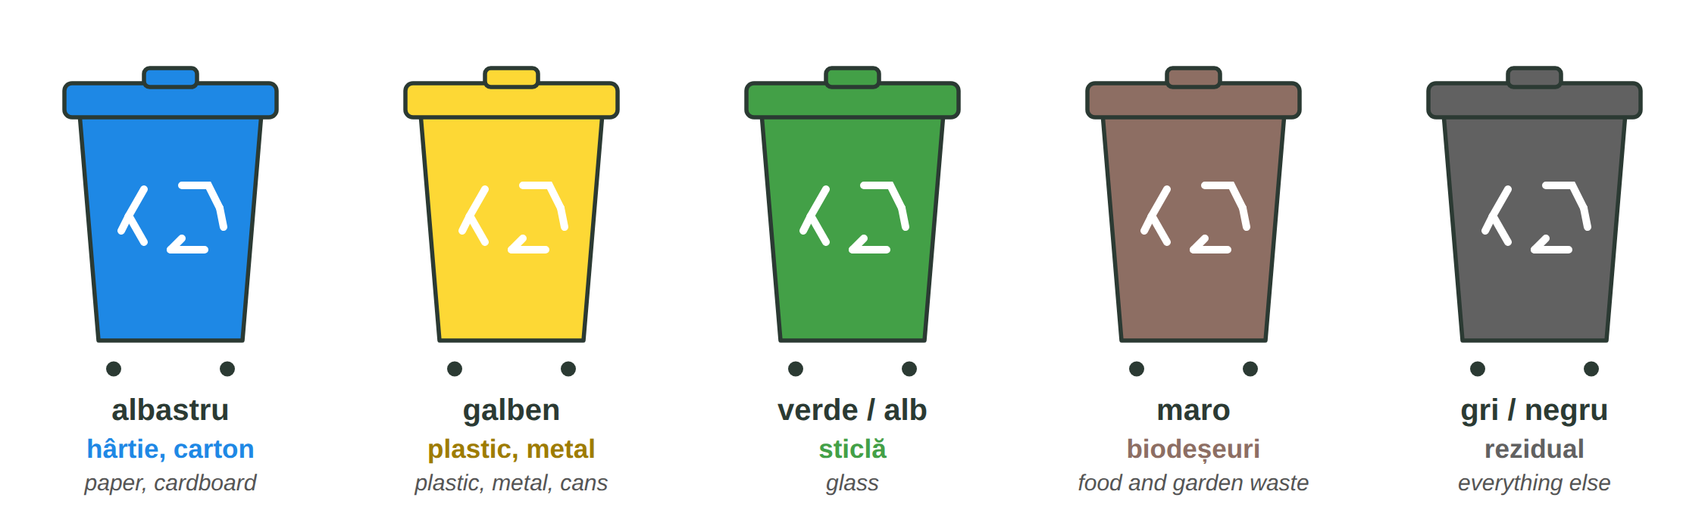
Fig. 12.2 — Colectarea separată: culorile containerelor / Separate collection: the colours of the bins
Town halls must organise separate collection of paper, plastic, metal and glass. Put clean packaging in the right bin; batteries, bulbs and old electronics go to special collection points, not in the bins. Each town has its own days and places — ask the administrator.
THE NEIGHBOUR COMPLAINS / VECINUL SE PLÂNGE | ENGLISH
— Bună seara! Sunt vecinul de la etajul 4. E trecut de ora zece și se aude muzica foarte tare. | Good evening! I'm your neighbour from the 4th floor. It's after ten and the music is very loud.
— Îmi pare rău, nu mi-am dat seama. O dau mai încet imediat. | I'm sorry, I didn't realise. I'll turn it down at once.
— Mulțumesc. Mâine mă scol la cinci. | Thank you. I get up at five tomorrow.
— Nu se mai întâmplă. Noapte bună! | It won't happen again. Good night!

GOOD NEIGHBOURS / VECINI BUNI | ENGLISH
Bună ziua! on the stairs and in the lift — always | greeting neighbours is normal in Romania
Ați putea să-mi țineți un colet? (Lesson 10.2) | Could you keep a parcel for me?
Vă deranjează dacă fac o mică petrecere sâmbătă, până la zece? | Do you mind if I have a small party on Saturday, until ten?

12.2 Which bin?
Write the colour: albastru · galben · verde · maro · gri.
1. o sticlă de apă din plastic → ______________ | 2. o cutie de carton → ______________
3. un borcan de sticlă → ______________ | 4. cojile de cartofi → ______________
5. o doză de suc → ______________ | 6. un scutec folosit → ______________

CUVINTE ȘI EXPRESII UZUALE / USEFUL WORDS AND PHRASES
vecinul · vecina | the neighbour | scara blocului | the staircase
liftul · etajul | the lift · the floor | avizierul | notice board
a face zgomot | to make noise | a recicla | to recycle
gunoiul menajer | household rubbish | ghena | the bin area of the block

GREȘELI FRECVENTE LA SCRIS / COMMON WRITING MISTAKES
WRITE | WHAT IT IS | EXAMPLE | THE TEST
ne-a | ne + a — (he / she) has ... us | Proprietarul ne-a dat cheile. · Ne-a cerut chiria. | you can say ne-au for many
nea | colloquial: mister, uncle — before the name of an older man | Nea Vasile, vecinul de la 2, e administrator. | a name comes after it
întruna | all the time, non-stop — one word | Câinele vecinului latră întruna. | you can say mereu
într-una | in one (of them) | Locuiesc într-una din camere. | followed by din / dintre

HOMEWORK — AFTER SESSION 45 / TEMĂ PENTRU ACASĂ
H45.1 Write a rental ad for your flat (or your dream flat) with the seven parts of Fig. 12.1.
H45.2 Write five questions for a viewing, with Aș dori... / Ați putea...?

SESSION 46 — CITY AND COUNTRYSIDE, THE IMPERFECT
SESIUNEA 46 — VIAȚA LA ORAȘ ȘI LA ȚARĂ, IMPERFECTUL · 3 hours

By the end of this session you will be able to:
☐ | compare life in the city and in the village
☐ | name nine farm animals and the work in the garden
☐ | say what is done in the village in each season
☐ | tell a story about your childhood with the imperfect: eram, locuiam, aveam

Lesson 12.3 — City and countryside / Orașul și satul
 | LA ORAȘ / IN THE CITY | LA ȚARĂ / IN THE COUNTRYSIDE
locuința | un apartament la bloc | o casă cu curte și grădină
transportul | metrou, autobuz, tramvai | mașina, microbuzul, bicicleta
munca | în fabrici, birouri, magazine, pe șantier | în agricultură, în gospodărie, la ferma
viața | agitată, zgomot, multe magazine | liniștită, aer curat, puține magazine
oamenii | nu se cunosc între ei | toți se cunosc
mâncarea | o cumperi de la supermarket (Lesson 8.3) | o crești singur: legume, ouă, lapte

IMAGINE | IMAGINE | IMAGINE | IMAGINE | IMAGINE | IMAGINE | IMAGINE | IMAGINE
o vacă | un taur | un vițel | un porc | o oaie | un berbec | o capră | un cal
IMAGINE | IMAGINE | IMAGINE | IMAGINE | IMAGINE | IMAGINE | IMAGINE | IMAGINE
un măgar | o găină | un cocoș | un pui | o rață | o gâscă | un curcan | un iepure
Fig. 12.3 — Animalele din gospodărie / Farm animals
ROMANIAN (cu un / o) | PLURAL | ENGLISH | CE NE DĂ / WHAT IT GIVES US
o vacă | vaci | a cow | lapte, carne
un taur | tauri | a bull | carne
un vițel | viței | a calf | carne
un porc | porci | a pig | carne
o oaie | oi | a sheep | lapte, lână, carne
un berbec | berbeci | a ram | lână, carne
o capră | capre | a goat | lapte, carne
un cal | cai | a horse | munca la câmp, transport
un măgar | măgari | a donkey | munca, transport
o găină | găini | a hen | ouă, carne
un cocoș | cocoși | a rooster | carne
un pui | pui | a chick · a chicken | carne
o rață | rațe | a duck | ouă, carne
o gâscă | gâște | a goose | ouă, carne
un curcan | curcani | a turkey | carne
un iepure | iepuri | a rabbit | carne

FROM THE ANIMALS | ENGLISH | IN THE YARD | ENGLISH
laptele — de la vacă, oaie, capră | milk | grajdul | the stable, the cowshed
ouăle — de la găină | eggs | cotețul | the henhouse, pigsty
brânza · lâna | cheese · wool | a da de mâncare animalelor | to feed the animals
carnea de porc, de pui | pork, chicken | a mulge vaca | to milk the cow

12.3 City or village?
Write O (oraș) or S (sat).
1. Iau metroul la muncă. ___ | 2. Am o vacă și zece găini. ___
3. Toți vecinii se cunosc. ___ | 4. Locuiesc la etajul 8. ___

CUVINTE ȘI EXPRESII UZUALE / USEFUL WORDS AND PHRASES
satul · orașul | village · town | gospodăria | the household, small farm
curtea | the yard | ferma | the farm
aerul curat | fresh air | a crește animale | to raise animals

Lesson 12.4 — The garden and the seasons / Grădina și anotimpurile
Vegetables and fruit are in Lesson 8.1. In the village almost every house has a grădină (vegetable garden) and pomi fructiferi (fruit trees). The names of many trees come from the fruit: măr = apple and apple tree!
THE FRUIT | THE TREE | THE FRUIT | THE TREE
un măr | un măr (apple tree) | o cireașă | un cireș (cherry tree)
o pară | un păr (pear tree) | o nucă | un nuc (walnut tree)
o prună | un prun (plum tree) | o piersică · o caisă | un piersic · un cais

IN THE GARDEN | ENGLISH | IN THE GARDEN | ENGLISH
a planta · a semăna | to plant · to sow | a uda | to water
a săpa | to dig | a culege · recolta | to pick · the harvest
răsadurile | seedlings | a cultiva roșii, ardei, cartofi | to grow tomatoes, peppers, potatoes

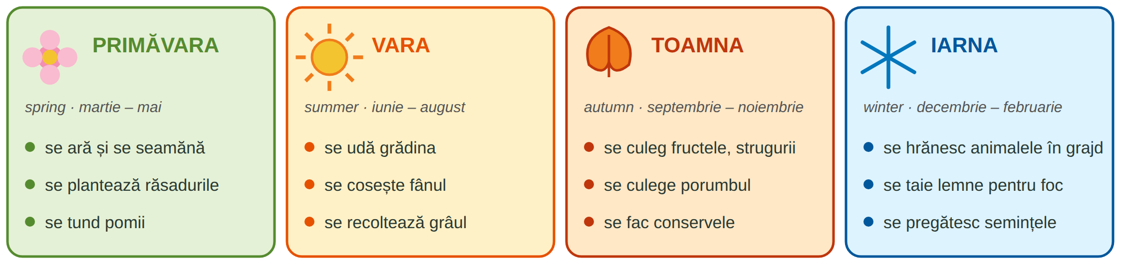
Fig. 12.4 — Muncile de la țară pe anotimpuri (anotimpurile: Lesson 5.4) / Farm work through the seasons
Se ară, se seamănă, se udă — the se form means „it is done” (people do it). You already know se from Lesson 3.12.*
12.4 When?
Write the season.
1. Se culeg strugurii. → ______________ | 2. Se seamănă. → ______________
3. Se cosește fânul. → ______________ | 4. Se taie lemne pentru foc. → ______________

CUVINTE ȘI EXPRESII UZUALE / USEFUL WORDS AND PHRASES
pomul fructifer | fruit tree | livada | the orchard
via · strugurii | the vineyard · grapes | fânul | hay
porumbul · grâul | maize · wheat | conservele · murăturile | preserves · pickles

Lesson 12.5 — The imperfect: when I was a child / Imperfectul: când eram copil
You know the past am lucrat (Lesson 3.14): one finished action. The imperfect describes how things were and what you used to do — perfect for memories: Când eram copil, locuiam la țară.
TIPAR — the imperfect
lucra → lucr- · avea → av- | + | -am, -ai, -a... / -eam, -eai, -ea... | = | lucram · aveam

PERSON | A LUCRA | A AVEA | A MERGE | A FI (irregular)
eu | lucram | aveam | mergeam | eram
tu | lucrai | aveai | mergeai | erai
el / ea | lucra | avea | mergea | era
noi | lucram | aveam | mergeam | eram
voi / dvs. | lucrați | aveați | mergeați | erați
ei / ele | lucrau | aveau | mergeau | erau

Also: a locui → locuiam, a scrie → scriam, a face → făceam, a sta → stăteam, a da → dădeam. Reflexive: mă trezeam, ne trezeam (Lesson 3.12).
A STORY / O POVESTE | ENGLISH
Când eram copil, locuiam la țară, într-un sat din Nepal. | When I was a child, I lived in the countryside, in a village in Nepal.
Bunicul avea vaci și capre. Ne trezeam devreme, la cinci. | My grandfather had cows and goats. We used to get up early, at five.
Eu dădeam de mâncare găinilor, iar sora mea aducea apă. | I fed the hens, and my sister brought water.
Într-o zi, a venit o furtună mare. (am venit = one event!) | One day a big storm came.

IMPERFECT OR PAST? / IMPERFECT SAU PERFECT COMPUS?
Imperfect = the background, a habit, a long situation: eram, locuiam, în fiecare zi mergeam. Perfect compus = one event, finished: am venit, a plouat, m-am mutat (Lesson 3.14). In a story: Locuiam la țară (background) când a venit furtuna (event).

12.5 Put the verbs in the imperfect
Write the correct form.
1. Când (eu, a fi) ________ copil, (a locui) ________ la țară. | 2. Bunica (a avea) ________ o grădină mare.
3. Noi (a merge) ________ la școală pe jos. | 4. Tata (a lucra) ________ la câmp.
5. Voi (a fi) ________ fericiți? | 6. Copiii (a se juca) ________ în curte.

CUVINTE ȘI EXPRESII UZUALE / USEFUL WORDS AND PHRASES
când eram copil | when I was a child | pe vremea aceea | at that time
în fiecare zi | every day | bunicul · bunica | grandfather · grandmother
îmi amintesc | I remember | de obicei | usually

GREȘELI FRECVENTE LA SCRIS / COMMON WRITING MISTAKES
WRITE | WHAT IT IS | EXAMPLE | THE TEST
decât | only (after nu) · than — one word | Nu am decât o vacă. · Satul e mai liniștit decât orașul. | you can say doar / than
de cât | how much / how long — in a question | De cât timp locuiești aici? | followed by a noun: timp, bani
câteodată | sometimes — one word | Câteodată merg la bunici. | you can say uneori
câte o dată | one time each | Ud roșiile câte o dată pe zi. | it means once each (time)

HOMEWORK — AFTER SESSION 46 / TEMĂ PENTRU ACASĂ
H46.1 Write eight sentences about your childhood with the imperfect: Când eram copil, locuiam... Aveam... În fiecare zi...
H46.2 Compare your village or town at home with a Romanian one: three things that are the same, three that are different.

SESSION 47 — O.U.G. 32/2026, RECAP AND TEST
SESIUNEA 47 — O.U.G. 32/2026, RECAPITULARE ȘI TEST · 3 hours

By the end of this session you will be able to:
☐ | explain what O.U.G. 32/2026 says about your first 6 months with the employer
☐ | know what happens if you leave before 6 months
☐ | know where to ask: IGI, ITM, the placement agency

Lesson 12.6 — O.U.G. 32/2026: your first 6 months / Primele 6 luni
O.U.G. nr. 32 din 23 aprilie 2026 is the Government Emergency Ordinance on the access of foreigners to the labour market in Romania. It is also the law behind this course. Below are the rules that concern your job — in simple words.
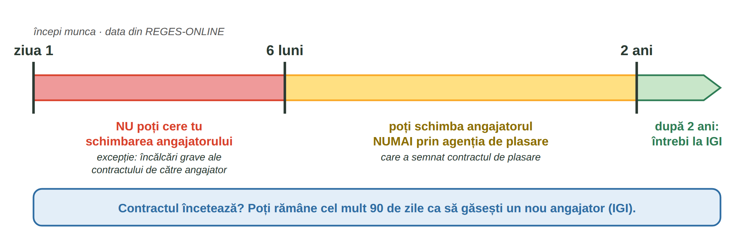
Fig. 12.5 — Primele 6 luni și primii 2 ani la angajator / The first 6 months and the first 2 years
Când încep cele 6 luni? / When do the 6 months start? | From the date you start work in Romania, as it is registered in REGES-ONLINE (the employee register, Lesson 11.6).
Pot să schimb angajatorul în primele 6 luni? / Can I change employer in the first 6 months? | No — you cannot ask for the change yourself in the first 6 months.
Există excepții? / Are there exceptions? | Yes: when the employer seriously breaks the contract or the rules of the working relationship. Keep proof (contract, payslips, messages) and complain to ITM (Lesson 11.9).
Ce se întâmplă dacă plec înainte de 6 luni? / What if I leave before 6 months? | If you leave without such a reason, the employer can ask you to pay back the money spent on your Romanian course, your accommodation and your transport.
Și dacă nu vin la lucru? / And if I don't come to work? | If you are absent without reason for more than 3 working days in a row, the employer must tell IGI and the placement agency within 5 working days. Your right to stay depends on your work.
Ce fac după 6 luni? / After 6 months? | Until 2 years from the start of work, you can change employer only through the placement agency that signed your placement contract.
Dacă se termină contractul? / If the contract ends? | IGI: you can stay in Romania at most 90 days to find a new employer. If your right of residence ends, you must leave Romania.
De ce acest curs? / Why this course? | Art. 7 (1) g): the employer must give you a Romanian course with cultural and social integration, for at least 6 months, at least 6 hours a week.

ATTENTION — ASK BEFORE YOU LEAVE / ÎNTREABĂ ÎNAINTE SĂ PLECI
These rules apply to workers who came under O.U.G. 32/2026; some details depend on your visa and your date of arrival. Before you resign or change job, ask in writing your employer's HR office, the placement agency and IGI (igi.mai.gov.ro, workinromania.gov.ro). Never sign a resignation you do not understand (Lesson 11.10).

USEFUL SENTENCES / FRAZE UTILE | ENGLISH
De când se calculează cele 6 luni pentru mine? | From when are the 6 months counted for me?
Aș dori să schimb locul de muncă. Ce trebuie să fac? | I would like to change my job. What do I have to do?
Angajatorul nu respectă contractul. Pot face o sesizare la ITM? | The employer does not respect the contract. Can I complain to ITM?
Îmi puteți da răspunsul în scris, vă rog? | Could you give me the answer in writing, please?

12.6 True or false?
Write A (adevărat) or F (fals).
1. Cele 6 luni încep de la data din REGES-ONLINE. ___ | 2. În primele 6 luni pot schimba angajatorul oricând. ___
3. Dacă plec fără motiv, angajatorul poate cere banii pe curs, cazare și transport. ___ | 4. După ce se termină contractul, pot rămâne cel mult 90 de zile. ___

CUVINTE ȘI EXPRESII UZUALE / USEFUL WORDS AND PHRASES
ordonanța de urgență | emergency ordinance | agenția de plasare | placement agency
a schimba angajatorul | to change employer | a da înapoi banii | to pay back
încălcarea gravă | serious breach | dreptul de ședere | right of residence

Lesson 12.7 — Recap / Recapitulare
TOPIC | EXAMPLE | LESSON
anunț · vizionare · contract · garanție · utilități | Chiria include utilitățile? | 12.1
asociația · administratorul · întreținerea · liniște 22–8, 13–14 | Se aude muzica foarte tare. | 12.2
albastru hârtie · galben plastic, metal · verde sticlă · maro bio | Pun sticla în containerul verde. | 12.2
oraș / sat · vaca, porcul, oaia, capra, calul, găina, rața, curcanul, iepurele | La țară toți se cunosc. | 12.3
măr → măr · se ară, se seamănă, se culege | Toamna se culeg strugurii. | 12.4
imperfect: eram, locuiam, aveam, mergeam | Când eram copil, locuiam la țară. | 12.5
6 luni · excepția · costurile · 2 ani prin agenție · 90 de zile | Îmi puteți da răspunsul în scris? | 12.6

GREȘELI FRECVENTE LA SCRIS / COMMON WRITING MISTAKES
WRITE | WHAT IT IS | EXAMPLE | THE TEST
dea | să + dea — (that) he / she gives | Proprietarul trebuie să-mi dea chitanța. | after să
de-a | de + a — in fixed phrases | de-a lungul drumului · de-a dreapta | you can say de a
s-ar | se + ar — it would (Lesson 10.2) | S-ar putea să plouă. · S-ar muta la țară. | a verb comes after it
sar | I jump / they jump (a sări) | Copiii sar în curte. | it is a verb

12.7 Everything together
Circle the correct form.
1. Când ( am fost / eram ) copil, locuiam la țară. | 2. Câinele latră ( întruna / într-una ).
3. Nu am ( decât / de cât ) o cameră. | 4. Proprietarul ( ne-a / nea ) dat cheile.
5. ( S-ar / Sar ) putea să ningă. | 6. ( Câteodată / Câte o dată ) merg la sat.

HOMEWORK — AFTER SESSION 47 / TEMĂ PENTRU ACASĂ
H47.1 Write in Romanian: the date you started work (ask HR — it is in REGES-ONLINE) and the date when your first 6 months end.
H47.2 Write a short story (8 sentences) about a day in your village when you were a child.

SECȚIUNE DETAȘABILĂ — EXEMPLAR FORMATOR
Detachable section — teacher's copy. Se detașează din suportul cursantului; testul completat, semnat și datat, se păstrează la dosarul cursantului. Conține: testul cumulativ, fișa de confirmare a Sesiunii 47, fișa de evidență a Modulului 12, cheia răspunsurilor, sursele.

TEST CUMULATIV — MODULUL 12
MODULE 12 — CUMULATIVE TEST · grilă, 22 de întrebări, 22 de puncte · semnat și datat de cursant

Nume și prenume cursant / Student name
Data / Date | _____ / _____ / 20_____
Semnătura cursantului / Student signature

Marcați cu X un singur răspuns la fiecare întrebare. Mark ONE answer with X for each question. Each correct answer = 1 point.
1. „1.800 lei / lună + utilități” înseamnă: (1 p)
☐ a) totul este inclus | ☐ b) curentul, gazul, apa se plătesc separat | ☐ c) nu se plătește nimic | ☐ d) chiria e pe an
2. Garanția este: (1 p)
☐ a) un cadou pentru proprietar | ☐ b) o sumă pe care o primești înapoi la sfârșit, dacă nu sunt pagube | ☐ c) comisionul agenției | ☐ d) impozitul
3. Contractul de închiriere se înregistrează la ANAF în: (1 p)
☐ a) 3 zile | ☐ b) 30 de zile | ☐ c) 6 luni | ☐ d) nu se înregistrează
4. Cine calculează întreținerea la bloc? (1 p)
☐ a) vecinul | ☐ b) administratorul | ☐ c) poliția | ☐ d) IGI
5. Orele de liniște sunt: (1 p)
☐ a) 20:00–06:00 | ☐ b) 22:00–08:00 și 13:00–14:00 | ☐ c) 00:00–05:00 | ☐ d) numai duminica
6. O cutie de carton se pune în containerul: (1 p)
☐ a) galben | ☐ b) verde | ☐ c) albastru | ☐ d) maro
7. O sticlă de plastic se pune în containerul: (1 p)
☐ a) galben | ☐ b) albastru | ☐ c) verde | ☐ d) maro
8. Vecinul spune: „Se aude muzica foarte tare.” Răspunzi: (1 p)
☐ a) Nu mă interesează. | ☐ b) Îmi pare rău, o dau mai încet. | ☐ c) Sunați la 112. | ☐ d) Pa!
9. Care animal dă ouă? (1 p)
☐ a) vaca | ☐ b) găina | ☐ c) calul | ☐ d) porcul
10. „Un măr” poate fi: (1 p)
☐ a) numai un fruct | ☐ b) un fruct sau un pom | ☐ c) o legumă | ☐ d) un animal
11. Primăvara, la țară: (1 p)
☐ a) se culeg strugurii | ☐ b) se ară și se seamănă | ☐ c) se taie lemne pentru foc | ☐ d) se cosește fânul
12. Completează: „Când ___ copil, locuiam la țară.” (1 p)
☐ a) am fost | ☐ b) eram | ☐ c) sunt | ☐ d) voi fi
13. Completează: „Bunicul ___ trei vaci.” (1 p)
☐ a) avea | ☐ b) aveam | ☐ c) aveau | ☐ d) avem
14. Completează: „Noi ___ devreme în fiecare zi.” (1 p)
☐ a) ne trezeam | ☐ b) ne-am trezit mâine | ☐ c) ne trezim ieri | ☐ d) se trezeau
15. Cele 6 luni din O.U.G. 32/2026 încep de la: (1 p)
☐ a) data vizei | ☐ b) data începerii muncii din REGES-ONLINE | ☐ c) 1 ianuarie | ☐ d) data cursului
16. În primele 6 luni, lucrătorul străin: (1 p)
☐ a) poate schimba angajatorul oricând | ☐ b) nu poate cere el schimbarea angajatorului, cu excepția încălcărilor grave ale angajatorului | ☐ c) trebuie să schimbe angajatorul | ☐ d) nu are contract
17. Dacă pleacă fără motiv înainte de 6 luni, angajatorul poate cere banii pentru: (1 p)
☐ a) curs, cazare și transport | ☐ b) mâncare și haine | ☐ c) telefon | ☐ d) nimic
18. După 6 luni și până la 2 ani, schimbarea angajatorului se face: (1 p)
☐ a) la primărie | ☐ b) numai prin agenția de plasare | ☐ c) la bancă | ☐ d) fără nicio regulă
19. După încetarea contractului, poți rămâne pentru un nou angajator cel mult: (1 p)
☐ a) 10 zile | ☐ b) 30 de zile | ☐ c) 90 de zile | ☐ d) 1 an
20. Care propoziție este scrisă corect? (1 p)
☐ a) Nu am de cât o cameră. | ☐ b) Nu am decât o cameră. | ☐ c) Nu am decăt o cameră. | ☐ d) Nu am deca o cameră.
21. Ce ne dă oaia? (1 p)
☐ a) ouă | ☐ b) miere | ☐ c) pene | ☐ d) lână și lapte
22. Pluralul lui „o găină” este: (1 p)
☐ a) două găine | ☐ b) doi găini | ☐ c) două găini | ☐ d) două găinuri

PUNCTAJ OBȚINUT / SCORE | _______ / 22
Semnătura formatorului / Teacher signature

SESSION COMPLETION RECORD
FIȘĂ DE CONFIRMARE A PARCURGERII SESIUNII — se păstrează la dosar

Module / Modul | Modulul 12 — Casa, viața la oraș și la țară, O.U.G. 32/2026 (finalizat)
Session / Sesiunea | Sesiunea 47 — O.U.G. 32/2026, recapitulare. TEST CUMULATIV MODULUL 12
Duration / Durata | 3 ore
Date / Data | _____ / _____ / 20_____
Student name / Nume și prenume cursant
Score / Punctaj obținut | _______ / 22
Student signature / Semnătura cursantului
Teacher signature / Semnătura formatorului

DECLARAȚIE CURSANT / STUDENT DECLARATION
Declar că am participat la această sesiune de curs și am parcurs conținutul prezentat mai sus.
I declare that I attended this course session and covered the content presented above.

MODULE 12 — COMPLETION RECORD
FIȘĂ DE EVIDENȚĂ A PARCURGERII MODULULUI 12 — se păstrează la dosarul cursantului

Cursant / Student
Act de identitate / ID document
Angajator / Employer
Formator / Teacher
Modul / Module | Modulul 12 — Casa, viața la oraș și la țară, O.U.G. 32/2026 (9 ore, Sesiunile 45–47)

NR. | SESIUNE / CONȚINUT | DATA | PUNCTAJ TEST | SEMNĂTURA CURSANTULUI
45 | Sesiunea 45 — Chiria și viața la bloc (3 ore) |  | —
46 | Sesiunea 46 — Viața la oraș și la țară, imperfectul (3 ore) |  | —
47 | Sesiunea 47 — O.U.G. 32/2026, recapitulare + TEST CUMULATIV (3 ore) |  | ___ / 22

CONFIRMARE FINALIZARE MODUL / MODULE COMPLETION
Confirm că cursantul a parcurs integral conținutul Modulului 12 — Casa, viața la oraș și la țară, O.U.G. 32/2026, în total 9 ore de curs, și a susținut testul de evaluare consemnat mai sus.
I confirm that the student completed the full content of Module 12 — Home, Life in the City and in the Countryside, O.U.G. 32/2026, 9 course hours in total, and sat the assessment recorded above.
Data: _____ / _____ / 20_____ Semnătura formatorului: ______________________

ANSWER KEY — TEACHER COPY
CHEIA RĂSPUNSURILOR — pentru formator

12.1 două · 1.800 lei pe lună · nu · o chirie (1.800 lei)
12.2 galben · albastru · verde · maro · galben · gri
12.3 O · S · S · O 12.4 toamna · primăvara · vara · iarna
12.5 eram, locuiam · avea · mergeam · lucra · erați · se jucau
12.6 A · F · A · A
12.7 eram · întruna · decât · ne-a · S-ar · Câteodată
Cumulative test — grilă answer key
TOTAL: 22 de puncte. Un răspuns corect = 1 punct. Nemarcat sau dublu marcat = 0 puncte.
1 – b | 2 – b | 3 – b | 4 – b | 5 – b | 6 – c | 7 – a | 8 – b | 9 – b | 10 – b
11 – b | 12 – b | 13 – a | 14 – a | 15 – b | 16 – b | 17 – a | 18 – b | 19 – c | 20 – b
21 – d | 22 – c

Surse și data verificării / Sources and date of verification
Informațiile factuale și legale din acest modul au fost verificate la 24.09.2026 pe surse oficiale. The factual and legal information was checked on 24 September 2026 against official sources.
INFORMAȚIA / INFORMATION | SURSA / SOURCE | UNDE ÎN MODUL / WHERE
Înregistrarea contractului de închiriere de către proprietar la ANAF în 30 de zile | ANAF — ghiduri privind veniturile din cedarea folosinței bunurilor (static.anaf.ro); Codul fiscal | Lesson 12.1, test q. 3
Asociația de proprietari, administratorul, lista de plată, contestarea în 10 zile | Legea nr. 196/2018 — legislatie.just.ro/Public/DetaliiDocument/203233 | Lesson 12.2, test q. 4
Orele de liniște 22:00–08:00 și 13:00–14:00; amendă 500–1.500 lei | Legea nr. 61/1991, republicată; Poliția Română — „Care sunt orele de liniște?” (politiaromana.ro) | Lesson 12.2, test q. 5
Culorile containerelor: albastru hârtie-carton; galben plastic-metal; verde/alb sticlă; maro biodeșeuri; gri/negru rezidual | Regulamentele serviciului de salubrizare publicate pe legislatie.just.ro (2025); Ministerul Mediului — întrebări frecvente deșeuri (mmediu.ro) | Lesson 12.2, test q. 6–7
O.U.G. nr. 32 din 23.04.2026: 6 luni de la începerea activității din REGES-ONLINE; excepția încălcărilor grave; recuperarea cheltuielilor (curs, cazare, transport); schimbarea prin agenția de plasare până la 2 ani; notificarea absenței nejustificate > 3 zile lucrătoare în 5 zile lucrătoare | O.U.G. nr. 32/2026 — legislatie.just.ro/Public/DetaliiDocument/309832; textul publicat de IGI (igi.mai.gov.ro); workinromania.gov.ro | Lesson 12.6, test q. 15–18
Cursul de limba română: minimum 6 luni, cel puțin 6 ore pe săptămână — art. 7 alin. (1) lit. g) | O.U.G. nr. 32/2026; Ordinul nr. 655/2026 (legislatie.just.ro/Public/DetaliiDocument/311310) | Lesson 12.6
Rămânerea cel mult 90 de zile după încetarea contractului, pentru un nou angajator | IGI — „Clarificări privind dreptul de ședere al străinilor după încetarea contractului de muncă” (igi.mai.gov.ro); O.U.G. nr. 194/2002 | Lesson 12.6, test q. 19
Lecțiile anterioare citate | Modulele 3–11: 3.12, 3.14, 3.15, 5.2, 5.4, 6.4–6.6, 8.1, 8.3, 10.2, 11.6, 11.8–11.10 | whole module

Anunțul din Fig. 12.1 și sumele din el sunt inventate. Muncile agricole pe anotimpuri sunt informații generale. Accesul direct la textul O.U.G. 32/2026 a fost blocat din mediul de lucru; prevederile au fost verificate prin extrasele oficiale indexate de pe legislatie.just.ro și igi.mai.gov.ro — formatorul confruntă Lecția 12.6 cu textul oficial înainte de predare. / The ad is invented; the O.U.G. provisions were checked through indexed official extracts.

LIMBA ROMÂNĂ PENTRU STRĂINI
Romanian Language for Foreign Workers
SUPORT DE CURS

MODULE 13 — EVERYDAY SERVICES AND HEALTH
MODULUL 13 — SERVICII DE ZI CU ZI ȘI SĂNĂTATE
Nivelul A2 / Level A2
LEVEL / NIVEL | DURATION / DURATĂ | LANGUAGE OF TEACHING
A2 — after Module 12 | 6 hours · Sessions 48–49 · Weeks 24–25 | English → Romanian

LEGAL BASIS / TEMEI LEGAL
Curs de limbă română cu elemente de integrare culturală și socială, organizat în conformitate cu O.U.G. nr. 32/2026, art. 7 alin. (1) lit. g) — minimum 6 luni, cel puțin 6 ore pe săptămână.
Romanian language course with cultural and social integration elements, organised under Government Emergency Ordinance no. 32/2026, art. 7(1)(g) — at least 6 months, at least 6 hours per week.
This module ends with ONE cumulative multiple-choice test (20 questions), signed and dated by the student and kept on file as proof of completion.

Before you start
Module 13 is about the services you use every week: ordering online, receiving a parcel, calling a taxi from an app and moving around Bucharest by metro and bus. Then you go one step further in health: after Module 8 (the body, symptoms, the pharmacy, the family doctor), you now make an appointment, go to a specialist with a referral, do tests and get a compensated prescription. No new grammar. App and company names are not given — only generic words.
YOU NEED | WHERE | WHY
transport in town, tickets, validating | Lesson 5.3 | now: passes, metro lines
the body, symptoms, pharmacy, doctor | Lessons 8.4–8.6 | not repeated
health insurance, family doctor, health card | Lesson 8.7 | referral, prescription
bank card, PIN, scams | Lessons 10.6, 11.10 | paying online
the polite conditional · the imperfect | Lessons 10.2, 12.5 | on the phone · your medical history

SESSION | DURATION | CONTENT
Session 48 | 3 hours | Lesson 13.1 Ordering online · 13.2 The courier · 13.3 Taxi by app and public transport in Bucharest
Session 49 | 3 hours | Lesson 13.4 Appointment, referral, tests · 13.5 The compensated prescription · 13.6 Your medical history · 13.7 Recap · Module 13 test

SESSION 48 — SERVICES AND APPS
SESIUNEA 48 — SERVICII ȘI APLICAȚII · 3 hours

By the end of this session you will be able to:
☐ | order a product online and understand the order e-mail
☐ | follow a parcel, talk to the courier on the phone, pay cash on delivery
☐ | order a taxi from an app safely
☐ | buy a pass and use the Bucharest metro

Lesson 13.1 — Ordering online / Comenzile online
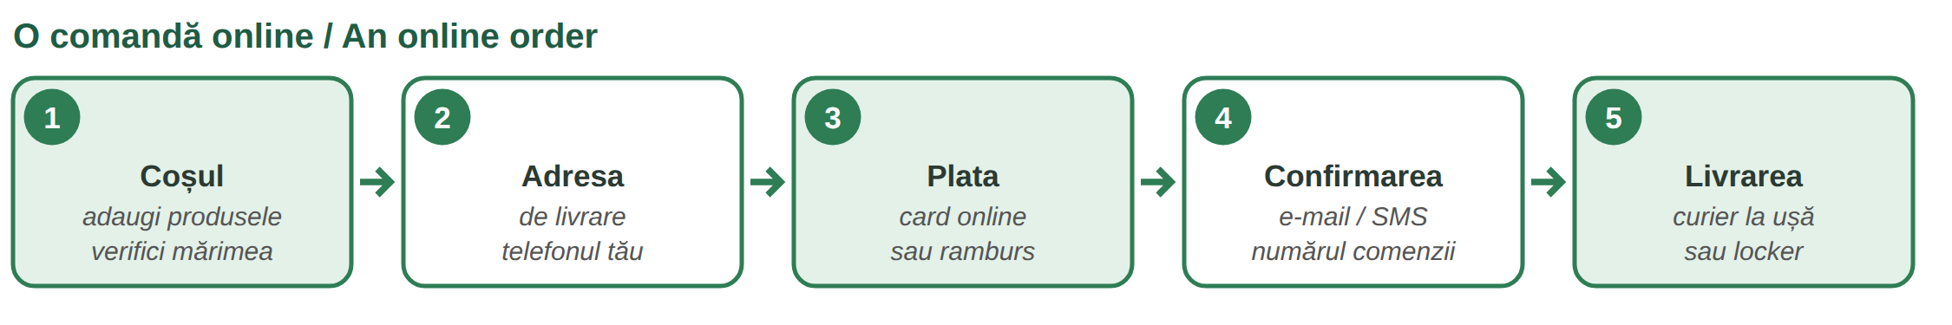
Fig. 13.1 — Pașii unei comenzi online / The steps of an online order
ON THE WEBSITE | ENGLISH | ON THE WEBSITE | ENGLISH
Adaugă în coș | Add to cart | Finalizează comanda | Checkout
Coșul meu · Vezi coșul | My cart · View cart | Adresa de livrare | Delivery address
Cont nou · Autentificare | New account · Log in | Metoda de plată | Payment method
Plata cu cardul online | Pay by card online | Plata la livrare (ramburs) | Cash on delivery
Cod de reducere | Discount code | Stoc epuizat | Out of stock
Comanda a fost plasată | Order placed | Retur | Return

ATTENTION — YOUR RIGHTS AND YOUR MONEY
For most things you buy online you can change your mind within 14 days without giving a reason, and the seller must return your money within 14 days (O.U.G. 34/2014, ANPC). Some products are exceptions — read the shop's rules. Pay only on secure sites; never send card codes by message (Lesson 11.10). Keep the order confirmation e-mail.

13.1 Put the order in the right order
Write 1–5.
___ Aleg plata: card sau ramburs. | ___ Adaug produsul în coș.
___ Primesc un e-mail de confirmare. | ___ Scriu adresa de livrare.
___ Curierul aduce coletul.

CUVINTE ȘI EXPRESII UZUALE / USEFUL WORDS AND PHRASES
comanda | the order | coșul | the cart
produsul · cantitatea | product · quantity | transportul gratuit | free delivery
returul | return | factura | the invoice

Lesson 13.2 — The courier / Curierul
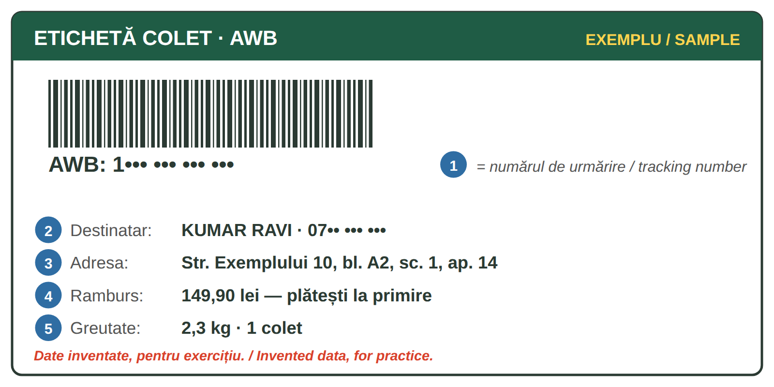
Fig. 13.2 — Eticheta coletului cu AWB. EXEMPLU inventat / The parcel label with the AWB. Invented SAMPLE
WORD | WHAT IT MEANS
coletul | the parcel
AWB-ul | the parcel's tracking number; with it you see on the courier's website or in the SMS where your parcel is
lockerul · easybox-ul | an automatic parcel locker; you get a code by SMS or in the app and open your box yourself
rambursul | you pay the courier when you receive the parcel — cash or card
destinatarul · expeditorul | the person who receives · the person who sends
avizul · nu am fost acasă | the courier leaves a notice or calls again; you can change the day or the address

ON THE PHONE WITH THE COURIER | ENGLISH
— Bună ziua, sunt curierul. Am un colet pentru dumneavoastră. Sunteți acasă? | Hello, I'm the courier. I have a parcel for you. Are you at home?
— Nu, sunt la serviciu. Ați putea să-l lăsați la vecina de la apartamentul 12? | No, I'm at work. Could you leave it with my neighbour in flat 12?
— Nu pot, e ramburs: 149,90 lei. Vă sun mâine? | I can't, it's cash on delivery. Shall I call you tomorrow?
— Da, după ora cinci, vă rog. Pot plăti cu cardul? — Da. | Yes, after five, please. Can I pay by card? — Yes.

A message says your parcel is „blocked” and you must pay a small fee on a link? It is probably a scam — check the AWB only on the courier's official website or app (Lesson 11.10).
13.2 Read the label
Look at Fig. 13.2 and answer.
1. Cine primește coletul? → ______________ | 2. Cât plătește la primire? → ______________
3. Ce este AWB-ul? → ______________ | 4. Cât cântărește coletul? → ______________

CUVINTE ȘI EXPRESII UZUALE / USEFUL WORDS AND PHRASES
a livra · livrarea | to deliver · delivery | a urmări coletul | to track the parcel
a ridica coletul | to pick up the parcel | codul de deschidere | opening code
a reprograma | to reschedule | plata la livrare | cash on delivery

Lesson 13.3 — Taxi by app and public transport / Taxi prin aplicație și transportul în comun
TAXI BY APP | ENGLISH
Comand o mașină din aplicație. Scriu adresa de plecare și destinația. | I order a car in the app. I type the pick-up address and the destination.
Verific numărul mașinii și numele șoferului înainte să urc. | I check the number plate and the driver's name before I get in.
Mă duceți la Gara de Nord, vă rog? · Opriți aici, vă rog. | Will you take me to Gara de Nord, please? · Stop here, please.
Prețul e în aplicație. · Plătesc cu cardul din aplicație. | The price is in the app. · I pay by card in the app.

In Bucharest (Lesson 5.3) you can pay the bus, tram and metro directly with a contactless bank card (plastic, phone or watch) at the validator or at the metro gate. For every day it is cheaper to buy an abonament (pass) on a transport card at the ticket office or online. The metro runs about 5:00–23:00; a new line to the airport (M6) is being built.

IMAGINE: harta liniilor de metrou din București (M1–M5)
Fig. 13.3 — Liniile de metrou din București, schemă simplificată / The Bucharest metro lines, simplified
LINIA | CAPETE DE LINIE / TERMINI | STAȚII DE LEGĂTURĂ / WHERE YOU CHANGE
M1 | Dristor 2 – Pantelimon | Piața Victoriei (M2) · Gara de Nord, Basarab (M4) · Eroilor (M3, M5) · Piața Unirii (M2, M3) · Nicolae Grigorescu (M3)
M2 | Pipera – Tudor Arghezi | Piața Victoriei (M1) · Piața Unirii (M1, M3)
M3 | Preciziei – Anghel Saligny | Eroilor (M1, M5) · Piața Unirii (M1, M2) · from Eroilor to Nicolae Grigorescu on the same track as M1
M4 | Gara de Nord – Străulești | Gara de Nord, Basarab (M1)
M5 | Eroilor – Râul Doamnei / Valea Ialomiței | Eroilor (M1, M3)

IN THE METRO | ENGLISH
Ce linie merge la Pipera? — M2, direcția Pipera. | Which line goes to Pipera? — M2, towards Pipera.
Unde schimb spre M4? — La Gara de Nord sau la Basarab. | Where do I change for M4? — At Gara de Nord or Basarab.
Aș vrea un abonament lunar pentru metrou. | I'd like a monthly metro pass.
Următoarea stație: Piața Unirii. · Coborâți la...? | Next station: Piața Unirii. · Are you getting off at...?

13.3 Plan the trip
Look at Fig. 13.3. Write the line(s) and where you change.
1. Piața Victoriei → Tudor Arghezi: ______________ | 2. Eroilor → Drumul Taberei: ______________
3. Pipera → Gara de Nord: ______________ | 4. Piața Unirii → Străulești: ______________

CUVINTE ȘI EXPRESII UZUALE / USEFUL WORDS AND PHRASES
abonamentul lunar | monthly pass | a valida · validatorul | to validate · reader
direcția | towards (direction) | a schimba linia | to change lines
șoferul · cursa | driver · ride | numărul de înmatriculare | number plate

GREȘELI FRECVENTE LA SCRIS / COMMON WRITING MISTAKES
WRITE | WHAT IT IS | EXAMPLE | THE TEST
ce-ai | ce + ai — what have you / what did you | Ce-ai comandat? · Ce-ai plătit? | you can say ce ai
ceai | tea | Beau un ceai cald. | it is a drink
iau | I take (a lua) | Iau metroul. · Iau coletul din locker. | you can say eu iau
i-au | îi + au — they (have) ... him / her | Curierii i-au adus coletul. | you can say i-a for one

HOMEWORK — AFTER SESSION 48 / TEMĂ PENTRU ACASĂ
H48.1 Find a product in an online shop. Write in Romanian: the price, the delivery cost, the payment methods, the return rule.
H48.2 Write your way to work by metro or bus: the line, the direction, where you change.

SESSION 49 — HEALTH A2, RECAP AND TEST
SESIUNEA 49 — SĂNĂTATEA A2, RECAPITULARE ȘI TEST · 3 hours

By the end of this session you will be able to:
☐ | make an appointment by phone or online
☐ | go to a specialist and to the laboratory with a referral
☐ | use a compensated prescription at the pharmacy
☐ | explain your medical history

Lesson 13.4 — Appointment, referral, tests / Programarea, trimiterea, analizele
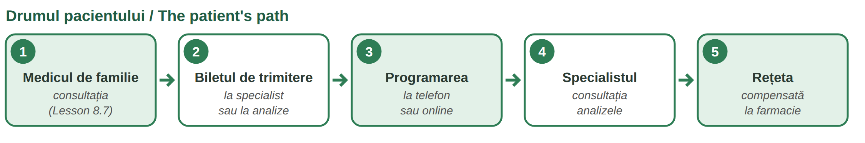
Fig. 13.4 — Drumul pacientului în sistemul de asigurări / The patient's path in the insurance system
WORD | WHAT IT MEANS (CNAS)
biletul de trimitere | the referral: your family doctor (Lesson 8.7) sends you to a specialist or to the laboratory; with it, the visit or the tests are paid by the health insurance
— pentru analize | valid 30 days; for chronic diseases, up to 90 days
programarea | the appointment: by phone, online on the clinic's website, or at the reception
analizele | blood or urine tests at a laboratory in contract with the health insurance house (CAS); ask if you must come pe nemâncate (without eating)
rezultatele | the results: on paper, by e-mail or online; you take them to your doctor

ON THE PHONE — AN APPOINTMENT | ENGLISH
— Clinica, bună ziua! — Aș dori o programare la cardiologie. Am bilet de trimitere. | Clinic, hello! — I'd like an appointment with a cardiologist. I have a referral.
— Sunteți asigurat? — Da, prin angajator. | Are you insured? — Yes, through my employer.
— Primul loc liber e pe 14 octombrie, la 9:30. Vă convine? | The first free slot is on 14 October at 9:30. Is it OK for you?
— Da. Ce trebuie să aduc? — Biletul, actul de identitate și cardul de sănătate. | Yes. What must I bring? — The referral, your ID and your health card.

13.4 Complete
Write: trimitere · programare · analize · pe nemâncate · rezultatele.
1. Medicul de familie îmi dă bilet de ______________. | 2. Sun la clinică pentru o ______________.
3. Mâine fac ______________ de sânge. | 4. Vin ______________, fără micul dejun.
5. Duc ______________ la medic.

CUVINTE ȘI EXPRESII UZUALE / USEFUL WORDS AND PHRASES
medicul specialist | specialist | clinica · policlinica | clinic · outpatient clinic
recepția | reception | primul loc liber | first free slot
a anula programarea | to cancel | recoltarea sângelui | taking a blood sample

Lesson 13.5 — The compensated prescription / Rețeta compensată
A compensated medicine is partly or fully paid by the health insurance. The doctor writes an electronic prescription (rețetă electronică); at the pharmacy you show your health card — you do not need to print the prescription. Only pharmacies in contract with CAS give compensated medicines.
LIST / SUBLISTA | THE INSURANCE PAYS | WHAT IT MEANS FOR YOU
A | 90% of the reference price | you pay a small part
B | 50% | you pay about half
C (sections C1, C3) | 100% | free — for some serious or chronic diseases
D | 20% | you pay most of the price

HOW LONG IS IT VALID?
chronic diseases | at most 30 days from the date of the prescription
acute diseases | at most 48 hours — go to the pharmacy the same day

AT THE PHARMACY | ENGLISH
Am o rețetă compensată. Poftiți cardul de sănătate. | I have a compensated prescription. Here is my health card.
Cât plătesc eu? · Există un medicament generic mai ieftin? | How much do I pay? · Is there a cheaper generic medicine?
Nu aveți pe stoc? · Când îl primiți? | Don't you have it in stock? · When will you get it?

13.5 How much does the insurance pay?
Write the percentage.
1. Sublista A → ______ % | 2. Sublista B → ______ %
3. Sublista D → ______ % | 4. Sublista C1 → ______ %

CUVINTE ȘI EXPRESII UZUALE / USEFUL WORDS AND PHRASES
compensat · gratuit | compensated · free | rețeta electronică | e-prescription
medicamentul generic | generic medicine | prețul de referință | reference price
boala cronică · acută | chronic · acute disease | pe stoc | in stock

Lesson 13.6 — Your medical history / Istoricul medical
A new doctor always asks about your past. Use the past (am avut o operație, Lesson 3.14) for events and the imperfect (când eram copil, aveam astm, Lesson 12.5) for long situations. Bring your documents from home — ideally translated.
THE DOCTOR ASKS · YOU ANSWER | ENGLISH
Aveți boli cronice? — Da, am diabet de cinci ani. / Am tensiune mare. | Do you have chronic diseases? — Yes, I've had diabetes for five years. / I have high blood pressure.
Luați vreun tratament? — Iau un medicament dimineața; am adus cutia. | Are you taking any treatment? — I take a medicine in the morning; I brought the box.
Ați avut operații? — Am fost operat de apendicită în 2019. | Have you had operations? — I had my appendix removed in 2019.
Sunteți alergic la ceva? — La penicilină. (Lesson 8.6) | Are you allergic to anything? — To penicillin.
Aveți vaccinurile făcute? · Boli în familie? — Tatăl meu avea probleme cu inima. | Are your vaccinations up to date? · Illnesses in the family? — My father had heart problems.
Am adus scrisoarea medicală și analizele din țara mea. | I brought my medical letter and test results from my country.

13.6 Your history
Answer about yourself (or invent).
1. Aveți boli cronice? → ______________ | 2. Luați vreun tratament? → ______________
3. Ați avut operații? → ______________ | 4. Sunteți alergic la ceva? → ______________

CUVINTE ȘI EXPRESII UZUALE / USEFUL WORDS AND PHRASES
istoricul medical | medical history | boala cronică | chronic disease
tratamentul | treatment | operația · a fi operat | operation · to be operated on
scrisoarea medicală | medical letter | antecedentele în familie | family history

GREȘELI FRECVENTE LA SCRIS / COMMON WRITING MISTAKES
WRITE | WHAT IT IS | EXAMPLE | THE TEST
mai | more · still · again | Mai am o programare. · Nu mai am rețete. | you can say încă
m-ai | mă + ai — you (have) ... me | M-ai sunat la clinică? · M-ai înțeles? | you can say m-a for one person
cel | the (masc.) before mai, an adjective or a number | cel mai bun medic · cel de-al doilea | no verb after it
ce-l | ce + îl — what ... him | Ce-l doare? · Ce-l supără? | you can say ce îl

Lesson 13.7 — Recap / Recapitulare
TOPIC | EXAMPLE | LESSON
coș · adresă · card / ramburs · confirmare · 14 zile | Adaug produsul în coș. | 13.1
colet · AWB · locker · ramburs · destinatar | Ați putea să-l lăsați la vecina? | 13.2
taxi din aplicație · contactless · abonament · M1–M5 | Unde schimb spre M4? | 13.3
trimitere · programare · analize 30 / 90 de zile | Aș dori o programare la cardiologie. | 13.4
rețetă compensată: A 90 · B 50 · C 100 · D 20 · 30 zile / 48 ore | Cât plătesc eu? | 13.5
boli cronice · tratament · operații · alergii | Am fost operat în 2019. | 13.6

13.7 Everything together
Circle the correct form.
1. ( Ce-ai / Ceai ) comandat? | 2. ( Iau / I-au ) metroul la 7.
3. Nu ( mai / m-ai ) am bilet de trimitere. | 4. ( Cel / Ce-l ) doare pe Ravi?
5. Curierii ( iau / i-au ) adus coletul. | 6. E ( cel / ce-l ) mai bun medic.

HOMEWORK — AFTER SESSION 49 / TEMĂ PENTRU ACASĂ
H49.1 Write your medical history in Romanian in six sentences: chronic diseases, treatment, operations, allergies, family.
H49.2 Write the dialogue for an appointment at a specialist, with Aș dori... / Ce trebuie să aduc?

SECȚIUNE DETAȘABILĂ — EXEMPLAR FORMATOR
Detachable section — teacher's copy. Se detașează din suportul cursantului; testul completat, semnat și datat, se păstrează la dosarul cursantului. Conține: testul cumulativ, fișa de confirmare a Sesiunii 49, fișa de evidență a Modulului 13, cheia răspunsurilor, sursele.

TEST CUMULATIV — MODULUL 13
MODULE 13 — CUMULATIVE TEST · grilă, 20 de întrebări, 20 de puncte · semnat și datat de cursant

Nume și prenume cursant / Student name
Data / Date | _____ / _____ / 20_____
Semnătura cursantului / Student signature

Marcați cu X un singur răspuns la fiecare întrebare. Mark ONE answer with X for each question. Each correct answer = 1 point.
1. „Adaugă în coș” înseamnă: (1 p)
☐ a) Pay now | ☐ b) Add to cart | ☐ c) Log in | ☐ d) Return
2. „Plata ramburs” înseamnă: (1 p)
☐ a) plătești online înainte | ☐ b) plătești curierului la primire | ☐ c) nu plătești | ☐ d) plătești la bancă
3. Pentru multe produse cumpărate online te poți răzgândi în: (1 p)
☐ a) 3 zile | ☐ b) 7 zile | ☐ c) 14 zile | ☐ d) 1 an
4. AWB-ul este: (1 p)
☐ a) prețul | ☐ b) numărul de urmărire a coletului | ☐ c) adresa curierului | ☐ d) o reducere
5. Primești un SMS: „Coletul e blocat, plătește 2 lei pe acest link.” Ce faci? (1 p)
☐ a) plătești repede | ☐ b) verifici AWB-ul doar pe site-ul oficial al curierului | ☐ c) trimiți datele cardului | ☐ d) răspunzi cu PIN-ul
6. Curierul sună, dar ești la serviciu. Spui: (1 p)
☐ a) Nu mă interesează! | ☐ b) Ați putea să-l lăsați la vecina? | ☐ c) Pa! | ☐ d) Sunați la 112.
7. Înainte să urci într-un taxi comandat din aplicație: (1 p)
☐ a) verifici numărul mașinii și numele șoferului | ☐ b) plătești cash dinainte | ☐ c) dai telefonul șoferului | ☐ d) nu verifici nimic
8. În București poți plăti metroul și autobuzul: (1 p)
☐ a) numai cu bani cash | ☐ b) cu cardul bancar contactless | ☐ c) numai cu cecuri | ☐ d) nu se plătește
9. Magistrala M2 merge: (1 p)
☐ a) Pipera – Tudor Arghezi | ☐ b) Gara de Nord – Străulești | ☐ c) Preciziei – Anghel Saligny | ☐ d) Dristor 2 – Pantelimon
10. Metroul circulă aproximativ: (1 p)
☐ a) 0:00–24:00 | ☐ b) 5:00–23:00 | ☐ c) 8:00–16:00 | ☐ d) numai ziua, în weekend
11. Biletul de trimitere îl primești de la: (1 p)
☐ a) farmacist | ☐ b) medicul de familie | ☐ c) curier | ☐ d) bancă
12. Biletul de trimitere pentru analize este valabil, de regulă: (1 p)
☐ a) 48 de ore | ☐ b) 30 de zile | ☐ c) 1 an | ☐ d) nelimitat
13. „Pe nemâncate” înseamnă: (1 p)
☐ a) după masă | ☐ b) fără să mănânci înainte | ☐ c) cu apă multă | ☐ d) seara
14. „Primul loc liber” înseamnă: (1 p)
☐ a) the first free slot | ☐ b) the free parking | ☐ c) the first floor | ☐ d) free medicine
15. Pentru sublista A, asigurarea plătește: (1 p)
☐ a) 20% | ☐ b) 50% | ☐ c) 90% | ☐ d) 100%
16. Medicamentele compensate le iei: (1 p)
☐ a) din orice magazin | ☐ b) din farmaciile în contract cu CAS | ☐ c) de la curier | ☐ d) de la clinică
17. Rețeta pentru o boală acută este valabilă cel mult: (1 p)
☐ a) 48 de ore | ☐ b) 30 de zile | ☐ c) 90 de zile | ☐ d) 6 luni
18. „Am fost operat de apendicită” vorbește despre: (1 p)
☐ a) alergii | ☐ b) o operație | ☐ c) un vaccin | ☐ d) o rețetă
19. Completează: „Când eram copil, ___ astm.” (1 p)
☐ a) am | ☐ b) aveam | ☐ c) voi avea | ☐ d) avem
20. Care propoziție este scrisă corect? (1 p)
☐ a) Ceai comandat? | ☐ b) Ce-ai comandat? | ☐ c) Ce ai-comandat? | ☐ d) Ce-a-i comandat?

PUNCTAJ OBȚINUT / SCORE | _______ / 20
Semnătura formatorului / Teacher signature

SESSION COMPLETION RECORD
FIȘĂ DE CONFIRMARE A PARCURGERII SESIUNII — se păstrează la dosar

Module / Modul | Modulul 13 — Servicii de zi cu zi și sănătate (finalizat)
Session / Sesiunea | Sesiunea 49 — Sănătatea A2, recapitulare. TEST CUMULATIV MODULUL 13
Duration / Durata | 3 ore
Date / Data | _____ / _____ / 20_____
Student name / Nume și prenume cursant
Score / Punctaj obținut | _______ / 20
Student signature / Semnătura cursantului
Teacher signature / Semnătura formatorului

DECLARAȚIE CURSANT / STUDENT DECLARATION
Declar că am participat la această sesiune de curs și am parcurs conținutul prezentat mai sus.
I declare that I attended this course session and covered the content presented above.

MODULE 13 — COMPLETION RECORD
FIȘĂ DE EVIDENȚĂ A PARCURGERII MODULULUI 13 — se păstrează la dosarul cursantului

Cursant / Student
Act de identitate / ID document
Angajator / Employer
Formator / Teacher
Modul / Module | Modulul 13 — Servicii de zi cu zi și sănătate (6 ore, Sesiunile 48–49)

NR. | SESIUNE / CONȚINUT | DATA | PUNCTAJ TEST | SEMNĂTURA CURSANTULUI
48 | Sesiunea 48 — Comenzi online, curierul, taxi, transportul în comun (3 ore) |  | —
49 | Sesiunea 49 — Programare, trimitere, analize, rețeta compensată, istoricul medical, recapitulare + TEST CUMULATIV (3 ore) |  | ___ / 20

CONFIRMARE FINALIZARE MODUL / MODULE COMPLETION
Confirm că cursantul a parcurs integral conținutul Modulului 13 — Servicii de zi cu zi și sănătate, în total 6 ore de curs, și a susținut testul de evaluare consemnat mai sus.
I confirm that the student completed the full content of Module 13 — Everyday Services and Health, 6 course hours in total, and sat the assessment recorded above.
Data: _____ / _____ / 20_____ Semnătura formatorului: ______________________

ANSWER KEY — TEACHER COPY
CHEIA RĂSPUNSURILOR — pentru formator

13.1 row by row: 3 · 1 · 4 · 2 · 5
13.2 Kumar Ravi · 149,90 lei · numărul de urmărire a coletului · 2,3 kg
13.3 M2 (direct) · M5 (direct) · M2 până la Piața Victoriei, apoi M1 până la Gara de Nord · M1 până la Gara de Nord (sau Basarab), apoi M4
13.4 trimitere · programare · analize · pe nemâncate · rezultatele 13.5 90 · 50 · 20 · 100
13.6 free answers 13.7 Ce-ai · Iau · mai · Ce-l · i-au · cel
Cumulative test — grilă answer key
TOTAL: 20 de puncte. Un răspuns corect = 1 punct. Nemarcat sau dublu marcat = 0 puncte.
1 – b | 2 – b | 3 – c | 4 – b | 5 – b | 6 – b | 7 – a | 8 – b | 9 – a | 10 – b
11 – b | 12 – b | 13 – b | 14 – a | 15 – c | 16 – b | 17 – a | 18 – b | 19 – b | 20 – b

Surse și data verificării / Sources and date of verification
Informațiile factuale și legale din acest modul au fost verificate la 24.09.2026 pe surse oficiale. The factual and legal information was checked on 24 September 2026 against official sources.
INFORMAȚIA / INFORMATION | SURSA / SOURCE | UNDE ÎN MODUL / WHERE
Dreptul de retragere în 14 zile la contractele la distanță; rambursarea în 14 zile | O.U.G. nr. 34/2014 — legislatie.just.ro/Public/DetaliiDocument/158913; ANPC (anpc.ro) | Lesson 13.1, test q. 3
Plata contactless cu cardul bancar în vehiculele STB și la porțile de metrou; carduri și abonamente | STB — „Modalități de plată” (stbsa.ro); Metrorex — Pagina călătorului (metrorex.ro); TPBI — abonamente integrate (tpbi.ro) | Lesson 13.3, test q. 8
Magistralele M1–M5 și capetele de linie; program aprox. 5:00–23:00; M6 în construcție | Metrorex — program de circulație, harta rețelei, POIM (metrorex.ro) | Lesson 13.3, test q. 9–10
Valabilitatea biletului de trimitere pentru analize: 30 de zile; 90 de zile pentru boli cronice | CNAS — Ordinul nr. 2168/502/2023; informări ale caselor de asigurări (cnas.ro) | Lesson 13.4, test q. 12
Compensare: sublista A 90%, B 50%, C1 și C3 100%, D 20% din prețul de referință | H.G. nr. 720/2008 și modificările ulterioare (legislatie.just.ro) | Lesson 13.5, test q. 15
Rețeta electronică: cronic max. 30 de zile, acut max. 48 de ore; farmacii în contract cu CAS; fără imprimarea rețetei | CNAS — informări privind prescrierea și eliberarea medicamentelor compensate (cnas.ro, 2025) | Lesson 13.5, test q. 16–17
Lecțiile anterioare citate | Modulele 3–12: 3.14, 5.3, 8.4–8.7, 10.2, 10.6, 11.10, 12.5 | whole module

Culorile liniilor de metrou și poziția stațiilor sunt schematice. Eticheta AWB și sumele sunt inventate. Nu sunt date nume de aplicații sau firme; „easybox” este folosit ca nume comun pentru lockerul de colete. / Metro colours and positions are schematic; the label is invented.

LIMBA ROMÂNĂ PENTRU STRĂINI
Romanian Language for Foreign Workers
SUPORT DE CURS

MODULE 14 — EMOTIONS, SOCIAL LIFE, THE ROMANIAN STATE AND FINAL TEST
MODULUL 14 — EMOȚII, VIAȚA SOCIALĂ, STATUL ROMÂN ȘI TEST FINAL
Nivelul A2 — modulul final / Level A2 — final module
LEVEL / NIVEL | DURATION / DURATĂ | LANGUAGE OF TEACHING
A2 — after Module 13 | 9 hours · Sessions 50–52 · Weeks 25–26 | English → Romanian

LEGAL BASIS / TEMEI LEGAL
Curs de limbă română cu elemente de integrare culturală și socială, organizat în conformitate cu O.U.G. nr. 32/2026, art. 7 alin. (1) lit. g) — minimum 6 luni, cel puțin 6 ore pe săptămână.
Romanian language course with cultural and social integration elements, organised under Government Emergency Ordinance no. 32/2026, art. 7(1)(g) — at least 6 months, at least 6 hours per week.
This module ends the course with the FINAL CUMULATIVE TEST (Modules 1–14, 56 questions), signed and dated by the student and kept on file with the course closure record.

Before you start
This is the last module. In Session 50 you learn to talk about feelings and opinions and the social customs of Romanians: visits, flowers, name days, a polite „no”. In Session 51 you meet the Romanian state: the Constitution and the institutions, and you review the whole course with six one-page summary sheets. Session 52 is the final test.
YOU NEED | WHERE | WHY
How do you feel? — basic emotions | Lesson 7.5 | now: more feelings, opinions
the polite conditional | Lesson 10.2 | Mi-ar plăcea, dar... · Aș zice că...
holidays, name days of Ion and Ioana | Lesson 5.6 | name days, wishes
basic rights and obligations, art. 18 | Lesson 8.8 | not repeated — only new rights
institutions: town hall, ITM, IGI | Lesson 5.2 | now: the central state
all the course | Modules 1–13 | summary sheets, final test

SESSION | DURATION | CONTENT
Session 50 | 3 hours | Lesson 14.1 Moods and feelings · 14.2 Opinions, agreement, comfort, congratulations · 14.3 Social customs
Session 51 | 3 hours | Lesson 14.4 The Constitution · 14.5 The institutions of the state · 14.6 Course recap: six summary sheets
Session 52 | 3 hours | Final cumulative test — Modules 1–14 · closing of the student file

SESSION 50 — EMOTIONS AND SOCIAL CUSTOMS
SESIUNEA 50 — EMOȚII ȘI OBICEIURI SOCIALE · 3 hours

By the end of this session you will be able to:
☐ | say how you feel with more exact words
☐ | give an opinion, agree and disagree politely
☐ | comfort someone and congratulate someone
☐ | behave well as a guest, on name days, and say no politely

Lesson 14.1 — Moods and feelings / Stări și emoții
In Lesson 7.5 you learned fericit, trist, obosit, supărat. Now: more exact feelings. Remember: a woman adds -ă (mândră, stresată), many people -i (mândri, stresați).
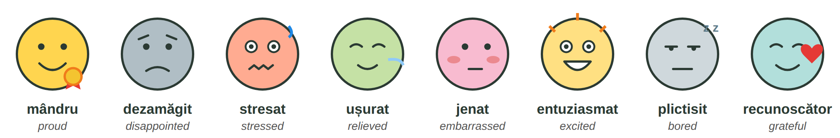
Fig. 14.1 — Stări și emoții / Moods and feelings
SAYING HOW YOU FEEL | ENGLISH
Sunt mândru de fiul meu. · Sunt dezamăgit de rezultat. | I'm proud of my son. · I'm disappointed with the result.
Mă bucur că ai venit! · Îmi pare rău că n-am putut veni. | I'm glad you came! · I'm sorry I couldn't come.
Mi-e dor de familie. · Mi-e teamă că nu reușesc. | I miss my family. · I'm afraid I won't make it.
Mă enervează zgomotul. · M-am speriat! | The noise gets on my nerves. · I got scared!
Sunt ușurat: am primit permisul! · Mulțumesc din suflet! | I'm relieved: I got the permit! · Thank you from my heart!

14.1 How do they feel?
Write the feeling: mândru · ușurat · plictisit · dezamăgit · stresat.
1. Fiica mea a luat nota 10. Sunt ______________. | 2. Am pierdut trenul. Sunt ______________.
3. N-am nimic de făcut. Sunt ______________. | 4. Am mult de lucru și puțin timp. Sunt ______________.
5. Testul a fost ușor! Sunt ______________.

CUVINTE ȘI EXPRESII UZUALE / USEFUL WORDS AND PHRASES
starea de spirit | mood | a se simți | to feel
a se bucura | to be glad | a-i fi dor de | to miss
a se enerva | to get angry | a se liniști | to calm down

Lesson 14.2 — Opinions, comfort, congratulations / Păreri, consolare, felicitări
OPINION | ENGLISH | AGREE · DISAGREE | ENGLISH
Cred că... | I think that... | Sunt de acord. · Ai dreptate. | I agree. · You're right.
După părerea mea... | In my opinion... | Exact! · Așa e. | Exactly! · That's true.
Din punctul meu de vedere... | From my point of view... | Nu prea sunt de acord. | I don't really agree.
Mi se pare că... | It seems to me that... | Înțeleg, dar... · Da, totuși... | I understand, but... · Yes, however...
Ce părere aveți? | What do you think? | Nu sunt sigur. · Depinde. | I'm not sure. · It depends.

Polite disagreement in Romania is soft: first agree with something, then add dar / totuși — „Aveți dreptate, dar eu aș face altfel.” (Lesson 10.2)
TO COMFORT | ENGLISH | TO CONGRATULATE | ENGLISH
Îmi pare foarte rău. | I'm very sorry. | Felicitări! · Bravo! | Congratulations! · Well done!
Nu-ți face griji, o să fie bine. | Don't worry, it will be fine. | La mulți ani! | birthday, name day, New Year
Sănătate! · Multă sănătate! | Get well! · Good health! | Casă de piatră! | to a newly married couple
Condoleanțe. · Dumnezeu să-l ierte. | My condolences. · God rest his soul. | Să vă trăiască! | for a new baby
Sunt aici dacă ai nevoie. | I'm here if you need me. | Mult succes! · Baftă! | Good luck! · Good luck! (informal)

14.2 What do you say?
Write one phrase.
1. Un coleg se căsătorește. → ______________ | 2. E ziua vecinei. → ______________
3. Tatăl unui prieten a murit. → ______________ | 4. Colegul are un test mâine. → ______________

CUVINTE ȘI EXPRESII UZUALE / USEFUL WORDS AND PHRASES
părerea · opinia | opinion | a fi de acord | to agree
a consola | to comfort | a felicita | to congratulate
nunta · botezul | wedding · christening | înmormântarea | funeral

Lesson 14.3 — Social customs / Obiceiuri sociale
A VISIT HOME | WHAT ROMANIANS USUALLY DO
invitația | people invite you la o cafea, la masă (to a meal), la ziua mea; answer yes or no in time
ce aduci | flowers for the hostess, a box of chocolates, a cake or a bottle of wine; for children, a small toy or sweets
florile | an odd number (3, 5, 7...) — an even number is only for funerals and graves (Fig. 14.2)
la ușă | many families take off their shoes at the door — ask „Să mă descalț?”
la masă | the host offers again and again: Mai luați! Mai serviți! You can say „Mulțumesc, am mâncat foarte bine!” · a toast: „Noroc!”

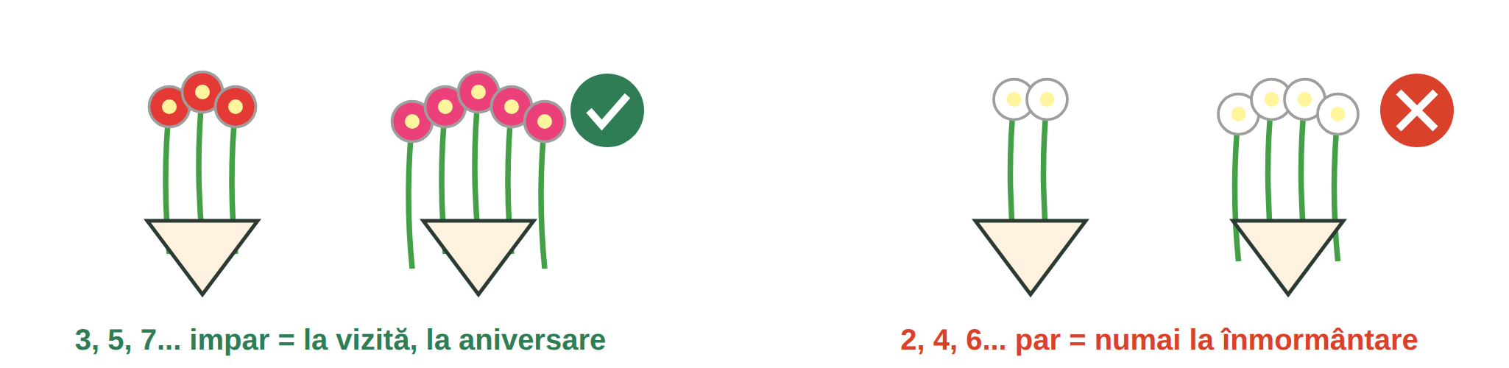
Fig. 14.2 — Număr impar de flori la vizită, număr par la înmormântare / Odd number for a visit, even for a funeral
NAME DAY / ZIUA NUMELUI | FOR | NAME DAY | FOR
7 ianuarie · Sf. Ioan | Ion, Ioana, Ionuț (Lesson 5.6) | 15 august · Sfânta Maria | Maria, Marian, Mariana
23 aprilie · Sf. Gheorghe | Gheorghe, George, Georgiana | 8 noiembrie · Sf. Mihail și Gavriil | Mihai, Mihaela, Gabriel, Gabriela
21 mai · Sf. Constantin și Elena | Constantin, Elena, Ilinca | 30 noiembrie · Sf. Andrei | Andrei, Andreea
29 iunie · Sf. Petru și Pavel | Petru, Petra, Pavel | 6 decembrie · Sf. Nicolae | Nicolae, Nicoleta

Romanians celebrate the ziua numelui (name day) almost like a birthday: you say „La mulți ani de ziua numelui!”, and the person often brings sweets to work.
SAYING NO POLITELY / REFUZUL POLITICOS | ENGLISH
Vă mulțumesc pentru invitație, dar din păcate nu pot. | Thank you for the invitation, but unfortunately I can't.
Mi-ar fi plăcut, dar lucrez în tura de noapte. | I would have liked to, but I work the night shift.
Poate altă dată? · Nu beau alcool, dar un suc, cu plăcere. | Maybe another time? · I don't drink alcohol, but a juice, with pleasure.

14.3 True or false?
Write A (adevărat) or F (fals).
1. La o vizită duci patru flori. ___ | 2. Pe 23 aprilie e ziua lui Gheorghe. ___
3. „Noroc!” se spune când ciocnești paharul. ___ | 4. Nu poți refuza niciodată o invitație. ___

CUVINTE ȘI EXPRESII UZUALE / USEFUL WORDS AND PHRASES
a invita · invitația | to invite · invitation | gazda | host, hostess
musafirul | guest | a se descălța | to take off one's shoes
ziua numelui | name day | Noroc! | Cheers!

GREȘELI FRECVENTE LA SCRIS / COMMON WRITING MISTAKES
WRITE | WHAT IT IS | EXAMPLE | THE TEST
ți-e | îți + e = îți este (feelings, with tu) | Ți-e dor de casă? · Ți-e foame? | you can say îți este
ție | to you (strong form) | Ție îți place? · Asta e pentru ție. | answers Cui? (like mie, Lesson 11.3)
ne-am | ne + am — we (have) ... ourselves / us | Ne-am bucurat mult. · Ne-am întâlnit la nuntă. | you can say ne-a for one person
neam | relatives, family (colloquial) · nation | Tot neamul a venit la botez. | it is a noun

HOMEWORK — AFTER SESSION 50 / TEMĂ PENTRU ACASĂ
H50.1 Write a short message to a Romanian colleague for his or her name day and one to refuse an invitation politely.
H50.2 Write your opinion (five sentences) about life in Romania with Cred că... / După părerea mea... / Sunt de acord că...

SESSION 51 — THE ROMANIAN STATE AND COURSE RECAP
SESIUNEA 51 — STATUL ROMÂN ȘI RECAPITULARE · 3 hours

By the end of this session you will be able to:
☐ | name more rights and obligations from the Constitution
☐ | explain who makes, applies and judges the laws
☐ | recognise the buildings of the President, the Parliament and the Government
☐ | review the whole course with six summary sheets

Lesson 14.4 — The Constitution / Constituția României
The Constitution was adopted in 1991 (referendum of 8 December 1991) and revised in 2003. Lesson 8.8 gave you the basic rights (life, religion, expression, health, work) and obligations (respect the laws, pay taxes, good faith). Here are more rights. Some belong to everyone who lives in Romania; others only to Romanian citizens.
RIGHT / DREPTUL | WHAT IT MEANS | ART. | FOR
accesul liber la justiție | anyone can go to court to defend their rights | 21 | everyone
libertatea individuală | nobody can be arrested without the conditions of the law | 23 | everyone
viața intimă și privată | your private and family life is protected | 26 | everyone
inviolabilitatea domiciliului | nobody can enter your home without your consent, except as the law says | 27 | everyone
secretul corespondenței | letters, phone calls, messages are secret | 28 | everyone
dreptul la informație | access to information of public interest | 31 | everyone
dreptul la învățătură | education — also for your children (Lesson 10.4) | 32 | everyone
libertatea întrunirilor | peaceful meetings and demonstrations, without weapons | 39 | everyone
dreptul la grevă | employees can strike to defend their professional interests | 43 | employees
dreptul de vot · de a fi ales | to vote and to be elected in national elections | 36, 37 | citizens
dreptul de petiționare | petitions to the authorities (for you: complaints to ITM, IGI — Lesson 11.9) | 51 | citizens

Obligations for everyone (Lesson 8.8): respect the Constitution and the laws (art. 1), pay taxes (art. 56), use your rights in good faith (art. 57). Only for citizens: loyalty to the country (art. 54) and its defence (art. 55). For foreigners there are also the rules of residence (IGI, Lesson 11.8). If an authority does not respect your rights, you can write to the Avocatul Poporului (the Ombudsman, art. 58).
14.4 Everyone or only citizens?
Write T (toți / everyone) or C (cetățeni / citizens).
1. dreptul de vot ___ | 2. accesul la justiție ___
3. secretul corespondenței ___ | 4. dreptul de a fi ales ___

CUVINTE ȘI EXPRESII UZUALE / USEFUL WORDS AND PHRASES
Constituția | the Constitution | cetățeanul | the citizen
drepturile · libertățile | rights · freedoms | instanța · judecătorul | the court · the judge
a vota · alegerile | to vote · elections | Avocatul Poporului | the Ombudsman

Lesson 14.5 — The institutions of the state / Instituțiile statului
Art. 1 (4) of the Constitution: the state is organised on the principle of the separation and balance of powers — legislative, executive and judicial.
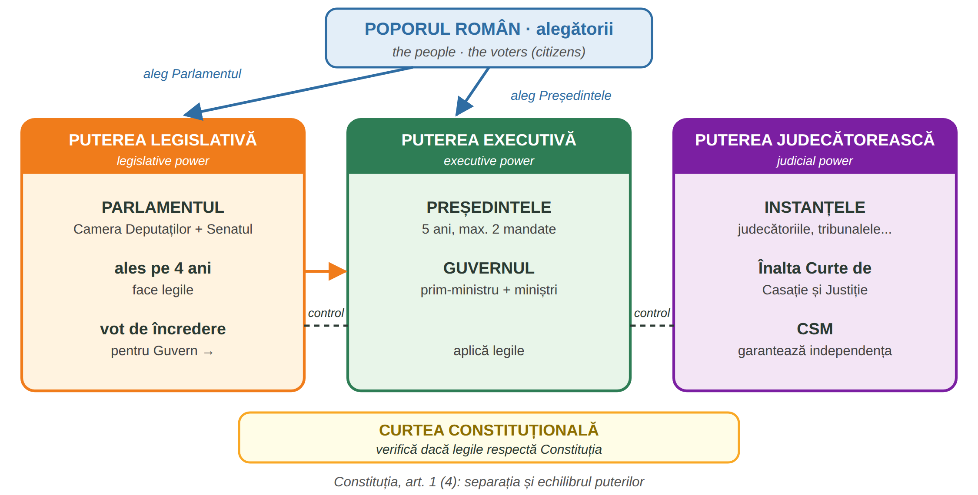
Fig. 14.3 — Separația puterilor în stat / The separation of powers
INSTITUTION | WHAT IT DOES | CONSTITUTION
Parlamentul | the only law-making authority; Camera Deputaților + Senatul; elected for 4 years | art. 61, 63
Președintele României | elected by direct vote for 5 years, at most two mandates; names the candidate for Prime Minister | art. 81, 83, 103
Guvernul | the Prime Minister and the ministers; carries out the policy of the country; needs the vote of confidence of Parliament | art. 102, 103
Justiția | the courts and the Înalta Curte de Casație și Justiție; judges are independent; the CSM guarantees the independence of justice | art. 124, 126, 133
Curtea Constituțională | checks that laws respect the Constitution | art. 142, 146

FOTO:  Palatul Cotroceni | FOTO:  Palatul Parlamentului | FOTO:  Palatul Victoria
Palatul Cotroceni — the Presidential Administration | Palatul Parlamentului — the Chamber of Deputies and the Senate | Palatul Victoria — the Government, Piața Victoriei

14.5 Who does it?
Write: Parlamentul · Președintele · Guvernul · instanțele · Curtea Constituțională.
1. Face legile. → ______________ | 2. Judecă procesele. → ______________
3. Aplică legile, are miniștri. → ______________ | 4. Verifică dacă legile respectă Constituția. → ______________
5. Are un mandat de 5 ani. → ______________

CUVINTE ȘI EXPRESII UZUALE / USEFUL WORDS AND PHRASES
puterea legislativă | legislative power | puterea executivă | executive power
puterea judecătorească | judicial power | mandatul | term of office
prim-ministrul · ministrul | prime minister · minister | deputatul · senatorul | MP · senator

Lesson 14.6 — Course recap: six summary sheets / Recapitularea cursului
One page for each big theme of the course. Read them before the final test; the lesson numbers show you where to look back.
FIȘA 1 — CITIM ȘI SCRIEM CORECT / READING AND WRITING
Module 1 (alphabet, pronunciation, writing) · Modules 10–14 (common writing mistakes)
TOPIC | THE RULE | EXAMPLE · LESSON
ă, â / î, ș, ț | five Romanian letters; â and î sound the same (â inside a word, î at the start and end) | mână, început, școală, țară — 1.3
read as written | every letter is read; ce, ci as in church · che, chi = [ke, ki] · ge, gi as in gin · ghe, ghi as in get | cer, ceai · cheie · ger · ghete — 2.2–2.4
diphthongs | two vowels in one syllable | doi, mai, seară, iarnă — 2.6
stress · capitals | stress has no written mark; days and months with a small letter — but holiday names: 1 Decembrie, 1 Mai (M1, 4.2) | luni, 1 decembrie — 3.2, 3.3
the cratima (-) | joins two words said together | într-o, mi-e, s-a, dă-mi — 4.1
-i, -ii, -iii | one i: plural; ii: the plural + the; iii: fiii | copii · copiii — 4.2, 11
forms, dates | name in capitals, date as day.month.year | KUMAR RAVI · 24.09.2026 — 4.3

PAIR | THE TEST | PAIR | THE TEST
să / s-a | verb after să · s-au for many | la / l-a | l-am possible → l-a
ia / i-a | i-am possible → i-a | sau / s-au | ori → sau · s-a → s-au
va / v-a | future → va · v-am → v-a | numai / nu mai | doar → numai
odată / o dată | de două ori → o dată | niciun / nicio | always one word
fi / fii | a fi → fi · tu → fii | mi-e / mie | îmi este → mi-e
copii / copiii | the children → copiii | cea / ce-a | ce a → ce-a
n-ai / nai | nu ai → n-ai | altfel / alt fel | alt fel de
mi-a / mia | mi-au possible → mi-a | deloc / de loc | de loc din
ne-a / nea | ne-au possible → ne-a | întruna / într-una | mereu → întruna
decât / de cât | doar → decât | câteodată / câte o dată | uneori → câteodată
dea / de-a | să dea · de-a lungul | s-ar / sar | verb after it → s-ar
ce-ai / ceai | ce ai → ce-ai | iau / i-au | eu iau · i-a → i-au
mai / m-ai | încă → mai | cel / ce-l | ce îl → ce-l
ți-e / ție | îți este → ți-e | ne-am / neam | ne-a → ne-am

VERIFICĂ-TE / CHECK YOURSELF
1. Scrie corect: ( într-o / întro ) zi. 2. Citește: cheie, ceai, ghete, ger. 3. Alege: Nu e ( nicio / nici o ) problemă.

FIȘA 2 — SUBSTANTIVUL ȘI PRIETENII LUI / NOUNS AND THEIR FRIENDS
Module 2 (the basics of grammar) · Module 4 (plurals, colours, shapes)
TOPIC | THE RULE | EXAMPLE · LESSON
gender | masculine (un / doi), feminine (o / două), neuter (un / două) | un pom · o casă · un tren, două trenuri — 2.1
plural | learn the plural with the word; some change inside | masă → mese · carte → cărți — 2.2, 4.2
the article | a / some: un, o, niște; the: at the end of the word | trenul · casa · trenurile · casele — 2.3
the adjective | after the noun, agrees with it | o mașină roșie · pantofi negri — 2.4, 4.4
numbers | from 20 on: de before the noun | cinci lei · douăzeci de lei — 2.5
personal pronouns | eu, tu, el, ea, noi, voi, ei, ele · polite: dumneavoastră | Dumneavoastră sunteți...? — 2.6
my, your... | agrees with the thing, not the owner | casa mea · telefonul meu · actele mele — 2.7
this, that | acesta / aceasta · acela / aceea (spoken: ăsta, asta) | Aceasta e fișa mea. — 2.8
whose | al, a, ai, ale + name / possessive | A cui e geanta? A Anei. — 2.9
short pronouns | îmi, îți, îi, ne, vă, le · mă, te, îl, o | Îmi place. · Te sun. · L-am văzut. — 2.10
building words | endings make new words | a lucra → lucrător · a citi → cititor — 2.11

IN THE CLASSROOM | ENGLISH | AT THE SHOP | ENGLISH
caietul · pixul | notebook · pen | Cât costă? | How much is it?
Nu înțeleg. Repetați, vă rog. | I don't understand. Repeat, please. | Aș dori... · O iau. | I'd like... · I'll take it.
Cum se spune...? | How do you say...? | cartela SIM · a reîncărca | SIM card · to top up
Ce înseamnă...? | What does ... mean? | roșu, galben, albastru, verde | colours — 4.4

VERIFICĂ-TE / CHECK YOURSELF
1. un tren → două ______. 2. 20 + lei → ______. 3. telefonul (my) → telefonul ______. 4. o mașină (red) → o mașină ______.

FIȘA 3 — VERBUL / THE VERB
Module 3 (the verb and the first conversation) · Module 10 (the conditional) · Module 12 (the imperfect)
TENSE / FORM | HOW IT IS BUILT | EXAMPLE | LESSON
present | four patterns + -ez / -esc verbs | lucrez · muncesc · merg | 3.3–3.5
a fi · a avea | irregular | sunt, ești, e... · am, ai, are... | 2.6
negative | nu + verb | Nu lucrez azi. | 3.6
questions | question word + verb | Unde lucrați? Când plecați? | 3.7–3.9
să + verb | after vreau, trebuie, pot, aș vrea | Trebuie să semnez. | 3.11
reflexive | mă, te, se, ne, vă, se + verb | Mă trezesc la 6. | 3.12
orders | imperative; negative: nu + infinitive | Semnați aici! · Nu atinge! | 3.13
past (perfect compus) | am, ai, a, am, ați, au + participle | Am lucrat. N-am înțeles. | 3.14, 3.15
future | o să + verb · voi + infinitive | O să plec. · Voi pleca. | 3.16
polite conditional | aș, ai, ar, am, ați, ar + infinitive | Aș vrea. Ați putea...? | 10.2
imperfect | stem + -am / -eam...; a fi: eram | Când eram copil, locuiam la țară. | 12.5

THE SAME VERB IN ALL FORMS — A LUCRA | ENGLISH
Lucrez în construcții. · Nu lucrez duminica. | I work in construction. · I don't work on Sundays.
Vreau să lucrez mai aproape de casă. | I want to work closer to home.
Am lucrat ieri 10 ore. · O să lucrez mâine. | I worked 10 hours yesterday. · I will work tomorrow.
Aș lucra în tura de zi. · Când eram în Nepal, lucram la fermă. | I would work the day shift. · When I was in Nepal, I worked on a farm.

WHAT YOU HEAR ON THE STREET (Lesson 3.17)
Unde-i gara? = Unde este gara? · Ce-i asta? · Nu-i acasă. · Hai! · Gata! · Stai puțin! — short spoken forms; you understand them, and you write the full form.

VERIFICĂ-TE / CHECK YOURSELF
Say a merge in all forms: merg · să merg · am mers · o să merg · aș merge · mergeam. Then do the same with a avea.

FIȘA 4 — VIAȚA DE ZI CU ZI ȘI SĂNĂTATEA / EVERYDAY LIFE AND HEALTH
Modules 4, 6, 7, 8, 11, 12, 13
SITUATION | KEY PHRASES | LESSON
introducing yourself | Mă numesc... Sunt din... Lucrez ca... Am ... ani. | 3.2, 3.18
clothes, sizes | Port mărimea M. Pot să-l probez? E prea mare. | 6.1–6.3
my home | Locuiesc la bloc, într-un apartament cu două camere. | 6.4–6.6
family | Sunt căsătorit, am doi copii. Fratele soției = cumnatul. | 7.1, 7.2
restaurant | Aș dori... Ce ne recomandați? Nota, vă rog! | 7.3–7.6
shopping for food | Un kilogram de roșii. Cât costă kilogramul? | 8.1–8.3
travel, free time | Un bilet dus-întors la Brașov. Hai la o plimbare! | 11.1–11.5
renting, the block | Chiria include utilitățile? Îmi pare rău, o dau mai încet. | 12.1, 12.2
services | Adaug în coș. Plata ramburs. Unde schimb spre M4? | 13.1–13.3

HEALTH | KEY PHRASES | LESSON
the body, symptoms | Mă doare capul. Mă dor picioarele. Am febră. | 8.4, 8.5
pharmacy, doctor | Aveți ceva pentru durere de cap? Sunt alergic la... | 8.5, 8.6
family doctor, card | medicul de familie · cardul de sănătate · concediul medical | 8.7
specialist, tests | Aș dori o programare. Am bilet de trimitere. Vin pe nemâncate. | 13.4
prescription | Am o rețetă compensată. Cât plătesc eu? | 13.5
medical history | Am diabet de cinci ani. Am fost operat în 2019. | 13.6
emergency | 112 — ambulanța, pompierii, poliția. Spui adresa exactă. | 5.2

VERIFICĂ-TE / CHECK YOURSELF
Say in Romanian: 1. I would like an appointment. 2. How much is a kilogram? 3. My head hurts. 4. I'd like a return ticket.

FIȘA 5 — MUNCA ȘI DREPTURILE TALE / WORK AND YOUR RIGHTS
Modules 5, 9, 10, 11, 12
TOPIC | WHAT TO REMEMBER | LESSON
at work | tools, materials, units, orders; Nu am înțeles. Puteți să-mi explicați? | 9.1–9.12
safety (SSM) | EIP free of charge; instructajul; never remove a protection; accident → 112, tell the boss | 9.13
the contract | written, in Romanian, before you start; your copy; REGES-ONLINE | 11.6
working time | probation max 90 days · 8 h / 40 h · max 48 h with overtime · leave min 20 working days | 11.6
the payslip | gross − CAS 25% − CASS 10% − tax 10% = net | 11.7
the bank | account, IBAN, card; never give the PIN or codes | 10.5, 10.6
residence permit | renew at IGI at least 30 days before it expires; CNP on the permit; changes → IGI | 5.2, 11.8
lost documents | police → embassy → IGI; card: block it | 11.9
problems at work | not paid, no contract → petition to ITM, answer in 30 days | 5.2, 11.9
scams | no money for a job; no codes by phone; do not sign what you do not understand; DNSC 1911 | 11.10
O.U.G. 32/2026 | 6 months: you cannot ask to change employer (except serious breaches); leaving early → costs can be claimed; after the contract ends: max 90 days to find a new employer | 12.6

WHERE TO GO / UNDE MERGI
112 emergency · ITM work problems · IGI residence · Primăria local taxes, documents · Poliția theft, loss · ambasada passport · CAS health insurance · DNSC 1911 online fraud · ANPC consumer rights · Avocatul Poporului rights vs authorities.

VERIFICĂ-TE / CHECK YOURSELF
1. Where do you go if you are not paid? 2. How many days before the permit expires do you apply at IGI? 3. What do you do if someone asks for your PIN?

FIȘA 6 — ROMÂNIA / ROMANIA
Modules 5, 10, 11, 14
TOPIC | WHAT TO REMEMBER | LESSON
the country | capital București; regions: Muntenia, Moldova, Transilvania, Banat, Oltenia, Dobrogea...; currency leul | 5.1
symbols | flag albastru, galben, roșu; coat of arms with 5 fields; anthem „Deșteaptă-te, române!” (1848) | 5.1, 10.7
national days | 24 Ianuarie (1859) · 1 Decembrie (1918, Ziua Națională) · 26 iunie flag · 29 iulie anthem | 5.6, 10.7
recent history | 1947–1989 communism · December 1989 Revolution (Timișoara) · NATO 2004 · EU 2007 · Schengen 2024–2025 | 10.8
famous Romanians | Eminescu, Brâncuși, Enescu, Nadia Comăneci, Henri Coandă, Hagi | 10.9
places | Peleș, Bran, Sighișoara, Delta Dunării, Transfăgărășan, Bucovina, the Black Sea... | 11.4
traditions | ia · Christmas, Easter (Hristos a înviat!) · name days · odd number of flowers | 5.6, 11.5, 14.3
social rules | dumneavoastră with officials; punctuality; Bună ziua! in the lift | 5.3, 12.2
the state | Constitution 1991 / 2003; Parliament (laws, 4 years) · President (5 years) · Government · courts · Constitutional Court | 14.4, 14.5

I CAN NOW... / ACUM POT... | KEY PHRASE
talk about Romania and my country | În România... În țara mea...
explain who does what in the state | Parlamentul face legile.
behave well at a Romanian home | Să mă descalț? · Noroc! · La mulți ani!
give my opinion politely | Cred că... · Înțeleg, dar...

VERIFICĂ-TE / CHECK YOURSELF
1. Who makes the laws? 2. When is the National Day? 3. How many flowers do you take to a visit: 4 or 5?

HOMEWORK — AFTER SESSION 51 / TEMĂ PENTRU ACASĂ
H51.1 Read the six summary sheets. Mark with a pencil what you are not sure about and ask the teacher in Session 52, before the test.
H51.2 Write five sentences: who makes the laws, who applies them, who judges, how long the President and the Parliament stay.

SESSION 52 — THE FINAL TEST
SESIUNEA 52 — TESTUL FINAL CUMULATIV · 3 hours

By the end of this session you will be able to:
☐ | show what you learned in Modules 1–14
☐ | close your course file

HOW IT WORKS
the test | 56 multiple-choice questions, four from each module (M1–M14); one correct answer each; 1 point per answer
how you answer | mark one box with X; two marks = 0 points; ask the teacher if you do not understand a word in a question
at the end | you sign and date the test; the teacher writes the score and signs; the test goes into your file with the course closure record
what you bring | a pen, your ID (passport or residence permit)

BEFORE THE TEST — CHECK YOURSELF
Read the six summary sheets of Lesson 14.6. For each theme, can you say three sentences in Romanian? If not, open the lesson shown on the sheet.

FELICITĂRI! / CONGRATULATIONS!
You have reached the end of 156 hours of Romanian. Vă mulțumim pentru efort și vă dorim mult succes în România!

SECȚIUNE DETAȘABILĂ — EXEMPLAR FORMATOR
Detachable section — teacher's copy. Se detașează din suportul cursantului; testul final completat, semnat și datat, se păstrează la dosarul cursantului împreună cu fișa de închidere a dosarului. Conține: testul final cumulativ, fișa de confirmare a Sesiunii 52, fișa de evidență a Modulului 14, fișa de închidere a dosarului, cheia răspunsurilor, sursele.

TEST FINAL CUMULATIV — MODULELE 1–14
FINAL CUMULATIVE TEST · grilă, 56 de întrebări (4 din fiecare modul), 56 de puncte · semnat și datat de cursant

Nume și prenume cursant / Student name
Act de identitate / ID document
Data / Date | _____ / _____ / 20_____
Semnătura cursantului / Student signature

Marcați cu X un singur răspuns la fiecare întrebare. Mark ONE answer with X for each question. Each correct answer = 1 point.
1. Care literă este specifică limbii române? (1 p)
☐ a) k | ☐ b) ș | ☐ c) w | ☐ d) y
2. În cuvântul „cer”, litera c se citește ca în cuvântul englezesc: (1 p)
☐ a) church | ☐ b) cat | ☐ c) city | ☐ d) kilo
3. În cuvântul „chiar”, grupul ch se citește: (1 p)
☐ a) [ș] | ☐ b) [ch], ca în church | ☐ c) [s] | ☐ d) [k], ca în kilo
4. Care formă este scrisă corect? (1 p)
☐ a) într o zi | ☐ b) întro zi | ☐ c) într-o zi | ☐ d) în-tro zi
5. Pluralul lui „un tren” este: (1 p)
☐ a) doi treni | ☐ b) două trenuri | ☐ c) două trene | ☐ d) doi trenuri
6. „Casa” înseamnă: (1 p)
☐ a) the house | ☐ b) a house | ☐ c) houses | ☐ d) some houses
7. Cum spui corect 20 lei? (1 p)
☐ a) doi zeci lei | ☐ b) douăzeci lei | ☐ c) douăzeci din lei | ☐ d) douăzeci de lei
8. Completează: „Aceasta este mașina ___.” (my) (1 p)
☐ a) mei | ☐ b) meu | ☐ c) mea | ☐ d) mele
9. Răspunsul corect la „Cum vă numiți?” este: (1 p)
☐ a) Am 30 de ani. | ☐ b) Mă numesc Ravi. | ☐ c) Sunt bine. | ☐ d) Din Nepal.
10. Completează: „Vreau ___ plec acasă.” (1 p)
☐ a) să | ☐ b) la | ☐ c) s-a | ☐ d) sa
11. Trecutul pentru „eu lucrez” este: (1 p)
☐ a) eu să lucrez | ☐ b) eu voi lucra | ☐ c) eu lucrez ieri | ☐ d) eu am lucrat
12. „O să merg mâine” este: (1 p)
☐ a) prezent | ☐ b) trecut | ☐ c) viitor | ☐ d) imperativ
13. „Caietul” este: (1 p)
☐ a) a pen | ☐ b) a notebook | ☐ c) a table | ☐ d) a bag
14. Completează: „o mașină ___” (red) (1 p)
☐ a) roșie | ☐ b) roșu | ☐ c) roșii | ☐ d) roși
15. Pentru telefon cumperi o ___ SIM. (1 p)
☐ a) cutie | ☐ b) cheie | ☐ c) carte | ☐ d) cartelă
16. „Cât costă?” înseamnă: (1 p)
☐ a) What is it? | ☐ b) Where is it? | ☐ c) How much is it? | ☐ d) Who is it?
17. Numărul unic de urgență este: (1 p)
☐ a) 911 | ☐ b) 112 | ☐ c) 1911 | ☐ d) 110
18. Nu primești salariul. Unde reclami? (1 p)
☐ a) la ITM | ☐ b) la IGI | ☐ c) la CFR | ☐ d) la bancă
19. Ziua Națională a României este: (1 p)
☐ a) 9 mai | ☐ b) 24 ianuarie | ☐ c) 26 iunie | ☐ d) 1 decembrie
20. „E frig și ninge.” Ce anotimp este? (1 p)
☐ a) primăvara | ☐ b) vara | ☐ c) iarna | ☐ d) toamna
21. „Îmi este mare. Aveți o mărime mai mică?” Unde ești? (1 p)
☐ a) la farmacie | ☐ b) la magazinul de haine | ☐ c) la bancă | ☐ d) la gară
22. „Dormitorul” este camera unde: (1 p)
☐ a) dormi | ☐ b) gătești | ☐ c) te speli | ☐ d) mănânci
23. Frigiderul este de obicei în: (1 p)
☐ a) hol | ☐ b) baie | ☐ c) dormitor | ☐ d) bucătărie
24. „Cartea este pe masă.” „Pe” înseamnă: (1 p)
☐ a) next to | ☐ b) under | ☐ c) on | ☐ d) behind
25. Fratele soției mele este: (1 p)
☐ a) socrul meu | ☐ b) cumnatul meu | ☐ c) nepotul meu | ☐ d) unchiul meu
26. „Sunt căsătorit” înseamnă: (1 p)
☐ a) I am married | ☐ b) I am single | ☐ c) I am divorced | ☐ d) I am engaged
27. La restaurant, la final, spui: (1 p)
☐ a) Casă de piatră! | ☐ b) Bună dimineața! | ☐ c) La mulți ani! | ☐ d) Nota, vă rog!
28. „Am emoții” înainte de un examen înseamnă: (1 p)
☐ a) I am sick | ☐ b) I am angry | ☐ c) I am nervous | ☐ d) I am bored
29. Completează: „Un kilogram ___ roșii.” (1 p)
☐ a) la | ☐ b) de | ☐ c) cu | ☐ d) pe
30. „Mă doare capul” înseamnă: (1 p)
☐ a) I have a headache | ☐ b) my head is big | ☐ c) I wash my hair | ☐ d) I nod
31. Medicul la care ești înscris pentru consultații de bază este: (1 p)
☐ a) chirurgul | ☐ b) farmacistul | ☐ c) dentistul | ☐ d) medicul de familie
32. Constituția României garantează libertatea: (1 p)
☐ a) de a lucra fără contract | ☐ b) de a nu plăti taxe | ☐ c) religioasă | ☐ d) de a conduce fără permis
33. EIP înseamnă: (1 p)
☐ a) o factură | ☐ b) echipament individual de protecție | ☐ c) un tip de contract | ☐ d) o sculă electrică
34. Nu înțelegi o instrucțiune la lucru. Spui: (1 p)
☐ a) Nu am înțeles. Puteți să-mi explicați, vă rog? | ☐ b) Gata! | ☐ c) Merge și așa. | ☐ d) Lasă-l!
35. La un accident grav de muncă suni la: (1 p)
☐ a) IGI | ☐ b) bancă | ☐ c) curier | ☐ d) 112
36. „Instructajul” la locul de muncă este: (1 p)
☐ a) the salary | ☐ b) a holiday | ☐ c) training on health and safety | ☐ d) a tool
37. Forma politicoasă este: „___ putea să mă ajutați?” (1 p)
☐ a) Aș | ☐ b) Ați | ☐ c) Ar | ☐ d) Am
38. Un e-mail oficial se încheie cu: (1 p)
☐ a) Cu stimă, | ☐ b) Pa! | ☐ c) Hai! | ☐ d) Salut!
39. Ce nu dai niciodată nimănui? (1 p)
☐ a) IBAN-ul pentru salariu, angajatorului | ☐ b) numele tău | ☐ c) orașul tău | ☐ d) PIN-ul cardului
40. Revoluția din decembrie 1989 a început la: (1 p)
☐ a) Cluj | ☐ b) Iași | ☐ c) Timișoara | ☐ d) Constanța
41. Perioada de probă pentru un post de execuție este de maximum: (1 p)
☐ a) 30 de zile | ☐ b) 90 de zile | ☐ c) 60 de zile | ☐ d) 1 an
42. Concediul de odihnă este de cel puțin: (1 p)
☐ a) 20 de zile lucrătoare | ☐ b) 10 zile lucrătoare | ☐ c) 5 zile lucrătoare | ☐ d) 60 de zile lucrătoare
43. Salariul net este: (1 p)
☐ a) impozitul | ☐ b) salariul din contract, înainte de taxe | ☐ c) contribuția CAS | ☐ d) suma pe care o primești pe card
44. Cineva îți cere bani ca să-ți dea un loc de muncă. Este: (1 p)
☐ a) obligatoriu | ☐ b) normal | ☐ c) o înșelătorie | ☐ d) o taxă de la IGI
45. Orele de liniște sunt: (1 p)
☐ a) 18:00–20:00 | ☐ b) 22:00–08:00 și 13:00–14:00 | ☐ c) 00:00–05:00 | ☐ d) numai duminica
46. O sticlă de plastic se pune în containerul: (1 p)
☐ a) galben | ☐ b) albastru | ☐ c) verde | ☐ d) maro
47. Completează: „Când eram copil, ___ la țară.” (1 p)
☐ a) am să locuiesc | ☐ b) voi locui | ☐ c) locuiesc | ☐ d) locuiam
48. În primele 6 luni (O.U.G. 32/2026), lucrătorul străin: (1 p)
☐ a) trebuie să schimbe angajatorul | ☐ b) poate schimba angajatorul oricând | ☐ c) nu poate cere el schimbarea angajatorului, cu excepția încălcărilor grave | ☐ d) nu are nevoie de contract
49. „Plata ramburs” înseamnă: (1 p)
☐ a) plătești online înainte | ☐ b) plătești curierului la primire | ☐ c) nu plătești | ☐ d) plătești la bancă
50. AWB-ul este: (1 p)
☐ a) numărul de urmărire a coletului | ☐ b) prețul | ☐ c) o reducere | ☐ d) adresa curierului
51. Biletul de trimitere la specialist ți-l dă: (1 p)
☐ a) banca | ☐ b) farmacistul | ☐ c) curierul | ☐ d) medicul de familie
52. Rețeta pentru o boală acută este valabilă cel mult: (1 p)
☐ a) 1 an | ☐ b) 30 de zile | ☐ c) 48 de ore | ☐ d) nelimitat
53. Cine face legile în România? (1 p)
☐ a) Guvernul | ☐ b) Parlamentul | ☐ c) Președintele | ☐ d) instanțele
54. Mandatul Președintelui României este de: (1 p)
☐ a) 5 ani | ☐ b) 4 ani | ☐ c) 6 ani | ☐ d) 10 ani
55. La o vizită, flori se duc în număr: (1 p)
☐ a) niciodată flori | ☐ b) par: 2, 4, 6 | ☐ c) oricât, nu contează | ☐ d) impar: 3, 5, 7
56. Cum spui politicos că nu ești de acord? (1 p)
☐ a) Nu mă interesează! | ☐ b) Taci! | ☐ c) Înțeleg, dar nu sunt de acord. | ☐ d) Pa!

PUNCTAJ OBȚINUT / SCORE | _______ / 56
Semnătura formatorului / Teacher signature

SESSION COMPLETION RECORD
FIȘĂ DE CONFIRMARE A PARCURGERII SESIUNII — se păstrează la dosar

Module / Modul | Modulul 14 — Emoții, viața socială, statul român și test final (finalizat)
Session / Sesiunea | Sesiunea 52 — TEST FINAL CUMULATIV, Modulele 1–14
Duration / Durata | 3 ore
Date / Data | _____ / _____ / 20_____
Student name / Nume și prenume cursant
Score / Punctaj obținut | _______ / 56
Student signature / Semnătura cursantului
Teacher signature / Semnătura formatorului

DECLARAȚIE CURSANT / STUDENT DECLARATION
Declar că am participat la această sesiune de curs și am susținut testul final.
I declare that I attended this course session and sat the final test.

MODULE 14 — COMPLETION RECORD
FIȘĂ DE EVIDENȚĂ A PARCURGERII MODULULUI 14 — se păstrează la dosarul cursantului

NR. | SESIUNE / CONȚINUT | DATA | PUNCTAJ | SEMNĂTURA CURSANTULUI
50 | Sesiunea 50 — Emoții, păreri, obiceiuri sociale (3 ore) |  | —
51 | Sesiunea 51 — Constituția, instituțiile statului, recapitularea cursului (3 ore) |  | —
52 | Sesiunea 52 — TEST FINAL CUMULATIV M1–M14 (3 ore) |  | ___ / 56

FIȘA DE ÎNCHIDERE A DOSARULUI CURSANTULUI
COURSE CLOSURE RECORD — curs de limbă română cu elemente de integrare culturală și socială, O.U.G. nr. 32/2026, art. 7 alin. (1) lit. g)

Nume și prenume cursant · cetățenie / Student · citizenship
Act de identitate · CNP / ID document · CNP
Angajator / Employer
Furnizor · formator / Course provider · teacher
Perioada cursului / Course period | de la ____ / ____ / 20____ până la ____ / ____ / 20____

M | MODULUL | SESIUNI | ORE | TEST MODUL | SEMNĂTURA FORMATORULUI
1 | Alfabetul, scrisul și pronunția | 1–4 | 12 | ____ / 20
2 | Bazele gramaticii | 5–9 | 15 | ____ / 25
3 | Verbul și prima conversație | 10–15 | 18 | ____ / 40
4 | La curs și la cumpărături | 16–18 | 9 | ____ / ___
5 | Orientare România și timpul | 19–22 | 12 | ____ / 20
6 | Haine și casa mea | 23–25 | 9 | ____ / 20
7 | Familia mea și la restaurant | 26–28 | 9 | ____ / 20
8 | Supermarket, piață, farmacie și medic (test A1) | 29–32 | 12 | ____ / 50
9 | Domeniul de activitate: ________________ | 33–36 | 12 | ____ / 25
10 | Politețe, educație, banca și România de azi | 37–40 | 12 | ____ / 20
11 | Călătorii, timp liber, munca și drepturile străinilor | 41–44 | 12 | ____ / 22
12 | Casa, viața la oraș și la țară, O.U.G. 32/2026 | 45–47 | 9 | ____ / 22
13 | Servicii de zi cu zi și sănătate | 48–49 | 6 | ____ / 20
14 | Emoții, viața socială, statul român și test final | 50–52 | 9 | ____ test final
 | TOTAL | 52 | 156

Test final / Final test · ore frecventate / hours attended | ____ / 56 · ____ din 156 ore · data __.__.20__

Documente în dosar: ☐ fișele de evidență M1–M14 ☐ fișele de confirmare a sesiunilor ☐ testele modulelor ☐ testul final ☐ copia actului de identitate
CONFIRMARE ÎNCHIDERE DOSAR / CLOSURE CONFIRMATION
Confirm că cursantul a parcurs cursul de limbă română cu elemente de integrare culturală și socială (O.U.G. nr. 32/2026, art. 7 alin. (1) lit. g)) în perioada menționată și a susținut testul final consemnat mai sus. I confirm that the student attended the course in the period above and sat the final test recorded above.
Semnătura cursantului: ______________ Semnătura formatorului: ______________
Reprezentant angajator (nume, semnătură, ștampilă): ______________ Data: __.__.20__

ANSWER KEY — TEACHER COPY
CHEIA RĂSPUNSURILOR — pentru formator

14.1 mândru · dezamăgit (sau stresat) · plictisit · stresat · ușurat
14.2 e.g. Casă de piatră! · La mulți ani! · Condoleanțe. / Dumnezeu să-l ierte. · Mult succes! / Baftă!
14.3 F · A · A · F 14.4 C · T · T · C
14.5 Parlamentul · instanțele · Guvernul · Curtea Constituțională · Președintele
Final test — grilă answer key
TOTAL: 56 de puncte, câte 4 din fiecare modul (întrebările 1–4 = M1, 5–8 = M2 ... 53–56 = M14). Un răspuns corect = 1 punct. Nemarcat sau dublu marcat = 0 puncte.
1 – b | 2 – a | 3 – d | 4 – c | 5 – b | 6 – a | 7 – d | 8 – c
9 – b | 10 – a | 11 – d | 12 – c | 13 – b | 14 – a | 15 – d | 16 – c
17 – b | 18 – a | 19 – d | 20 – c | 21 – b | 22 – a | 23 – d | 24 – c
25 – b | 26 – a | 27 – d | 28 – c | 29 – b | 30 – a | 31 – d | 32 – c
33 – b | 34 – a | 35 – d | 36 – c | 37 – b | 38 – a | 39 – d | 40 – c
41 – b | 42 – a | 43 – d | 44 – c | 45 – b | 46 – a | 47 – d | 48 – c
49 – b | 50 – a | 51 – d | 52 – c | 53 – b | 54 – a | 55 – d | 56 – c

Pragul de promovare nu este stabilit în acest suport — se aplică regula furnizorului de curs. / The pass mark is not set here — the course provider's rule applies.
Surse și data verificării / Sources and date of verification
Informațiile factuale și legale din acest modul au fost verificate la 24.09.2026 pe surse oficiale. The factual and legal information was checked on 24 September 2026 against official sources.
INFORMAȚIA / INFORMATION | SURSA / SOURCE | UNDE ÎN MODUL / WHERE
Constituția: adoptată 21.11.1991, aprobată prin referendum 8.12.1991, revizuită prin Legea nr. 429/2003 (referendum 18–19.10.2003) | Constituția României, republicată — legislatie.just.ro/Public/DetaliiDocument/47355; Camera Deputaților (cdep.ro); CCR (ccr.ro) | Lesson 14.4
Drepturile: art. 21, 23, 26, 27, 28, 31, 32, 39, 43, 36–37, 51; obligațiile: art. 1, 54–57; Avocatul Poporului art. 58 | Constituția României, Titlul II (cdep.ro, legislatie.just.ro); avp.ro | Lesson 14.4
Separația și echilibrul puterilor — art. 1 alin. (4) | Constituția; CCR — rolul Curții în echilibrul puterilor (ccr.ro) | Lesson 14.5
Parlamentul: art. 61, mandat 4 ani art. 63; Președintele: art. 81 (max. două mandate), art. 83 (5 ani); Guvernul: art. 102–103 (vot de încredere); Justiția: art. 124, 126, 133 | Constituția (cdep.ro, senat.ro, presidency.ro); ÎCCJ (scj.ro) | Lesson 14.5, test q. 53–54
Sediile: Palatul Cotroceni — Administrația Prezidențială; Palatul Parlamentului — Camera Deputaților și Senatul; Palatul Victoria — Guvernul | presidency.ro; cic.cdep.ro; gov.ro | Lesson 14.5
Test final: conținutul Modulelor 1–13 | Suporturile de curs M1–M13 și sursele lor | test final
Lecțiile anterioare citate | Modulele 1–13 | whole module

Obiceiurile sociale (florile în număr impar / par, descălțatul, ziua numelui) și datele zilelor de nume din calendarul ortodox sunt informații culturale generale, nu reglementări. / Social customs and name-day dates are general cultural information.

