LIMBA ROMÂNĂ PENTRU STRĂINI
Romanian Language for Foreign Workers
SUPORT DE CURS
MODULE 9 — MY FIELD OF WORK
MODULUL 9 — DOMENIUL DE ACTIVITATE
VARIANTA: LIVRARE DE MÂNCARE / FOOD DELIVERY
LEVEL / NIVEL | DURATION / DURATĂ | LANGUAGE OF TEACHING
A1+ — after Level A1 | 12 hours · Sessions 33–36 · Weeks 17–18 | English → Romanian

LEGAL BASIS / TEMEI LEGAL
Curs de limbă română cu elemente de integrare culturală și socială, organizat în conformitate cu O.U.G. nr. 32/2026, art. 7 alin. (1) lit. g) — minimum 6 luni, cel puțin 6 ore pe săptămână.
Romanian language course with cultural and social integration elements, organised under Government Emergency Ordinance no. 32/2026, art. 7(1)(g) — at least 6 months, at least 6 hours per week.
This module ends with ONE cumulative multiple-choice test (25 questions), signed and dated by the student and kept on file as proof of completion.

ONE MODULE, SEVERAL FIELDS / UN MODUL, MAI MULTE DOMENII
Module 9 is about the Romanian you need at your own workplace. It exists in several versions — construction, hotels and restaurants (HoReCa), transport and logistics, retail, manufacturing. All versions have the same four sessions: tools and equipment · numbers and measurements · the work step by step · instructions, safety and the language of the workplace. The student follows the version for their own job. This book is the food delivery version (Livrare de mâncare).

Before you start
You have finished Level A1. Module 9 uses everything you know on the bicycle, the e-scooter or the moped, at the restaurant counter and at the customer's door. You will name your vehicle and equipment, read an order in the app, work with minutes, kilometres, battery and money, follow a delivery from the restaurant to the door, keep the food safe, know the main traffic rules for your vehicle and your duties for health and safety at work (SSM).
You need these lessons first — look back at them if you are not sure:
YOU NEED | WHERE | WHY
numbers · de after 20 · decimals | Lesson 2.5 | 3,2 km, 48,50 lei, 20 de minute
orders and requests | Lesson 3.13 | Ia comanda! Sunați-mă, vă rog!
the time | Lesson 5.4 | ajung la 19:40, în 10 minute
the weather | Lesson 5.5 | plouă, ninge, e polei
address, floor, block | Lessons 6.4, 6.6 | bl. B3, sc. 2, et. 4, ap. 17
food, ordering and paying | Lessons 7.3, 7.4 | the order, the bill, cash or card
the phone call, 112 | Lesson 5.2 | calling a customer, an accident

Where this module sits in the course
SESSION | DURATION | CONTENT
Session 33 | 3 hours | Lesson 9.1 The app and the order · 9.2 The vehicle · 9.3 Your equipment
Session 34 | 3 hours | Lesson 9.4 Time, distance, battery · 9.5 The address and the customer · 9.6 Money
Session 35 | 3 hours | Lesson 9.7 At the restaurant · 9.8 The food in the bag · 9.9 At the door · 9.10 Problems and support · 9.11 On the road
Session 36 | 3 hours | Lesson 9.12 Orders and messages · 9.13 Safety at work · 9.14 Expressions and recap · Module 9 cumulative test

NO NEW GRAMMAR IN THIS MODULE
The orders at work are the forms from Lesson 3.13 — here you only use them. Everything else is words and phrases of your job.
Words differ from workplace to workplace. One courier says comandă, another livrare; one says geantă, another cutie or rucsac. When you hear a new word, ask: Cum se numește asta? · Ce înseamnă...? (Lesson 4.3).

SESSION 33 — THE APP, THE VEHICLE, THE EQUIPMENT
SESIUNEA 33 — APLICAȚIA, VEHICULUL, ECHIPAMENTUL · 3 hours

By the end of this session you will be able to:
☐ | read a new order in the app
☐ | name the parts of a bicycle, an e-scooter and a moped
☐ | name your equipment and say what is missing or broken

Lesson 9.1 — The app and the order / Aplicația și comanda
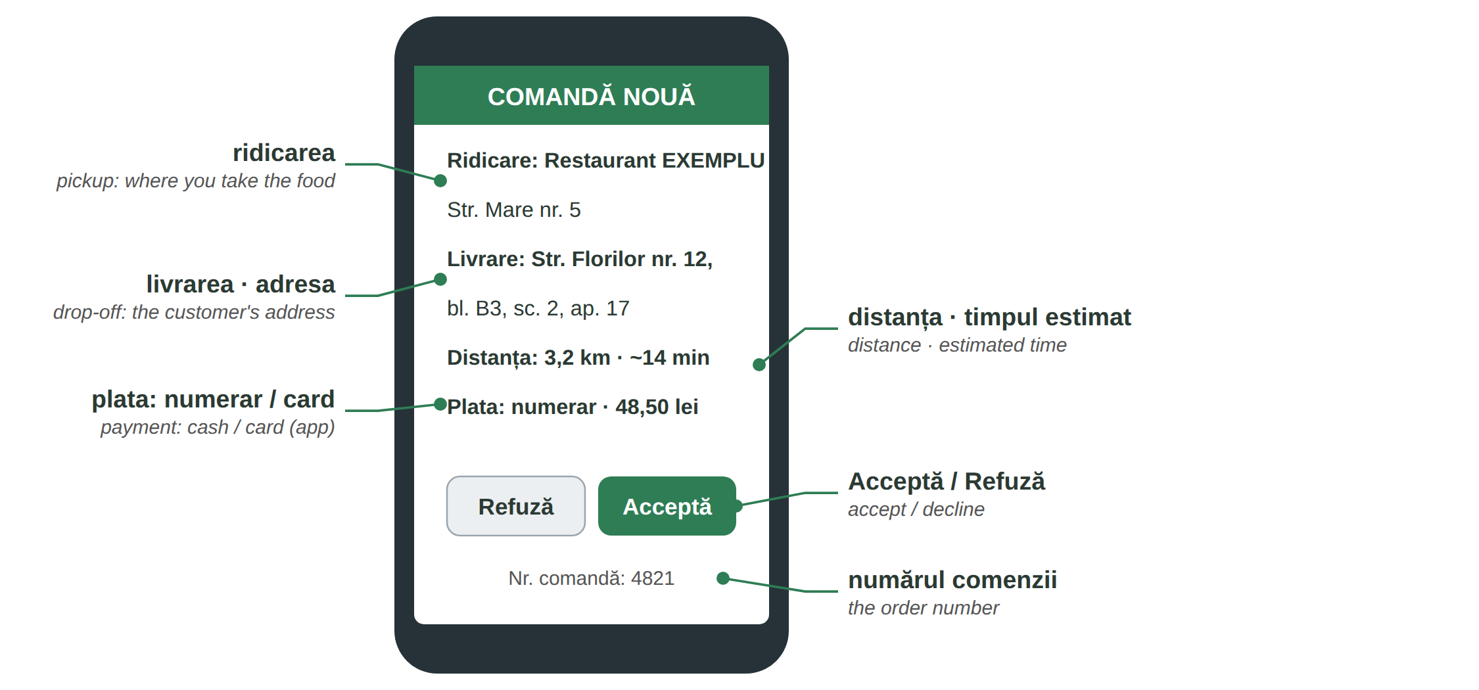
Fig. 9.1 — O comandă nouă în aplicație (exemplu) / A new order in the app (example)
IN THE APP | ENGLISH | IN THE APP | ENGLISH
Acceptă · Refuză | accept · decline | Ridicare | pickup
Am ajuns la restaurant | I'm at the restaurant | Comanda e gata | the order is ready
Am ridicat comanda | I've picked up the order | Livrare | drop-off
Am ajuns la client | I'm at the customer | Livrat | delivered
online · offline | available · not available | Istoric | history (your deliveries)

People: curierul / livratorul (you) · clientul · personalul restaurantului · suportul (the support team in the app) · coordonatorul or șeful at the company you work for.
9.1 Read the order
Look at Fig. 9.1.
1. De unde ridici comanda? — ______________ | 2. Unde livrezi? — ______________
3. Câți kilometri sunt? — ______________ | 4. Cum plătește clientul? — ______________

CUVINTE ȘI EXPRESII UZUALE / USEFUL WORDS AND PHRASES
a accepta o comandă | to accept an order | a refuza | to decline
sunt online | I'm available | Nu-mi merge aplicația. | My app doesn't work.
numărul comenzii | the order number | o comandă nouă | a new order

Lesson 9.2 — The vehicle / Vehiculul
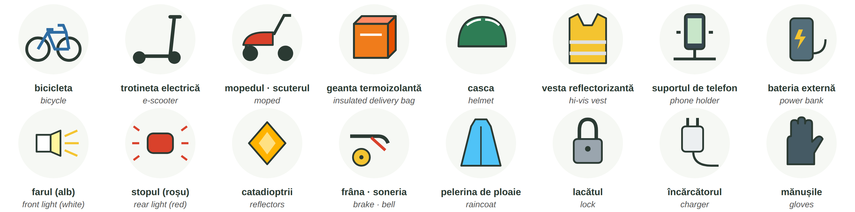
Fig. 9.2 — Vehiculul și echipamentul curierului / The courier's vehicle and equipment
THE VEHICLE | ENGLISH | THE VEHICLE | ENGLISH
ghidonul · șaua | handlebar · saddle | pedalele · lanțul | pedals · chain
roata · camera · anvelopa | wheel · inner tube · tyre | frâna · soneria | brake · bell
farul · stopul | front light · rear light | catadioptrii | reflectors
bateria · încărcătorul | battery · charger | lacătul | the lock
motorul · rezervorul (moped) | engine · fuel tank | plăcuța cu numărul | number plate

9.2 Which part?
Write the part.
1. Opresc cu ______________. | 2. Noaptea, în față, aprind ______________.
3. Încarc ______________ trotinetei. | 4. Leg bicicleta cu ______________.

CUVINTE ȘI EXPRESII UZUALE / USEFUL WORDS AND PHRASES
am făcut pană | I have a flat tyre | s-a descărcat bateria | the battery is flat
nu merge frâna | the brake doesn't work | a umfla roata | to pump up the tyre
service-ul | the repair shop | s-a rupt lanțul | the chain broke

Lesson 9.3 — Your equipment / Echipamentul tău
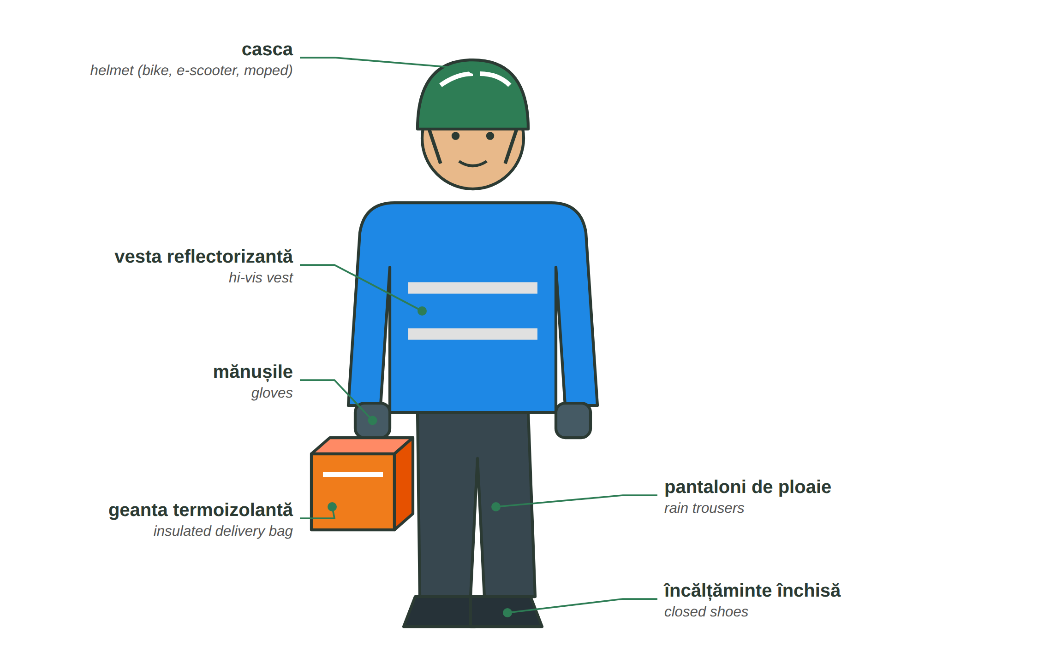
Fig. 9.3 — Curierul echipat / The courier and the equipment
Keep the geanta termoizolantă (the insulated bag) clean and closed. In the dark and in rain, wear light-coloured, reflective clothes — the drivers must see you. Your phone needs a suport on the handlebar and a baterie externă for the long evenings.
9.3 What do you need?
Complete.
1. Pun mâncarea în ______________. | 2. Pe cap port ______________.
3. Noaptea port ______________ reflectorizantă. | 4. Telefonul stă pe ______________.

CUVINTE ȘI EXPRESII UZUALE / USEFUL WORDS AND PHRASES
geanta e murdară | the bag is dirty | o pelerină de ploaie | a raincoat
Îmi trebuie o vestă nouă. | I need a new vest. | Unde pot încărca telefonul? | Where can I charge my phone?

HOMEWORK — AFTER SESSION 33 / TEMĂ PENTRU ACASĂ
H33.1 Write ten things you use at work, with un / o and the plural.
H33.2 Write what is not working on your vehicle today — or what could go wrong (three sentences).

SESSION 34 — TIME, DISTANCE, ADDRESS, MONEY
SESIUNEA 34 — TIMP, DISTANȚĂ, ADRESĂ, BANI · 3 hours

By the end of this session you will be able to:
☐ | say how far, how long and how much battery
☐ | read an address and find the right door
☐ | take cash, give change and say thank you for a tip

Lesson 9.4 — Time, distance, battery / Timp, distanță, baterie
WRITTEN | YOU SAY | ENGLISH | EXAMPLE
km · m | kilometru · metru | kilometre · metre | mai am 800 de metri
min | minut | minute | ajung în 5 minute
km/h | kilometri pe oră | km per hour | trotineta merge cu cel mult 25 km/h
% | la sută | per cent | bateria are 15 la sută
19:40 | ora nouăsprezece și patruzeci | at 7.40 pm | comanda e gata la 19:40

QUESTION | CALCULATION | ANSWER
Ai 6 km cu 18 km/h. Cât durează? | 6 : 18 = 1/3 oră | 20 de minute
Pleci la 19:45. Drumul durează 15 minute. Când ajungi? | 19:45 + 0:15 | la 20:00
Bateria are 40%. Consumi 5% pe livrare. Câte livrări mai poți face? | 40 : 5 = 8 | 8 livrări (better 7: keep a reserve)

9.4 Say it and calculate
Write the answer.
1. 12 km cu 24 km/h = ______ minute | 2. Plec la 20:10 + 25 min = ______
3. „15%” = ______________________ | 4. „800 m” = ______________________

CUVINTE ȘI EXPRESII UZUALE / USEFUL WORDS AND PHRASES
Cât mai e? | How far is it still? | Ajung în cinci minute. | I'll be there in five minutes.
Întârzii puțin. | I'm a little late. | aproape · departe | near · far

Lesson 9.5 — The address and the customer / Adresa și clientul
RECAP — THE ADDRESS (Lessons 6.4, 6.6)
Str. Florilor nr. 12, bl. B3, sc. 2, et. 4, ap. 17 — strada, numărul, blocul, scara, etajul, apartamentul. At a block you ring the interfon with the apartment number.

IN THE ORDER / YOU HEAR | WHAT IT MEANS
interfon 17 · cod 1234 | ring 17 on the intercom · the door code is 1234
Lăsați la ușă, vă rog. | leave it at the door (no contact)
Sunați când ajungeți. | call when you arrive
Nu merge interfonul. | the intercom doesn't work — call the customer
reperul: lângă farmacie | the landmark: next to the pharmacy
intrarea din spate · poarta verde | the back entrance · the green gate

ON THE PHONE | ENGLISH
C: Bună seara! Sunt curierul cu comanda dumneavoastră. Sunt la bloc. | Good evening! I'm the courier with your order. I'm at the block.
D: Scara 2, etajul 4. Vă deschid. | Entrance 2, 4th floor. I'll open the door for you.
C: Nu găsesc scara. Puteți coborî, vă rog? | I can't find the entrance. Can you come down, please?

9.5 What do you say?
Write one sentence.
1. You are at the block: ______________________ | 2. The intercom doesn't work: ______________________
3. You can't find the entrance: ______________________ | 4. You are 5 minutes late: ______________________

CUVINTE ȘI EXPRESII UZUALE / USEFUL WORDS AND PHRASES
Unde e scara 2? | Where is entrance 2? | Vă aștept jos. | I'm waiting downstairs.
Deschideți, vă rog. | Open the door, please. | clientul nu răspunde | the customer doesn't answer
codul ușii | the door code | un reper | a landmark

Lesson 9.6 — Money / Banii
RECAP — PAYING (Lesson 7.4)
Plătiți cash sau cu cardul? · Poftiți restul. · 48,50 lei = patruzeci și opt de lei și cincizeci de bani.

THE CUSTOMER PAYS | CALCULATION | THE CHANGE / RESTUL
Comanda: 48,50 lei. Clientul dă 50 de lei. | 50 − 48,50 | 1,50 lei
Comanda: 73 de lei. Clientul dă 100 de lei. | 100 − 73 | 27 de lei
Comanda: 36,20 lei. Clientul dă 40 de lei. | 40 − 36,20 | 3,80 lei

AT THE DOOR | ENGLISH
Sunt 48,50 lei, vă rog. | It's 48.50 lei, please.
Aveți mărunt? · N-am rest la 200 de lei. | Do you have small change? · I have no change for 200 lei.
E plătită cu cardul în aplicație. | It's paid by card in the app.
Păstrați restul. — Mulțumesc frumos! | Keep the change. — Thank you very much!

A bacșiș (tip) is never compulsory — do not ask for it. Keep the cash money separate and count it at the end of the day: the app shows what you must hand in or what is yours, depending on your contract.
9.6 Calculate the change
Write the answer.
1. Comanda 42 lei, clientul dă 50 → ______ | 2. Comanda 67,50 lei, clientul dă 70 → ______
3. Comanda 18,40 lei, clientul dă 20 → ______ | 4. Comanda 91 lei, clientul dă 100 → ______

CUVINTE ȘI EXPRESII UZUALE / USEFUL WORDS AND PHRASES
restul | the change | bani mărunți · mărunt | small change
bacșișul | the tip | o bancnotă de 100 | a 100-lei note
plătit online | paid online | numerar · cash | cash

HOMEWORK — AFTER SESSION 34 / TEMĂ PENTRU ACASĂ
H34.1 Write your own address in the Romanian order, with abbreviations and the intercom number.
H34.2 Write three payments with the change, like the table in Lesson 9.6.

SESSION 35 — A DELIVERY STEP BY STEP
SESIUNEA 35 — O LIVRARE PAS CU PAS · 3 hours

By the end of this session you will be able to:
☐ | pick up an order at the restaurant and check it
☐ | keep the food safe and clean in the bag
☐ | hand over the order and check the age for alcohol
☐ | explain a problem to support
☐ | know the main traffic rules for your vehicle

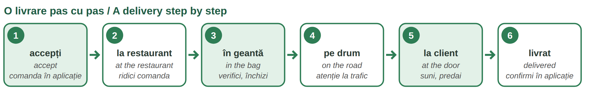
Fig. 9.4 — O livrare pas cu pas / A delivery step by step

Lesson 9.7 — At the restaurant / La restaurant
AT THE COUNTER | ENGLISH
C: Bună seara! Am venit pentru comanda 4821. | Good evening! I'm here for order 4821.
R: Mai durează cinci minute. Așteptați, vă rog. | Five more minutes. Please wait.
C: E completă? Sunt două pungi și o băutură. | Is it complete? Two bags and a drink.
R: Da, totul e aici. Și bonul. C: Mulțumesc! | Yes, everything is here. And the receipt. — Thank you!

Check the numărul comenzii, the number of bags and the drinks before you leave. Do not open the sealed bags. Wait where the staff asks you to wait — not in the kitchen.
9.7 Put in order
Write 1–4.
___ Pun comanda în geantă. | ___ Spun numărul comenzii.
___ Apăs „Am ridicat comanda”. | ___ Verific pungile și băuturile.

CUVINTE ȘI EXPRESII UZUALE / USEFUL WORDS AND PHRASES
Comanda nu e gata. | The order isn't ready. | Lipsește o băutură. | A drink is missing.
punga · bonul | the bag · the receipt | sigilat | sealed

Lesson 9.8 — The food in the bag / Mâncarea în geantă
THE RULE | WHY / HOW
geanta curată | wash and dry the inside often; nothing else in the bag — no clothes, no fuel, no animals
cald separat de rece | hot food on one side, cold drinks and desserts on the other side, or in a separate bag
băuturile în picioare | drinks upright, in a holder, so they do not spill
nimic greu deasupra | heavy things at the bottom, light things on top
geanta închisă | close the bag at once — the food stays warm or cold and clean
sigiliul | never open a sealed bag; if it is torn, tell the restaurant and support

Anyone who transports food must keep it protected from dirt and at the right temperature — this is the basic EU food hygiene rule (Regulation (EC) no. 852/2004). Wash your hands, and do not work when you have a stomach illness.
9.8 Correct or not?
Write C (corect) or G (greșit).
1. ___ Pun supa lângă înghețată. | 2. ___ Închid geanta imediat.
3. ___ Pun băuturile culcat. | 4. ___ Deschid punga sigilată ca să verific.

CUVINTE ȘI EXPRESII UZUALE / USEFUL WORDS AND PHRASES
s-a vărsat | it spilled | cald · rece | hot · cold
a spăla geanta | to wash the bag | sigiliul e rupt | the seal is torn

Lesson 9.9 — At the door / La ușa clientului
AT THE DOOR | ENGLISH
C: Bună seara! Comanda dumneavoastră. Poftă bună! | Good evening! Your order. Enjoy your meal!
D: Mulțumesc! E totul? | Thank you! Is that everything?
C: Da: două pungi și o băutură. O seară bună! | Yes: two bags and a drink. Have a nice evening!

ATTENTION — ALCOHOL AND ENERGY DRINKS: ONLY 18+
In Romania it is forbidden to sell alcoholic drinks and energy drinks to minors (under 18) — Law no. 61/1991. If the order contains alcohol, ask for an ID: Vă rog, un act de identitate. Comanda conține alcool. If the customer is under 18, has no ID or is clearly drunk, do not hand over the drink and follow the steps in the app for this situation.

SITUATION | WHAT YOU SAY / DO
clientul nu răspunde | Sunt la ușă, vă aștept. — call, write in the chat, wait the time the app says
lipsește ceva | Îmi pare rău, restaurantul a pregătit comanda. — the customer reports it in the app
clientul vrea să intri | Îmi pare rău, las comanda aici. — you do not need to enter the flat
clientul e supărat | Înțeleg. Vă rog să scrieți la suport. — stay calm and polite

9.9 What do you say?
Write one sentence.
1. You hand over the order: ______________________ | 2. The order contains beer: ______________________
3. The customer doesn't answer: ______________________ | 4. The customer is angry: ______________________

CUVINTE ȘI EXPRESII UZUALE / USEFUL WORDS AND PHRASES
Poftă bună! | Enjoy your meal! | un act de identitate | an ID document
Aveți 18 ani? | Are you 18? | Nu pot să vă dau băutura. | I can't give you the drink.
Las comanda la ușă. | I'll leave the order at the door. | O seară bună! | Have a nice evening!

Lesson 9.10 — Problems and support / Probleme și suportul
When something goes wrong, write to the suport in the app. Short, clear sentences work best — what, where, the order number:
TO SUPPORT (CHAT) | ENGLISH
Comanda 4821: restaurantul e închis. | Order 4821: the restaurant is closed.
Clientul nu răspunde. Aștept de 10 minute. | The customer doesn't answer. I've been waiting 10 minutes.
Adresa e greșită. Clientul nu e aici. | The address is wrong. The customer isn't here.
S-a vărsat băutura. Ce fac? | The drink spilled. What do I do?
Am făcut pană. Nu pot livra comanda. | I have a flat tyre. I can't deliver the order.
Am avut un accident. Sunt bine / Sunt rănit. | I've had an accident. I'm OK / I'm hurt.

9.10 Write to support
One sentence with the order number 5093.
1. The restaurant is closed: ______________________ | 2. The address is wrong: ______________________
3. The customer doesn't answer: ______________________ | 4. Your battery is flat: ______________________

CUVINTE ȘI EXPRESII UZUALE / USEFUL WORDS AND PHRASES
Ce fac? | What do I do? | Anulați comanda, vă rog. | Please cancel the order.
o poză | a photo | am trimis o poză | I've sent a photo

Lesson 9.11 — On the road / Pe drum
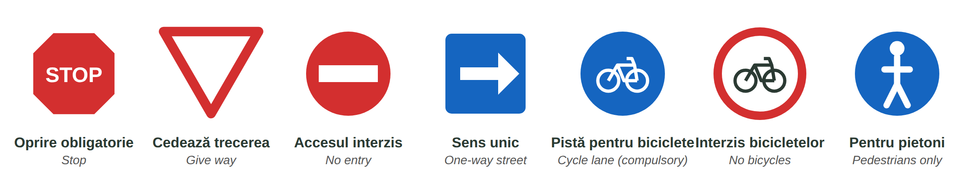
Fig. 9.5 — Indicatoare pentru biciclete și trotinete / Signs for bicycles and e-scooters
VEHICLE | WHAT THE LAW SAYS (checked with the Romanian Police)
bicicleta | on the pistă pentru biciclete if there is one · at night: white or yellow light in front, red light at the back, reflectors, working brakes and a bell · reflective vest at night
trotineta electrică | from 14 years · maximum 25 km/h · on the cycle lane; if there is none, only on streets with a speed limit of maximum 50 km/h · helmet compulsory under 16 · lights and reflectors at night, brakes, bell
mopedul | maximum 45 km/h, up to 50 cm³ or 4 kW · from 16 years · a driving licence (category AM, A1 or B1) · registration, compulsory insurance (RCA), technical inspection · helmet

ATTENTION — THE PHONE AND THE ROAD
Do not hold the phone in your hand while you ride. Put it in the holder before you leave; to read or write, stop at the side. No headphones in both ears. Never on the pavement among pedestrians, and never through a red light — being in a hurry is not a reason.
Your driving licence for the moped: whether you can use a licence from your country in Romania, and for how long, depends on the country that issued it. Check with your employer and the driving licence service (DRPCIV) first.

9.11 Which sign?
Look at Fig. 9.5 and write the sign.
1. Aici merg numai bicicletele. → ______________ | 2. Aici nu ai voie cu bicicleta. → ______________
3. Trebuie să oprești complet. → ______________ | 4. Aici merg numai pietonii. → ______________

CUVINTE ȘI EXPRESII UZUALE / USEFUL WORDS AND PHRASES
pista pentru biciclete | the cycle lane | trotuarul | the pavement
trecerea de pietoni | the pedestrian crossing | semaforul e roșu | the light is red
e polei | it's icy | un sens giratoriu | a roundabout

HOMEWORK — AFTER SESSION 35 / TEMĂ PENTRU ACASĂ
H35.1 Write the steps of a delivery in order with întâi, apoi, după aceea, la sfârșit.
H35.2 Write three messages to support about three different problems.

SESSION 36 — ORDERS, SAFETY, EXPRESSIONS, RECAP AND TEST
SESIUNEA 36 — COMENZI, SSM, EXPRESII, RECAPITULARE ȘI TEST · 3 hours

By the end of this session you will be able to:
☐ | understand the orders and messages you get at work
☐ | know the risks of your work and how to stay safe
☐ | know what to do in an accident
☐ | recognise the expressions you hear on the street and at the restaurant

Lesson 9.12 — Orders and messages / Comenzi și mesaje
RECAP — ORDERS (Lesson 3.13)
At the counter they say tu: Așteaptă! Ia comanda! A customer or support writes politely: Sunați-mă! Lăsați la ușă, vă rog!

DIRECT (tu) | POLITE (dumneavoastră) | ENGLISH — EXAMPLE
Așteaptă! | Așteptați! | Wait! — Așteaptă afară, te rog!
Ia comanda! | Luați comanda! | Take the order! — Ia comanda 4821, e gata!
Sună-mă! | Sunați-mă! | Call me! — Sunați-mă când ajungeți.
Lasă la ușă! | Lăsați la ușă! | Leave it at the door!
Urcă! | Urcați! | Come up! — Urcați la etajul 4.
Trimite o poză! | Trimiteți o poză! | Send a photo! (support)
Oprește! | Opriți! | Stop! — the police or a worker on the road

9.12 Understand the message
Write in English.
1. „Lăsați la ușă, vă rog.” → ______________ | 2. „Sunați-mă când ajungeți.” → ______________
3. „Trimiteți o poză.” → ______________ | 4. „Urcați la etajul 3.” → ______________

CUVINTE ȘI EXPRESII UZUALE / USEFUL WORDS AND PHRASES
Am înțeles. | Understood. | Vin imediat. | I'm coming right away.
Sunt pe drum. | I'm on my way. | Am ajuns. | I've arrived.

Lesson 9.13 — Safety at work / Securitatea și sănătatea în muncă

Your duties and your rights
YOU MUST (Law 319/2006, art. 22–23) | YOUR EMPLOYER MUST
work as you were trained, without putting yourself or others in danger | give you the protective equipment free of charge (HG 1048/2006)
use machines, tools and substances correctly and wear the EIP | train you in SSM before you start work (HG 1425/2006)
never remove or switch off a safety device | explain the risks of your workplace
report at once any danger you see | repeat the training periodically
tell your manager / employer about any accident you have | If there is a problem: ITM (Lesson 5.2)

PRACTICAL NOTE — THE SSM TRAINING / INSTRUCTAJUL SSM
Before you start work you receive the instructajul introductiv-general, then the instructajul la locul de muncă, and later the instructajul periodic — the interval between two periodic trainings cannot be longer than 6 months (HG 1425/2006). At the end there is a short test and you sign the fișa individuală de instruire. Sign only what you have understood: Nu am înțeles. Puteți să-mi explicați, vă rog?

THE RISK | WHAT YOU DO
traficul — traffic | follow the rules of Lesson 9.11; watch the doors of parked cars; make eye contact with drivers
noaptea — the dark | lights on, reflective vest, light-coloured clothes
vremea — rain, snow, ice, heat | slower, longer braking distance; in heat drink water; you may stop when it is dangerous
oboseala — tiredness | take breaks; tired = slow reactions
geanta grea — a heavy bag | bag on both shoulders, not too full; heavy things at the bottom
scările, câinii — stairs, dogs | use the handrail; keep away from dogs and ask the customer to hold the dog

ATTENTION — WHAT TO DO IN AN ACCIDENT
Stop in a safe place. If someone is hurt, call 112 (Lesson 5.2). Do not move an injured person unless there is danger. Write to support in the app and tell the company you work for. Always report any accident — also a small one (Law 319/2006, art. 23).

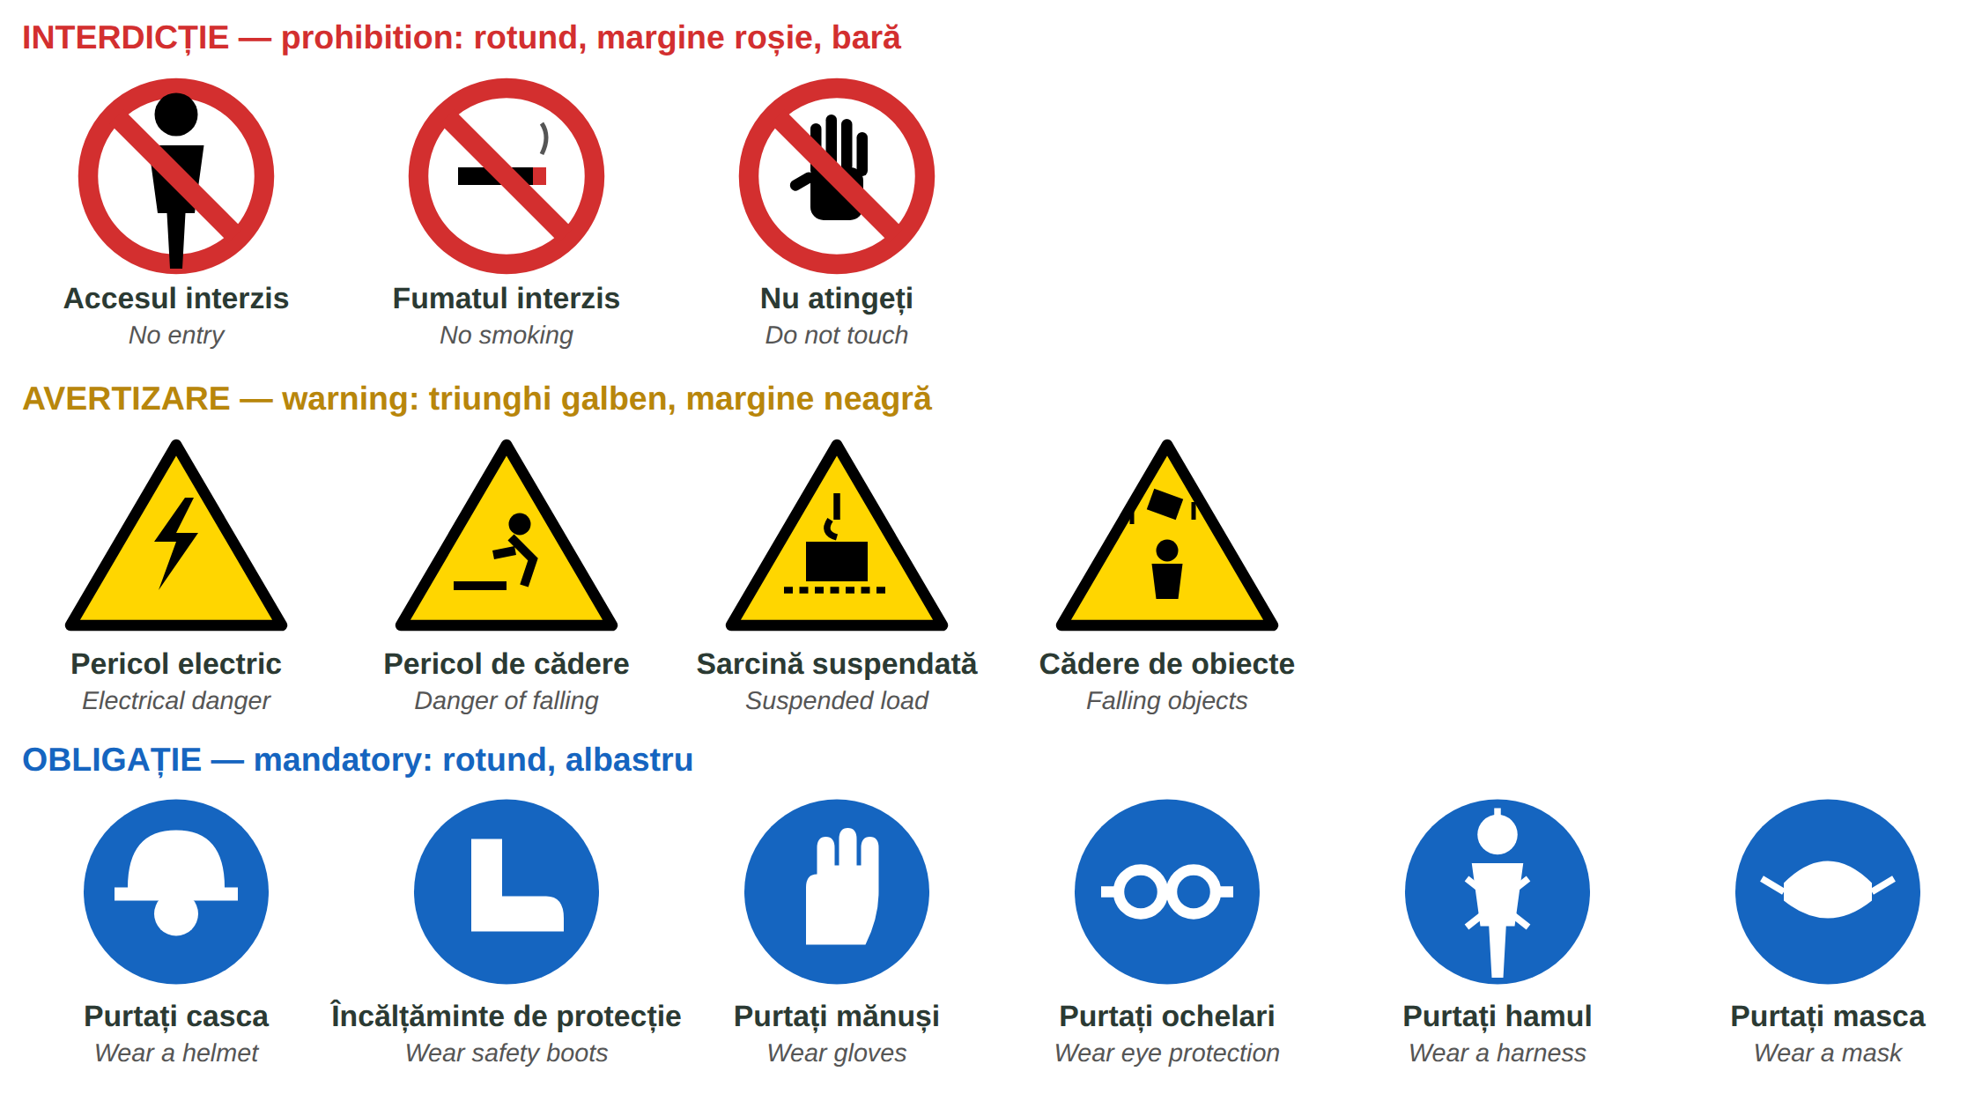
Fig. 9.6 — Indicatoare de securitate / Safety signs
9.13 What do you do?
Write one sentence.
1. Plouă tare și e întuneric. → ______________________ | 2. Ești foarte obosit. → ______________________
3. Un câine latră la ușă. → ______________________ | 4. Ai căzut cu bicicleta. → ______________________

CUVINTE ȘI EXPRESII UZUALE / USEFUL WORDS AND PHRASES
Am căzut. | I fell. | M-am lovit la genunchi. | I hurt my knee.
E periculos. | It's dangerous. | Fac o pauză. | I'm taking a break.

Lesson 9.14 — Expressions and recap / Expresii și recapitulare
EXPRESSIONS YOU HEAR AT THE RESTAURANT, ON THE STREET AND IN THE STREET — FOR RECOGNITION ONLY
Informal. Understand them; use them only with colleagues you know well — never with a customer, an official or the police.

YOU HEAR | WHAT IT MEANS | ENGLISH
Hai! | haide — hai să mergem, hai să începem | Come on! · Let's go!
Gata! | am terminat · e pregătit · ajunge | Done! · Ready! · That's enough!
Las' că merge. | nu-i nimic, e bine și așa | Never mind, it'll work.
Nu-i bai. | nu e nicio problemă (mai ales în Ardeal și Banat) | No problem.
Stai puțin! | așteaptă un moment | Wait a moment!
Bagă mare! | dă-i drumul, repede, cu toată puterea | Go for it! · Full speed!
Merge și așa. | e destul de bine, nu mai reparăm | It's good enough like that.
N-ai grijă! | nu-ți face griji, mă ocup eu | Don't worry!
Ce faci, mă? | salut prietenesc (sau: ce tot faci acolo?) | Hey, how's it going? / What are you doing?
Pe bune? | serios? adevărat? | Really? · Seriously?
Lasă-l! | nu-l mai deranja · lasă lucrul acolo | Leave him alone! · Leave it!
Dă-i bice! | grăbește-te, mai repede | Hurry up!
Vine acum-acum. | e aproape gata (dar poate mai durează) | It's coming any minute.
E jale pe drum. | e trafic foarte mare | The traffic is terrible.

ATTENTION — „LAS' CĂ MERGE” IS NEVER ABOUT SAFETY OR HYGIENE
Las' că merge and merge și așa (it is good enough) are never acceptable for safety or hygiene: riding through a red light because you are late, a torn seal, a dirty bag. Answer calmly: Nu, așa nu e sigur. — No, it's not safe like that. Mă, măi is familiar: fine between friends, rude to a stranger.

Module 9 in one table
THE APP | THE DELIVERY | NUMBERS AND MONEY | SAFETY
Acceptă · Refuză | ridicare · livrare | km · min · % | casca · vesta
Am ridicat · Livrat | geanta termoizolantă | 19:40 · în 10 minute | farul alb · stopul roșu
suportul · chatul | cald separat de rece | restul · bacșișul | pista pentru biciclete
numărul comenzii | alcool → act, 18+ | 48,50 lei | telefonul în suport · 112

9.14 Everything together
Circle the correct word.
1. Pun mâncarea în ( geanta termoizolantă / lacăt ). | 2. Noaptea, în spate: lumina ( roșie / albă ).
3. 50 − 48,50 = ( 1,50 / 2,50 ) lei | 4. Alcool: clientul trebuie să aibă ( 16 / 18 ) ani.
5. ( Sunați-mă / Sună-mă ) când ajungeți! | 6. Citesc telefonul ( în mers / oprit pe margine ).

HOMEWORK — AFTER SESSION 36 / TEMĂ PENTRU ACASĂ
H36.1 Write five messages you get every day at work and what they mean.
H36.2 Write what you do if it starts to snow in the middle of a delivery.

SECȚIUNE DETAȘABILĂ — EXEMPLAR FORMATOR
Detachable section — teacher's copy. Se detașează din suportul cursantului; testul completat, semnat și datat, se păstrează la dosarul cursantului. Conține: testul cumulativ, fișa de confirmare a Sesiunii 36, fișa de evidență a Modulului 9, cheia răspunsurilor, sursele.
TEST CUMULATIV — MODULUL 9 (LIVRARE DE MÂNCARE)
MODULE 9 — CUMULATIVE TEST · FOOD DELIVERY · grilă, 25 de întrebări, 25 de puncte · semnat și datat de cursant

Nume și prenume cursant / Student name
Data / Date | _____ / _____ / 20_____
Semnătura cursantului / Student signature

Marcați cu X un singur răspuns la fiecare întrebare. Mark ONE answer with X for each question. Each correct answer = 1 point.
1. În aplicație, „Acceptă” înseamnă: (1 p)
☐ a) decline | ☐ b) accept | ☐ c) deliver | ☐ d) cancel
2. „Ridicare” este locul unde: (1 p)
☐ a) iei comanda | ☐ b) lași comanda | ☐ c) plătești | ☐ d) încarci bateria
3. Cu ce oprești bicicleta? (1 p)
☐ a) cu soneria | ☐ b) cu frâna | ☐ c) cu lacătul | ☐ d) cu șaua
4. Pluralul lui „comandă” este: (1 p)
☐ a) comanduri | ☐ b) comandi | ☐ c) comenzi | ☐ d) comande
5. Mâncarea caldă o transporți în: (1 p)
☐ a) rucsacul personal | ☐ b) geanta termoizolantă | ☐ c) coșul de gunoi | ☐ d) mână
6. „S-a descărcat bateria” înseamnă: (1 p)
☐ a) the battery is flat | ☐ b) the battery is new | ☐ c) I charged the battery | ☐ d) the battery is full
7. 12 km cu 24 km/h durează: (1 p)
☐ a) 12 minute | ☐ b) 24 de minute | ☐ c) 30 de minute | ☐ d) o oră
8. „15%” se citește: (1 p)
☐ a) cincisprezece la sută | ☐ b) cincisprezece procente la mie | ☐ c) cincizeci la sută | ☐ d) unu cinci
9. „interfon 17” înseamnă: (1 p)
☐ a) etajul 17 | ☐ b) suni la interfon la apartamentul 17 | ☐ c) blocul 17 | ☐ d) codul ușii e 17
10. Clientul dă 50 de lei pentru o comandă de 48,50 lei. Restul este: (1 p)
☐ a) 0,50 lei | ☐ b) 1,50 lei | ☐ c) 2,50 lei | ☐ d) 15 lei
11. „Păstrați restul” înseamnă: (1 p)
☐ a) give me the change | ☐ b) keep the change | ☐ c) I have no change | ☐ d) count the money
12. La restaurant spui întâi: (1 p)
☐ a) numărul comenzii | ☐ b) adresa ta | ☐ c) parola aplicației | ☐ d) numărul de telefon al clientului
13. Punga sigilată: (1 p)
☐ a) o deschizi ca să verifici | ☐ b) nu o deschizi | ☐ c) o arunci | ☐ d) o dai altui curier
14. Supa caldă și înghețata le pui: (1 p)
☐ a) împreună | ☐ b) separat | ☐ c) supa deasupra | ☐ d) în aceeași pungă
15. Comanda conține bere. Ce faci? (1 p)
☐ a) o lași la ușă | ☐ b) ceri un act de identitate | ☐ c) o bei | ☐ d) nu spui nimic
16. Băuturile alcoolice nu se vând persoanelor sub: (1 p)
☐ a) 14 ani | ☐ b) 16 ani | ☐ c) 18 ani | ☐ d) 21 de ani
17. Clientul nu răspunde. Scrii la suport: (1 p)
☐ a) Clientul nu răspunde. Aștept de 10 minute. | ☐ b) Pleacă! | ☐ c) Nu știu. | ☐ d) Comanda e bună.
18. Noaptea, bicicleta are în spate lumină: (1 p)
☐ a) albă | ☐ b) roșie | ☐ c) verde | ☐ d) albastră
19. Viteza maximă a trotinetei electrice este: (1 p)
☐ a) 15 km/h | ☐ b) 25 km/h | ☐ c) 45 km/h | ☐ d) 50 km/h
20. Cu trotineta electrică poți circula de la vârsta de: (1 p)
☐ a) 10 ani | ☐ b) 14 ani | ☐ c) 18 ani | ☐ d) 21 de ani
21. Pentru moped ai nevoie de: (1 p)
☐ a) nimic | ☐ b) permis de conducere (AM, A1 sau B1) | ☐ c) numai de o cască | ☐ d) numai de aplicație
22. Telefonul pe drum: (1 p)
☐ a) în mână, în mers | ☐ b) în suport; citești oprit pe margine | ☐ c) în buzunar, cu căști în ambele urechi | ☐ d) pe ghidon, scriind în mers
23. „Lăsați la ușă, vă rog” înseamnă: (1 p)
☐ a) Come in, please. | ☐ b) Leave it at the door, please. | ☐ c) Open the door, please. | ☐ d) Call me, please.
24. Ai căzut cu bicicleta și ești rănit grav. Suni la: (1 p)
☐ a) 112 | ☐ b) restaurant | ☐ c) client | ☐ d) nimeni
25. „Dă-i bice!” înseamnă: (1 p)
☐ a) Hit him! | ☐ b) Hurry up! | ☐ c) Stop! | ☐ d) Be careful!

PUNCTAJ OBȚINUT / SCORE | _______ / 25
Semnătura formatorului / Teacher signature

SESSION COMPLETION RECORD
FIȘĂ DE CONFIRMARE A PARCURGERII SESIUNII — se păstrează la dosar

Module / Modul | Modulul 9 — Domeniul de activitate: Livrare de mâncare (finalizat)
Session / Sesiunea | Sesiunea 36 — Instrucțiuni, SSM, expresii, recapitulare. TEST CUMULATIV MODULUL 9
Duration / Durata | 3 ore
Date / Data | _____ / _____ / 20_____
Student name / Nume și prenume cursant
Score / Punctaj obținut | _______ / 25
Student signature / Semnătura cursantului
Teacher signature / Semnătura formatorului

DECLARAȚIE CURSANT / STUDENT DECLARATION
Declar că am participat la această sesiune de curs și am parcurs conținutul prezentat mai sus.
I declare that I attended this course session and covered the content presented above.

MODULE 9 — COMPLETION RECORD
FIȘĂ DE EVIDENȚĂ A PARCURGERII MODULULUI 9 — se păstrează la dosarul cursantului

Cursant / Student
Act de identitate / ID document
Angajator / Employer
Formator / Teacher
Modul / Module | Modulul 9 — Domeniul de activitate: Livrare de mâncare (12 ore, Sesiunile 33–36)

NR. | SESIUNE / CONȚINUT | DATA | PUNCTAJ TEST | SEMNĂTURA CURSANTULUI
33 | Sesiunea 33 — Aplicația și comanda, vehiculul, echipamentul (3 ore) |  | —
34 | Sesiunea 34 — Timp, distanță, baterie, adresa și clientul, banii (3 ore) |  | —
35 | Sesiunea 35 — La restaurant, mâncarea în geantă, la ușa clientului, probleme și suport, pe drum (3 ore) |  | —
36 | Sesiunea 36 — Comenzi și mesaje, SSM, expresii, recapitulare + TEST CUMULATIV (3 ore) |  | ___ / 25

CONFIRMARE FINALIZARE MODUL / MODULE COMPLETION
Confirm că cursantul a parcurs integral conținutul Modulului 9 — Domeniul de activitate: Livrare de mâncare, în total 12 ore de curs, și a susținut testul de evaluare consemnat mai sus.
I confirm that the student completed the full content of Module 9 — My Field of Work: Food delivery, 12 course hours in total, and sat the assessment recorded above.
Data: _____ / _____ / 20_____ Semnătura formatorului: ______________________

ANSWER KEY — TEACHER COPY
CHEIA RĂSPUNSURILOR — pentru formator

9.1 Restaurant EXEMPLU, Str. Mare nr. 5 · Str. Florilor nr. 12, bl. B3, sc. 2, ap. 17 · 3,2 km · numerar (48,50 lei)
9.2 frâna · farul · bateria · lacătul 9.3 geanta termoizolantă · casca · vesta · suport
9.4 30 · 20:35 · cincisprezece la sută · opt sute de metri
9.5 e.g. Bună seara, sunt curierul, sunt la bloc. · Nu merge interfonul. · Nu găsesc scara. Puteți coborî? · Întârzii cinci minute.
9.6 8 lei · 2,50 lei · 1,60 lei · 9 lei 9.7 3 · 1 · 4 · 2 (spun numărul → verific → pun în geantă → apăs „Am ridicat comanda”)
9.8 G · C · G · G 9.9 e.g. Comanda dumneavoastră, poftă bună! · Vă rog, un act de identitate. Comanda conține alcool. · Sunt la ușă, vă aștept. · Înțeleg. Vă rog să scrieți la suport.
9.10 e.g. Comanda 5093: restaurantul e închis. · Comanda 5093: adresa e greșită. · Comanda 5093: clientul nu răspunde. · Comanda 5093: s-a descărcat bateria, nu pot livra.
9.11 Pistă pentru biciclete · Interzis bicicletelor · STOP · Pentru pietoni 9.12 Leave it at the door · Call me when you arrive · Send a photo · Come up to the 3rd floor
9.13 e.g. Merg încet, cu luminile aprinse, cu vesta. · Fac o pauză. · Rog clientul să țină câinele. · Opresc, sun la 112 dacă e nevoie, scriu la suport.
9.14 geanta termoizolantă · roșie · 1,50 · 18 · Sunați-mă · oprit pe margine

Cumulative test — grilă answer key
TOTAL: 25 de puncte. Un răspuns corect = 1 punct. Nemarcat sau dublu marcat = 0 puncte.
1 – b | 2 – a | 3 – b | 4 – c | 5 – b | 6 – a | 7 – c | 8 – a | 9 – b | 10 – b
11 – b | 12 – a | 13 – b | 14 – b | 15 – b | 16 – c | 17 – a | 18 – b | 19 – b | 20 – b
21 – b | 22 – b | 23 – b | 24 – a | 25 – b

Surse și data verificării / Sources and date of verification
Informațiile legale din acest modul au fost verificate la 24.09.2026 pe surse oficiale. The legal information in this module was checked on 24 September 2026 against official sources.
INFORMAȚIA / INFORMATION | SURSA / SOURCE | UNDE ÎN MODUL / WHERE
Obligațiile lucrătorilor (instruire, echipamente, EIP, dispozitive de securitate, pericole, accidente) | Legea nr. 319/2006, art. 22–23 — legislatie.just.ro/Public/DetaliiDocumentAfis/73772 | Lesson 9.13
EIP gratuit de la angajator · instructajul (introductiv-general, la locul de muncă, periodic — max. 6 luni) | HG nr. 1048/2006, art. 10 — .../74559 · HG nr. 1425/2006 — .../DetaliiDocument/76337 | Lessons 9.3, 9.13
Semnalizarea de securitate: forme și culori | HG nr. 971/2006 — .../74127; Directiva 92/58/CEE | Lesson 9.13
Trotineta electrică: vârsta minimă 14 ani, viteza max. 25 km/h, pista pentru biciclete / drumuri cu limita max. 50 km/h, casca obligatorie sub 16 ani, lumini și dispozitive reflectorizante | OUG nr. 195/2002 (republicată, cu modificările ulterioare); Poliția Română — politiaromana.ro; MAI | Lesson 9.11, test q. 19–20
Bicicleta: lumină albă sau galbenă în față, roșie în spate, catadioptri, frâne, sonerie; vesta reflectorizantă noaptea | OUG nr. 195/2002; Poliția Română — politiaromana.ro (ghidul bicicliștilor) | Lessons 9.2, 9.11, test q. 18
Mopedul: 25–45 km/h, max. 50 cm³ / 4 kW; permis AM, A1 sau B1; vârsta 16 ani; înmatriculare, RCA, ITP | OUG nr. 195/2002; Poliția Română — politiaromana.ro | Lesson 9.11, test q. 21
Interzicerea vânzării băuturilor alcoolice și energizante către minori | Legea nr. 61/1991 (republicată, cu modificările ulterioare) | Lesson 9.9, test q. 15–16
Igiena transportului alimentelor (protejate de contaminare, la temperatura potrivită) | Regulamentul (CE) nr. 852/2004, anexa II — eur-lex.europa.eu | Lesson 9.8
Lecțiile anterioare citate | Modulele 1–8 (see each RECAP box) | whole module

Pașii de lucru și cifrele din exerciții sunt exemple didactice de vocabular, nu instrucțiuni tehnice: la locul de muncă se respectă procedurile firmei și indicațiile șefului. / The work steps and figures are teaching examples for vocabulary, not technical instructions.

